PYTHON MINI PROJECT REPORT

Project Title | IC Engine Fuel Consumption & Brake Thermal Efficiency Tool
Course Name | Semetser-3: Python Programming
Class Name | Mechanical-3A
Branch Name | Mechanical Engineering / Automation & Robotics
Prepared By | RATHOD JENIL KUMAR RAVI KUMAR | 25012251210003
Guided By | Mr. MohammedAzim Shaikh
Submitted to | Department of Mechanical Engineering,  LJ Polytechnic,  Lok Jagruti Kendra University,  Ahmedabad, Gujarat, India.

Certificate

This certificate is proudly presented to the following student for successfully completing the Python Mini-Project entitled “IC Engine Fuel Consumption & Brake Thermal Efficiency Tool” as part of the Diploma in Mechanical Engineering curriculum. This project work has been carried out under my guidance and supervision and it is up to my satisfaction.
Name of Students | Enrolment Number | Class
RATHOD JENIL KUMAR RAVI KUMAR | 25012251210003 | Mechanical-3A

Date: | Name & Signature of Guide
Place: Ahmedabad | Mr. MohammedAzim Shaikh

Table of Contents
Certificate 2
Table of Contents 3
1. Introduction 4
2. Objective 4
3. Methodology 4
4. Mechanical Engineering Application 4
5. Python Code 4
6. Screenshots 5
7. Results and Discussions 5
8. Conclusion 5
9. References 5
10. Course Certificates 6

Introduction
This Python and Streamlit app calculates IC-engine power, fuel consumption and efficiency. It supports Petrol, Diesel and CNG with correct ignition animation.

Objective
To calculate brake power, indicated power, BSFC, thermal and mechanical efficiency, display an energy balance, and compare spark- and compression-ignition operation.

Methodology
Streamlit collects and validates the inputs, then applies BP = 2*pi*N*T/(60*1000), fuel power = (mf/3600)*CV, IP = BP + FP, BSFC = mf/BP and efficiency = BP/fuel power*100. Petrol/CNG use spark ignition; Diesel uses compression ignition.

Mechanical Engineering Application
- The app evaluates engine power, fuel consumption and efficiency using editable Petrol (44000), Diesel (42500) and CNG (47000 kJ/kg) presets.
- For T = 100 N*m, N = 1500 RPM, mf = 5 kg/h, CV = 44000 kJ/kg and FP = 2 kW, manual and app answers match.

Python Code
The code below performs calculations; the app also validates inputs, plots charts and exports CSV.
Animation: spark plugs for Petrol/CNG; fuel injector and no spark plug for Diesel.

from math import pi
def engine_performance(T, N, mf, CV):
BP=2*pi*N*T/(60*1000); Qin=(mf/3600)*CV
return BP, mf/BP, (BP/Qin)*100

Screenshots
The figures show the live engine dashboard and verified energy balance. Fuel selection changes the ignition hardware and cycle labels.
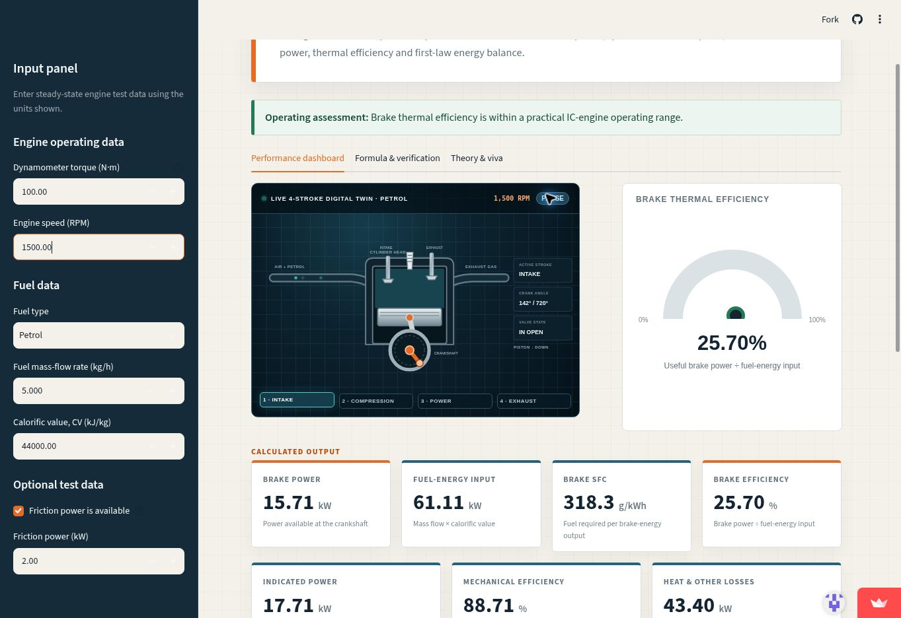 | 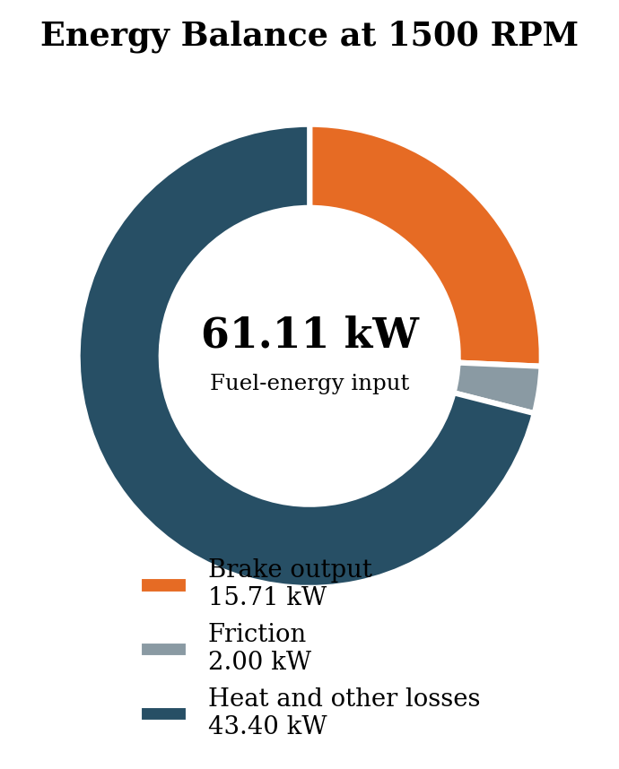

Results and Discussions
Manual and app results match for the verified petrol case: BP = 15.708 kW, fuel input = 61.111 kW, IP = 17.708 kW, BSFC = 318.31 g/kWh and brake efficiency = 25.704%. Tests also confirm spark plugs for Petrol/CNG and an injector with no spark plug for Diesel.

Conclusion
The app meets the objectives for Petrol, Diesel and CNG. It correctly separates spark ignition from diesel compression ignition; accuracy depends on steady-state test data.

References
R. K. Rajput, Thermal Engineering; V. Ganesan, Internal Combustion Engines; U.S. DOE AFDC, Fuel Properties Comparison; official Python, Streamlit, NumPy and Matplotlib documentation.

Course Certificates
