Weather Test automation

User Guide

Author: Ketan Rathod

Contents

Pre-requisites 2

Test Framework 2

Test Execution 3

Test Report 3

CI using Jenkins 4

# Pre-requisites

* Java JDK
* Eclipse
* Selenium WebDriver
* Maven
* TestNG
* Jenkins for CI

# Test Framework

Structure –

Implemented using Selenium WebDriver, TestNG & Maven

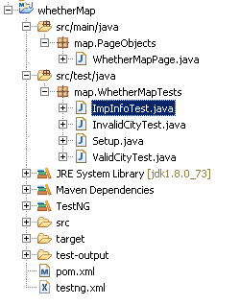

* WhetherMapPage.java file is implemented using the Page Object Model & page factory
* Setup.java class contains all the pre-requisites for launching the browser (like chrome, IE)
* Separate test java files are created for different tests Important Info on page, Search using invalid city name and search using valid city name .
* pom.xml contains all the dependencies and necessary plugins
* Tests are configured in the testing.xml file

# Test Execution

testng.xml structure

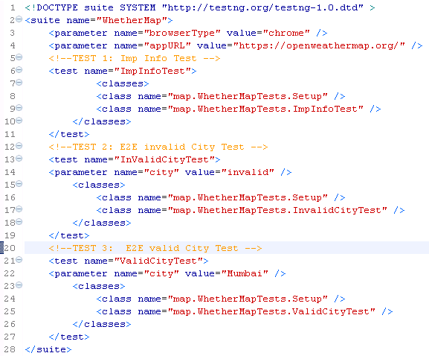

To execute the **TEST 1: Imp Info Test** test , keep the test name=”ImpInfoTest” and comment the other two tests in testing.xml file. Similar for running TEST 2 & TEST 3.

Tests can be executed by two ways:

1. run as TestNG Suite (Right click on the testing.xml file & click Run As TestNG Suite)

2. Run as Maven Test (Right click on the pom.xml file & click Run As Maven Test)

# Test Report

1. For Test executed as TestNG Suite , the reports will be generated in the target-output folder and open index.html file
2. For Test executed as Maven Clean, the reports will be generated in the target/surefire-reports folder and open index.html file

# CI using Jenkins

Jenkins can be used for CI.

* In Jenkins application , select New Item >> Maven Project
* Enter the item name,
* Provide the path of the pom.xml in the Root POM and provide the Goals & Options value as test
* Provided all the other required configurations like java , maven path.
* Save the job details

Once the build is triggered the test execution is performed as per the details provided in the TestNG file and reports are provided in Jenkins

