Task :2

Code:-

a=20  
b=1.5  
c="hello"  
print("value of a is:",a)  
print("value of a is:",b)  
print("value of a is:",c)

Output:-

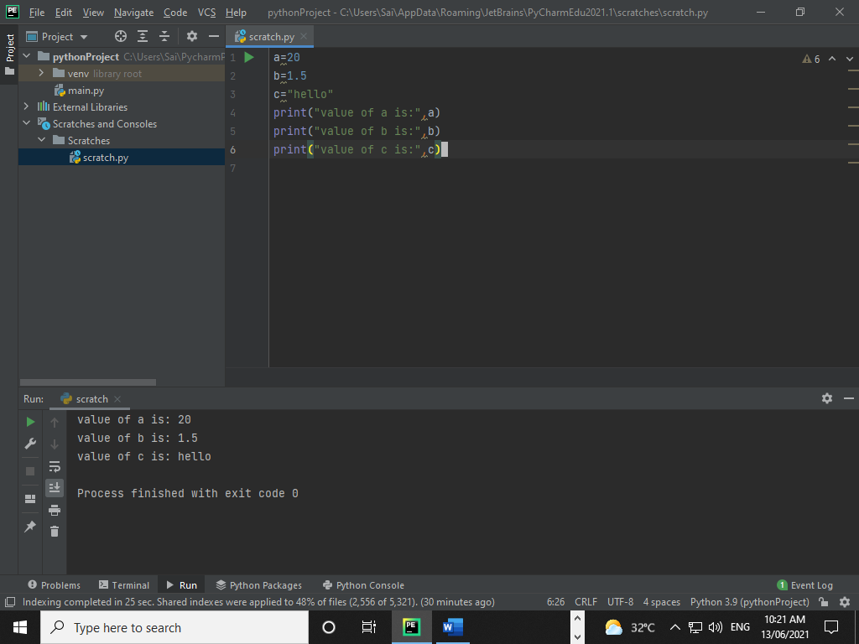

Changing the value of variable

Code:-

name="Hello"  
print("name is :",name)  
  
#assigning a new value  
name="HELLO WORLD!!"  
print("name is :",name)

Output:-

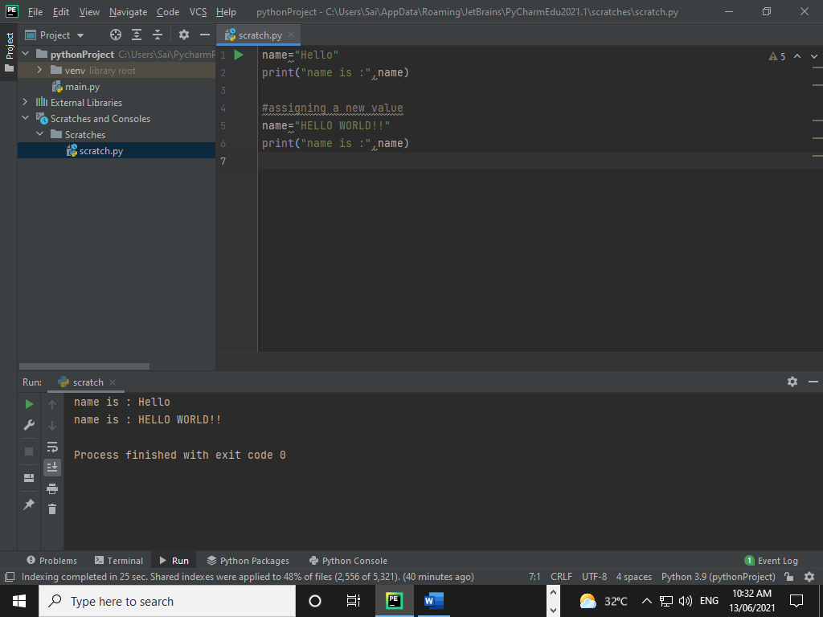

Assign multiple values:-

Code

a, b, c = "orange", "banana", "cherry"  
  
print(a)  
print(b)  
print(c)

Output:-

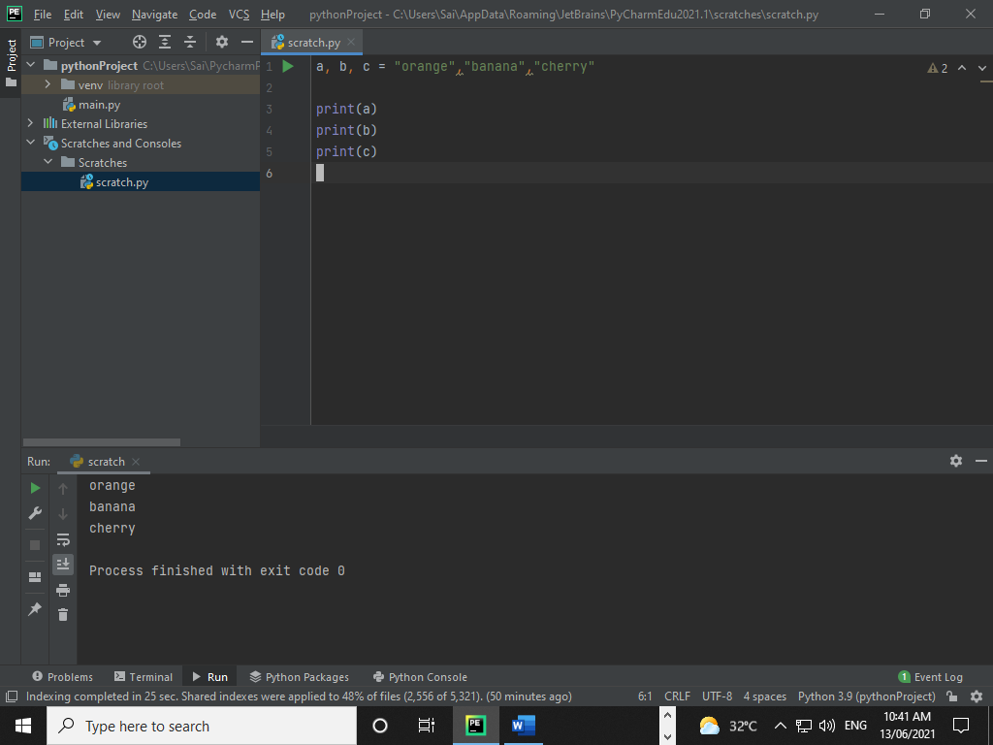

Assign the same value to multiple variables

a=b=c = 7  
  
print("value of a is:",a)  
print("value of b is:",b)  
print("value of c is:",c)

Output:-

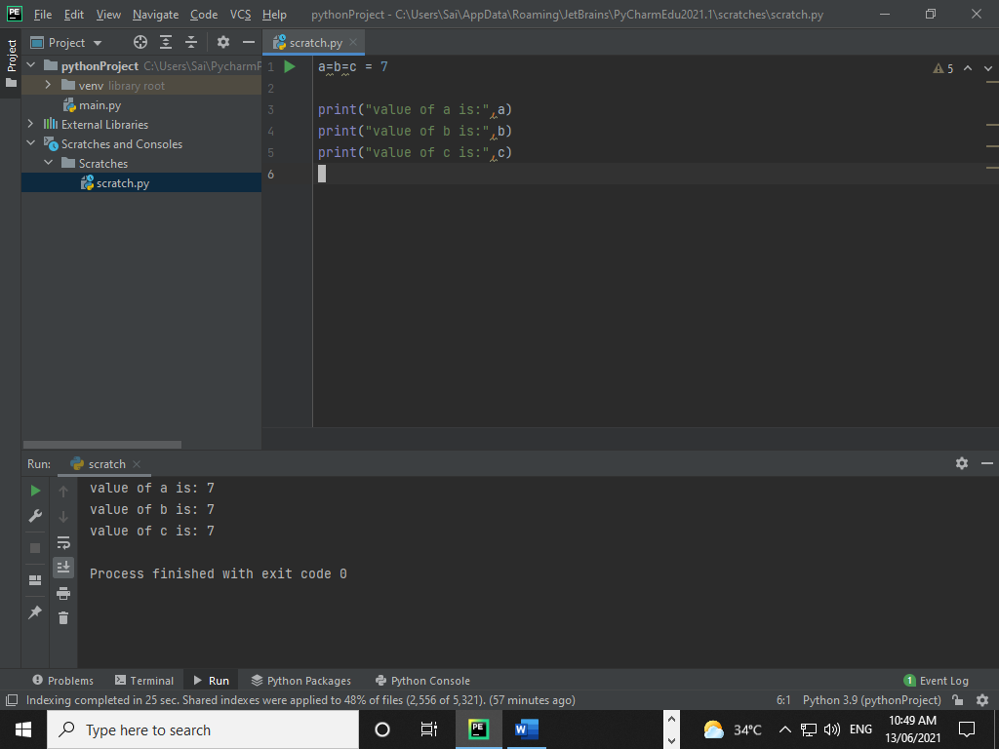 **Data type:-**

**Python has 5 standard data types namely:-**

* Numbers
* String
* List
* Tuple
* Dictionary
* Boolean- true and false

**Number:-**

**Code:**

n1 =10  
print (n1, "is of type", type(n1))  
  
n2 = 10.8  
print (n2, "is of type", type(n2))  
  
n3 = 1+2j  
print (n3, "is complex number?", isinstance(1+2j, complex))

**Output:-**

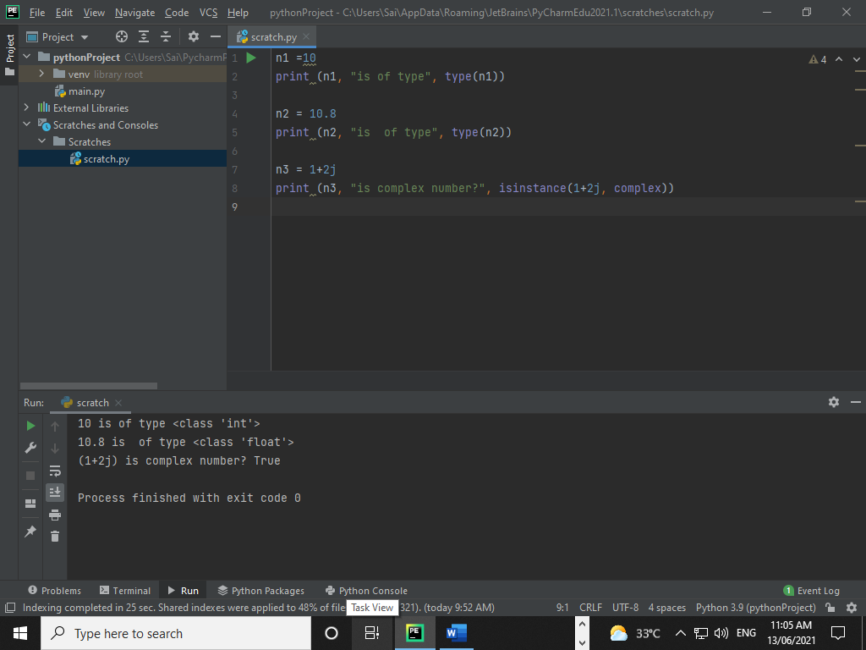

**String:-**

**Code:-**

name = "HELLO WORLD"  
print("name is : ", name)  
#print frist character of the string  
print(name[0])  
  
print(name[2:5])  
  
print(name[2:])  
  
print(name + "Hello")

**Output:-**

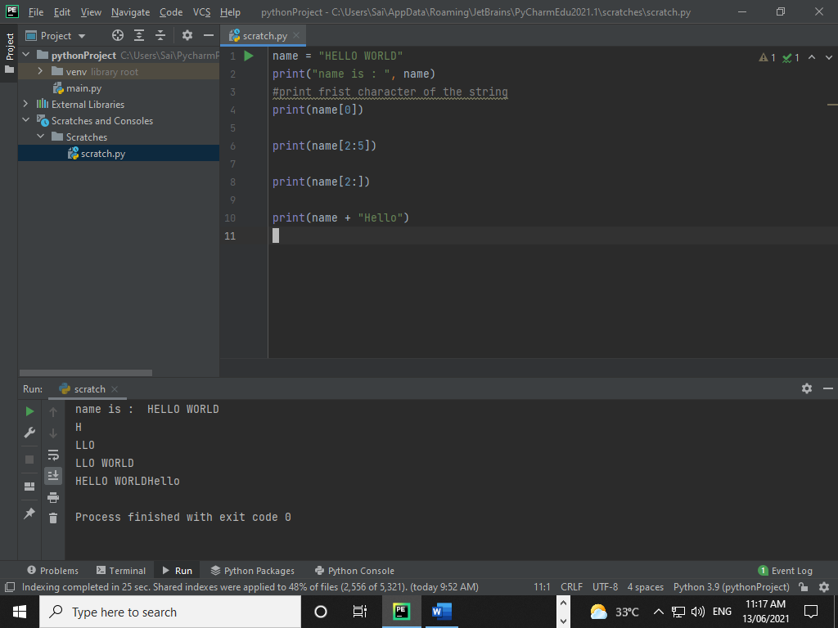

**List:-**

**Code:**

list1 = [1, 10.2,'Hello World']  
  
print(list1)

**Output:-**

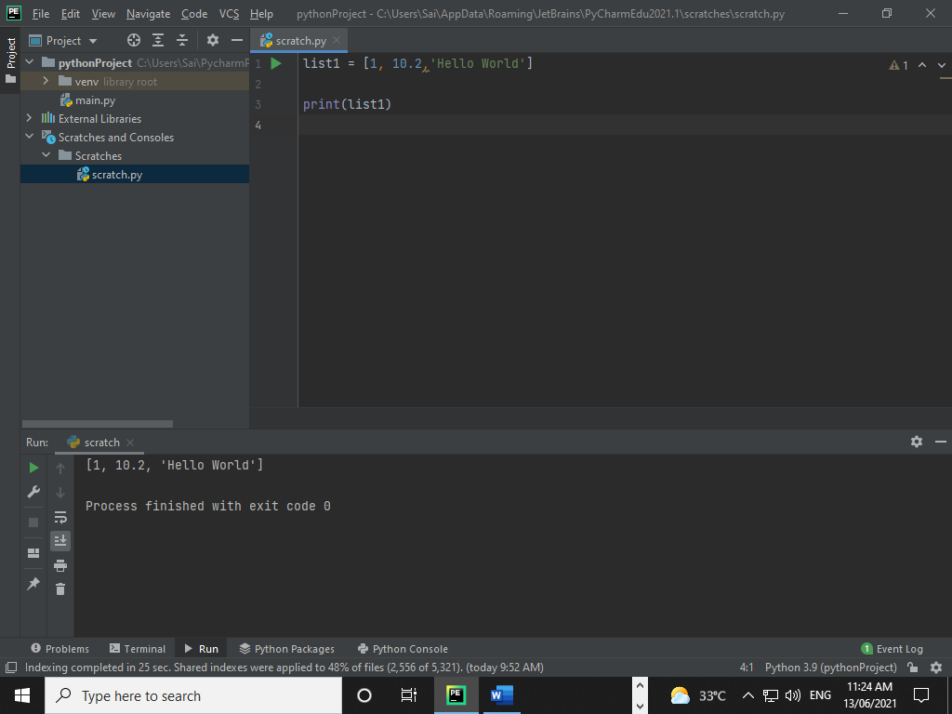

**Tuple:-**

**Code:**

tuple1 =(10, 20, 30,"Hello", 50, 60, "world", 70)  
  
print (tuple1)

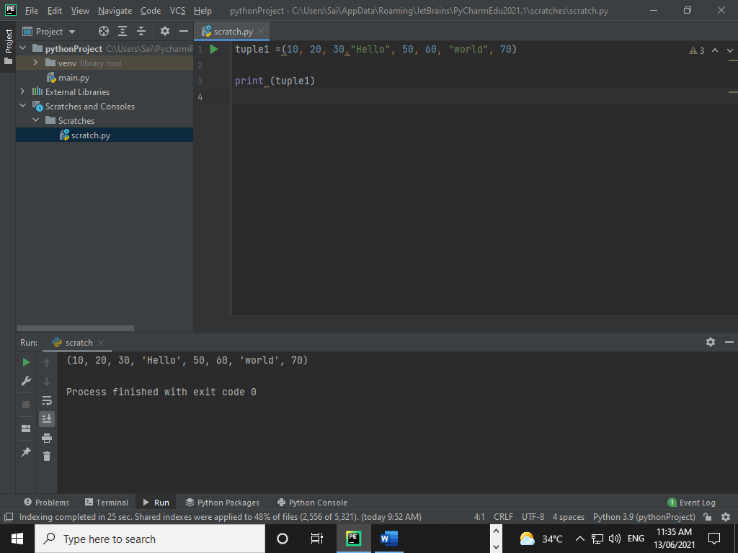

**Dictionary:-**

**Code:**

d = {1: 'Hello', 2: 'Wolrd', 'key': 20}  
print (type(d))  
  
print ("d[1] =", d[1])  
  
print ("d[2] = ", d[2])  
  
print ("d['key]=", d['key'])

**Output:-**

