Task :3

***Code:***

*n1 = int (input ('Enter number1 :'))  
n2 = int (input ('Enter number2 :'))  
  
ans = n1+n2  
  
print (ans)*

***Output:-***

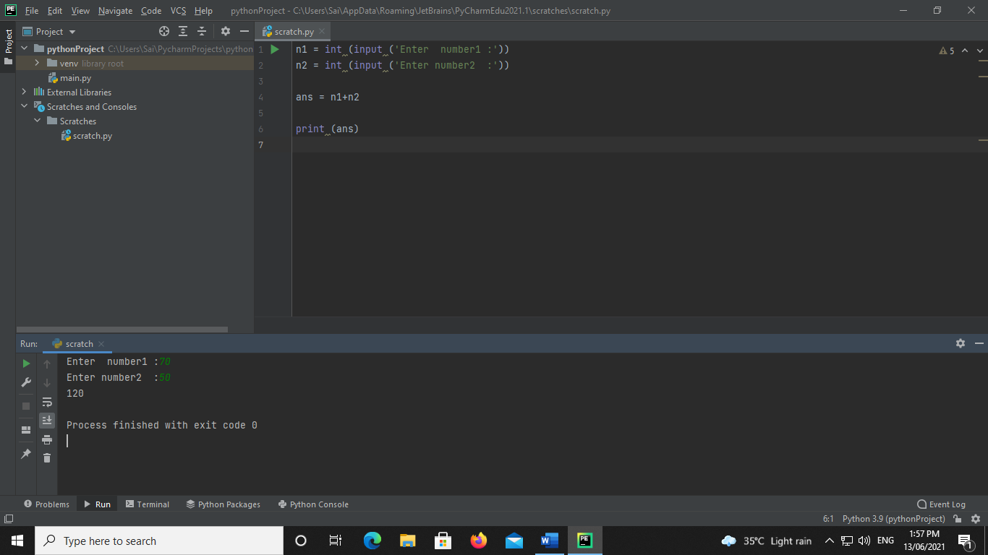

**Conditional Statement:**

**If ….. Statement**

**Code:**

a = 20  
b = 30  
  
if a > b :  
 print ("a is greater number")  
if a < b :  
 print (" b is greater number")

**Output:-**

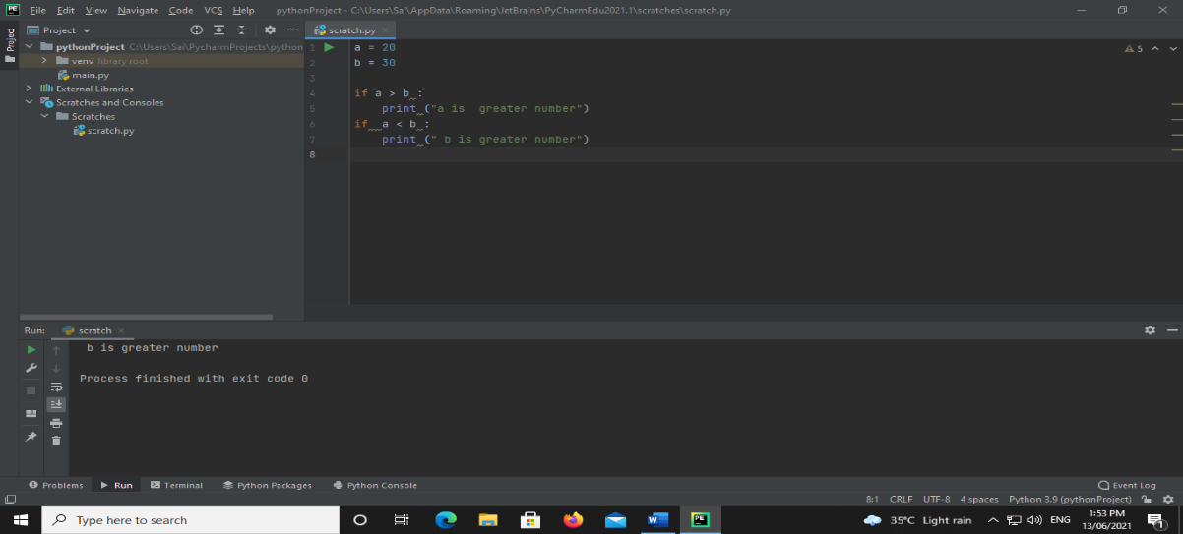

**If…. elif …else Statement**

**Code:**

x = 70  
y = 50  
  
if x == y:  
 print (" both number are equal")  
elif x > y:  
 print ("x is a greater")  
else:  
 print ("y is a greater")

**Output:-**

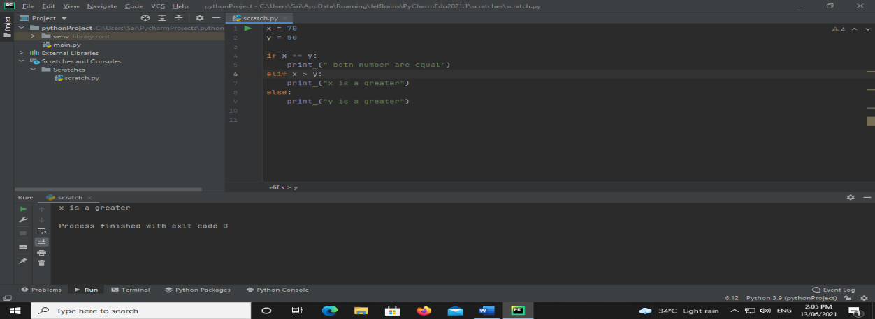

**Nested if statement**

**Code:**

x = 70  
  
  
if x >= 0:  
 if x == 0:  
 print (" zero")  
 else:  
 print ("x is a positive number")  
else:  
 print ("x is a negative number")

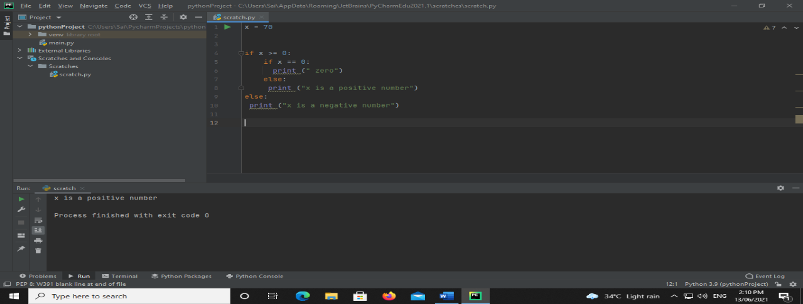

**Loop**

**while loop**

**code:**

i = 0  
while i < 6:  
 print ("value of i :",i)  
 i += 1

**Output:-** 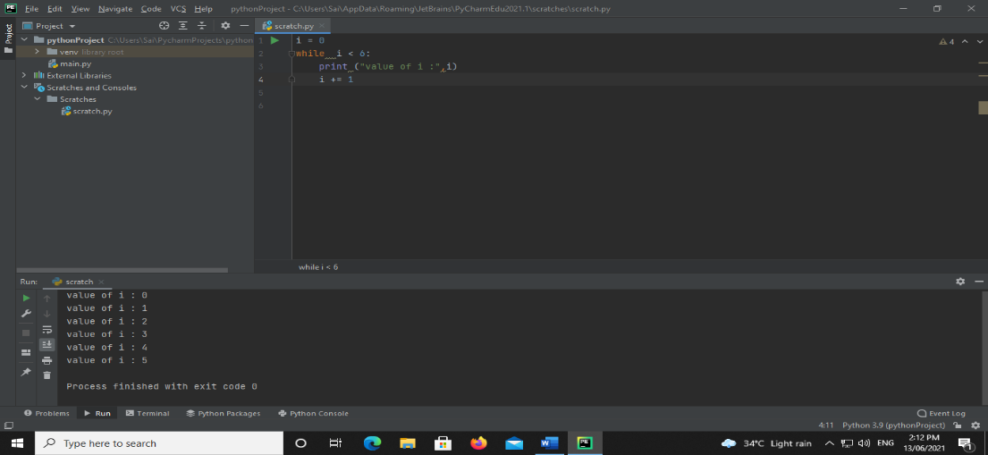

**for loop**

**Code:**

for i in 'ARMY' :  
 print ('value :', i)

**Output:-**

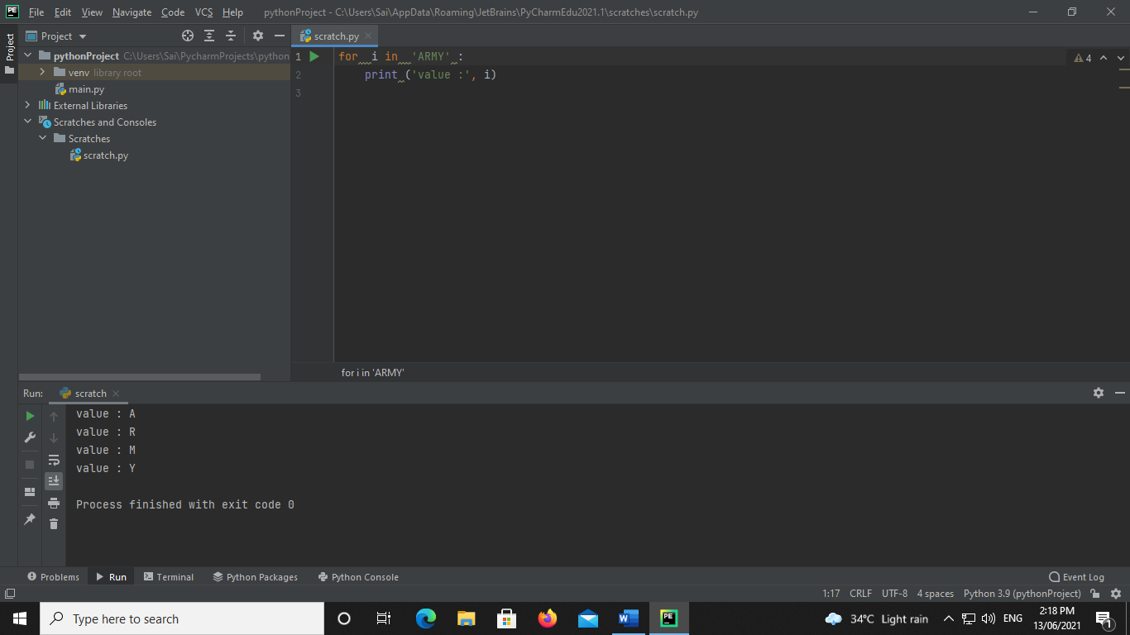

**the range () function**

**Code:**

for x in range (4) :  
 print ("first range : ", x)  
for y in range (3 , 5) :  
 print ("second range :", y )

**Output:-**

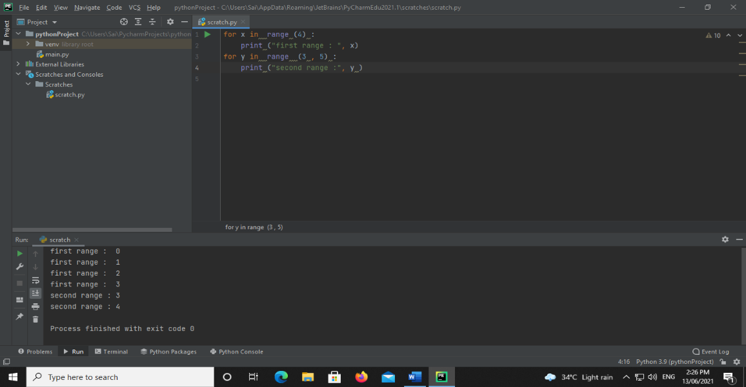

**loop with else**

**Code:**

list1 = (10, 20, " hello world")  
for i in range (len(list1)):  
 print ('value is :', list1 [i])  
  
else:  
 print ("no elements")

**Output:-**

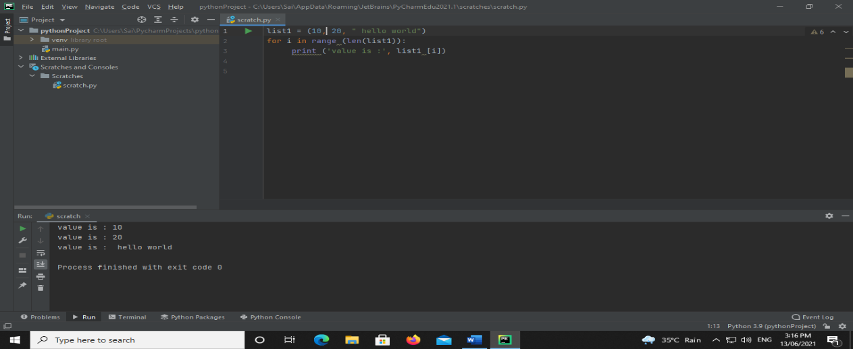

**break statement**

**Code:**

i = 0  
while i < 10:  
 print ("value is :", i)  
 i += 1  
 if i >= 4 :  
 break

**Output:-**

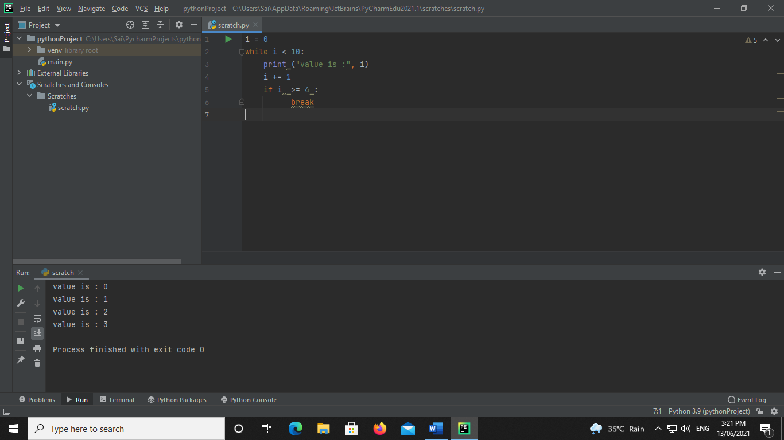

**Continue**

**Code:**

for x in range (5) :  
 if x % 2 == 0:  
 continue  
 print("value is :", x)

**Output:-**

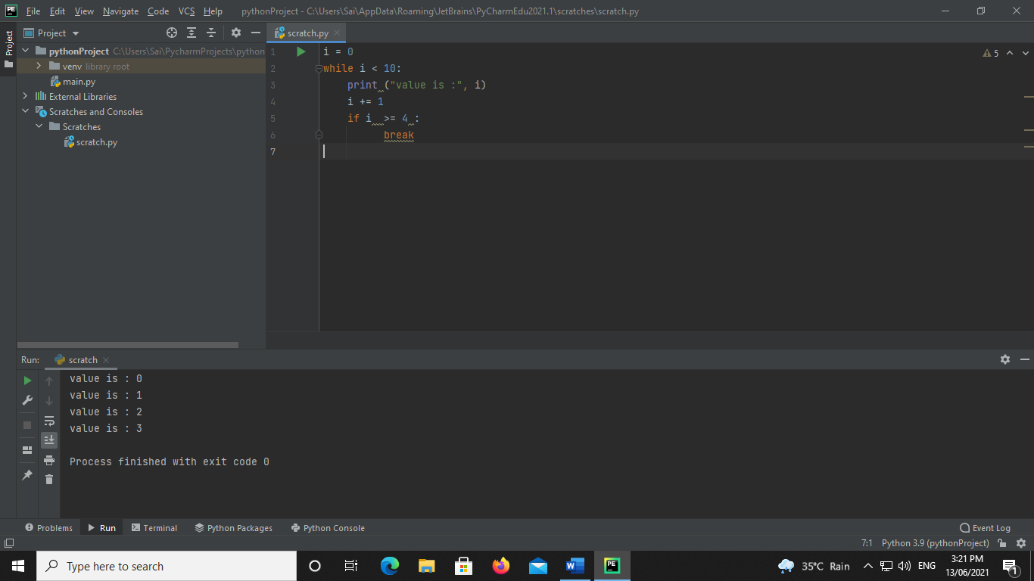

**Pass**

**Code:**

i = (1, 2 ,3)  
for val in i :  
 pass

**Output:-**

