**Task:-5**

**Django install** :-

Step 1- Open Powershell

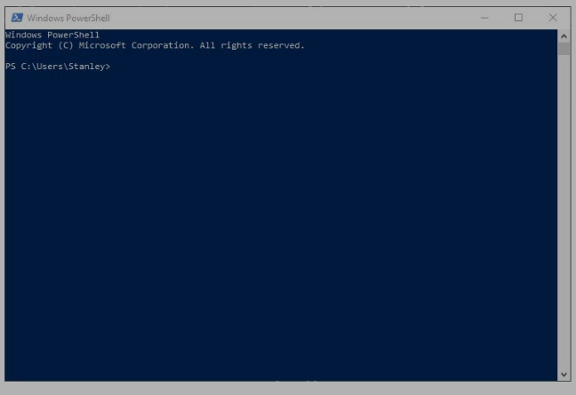

Step 2- verify Python installation

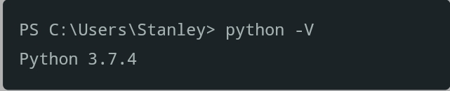

Step 3- Upgrade pip

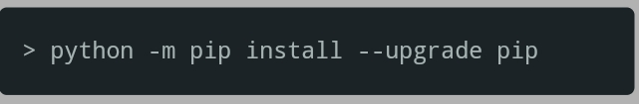

Step 4-Create project



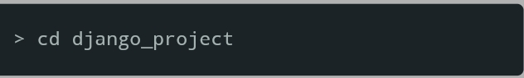



Step 5-create virtual environment

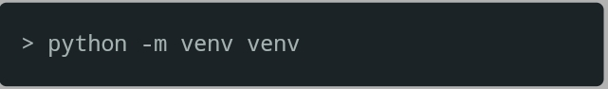

Step 6-Activate virtual environment

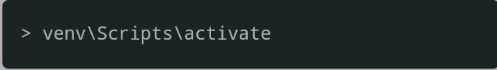

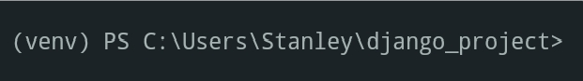

Step 7-install Django

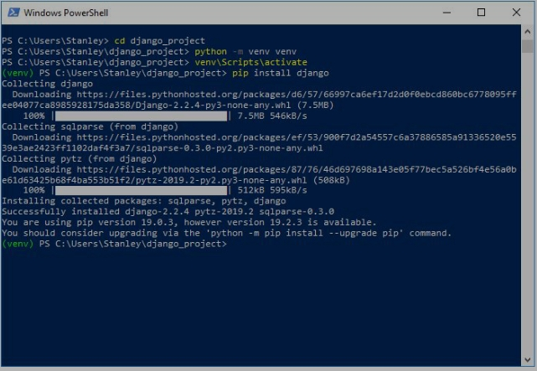

Step 8-Start new Project

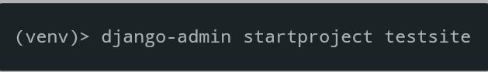

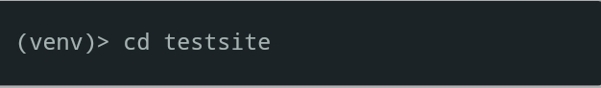



Step 9-Run the server



Welcome Screen