https://www.startutorial.com/articles/view/php-curl
http://www.techflirt.com/php/php-curl/index.html

What is cURL

CURL stand for Client URL. cURL is a library to transfer data via various protocol like http, ftp, tftp etc. By using cURL we can send HTTP request using various method like GET, POST etc.

How to install cURL Library in PHP
PHP has extension which need to be installed and enable to use cURL features. But to use the PHP cURL functionality you need to install libcurl package on your system/server. Most of the Linux system come with the by default installation of libcurl. Also if you are going to use PHP using XAMPP or WAMPP then also you no need to think about the libcurl package installation.
To check whether curl is enabled or not you can use phpinfo() command. If your phpinfo page has below section appeared then curl is enable with your PHP.
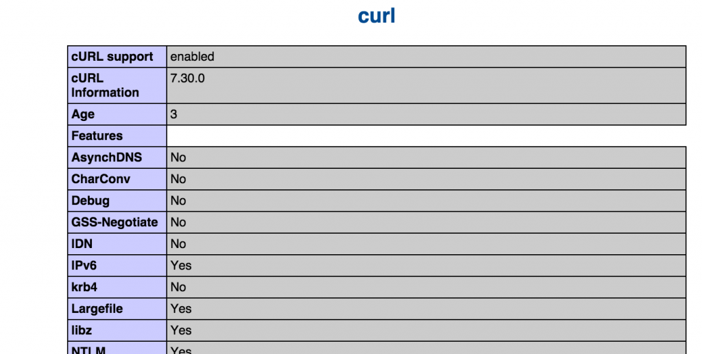

If above section is not available then you need to enable curl. Below are the
steps to enable curl extension in PHP
- If you are using WAMPP or XAMPP then open your php.ini file and uncomment below line
;extension=php_curl.dll
- If you have manually installed PHP then you can install php_curl library and then add below line in your php.ini
extension=php_curl.dll
- If you are using PHP by compiling the source code then please compile with parameter –with-curl.

Complete the goal
To use curl in PHP is very straightforward. The basic idea of using curl in PHP is
- Initialize a curl session
- Set various options for the session
- Execute and fetch/send data from/to server
- Close the session
To complete our goal, the code is simple as
?
1  2  3  4  5  6  7  8  9  10  11  12  13  14 | <?php  //step1  $cSession = curl_init();  //step2  curl_setopt($cSession,CURLOPT_URL,"http://www.google.com/search?q=curl");  curl_setopt($cSession,CURLOPT_RETURNTRANSFER,true);  curl_setopt($cSession,CURLOPT_HEADER, false);  //step3  $result=curl_exec($cSession);  //step4  curl_close($cSession);  //step5  echo $result;  ?>
- step1: Initialize a curl session use curl_init().
- step2: Set option for CURLOPT_URL. This value is the URL which we are sending the request to. Append a search term "curl" using parameter "q=". Set option for CURLOPT_RETURNTRANSFER, true will tell curl to return the string instead of print it out. Set option for CURLOPT_HEADER, false will tell curl to ignore the header in the return value.
- step3: Execute the curl session using curl_exec().
- step4: Close the curl session we have created.
- step5: Output the return string.

cURL Function
PHP cUrl library provides 29 function. You can get full list of PHP curl function here. Let us look at some of the important cURL function:
- curl_init
- curl_setopt & curl_setopt_array
- curl_exec
- curl_getinfo
- curl_close
- curl_error
- curl_errorno

curl set option as per requirement

$headers = array(
'Content-Type: application/json',
'QuickBlox-REST-API-Version: 0.1.0'
//'QB-Token: cf5709d6013fdb7a6787fbeb8340afed8aec4c69'
);

$fields = array("application_id"=>$ap_id,"auth_key"=>$auth_key,"timestamp"=>$date,"nonce"=>$date,"signature"=>$my_sign);

// Open connection
$ch = curl_init();
// Set the url, number of POST vars, POST data
curl_setopt($ch, CURLOPT_URL, $url); // url set here
curl_setopt($ch, CURLOPT_POST, true); // post type here
curl_setopt($ch, CURLOPT_HTTPHEADER, $headers); // set header type
curl_setopt($ch, CURLOPT_RETURNTRANSFER, true); // set return transfer true means json false means string

// Disabling SSL Certificate support temporarly
curl_setopt($ch, CURLOPT_SSL_VERIFYPEER, false);
curl_setopt($ch, CURLOPT_POSTFIELDS, json_encode($fields)); //set post data or fields in json formate

// Execute post
$result = curl_exec($ch);

// Check errors
if ($result) {
echo $result . "\n";
} else {
$error = curl_error($ch). '(' .curl_errno($ch). ')';
echo $error . "\n";
}

// Close connection
curl_close($ch);
$result;
$returnResult = json_decode($result);

$result ma return data ave je print_r($result); kro etle male jene array k object ma convert karvo hoy to karo

curl file upload by giving file path

$filepath = $this->config->item('upload_path').$_FILES["fileToUpload"]["name"];

if (function_exists('curl_file_create')) { // php 5.5+
$cFile = curl_file_create($filepath);
} else { //
$cFile = '@' . realpath($filepath);
}

