1.install node & npm
2.install angular cli 6 by command "npm -g install @angular/cli"
3.To Check cli version by command "ng version"
getting like below

This is the output I'm getting:

/ \ _ __ __ _ _ _| | __ _ _ __ / ___| | |_ _|
/ △ \ | '_ \ / _` | | | | |/ _` | '__| | | | | | |
/ ___ \| | | | (_| | |_| | | (_| | | | |___| |___ | |
/_/ \_\_| |_|\__, |\__,_|_|\__,_|_| \____|_____|___|
|___/

Angular CLI: 6.0.0
Node: 8.11.1
OS: linux x64
Angular:
...

4.create project by "ng new crmapp" here crmapp is a yr proj name

5. We will mostly be working inside the src/app folder. This is the directory structure of the project:

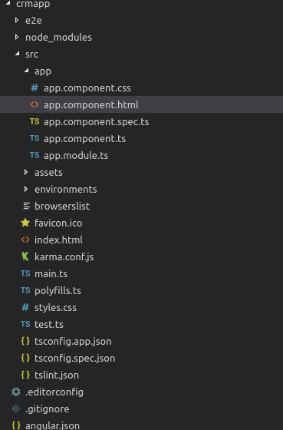

e2e: end-to-end testing files for the project are contained here.
- node_modules: node modules are stored here.
- src: this is the main application source folder, where you will be working in 97% of the time.
- other configuration json files: tsconfig, tslint,readMe, package, angular, editorconfig and gitignore.

6. Navigate inside your project's folder by command “ cd crmapp”
7. Serve your application by “ ng serve “
ng serve --host 0.0.0.0 for local running in any pc

8. You application will be running from . In browser

understand the structure

A) index.html is main file its structure like

<!doctype html>
<html lang="en">
<head>
<meta charset="utf-8">
<title>Crmapp</title>
<meta name="viewport" content="width=device-width, initial-scale=1">

<!-- CSS FILE INCLUDE -->
<link rel="stylesheet" href="assets/bootstrap/css/bootstrap.min.css">
</head>
<body>
<div class="wrapper">
<app-root></app-root>
</div>

<!-- JS FILE INCLUDE -->
<script src="assets/plugins/jQuery/jquery-2.2.3.min.js"></script>
</body>
</html>

B) Put css file & js file into assest folder (path as above) & write css in style.css file like core

C) by default in src/app directory

- app.components.html (write below code in this file)

<app-header></app-header>
<app-sidebar></app-sidebar>
<div id="content">
<router-outlet></router-outlet>
</div>
<app-footer></app-footer>

- app.component.css or scss ( write css for html of particular component)
- app.component.spec.ts
- app.component.ts (component file wherein css & html link)

index.html ma <app-root></app-root> tag e app.component.ts file ma selector hoy
@ ne decorate kehvay
templateUrl: './app.component.html', --------------------------v
styleUrls: ['./app.component.css']

- app.component.html

in this file call selector of other component & routing
like, for ex.

<app-header></app-header> <------------ this is other component make by command
<app-sidebar></app-sidebar>
<div id="content">
<router-outlet></router-outlet> <------- this is for routing
</div>
<app-footer></app-footer>

make new component by command “ng g c header” or “ng g c layouts/header”
or
ng generate component AccountList

then 4 file generate in app/src or app/src/layout directory as well as component added automatically in app.module.ts file 's declarations.

header.component.html write header code & its css write in header.component..css file

- app.module.ts (this file internal link with ng modules)

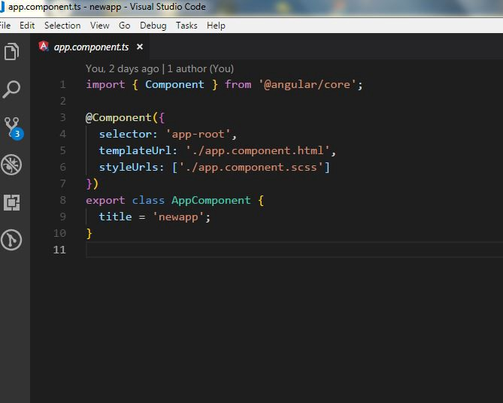

in the component.ts file. Let us take a look at what is contains:
app component.ts
Every Component.ts file contains:
- an import statement which signifies an angular component.
- the component decorator which as an object contains:
- The Selector: the selector is simply a name you give your component to be able to use it in templates like index.html as a html element.
- The Template Url: here is the place to record the file location of the corresponding html template or to just inject the html code in back-ticks.
- The Style Urls: here is the place you record the file location of your stylesheet for this particular component.
- export statement to be able to bring the component into another component.

Remember
app.module.ts file mens koi pan module file hoy tema
component ‘declaration ’ ma hoy & module ‘imports’ ma hoy ane je aa banne ma hoy e uper top per import krva jruri.

For theme integration
Pls check my book

In Deep diving

1) Structural directives

REF: https://codecraft.tv/courses/angular/built-in-directives/ngif-and-ngswitch/

-Ng for used for iterate over the element in the template.
*ngFor="let person of people"
-Ng if used for checks the value of the property
*ngIf="condition"
-Ng switch

Example
------
For & if example
<ul *ngFor="let person of people">
<li *ngIf="person.age < 30"> (1)
{{ person.name }} ({{ person.age }})
</li>

<li *ngIf="person.country !== 'HK' && person.country !== 'UK' && person.country !== 'USA'"
class="text-warning">{{ person.name }} ({{ person.country }})
</li>
</ul>

if & else exmple

<div *ngIf="isLoggedIn; else loggedOut">
Welcome back, friend.
</div>

<ng-template #loggedOut>
Please friend, login.
</ng-template>

if then else example

<ng-container
*ngIf="isLoggedIn; then loggedIn; else loggedOut">
</ng-container>

<ng-template #loggedIn>
<div>
Welcome back, friend.
</div>
</ng-template>
<ng-template #loggedOut>
<div>
Please friend, login.
</div>
</ng-template>

Switch case exmple

<ul *ngFor="let person of people"
[ngSwitch]="person.country"> (1)

<li *ngSwitchCase="'UK'" (2)
class="text-success">{{ person.name }} ({{ person.country }})
</li>
<li *ngSwitchCase="'USA'"
class="text-primary">{{ person.name }} ({{ person.country }})
</li>
<li *ngSwitchCase="'HK'"
class="text-danger">{{ person.name }} ({{ person.country }})
</li>
<li *ngSwitchDefault (3)
class="text-warning">{{ person.name }} ({{ person.country }})
</li>
</ul>`

ReF: https://coursetro.com/posts/code/108/Angular-5-Interpolation,-Property-Binding-&-Event-Binding-Tutorial

2) Interpolation Syntax {{ }} — renders a property value as text in html template only.

-Whenever you need to communicate properties (variables, objects, arrays, etc..) from the component class to the template, you can use interpolation.
-syntex : {{ propertyName }}

-concate varible with static value
<div>{{'Hello, ' + city}}</div>

-concate two variable <strong> {{locality +', '+ city}}</strong>

-to avoid undefined error <div>City: {{place && place.city}}</div> here place is the object & its have city key & value then show its value
-by safe navigation operator <div>City: {{place?.city}}</div>

3) Property binding

Syntax [ ] — renders a property value in a template expression(in html set attrbute's value).

In /home.component.ts have following property:

itemCount: number = 4;
btnText: string = 'Add an Item'; // Add this line

Then, open /home.component.html and set the value property through property binding, to our btnText property:

<!-- From: -->
<input type="submit" class="btn" value="Add Item">

<!-- To: -->
<input type="submit" class="btn" [value]="btnText">

Note: You can also define property binding through interpolation:

<!-- Interpolation -->
input type="submit" class="btn" value="{{ btnText }}">

4) Event binding

Syntax ( ) — event binding uses a set of parentheses(), around the click event.

Let's define a click event on our Add an Item button:

<!-- From: -->
<input type="submit" class="btn" value="{{ btnText }}">

<!-- To: -->
<input type="submit" class="btn" value="{{ btnText }}" (click)="addItem()">

Now in component.ts file

addItem() {
this.goals.push(this.goalText);
this.goalText = '';
this.itemCount = this.goals.length;
}

5) data binding

Ref: http://logic24by7.com/angular-6-4-ways-to-fetch-the-value-of-input-in-the-controller/

a) one way
b) two way

get value as in argument

1) Passing Local Reference #id (1-way data binding)
<select (change)="handle(selectField.value);" #selectField>
in component.ts
handle(value) {
this.serverName = value;
}

2) Using event Binding (1-way data binding)
<input type="text" class="form-control" (keyup.enter)="OnInput($event)" >
in component.ts
OnInput(event: any) {
this.serverName = event.target.value;
}

3) Using ngModel (2-way data binding)

2 ways data binding, which means you can even get the value from HTML to controller and set value from controller to HTML

1. Provide ngModel directive in the HTML element

<input type="text" [(ngModel)]="myInput">
2. To make it work you need to import theFormsModule from the @angular/forms package.

import {FormsModule} from '@angular/forms';

imports: [
BrowserModule,
FormsModule
],
3. Now you can access it using variable myInput which we used in step 1 for ngModel.

4) Using Local Reference @ViewChild (2-way)

use ref url for more & its not wide use.

6)class binding

Ref:https://www.c-sharpcorner.com/article/binding-property-styles-and-class-in-angular/
https://codeburst.io/how-to-add-styles-in-angular-e6918228eff2

1. using normal use ‘class’ attribute.

in test.component.css
.red{
color:red;
}

so in test.component.html
<p class="red">This is p tag wit></p>

2.From css ->ts -> html

in test.component.css
.red{
color:red;
}

in component.ts ma

public classRed = "red"

in test.component.html ma

<p class="{{classRed}}">This is p tag with class - red.</p> inetepollation na jem
or
<p [class]="classRed">This is p tag with class - red.</p> property binding na jem

3. conditionaly apply the class

in test.component.ts ma
public setRed = true;

in test.component.html ma

<p [class.red]="setRed">This is p tag with color red based on condition.</p>
Means if setRed is true then only class red is applicable to P tag.

4.using ngclass directive

Use: This directive is used to apply multiple class to HTML tag element.

test.component.css and add the classes below,

.red{
color:red;
}
.bgYellow{
background-color: yellow;
}
.italic{
font-style: italic;
}

Open test.component.ts and add below content,

import { Component, OnInit } from '@angular/core';

@Component({
selector: 'app-test',
templateUrl: './test.component.html',
styleUrls: ['./test.component.css']
})
export class TestComponent implements OnInit {

public classObj = {
red : true,
bgYellow : true,
italic: true
};
constructor() { }
ngOnInit() {
}
}

Open test.comonent.html and add below content.

<p [ngClass]="classObj">This is p tag with color red based on condition.</p>

5. ngclass conditioally with ternoray operation

in test.component.ts
public isActive=true;

in test.component.html ma

<div [ngClass]="isActive? 'box-1’:’box-2' " >

7) style binding

1. normal by stye attribute

2. ngsyle

export class AppComponent {
isActive=false
box = {
border: '1px solid black',
width: "50%",
color:"blue"
}
}

<div [ngStyle]="box"> <h1>Hello</h1> </div>

3. ngStyle with condition (ternory operation)

<p [ngStyle]="{color:isActive?'red':'green'}">

LIfe Cycle Hooks
================

1.ngOnChanges()
Used in pretty much any component that has an input.
Called whenever an input value changes
Is called the first time before ngOnInit

2.ngOnInit()
Used to initialize data in a component.
Called after input values are set when a component is initialized.
Added to every component by default by the Angular CLI.
Called only once

3.ngDoCheck()
Called during all change detection runs
A run through the view by Angular to update/detect changes

4.ngAfterContentInit()
Called only once after first ngDoCheck()
Called after the first run through of initializing content

5.ngAfterContentChecked()
Called after every ngDoCheck()
Waits till after ngAfterContentInit() on first run through

6.ngAfterViewInit()
Called after Angular initializes component and child component content.
Called only once after view is initialized

7.ngAfterViewChecked()
Called after all the content is initialized and checked. (Component and child components).
First call is after ngAfterViewInit()
Called after every ngAfterContentChecked() call is completed

8.ngOnDestroy()
Used to clean up any necessary code when a component is removed from the DOM.
Fairly often used to unsubscribe from things like services.
Called only once just before component is removed from the DOM.

Most usefull 4 hook

ngOnChanges()
ngOnInit()
ngAfterViewInit()
ngOnDestory()

@input & @output
=================

@input used for passing data from parent component to child component
@output used for passing data from child to parent component

Remember:
-Both are write into child component
-parent componet means one componet
-child component means use selector tag of child in html part of parent component.

see example: https://angularman.wordpress.com/2017/08/10/input-and-output-in-angular/
https://medium.com/@foolishneo/understanding-input-output-and-eventemitter-in-angular-c1aeb9fff594

Some Practicle Usefull link :
===========================

form
-----
https://angular-2-training-book.rangle.io/forms/template-driven_forms/template-model-binding

date picker in angular:
---------------------
https://www.positronx.io/angular-calendar-tutorial-with-ngx-bootstrap-datepicker-examples/

Sweet alert in angular
-----------------------
https://www.positronx.io/angular-popup-notification-with-sweetalert2-example/

PDF export in angular
---------------------
https://www.positronx.io/angular-pdf-tutorial-export-pdf-in-angular-with-jspdf/

deploy & full
----------------
https://www.techiediaries.com/angular/angular-9-8-tutorial-by-example-rest-crud-apis-http-get-requests-with-httpclient/

crud
------
https://www.freakyjolly.com/angular-7-8-httpclient-service-tutorial-to-consume-restfull-api-from-server/#.XzIlJnUzbVM

loader
-------
https://www.freakyjolly.com/angular-material-progress-spinner-loader-bar-tutorial/#.XzZonXUzbVM

Ckeditor
----------
https://www.itsolutionstuff.com/post/how-to-install-and-use-ckeditor-in-angularexample.html

Image upload
------------
https://www.itsolutionstuff.com/post/angular-image-upload-with-crop-zoom-scale-preview-tutorialexample.html

Data Table
-----------
https://www.itsolutionstuff.com/post/angular-9-8-datatable-example-with-pagination-sorting-filteringexample.html

HighChart
---------
https://www.itsolutionstuff.com/post/angular-8-highcharts-example-tutorialexample.html

Eviroment variable use
-----------
https://www.itsolutionstuff.com/post/how-to-use-environment-variable-in-angularexample.html

Making module
---------
https://www.itsolutionstuff.com/post/angular-9-create-module-with-routing-exampleexample.html

CANaCTIVE
-----
https://www.freakyjolly.com/angular-7-6-use-auth-guards-canactivate-and-resolve-in-angular-routing-quick-example/

Multilayout(theme integration)
---------
https://stackblitz.com/edit/angular-multi-layout-example
https://medium.com/angular-in-depth/angular-routing-reusing-common-layout-for-pages-from-different-modules-440a23f86b57

Extra

After Installtion & under standing structure now its time to implement theme

first install boostrape in

Install Bootstrap and FontAwesome
We will use npm to install the dependencies:
npm install bootstrap font-awesome
Now that the dependencies are installed we can tell Angular CLI that it needs to load these styles.
One easy way to do this is by opening the file src/styles.css and adding the following lines:
@import "~bootstrap/dist/css/bootstrap.css";
@import "~font-awesome/css/font-awesome.css";

Make Module for theme
Note: module base theme
https://medium.com/@beeman/tutorial-styling-angular-cli-v6-apps-with-bootstrap-8d4f8ea5adae

SUBLIME UNTITLED
============

CRUD with HTTP
https://www.freakyjolly.com/angular-7-8-httpclient-service-tutorial-to-consume-restfull-api-from-server/

LAZYLOAD

// create angular module
ng g module HomeDashboard --routing

https://codehandbook.org/how-to-create-module-in-angular-7/
freakyjolly.com/angular-6-lazy-loading-example/

https://appdividend.com/2018/12/14/angular-7-routing-and-sub-routing-tutorial-with-example/

CANaCTIVE
https://www.freakyjolly.com/angular-7-6-use-auth-guards-canactivate-and-resolve-in-angular-routing-quick-example/

Multilayout
https://stackblitz.com/edit/angular-multi-layout-example

https://blog.angularindepth.com/angular-routing-reusing-common-layout-for-pages-from-different-modules-440a23f86b57

https://medium.com/angular-in-depth/angular-routing-reusing-common-layout-for-pages-from-different-modules-440a23f86b57

make component then in app routing, app module , app component
make module then in

Transaction Reference Number:930918781855Transaction Date:05/11/2019

theme
modules
route
redirect
lazyload
resolver and data(in akashacode)
Data in route (paasing data into route https://www.tektutorialshub.com/angular/angular-pass-data-to-route/)
child route

http services all method

obsserver, subscribe
form (Temolate driven form :https://www.concretepage.com/angular/angular-template-driven-forms)
pipe

https://www.techiediaries.com/angular/angular-9-8-crud-example-and-tutorial/

