Robot Controller – Assignment Documentation
Prepared by: Aaditya Rathore

1. Introduction
This project implements a Robot Controller that navigates a 2D grid using simple commands. The robot can move forward or rotate left/right, and the grid may contain obstacles that affect its movement.

2. Requirements
Commands:
• L - Turn Left
• R - Turn Right
• F - Move Forward
Obstacles:
• Rock - Blocks movement
• Hole - Teleports the robot to another location
• Spinner - Rotates the robot by 90-degree increments
Output:
• Final position
• Final direction
• Full path of visited coordinates

3. Project Structure
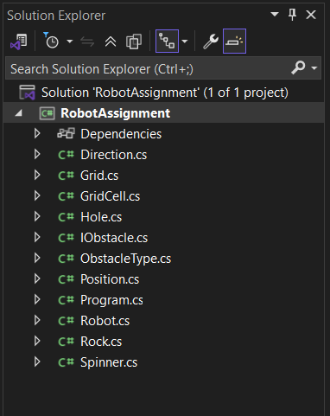
RobotAssignment/
Program.cs
Robot.cs
Grid.cs
GridCell.cs
Direction.cs
Position.cs
IObstacle.cs
Rock.cs
Hole.cs
Spinner.cs

4. How the Robot Moves
The robot tracks its (X, Y) position and direction. Turning left or right adjusts direction, and moving forward attempts to enter the next cell. Before moving, the robot checks if the target cell is inside the grid and whether an obstacle is present.

5. Obstacle Behaviour
Rock: Blocks the robot completely.
Hole: Teleports the robot to a connected position without changing direction.
Spinner: Rotates the robot based on the spinner's rotation parameter.

6. Execution Flow

1. Calculate the next cell
2. Check boundary
3. Check the obstacle
4. Apply obstacle effect or move normally

7. Running the Program
Using Visual Studio:
• Open project
• Press Start
Using Command Prompt:
project folder
dotnet run

8. Output
Final Position: (0, 3)
Direction: North
Path:
(1,1)
(0,1)
(0,2)
(0,3)

9. Testing
The project was tested to make sure the robot works correctly in different situations.
I created a separate test project (RobotAssignment.Tests) using xUnit and ran all tests with dotnet test.
- The robot moves correctly and follows the commands (L, R, F).
- It does not go outside the grid.
- Rock blocks the robot as expected.
- Hole teleports the robot to the connected position.
- Spinner rotates the robot by the correct angle.
- The robot’s path is recorded properly after each valid move.
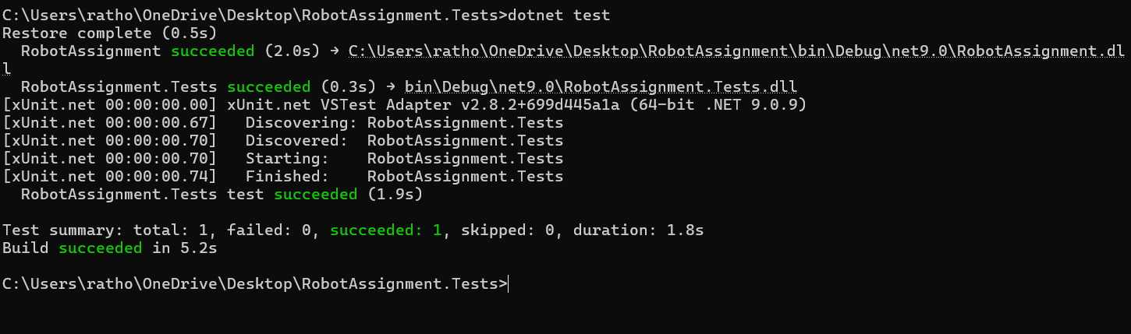

10. Extra Credit
The IObstacle interface makes the project future-friendly. New obstacles can be added simply by creating a new class. Robot logic stays clean and easy to understand.
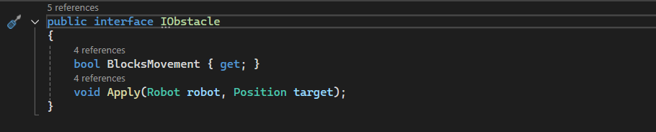

11. Conclusion
This solution meets all assignment requirements, includes path tracking, handles multiple obstacles, and supports future extension without complicating the core logic.

