***Project Report***

***Environment Saving***

***Mritunjay Rathore***

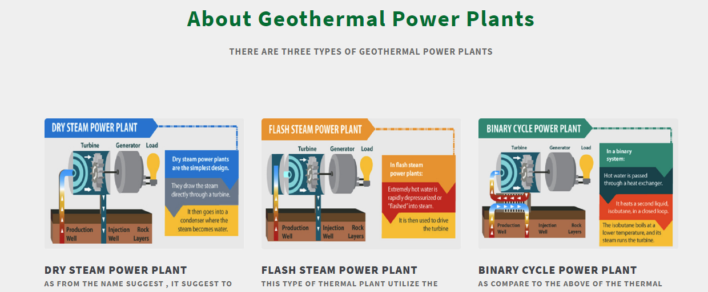

**Save Environment Intro**

Using geothermal vitality to create power is a significantly new industry, which showed in 1904 in Italy. Italians previously fueled a turbine generator utilizing common steam emitting from underneath the earth. The year 1960 proclaimed the main effective activity of the enormous scope geothermal power age plant at the Geysers, North California. A great deal of American geothermal force plants are spread across California, while the rest are situated in Hawaii, Nevada, Utah, Idaho and Montana.  
The transformation of geothermal vitality into power happens through a geothermal force plant. The force plant tackles the steam from the heated water underneath the world's surface to turn turbines, which later enacts a generator to deliver power. Some geothermal force plants use steam to legitimately turn the turbine. Others use the steam to warm a fluid that is utilized to turn the turbine.

**About Project**

The project is all telling about the saving environment topics that how can we save our environment from pollution and all other polluting elements and about the Geothermal vitality is the warmth that originates from the sub-surface of the earth. It is contained in the stones and liquids underneath the world's hull and can be found as far down to the world's hot liquid stone, magma.  
To deliver power from geothermal vitality, wells are dove a mile deep into underground repositories to get to the steam and high temp water there, which would then be able to be utilized to drive turbines associated with power generators. There are three sorts of geothermal force plants; dry steam, blaze and parallel.  
Dry steam is the most seasoned type of geothermal innovation and removes steam starting from the earliest stage utilizes it to legitimately drive a turbine. Streak plants utilize high-pressure heated water into cool, low-pressure water while parallel plants go heated water through an optional fluid with a lower breaking point, which goes to fume to drive the turbine.

**Language used for Project & Why**

ASP.NET is a popular web-development framework for building web apps on the .NET platform.

ASP.NET Core is the open-source version of ASP.NET, that runs on macOS, Linux, and Windows. ASP.NET Core was first released in 2016 and is a re-design of earlier Windows-only versions of ASP.NET.

**Modern & innovative**

ASP.NET Core is designed to allow runtime components, APIs, compilers and languages evolve quickly, while still providing a stable and supported platform to keep apps running.

Multiple versions of ASP.NET Core can exist side by side on the same server. Meaning one app can adopt the latest version, while other apps keep running on the version they were tested on.

ASP.NET Core provides various support lifecycle options to meet the needs of your app. You can chose a long-term support release, or run with the latest release if you commit to upgrade more often

**Admin details**

After clicking Geothermal Energy it will open the admin area and now admin can enter the details in the boxes

|  |  |
| --- | --- |
| Email | Password |
| [admin@admin.com](mailto:admin@admin.com) | Admin |
|  |  |

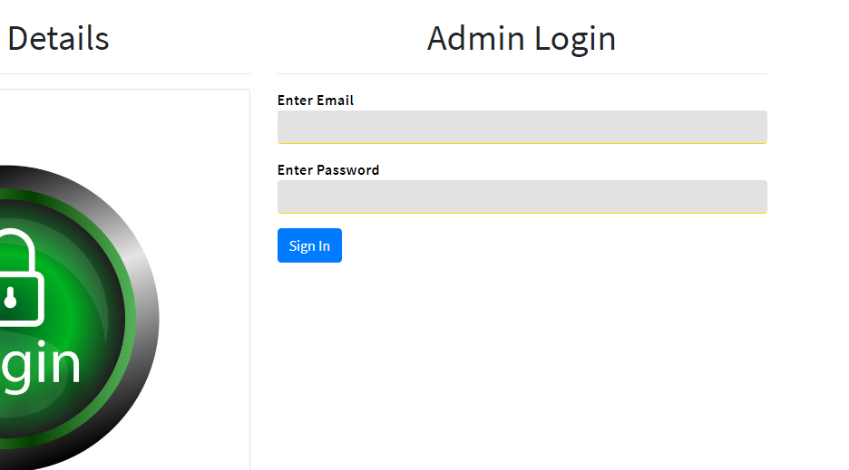

After logging in



**View Technology**

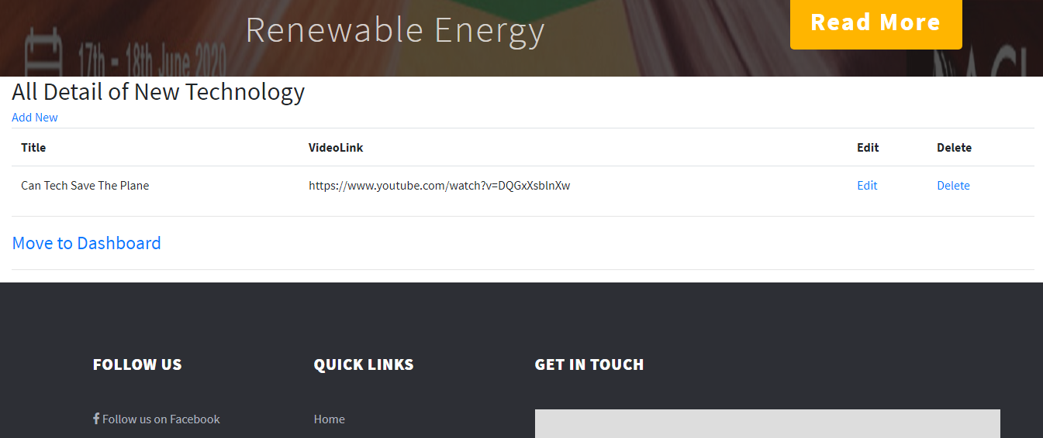

All details page

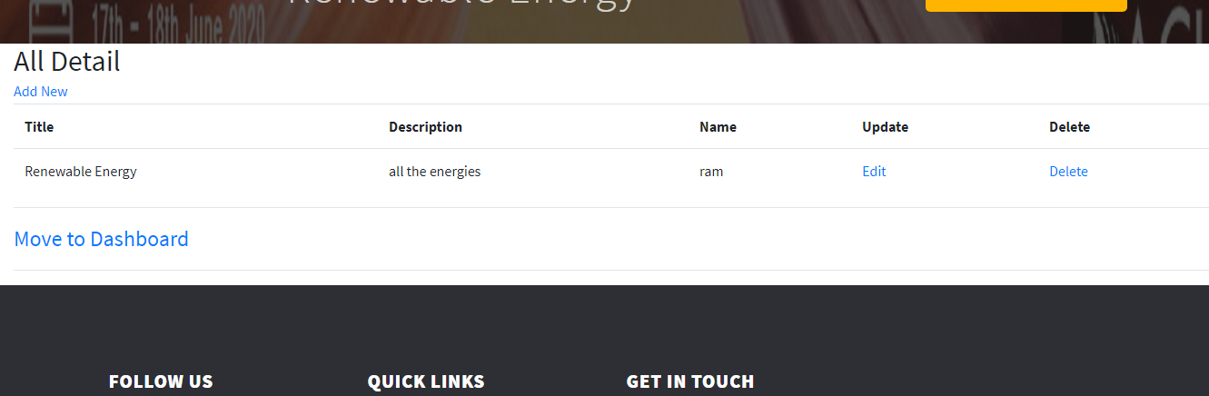

All feedback Page

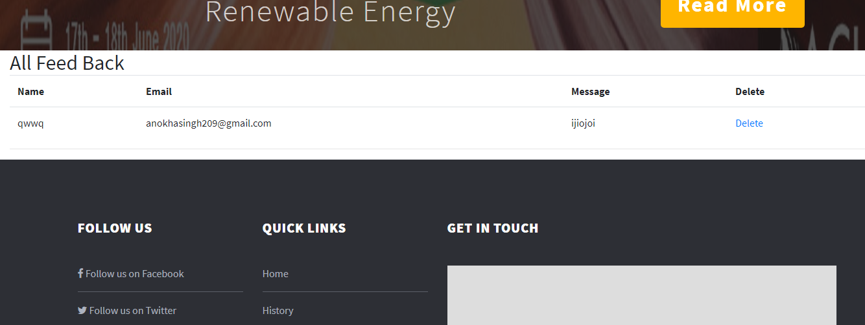

History Page :

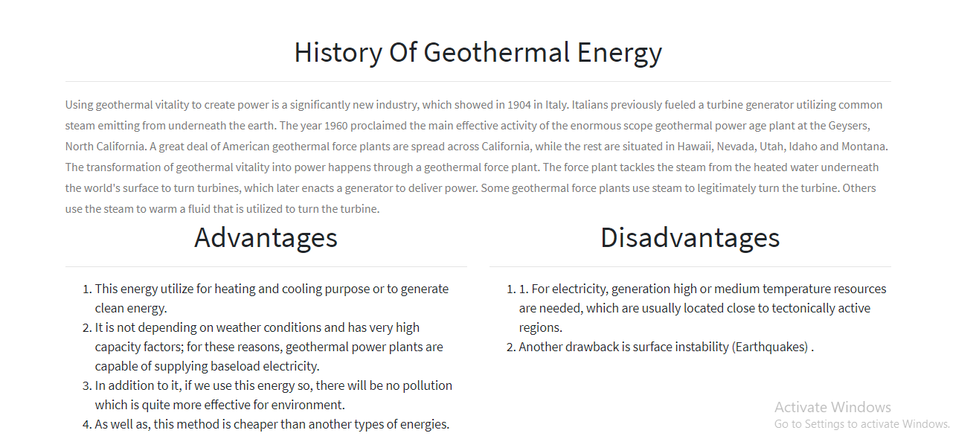

**Suggestion Page output**

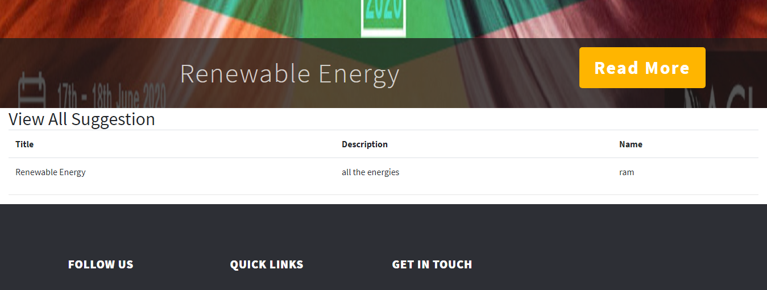

**Technology Page**



**Contact Page**

