**QA Session 3 and 4 Assignment**

**Q.1 Which software development technique is good for the systems that have third party API calls, cron jobs, data exports/imports, etc.**

**Answer**. Test-driven development technique is good for the systems that have third party API calls, cron jobs, data exports/imports, etc.

Test-driven development is a process of modifying the code in order to pass a test designed previously. In Software Engineering, It is sometimes known as "Test First Development." TDD includes refactoring a code i.e. changing/adding some amount of code to the existing code without affecting the behavior of the code.

**Q.2 Where does Test Automation fit in the Software Life Cycle? Explain with diagram**

**Anwer.** Considering the software development life cycle such as the waterfall model / agile model the test automation appears in this life cycle during the development and testing phases.

**.**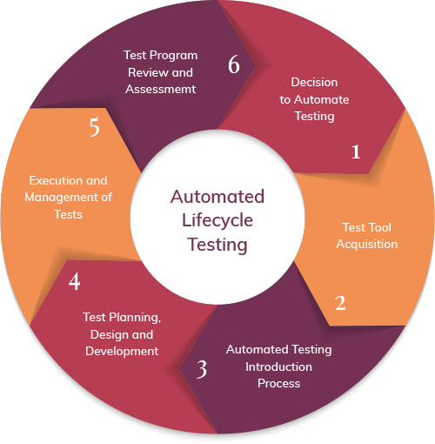

**Q3. Can we skip the manual testing and why?**

Ans. No, Automation Testing is just robotic and can’t act as a real user prospective. Manual testing, on the other end, allows the developing program to be used as it would be upon launch. Any bugs that may pop up when a user handles the program in a certain way are more likely to be caught with manual testing.

# **Q4. Give the names of the selector?**

# **Ans. Targeting using Ids : -**

<input id="email" value=""> #email

Targeting using attributes

<input name="email" value=""> [name="email"]

# **Targeting using class names : -**

<div class="some-class another-class">...</div>

.some-class.another-class

# **Targeting using element tag : -**

<div class="username">Justin</div>

<span class="username">Justin</span> div.username

span.username

# **Targeting using hierarchy : -**

<div class=”name”> <label>Deekshika</label> </div> .name label

# **Targeting using ordering : -**

<ul class=”fruits”>

<li>Apple</li>

<li>Banana</li>

<li>Coconut</li>

</ul> .fruits li:nth-child(2)

**5**. **What is the modular framework?**

Ans : Modular Framework consists of :

* Driver scripts “drive” test execution
* Interaction with the SUT done by functions in a test library
* The objects are defined once and reusable in all test methods.
* Small and to-the-point methods are created for individual functionalities.
* The test case is the collection of these small methods and reusable objects

**6.** **Explain the Open source tool**

Open-source tools are software tools that are freely available without a commercial license. Many different kinds of open-source tools allow developers and others to do certain things in programming, maintaining technologies or other types of technology tasks.

**Q 7. What is Hybrid framework?**

**Ans.**

**Hybrid** Test **framework** is a concept where we are using the advantage of both Keyword and Data driven **framework**. Here for keywords, we will use Excel files to maintain test cases, and for test data, we can use data, provider of Testng **framework.**

* The framework can use the modular approach along with either data-driven or keyword-driven framework.
* The framework can use scripts to perform some tasks that might be too difficult to implement in a pure keyword driven approach.

**Q8. Write a name of record and replay tool.**

**Ans. Selenium IDE**

Selenium IDE (Integrated Development Environment) is the simplest tool in the Selenium Suite. It is a Firefox add-on that creates tests very quickly through its record-and-playback functionality. This feature is similar to that of QTP. It is effortless to install and easy to learn.

Because of its simplicity, Selenium IDE should only be used as a prototyping tool, not an overall solution for developing and maintaining complex test suites.

Selenium IDE supports autocomplete mode when creating tests. This feature serves two purposes:

* It helps the tester to enter commands more quickly.
* It restricts the user from entering invalid commands.

**9. What is the difference between BDD and Cucumber?**

BDD (Behavior Driven Development) technique is a software development technique that defines the user behavior prior to writing test automation scripts or the functional pieces of code.

While, Cucumber is a framework for writing and executing high level descriptions of your software's functionality.

Cucumber plays a central role in a development approach called Behaviour Driven Development (BDD)

**10. Can we replace the Regression testing from Test automation and how?**

The words “automated” and “regression testing” go hand-in-hand. When companies first consider how they can maximize their QA teams’ potential through automation, they look to regression tests.

This is because regression tests are naturally good candidates for automation. In general, automated test cases should be:

1. Stable
2. Repeated frequently
3. Simple
4. Worth maintaining

**11. How many ‘A’s test script has? Explain them.**

ARRANGEMENT or Object Identification

1. We identify objects (buttons, dropdowns etc.) either by their ids, names or by their Window Titles etc.

2. In case of web application, we identify by user ID, or By XPath or By CSS or By Class Name etc. If nothing works, we then identify objects by using mouse coordinates (But it is not a reliable method of object identification).

ACTION on the Identified Object

1. When the objects are identified, we perform some kind of action on it either by mouse or by keyboard. For example, either we click, or we double-click, or we mouse hover over it or sometimes we drag-drop. Sometimes we write on text boxes. So any kind of action we perform on these objects are covered in this second step.

ASSERTION

The assertion is basically checking the object with some expected result.