B.M.S. COLLEGE OF ENGINEERING

DEPARTMENT OF ELECTRONICS AND COMMUNICATION ENGINEERING

SELF LEARNING ACTIVITY (SLA) & AAT REPORT

AAT Topic:-
Part A: Design and characterization of a branch-line coupler at 2.4 GHz.
Part B: Design and characterization of a printed UWB monopole antenna on FR4 substrate with 1.6mm thickness or any substrate of your choice.
______________________________________________________________

IN THE COURSE

MICROWAVE THEORY AND ANTENNA (23EC5PCMTA)

Submitted By Team No:-1

Name | USN
Nabi Abhishikth Zacharias | 1BF24EC086
Ratik Agrawal | 1BF24EC118
Rohit Nair | 1BF24EC121
Sawan Kumar | 1BF24EC136

For Teacher’s Use ONLY

Course Instructor
Dr. SHAILA V. HEGDE
Professor in ECE
B.M.S. COLLEGE OF ENGINEERING

(June 2026)

Table of Contents
____________________________________________________

Section No. | Particulars | Page No
PART A: Branch-Line Coupler
1. | Introduction | 3
2. | Branch-Line Coupler Theory | 3
3. | Design at 2.4 GHz on FR4 | 5
4. | HFSS Model and Simulation Setup | 5
5. | Results and Characterization | 7
6. | Conclusion and References | 9
PART B: UWB Monopole Antenna
1. | Introduction | 11
2. | Theory: UWB Antennas and Design Relations | 11
3. | Antenna Design on FR4 Substrate | 12
4. | HFSS Simulation Setup | 13
5. | Results and Discussion | 14
6. | Conclusion and References | 16
PART - A
1. Introduction
A directional coupler divides the power entering one port between two output ports and keeps a fourth port isolated. The branch-line coupler (also called a 90° hybrid) is the simplest planar version: four quarter-wavelength microstrip sections form a closed ring, it splits the input power equally (−3 dB to each output), and the two outputs differ in phase by 90°. It is widely used in balanced amplifiers, mixers, phase shifters and antenna feed networks.
This report presents the design and characterization of a branch-line coupler for 2.4 GHz (the ISM band) on FR4 substrate (ε_{r} = 4.4, tan δ = 0.02, thickness 1.6 mm). The ring dimensions are derived from microstrip design equations and the coupler is simulated in Ansys HFSS to extract its S-parameters.
Objectives
(i) Understand the operation of the branch-line coupler and its ideal S-parameters.
(ii) Design the 50 Ω and 35.4 Ω quarter-wave microstrip sections on 1.6 mm FR4 for 2.4 GHz.
(iii) Model the coupler in HFSS with four 50 Ω ports and sweep it from 1.2 GHz to 3.6 GHz.
(iv) Characterize it by its return loss, isolation, power split, centre frequency and bandwidth.
2. Branch-Line Coupler Theory
2.1 Structure and operation
The coupler is a ring of four quarter-wave sections, with a port at each corner (Figure 1). Two opposite sections have characteristic impedance Z₀/√2 = 35.4 Ω (the series arms) and the other two have Z₀ = 50 Ω (the shunt arms). With the signal applied at port 1, the power divides into two paths around the ring. At the isolated port the two paths differ by half a wavelength and cancel, so nothing arrives there. At the through and coupled ports the paths add, and the power splits equally. The cancellation depends on the arms being a quarter wavelength long, so the action is exact only at the design frequency, which is why the coupler is narrowband.
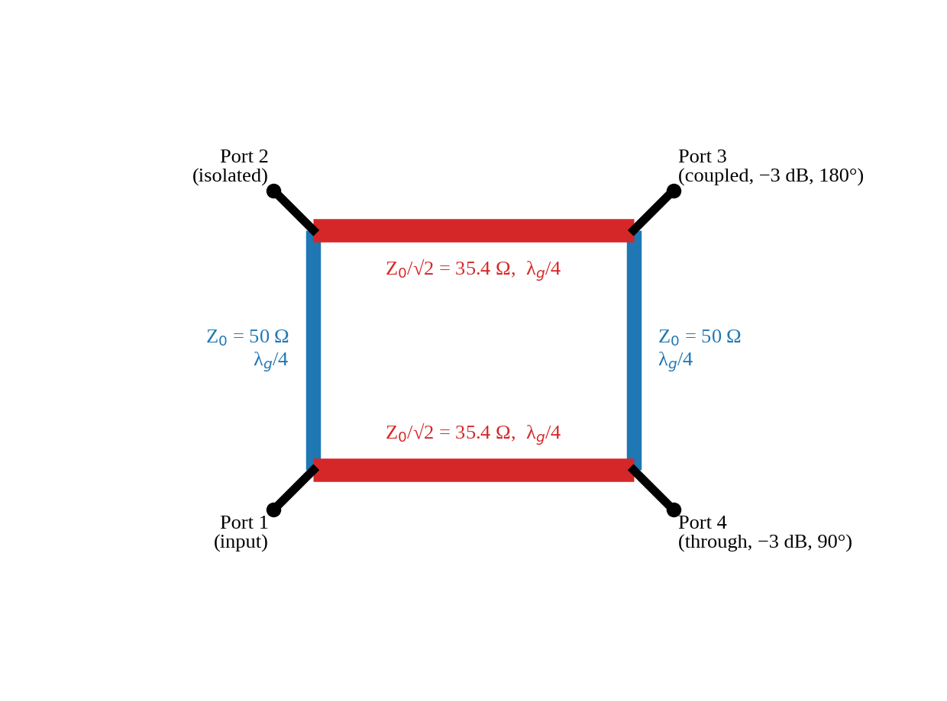
Figure 1: Branch-line coupler: arm impedances and port functions (port numbering as in the HFSS model)
2.2 Ideal S-parameters at the design frequency
With port 1 as the input (ports numbered as in the standard analysis [1]), the ideal scattering parameters at f₀ are
S₁₁ = 0, S₂₁ = −j/√2, S₃₁ = −1/√2, S₄₁ = 0 (1)
where the port labelled “2” here is the through port, “3” the coupled port and “4” the isolated one. So all four ports are matched (S₁₁ = 0), the isolation is infinite, each output receives −3.01 dB and the outputs are 90° apart in phase. Because the ring is symmetric, the same holds for an input at any port.
2.3 Performance quantities
The coupler is characterized by the following quantities, all in dB and read from the S-parameters:
Return loss = −20 log|S₁₁|, Isolation = −20 log|S_{isolated}|, Coupling = −20 log|S_{coupled}| (2)
For an equal-split coupler the ideal coupling and through levels are each 3.01 dB, and the directivity (isolation minus coupling) should be large. The reflection coefficient |Γ| = 10^{S_{11}/20} and the VSWR = (1 + |Γ|)/(1 − |Γ|) describe how well the port is matched. The operating bandwidth is the range over which the return loss and isolation stay above a chosen limit (typically 10 dB or 20 dB) and the split stays close to −3 dB.
Table 1: Ideal behaviour of the equal-split branch-line coupler at f₀
Quantity | Ideal value
Input return loss (port matching) | ∞ (S₁₁ = 0)
Isolation | ∞ (S_{isolated} = 0)
Power split to each output | −3.01 dB
Phase difference between outputs | 90°
Series arms / shunt arms | Z₀/√2 = 35.4 Ω / Z₀ = 50 Ω, each λ_{g}/4

3. Design at 2.4 GHz on FR4
The microstrip width for each arm follows from the Hammerstad equations. With ε_{r} = 4.4 and h = 1.6 mm, the effective permittivity and impedance are
ε_{eff} = (ε_{r}+1)/2 + [(ε_{r}−1)/2](1 + 12h/w)^{−1/2} (3)
Z₀ = 120π / { √ε_{eff} [ w/h + 1.393 + 0.667 ln(w/h + 1.444) ] } (w/h ≥ 1) (4)
and the guided wavelength is λ_{g} = c/(f√ε_{eff}), with each arm a quarter of it. Table 2 gives the results for the two impedances at 2.4 GHz (free-space wavelength 125 mm).
Table 2: Calculated microstrip parameters at 2.4 GHz
Quantity | 50 Ω arms and feeds | 35.4 Ω arms
Width from synthesis | w/h = 1.912, w = 3.06 mm | w ≈ 5.3 mm
Width used in HFSS | 3.0 mm | 5.3 mm
Z₀ at the width used | 50.8 Ω | 35.1 Ω
ε_{eff} | 3.32 | 3.49
Guided wavelength λ_{g} | 68.6 mm | 66.9 mm
Quarter wavelength λ_{g}/4 | 17.1 mm | 16.7 mm

The 3.0 mm line is 50.8 Ω (1.6 % above 50 Ω) and the 5.3 mm line is 35.1 Ω (0.8 % below 35.4 Ω), both well within normal tolerance. The dielectric attenuation of the FR4 is about 0.83 Np/m (7.2 dB/m) at 2.4 GHz, roughly 0.5 dB per guided wavelength, so a few tenths of a dB of loss are expected in the coupler.
4. HFSS Model and Simulation Setup
The coupler was modelled in Ansys Electronics Desktop Student 2025 R2.4 (project Branch_line_coupler, design HFSSDesign1, solution type HFSS Terminal Network). Figure 2 shows the layout and Figure 3 the substrate and conductor outline; Figure 4 shows the model tree with the four lumped ports. Table 3 lists the model dimensions and solution settings taken from the project file.
Table 3: HFSS model and solution settings
Item | Setting
Substrate | FR4_epoxy (ε_{r} = 4.4, tan δ = 0.02), 30 mm × 40 mm × 1.6 mm
Conductors | Perfect E sheets: “Rectangle1” (30 mm × 40 mm, ground plane) and “top” (coupler pattern)
Ring | Outer 24.7 mm × 19.7 mm, inner 14.1 mm × 13.7 mm: arms 5.3 mm wide (35.4 Ω) and 3.0 mm wide (50 Ω)
Feed lines | 3.0 mm wide (50 Ω), running to the substrate edges at y = ±20 mm
Ports | Four lumped ports, 50 Ω, at the substrate edges: P1 (x = −8.6, y = −20), P2 (−8.6, +20), P3 (+8.55, +20), P4 (+8.55, −20) mm
Air box | Vacuum, 50 mm × 50 mm × 50 mm, radiation boundary
Setup1 | Adaptive solution at 2.4 GHz, maximum 6 passes, maximum ΔS = 0.02
Frequency sweep | 1.2 GHz to 3.6 GHz, 6 MHz step (401 points)

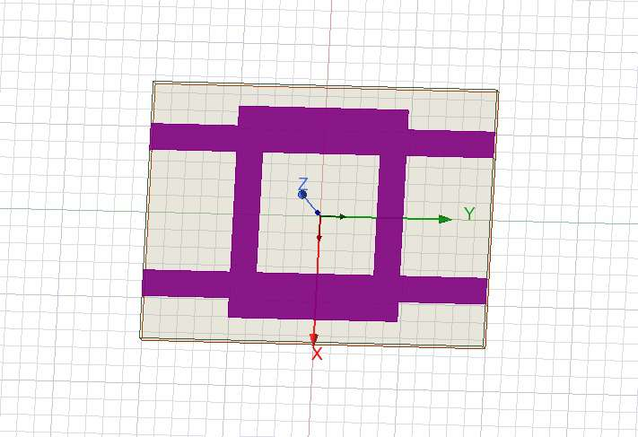
Figure 2: Top view of the coupler pattern on the FR4 substrate (HFSS)
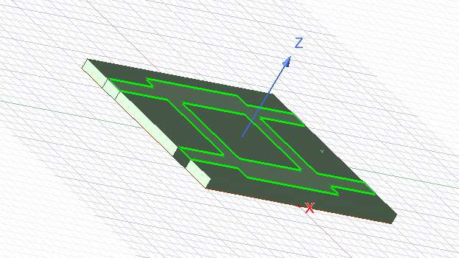
Figure 3: 3-D view of the substrate and conductor outline (HFSS)
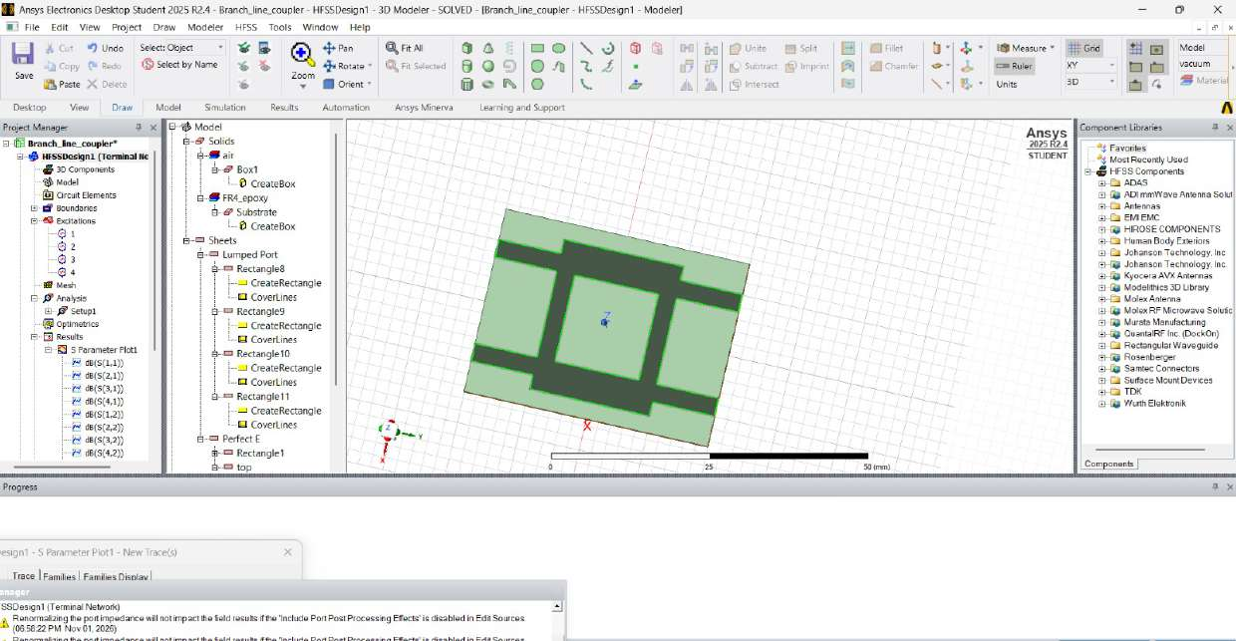
Figure 4: HFSS modeler window with the model tree, the four lumped ports and the air box
From the geometry, the two 50 Ω arms (3.0 mm wide) join ports 1 and 2, and ports 3 and 4, while the two 35.4 Ω arms (5.3 mm wide) join ports 1 and 4, and ports 2 and 3. If port 1 is the input, port 4 is therefore the through port, port 3 (diagonal) the coupled port, and port 2 the isolated port, as labelled in Figure 1. The centre-line length of the 50 Ω arms (19.4 mm) is longer than that of the 35.4 Ω arms (16.7 mm) because it is measured between the corners of the ring.
5. Results and Characterization
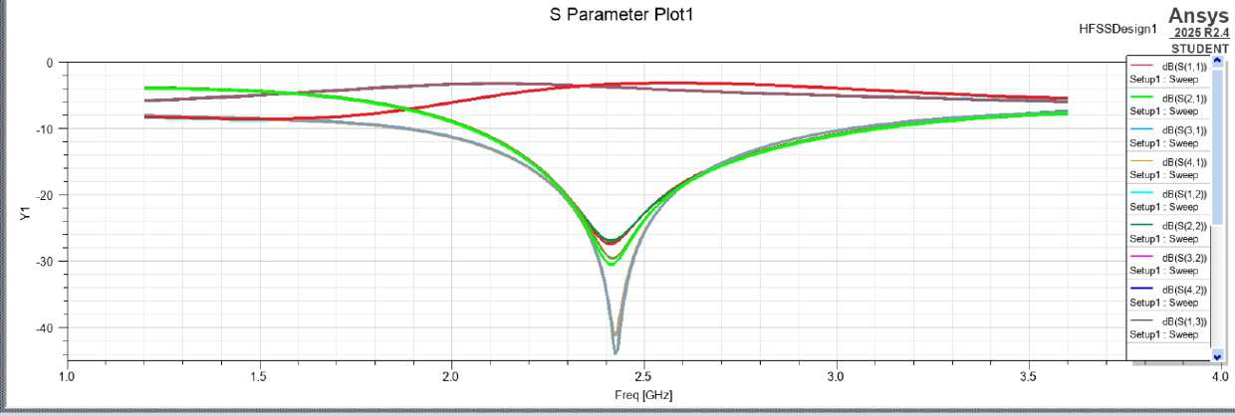
Figure 5: Simulated S-parameters of the 4-port coupler from 1.2 GHz to 3.6 GHz
Figure 5 shows two families of curves. In the first, the curves are close to −3 to −4 dB across the middle of the band: these are the power-split paths (through and coupled). In the second, the curves dip sharply near 2.42 GHz: these are the input reflection and the isolation, which become small at the centre frequency exactly as the theory in Section 2 predicts. The two families cross near the centre, where the power is shared equally between the two outputs and nothing returns to the input or reaches the isolated port.
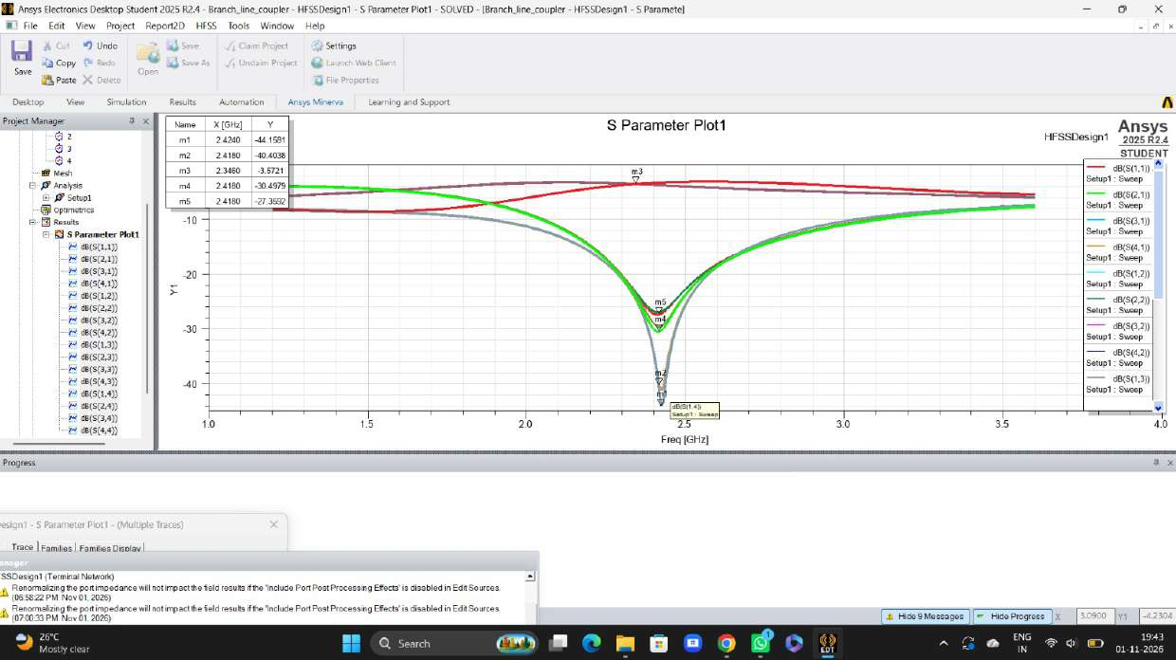
Figure 6: S-parameter plot with markers m1 to m5 near the centre frequency
Table 4: Marker readings (Figure 6) and derived quantities
Marker | Frequency (GHz) | Level (dB) | |Γ| or |S| | VSWR | Curve family
m1 | 2.434 | −44.16 | 0.0062 | 1.01 | Dip (match / isolation)
m2 | 2.418 | −40.49 | 0.0095 | 1.02 | Dip (match / isolation)
m4 | 2.418 | −30.50 | 0.030 | 1.06 | Dip (match / isolation)
m5 | 2.418 | −27.36 | 0.043 | 1.09 | Dip (match / isolation)
m3 | 2.346 | −3.57 | 0.66 | — | Power split

Return loss and isolation. Near 2.42 GHz the dip curves reach −27 dB to −44 dB. The worst case (m5, −27.4 dB) corresponds to |S| = 0.043, so the ports are matched to a VSWR of at most 1.09 and the isolated port receives less than 0.2 % of the input power. The curves are not identical, which shows that the layout is not perfectly symmetric, but all of them are far below the usual −20 dB goal.
Centre frequency. The minima occur at about 2.42 GHz, which is 0.8 % above the 2.4 GHz target. The shift is small and is the kind of offset that comes from junction (corner) discontinuities and fringing that the simple quarter-wave equations ignore. If exactly 2.4 GHz were required, the arms could be lengthened very slightly.
Power split. The ideal split is −3.01 dB. A marker on one of the split curves reads −3.57 dB at 2.346 GHz, about 0.56 dB lower than ideal. This difference is consistent with the dielectric loss of FR4 estimated in Section 3 (about 0.5 dB per wavelength) together with some radiation. The two split curves also differ slightly in level and cross close to the centre, so the split is nearly, but not perfectly, equal.
Bandwidth. Reading Figure 5, the return loss and isolation stay better than about 20 dB over roughly 2.3 GHz to 2.55 GHz (about 10 % fractional bandwidth) and better than about 10 dB over a much wider range, roughly 2.0 GHz to 3.0 GHz. Away from the centre, the return loss falls to about 8 dB at the band edges (1.2 GHz and 3.6 GHz) and the split curves move away from −3 dB, which confirms the narrowband behaviour of the quarter-wave ring. These bandwidth values are read from the plot and are approximate.
Table 5: Summary of the simulated coupler
Parameter | Ideal | Simulated
Centre frequency | 2.4 GHz | ≈ 2.42 GHz
Return loss / isolation at centre | ∞ | 27 dB to 44 dB (VSWR ≤ 1.09)
Power split to each output | −3.01 dB | about −3 to −4 dB (−3.57 dB at m3)
20 dB bandwidth (approx.) | — | ≈ 2.3 GHz to 2.55 GHz (≈ 10 %)

5.1 Limitations
The legend in the screenshots is truncated, so the individual curves are identified here by their behaviour (dip curves and split curves) and by the port roles that follow from the geometry, not by trace name; the marker-to-trace assignment should be confirmed in Ansys. The 90° phase difference between the outputs is a defining property of this coupler but is not shown in the supplied plots, so it is not verified here. Conductors are perfect-E sheets, so only dielectric loss is included, and the bandwidth figures are approximate readings. Fabrication and measurement would be needed to confirm the results on a real board.
6. Conclusion
A 2.4 GHz branch-line coupler was designed on 1.6 mm FR4 using 50 Ω (3.0 mm) and 35.4 Ω (5.3 mm) quarter-wave microstrip arms, and simulated in HFSS. The results show that:
(i) the coupler is centred at about 2.42 GHz, only 0.8 % above the 2.4 GHz design frequency;
(ii) at the centre the input return loss and isolation are 27 dB to 44 dB (VSWR ≤ 1.09), so the input is well matched and the isolated port is effectively cut off;
(iii) the power divides roughly equally between the two outputs, with a level near −3.6 dB, slightly below the ideal −3.01 dB because of the loss of FR4;
(iv) the useful bandwidth is narrow, about 10 % for 20 dB return loss and isolation, as expected for a quarter-wave ring.
The simulation thus agrees well with the theory, and the design meets the 2.4 GHz requirement with only a small frequency offset.
References
[1] D. M. Pozar, Microwave Engineering, 4th ed. Hoboken, NJ: Wiley, 2012, ch. 7.
[2] E. Hammerstad and O. Jensen, “Accurate models for microstrip computer-aided design,” in IEEE MTT-S Int. Microwave Symp. Dig., 1980, pp. 407–409.
[3] Ansys, Inc., Ansys HFSS / Electronics Desktop Student 2025 R2 documentation.
PART - B
1. Introduction
Ultra-wideband (UWB) radio uses a very large bandwidth for short-range, high-data-rate links and radar. The U.S. FCC allows unlicensed UWB operation from 3.1 GHz to 10.6 GHz and defines a UWB signal as one whose fractional bandwidth is at least 20 % or whose bandwidth is at least 500 MHz [1]. The antenna must therefore stay matched, and keep a usable radiation pattern, over a frequency span of more than 3:1. A printed monopole is a popular choice because it is planar, cheap, easy to feed with a microstrip line and naturally wideband.
This report presents the design and characterization of a printed UWB monopole antenna on FR4 substrate (ε_{r} = 4.4, tan δ = 0.02, thickness 1.6 mm), simulated in Ansys HFSS. FR4 was chosen because it is cheap and widely available, and the same 1.6 mm board was used for the transmission-line work of Part A.
Objectives
(i) Choose a substrate and a radiator shape and estimate the lower cut-off frequency from design relations.
(ii) Model the antenna with a 50 Ω microstrip feed in HFSS and sweep it from 1 GHz to 15 GHz.
(iii) Characterize it by its reflection coefficient S₁₁, −10 dB bandwidth, fractional bandwidth and VSWR.
(iv) Characterize its radiation by the realized-gain patterns at 5 GHz, and compare the result with the UWB requirement.
2. Theory: UWB Antennas and Design Relations
2.1 Bandwidth definitions
If the lower and upper −10 dB frequencies are f_{L} and f_{H}, the centre frequency, the fractional bandwidth and the bandwidth ratio are
f_{c} = (f_{H} + f_{L})/2, FBW = (f_{H} − f_{L})/f_{c} × 100 %, BR = f_{H}/f_{L} (1)
The −10 dB limit on S₁₁ is the usual impedance-bandwidth criterion. It corresponds to |Γ| = 10^{−10/20} = 0.316, a VSWR of 1.92, and 10 % of the incident power reflected (a mismatch loss of 0.46 dB).
2.2 Why a printed monopole is wideband
A thin wire monopole resonates when its length is near a quarter wavelength and has a narrow bandwidth. A wide, smoothly curved radiator such as a disc behaves like a tapered transition from the feed line to free space: it supports several closely spaced resonant modes that merge into one broad matched band, and the current path length changes gradually with frequency. A partial ground plane under the feed line only (not under the radiator) keeps the radiator open to the air and helps the match. The antenna radiates much like a monopole, so it has a broad, nearly omnidirectional pattern.
2.3 First estimate of the lower cut-off frequency
The lowest frequency is set by the longest current path L from the ground edge to the far end of the radiator. A quarter-wave estimate, using the average permittivity of a substrate with air on the other side, is
f_{L} ≈ c / (4 L √ε_{eff}), ε_{eff} ≈ (ε_{r} + 1)/2 (2)
For FR4 this gives ε_{eff} ≈ 2.7. The estimate is a starting point only; the final edge is found by simulation. The feed line is a 50 Ω microstrip, whose width follows from the Hammerstad equations of Part A: w/h = 1.91, so w ≈ 3.06 mm for h = 1.6 mm.
2.4 Performance quantities
The reflection coefficient is |Γ| = 10^{S_{11}(dB)/20}, the VSWR is (1 + |Γ|)/(1 − |Γ|), and the realized gain includes the mismatch:
G_{realized} = (1 − |Γ|²) · G_{antenna} (3)
Realized gain is therefore the quantity plotted by HFSS (dB(RealizedGainTotal)), in dB relative to an isotropic radiator.
3. Antenna Design on FR4 Substrate
The antenna is a circular-disc monopole fed by a 3 mm microstrip line. The disc sits on the top face of the board, the feed line runs from the disc to the board edge, and a partial ground plane on the bottom face lies under the feed line only. The dimensions in Table 1 are those of the HFSS project; Figure 1 is a top-view schematic drawn from them.
Table 1: Antenna dimensions (from the HFSS project)
Part | Dimension
Substrate | FR4 epoxy (ε_{r} = 4.4, tan δ = 0.02), 26 mm × 27 mm × 1.6 mm
Radiator (top) | Disc of radius 13 mm centred at x = −12 mm, cut off at the board edge x = −13 mm
Feed line (top) | Strip 3 mm wide (50 Ω) and 13 mm long, from x = 0 to the board edge at x = +13 mm
Ground (bottom) | Partial ground 11.5 mm × 27 mm, from x = 1.5 mm to x = 13 mm
Feed | Lumped port, 3 mm × 1.6 mm, 50 Ω, at the board edge x = 13 mm
Air box | 40 mm × 40 mm × 40 mm, radiation boundary

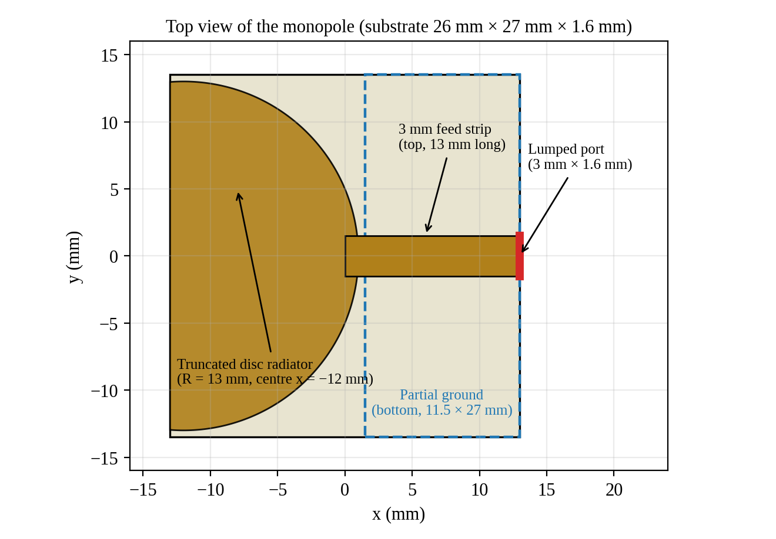
Figure 1: Top-view schematic of the printed monopole (dashed: ground on the bottom face)
Design check. The longest current path from the edge of the ground (x = 1.5 mm) to the far end of the radiator (x = −13 mm) is L = 14.5 mm. Equation (2) gives f_{L} ≈ 3.15 GHz. The simulated −10 dB edge (Section 5) is 3.52 GHz; this is close and a little higher, as expected, since a match better than −10 dB needs the radiator to be slightly longer than a quarter wavelength at that frequency. Lengthening the radiator would lower the edge, as equation (2) shows.
4. HFSS Simulation Setup
The antenna was modelled in Ansys Electronics Desktop Student 2025 R2.4 (project UWB_Monopole_Antenna, design HFSSDesign1, driven modal solution). The conductors are zero-thickness Perfect E sheets and the FR4 substrate is lossy. Table 2 lists the solution settings found in the project file.
Table 2: HFSS solution settings
Item | Setting
Excitation | One lumped port, 50 Ω
Boundaries | Perfect E (radiator, feed and ground); radiation boundary on the air box
Adaptive solution | Setup1 at 5 GHz, maximum 6 passes, maximum ΔS = 0.02
Frequency sweep | 1 GHz to 15 GHz, 141 points (100 MHz step)
Results | S₁₁ in dB; realized gain at 5 GHz for φ = 0° and φ = 90° and as a 3-D plot

5. Results and Discussion
5.1 Reflection coefficient and bandwidth
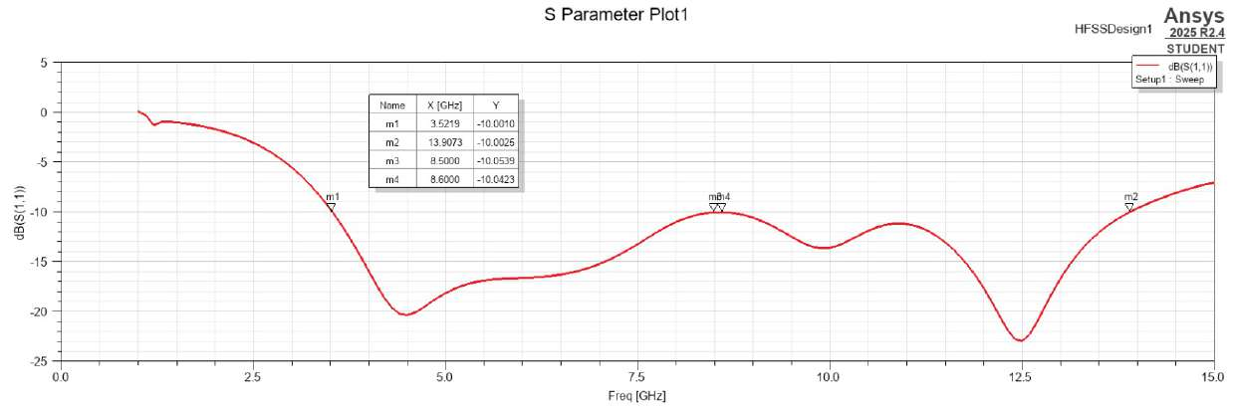
Figure 2: Simulated S₁₁ of the antenna from 1 GHz to 15 GHz, with markers m1 to m4
S₁₁ falls below −10 dB at 3.52 GHz (marker m1) and stays below it until 13.91 GHz (marker m2). Inside the band there are two deep resonances, about −20 dB near 4.5 GHz and about −23 dB near 12.5 GHz, and a shallow hump around 8.5–8.6 GHz where S₁₁ only just meets the limit (markers m3 and m4, about −10.05 dB). Table 3 gives the marker values with the derived |Γ| and VSWR, and Table 4 summarizes the bandwidth.
Table 3: Marker readings and derived reflection quantities
Marker | Frequency (GHz) | S₁₁ (dB) | |Γ| | VSWR
m1 | 3.522 | −10.00 | 0.316 | 1.93
m3 | 8.500 | −10.05 | 0.314 | 1.92
m4 | 8.600 | −10.04 | 0.315 | 1.92
m2 | 13.907 | −10.00 | 0.316 | 1.93
Table 4: Bandwidth summary
Quantity | Value
−10 dB band (f_{L} to f_{H}) | 3.52 GHz to 13.91 GHz
Absolute bandwidth | 10.39 GHz
Centre frequency f_{c} | 8.71 GHz
Fractional bandwidth | 119 %
Bandwidth ratio f_{H}/f_{L} | 3.95 : 1
VSWR at the band edges | 1.93

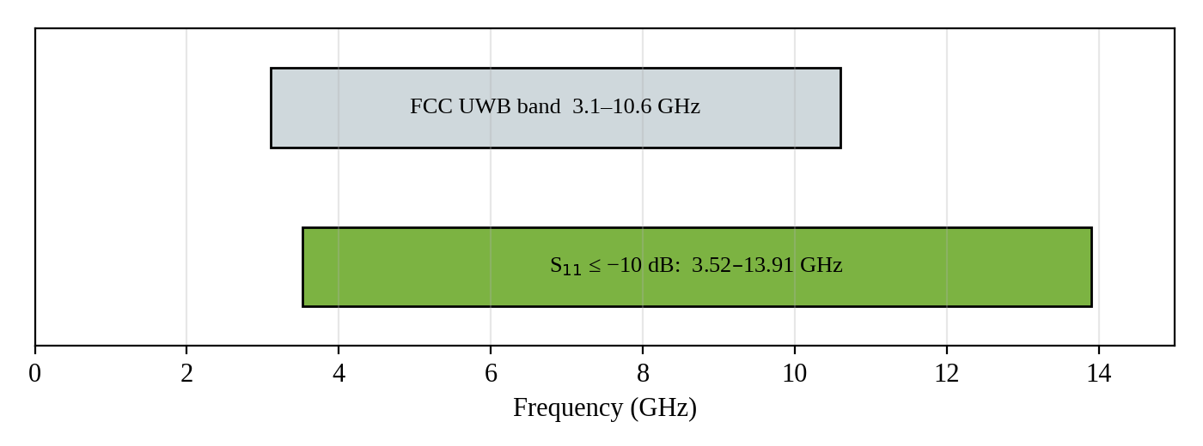
Figure 3: The −10 dB band of the antenna against the FCC UWB band
The fractional bandwidth of 119 % is far above the 20 % UWB threshold. The antenna covers the FCC band from 3.52 GHz to 10.6 GHz, and continues up to 13.9 GHz. It does not cover the lowest part of the FCC band, 3.1 GHz to 3.52 GHz, so it meets the UWB definition but not the whole of the 3.1–10.6 GHz mask. In addition, the margin at 8.5–8.6 GHz is only about 0.05 dB, so a small fabrication or material change could push S₁₁ just above −10 dB there.
5.2 Radiation characteristics at 5 GHz
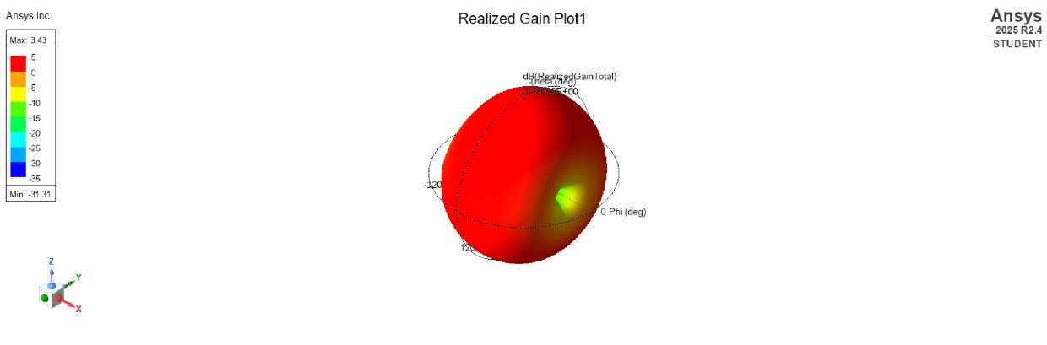
Figure 4: Three-dimensional realized gain at 5 GHz (maximum 3.43 dB, minimum −31.31 dB)
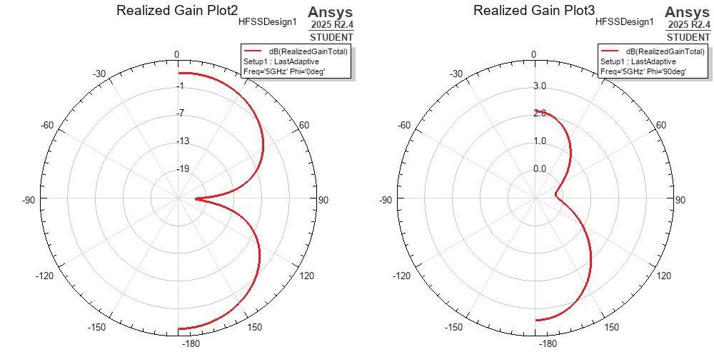
Figure 5: Realized-gain polar plots at 5 GHz: (a) φ = 0°, (b) φ = 90°
At 5 GHz the peak realized gain is 3.43 dB and S₁₁ is about −18 dB, so the mismatch loss is small (1.6 % reflected power or less). The 3-D plot is almost uniformly red, meaning that over most of the sphere the realized gain stays within a few dB of its maximum, with one narrow null (down to −31.31 dB). This is the broad, nearly omnidirectional pattern expected from a monopole. In the φ = 90° cut the gain is roughly 2 dB at θ = 0° and about 3 dB at θ = 180°, with only a shallow dip near θ = 90°. In the φ = 0° cut the gain is about 0 dB near θ = 0° and 180° (read from the plot) and a deep null appears toward θ = ±90°. The gain values are read from the polar plots and are approximate.
5.3 Limitations
The results come from simulation only; the antenna was not fabricated or measured. Radiation patterns were computed only at 5 GHz, so the pattern at the band edges, the efficiency and the group delay (important for pulse distortion in UWB) are not characterized. The air box extends only about 7 mm from the board on some sides, which is about λ₀/8 at 5 GHz and less at 3.5 GHz, so the radiation boundary is closer than the usual quarter-wavelength guideline and the low-frequency results should be treated with some caution. The conductors are lossless sheets, so on a real FR4 board the gain and efficiency, especially at the upper frequencies, will be lower because of the dielectric loss (tan δ = 0.02).
6. Conclusion
A printed disc monopole with a 3 mm (50 Ω) microstrip feed and a partial ground plane on a 26 mm × 27 mm × 1.6 mm FR4 board was designed and simulated in HFSS. The quarter-wave estimate of 3.15 GHz for the lower edge agrees with the simulated 3.52 GHz. The simulation shows that:
(i) S₁₁ stays below −10 dB from 3.52 GHz to 13.91 GHz, a bandwidth of 10.39 GHz, a fractional bandwidth of 119 % and a ratio of 3.95:1, with VSWR below 1.93 throughout the band;
(ii) the band covers the FCC UWB range from 3.52 GHz to 10.6 GHz but not the 3.1–3.52 GHz portion, and has a narrow margin around 8.5–8.6 GHz;
(iii) at 5 GHz the pattern is broad and nearly omnidirectional with a peak realized gain of 3.43 dB.
Making the radiator slightly longer would extend the band toward 3.1 GHz, and fabrication and measurement would be the natural next step to confirm the simulated results.
References
[1] Federal Communications Commission, “Revision of Part 15 of the Commission’s Rules Regarding Ultra-Wideband Transmission Systems,” First Report and Order, ET Docket 98-153, FCC 02-48, Apr. 2002.
[2] C. A. Balanis, Antenna Theory: Analysis and Design, 4th ed. Hoboken, NJ: Wiley, 2016.
[3] D. M. Pozar, Microwave Engineering, 4th ed. Hoboken, NJ: Wiley, 2012.
[4] Ansys, Inc., Ansys HFSS / Electronics Desktop Student 2025 R2 documentation.

