ARCHITECTURE NOTE
Quarry Web and Desktop Separation
How the shared React product uses Tauri as a desktop transport and native-capability routing layer
Document status | Repository snapshot | Scope
Current-state architecture | main @ c20318b1a18e + reviewed working-tree changes  20 Aug 2026 | Frontend build boundary, Tauri gateway, Axum routing, and native capabilities

Short answer Quarry has one React application and one hosted Axum product API. The web build reaches Axum directly. The desktop build selects a Tauri-backed adapter, so most product API calls make one extra local hop through Tauri IPC and Rust before reaching the same Axum routes. Tauri also owns the small set of operations that genuinely require desktop trust, such as native save dialogs and authorized local data-room access.
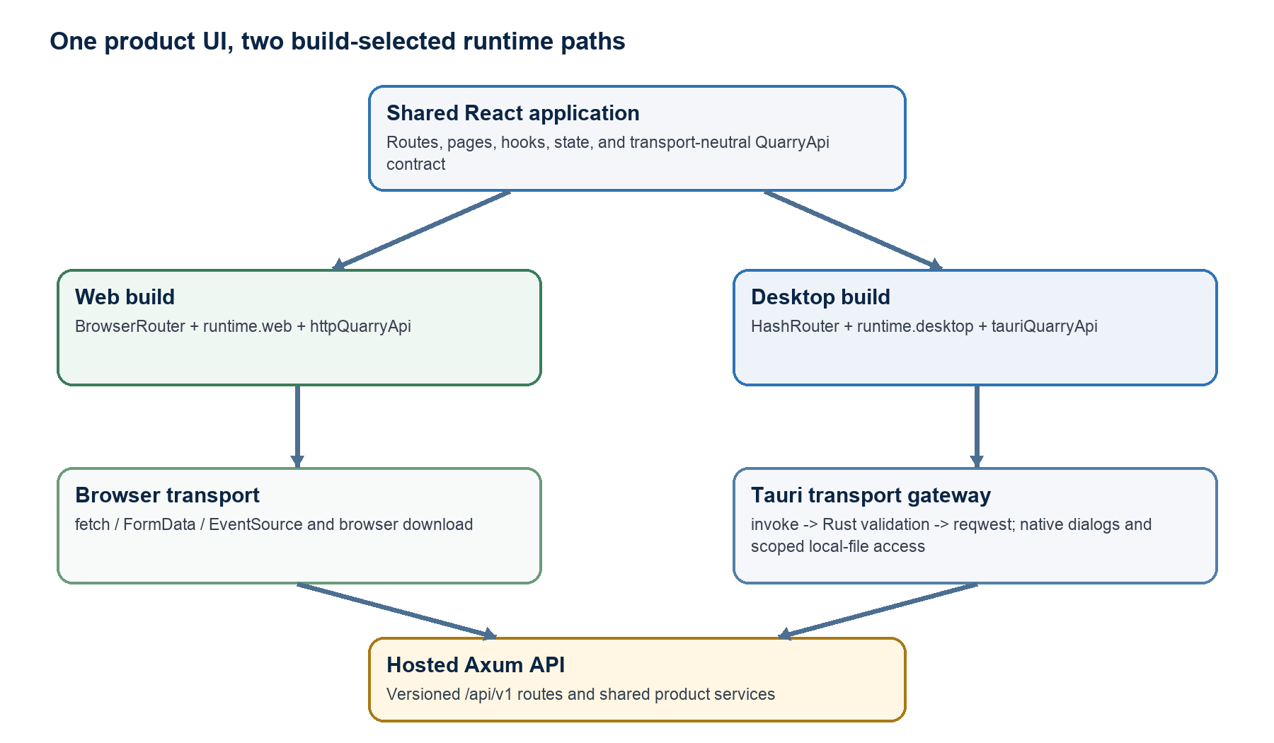
Figure 1. Build-time aliases select the transport path; both clients converge on the same product API.

Executive summary
- One UI source tree. Pages, routes, hooks, state, and the QuarryApi contract live under frontend/src and are shared by both distributions.
- Separation happens at build time. Vite and TypeScript aliases bind @quarry/router and @quarry/runtime to either their web or desktop implementations.
- React Router owns screen navigation. BrowserRouter is used on the web; HashRouter is used inside the bundled Tauri webview. Tauri is not the page router.
- Tauri is a desktop transport gateway. In the current desktop build, generic IPC commands validate and relay /api/v1 calls through Rust reqwest to Axum; server-sent events are consumed in Rust and re-emitted to the webview.
- Tauri is also the native capability boundary. Dedicated commands own save dialogs, atomic file writes, folder selection, and scoped local-file reads. Those operations do not exist in the web build or have browser-native equivalents.
- Axum remains the product backend. Users, deals, documents, summaries, search, and job endpoints are routed by Axum; the Tauri shell does not become a second domain backend.

1. What “routing” means in this repository
The word routing refers to four different decisions. Keeping them separate prevents the desktop shell from accumulating responsibilities that belong to React or Axum.
Routing concern | Owner | Web build | Desktop build
Screen / URL navigation | React Router | BrowserRouter with normal history URLs | HashRouter for bundled static assets
Build-time module selection | Vite + TypeScript | Aliases resolve to *.web modules | Aliases resolve to *.desktop modules
Product API transport | Runtime adapter | Browser fetch, FormData, and EventSource | Tauri invoke -> Rust reqwest -> Axum
Backend endpoint dispatch | Axum Router | Routes /api/v1 to handlers | The same /api/v1 routes after the Tauri hop
Native OS capability dispatch | Tauri commands | Browser equivalent or unavailable | Dedicated validated commands

The key clarification
Tauri is “sometimes” the routing layer because the Vite desktop mode swaps in runtime.desktop.ts. In web mode there is no Tauri hop. In desktop mode product API traffic is currently routed through Tauri, while page navigation still stays inside React Router.

Decision rule for new work
- If it changes the visible page or URL, add it to the shared React route manifest and let BrowserRouter or HashRouter interpret it.
- If it is a product operation over server-owned data, add it to QuarryApi and the Axum /api/v1 contract. The web adapter calls it directly; the desktop adapter currently relays it through Tauri.
- If it requires OS trust or a native user gesture, expose a narrow dedicated Tauri command with validation and scoped permissions.
- If it contains domain logic, persistence, AI, search, or job orchestration, keep it behind Axum rather than in the Tauri shell.

Ownership boundaries
Layer | Owns | Must not own
Shared React | Presentation, page routes, state, hooks, contracts | Raw Tauri imports or Axum-shaped transport details
Web adapter | Browser HTTP/SSE, file inputs, browser downloads | Desktop APIs or local filesystem paths
Desktop adapter | IPC mapping, desktop event bridge, native capability calls | Product business rules or durable product state
Tauri Rust | Origin checks, input validation, native I/O, HTTP relay | A second users/deals/documents backend
Axum | Versioned product API, handlers, services, repositories, jobs | Client-specific navigation behavior

2. How web and desktop are separated

A single shared application shell
frontend/src/main.tsx always mounts the same App component. App.tsx declares one set of routes for login, hub, account, vault, summarize, logs, deal rooms, and data rooms. Shared pages import runtime from @quarry/runtime instead of selecting a transport themselves.
main.tsx -> @quarry/router -> <AppRouter><App /></AppRouter>
shared page/hook -> @quarry/runtime -> runtime.api or runtime.platform

Build-time selection, not scattered runtime detection
frontend/vite.config.ts derives a target from the Vite mode and aliases two stable module names. The matching tsconfig repeats those paths and excludes the opposite platform implementation, so each target is type-checked against only its selected boundary.
Build command | Router binding | Runtime binding | Output behavior
npm run build:web | Router.web.tsx / BrowserRouter | runtime.web.ts | Static browser app; host must rewrite application routes to index.html
npm run build:desktop-ui | Router.desktop.tsx / HashRouter | runtime.desktop.ts | Static assets bundled into the Tauri application
npm run build:desktop | Runs the desktop UI build first | Tauri shell loads ../dist | Native installers/bundles for the configured targets

Boundary enforcement
frontend/scripts/check-runtime-boundaries.mjs turns the intended separation into a lightweight build rule. At the reviewed snapshot, npm run check:boundaries passes.
- @tauri-apps imports are allowed only in src/platform/runtime.desktop.ts.
- The desktop runtime may not import httpQuarryApi; desktop API access must cross IPC.
- Raw fetch and EventSource calls belong under src/api.
- The optional web-bundle check fails if built JavaScript contains __TAURI_INTERNALS__.

Platform behavior that intentionally differs
Capability | Web | Desktop
Save summary or logs | Blob + temporary object URL + download attribute | save_text_file command + native dialog + atomic sibling-temp write
Choose deal data room | Unavailable; web flow uses browser files / SharePoint metadata | Native folder picker, scan, and in-memory authorization of the canonical root
Read selected source files | Browser supplies File objects | Only files under the previously authorized root; one or two files, 50 MB total
Product API | Direct browser transport | Tauri transport gateway

3. The two product-API request paths

Web path: direct browser transport
React -> runtime.web -> httpQuarryApi -> fetch/FormData/EventSource -> Axum /api/v1
runtime.web.ts composes httpQuarryApi. The HTTP client validates VITE_API_BASE_URL, allows HTTPS outside local development, builds versioned paths, serializes JSON or FormData, logs requests, and uses EventSource for document-job updates. An empty development base URL relies on Vite's /api proxy to 127.0.0.1:3001.

Desktop path: Tauri as transport gateway
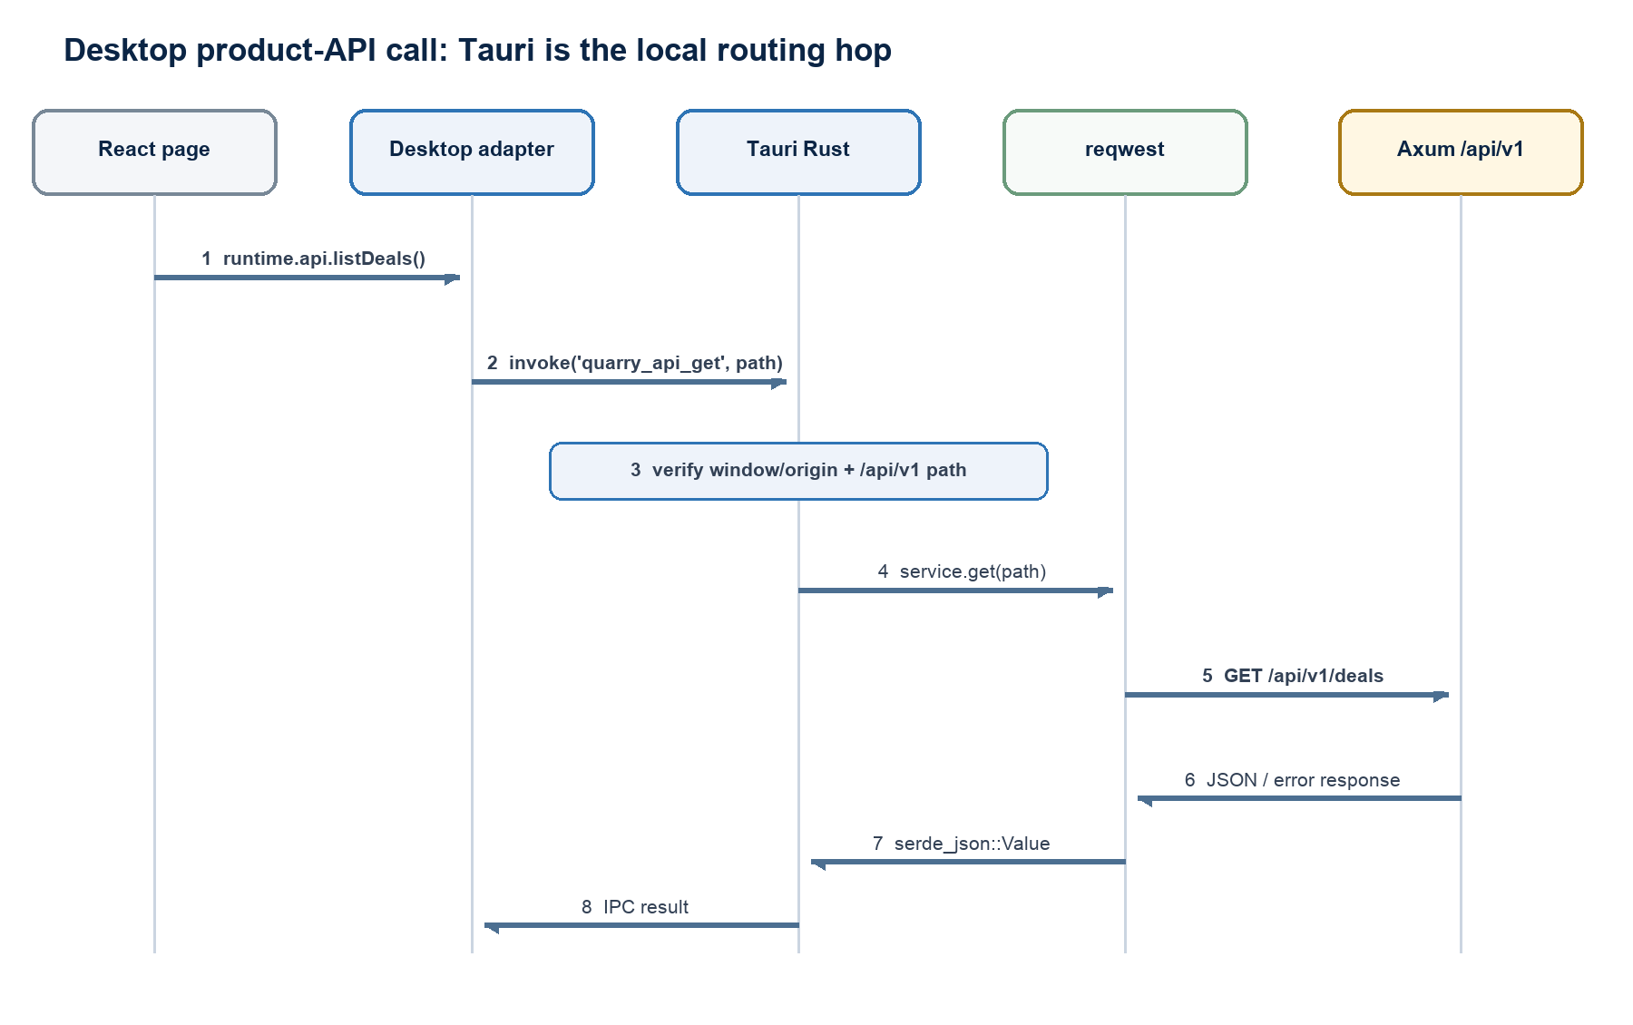
Figure 2. A desktop API call is mapped in TypeScript, validated in Tauri Rust, and forwarded to the same Axum endpoint.
runtime.desktop.ts composes createTauriQuarryApi with a Tauri transport. The TypeScript adapter still presents the same QuarryApi interface to pages, but maps each operation to one of four generic transport actions.
Desktop transport action | Tauri command | Purpose
GET JSON | quarry_api_get | Forward a validated /api/v1 GET and return parsed JSON
POST JSON | quarry_api_post | Forward JSON to a validated /api/v1 path
POST multipart | quarry_api_post_multipart | Decode base64 files, enforce limits, rebuild reqwest multipart, and forward
Subscribe to job | subscribe_document_job | Consume Axum SSE in Rust and emit quarry-document-job-event to the webview

Why route through Tauri? The current desktop design centralizes network policy, path validation, multipart reconstruction, and event bridging in Rust. It also guarantees that the desktop build does not silently fall back to the browser HTTP adapter. This is a local gateway, not a second product server.

Axum is the final router
backend/src/routes/mod.rs merges the feature routers and mounts them at /api and /api/v1. Clients in this architecture use /api/v1; /api is transitional. Request IDs, CORS, tracing, compression, and timeouts wrap the combined router.

4. Detailed desktop flows

Normal JSON request
- A page calls runtime.api.listDeals(), createDeal(), getDeal(), or another QuarryApi method.
- tauriQuarryApi constructs an encoded /api/v1 path and delegates to the supplied desktop transport.
- runtime.desktop invokes quarry_api_get or quarry_api_post and records the IPC activity.
- The Rust command verifies that the caller is the main window and that its origin is the bundled Tauri origin or the approved debug origin.
- QuarryApiService restricts the path to /api/v1, rejects traversal/newlines/fragments, and forwards through QuarryHttpClient.
- QuarryHttpClient accepts only an HTTPS base URL or HTTP loopback, applies timeouts, parses JSON, and returns the result through IPC.

Multipart upload
For processDocuments, saveDealMetadata, startProcessFile, and summarizeUpload, the desktop TypeScript adapter reads each File into memory and base64-encodes it. Rust decodes the payload, validates names and MIME strings, caps each file and the full request at 50 MB, reconstructs multipart parts, and posts to Axum.
File -> ArrayBuffer -> base64 -> Tauri IPC -> bytes -> reqwest multipart -> Axum
Current constraint This path is simple and validated, but base64 adds roughly one-third wire overhead and both sides hold complete copies in memory. It is acceptable as a bounded interim route, not the preferred long-term path for large or numerous documents.

Document-job event stream
The web client subscribes with EventSource directly. The desktop client invokes subscribe_document_job with a random subscription ID. Rust opens the Axum SSE stream, parses event/data frames, and emits quarry-document-job-event. The TypeScript listener filters by subscription ID before calling the shared job handlers.
Axum SSE -> Rust bytes stream -> Tauri event -> desktop adapter -> shared handler

Local deal data room
This is a dedicated native capability, separate from the generic API relay. select_deal_data_room opens a native folder picker, canonicalizes the chosen root, scans supported files for SOW and timeline matches, and stores the authorized canonical root in process memory. read_deal_source_files later permits only selected files under that authorized root.
The React deal flow converts returned base64 bytes back into File objects, then passes those files through the shared saveDealMetadata API. In the desktop build, that upload consequently crosses IPC again through the generic multipart relay.

Native export
save_text_file accepts only nonempty JSON or Markdown content, validates title, filename, extension, MIME pairing, and a 5 MB limit, opens a native save dialog, and uses a sibling temporary file plus rename. The web adapter implements the same capability contract with a browser download.

5. Security and trust boundaries
Because desktop web content can invoke native code, every IPC boundary is treated as untrusted input. The existing design applies multiple independent gates before a request reaches the network or filesystem.
Boundary | Control in the reviewed code | Effect
Build | Only runtime.desktop.ts may import @tauri-apps; web-bundle scan checks for Tauri internals | Reduces accidental native reachability from the web distribution
Window/origin | Commands require window label main and a bundled Tauri or approved debug origin | Rejects other windows and unexpected origins
API path | Only /api/v1 paths; rejects .., CR/LF, #, and excessive length | Prevents arbitrary URL forwarding and common path manipulation
API destination | QUARRY_API_BASE_URL must be HTTPS or HTTP loopback; query and fragment are rejected | Constrains the Rust gateway's upstream destination
Multipart | Filename/path metadata validation plus 50 MB per-file and total limits | Bounds memory use and rejects obvious traversal metadata
Local files | Canonical root must be selected first; reads must remain under it | Turns user selection into a scoped, temporary grant
Export | Strict MIME/extension pairing, simple filename, native dialog, atomic write | Avoids arbitrary path input and partial writes
Webview | Restrictive CSP, freezePrototype, one main window, core:default capability | Narrows webview behavior and exposed platform surface

Important non-goals
- Tauri is not the source of truth for users, deals, documents, summaries, or jobs.
- The desktop build does not maintain a second React application.
- The Tauri shell does not load the production web application from a remote URL; it bundles the built UI.
- This architecture does not currently promise offline-first behavior or desktop/server data synchronization.
- A generic Tauri proxy is not authorization. Axum still needs real identity, tenancy, and endpoint authorization.

Configuration sources
Concern | Web | Desktop
API base URL | VITE_API_BASE_URL, public build-time configuration | QUARRY_API_BASE_URL, read by Rust at app startup
Local development | Empty base uses Vite /api proxy to 127.0.0.1:3001 | Defaults to http://127.0.0.1:3001
Production transport | HTTPS required outside development | HTTPS required except loopback
Webview network policy | Not applicable | tauri.conf.json CSP connect-src must match the deployed topology

6. Constraints, drift, and recommended evolution

Current implementation constraints
Constraint | Why it matters | Recommended direction
Generic /api/v1 proxy commands | The gateway authorizes a namespace rather than explicit methods/endpoints | Keep the proxy only if desired, then add method/endpoint policy or narrow commands for sensitive operations
Base64 multipart across IPC | Extra memory copies and ~33% encoding overhead | Use opaque file grants and stream from Rust to an upload session
SSE subscription lifetime | Removing the webview listener does not explicitly cancel the Rust HTTP stream | Add a cancel command or managed subscription registry with cleanup
API errors become validation errors | HTTP status, retryability, and server operation IDs are lost | Preserve a stable cross-transport error envelope
Two API mapping implementations | httpQuarryApi and tauriQuarryApi can drift method by method | Generate or share endpoint descriptors and contract tests across transports
Backend identity is not yet a production boundary | The route transport can be secure while product data remains unauthenticated | Add OIDC/tenant authorization at Axum before public deployment

Documentation drift to resolve
Code is ahead of the earlier ADR and README The accepted ADR says both adapters compose the same HTTPS client, and the README says the shell exposes only save_text_file and packaged desktop uses VITE_API_BASE_URL. The reviewed working tree instead routes desktop API traffic through Tauri, exposes additional data-room and API commands, and configures Rust with QUARRY_API_BASE_URL. This document records the current code path; the ADR/README should be amended once the transport decision is finalized.

Recommended sequence
- Name the decision explicitly: retain the desktop Tauri API gateway or return desktop product calls to direct HTTPS. Avoid maintaining both as implicit alternatives.
- If the gateway stays, strengthen it as a first-class transport: explicit endpoint/method policy, authentication propagation, stable error envelopes, cancellation, and contract tests.
- Replace base64 uploads and local-file round trips with short-lived opaque grants and Rust streaming.
- Align README, ADR 0001, environment-variable guidance, CSP origins, and release checks with the selected design.
- Keep adding native features as dedicated capabilities; do not move Axum services or persistence into Tauri.

Architecture acceptance checks
- The web build contains no reachable Tauri runtime.
- Web and desktop pages compile against the same QuarryApi and route manifest.
- All desktop IPC commands verify the expected window/origin and validate input.
- Product operations terminate at versioned Axum routes and share server-owned data.
- Native operations are narrow, user-mediated where appropriate, and least-privileged.
- A desktop release can identify the supported API contract and fail safely when incompatible.

Appendix A. One-line flow reference
WEB PAGE ROUTE React Router -> BrowserRouter -> /hub/...
DESKTOP PAGE ROUTE React Router -> HashRouter -> #/hub/...
WEB PRODUCT API runtime.web -> httpQuarryApi -> fetch/EventSource -> Axum /api/v1
DESKTOP PRODUCT API runtime.desktop -> Tauri IPC -> Rust reqwest/SSE -> Axum /api/v1
DESKTOP NATIVE runtime.platform -> dedicated Tauri command -> validated OS capability
SERVER ROUTE Axum Router -> handler -> service/repository/job

Appendix B. Source map
The architecture above was traced from the following files in the current repository working tree. Paths are relative to the repository root.
Source | Architectural responsibility
frontend/vite.config.ts; tsconfig.web.json; tsconfig.desktop.json | Mode aliases, target-specific type resolution, and opposite-platform exclusions
frontend/src/main.tsx; src/App.tsx; src/platform/Router.*.tsx | Shared mount and route manifest with BrowserRouter / HashRouter selection
frontend/src/contracts/quarryApi.ts; src/platform/runtime.web.ts; src/api/httpQuarryApi.ts | Shared contracts and direct browser JSON, multipart, SSE, and download behavior
frontend/src/platform/runtime.desktop.ts; src/api/tauriQuarryApi.ts | Desktop IPC/event composition and QuarryApi-to-Tauri transport mapping
frontend/src-tauri/src/lib.rs; src/quarry_api/{commands,service,client}.rs | Command registration, origin/path checks, multipart reconstruction, SSE parsing, and reqwest relay
frontend/src-tauri/src/security.rs; tauri.conf.json; capabilities/default.json | Window/origin trust, bundled UI, CSP, window, and capability configuration
frontend/src-tauri/src/deal_files.rs; src/save_file.rs | Scoped native folder/file access and validated atomic export
backend/src/routes/mod.rs; backend/src/routes/*.rs | Axum route composition, /api and /api/v1 mounts, middleware, and endpoint dispatch
frontend/scripts/check-runtime-boundaries.mjs | Automated enforcement of the web/desktop import and transport boundary
docs/adr/0001-shared-runtime-boundary.md | Original accepted boundary decision; partially superseded by current working-tree transport changes

