**1D Kinematics**

**Questions from a Conceptual Course**

**Category 1: Average Speed and Average Velocity**

**Question 1:**

aa. For which one of the following motions is the object’s displacement different than the distance traveled?

a. A car accelerates from rest to a high speed.

b. After a home run, a baseball player runs all the way around the bases.

c. A buggy car moves across the floor at a constant speed.

**Question 2:**

aa. For which one of the following motions is the object’s displacement different than the distance traveled?

a. An infant crawls across the room at a constant speed.

b. Seeing the light turn yellow, Lin skids to a stop.

c. In gym class, Jeffrey runs a complete lap around the track at a constant pace.

**Question 3:**

aa. For which one of the following motions is the object’s displacement different than the distance traveled?

a. A football coach paces back and forth along the sidelines.

b. The plane moves form a low speed to a high speed along the runway.

c. Jeremy darts straight down the hallway at a constant speed.

**Question 4:**

aa. For which one of the following motions is the object’s displacement the same as the distance that it travels?

a. A football coach paces back and forth along the sidelines.

b. An infant crawls across the room at a constant speed.

c. After a home run, a baseball player runs all the way around the bases.

**Question 5:**

aa. For which one of the following motions is the object’s displacement the same as the distance that it travels?

a. Mr. R’s lawn mower made a straight path (perfectly) across the edge of the lawn.

b. Sheila made one complete loop around the race track.

c. The painter climbed up the ladder and then back down to the floor.

**Question 6:**

aa. **TRUE** or **FALSE**:

The distance traveled for an object that makes a round-trip motion is always 0.

a. True b. False

**Question 7:**

aa. **TRUE** or **FALSE**:

The displacement for an object that makes a round-trip motion is always 0.

a. True b. False

**Question 8:**

aa. Which of the following objects has an average velocity of 0 m/s?

a. A truck skids to a stop along a straight section of highway.

b. A runner makes one complete lap around the track at a constant speed.

c. Suzie walks one block north, turns left and walks one block west.

**Question 9:**

aa. Which one of the following statements describes a fast-moving object?

a. An object moves forward and then backwards to the starting position.

b. An object moves relatively far in a long amount of time.

c. An object moves the same distance during each time interval.

d. An object move relatively far in a short amount of time.

**Question 10:**

aa. **TRUE** or **FALSE**:

The average speed for an object that makes a round-trip motion is always 0.

a. True b. False

**Question 11:**

aa. **TRUE** or **FALSE**:

The average velocity for an object that makes a round-trip motion is always 0.

a. True b. False

**Question 12:**

aa. Which one of the following is true of an object that is said to be moving fast?

a. The object has a large acceleration.

b. The object covers a long distance.

c. The object has been moving for a long time.

d. The object has a large instantaneous speed.

e. The object has NOT changed its direction.

**Question 13:**

aa. Which one of the following is true of an object that is said to be moving slow?

a. The object has a small acceleration.

b. The object covers a short distance.

c. The object has been moving for a short time.

d. The object has a small instantaneous speed.

e. The object has changed its direction.

**Question 14:**

aa. Which of the following two objects have the same speed value? Bubble in two letters.

a. An object travels 40 meters in 10 seconds.

b. An object travels 40 meters in 5 seconds.

c. An object travels 20 meters in 10 seconds.

d. An object travels 20 meters in 5 seconds.

**Question 15:**

aa. Which of the following two objects have the same speed value? Bubble in two letters.

a. An object travels 20 miles in 4 hours.

b. An object travels 40 miles in 4 hours.

c. An object travels 20 miles in 2 hours.

d. An object travels 20 miles in 2 hours.

**Question 16:**

aa. Which one of the following cars has an eastward displacement?

a. A car travels east for 5 miles, turns around and returns to the starting position.

b. A car travels west for 5 miles, turns around and returns to the starting position.

c. A car travels east for 5 miles, turns around and travels west for 8 miles.

d. A car travels west for 5 miles, turns around and travels east for 8 miles.

**Question 17:**

aa. Which one of the following cars has a westward displacement?

a. A car travels east for 5 miles, turns around and returns to the starting position.

b. A car travels west for 5 miles, turns around and returns to the starting position.

c. A car travels east for 5 miles, turns around and travels west for 8 miles.

d. A car travels west for 5 miles, turns around and travels east for 8 miles.

**Question 18:**

aa. Which one of the following trucks has a northward displacement?

a. A truck travels north for 8 miles, turns around a travels south for 15 miles.

b. A truck travels south for 8 miles, turns around and travels north for 18 miles.

c. A truck travels north for 8 miles, turns around and returns to the starting position.

d. A truck travels south for 8 miles, turns around and returns to the starting position.

**Question 19:**

aa. Which one of the following objects has a average speed of 20 mi/hour?

a. A car moves a distance of 20 miles and is 20 miles from the starting point after 4 hours.

b. A car moves a distance of 40 miles and is 20 miles from the starting point after 1 hour.

c. A car moves a distance of 40 miles and is 20 miles from the starting point after 2 hours.

d. A car moves a distance of 40 miles and changes its velocity by 20 mi/hr after 1 hour.

**Question 20:**

aa. Which one of the following objects has a average speed of 40 mi/hour?

a. A car moves a distance of 60 miles and is 20 miles from the starting point after 1 hour.

b. A car moves a distance of 40 miles and is 40 miles from the starting point after 2 hours.

c. A car moves a distance of 80 miles and is 40 miles from the starting point after 1 hour.

d. A car moves a distance of 80 miles and is 40 miles from the starting point after 2 hours.

**Question 21:**

aa. Which one of the following objects has a average velocity of 20 mi/hour?

a. A car moves a distance of 20 miles and is 20 miles from the starting point after 4 hours.

b. A car moves a distance of 40 miles and is 20 miles from the starting point after 1 hour.

c. A car moves a distance of 40 miles and is 20 miles from the starting point after 2 hours.

d. A car moves a distance of 40 miles and changes its velocity by 20 mi/hr after 1 hour.

**Question 22:**

aa. Which one of the following objects has a average velocity of 40 mi/hour?

a. A car moves a distance of 60 miles and is 20 miles from the starting point after 1 hour.

b. A car moves a distance of 40 miles and is 40 miles from the starting point after 2 hours.

c. A car moves a distance of 80 miles and is 40 miles from the starting point after 1 hour.

d. A car moves a distance of 80 miles and is 40 miles from the starting point after 2 hours.

**Question 23:**

aa. Which one of the following objects has a rightward velocity?

a. An object that is moving to the right.

b. An object that is moving to the right and slowing down.

c. An object that is moving to the left and slowing down.

**Question 24:**

aa. What must be true of an object if its velocity is directed to the east?

a. The object must be moving to the east.

b. The object must be moving to the east and slowing down.

c. The object must be moving to the west and slowing down.

**Question 25:**

aa. What factors must be considered in determining the direction of an object’s velocity?

a. The direction that the object is moving.

b. Whether or not the object is accelerating.

c. Whether the object is speeding up or slowing down.

d. The distance and the time that the object has moved.

**Question 26:**

aa. The four data sets below represent the position (**p**) and time (**t)** of four different objects. Which data set describes the fastest moving object?

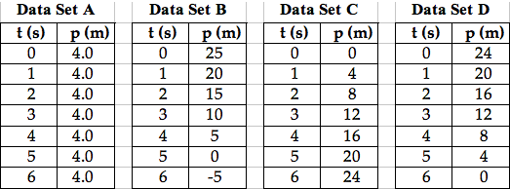

**Question 27:**

aa. The four data sets below represent the position (**p**) and time (**t)** of four different objects. Which data set describes the fastest moving object?

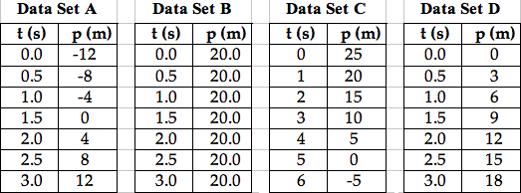

**Question 28:**

aa. The four data sets below represent the position (**p**) and time (**t)** of four different objects. Which data set describes the fastest moving object?

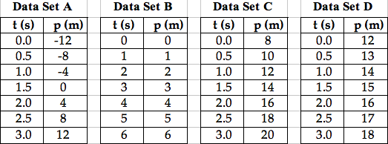

**Question 29:**

aa. The four data sets below represent the position (**p**) and time (**t)** of four different objects. Which data set describes the slowest moving object?



**Question 30:**

aa. The four data sets below represent the position (**p**) and time (**t)** of four different objects. Which data set describes the fastest moving object?

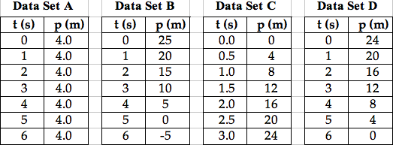

**Question 31:**

aa. The four data sets below represent the position (**p**) and time (**t)** of four different objects. Which data set describes the fastest moving object?

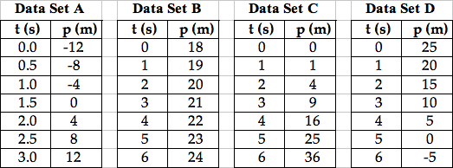

**Category 2: Acceleration**

**Question 32:**

aa. Which one of the following characteristics is true of all accelerating objects?

a. Accelerating objects are moving very fast.

b. Accelerating objects are moving in a straight line.

c. Accelerating objects are moving in a circle.

d. Accelerating objects are changing their velocity.

**Question 33:**

aa. Which of the following objects is accelerating? Bubble in all that apply.

a. A car is skidding to a stop.

b. A ball is following a curved path through the air.

c. A student walks down the hallway at a constant speed.

**Question 34:**

aa. Which of the following objects is accelerating? Bubble in all that apply.

a. A base runner slows to a stop while diving into third base.

b. A ball speeds up while rolling down a hill.

c. A race car moves fast along a straight section of track at constant speed.

**Question 35:**

aa. Objects that are speeding up are said to be _____.

a. accelerating

b. accelerating (but only if moving along a curved path)

c. accelerating (but only if moving along a straight line)

**Question 36:**

aa. Objects that are slowing down are said to be _____.

a. accelerating

b. accelerating (but only if moving along a curved path)

c. accelerating (but only if moving along a straight line)

**Question 37:**

aa. **TRUE** or **FALSE**:

An object that is slowing down does **NOT** have an acceleration.

a. True b. False

**Question 38:**

aa. An object is moving rightward and slowing down. Its acceleration is directed _____.

a. rightward b. leftward

**Question 39:**

aa. An object is moving rightward and speeding up. Its acceleration is directed _____.

a. rightward b. leftward

**Question 40:**

aa. An object is moving leftward and slowing down. Its acceleration is directed _____.

a. rightward b. leftward

**Question 41:**

aa. An object is moving leftward and speeding up. Its acceleration is directed _____.

a. rightward b. leftward

**Question 42:**

aa. An object is moving upward and slowing down. Its acceleration is directed _____.

a. upward b. downward

**Question 43:**

aa. An object is moving upward and speeding up. Its acceleration is directed _____.

a. upward b. downward

**Question 44:**

aa. An object is moving downward and slowing down. Its acceleration is directed _____.

a. upward b. downward

**Question 45:**

aa. An object is moving downward and speeding up. Its acceleration is directed _____.

a. upward b. downward

**Question 46:**

aa. An object is moving rightward and speeding up. Its velocity is directed ______ and its acceleration is directed _____.

a. rightward, leftward b. leftward, rightward

c. rightward, rightward d. leftward, leftward

**Question 47:**

aa. An object is moving rightward and slowing down. Its velocity is directed ______ and its acceleration is directed _____.

a. rightward, leftward b. leftward, rightward

c. rightward, rightward d. leftward, leftward

**Question 48:**

aa. An object is moving leftward and speeding up. Its velocity is directed ______ and its acceleration is directed _____.

a. rightward, leftward b. leftward, rightward

c. rightward, rightward d. leftward, leftward

**Question 49:**

aa. An object is moving leftward and slowing down. Its velocity is directed ______ and its acceleration is directed _____.

a. rightward, leftward b. leftward, rightward

c. rightward, rightward d. leftward, leftward

**Question 50:**

aa. **TRUE** or **FALSE**:

An object can be moving to the right and have an acceleration that is directed to the left.

a. True b. False

**Question 51:**

aa. **TRUE** or **FALSE**:

An object can be moving to the left and have an acceleration that is directed to the right.

a. True b. False

**Question 52:**

aa. **TRUE** or **FALSE**:

An object can be moving upward and have an acceleration that is directed downward.

a. True b. False

**Question 53:**

aa. **TRUE** or **FALSE**:

An object can be moving downward and have an acceleration that is directed upward.

a. True b. False

**Question 54:**

aa. **TRUE** or **FALSE**:

An object that is moving to the right and changing its speed MUST have an acceleration that is directed to the right.

a. True b. False

**Question 55:**

aa. **TRUE** or **FALSE**:

An object that is moving to the left and changing its speed MUST have an acceleration that is directed to the left.

a. True b. False

**Question 56:**

aa. **TRUE** or **FALSE**:

An object that is moving to the left and changing its speed MUST have an acceleration that is directed to the left.

a. True b. False

**Question 57:**

aa. **TRUE** or **FALSE**:

An object that is moving up and changing its speed MUST have an acceleration that is directed upward.

a. True b. False

**Question 58:**

aa. **TRUE** or **FALSE**:

An object that is moving down and changing its speed MUST have an acceleration that is directed downward.

a. True b. False

**Question 59:**

aa. An object has an acceleration that is directed opposite of its motion. What is true of the object?

a. It is moving in a circle. b. It is moving vertically.

c. It is slowing down. d. It is speeding up.

e. It is moving at a constant speed.

**Question 60:**

aa. An object has an acceleration that is directed in the same direction as its motion. What is true of the object?

a. It is moving in a circle. b. It is moving vertically.

c. It is slowing down. d. It is speeding up.

e. It is moving at a constant speed.

**Question 61:**

aa. Which one of the following is true of an object that has an acceleration that is in the same direction as its velocity?

a. The object is moving in a circle. b. The object is moving downward.

c. The object is slowing down. d. The object is speeding up.

**Question 62:**

aa. Which one of the following is true of an object that has an acceleration that is in the opposite direction as its velocity?

a. The object is moving in a circle. b. The object is moving downward.

c. The object is slowing down. d. The object is speeding up.

**Question 63:**

aa. An object is moving east with a constant speed of 30 m/s for 5 seconds. What is the object’s acceleration?

a. 0 m/s/s b. 6 m/s/s

c. 30 m/s/s d. 150 m/s/s

**Question 64:**

aa. An object is moving east with a constant speed of 25 m/s for 5 seconds. What is the object’s acceleration?

a. 0 m/s/s b. 5 m/s/s

c. 25 m/s/s d. 125 m/s/s

**Question 65:**

aa. An object is moving east with a constant speed of 20 m/s for 4 seconds. What is the object’s acceleration?

a. 0 m/s/s b. 5 m/s/s

c. 20 m/s/s d. 80 m/s/s

**Question 66:**

aa. A car that is moving in a straight line has an acceleration of 8.0 m/s/s for 4.0 seconds. Which one of the following is true of this car?

a. The car is moving with a speed of 8.0 m/s for 4.0 seconds.

b. The car is moving with a speed of 32.0 m/s for 4.0 seconds.

c. The car is changing its speed by 8.0 m/s in 4.0 seconds.

d. The car is changing its speed by 32.0 m/s in 4.0 seconds.

**Question 67:**

aa. A car that is moving in a straight line has an acceleration of 10.0 m/s/s for 5.0 seconds. Which one of the following is true of this car?

a. The car is moving with a speed of 10.0 m/s for 5.0 seconds.

b. The car is moving with a speed of 50.0 m/s for 5.0 seconds.

c. The car is changing its speed by 10.0 m/s in 5.0 seconds.

d. The car is changing its speed by 50.0 m/s in 5.0 seconds.

**Question AAA:**

aa. Which one of the following statements is true of an object that has an acceleration of 6 m/s/s?

a. The object changes its velocity by 6 m/s.

b. The object moves with a constant speed of 6 m/s.

c. The object changes its velocity by 6 m/s each second.

d. The object moves a distance of 6 meters each second.

**Question 68:**

aa. Which one of the following statements is true of an object that has an acceleration of 4 m/s/s?

a. The object changes its velocity by 4 m/s.

b. The object moves with a constant speed of 4 m/s.

c. The object changes its velocity by 4 m/s each second.

d. The object moves a distance of 4 meters each second.

**Question 69:**

aa. As Jaclyn drives down the straight road, she notices her speedometer is increasing from 10 mi/hr to 15 mi/hr to 20 mi/hr to 25 mi/hr … each consecutive second. This is evidence that ____.

a. Jaclyn is accelerating.

b. Jaclyn is slowing down.

c. Jaclyn is moving with a constant speed.

d. Jaclyn is late for an important appointment.

**Question 70:**

aa. Which one of the oil drop diagrams describes an object that is moving to the right and speeding up?



**A**

**B**

**C**



**Question 71:**

aa. Which one of the oil drop diagrams describes an object that is moving to the right and slowing down?



**A**

**B**

**C**



**Question 72:**

aa. Which one of the oil drop diagrams describes an object that is moving to the left and speeding up?



**A**

**B**

**C**



**Question 73:**

aa. Which one of the oil drop diagrams describes an object that is moving to the left and slowing down?



**A**

**B**

**C**



**Question 74:**

aa. An old car with a leaky engine leaves the following oil drop trace on the street.



Which statement describes how the car was moving?

a. The car moved at a constant speed; it decelerated; it then remained at rest.

b. The car decelerated from a high speed to a rest position and remained at rest.

c. The car moved at a constant speed; it then was at rest for several seconds.

**Question 75:**

aa. An old car with a leaky engine leaves the following oil drop trace on the street.



Which statement describes how the car was moving?

a. The car moves at a constant speed; it then accelerates for the remaining time.

b. The car moves at a constant speed; it accelerates; it maintains a higher, constant speed.

c. The car remains at rest for several seconds; it then accelerates to a high speed.

**Question 76:**

aa. The following oil drop pattern describes the motion of a car moving to the left.



Which statement best describes the direction of the velocity and of the acceleration of the car?

a. The velocity is rightward (+) and the acceleration is rightward (+).

b. The velocity is rightward (+) and the acceleration is leftward (-).

c. The velocity is leftward (-) and the acceleration is rightward (+).

d. The velocity is leftward (-) and the acceleration is leftward (-).

**Question 77:**

aa. **TRUE** or **FALSE**:

An object that is moving in a circle at a constant speed is accelerating.

a. True b. False

**Question 78:**

aa. **TRUE** or **FALSE**:

An object that is changing its velocity is accelerating.

a. True b. False

**Question 79:**

aa. **TRUE** or **FALSE**:

An object that is changing its speed at a constant rate is accelerating.

a. True b. False

aa. **TRUE** or **FALSE**:

An object that is making a turn is definitely accelerating.

a. True b. False

**Question 80:**

aa. **TRUE** or **FALSE**:

An object that is slowing down is said to have an acceleration.

a. True b. False

**Question 81:**

aa. **TRUE** or **FALSE**:

An object that is speeding up is said to have an acceleration.

a. True b. False

**Question 82:**

aa. **TRUE** or **FALSE**:

A car is moving in such a manner that the speedometer is steadily increasing to higher and higher speeds. This is an example of acceleration.

a. True b. False

**Question 83:**

aa. The four data sets below represent the position (**p**) and time (**t)** of four different objects. Which data set describes an accelerating object?



**Question 84:**

aa. The four data sets below represent the position (**p**) and time (**t)** of four different objects. Which data set describes an accelerating object?

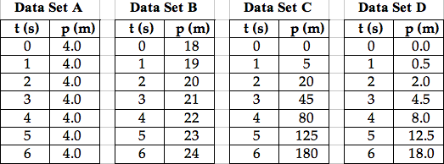

**Question 85:**

aa. The four data sets below represent the position (**p**) and time (**t)** of four different objects. Which data set describes an accelerating object?

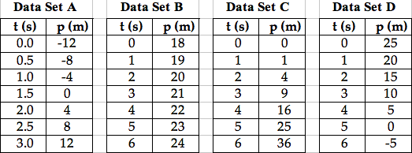

**Question 86:**

aa. The four data sets below represent the position (**p**) and time (**t)** of four different objects. Which data set describes an accelerating object?



**Question 87:**

aa. The four data sets below represent the velocity (**v**) and time (**t)** of four different objects. Which data set describes the object with the greatest acceleration?

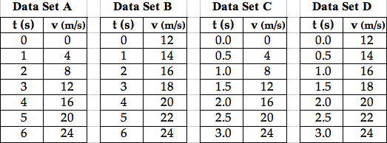

**Question 88:**

aa. The four data sets below represent the velocity (**v**) and time (**t)** of four different objects. Which data set describes the object with the smallest acceleration?



**Question 89:**

aa. The four data sets below represent the velocity (**v**) and time (**t)** of four different objects. Which data set describes the object with the greatest acceleration?

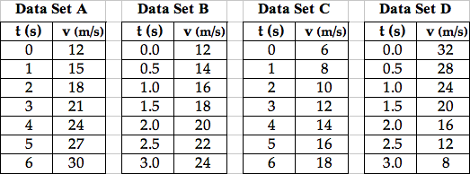

**Question 90:**

aa. The four data sets below represent the velocity (**v**) and time (**t)** of four different objects. Which data set describes the object with the smallest acceleration?



**Question 91:**

aa. The four data sets below represent the velocity (**v**) and time (**t)** of four different objects. Which data set describes the object with the greatest acceleration?

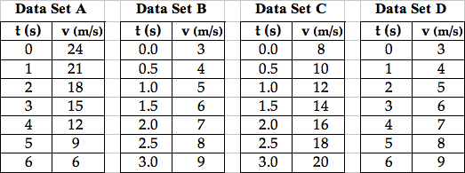

**Question 92:**

aa. The four data sets below represent the velocity (**v**) and time (**t)** of four different objects. Which data set describes the object with the smallest acceleration?



**Question 93:**

aa. The four data sets below represent the velocity (**v**) and time (**t)** of four different objects. Which data set describes the object with the greatest acceleration?



**Question 94:**

aa. The four data sets below represent the velocity (**v**) and time (**t)** of four different objects. Which data set describes the object with the smallest acceleration?



**Question 95:**

aa. The four data sets below represent the velocity (**v**) and time (**t)** of four different objects. Which data set describes the object with the greatest acceleration?

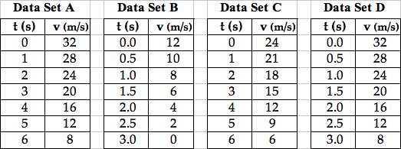

**Question 96:**

aa. The four data sets below represent the velocity (**v**) and time (**t)** of four different objects. Which data set describes the object with the smallest acceleration?



**Category 3: Position-Time Graphs**

**Question 97:**

aa. What does the slope of the line on a position-time plot describe about an object’s motion?

a. It describes the acceleration value.

b. It describes how far the object has moved.

c. It describes how much time that object has been moving.

d. It describes how fast and in what direction the object is moving.

**Question 98:**

aa. How can the velocity of an object be determined from a position-time graph of its motion?

a. The velocity is the change in the vertical coordinates.

b. The velocity is the change in the horizontal coordinates.

c. The velocity is the ratio of the vertical to the horizontal coordinate for any given point.

d. The velocity is the slope of the line on the graph.

**Question 99:**

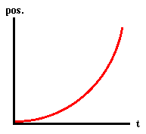aa. Consider the plot shown at the right. Which of the motions is consistent with the graph?

a. The object is moving to the right and speeding up.

b. The object is moving to the left and speeding up.

c. The object is moving to the right and slowing down.

d. The object is moving to the left and slowing down.

**Question 100:**

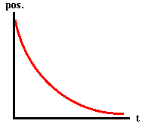aa. Consider the plot shown at the right. Which of the motions is consistent with the graph?

a. The object is moving to the right and speeding up.

b. The object is moving to the left and speeding up.

c. The object is moving to the right and slowing down.

d. The object is moving to the left and slowing down.

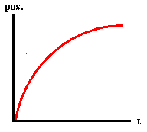**Question 101:**

aa. Consider the plot shown at the right. Which of the motions is consistent with the graph?

a. The object is moving to the right and speeding up.

b. The object is moving to the left and speeding up.

c. The object is moving to the right and slowing down.

d. The object is moving to the left and slowing down.

**Question 102:**

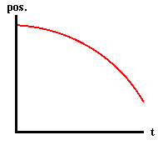aa. Consider the plot shown at the right. Which of the motions is consistent with the graph?

a. The object is moving to the right and speeding up.

b. The object is moving to the left and speeding up.

c. The object is moving to the right and slowing down.

d. The object is moving to the left and slowing down.

**Question 103:**

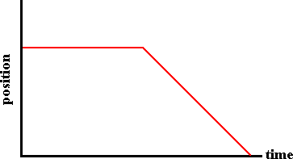aa. Consider the plot shown at the right. Which description below is consistent with the graph?

a. The object moves at a constant speed and then slows down to rest.

b. The object moves horizontally and then falls at a constant speed.

c. The object is at rest and then moves in the negative direction at a constant speed.

**Question 104:**

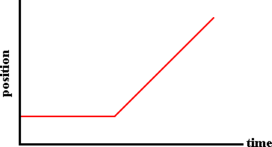aa. Consider the plot shown at the right. Which description below is consistent with the graph?

a. The object moves at a constant speed and then speeds up in the positive direction.

b. The object moves horizontally and then moves up a hill at a constant speed.

c. The object is at rest and then moves in the positive direction at a constant speed.

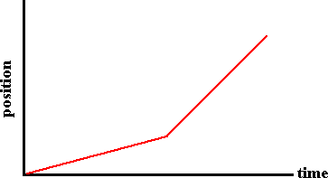

**Question 105:**

aa. Consider the plot shown at the right. Which description below is consistent with the graph?

a. The object moves slowly at a constant speed and then faster at a constant speed.

b. The object accelerates in the positive direction and then accelerates more rapidly.

c. The object moves forward, changes direction and then accelerates more rapidly.

**Question 106:**

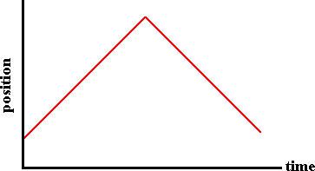aa. Consider the plot shown at the right. Which description below is consistent with the graph?

a. The object accelerates in the positive direction and then in the negative direction.

b. The object moves upwards, reaches its peak and then falls with an acceleration.

c. The object moves in the positive direction and then moves in the negative direction.

**Question 107:**

aa. Which one of the following graphs describes an object that is moving from slow to fast?

**Graph A Graph B Graph C Graph D**

position

time

position

time

position

time

position

time

**Question 108:**

aa. Which one of the following graphs describes an object that is moving from fast to slow?

**Graph A Graph B Graph C Graph D**

position

time

position

time

position

time

position

time

**Question 109:**

aa. Which one of the following graphs describes an object that is moving at a constant speed to the right (+ direction)?

**Graph A Graph B Graph C Graph D**

position

time

position

time

position

time

position

time

**Question 110:**

aa. Which one of the following graphs describes an object that is moving at a constant speed to the left (- direction)?

**Graph A Graph B Graph C Graph D**

position

time

position

time

position

time

position

time

**Question 111:**

Use the position-time data table below on right to answer the next two questions.

aa. Which dot diagram shown below is consistent with this position-time data?

|  |  |  |
| --- | --- | --- |
| **A**  **B**  **C** | Time  (s) | Position (m) |
| 0.0 | 0 |
| 1.0 | 2.0 |
| 2.0 | 8.0 |
| 3.0 | 18.0 |
| 4.0 | 32.0 |
| 5.0 | 50.0 |
| 6.0 | 72.0 |

**Question 112:**

aa. Which position-time graph below is consistent with the data shown at the right?

**Graph A Graph B Graph C Graph D**

position

time

position

time

position

time

position

time

**Category 4: Velocity-Time Graphs**

**Question 113:**

aa. What does the slope of the line on a velocity-time plot describe about an object’s motion?

a. It describes the acceleration value.

b. It describes how far the object has moved.

c. It describes how much time that object has been moving.

d. It describes how fast and in what direction the object is moving.

**Question 114:**

aa. How can the velocity of an object at any given instant in time be determined from a velocity-time graph of its motion?

a. The velocity is the change in the vertical coordinate.

b. The velocity is the slope of the line at that particular time.

c. The velocity is the area between the line and the time axis.

d. The velocity is the vertical coordinate value at that particular time.

**Question 115:**

aa. How can the acceleration of an object at any given instant in time be determined from a velocity-time graph of its motion?

a. The acceleration is the change in the vertical coordinate.

b. The acceleration is the slope of the line at that particular time.

c. The acceleration is the area between the line and the time axis.

d. The acceleration is the vertical coordinate value at that particular time.

**Question 116:**

aa. How can a velocity-time graph be used to determine the acceleration of an object?

a. The acceleration is the slope of the line on the graph.

b. The acceleration is the area between the line on the graph and the time axis.

c. The acceleration is the difference between the highest and lowest vertical coordinate.

**Question 117:**

aa. Consider the graph shown at the right. Which of the motions is consistent with the graph?

velocity

time

**+**

**0**

**-**

a. The object moves with a constant speed in the positive direction.

b. The object moves in the positive direction, accelerating from rest to high speed.

c. The object has a changing acceleration, from a low acceleration to a high acceleration.

**Question 118:**

aa. Consider the graph shown at the right. Which of the motions is consistent with the graph?

velocity

time

**+**

**0**

**-**

a. The object has a constant velocity in the negative direction.

b. The object is moving in the negative direction with a changing speed.

c. The object is moving in the positive direction and slowing down.

**Question 119:**

aa. Consider the graph shown at the right. Which of the motions is consistent with the graph?

velocity

time

**+**

**0**

**-**

a. The object is moving in the negative direction and slowing down.

b. The object has a negative velocity but a positive acceleration.

c. The object is moving in the negative direction, accelerating from rest to a high speed.

**Question 120:**

velocity

time

**+**

**0**

**-**

aa. Consider the graph shown at the right. Which of the motions is consistent with the graph?

a. The object is moving in the positive direction and speeding up.

b. The object is moving in the negative direction and slowing down.

c. The object is moving in the positive direction and slowing down.

d. The object is moving in the negative direction and speeding up.

**Question 121:**

aa. Consider the plot shown at the right. Which of the motions is consistent with the graph?

velocity

time

**+**

**0**

**-**

a. The object is at rest for the entire time.

b. The object is moving in the positive direction with a constant speed and a large acceleration.

c. The object is moving in the positive direction with a constant speed and no acceleration.

**Question 122:**

velocity

time

**+**

**0**

**-**

aa. Consider the plot shown at the right. Which of the motions is consistent with the graph?

a. The object is at rest for the entire time.

b. The object is moving in the negative direction with a constant speed and a large acceleration.

c. The object is moving in the negative direction with a constant speed and no acceleration.

**Question 123:**

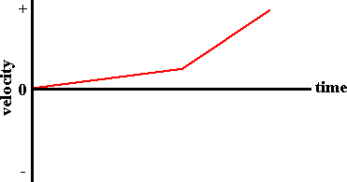aa. Consider the plot shown at the right. Which description below is consistent with the graph?

a. The object moves slowly at a constant speed; it then moves fast at a constant speed.

b. The object moves at a constant speed; it then changes direction and moves faster.

c. The object accelerates at a low rate; it then moves with a higher rate of acceleration.

**Question 124:**

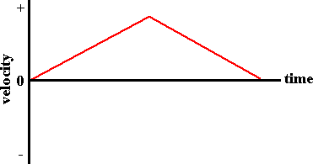aa. Consider the plot shown at the right. Which description below is consistent with the graph?

a. The object moves in the + direction, changes direction and moves in the – direction.

b. The object moves away from its starting position at a constant speed, turns around and returns to the starting position.

c. The object speeds up while moving in the + direction; it then slows down to a stop.

**Question 125:**

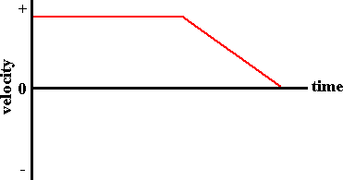aa. Consider the plot shown at the right. Which description below is consistent with the graph?

a. The object is at rest; it then moves in the negative direction at a constant speed.

b. The object moves with a constant speed; it turns and moves in the negative direction with an acceleration.

c. The object moves in the positive direction at a constant speed; it then slows to a stop.

**Question 126:**

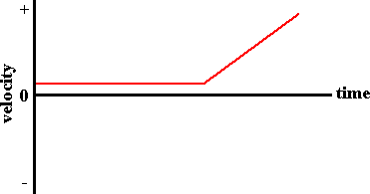aa. Consider the plot shown at the right. Which description below is consistent with the graph?

a. The object is at rest; it then moves in the positive direction at a constant speed.

b. The object is at rest; it then accelerates in the positive direction.

c. The object moves in the positive direction at a constant speed; it then speeds up.

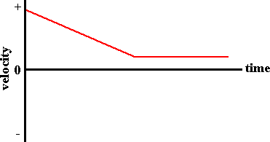

**Question 127:**

aa. Consider the plot shown at the right. Which description below is consistent with the graph?

a. The object moves in the negative direction at a constant speed; it then remains at rest.

b. The object moves in the negative direction with an acceleration; it turns and moves with a constant speed.

c. The object moves in the positive direction and slows down; it then maintains a constant speed.