Light Waves and Color

Questions from a Conceptual Course

Category 1: The Electromagnetic Wave Model

Question 1:

aa. In what manner does the distance from the source of light affect the intensity of light?

a. Light is more intense at locations further from the source.

b. Light is more intense at locations closer to the source.

c. The distance from the source has no affect upon the intensity of light.

Question 2:

aa. Which one of the following regions of the electromagnetic spectrum is NOT an ionizing form of radiation?

a. Gamma rays b. Microwave

c. Ultraviolet waves d. X-Rays

Question 3:

aa. Which one of the following regions of the electromagnetic spectrum is NOT an ionizing form of radiation?

a. Infrared waves b. Microwave

c. Radio waves d. Ultraviolet waves

Question 4:

aa. Which one of the following regions of the electromagnetic spectrum is NOT capable of causing damage to the human body?

a. Gamma rays b. Infrared

c. Ultraviolet waves d. X-Rays

Question 5:

aa. Which one of the following regions of the electromagnetic spectrum is capable of causing damage to the human body?

a. Infrared waves b. Visible light waves

c. Radio waves d. Ultraviolet waves

Question 6:

aa. Which one of the following regions of the electromagnetic spectrum consists of waves with the longest wavelength?

a. Infrared b. Radio waves

c. Ultraviolet d. Visible light

Question 7:

aa. Which one of the following regions of the electromagnetic spectrum consists of waves with the shortest wavelength?

a. Infrared b. Radio waves

c. Ultraviolet d. Visible light

Question 8:

aa. Which one of the following regions of the electromagnetic spectrum consists of waves with the highest frequency?

a. Infrared b. Radio waves

c. Ultraviolet d. Visible light

Question 9:

aa. Which one of the following regions of the electromagnetic spectrum consists of waves with the lowest frequency?

a. Infrared b. Radio waves

c. Ultraviolet d. Visible light

Question 10:

aa. Which is the proper ordering of the infrared, microwave, ultraviolet and visible regions of the electromagnetic spectrums, from shortest to longest wavelength?

a. microwave, infrared, visible, ultraviolet

b. infrared, visible, ultraviolet, microwave

c. ultraviolet, microwave, visible, infrared

d. infrared, ultraviolet, microwave, visible

e. ultraviolet, visible, infrared, microwave

Question 11:

aa. Which is the proper ordering of the infrared, microwave, ultraviolet and visible regions of the electromagnetic spectrums, from longest to shortest wavelength?

a. microwave, infrared, visible, ultraviolet

b. infrared, visible, ultraviolet, microwave

c. ultraviolet, microwave, visible, infrared

d. infrared, ultraviolet, microwave, visible

e. ultraviolet, visible, infrared, microwave

Question 12:

aa. Which is the proper ordering of the infrared, microwave, ultraviolet and visible regions of the electromagnetic spectrums, from lowest frequency to highest frequency?

a. microwave, infrared, visible, ultraviolet

b. infrared, visible, ultraviolet, microwave

c. ultraviolet, microwave, visible, infrared

d. infrared, ultraviolet, microwave, visible

e. ultraviolet, visible, infrared, microwave

Question 13:

aa. Which is the proper ordering of the infrared, microwave, ultraviolet and visible regions of the electromagnetic spectrums, from highest frequency to lowest frequency?

a. microwave, infrared, visible, ultraviolet

b. infrared, visible, ultraviolet, microwave

c. ultraviolet, microwave, visible, infrared

d. infrared, ultraviolet, microwave, visible

e. ultraviolet, visible, infrared, microwave

Question 14:

aa. Which one of the following traits or behaviors is an indicator that light is a wave?

a. Light occupies space. b. Light travels at enormous speeds.

d. Light particles possess mass. d. Light is observed to undergo interference.

Question 15:

aa. Which one of the following traits or behaviors is an indicator that light is a wave?

a. Light occupies space. b. Light waves can be polarized.

d. Light particles possess mass. d. Light travels at enormous speeds.

Question 16:

aa. The passage of light into, through, and out of a material is known as _____.

a. Absorption b. Reflection

c. Polarization d. Transmission

Question 17:

aa. The transformation of light from a state of vibrating in variety of directions to a state of vibrating in a single direction is known as _____.

a. Absorption b. Monochromission

c. Polarization d. Refraction

Question 18:

aa. Red laser light is directed towards two small slits in a slide. The light passes through the slits and forms a pattern of bright red dots separated by dark areas. What wave behavior causes this pattern?

a. Absorption b. Interference

c. Reflection d. Refraction

Question 19:

aa. Sunlight hits the black asphalt pavement on a sunny, summer day. The pavement becomes excessively hot. What wave behavior is demonstrated by this phenomenon?

a. Absorption b. Photoelectric effect

c. Reflection d. Refraction

Question 20:

aa. Light from a flashlight is shone upon a Polaroid™ filter. A portion of the light passes through the filter. What happens to the portion of light that does NOT pass through the filter?

a. It is absorbed by the filter. b. It is reflected by the filter.

c. It diffracts around the filter. d. It becomes twisted in a different direction.

Question 21:

aa. Light from a flashlight is shone upon a Polaroid™ filter. The light passes through the filter and is said to be polarized. The light that passes through is sometimes said to have been _____.

a. absorbed b. interfered

c. reflected d. transmitted

Question 22:

aa. Sunlight shines on a sheet of paper. The red light bounces off the paper and travels to our eye. This light is said to have been _____ by the paper.

a. absorbed b. polarized

c. reflected d. transmitted

Question 23:

aa. Light that is vibrating in a single direction – for instance, up and down – is said to be _____.

a. electromagnetic b. ionizing

c. polarized light d. non-polarized light

Question 24:

aa. Light that is vibrating in many different directions is said to be _____.

a. electromagnetic b. ionizing

c. polarized light d. non-polarized light

Question 25:

aa. What two changes occur to light that has passed through a Polaroid™ filter? Select two answers.

a. It is vibrating in a single direction.

b. It is vibrating in many different directions.

c. It has a different wavelength and frequency.

d. It has one-half the intensity of the original light.

Question 26:

aa. Which one of the following statements describes the process of polarization using a Polaroid™ filter?

a. One-half of the light is absorbed by the filter; the transmitted light is vibrating in a single direction.

b. Light with just the right wavelength is passed through while the rest of the light is absorbed by the filter.

c. One-half of the light has its vibrations re-oriented so that all the original light is vibrating in a single direction.

Question 27:

aa. TRUE or FALSE:

When light passes through a Polaroid™ filter, half of its vibrations are reoriented so that all the light that entered it is now vibrating in a single direction.

a. True b. False

Question 28:

aa. A physics teacher shines light upon a pair of Polaroid™ filters. The polarization axes of the filters are aligned in the same direction. What will be the result?

a. The first filter absorbs one-half the light; the second filter polarizes the light.

b. The first filter polarizes the light; the second filter absorbs the remaining light.

c. The first filter absorbs one-half the light; the second filter absorbs the rest of the light.

d. The first filter absorbs one-half the light and polarizes it; the second filter has no effect on the light.

Question 29:

aa. A physics teacher shines light upon a pair of Polaroid™ filters. The polarization axes of the filters are aligned in the same direction. What will be the effect of the first filter?

a. The first filter absorbs all the light.

b. The first filter absorbs one-half the light and polarizes it.

c. The first filter absorbs one-half the light, but does not polarize it.

d. The first filter polarizes the light but lets all of it through.

Question 30:

aa. A physics teacher shines light upon a pair of Polaroid™ filters. The polarization axes of the filters are aligned at a 90-degree angle to one another. What will be the result?

a. The first filter absorbs one-half the light; the second filter polarizes the light.

b. The first filter polarizes the light; the second filter absorbs the light.

c. The first filter absorbs one-half the light; the second filter absorbs the rest of the light.

d. The first filter absorbs one-half the light and polarizes it; the second filter has no effect on the light.

Question 31:

aa. A physics teacher shines light upon a pair of Polaroid™ filters. The polarization axes of the filters are aligned at a 90-degree angle to one another. What will be the result?

a. All the light will be absorbed; no light will pass through.

b. All of the light will pass through; but it will be polarized.

c. One-half of the light will pass through and one-half will be absorbed.

d. One-half of the light will pass through and one-half will be reflected.

Question 32:

aa. A physics teacher shines light upon a pair of Polaroid™ filters. The polarization axes of the filters are aligned in the same direction. What will be the result?

a. All the light will be absorbed; no light will pass through.

b. All of the light will pass through; but it will be polarized.

c. One-half of the light will pass through and one-half will be absorbed.

d. One-half of the light will pass through and one-half will be reflected.

Question 33:

aa. Which color of the visible light spectrum has the longest wavelength?

a. blue b. green

c. red d. violet

Question 34:

aa. Which color of the visible light spectrum has the shortest wavelength?

a. blue b. green

c. red d. violet

Question 35:

aa. Which color of the visible light spectrum has the lowest frequency?

a. blue b. green

c. red d. violet

Question 36:

aa. Which color of the visible light spectrum has the highest frequency?

a. blue b. green

c. red d. violet

Category 2: Perception of Color

Question 37:

aa. Which one of the following statements best describes how the eye is able to perceive the blue numbers on a Titan football jersey?

a. Wavelengths of blue light shine on the shirt; these wavelengths are absorbed by the shirt and send signals to our brain.

b. Blue is produced by the numbers on the shirt and directed to our eye; our brain translates this information to detect color.

c. White light strikes the numbers, causing them to create blue light. Once this light hits our eye, blue wavelengths are sent to our brain.

d. The invisible colors of white light shine on the shirt; all colors are absorbed except for blue; blue is reflected to our eyes; our brain interprets this information.

Question 38:

aa. What are the three primary colors of light?

a. Black, white and grey. b. Red, blue and yellow.

c. Red, green and blue. d. Cyan, magenta, and yellow.

Question 39:

aa. Which three colors of light will produce white light when mixed in equal intensity?

a. Black, grey and brown. b. Red, blue and yellow.

c. Red, green and blue. d. Red, green and yellow.

Question 40:

aa. Which two colors of light will produce cyan light when mixed with equal intensity?

a. Red and blue.

b. Red and green.

c. Blue and green

Question 41:

aa. Which two colors of light will produce magenta light when mixed with equal intensity?

a. Red and blue.

b. Red and green.

c. Blue and green

Question 42:

aa. Which two colors of light will produce yellow light when mixed with equal intensity?

a. Red and blue.

b. Red and green.

c. Blue and green

Question 43:

aa. What light color is the complementary color of blue light?

a. red b. cyan

c. green d. yellow

e. magenta

Question 44:

aa. What light color is the complementary color of yellow light?

a. red b. cyan

c. green d. blue

e. magenta

Question 45:

aa. What light color is the complementary color of cyan light?

a. red b. blue

c. green d. yellow

e. magenta

Question 46:

aa. What light color is the complementary color of red light?

a. green b. blue

c. cyan d. yellow

e. magenta

Question 47:

aa. What light color is the complementary color of green light?

a. red b. blue

c. cyan d. yellow

e. magenta

Question 48:

aa. What light color is the complementary color of magenta light?

a. red b. blue

c. cyan d. yellow

e. green

Question 49:

aa. The lighting crew for the Spring play is attempting to control the red, green and blue spotlights in order to light a particular area of the stage so that it is illuminated with yellow light. Which lights should be shining on that part of the stage?

a. Only the red light. b. Only the blue light.

c. Only the green light. d. Both the red and blue lights.

e. Both the red and green lights. ab. Both the blue and green lights.

Question 50:

aa. The lighting crew for the Spring play is attempting to control the red, green and blue spotlights in order to light a particular area of the stage so that it is illuminated with cyan light. Which lights should be shining on that part of the stage?

a. Only the red light. b. Only the blue light.

c. Only the green light. d. Both the red and blue lights.

e. Both the red and green lights. ab. Both the blue and green lights.

Question 51:

aa. The lighting crew for the Spring play is attempting to control the red, green and blue spotlights in order to light a particular area of the stage so that it is illuminated with magenta light. Which lights should be shining on that part of the stage?

a. Only the red light. b. Only the blue light.

c. Only the green light. d. Both the red and blue lights.

e. Both the red and green lights. ab. Both the blue and green lights.

Question 52:

aa. What is the color appearance of a white sheet of paper when it is illuminated with red and green spotlights of equal intensity?

a. It appears blue. b. It appears white.

c. It appears cyan. d. It appears magenta.

e. It appears yellow. ab. It appears black.

Question 53:

aa. What is the color appearance of a white sheet of paper when it is illuminated with red and blue spotlights of equal intensity?

a. It appears green. b. It appears white.

c. It appears cyan. d. It appears magenta.

e. It appears yellow. ab. It appears black.

Question 54:

aa. What is the color appearance of a white sheet of paper when it is illuminated with blue and green spotlights of equal intensity?

a. It appears green. b. It appears white.

c. It appears cyan. d. It appears magenta.

e. It appears yellow. ab. It appears black.

Question 55:

aa. What is the color appearance of a white sheet of paper when it is illuminated with red and cyan spotlights of equal intensity?

a. It appears black. b. It appears blue.

c. It appears cyan. d. It appears green.

e. It appears magenta. ab. It appears red.

ac. It appears white. ad. It appears yellow.

Question 56:

aa. What is the color appearance of a white sheet of paper when it is illuminated with blue and yellow spotlights of equal intensity?

a. It appears black. b. It appears blue.

c. It appears cyan. d. It appears green.

e. It appears magenta. ab. It appears red.

ac. It appears white. ad. It appears yellow.

Question 57:

aa. What is the color appearance of a white sheet of paper when it is illuminated with green and magenta spotlights of equal intensity?

a. It appears black. b. It appears blue.

c. It appears cyan. d. It appears green.

e. It appears magenta. ab. It appears red.

ac. It appears white. ad. It appears yellow.

Question 58:

aa. What are the three primary pigment (paint) colors?

a. Red, green and blue. b. Red, blue and yellow.

c. Red, green and yellow. d. Cyan, magenta and yellow.

Question 59:

aa. What is a primary pigment (paint) color?

b. It is one of the three most popular pigments.

a. It is a pigment that is very abundant in an artist's lab.

c. It is a pigment that can absorb a single primary color of light.

d. It is a pigment that when added to other pigments produces white light.

Question 60:

aa. What primary color(s) of light can be absorbed by cyan pigment (paint)?

a. red b. blue

c. green d. red and blue

e. red and green ab. blue and green

ac. red, green and blue - depending on the situation.

Question 61:

aa. What primary color(s) of light can be absorbed by magenta pigment (paint)?

a. red b. blue

c. green d. red and blue

e. red and green ab. blue and green

ac. red, green and blue - depending on the situation.

Question 62:

aa. What primary color(s) of light can be absorbed by yellow pigment (paint)?

a. red b. blue

c. green d. red and blue

e. red and green ab. blue and green

ac. red, green and blue - depending on the situation.

Question 63:

aa. What primary color(s) of light can be reflected by cyan pigment (paint)?

a. red b. blue

c. green d. red and blue

e. red and green ab. blue and green

ac. red, green and blue - depending on the situation.

Question 64:

aa. What primary color(s) of light can be reflected by magenta pigment (paint)?

a. red b. blue

c. green d. red and blue

e. red and green ab. blue and green

ac. red, green and blue - depending on the situation.

Question 65:

aa. What primary color(s) of light can be reflected by yellow pigment (paint)?

a. red b. blue

c. green d. red and blue

e. red and green ab. blue and green

ac. red, green and blue - depending on the situation.

Question 66:

aa. How does the pigment in a sheet of paper affect the color appearance of the sheet of paper?

a. The pigments adds a specific color (or two or three) to the reflected light.

b. The pigment changes the color(s) that approach into other colors that reflect off it.

c. The pigment affects what color(s) of light shine upon it and what colors reflect off it.

d. The pigment absorbs a specific color (or two or three) from the light that shines on it.

Question 67:

aa. Red, green and blue spotlights shine on a red sheet of paper. Which of these three light colors will be reflected off the sheet of paper?

a. Only the red. b. Only the blue.

c. Only the green. d. Both the red and the blue.

e. Both the red and the green. ab. Both the blue and the green.

Question 68:

aa. Red, green and blue spotlights shine on a red sheet of paper. Which of these three light colors will be reflected off the sheet of paper?

a. Only the red. b. Only the blue.

c. Only the green. d. Both the red and the blue.

e. Both the red and the green. ab. Both the blue and the green.

Question 69:

aa. Red, green and blue spotlights shine on a red sheet of paper. Which of these three light colors will be reflected off the sheet of paper?

a. Only the red. b. Only the blue.

c. Only the green. d. Both the red and the blue.

e. Both the red and the green. ab. Both the blue and the green.

Question 70:

aa. Red, green and blue spotlights shine on a red sheet of paper. Which of these three light colors will be reflected off the sheet of paper?

a. Only the red. b. Only the blue.

c. Only the green. d. Both the red and the blue.

e. Both the red and the green. ab. Both the blue and the green.

Question 71:

aa. Red, green and blue spotlights shine on a red sheet of paper. Which of these three light colors will be reflected off the sheet of paper?

a. Only the red. b. Only the blue.

c. Only the green. d. Both the red and the blue.

e. Both the red and the green. ab. Both the blue and the green.

Question 72:

aa. Red, green and blue spotlights shine on a red sheet of paper. Which of these three light colors will be reflected off the sheet of paper?

a. Only the red. b. Only the blue.

c. Only the green. d. Both the red and the blue.

e. Both the red and the green. ab. Both the blue and the green.

Question 73:

aa. Red, green and blue spotlights shine on a red sheet of paper. Which of these three light colors will be absorbed by the sheet of paper?

a. Only the red. b. Only the blue.

c. Only the green. d. Both the red and the blue.

e. Both the red and the green. ab. Both the blue and the green.

Question 74:

aa. Red, green and blue spotlights shine on a red sheet of paper. Which of these three light colors will be absorbed by the sheet of paper?

a. Only the red. b. Only the blue.

c. Only the green. d. Both the red and the blue.

e. Both the red and the green. ab. Both the blue and the green.

Question 75:

aa. Red, green and blue spotlights shine on a red sheet of paper. Which of these three light colors will be absorbed by the sheet of paper?

a. Only the red. b. Only the blue.

c. Only the green. d. Both the red and the blue.

e. Both the red and the green. ab. Both the blue and the green.

Question 76:

aa. Red, green and blue spotlights shine on a red sheet of paper. Which of these three light colors will be absorbed by the sheet of paper?

a. Only the red. b. Only the blue.

c. Only the green. d. Both the red and the blue.

e. Both the red and the green. ab. Both the blue and the green.

Question 77:

aa. Red, green and blue spotlights shine on a red sheet of paper. Which of these three light colors will be absorbed by the sheet of paper?

a. Only the red. b. Only the blue.

c. Only the green. d. Both the red and the blue.

e. Both the red and the green. ab. Both the blue and the green.

Question 78:

aa. Red, green and blue spotlights shine on a red sheet of paper. Which of these three light colors will be absorbed by the sheet of paper?

a. Only the red. b. Only the blue.

c. Only the green. d. Both the red and the blue.

e. Both the red and the green. ab. Both the blue and the green.

Question 79:

aa. Light from red, green and blue spotlights shine on a sheet of paper. The paper contains cyan pigment. Which of the three primary light colors will be absorbed by the pigment?

a. red b. green

c. blue d. red and green

e. red and blue e. green and blue

Question 80:

aa. Light from red, green and blue spotlights shine on a sheet of paper. The paper contains yellow pigment. Which of the three primary light colors will be absorbed by the pigment?

a. red b. green

c. blue d. red and green

e. red and blue e. green and blue

Question 81:

aa. Light from red, green and blue spotlights shine on a sheet of paper. The paper contains magenta pigment. Which of the three primary light colors will be absorbed by the pigment?

a. red b. green

c. blue d. red and green

e. red and blue e. green and blue

Question 82:

aa. Light from red, green and blue spotlights shine on a sheet of paper. The paper contains cyan and magenta pigments. Which of the three primary light colors will be absorbed by the pigments?

a. red b. green

c. blue d. red and green

e. red and blue e. green and blue

Question 83:

aa. Light from red, green and blue spotlights shine on a sheet of paper. The paper contains cyan and yellow pigments. Which of the three primary light colors will be absorbed by the pigments?

a. red b. green

c. blue d. red and green

e. red and blue e. green and blue

Question 84:

aa. Light from red, green and blue spotlights shine on a sheet of paper. The paper contains yellow and magenta pigments. Which of the three primary light colors will be absorbed by the pigments?

a. red b. green

c. blue d. red and green

e. red and blue e. green and blue

Question 85:

aa. Light from red, green and blue spotlights shine on a sheet of paper. The paper contains cyan and magenta pigments. Which of the three primary light colors will be reflected by the pigments?

a. red b. green

c. blue d. red and green

e. red and blue e. green and blue

Question 86:

aa. Light from red, green and blue spotlights shine on a sheet of paper. The paper contains cyan and yellow pigments. Which of the three primary light colors will be reflected by the pigments?

a. red b. green

c. blue d. red and green

e. red and blue e. green and blue

Question 87:

aa. Light from red, green and blue spotlights shine on a sheet of paper. The paper contains yellow and magenta pigments. Which of the three primary light colors will be reflected by the pigments?

a. red b. green

c. blue d. red and green

e. red and blue e. green and blue

Question 88:

aa. Light from red, green and blue spotlights shine on a sheet of paper. The paper contains cyan and magenta pigments. What color will the paper appear?

a. It will appear black. b. It will appear blue.

c. It will appear cyan. d. It will appear green.

e. It will appear magenta. ab. It will appear red.

ac. It will appear white. ad. It will appear yellow.

Question 89:

aa. Light from red, green and blue spotlights shine on a sheet of paper. The paper contains cyan and yellow pigments. What color will the paper appear?

a. It will appear black. b. It will appear blue.

c. It will appear cyan. d. It will appear green.

e. It will appear magenta. ab. It will appear red.

ac. It will appear white. ad. It will appear yellow.

Question 90:

aa. Light from red, green and blue spotlights shine on a sheet of paper. The paper contains yellow and magenta pigments. What color will the paper appear?

a. It will appear black. b. It will appear blue.

c. It will appear cyan. d. It will appear green.

e. It will appear magenta. ab. It will appear red.

ac. It will appear white. ad. It will appear yellow.

Question 91:

aa. Consider the diagram at the right with red, green and blue light shining on a cyan sheet of paper. Which of the light colors will be absorbed by the paper?

**R G B**

**“Cyan Paper”**

a. Red b. Green

c. Blue d. Red and green

e. Red and Blue ab. Green and blue

R G B

“Yellow Paper”

Question 92:

**R G B**

**“Magenta Paper”**

aa. Consider the diagram at the right with red, green and blue light shining on a magenta sheet of paper. Which of the light colors will be absorbed by the paper?

a. Red b. Green

c. Blue d. Red and green

e. Red and Blue ab. Green and blue

Question 93:

aa. Consider the diagram at the right with red, green and blue light shining on a yellow sheet of paper. Which of the light colors will be absorbed by the paper?

R G B

Yellow Paper

a. Red b. Green

c. Blue d. Red and green

e. Red and Blue ab. Green and blue

Question 94:

aa. Consider the diagram at the right with red, green and blue light shining on a cyan sheet of paper. Which of the light colors will be reflected by the paper?

???

R G B

Cyan Paper

a. Red b. Green

c. Blue d. Red and green

e. Red and Blue ab. Green and blue

Question 95:

???

R G B

Magenta Paper

aa. Consider the diagram at the right with red, green and blue light shining on a magenta sheet of paper. Which of the light colors will be reflected by the paper?

a. Red b. Green

c. Blue d. Red and green

e. Red and Blue ab. Green and blue

Question 96:

aa. Consider the diagram at the right with red, green and blue light shining on a yellow sheet of paper. Which of the light colors will be reflected by the paper?

???

R G B

Yellow Paper

a. Red b. Green

c. Blue d. Red and green

e. Red and Blue ab. Green and blue

Question 97:

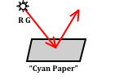aa. Consider the diagram at the right with red and green light shining on a cyan sheet of paper. Which of the light colors will be absorbed by the paper?

a. Red b. Green

c. Red and green d. Neither red nor green

Question 98:

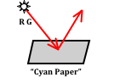aa. Consider the diagram at the right with red and green light shining on a cyan sheet of paper. Which of the light colors will be reflected by the paper?

a. Red b. Green

c. Red and green d. Neither red nor green

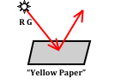Question 99:

aa. Consider the diagram at the right with red and green light shining on a yellow sheet of paper. Which of the light colors will be absorbed by the paper?

a. Red b. Green

c. Red and green d. Neither red nor green

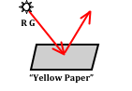Question 100:

aa. Consider the diagram at the right with red and green light shining on a yellow sheet of paper. Which of the light colors will be reflected by the paper?

a. Red b. Green

c. Red and green d. Neither red nor green

Question 101:

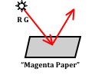aa. Consider the diagram at the right with red and green light shining on a magenta sheet of paper. Which of the light colors will be absorbed by the paper?

a. Red b. Green

c. Red and green d. Neither red nor green

Question 102:

aa. Consider the diagram at the right with red and green light shining on a magenta sheet of paper. Which of the light colors will be reflected by the paper?

a. Red b. Green

c. Red and green d. Neither red nor green

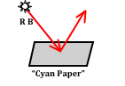Question 103:

aa. Consider the diagram at the right with red and blue light shining on a cyan sheet of paper. Which of the light colors will be absorbed by the paper?

a. Red b. Blue

c. Red and blue d. Neither red nor blue

Question 104:

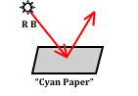aa. Consider the diagram at the right with red and blue light shining on a cyan sheet of paper. Which of the light colors will be reflected by the paper?

a. Red b. Blue

c. Red and blue d. Neither red nor blue

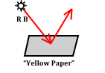Question 105:

aa. Consider the diagram at the right with red and blue light shining on a yellow sheet of paper. Which of the light colors will be absorbed by the paper?

a. Red b. Blue

c. Red and blue d. Neither red nor blue

Question 106:

aa. Consider the diagram at the right with red and blue light shining on a yellow sheet of paper. Which of the light colors will be reflected by the paper?

a. Red b. Blue

c. Red and blue d. Neither red nor blue

Question 107:

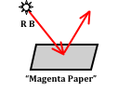aa. Consider the diagram at the right with red and blue light shining on a magenta sheet of paper. Which of the light colors will be absorbed by the paper?

a. Red b. Blue

c. Red and blue d. Neither red nor blue

Question 108:

aa. Consider the diagram at the right with red and blue light shining on a magenta sheet of paper. Which of the light colors will be reflected by the paper?

a. Red b. Blue

c. Red and blue d. Neither red nor blue

Question 109:

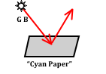aa. Consider the diagram at the right with green and blue light shining on a cyan sheet of paper. Which of the light colors will be absorbed by the paper?

a. Green b. Blue

c. Green and blue d. Neither green nor blue

Question 110:

aa. Consider the diagram at the right with red and blue light shining on a cyan sheet of paper. Which of the light colors will be reflected by the paper?

a. Green b. Blue

c. Green and blue d. Neither red nor blue

Question 111:

aa. Consider the diagram at the right with green and blue light shining on a yellow sheet of paper. Which of the light colors will be absorbed by the paper?

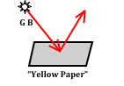 a. Green b. Blue

c. Green and blue d. Neither green nor blue

Question 112:

aa. Consider the diagram at the right with green and blue light shining on a yellow sheet of paper. Which of the light colors will be reflected by the paper?

a. Green b. Blue

c. Green and blue d. Neither green nor blue

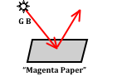Question 113:

aa. Consider the diagram at the right with green and blue light shining on a magenta sheet of paper. Which of the light colors will be absorbed by the paper?

a. Green b. Blue

c. Green and blue d. Neither green nor blue

Question 114:

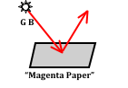aa. Consider the diagram at the right with green and blue light shining on a magenta sheet of paper. Which of the light colors will be reflected by the paper?

a. Green b. Blue

c. Green and blue d. Neither green nor blue

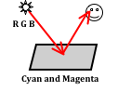Question 115:

aa. Consider the diagram at the right with red, green and blue light shining on a sheet of paper. The paper contains two pigments – cyan and magenta pigments. What color will the paper appear?

a. Black b. Blue

c. Cyan d. Gree

e. Magenta ab. Red

ac. White ad. Yellow

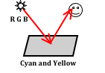Question 116:

aa. Consider the diagram at the right with red, green and blue light shining on a sheet of paper. The paper contains two pigments – cyan and yellow pigments. What color will the paper appear?

a. Black b. Blue

c. Cyan d. Green

e. Magenta ab. Red

ac. White ad. Yellow

Question 117:

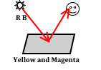aa. Consider the diagram at the right with red and blue light shining on a sheet of paper. The paper contains two pigments – yellow and magenta pigments. What color will the paper appear?

a. Black b. Blue

c. Cyan d. Green

e. Magenta ab. Red

ac. White ad. Yellow

Question 118:

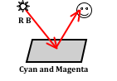aa. Consider the diagram at the right with red and blue light shining on a sheet of paper. The paper contains two pigments – cyan and magenta pigments. What color will the paper appear?

a. Black b. Blue

c. Cyan d. Green

e. Magenta ab. Red

ac. White ad. Yellow

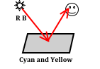Question 119:

aa. Consider the diagram at the right with red and blue light shining on a sheet of paper. The paper contains two pigments – cyan and yellow pigments. What color will the paper appear?

a. Black b. Blue

c. Cyan d. Green

e. Magenta ab. Red

ac. White ad. Yellow

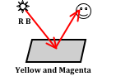Question 120:

aa. Consider the diagram at the right with red and blue light shining on a sheet of paper. The paper contains two pigments – yellow and magenta pigments. What color will the paper appear?

a. Black b. Blue

c. Cyan d. Green

e. Magenta ab. Red

ac. White ad. Yellow

Question 121:

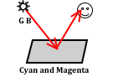aa. Consider the diagram at the right with green and blue light shining on a sheet of paper. The paper contains two pigments – cyan and magenta pigments. What color will the paper appear?

a. Black b. Blue

c. Cyan d. Green

e. Magenta ab. Red

ac. White ad. Yellow

Question 122:

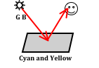aa. Consider the diagram at the right with green and blue light shining on a sheet of paper. The paper contains two pigments – cyan and yellow pigments. What color will the paper appear?

a. Black b. Blue

c. Cyan d. Green

e. Magenta ab. Red

ac. White ad. Yellow

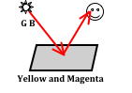Question 123:

aa. Consider the diagram at the right with green and blue light shining on a sheet of paper. The paper contains two pigments – yellow and magenta pigments. What color will the paper appear?

a. Black b. Blue

c. Cyan d. Green

e. Magenta ab. Red

ac. White ad. Yellow

Question 124:

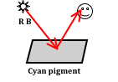aa. Consider the diagram at the right with red and blue light shining on a sheet of paper. The paper contains cyan pigment. What color will the paper appear?

a. Black b. Blue

c. Cyan d. Green

e. Magenta ab. Red

ac. White ad. Yellow

Question 125:

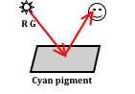aa. Consider the diagram at the right with red and green light shining on a sheet of paper. The paper contains cyan pigment. What color will the paper appear?

a. Black b. Blue

c. Cyan d. Green

e. Magenta ab. Red

ac. White ad. Yellow

Question 126:

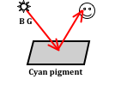aa. Consider the diagram at the right with blue and green light shining on a sheet of paper. The paper contains cyan pigment. What color will the paper appear?

a. Black b. Blue

c. Cyan d. Green

e. Magenta ab. Red

ac. White ad. Yellow

Question 127:

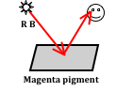aa. Consider the diagram at the right with red and blue light shining on a sheet of paper. The paper contains magenta pigment. What color will the paper appear?

a. Black b. Blue

c. Cyan d. Green

e. Magenta ab. Red

ac. White ad. Yellow

Question 128:

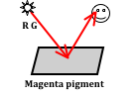aa. Consider the diagram at the right with red and green light shining on a sheet of paper. The paper contains magenta pigment. What color will the paper appear?

a. Black b. Blue

c. Cyan d. Green

e. Magenta ab. Red

ac. White ad. Yellow

Question 129:

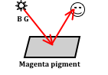aa. Consider the diagram at the right with blue and green light shining on a sheet of paper. The paper contains magenta pigment. What color will the paper appear?

a. Black b. Blue

c. Cyan d. Green

e. Magenta ab. Red

ac. White ad. Yellow

Question 130:

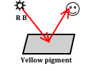aa. Consider the diagram at the right with red and blue light shining on a sheet of paper. The paper contains yellow pigment. What color will the paper appear?

a. Black b. Blue

c. Cyan d. Green

e. Magenta ab. Red

ac. White ad. Yellow

Question 131:

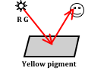aa. Consider the diagram at the right with red and green light shining on a sheet of paper. The paper contains yellow pigment. What color will the paper appear?

a. Black b. Blue

c. Cyan d. Green

e. Magenta ab. Red

ac. White ad. Yellow

Question 132:

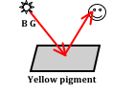aa. Consider the diagram at the right with blue and green light shining on a sheet of paper. The paper contains yellow pigment. What color will the paper appear?

a. Black b. Blue

c. Cyan d. Green

e. Magenta ab. Red

ac. White ad. Yellow

Question 133:

aa. What primary color(s) of light does a red filter absorb?

a. Red b. Green

c. Blue d. Red and Blue

e. Red and Green ab. Blue and Green

Question 134:

aa. What primary color(s) of light does a red filter transmit?

a. Red b. Green

c. Blue d. Red and Blue

e. Red and Green ab. Blue and Green

Question 135:

aa. What primary color(s) of light does a green filter absorb?

a. Red b. Green

c. Blue d. Red and Blue

e. Red and Green ab. Blue and Green

Question 136:

aa. What primary color(s) of light does a green filter transmit?

a. Red b. Green

c. Blue d. Red and Blue

e. Red and Green ab. Blue and Green

Question 137:

aa. What primary color(s) of light does a blue filter absorb?

a. Red b. Green

c. Blue d. Red and Blue

e. Red and Green ab. Blue and Green

Question 138:

aa. What primary color(s) of light does a blue filter transmit?

a. Red b. Green

c. Blue d. Red and Blue

e. Red and Green ab. Blue and Green

Question 139:

aa. What primary color(s) of light does a cyan filter absorb?

a. Red b. Green

c. Blue d. Red and Blue

e. Red and Green ab. Blue and Green

Question 140:

aa. What primary color(s) of light does a cyan filter transmit?

a. Red b. Green

c. Blue d. Red and Blue

e. Red and Green ab. Blue and Green

Question 141:

aa. What primary color(s) of light does a magenta filter absorb?

a. Red b. Green

c. Blue d. Red and Blue

e. Red and Green ab. Blue and Green

Question 142:

aa. What primary color(s) of light does a magenta filter transmit?

a. Red b. Green

c. Blue d. Red and Blue

e. Red and Green ab. Blue and Green

Question 143:

aa. What primary color(s) of light does a yellow filter absorb?

a. Red b. Green

c. Blue d. Red and Blue

e. Red and Green ab. Blue and Green

Question 144:

aa. What primary color(s) of light does a yellow filter transmit?

a. Red b. Green

c. Blue d. Red and Blue

e. Red and Green ab. Blue and Green

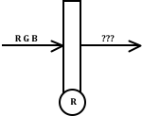Question 145:

aa. Red, green and blue primary colors of light shine upon a red filter. Which color(s) is/are transmitted by the filter?

a. Red b. Green

c. Blue d. Red and Blue

e. Red and Green ab. Blue and Green

ac. Red, Green and Blue

Question 146:

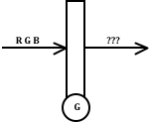aa. Red, green and blue primary colors of light shine upon a green filter. Which color(s) is/are transmitted by the filter?

a. Red b. Green

c. Blue d. Red and Blue

e. Red and Green ab. Blue and Green

ac. Red, Green and Blue

Question 147:

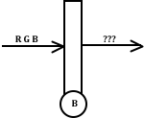aa. Red, green and blue primary colors of light shine upon a blue filter. Which color(s) is/are transmitted by the filter?

a. Red b. Green

c. Blue d. Red and Blue

e. Red and Green ab. Blue and Green

ac. Red, Green and Blue

Question 148:

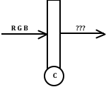aa. Red, green and blue primary colors of light shine upon a cyan filter. Which color(s) is/are transmitted by the filter?

a. Red b. Green

c. Blue d. Red and Blue

e. Red and Green ab. Blue and Green

ac. Red, Green and Blue

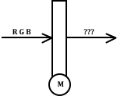Question 149:

aa. Red, green and blue primary colors of light shine upon a magenta filter. Which color(s) is/are transmitted by the filter?

a. Red b. Green

c. Blue d. Red and Blue

e. Red and Green ab. Blue and Green

ac. Red, Green and Blue

Question 150:

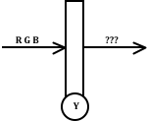aa. Red, green and blue primary colors of light shine upon a yellow filter. Which color(s) is/are transmitted by the filter?

a. Red b. Green

c. Blue d. Red and Blue

e. Red and Green ab. Blue and Green

ac. Red, Green and Blue

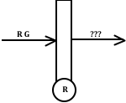Question 151:

aa. Red and green primary colors of light shine upon a red filter. Which color(s) is/are transmitted by the filter?

a. Red b. Green

c. Red and green d. Neither color

Question 152:

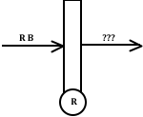aa. Red and blue primary colors of light shine upon a red filter. Which color(s) is/are transmitted by the filter?

a. Red b. Blue

c. Red and blue d. Neither color

Question 153:

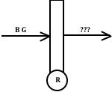aa. Blue and green primary colors of light shine upon a red filter. Which color(s) is/are transmitted by the filter?

a. Blue b. Green

c. Blue and green d. Neither color

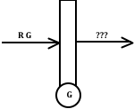Question 154:

aa. Red and green primary colors of light shine upon a green filter. Which color(s) is/are transmitted by the filter?

a. Red b. Green

c. Red and green d. Neither color

Question 155:

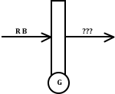aa. Red and blue primary colors of light shine upon a green filter. Which color(s) is/are transmitted by the filter?

a. Red b. Blue

c. Red and blue d. Neither color

Question 156:

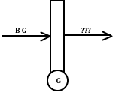aa. Blue and green primary colors of light shine upon a green filter. Which color(s) is/are transmitted by the filter?

a. Blue b. Green

c. Blue and green d. Neither color

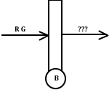Question 157:

aa. Red and green primary colors of light shine upon a blue filter. Which color(s) is/are transmitted by the filter?

a. Red b. Green

c. Red and green d. Neither color

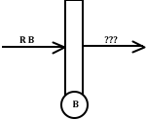Question 158:

aa. Red and blue primary colors of light shine upon a blue filter. Which color(s) is/are transmitted by the filter?

a. Red b. Blue

c. Red and blue d. Neither color

Question 159:

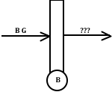aa. Blue and green primary colors of light shine upon a blue filter. Which color(s) is/are transmitted by the filter?

a. Blue b. Green

c. Blue and green d. Neither color

Question 160:

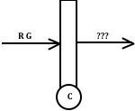aa. Red and green primary colors of light shine upon a cyan filter. Which color(s) is/are transmitted by the filter?

a. Red b. Green

c. Red and green d. Neither color

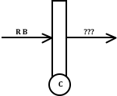Question 161:

aa. Red and blue primary colors of light shine upon a cyan filter. Which color(s) is/are transmitted by the filter?

a. Red b. Blue

c. Red and blue d. Neither color

Question 162:

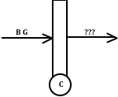aa. Blue and green primary colors of light shine upon a cyan filter. Which color(s) is/are transmitted by the filter?

a. Blue b. Green

c. Blue and green d. Neither color

Question 163:

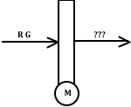aa. Red and green primary colors of light shine upon a magenta filter. Which color(s) is/are transmitted by the filter?

a. Red b. Green

c. Red and green d. Neither color

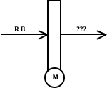Question 164:

aa. Red and blue primary colors of light shine upon a magenta filter. Which color(s) is/are transmitted by the filter?

a. Red b. Blue

c. Red and blue d. Neither color

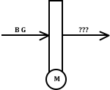Question 165:

aa. Blue and green primary colors of light shine upon a magenta filter. Which color(s) is/are transmitted by the filter?

a. Blue b. Green

c. Blue and green d. Neither color

Question 166:

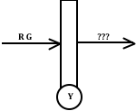aa. Red and green primary colors of light shine upon a yellow filter. Which color(s) is/are transmitted by the filter?

a. Red b. Green

c. Red and green d. Neither color

Question 167:

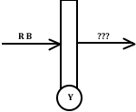aa. Red and blue primary colors of light shine upon a yellow filter. Which color(s) is/are transmitted by the filter?

a. Red b. Blue

c. Red and blue d. Neither color

Question 168:

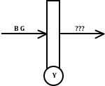aa. Blue and green primary colors of light shine upon a yellow filter. Which color(s) is/are transmitted by the filter?

a. Blue b. Green

c. Blue and green d. Neither color

Question 169:

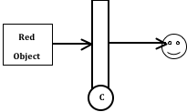aa. A red object is viewed through a cyan filter. What color will the object appear?

a. Black b. Blue

c. Cyan d. Green

e. Magenta ab. Red

ac. White ad. Yellow

Question 170:

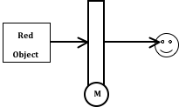aa. A red object is viewed through a magenta filter. What color will the object appear?

a. Black b. Blue

c. Cyan d. Green

e. Magenta ab. Red

ac. White ad. Yellow

Question 171:

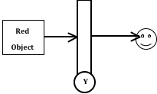aa. A red object is viewed through a yellow filter. What color will the object appear?

a. Black b. Blue

c. Cyan d. Green

e. Magenta ab. Red

ac. White ad. Yellow

Question 172:

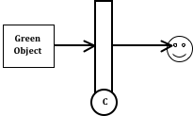aa. A green object is viewed through a cyan filter. What color will the object appear?

a. Black b. Blue

c. Cyan d. Green

e. Magenta ab. Red

ac. White ad. Yellow

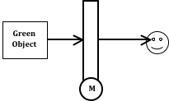Question 173:

aa. A green object is viewed through a magenta filter. What color will the object appear?

a. Black b. Blue

c. Cyan d. Green

e. Magenta ab. Red

ac. White ad. Yellow

Question 174:

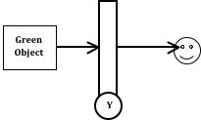aa. A green object is viewed through a yellow filter. What color will the object appear?

a. Black b. Blue

c. Cyan d. Green

e. Magenta ab. Red

ac. White ad. Yellow

Question 175:

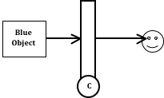aa. A blue object is viewed through a cyan filter. What color will the object appear?

a. Black b. Blue

c. Cyan d. Green

e. Magenta ab. Red

ac. White ad. Yellow

Question 176:

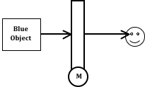aa. A blue object is viewed through a magenta filter. What color will the object appear?

a. Black b. Blue

c. Cyan d. Green

e. Magenta ab. Red

ac. White ad. Yellow

Question 177:

aa. A blue object is viewed through a yellow filter. What color will the object appear?

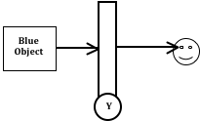 a. Black b. Blue

c. Cyan d. Green

e. Magenta ab. Red

ac. White ad. Yellow

Question 178:

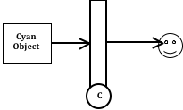aa. A cyan object is viewed through a cyan filter. What color will the object appear?

a. Black b. Blue

c. Cyan d. Green

e. Magenta ab. Red

ac. White ad. Yellow

Question 179:

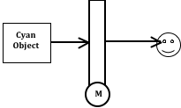aa. A cyan object is viewed through a magenta filter. What color will the object appear?

a. Black b. Blue

c. Cyan d. Green

e. Magenta ab. Red

ac. White ad. Yellow

Question 180:

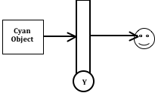aa. A cyan object is viewed through a yellow filter. What color will the object appear?

a. Black b. Blue

c. Cyan d. Green

e. Magenta ab. Red

ac. White ad. Yellow

Question 181:

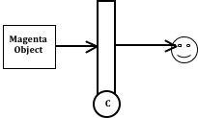aa. A magenta object is viewed through a cyan filter. What color will the object appear?

a. Black b. Blue

c. Cyan d. Green

e. Magenta ab. Red

ac. White ad. Yellow

Question 182:

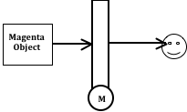aa. A magenta object is viewed through a magenta filter. What color will the object appear?

a. Black b. Blue

c. Cyan d. Green

e. Magenta ab. Red

ac. White ad. Yellow

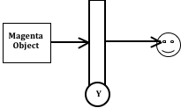Question 183:

aa. A magenta object is viewed through a yellow filter. What color will the object appear?

a. Black b. Blue

c. Cyan d. Green

e. Magenta ab. Red

ac. White ad. Yellow