**Minds On Physics Question Banks – Kinematic Concepts**

**KC1: Vectors and Scalars**

**Question 1:**

aa. A scalar is a quantity that is fully described by ____.

a. magnitude alone

b. both its magnitude and its direction

c. both its displacement and its velocity

d. both its distance and its speed

e. none of these

**Question 2:**

aa. A scalar is a quantity that is fully described by ____.

a. both its distance and its speed

b. both its displacement and its velocity

c. both its magnitude and its direction

d. magnitude alone

e. none of these

**Question 3:**

aa. A scalar is a quantity that is fully described by ____.

a. both its magnitude and its direction

b. magnitude alone

c. both its distance and its speed

d. both its displacement and its velocity

e. none of these

**Question 4:**

aa. A scalar is a quantity that is fully described by ____.

a. both its displacement and its velocity

b. both its distance and its speed

c. magnitude alone

d. both its magnitude and its direction

e. none of these

**Question 5:**

aa. A vector is a quantity that is fully described by ____.

a. both its magnitude and its direction

b. magnitude alone

c. both its distance and its speed

d. both its displacement and its velocity

e. none of these

**Question 6:**

aa. A vector is a quantity that is fully described by ____.

a. both its distance and its speed

b. both its displacement and its velocity

c. both its magnitude and its direction

d. magnitude alone

e. none of these

**Question 7:**

aa. A vector is a quantity that is fully described by ____.

a. magnitude alone

b. both its magnitude and its direction

c. both its displacement and its velocity

d. both its distance and its speed

e. none of these

**Question 8:**

aa. A vector is a quantity that is fully described by ____.

a. both its distance and its speed

b. both its displacement and its velocity

c. magnitude alone

d. both its magnitude and its direction

e. none of these

**Question 9:**

aa. Identify the following quantity as being either a scalar or a vector:

50 mi/hr, east

a. Scalar b. Vector c. Neither

**Question 10:**

aa. Identify the following quantity as being either a scalar or a vector:

55 mi/hr

a. Scalar b. Vector c. Neither

**Question 11:**

aa. Identify the following quantity as being either a scalar or a vector:

9.8 m/s/s, down

a. Scalar b. Vector c. Neither

**Question 12:**

aa. Identify the following quantity as being either a scalar or a vector:

32 degrees Fahrenheit

a. Scalar b. Vector c. Neither

**Question 13:**

aa. Identify the following quantity as being either a scalar or a vector:

20 m

a. Scalar b. Vector c. Neither

**Question 14:**

aa. Identify the following quantity as being either a scalar or a vector:

20 m, south

a. Scalar b. Vector c. Neither

**Question 15:**

aa. Identify the following quantity as being either a scalar or a vector:

55 mi/hr, west

a. Scalar b. Vector c. Neither

**Question 16:**

aa.

55 mi/hr

a. Scalar b. Vector c. Neither

**Question 17:**

aa. Which of the following quantities are vectors? Select all that apply.

a. Displacement b. Distance c. Velocity

d. Speed e. Acceleration

**Question 18:**

aa. Which of the following quantities are vectors? Select all that apply.

a. Distance b. Displacement c. Speed

d. Velocity e. Acceleration

**Question 19:**

aa. Which of the following quantities are scalars? Select all that apply.

a. Displacement b. Distance c. Velocity

d. Speed e. Acceleration

**Question 20:**

aa. Which of the following quantities are scalars? Select all that apply.

a. Distance b. Displacement c. Speed

d. Velocity e. Acceleration

**KC2: Distance and Displacement**

**Question 1:**

aa. In terms of their definitions, an essential difference between displacement and distance is that ____.

a. displacement is a scalar and distance is a vector.

b. distance is a scalar and displacement is a vector.

c. distance is a large number and displacement is a small number.

d. distance has a direction and displacement has no direction.

e. none of these

**Question 2:**

aa. In terms of their definitions, an essential difference between displacement and distance is that ____.

a. distance is a scalar and displacement is a vector.

b. displacement is a scalar and distance is a vector.

c. distance has a direction and displacement has no direction.

d. distance is a large number and displacement is a small number.

e. none of these

**Question 3:**

aa. In terms of their definitions, an essential difference between displacement and distance is that ____.

a. distance is a large number and displacement is a small number.

b. distance has a direction and displacement has no direction.

c. displacement is a scalar and distance is a vector.

d. distance is a scalar and displacement is a vector.

e. none of these

**Question 4:**

aa. In terms of their definitions, an essential difference between displacement and distance is that ____.

a. distance has a direction and displacement has no direction.

b. distance is a large number and displacement is a small number.

c. distance is a scalar and displacement is a vector.

d. displacement is a scalar and distance is a vector.

e. none of these

**Question 5:**

aa. For any given motion, the distance is ____.

a. the direction which an object moves.

b. the scalar of the object's velocity.

c. how far out of place which the object finishes relative to the starting location.

d. the amount of ground which is covered by the moving object.

e. none of these

**Question 6:**

aa. For any given motion, the distance is ____.

a. the scalar of the object's velocity.

b. the direction which an object moves.

c. the amount of ground which is covered by the moving object.

d. how far out of place which the object finishes relative to the starting location.

e. none of these

**Question 7:**

aa. For any given motion, the distance is ____.

a. the amount of ground which is covered by the moving object.

b. how far out of place which the object finishes relative to the starting location.

c. the scalar of the object's velocity.

d. the direction which an object moves.

e. none of these

**Question 8:**

aa. For any given motion, the distance is ____.

a. how far out of place which the object finishes relative to the starting location.

b. the amount of ground which is covered by the moving object.

c. the direction which an object moves.

d. the scalar of the object's velocity.

e. none of these

**Question 9:**

aa. For any given motion, displacement is ____.

a. the direction which an object moves.

b. the magnitude which the object moves.

c. how far out of place which the object finishes relative to the starting location.

d. the amount of ground which is covered by the moving object.

e. none of these

**Question 10:**

aa. For any given motion, displacement is ____.

a. the scalar of the object's velocity.

b. the direction which an object moves.

c. the amount of ground which is covered by the moving object.

d. how far out of place which the object finishes relative to the starting location.

e. none of these

**Question 11:**

aa. For any given motion, displacement is ____.

a. the amount of ground which is covered by the moving object.

b. how far out of place which the object finishes relative to the starting location.

c. the scalar of the object's velocity.

d. the direction which an object moves.

e. none of these

**Question 12:**

aa. For any given motion, displacement is ____.

a. how far out of place which the object finishes relative to the starting location.

b. the amount of ground which is covered by the moving object.

c. the direction which an object moves.

d. the scalar of the object's velocity.

e. none of these

**Question 13:**

aa. A teacher does the following:

i. walks 2 m, south

ii. walks 4 m, east

iii. walks 2 m, north

iv. walks 4 m, west.

The overall displacement of the teacher is ____.

a. 0 m b. 6 m c. 12 m

d. ... Nonsense! It cannot be calculated without knowing time information.

**Question 14:**

aa. A teacher does the following:

i. walks 4 m, south

ii. walks 8 m, east

iii. walks 4 m, north

iv. walks 8 m, west.

The overall displacement of the teacher is ____.

a. 0 m b. 6 m c. 12 m

d. ... Nonsense! It cannot be calculated without knowing time information.

**Question 15:**

aa. A teacher does the following:

i. walks 2 m, south

ii. walks 4 m, east

iii. walks 2 m, north

iv. walks 4 m, west.

The overall distance traveled by the teacher is ____.

a. 0 m b. 6 m c. 12 m

d. ... Nonsense! It cannot be calculated without knowing time information.

**Question 16:**

aa. A teacher does the following:

i. walks 4 m, south

ii. walks 8 m, east

iii. walks 4 m, north

iv. walks 8 m, west.

The overall distance traveled by the teacher is ____.

a. 0 m b. 12 m c. 24 m

d. ... Nonsense! It cannot be calculated without knowing time information.

**Question 17:**

aa. Grandma H challenges Michael Johnson in the 400-meter dash. Grandma H spins her wheelchair wheels five times and gives up 15 meters from the starting line. MJ makes a complete circle around the track and stops at the starting line. In this race, ____.

a. Michael Johnson has the greatest displacement

b. Grandma Henderson has the greatest displacement

c. Their displacements are the same

d. Neither has any displacement since they start at rest and each eventually stop

e. none of these

**Question 18:**

aa. Grandma H challenges Michael Johnson in the 400-meter dash. Grandma H spins her wheelchair wheels five times and gives up 15 meters from the starting line. MJ makes a complete circle around the track and stops at the starting line. In this race, ____.

a. Grandma Henderson has the greatest displacement

b. Michael Johnson has the greatest displacement

c. Neither has any displacement since they start at rest and each eventually stop

d. Their displacements are the same

e. none of these

**Question 19:**

aa. Grandma H challenges Michael Johnson in the 400-meter dash. Grandma H spins her wheelchair wheels five times and gives up 15 meters from the starting line. MJ makes a complete circle around the track and stops at the starting line. In this race, ____.

a. Michael Johnson has the greatest distance

b. Grandma Henderson has the greatest distance

c. Their distance values are the same

d. Neither has any distance since they start at rest and each eventually stop

e. none of these

**Question 20:**

aa. Grandma H challenges Michael Johnson in the 400-meter dash. Grandma H spins her wheelchair wheels five times and gives up 15 meters from the starting line. MJ makes a complete circle around the track and stops at the starting line. In this race, ____.

a. Their distance values are the same

b. Grandma Henderson has the greatest distance

c. Michael Johnson has the greatest distance

d. Neither has any distance since they start at rest and each eventually stop

e. none of these

**Question 21:**

aa. A football coach starts at the 10-yard line (A) and walks to the 40-yard line (B). He turns around and walks to the 0-yard line (C). He turns around again and walks back to the 50-yard line (D). He turns around once more and walks back to the 25-yard line (E), thus completing his 10 minutes of pacing.

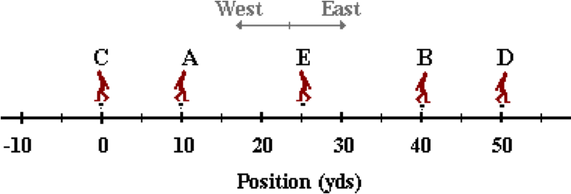

The coach's overall distance is ____.

a. 15 yd, east b. 15 yd, west c. 15 yd

d. 50 yd, east e. 50 yd, west f. 50 yd

g. 60 yd, east h. 60 yd, west i. 60 yd

j. 85 yd, east k. 85 yd, west l. 85 yd

m. 145 yd, east n. 145 yd, west o. 145 yd

p. none of these

**Question 22:**

aa. A football coach starts at the 35-yard line (A) and walks to the 15-yard line (B). He turns around and walks to the 40-yard line (C). He turns around again and walks back to the 0-yard line (D). He turns around once more and walks back to the 25-yard line (E), thus completing his 10 minutes of pacing.

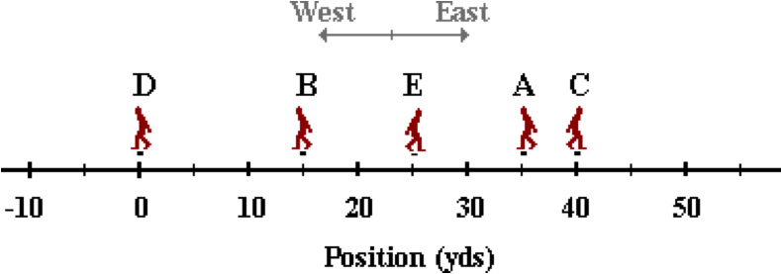

The coach's overall distance is ____.

a. 5 yd, east b. 5 yd, west c. 5 yd

d. 10 yd, east e. 10 yd, west f. 10 yd

g. 35 yd, east h. 35 yd, west i. 35 yd

j. 40 yd, east k. 40 yd, west l. 40 yd

m. 110 yd, east n. 110 yd, west o. 110 yd

p. none of these

**Question 23:**

aa. A football coach starts at the 50-yard line (A) and walks to the 10-yard line (B). He turns around and walks to the 40-yard line (C). He turns around again and walks back to the 0-yard line (D). He turns around once more and walks back to the 30-yard line (E), thus completing his 10 minutes of pacing.

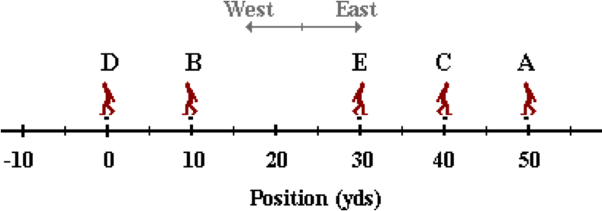

The coach's overall distance is ____.

a. 20 yd, east b. 20 yd, west c. 20 yd

d. 50 yd, east e. 50 yd, west f. 50 yd

g. 70 yd, east h. 70 yd, west i. 70 yd

j. 80 yd, east k. 80 yd, west l. 80 yd

m. 140 yd, east n. 140 yd, west o. 140 yd

p. none of these

**Question 24:**

aa. A football coach starts at the 10-yard line (A) and walks to the 40-yard line (B) in 3 minutes. He turns around and walks to the 0-yard line (C) in the next 2 minutes. He turns around again and walks back to the 50-yard line (D) in the next three minutes. He turns around once more and walks back to the 25-yard line (E) in the next two minutes, thus completing his 10 minutes of pacing.

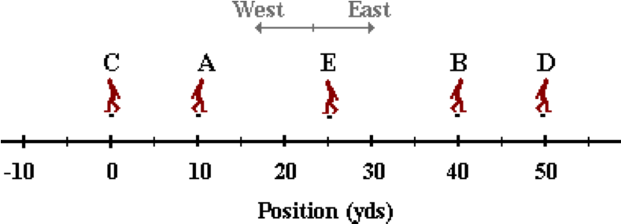

The coach's overall displacement is ____.

a. 15 yd, east b. 15 yd, west c. 15 yd

d. 50 yd, east e. 50 yd, west f. 50 yd

g. 60 yd, east h. 60 yd, west i. 60 yd

j. 85 yd, east k. 85 yd, west l. 85 yd

m. 145 yd, east n. 145 yd, west o. 145 yd

p. none of these

**Question 25:**

aa. A football coach starts at the 35-yard line (A) and walks to the 15-yard line (B). He turns around and walks to the 40-yard line (C). He turns around again and walks back to the 0-yard line (D). He turns around once more and walks back to the 25-yard line (E), thus completing his 10 minutes of pacing.

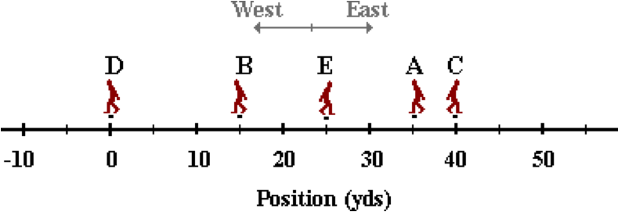

The coach's overall displacement is ____.

a. 5 yd, east b. 5 yd, west c. 5 yd

d. 10 yd, east e. 10 yd, west f. 10 yd

g. 35 yd, east h. 35 yd, west i. 35 yd

j. 40 yd, east k. 40 yd, west l. 40 yd

m. 110 yd, east n. 110 yd, west o. 110 yd

p. none of these

**Question 26:**

aa. A football coach starts at the 50-yard line (A) and walks to the 10-yard line (B). He turns around and walks to the 40-yard line (C). He turns around again and walks back to the 0-yard line (D). He turns around once more and walks back to the 30-yard line (E), thus completing his 10 minutes of pacing.

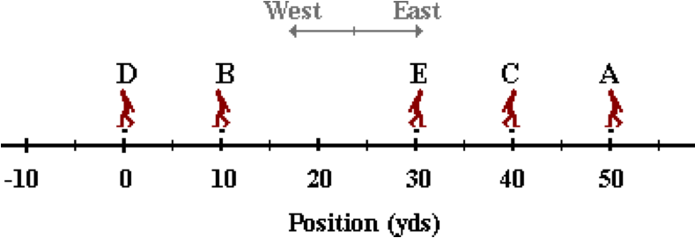

The coach's overall displacement is ____.

a. 20 yd, east b. 20 yd, west c. 20 yd

d. 50 yd, east e. 50 yd, west f. 50 yd

g. 70 yd, east h. 70 yd, west i. 70 yd

j. 80 yd, east k. 80 yd, west l. 80 yd

m. 140 yd, east n. 140 yd, west o. 140 yd

p. none of these

**KC3: Speed and Velocity**

**Question 1:**

aa. In terms of their definitions, an essential difference between velocity and speed is that ____.

a. speed is a scalar and velocity is a vector

b. velocity is a scalar and speed is a vector

c. velocity is a large number and speed is a small number

d. speed has a direction and velocity has no direction

e. none of these

**Question 2:**

aa. In terms of their definitions, an essential difference between velocity and speed is that ____.

a. velocity is a scalar and speed is a vector

b. speed is a scalar and velocity is a vector

c. speed has a direction and velocity has no direction

d. velocity is a large number and speed is a small number

e. none of these

**Question 3:**

aa. In terms of their definitions, an essential difference between velocity and speed is that ____.

a. velocity is a large number and speed is a small number

b. speed has a direction and velocity has no direction

c. speed is a scalar and velocity is a vector

d. velocity is a scalar and speed is a vector

e. none of these

**Question 4:**

aa. In terms of their definitions, an essential difference between velocity and speed is that ____.

a. speed has a direction and velocity has no direction

b. velocity is a large number and speed is a small number

c. velocity is a scalar and speed is a vector

d. speed is a scalar and velocity is a vector

e. none of these

**Question 5:**

aa. For any given motion, the velocity is ____.

a. the direction which an object moves

b. the scalar of the object's distance

c. how far out of place which the object finishes relative to the starting location

d. the rate at which an object's position changes

e. none of these

**Question 6:**

aa. For any given motion, the velocity is ____.

a. the scalar of the object's distance

b. the direction which an object moves

c. the rate at which an object's position changes

d. how far out of place which the object finishes relative to the starting location

e. none of these

**Question 7:**

aa. For any given motion, the velocity is ____.

a. how far out of place which the object finishes relative to the starting location

b. the rate at which an object's position changes

c. the direction which an object moves

d. the scalar of the object's distance

e. none of these

**Question 8:**

aa. For any given motion, the velocity is ____.

a. the rate at which an object's position changes

b. how far out of place which the object finishes relative to the starting location

c. the scalar of the object's distance

d. the direction which an object moves

e. none of these

**Question 9:**

aa. For any given motion, speed refers to ____.

a. the direction which an object moves

b. the magnitude which the object moves

c. how fast an object is traveling

d. the vector of an object's magnitude

e. none of these

**Question 10:**

aa. For any given motion, speed refers to ____.

a. the magnitude which the object moves

b. the direction which an object moves

c. the vector of an object's magnitude

d. how fast an object is traveling

**Question 11:**

aa. For any given motion, speed refers to ____.

a. how fast an object is traveling

b. the vector of an object's magnitude

c. the direction which an object moves

d. the magnitude which the object moves

e. none of these

**Question 12:**

aa. For any given motion, speed refers to ____.

a. the vector of an object's magnitude

b. how fast an object is traveling

c. the magnitude which the object moves

d. the direction which an object moves

e. none of these

**Question 13:**

aa. Which one of the following statements is true?

a. Velocity is speed with a direction.

b. Speed is velocity with a direction.

c. Speed is a scalar with a direction.

d. Speed is a velocity with a vector.

e. None of the above statements are true.

**Question 14:**

aa. Which one of the following statements is true?

a. Speed is velocity with a direction.

b. Velocity is speed with a direction.

c. Speed is a velocity with a vector.

d. Speed is a scalar with a direction.

e. None of the above statements are true.

**Question 15:**

aa. Which one of the following statements is true?

a. Speed is a scalar with a direction.

b. Speed is a velocity with a vector.

c. Velocity is speed with a direction.

d. Speed is velocity with a direction.

e. None of the above statements are true.

**Question 16:**

aa. Which one of the following statements is true?

a. Speed is a velocity with a vector.

b. Speed is a scalar with a direction.

c. Speed is velocity with a direction.

d. Velocity is speed with a direction.

e. None of the above statements are true.

**Question 17:**

aa. A teacher does the following motion in 10 seconds:

i. walks 2 m, south

ii. walks 4 m, east

iii. walks 2 m, north

iv. walks 4 m, west.

The average speed of the teacher is ____.

a. 0.0 m/s b. 0.3 m/s c. 0.6 m/s

d. 1.2 m/s e. 3 m/s

f. ... nonsense! An average speed cannot be determined since individual speed values are not given.

**Question 18:**

aa. A teacher does the following motion in 10 seconds:

i. walks 4 m, south

ii. walks 8 m, east

iii. walks 4 m, north

iv. walks 8 m, west.

The average speed of the teacher is ____.

a. 0.0 m/s b. 0.6 m/s c. 1.2 m/s

d. 2.4 m/s e. 6 m/s

f. ... nonsense! An average speed cannot be determined since individual speed values are not given.

**Question 19:**

aa. A teacher does the following motion in 10 seconds:

i. walks 2 m, south

ii. walks 4 m, east

iii. walks 2 m, north

iv. walks 4 m, west.

The average velocity of the teacher is ____.

a. 0.0 m/s b. 0.3 m/s c. 0.6 m/s

d. 1.2 m/s e. 3 m/s

f. ... nonsense! An average velocity cannot be determined since individual velocity values are not given.

**Question 20:**

aa. A teacher does the following motion in 10 seconds:

i. walks 4 m, south

ii. walks 8 m, east

iii. walks 4 m, north

iv. walks 8 m, west.

The average velocity of the teacher is ____.

a. 0.0 m/s b. 0.6 m/s c. 1.2 m/s

d. 2.4 m/s e. 6 m/s

f. ... nonsense! An average velocity cannot be determined since individual velocity values are not given.

**Question 21:**

aa. Grandma Henderson challenges Michael Johnson in the 400-meter dash. Grandma H spins her wheelchair wheels five times and gives up 15 meters from the starting line. MJ makes a complete circle around the track and stops at the starting line. In this race, ____.

a. Michael Johnson has the greatest average speed

b. Grandma Henderson has the greatest average speed

c. their average speed values are the same

d. they both have an average speed of 0 m/s since they both start at rest and each eventually stops

e. none of these

**Question 22:**

aa. Grandma Henderson challenges Michael Johnson in the 400-meter dash. Grandma H spins her wheelchair wheels five times and gives up 15 meters from the starting line. MJ makes a complete circle around the track and stops at the starting line. In this race, ____.

a. Grandma Henderson has the greatest average speed

b. Michael Johnson has the greatest average speed

c. they both have an average speed of 0 m/s since they both start at rest and each eventually stops

d. their average speed values are the same

e. none of these

**Question 23:**

aa. Grandma Henderson challenges Michael Johnson in the 400-meter dash. Grandma H spins her wheelchair wheels five times and gives up 15 meters from the starting line. MJ makes a complete circle around the track and stops at the starting line. In this race, ____.

a. they both have an average speed of 0 m/s since they both start at rest and each eventually stops

b. Grandma Henderson has the greatest average speed

c. Michael Johnson has the greatest average speed

d. their average speed values are the same

e. none of these

**Question 24:**

aa. Grandma Henderson challenges Michael Johnson in the 400-meter dash. Grandma H spins her wheelchair wheels five times and gives up 15 meters from the starting line. MJ makes a complete circle around the track and stops at the starting line. In this race, ____.

a. they both have an average speed of 0 m/s since they both start at rest and each eventually stops

b. their average speed values are the same

c. Grandma Henderson has the greatest average speed

d. Michael Johnson has the greatest average speed

e. none of these

**Question 25:**

aa. Grandma Henderson challenges Michael Johnson in the 400-meter dash. Grandma H spins her wheelchair wheels five times and gives up 15 meters from the starting line. MJ makes a complete circle around the track and stops at the starting line. In this race,

a. Michael Johnson has the greatest average velocity.

b. Grandma Henderson has the greatest average velocity.

c. Their average velocity are the same.

d. They both have an average velocity of 0 m/s since they both start at rest and each eventually stops.

e. none of these

**Question 26:**

aa. Grandma Henderson challenges Michael Johnson in the 400-meter dash. Grandma H spins her wheelchair wheels five times and gives up 15 meters from the starting line. MJ makes a complete circle around the track and stops at the starting line. In this race,

a. Grandma Henderson has the greatest average velocity.

b. Michael Johnson has the greatest average velocity.

c. They both have an average velocity of 0 m/s since they both start at rest and each eventually stops.

d. Their average velocity are the same.

e. none of these

**Question 27:**

aa. Grandma Henderson challenges Michael Johnson in the 400-meter dash. Grandma H spins her wheelchair wheels five times and gives up 15 meters from the starting line. MJ makes a complete circle around the track and stops at the starting line. In this race,

a. Their average velocity are the same.

b. They both have an average velocity of 0 m/s since they both start at rest and each eventually stops.

c. Michael Johnson has the greatest average velocity.

d. Grandma Henderson has the greatest average velocity.

e. none of these

**Question 28:**

aa. Grandma Henderson challenges Michael Johnson in the 400-meter dash. Grandma H spins her wheelchair wheels five times and gives up 15 meters from the starting line. MJ makes a complete circle around the track and stops at the starting line. In this race,

a. They both have an average velocity of 0 m/s since they both start at rest and each eventually stops.

b. Their average velocity are the same.

c. Grandma Henderson has the greatest average velocity.

d. Michael Johnson has the greatest average velocity.

e. none of these

**Question 29:**

aa. A football coach starts at the 10-yard line (A) and walks to the 40-yard line (B). He turns around and walks to the 0-yard line (C). He turns around again and walks back to the 50-yard line (D). He turns around once more and walks back to the 25-yard line (E), thus completing his 10 minutes of pacing.

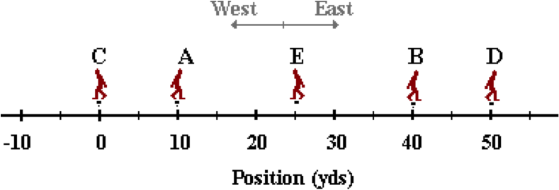

The coach's average speed is ____.

a. 1.5 y/min, East b. 1.5 y/min, West c. 1.5 y/min

d. 5.0 y/min, East e. 5.0 y/min, West f. 5.0 y/min

g. 6.0 y/min, East h. 6.0 y/min, West i. 6.0 y/min

j. 8.5 y/min, East k. 8.5 y/min, West l. 8.5 y/min

m. 14.5 y/min, East n. 14.5 yd/min, West o. 14.5 y/min

p. none of these

**Question 30:**

aa. A football coach starts at the 35-yard line (A) and walks to the 15-yard line (B). He turns around and walks to the 40-yard line (C). He turns around again and walks back to the 0-yard line (D). He turns around once more and walks back to the 25-yard line (E), thus completing his 10 minutes of pacing.

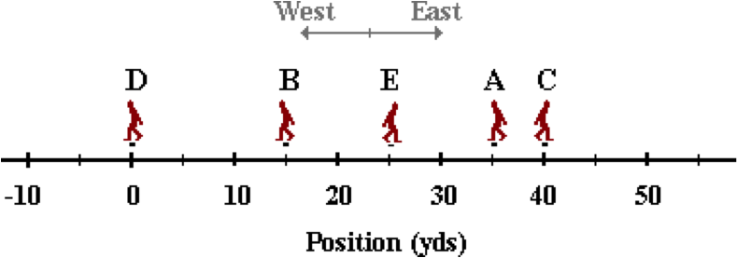

The coach's average speed is ____.

a. 0.5 y/min, East b. 0.5 y/min, West c. 0.5 y/min

d. 1.0 y/min, East e. 1.0 y/min, West f. 1.0 y/min

g. 3.5 y/min, East h. 3.5 y/min, West i. 3.5 y/min

j. 4.0 y/min, East k. 4.0 y/min, West l. 4.0 y/min

m. 11.0 y/min, East n. 11.0 y/min, West o. 11.0 y/min

p. none of these

**Question 31:**

aa. A football coach starts at the 50-yard line (A) and walks to the 10-yard line (B). He turns around and walks to the 40-yard line (C). He turns around again and walks back to the 0-yard line (D). He turns around once more and walks back to the 30-yard line (E), thus completing his 10 minutes of pacing.

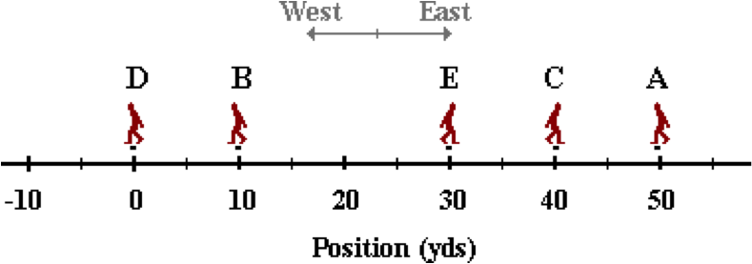

The coach's average speed is ____.

a. 2.0 y/min, East b. 2.0 y/min, West c. 2.0 y/min

d. 5.0 y/min, East e. 5.0 y/min, West f. 5.0 y/min

g. 7.0 y/min, East h. 7.0 y/min, West i. 7.0 y/min

j. 8.0 y/min, East k. 8.0 y/min, West l. 8.0 y/min

m. 14.0 y/min, East n. 14.0 y/min, West o. 14.0 y/min

p. none of these

**Question 32:**

aa. A football coach starts at the 10-yard line (A) and walks to the 40-yard line (B) in 3 minutes. He turns around and walks to the 0-yard line (C) in the next 2 minutes. He turns around again and walks back to the 50-yard line (D) in the next three minutes. He turns around once more and walks back to the 25-yard line (E) in the next two minutes, thus completing his 10 minutes of pacing.

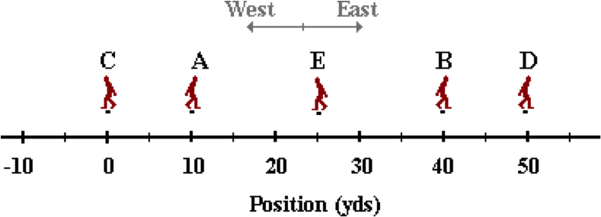

The coach's average velocity is ____.

a. 1.5 y/min, East b. 1.5 y/min, West c. 1.5 y/min

d. 5.0 y/min, East e. 5.0 y/min, West f. 5.0 y/min

g. 6.0 y/min, East h. 6.0 y/min, West i. 6.0 y/min

j. 8.5 y/min, East k. 8.5 y/min, West l. 8.5 y/min

m. 14.5 y/min, East n. 14.5 yd, West o. 14.5 y/min

p. none of these

**Question 33:**

aa. A football coach starts at the 35-yard line (A) and walks to the 15-yard line (B). He turns around and walks to the 40-yard line (C). He turns around again and walks back to the 0-yard line (D). He turns around once more and walks back to the 25-yard line (E), thus completing his 10 minutes of pacing.

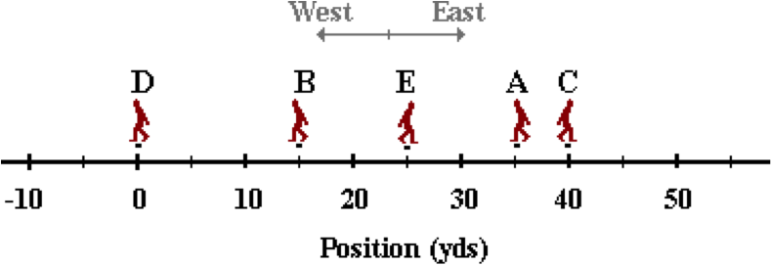

The coach's average velocity is ____.

a. 0.5 y/min, East b. 0.5 y/min, West c. 0.5 y/min

d. 1.0 y/min, East e. 1.0 y/min, West f. 1.0 y/min

g. 3.5 y/min, East h. 3.5 y/min, West i. 3.5 y/min

j. 4.0 y/min, East k. 4.0 y/min, West l. 4.0 y/min

m. 11.0 y/min, East n. 11.0 y/min, West o. 11.0 y/min

p. none of these

**Question 34:**

aa. A football coach starts at the 50-yard line (A) and walks to the 10-yard line (B). He turns around and walks to the 40-yard line (C). He turns around again and walks back to the 0-yard line (D). He turns around once more and walks back to the 30-yard line (E), thus completing his 10 minutes of pacing.

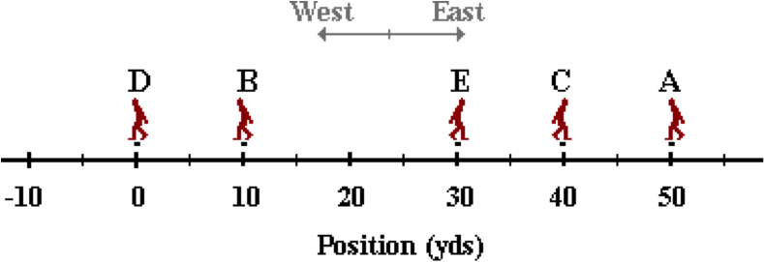

The coach's average velocity is ____.

a. 2.0 y/min, East b. 2.0 y/min, West c. 2.0 y/min

d. 5.0 y/min, East e. 5.0 y/min, West f. 5.0 y/min

g. 7.0 y/min, East h. 7.0 y/min, West i. 7.0 y/min

j. 8.0 y/min, East k. 8.0 y/min, West l. 8.0 y/min

m. 14.0 y/min, East n. 14.0 y/min, West o. 14.0 y/min

p. none of these

**KC4: Acceleration**

**Question 1:**

aa. Acceleration is defined as ____.

a. the rate at which the position changes

b. the rate at which the displacement changes

c. the rate at which the speed changes

d. the rate at which the velocity changes

e. none of these

**Question 2:**

Acceleration is defined as ____.

a. the rate at which the displacement changes

b. the rate at which the position changes

c. the rate at which the velocity changes

d. the rate at which the speed changes

e. none of these

**Question 3:**

Acceleration is defined as ____.

a. the rate at which the speed changes

b. the rate at which the velocity changes

c. the rate at which the position changes

d. the rate at which the displacement changes

e. none of these

**Question 4:**

aa. Acceleration is defined as ____.

a. the rate at which the velocity changes

b. the rate at which the speed changes

c. the rate at which the displacement changes

d. the rate at which the position changes

e. none of these

**Question 5:**

aa. A car that is moving at a constant velocity of 20 m/s, east for 10 seconds has an acceleration of ____ m/s/s.

a. 0 b. 2 c. 20 d. 200

e. none of these

**Question 6:**

aa. A car that is moving at a constant velocity of 20 m/s, east for 5 seconds has an acceleration of ____ m/s/s.

a. 0 b. 4 c. 20 d. 100

e. none of these

**Question 7:**

aa. A car that is moving at a constant velocity of 30 m/s, east for 10 seconds has an acceleration of ____ m/s/s.

a. 0 b. 3 c. 30 d. 300

e. none of these

**Question 8:**

aa. A car that is moving at a constant velocity of 30 m/s, east for 5 seconds has an acceleration of ____ m/s/s.

a. 0 b. 6 c. 30 d. 150

e. none of these

**Question 9:**

aa. Which of the following represent an accelerated motion? Select all that apply.

a. An object that remains at rest.

b. An object moving in a circle at constant speed.

c. An object moving at constant speed in the same direction.

d. An object that changes its velocity

e. An object that turns around and changes direction.

f. none of these

**Question 10:**

aa. Which of the following represent an accelerated motion? Select all that apply.

a. An object moving in a circle at constant speed.

b. An object that remains at rest.

c. An object that changes its velocity

d. An object moving at constant speed in the same direction.

e. An object that turns around and changes direction.

f. none of these

**Question 11:**

aa. Which of the following represent an accelerated motion? Select all that apply.

a. An object moving in a circle at constant speed.

b. An object moving at constant speed in the same direction.

c. An object that turns around and changes direction.

d. An object that changes its velocity

e. An object that remains at rest.

f. none of these

**Question 12:**

aa. Which of the following represent an accelerated motion? Select all that apply.

a. An object that turns around and changes direction.

b. An object that changes its velocity

c. An object moving at constant speed in the same direction.

d. An object that remains at rest.

e. An object moving in a circle at constant speed.

f. none of these

**Question 13:**

aa. If an object has an acceleration then it MUST be ____. Select all that apply.

a. changing its direction b. changing its speed

c. changing its velocity d. none of these

**Question 14:**

aa. An object that is NOT accelerating MUST ____. Select all that apply.

a. be at rest b. be moving and moving with a constant speed

c. be changing its direction d. be maintaining a constant velocity.

e. none of these

**Question 15:**

aa. If an object has an acceleration then it MUST be ____. Select all that apply.

a. changing its direction b. changing its velocity

c. changing its speed d. none of these

**Question 16:**

aa. An object which is NOT accelerating MUST ____. Select all that apply.

a. be maintaining a constant velocity.

b. be at rest

c. be moving and moving with a constant speed

d. be changing its direction

e. none of these

**Question 17:**

aa. Which of the following are controls on an automobile that allow the driver to cause an acceleration of the car? Select all that apply.

a. brake pedal b. gas tank

c. gas pedal d. windshield washer

e. steering wheel f. radio

g. sun visor h. cigarette lighter

**Question 18:**

aa. Which of the following are controls on an automobile that allow the driver to cause an acceleration of the car? Select all that apply.

a. radio b. steering wheel

c. gas tank d. brake pedal

e. gas pedal f. windshield washer

g. sun visor h. cigarette lighter

**Question 19:**

aa. Which of the following are controls on an automobile that allow the driver to cause an acceleration of the car? Select all that apply.

a. cigarette lighter b. gas tank

c. windshield washer d. steering wheel

e. gas pedal f. radio

g. brake pedal h. sun visor

**Question 20:**

aa. Which of the following are controls on an automobile that allow the driver to cause an acceleration of the car? List all that apply in alphabetical order with neither spaces nor commas between letters.

a. radio b. sun visor

c. cigarette lighter d. windshield washer

e. gas tank f. gas pedal

g. steering wheel h. brake pedal

**Question 21:**

aa. A car's velocity after each consecutive second of motion is 2 m/s, 4 m/s, 6 m/s, 8 m/s. This is evidence that the car is ____.

a. moving with a constant speed

b. moving with a constant acceleration

c. moving with a constant velocity

**Question 22:**

aa. A car's velocity after each consecutive second of motion is 2 m/s, 4 m/s, 6 m/s, 8 m/s. This is evidence that the car is ____.

a. moving with a constant velocity

b. moving with a constant speed

c. moving with a constant acceleration

**Question 23:**

aa. A car's velocity after each consecutive second of motion is 2 m/s, 4 m/s, 6 m/s, 8 m/s. This is evidence that the car ____.

a. is covering the same distance every second

b. is covering more distance in each consecutive second

c. may be covering more or less distance each consecutive second, depending on its acceleration

**Question 24:**

aa. A car's velocity after each consecutive second of motion is 2 m/s, 4 m/s, 6 m/s, 8 m/s. This is evidence that the car ____.

a. is covering more distance in each consecutive second

b. is covering the same distance every second

c. may be covering more or less distance each consecutive second, depending on its acceleration

**Question 25:**

aa. Which of the following is NOT an acceleration unit? List all that apply in alphabetical order with neither spaces nor commas between letters.

a. m/s/s b. (km/hr)/s c. (km/hr)/hr

d. km/s e. (m/s)/s

**Question 26:**

aa. Which of the following is NOT an acceleration unit? List all that apply in alphabetical order with neither spaces nor commas between letters.

a. km/s b. m/s/s c. (m/s)/s

d. (km/hr)/s e. (km/hr)/hr

**Question 27:**

aa. Which of the following is NOT an acceleration unit? List all that apply in alphabetical order with neither spaces nor commas between letters.

a. (m/s)/s b. m/s/s c. (km/hr)/hr

d. (km/hr)/s e. km/s

**Question 28:**

aa. Which of the following is NOT an acceleration unit? List all that apply in alphabetical order with neither spaces nor commas between letters.

a. (km/hr)/hr b. (km/hr)/s c. km/s

d. (m/s)/s e. m/s/s

**Question 29:**

aa. A car is moving eastward along Lake Avenue and decreasing its speed from 35 mph to 25 mph. The direction of this car's acceleration is ____.

a. eastward

b. westward

c. neither; there is no acceleration

d. ... nonsense! Acceleration does not have a direction associated with it.

**Question 30:**

aa. A car is moving westward along Lake Avenue and decreasing its speed from 35 mph to 25 mph. The direction of this car's acceleration is ____.

a. eastward

b. westward

c. neither; there is no acceleration

d. ... nonsense! Acceleration does not have a direction associated with it.

**Question 31:**

aa. A baseball is traveling upwards towards the peak of its trajectory and slowing down at a constant rate. The direction of the baseball's acceleration is ____.

a. upward

b. downward

c. neither; there is no acceleration

d. ... nonsense! Acceleration does not have a direction associated with it.

**Question 32:**

aa. A baseball is falling downwards from the peak of its trajectory and speeding up at a constant rate. The direction of the baseball's acceleration is ____.

a. upward

b. downward

c. neither; there is no acceleration

d. ... nonsense! Acceleration does not have a direction associated with it.

**Question 33:**

aa. TRUE or FALSE?

A car can be moving to the right and have a leftward acceleration.

a. TRUE b. FALSE

**Question 34:**

aa. TRUE or FALSE?

An object can be moving upward and have a downward acceleration.

a. TRUE b. FALSE

**Question 35:**

aa. TRUE or FALSE?

A car can be moving to the left and have a rightward acceleration.

a. TRUE b. FALSE

**Question 36:**

aa. TRUE or FALSE?

An object can be moving downward and have a upward acceleration.

a. TRUE b. FALSE

**Question 37:**

aa. A car with a rightward velocity and a leftward acceleration is ____.

a. moving to the right and speeding up

b. moving to the right and slowing down

c. moving to the left and speeding up

d. moving to the left and slowing down

e. Two or more of the above are possible.

**Question 38:**

aa. A car with a rightward velocity and a leftward acceleration is ____.

a. moving to the left and speeding up

b. moving to the left and slowing down

c. moving to the right and speeding up

d. moving to the right and slowing down

e. Two or more of the above are possible.

**Question 39:**

aa. A car with a leftward velocity and a rightward acceleration is ____.

a. moving to the right and speeding up

b. moving to the right and slowing down

c. moving to the left and speeding up

d. moving to the left and slowing down

e. Two or more of the above are possible.

**Question 40:**

aa. A car with a leftward velocity and a rightward acceleration is ____.

a. moving to the left and speeding up

b. moving to the left and slowing down

c. moving to the right and speeding up

d. moving to the right and slowing down

e. Two or more of the above are possible.

**KC5: Oil Drop Representations**

**Question 1:**

aa. An old car has a leaky engine and leaves the following oil drop trace on the street; the drops hit the street at regular time intervals. The oil drop pattern depicts ____.

a. a constant velocity

b. an accelerated motion

c. ... it's impossible to tell without any distance-time data.

**Question 2:**

aa. An old car has a leaky engine and leaves the following oil drop trace on the street; the drops hit the street at regular time intervals. The oil drop pattern depicts ____.

a. a constant velocity

b. an accelerated motion

c. ... it's impossible to tell without any distance-time data.

**Question 3:**

aa. An old car has a leaky engine and leaves the following oil drop trace on the street; the drops hit the street at regular time intervals. The oil drop pattern depicts ____.

a. a constant velocity

b. an accelerated motion

c. ... it's impossible to tell without any distance-time data.

**Question 4:**

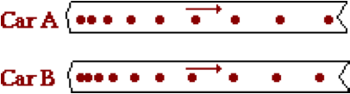aa. Based on the oil drop pattern for Car A and Car B, which of the following statements are true? List all that apply in alphabetical order without any spaces or commas between letters.

a. Both cars have a constant velocity.

b. Both cars have an accelerated motion.

c. Car A is accelerating; Car B is not.

d. Car B is accelerating; Car A is not.

e. Car A has a greater acceleration than Car B.

f. Car B has a greater acceleration than Car A.

g. none of these

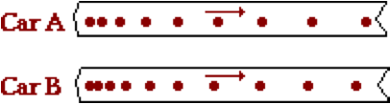**Question 5:**

aa. Based on the oil drop pattern for Car A and Car B, which of the following statements are true? List all that apply in alphabetical order without any spaces or commas between letters.

a. Both cars have an accelerated motion.

b. Car A is accelerating; Car B is not.

c. Car B is accelerating; Car A is not.

d. Both cars have a constant velocity.

e. Car A has a greater acceleration than Car B.

f. Car B has a greater acceleration than Car A.

g. none of these

**Question 6:**

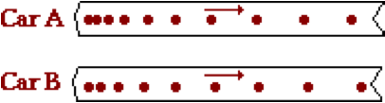aa. Based on the oil drop pattern for Car A and Car B, which of the following statements are true? List all that apply in alphabetical order without any spaces or commas between letters.

a. Both cars have a constant velocity.

b. Both cars have an accelerated motion.

c. Car A is accelerating; Car B is not.

d. Car B is accelerating; Car A is not.

e. Car A has a greater acceleration than Car B.

f. Car B has a greater acceleration than Car A.

g. none of these

**Question 7:**

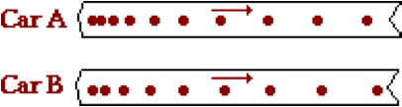aa. Based on the oil drop pattern for Car A and Car B, which of the following statements are true? List all that apply in alphabetical order without any spaces or commas between letters.

a. Both cars have an accelerated motion.

b. Car A is accelerating; Car B is not.

c. Car B is accelerating; Car A is not.

d. Both cars have a constant velocity.

e. Car A has a greater acceleration than Car B.

f. Car B has a greater acceleration than Car A.

g. none of these

**Question 8:**

aa. Which one of the following verbal descriptions best describes the oil drop pattern shown below?



a. Moves at a constant speed, decelerates to a stop, remains at rest.

b. Moves at a constant speed and then is at rest for several seconds.

c. Decelerates to a rest position.

d. None of these

**Question 9:**

aa. Which one of the following verbal descriptions best describes the oil drop pattern shown below?



a. Moves at a constant speed and then is at rest for several seconds.

b. Decelerates to a rest position.

c. Moves at a constant speed, decelerates to a stop, remains at rest.

d. None of these

**Question 10:**

aa. Which one of the following verbal descriptions best describes the oil drop pattern shown below?



a. Decelerates to a rest position.

b. Moves at a constant speed, decelerates to a stop, remains at rest.

c. Moves at a constant speed and then is at rest for several seconds.

d. None of these

**Question 11:**

aa. Which one of the following verbal descriptions best describes the oil drop pattern shown below?



a. At rest for several seconds and then accelerates.

b. Moves at a constant speed and then accelerates for the remaining time.

c. Moves at a constant speed, accelerates, maintains a new constant speed.

d. None of these

**Question 12:**

aa. Which one of the following verbal descriptions best describes the oil drop pattern shown below?



a. Moves at a constant speed and then accelerates for the remaining time.

b. Moves at a constant speed, accelerates, maintains a new constant speed.

c. At rest for several seconds and then accelerates.

d. None of these

**Question 13:**

aa. Which one of the following verbal descriptions best describes the oil drop pattern shown below?



a. Moves at a constant speed, accelerates, maintains a new constant speed.

b. At rest for several seconds and then accelerates.

c. Moves at a constant speed and then accelerates for the remaining time.

d. None of these

**Question 14:**

aa. An object is moving from left to right. It's motion is represented by the oil drop diagram at the right. This object has a _______ velocity and a _______ acceleration.

a. rightward, rightward b. rightward, leftward

c. leftward, rightward d. leftward, leftward

e. rightward, zero f. leftward, zero

g. none of these

**Question 15:**

aa. An object is moving from left to right. It's motion is represented by the oil drop diagram at the right. This object has a _______ velocity and a _______ acceleration.

a. rightward, zero b. leftward, zero

c. rightward, rightward d. leftward, leftward

e. rightward, leftward f. leftward, rightward

g. none of these

**Question 16:**

aa. An object is moving from right to left. It's motion is represented by the oil drop diagram at the right. This object has a _______ velocity and a _______ acceleration.

a. rightward, rightward b. rightward, leftward

c. leftward, rightward d. leftward, leftward

e. rightward, zero f. leftward, zero

g. none of these

**Question 17:**

aa. An object is moving from right to left. It’s motion is represented by the oil drop diagram at the right. This object has a _______ velocity and a _______ acceleration.

a. rightward, zero b. leftward, zero

c. rightward, rightward d. leftward, leftward

e. rightward, leftward f. leftward, rightward

g. none of these

**Question 18:**

aa. An object is moving from left to right. It’s motion is represented by the oil drop diagram at the right. This object has a _______ velocity and a _______ acceleration.

a. rightward, rightward b. rightward, leftward

c. leftward, rightward d. leftward, leftward

e. rightward, zero f. leftward, zero

g. none of these

**Question 19:**

aa. An object is moving from left to right. It’s motion is represented by the oil drop diagram at the right. This object has a _______ velocity and a _______ acceleration.

a. rightward, zero b. leftward, zero

c. rightward, rightward d. leftward, leftward

e. rightward, leftward f. leftward, rightward

g. none of these

**Question 20:**

aa. An object is moving from left to right. It’s motion is represented by the oil drop diagram at the right. This object has a _______ velocity and a _______ acceleration.

a. rightward, leftward b. leftward, rightward

c. rightward, zero d. leftward, zero

e. rightward, rightward f. leftward, leftward

g. none of these

**Question 21:**

An object is moving from left to right. It’s motion is represented by the oil drop diagram at the right. This object has a _______ velocity and a _______ acceleration.

a. rightward, rightward b. rightward, leftward

c. rightward, zero d. leftward, rightward

e. leftward, leftward f. leftward, zero

g. none of these

**Question 22:**

aa. An object is moving from left to right. It’s motion is represented by the oil drop diagram at the right. This object has a _______ velocity and a _______ acceleration.

a. rightward, rightward b. rightward, leftward

c. leftward, rightward d. leftward, leftward

e. rightward, zero f. leftward, zero

g. none of these

**Question 23:**

aa. An object is moving from left to right. It’s motion is represented by the oil drop diagram at the right. This object has a _______ velocity and a _______ acceleration.

a. rightward, zero b. leftward, zero

c. rightward, rightward d. leftward, leftward

e. rightward, leftward f. leftward, rightward

g. none of these

**Question 24:**

aa. An object is moving from left to right. It’s motion is represented by the oil drop diagram at the right. This object has a _______ velocity and a _______ acceleration.

a. rightward, leftward b. leftward, rightward

c. rightward, zero d. leftward, zero

e. rightward, rightward f. leftward, leftward

g. none of these

**Question 25:**

aa. An object is moving from left to right. It's motion is represented by the oil drop diagram at the right. This object has a _______ velocity and a _______ acceleration.

a. rightward, rightward b. rightward, leftward

c. rightward, zero d. leftward, rightward

e. leftward, leftward f. leftward, zero

g. none of these

**Question 26:**

aa. An object is moving from right to left. It's motion is represented by the oil drop diagram at the right. This object has a _______ velocity and a _______ acceleration.

a. rightward, rightward b. rightward, leftward

c. leftward, rightward d. leftward, leftward

e. rightward, zero f. leftward, zero

g. none of these

**Question 27:**

aa. An object is moving from right to left. It's motion is represented by the oil drop diagram at the right. This object has a _______ velocity and a _______ acceleration.

a. rightward, zero b. leftward, zero

c. rightward, rightward d. leftward, leftward

e. rightward, leftward f. leftward, rightward

g. none of these

**Question 28:**

aa. An object is moving from right to left. It's motion is represented by the oil drop diagram at the right. This object has a _______ velocity and a _______ acceleration.

a. rightward, leftward b. leftward, rightward

c. rightward, zero d. leftward, zero

e. rightward, rightward f. leftward, leftward

g. none of these

**Question 29:**

aa. An object is moving from right to left. It's motion is represented by the oil drop diagram at the right. This object has a _______ velocity and a _______ acceleration.

a. rightward, rightward b. rightward, leftward

c. rightward, zero d. leftward, rightward

e. leftward, leftward f. leftward, zero

g. none of these

**Question 30:**

aa. An object is moving from right to left. It's motion is represented by the oil drop diagram at the right. This object has a _______ velocity and a _______ acceleration.

a. rightward, rightward b. rightward, leftward

c. leftward, rightward d. leftward, leftward

e. rightward, zero f. leftward, zero

g. none of these

**Question 31:**

aa. An object is moving from right to left. It's motion is represented by the oil drop diagram at the right. This object has a _______ velocity and a _______ acceleration.

a. rightward, zero b. leftward, zero

c. rightward, rightward d. leftward, leftward

e. rightward, leftward f. leftward, rightward

g. none of these

**Question 32:**

aa. An object is moving from right to left. It's motion is represented by the oil drop diagram at the right. This object has a _______ velocity and a _______ acceleration.

a. rightward, leftward b. leftward, rightward

c. rightward, zero d. leftward, zero

e. rightward, rightward f. leftward, leftward

g. none of these

**Question 33:**

aa. An object is moving from right to left. It's motion is represented by the oil drop diagram at the right. This object has a _______ velocity and a _______ acceleration.

a. rightward, rightward b. rightward, leftward

c. rightward, zero d. leftward, rightward

e. leftward, leftward f. leftward, zero

g. none of these

**KC6: Average Speed Computations**

**Question 1:**

aa. A race car travels 500 miles in 2.25 hours. Determine the average speed of the race car in mi/hr. Enter a numerical answer.

**Question 2:**

aa. A race car travels 250 miles in 1.30 hours. Determine the average speed of the race car in mi/hr. Enter a numerical answer.

**Question 3:**

aa. An Olympic sprinter runs the 100-meter dash in 9.50 seconds. Determine the average speed of the runner in m/s. Enter a numerical answer.

**Question 4:**

aa. An Olympic sprinter runs the 100-meter dash in 9.35 seconds. Determine the average speed of the runner in m/s. Enter a numerical answer.

**Question 5:**

aa. If a football player runs 40-meters in 4.45 seconds, then what is his average speed in m/s? Enter a numerical answer.

**Question 6:**

aa. If a football player runs 40-meters in 4.69 seconds, then what is his average speed in m/s? Enter a numerical answer.

**Question 7:**

aa. If a migrating bird averages a speed of 25 mi/hr, then how far (in miles) will it migrate in 2 weeks? Assume the bird averages 12 hours of flight/day. Enter a numerical answer.

**Question 8:**

aa. If a migrating bird averages a speed of 20 mi/hr, then how far (in miles) will it migrate in 3 weeks? Assume the bird averages 12 hours of flight/day. Enter a numerical answer.

**Question 9:**

aa. If a plane averages a speed of 260 mi/hr, then how much time (in hours) will it take to travel a distance of 984 miles? Enter a numerical answer.

**Question 10:**

aa. If a plane averages a speed of 270 mi/hr, then how much time (in hours) will it take to travel a distance of 852 miles? Enter a numerical answer.

**Question 11:**

aa. If a driver averages a speed of 49.5 miles/hour, then how far (in miles) will she travel during a 12.2-hour day trip? Enter a numerical answer.

**Question 12:**

aa. If a driver averages a speed of 52.1 miles/hour, then how far (in miles) will she travel during a 11.5-hour day trip? Enter a numerical answer.

**Question 13:**

aa. If a football player runs with an average speed of 9.24 m/s, then how much time (in seconds) would it take to run 94.1 meters? Enter a numerical answer.

**Question 14:**

aa. If a football player runs with an average speed of 9.52 m/s, then how much time (in seconds) would it take to run 91.8 meters? Enter a numerical answer.

**KC7: Acceleration Computations**

**Question 1:**

aa. A rightward-moving dragster accelerates from 0 m/s to 75 m/s in 4.5 s. Determine the magnitude of the average acceleration of the dragster in m/s/s. Enter a numerical answer.

**Question 2:**

aa. A rightward-moving dragster accelerates from 0 m/s to 85 m/s in 4.9 s. Determine the magnitude of the average acceleration of the dragster in m/s/s. Enter a numerical answer.

**Question 3:**

aa. A rightward-moving airplane accelerates from 0 m/s to 65 m/s in 7.1 s. Determine the magnitude of the average acceleration of the airplane in m/s/s. Enter a numerical answer.

**Question 4:**

aa. A rightward-moving airplane accelerates from 0 m/s to 72 m/s in 8.2 s. Determine the magnitude of the average acceleration of airplane dragster in m/s/s. Enter a numerical answer.

**Question 5:**

aa. A rightward-moving car accelerates from 0 mi/hr to 60 mi/hr in 5.2 seconds. Determine the magnitude of the average acceleration of the car in mi/hr/s. Enter a numerical answer.

**Question 6:**

aa. A rightward-moving car accelerates from 0 mi/hr to 55 mi/hr in 5.6 seconds. Determine the magnitude of the average acceleration of the car in mi/hr/s. Enter a numerical answer.

**Question 7:**

aa. A rightward-moving car accelerates from 55 mi/hr to 0 mi/hr in 5.1 seconds. Determine the magnitude of the average acceleration of the car in mi/hr/s. Enter a numerical answer.

**Question 8:**

aa. A rightward-moving car accelerates from 60 mi/hr to 0 mi/hr in 6.2 seconds. Determine the magnitude of the average acceleration of the car in mi/hr/s. Enter a numerical answer.

**Question 9:**

aa. A rightward-moving car accelerates from 55 mi/hr to 25 mi/hr in 4.2 seconds. Determine the magnitude of the average acceleration of the car in mi/hr/s. Enter a numerical answer.

**Question 10:**

aa. A rightward-moving car accelerates from 60 mi/hr to 26 mi/hr in 3.9 seconds. Determine the magnitude of the average acceleration of the car in mi/hr/s. Enter a numerical answer.

**Question 11:**

aa. Upon landing, a rightward-moving airplane accelerates from 65 m/s to 10 m/s in 4.9 s. Determine the magnitude of the average acceleration of the airplane in m/s/s. Enter a numerical answer.

**Question 12:**

aa. Upon landing, a rightward-moving airplane accelerates from 72 m/s to 8 m/s in 5.3 s. Determine the magnitude of the average acceleration of the airplane in m/s/s. Enter a numerical answer.

**Question 13:**

aa. A ball falls from rest for 0.67 seconds, reaching a final speed of 6.57 m/s just prior to hitting the ground. Determine the magnitude of the average acceleration of the ball in m/s/s. Enter a numerical answer.

**Question 14:**

aa. A ball falls from rest for 0.87 seconds, reaching a final speed of 8.53 m/s just prior to hitting the ground. Determine the magnitude of the average acceleration of the ball in m/s/s. Enter a numerical answer.

**KC8: Position-time and Velocity-time Data Analysis**

**Question 1:**

aa. The position-time data sets below represent the motion of four objects.

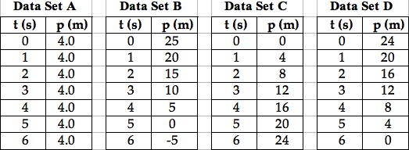

Which data set depicts the largest speed? Ignore all + and - signs; compare magnitude only.

**Question 2:**

aa. The position-time data sets below represent the motion of four objects.

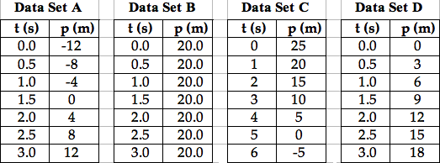

Which data set depicts the largest speed? Ignore all + and - signs; compare magnitude only.

**Question 3:**

aa. The position-time data sets below represent the motion of four objects.

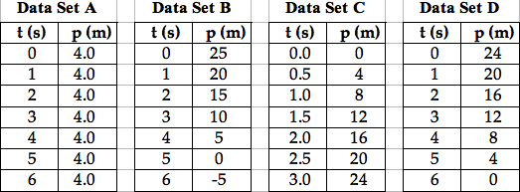

Which data set depicts an object that is moving, yet with the smallest speed? Ignore all + and - signs; compare magnitude only.

**Question 4:**

aa. The position-time data sets below represent the motion of four objects.

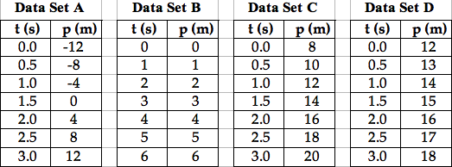

Which data set depicts an object that is moving, yet with the smallest speed? Ignore all + and - signs; compare magnitude only.

**Question 5:**

aa. The position-time data sets below represent the motion of four objects.

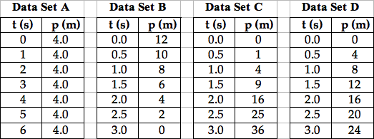

Which data set depicts a constant, non-zero speed? Select all that apply.

**Question 6:**

aa. The position-time data sets below represent the motion of four objects.

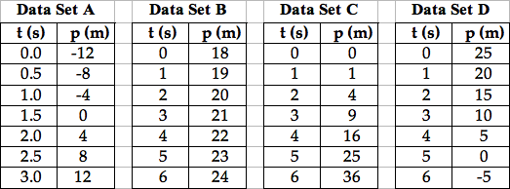

Which data set depicts a constant, non-zero speed? Select all that apply.

**Question 7:**

aa. The position-time data sets below represent the motion of four objects.

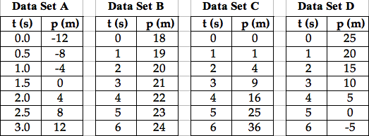

Which data sets depict an acceleration? Select all that apply.

**Question 8:**

aa. The position-time data sets below represent the motion of four objects.

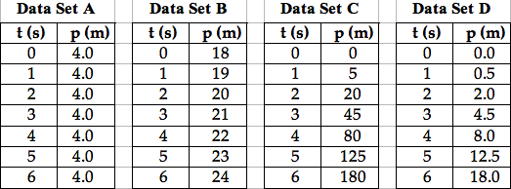

Which data sets depict an acceleration? Select all that apply.

**Question 9:**

aa. The velocity-time data sets below represent the motion of four objects.

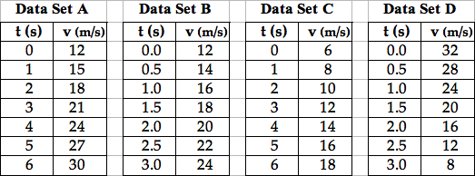

Which data set depicts the largest acceleration? Ignore all + and - signs; compare magnitude only.

**Question 10:**

aa. The velocity-time data sets below represent the motion of four objects.

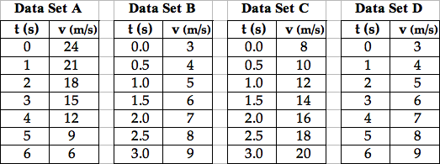

Which data set depicts the largest acceleration? Ignore all + and - signs; compare magnitude only.

**Question 11:**

aa. The velocity-time data sets below represent the motion of four objects.

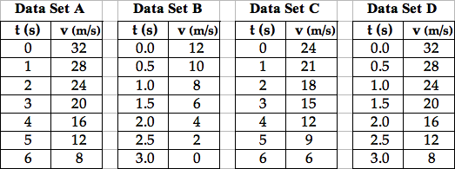

Which data set depicts the smallest acceleration? Ignore all + and - signs; compare magnitude only.

**Question 12:**

aa. The velocity-time data sets below represent the motion of four objects.

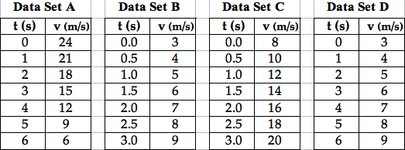

Which data set depicts the smallest acceleration? Ignore all + and - signs; compare magnitude only.

**Question 13:**

aa. The velocity-time data sets below represent the motion of four objects.

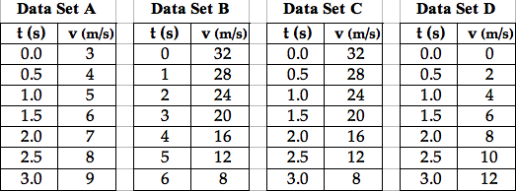

Which data set(s) depict(s) a negative acceleration? Select all that apply.

**Question 14:**

aa. The velocity-time data sets below represent the motion of four objects.

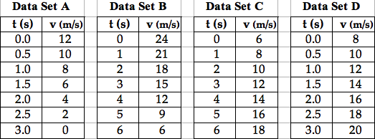

Which data set(s) depict(s) a negative acceleration? Select all that apply.

**Question 15:**

aa. Which of the following data sets represent the motion of an object with an acceleration of +4.0 m/s/s?

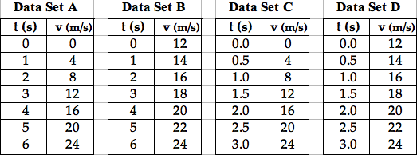

Select all that apply.

**Question 16:**

aa. Which of the following data sets represent the motion of an object with an acceleration of +3.0 m/s/s?

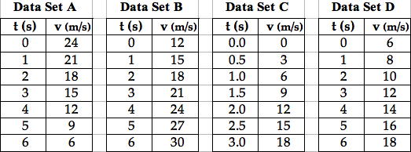

Select all that apply.

**Question 17:**

aa. Which of the following data sets represent the motion of an object with an acceleration of +2.0 m/s/s?

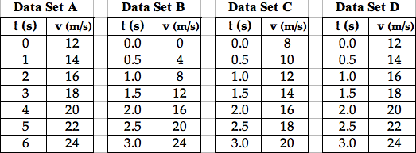

Select all that apply.

**Question 18:**

aa. Which of the following data sets represent the motion of an object with an acceleration of +8.0 m/s/s?

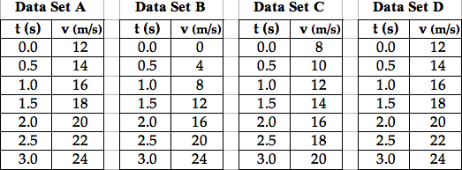

Select all that apply.

**Question 19:**

aa. Which of the following data sets represent the motion of an object with an acceleration of +2.0 m/s/s?

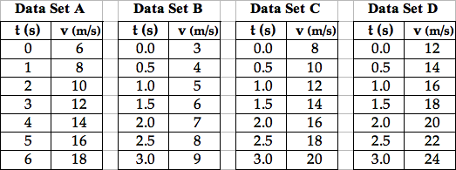

Select all that apply.