**Minds On Physics Question Banks – Circular Motion and Gravitation**

**CG1: Speed and Velocity**

**Question 1:**

aa. Speed is a ____ quantity and velocity is a ___ quantity. Identify the two terms that fill the blanks in their respective order.

a. scalar, vector b. vector, scalar

c. measurable, immeasurable d. immeasurable, measurable

e. None of these terms appropriate fill in the blank.

**Question 2:**

aa. Speed is a ____ quantity and velocity is a ___ quantity. Identify the two terms that fill the blanks in their respective order.

a. vector, scalar b. scalar, vector

c. immeasurable, measurable d. measurable, immeasurable

e. None of these terms appropriate fill in the blank.

**Question 3:**

aa. Speed is a ____ quantity and velocity is a ___ quantity. Identify the two terms that fill the blanks in their respective order.

a. measurable, immeasurable b. immeasurable, measurable

c. scalar, vector d. vector, scalar

e. None of these terms appropriate fill in the blank.

**Question 4:**

aa. Speed is a ____ quantity and velocity is a ___ quantity. Identify the two terms that fill the blanks in their respective order.

a. immeasurable, measurable b. measurable, immeasurable

c. vector, scalar d. scalar, vector

e. None of these terms appropriate fill in the blank.

**Question 5:**

aa. A ___ quantity has both magnitude and direction. A ___ quantity has magnitude alone. Identify the two terms that fill the blanks in their respective order.

a. immeasurable, measurable b. measurable, immeasurable

c. scalar, vector d. vector, scalar

e. None of these terms appropriate fill in the blank.

**Question 6:**

aa. A ___ quantity has both magnitude and direction. A ___ quantity has magnitude alone. Identify the two terms that fill the blanks in their respective order.

a. measurable, immeasurable b. immeasurable, measurable

c. vector, scalar d. scalar, vector

e. None of these terms appropriate fill in the blank.

**Question 7:**

aa. A ___ quantity has both magnitude and direction. A ___ quantity has magnitude alone. Identify the two terms that fill the blanks in their respective order.

a. scalar, vector b. vector, scalar

c. immeasurable, measurable d. measurable, immeasurable

e. None of these terms appropriate fill in the blank.

**Question 8:**

aa. A ___ quantity has both magnitude and direction. A ___ quantity has magnitude alone. Identify the two terms that fill the blanks in their respective order.

a. vector, scalar b. scalar, vector

c. measurable, immeasurable d. immeasurable, measurable

e. None of these terms appropriate fill in the blank.

**Question 9:**

aa. **TRUE** or **FALSE**?

An object can move in a circle at a constant speed and still have a changing velocity.

a. True b. False

**Question 10:**

aa. **TRUE** or **FALSE**?

An object that moves in a circle at a constant speed will also have a constant velocity.

a. True b. False

**Question 11:**

aa. **TRUE** or **FALSE**?

An object CAN move in a circle and have a constant speed.

a. True b. False

**Question 12:**

aa. **TRUE** or **FALSE**?

An object CAN move in a circle and have a constant velocity.

a. True b. False

**Question 13:**

aa. An object is moving in a circle. The velocity of the object at any given moment is directed ____.

a. tangent to the circle

b. inward, towards the center of the circle

c. outward, away from the center of the circle

d. Nonsense! There is never a direction associated with the velocity.

e. No such generalization can be made about the direction of the velocity vector.

**Question 14:**

aa. An object is moving in a circle. The velocity of the object at any given moment is directed ____.

a. outward, away from the center of the circle

b. tangent to the circle

c. inward, towards the center of the circle

d. Nonsense! There is never a direction associated with the velocity.

e. No such generalization can be made about the direction of the velocity vector.

**Question 15:**

aa. An object is moving in a circle. The velocity of the object at any given moment is directed ____.

a. inward, towards the center of the circle

b. outward, away from the center of the circle

c. tangent to the circle

d. Nonsense! There is never a direction associated with the velocity.

e. No such generalization can be made about the direction of the velocity vector.

**Question 16:**

aa. An object is moving in a circle. The velocity of the object at any given moment is directed ____.

a. Nonsense! There is never a direction associated with the velocity.

b. inward, towards the center of the circle

c. outward, away from the center of the circle

d. tangent to the circle

e. No such generalization can be made about the direction of the velocity vector.

**Question 17:**

aa. An object is moving in a circle at a constant speed in a 'clockwise fashion.' A 'God's eye' view of the circle and the object's location is shown.

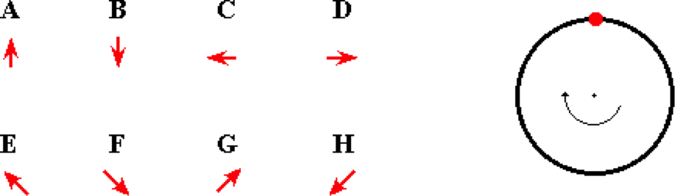

The vector arrow that best represents the direction of the velocity at the indicated location (12 o'clock) is ____.

**Question 18:**

aa. An object is moving in a circle at a constant speed in a 'clockwise fashion.' A 'God's eye' view of the circle and the object's location is shown.

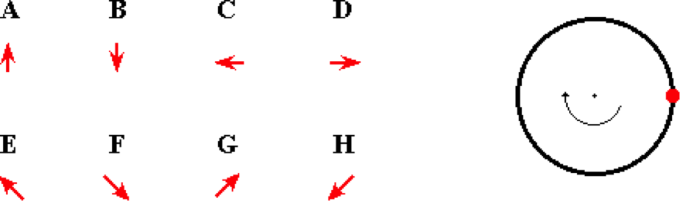

The vector arrow that best represents the direction of the velocity at the indicated location (3 o'clock) is ____.

**Question 19:**

aa. An object is moving in a circle at a constant speed in a 'clockwise fashion.' A 'God's eye' view of the circle and the object's location is shown.

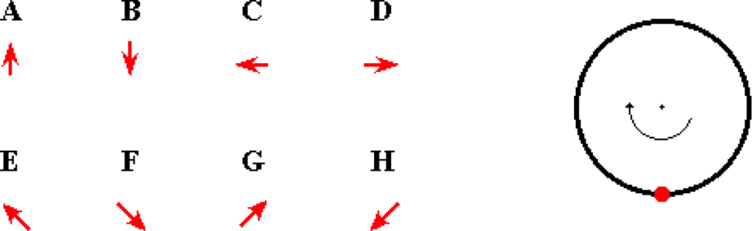

The vector arrow that best represents the direction of the velocity at the indicated location (6 o'clock) is ____.

**Question 20:**

aa. An object is moving in a circle at a constant speed in a 'clockwise fashion.' A 'God's eye' view of the circle and the object's location is shown.

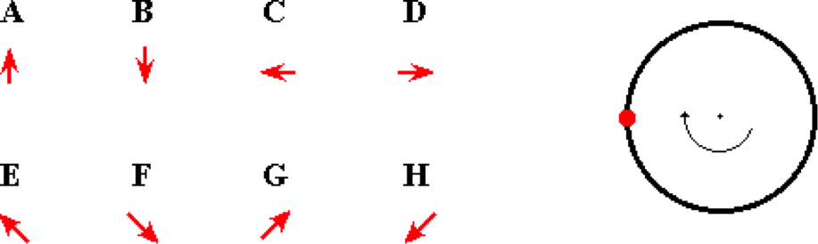

The vector arrow that best represents the direction of the velocity at the indicated location (9 o'clock) is ____.

**Question 21:**

aa. An object is moving in a circle at a constant speed in a 'clockwise fashion.' A 'God's eye' view of the circle and the object's location is shown.

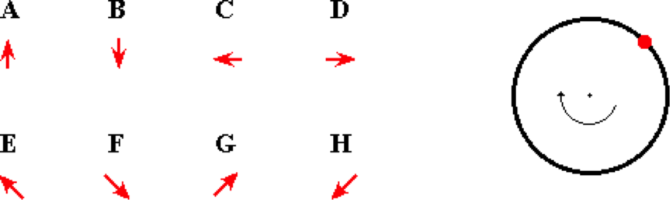

The vector arrow that best represents the direction of the velocity at the indicated location (1:30 position) is ____.

**Question 22:**

aa. An object is moving in a circle at a constant speed in a 'clockwise fashion.' A 'God's eye' view of the circle and the object's location is shown.

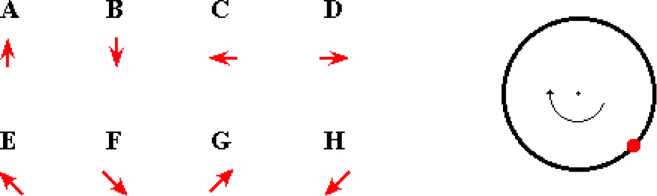

The vector arrow that best represents the direction of the velocity at the indicated location (4:30 position) is ____.

**Question 23:**

aa. An object is moving in a circle at a constant speed in a 'clockwise fashion.' A 'God's eye' view of the circle and the object's location is shown.

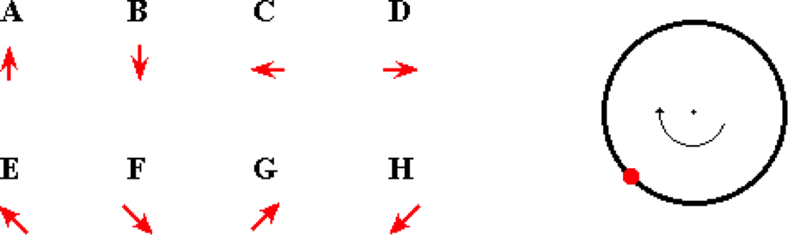

The vector arrow that best represents the direction of the velocity at the indicated location (7:30 position) is ____.

**Question 24:**

aa. An object is moving in a circle at a constant speed in a 'clockwise fashion.' A 'God's eye' view of the circle and the object's location is shown.

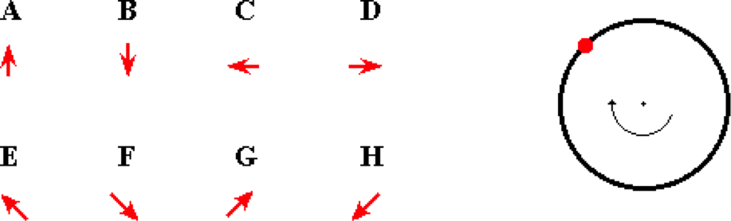

The vector arrow that best represents the direction of the velocity at the indicated location (10:30 position) is ____.

**Question 25:**

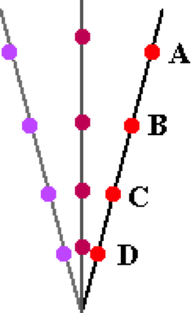aa. Four objects are attached to a 1-meter long string at various locations. The string is held at one end and twirled in a circle. The object that moves with the greatest speed is object ___.

a. A

b. B

c. C

d. D

e. Nonsense! They all move with the same speed.

**Question 26:**

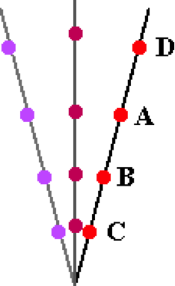aa. Four objects are attached to a 1-meter long string at various locations. The string is held at one end and twirled in a circle. The object that moves with the greatest speed is object ___.

a. A

b. B

c. C

d. D

e. Nonsense! They all move with the same speed.

**Question 27:**

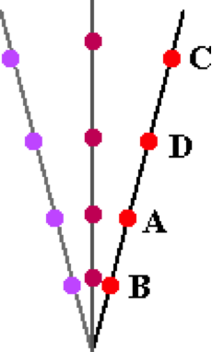aa. Four objects are attached to a 1-meter long string at various locations. The string is held at one end and twirled in a circle. The object that moves with the greatest speed is object ___.

a. A

b. B

c. C

d. D

e. Nonsense! They all move with the same speed.

**Question 28:**

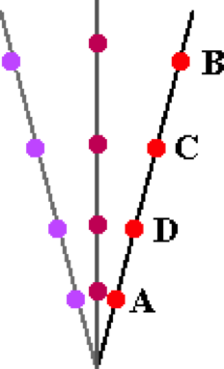aa. Four objects are attached to a 1-meter long string at various locations. The string is held at one end and twirled in a circle. The object that moves with the greatest speed is object ___.

a. A

b. B

c. C

d. D

e. Nonsense! They all move with the same speed.

**Question 29:**

aa. Four objects move in circles at different speeds. The radius and the period are listed below. Rank these four objects in increasing order of their speed, beginning with the slowest. List the four letters with no spaces or commas between letters.

Object A Object B Object C Object D

R = 1.0 m R = 2.0 m R = 1.0 m R = 1.0 m

T = 2.0 s T = 0.5 s T = 0.5 s T = 1.0 s

**Question 30:**

aa. Four objects move in circles at different speeds. The radius and the period are listed below. Rank these four objects in increasing order of their speed, beginning with the slowest. List the four letters with no spaces or commas between letters.

Object A Object B Object C Object D

R = 2.0 m R = 1.0 m R = 1.0 m R = 1.0 m

T = 0.5 s T = 0.5 s T = 1.0 s T = 2.0 s

**Question 31:**

aa. Four objects move in circles at different speeds. The radius and the period are listed below. Rank these four objects in increasing order of their speed, beginning with the slowest. List the four letters with no spaces or commas between letters.

Object A Object B Object C Object D

R = 1.0 m R = 1.0 m R = 1.0 m R = 2.0 m

T = 0.5 s T = 1.0 s T = 2.0 s T = 0.5 s

**Question 32:**

aa. Four objects move in circles at different speeds. The radius and the period are listed below. Rank these four objects in increasing order of their speed, beginning with the slowest. List the four letters with no spaces or commas between letters.

Object A Object B Object C Object D

R = 1.0 m R = 1.0 m R = 2.0 m R = 1.0 m

T = 1.0 s T = 2.0 s T = 0.5 s T = 0.5 s

**CG2: Acceleration and Net Force**

**Question 1:**

aa. If an object is accelerating, then the object MUST be ____. List all that apply in alphabetical order with no commas or spaces between letters.

a. changing its direction b. slowing down

c. speeding up d. changing its velocity

e. changing its speed f. maintaining a constant velocity

**Question 2:**

aa. If an object is accelerating, then the object MUST be ____. List all that apply in alphabetical order with no commas or spaces between letters.

a. speeding up b. slowing down

c. changing its direction d. changing its speed

e. maintaining a constant velocity f. changing its velocity

**Question 3:**

aa. If an object is accelerating, then the object MUST be ____. List all that apply in alphabetical order with no commas or spaces between letters.

a. maintaining a constant velocity b. changing its speed

c. changing its velocity d. changing its direction

e. slowing down f. speeding up

**Question 4:**

aa. If an object is accelerating, then the object MUST be ____. List all that apply in alphabetical order with no commas or spaces between letters.

a. maintaining a constant velocity b. changing its velocity

c. changing its direction d. changing its speed

e. slowing down f. speeding up

**Question 5:**

aa. An object is moving in a circle at a constant speed of 30 m/s. It is known for sure that the object is accelerating because it is ____.

a. increasing the magnitude of its velocity

b. decreasing the magnitude of its velocity

c. changing the direction of its velocity

d. returning to its original location

e. changing its location

f. changing the distance that it is from the center of the circle

g. Nonsense! Such an object is NOT accelerating.

**Question 6:**

aa. An object is moving in a circle at a constant speed of 30 m/s. It is known for sure that the object is accelerating because it is ____.

a. returning to its original location

b. changing its location

c. changing the distance that it is from the center of the circle

d. increasing the magnitude of its velocity

e. decreasing the magnitude of its velocity

f. changing the direction of its velocity

g. Nonsense! Such an object is NOT accelerating.

**Question 7:**

aa. An object is moving in a circle at a constant speed of 30 m/s. It is known for sure that the object is accelerating because it is ____.

a. changing the distance that it is from the center of the circle

b. changing the direction of its velocity

c. increasing the magnitude of its velocity

d. decreasing the magnitude of its velocity

e. returning to its original location

f. changing its location

g. Nonsense! Such an object is NOT accelerating.

**Question 8:**

aa. An object is moving in a circle at a constant speed of 30 m/s. It is known for sure that the object is accelerating because it is ____.

a. returning to its original location

b. changing its location

c. changing the distance that it is from the center of the circle

d. changing the direction of its velocity

e. decreasing the magnitude of its velocity

f. increasing the magnitude of its velocity

g. Nonsense! Such an object is NOT accelerating.

**Question 9:**

aa. Consider the general motion of any object. The acceleration of the object is ____ as the direction of the velocity of the object; and the acceleration is ____ as the direction of the net force acting upon the object. List the two letters in their respective order.

a. always in the same direction

b. always in the opposite direction

c. sometimes (but not always) in the same direction

d. never in the same direction (but not necessarily in the opposite direction)

**Question 10:**

aa. Consider the general motion of any object. The acceleration of the object is ____ as the direction of the velocity of the object; and the acceleration is ____ as the direction of the net force acting upon the object. List the two letters in their respective order.

a. never in the same direction (but not necessarily in the opposite direction)

b. sometimes (but not always) in the same direction

c. always in the same direction

d. always in the opposite direction

**Question 11:**

aa. Consider the general motion of any object. The acceleration of the object is ____ as the direction of the velocity of the object; and the acceleration is ____ as the direction of the net force acting upon the object. List the two letters in their respective order.

a. always in the same direction

b. sometimes (but not always) in the same direction

c. never in the same direction (but not necessarily in the opposite direction)

d. always in the opposite direction

**Question 12:**

aa. Consider the general motion of any object. The acceleration of the object is ____ as the direction of the velocity of the object; and the acceleration is ____ as the direction of the net force acting upon the object. List the two letters in their respective order.

a. never in the same direction (but not necessarily in the opposite direction)

b. always in the same direction

c. sometimes (but not always) in the same direction

d. always in the opposite direction

**Question 13:**

aa. An object moves in a circle at a constant speed. The direction of the acceleration vector is best described as being ____.

a. inward, towards the center of the circle

b. outward, away from the center of the circle

c. tangent to the circle in the same direction as the motion

d. Nonsense! If the speed is constant, then there is no acceleration vector.

e. No such generalization can be made about the direction of the acceleration vector.

**Question 14:**

aa. An object moves in a circle at a constant speed. The direction of the acceleration vector is best described as being ____.

a. tangent to the circle in the same direction as the motion

b. outward, away from the center of the circle

c. inward, towards the center of the circle

d. Nonsense! If the speed is constant, then there is no acceleration vector.

e. No such generalization can be made about the direction of the acceleration vector.

**Question 15:**

aa. An object moves in a circle at a constant speed. The direction of the acceleration vector is best described as being ____.

a. outward, away from the center of the circle

b. inward, towards the center of the circle

c. tangent to the circle in the same direction as the motion

d. Nonsense! If the speed is constant, then there is no acceleration vector.

e. No such generalization can be made about the direction of the acceleration vector.

**Question 16:**

aa. An object moves in a circle at a constant speed. The direction of the acceleration vector is best described as being ____.

a. Nonsense! If the speed is constant, then there is no acceleration vector.

b. tangent to the circle in the same direction as the motion

c. outward, away from the center of the circle

d. inward, towards the center of the circle

e. No such generalization can be made about the direction of the acceleration vector.

**Question 17:**

aa. An object moves in a circle at a constant speed. The direction of the net force is best described as being ____.

a. inward, towards the center of the circle

b. outward, away from the center of the circle

c. tangent to the circle in the same direction as the motion

d. Nonsense! If the speed is constant then the net force is zero.

e. Nonsense! There is never a direction associated with the net force.

**Question 18:**

aa. An object moves in a circle at a constant speed. The direction of the net force is best described as being ____.

a. outward, away from the center of the circle

b. inward, towards the center of the circle

c. tangent to the circle in the same direction as the motion

d. Nonsense! If the speed is constant then the net force is zero.

e. Nonsense! There is never a direction associated with the net force.

**Question 19:**

aa. An object moves in a circle at a constant speed. The direction of the net force is best described as being ____.

a. tangent to the circle in the same direction as the motion

b. outward, away from the center of the circle

c. inward, towards the center of the circle

d. Nonsense! If the speed is constant then the net force is zero.

e. Nonsense! There is never a direction associated with the net force.

**Question 20:**

aa. An object moves in a circle at a constant speed. The direction of the net force is best described as being ____.

a. Nonsense! If the speed is constant then the net force is zero.

b. tangent to the circle in the same direction as the motion

c. outward, away from the center of the circle

d. inward, towards the center of the circle

e. Nonsense! There is never a direction associated with the net force.

**Question 21:**

aa. An object is moving in a circle at a constant speed in a 'clockwise fashion.' A 'God's eye' view of the circle is shown.



For the indicated position (12 o'clock), the direction of the velocity vector is represented by arrow ____; the direction of the acceleration vector is represented by ____; and the direction of the net force vector is represented by arrow ____.

**Question 22:**

aa. An object is moving in a circle at a constant speed in a 'clockwise fashion.' A 'God's eye' view of the circle is shown.



For the indicated position (3 o'clock), the direction of the velocity vector is represented by arrow ____; the direction of the acceleration vector is represented by ____; and the direction of the net force vector is represented by arrow ____.

**Question 23:**

aa. An object is moving in a circle at a constant speed in a 'clockwise fashion.' A 'God's eye' view of the circle is shown.



For the indicated position (6 o'clock), the direction of the velocity vector is represented by arrow ____; the direction of the acceleration vector is represented by ____; and the direction of the net force vector is represented by arrow ____.

**Question 24:**

aa. An object is moving in a circle at a constant speed in a 'clockwise fashion.' A 'God's eye' view of the circle is shown.



For the indicated position (9 o'clock), the direction of the velocity vector is represented by arrow ____; the direction of the acceleration vector is represented by ____; and the direction of the net force vector is represented by arrow ____.

**Question 25:**

aa. An object is moving in a circle at a constant speed in a 'clockwise fashion.' A 'God's eye' view of the circle is shown.



For the indicated position (1:30), the direction of the velocity vector is represented by arrow ____; the direction of the acceleration vector is represented by ____; and the direction of the net force vector is represented by arrow ____.

**Question 26:**

aa. An object is moving in a circle at a constant speed in a 'clockwise fashion.' A 'God's eye' view of the circle is shown.



For the indicated position (4:30), the direction of the velocity vector is represented by arrow ____; the direction of the acceleration vector is represented by ____; and the direction of the net force vector is represented by arrow ____.

**Question 27:**

aa. An object is moving in a circle at a constant speed in a 'clockwise fashion.' A 'God's eye' view of the circle is shown.



For the indicated position (7:30), the direction of the velocity vector is represented by arrow ____; the direction of the acceleration vector is represented by ____; and the direction of the net force vector is represented by arrow ____.

**Question 28:**

aa. An object is moving in a circle at a constant speed in a 'clockwise fashion.' A 'God's eye' view of the circle is shown.



For the indicated position (10:30), the direction of the velocity vector is represented by arrow ____; the direction of the acceleration vector is represented by ____; and the direction of the net force vector is represented by arrow ____.

**Question 29:**

aa. An object with mass 'm' is moving in a circle of radius 'R' at a constant speed of 'v.' The acceleration of the object will INCREASE if ____. List all that apply in alphabetical order with no commas or spaces between letters.

a. its speed were increased (while 'R' and "m" are held constant)

b. its speed were decreased (while 'R' and "m" are held constant)

c. its radius were increased (while 'v' and "m" are held constant)

d. its radius were decreased (while 'v' and "m" are held constant)

e. its mass were increased (while 'R' and "v" are held constant)

f. its mass were decreased (while 'R' and "v" are held constant)

g. Nonsense! None of these alterations would increase the acceleration of the object.

**Question 30:**

aa. An object with mass 'm' is moving in a circle of radius 'R' at a constant speed of 'v.' The acceleration of the object will INCREASE if ____. List all that apply in alphabetical order with no commas or spaces between letters.

a. its mass were increased (while 'R' and "v" are held constant)

b. its speed were increased (while 'R' and "m" are held constant)

c. its radius were increased (while 'v' and "m" are held constant)

d. its mass were decreased (while 'R' and "v" are held constant)

e. its speed were decreased (while 'R' and "m" are held constant)

f. its radius were decreased (while 'v' and "m" are held constant)

g. Nonsense! None of these alterations would increase the acceleration of the object.

**Question 31:**

aa. An object with mass 'm' is moving in a circle of radius 'R' at a constant speed of 'v.' The acceleration of the object will DECREASE if ____. List all that apply in alphabetical order with no commas or spaces between letters.

a. its mass were increased (while 'R' and "v" are held constant)

b. its mass were decreased (while 'R' and "v" are held constant)

c. its radius were increased (while 'v' and "m" are held constant)

d. its radius were decreased (while 'v' and "m" are held constant)

e. its speed were increased (while 'R' and "m" are held constant)

f. its speed were decreased (while 'R' and "m" are held constant)

g. Nonsense! None of these alterations would decrease the acceleration of the object.

**Question 32:**

aa. An object with mass 'm' is moving in a circle of radius 'R' at a constant speed of 'v.' The acceleration of the object will DECREASE if ____. List all that apply in alphabetical order with no commas or spaces between letters.

a. its mass were decreased (while 'R' and "v" are held constant)

b. its radius were decreased (while 'v' and "m" are held constant)

c. its speed were decreased (while 'R' and "m" are held constant)

d. its mass were increased (while 'R' and "v" are held constant)

e. its radius were increased (while 'v' and "m" are held constant)

f. its speed were increased (while 'R' and "m" are held constant)

g. Nonsense! None of these alterations would decrease the acceleration of the object.

**Question 33:**

aa. An object with mass 'm' is moving in a circle of radius 'R' at a constant speed of 'v.' The net force acting upon the object must be INCREASED if ____. List all that apply in alphabetical order with no commas or spaces between letters.

a. its speed were increased (while 'R' and "m" are held constant)

b. its speed were decreased (while 'R' and "m" are held constant)

c. its radius were increased (while 'v' and "m" are held constant)

d. its radius were decreased (while 'v' and "m" are held constant)

e. its mass were increased (while 'R' and "v" are held constant)

f. its mass were decreased (while 'R' and "v" are held constant)

g. Nonsense! None of these alterations will increase the net force acting upon the object.

**Question 34:**

aa. An object with mass 'm' is moving in a circle of radius 'R' at a constant speed of 'v.' The net force acting upon the object must be INCREASED if ____. List all that apply in alphabetical order with no commas or spaces between letters.

a. its mass were increased (while 'R' and "v" are held constant)

b. its speed were increased (while 'R' and "m" are held constant)

c. its radius were increased (while 'v' and "m" are held constant)

d. its mass were decreased (while 'R' and "v" are held constant)

e. its speed were decreased (while 'R' and "m" are held constant)

f. its radius were decreased (while 'v' and "m" are held constant)

g. Nonsense! None of these alterations will increase the net force acting upon the object.

**Question 35:**

aa. An object with mass 'm' is moving in a circle of radius 'R' at a constant speed of 'v.' The net force acting upon the object must be DECREASED if ____. List all that apply in alphabetical order with no commas or spaces between letters.

a. its mass were increased (while 'R' and "v" are held constant)

b. its mass were decreased (while 'R' and "v" are held constant)

c. its radius were increased (while 'v' and "m" are held constant)

d. its radius were decreased (while 'v' and "m" are held constant)

e. its speed were increased (while 'R' and "m" are held constant)

f. its speed were decreased (while 'R' and "m" are held constant)

g. Nonsense! None of these alterations will increase the net force acting upon the object.

**Question 36:**

aa. An object with mass 'm' is moving in a circle of radius 'R' at a constant speed of 'v.' The net force acting upon the object must be DECREASED if ____. List all that apply in alphabetical order with no commas or spaces between letters.

a. its mass were decreased (while 'R' and "v" are held constant)

b. its radius were decreased (while 'v' and "m" are held constant)

c. its speed were decreased (while 'R' and "m" are held constant)

d. its mass were increased (while 'R' and "v" are held constant)

e. its radius were increased (while 'v' and "m" are held constant)

f. its speed were increased (while 'R' and "m" are held constant)

g. Nonsense! None of these alterations will increase the net force acting upon the object.

**CG3: Centripetal Force and Inertia**

**Question 1:**

aa. An eraser is tied to a string and held by a physics teacher. The eraser is whirled in a circle at constant speed. A 'God's eye' view of the circle is shown in the diagrams below.

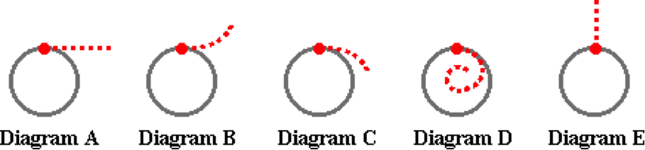

If the teacher lets go of the string when the eraser is at the indicated position, then which one of the paths best represents the motion of the eraser?

**Question 2:**

aa. An eraser is tied to a string and held by a physics teacher. The eraser is whirled in a circle at constant speed. A 'God's eye' view of the circle is shown in the diagrams below.

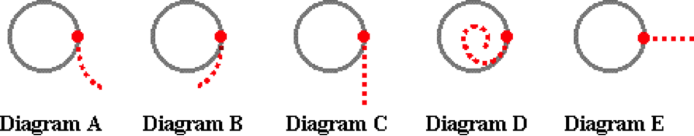

If the teacher lets go of the string when the eraser is at the indicated position, then which one of the paths best represents the motion of the eraser?

**Question 3:**

aa. An eraser is tied to a string and held by a physics teacher. The eraser is whirled in a circle at constant speed. A 'God's eye' view of the circle is shown in the diagrams below.

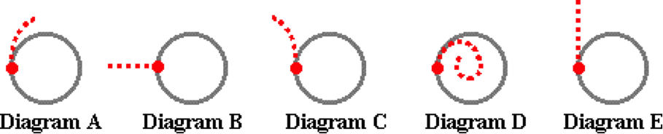

If the teacher lets go of the string when the eraser is at the indicated position, then which one of the paths best represents the motion of the eraser?

**Question 4:**

aa. An eraser is tied to a string and held by a physics teacher. The eraser is whirled in a circle at constant speed. A 'God's eye' view of the circle is shown in the diagrams below.

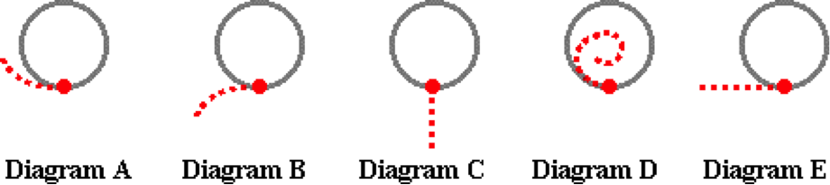

If the teacher lets go of the string when the eraser is at the indicated position, then which one of the paths best represents the motion of the eraser?

**Question 5:**

aa. An eraser is tied to a string and whirled in a horizontal circle at a constant speed. Inertia is the natural tendency of the eraser to resist changes in its state of motion. This means that the eraser ___.

a. will continue along its circular path if the forces on it suddenly become balanced

b. is not accelerating since it is maintaining the same circular path at a constant speed

c. is experiencing a balance of forces - the inward and the outward force balance each other

d. would require an unbalanced force in order to leave the circle and continue tangent to it

e. would naturally move tangent to the circle if the string is released

**Question 6:**

aa. An eraser is tied to a string and whirled in a horizontal circle at a constant speed. Inertia is the natural tendency of the eraser to resist changes in its state of motion. This means that the eraser ___.

a. is experiencing a balance of forces - the inward and the outward force balance each other

b. would require an unbalanced force in order to leave the circle and continue tangent to it

c. will continue along its circular path if the forces on it suddenly become balanced

d. would naturally move tangent to the circle if the string is released

e. is not accelerating since it is maintaining the same circular path at a constant speed

**Question 7:**

aa. An eraser is tied to a string and whirled in a horizontal circle at a constant speed. Inertia is the natural tendency of the eraser to resist changes in its state of motion. This means that the eraser ___.

a. is not accelerating since it is maintaining the same circular path at a constant speed

b. would naturally move tangent to the circle if the string is released

c. will continue along its circular path if the forces on it suddenly become balanced

d. would require an unbalanced force in order to leave the circle and continue tangent to it

e. is experiencing a balance of forces - the inward and the outward force balance each other

**Question 8:**

aa. An eraser is tied to a string and whirled in a horizontal circle at a constant speed. Inertia is the natural tendency of the eraser to resist changes in its state of motion. This means that the eraser ___.

a. is experiencing a balance of forces - the inward and the outward force balance each other

b. would require an unbalanced force in order to leave the circle and continue tangent to it

c. would naturally move tangent to the circle if the string is released

d. is not accelerating since it is maintaining the same circular path at a constant speed

e. will continue along its circular path if the forces on it suddenly become balanced

**Question 9:**

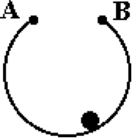aa. **TRUE** or **FALSE**:

A ball is moving around a circular ring in a clockwise direction. A 'God's-eye' view is shown in the diagram. The ball will lose contact with the ring at A and regain contact at B.

a. True b. False

**Question 10:**

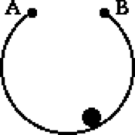aa. **TRUE** or **FALSE**:

A ball is moving around a circular ring in a clockwise direction. A 'God's-eye' view is shown in the diagram. When the ball loses contact with the ring at A, an outward force will begin to push on the ball such that it will not meet up with the ring at point B.

a. True b. False

**Question 11:**

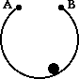aa. **TRUE** or **FALSE**:

A ball is moving around a circular ring in a clockwise direction. A 'God's-eye' view is shown in the diagram. When the ball loses contact with the ring at A, it will continue forward in the same direction tangent to the ring and not meet up with the ring at point B. This behavior is explained by the law of inertia.

a. True b. False

**Question 12:**

aa. **TRUE** or **FALSE**:

A ball is moving around a circular ring in a clockwise direction. A 'God's-eye' view is shown in the diagram. When the ball loses contact with the ring at A, it will continue forward in the same direction and not meet up with the ring at point B. This behavior is explained by the presence of an outward force pushing on the ball to move it away from the circle.

a. True b. False

**Question 13:**

aa. Suppose that you're at an amusement park and you get on a barrel ride. You stand on a platform with your back to the barrel wall. The barrel spins rapidly in a circle and the platform is suddenly dropped out from under you. Rather than falling, you and the wall remain 'pressed together.' This is best explained by the fact that ____.

a. your inertial path is directed tangent to the circle but the wall presses inward to keep you moving in a circle

b. there is a centrifugal force acting upon any object which moves in a circle; this outward force presses you against the wall

c. over the years, many riders have spilled cotton candy on the walls; this makes for a very sticky surface

d. there is an outward force applied by the circle which presses you against the wall

**Question 14:**

aa. Suppose that you're at an amusement park and you get on a barrel ride. You stand on a platform with your back to the barrel wall. The barrel spins rapidly in a circle and the platform is suddenly dropped out from under you. Rather than falling, you and the wall remain 'pressed together.' This is best explained by the fact that ____.

a. there is an outward force applied by the circle which presses you against the wall

b. your inertial path is directed tangent to the circle but the wall presses inward to keep you moving in a circle

c. there is a centrifugal force acting upon any object which moves in a circle; this outward force presses you against the wall

d. over the years, many riders have spilled cotton candy on the walls; this makes for a very sticky surface

**Question 15:**

aa. Suppose that you're at an amusement park and you get on a barrel ride. You stand on a platform with your back to the barrel wall. The barrel spins rapidly in a circle and the platform is suddenly dropped out from under you. Rather than falling, you and the wall remain 'pressed together.' This is best explained by the fact that ____.

a. over the years, many riders have spilled cotton candy on the walls; this makes for a very sticky surface

b. there is an outward force applied by the circle which presses you against the wall

c. your inertial path is directed tangent to the circle but the wall presses inward to keep you moving in a circle

d. there is a centrifugal force acting upon any object which moves in a circle; this outward force presses you against the wall

**Question 16:**

aa. Suppose that you're at an amusement park and you get on a barrel ride. You stand on a platform with your back to the barrel wall. The barrel spins rapidly in a circle and the platform is suddenly dropped out from under you. Rather than falling, you and the wall remain 'pressed together.' This is best explained by the fact that ____.

a. there is a centrifugal force acting upon any object which moves in a circle; this outward force presses you against the wall

b. over the years, many riders have spilled cotton candy on the walls; this makes for a very sticky surface

c. there is an outward force applied by the circle which presses you against the wall

d. your inertial path is directed tangent to the circle but the wall presses inward to keep you moving in a circle

**Question 17:**

aa. A car makes a left-hand turn. The front-seat passenger claims that she feels a sensation of being pulled outwards. This is best explained by the fact that ____.

a. there is a centripetal force pushing the person 'out the door'

b. there is a centrifugal force which pushes the person 'out the door'

c. while there may be a net inward force, there is still an outward force upon the passenger

d. the passenger has a natural tendency to move tangent to and out of the circular path

e. the driver is not enjoying the passenger's company

f. the passenger ate her Big Mac way too fast and is now paying for it

**Question 18:**

aa. A car makes a left-hand turn. The front-seat passenger claims that she feels a sensation of being pulled outwards. This is best explained by the fact that ____.

a. there is a centrifugal force which pushes the person 'out the door'

b. there is a centripetal force pushing the person 'out the door'

c. the passenger has a natural tendency to move tangent to and out of the circular path

d. while there may be a net inward force, there is still an outward force upon the passenger

e. the passenger ate her Big Mac way too fast and is now paying for it

f. the driver is not enjoying the passenger's company

**Question 19:**

aa. A car makes a left-hand turn. The front-seat passenger claims that she feels a sensation of being pulled outwards. This is best explained by the fact that ____.

a. while there may be a net inward force, there is still an outward force upon the passenger

b. the passenger has a natural tendency to move tangent to and out of the circular path

c. there is a centripetal force pushing the person 'out the door'

d. there is a centrifugal force which pushes the person 'out the door'

e. the driver is not enjoying the passenger's company

f. the passenger ate her Big Mac way too fast and is now paying for it

**Question 20:**

aa. A car makes a left-hand turn. The front-seat passenger claims that she feels a sensation of being pulled outwards. This is best explained by the fact that ____.

a. the passenger has a natural tendency to move tangent to and out of the circular path

b. while there may be a net inward force, there is still an outward force upon the passenger

c. there is a centrifugal force which pushes the person 'out the door'

d. there is a centripetal force pushing the person 'out the door'

e. the driver is not enjoying the passenger's company

f. the passenger ate her Big Mac way too fast and is now paying for it

**Question 21:**

aa. Suppose you go with your friend on a roller coaster ride. After the ride, your friend describes the 'awesome outward pull on the second loop.' Such a statement only proves that your friend ____.

a. is a coaster fanatic

b. truly experienced a centrifugal force

c. has consumed way too much cotton candy

d. knows that riders moving through circles experience outward forces

e. might not understand the physics of circular motion

**Question 22:**

aa. Suppose you go with your friend on a roller coaster ride. After the ride, your friend describes the 'awesome outward pull on the second loop.' Such a statement only proves that your friend ____.

a. knows that riders moving through circles experience outward forces

b. is a coaster fanatic

c. truly experienced a centrifugal force

d. has consumed way too much cotton candy

e. might not understand the physics of circular motion

**Question 23:**

aa. Suppose you go with your friend on a roller coaster ride. After the ride, your friend describes the 'awesome outward pull on the second loop.' Such a statement only proves that your friend ____.

a. has consumed way too much cotton candy

b. knows that riders moving through circles experience outward forces

c. is a coaster fanatic

d. truly experienced a centrifugal force

e. might not understand the physics of circular motion

**Question 24:**

aa. Suppose you go with your friend on a roller coaster ride. After the ride, your friend describes the 'awesome outward pull on the second loop.' Such a statement only proves that your friend ____.

a. truly experienced a centrifugal force

b. has consumed way too much cotton candy

c. knows that riders moving through circles experience outward forces

d. is a coaster fanatic

e. might not understand the physics of circular motion

**Question 25:**

aa. Suppose that you are a passenger in a car. The car travels over the top of a small hill in the road at a high speed. As the car reaches the crest of the hill, you feel your body still moving upward; your glutis might even be lifted off the car seat. It might even feel like there is an upward push on your body. This upward sensation is best explained by the ____.

a. tendency of your body to follow its original upward path

b. presence of an upward force on your body

c. presence of a centripetal force on your body

d. presence of a centrifugal force on your body

**Question 26:**

aa. Suppose that you are a passenger in a car. The car travels over the top of a small hill in the road at a high speed. As the car reaches the crest of the hill, you feel your body still moving upward; your glutis might even be lifted off the car seat. It might even feel like there is an upward push on your body. This upward sensation is best explained by the ____.

a. presence of a centrifugal force on your body

b. tendency of your body to follow its original upward path

c. presence of an upward force on your body

d. presence of a centripetal force on your body

**Question 27:**

aa. Suppose that you are a passenger in a car. The car travels over the top of a small hill in the road at a high speed. As the car reaches the crest of the hill, you feel your body still moving upward; your glutis might even be lifted off the car seat. It might even feel like there is an upward push on your body. This upward sensation is best explained by the ____.

a. presence of a centripetal force on your body

b. presence of a centrifugal force on your body

c. tendency of your body to follow its original upward path

d. presence of an upward force on your body

**Question 28:**

aa. Suppose that you are a passenger in a car. The car travels over the top of a small hill in the road at a high speed. As the car reaches the crest of the hill, you feel your body still moving upward; your glutis might even be lifted off the car seat. It might even feel like there is an upward push on your body. This upward sensation is best explained by the ____.

a. presence of an upward force on your body

b. presence of a centripetal force on your body

c. presence of a centrifugal force on your body

d. tendency of your body to follow its original upward path

"

**CG4: The Centripetal Force Requirement**

**Question 1:**

aa. An object is moving in a circle at a constant speed in a 'clockwise fashion.' A 'God's eye' view of the circle is shown.



For the indicated position (12 o'clock), the direction of the velocity vector is represented by arrow ____; the direction of the acceleration vector is represented by ____; and the direction of the net force vector is represented by arrow ____.

**Question 2:**

aa. An object is moving in a circle at a constant speed in a 'clockwise fashion.' A 'God's eye' view of the circle is shown.



For the indicated position (3 o'clock), the direction of the velocity vector is represented by arrow ____; the direction of the acceleration vector is represented by ____; and the direction of the net force vector is represented by arrow ____.

**Question 3:**

aa. An object is moving in a circle at a constant speed in a 'clockwise fashion.' A 'God's eye' view of the circle is shown.



For the indicated position (6 o'clock), the direction of the velocity vector is represented by arrow ____; the direction of the acceleration vector is represented by ____; and the direction of the net force vector is represented by arrow ____.

**Question 4:**

aa. An object is moving in a circle at a constant speed in a 'clockwise fashion.' A 'God's eye' view of the circle is shown.



For the indicated position (9 o'clock), the direction of the velocity vector is represented by arrow ____; the direction of the acceleration vector is represented by ____; and the direction of the net force vector is represented by arrow ____.

**Question 5:**

aa. A car is making a turn on a level roadway. The type of force that causes the car to make the turn is the ____.

a. force of gravity b. normal force

c. air resistance force d. force of friction

e. tension force f. applied force

g. centrifugal force h. inertial force

**Question 6:**

aa. A car is making a turn on a level roadway. The type of force that causes the car to make the turn is the ____.

a. normal force b. force of gravity

c. force of friction d. air resistance force

e. applied force f. tension force

g. inertial force h. centrifugal force

**Question 7:**

aa. A car is making a turn on a level roadway. The type of force that causes the car to make the turn is the ____.

a. centrifugal force b. inertial force

c. tension force d. applied force

e. air resistance force f. force of friction

g. force of gravity h. normal force

**Question 8:**

aa. A car is making a turn on a level roadway. The type of force that causes the car to make the turn is the ____.

a. inertial force b. centrifugal force

c. applied force d. tension force

e. force of friction f. air resistance force

g. normal force h. force of gravity

**Question 9:**

aa. An eraser is tied to a string and whirled in a horizontal circle at a constant speed. The type of force that causes the eraser to turn in a circle is the ____.

a. force of gravity b. normal force

c. air resistance force d. force of friction

e. tension force f. applied force

g. centrifugal force h. inertial force

**Question 10:**

aa. An eraser is tied to a string and whirled in a horizontal circle at a constant speed. The type of force that causes the eraser to turn in a circle is the ____.

a. normal force b. force of gravity

c. force of friction d. air resistance force

e. applied force f. tension force

g. inertial force h. centrifugal force

**Question 11:**

aa. An eraser is tied to a string and whirled in a horizontal circle at a constant speed. The type of force that causes the eraser to turn in a circle is the ____.

a. centrifugal force b. inertial force

c. tension force d. applied force

e. air resistance force f. force of friction

g. force of gravity h. normal force

**Question 12:**

aa. An eraser is tied to a string and whirled in a horizontal circle at a constant speed. The type of force that causes the eraser to turn in a circle is the ____.

a. inertial force b. centrifugal force

c. applied force d. tension force

e. force of friction f. air resistance force

g. normal force h. force of gravity

**Question 13:**

aa. Suppose that you're at an amusement park and you get on a barrel ride. You stand on a platform with your back to the barrel wall. The barrel spins rapidly in a circle, the platform is suddenly dropped out from under you, and you continue moving in a circle. The type of force that causes you to turn in a circle is the ____.

a. force of gravity b. normal force

c. air resistance force d. force of friction

e. tension force f. applied force

g. centrifugal force h. inertial force

**Question 14:**

aa. Suppose that you're at an amusement park and you get on a barrel ride. You stand on a platform with your back to the barrel wall. The barrel spins rapidly in a circle, the platform is suddenly dropped out from under you, and you continue moving in a circle. The type of force that causes you to turn in a circle is the ____.

a. normal force b. force of gravity

c. force of friction d. air resistance force

e. applied force f. tension force

g. inertial force h. centrifugal force

**Question 15:**

aa. Suppose that you're at an amusement park and you get on a barrel ride. You stand on a platform with your back to the barrel wall. The barrel spins rapidly in a circle, the platform is suddenly dropped out from under you, and you continue moving in a circle. The type of force that causes you to turn in a circle is the ____.

a. centrifugal force b. inertial force

c. tension force d. applied force

e. air resistance force f. force of friction

g. force of gravity h. normal force

**Question 16:**

aa. Suppose that you're at an amusement park and you get on a barrel ride. You stand on a platform with your back to the barrel wall. The barrel spins rapidly in a circle, the platform is suddenly dropped out from under you, and you continue moving in a circle. The type of force that causes you to turn in a circle is the ____.

a. inertial force b. centrifugal force

c. applied force d. tension force

e. force of friction f. air resistance force

g. normal force h. force of gravity

**Question 17:**

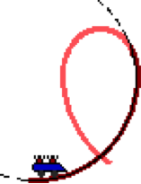aa. Suppose that you are on a roller coaster ride and are moving through a somewhat circular loop. You are at the bottom of the loop and have just begun the upward ascent through the loop (as pictured). One can conclude that the normal force acting upon your body is _____. List all that apply in alphabetical order with no commas or spaces between letters.

a. directed upward

b. directed downward

c. non-existent

d. of greater magnitude than the force of gravity

e. of lesser magnitude than the force of gravity

f. of equal magnitude to the force of gravity

g. ... impossible to tell the relative magnitude since the acceleration value is not explicitly stated

**Question 18:**

aa. Suppose that you are on a roller coaster ride and are moving through a somewhat circular loop. You are at the bottom of the loop and have just begun the upward ascent through the loop (as pictured). One can conclude that the normal force acting upon your body is _____. List all that apply in alphabetical order with no commas or spaces between letters.

a. directed downward

b. directed upward

c. non-existent

d. of equal magnitude to the force of gravity

e. of lesser magnitude than the force of gravity

f. of greater magnitude than the force of gravity

g. ... impossible to tell the relative magnitude since the acceleration value is not explicitly stated

**Question 19:**

aa. Suppose that you are on a roller coaster ride and are moving through a somewhat circular loop. You are at the bottom of the loop and have just begun the upward ascent through the loop (as pictured). One can conclude that the normal force acting upon your body is _____. List all that apply in alphabetical order with no commas or spaces between letters.

a. non-existent

b. of greater magnitude than the force of gravity

c. of lesser magnitude than the force of gravity

d. of equal magnitude to the force of gravity

e. ... impossible to tell the relative magnitude since the acceleration value is not explicitly stated

f. directed upward

g. directed downward

**Question 20:**

aa. Suppose that you are on a roller coaster ride and are moving through a somewhat circular loop. You are at the bottom of the loop and have just begun the upward ascent through the loop (as pictured). One can conclude that the normal force acting upon your body is _____. List all that apply in alphabetical order with no commas or spaces between letters.

a. of equal magnitude to the force of gravity

b. of lesser magnitude than the force of gravity

c. of greater magnitude than the force of gravity

d. ... impossible to tell the relative magnitude since the acceleration value is not explicitly stated

e. non-existent

f. directed downward

g. directed upward

**Question 21:**

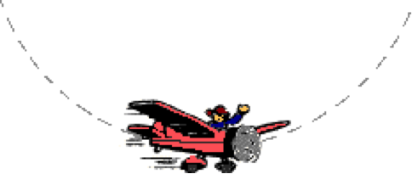aa. To the pleasure of the air show crowd, a pilot makes a series of loop-the-loops. At the bottom of one of the circular loops, the normal force on the pilot is ____. List all that apply in alphabetical order with no commas or spaces between letters.

a. directed upward

b. directed downward

c. non-existent

d. of greater magnitude than the force of gravity

e. of lesser magnitude than the force of gravity

f. of equal magnitude to the force of gravity

g. ... impossible to tell the relative magnitude since the acceleration value is not explicitly stated

**Question 22:**

aa. To the pleasure of the air show crowd, a pilot makes a series of loop-the-loops. At the bottom of one of the circular loops, the normal force on the pilot is ____. List all that apply in alphabetical order with no commas or spaces between letters.

a. directed downward

b. directed upward

c. non-existent

d. of equal magnitude to the force of gravity

e. of lesser magnitude than the force of gravity

f. of greater magnitude than the force of gravity

g. ... impossible to tell the relative magnitude since the acceleration value is not explicitly stated

**Question 23:**

aa. To the pleasure of the air show crowd, a pilot makes a series of loop-the-loops. At the bottom of one of the circular loops, the normal force on the pilot is ____. List all that apply in alphabetical order with no commas or spaces between letters.

a. non-existent

b. of lesser magnitude than the force of gravity

c. of equal magnitude to the force of gravity

d. of greater magnitude than the force of gravity

e. ... impossible to tell the relative magnitude since the acceleration value is not explicitly stated

f. directed upward

g. directed downward

**Question 24:**

aa. To the pleasure of the air show crowd, a pilot makes a series of loop-the-loops. At the bottom of one of the circular loops, the normal force on the pilot is ____. List all that apply in alphabetical order with no commas or spaces between letters.

a. of lesser magnitude than the force of gravity

b. of equal magnitude to the force of gravity

c. of greater magnitude than the force of gravity

d. ... impossible to tell the relative magnitude since the acceleration value is not explicitly stated

e. directed upward

f. directed downward

g. non-existent

**Question 25:**

aa. Suppose that you are on a roller coaster ride and are safely moving through a somewhat circular loop. You are at the top of the loop and riding along the inside of the loop (as pictured). One can conclude that the normal force acting upon your body is _____. List all that apply in alphabetical order with no commas or spaces between letters.

a. directed upward

b. directed downward

c. non-existent

d. of greater magnitude than the force of gravity

e. of lesser magnitude than the force of gravity

f. of equal magnitude to the force of gravity

g. ... impossible to tell the relative magnitude since the acceleration value is not explicitly stated

**Question 26:**

aa. Suppose that you are on a roller coaster ride and are safely moving through a somewhat circular loop. You are at the top of the loop and riding along the inside of the loop (as pictured). One can conclude that the normal force acting upon your body is _____. List all that apply in alphabetical order with no commas or spaces between letters.

a. directed downward

b. directed upward

c. non-existent

d. of equal magnitude to the force of gravity

e. of lesser magnitude than the force of gravity

f. of greater magnitude than the force of gravity

g. ... impossible to tell the relative magnitude since the acceleration value is not explicitly stated

**Question 27:**

aa. Suppose that you are on a roller coaster ride and are safely moving through a somewhat circular loop. You are at the top of the loop and riding along the inside of the loop (as pictured). One can conclude that the normal force acting upon your body is _____. List all that apply in alphabetical order with no commas or spaces between letters.

a. non-existent

b. of greater magnitude than the force of gravity

c. of lesser magnitude than the force of gravity

d. of equal magnitude to the force of gravity

e. ... impossible to tell the relative magnitude since the acceleration value is not explicitly stated

f. directed upward

g. directed downward

**Question 28:**

aa. Suppose that you are on a roller coaster ride and are safely moving through a somewhat circular loop. You are at the top of the loop and riding along the inside of the loop (as pictured). One can conclude that the normal force acting upon your body is _____. List all that apply in alphabetical order with no commas or spaces between letters.

a. of equal magnitude to the force of gravity

b. of lesser magnitude than the force of gravity

c. of greater magnitude than the force of gravity

d. ... impossible to tell the relative magnitude since the acceleration value is not explicitly stated

e. non-existent

f. directed downward

g. directed upward

**Question 29:**

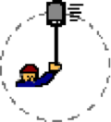aa. A bucket of water is held by a rope and twirled in a vertical circle. The bucket is whirled more rapidly such that the speeds at both the top and the bottom of the circle are increased. As this increase in speed occurs, the _____. List all that apply in alphabetical order with no commas or spaces between letters.

a. acceleration increases b. acceleration decreases

c. acceleration remains unchanged d. tension force increases

e. tension force decreases f. tension force remains unchanged

g. force of gravity increases h. force of gravity decreases

i. force of gravity remains unchanged

**Question 30:**

aa. A bucket of water is held by a rope and twirled in a vertical circle. The bucket is whirled more rapidly such that the speeds at both the top and the bottom of the circle are increased. As this increase in speed occurs, the _____. List all that apply in alphabetical order with no commas or spaces between letters.

a. acceleration remains unchanged b. acceleration increases

c. acceleration decreases d. force of gravity remains unchanged

e. force of gravity increases f. force of gravity decreases

g. tension force remains unchanged h. tension force increases

i. tension force decreases

**Question 31:**

aa. A bucket of water is held by a rope and twirled in a vertical circle. The bucket is whirled more rapidly such that the speeds at both the top and the bottom of the circle are increased. As this increase in speed occurs, the _____. List all that apply in alphabetical order with no commas or spaces between letters.

a. tension force increases b. tension force decreases

c. tension force remains unchanged d. force of gravity increases

e. force of gravity decreases f. force of gravity remains unchanged

g. acceleration increases h. acceleration decreases

i. acceleration remains unchanged

**Question 32:**

aa. A bucket of water is held by a rope and twirled in a vertical circle. The bucket is whirled more rapidly such that the speeds at both the top and the bottom of the circle are increased. As this increase in speed occurs, the _____. List all that apply in alphabetical order with no commas or spaces between letters.

a. acceleration remains unchanged b. acceleration decreases

c. acceleration increases d. tension force remains unchanged

e. tension force decreases f. tension force increases

g. force of gravity remains unchanged h. force of gravity decreases

i. force of gravity increases

**Question 33:**

aa. A bucket of water is held by a rope and twirled in a vertical circle. The tension force acting upon the bucket would decrease to zero if ____.

a. the acceleration was increased to an immeasurably high value

b. the acceleration decreased to a value of 9.8 m/s/s

c. the speed decreased to a value of 9.8 m/s

d. ... nonsense! The tension force cannot be zero if a rope connected to the bucket

**Question 34:**

aa. A bucket of water is held by a rope and twirled in a vertical circle. The tension force acting upon the bucket would decrease to zero if ____.

a. the acceleration decreased to a value of 9.8 m/s/s

b. the speed decreased to a value of 9.8 m/s

c. the acceleration was increased to an immeasurably high value

d. ... nonsense! The tension force cannot be zero if a rope connected to the bucket

**Question 35:**

aa. A bucket of water is held by a rope and twirled in a vertical circle. The tension force acting upon the bucket would decrease to zero if ____.

a. the acceleration was increased to an immeasurably high value

b. the speed decreased to a value of 9.8 m/s

c. the acceleration decreased to a value of 9.8 m/s/s

d. ... nonsense! The tension force cannot be zero if a rope connected to the bucket

**Question 36:**

aa. A bucket of water is held by a rope and twirled in a vertical circle. The tension force acting upon the bucket would decrease to zero if ____.

a. the speed decreased to a value of 9.8 m/s

b. the acceleration decreased to a value of 9.8 m/s/s

c. the acceleration was increased to an immeasurably high value

d. ... nonsense! The tension force cannot be zero if a rope connected to the bucket

**CG5: Mathematical Analysis of Circular Motion**

**Question 1:**

aa. A 1050-kg car is making a turn on a level roadway at 22.5 m/s. The curve resembles the shape of a circle with a radius of 51.9 m. Determine the acceleration (in m/s/s), the net force (in N) and the magnitudes of all individual forces. Finally, indicate the direction of the net force and acceleration. Use g = 9.80 m/s/s.

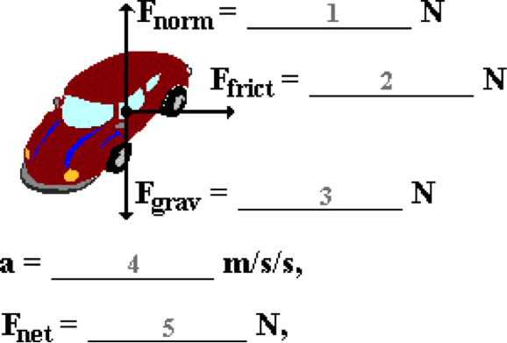

**Question 2:**

aa. A 1120-kg car is making a turn on a level roadway at 18.5 m/s. The curve resembles the shape of a circle with a radius of 45.3 m. Determine the acceleration (in m/s/s), the net force (in N) and the magnitudes of all individual forces. Finally, indicate the direction of the net force and acceleration. Use g = 9.80 m/s/s.



**Question 3:**

aa. A 961-kg car is making a turn on a level roadway at 19.1 m/s. The curve resembles the shape of a circle with a radius of 42.8 m. Determine the acceleration (in m/s/s), the net force (in N) and the magnitudes of all individual forces. Finally, indicate the direction of the net force and acceleration. Use g = 9.80 m/s/s.



**Question 4:**

aa. A 985-kg car is making a turn on a level roadway at 24.5 m/s. The curve resembles the shape of a circle with a radius of 66.1 m. Determine the acceleration (in m/s/s), the net force (in N) and the magnitudes of all individual forces. Finally, indicate the direction of the net force and acceleration. Use g = 9.80 m/s/s.



**Question 5:**

aa. An 82.5-kg person is on a barrel ride at an amusement park. He stands on a platform with his back to the barrel wall. The 4.41-meter diameter barrel spins rapidly in a circle, making a revolution every 2.19 seconds. Determine the velocity (in m/s), acceleration (in m/s/s), the net force (in N) and the magnitudes of all individual forces. Finally, indicate the direction of the net force and acceleration. Use g = 9.80 m/s/s.

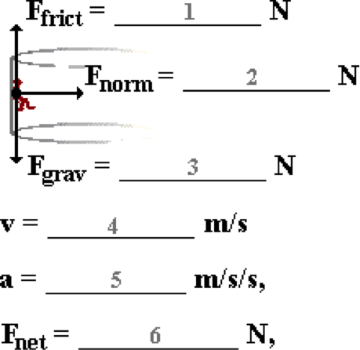

**Question 6:**

aa. A 74.5-kg person is on a barrel ride at an amusement park. He stands on a platform with his back to the barrel wall. The 4.68-meter diameter barrel spins rapidly in a circle, making a revolution every 2.08 seconds. Determine the velocity (in m/s), acceleration (in m/s/s), the net force (in N) and the magnitudes of all individual forces. Finally, indicate the direction of the net force and acceleration. Use g = 9.80 m/s/s.



**Question 7:**

aa. A 62.8-kg person is on a barrel ride at an amusement park. She stands on a platform with her back to the barrel wall. The 3.74-meter diameter barrel spins rapidly in a circle, making a revolution every 1.65 seconds. Determine the velocity (in m/s), acceleration (in m/s/s), the net force (in N) and the magnitudes of all individual forces. Finally, indicate the direction of the net force and acceleration. Use g = 9.80 m/s/s.



**Question 8:**

aa. A 45.2-kg person is on a barrel ride at an amusement park. She stands on a platform with her back to the barrel wall. The 3.74-meter diameter barrel spins rapidly in a circle, making a revolution every 1.65 seconds. Determine the velocity (in m/s), acceleration (in m/s/s), the net force (in N) and the magnitudes of all individual forces. Finally, indicate the direction of the net force and acceleration. Use g = 9.80 m/s/s.



**Question 9:**

aa. A 2.32-kg bucket of water is suspended from a string and swung in a horizontal circle, making 10 revolutions in 8.63 seconds. The radius of the circle is 0.945 meters. Determine the velocity (in m/s), acceleration (in m/s/s), the net force (in N) and the magnitudes of all individual forces. (Note that the tension force has been resolved into horizontal and vertical components.) Finally, indicate the direction of the net force and acceleration. Use g = 9.80 m/s/s.

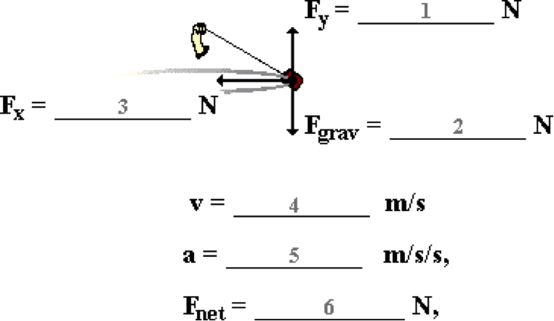

**Question 10:**

aa. A 2.16-kg bucket of water is suspended from a string and swung in a horizontal circle, making 10 revolutions in 9.21 seconds. The radius of the circle is 0.978 meters. Determine the velocity (in m/s), acceleration (in m/s/s), the net force (in N) and the magnitudes of all individual forces. (Note that the tension force has been resolved into horizontal and vertical components.) Finally, indicate the direction of the net force and acceleration. Use g = 9.80 m/s/s.



**Question 11:**

aa. A 1.74-kg bucket of water is suspended from a string and swung in a horizontal circle, making 10 revolutions in 7.63 seconds. The radius of the circle is 0.925 meters. Determine the velocity (in m/s), acceleration (in m/s/s), the net force (in N) and the magnitudes of all individual forces. (Note that the tension force has been resolved into horizontal and vertical components.) Finally, indicate the direction of the net force and acceleration. Use g = 9.80 m/s/s.



**Question 12:**

aa. A 3.31-kg bucket of water is suspended from a string and swung in a horizontal circle, making 10 revolutions in 9.86 seconds. The radius of the circle is 0.920 meters. Determine the velocity (in m/s), acceleration (in m/s/s), the net force (in N) and the magnitudes of all individual forces. (Note that the tension force has been resolved into horizontal and vertical components.) Finally, indicate the direction of the net force and acceleration. Use g = 9.80 m/s/s.



**Question 13:**

aa. A 2.32-kg bucket of water is suspended from a string and swung in a vertical circle. The radius of the circle is 0.945 meters. The speed at the top of the circle is 3.92 m/s. Determine the acceleration (in m/s/s), net force (in N) and the magnitudes of all individual forces when the bucket is at the top of the circle. Finally, indicate the direction of the net force and acceleration. Use g = 9.80 m/s/s.

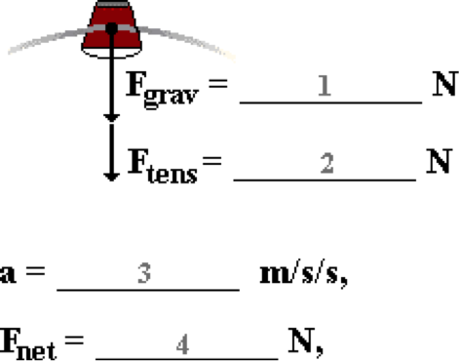

**Question 14:**

aa. A 2.16-kg bucket of water is suspended from a string and swung in a vertical circle. The radius of the circle is 0.978 meters. The speed at the top of the circle is 3.56 m/s. Determine the acceleration (in m/s/s), net force (in N) and the magnitudes of all individual forces when the bucket is at the top of the circle. Finally, indicate the direction of the net force and acceleration. Use g = 9.80 m/s/s.



**Question 15:**

aa. A 1.74-kg bucket of water is suspended from a string and swung in a vertical circle. The radius of the circle is 0.925 meters. The speed at the top of the circle is 4.08 m/s. Determine the acceleration (in m/s/s), net force (in N) and the magnitudes of all individual forces when the bucket is at the top of the circle. Finally, indicate the direction of the net force and acceleration. Use g = 9.80 m/s/s.



**Question 16:**

aa. A 3.31-kg bucket of water is suspended from a string and swung in a vertical circle. The radius of the circle is 0.920 meters. The speed at the top of the circle is 4.22 m/s. Determine the acceleration (in m/s/s), net force (in N) and the magnitudes of all individual forces when the bucket is at the top of the circle. Finally, indicate the direction of the net force and acceleration. Use g = 9.80 m/s/s.



**Question 17:**

aa. A 2.32-kg bucket of water is suspended from a string and swung in a vertical circle. The radius of the circle is 0.945 meters. The speed at the bottom of the circle is 5.36 m/s. Determine the acceleration (in m/s/s), net force (in N) and the magnitudes of all individual forces when the bucket is at the bottom of the circle. Finally, indicate the direction of the net force and acceleration. Use g = 9.80 m/s/s.

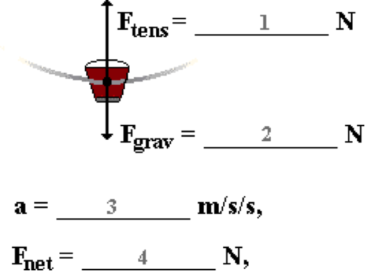

**Question 18:**

aa. A 2.16-kg bucket of water is suspended from a string and swung in a vertical circle. The radius of the circle is 0.978 meters. The speed at the bottom of the circle is 5.81 m/s. Determine the acceleration (in m/s/s), net force (in N) and the magnitudes of all individual forces when the bucket is at the bottom of the circle. Finally, indicate the direction of the net force and acceleration. Use g = 9.80 m/s/s.



**Question 19:**

aa. A 1.74-kg bucket of water is suspended from a string and swung in a vertical circle. The radius of the circle is 0.925 meters. The speed at the bottom of the circle is 6.25 m/s. Determine the acceleration (in m/s/s), net force (in N) and the magnitudes of all individual forces when the bucket is at the bottom of the circle. Finally, indicate the direction of the net force and acceleration. Use g = 9.80 m/s/s.



**Question 20:**

aa. A 3.31-kg bucket of water is suspended from a string and swung in a vertical circle. The radius of the circle is 0.920 meters. The speed at the bottom of the circle is 6.78 m/s. Determine the acceleration (in m/s/s), net force (in N) and the magnitudes of all individual forces when the bucket is at the bottom of the circle. Finally, indicate the direction of the net force and acceleration. Use g = 9.80 m/s/s.



**Question 21:**

aa. To the pleasure of the air show crowd, a 62.0-kg pilot makes a series of loop-the-loops. At the bottom of a 176-meter diameter circular loop, the pilot is flying with a speed of 58.7 m/s. Determine the acceleration (in m/s/s), net force (in N) and the magnitudes of all individual forces when the pilot is at the bottom of the loop. Finally, indicate the direction of the net force and acceleration. Use g = 9.80 m/s/s.

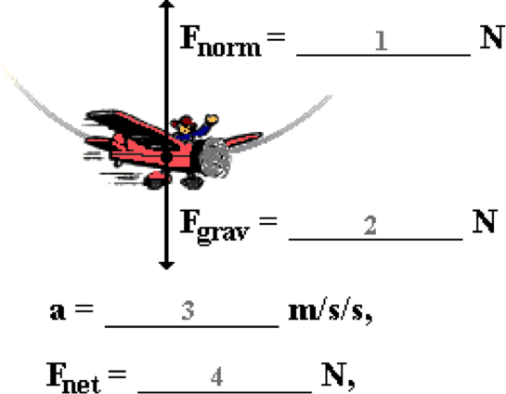

**Question 22:**

aa. To the pleasure of the air show crowd, a 75.2-kg pilot makes a series of loop-the-loops. At the bottom of a 192-meter diameter circular loop, the pilot is flying with a speed of 63.1 m/s. Determine the acceleration (in m/s/s), net force (in N) and the magnitudes of all individual forces when the pilot is at the bottom of the loop. Finally, indicate the direction of the net force and acceleration. Use g = 9.80 m/s/s.



**Question 23:**

aa. To the pleasure of the air show crowd, a 58.1-kg pilot makes a series of loop-the-loops. At the bottom of a 164-meter diameter circular loop, the pilot is flying with a speed of 52.5 m/s. Determine the acceleration (in m/s/s), net force (in N) and the magnitudes of all individual forces when the pilot is at the bottom of the loop. Finally, indicate the direction of the net force and acceleration. Use g = 9.80 m/s/s.



**Question 24:**

aa. To the pleasure of the air show crowd, a 71.6-kg pilot makes a series of loop-the-loops. At the bottom of a 188-meter diameter circular loop, the pilot is flying with a speed of 60.9 m/s. Determine the acceleration (in m/s/s), net force (in N) and the magnitudes of all individual forces when the pilot is at the bottom of the loop. Finally, indicate the direction of the net force and acceleration. Use g = 9.80 m/s/s.



**Question 25:**

aa. To the pleasure of the air show crowd, a 62.0-kg pilot makes a series of loop-the-loops. At the top of a 176-meter diameter circular loop, the pilot is flying with a speed of 35.1 m/s. Determine the acceleration (in m/s/s), net force (in N) and the magnitudes of all individual forces when the pilot is at the top of the loop. Finally, indicate the direction of the net force and acceleration. Use g = 9.80 m/s/s.

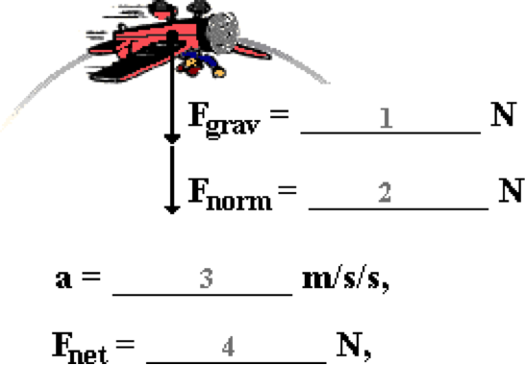

**Question 26:**

aa. To the pleasure of the air show crowd, a 75.2-kg pilot makes a series of loop-the-loops. At the top of a 192-meter diameter circular loop, the pilot is flying with a speed of 39.5 m/s. Determine the acceleration (in m/s/s), net force (in N) and the magnitudes of all individual forces when the pilot is at the top of the loop. Finally, indicate the direction of the net force and acceleration. Use g = 9.80 m/s/s.



**Question 27:**

aa. To the pleasure of the air show crowd, a 58.1-kg pilot makes a series of loop-the-loops. At the top of a 164-meter diameter circular loop, the pilot is flying with a speed of 31.5 m/s. Determine the acceleration (in m/s/s), net force (in N) and the magnitudes of all individual forces when the pilot is at the top of the loop. Finally, indicate the direction of the net force and acceleration. Use g = 9.80 m/s/s.



**Question 28:**

aa. To the pleasure of the air show crowd, a 71.6-kg pilot makes a series of loop-the-loops. At the top of a 188-meter diameter circular loop, the pilot is flying with a speed of 32.4 m/s. Determine the acceleration (in m/s/s), net force (in N) and the magnitudes of all individual forces when the pilot is at the top of the loop. Finally, indicate the direction of the net force and acceleration. Use g = 9.80 m/s/s.



**Question 29:**

aa. Mac and Tosh are on a roller coaster ride and moving rapidly over the crest of a small hill. The hilltop has a curve that resembles a section of a circle with a radius of 27.3 meters. The speed of the 421-kg roller coaster car at the crest is 15.6 m/s. Determine the acceleration (in m/s/s), net force (in N) and the magnitudes of all individual forces when the car is at the crest. Finally, indicate the direction of the net force and acceleration. Use g = 9.80 m/s/s.

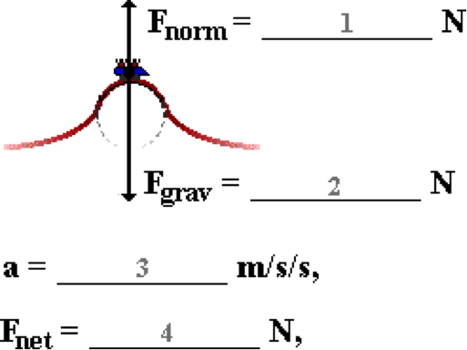

**Question 30:**

aa. Mac and Tosh are on a roller coaster ride and moving rapidly over the crest of a small hill. The hilltop has a curve that resembles a section of a circle with a radius of 35.6 meters. The speed of the 392-kg roller coaster car at the crest is 17.1 m/s. Determine the acceleration (in m/s/s), net force (in N) and the magnitudes of all individual forces when the car is at the crest. Finally, indicate the direction of the net force and acceleration. Use g = 9.80 m/s/s.



**Question 31:**

aa. Mac and Tosh are on a roller coaster ride and moving rapidly over the crest of a small hill. The hilltop has a curve that resembles a section of a circle with a radius of 37.8 meters. The speed of the 465-kg roller coaster car at the crest is 16.6 m/s. Determine the acceleration (in m/s/s), net force (in N) and the magnitudes of all individual forces when the car is at the crest. Finally, indicate the direction of the net force and acceleration. Use g = 9.80 m/s/s.



**Question 32:**

aa. Mac and Tosh are on a roller coaster ride and moving rapidly over the crest of a small hill. The hilltop has a curve that resembles a section of a circle with a radius of 57.3 meters. The speed of the 405-kg roller coaster car at the crest is 21.1 m/s. Determine the acceleration (in m/s/s), net force (in N) and the magnitudes of all individual forces when the car is at the crest. Finally, indicate the direction of the net force and acceleration. Use g = 9.80 m/s/s.



**CG6: Newton’s Law of Universal Gravitation**

**Question 1:**

aa. Isaac Newton is credited with the law of universal gravitation. One of the major elements of Newton's discovery (that had not yet been recognized) was the recognition that the force that causes the apple to fall to the Earth is ______.

a. gravity

b. the same force that causes rain to fall to the Earth

c. the same force that causes any object on Earth to fall to the Earth

d. the same force that causes any two objects in the universe to attract each other

e. none of these

**Question 2:**

aa. Isaac Newton is credited with the law of universal gravitation. One of the major elements of Newton's discovery (that had not yet been recognized) was the recognition that the force that causes the apple to fall to the Earth is ______.

a. the same force that causes rain to fall to the Earth

b. gravity

c. the same force that causes any two objects in the universe to attract each other

d. the same force that causes any object on Earth to fall to the Earth

e. none of these

**Question 3:**

aa. Isaac Newton is credited with the law of universal gravitation. One of the major elements of Newton's discovery (that had not yet been recognized) was the recognition that the force that causes the apple to fall to the Earth is ______.

a. the same force that causes any object on Earth to fall to the Earth

b. the same force that causes any two objects in the universe to attract each other

c. gravity

d. the same force that causes rain to fall to the Earth

e. none of these

**Question 4:**

aa. Isaac Newton is credited with the law of universal gravitation. One of the major elements of Newton's discovery (that had not yet been recognized) was the recognition that the force that causes the apple to fall to the Earth is ______.

a. the same force that causes any two objects in the universe to attract each other

b. the same force that causes any object on Earth to fall to the Earth

c. the same force that causes rain to fall to the Earth

d. gravity

e. none of these

**Question 5:**

aa. According to Newton's law of universal gravitation, which of the following pairs of objects would not experience a mutual force of gravitation. List all that apply in alphabetical order with no spaces or commas between letters.

a. The Earth and the moon b. An apple and the Earth

c. You and your lab partner d. Two electrons in an atom

e. A planet and the Sun f. The Earth and another planet

g. Nonsense! All objects experience a mutual force of gravitational pull.

**Question 6:**

aa. According to Newton's law of universal gravitation, which of the following pairs of objects would not experience a mutual force of gravitation. List all that apply in alphabetical order with no spaces or commas between letters.

a. Two electrons in an atom b. You and your lab partner

c. The Earth and the moon d. A planet and the Sun

e. The Earth and another planet f. An apple and the Earth

g. Nonsense! All objects experience a mutual force of gravitational pull.

**Question 7:**

aa. According to Newton's law of universal gravitation, which of the following pairs of objects would not experience a mutual force of gravitation. List all that apply in alphabetical order with no spaces or commas between letters.

a. You and your lab partner b. Two electrons in an atom

c. A planet and the Sun d. The Earth and another planet

e. An apple and the Earth f. The Earth and the moon

g. Nonsense! All objects experience a mutual force of gravitational pull.

**Question 8:**

aa. According to Newton's law of universal gravitation, which of the following pairs of objects would not experience a mutual force of gravitation. List all that apply in alphabetical order with no spaces or commas between letters.

a. The Earth and another planet b. A planet and the Sun

c. An apple and the Earth d. The Earth and the moon

e. Two electrons in an atom f. You and your lab partner

g. Nonsense! All objects experience a mutual force of gravitational pull.

**Question 9:**

aa. The force of gravitation between two objects is ____.

a. always an attractive force

b. usually (but not always) an attractive force

c. a force which is attractive for one object and repulsive for the other

d. an attractive force on Earth but neither attractive nor repulsive in space

e. an attractive force which is always balanced by a repulsive force to keep the objects from moving towards each other

**Question 10:**

aa. The force of gravitation between two objects is ____.

a. usually (but not always) an attractive force

b. always an attractive force

c. an attractive force on Earth but neither attractive nor repulsive in space

d. a force which is attractive for one object and repulsive for the other

e. an attractive force which is always balanced by a repulsive force to keep the objects from moving towards each other

**Question 11:**

aa. The force of gravitation between two objects is ____.

a. a force which is attractive for one object and repulsive for the other

b. an attractive force on Earth but neither attractive nor repulsive in space

c. always an attractive force

d. usually (but not always) an attractive force

e. an attractive force which is always balanced by a repulsive force to keep the objects from moving towards each other

**Question 12:**

aa. The force of gravitation between two objects is ____.

a. an attractive force on Earth but neither attractive nor repulsive in space

b. a force which is attractive for one object and repulsive for the other

c. usually (but not always) an attractive force

d. always an attractive force

e. an attractive force which is always balanced by a repulsive force to keep the objects from moving towards each other

**Question 13:**

aa. There is much talk about Isaac Newton's law of universal gravitation and the falling apple. The significance of the apple was that Newton ____.

a. measured the acceleration of the apple and determined it to be 9.8 m/s/s

b. compared the Earth's gravitational pull on the apple to Earth's pull on the moon

c. proposed that the force of gravity acting on an apple is the same value for all objects

d. proposed that the acceleration of gravity of a falling apple is the same value for all objects

e. had drunk way too much fermented apple juice when he proposed his theory

**Question 14:**

aa. There is much talk about Isaac Newton's law of universal gravitation and the falling apple. The significance of the apple was that Newton ____.

a. compared the Earth's gravitational pull on the apple to Earth's pull on the moon

b. measured the acceleration of the apple and determined it to be 9.8 m/s/s

c. proposed that the acceleration of gravity of a falling apple is the same value for all objects

d. proposed that the force of gravity acting on an apple is the same value for all objects

e. had drunk way too much fermented apple juice when he proposed his theory

**Question 15:**

aa. There is much talk about Isaac Newton's law of universal gravitation and the falling apple. The significance of the apple was that Newton ____.

a. proposed that the force of gravity acting on an apple is the same value for all objects

b. proposed that the acceleration of gravity of a falling apple is the same value for all objects

c. measured the acceleration of the apple and determined it to be 9.8 m/s/s

d. compared the Earth's gravitational pull on the apple to Earth's pull on the moon

e. had drunk way too much fermented apple juice when he proposed his theory

**Question 16:**

aa. There is much talk about Isaac Newton's law of universal gravitation and the falling apple. The significance of the apple was that Newton ____.

a. proposed that the acceleration of gravity of a falling apple is the same value for all objects

b. proposed that the force of gravity acting on an apple is the same value for all objects

c. compared the Earth's gravitational pull on the apple to Earth's pull on the moon

d. measured the acceleration of the apple and determined it to be 9.8 m/s/s

e. had been drinking way too much fermented apple juice when he proposed his theory

**Question 17:**

aa. The force of gravitational attraction between the Sun and a planet is dependent upon ____. List all that apply in alphabetical order with no spaces or commas between letters.

a. the mass of the Sun

b. the mass of the planet

c. the radius of the planet

d. the radius of the Sun

e. the distance between the planet's center and the Sun's center

f. None of these

**Question 18:**

aa. The force of gravitational attraction between the Sun and a planet is dependent upon ____. List all that apply in alphabetical order with no spaces or commas between letters.

a. the radius of the planet

b. the radius of the Sun

c. the mass of the Sun

d. the mass of the planet

e. the distance between the planet's center and the Sun's center

f. None of these

**Question 19:**

aa. The force of gravitational attraction between the Sun and a planet is dependent upon ____. List all that apply in alphabetical order with no spaces or commas between letters.

a. the distance between the planet's center and the Sun's center

b. the mass of the Sun

c. the mass of the planet

d. the radius of the planet

e. the radius of the Sun

f. None of these

**Question 20:**

aa. The force of gravitational attraction between the Sun and a planet is dependent upon ____. List all that apply in alphabetical order with no spaces or commas between letters.

a. the distance between the planet's center and the Sun's center

b. the radius of the planet

c. the radius of the Sun

d. the mass of the Sun

e. the mass of the planet

f. None of these

**Question 21:**

aa. The force of gravitational attraction between any two objects is ____. List the two that apply in alphabetical order with no spaces or commas between letters.

a. directly proportional to the product of their masses

b. directly proportional to the sum of their masses

c. inversely proportional to the product of their masses

d. inversely proportional to the sum of their masses

e. inversely proportional to the distance between their centers

f. inversely proportional to the square of the distances between their centers

g. directly proportional to the distance between their centers

h. directly proportional to the square of the distances between their centers

**Question 22:**

aa. The force of gravitational attraction between any two objects is ____. List the two that apply in alphabetical order with no spaces or commas between letters.

a. directly proportional to the sum of their masses

b. inversely proportional to the sum of their masses

c. directly proportional to the product of their masses

d. inversely proportional to the product of their masses

e. inversely proportional to the distance between their centers

f. directly proportional to the distance between their centers

g. inversely proportional to the square of the distances between their centers

h. directly proportional to the square of the distances between their centers

**Question 23:**

aa. The force of gravitational attraction between any two objects is ____. List the two that apply in alphabetical order with no spaces or commas between letters.

a. directly proportional to the product of their masses

b. inversely proportional to the product of their masses

c. directly proportional to the sum of their masses

d. inversely proportional to the sum of their masses

e. inversely proportional to the square of the distances between their centers

f. directly proportional to the square of the distances between their centers

g. inversely proportional to the distance between their centers

h. directly proportional to the distance between their centers

**Question 24:**

aa. The force of gravitational attraction between any two objects is ____. List the two that apply in alphabetical order with no spaces or commas between letters.

a. directly proportional to the distance between their centers

b. directly proportional to the square of the distances between their centers

c. inversely proportional to the distance between their centers

d. inversely proportional to the square of the distances between their centers

e. directly proportional to the sum of their masses

f. directly proportional to the product of their masses

g. inversely proportional to the sum of their masses

h. inversely proportional to the product of their masses

**Question 25:**

aa. Suppose that an object weighs 20 Newton on the surface of the earth (a distance of R from its center). If the same object is located a distance of R above the Earth's surface (a distance of 2R from its center), then the force of gravity upon it would be ____ Newton.

a. 2.22 b. 5.00

c. 6.67 d. 10.0

e. 20.0 f. 40.0

g. 60.0 h. 80.0

i. 180 j. None of these are even close.

**Question 26:**

aa. Suppose that an object weighs 30 Newton on the surface of the earth (a distance of R from its center). If the same object is located a distance of R above the Earth's surface (a distance of 2R from its center), then the force of gravity upon it would be ____ Newton.

a. 3.33 b. 7.50

c. 10.0 d. 15.0

e. 30.0 f. 60.0

g. 90.0 h. 120

i. 270 j. None of these are even close.

**Question 27:**

aa. Suppose that an object weighs 60 Newton on the surface of the earth (a distance of R from its center). If the same object is located a distance of R above the Earth's surface (a distance of 2R from its center), then the force of gravity upon it would be ____ Newton.

a. 6.67 b. 15.0

c. 20.0 d. 30.0

e. 60.0 f. 120

g. 180 h. 240

i. 540 j. None of these are even close.

**Question 28:**

aa. Suppose that an object weighs 90 Newton on the surface of the earth (a distance of R from its center). If the same object is located a distance of R above the Earth's surface (a distance of 2R from its center), then the force of gravity upon it would be ____ Newton.

a. 10.0 b. 22.5

c. 30.0 d. 45.0

e. 90.0 f. 180

g. 270 h. 360

i. 810 j. None of these are even close.

**Question 29:**

aa. Suppose that an object weighs 20 Newton on the surface of the earth (a distance of R from its center). If the same object is located a distance of 2R above the Earth's surface (a distance of 3R from its center), then the force of gravity upon it would be ____ Newton.

a. 2.22 b. 5.00

c. 6.67 d. 10.0

e. 20.0 f. 40.0

g. 60.0 h. 80.0

i. 180 j. None of these are even close.

**Question 30:**

aa. Suppose that an object weighs 30 Newton on the surface of the earth (a distance of R from its center). If the same object is located a distance of 2R above the Earth's surface (a distance of 3R from its center), then the force of gravity upon it would be ____ Newton.

a. 3.33 b. 7.50

c. 10.0 d. 15.0

e. 30.0 f. 60.0

g. 90.0 h. 120

i. 270 j. None of these are even close.

**Question 31:**

aa. Suppose that an object weighs 60 Newton on the surface of the earth (a distance of R from its center). If the same object is located a distance of 2R above the Earth's surface (a distance of 3R from its center), then the force of gravity upon it would be ____ Newton.

a. 6.67 b. 15.0

c. 20.0 d. 30.0

e. 60.0 f. 120

g. 180 h. 240

i. 540 j. None of these are even close.

**Question 32:**

aa. Suppose that an object weighs 90 Newton on the surface of the earth (a distance of R from its center). If the same object is located a distance of 2R above the Earth's surface (a distance of 3R from its center), then the force of gravity upon it would be ____ Newton.

a. 10.0 b. 22.5

c. 30.0 d. 45.0

e. 90.0 f. 180

g. 270 h. 360

i. 810 j. None of these are even close.

**CG7: The Acceleration of Gravity**

**Question 1:**

aa. The acceleration of gravity (g) refers to the ____. List all that apply in alphabetical order with no spaces or commas between letters.

a. rate of acceleration of an object which is acted upon solely by gravity

b. force of gravity acting upon an object

c. gravity

d. weight of an object

e. acceleration of any object when acted upon by some net force

**Question 2:**

aa. The acceleration of gravity (g) refers to the ____. List all that apply in alphabetical order with no spaces or commas between letters.

a. gravity

b. weight of an object

c. force of gravity acting upon an object

d. acceleration of any object when acted upon by some net force

e. rate of acceleration of an object which is acted upon solely by gravity

**Question 3:**

aa. The acceleration of gravity (g) refers to the ____. List all that apply in alphabetical order with no spaces or commas between letters.

a. weight of an object

b. gravity

c. acceleration of any object when acted upon by some net force

d. rate of acceleration of an object which is acted upon solely by gravity

e. force of gravity acting upon an object

**Question 4:**

aa. The acceleration of gravity (g) refers to the ____. List all that apply in alphabetical order with no spaces or commas between letters.

a. force of gravity acting upon an object

b. rate of acceleration of an object which is acted upon solely by gravity

c. acceleration of any object when acted upon by some net force

d. weight of an object

e. gravity

**Question 5:**

aa. The acceleration of gravity (g) value for an object of mass 'm' located on the surface of some planet of mass 'M' and radius 'R' is ____ related to the ____. List the two that apply in alphabetical order with no spaces or commas between letters.

a. directly, mass of the object (m) b. inversely, mass of the object (m)

c. directly, mass of the planet (M) d. inversely, mass of the planet (M)

e. directly, radius of the planet (R) f. inversely, radius of the planet (R)

**Question 6:**

aa. The acceleration of gravity (g) value for an object of mass 'm' located on the surface of some planet of mass 'M' and radius 'R' is ____ related to the ____. List the two that apply in alphabetical order with no spaces or commas between letters.

a. directly, mass of the planet (M) b. inversely, mass of the planet (M)

c. directly, radius of the planet (R) d. inversely, radius of the planet (R)

e. directly, mass of the object (m) f. inversely, mass of the object (m)

**Question 7:**

aa. The acceleration of gravity (g) value for an object of mass 'm' located on the surface of some planet of mass 'M' and radius 'R' is ____ related to the ____. List the two that apply in alphabetical order with no spaces or commas between letters.

a. directly, radius of the planet (R) b. inversely, radius of the planet (R)

c. directly, mass of the planet (M) d. inversely, mass of the planet (M)

e. directly, mass of the object (m) f. inversely, mass of the object (m)

**Question 8:**

aa. The acceleration of gravity (g) value for an object of mass 'm' located on the surface of some planet of mass 'M' and radius 'R' is ____ related to the ____. List the two that apply in alphabetical order with no spaces or commas between letters.

a. directly, mass of the object (m) b. directly, mass of the planet (M)

c. directly, radius of the planet (R) d. inversely, mass of the object (m)

e. inversely, mass of the planet (M) f. inversely, radius of the planet (R)

**Question 9:**

aa. The acceleration of gravity on the surface of the Earth is 9.8 m/s/s. As one moves increasingly further from the surface of the Earth, the acceleration of gravity value ____.

a. increases b. decreases c. remains the same

d. ... impossible to tell without knowledge of the mass of the object.

**Question 10:**

aa. The acceleration of gravity on the surface of the Earth is 9.8 m/s/s. As one moves increasingly further from the surface of the Earth, the acceleration of gravity value ____.

a. decreases b. increases c. remains the same

d. ... impossible to tell without knowledge of the mass of the object.

**Question 11:**

aa. The acceleration of gravity on the surface of the Earth is 9.8 m/s/s. As one moves increasingly further from the surface of the Earth, the acceleration of gravity value ____.

a. remains the same b. increases c. decreases

d. ... impossible to tell without knowledge of the mass of the object.

**Question 12:**

aa. The acceleration of gravity on the surface of the Earth is 9.8 m/s/s. As one moves increasingly further from the surface of the Earth, the acceleration of gravity value ____.

a. remains the same b. decreases c. increases

d. ... impossible to tell without knowledge of the mass of the object.

**Question 13:**

aa. An astronaut is on the orbiting Space Shuttle, approximately 60 miles (~100 000 meters) above the surface of the Earth. (The Earth's radius is ~6 360 000 meters and its mass is ~5.98 x 1024 kg.) At this location, one might predict the acceleration of gravity to be ____.

a. significantly less (at least 10% less) than 9.8 m/s/s

b. significantly greater (at least 10% greater) than 9.8 m/s/s

c. a small percent less (1-10%) than 9.8 m/s/s

d. a small percent more (1-10%) than 9.8 m/s/s

e. 0 m/s/s, since the astronauts are 'in space'

f. ... impossible to make such a prediction with so little information

**Question 14:**

aa. An astronaut is on the orbiting Space Shuttle, approximately 60 miles (~100 000 meters) above the surface of the Earth. (The Earth's radius is ~6 360 000 meters and its mass is ~5.98 x 1024 kg.) At this location, one might predict the acceleration of gravity to be ____.

a. significantly greater (at least 10% greater) than 9.8 m/s/s

b. significantly less (at least 10% less) than 9.8 m/s/s

c. a small percent more (1-10%) than 9.8 m/s/s

d. a small percent less (1-10%) than 9.8 m/s/s

e. 0 m/s/s, since the astronauts are 'in space'

f. ... impossible to make such a prediction with so little information

**Question 15:**

aa. An astronaut is on the orbiting Space Shuttle, approximately 60 miles (~100 000 meters) above the surface of the Earth. (The Earth's radius is ~6 360 000 meters and its mass is ~5.98 x 1024 kg.) At this location, one might predict the acceleration of gravity to be ____.

a. 0 m/s/s, since the astronauts are 'in space'

b. a small percent less (1-10%) than 9.8 m/s/s

c. a small percent more (1-10%) than 9.8 m/s/s

d. significantly less (at least 10% less) than 9.8 m/s/s

e. significantly greater (at least 10% greater) than 9.8 m/s/s

f. ... impossible to make such a prediction with so little information

**Question 16:**

aa. An astronaut is on the orbiting Space Shuttle, approximately 60 miles (~100 000 meters) above the surface of the Earth. (The Earth's radius is ~6 360 000 meters and its mass is ~5.98 x 1024 kg.) At this location, one might predict the acceleration of gravity to be ____.

a. 0 m/s/s, since the astronauts are 'in space'

b. a small percent more (1-10%) than 9.8 m/s/s

c. a small percent less (1-10%) than 9.8 m/s/s

d. significantly greater (at least 10% greater) than 9.8 m/s/s

e. significantly less (at least 10% less) than 9.8 m/s/s

f. ... impossible to make such a prediction with so little information

**Question 17:**

aa. The acceleration of gravity upon Earth's surface is 9.80 m/s/s. At a location of 'R' above Earth's surface (where 'R' is the radius of the Earth), the acceleration of gravity is closest to ____ m/s/s.

a. 9.80 b. 4.90 c. 3.27

d. 2.45 e. 1.09 f. 19.60

g. 29.40 h. 39.20 i. 88.20

j. None of these are even close

**Question 18:**

aa. The acceleration of gravity upon Mars' surface is 3.75 m/s/s. At a location of 'R' above Mars' surface (where 'R' is the radius of the Mars), the acceleration of gravity is closest to ____ m/s/s.

a. 3.75 b. 1.88 c. 1.25

d. 0.94 e. 0.42 f. 7.50

g. 11.25 h. 15.00 i. 33.75

j. None of these are even close

**Question 19:**

aa. The acceleration of gravity upon Neptune's surface is 13.30 m/s/s. At a location of 'R' above Neptune's surface (where 'R' is the radius of the Neptune), the acceleration of gravity is closest to ____ m/s/s.

a. 13.30 b. 6.65 c. 4.43

d. 3.33 e. 1.48 f. 26.60

g. 39.90 h. 53.20 i. 119.70

j. None of these are even close

**Question 20:**

aa. The acceleration of gravity upon Jupiter's surface is 26.00 m/s/s. At a location of 'R' above Jupiter's surface (where 'R' is the radius of the Jupiter), the acceleration of gravity is closest to ____ m/s/s.

a. 26.00 b. 13.00 c. 8.67

d. 6.50 e. 2.89 f. 52.00

g. 78.00 h. 104.00 i. 234.00

j. None of these are even close

**Question 21:**

aa. The acceleration of gravity upon Earth's surface is 9.80 m/s/s. At a location of '2R' above Earth's surface (where 'R' is the radius of the Earth), the acceleration of gravity is closest to ____ m/s/s.

a. 9.80 b. 4.90 c. 3.27

d. 2.45 e. 1.09 f. 19.60

g. 29.40 h. 39.20 i. 88.20

j. None of these are even close

**Question 22:**

aa. The acceleration of gravity upon Mars' surface is 3.75 m/s/s. At a location of '2R' above Mars' surface (where 'R' is the radius of the Mars), the acceleration of gravity is closest to ____ m/s/s.

a. 3.75 b. 1.88 c. 1.25

d. 0.94 e. 0.42 f. 7.50

g. 11.25 h. 15.00 i. 33.75

j. None of these are even close

**Question 23:**

aa. The acceleration of gravity upon Neptune's surface is 13.30 m/s/s. At a location of '2R' above Neptune's surface (where 'R' is the radius of the Neptune), the acceleration of gravity is closest to ____ m/s/s.

a. 13.30 b. 6.65 c. 4.43

d. 3.33 e. 1.48 f. 26.60

g. 39.90 h. 53.20 i. 119.70

j. None of these are even close

**Question 24:**

aa. The acceleration of gravity upon Jupiter's surface is 26.00 m/s/s. At a location of '2R' above Jupiter's surface (where 'R' is the radius of the Jupiter), the acceleration of gravity is closest to ____ m/s/s.

a. 26.00 b. 13.00 c. 8.67

d. 6.50 e. 2.89 f. 52.00

g. 78.00 h. 104.00 i. 234.00

j. None of these are even close

**Question 25:**

aa. An object of mass 'm' is located a distance 'R' from the center of a planet with mass 'M.' The acceleration of gravity of the mass 'm' at this location is 12 m/s/s. Suppose that the mass of the object is doubled to '2m' and the separation distance is halved to '0.5R.' The new acceleration of gravity value for the mass and the new location would be ____ m/s/s.

a. 1.5 b. 2.0 c. 3.0

d. 6.0 e. 12 f. 24

g. 48 h. 96

i. None of these are even close.

**Question 26:**

aa. An object of mass 'm' is located a distance 'R' from the center of a planet with mass 'M.' The acceleration of gravity of the mass 'm' at this location is 12 m/s/s. Suppose that the mass of the object is doubled to '2m' and the separation distance is doubled to '2R.' The new acceleration of gravity value for the mass and the new location would be ____ m/s/s.

a. 1.5 b. 2.0 c. 3.0

d. 6.0 e. 12 f. 24

g. 48 h. 96

i. None of these are even close.

**Question 27:**

aa. An object of mass 'm' is located a distance 'R' from the center of a planet with mass 'M.' The acceleration of gravity of the mass 'm' at this location is 24.0 m/s/s. Suppose that the mass of the object is tripled to '3m' and the separation distance is halved to '0.5R.' The new acceleration of gravity value for the mass and the new location would be ____ m/s/s.

a. 4.00 b. 6.00 c. 5.76 d. 12.0

e. 16.0 f. 32.0 g. 36.0 h. 48.0

i. 72.0 j. 96.0 k. 576

l. None of these are even close.

**Question 28:**

aa. An object of mass 'm' is located a distance 'R' from the center of a planet with mass 'M.' The acceleration of gravity of the mass 'm' at this location is 24.0 m/s/s. Suppose that the mass of the object is halved to '0.5m' and the separation distance is tripled to '3R.' The new acceleration of gravity value for the mass and the new location would be ____ m/s/s.

a. 1.33 b. 2.67 c. 4.00 d. 5.33

e. 8.00 f. 16.0 g. 36.0 h. 96.0

i. 144 j. 216 k. None of these are even close.

**Question 29:**

aa. Four different planets with different masses are depicted below. A location about the planet is also indicated.

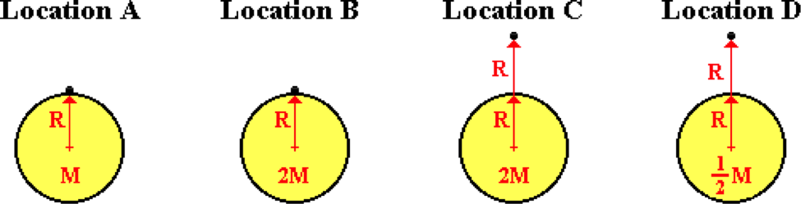

Rank the four locations in increasing order of their acceleration of gravity value, beginning with the lowest. Enter your four answers in increasing order with no spaces or commas between letters.

**Question 30:**

aa. Four different planets with different masses are depicted below. A location about the planet is also indicated.

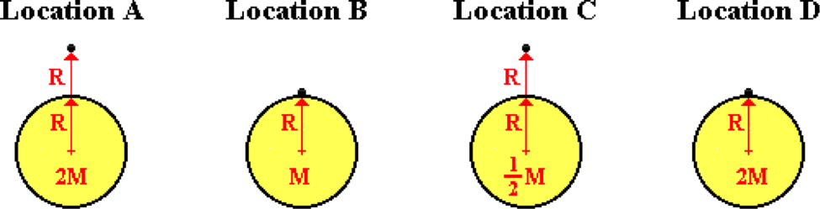

Rank the four locations in increasing order of their acceleration of gravity value, beginning with the lowest. Enter your four answers in increasing order with no spaces or commas between letters.

**Question 31:**

aa. Four different planets with different masses are depicted below. A location about the planet is also indicated.

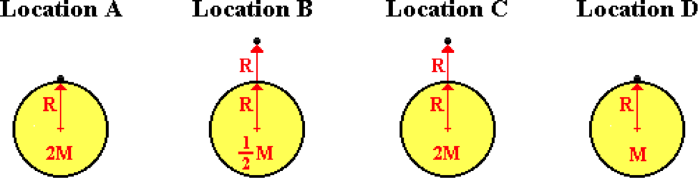

Rank the four locations in increasing order of their acceleration of gravity value, beginning with the lowest. Enter your four answers in increasing order with no spaces or commas between letters.

**Question 32:**

aa. Four different planets with different masses are depicted below. A location about the planet is also indicated.

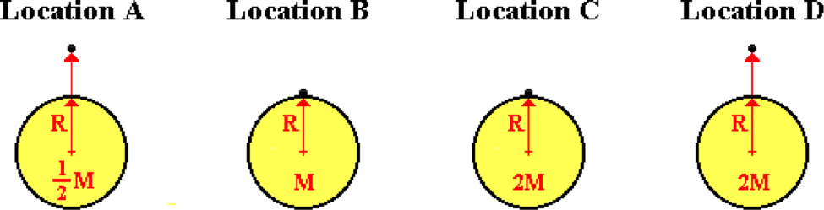

Rank the four locations in increasing order of their acceleration of gravity value, beginning with the lowest. Enter your four answers in increasing order with no spaces or commas between letters.

**Question 33:**

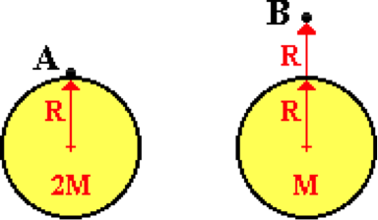aa. Two objects are located at different locations about two planets with distinctly different masses. Compared to location A, the acceleration of gravity value at location B is ____.

a. one-eighth the magnitude

b. one-fourth the magnitude

c. one-half the magnitude

d. the same magnitude

e. two times the magnitude

f. four times the magnitude

g. eight times the magnitude

h. None of these

**Question 34:**

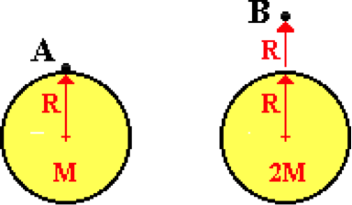aa. Two objects are located at different locations about two planets with distinctly different masses. Compared to location A, the acceleration of gravity value at location B is ____.

a. one-eighth the magnitude

b. one-fourth the magnitude

c. one-half the magnitude

d. the same magnitude

e. two times the magnitude

f. four times the magnitude

g. eight times the magnitude

h. None of these

**Question 35:**

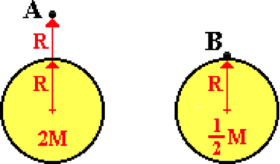aa. Two objects are located at different locations about two planets with distinctly different masses. Compared to location A, the acceleration of gravity value at location B is ____.

a. one-sixteenth the magnitude

b. one-eighth the magnitude

c. one-fourth the magnitude

d. one-half the magnitude

e. the same magnitude

f. two times the magnitude

g. four times the magnitude

h. eight times the magnitude

i. sixteen times the magnitude

j. None of these

**Question 36:**

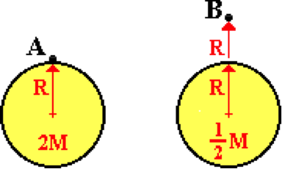aa. Two objects are located at different locations about two planets with distinctly different masses. Compared to location A, the acceleration of gravity value at location B is ____.

a. one-sixteenth the magnitude

b. one-eighth the magnitude

c. one-fourth the magnitude

d. one-half the magnitude

e. the same magnitude

f. two times the magnitude

g. four times the magnitude

h. eight times the magnitude

i. sixteen times the magnitude

j. None of these

**CG8: Satellite Motion**

**Question 1:**

aa. The orbital speed of an Earth-orbiting satellite is dependent upon the ____. List all that apply in alphabetical order with no spaces or commas between letters.

a. mass of the satellite

b. mass of the Earth

c. distance from the satellite to the center of the Earth

d. radius of the Earth

e. ... nonsense! None of these variables effect the orbital speed.

**Question 2:**

aa. The orbital speed of an Earth-orbiting satellite is dependent upon the ____. List all that apply in alphabetical order with no spaces or commas between letters.

a. mass of the Earth

b. mass of the satellite

c. radius of the Earth

d. distance from the satellite to the center of the Earth

e. ... nonsense! None of these variables effect the orbital speed.

**Question 3:**

aa. The orbital speed of an Earth-orbiting satellite is dependent upon the ____. List all that apply in alphabetical order with no spaces or commas between letters.

a. distance from the satellite to the center of the Earth

b. radius of the Earth

c. mass of the satellite

d. mass of the Earth

e. ... nonsense! None of these variables effect the orbital speed.

**Question 4:**

aa. The orbital speed of an Earth-orbiting satellite is dependent upon the ____. List all that apply in alphabetical order with no spaces or commas between letters.

a. radius of the Earth

b. distance from the satellite to the center of the Earth

c. mass of the Earth

d. mass of the satellite

e. ... nonsense! None of these variables effect the orbital speed.

**Question 5:**

aa. A satellite is orbiting the Earth. If the mass of the satellite were increased by a factor of 2, then the orbital speed of the satellite would ____ by a factor of ____.

a. increase, 2 b. increase, 4

c. increase, square root of 2 d. decrease, 2

e. decrease, 4 f. decrease, square root of 2

g. ... nonsense! An alteration in the mass of the satellite would not affect its orbital speed.

**Question 6:**

aa. A satellite is orbiting the Earth. If the mass of the satellite were increased by a factor of 2, then the orbital speed of the satellite would ____ by a factor of ____.

a. increase, 2 b. decrease, 2

c. increase, 4 d. decrease, 4

e. increase, square root of 2 f. decrease, square root of 2

g. ... nonsense! An alteration in the mass of the satellite would not affect its orbital speed.

**Question 7:**

aa. A satellite is orbiting the Earth. If the mass of the satellite were increased by a factor of 3, then the orbital speed of the satellite would ____ by a factor of ____.

a. increase, square root of 3 b. decrease, square root of 3

c. increase, 3 d. decrease, 3

e. increase, 9 f. decrease, 9

g. ... nonsense! An alteration in the mass of the satellite would not affect its orbital speed.

**Question 8:**

aa. A satellite is orbiting the Earth. If the mass of the satellite were increased by a factor of 3, then the orbital speed of the satellite would ____ by a factor of ____.

a. decrease, 9 b. increase, 9

c. decrease, 3 d. increase, 3

e. decrease, square root of 3 f. increase, square root of 3

g. ... nonsense! An alteration in the mass of the satellite would not affect its orbital speed.

**Question 9:**

aa. A satellite is orbiting the Earth. If the mass of the Earth were somehow increased by a factor of 2 (without altering the orbital radius of the satellite), then the orbital speed of the satellite would ____ by a factor of ____.

a. increase, 2 b. increase, 4

c. increase, square root of 2 d. decrease, 2

e. decrease, 4 f. decrease, square root of 2

g. ... nonsense! An alteration in the mass of the Earth would not affect the orbital speed.

**Question 10:**

aa. A satellite is orbiting the Earth. If the mass of the Earth were somehow increased by a factor of 2 (without altering the orbital radius of the satellite), then the orbital speed of the satellite would ____ by a factor of ____.

a. increase, square root of 2 b. increase, 2

c. increase, 4 d. decrease, square root of 2

e. decrease, 2 f. decrease, 4

g. ... nonsense! An alteration in the mass of the Earth would not affect the orbital speed.

**Question 11:**

aa. A satellite is orbiting the Earth. If the mass of the Earth were somehow increased by a factor of 3 (without altering the orbital radius of the satellite), then the orbital speed of the satellite would ____ by a factor of ____.

a. decrease, 3 b. decrease, square root of 3

c. decrease, 9 d. increase, 3

e. increase, square root of 3 f. increase, 9

g. ... nonsense! An alteration in the mass of the Earth would not affect the orbital speed.

**Question 12:**

aa. A satellite is orbiting the Earth. If the mass of the Earth were somehow increased by a factor of 3 (without altering the orbital radius of the satellite), then the orbital speed of the satellite would ____ by a factor of ____.

a. increase, square root of 3 b. decrease, square root of 3

c. increase, 3 d. decrease, 3

e. increase, 9 f. decrease, 9

g. ... nonsense! An alteration in the mass of the Earth would not affect the orbital speed.

**Question 13:**

aa. A satellite is orbiting the Earth. If the orbital radius (the distance from the satellite to Earth's center) were somehow increased by a factor of 2, then the orbital speed of the satellite would ____ by a factor of ____.

a. increase, 2 b. increase, 4

c. increase, square root of 2 d. decrease, 2

e. decrease, 4 f. decrease, square root of 2

g. ... nonsense! An alteration in the orbital radius would not affect the orbital speed.

**Question 14:**

aa. A satellite is orbiting the Earth. If the orbital radius (the distance from the satellite to Earth's center) were somehow increased by a factor of 2, then the orbital speed of the satellite would ____ by a factor of ____.

a. increase, square root of 2 b. increase, 2

c. increase, 4 d. decrease, square root of 2

e. decrease, 2 f. decrease, 4

g. ... nonsense! An alteration in the orbital radius would not affect the orbital speed.

**Question 15:**

aa. A satellite is orbiting the Earth. If the orbital radius (the distance from the satellite to Earth's center) were somehow increased by a factor of 3, then the orbital speed of the satellite would ____ by a factor of ____.

a. decrease, square root of 3 b. decrease, 3

c. decrease, 9 d. increase, square root of 3

e. increase, 3 f. increase, 9

g. ... nonsense! An alteration in the orbital radius would not affect the orbital speed.

**Question 16:**

aa. A satellite is orbiting the Earth. If the orbital radius (the distance from the satellite to Earth's center) were somehow increased by a factor of 3, then the orbital speed of the satellite would ____ by a factor of ____.

a. decrease, square root of 3 b. increase, square root of 3

c. decrease, 3 d. increase, 3

e. decrease, 9 f. increase, 9

g. ... nonsense! An alteration in the orbital radius would not affect the orbital speed.

**Question 17:**

aa. The elliptical path of an orbiting satellite is shown below. Several locations along the path are labeled with letters.

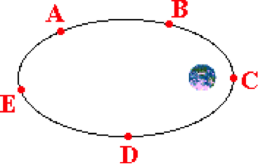

Rank these locations in increasing order of speed, beginning with the location of lowest speed. List the letters in increasing order with no spaces or commas between letters. If the speed is the same at all location, simply enter 'Z' into the answer box.

**Question 18:**

The elliptical path of an orbiting satellite is shown below. Several locations along the path are labeled with letters.

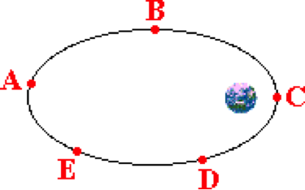

Rank these locations in increasing order of speed, beginning with the location of lowest speed. List the letters in increasing order with no spaces or commas between letters. If the speed is the same at all location, simply enter 'Z' into the answer box.

**Question 19:**

aa. The elliptical path of an orbiting satellite is shown below. Several locations along the path are labeled with letters.

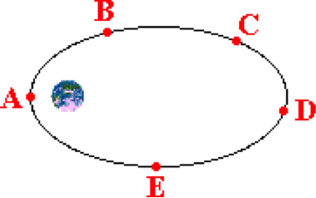

Rank these locations in increasing order of speed, beginning with the location of lowest speed. List the letters in increasing order with no spaces or commas between letters. If the speed is the same at all location, simply enter 'Z' into the answer box.

**Question 20:**

aa. The elliptical path of an orbiting satellite is shown below. Several locations along the path are labeled with letters.

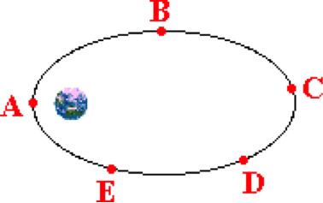

Rank these locations in increasing order of speed, beginning with the location of lowest speed. List the letters in increasing order with no spaces or commas between letters. If the speed is the same at all location, simply enter 'Z' into the answer box.

**Question 21:**

aa. A satellite is orbiting the Earth at a constant speed and a constant altitude above the Earth. The best words that could be used to describe the motion of the Earth-orbiting satellite is to say that the satellite is _____. List all that apply in alphabetical order with no spaces or commas between letters.

a. at equilibrium b. moving at a terminal velocity

c. not accelerating d. free of gravitational influences

e. in a state of free fall

**Question 22:**

aa. A satellite is orbiting the Earth at a constant speed and a constant altitude above the Earth. The best words that could be used to describe the motion of the Earth-orbiting satellite is to say that the satellite is _____. List all that apply in alphabetical order with no spaces or commas between letters.

a. not accelerating b. at equilibrium

c. moving at a terminal velocity d. in a state of free fall

e. free of gravitational influences

**Question 23:**

aa. A satellite is orbiting the Earth at a constant speed and a constant altitude above the Earth. The best words that could be used to describe the motion of the Earth-orbiting satellite is to say that the satellite is _____. List all that apply in alphabetical order with no spaces or commas between letters.

a. free of gravitational influences b. in a state of free fall

c. at equilibrium d. not accelerating

e. moving at a terminal velocity

**Question 24:**

aa. A satellite is orbiting the Earth at a constant speed and a constant altitude above the Earth. The best words that could be used to describe the motion of the Earth-orbiting satellite is to say that the satellite is _____. List all that apply in alphabetical order with no spaces or commas between letters.

a. in a state of free fall b. moving at a terminal velocity

c. free of gravitational influences d. not accelerating

e. at equilibrium

**Question 25:**

aa. The elliptical path of an orbiting satellite is shown below. Several locations along the path are labeled with letters.



Rank these locations in increasing order of net force, beginning with the location of lowest net force. List the letters in increasing order with no spaces or commas between letters. If the net force is the same at all location, simply enter 'Z' into the answer box.

**Question 26:**

aa. The elliptical path of an orbiting satellite is shown below. Several locations along the path are labeled with letters.



Rank these locations in increasing order of net force, beginning with the location of lowest net force. List the letters in increasing order with no spaces or commas between letters. If the net force is the same at all location, simply enter 'Z' into the answer box.

**Question 27:**

aa. The elliptical path of an orbiting satellite is shown below. Several locations along the path are labeled with letters.



Rank these locations in increasing order of net force, beginning with the location of lowest net force. List the letters in increasing order with no spaces or commas between letters. If the net force is the same at all location, simply enter 'Z' into the answer box.

**Question 28:**

aa. The elliptical path of an orbiting satellite is shown below. Several locations along the path are labeled with letters.



Rank these locations in increasing order of net force, beginning with the location of lowest net force. List the letters in increasing order with no spaces or commas between letters. If the net force is the same at all location, simply enter 'Z' into the answer box.

**Question 29:**

aa. The elliptical path of an orbiting satellite is shown below. Several locations along the path are labeled with letters. The satellite is orbiting in a counter-clockwise direction. A vector is shown to the left of the orbital path.

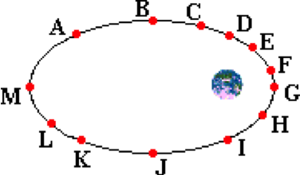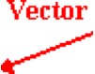

The direction of this vector is representative of the direction of the velocity vector at location ____ and the direction of the net force vector at location ____. List the two letters in their respective order with neither spaces nor commas between letters.

**Question 30:**

aa. The elliptical path of an orbiting satellite is shown below. Several locations along the path are labeled with letters. The satellite is orbiting in a counter-clockwise direction. A vector is shown to the left of the orbital path.

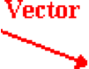

The direction of this vector is representative of the direction of the velocity vector at location ____ and the direction of the net force vector at location ____. List the two letters in their respective order with neither spaces nor commas between letters.

**Question 31:**

aa. The elliptical path of an orbiting satellite is shown below. Several locations along the path are labeled with letters. The satellite is orbiting in a counter-clockwise direction. A vector is shown to the left of the orbital path.

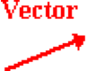

The direction of this vector is representative of the direction of the velocity vector at location ____ and the direction of the net force vector at location ____. List the two letters in their respective order with neither spaces nor commas between letters.

**Question 32:**

aa. The elliptical path of an orbiting satellite is shown below. Several locations along the path are labeled with letters. The satellite is orbiting in a counter-clockwise direction. A vector is shown to the left of the orbital path.



The direction of this vector is representative of the direction of the velocity vector at location ____ and the direction of the net force vector at location ____. List the two letters in their respective order with neither spaces nor commas between letters.

**Question 33:**

aa. The net force acting upon an Earth-orbiting satellite is dependent upon the ____. List all that apply in alphabetical order with no spaces or commas between letters.

a. mass of the satellite

b. mass of the Earth

c. distance from the satellite to the center of the Earth

d. radius of the Earth

e. ... nonsense! None of these variables affect the net force.

**Question 34:**

aa. The net force acting upon an Earth-orbiting satellite is dependent upon the ____. List all that apply in alphabetical order with no spaces or commas between letters.

a. mass of the Earth

b. mass of the satellite

c. radius of the Earth

d. distance from the satellite to the center of the Earth

e. ... nonsense! None of these variables affect the net force.

**Question 35:**

aa. The net force acting upon an Earth-orbiting satellite is dependent upon the ____. List all that apply in alphabetical order with no spaces or commas between letters.

a. distance from the satellite to the center of the Earth

b. radius of the Earth

c. mass of the satellite

d. mass of the Earth

e. ... nonsense! None of these variables affect the net force.

**Question 36:**

aa. The net force acting upon an Earth-orbiting satellite is dependent upon the ____. List all that apply in alphabetical order with no spaces or commas between letters.

a. radius of the Earth

b. distance from the satellite to the center of the Earth

c. mass of the Earth

d. mass of the satellite

e. ... nonsense! None of these variables affect the net force.

**CG9: Weightlessness**

**Question 1:**

aa. A person who feels weightless MUST be ____. Choose one.

a. in orbit about the Earth

b. in a location where there is no force of gravity

c. in an environment in which there is no atmosphere (a vacuum)

d. in an environment in which the only force acting upon them is gravity

e. hallucinating

f. having an out-of-the-body experience

**Question 2:**

aa. A person who feels weightless MUST be ____. Choose one.

a. in a location where there is no force of gravity

b. in orbit about the Earth

c. in an environment in which the only force acting upon them is gravity

d. in an environment in which there is no atmosphere (a vacuum)

e. hallucinating

f. having an out-of-the-body experience

**Question 3:**

aa. A person who feels weightless MUST be ____. Choose one.

a. in an environment in which there is no atmosphere (a vacuum)

b. in an environment in which the only force acting upon them is gravity

c. in orbit about the Earth

d. in a location where there is no force of gravity

e. hallucinating

f. having an out-of-the-body experience

**Question 4:**

aa. A person who feels weightless MUST be ____. Choose one.

a. in an environment in which the only force acting upon them is gravity

b. in an environment in which there is no atmosphere (a vacuum)

c. in a location where there is no force of gravity

d. in orbit about the Earth

e. hallucinating

f. having an out-of-the-body experience

**Question 5:**

aa. A person will feel weightless whenever ____. List all that apply in alphabetical order with no spaces or commas between letters.

a. there is no gravitational force acting upon their body

b. they weigh nothing due to reduced gravitational forces upon their body

c. the air resistance acting upon their body is negligible

d. there is no support force to balance the force of gravity upon their body

e. they are in a free-fall environment

f. they drink large quantities of soda pop and the carbonation makes them float

**Question 6:**

aa. A person will feel weightless whenever ____. List all that apply in alphabetical order with no spaces or commas between letters.

a. there is no gravitational force acting upon their body

b. they are in a free-fall environment

c. there is no support force to balance the force of gravity upon their body

d. the air resistance acting upon their body is negligible

e. they weigh nothing due to reduced gravitational forces upon their body

f. they drink large quantities of soda pop and the carbonation makes them float

**Question 7:**

aa. A person will feel weightless whenever ____. List all that apply in alphabetical order with no spaces or commas between letters.

a. the air resistance acting upon their body is negligible

b. they weigh nothing due to reduced gravitational forces upon their body

c. there is no support force to balance the force of gravity upon their body

d. there is no gravitational force acting upon their body

e. they are in a free-fall environment

f. they drink large quantities of soda pop and the carbonation makes them float

**Question 8:**

aa. A person will feel weightless whenever ____. List all that apply in alphabetical order with no spaces or commas between letters.

a. they weigh nothing due to reduced gravitational forces upon their body

b. there is no gravitational force acting upon their body

c. the air resistance acting upon their body is negligible

d. they are in a free-fall environment

e. there is no support force to balance the force of gravity upon their body

f. they drink large quantities of soda pop and the carbonation makes them float

**Question 9:**

aa. TRUE or FALSE:

A person who feels weightless is NOT being acted upon by the force of gravity.

a. True b. False

**Question 10:**

aa. TRUE or FALSE:

A person can feel weightless and still be acted upon by the force of gravity.

a. True b. False

**Question 11:**

aa. TRUE or FALSE:

A person can feel weightless and still be experiencing the same amount of gravitational force as they usually experience.

a. True b. False

**Question 12:**

aa. TRUE or FALSE:

A person who feels weightless is definitely experiencing less gravitational force than they usually experience.

a. True b. False

**Question 13:**

aa. TRUE or FALSE:

A person who feels weightless must NOT weigh anything.

a. True b. False

**Question 14:**

aa. TRUE or FALSE:

A person who feels weightless must NOT weigh anything.

a. True b. False

**Question 15:**

aa. TRUE or FALSE:

A person who feels weightless must NOT weigh anything.

a. True b. False

**Question 16:**

aa. Orbiting astronauts on the space shuttle do not have weight in space because _____.

a. there is no gravity in space

b. there is no air resistance in space

c. there are no scales in space to weigh themselves

d. the food is terrible and they work all the time

e. ... nonsense! The astronauts do have weight in space.

**Question 17:**

aa. Orbiting astronauts on the space shuttle do not have weight in space because _____.

a. there are no scales in space to weigh themselves

b. there is no gravity in space

c. the food is terrible and they work all the time

d. there is no air resistance in space

e. ... nonsense! The astronauts do have weight in space.

**Question 18:**

aa. Orbiting astronauts on the space shuttle do not have weight in space because _____.

a. the food is terrible and they work all the time

b. there are no scales in space to weigh themselves

c. there is no air resistance in space

d. there is no gravity in space

e. ... nonsense! The astronauts do have weight in space.

**Question 19:**

aa. Orbiting astronauts on the space shuttle do not have weight in space because _____.

a. there is no air resistance in space

b. there is no gravity in space

c. the food is terrible and they work all the time

d. there are no scales in space to weigh themselves

e. ... nonsense! The astronauts do have weight in space.

**Question 20:**

aa. Which of the following persons would feel less than their normal weight? That is, which would feel *less weighty* than they feel when they sit stationary in a seat? List all that apply in alphabetical order with no spaces or commas between letters.

a. A person moving downward in an elevator at a constant speed.

b. A person moving upward in an elevator at a constant speed.

c. A person moving rapidly over the crest of a small hill on a roller coaster ride.

d. A person orbiting the earth in a spaceship.

e. A person on a free fall ride at an amusement park.

f. A person at the bottom of a loop on a roller coaster ride.

**Question 21:**

aa. Which of the following persons would feel less than their normal weight? That is, which would feel *less weighty* than they feel when they sit stationary in a seat? List all that apply in alphabetical order with no spaces or commas between letters.

a. A person moving upward in an elevator at a constant speed.

b. A person moving downward in an elevator at a constant speed.

c. A person orbiting the earth in a spaceship.

d. A person moving rapidly over the crest of a small hill on a roller coaster ride.

e. A person at the bottom of a loop on a roller coaster ride.

f. A person on a free fall ride at an amusement park.

**Question 22:**

aa. Which of the following persons would feel less than their normal weight? That is, which would feel *less weighty* than they feel when they sit stationary in a seat? List all that apply in alphabetical order with no spaces or commas between letters.

a. A person moving rapidly over the crest of a small hill on a roller coaster ride.

b. A person on a free fall ride at an amusement park.

c A person at the bottom of a loop on a roller coaster ride.

d. A person moving downward in an elevator at a constant speed.

e. A person moving upward in an elevator at a constant speed.

f. A person orbiting the earth in a spaceship.

**Question 23:**

aa. Which of the following persons would feel less than their normal weight? That is, which would feel *less weighty* than they feel when they sit stationary in a seat? List all that apply in alphabetical order with no spaces or commas between letters.

a. A person orbiting the earth in a spaceship.

b. A person moving downward in an elevator at a constant speed.

c. A person moving upward in an elevator at a constant speed.

d. A person moving rapidly over the crest of a small hill on a roller coaster ride.

e. A person at the bottom of a loop on a roller coaster ride.

f. A person on a free fall ride at an amusement park.

**Question 24:**

aa. Consider the several stages of Otis's elevator experiments.

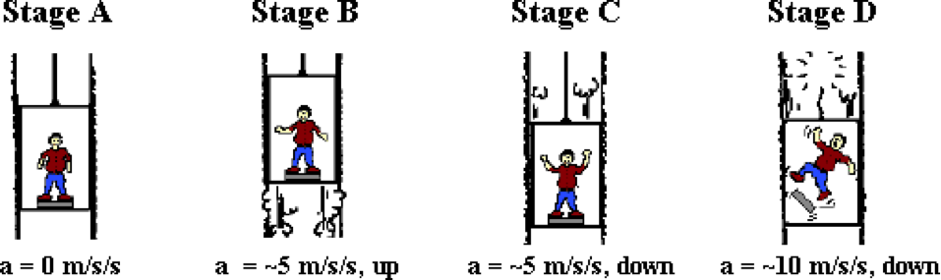

In which stage(s) would Otis feel less than his normal weight? List all that apply in alphabetical order with no spaces or commas between letters.

**Question 25:**

aa. Consider the several stages of Otis's elevator experiments.

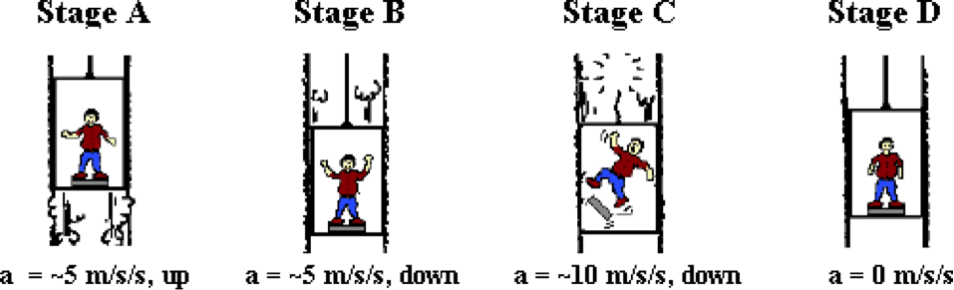

In which stage(s) would Otis feel less than his normal weight? List all that apply in alphabetical order with no spaces or commas between letters.

**Question 26:**

aa. Consider the several stages of Otis's elevator experiments.

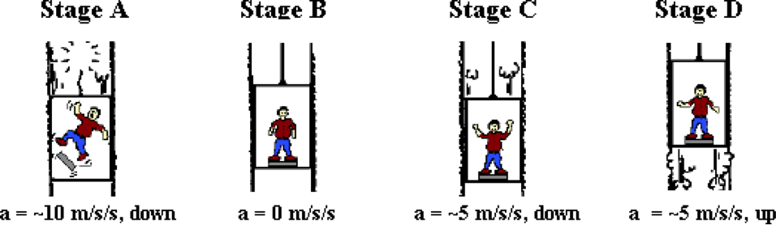

In which stage(s) would Otis feel less than his normal weight? List all that apply in alphabetical order with no spaces or commas between letters.

**Question 27:**

aa. Consider the several stages of Otis's elevator experiments.

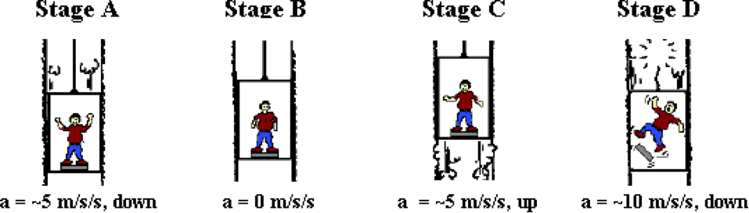

In which stage(s) would Otis feel less than his normal weight? List all that apply in alphabetical order with no spaces or commas between letters.

**Question 28:**

aa. Consider the several locations along a roller coaster track.

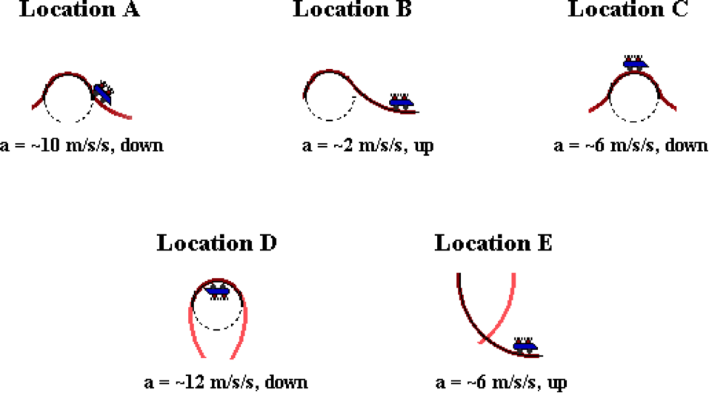

In which location(s) would the riders feel less than their normal weight? List all that apply in alphabetical order with no spaces or commas between letters.

**Question 29:**

aa. Consider the several locations along a roller coaster track.

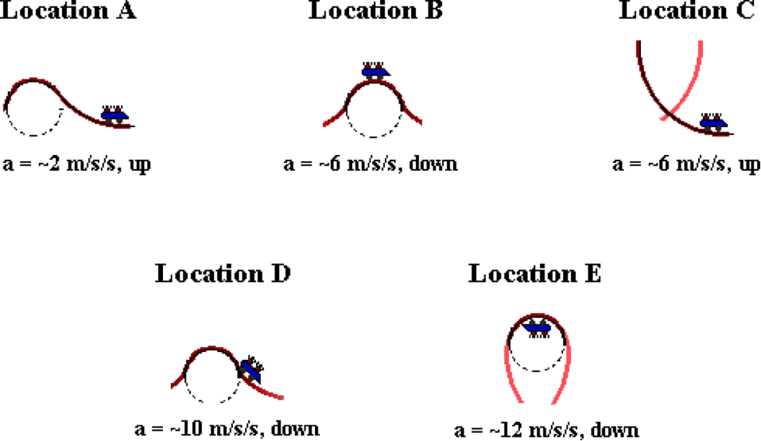

In which location(s) would the riders feel less than their normal weight? List all that apply in alphabetical order with no spaces or commas between letters.

**Question 30:**

aa. Consider the several locations along a roller coaster track.

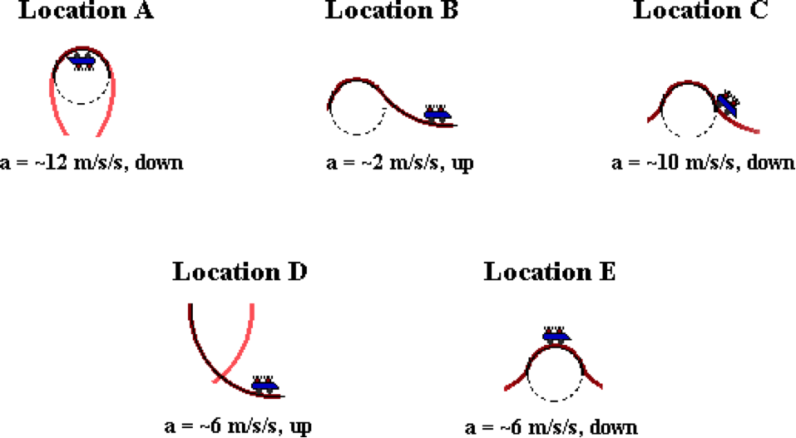

In which location(s) would the riders feel less than their normal weight? List all that apply in alphabetical order with no spaces or commas between letters.

**Question 31:**

aa. Consider the several locations along a roller coaster track.

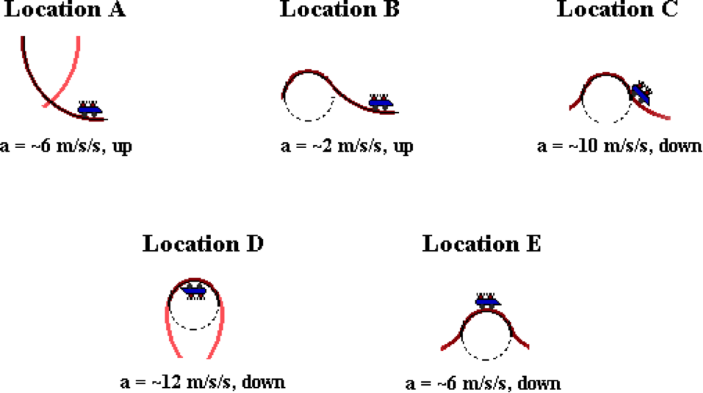

In which location(s) would the riders feel less than their normal weight? List all that apply in alphabetical order with no spaces or commas between letters.

**CG10: Kepler’s Laws of Planetary Motion**

**Question 1:**

aa. Identify the common names given to Kepler's three laws of planetary motion. List the three letters in alphabetical order with no commas or spaces between letters.

a. Law of Universal Gravitation b. Law of Heliocentricity

c. Law of Harmonies d. Law of Equal Areas

e. Law of Uniform Speed f. Law of Ellipses

**Question 2:**

aa. Identify the common names given to Kepler's three laws of planetary motion. List the three letters in alphabetical order with no commas or spaces between letters.

a. Law of Heliocentricity b. Law of Universal Gravitation

c. Law of Equal Areas d. Law of Harmonies

e. Law of Ellipses f. Law of Uniform Speed

**Question 3:**

aa. Identify the common names given to Kepler's three laws of planetary motion. List the three letters in alphabetical order with no commas or spaces between letters.

a. Law of Equal Areas b. Law of Heliocentricity

c. Law of Ellipses d. Law of Uniform Speed

e. Law of Universal Gravitation f. Law of Harmonies

**Question 4:**

aa. Identify the common names given to Kepler's three laws of planetary motion. List the three letters in alphabetical order with no commas or spaces between letters.

a. Law of Harmonies b. Law of Equal Areas

c. Law of Heliocentricity d. Law of Ellipses

e. Law of Uniform Speed f. Law of Universal Gravitation

**Question 5:**

aa. Which one of the following statements would NOT be consistent with Kepler's three laws of planetary motion?

a. The orbit of planets about the Sun are elliptical.

b. During its orbit about the Sun, a planet will travel fastest when it is nearest the Sun.

c. The area of the Sun as seen from a planet is the same during all periods of the planet's orbit.

d. Planets that are furthest from the Sun have longer periods than those that are closer.

e. ... nonsense! All of these statements are consistent with Kepler's laws.

**Question 6:**

aa. Which one of the following statements would NOT be consistent with Kepler's three laws of planetary motion?

a. During its orbit about the Sun, a planet will travel fastest when it is nearest the Sun.

b. The orbit of planets about the Sun are elliptical.

c. Planets that are furthest from the Sun have longer periods than those that are closer.

d. The area of the Sun as seen from a planet is the same during all periods of the planet's orbit.

e. ... nonsense! All of these statements are consistent with Kepler's laws.

**Question 7:**

aa. Which one of the following statements would NOT be consistent with Kepler's three laws of planetary motion?

a. The area of the Sun as seen from a planet is the same during all periods of the planet's orbit.

b. Planets that are furthest from the Sun have longer periods than those that are closer.

c. The orbit of planets about the Sun are elliptical.

d. During its orbit about the Sun, a planet will travel fastest when it is nearest the Sun.

e. ... nonsense! All of these statements are consistent with Kepler's laws.

**Question 8:**

aa. Which one of the following statements would NOT be consistent with Kepler's three laws of planetary motion?

a. Planets that are furthest from the Sun have longer periods than those that are closer.

b. The area of the Sun as seen from a planet is the same during all periods of the planet's orbit.

c. During its orbit about the Sun, a planet will travel fastest when it is nearest the Sun.

d. The orbit of planets about the Sun are elliptical.

e. ... nonsense! All of these statements are consistent with Kepler's laws.

**Question 9:**

aa. Kepler's second law of planetary motion is the law of equal areas. Which one of the following statements would be an extension of this law?

a. A planet would move at the same speed at all times during its orbit about the Sun.

b. When two different planets lie along the same imaginary line from planet to the Sun, their speeds are equal.

c. The longer the imaginary line from a planet to the Sun, the greater the speed of the planet.

d. Any given planet will travel fastest along its orbital path when it is closest to the Sun.

e. The length of an imaginary line drawn from a planet to the Sun multiplied by the period is equal to the planet's area.

**Question 10:**

aa. Kepler's second law of planetary motion is the law of equal areas. Which one of the following statements would be an extension of this law?

a. The length of an imaginary line drawn from a planet to the Sun multiplied by the period is equal to the planet's area.

b. Any given planet will travel fastest along its orbital path when it is closest to the Sun.

c. The longer the imaginary line from a planet to the Sun, the greater the speed of the planet.

d. When two different planets lie along the same imaginary line from planet to the Sun, their speeds are equal.

e. A planet would move at the same speed at all times during its orbit about the Sun.

**Question 11:**

aa. Kepler's second law of planetary motion is the law of equal areas. Which one of the following statements would be an extension of this law?

a. When two different planets lie along the same imaginary line from planet to the Sun, their speeds are equal.

b. A planet would move at the same speed at all times during its orbit about the Sun.

c. The length of an imaginary line drawn from a planet to the Sun multiplied by the period is equal to the planet's area.

d. The longer the imaginary line from a planet to the Sun, the greater the speed of the planet.

e. Any given planet will travel fastest along its orbital path when it is closest to the Sun.

**Question 12:**

aa. Kepler's second law of planetary motion is the law of equal areas. Which one of the following statements would be an extension of this law?

a. Any given planet will travel fastest along its orbital path when it is closest to the Sun.

b. The length of an imaginary line drawn from a planet to the Sun multiplied by the period is equal to the planet's area.

c. When two different planets lie along the same imaginary line from planet to the Sun, their speeds are equal.

d. The longer the imaginary line from a planet to the Sun, the greater the speed of the planet.

e. A planet would move at the same speed at all times during its orbit about the Sun.

**Question 13:**

aa. Kepler's second law of planetary motion states that a line connecting a planet to the Sun ____. Choose one.

a. is longest in winter and shortest in summer

b. sweeps out more area during a winter month than during the summer month

c. sweeps out the same amount of area in any two equal periods of time

d. sweeps out the same amount of area regardless of the planet

**Question 14:**

aa. Kepler's second law of planetary motion states that a line connecting a planet to the Sun ____. Choose one.

a. sweeps out more area during a winter month than during the summer month

b. is longest in winter and shortest in summer

c. sweeps out the same amount of area regardless of the planet

d. sweeps out the same amount of area in any two equal periods of time

**Question 15:**

aa. Kepler's second law of planetary motion states that a line connecting a planet to the Sun ____. Choose one.

a. sweeps out the same amount of area in any two equal periods of time

b. sweeps out the same amount of area regardless of the planet

c. is longest in winter and shortest in summer

d. sweeps out more area during a winter month than during the summer month

**Question 16:**

aa. Kepler's second law of planetary motion states that a line connecting a planet to the Sun ____. Choose one.

a. sweeps out the same amount of area regardless of the planet

b. sweeps out the same amount of area in any two equal periods of time

c. sweeps out more area during a winter month than during the summer month

d. is longest in winter and shortest in summer

**Question 17:**

aa. Kepler's third law of planetary motion states that the ratio of ____.

a. the orbital period to the orbital radius is the same for all planets

b. the orbital periods of any two planets equals the ratio of the orbital radii

c. all planets would orbit with the same orbital period

d. the period squared to the radius cubed is the same ratio for all planets

**Question 18:**

aa. Kepler's third law of planetary motion states that the ratio of ____.

a. the orbital periods of any two planets equals the ratio of the orbital radii

b. the orbital period to the orbital radius is the same for all planets

c. the period squared to the radius cubed is the same ratio for all planets

d. all planets would orbit with the same orbital period

**Question 19:**

aa. Kepler's third law of planetary motion states that the ratio of ____.

a. all planets would orbit with the same orbital period

b. the period squared to the radius cubed is the same ratio for all planets

c. the orbital period to the orbital radius is the same for all planets

d. the orbital periods of any two planets equals the ratio of the orbital radii

**Question 20:**

aa. Kepler's third law of planetary motion states that the ratio of ____.

a. the period squared to the radius cubed is the same ratio for all planets

b. all planets would orbit with the same orbital period

c. the orbital periods of any two planets equals the ratio of the orbital radii

d. the orbital period to the orbital radius is the same for all planets

**Question 21:**

aa. Two planets - planet A and planet B - are orbiting a star. If Planet A has an orbital radius which is two times as large as Planet B, then the period of Planet A's orbit is ____ times larger than the period of Planet B's orbit.

a. 0.67 b. 1.33 c. 2.00 d. 2.67

e. 2.83 f. 4.00 g. 8.00

h. None of these are even close.

**Question 22:**

aa. Two planets - planet A and planet B - are orbiting a star. If Planet A has an orbital radius which is two times as large as Planet B, then the period of Planet A's orbit is ____ times larger than the period of Planet B's orbit.

a. 8.00 b. 4.00 c. 2.83 d. 2.67

e. 2.00 f. 1.33 g. 0.67

h. None of these are even close.

**Question 23:**

aa. Two planets - planet A and planet B - are orbiting a star. If Planet A has an orbital radius which is three times as large as Planet B, then the period of Planet A's orbit is ____ times larger than the period of Planet B's orbit.

a. 1.00 b. 2.00 c. 3.00 d. 5.20

e. 9.00 f. 13.5 g. 27.0

h. None of these are even close.

**Question 24:**

aa. Two planets - planet A and planet B - are orbiting a star. If Planet A has an orbital radius which is three times as large as Planet B, then the period of Planet A's orbit is ____ times larger than the period of Planet B's orbit.

a. 27.0 b. 13.5 c. 9.00 d. 5.20

e. 3.00 f. 2.00 g. 1.00

h. None of these are even close.

**Question 25:**

aa. Two planets - planet A and planet B - are orbiting a star. If Planet A has an orbital radius which is four times as large as Planet B, then the period of Planet A's orbit is ____ times larger than the period of Planet B's orbit.

a. 1.33 b. 1.59 c. 2.67 d. 4.00

e. 5.33 f. 8.00 g. 16.0 h. 21.3

i. 32.0 j. 64.0 k. None of these are even close.

**Question 26:**

aa. Two planets - planet A and planet B - are orbiting a star. If Planet A has an orbital radius which is four times as large as Planet B, then the period of Planet A's orbit is ____ times larger than the period of Planet B's orbit.

a. 64.0 b. 32.0 c. 21.3 d. 16.0

e. 8.00 f. 5.33 g. 4.00 h. 2.67

i. 1.59 j. 1.33 k. None of these are even close.

**Question 27:**

aa. Two planets - planet A and planet B - are orbiting a star. If Planet A has an orbital radius which is five times as large as Planet B, then the period of Planet A's orbit is ____ times larger than the period of Planet B's orbit.

a. 1.67 b. 1.71 c. 3.33 d. 5.00

e. 8.33 f. 11.2 g. 25.0 h. 41.7

i. 62.5 j. 125 k. None of these are even close.

**Question 28:**

aa. Two planets - planet A and planet B - are orbiting a star. If Planet A has an orbital radius which is five times as large as Planet B, then the period of Planet A's orbit is ____ times larger than the period of Planet B's orbit.

a. 125 b. 62.5 c. 41.7 d. 25.0

e. 11.2 f. 8.33 g. 5.00 h. 3.33

i. 1.71 j. 1.67 k. None of these are even close.