**Minds On Physics Question Banks – Forces in Two Dimensions**

**2D1: Vector Components**

**Question 1:**

aa. A vector component describes _____.

a. the result of adding two or more vectors

b. the magnitude of a vector

c. the direction of a vector

d. the effect of a vector in a given direction

e. the scale used in constructing a vector diagram

f. a mathematical operation which uses trigonometric functions

**Question 2:**

aa. A vector component describes _____.

a. the magnitude of a vector

b. the direction of a vector

c. the effect of a vector in a given direction

d. the result of adding two or more vectors

e. the scale used in constructing a vector diagram

f. a mathematical operation which uses trigonometric functions

**Question 3:**

aa. A vector component describes _____.

a. the scale used in constructing a vector diagram

b. a mathematical operation which uses trigonometric functions

c. the effect of a vector in a given direction

d. the result of adding two or more vectors

e. the direction of a vector

f. the magnitude of a vector

**Question 4:**

aa. A vector component describes _____.

a. the direction of a vector

b. the magnitude of a vector

c. a mathematical operation which uses trigonometric functions

d. the scale used in constructing a vector diagram

e. the result of adding two or more vectors

f. the effect of a vector in a given direction

**Question 5:**

aa. Consider the force vector shown in the diagram. This force vector would have components that are directed ____ and ____. List the two answers in alphabetical order with no spaces between letters.

a. North b. South

c. East d. West

**Question 6:**

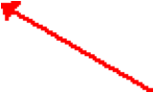aa. Consider the force vector shown in the diagram. This force vector would have components that are directed ____ and ____. List the two answers in alphabetical order with no spaces between letters.

a. North b. South

c. East d. West

**Question 7:**

aa. Consider the force vector shown in the diagram. This force vector would have components that are directed ____ and ____. List the two answers in alphabetical order with no spaces between letters.

a. North b. South

c. East d. West

**Question 8:**

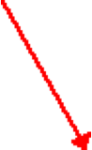aa. Consider the force vector shown in the diagram. This force vector would have components that are directed ____ and ____. List the two answers in alphabetical order with no spaces between letters.

a. North b. South

c. East d. West

**Question 9:**

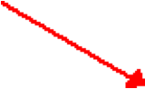aa. Consider the force vector shown in the diagram. This force vector would have components that are directed ____ and ____. List the two answers in alphabetical order with no spaces between letters.

a. North b. South

c. East d. West

**Question 10:**

aa. Consider the force vector shown in the diagram. This force vector would have components that are directed ____ and ____. List the two answers in alphabetical order with no spaces between letters.

a. North b. South

c. East d. West

**Question 11:**

aa. A vector is directed at a direction of 60 degrees (as measured counter-clockwise from east). Such a vector would have two components. The ____ component would be greater than the ____ component. (Pick the best applicable answer.)

a. eastward, northward b. eastward, southward

c. westward, northward d. westward, southward

e. northward, eastward f. northward, westward

g. southward, eastward h. southward, westward

i. ... nonsense! The horizontal and vertical components are equal in magnitude.

**Question 12:**

aa. A vector is directed at a direction of 110 degrees (as measured counter-clockwise from east). Such a vector would have two components. The ____ component would be greater than the ____ component. (Pick the best applicable answer.)

a. eastward, northward b. eastward, southward

c. westward, northward d. westward, southward

e. northward, eastward f. northward, westward

g. southward, eastward h. southward, westward

i. ... nonsense! The horizontal and vertical components are equal in magnitude.

**Question 13:**

aa. A vector is directed at a direction of 150 degrees (as measured counter-clockwise from east). Such a vector would have two components. The ____ component would be greater than the ____ component. (Pick the best applicable answer.)

a. eastward, northward b. eastward, southward

c. westward, northward d. westward, southward

e. northward, eastward f. northward, westward

g. southward, eastward h. southward, westward

i. ... nonsense! The horizontal and vertical components are equal in magnitude.

**Question 14:**

aa. A vector is directed at a direction of 200 degrees (as measured counter-clockwise from east). Such a vector would have two components. The ____ component would be greater than the ____ component. (Pick the best applicable answer.)

a. eastward, northward b. eastward, southward

c. westward, northward d. westward, southward

e. northward, eastward f. northward, westward

g. southward, eastward h. southward, westward

i. ... nonsense! The horizontal and vertical components are equal in magnitude.

**Question 15:**

aa. A vector is directed at a direction of 250 degrees (as measured counter-clockwise from east). Such a vector would have two components. The ____ component would be greater than the ____ component. (Pick the best applicable answer.)

a. eastward, northward b. eastward, southward

c. westward, northward d. westward, southward

e. northward, eastward f. northward, westward

g. southward, eastward h. southward, westward

i. ... nonsense! The horizontal and vertical components are equal in magnitude.

**Question 16:**

aa. A vector is directed at a direction of 300 degrees (as measured counter-clockwise from east). Such a vector would have two components. The ____ component would be greater than the ____ component. (Pick the best applicable answer.)

a. eastward, northward b. eastward, southward

c. westward, northward d. westward, southward

e. northward, eastward f. northward, westward

g. southward, eastward h. southward, westward

i. ... nonsense! The horizontal and vertical components are equal in magnitude.

**Question 17:**

aa. A vector is shown in the diagram below. This vector has two components. The ____ component would be greater than the ____ component. (Pick the best applicable answer.)

a. eastward, northward b. eastward, southward

c. westward, northward d. westward, southward

e. northward, eastward f. northward, westward

g. southward, eastward h. southward, westward

i. ... nonsense! The horizontal and vertical components are equal in magnitude.

**Question 18:**

aa. A vector is shown in the diagram below. This vector has two components. The ____ component would be greater than the ____ component. (Pick the best applicable answer.)

a. eastward, northward b. eastward, southward

c. westward, northward d. westward, southward

e. northward, eastward f. northward, westward

g. southward, eastward h. southward, westward

i. ... nonsense! The horizontal and vertical components are equal in magnitude.

**Question 19:**

aa. A vector is shown in the diagram below. This vector has two components. The ____ component would be greater than the ____ component. (Pick the best applicable answer.)

a. eastward, northward b. eastward, southward

c. westward, northward d. westward, southward

e. northward, eastward f. northward, westward

g. southward, eastward h. southward, westward

i. ... nonsense! The horizontal and vertical components are equal in magnitude.

**Question 20:**

aa. A vector is shown in the diagram below. This vector has two components. The ____ component would be greater than the ____ component. (Pick the best applicable answer.)

a. eastward, northward b. eastward, southward

c. westward, northward d. westward, southward

e. northward, eastward f. northward, westward

g. southward, eastward h. southward, westward

i. ... nonsense! The horizontal and vertical components are equal in magnitude.

**Question 21:**

aa. A vector is shown in the diagram below. This vector has two components. The ____ component would be greater than the ____ component. (Pick the best applicable answer.)

a. eastward, northward b. eastward, southward

c. westward, northward d. westward, southward

e. northward, eastward f. northward, westward

g. southward, eastward h. southward, westward

i. ... nonsense! The horizontal and vertical components are equal in magnitude.

**Question 22:**

aa. A vector is shown in the diagram below. This vector has two components. The ____ component would be greater than the ____ component. (Pick the best applicable answer.)

a. eastward, northward b. eastward, southward

c. westward, northward d. westward, southward

e. northward, eastward f. northward, westward

g. southward, eastward h. southward, westward

i. ... nonsense! The horizontal and vertical components are equal in magnitude.

**Question 23:**

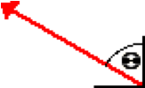Consider the diagram of a force vector shown below. The angle theta is expressed as the angle of the vector with respect to due north. As the angle theta INCREASES from the current value to 90 degrees, the horizontal component of force ____ and the vertical component of force ____.

a. increases, increases b. increases, decreases

c. decreases, decreases d. decreases, increases

e. ... nonsense! A change in theta will not affect the magnitude of the force components.

**Question 24:**

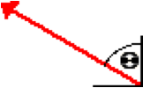aa. Consider the diagram of a force vector shown below. The angle theta is expressed as the angle of the vector with respect to due north. As the angle theta DECREASES from the current value to 0 degrees, the horizontal component of force ____ and the vertical component of force ____.

a. increases, increases b. increases, decreases

c. decreases, decreases d. decreases, increases

e. ... nonsense! A change in theta will not affect the magnitude of the force components.

**Question 25:**

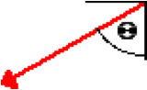aa. Consider the diagram of a force vector shown below. The angle theta is expressed as the angle of the vector with respect to due south. As the angle theta INCREASES from the current value to 90 degrees, the horizontal component of force ____ and the vertical component of force ____.

a. increases, increases b. increases, decreases

c. decreases, decreases d. decreases, increases

e. ... nonsense! A change in theta will not affect the magnitude of the force components.

**Question 26:**

aa. Consider the diagram of a force vector shown below. The angle theta is expressed as the angle of the vector with respect to due south. As the angle theta DECREASES from the current value to 0 degrees, the horizontal component of force ____ and the vertical component of force ____.

a. increases, increases b. increases, decreases

c. decreases, decreases d. decreases, increases

e. ... nonsense! A change in theta will not affect the magnitude of the force components.

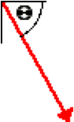**Question 27:**

aa. Consider the diagram of a force vector shown below. The angle theta is expressed as the angle of the vector with respect to due east. As the angle theta INCREASES from the current value to 90 degrees, the horizontal component of force ____ and the vertical component of force ____.

a. increases, increases b. increases, decreases

c. decreases, decreases d. decreases, increases

e. ... nonsense! A change in theta will not affect the magnitude of the force components.

**Question 28:**

aa. Consider the diagram of a force vector shown below. The angle theta is expressed as the angle of the vector with respect to due east. As the angle theta DECREASES from the current value to 0 degrees, the horizontal component of force ____ and the vertical component of force ____.

a. increases, increases b. increases, decreases

c. decreases, decreases d. decreases, increases

e. ... nonsense! A change in theta will not affect the magnitude of the force components.

**Question 29:**

aa. Suppose that a force with a magnitude of 42.6 N is exerted at an angle of 36 degrees with the horizontal. This force would be the same as having two forces which are exerted at ____ and ____.

a. 21.3 N horizontally, 21.3 N vertically

b. 26.5 N horizontally, 16.1 N vertically

c. 5.5 N horizontally, 42.3 N vertically

d. 42.3 N horizontally, 5.5 N vertically

e. 34.5 N horizontally, 25.0 N vertically

f. 25.0 N horizontally, 34.5 N vertically

g. 24.4 N horizontally, 26.5 N vertically

h. 26.5 N horizontally, 24.4 N vertically

i. 35.4 N horizontally, 6.8 N vertically

j. 6.8 N horizontally, 35.4 N vertically

k. ... nonsense! It would be impossible to replace a single force by two different forces.

l. ... none of these answers are even close. Yet it would be possible to find two forces.

**Question 30:**

aa. Suppose that a force with a magnitude of 42.6 N is exerted at an angle of 36 degrees with the horizontal. This force would be the same as having two forces which are exerted at ____ and ____.

a. 24.4 N horizontally, 26.5 N vertically

b. 26.5 N horizontally, 24.4 N vertically

c. 21.3 N horizontally, 21.3 N vertically

d. 26.5 N horizontally, 16.1 N vertically

e. 35.4 N horizontally, 6.8 N vertically

f. 6.8 N horizontally, 35.4 N vertically

g. 34.5 N horizontally, 25.0 N vertically

h. 25.0 N horizontally, 34.5 N vertically

i. 5.5 N horizontally, 42.3 N vertically

j. 42.3 N horizontally, 5.5 N vertically

k. ... nonsense! It would be impossible to replace a single force by two different forces.

l. ... none of these answers are even close. Yet it would be possible to find two forces.

**Question 31:**

aa. Suppose that a force with a magnitude of 52.8 N is exerted at an angle of 18 degrees with the horizontal. This force would be the same as having two forces which are exerted at ____ and ____.

a. 10.9 N horizontally, 41.9 N vertically

b. 26.4 N horizontally, 26.4 N vertically

c. 50.2 N horizontally, 16.3 N vertically

d. 16.3 N horizontally, 50.2 N vertically

e. 39.7 N horizontally, 34.9 N vertically

f. 34.9 N horizontally, 39.7 N vertically

g. 10.3 N horizontally, 14.8 N vertically

h. 14.8 N horizontally, 10.3 N vertically

i. 14.3 N horizontally, 10.9 N vertically

j. 10.9 N horizontally, 14.3 N vertically

k. ... nonsense! It would be impossible to replace a single force by two different forces.

l. ... none of these answers are even close. Yet it would be possible to find two forces.

**Question 32:**

aa. Suppose that a force with a magnitude of 52.8 N is exerted at an angle of 18 degrees with the horizontal. This force would be the same as having two forces which are exerted at ____ and ____.

a. 10.9 N horizontally, 14.3 N vertically

b. 14.3 N horizontally, 10.9 N vertically

c. 39.7 N horizontally, 34.9 N vertically

d. 34.9 N horizontally, 39.7 N vertically

e. 26.4 N horizontally, 26.4 N vertically

f. 10.9 N horizontally, 41.9 N vertically

g. 16.3 N horizontally, 50.2 N vertically

h. 50.2 N horizontally, 16.3 N vertically

i. 14.8 N horizontally, 10.3 N vertically

j. 10.3 N horizontally, 14.8 N vertically

k. ... nonsense! It would be impossible to replace a single force by two different forces.

l. ... none of these answers are even close. Yet it would be possible to find two forces.

**Question 33:**

aa. Suppose that a force with a magnitude of 44.2 N is exerted at an angle of 40 degrees with the horizontal. This force would be the same as having two forces which are exerted at ____ and ____.

a. 28.7 N horizontally, 15.5 N vertically

b. 22.1 N horizontally, 22.1 N vertically

c. 28.4 N horizontally, 33.9 N vertically

d. 33.9 N horizontally, 28.4 N vertically

e. 8.6 N horizontally, 39.1 N vertically

f. 39.1 N horizontally, 8.6 N vertically

g. 28.7 N horizontally, 27.9 N vertically

h. 27.9 N horizontally, 28.7 N vertically

i. 32.9 N horizontally, 29.5 N vertically

j. 29.5 N horizontally, 32.9 N vertically

k. ... nonsense! It would be impossible to replace a single force by two different forces.

l. ... none of these answers are even close. Yet it would be possible to find two forces.

**Question 34:**

aa. Suppose that a force with a magnitude of 44.2 N is exerted at an angle of 40 degrees with the horizontal. This force would be the same as having two forces which are exerted at ____ and ____.

a. 33.9 N horizontally, 28.4 N vertically

b. 28.4 N horizontally, 33.9 N vertically

c. 28.7 N horizontally, 27.9 N vertically

d. 27.9 N horizontally, 28.7 N vertically

e. 22.1 N horizontally, 22.1 N vertically

f. 28.7 N horizontally, 15.5 N vertically

g. 8.6 N horizontally, 39.1 N vertically

h. 39.1 N horizontally, 8.6 N vertically

i. 32.9 N horizontally, 29.5 N vertically

j. 29.5 N horizontally, 32.9 N vertically

k. ... nonsense! It would be impossible to replace a single force by two different forces.

l. ... none of these answers are even close. Yet it would be possible to find two forces.

**Question 35:**

aa. Suppose that a force with a magnitude of 54.6 N is exerted at a direction of 160 degrees (expressed as a counter-clockwise angle of rotation from due east). This force would be the same as having two forces which are exerted at ____ and ____.

a. 27.3 N west, 27.3 N north

b. 92.7 N west, 38.1 N north

c. 51.3 N west, 18.7 N north

d. 18.7 N west, 51.3 N north

e. 53.3 N west, 12.0 N north

f. 12.0 N west, 53.3 N north

g. 92.7 N west, 130.4 N north

h. 130.4 N west, 92.7 N north

i. 148.7 N west, 59.0 N north

j. 59.0 N west, 148.7 N north

k. ... nonsense! It would be impossible to replace a single force by two different forces.

l. ... none of these answers are even close. Yet it would be possible to find two forces.

**Question 36:**

aa. Suppose that a force with a magnitude of 54.6 N is exerted at a direction of 160 degrees (expressed as a counter-clockwise angle of rotation from due east). This force would be the same as having two forces which are exerted at ____ and ____.

a. 59.0 N west, 148.7 N north

b. 148.7 N west, 59.0 N north

c. 92.7 N west, 38.1 N north

d. 27.3 N west, 27.3 N north

e. 130.4 N west, 92.7 N north

f. 92.7 N west, 130.4 N north

g. 18.7 N west, 51.3 N north

h. 51.3 N west, 18.7 N north

i. 53.3 N west, 12.0 N north

j. 12.0 N west, 53.3 N north

k. ... nonsense! It would be impossible to replace a single force by two different forces.

l. ... none of these answers are even close. Yet it would be possible to find two forces.

**Question 37:**

aa. Suppose that a force with a magnitude of 54.6 N is exerted at a direction of 223 degrees (expressed as a counter-clockwise angle of rotation from due east). This force would be the same as having two forces which are exerted at ____ and ____.

a. 129.2 N west, 74.6 N south

b. 27.3 N west, 27.3 N south

c. 207.3 N west, 82.3 N south

d. 82.3 N west, 207.3 N south

e. 39.9 N west, 37.2 N south

f. 37.2 N west, 39.9 N south

g. 2.9 N west, 54.5 N south

h. 54.5 N west, 2.9 N south

i. 129.2 N west, 181.8 N south

j. 181.8 N west, 129.2N south

k. ... nonsense! It would be impossible to replace a single force by two different forces.

l. ... none of these answers are even close. Yet it would be possible to find two forces.

**Question 38:**

aa. Suppose that a force with a magnitude of 54.6 N is exerted at a direction of 223 degrees (expressed as a counter-clockwise angle of rotation from due east). This force would be the same as having two forces which are exerted at ____ and ____.

a. 82.3 N west, 207.3 N south

b. 207.3 N west, 82.3 N south

c. 2.9 N west, 54.5 N south

d. 54.5 N west, 2.9 N south

e. 37.2 N west, 39.9 N south

f. 39.9 N west, 37.2 N south

g. 129.2 N west, 74.6 N south

h. 27.3 N west, 27.3 N south

i. 129.2 N west, 181.8 N south

j. 181.8 N west, 129.2N south

k. ... nonsense! It would be impossible to replace a single force by two different forces.

l. ... none of these answers are even close. Yet it would be possible to find two forces.

**Question 39:**

aa. Suppose that a force with a magnitude of 422 N is exerted at a direction of 336 degrees (expressed as a counter-clockwise angle of rotation from due east). This force would be the same as having two forces which are exerted at ____ and ____.

a. 174.0 N east, 287.5 N south

b. 287.5 N east, 174.0 N south

c. 296.7 N east, 157.7 N south

d. 157.7 N east, 296.7 N south

e. 417.2 N east, 63.2 N south

f. 63.2 N east, 417.2 N south

g. 171.6 N east, 385.5 N south

h. 385.5 N east, 171.6 N south

i. 211 N east, 211 N south

j. 157.7 N east, 264.3 N south

k. ... nonsense! It would be impossible to replace a single force by two different forces.

l. ... none of these answers are even close. Yet it would be possible to find two forces.

**Question 40:**

aa. Suppose that a force with a magnitude of 422 N is exerted at a direction of 336 degrees (expressed as a counter-clockwise angle of rotation from due east). This force would be the same as having two forces which are exerted at ____ and ____.

a. 63.2 N east, 417.2 N south

b. 417.2 N east, 63.2 N south

c. 171.6 N east, 385.5 N south

d. 385.5 N east, 171.6 N south

e. 287.5 N east, 174.0 N south

f. 174.0 N east, 287.5 N south

g. 157.7 N east, 296.7 N south

h. 296.7 N east, 157.7 N south

i. 157.7 N east, 264.3 N south

j. 211 N east, 211 N south

k. ... nonsense! It would be impossible to replace a single force by two different forces.

l. ... none of these answers are even close. Yet it would be possible to find two forces.

**2D2: Fnet = m•a and Forces at Angles**

**Question 1:**

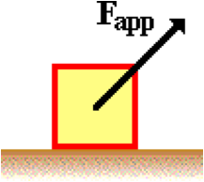aa. A box is being accelerated across a level surface. A force is being applied to the box in an upward and rightward direction (as shown below). In this situation, the normal force is ____ the force of gravity.

a. equal to b. greater than c. less than

d. ... nonsense! It is impossible to tell without any actual numbers.

**Question 2:**

aa. A box is being accelerated across a level surface. A force is being applied to the box in an upward and rightward direction (as shown below). In this situation, the normal force is ____ the force of gravity.

a. equal to b. less than c. greater than

d. ... nonsense! It is impossible to tell without any actual numbers.

**Question 3:**

aa. A box is being accelerated across a level surface. A force is being applied to the box in an upward and rightward direction (as shown below). In this situation, the normal force is ____ the force of gravity.

a. less than b. greater than c. equal to

d. ... nonsense! It is impossible to tell without any actual numbers.

**Question 4:**

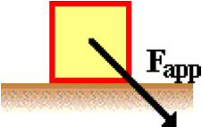aa. A box is being accelerated across a level surface. A force is being applied to the box in a downward and rightward direction (as shown below). In this situation, the normal force is ____ the force of gravity.

a. equal to b. greater than c. less than

d. ... nonsense! It is impossible to tell without any actual numbers.

**Question 5:**

aa. A box is being accelerated across a level surface. A force is being applied to the box in a downward and rightward direction (as shown below). In this situation, the normal force is ____ the force of gravity.

a. equal to b. less than c. greater than

d. ... nonsense! It is impossible to tell without any actual numbers.

**Question 6:**

aa. A box is being accelerated across a level surface. A force is being applied to the box in a downward and rightward direction (as shown below). In this situation, the normal force is ____ the force of gravity.

a. greater than b. less than c. equal to

d. ... nonsense! It is impossible to tell without any actual numbers.

**Question 7:**

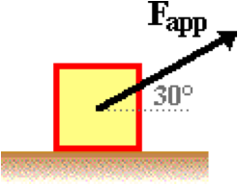aa. A box is being accelerated across a level surface. A force is being applied to the box in an upward and a rightward direction (as shown below). This force makes an angle of 30 degrees with the horizontal. If the angle at which the force is exerted is increased to 45 degrees, then the normal force would ____.

a. increase b. decrease c. not be changed

d. ... nonsense! It is impossible to tell without an actual force value.

**Question 8:**

aa. A box is being accelerated across a level surface. A force is being applied to the box in an upward and a rightward direction (as shown below). This force makes an angle of 30 degrees with the horizontal. If the angle at which the force is exerted is increased to 45 degrees, then the normal force would ____.

a. decrease b. increase c. not be changed

d. ... nonsense! It is impossible to tell without an actual force value.

**Question 9:**

aa. A box is being accelerated across a level surface. A force is being applied to the box in an upward and a rightward direction (as shown below). This force makes an angle of 30 degrees with the horizontal. If the angle at which the force is exerted is increased to 45 degrees, then the normal force would ____.

a. not be changed b. increase c. decrease

d. ... nonsense! It is impossible to tell without an actual force value.

**Question 10:**

aa. A box is being accelerated across a rough, level surface. A force is being applied to the box in an upward and a rightward direction (as shown below). This force makes an angle of 30 degrees with the horizontal. If the angle at which the force is exerted is increased to 45 degrees, then the friction force would ____.

a. increase b. decrease c. not be changed

d. ... nonsense! It is impossible to tell without an actual force value.

**Question 11:**

aa. A box is being accelerated across a rough, level surface. A force is being applied to the box in an upward and a rightward direction (as shown below). This force makes an angle of 30 degrees with the horizontal. If the angle at which the force is exerted is increased to 45 degrees, then the friction force would ____.

a. decrease b. increase c. not be changed

d. ... nonsense! It is impossible to tell without an actual force value.

**Question 12:**

aa. A box is being accelerated across a rough, level surface. A force is being applied to the box in an upward and a rightward direction (as shown below). This force makes an angle of 30 degrees with the horizontal. If the angle at which the force is exerted is increased to 45 degrees, then the friction force would ____.

a. not be changed b. increase c. decrease

d. ... nonsense! It is impossible to tell without an actual force value.

**Question 13:**

aa. A box is being accelerated across a level surface. A force is being applied to the box in an upward and a rightward direction (as shown below). This force makes an angle of 30 degrees with the horizontal. If the angle at which the force is exerted is increased to 45 degrees, then the force of gravity would ____.

a. increase b. decrease c. not be changed

d. ... nonsense! It is impossible to tell without an actual force value.

**Question 14:**

aa. A box is being accelerated across a level surface. A force is being applied to the box in an upward and a rightward direction (as shown below). This force makes an angle of 30 degrees with the horizontal. If the angle at which the force is exerted is increased to 45 degrees, then the force of gravity would ____.

a. decrease b. increase c. not be changed

d. ... nonsense! It is impossible to tell without an actual force value.

**Question 15:**

aa. A box is being accelerated across a level surface. A force is being applied to the box in an upward and a rightward direction (as shown below). This force makes an angle of 30 degrees with the horizontal. If the angle at which the force is exerted is increased to 45 degrees, then the force of gravity would ____.

a. not be changed b. increase c. decrease

d. ... nonsense! It is impossible to tell without an actual force value.

**Question 16:**

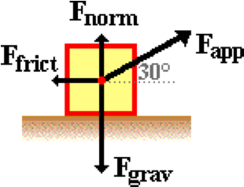aa. A box of mass 'm' is being dragged across a rough, level surface having a coefficient of friction of 'mu.' A force is being applied to the box in an upward and a rightward direction (as shown below). This force makes an angle of 30 degrees with the horizontal. The force of friction experienced by the box would be equal to ____. List all that apply in alphabetical order with no spaces between letters.

a. the weight of the box

b. applied force acting upon the block

c. the coefficient of friction multiplied by the weight of the box

d. the mass of the box multiplied by the acceleration of the box

e. mu • m • g

f. m • g / mu

g. mu • Fapp • sin (30 degrees)

h. ... nonsense! None of these would be equal to the force of friction on the box.

**Question 17:**

aa. A box of mass 'm' is being dragged across a rough, level surface having a coefficient of friction of 'mu.' A force is being applied to the box in an upward and a rightward direction (as shown below). This force makes an angle of 30 degrees with the horizontal. The force of friction experienced by the box would be equal to ____. List all that apply in alphabetical order with no spaces between letters.

a. the weight of the box

b. applied force acting upon the block

c. the coefficient of friction multiplied by the normal force acting upon the box

d. the mass of the box multiplied by the acceleration of the box

e. mu • m • g

f. m • g / mu

g. mu • Fapp ï sin (30 degrees)

h. mu • ( m • g - Fapp • sin (30 degrees) )

i. ... nonsense! None of these would be equal to the force of friction on the box.

**Question 18:**

aa. A box of mass 'm' is being dragged across a rough, level surface having a coefficient of friction of 'mu.' A force is being applied to the box in an upward and a rightward direction (as shown below). This force makes an angle of 30 degrees with the horizontal. The force of friction experienced by the box would be equal to ____. List all that apply in alphabetical order with no spaces between letters.

a. applied force acting upon the block

b. the weight of the box

c. the mass of the box multiplied by the acceleration of the box

d. the coefficient of friction multiplied by the normal force acting upon the box

e. mu • m • g

f. m • g / mu

g. mu • Fapp • sin (30 degrees)

h. mu • m • g • sin (30 degrees)

i. ... nonsense! None of these would be equal to the force of friction on the box.

**Question 19:**

aa. A box of mass 'm' is being dragged across a rough, level surface having a coefficient of friction of 'mu.' A force is being applied to the box in an upward and a rightward direction (as shown below). This force makes an angle of 30 degrees with the horizontal. The force of friction experienced by the box would be equal to ____. List all that apply in alphabetical order with no spaces between letters.

a. the mass of the box multiplied by the acceleration of the box

b. the weight of the box

c. applied force acting upon the block

d. the coefficient of friction multiplied by the normal force acting upon the box

e. m • g / mu

f. mu • m • g

g. mu • ( m • g - Fapp • sin (30 degrees) )

h. mu • Fapp• sin (30 degrees)

i. ... nonsense! None of these would be equal to the force of friction on the box.

**Question 20:**

aa. Consider the physical situation shown below. A 28.5-Newton force is applied at a 30-degree angle to the horizontal to accelerate a 6.5-kg box across a rough surface (coefficient of friction = 0.22). Use g = 9.8 m/s/s to fill in all the blanks and determine the acceleration of the box.

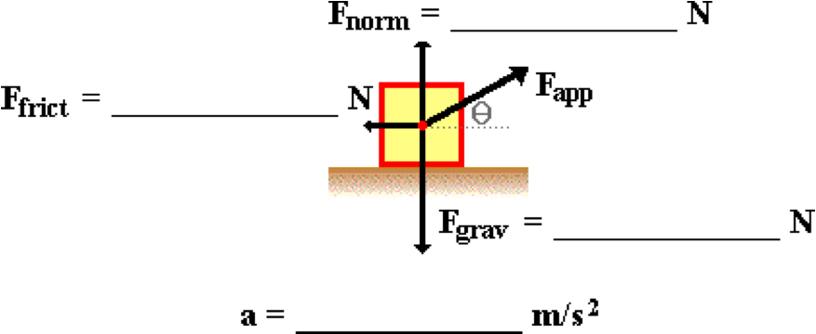

**Question 21:**

aa. Consider the physical situation shown below. A 32.8-Newton force is applied at a 34-degree angle to the horizontal to accelerate a 7.2-kg box across a rough surface (coefficient of friction = 0.25). Use g = 9.8 m/s/s to fill in all the blanks and determine the acceleration of the box.



**Question 22:**

aa. Consider the physical situation shown below. A 43.1-Newton force is applied at a 32-degree angle to the horizontal to accelerate a 8.8-kg box across a rough surface (coefficient of friction = 0.35). Use g = 9.8 m/s/s to fill in all the blanks and determine the acceleration of the box.



**Question 23:**

aa. Consider the physical situation shown below. A 27.2-Newton force is applied at a 33-degree angle to the horizontal to accelerate a 4.5-kg box across a rough surface (coefficient of friction = 0.31). Use g = 9.8 m/s/s to fill in all the blanks and determine the acceleration of the box.



**Question 24:**

aa. Consider the physical situation shown below. A 21.9-Newton force is applied at a 25-degree angle to the horizontal to accelerate a 5.2-kg box across a rough surface (coefficient of friction = 0.32). Use g = 9.8 m/s/s to fill in all the blanks and determine the acceleration of the box.



**Question 25:**

aa. Consider the physical situation shown below. A 43.8-Newton force is applied at a 34-degree angle to the horizontal to accelerate a 8.2-kg box across a rough surface (coefficient of friction = 0.29). Use g = 9.8 m/s/s to fill in all the blanks and determine the acceleration of the box.



**Question 26:**

aa. Consider the physical situation shown below. A 52.6-Newton force is applied at a 26-degree angle to the horizontal to accelerate a 12.5-kg box across a rough surface (coefficient of friction = 0.26). Use g = 9.8 m/s/s to fill in all the blanks and determine the acceleration of the box.



**Question 27:**

aa. Consider the physical situation shown below. A 76.2-Newton force is applied at a 37-degree angle to the horizontal to accelerate a 15.4-kg box across a rough surface (coefficient of friction = 0.18). Use g = 9.8 m/s/s to fill in all the blanks and determine the acceleration of the box.



**Question 28:**

aa. Consider the physical situation shown below. A 55.8-Newton force is applied at a 22-degree angle to the horizontal to accelerate a 9.7-kg box across a rough surface (coefficient of friction = 0.25). Use g = 9.8 m/s/s to fill in all the blanks and determine the acceleration of the box.



**2D3: Equilibrium Concepts**

**Question 1:**

aa. An object that is at equilibrium is an object upon which all the forces are ____.

a. zero b. equal c. balanced d. non-existent

**Question 2:**

aa. An object that is at equilibrium is an object upon which all the forces are ____.

a. non-existent b. zero c. equal d. balanced

**Question 3:**

aa. An object that is at equilibrium is an object upon which all the forces are ____.

a. balanced b. non-existent c. zero d. equal

**Question 4:**

aa. An object that is at equilibrium is an object upon which all the forces are ____.

a. equal b. balanced c. non-existent d. zero

**Question 5:**

aa. TRUE or FALSE?

If an object is at equilibrium, then all the individual forces acting upon it are equal to each other.

a. True b. False

**Question 6:**

aa. TRUE or FALSE?

If an object is at equilibrium, then all the individual forces acting upon it are equal to each other.

a. True b. False

**Question 7:**

aa. TRUE or FALSE?

If an object is at equilibrium, then all the individual forces acting upon it are balanced.

a. True b. False

**Question 8:**

aa. Which of the following descriptions COULD be true of an object that is at equilibrium? List all that apply in alphabetical order with no spaces between letters.

a. The object is at rest.

b. The object is moving.

c. The object is moving in a circle at a constant speed.

d. The object is accelerating.

e. The object is slowing down.

f. The object is moving with a constant velocity.

g. The object is changing its velocity.

**Question 9:**

aa. Which of the following descriptions COULD be true of an object that is at equilibrium? List all that apply in alphabetical order with no spaces between letters.

a. The object is moving.

b. The object is accelerating.

c. The object is at rest.

d. The object is changing its velocity.

e. The object is slowing down.

f. The object is moving with a constant velocity.

g. The object is moving in a circle at a constant speed.

**Question 10:**

aa. Which of the following descriptions COULD be true of an object that is at equilibrium? List all that apply in alphabetical order with no spaces between letters.

a. The object is moving in a circle at a constant speed.

b. The object is changing its velocity.

c. The object is moving with a constant velocity.

d. The object is moving.

e. The object is accelerating.

f. The object is slowing down.

g. The object is at rest.

**Question 11:**

aa. Which of the following descriptions COULD be true of an object that is at equilibrium? List all that apply in alphabetical order with no spaces between letters.

a. The object is moving with a constant velocity.

b. The object is changing its velocity.

c. The object is at rest.

d. The object is moving.

e. The object is slowing down.

f. The object is accelerating.

g. The object is moving in a circle at a constant speed.

**Question 12:**

aa. If an object is at equilibrium, then which of the following MUST be true? List all that apply in alphabetical order with no spaces between letters.

a. The acceleration is 0 m/s/s.

b. The object is at rest.

c. All individual forces acting upon the object are equal in magnitude.

d. The net force is 0 N.

e. The force of gravity is equal to the normal force.

f. The forces are balanced.

g. The velocity (whether zero or non-zero) is constant.

h. The velocity is changing.

**Question 13:**

aa. If an object is at equilibrium, then which of the following MUST be true? List all that apply in alphabetical order with no spaces between letters.

a. All individual forces acting upon the object are equal in magnitude.

b. The net force is 0 N.

c. The force of gravity is equal to the normal force.

d. The forces are balanced.

e. The acceleration is 0 m/s/s.

f. The object is at rest.

g. The velocity (whether zero or non-zero) is constant.

h. The velocity is changing.

**Question 14:**

aa. If an object is at equilibrium, then which of the following MUST be true? List all that apply in alphabetical order with no spaces between letters.

a. The object is at rest.

b. The velocity (whether zero or non-zero) is constant.

c. The velocity is changing.

d. The acceleration is 0 m/s/s.

e. The net force is 0 N.

f. All individual forces acting upon the object are equal in magnitude.

g. The force of gravity is equal to the normal force.

h. The forces are balanced.

**Question 15:**

aa. If an object is at equilibrium, then which of the following MUST be true? List all that apply in alphabetical order with no spaces between letters.

a. The object is at rest.

b. The acceleration is 0 m/s/s.

c. The forces are balanced.

d. The force of gravity is equal to the normal force.

e. The net force is 0 N.

f. All individual forces acting upon the object are equal in magnitude.

g. The velocity is changing.

h. The velocity (whether zero or non-zero) is constant.

**Question 16:**

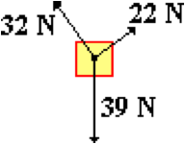aa. An object is at equilibrium. The individual forces acting upon the object are shown in the diagram below. The magnitude of the net force experienced by this object is ____ N.

a. 0 b. 10 c. 15

d. 39 e. ~40 f. 93

g. ... nonsense! It is impossible to determine without the direction of the forces.

h. ... nonsense! None of these values are even close (but the answer could be found with the known information.)

**Question 17:**

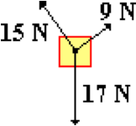aa. An object is at equilibrium. The individual forces acting upon the object are shown in the diagram below. The magnitude of the net force experienced by this object is ____ N.

a. 0 b. 6 c. 7

d. 17 e. 18 f. 41

g. ... nonsense! It is impossible to determine without the direction of the forces.

h. ... nonsense! None of these values are even close (but the answer could be found with the known information.)

**Question 18:**

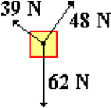aa. An object is at equilibrium. The individual forces acting upon the object are shown in the diagram below. The magnitude of the net force experienced by this object is ____ N.

a. 0 b. 9 c. 25

d. 62 e. ~63 f. 149

g. ... nonsense! It is impossible to determine without the direction of the forces.

h. ... nonsense! None of these values are even close (but the answer could be found with the known information.)

**Question 19:**

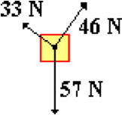aa. An object is at equilibrium. The individual forces acting upon the object are shown in the diagram below. The magnitude of the net force experienced by this object is ____ N.

a. 0 b. 13 c. 22

d. 57 e. ~58 f. 136

g. ... nonsense! It is impossible to determine without the direction of the forces.

h. ... nonsense! None of these values are even close (but the answer could be found with the known information.)

**2D4: Static Equilibrium Analysis**

**Question 1:**

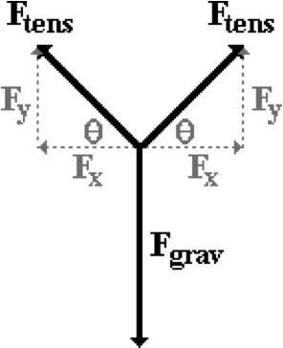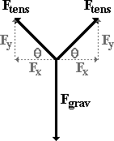aa. A sign with a mass of m is hung symmetrically from two cables which make an angle of theta with the horizontal (see diagram). The tension in each one of the cables is Ftens. The vertical component of the tension force is Fy; the horizontal component is Fx. Which of the following mathematical statements are true? (Statements are comparing the magnitudes only; not the directions.) List all that apply in alphabetical order with no spaces between letters.

a. Fy = m

b. Fy = 0.5• m

c. Fy = m • g

d. Fy = 0.5 • m • g

e. Fnet = m • g

f. Fnet = 2 • Ftens

g. Fgrav = Fy + Fy

h. Fgrav = 2 • m

i. Fgrav = 2 • m • g

**Question 2:**

aa. A sign with a mass of m is hung symmetrically from two cables which make an angle of theta with the horizontal (see diagram). The tension in each one of the cables is Ftens. The vertical component of the tension force is Fy; the horizontal component is Fx. Which of the following mathematical statements are true? (Statements are comparing the magnitudes only; not the directions.) List all that apply in alphabetical order with no spaces between letters.

a. Fnet = m • g

b. Fnet = 2 • Ftens

c. Fy = 0.5 • m • g

d. Fy = 0.5 • m

e. Fy = m • g

f. Fy = m

g. Fgrav = 2 • m

h. Fgrav = 2 • m • g

i. Fgrav = Fy + Fy

**Question 3:**

aa. A sign with a mass of m is hung symmetrically from two cables which make an angle of theta with the horizontal (see diagram). The tension in each one of the cables is Ftens. The vertical component of the tension force is Fy; the horizontal component is Fx. Which of the following mathematical statements are true? (Statements are comparing the magnitudes only; not the directions.) List all that apply in alphabetical order with no spaces between letters.

a. Fgrav = Fy + Fy

b. Fgrav = 2 • m

c. Fgrav = 2 • m • g

d. Fy = m

e Fy = m • g

f. Fy = 0.5 • m • g

g. Fy = 0.5 • m

h. Fnet = 2 • Ftens

i. Fnet = m • g

**Question 4:**

aa. A sign with a mass of m is hung symmetrically from two cables which make an angle of theta with the horizontal (see diagram). The tension in each one of the cables is Ftens. The vertical component of the tension force is Fy; the horizontal component is Fx. Which of the following mathematical statements are true? (Statements are comparing the magnitudes only; not the directions.) List all that apply in alphabetical order with no spaces between letters.

a. Fy = 0.5 • m

b. Fy = 0.5 • m • g

c. Fnet = 2 • Ftens

d. Fgrav = 2 • m • g

e. Fgrav = 2 • m

f. Fnet = m • g

g. Fy = m

h. Fy = m • g

i. Fgrav = Fy + Fy

**Question 5:**

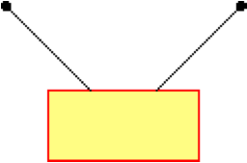aa. A sign is hung symmetrically from two cables that make an angle with the horizontal (see diagram). The sign is in a state of static equilibrium. Which of the following statements are true? List all that apply in alphabetical order with no spaces between letters.

a. Gravity does NOT exert a horizontal force component on the sign.

b. The vector sum of all the forces is zero.

c. All three of the force vectors are equal.

d. The net force on the sign is zero.

e. The horizontal component of force in one cable balances the horizontal component of force in the other cable.

f. Neither one of the cables exerts a horizontal pull upon the sign.

g. ... nonsense! None of these statements are true.

**Question 6:**

aa. A sign is hung symmetrically from two cables that make an angle with the horizontal (see diagram). The sign is in a state of static equilibrium. Which of the following statements are true? List all that apply in alphabetical order with no spaces between letters.

a. The net force on the sign is zero.

b. Gravity does NOT exert a horizontal force component on the sign.

c. All three of the force vectors are equal.

d. The vector sum of all the forces is zero.

e. Neither one of the cables exerts a horizontal pull upon the sign.

f. The horizontal component of force in one cable balances the horizontal component of force in the other cable.

g. ... nonsense! None of these statements are true.

**Question 7:**

aa. A sign is hung symmetrically from two cables that make an angle with the horizontal (see diagram). The sign is in a state of static equilibrium. Which of the following statements are true? List all that apply in alphabetical order with no spaces between letters.

a. The horizontal component of force in one cable balances the horizontal component of force in the other cable.

b. The vector sum of all the forces is zero.

c. Neither one of the cables exerts a horizontal pull upon the sign.

d. All three of the force vectors are equal.

e. The net force on the sign is zero.

f. Gravity does NOT exert a horizontal force component on the sign.

g. ... nonsense! None of these statements are true.

**Question 8:**

aa. A sign is hung symmetrically from two cables that make an angle with the horizontal (see diagram). The sign is in a state of static equilibrium. Which of the following statements are true? List all that apply in alphabetical order with no spaces between letters.

a. The net force on the sign is zero.

b. The vector sum of all the forces is zero.

c. Gravity does NOT exert a horizontal force component on the sign.

d. The horizontal component of force in one cable balances the horizontal component of force in the other cable.

e. All three of the force vectors are equal.

f. Neither one of the cables exerts a horizontal pull upon the sign.

g. ... nonsense! None of these statements are true.

**Question 9:**

aa. A sign that weighs 100 N is supported symmetrically by two cables which make an angle of 20.0 degrees with the horizontal. A single cable will pull upward on the sign with a force of ____ Newton.

a. 10.0 b. 17.1 c. 34.2 d. 40.0

e. 50.0 f. 68.4 g. 100 h. 200

i. ... nonsense! The answer cannot be determined without knowing the actual tension in a single cable.

**Question 10:**

aa. A sign that weighs 50.0 N is supported symmetrically by two cables which make an angle of 70.0 degrees with the horizontal. A single cable will pull upward on the sign with a force of ____ Newton.

a. 23.5 b. 25.0 c. 35.0 d. 47.0

e. 50.0 f. 94.0 g. 100 h. 140

i. ... nonsense! The answer cannot be determined without knowing the actual tension in a single cable.

**Question 11:**

aa. A sign that weighs 80.0 N is supported symmetrically by two cables which make an angle of 45.0 degrees with the horizontal. A single cable will pull upward on the sign with a force of ____ Newton.

a. 22.5 b. 28.3 c. 40.0 d. 56.6

e. 80.0 f. 90.0 g. 113 h. 160

i. ... nonsense! The answer cannot be determined without knowing the actual tension in a single cable.

**Question 12:**

aa. A sign that weighs 70.0 N is supported symmetrically by two cables which make an angle of 25.0 degrees with the horizontal. A single cable will pull upward on the sign with a force of ____ Newton.

a. 12.5 b. 14.8 c. 29.6 d. 35.0

e. 50.0 f. 59.2 g. 70.0 h. 140

i. ... nonsense! The answer cannot be determined without knowing the actual tension in a single cable.

**Question 13:**

aa. A flower pot that weighs 20.0 N is supported symmetrically by three cables which make an angle of 60.0 degrees with the horizontal. A single cable will pull upward on the flower pot with a force of ____ Newton.

a. 5.8 b. 6.7 c. 17.3 d. 20.0

e. 52.0 f. 60.0 g. 120.0

h. ... nonsense! The answer can be determined, but none of these answers are even close.

i. ... nonsense! The answer cannot be determined without knowing the actual tension in a single cable.

**Question 14:**

aa. A flower pot that weighs 50.0 N is supported symmetrically by four cables which make an angle of 40.0 degrees with the horizontal. A single cable will pull upward on the flower pot with a force of ____ Newton.

a. 8.0 b. 10.0 c. 12.5 d. 32.1

e. 50.0 f. 80.0 g. 129 h. 200

i. ... nonsense! The answer can be determined, but none of these answers are even close.

j. ... nonsense! The answer cannot be determined without knowing the actual tension in a single cable.

**Question 15:**

aa. A flower pot that weighs 80.0 N is supported symmetrically by five cables which make an angle of 35.0 degrees with the horizontal. A single cable will pull upward on the flower pot with a force of ____ Newton.

a. 7.0 b. 9.2 c. 16.0 d. 45.9

e. 70.0 f. 80.0 g. 229.4 h. 400.0

i. ... nonsense! The answer can be determined, but none of these answers are even close.

j. ... nonsense! The answer cannot be determined without knowing the actual tension in a single cable.

**Question 16:**

aa. A flower pot that weighs 36.0 N is supported symmetrically by four cables which make an angle of 75.0 degrees with the horizontal. A single cable will pull upward on the flower pot with a force of ____ Newton.

a. 8.7 b. 9.0 c. 18.8 d. 34.8

e. 36.0 f. 139 g. 144 h. 150

i. ... nonsense! The answer can be determined, but none of these answers are even close.

j. ... nonsense! The answer cannot be determined without knowing the actual tension in a single cable.

**Question 17:**

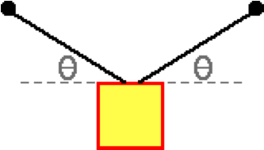aa. A sign is hung by two cables; each makes an angle of theta with the horizontal. As the angle theta is INCREASED, the weight of the sign ____; the tension force in the cable ____; and the vertical component of the tension force ____. Enter the three answers in their respective order.

a. increases

b. decreases

c. remains unchanged

**Question 18:**

aa. A sign is hung by two cables; each makes an angle of theta with the horizontal. As the angle theta is INCREASED, the weight of the sign ____; the tension force in the cable ____; and the vertical component of the tension force ____. Enter the three answers in their respective order.

a. remains unchanged

b. decreases

c. increases

**Question 19:**

aa. A sign is hung by two cables; each makes an angle of theta with the horizontal. As the angle theta is DECREASED, the weight of the sign ____; the tension force in the cable ____; and the vertical component of the tension force ____. Enter the three answers in their respective order.

a. increases

b. decreases

c. remains unchanged

**Question 20:**

aa. A sign is hung by two cables; each makes an angle of theta with the horizontal. As the angle theta is DECREASED, the weight of the sign ____; the tension force in the cable ____; and the vertical component of the tension force ____. Enter the three answers in their respective order.

a. remains unchanged

b. decreases

c. increases

**Question 21:**

aa. Suppose you are hanging a picture by two cables in your living room. You are considering three different angle orientations as shown.

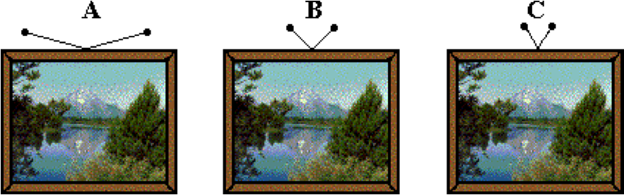

Which orientation - A, B or C - would result in the least tension in the cables?

**Question 22:**

aa. Suppose you are hanging a picture by two cables in your living room. You are considering three different angle orientations as shown.

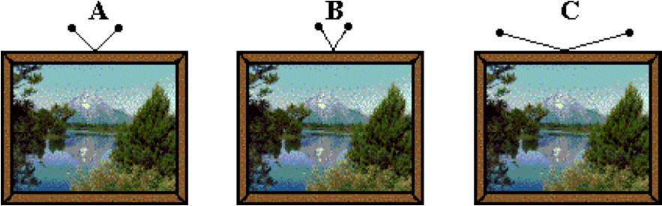

Which orientation - A, B or C - would result in the least tension in the cables?

**Question 23:**

aa. Suppose you are hanging a picture by two cables in your living room. You are considering three different angle orientations as shown.

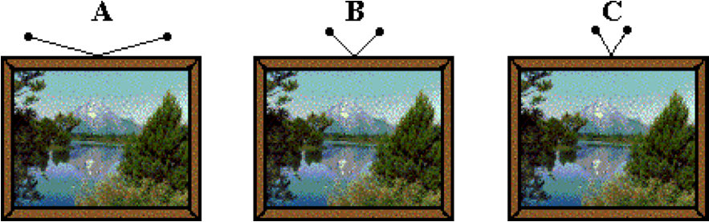

Which orientation - A, B or C - would result in the greatest tension in the cables?

**Question 24:**

aa. Suppose you are hanging a picture by two cables in your living room. You are considering three different angle orientations as shown.

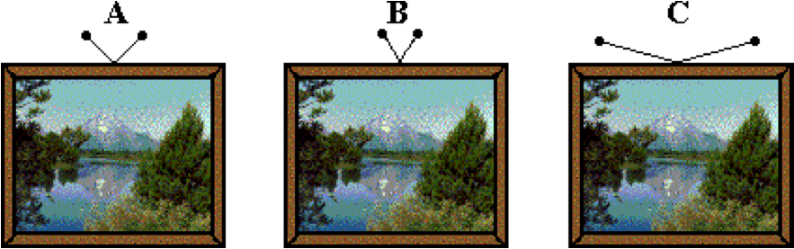

Which orientation - A, B or C - would result in the greatest tension in the cables?

**Question 25:**

aa. A sign with a mass of 3.66 kg is hung symmetrically by two cables that make an angle of 37.2 degrees with the horizontal. Draw a free-body diagram and perform a trigonometric analysis to determine the tension (in Newton) in one of the cables. Enter a numerical answer.

**Question 26:**

aa. A sign with a mass of 4.53 kg is hung symmetrically by two cables that make an angle of 27.8 degrees with the horizontal. Draw a free-body diagram and perform a trigonometric analysis to determine the tension (in Newton) in one of the cables. Enter a numerical answer.

**Question 27:**

aa. A sign with a mass of 6.92 kg is hung symmetrically by two cables that make an angle of 55.8 degrees with the horizontal. Draw a free-body diagram and perform a trigonometric analysis to determine the tension (in Newton) in one of the cables. Enter a numerical answer.

**Question 28:**

aa. A sign with a mass of 3.77 kg is hung symmetrically by two cables that make an angle of 61.4 degrees with the horizontal. Draw a free-body diagram and perform a trigonometric analysis to determine the tension (in Newton) in one of the cables. Enter a numerical answer.

**Question 29:**

aa. A sign with a mass of 4.68 kg is hung symmetrically by two cables that make an angle of 72.6 degrees with the horizontal. Draw a free-body diagram and perform a trigonometric analysis to determine the tension (in Newton) in one of the cables. Enter a numerical answer.

**Question 30:**

aa. A sign with a mass of 8.17 kg is hung symmetrically by two cables that make an angle of 55.3 degrees with the horizontal. Draw a free-body diagram and perform a trigonometric analysis to determine the tension (in Newton) in one of the cables. Enter a numerical answer.

**Question 31:**

aa. A sign that weighs 42.6 N is hung symmetrically by two cables that make an angle of 17.5 degrees with the horizontal. Draw a free-body diagram and perform a trigonometric analysis to determine the tension (in Newton) in one of the cables. Enter a numerical answer.

**Question 32:**

aa. A sign that weighs 56.6 N is hung symmetrically by two cables that make an angle of 27.9 degrees with the horizontal. Draw a free-body diagram and perform a trigonometric analysis to determine the tension (in Newton) in one of the cables. Enter a numerical answer.

**Question 33:**

aa. A sign that weighs 72.2 N is hung symmetrically by two cables that make an angle of 36.8 degrees with the horizontal. Draw a free-body diagram and perform a trigonometric analysis to determine the tension (in Newton) in one of the cables. Enter a numerical answer.

**Question 34:**

aa. A sign that weighs 58.0 N is hung symmetrically by two cables that make an angle of 48.1 degrees with the horizontal. Draw a free-body diagram and perform a trigonometric analysis to determine the tension (in Newton) in one of the cables. Enter a numerical answer.

**Question 35:**

aa. A sign that weighs 74.4 N is hung symmetrically by two cables that make an angle of 59.3 degrees with the horizontal. Draw a free-body diagram and perform a trigonometric analysis to determine the tension (in Newton) in one of the cables. Enter a numerical answer.

**Question 36:**

aa. A sign that weighs 82.2 N is being hung symmetrically by two cables that make an angle of 67.1 degrees with the horizontal. Draw a free-body diagram and perform a trigonometric analysis to determine the tension (in Newton) in one of the cables. Enter a numerical answer.

**Question 37:**

aa. A light fixture that weighs 82.2 N is hung symmetrically by three cables that make an angle of 67.1 degrees with the horizontal. Draw a free-body diagram and perform a trigonometric analysis to determine the tension (in Newton) in one of the cables. Enter a numerical answer.

**Question 38:**

aa. A light fixture that weighs 74.1 N is hung symmetrically by three cables that make an angle of 86.0 degrees with the horizontal. Draw a free-body diagram and perform a trigonometric analysis to determine the tension (in Newton) in one of the cables. Enter a numerical answer.

**Question 39:**

aa. A light fixture that weighs 98.3 N is hung symmetrically by three cables that make an angle of 75.2 degrees with the horizontal. Draw a free-body diagram and perform a trigonometric analysis to determine the tension (in Newton) in one of the cables. Enter a numerical answer.

**Question 40:**

aa. A light fixture that weighs 112 N is hung symmetrically by four cables that make an angle of 67.7 degrees with the horizontal. Draw a free-body diagram and perform a trigonometric analysis to determine the tension (in Newton) in one of the cables. Enter a numerical answer.

**2D5: Inclined Plane Concepts**

**Question 1:**

aa. An object is held at rest upon an inclined plane. When let go of, it begins to naturally accelerate down the incline. Friction is absent. Which ONE of the following diagrams represents the free-body diagram for such an object? Observe all labels carefully.

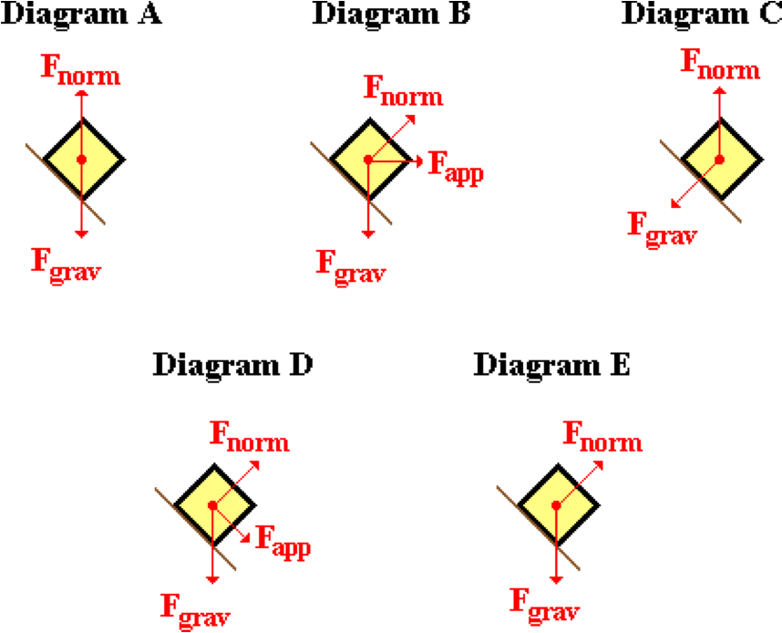

**Question 2:**

aa. An object is held at rest upon an inclined plane. When let go of, it begins to naturally accelerate down the incline. Friction is absent. Which ONE of the following diagrams represents the free-body diagram for such an object? Observe all labels carefully.

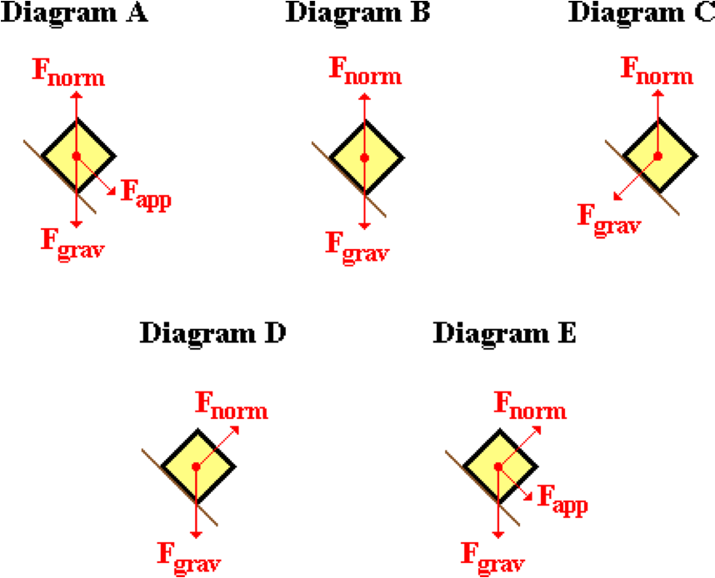

**Question 3:**

aa. An object is held at rest upon an inclined plane. When let go of, it begins to naturally accelerate down the incline. Friction is absent. Which ONE of the following diagrams represents the free-body diagram for such an object? Observe all labels carefully.

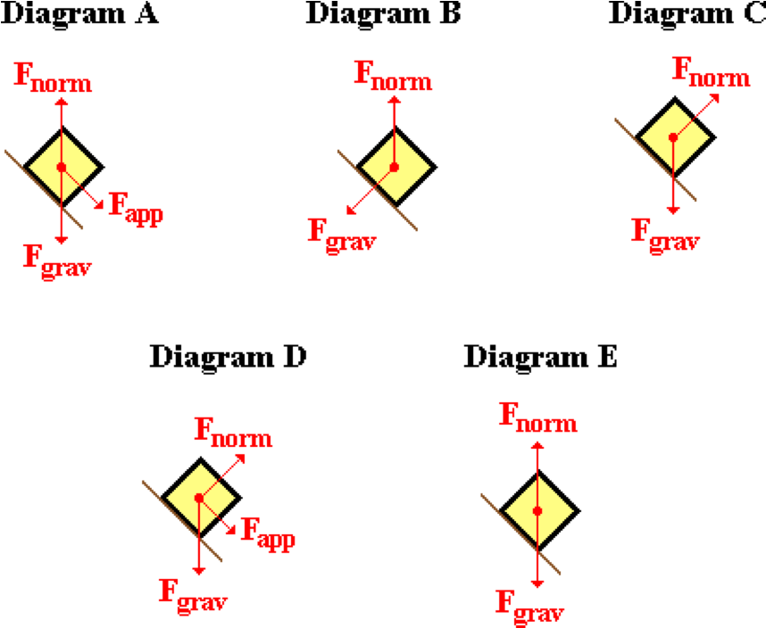

**Question 4:**

aa. An object is held at rest upon an inclined plane. When let go of, it begins to naturally accelerate down the incline. Friction is absent. Which ONE of the following diagrams represents the free-body diagram for such an object? Observe all labels carefully.

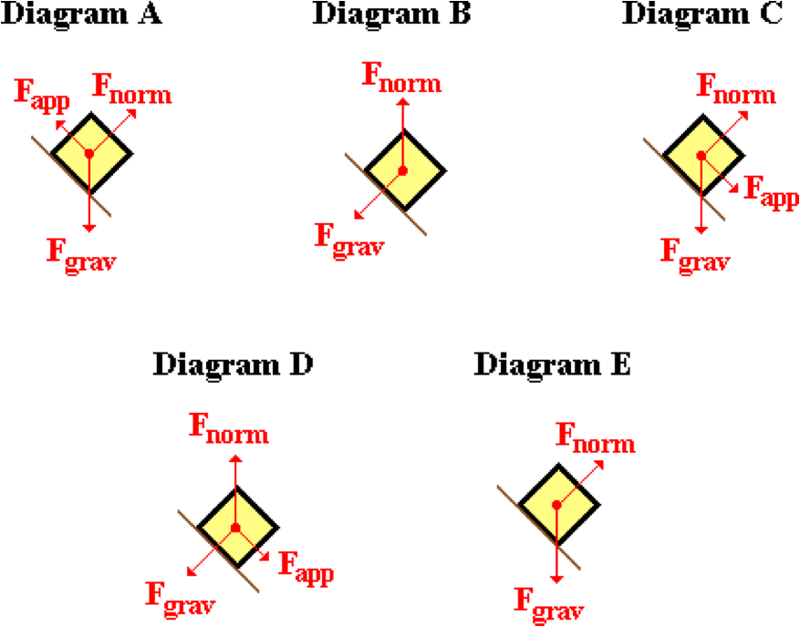

**Question 5:**

aa. An object is held at rest upon an inclined plane. When let go of, it begins to naturally accelerate down the incline. Friction is present. Which ONE of the following diagrams represents the free-body diagram for such an object? Observe all labels carefully.

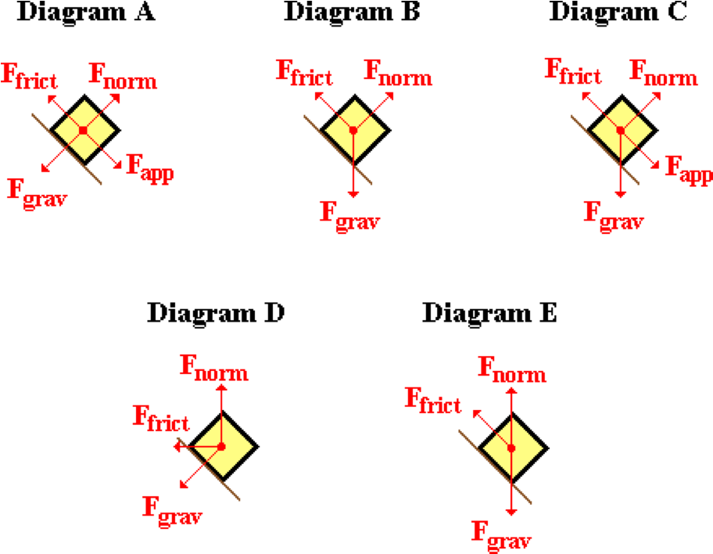

**Question 6:**

aa. An object is held at rest upon an inclined plane. When let go of, it begins to naturally accelerate down the incline. Friction is present. Which ONE of the following diagrams represents the free-body diagram for such an object? Observe all labels carefully.

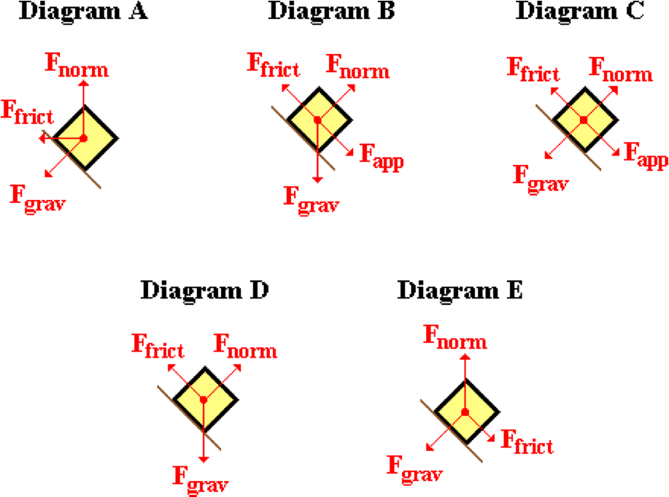

**Question 7:**

aa. An object is held at rest upon an inclined plane. When let go of, it begins to naturally accelerate down the incline. Friction is present. Which ONE of the following diagrams represents the free-body diagram for such an object? Observe all labels carefully.

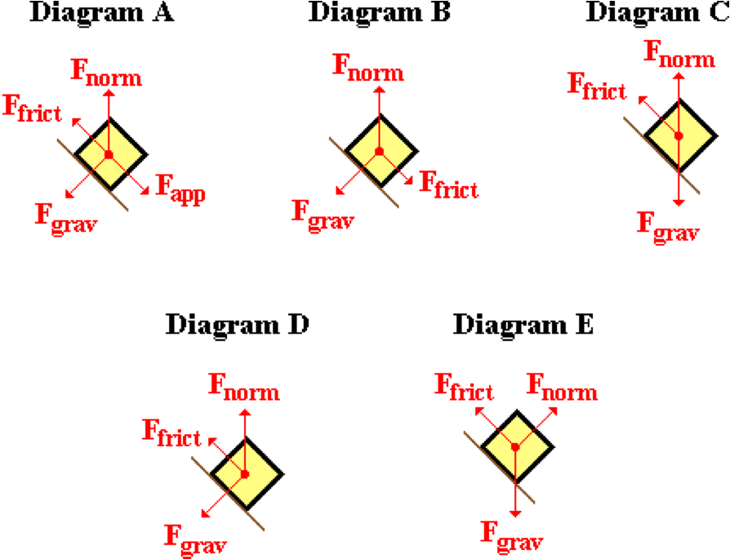

**Question 8:**

aa. An object is held at rest upon an inclined plane. When let go of, it begins to naturally accelerate down the incline. Friction is present. Which ONE of the following diagrams represents the free-body diagram for such an object? Observe all labels carefully.

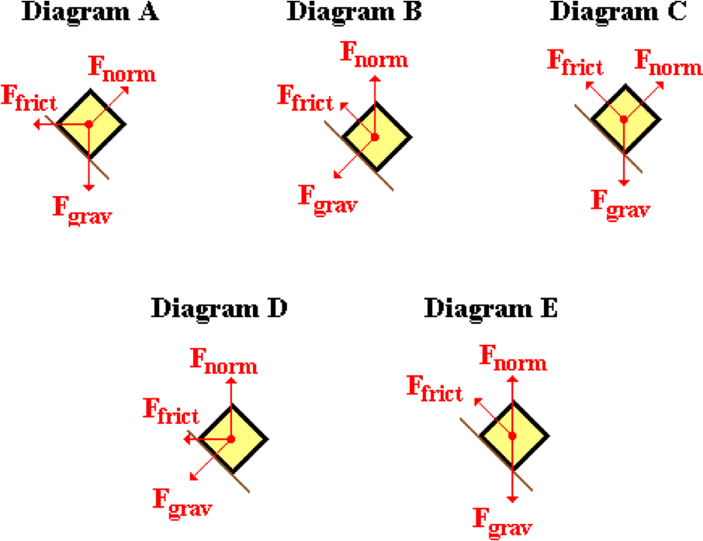

**Question 9:**

aa. An object of mass 'm' is placed upon an inclined plane with an incline angle of 'theta.' If frictional forces can be ignored, the force that causes the object to accelerate down the incline is equivalent to ____.

a. m • g b. Fnorm • sine(theta)

c. Fnorm • cosine(theta) d. m • g • sine(theta)

e. m • g • cosine(theta) f. m • g • tangent(theta)

**Question 10:**

aa. An object of mass 'm' is placed upon an inclined plane with an incline angle of 'theta.' If frictional forces can be ignored, the force that causes the object to accelerate down the incline is equivalent to ____.

a. m • g b. Fnorm • cosine(theta)

c. Fnorm • sine(theta) d. m • g • tangent(theta)

e. m • g • cosine(theta) f. m • g • sine(theta)

**Question 11:**

aa. An object of mass 'm' is placed upon an inclined plane with an incline angle of 'theta.' If frictional forces can be ignored, the force that causes the object to accelerate down the incline is equivalent to ____.

a. m • g • sine(theta) b. m • g • cosine(theta)

c. m • g • tangent(theta) d. Fnorm • sine(theta)

e. Fnorm • cosine(theta) f. m • g

**Question 12:**

aa. An object of mass 'm' is placed upon an inclined plane with an incline angle of 'theta.' If frictional forces can be ignored, the force that causes the object to accelerate down the incline is equivalent to ____.

a. m • g b. m • g • tangent(theta)

c. m • g • cosine(theta) d. m • g • sine(theta)

e. Fnorm • sine(theta) f. Fnorm • cosine(theta)

**Question 13:**

aa. An object of mass 'm' is placed upon an inclined plane with an incline angle of 'theta'. The surface is rough and there is a coefficient of friction of 'mu.' The force of friction acting upon the object is equivalent to ____.

a. mu • g b. mu • m • g

c. mu • Fnorm • g d. mu • m • g • tangent(theta)

e. mu • m • g • cosine(theta) f. mu • m • g • sine(theta)

g. mu • Fnorm • cosine(theta) h. mu • Fnorm • sine(theta)

**Question 14:**

aa. An object of mass 'm' is placed upon an inclined plane with an incline angle of 'theta'. The surface is rough and there is a coefficient of friction of 'mu.' The force of friction acting upon the object is equivalent to ____.

a. mu • g b. mu • Fnorm • g

c. mu • m • g d. mu • m • g • sine(theta)

e. mu • m • g • tangent(theta) f. mu • m • g • cosine(theta)

g. mu • Fnorm • sine(theta) h. mu • Fnorm • cosine(theta)

**Question 15:**

aa. An object of mass 'm' is placed upon an inclined plane with an incline angle of 'theta'. The surface is rough and there is a coefficient of friction of 'mu.' The force of friction acting upon the object is equivalent to ____.

a. mu • Fnorm • g b. mu • Fnorm • cosine(theta)

c. mu • Fnorm • sine(theta) d. mu • m • g • tangent(theta)

e. mu • m • g • sine(theta) f. mu • m • g • cosine(theta)

g. mu • g h. mu • m • g

**Question 16:**

aa. An object of mass 'm' is placed upon an inclined plane with an incline angle of 'theta'. The surface is rough and there is a coefficient of friction of 'mu.' The force of friction acting upon the object is equivalent to ____.

a. mu • Fnorm • g b. mu • Fnorm • sine(theta)

c. mu • Fnorm • cosine(theta) d. mu • g

e. mu • m • g f. mu • m • g • sine(theta)

g. mu • m • g • cosine(theta) h. mu • m • g • tangent(theta)

**Question 17:**

aa. An object is placed upon an inclined plane with an incline angle of 25 degrees. As the incline angle is increased towards 90 degrees, the normal force experienced by the object ____.

a. increases b. decreases c. remains the same

d. ... nonsense! It is impossible to make such a prediction without actual numbers.

**Question 18:**

aa. An object is placed upon an inclined plane with an incline angle of 25 degrees. As the incline angle is increased towards 90 degrees, the normal force experienced by the object ____.

a. decreases b. increases c. remains the same

d. ... nonsense! It is impossible to make such a prediction without actual numbers.

**Question 19:**

aa. An object is placed upon an inclined plane with an incline angle of 25 degrees. As the incline angle is increased towards 90 degrees, the normal force experienced by the object ____.

a. remains the same b. increases c. decreases

d. ... nonsense! It is impossible to make such a prediction without actual numbers.

**Question 20:**

aa. An object is placed upon an inclined plane with an incline angle of 25 degrees. As the incline angle is increased towards 90 degrees, the parallel component of the weight vector ____.

a. increases b. decreases c. remains the same

d. ... nonsense! It is impossible to make such a prediction without actual numbers.

**Question 21:**

aa. An object is placed upon an inclined plane with an incline angle of 25 degrees. As the incline angle is increased towards 90 degrees, the parallel component of the weight vector ____.

a. decreases b. increases c. remains the same

d. ... nonsense! It is impossible to make such a prediction without actual numbers.

**Question 22:**

aa. An object is placed upon an inclined plane with an incline angle of 25 degrees. As the incline angle is increased towards 90 degrees, the parallel component of the weight vector ____.

a. remains the same b. decreases c. increases

d. ... nonsense! It is impossible to make such a prediction without actual numbers.

**Question 23:**

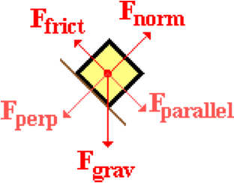aa. An object of mass 'm' is resting upon an inclined plane with an incline angle of 'theta.' The coefficient of friction between the object and the plane is 'mu.' The object is at rest upon the incline. The free-body diagram is shown with the weight vector resolved into parallel and perpendicular components. Which of the following mathematical statements are correct? List all that apply in alphabetical order without commas or spaces between letters.

a. Fnorm = Fgrav

b. Fnorm = Ffrict

c. Fparallel = Ffrict

d. Fperpendicular = Fgrav

e. Fnet = Fparallel

f. Ffrict = mu • Fnorm

g. Fperpendicular = Fnorm

**Question 24:**

aa. An object of mass 'm' is resting upon an inclined plane with an incline angle of 'theta.' The coefficient of friction between the object and the plane is 'mu.' The object is at rest upon the incline. The free-body diagram is shown with the weight vector resolved into parallel and perpendicular components. Which of the following mathematical statements are correct? List all that apply in alphabetical order without commas or spaces between letters.

a. Fnorm = Ffrict

b. Fparallel = Ffrict

c. Fnet = Fparallel

d. Fperpendicular = Fgrav

e. Fnorm = Fgrav

f. Fperpendicular = Fnorm

g. Ffrict = mu • Fnorm

**Question 25:**

aa. An object of mass 'm' is resting upon an inclined plane with an incline angle of 'theta.' The coefficient of friction between the object and the plane is 'mu.' The object is at rest upon the incline. The free-body diagram is shown with the weight vector resolved into parallel and perpendicular components. Which of the following mathematical statements are correct? List all that apply in alphabetical order without commas or spaces between letters.

a. Fnorm = Fgrav

b. Fperpendicular = Fnorm

c. Fperpendicular = Fgrav

d. Ffrict = mu • Fperpendicular

e. Fnorm = Ffrict

f. Fnorm = Ffrict

g. Fnet = Fparallel

**Question 26:**

aa. An object of mass 'm' is resting upon an inclined plane with an incline angle of 'theta.' The coefficient of friction between the object and the plane is 'mu.' The object is at rest upon the incline. The free-body diagram is shown with the weight vector resolved into parallel and perpendicular components. Which of the following mathematical statements are correct? List all that apply in alphabetical order without commas or spaces between letters.

a. Fperpendicular = Fnorm

b. Fnorm = Ffrict

c. Fnorm = Fgrav

d. Fnet = Fparallel

e. Fparallel = Ffrict

f. Fperpendicular = Fgrav

g. Ffrict = mu • Fperpendicular

**Question 27:**

aa. An object of mass 'm' is upon an inclined plane with an incline angle of 'theta.' The object is moving downwards along the incline at a constant speed. The free-body diagram is shown with the weight vector resolved into parallel and perpendicular components. Which of the following mathematical statements are correct? List all that apply in alphabetical order without commas or spaces between letters.

a. Fnorm = Fperpendicular

b. Fnorm = Fgrav

c. Fnorm > Fperpendicular

d. Fparallel = Ffrict

e. Fparallel > Ffrict

f. Fparallel < Ffrict

g. Fnet = Fparallel

h. Fparallel = Fnorm

**Question 28:**

aa. An object of mass 'm' is upon an inclined plane with an incline angle of 'theta.' The object is moving downwards along the incline at a constant speed. The free-body diagram is shown with the weight vector resolved into parallel and perpendicular components. Which of the following mathematical statements are correct? List all that apply in alphabetical order without commas or spaces between letters.

a. Fnorm = Fgrav

b. Fnorm = Fperpendicular

c. Fnorm > Fperpendicular

d. Fparallel = Ffrict

e. Fparallel < Ffrict

f. Fparallel > Ffrict

g. Fparallel = Fnorm

h. Fnet = Fparallel

**Question 29:**

aa. An object of mass 'm' is upon an inclined plane with an incline angle of 'theta.' The object is moving downwards along the incline at a constant speed. The free-body diagram is shown with the weight vector resolved into parallel and perpendicular components. Which of the following mathematical statements are correct? List all that apply in alphabetical order without commas or spaces between letters.

a. Fnet = Fparallel

b. Fparallel = Fnorm

c. Fparallel = Ffrict

d. Fparallel > Ffrict

e. Fparallel < Ffrict

f. Fnorm = Fperpendicular

g. Fnorm = Fgrav

h. Fnorm > Fperpendicular

**Question 30:**

aa. An object of mass 'm' is upon an inclined plane with an incline angle of 'theta.' The object is moving downwards along the incline at a constant speed. The free-body diagram is shown with the weight vector resolved into parallel and perpendicular components. Which of the following mathematical statements are correct? List all that apply in alphabetical order without commas or spaces between letters.

a. Fnet = Fparallel

b. Fparallel = Ffrict

c. Fparallel = Fnorm

d. Fparallel < Ffrict

e. Fparallel > Ffrict

f. Fnorm > Fperpendicular

g. Fnorm = Fgrav

h. Fnorm = Fperpendicular

**Question 31:**

aa. An object of mass 'm' is upon an inclined plane with an incline angle of 'theta.' The object is moving downwards along the incline and speeding up as it moves. The free-body diagram is shown with the weight vector resolved into parallel and perpendicular components. Which of the following mathematical statements are correct? List all that apply in alphabetical order without commas or spaces between letters.

a. Fnorm = Fperpendicular

b. Fnorm = Fgrav

c. Fnorm > Fperpendicular

d. Fparallel = Ffrict

e. Fparallel > Ffrict

f. Fparallel < Ffrict

g. Fnet = Fparallel

h. Fparallel = Fnorm

**Question 32:**

aa. An object of mass 'm' is upon an inclined plane with an incline angle of 'theta.' The object is moving downwards along the incline and speeding up as it moves. The free-body diagram is shown with the weight vector resolved into parallel and perpendicular components. Which of the following mathematical statements are correct? List all that apply in alphabetical order without commas or spaces between letters.

a. Fnorm = Fgrav

b. Fnorm = Fperpendicular

c. Fnorm > Fperpendicular

d. Fparallel = Ffrict

e. Fparallel < Ffrict

f. Fparallel > Ffrict

g. Fparallel = Fnorm

h. Fnet = Fparallel

**Question 33:**

aa. An object of mass 'm' is upon an inclined plane with an incline angle of 'theta.' The object is moving downwards along the incline and speeding up as it moves. The free-body diagram is shown with the weight vector resolved into parallel and perpendicular components. Which of the following mathematical statements are correct? List all that apply in alphabetical order without commas or spaces between letters.

a. Fnet = Fparallel

b. Fparallel = Fnorm

c. Fparallel = Ffrict

d. Fparallel > Ffrict

e. Fparallel < Ffrict

f. Fnorm = Fperpendicular

g. Fnorm = Fgrav

h. Fnorm > Fperpendicular

**Question 34:**

aa. An object of mass 'm' is upon an inclined plane with an incline angle of 'theta.' The object is moving downwards along the incline and speeding up as it moves. The free-body diagram is shown with the weight vector resolved into parallel and perpendicular components. Which of the following mathematical statements are correct? List all that apply in alphabetical order without commas or spaces between letters.

a. Fnet = Fparallel

b. Fparallel = Ffrict

c. Fparallel = Fnorm

d. Fparallel < Ffrict

e. Fparallel > Ffrict

f. Fnorm > Fperpendicular

g. Fnorm = Fgrav

h. Fnorm = Fperpendicular

**2D6: Inclined Plane Analysis**

**Question 1:**

aa. A 2.68-kg object is placed upon an inclined plane. The incline angle is 12.7 degrees. Friction is negligible. Use g = 9.8 m/s/s and the free-body diagram to fill in the blanks and to determine the acceleration of the object. Enter all answers as positive numbers accurate to the second decimal place.

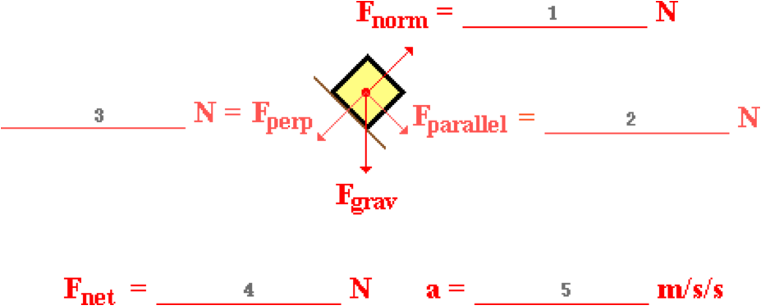

**Question 2:**

aa. A 3.34-kg object is placed upon an inclined plane. The incline angle is 16.4 degrees. Friction is negligible. Use g = 9.8 m/s/s and the free-body diagram to fill in the blanks and to determine the acceleration of the object. Enter all answers as positive numbers accurate to the second decimal place.



**Question 3:**

aa. A 4.68-kg object is placed upon an inclined plane. The incline angle is 22.9 degrees. Friction is negligible. Use g = 9.8 m/s/s and the free-body diagram to fill in the blanks and to determine the acceleration of the object. Enter all answers as positive numbers accurate to the second decimal place.



**Question 4:**

aa. A 5.27-kg object is placed upon an inclined plane. The incline angle is 31.6 degrees. Friction is negligible. Use g = 9.8 m/s/s and the free-body diagram to fill in the blanks and to determine the acceleration of the object. Enter all answers as positive numbers accurate to the second decimal place.



**Question 5:**

aa. A 6.44-kg object is placed upon an inclined plane. The incline angle is 37.5 degrees. Friction is negligible. Use g = 9.8 m/s/s and the free-body diagram to fill in the blanks and to determine the acceleration of the object. Enter all answers as positive numbers accurate to the second decimal place.



**Question 6:**

aa. A 7.83-kg object is placed upon an inclined plane. The incline angle is 30.9 degrees. Friction is negligible. Use g = 9.8 m/s/s and the free-body diagram to fill in the blanks and to determine the acceleration of the object. Enter all answers as positive numbers accurate to the second decimal place.



**Question 7:**

aa. A 8.33-kg object is placed upon an inclined plane. The incline angle is 26.6 degrees. Friction is negligible. Use g = 9.8 m/s/s and the free-body diagram to fill in the blanks and to determine the acceleration of the object. Enter all answers as positive numbers accurate to the second decimal place.



**Question 8:**

aa. A 9.57-kg object is placed upon an inclined plane. The incline angle is 22.6 degrees. Friction is negligible. Use g = 9.8 m/s/s and the free-body diagram to fill in the blanks and to determine the acceleration of the object. Enter all answers as positive numbers accurate to the second decimal place.



**Question 9:**

aa. A 2.68-kg object is placed upon an inclined plane. The incline angle is 12.7 degrees. The coefficient of friction is 0.097. Use g = 9.8 m/s/s and the free-body diagram to fill in the blanks and to determine the acceleration of the object. Enter all answers as positive numbers accurate to the second decimal place.

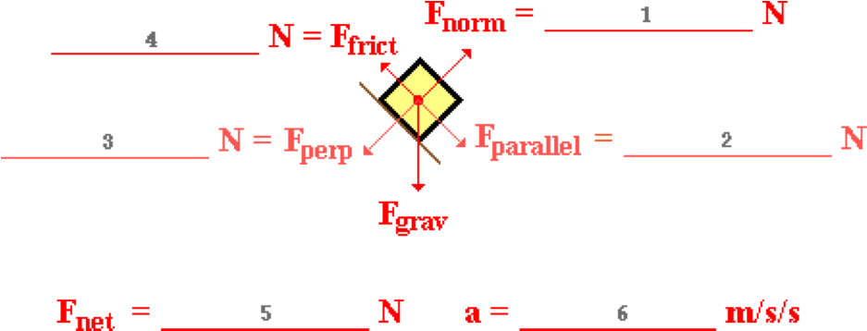

**Question 10:**

aa. A 3.34-kg object is placed upon an inclined plane. The incline angle is 16.4 degrees. The coefficient of friction is 0.112. Use g = 9.8 m/s/s and the free-body diagram to fill in the blanks and to determine the acceleration of the object. Enter all answers as positive numbers accurate to the second decimal place.



**Question 11:**

aa. A 4.68-kg object is placed upon an inclined plane. The incline angle is 22.9 degrees. The coefficient of friction is 0.151. Use g = 9.8 m/s/s and the free-body diagram to fill in the blanks and to determine the acceleration of the object. Enter all answers as positive numbers accurate to the second decimal place.



**Question 12:**

aa. A 5.27-kg object is placed upon an inclined plane. The incline angle is 31.6 degrees. The coefficient of friction is 0.228. Use g = 9.8 m/s/s and the free-body diagram to fill in the blanks and to determine the acceleration of the object. Enter all answers as positive numbers accurate to the second decimal place.



**Question 13:**

aa. A 6.44-kg object is placed upon an inclined plane. The incline angle is 37.5 degrees. The coefficient of friction is 0.366. Use g = 9.8 m/s/s and the free-body diagram to fill in the blanks and to determine the acceleration of the object. Enter all answers as positive numbers accurate to the second decimal place.



**Question 14:**

aa. A 7.83-kg object is placed upon an inclined plane. The incline angle is 30.9 degrees. The coefficient of friction is 0.428. Use g = 9.8 m/s/s and the free-body diagram to fill in the blanks and to determine the acceleration of the object. Enter all answers as positive numbers accurate to the second decimal place.



**Question 15:**

aa. A 8.83-kg object is placed upon an inclined plane. The incline angle is 26.6 degrees. The coefficient of friction is 0.358. Use g = 9.8 m/s/s and the free-body diagram to fill in the blanks and to determine the acceleration of the object. Enter all answers as positive numbers accurate to the second decimal place.



**Question 16:**

aa. A 9.57-kg object is placed upon an inclined plane. The incline angle is 22.6 degrees. The coefficient of friction is 0.220. Use g = 9.8 m/s/s and the free-body diagram to fill in the blanks and to determine the acceleration of the object. Enter all answers as positive numbers accurate to the second decimal place.

