**Minds On Physics Question Banks – Light and Color**

**LC1: Electromagnetic and Visible Spectrum**

**Question 1:**

aa. An electromagnetic wave is different than a mechanical wave in that an electromagnetic wave _____ (unlike a mechanical wave).

a. has a constant speed when traveling through a uniform medium

b. cannot be described by a wavelength and a frequency

c. can propagate through a region void of matter

d. has a non-measurable speed

e. can travel through a variety of media

f. ... nonsense! None of these describe the differences.

**Question 2:**

aa. An electromagnetic wave is different than a mechanical wave in that an electromagnetic wave _____ (unlike a mechanical wave).

a. has a non-measurable speed

b. has a constant speed when traveling through a uniform medium

c. cannot be described by a wavelength and a frequency

d. can travel through a variety of media

e. can propagate through a region void of matter

f. ... nonsense! None of these describe the differences.

**Question 3:**

aa. An electromagnetic wave is different than a mechanical wave in that an electromagnetic wave _____ (unlike a mechanical wave).

a. cannot be described by a wavelength and a frequency

b. can propagate through a region void of matter

c. can travel through a variety of media

d. has a non-measurable speed

e. has a constant speed when traveling through a uniform medium

f. ... nonsense! None of these describe the differences.

**Question 4:**

aa. An electromagnetic wave is different than a mechanical wave in that an electromagnetic wave _____ (unlike a mechanical wave).

a. cannot be described by a wavelength and a frequency

b. has a constant speed when traveling through a uniform medium

c. has a non-measurable speed

d. can travel through a variety of media

e. can propagate through a region void of matter

f. ... nonsense! None of these describe the differences.

**Question 5:**

aa. Which of the following are not examples of electromagnetic waves? List all that apply in alphabetical order with no commas or spaces between letters.

a. visible light b. infrared radiation

c. radio waves d. sound waves

e. microwave radiation f.. ultraviolet radiation

g. ... nonsense! These are all examples of electromagnetic waves.

**Question 6:**

aa. Which of the following are not examples of electromagnetic waves? List all that apply in alphabetical order with no commas or spaces between letters.

a. infrared radiation b. radio waves

c. visible light d. ultraviolet radiation

e. sound waves f. microwave radiation

g. ... nonsense! These are all examples of electromagnetic waves.

**Question 7:**

aa. Which of the following are not examples of electromagnetic waves? List all that apply in alphabetical order with no commas or spaces between letters.

a. sound waves b. visible light

c. ultraviolet radiation d. infrared radiation

e. microwave radiation f. radio waves

g. ... nonsense! These are all examples of electromagnetic waves.

**Question 8:**

aa. Which of the following are not examples of electromagnetic waves? List all that apply in alphabetical order with no commas or spaces between letters.

a. microwave radiation b. ultraviolet radiation

c. infrared radiation d. visible light

e. radio waves f. sound waves

g. ... nonsense! These are all examples of electromagnetic waves.

**Question 9:**

aa. The speed of an electromagnetic wave depends primarily upon ____. List all that apply in alphabetical order with no commas or spaces between letters.

a. the wavelength of the wave

b. the frequency of the wave

c. the intensity of the wave

d. the portion of the electromagnetic spectrum from which it originates

e. the properties of the medium through which it moves

f. ... nonsense! The speed of an electromagnetic wave is a constant value and independent of all variables.

**Question 10:**

aa. The speed of an electromagnetic wave depends primarily upon ____. List all that apply in alphabetical order with no commas or spaces between letters.

a. the portion of the electromagnetic spectrum from which it originates

b. the intensity of the wave

c. the wavelength of the wave

d. the frequency of the wave

e. the properties of the medium through which it moves

f. ... nonsense! The speed of an electromagnetic wave is a constant value and independent of all variables.

**Question 11:**

aa. The speed of an electromagnetic wave depends primarily upon ____. List all that apply in alphabetical order with no commas or spaces between letters.

a. the portion of the electromagnetic spectrum from which it originates

b. the intensity of the wave

c. the frequency of the wave

d. the wavelength of the wave

e. the properties of the medium through which it moves

f. ... nonsense! The speed of an electromagnetic wave is a constant value and independent of all variables.

**Question 12:**

aa. The speed of an electromagnetic wave depends primarily upon ____. List all that apply in alphabetical order with no commas or spaces between letters.

a. the properties of the medium through which it moves

b. the portion of the electromagnetic spectrum from which it originates

c. the wavelength of the wave

d. the frequency of the wave

e. the intensity of the wave

f. ... nonsense! The speed of an electromagnetic wave is a constant value and independent of all variables.

**Question 13:**

aa. Consider the electromagnetic spectrum. Of the following listed regions of the spectrum, which consists of waves with the HIGHEST frequency?

a. visible light b. microwave radiation

c. infrared radiation d. ultraviolet radiation

e. ... nonsense! All of these have the same frequency.

**Question 14:**

aa. Consider the electromagnetic spectrum. Of the following listed regions of the spectrum, which consists of waves with the HIGHEST frequency?

a. microwave radiation b. infrared radiation

c. ultraviolet radiation d. visible light

e. ... nonsense! All of these have the same frequency.

**Question 15:**

aa. Consider the electromagnetic spectrum. Of the following listed regions of the spectrum, which consists of waves with the LOWEST frequency?

a. infrared radiation b. ultraviolet radiation

c. visible light d. microwave radiation

e. ... nonsense! All of these have the same frequency.

**Question 16:**

aa. Consider the electromagnetic spectrum. Of the following listed regions of the spectrum, which consists of waves with the LOWEST frequency?

a. ultraviolet radiation b. visible light

c. microwave radiation d. infrared radiation

e. ... nonsense! All of these have the same frequency.

**Question 17:**

aa. Consider the electromagnetic spectrum. Of the following listed regions of the spectrum, which consists of waves with the LONGEST wavelength?

a. visible light b. microwave radiation

c. infrared radiation d. ultraviolet radiation

e. ... nonsense! All of these have the same wavelength.

**Question 18:**

aa. Consider the electromagnetic spectrum. Of the following listed regions of the spectrum, which consists of waves with the LONGEST wavelength?

a. microwave radiation b. infrared radiation

c. ultraviolet radiation d. visible light

e. ... nonsense! All of these have the same wavelength.

**Question 19:**

aa. Consider the electromagnetic spectrum. Of the following listed regions of the spectrum, which consists of waves with the SHORTEST wavelength?

a. infrared radiation b. ultraviolet radiation

c. visible light d. microwave radiation

e. ... nonsense! All of these have the same wavelength.

**Question 20:**

aa. Consider the electromagnetic spectrum. Of the following listed regions of the spectrum, which consists of waves with the SHORTEST wavelength?

a. ultraviolet radiation b. visible light

c. microwave radiation d. infrared radiation

e. ... nonsense! All of these have the same wavelength.

**Question 21:**

aa. Consider the visible light spectrum. Of the following listed regions of the spectrum, which consists of waves with the HIGHEST frequency?

a. orange b. blue c. red d. violet

e. yellow f. ... nonsense! All of these have the same frequency.

**Question 22:**

aa. Consider the visible light spectrum. Of the following listed regions of the spectrum, which consists of waves with the HIGHEST frequency?

a. yellow b. red c. violet d. blue

e. orange f. ... nonsense! All of these have the same frequency.

**Question 23:**

aa. Consider the visible light spectrum. Of the following listed regions of the spectrum, which consists of waves with the LOWEST frequency?

a. blue b. violet c. red d. yellow

e. orange f. ... nonsense! All of these have the same frequency.

**Question 24:**

aa. Consider the visible light spectrum. Of the following listed regions of the spectrum, which consists of waves with the LOWEST frequency?

a. red b. violet c. yellow d. orange

e. blue f. ... nonsense! All of these have the same frequency.

**Question 25:**

aa. Consider the visible light spectrum. Of the following listed regions of the spectrum, which consists of waves with the LONGEST wavelength?

a. orange b. blue c. red d. violet

e. yellow f. ... nonsense! All of these have the same wavelength.

**Question 26:**

aa. Consider the visible light spectrum. Of the following listed regions of the spectrum, which consists of waves with the LONGEST wavelength?

a. yellow b. red c. violet d. blue

e. orange f. ... nonsense! All of these have the same wavelength.

**Question 27:**

aa. Consider the visible light spectrum. Of the following listed regions of the spectrum, which consists of waves with the SHORTEST wavelength?

a. blue b. violet c. red d. yellow

e. orange f. ... nonsense! All of these have the same wavelength.

**Question 28:**

aa. Consider the visible light spectrum. Of the following listed regions of the spectrum, which consists of waves with the SHORTEST wavelength?

a. red b. yellow c. orange d. violet

e. blue f. ... nonsense! All of these have the same wavelength.

**LC2: Polarization**

**Question 1:**

aa. A light wave that is vibrating in a single plane is referred to as being ____.

a. monochromatic b. monomagnetic

c. monoelectric d. polarized

e. unpolarized f. visible

**Question 2:**

aa. A light wave that is vibrating in a single plane is referred to as being ____.

a. visible b. monomagnetic

c. monochromatic d. monoelectric

e. unpolarized f. polarized

**Question 3:**

aa. A light wave that is vibrating in a single plane is referred to as being ____.

a. monoelectric b. monomagnetic

c. monochromatic d. unpolarized

e. polarized f. visible

**Question 4:**

aa. A light wave that is vibrating in a single plane is referred to as being ____.

a. polarized b. unpolarized

c. monochromatic d. monomagnetic

e. monoelectric f. visible

**Question 5:**

aa. A light wave that is vibrating in more than one plane is referred to as being ____.

a. polarized b. unpolarized

c. multichromatic d. magnetized

e. spectral f. visible

**Question 6:**

aa. A light wave that is vibrating in more than one plane is referred to as being ____.

a. visible b. multichromatic

c. spectral d. magnetized

e. polarized f. unpolarized

**Question 7:**

aa. A light wave that is vibrating in more than one plane is referred to as being ____.

a. spectral b. multichromatic

c. magnetized d. unpolarized

e. polarized f. visible

**Question 8:**

aa. A light wave that is vibrating in more than one plane is referred to as being ____.

a. multichromatic b. magnetized

c. spectral d. polarized

e. unpolarized f. visible

**Question 9:**

aa. Incident light passes through a Polaroid filter and becomes polarized. The best description of the role of the filter is to state that it serves to ____.

a. subtract certain colors from the incident light

b. add certain colors to the incident light

c. take all the vibrations and twist them so that they align in a single direction

d. block a portion of the vibrations that are aligned in a specific direction

e. simply block the light, regardless of its vibrational direction

**Question 10:**

aa. Incident light passes through a Polaroid filter and becomes polarized. The best description of the role of the filter is to state that it serves to ____.

a. add certain colors to the incident light

b. subtract certain colors from the incident light

c. simply block the light, regardless of its vibration direction

d. take all the vibrations and twist them so that they align in a single direction

e. block a portion of the vibrations that are aligned in a specific direction

**Question 11:**

aa. Incident light passes through a Polaroid filter and becomes polarized. The best description of the role of the filter is to state that it serves to ____.

a. simply block the light, regardless of its vibration direction

b. take all the vibrations and twist them so that they align in a single direction

c. block a portion of the vibrations that are aligned in a specific direction

d. subtract certain colors from the incident light

e. add certain colors to the incident light

**Question 12:**

aa. Incident light passes through a Polaroid filter and becomes polarized. The best description of the role of the filter is to state that it serves to ____.

a. simply block the light, regardless of its vibration direction

b. block a portion of the vibrations that are aligned in a specific direction

c. take all the vibrations and twist them so that they align in a single direction

d. add certain colors to the incident light

e. subtract certain colors from the incident light

**Question 13:**

aa. Unpolarized light is approaching a Polaroid filter whose transmission axis is aligned vertically. Upon passing through the filter, the light will have ____ and be vibrating in a ____ plane of vibration.

a. the same intensity, vertical

b. the same intensity, horizontal

c. one-half the intensity, vertical

d. one-half the intensity, horizontal

e. twice the intensity, vertical

f. twice the intensity, horizontal

**Question 14:**

aa. Unpolarized light is approaching a Polaroid filter whose transmission axis is aligned vertically. Upon passing through the filter, the light will have ____ and be vibrating in a ____ plane of vibration.

a. the same intensity, horizontal

b. the same intensity, vertical

c. one-half the intensity, horizontal

d. one-half the intensity, vertical

e. twice the intensity, horizontal

f. twice the intensity, vertical

**Question 15:**

aa. Unpolarized light is approaching a Polaroid filter whose transmission axis is aligned vertically. Upon passing through the filter, the light will have ____ and be vibrating in a ____ plane of vibration.

a. the same intensity, vertical

b. the same intensity, horizontal

c. twice the intensity, vertical

d. twice the intensity, horizontal

e. one-half the intensity, vertical

f. one-half the intensity, horizontal

**Question 16:**

aa. Unpolarized light is approaching a Polaroid filter whose transmission axis is aligned vertically. Upon passing through the filter, the light will have ____ and be vibrating in a ____ plane of vibration.

a. the same intensity, vertical

b. the same intensity, horizontal

c. twice the intensity, horizontal

d. twice the intensity, vertical

e. one-half the intensity, horizontal

f. one-half the intensity, vertical

**Question 17:**

aa. Unpolarized light passes through a first Polaroid filter and then through a second Polarioid filter whose transmission axes are aligned as shown.

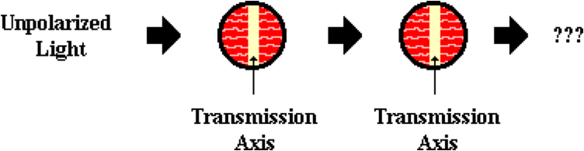

The light emerging from the second filter will have ____ the original intensity and be vibrating in a ____ plane of vibration.

a. one-half, horizontal

b. one-half, vertical

c. one-fourth, horizontal

d. one-fourth, vertical

e. the same intensity as, horizontal

f. the same intensity as, vertical

g. ... nonsense! This system will block all the light.

**Question 18:**

aa. Unpolarized light passes through a first Polaroid filter and then through a second Polarioid filter whose transmission axes are aligned as shown.



The light emerging from the second filter will have ____ the original intensity and be vibrating in a ____ plane of vibration.

a. one-half, vertical

b. one-half, horizontal

c. one-fourth, vertical

d. one-fourth, horizontal

e. the same intensity as, vertical

f. the same intensity as, horizontal

g. ... nonsense! This system will block all the light.

**Question 19:**

aa. Unpolarized light passes through a first Polaroid filter and then through a second Polarioid filter whose transmission axes are aligned as shown.

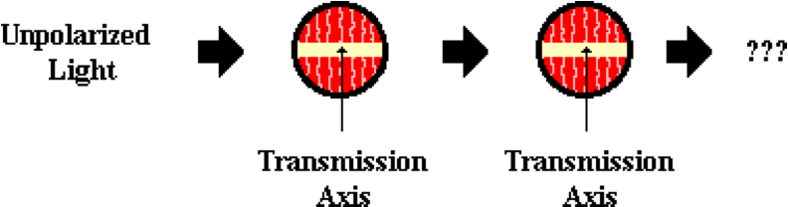

The light emerging from the second filter will have ____ the original intensity and be vibrating in a ____ plane of vibration.

a. the same intensity as, vertical

b. the same intensity as, horizontal

c. one-half, vertical

d. one-half, horizontal

e. one-fourth, vertical

f. one-fourth, horizontal

g. ... nonsense! This system will block all the light.

**Question 20:**

aa. Unpolarized light passes through a first Polaroid filter and then through a second Polarioid filter whose transmission axes are aligned as shown.



The light emerging from the second filter will have ____ the original intensity and be vibrating in a ____ plane of vibration.

a. the same intensity as, horizontal

b. the same intensity as, vertical

c. one-half, horizontal

d. one-half, vertical

e. one-fourth, horizontal

f. one-fourth, vertical

g. ... nonsense! This system will block all the light.

**Question 21:**

aa. Unpolarized light passes through a first Polaroid filter and then through a second Polarioid filter whose transmission axes are aligned as shown.

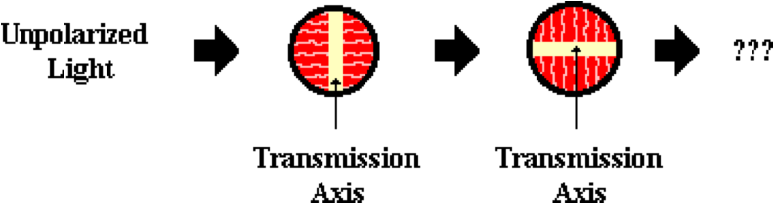

The light emerging from the second filter will have ____ the original intensity and be vibrating in a ____ plane of vibration.

a. one-half, horizontal

b. one-half, vertical

c. one-fourth, horizontal

d. one-fourth, vertical

e. the same intensity as, horizontal

f. the same intensity as, vertical

g. ... nonsense! This system will block all the light.

**Question 22:**

aa. Unpolarized light passes through a first Polaroid filter and then through a second Polarioid filter whose transmission axes are aligned as shown.



The light emerging from the second filter will have ____ the original intensity and be vibrating in a ____ plane of vibration.

a. one-half, vertical

b. one-half, horizontal

c. one-fourth, vertical

d. one-fourth, horizontal

e. the same intensity as, vertical

f. the same intensity as, horizontal

g. ... nonsense! This system will block all the light.

**Question 23:**

aa. Unpolarized light passes through a first Polaroid filter and then through a second Polarioid filter whose transmission axes are aligned as shown.

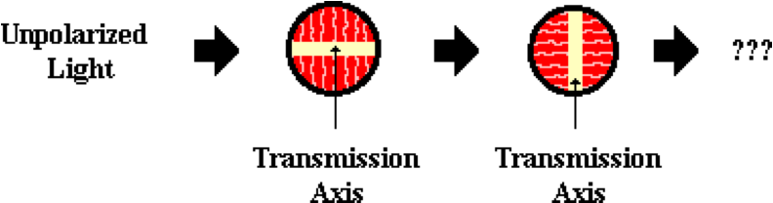

The light emerging from the second filter will have ____ the original intensity and be vibrating in a ____ plane of vibration.

a. the same intensity as, vertical

b. the same intensity as, horizontal

c. one-half, vertical

d. one-half, horizontal

e. one-fourth, vertical

f. one-fourth, horizontal

g. ... nonsense! This system will block all the light.

**Question 24:**

aa. Unpolarized light passes through a first Polaroid filter and then through a second Polarioid filter whose transmission axes are aligned as shown.



The light emerging from the second filter will have ____ the original intensity and be vibrating in a ____ plane of vibration.

a. the same intensity as, horizontal

b. the same intensity as, vertical

c. one-half, horizontal

d. one-half, vertical

e. one-fourth, horizontal

f. one-fourth, vertical

g. ... nonsense! This system will block all the light.

**Question 25:**

aa. When light reflects off a non-metallic surface, it becomes polarized. A generalization can be made about the direction of vibration of the polarized light. The reflected light tends to be vibrating in a plane that is ____.

a. horizontal

b. vertical

c. diagonal

d. parallel to the reflecting surface

e. perpendicular to the reflecting surface

f. nonsense! Light does not polarize when reflecting off non-metallic surfaces.

**Question 26:**

aa. When light reflects off a non-metallic surface, it becomes polarized. A generalization can be made about the direction of vibration of the polarized light. The reflected light tends to be vibrating in a plane that is ____.

a. diagonal

b. horizontal

c. vertical

d. perpendicular to the reflecting surface

e. parallel to the reflecting surface

f. nonsense! Light does not polarize when reflecting off non-metallic surfaces.

**Question 27:**

aa. When light reflects off a non-metallic surface, it becomes polarized. A generalization can be made about the direction of vibration of the polarized light. The reflected light tends to be vibrating in a plane that is ____.

a. perpendicular to the reflecting surface

b. parallel to the reflecting surface

c. horizontal

d. vertical

e. diagonal

f. nonsense! Light does not polarize when reflecting off non-metallic surfaces.

**Question 28:**

aa. When light reflects off a non-metallic surface, it becomes polarized. A generalization can be made about the direction of vibration of the polarized light. The reflected light tends to be vibrating in a plane that is ____.

a. parallel to the reflecting surface

b. perpendicular to the reflecting surface

c. diagonal

d. vertical

e. horizontal

f. nonsense! Light does not polarize when reflecting off non-metallic surfaces.

**Question 29:**

aa. A fisherman wishes to purchase some Polaroid sunglasses that are capable of blocking the glare resulting from reflection of sunlight off lake water. Consider the choices shown below. The lines represent the transmission axes of the filters.

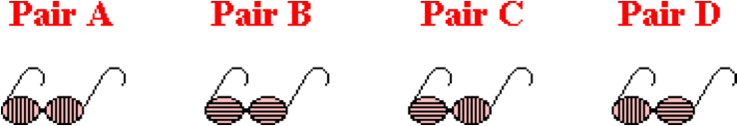

Which pair(s) should he/she purchase? List all that apply in alphabetical order with no commas or spaces between letters.

**Question 30:**

aa. A fisherman wishes to purchase some Polaroid sunglasses that are capable of blocking the glare resulting from reflection of sunlight off lake water. Consider the choices shown below. The lines represent the transmission axes of the filters.

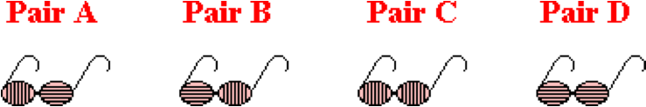

Which pair(s) should he/she purchase? List all that apply in alphabetical order with no commas or spaces between letters.

**Question 31:**

aa. A fisherman wishes to purchase some Polaroid sunglasses that are capable of blocking the glare resulting from reflection of sunlight off lake water. Consider the choices shown below. The lines represent the transmission axes of the filters.

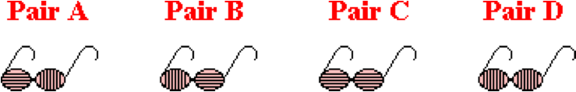

Which pair(s) should he/she purchase? List all that apply in alphabetical order with no commas or spaces between letters.

**Question 32:**

aa. A fisherman wishes to purchase some Polaroid sunglasses that are capable of blocking the glare resulting from reflection of sunlight off lake water. Consider the choices shown below. The lines represent the transmission axes of the filters.

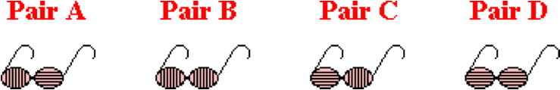

Which pair(s) should he/she purchase? List all that apply in alphabetical order with no commas or spaces between letters.

**LC3: Primary Colors of Light**

**Question 1:**

aa. The three primary colors of light are ____. List the three letters in alphabetical order with no commas or spaces between letters.

a. Magenta b. Blue c. Cyan

d. Red e. Yellow f. Black

g. Green h. White i. Brown

**Question 2:**

aa. The three primary colors of light are ____. List the three letters in alphabetical order with no commas or spaces between letters.

a. Yellow b. Black c. Brown

d. Blue e. White f. Cyan

g. Magenta h. Red i. Green

**Question 3:**

aa. The three primary colors of light are ____. List the three letters in alphabetical order with no commas or spaces between letters.

a. Red b. Black c. Blue

d. Yellow e. Brown f. Green

g. Magenta h. White i. Cyan

**Question 4:**

aa. The three primary colors of light are ____. List the three letters in alphabetical order with no commas or spaces between letters.

a. White b. Blue c. Brown

d. Green e. Yellow f. Red

g. Black h. Cyan i. Magenta

**Question 5:**

aa. When the three primary colors of light are mixed with equal intensities, the result will be the color ____.

a. Magenta b. Blue c. Cyan

d. Red e. Yellow f. Black

g. Green h. White i. Brown

**Question 6:**

aa. When the three primary colors of light are mixed with equal intensities, the result will be the color ____.

a. Yellow b. Black c. Brown

d. Blue e. White f. Cyan

g. Magenta h. Red i. Green

**Question 7:**

aa. When the three primary colors of light are mixed with equal intensities, the result will be the color ____.

a. Red b. Black c. Blue

d. Yellow e. Brown f. Green

g. Magenta h. White i. Cyan

**Question 8:**

aa. When the three primary colors of light are mixed with equal intensities, the result will be the color ____.

a. White b. Blue c. Brown

d. Green e. Yellow f. Red

g. Black h. Cyan i. Magenta

**Question 9:**

aa. White is not really a color. Rather, white can be considered to be ____.

a. a frequency of light which lies beyond the red of ROYGBIV

b. a frequency of light which lies beyond the violet of ROYGBIV

c. the result of an eye malfunction

d. the presence of all the colors of light

e. the absence of all the colors of light

f. ... nonsense! None of these explain the nature of white.

**Question 10:**

aa. White is not really a color. Rather, white can be considered to be ____.

a. a frequency of light which lies beyond the violet of ROYGBIV

b. a frequency of light which lies beyond the red of ROYGBIV

c. the result of an eye malfunction

d. the absence of all the colors of light

e. the presence of all the colors of light

f. ... nonsense! None of these explain the nature of white.

**Question 11:**

aa. White is not really a color. Rather, white can be considered to be ____.

a. the presence of all the colors of light

b. the absence of all the colors of light

c. a frequency of light which lies beyond the red of ROYGBIV

d. a frequency of light which lies beyond the violet of ROYGBIV

e. the result of an eye malfunction

f. ... nonsense! None of these explain the nature of white.

**Question 12:**

aa. White is not really a color. Rather, white can be considered to be ____.

a. the absence of all the colors of light

b. the presence of all the colors of light

c. a frequency of light which lies beyond the violet of ROYGBIV

d. a frequency of light which lies beyond the red of ROYGBIV

e. the result of an eye malfunction

f. ... nonsense! None of these explain the nature of white.

**Question 13:**

aa. Black is not really a color. Rather, black can be considered to be ____.

a. a frequency of light which lies beyond the red of ROYGBIV

b. a frequency of light which lies beyond the violet of ROYGBIV

c. the result of an eye malfunction

d. the presence of all the colors of light

e. the absence of all the colors of light

f. ... nonsense! None of these explain the nature of black.

**Question 14:**

aa. Black is not really a color. Rather, black can be considered to be ____.

a. a frequency of light which lies beyond the violet of ROYGBIV

b. a frequency of light which lies beyond the red of ROYGBIV

c. the result of an eye malfunction

d. the absence of all the colors of light

e. the presence of all the colors of light

f. ... nonsense! None of these explain the nature of white.

**Question 15:**

aa. Black is not really a color. Rather, black can be considered to be ____.

a. the presence of all the colors of light

b. the absence of all the colors of light

c. a frequency of light which lies beyond the red of ROYGBIV

d. a frequency of light which lies beyond the violet of ROYGBIV

e. the result of an eye malfunction

f. ... nonsense! None of these explain the nature of white.

**Question 16:**

aa. Black is not really a color. Rather, black can be considered to be ____.

a. the absence of all the colors of light

b. the presence of all the colors of light

c. a frequency of light which lies beyond the violet of ROYGBIV

d. a frequency of light which lies beyond the red of ROYGBIV

e. the result of an eye malfunction

f. ... nonsense! None of these explain the nature of white.

**Question 17:**

aa. Determine the result of mixing the following colors of light with equal intensities:

Red light mixed with green light produces ____ light.

Red light mixed with blue light produces ____ light.

Green light mixed with blue light produces ____ light.

Red light, green light and blue light mixed together produces ____ light.

Enter four letters that fit the blanks in their respective order. Do not place commas or spaces between letters.

a. Magenta b. Blue c. Cyan

d. Red e. Yellow f. Black

g. Green h. White i. Brown

**Question 18:**

aa. Determine the result of mixing the following colors of light with equal intensities:

Red light mixed with green light produces ____ light.

Red light mixed with blue light produces ____ light.

Green light mixed with blue light produces ____ light.

Red light, green light and blue light mixed together produces ____ light.

Enter four letters that fit the blanks in their respective order. Do not place commas or spaces between letters.

a. Yellow b. Black c. Brown

d. Blue e. White f. Cyan

g. Magenta h. Red i. Green

**Question 19:**

aa. Determine the result of mixing the following colors of light with equal intensities:

Red light mixed with green light produces ____ light.

Red light mixed with blue light produces ____ light.

Green light mixed with blue light produces ____ light.

Red light, green light and blue light mixed together produces ____ light.

Enter four letters that fit the blanks in their respective order. Do not place commas or spaces between letters.

a. Red b. Black c. Blue

d. Yellow e. Brown f. Green

g. Magenta h. White i. Cyan

**Question 20:**

aa. Determine the result of mixing the following colors of light with equal intensities:

Red light mixed with green light produces ____ light.

Red light mixed with blue light produces ____ light.

Green light mixed with blue light produces ____ light.

Red light, green light and blue light mixed together produces ____ light.

Enter four letters that fit the blanks in their respective order. Do not place commas or spaces between letters.

a. White b. Blue c. Brown

d. Green e. Yellow f. Red

g. Black h. Cyan i. Magenta

**Question 21:**

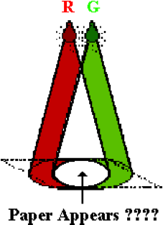aa. Two lights - a Red light and a Green light - are used to illuminate a white sheet of paper. When these light colors are mixed with equal intensities, the paper will appear ____.

a. Magenta b. Blue c. Cyan

d. Red e. Yellow f. Black

g. Green h. White i. Brown

**Question 22:**

aa. Two lights - a Red light and a Green light - are used to illuminate a white sheet of paper. When these light colors are mixed with equal intensities, the paper will appear ____.

a. Yellow b. Black c. Brown

d. Blue e. White f. Cyan

g. Magenta h. Red i. Green

**Question 23:**

aa. Two lights - a Red light and a Green light - are used to illuminate a white sheet of paper. When these light colors are mixed with equal intensities, the paper will appear ____.

a. Red b. Black c. Blue

d. Yellow e. Brown f. Green

g. Magenta h. White i. Cyan

**Question 24:**

aa. Two lights - a Red light and a Green light - are used to illuminate a white sheet of paper. When these light colors are mixed with equal intensities, the paper will appear ____.

a. White b. Blue c. Brown

d. Green e. Yellow f. Red

g. Black h. Cyan i. Magenta

**Question 25:**

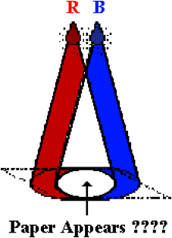aa. Two lights - a Red light and a Blue light - are used to illuminate a white sheet of paper. When these light colors are mixed with equal intensities, the paper will appear ____.

a. Magenta b. Blue c. Cyan

d. Red e. Yellow f. Black

g. Green h. White i. Brown

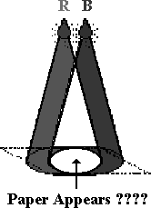**Question 26:**

aa. Two lights - a Red light and a Blue light - are used to illuminate a white sheet of paper. When these light colors are mixed with equal intensities, the paper will appear ____.

a. Yellow b. Black c. Brown

d. Blue e. White f. Cyan

g. Magenta h. Red i. Green

**Question 27:**

aa. Two lights - a Red light and a Blue light - are used to illuminate a white sheet of paper. When these light colors are mixed with equal intensities, the paper will appear ____.

a. Red b. Black c. Blue

d. Yellow e. Brown f. Green

g. Magenta h. White i. Cyan

**Question 28:**

aa. Two lights - a Red light and a Blue light - are used to illuminate a white sheet of paper. When these light colors are mixed with equal intensities, the paper will appear ____.

a. White b. Blue c. Brown

d. Green e. Yellow f. Red

g. Black h. Cyan i. Magenta

**Question 29:**

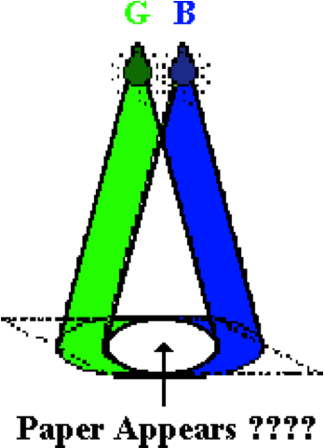aa. Two lights - a Green light and a Blue light - are used to illuminate a white sheet of paper. When these light colors are mixed with equal intensities, the paper will appear ____.

a. Magenta b. Blue c. Cyan

d. Red e. Yellow f. Black

g. Green h. White i. Brown

**Question 30:**

aa. Two lights - a Green light and a Blue light - are used to illuminate a white sheet of paper. When these light colors are mixed with equal intensities, the paper will appear ____.

a. Yellow b. Black c. Brown

d. Blue e. White f. Cyan

g. Magenta h. Red i. Green

**Question 31:**

aa. Two lights - a Green light and a Blue light - are used to illuminate a white sheet of paper. When these light colors are mixed with equal intensities, the paper will appear ____.

a. Red b. Black c. Blue

d. Yellow e. Brown f. Green

g. Magenta h. White i. Cyan

**Question 32:**

aa. Two lights - a Green light and a Blue light - are used to illuminate a white sheet of paper. When these light colors are mixed with equal intensities, the paper will appear ____.

a. White b. Blue c. Brown

d. Green e. Yellow f. Red

g. Black h. Cyan i. Magenta

**LC4: Complementary Colors of Light**

**Question 1:**

aa. In physics, complementary colors of light are combinations of light colors that ____.

a. produce brown when added together

b. produce black when added together

c. produce white light when added together

d. will cancel each other out when mixed

e. look very stunning when used together

**Question 2:**

aa. In physics, complementary colors of light are combinations of light colors that ____.

a. produce black when added together

b. produce white light when added together

c. produce brown when added together

d. will cancel each other out when mixed

e. look very stunning when used together

**Question 3:**

aa. In physics, complementary colors of light are combinations of light colors that ____.

a. produce white light when added together

b. produce black when added together

c. produce brown when added together

d. will cancel each other out when mixed

e. look very stunning when used together

**Question 4:**

aa. In physics, complementary colors of light are combinations of light colors that ____.

a. will cancel each other out when mixed

b. produce brown when added together

c. produce black when added together

d. produce white light when added together

e. look very stunning when used together

**Question 5:**

aa. The complementary color of red light is ____ light.

a. Magenta b. Blue c. Cyan

d. Red e. Yellow f. Black

g. Green h. White i. Brown

**Question 6:**

aa. The complementary color of red light is ____ light.

a. Yellow b. Black c. Brown

d. Blue e. White f. Cyan

g. Magenta h. Red i. Green

**Question 7:**

aa. The complementary color of cyan light is ____ light.

a. Red b. Black c. Blue

d. Yellow e. Brown f. Green

g. Magenta h. White i. Cyan

**Question 8:**

aa. The complementary color of cyan light is ____ light.

a. White b. Blue c. Brown

d. Green e. Yellow f. Red

g. Black h. Cyan i. Magenta

**Question 9:**

aa. The complementary color of green light is ____ light.

a. Magenta b. Blue c. Cyan

d. Red e. Yellow f. Black

g. Green h. White i. Brown

**Question 10:**

aa. The complementary color of green light is ____ light.

a. Yellow b. Black c. Brown

d. Blue e. White f. Cyan

g. Magenta h. Red i. Green

**Question 11:**

aa. The complementary color of magenta light is ____ light.

a. Red b. Black c. Blue

d. Yellow e. Brown f. Green

g. Magenta h. White i. Cyan

**Question 12:**

aa. The complementary color of magenta light is ____ light.

a. White b. Blue c. Brown

d. Green e. Yellow f. Red

g. Black h. Cyan i. Magenta

**Question 13:**

aa. The complementary color of blue light is ____ light.

a. Magenta b. Blue c. Cyan

d. Red e. Yellow f. Black

g. Green h. White i. Brown

**Question 14:**

aa. The complementary color of blue light is ____ light.

a. Yellow b. Black c. Brown

d. Blue e. White f. Cyan

g. Magenta h. Red i. Green

**Question 15:**

aa. The complementary color of yellow light is ____ light.

a. Red b. Black c. Blue

d. Yellow e. Brown f. Green

g. Magenta h. White i. Cyan

**Question 16:**

aa. The complementary color of yellow light is ____ light.

a. White b. Blue c. Brown

d. Green e. Yellow f. Red

g. Black h. Cyan i. Magenta

**Question 17:**

aa. Three colored spotlights - red, green and blue - with equal intensities are used to shine white light upon a red shirt. The shirt appears red because it absorbs the ____ light and reflects the ____ light. Enter the two letters in their respective order with no commas or spaces between letters.

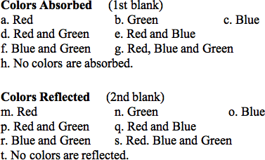

**Question 18:**

aa. Three colored spotlights - red, green and blue - with equal intensities are used to shine white light upon a red shirt. The shirt appears red because it absorbs the ____ light and reflects the ____ light. Enter the two letters in their respective order with no commas or spaces between letters.

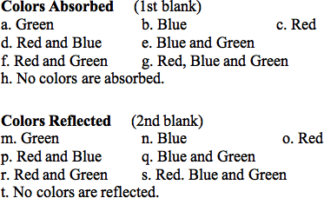

**Question 19:**

aa. Three colored spotlights - red, green and blue - with equal intensities are used to shine white light upon a red shirt. The shirt appears red because it absorbs the ____ light and reflects the ____ light. Enter the two letters in their respective order with no commas or spaces between letters.

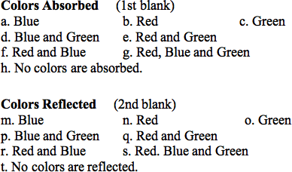

**Question 20:**

aa. Three colored spotlights - red, green and blue - with equal intensities are used to shine white light upon a red shirt. The shirt appears red because it absorbs the ____ light and reflects the ____ light. Enter the two letters in their respective order with no commas or spaces between letters.

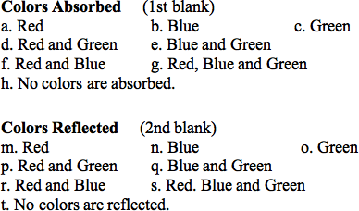

**Question 21:**

aa. Three colored spotlights - red, green and blue - with equal intensities are used to shine white light upon a green shirt. The shirt appears green because it absorbs the ____ light and reflects the ____ light. Enter the two letters in their respective order with no commas or spaces between letters.



**Question 22:**

aa. Three colored spotlights - red, green and blue - with equal intensities are used to shine white light upon a green shirt. The shirt appears green because it absorbs the ____ light and reflects the ____ light. Enter the two letters in their respective order with no commas or spaces between letters.



**Question 23:**

aa. Three colored spotlights - red, green and blue - with equal intensities are used to shine white light upon a green shirt. The shirt appears green because it absorbs the ____ light and reflects the ____ light. Enter the two letters in their respective order with no commas or spaces between letters.



**Question 24:**

aa. Three colored spotlights - red, green and blue - with equal intensities are used to shine white light upon a green shirt. The shirt appears green because it absorbs the ____ light and reflects the ____ light. Enter the two letters in their respective order with no commas or spaces between letters.



**Question 25:**

aa. Three colored spotlights - red, green and blue - with equal intensities are used to shine white light upon a blue shirt. The shirt appears blue because it absorbs the ____ light and reflects the ____ light. Enter the two letters in their respective order with no commas or spaces between letters.



**Question 26:**

aa. Three colored spotlights - red, green and blue - with equal intensities are used to shine white light upon a blue shirt. The shirt appears blue because it absorbs the ____ light and reflects the ____ light. Enter the two letters in their respective order with no commas or spaces between letters.



**Question 27:**

aa. Three colored spotlights - red, green and blue - with equal intensities are used to shine white light upon a blue shirt. The shirt appears blue because it absorbs the ____ light and reflects the ____ light. Enter the two letters in their respective order with no commas or spaces between letters.



**Question 28:**

aa. Three colored spotlights - red, green and blue - with equal intensities are used to shine white light upon a blue shirt. The shirt appears blue because it absorbs the ____ light and reflects the ____ light. Enter the two letters in their respective order with no commas or spaces between letters.



**Question 29:**

aa. Three colored spotlights - red, green and blue - with equal intensities are used to shine white light upon a cyan shirt. The shirt appears cyan because it absorbs the ____ light and reflects the ____ light. Enter the two letters in their respective order with no commas or spaces between letters.



**Question 30:**

aa. Three colored spotlights - red, green and blue - with equal intensities are used to shine white light upon a cyan shirt. The shirt appears cyan because it absorbs the ____ light and reflects the ____ light. Enter the two letters in their respective order with no commas or spaces between letters.



**Question 31:**

aa. Three colored spotlights - red, green and blue - with equal intensities are used to shine white light upon a cyan shirt. The shirt appears cyan because it absorbs the ____ light and reflects the ____ light. Enter the two letters in their respective order with no commas or spaces between letters.



**Question 32:**

aa. Three colored spotlights - red, green and blue - with equal intensities are used to shine white light upon a cyan shirt. The shirt appears cyan because it absorbs the ____ light and reflects the ____ light. Enter the two letters in their respective order with no commas or spaces between letters.



**Question 33:**

aa. Three colored spotlights - red, green and blue - with equal intensities are used to shine white light upon a magenta shirt. The shirt appears magenta because it absorbs the ____ light and reflects the ____ light. Enter the two letters in their respective order with no commas or spaces between letters.



**Question 34:**

aa. Three colored spotlights - red, green and blue - with equal intensities are used to shine white light upon a magenta shirt. The shirt appears magenta because it absorbs the ____ light and reflects the ____ light. Enter the two letters in their respective order with no commas or spaces between letters.



**Question 35:**

aa. Three colored spotlights - red, green and blue - with equal intensities are used to shine white light upon a magenta shirt. The shirt appears magenta because it absorbs the ____ light and reflects the ____ light. Enter the two letters in their respective order with no commas or spaces between letters.



**Question 36:**

aa. Three colored spotlights - red, green and blue - with equal intensities are used to shine white light upon a magenta shirt. The shirt appears magenta because it absorbs the ____ light and reflects the ____ light. Enter the two letters in their respective order with no commas or spaces between letters.



**Question 37:**

aa. Three colored spotlights - red, green and blue - with equal intensities are used to shine white light upon a yellow shirt. The shirt appears yellow because it absorbs the ____ light and reflects the ____ light. Enter the two letters in their respective order with no commas or spaces between letters.



**Question 38:**

aa. Three colored spotlights - red, green and blue - with equal intensities are used to shine white light upon a yellow shirt. The shirt appears yellow because it absorbs the ____ light and reflects the ____ light. Enter the two letters in their respective order with no commas or spaces between letters.



**Question 39:**

aa. Three colored spotlights - red, green and blue - with equal intensities are used to shine white light upon a yellow shirt. The shirt appears yellow because it absorbs the ____ light and reflects the ____ light. Enter the two letters in their respective order with no commas or spaces between letters.



**Question 40:**

aa. Three colored spotlights - red, green and blue - with equal intensities are used to shine white light upon a yellow shirt. The shirt appears yellow because it absorbs the ____ light and reflects the ____ light. Enter the two letters in their respective order with no commas or spaces between letters.



**LC5: Color Subtraction**

**Question 1:**

aa. Three colored spotlights - red, green and blue - with equal intensities are used to illuminate a shirt with different colors of light. If a shirt which appears red under white light is illuminated with yellow light, then the shirt will absorb the ____ light and appear as _____. Enter the two letters in their respective order with no commas or spaces between letters.

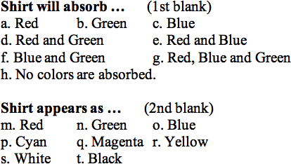

**Question 2:**

aa. Three colored spotlights - red, green and blue - with equal intensities are used to illuminate a shirt with different colors of light. If a shirt which appears green under white light is illuminated with yellow light, then the shirt will absorb the ____ light and appear as _____. Enter the two letters in their respective order with no commas or spaces between letters.



**Question 3:**

aa. Three colored spotlights - red, green and blue - with equal intensities are used to illuminate a shirt with different colors of light. If a shirt which appears red under white light is illuminated with magenta light, then the shirt will absorb the ____ light and appear as _____. Enter the two letters in their respective order with no commas or spaces between letters.



**Question 4:**

aa. Three colored spotlights - red, green and blue - with equal intensities are used to illuminate a shirt with different colors of light. If a shirt which appears blue under white light is illuminated with magenta light, then the shirt will absorb the ____ light and appear as _____. Enter the two letters in their respective order with no commas or spaces between letters.



**Question 5:**

aa. Three colored spotlights - red, green and blue - with equal intensities are used to illuminate a shirt with different colors of light. If a shirt which appears blue under white light is illuminated with cyan light, then the shirt will absorb the ____ light and appear as _____. Enter the two letters in their respective order with no commas or spaces between letters.



**Question 6:**

aa. Three colored spotlights - red, green and blue - with equal intensities are used to illuminate a shirt with different colors of light. If a shirt which appears green under white light is illuminated with cyan light, then the shirt will absorb the ____ light and appear as _____. Enter the two letters in their respective order with no commas or spaces between letters.



**Question 7:**

aa. Three colored spotlights - red, green and blue - with equal intensities are used to illuminate a shirt with different colors of light. If a shirt which appears cyan under white light is illuminated with magenta light, then the shirt will absorb the ____ light and appear as _____. Enter the two letters in their respective order with no commas or spaces between letters.



**Question 8:**

aa. Three colored spotlights - red, green and blue - with equal intensities are used to illuminate a shirt with different colors of light. If a shirt which appears yellow under white light is illuminated with magenta light, then the shirt will absorb the ____ light and appear as _____. Enter the two letters in their respective order with no commas or spaces between letters.



**Question 9:**

aa. Three colored spotlights - red, green and blue - with equal intensities are used to illuminate a shirt with different colors of light. If a shirt which appears magenta under white light is illuminated with cyan light, then the shirt will absorb the ____ light and appear as _____. Enter the two letters in their respective order with no commas or spaces between letters.



**Question 10:**

aa. Three colored spotlights - red, green and blue - with equal intensities are used to illuminate a shirt with different colors of light. If a shirt which appears yellow under white light is illuminated with cyan light, then the shirt will absorb the ____ light and appear as _____. Enter the two letters in their respective order with no commas or spaces between letters.



**Question 11:**

aa. Three colored spotlights - red, green and blue - with equal intensities are used to illuminate a shirt with different colors of light. If a shirt which appears cyan under white light is illuminated with yellow light, then the shirt will absorb the ____ light and appear as _____. Enter the two letters in their respective order with no commas or spaces between letters.



**Question 12:**

aa. Three colored spotlights - red, green and blue - with equal intensities are used to illuminate a shirt with different colors of light. If a shirt which appears magenta under white light is illuminated with yellow light, then the shirt will absorb the ____ light and appear as _____. Enter the two letters in their respective order with no commas or spaces between letters.



**Question 13:**

aa. Three colored spotlights - red, green and blue - with equal intensities are used to illuminate a shirt with different colors of light. If a shirt which appears red under white light is illuminated with cyan light, then the shirt will absorb the ____ light and appear as _____. Enter the two letters in their respective order with no commas or spaces between letters.



**Question 14:**

aa. Three colored spotlights - red, green and blue - with equal intensities are used to illuminate a shirt with different colors of light. If a shirt which appears green under white light is illuminated with magenta light, then the shirt will absorb the ____ light and appear as _____. Enter the two letters in their respective order with no commas or spaces between letters.



**Question 15:**

aa. Three colored spotlights - red, green and blue - with equal intensities are used to illuminate a shirt with different colors of light. If a shirt which appears blue under white light is illuminated with yellow light, then the shirt will absorb the ____ light and appear as _____. Enter the two letters in their respective order with no commas or spaces between letters.



**Question 16:**

aa. Three colored spotlights - red, green and blue - with equal intensities are used to illuminate a shirt with different colors of light. If a shirt which appears cyan under white light is illuminated with red light, then the shirt will absorb the ____ light and appear as _____. Enter the two letters in their respective order with no commas or spaces between letters.



**Question 17:**

aa. Three colored spotlights - red, green and blue - with equal intensities are used to illuminate a shirt with different colors of light. If a shirt which appears yellow under white light is illuminated with blue light, then the shirt will absorb the ____ light and appear as _____. Enter the two letters in their respective order with no commas or spaces between letters.



**Question 18:**

aa. Three colored spotlights - red, green and blue - with equal intensities are used to illuminate a shirt with different colors of light. If a shirt which appears magenta under white light is illuminated with green light, then the shirt will absorb the ____ light and appear as _____. Enter the two letters in their respective order with no commas or spaces between letters.



**Question 19:**

aa. Three colored spotlights - red, green and blue - with equal intensities may be turned ON and OFF in order to illuminate a shirt with different colors of light. Suppose that a shirt appears yellow when placed under the spotlights. One can say conclusively that the ____ spotlight(s) is/are turned ON.

a. Red b. Green c. Blue

d. Red and Green e. Red and Blue

f. Blue and Green g. Red, Blue and Green

h. ... nonsense! One cannot conclude if any of the spotlights are ON.

**Question 20:**

aa. Three colored spotlights - red, green and blue - with equal intensities may be turned ON and OFF in order to illuminate a shirt with different colors of light. Suppose that a shirt appears cyan when placed under the spotlights. One can say conclusively that the ____ spotlight(s) is/are turned ON.

a. Red b. Green c. Blue

d. Red and Green e. Red and Blue

f. Blue and Green g. Red, Blue and Green

h. ... nonsense! One cannot conclude if any of the spotlights are ON.

**Question 21:**

aa. Three colored spotlights - red, green and blue - with equal intensities may be turned ON and OFF in order to illuminate a shirt with different colors of light. Suppose that a shirt appears magenta when placed under the spotlights. One can say conclusively that the ____ spotlight(s) is/are turned ON.

a. Red b. Green c. Blue

d. Red and Green e. Red and Blue

f. Blue and Green g. Red, Blue and Green

h. ... nonsense! One cannot conclude if any of the spotlights are ON.

**Question 22:**

aa. Three colored spotlights - red, green and blue - with equal intensities may be turned ON and OFF in order to illuminate a shirt with different colors of light. A shirt that appears magenta under white light is placed under the spotlights and then appears as red. One can say conclusively that the ____ spotlight(s) is/are turned OFF.

a. Red b. Green c. Blue

d. Red and Green e. Red and Blue

f. Blue and Green g. Red, Blue and Green

h. ... nonsense! One cannot conclude if any of the spotlights are OFF.

**Question 23:**

aa. Three colored spotlights - red, green and blue - with equal intensities may be turned ON and OFF in order to illuminate a shirt with different colors of light. A shirt that appears magenta under white light is placed under the spotlights and then appears as blue. One can say conclusively that the ____ spotlight(s) is/are turned OFF.

a. Red b. Green c. Blue

d. Red and Green e. Red and Blue

f. Blue and Green g. Red, Blue and Green

h. ... nonsense! One cannot conclude if any of the spotlights are OFF.

**Question 24:**

aa. Three colored spotlights - red, green and blue - with equal intensities may be turned ON and OFF in order to illuminate a shirt with different colors of light. A shirt that appears yellow under white light is placed under the spotlights and then appears as red. One can say conclusively that the ____ spotlight(s) is/are turned OFF

a. Red b. Green c. Blue

d. Red and Green e. Red and Blue

f. Blue and Green g. Red, Blue and Green

h. ... nonsense! One cannot conclude if any of the spotlights are OFF.

**Question 25:**

aa. Three colored spotlights - red, green and blue - with equal intensities may be turned ON and OFF in order to illuminate a shirt with different colors of light. A shirt that appears yellow under white light is placed under the spotlights and then appears as green. One can say conclusively that the ____ spotlight(s) is/are turned OFF.

a. Red b. Green c. Blue

d. Red and Green e. Red and Blue

f. Blue and Green g. Red, Blue and Green

h. ... nonsense! One cannot conclude if any of the spotlights are OFF.

**Question 26:**

aa. Three colored spotlights - red, green and blue - with equal intensities may be turned ON and OFF in order to illuminate a shirt with different colors of light. A shirt that appears cyan under white light is placed under the spotlights and then appears as blue. One can say conclusively that the ____ spotlight(s) is/are turned OFF.

a. Red b. Green c. Blue

d. Red and Green e. Red and Blue

f. Blue and Green g. Red, Blue and Green

h. ... nonsense! One cannot conclude if any of the spotlights are OFF.

**Question 27:**

aa. Three colored spotlights - red, green and blue - with equal intensities may be turned ON and OFF in order to illuminate a shirt with different colors of light. A shirt that appears cyan under white light is placed under the spotlights and then appears as green. One can say conclusively that the ____ spotlight(s) is/are turned OFF.

a. Red b. Green c. Blue

d. Red and Green e. Red and Blue

f. Blue and Green g. Red, Blue and Green

h. ... nonsense! One cannot conclude if any of the spotlights are OFF.

**Question 28:**

aa. Three colored spotlights - red, green and blue - with equal intensities may be turned ON and OFF in order to illuminate a shirt with different colors of light. Suppose that a shirt that appears cyan under white light is placed under the spotlights and then appears as green. From this information, one cannot make any conclusions as to whether the ____ spotlight(s) is/are turned ON or OFF.

a. Red b. Green c. Blue

d. Red and Green e. Red and Blue

f. Blue and Green g. Red, Blue and Green

h. ... nonsense! One can be certain that spotlights are ON and which spotlights are OFF.

**Question 29:**

aa. Three colored spotlights - red, green and blue - with equal intensities may be turned ON and OFF in order to illuminate a shirt with different colors of light. Suppose that a shirt that appears cyan under white light is placed under the spotlights and then appears as blue. From this information, one cannot make any conclusions as to whether the ____ spotlight(s) is/are turned ON or OFF.

a. Red b. Green c. Blue

d. Red and Green e. Red and Blue

f. Blue and Green g. Red, Blue and Green

h. ... nonsense! One can be certain that spotlights are ON and which spotlights are OFF.

**Question 30:**

aa. Three colored spotlights - red, green and blue - with equal intensities may be turned ON and OFF in order to illuminate a shirt with different colors of light. Suppose that a shirt that appears yellow under white light is placed under the spotlights and then appears as red. From this information, one cannot make any conclusions as to whether the ____ spotlight(s) is/are turned ON or OFF.

a. Red b. Green c. Blue

d. Red and Green e. Red and Blue

f. Blue and Green g. Red, Blue and Green

h. ... nonsense! One can be certain that spotlights are ON and which spotlights are OFF.

**Question 31:**

aa. Three colored spotlights - red, green and blue - with equal intensities may be turned ON and OFF in order to illuminate a shirt with different colors of light. Suppose that a shirt that appears yellow under white light is placed under the spotlights and then appears as green. From this information, one cannot make any conclusions as to whether the ____ spotlight(s) is/are turned ON or OFF.

a. Red b. Green c. Blue

d. Red and Green e. Red and Blue

f. Blue and Green g. Red, Blue and Green

h. ... nonsense! One can be certain which spotlights are ON and which spotlights are OFF.

**Question 32:**

aa. Three colored spotlights - red, green and blue - with equal intensities may be turned ON and OFF in order to illuminate a shirt with different colors of light. Suppose that a shirt that appears magenta under white light is placed under the spotlights and then appears as blue. From this information, one cannot make any conclusions as to whether the ____ spotlight(s) is/are turned ON or OFF.

a. Red b. Green c. Blue

d. Red and Green e. Red and Blue

f. Blue and Green g. Red, Blue and Green

h. ... nonsense! One can be certain that spotlights are ON and which spotlights are OFF.

**Question 33:**

aa. Three colored spotlights - red, green and blue - with equal intensities may be turned ON and OFF in order to illuminate a shirt with different colors of light. Suppose that a shirt that appears magenta under white light is placed under the spotlights and then appears as red . From this information, one cannot make any conclusions as to whether the ____ spotlight(s) is/are turned ON or OFF.

a. Red b. Green c. Blue

d. Red and Green e. Red and Blue

f. Blue and Green g. Red, Blue and Green

h. ... nonsense! One can be certain which spotlights are ON and which spotlights are OFF.

**LC6: Primary Pigments**

**Question 1:**

aa. In physics, the primary pigments or paints are ____, ____, and ____. List the letters of the three primary pigments in alphabetical order with no commas or spaces between letters.

a. Magenta b. Blue c. Cyan

d. Red e. Yellow f. Black

g. Green h. White i. Brown

**Question 2:**

aa. In physics, the primary pigments or paints are ____, ____, and ____. List the letters of the three primary pigments in alphabetical order with no commas or spaces between letters.

a. Yellow b. Black c. Brown

d. Blue e. White f. Cyan

g. Magenta h. Red i. Green

**Question 3:**

aa. In physics, the primary pigments or paints are ____, ____, and ____. List the letters of the three primary pigments in alphabetical order with no commas or spaces between letters.

a. Red b. Black c. Blue

d. Yellow e. Brown f. Green

g. Magenta h. White i. Cyan

**Question 4:**

aa. In physics, the primary pigments or paints are ____, ____, and ____. List the letters of the three primary pigments in alphabetical order with no commas or spaces between letters.

a. White b. Blue c. Brown

d. Green e. Yellow f. Red

g. Black h. Cyan i. Magenta

**Question 5:**

aa. A primary pigment is unique in that it is a pigment capable of ____.

a. producing white light when mixed with other primary pigments

b. producing black light when mixed with other primary pigments

c. producing all the colors of light when mixed with other primary pigments

d. absorbing a single primary color of light

e. absorbing two primary colors of light

f. Being eligible for inclusion in Crayola's 256 top colors

**Question 6:**

aa. A primary pigment is unique in that it is a pigment capable of ____.

a. producing black light when mixed with other primary pigments

b. producing all the colors of light when mixed with other primary pigments

c. producing white light when mixed with other primary pigments

d. absorbing two primary colors of light

e. absorbing a single primary color of light

f. being eligible for inclusion in Crayola's 256 top colors

**Question 7:**

aa. A primary pigment is unique in that it is a pigment capable of ____.

a. absorbing a single primary color of light

b. absorbing two primary colors of light

c. producing white light when mixed with other primary pigments

d. producing black light when mixed with other primary pigments

e. producing all the colors of light when mixed with other primary pigments

f. being eligible for inclusion in Crayola's 256 top colors

**Question 8:**

aa. A primary pigment is unique in that it is a pigment capable of ____.

a. absorbing two primary colors of light

b. absorbing a single primary color of light

c. producing black light when mixed with other primary pigments

d. producing all the colors of light when mixed with other primary pigments

e. producing white light when mixed with other primary pigments

f. being eligible for inclusion in Crayola's 256 top colors

**Question 9:**

aa. An object that is painted with cyan pigment will be capable of absorbing ___ light.

a. Red b. Green c. Blue

d. Red and Green e. Red and Blue

f. Blue and Green g. Red, Blue and Green

h. ... nonsense! Pigments don't absorb light; they produce light.

**Question 10:**

aa. An object that is painted with cyan pigment will be capable of absorbing ___ light.

a. Green b. Blue c. Red

d. Red and Blue e. Green and Blue

f. Red and Green g. Red, Green and Blue

h. ... nonsense! Pigments don't absorb light; they produce light.

**Question 11:**

aa. An object that is painted with cyan pigment will be capable of absorbing ___ light.

a. Blue b. Red c. Green

d. Green and Blue e. Red and Green

f. Red and Blue g. Red, Green and Blue

h. ... nonsense! Pigments don't absorb light; they produce light.

**Question 12:**

aa. An object that is painted with cyan pigment will be capable of absorbing ___ light.

a. Red b. Blue c. Green

d. Red and Green e. Green and Blue

f. Red and Blue g. Red, Green and Blue

h. ... nonsense! Pigments don't absorb light; they produce light.

**Question 13:**

aa. An object that is painted with magenta pigment will be capable of absorbing ___ light.

a. Red b. Green c. Blue

d. Red and Green e. Red and Blue

f. Blue and Green g. Red, Blue and Green

h. ... nonsense! Pigments don't absorb light; they produce light.

**Question 14:**

aa. An object that is painted with magenta pigment will be capable of absorbing ___ light.

a. Green b. Blue c. Red

d. Red and Blue e. Green and Blue

f. Red and Green g. Red, Green and Blue

h. ... nonsense! Pigments don't absorb light; they produce light.

**Question 15:**

aa. An object that is painted with magenta pigment will be capable of absorbing ___ light.

a. Blue b. Red c. Green

d. Green and Blue e. Red and Green

f. Red and Blue g. Red, Green and Blue

h. ... nonsense! Pigments don't absorb light; they produce light.

**Question 16:**

aa. An object that is painted with magenta pigment will be capable of absorbing ___ light.

a. Red b. Blue c. Green

d. Red and Green e. Green and Blue

f. Red and Blue g. Red, Green and Blue

h. ... nonsense! Pigments don't absorb light; they produce light.

**Question 17:**

aa. An object that is painted with yellow pigment will be capable of absorbing ___ light.

a. Red b. Green c. Blue

d. Red and Green e. Red and Blue

f. Blue and Green g. Red, Blue and Green

h. ... nonsense! Pigments don't absorb light; they produce light.

**Question 18:**

aa. An object that is painted with yellow pigment will be capable of absorbing ___ light.

a. Green b. Blue c. Red

d. Red and Blue e. Green and Blue

f. Red and Green g. Red, Green and Blue

h. ... nonsense! Pigments don't absorb light; they produce light.

**Question 19:**

aa. An object that is painted with yellow pigment will be capable of absorbing ___ light.

a. Blue b. Red c. Green

d. Green and Blue e. Red and Green

f. Red and Blue g. Red, Green and Blue

h. ... nonsense! Pigments don't absorb light; they produce light.

**Question 20:**

aa. An object that is painted with yellow pigment will be capable of absorbing ___ light.

a. Red b. Blue c. Green

d. Red and Green e. Green and Blue

f. Red and Blue g. Red, Green and Blue

h. ... nonsense! Pigments don't absorb light; they produce light.

**Question 21:**

aa. Most color printing processes use cyan, magenta, and yellow pigments to create a colored image on a white sheet of paper. Which pigment(s) would have to be imparted to a portion of the paper in order for that portion to appear red when viewed under white light? List all that apply in alphabetical order with no commas or spaces between letters.

a. cyan b. magenta c. yellow

d. ... nonsense! Impossible to tell with so little information.

**Question 22:**

aa. Most color printing processes use cyan, magenta, and yellow pigments to create a colored image on a white sheet of paper. Which pigment(s) would have to be imparted to a portion of the paper in order for that portion to appear red when viewed under white light? List all that apply in alphabetical order with no commas or spaces between letters.

a. magenta b. yellow c. cyan

d. ... nonsense! Impossible to tell with so little information.

**Question 23:**

aa. Most color printing processes use cyan, magenta, and yellow pigments to create a colored image on a white sheet of paper. Which pigment(s) would have to be imparted to a portion of the paper in order for that portion to appear red when viewed under white light? List all that apply in alphabetical order with no commas or spaces between letters.

a. yellow b. cyan c. magenta

d. ... nonsense! It is impossible to tell with so little information.

**Question 24:**

aa. Most color printing processes use cyan, magenta, and yellow pigments to create a colored image on a white sheet of paper. Which pigment(s) would have to be imparted to a portion of the paper in order for that portion to appear red when viewed under white light? List all that apply in alphabetical order with no commas or spaces between letters.

a. magenta b. cyan c. yellow

d. ... nonsense! It is impossible to tell with so little information.

**Question 25:**

aa. Most color printing processes use cyan, magenta, and yellow pigments to create a colored image on a white sheet of paper. Which pigment(s) would have to be imparted to a portion of the paper in order for that portion to appear blue when viewed under white light? List all that apply in alphabetical order with no commas or spaces between letters.

a. cyan b. magenta c. yellow

d. ... nonsense! Impossible to tell with so little information.

**Question 26:**

aa. Most color printing processes use cyan, magenta, and yellow pigments to create a colored image on a white sheet of paper. Which pigment(s) would have to be imparted to a portion of the paper in order for that portion to appear blue when viewed under white light? List all that apply in alphabetical order with no commas or spaces between letters.

a. magenta b. yellow c. cyan

d. ... nonsense! It is impossible to tell with so little information.

**Question 27:**

aa. Most color printing processes use cyan, magenta, and yellow pigments to create a colored image on a white sheet of paper. Which pigment(s) would have to be imparted to a portion of the paper in order for that portion to appear blue when viewed under white light? List all that apply in alphabetical order with no commas or spaces between letters.

a. yellow b. cyan c. magenta

d. ... nonsense! It is impossible to tell with so little information.

**Question 28:**

aa. Most color printing processes use cyan, magenta, and yellow pigments to create a colored image on a white sheet of paper. Which pigment(s) would have to be imparted to a portion of the paper in order for that portion to appear blue when viewed under white light? List all that apply in alphabetical order with no commas or spaces between letters.

a. magenta b. cyan c. yellow

d. ... nonsense! It is impossible to tell with so little information.

**Question 29:**

aa. Most color printing processes use cyan, magenta, and yellow pigments to create a colored image on a white sheet of paper. Which pigment(s) would have to be imparted to a portion of the paper in order for that portion to appear green when viewed under white light? List all that apply in alphabetical order with no commas or spaces between letters.

a. cyan b. magenta c. yellow

d. ... nonsense! Impossible to tell with so little information.

**Question 30:**

aa. Most color printing processes use cyan, magenta, and yellow pigments to create a colored image on a white sheet of paper. Which pigment(s) would have to be imparted to a portion of the paper in order for that portion to appear green when viewed under white light? List all that apply in alphabetical order with no commas or spaces between letters.

a. magenta b. yellow c. cyan

d. ... nonsense! It is impossible to tell with so little information.

**Question 31:**

aa. Most color printing processes use cyan, magenta, and yellow pigments to create a colored image on a white sheet of paper. Which pigment(s) would have to be imparted to a portion of the paper in order for that portion to appear green when viewed under white light? List all that apply in alphabetical order with no commas or spaces between letters.

a. yellow b. cyan c. magenta

d. ... nonsense! It is impossible to tell with so little information.

**Question 32:**

aa. Most color printing processes use cyan, magenta, and yellow pigments to create a colored image on a white sheet of paper. Which pigment(s) would have to be imparted to a portion of the paper in order for that portion to appear green when viewed under white light? List all that apply in alphabetical order with no commas or spaces between letters.

a. magenta b. cyan c. yellow

d. ... nonsense! It is impossible to tell with so little information.

**Question 33:**

aa. Most color printing processes use cyan, magenta, and yellow pigments to create a colored image on a white sheet of paper. Suppose that cyan and magenta paints are imparted to a portion of a paper and then viewed under white light. These paints would absorb ____ light and appear _____. (Enter two letters - one for each blank - with no spaces or commas between them.)

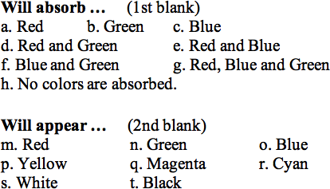

**Question 34:**

aa. Most color printing processes use cyan, magenta, and yellow pigments to create a colored image on a white sheet of paper. Suppose that cyan and magenta paints are imparted to a portion of a paper and then viewed under white light. These paints would absorb ____ light and appear _____. (Enter two letters - one for each blank - with no spaces or commas between them.)

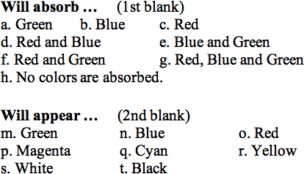

**Question 35:**

aa. Most color printing processes use cyan, magenta, and yellow pigments to create a colored image on a white sheet of paper. Suppose that cyan and magenta paints are imparted to a portion of a paper and then viewed under white light. These paints would absorb ____ light and appear _____. (Enter two letters - one for each blank - with no spaces or commas between them.)

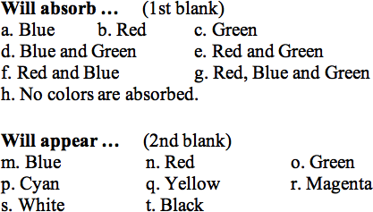

**Question 36:**

aa. Most color printing processes use cyan, magenta, and yellow pigments to create a colored image on a white sheet of paper. Suppose that cyan and yellow paints are imparted to a portion of a paper and then viewed under white light. These paints would absorb ____ light and appear _____. (Enter two letters - one for each blank - with no spaces or commas between them.)



**Question 37:**

aa. Most color printing processes use cyan, magenta, and yellow pigments to create a colored image on a white sheet of paper. Suppose that cyan and yellow paints are imparted to a portion of a paper and then viewed under white light. These paints would absorb ____ light and appear _____. (Enter two letters - one for each blank - with no spaces or commas between them.)



**Question 38:**

aa. Most color printing processes use cyan, magenta, and yellow pigments to create a colored image on a white sheet of paper. Suppose that cyan and yellow paints are imparted to a portion of a paper and then viewed under white light. These paints would absorb ____ light and appear _____. (Enter two letters - one for each blank - with no spaces or commas between them.)



**Question 39:**

aa. Most color printing processes use cyan, magenta, and yellow pigments to create a colored image on a white sheet of paper. Suppose that magenta and yellow paints are imparted to a portion of a paper and then viewed under white light. These paints would absorb ____ light and appear _____. (Enter two letters - one for each blank - with no spaces or commas between them.)



**Question 40:**

aa. Most color printing processes use cyan, magenta, and yellow pigments to create a colored image on a white sheet of paper. Suppose that magenta and yellow paints are imparted to a portion of a paper and then viewed under white light. These paints would absorb ____ light and appear _____. (Enter two letters - one for each blank - with no spaces or commas between them.)



**LC7: Pigments and Color Subtraction**

**Question 1:**

aa. Three colored spotlights - red, green and blue - with equal intensities are used to illuminate a shirt with different colors of light. Cyan pigment is imparted to a shirt and it is then illuminated with red and green light. The shirt will appear ____.

a. Magenta b. Blue c. Cyan

d. Red e. Yellow f. Black

g. Green h. White i. Brown

**Question 2:**

aa. Three colored spotlights - red, green and blue - with equal intensities are used to illuminate a shirt with different colors of light. Cyan pigment is imparted to a shirt and it is then illuminated with red and blue light. The shirt will appear ____.

a. Magenta b. Blue c. Cyan

d. Red e. Yellow f. Black

g. Green h. White i. Brown

**Question 3:**

aa. Three colored spotlights - red, green and blue - with equal intensities are used to illuminate a shirt with different colors of light. Yellow pigment is imparted to a shirt and it is then illuminated with green and blue light. The shirt will appear ____.

a. Magenta b. Blue c. Cyan

d. Red e. Yellow f. Black

g. Green h. White i. Brown

**Question 4:**

aa. Three colored spotlights - red, green and blue - with equal intensities are used to illuminate a shirt with different colors of light. Yellow pigment is imparted to a shirt and it is then illuminated with red and blue light. The shirt will appear ____.

a. Magenta b. Blue c. Cyan

d. Red e. Yellow f. Black

g. Green h. White i. Brown

**Question 5:**

aa. Three colored spotlights - red, green and blue - with equal intensities are used to illuminate a shirt with different colors of light. Magenta pigment is imparted to a shirt and it is then illuminated with red and green light. The shirt will appear ____.

a. Magenta b. Blue c. Cyan

d. Red e. Yellow f. Black

g. Green h. White i. Brown

**Question 6:**

aa. Three colored spotlights - red, green and blue - with equal intensities are used to illuminate a shirt with different colors of light. Magenta pigment is imparted to a shirt and it is then illuminated with green and blue light. The shirt will appear ____.

a. Magenta b. Blue c. Cyan

d. Red e. Yellow f. Black

g. Green h. White i. Brown

**Question 7:**

aa. Three colored spotlights - red, green and blue - with equal intensities are used to illuminate a shirt with different colors of light. Cyan pigment is imparted to a shirt and it is then illuminated with red light. The shirt will appear ____.

a. Magenta b. Blue c. Cyan

d. Red e. Yellow f. Black

g. Green h. White i. Brown

**Question 8:**

aa. Three colored spotlights - red, green and blue - with equal intensities are used to illuminate a shirt with different colors of light. Magenta pigment is imparted to a shirt and it is then illuminated with green light. The shirt will appear ____.

a. Magenta b. Blue c. Cyan

d. Red e. Yellow f. Black

g. Green h. White i. Brown

**Question 9:**

aa. Three colored spotlights - red, green and blue - with equal intensities are used to illuminate a shirt with different colors of light. Yellow pigment is imparted to a shirt and it is then illuminated with blue light. The shirt will appear ____.

a. Magenta b. Blue c. Cyan

d. Red e. Yellow f. Black

g. Green h. White i. Brown

**Question 10:**

aa. Three colored spotlights - red, green and blue - with equal intensities are used to illuminate a shirt with different colors of light. Cyan pigment is imparted to a shirt and it is then illuminated with green and blue light. The shirt will appear ____.

**Question 11:**

aa. Three colored spotlights - red, green and blue - with equal intensities are used to illuminate a shirt with different colors of light. Magenta pigment is imparted to a shirt and it is then illuminated with red and blue light. The shirt will appear ____.

**Question 12:**

aa. Three colored spotlights - red, green and blue - with equal intensities are used to illuminate a shirt with different colors of light. Yellow pigment is imparted to a shirt and it is then illuminated with red and green light. The shirt will appear ____.

a. Magenta b. Blue c. Cyan

d. Red e. Yellow f. Black

g. Green h. White i. Brown

**Question 13:**

aa. Three colored spotlights - red, green and blue - with equal intensities are used to illuminate a shirt with different colors of light. Cyan and magenta pigments are imparted to a shirt and it is then illuminated with red and blue light. The shirt will appear ____.

a. Magenta b. Blue c. Cyan

d. Red e. Yellow f. Black

g. Green h. White i. Brown

**Question 14:**

aa. Three colored spotlights - red, green and blue - with equal intensities are used to illuminate a shirt with different colors of light. Cyan and magenta pigments are imparted to a shirt and it is then illuminated with green and blue light. The shirt will appear ____.

a. Magenta b. Blue c. Cyan

d. Red e. Yellow f. Black

g. Green h. White i. Brown

**Question 15:**

aa. Three colored spotlights - red, green and blue - with equal intensities are used to illuminate a shirt with different colors of light. Cyan and yellow pigments are imparted to a shirt and it is then illuminated with red and green light. The shirt will appear ____.

a. Magenta b. Blue c. Cyan

d. Red e. Yellow f. Black

g. Green h. White i. Brown

**Question 16:**

aa. Three colored spotlights - red, green and blue - with equal intensities are used to illuminate a shirt with different colors of light. Cyan and yellow pigments are imparted to a shirt and it is then illuminated with green and blue light. The shirt will appear ____.

a. Magenta b. Blue c. Cyan

d. Red e. Yellow f. Black

g. Green h. White i. Brown

**Question 17:**

aa. Three colored spotlights - red, green and blue - with equal intensities are used to illuminate a shirt with different colors of light. Magenta and yellow pigments are imparted to a shirt and it is then illuminated with red and green light. The shirt will appear ____.

a. Magenta b. Blue c. Cyan

d. Red e. Yellow f. Black

g. Green h. White i. Brown

**Question 18:**

aa. Three colored spotlights - red, green and blue - with equal intensities are used to illuminate a shirt with different colors of light. Magenta and yellow pigments are imparted to a shirt and it is then illuminated with red and blue light. The shirt will appear ____.

a. Magenta b. Blue c. Cyan

d. Red e. Yellow f. Black

g. Green h. White i. Brown

**Question 19:**

aa. Three colored spotlights - red, green and blue - with equal intensities are used to illuminate a shirt with different colors of light. Cyan and magenta pigments are imparted to a shirt and it is then illuminated with red and green light. The shirt will appear ____.

a. Magenta b. Blue c. Cyan

d. Red e. Yellow f. Black

g. Green h. White i. Brown

**Question 20:**

aa. Three colored spotlights - red, green and blue - with equal intensities are used to illuminate a shirt with different colors of light. Cyan and yellow pigments are imparted to a shirt and it is then illuminated with red and blue light. The shirt will appear ____.

a. Magenta b. Blue c. Cyan

d. Red e. Yellow f. Black

g. Green h. White i. Brown

**Question 21:**

aa. Three colored spotlights - red, green and blue - with equal intensities are used to illuminate a shirt with different colors of light. Magenta and yellow pigments are imparted to a shirt and it is then illuminated with green and blue light. The shirt will appear ____.

a. Magenta b. Blue c. Cyan

d. Red e. Yellow f. Black

g. Green h. White i. Brown

**Question 22:**

aa. A shirt appears green when illuminated with yellow light and blue when illuminated with magenta light. Identify the primary pigments that have been imparted to the shirt. List all that apply in alphabetical order with no commas or spaces between letters.

a. Cyan b. Magenta c. Yellow

**Question 23:**

aa. A shirt appears red when illuminated with yellow light and blue when illuminated with cyan light. Identify the primary pigments that have been imparted to the shirt. List all that apply in alphabetical order with no commas or spaces between letters.

a. Cyan b. Magenta c. Yellow

**Question 24:**

aa. A shirt appears green when illuminated with cyan light and red when illuminated with magenta light. Identify the primary pigments that have been imparted to the shirt. List all that apply in alphabetical order with no commas or spaces between letters.

a. Cyan b. Magenta c. Yellow

**Question 25:**

aa. A shirt appears green when illuminated with yellow light and black when illuminated with magenta light. Identify the primary pigments that have been imparted to the shirt. List all that apply in alphabetical order with no commas or spaces between letters.

a. Cyan b. Magenta c. Yellow

**Question 26:**

aa. A shirt appears green when illuminated with cyan light and black when illuminated with magenta light. Identify the primary pigments that have been imparted to the shirt. List all that apply in alphabetical order with no commas or spaces between letters.

a. Cyan b. Magenta c. Yellow

**Question 27:**

aa. A shirt appears red when illuminated with yellow light and black when illuminated with cyan light. Identify the primary pigments that have been imparted to the shirt. List all that apply in alphabetical order with no commas or spaces between letters.

a. Cyan b. Magenta c. Yellow

**Question 28:**

A shirt appears red when illuminated with magenta light and black when illuminated with cyan light. Identify the primary pigments that have been imparted to the shirt. List all that apply in alphabetical order with no commas or spaces between letters.

a. Cyan b. Magenta c. Yellow

**Question 29:**

aa. A shirt appears blue when illuminated with magenta light and black when illuminated with yellow light. Identify the primary pigments that have been imparted to the shirt. List all that apply in alphabetical order with no commas or spaces between letters.

a. Cyan b. Magenta c. Yellow

**Question 30:**

aa. A shirt appears blue when illuminated with cyan light and black when illuminated with yellow light. Identify the primary pigments that have been imparted to the shirt. List all that apply in alphabetical order with no commas or spaces between letters.

a. Cyan b. Magenta c. Yellow

**Question 31:**

aa. A shirt appears black when illuminated with cyan light and black when illuminated with magenta light. Identify the primary pigments that have been imparted to the shirt. List all that apply in alphabetical order with no commas or spaces between letters.

a. Cyan b. Magenta c. Yellow

**Question 32:**

aa. A shirt appears black when illuminated with cyan light and black when illuminated with yellow light. Identify the primary pigments that have been imparted to the shirt. List all that apply in alphabetical order with no commas or spaces between letters.

a. Cyan b. Magenta c. Yellow

**Question 33:**

aa. A shirt appears black when illuminated with magenta light and black when illuminated with yellow light. Identify the primary pigments that have been imparted to the shirt. List all that apply in alphabetical order with no commas or spaces between letters.

a. Cyan b. Magenta c. Yellow

**Question 34:**

aa. A shirt appears black when illuminated with red light and blue when illuminated with cyan light. Identify the primary pigments that have been imparted to the shirt. List all that apply in alphabetical order with no commas or spaces between letters.

a. Cyan b. Magenta c. Yellow

**Question 35:**

aa. A shirt appears black when illuminated with green light and blue when illuminated magenta light. Identify the primary pigments that have been imparted to the shirt. List all that apply in alphabetical order with no commas or spaces between letters.

a. Cyan b. Magenta c. Yellow

**Question 36:**

aa. A shirt appears black when illuminated with blue light and green when illuminated yellow light. Identify the primary pigments that have been imparted to the shirt. List all that apply in alphabetical order with no commas or spaces between letters.

a. Cyan b. Magenta c. Yellow

**Question 37:**

aa. A shirt appears black when illuminated with red light and green when illuminated cyan light. Identify the primary pigments that have been imparted to the shirt. List all that apply in alphabetical order with no commas or spaces between letters.

a. Cyan b. Magenta c. Yellow

**Question 38:**

aa. A shirt appears black when illuminated with green light and red when illuminated magenta light. Identify the primary pigments that have been imparted to the shirt. List all that apply in alphabetical order with no commas or spaces between letters.

a. Cyan b. Magenta c. Yellow

**Question 39:**

aa. A shirt appears black when illuminated with blue light and red when illuminated yellow light. Identify the primary pigments that have been imparted to the shirt. List all that apply in alphabetical order with no commas or spaces between letters.

a. Cyan b. Magenta c. Yellow

**LC8: Filters**

**Question 1:**

aa. Suppose that red, green and blue light are incident upon filters of different colors. A red filter can block ____ color(s) of light; a green filter can block ____ color(s) of light; a blue filter can block ____ color(s) of light. Enter the letters of the three choices in their respective order with no commas or spaces between letters.

a. Red b. Green c. Blue

d. Red and Green e. Red and Blue

f. Blue and Green g. Red, Blue and Green

h. No colors are blocked by this filter.

**Question 2:**

aa. Suppose that red, green and blue light are incident upon filters of different colors. A green filter can block ____ color(s) of light; a blue filter can block ____ color(s) of light; a red filter can block ____ color(s) of light. Enter the letters of the three choices in their respective order with no commas or spaces between letters.

a. Red b. Green c. Blue

d. Red and Green e. Red and Blue

f. Blue and Green g. Red, Blue and Green

h. No colors are blocked by this filter.

**Question 3:**

aa. Suppose that red, green and blue light are incident upon filters of different colors. A blue filter can block ____ color(s) of light; a red filter can block ____ color(s) of light; a green filter can block ____ color(s) of light. Enter the letters of the three choices in their respective order with no commas or spaces between letters.

a. Red b. Green c. Blue

d. Red and Green e. Red and Blue

f. Blue and Green g. Red, Blue and Green

h. No colors are blocked by this filter.

**Question 4:**

aa. Suppose that red, green and blue light are incident upon filters of different colors. A blue filter can block ____ color(s) of light; a green filter can block ____ color(s) of light; a red filter can block ____ color(s) of light. Enter the letters of the three choices in their respective order with no commas or spaces between letters.

a. Red b. Green c. Blue

d. Red and Green e. Red and Blue

f. Blue and Green g. Red, Blue and Green

h. No colors are blocked by this filter.

**Question 5:**

aa. Suppose that red, green and blue light are incident upon filters of different colors. A cyan filter can block ____ color(s) of light; a magenta filter can block ____ color(s) of light; a yellow filter can block ____ color(s) of light. Enter the letters of the three choices in their respective order with no commas or spaces between letters.

a. Red b. Green c. Blue

d. Red and Green e. Red and Blue

f. Blue and Green g. Red, Blue and Green

h. No colors are blocked by this filter.

**Question 6:**

aa. Suppose that red, green and blue light are incident upon filters of different colors. A magenta filter can block ____ color(s) of light; a yellow filter can block ____ color(s) of light; a cyan filter can block ____ color(s) of light. Enter the letters of the three choices in their respective order with no commas or spaces between letters.

a. Red b. Green c. Blue

d. Red and Green e. Red and Blue

f. Blue and Green g. Red, Blue and Green

h. No colors are blocked by this filter.

**Question 7:**

aa. Suppose that red, green and blue light are incident upon filters of different colors. A yellow filter can block ____ color(s) of light; a cyan filter can block ____ color(s) of light; a magenta filter can block ____ color(s) of light. Enter the letters of the three choices in their respective order with no commas or spaces between letters.

a. Red b. Green c. Blue

d. Red and Green e. Red and Blue

f. Blue and Green g. Red, Blue and Green

h. No colors are blocked by this filter.

**Question 8:**

aa. Suppose that red, green and blue light are incident upon filters of different colors. A yellow filter can block ____ color(s) of light; a magenta filter can block ____ color(s) of light; a cyan filter can block ____ color(s) of light. Enter the letters of the three choices in their respective order with no commas or spaces between letters.

a. Red b. Green c. Blue

d. Red and Green e. Red and Blue

f. Blue and Green g. Red, Blue and Green

h. No colors are blocked by this filter.

**Question 9:**

aa. Jack is wearing a red shirt. The shirt is illuminated with white light. Jill views Jack's shirt while looking through a magenta filter. To Jill, Jack's shirt will appear ____.

a. Magenta b. Blue c. Cyan

d. Red e. Yellow f. Black

g. Green h. White i. Brown

**Question 10:**

aa. Jack is wearing a green shirt. The shirt is illuminated with white light. Jill views Jack's shirt while looking through a magenta filter. Jack's shirt will appear ____.

a. Magenta b. Blue c. Cyan

d. Red e. Yellow f. Black

g. Green h. White i. Brown

**Question 11:**

aa. Jack is wearing a blue shirt. The shirt is illuminated with white light. Jill views Jack's shirt while looking through a magenta filter. To Jill, Jack's shirt will appear ____.

a. Magenta b. Blue c. Cyan

d. Red e. Yellow f. Black

g. Green h. White i. Brown

**Question 12:**

aa. Jack is wearing a red shirt. The shirt is illuminated with white light. Jill views Jack's shirt while looking a cyan filter. To Jill, Jack's shirt will appear ____.

a. Magenta b. Blue c. Cyan

d. Red e. Yellow f. Black

g. Green h. White i. Brown

**Question 13:**

aa. Jack is wearing a green shirt. The shirt is illuminated with white light. Jill views Jack's shirt while looking through a cyan filter. To Jill, Jack's shirt will appear ____.

a. Magenta b. Blue c. Cyan

d. Red e. Yellow f. Black

g. Green h. White i. Brown

**Question 14:**

aa. Jack is wearing a blue shirt. The shirt is illuminated with white light. Jill views Jack's shirt while looking through a cyan filter. To Jill, Jack's shirt will appear ____.

a. Magenta b. Blue c. Cyan

d. Red e. Yellow f. Black

g. Green h. White i. Brown

**Question 15:**

aa. Jack is wearing a red shirt. The shirt is illuminated with white light. Jill views Jack's shirt while looking through a yellow filter. To Jill, Jack's shirt will appear ____.

a. Magenta b. Blue c. Cyan

d. Red e. Yellow f. Black

g. Green h. White i. Brown

**Question 16:**

aa. Jack is wearing a green shirt. The shirt is illuminated with white light. Jill views Jack's shirt while looking through a yellow filter. To Jill, Jack's shirt will appear ____.

a. Magenta b. Blue c. Cyan

d. Red e. Yellow f. Black

g. Green h. White i. Brown

**Question 17:**

aa. Jack is wearing a blue shirt. The shirt is illuminated with white light. Jill views Jack's shirt while looking through a yellow filter. To Jill, Jack's shirt will appear ____.

a. Magenta b. Blue c. Cyan

d. Red e. Yellow f. Black

g. Green h. White i. Brown

**Question 18:**

aa. Mac is wearing a magenta shirt. The shirt is illuminated with white light. Tosh views Mac's shirt while looking through a cyan filter. To Tosh, Mac's shirt will appear ____.

a. Magenta b. Blue c. Cyan

d. Red e. Yellow f. Black

g. Green h. White i. Brown

**Question 19:**

aa. Mac is wearing a yellow shirt. The shirt is illuminated with white light. Tosh views Mac's shirt while looking through a cyan filter. To Tosh, Mac's shirt will appear ____.

a. Magenta b. Blue c. Cyan

d. Red e. Yellow f. Black

g. Green h. White i. Brown

**Question 20:**

aa. Mac is wearing a cyan shirt. The shirt is illuminated with white light. Tosh views Mac's shirt while looking through a magenta filter. To Tosh, Mac's shirt will appear ____.

a. Magenta b. Blue c. Cyan

d. Red e. Yellow f. Black

g. Green h. White i. Brown

**Question 21:**

aa. Mac is wearing a yellow shirt. The shirt is illuminated with white light. Tosh views Mac's shirt while looking through a magenta filter. To Tosh, Mac's shirt will appear ____.

a. Magenta b. Blue c. Cyan

d. Red e. Yellow f. Black

g. Green h. White i. Brown

**Question 22:**

aa. Mac is wearing a cyan shirt. The shirt is illuminated with white light. Tosh views Mac's shirt while looking through a yellow filter. To Tosh, Mac's shirt will appear ____.

a. Magenta b. Blue c. Cyan

d. Red e. Yellow f. Black

g. Green h. White i. Brown

**Question 23:**

aa. Mac is wearing a magenta shirt. The shirt is illuminated with white light. Tosh views Mac's shirt while looking through a yellow filter. To Tosh, Mac's shirt will appear ____.

a. Magenta b. Blue c. Cyan

d. Red e. Yellow f. Black

g. Green h. White i. Brown

**Question 24:**

aa. Ben is wearing a cyan shirt. The shirt is illuminated with white light. Jerry views Ben's shirt while looking through a red filter. To Jerry, Ben's shirt will appear ____.

a. Magenta b. Blue c. Cyan

d. Red e. Yellow f. Black

g. Green h. White i. Brown

**Question 25:**

aa. Ben is wearing a magenta shirt. The shirt is illuminated with white light. Jerry views Ben's shirt while looking through a red filter. To Jerry, Ben's shirt will appear ____.

a. Magenta b. Blue c. Cyan

d. Red e. Yellow f. Black

g. Green h. White i. Brown

**Question 26:**

aa. Ben is wearing a yellow shirt. The shirt is illuminated with white light. Jerry views Ben's shirt while looking through a red filter. To Jerry, Ben's shirt will appear ____.

a. Magenta b. Blue c. Cyan

d. Red e. Yellow f. Black

g. Green h. White i. Brown

**Question 27:**

aa. Ben is wearing a cyan shirt. The shirt is illuminated with white light. Jerry views Ben's shirt while looking through a green filter. To Jerry, Ben's shirt will appear ____.

a. Magenta b. Blue c. Cyan

d. Red e. Yellow f. Black

g. Green h. White i. Brown

**Question 28:**

aa. Ben is wearing a magenta shirt. The shirt is illuminated with white light. Jerry views Ben's shirt while looking through a green filter. To Jerry, Ben's shirt will appear ____.

a. Magenta b. Blue c. Cyan

d. Red e. Yellow f. Black

g. Green h. White i. Brown

**Question 29:**

aa. Ben is wearing a yellow shirt. The shirt is illuminated with white light. Jerry views Ben's shirt while looking through a green filter. To Jerry, Ben's shirt will appear ____.

a. Magenta b. Blue c. Cyan

d. Red e. Yellow f. Black

g. Green h. White i. Brown

**Question 30:**

aa. Ben is wearing a cyan shirt. The shirt is illuminated with white light. Jerry views Ben's shirt while looking through a blue filter. To Jerry, Ben's shirt will appear ____.

a. Magenta b. Blue c. Cyan

d. Red e. Yellow f. Black

g. Green h. White i. Brown

**Question 31:**

aa. Ben is wearing a magenta shirt. The shirt is illuminated with white light. Jerry views Ben's shirt while looking through a blue filter. To Jerry, Ben's shirt will appear ____.

a. Magenta b. Blue c. Cyan

d. Red e. Yellow f. Black

g. Green h. White i. Brown

**Question 32:**

aa. Ben is wearing a yellow shirt. The shirt is illuminated with white light. Jerry views Ben's shirt while looking through a blue filter. To Jerry, Ben's shirt will appear ____.

a. Magenta b. Blue c. Cyan

d. Red e. Yellow f. Black

g. Green h. White i. Brown

**LC9: Shadows**

**Question 1:**

aa. Two spotlights of equal intensity illuminate a 'white' screen with red and green light. A person stands between the spotlights and the screen in such a manner as to cast two colored shadows upon the screen. The two shadows overlap, producing several colored regions. Indicate the color of each region.

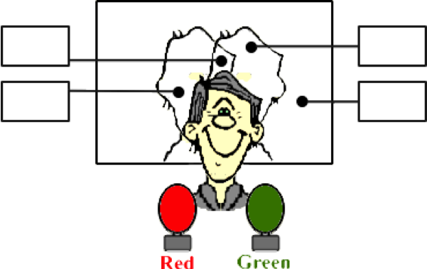

**Place a letter**

**in each box:**

**a. Magenta**

**b. Blue**

**c. Cyan**

**d. Red**

**e. Yellow**

**f. Black**

**g. Green**

**h. White**

**Question 2:**

aa. Two spotlights of equal intensity illuminate a 'white' screen with red and green light. A person stands between the spotlights and the screen in such a manner as to cast two colored shadows upon the screen. The two shadows overlap, producing several colored regions. Indicate the color of each region.

**Place a letter**

**in each box:**

**a. Magenta**

**b. Blue**

**c. Cyan**

**d. Red**

**e. Yellow**

**f. Black**

**g. Green**

**h. White**

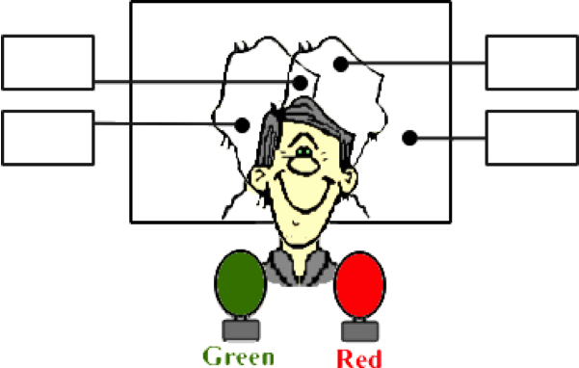

**Question 3:**

aa. Two spotlights of equal intensity illuminate a 'white' screen with red and green light. A person stands between the spotlights and the screen in such a manner as to cast two colored shadows upon the screen. The two shadows overlap, producing several colored regions. Indicate the color of each region.



**Place a letter**

**in each box:**

**a. Red**

**b. Green**

**c. Blue**

**d. Cyan**

**e. Magenta**

**f. Yellow**

**g. White**

**h. Black**

**Question 4:**

aa. Two spotlights of equal intensity illuminate a 'white' screen with red and green light. A person stands between the spotlights and the screen in such a manner as to cast two colored shadows upon the screen. The two shadows overlap, producing several colored regions. Indicate the color of each region.

**Place a letter**

**in each box:**

**a. Red**

**b. Green**

**c. Blue**

**d. Cyan**

**e. Magenta**

**f. Yellow**

**g. White**

**h. Black**



**Question 5:**

aa. Two spotlights of equal intensity illuminate a 'white' screen with red and blue light. A person stands between the spotlights and the screen in such a manner as to cast two colored shadows upon the screen. The two shadows overlap, producing several colored regions. Indicate the color of each region.

**Place a letter**

**in each box:**

**a. Magenta**

**b. Blue**

**c. Cyan**

**d. Red**

**e. Yellow**

**f. Black**

**g. Green**

**h. White**

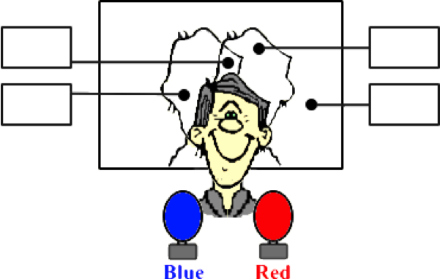

**Question 6:**

aa. Two spotlights of equal intensity illuminate a 'white' screen with red and blue light. A person stands between the spotlights and the screen in such a manner as to cast two colored shadows upon the screen. The two shadows overlap, producing several colored regions. Indicate the color of each region.

**Place a letter**

**in each box:**

**a. Magenta**

**b. Blue**

**c. Cyan**

**d. Red**

**e. Yellow**

**f. Black**

**g. Green**

**h. White**

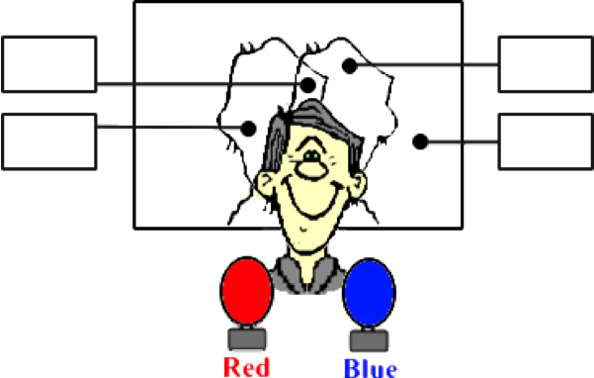

**Question 7:**

aa. Two spotlights of equal intensity illuminate a 'white' screen with red and blue light. A person stands between the spotlights and the screen in such a manner as to cast two colored shadows upon the screen. The two shadows overlap, producing several colored regions. Indicate the color of each region.

**Place a letter**

**in each box:**

**a. Red**

**b. Green**

**c. Blue**

**d. Cyan**

**e. Magenta**

**f. Yellow**

**g. White**

**h. Black**



**Question 8:**

aa. Two spotlights of equal intensity illuminate a 'white' screen with red and blue light. A person stands between the spotlights and the screen in such a manner as to cast two colored shadows upon the screen. The two shadows overlap, producing several colored regions. Indicate the color of each region.

**Place a letter**

**in each box:**

**a. Red**

**b. Green**

**c. Blue**

**d. Cyan**

**e. Magenta**

**f. Yellow**

**g. White**

**h. Black**



**Question 9:**

aa. Two spotlights of equal intensity illuminate a 'white' screen with green and blue light. A person stands between the spotlights and the screen in such a manner as to cast two colored shadows upon the screen. The two shadows overlap, producing several colored regions. Indicate the color of each region.

**Place a letter**

**in each box:**

**a. Magenta**

**b. Blue**

**c. Cyan**

**d. Red**

**e. Yellow**

**f. Black**

**g. Green**

**h. White**

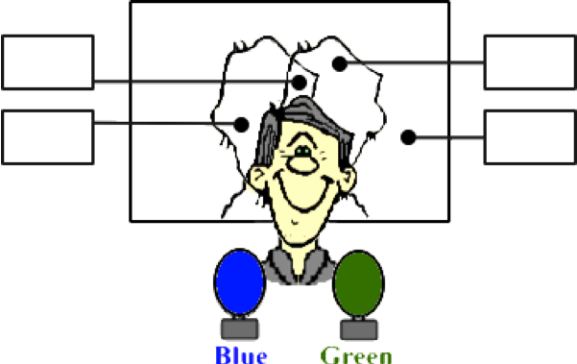

**Question 10:**

aa. Two spotlights of equal intensity illuminate a 'white' screen with green and blue light. A person stands between the spotlights and the screen in such a manner as to cast two colored shadows upon the screen. The two shadows overlap, producing several colored regions. Indicate the color of each region.

**Place a letter**

**in each box:**

**a. Magenta**

**b. Blue**

**c. Cyan**

**d. Red**

**e. Yellow**

**f. Black**

**g. Green**

**h. White**

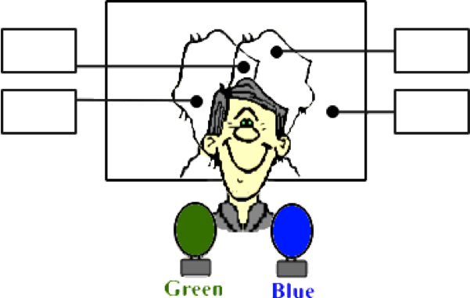

**Question 11:**

aa. Two spotlights of equal intensity illuminate a 'white' screen with green and blue light. A person stands between the spotlights and the screen in such a manner as to cast two colored shadows upon the screen. The two shadows overlap, producing several colored regions. Indicate the color of each region.

**Place a letter**

**in each box:**

**a. Red**

**b. Green**

**c. Blue**

**d. Cyan**

**e. Magenta**

**f. Yellow**

**g. White**

**h. Black**



**Question 12:**

aa. Two spotlights of equal intensity illuminate a 'white' screen with green and blue light. A person stands between the spotlights and the screen in such a manner as to cast two colored shadows upon the screen. The two shadows overlap, producing several colored regions. Indicate the color of each region.

**Place a letter**

**in each box:**

**a. Red**

**b. Green**

**c. Blue**

**d. Cyan**

**e. Magenta**

**f. Yellow**

**g. White**

**h. Black**

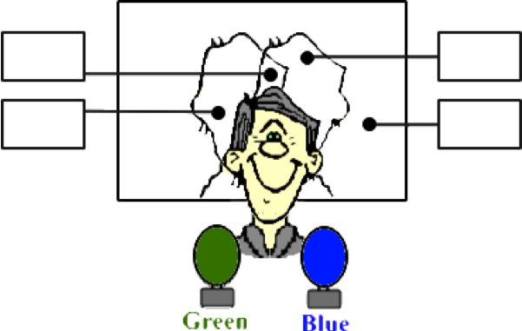

**Question 13:**

aa. Three spotlights of equal intensity illuminate a 'white' screen with red, green and blue light. A person stands between the spotlights and the screen in such a manner as to cast three colored shadows upon the screen. The three shadows overlap, producing several colored regions. Indicate the color of each region.

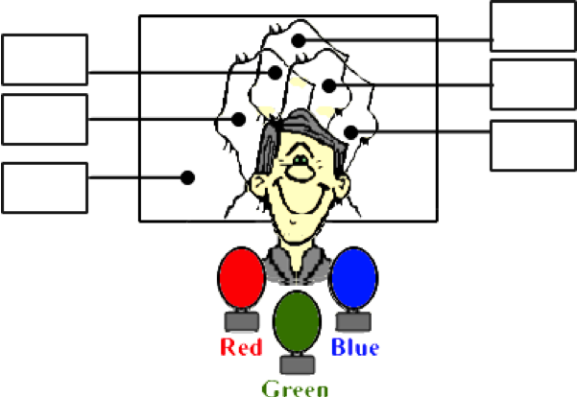

**Place a letter**

**in each box:**

**a. Magenta**

**b. Blue**

**c. Cyan**

**d. Red**

**e. Yellow**

**f. Black**

**g. Green**

**h. White**

**Question 14:**

aa. Three spotlights of equal intensity illuminate a 'white' screen with red, green and blue light. A person stands between the spotlights and the screen in such a manner as to cast three colored shadows upon the screen. The three shadows overlap, producing several colored regions. Indicate the color of each region.

**Place a letter**

**in each box:**

**a. Magenta**

**b. Blue**

**c. Cyan**

**d. Red**

**e. Yellow**

**f. Black**

**g. Green**

**h. White**

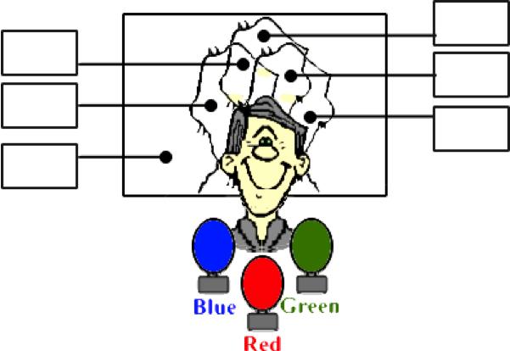

**Question 15:**

aa. Three spotlights of equal intensity illuminate a 'white' screen with red, green and blue light. A person stands between the spotlights and the screen in such a manner as to cast three colored shadows upon the screen. The three shadows overlap, producing several colored regions. Indicate the color of each region.

**Place a letter**

**in each box:**

**a. Magenta**

**b. Blue**

**c. Cyan**

**d. Red**

**e. Yellow**

**f. Black**

**g. Green**

**h. White**

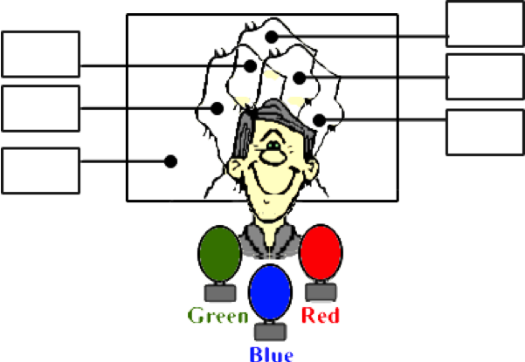

**Question 16:**

aa. Three spotlights of equal intensity illuminate a 'white' screen with red, green and blue light. A person stands between the spotlights and the screen in such a manner as to cast three colored shadows upon the screen. The three shadows overlap, producing several colored regions. Indicate the color of each region.

**Place a letter**

**in each box:**

**a. Magenta**

**b. Blue**

**c. Cyan**

**d. Red**

**e. Yellow**

**f. Black**

**g. Green**

**h. White**

