**Minds On Physics Question Banks – Momentum and Collisions**

**MC1: Momentum**

**Question 1:**

aa. An object that has momentum can best be described as ____.

a. changing its velocity

b. moving fast

c. resisting changes in its state of motion

d. having its mass in motion

e. encountering a net force

**Question 2:**

aa. An object that has momentum can best be described as ____.

a. moving fast

b. resisting changes in its state of motion

c. changing its velocity

d. encountering a net force

e. having its mass in motion

**Question 3:**

aa. An object that has momentum can best be described as ____.

a. moving fast

b. having its mass in motion

c. encountering a net force

d. resisting changes in its state of motion

e. changing its velocity

**Question 4:**

aa. An object that has momentum can best be described as ____.

a. changing its velocity

b. encountering a net force

c. having its mass in motion

d. resisting changes in its state of motion

e. moving fast

**Question 5:**

aa. If an object has momentum, then one can be sure that the object is ____. List all that apply in alphabetical order with no commas or spaces between letters.

a. moving

b. moving fast

c. speeding up

d. slowing down

e. encountering a force

f. One cannot be certain that an object with momentum has any of these characteristics.

**Question 6:**

aa. If an object has momentum, then one can be sure that the object is ____. List all that apply in alphabetical order with no commas or spaces between letters.

a. encountering a force

b. slowing down

c. speeding up

d. moving

e. moving fast

f. One cannot be certain that an object with momentum has any of these characteristics.

**Question 7:**

aa. If an object has momentum, then one can be sure that the object is ____. List all that apply in alphabetical order with no commas or spaces between letters.

a. slowing down

b. speeding up

c. encountering a force

d. moving fast

e. moving

f. One cannot be certain that an object with momentum has any of these characteristics.

**Question 8:**

aa. If an object has momentum, then one can be sure that the object is ____. List all that apply in alphabetical order with no commas or spaces between letters.

a. slowing down

b. speeding up

c. moving

d. moving fast

e. encountering a force

f. One cannot be certain that an object with momentum has any of these characteristics.

**Question 9:**

aa. TRUE or FALSE:

Momentum is a vector quantity; it has a direction associated with it.

a. True b. False

**Question 10:**

aa. TRUE or FALSE:

Momentum is a scalar quantity; it has a direction associated with it.

a. True b. False

**Question 11:**

aa. TRUE or FALSE:

Momentum is a vector quantity.

a. True b. False

**Question 12:**

aa. Which one of the following units represent the standard metric units of momentum?

a. pound / second b. Newton - meter /second

c. kilogram - meter /second2 d. meter /second

e. kilogram - meter /second

f. None of these represent the standard metric units of momentum.

**Question 13:**

aa. Which one of the following units represent the standard metric units of momentum?

a. meter /second b. pound / second

c. Newton - meter /second d. kilogram - meter /second

e. kilogram - meter /second2

f. None of these represent the standard metric units of momentum.

**Question 14:**

aa. Which one of the following units represent the standard metric units of momentum?

a. kilogram - meter /second2 b. Newton - meter /second

c. kilogram - meter /second d. meter /second

e. pound / second

f. None of these represent the standard metric units of momentum.

**Question 15:**

aa. Which one of the following units represent the standard metric units of momentum?

a. Newton - meter /second b. kilogram - meter /second

c. kilogram - meter /second2 d. meter /second

e. pound / second

f. None of these represent the standard metric units of momentum.

**Question 16:**

aa. A rightward moving object is slowing down. The direction of its momentum is ____.

a. rightward b. leftward c. impossible to tell with this information

d. ... nonsense! Momentum does not have a direction.

**Question 17:**

aa. A rightward moving object is slowing down. The direction of its momentum is ____.

a. leftward b. rightward c. impossible to tell with this information

d. ... nonsense! Momentum does not have a direction.

**Question 18:**

aa. A leftward moving object is slowing down. The direction of its momentum is __

a. rightward b. leftward c. impossible to tell with this information

d. ... nonsense! Momentum does not have a direction.

**Question 19:**

aa. A leftward moving object is slowing down. The direction of its momentum is ____.

a. leftward b. rightward c. impossible to tell with this information

d. ... nonsense! Momentum does not have a direction.

**Question 20:**

aa. An object that has a lot of momentum can be sure to ____.

a. have a lot of mass

b. be moving very fast

c. be changing its velocity very rapidly

d. be encountering a large net force

e. be exceeding the speed limit

f. ... nonsense! None of these are necessarily true of an object having a lot of momentum.

**Question 21:**

aa. An object that has a lot of momentum can be sure to ____.

a. be moving very fast

b. have a lot of mass

c. be encountering a large net force

d. be changing its velocity very rapidly

e. be exceeding the speed limit

f. ... nonsense! None of these are necessarily true of an object having a lot of momentum.

**Question 22:**

aa. An object that has a lot of momentum can be sure to ____.

a. be changing its velocity very rapidly

b. be encountering a large net force

c. be moving very fast

d. have a lot of mass

e. be exceeding the speed limit

f. ... nonsense! None of these are necessarily true of an object having a lot of momentum.

**Question 23:**

aa. An object that has a lot of momentum can be sure to ____.

a. be encountering a large net force

b. be changing its velocity very rapidly

c. be moving very fast

d. have a lot of mass

e. be exceeding the speed limit

f. ... nonsense! None of these are necessarily true of an object having a lot of momentum.

**Question 24:**

aa. An object that is speeding up would have _____.

a. an increasing momentum b. a decreasing momentum

c. a positive momentum d. a negative momentum

e. a constant momentum f. zero momentum

**Question 25:**

aa. An object that is speeding up would have _____.

a. a negative momentum b. a positive momentum

c. zero momentum d. a constant momentum

e. a decreasing momentum f. an increasing momentum

**Question 26:**

aa. An object that is slowing down would have _____.

a. an increasing momentum b. a decreasing momentum

c. a positive momentum d. a negative momentum

e. a constant momentum f. zero momentum

**Question 27:**

aa. An object that is slowing down would have _____.

a. a negative momentum b. a positive momentum

c. zero momentum d. a constant momentum

e. a decreasing momentum f. an increasing momentum

**Question 28:**

aa. Consider the mass and velocity values of Objects A and B below.

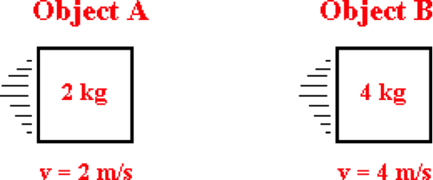

Compared to Object B, Object A has ____ momentum.

a. two times the b. four times the c. six times the

d. eight times the e. the same f. one-half the

g. one-fourth the h. one-sixth the i. one-eighth the

j. ... impossible to tell without knowledge of the force and acceleration.

**Question 29:**

aa. Consider the mass and velocity values of Objects A and B below.

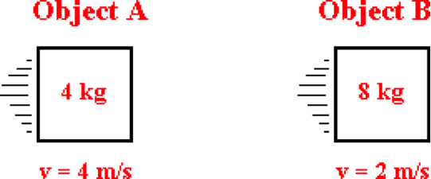

Compared to Object B, Object A has ____ momentum.

a. two times the b. four times the c. six times the

d. eight times the e. the same f. one-half the

g. one-fourth the h. one-sixth the i. one-eighth the

j. ... impossible to tell without knowledge of the force and acceleration.

**Question 30:**

aa. Consider the mass and velocity values of Objects A and B below.

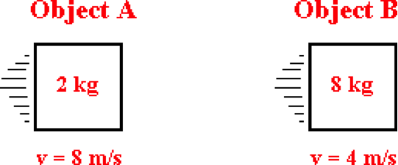

Compared to Object B, Object A has ____ momentum.

a. two times the b. four times the c. six times the

d. eight times the e. the same f. one-half the

g. one-fourth the h. one-sixth the i. one-eighth the

j. ... impossible to tell without knowledge of the force and acceleration.

**Question 31:**

aa. Consider the mass and velocity values of Objects A and B below.

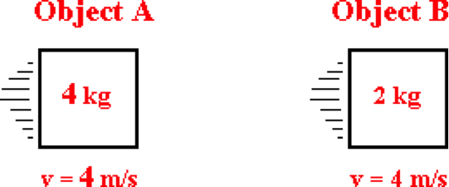

Compared to Object B, Object A has ____ momentum.

a. two times the b. four times the c. six times the

d. eight times the e. the same f. one-half the

g. one-fourth the h. one-sixth the i. one-eighth the

j. ... impossible to tell without knowledge of the force and acceleration.

**Question 32:**

aa. Consider the mass and velocity values of Objects A and B below.

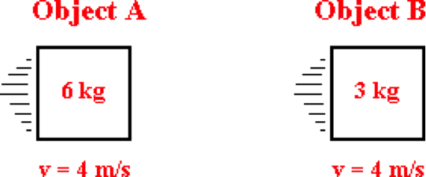

Compared to Object B, Object A has ____ momentum.

a. two times the b. four times the c. six times the

d. eight times the e. the same f. one-half the

g. one-fourth the h. one-sixth the i. one-eighth the

j. ... impossible to tell without knowledge of the force and acceleration.

**Question 33:**

aa. Consider the mass and velocity values of Objects A and B below.

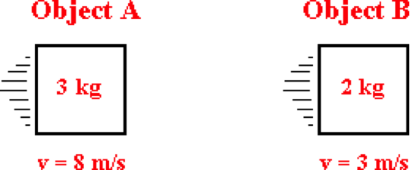

Compared to Object B, Object A has ____ momentum.

a. two times the b. four times the c. six times the

d. eight times the e. the same f. one-half the

g. one-fourth the h. one-sixth the i. one-eighth the

j. ... impossible to tell without knowledge of the force and acceleration.

**Question 34:**

aa. Consider the mass and velocity values of Objects A and B below.

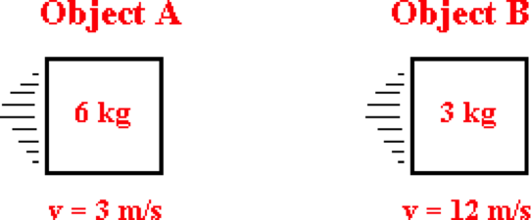

Compared to Object B, Object A has ____ momentum.

a. two times the b. four times the c. six times the

d. eight times the e. the same f. one-half the

g. one-fourth the h. one-sixth the i. one-eighth the

j. ... impossible to tell without knowledge of the force and acceleration.

**Question 35:**

aa. At any given instant in time, the momentum of an object depends upon ____. List all that apply in alphabetical order with no commas or spaces between letters.

a. how fast (or slow) the object is moving

b. how rapidly the object is accelerating

c. how much mass the object has

d. the net force which the object is experiencing

e. the rate at which the object is changing its velocity

f. the time over which the object has been moving

**Question 36:**

aa. At any given instant in time, the momentum of an object depends upon ____. List all that apply in alphabetical order with no commas or spaces between letters.

a. how rapidly the object is accelerating

b. the rate at which the object is changing its velocity

c. the net force which the object is experiencing

d. how fast (or slow) the object is moving

e. the time over which the object has been moving

f. how much mass the object has

**Question 37:**

aa. At any given instant in time, the momentum of an object depends upon ____. List all that apply in alphabetical order with no commas or spaces between letters.

a. the time over which the object has been moving

b. the net force which the object is experiencing

c. how much mass the object has

d. how fast (or slow) the object is moving

e. the rate at which the object is changing its velocity

f. how rapidly the object is accelerating

**Question 38:**

aa. At any given instant in time, the momentum of an object depends upon ____. List all that apply in alphabetical order with no commas or spaces between letters.

a. how much mass the object has

b. the net force which the object is experiencing

c. how rapidly the object is accelerating

d. the rate at which the object is changing its velocity

e. how fast (or slow) the object is moving

f. the time over which the object has been moving

**MC2: Impulse and Momentum Change**

**Question 1:**

aa. An impulse occurs when a ____ is acting upon an object for a given amount of ____ in order to cause a change in ____. Enter the letters of the three answers in their respective order.

a. time b. position c. momentum d. acceleration

e. mass f. force g. energy

h. None of these choices can suitably fill in this blank.

**Question 2:**

aa. An impulse occurs when a ____ is acting upon an object for a given amount of ____ in order to cause a change in ____. Enter the letters of the three answers in their respective order.

a. position b. time c. mass d. acceleration

e. momentum f. energy g. force

h. None of these choices can suitably fill in this blank.

**Question 3:**

aa. An impulse occurs when a ____ is acting upon an object for a given amount of ____ in order to cause a change in ____. Enter the letters of the three answers in their respective order.

a. force b. mass c. acceleration d. position

e. time f. momentum g. energy

h. None of these choices can suitably fill in this blank.

**Question 4:**

aa. An impulse occurs when a ____ is acting upon an object for a given amount of ____ in order to cause a change in ____. Enter the letters of the three answers in their respective order.

a. force b. energy c. mass d. momentum

e. time f. position g. acceleration

h. None of these choices can suitably fill in this blank.

**Question 5:**

aa. Which of the following are standard metric units of impulse?

a. kilogram • meter /second2 b. Newton • meter

c. meter /second2 d. Newton • second

e. Newton • second2 f. Newton / second

g. Joule h. Joule / second

i. Watt

**Question 6:**

aa. Which of the following are standard metric units of impulse?

a. Newton • meter b. Newton / second

c. Newton • second d. Newton • second2

e. Watt f. kilogram • meter /second2

g. meter /second2 h. Joule

i. Joule / second

**Question 7:**

aa. Which of the following are standard metric units of impulse?

a. Watt b. kilogram • meter /second2

c. meter /second2 d. Joule

e. Joule / second f. Newton • meter

g. Newton / second h. Newton • second

i. Newton • second2

**Question 8:**

aa. Which of the following are standard metric units of impulse?

a. Joule / second b. Newton / second

c. meter /second2 d. Newton • second2

e. Newton • second f. kilogram • meter /second2

g. Newton • meter h. Joule

i. Watt

**Question 9:**

aa. In a collision, an object experiences an impulse. This impulse causes and is equal to the _____ of the object.

a. energy change b. kinetic energy change

c. force d. momentum

e. momentum change f. velocity change

g. acceleration h. velocity

**Question 10:**

aa. In a collision, an object experiences an impulse. This impulse causes and is equal to the _____ of the object.

a. force b. momentum

c. acceleration d. velocity

e. energy change f. kinetic energy change

g. momentum change h. velocity change

**Question 11:**

aa. In a collision, an object experiences an impulse. This impulse causes and is equal to the _____ of the object.

a. momentum b. force

c. velocity d. acceleration

e. kinetic energy change f. energy change

g. velocity change h. momentum change

**Question 12:**

aa. In a collision, an object experiences an impulse. This impulse causes and is equal to the _____ of the object.

a. velocity change b. energy change

c. momentum change d. kinetic energy change

e. momentum f. force

g. velocity h. acceleration

**Question 13:**

aa. In a collision, an object experiences an impulse. This impulse can be determined by ____. Enter the two answers in alphabetical order with no commas or spaces between letters.

a. multiplying the force on the object by the time over which the force acts

b. multiplying the force on the object by the mass of the object

c. multiplying the mass of the object by the acceleration of the object

d. multiplying the mass of the object by the velocity change of the object

e. dividing the force on the object by the time over which the force act

f. dividing the force on the object by the mass of the object

g. dividing the force on the object by the acceleration of the object

h. dividing the momentum change of the object by the time over which this change occurs

**Question 14:**

aa. In a collision, an object experiences an impulse. This impulse can be determined by ____. Enter the two answers in alphabetical order with no commas or spaces between letters.

a. dividing the force on the object by the time over which the force acts

b. dividing the force on the object by the mass of the object

c. dividing the force on the object by the acceleration of the object

d. dividing the momentum change of the object by the time over which this change occurs

e. multiplying the force on the object by the time over which the force acts

f. multiplying the force on the object by the mass of the object

g. multiplying the mass of the object by the acceleration of the object

h. multiplying the mass of the object by the velocity change of the object

**Question 15:**

aa. In a collision, an object experiences an impulse. This impulse can be determined by ____. Enter the two answers in alphabetical order with no commas or spaces between letters.

a. multiplying the mass of the object by the acceleration of the object

b. multiplying the mass of the object by the velocity change of the object

c. multiplying the force on the object by the time over which the force acts

d. multiplying the force on the object by the mass of the object

e. dividing the force on the object by the acceleration of the object

f. dividing the momentum change of the object by the time over which this change occurs

g. dividing the force on the object by the time over which the force acts

h. dividing the force on the object by the mass of the object

**Question 16:**

aa. In a collision, an object experiences an impulse. This impulse can be determined by ____. Enter the two answers in alphabetical order with no commas or spaces between letters.

a. dividing the momentum change of the object by the time over which this change occurs

b. dividing the force on the object by the mass of the object

c. dividing the force on the object by the time over which the force acts

d. dividing the force on the object by the acceleration of the object

e. multiplying the mass of the object by the velocity change of the object

f. multiplying the force on the object by the mass of the object

g. multiplying the force on the object by the time over which the force acts

h. multiplying the mass of the object by the acceleration of the object

**Question 17:**

aa. TRUE or FALSE:

In a collision, the impulse encountered by an object is equal to its momentum.

a. True b. False

**Question 18:**

aa. TRUE or FALSE:

In a collision, the impulse encountered by an object is equal to its momentum.

a. True b. False

**Question 19:**

aa. TRUE or FALSE:

In a collision, the impulse encountered by an object is equal to its momentum change.

a. True b. False

**Question 20:**

aa. TRUE or FALSE:

In a collision, the impulse encountered by an object is equal to its momentum change.

a. True b. False

**Question 21:**

aa. A 2.0-kg object moving at 5.0 m/s encounters a 30-Newton resistive force over a duration of 0.10 seconds. The impulse (magnitude only) experienced by this object is approximately ____ N • s.

a. 0.30 b. 2.0 c. 2.5 d. 3.0

e. 7.0 f. 8.0 g. 10 h. 13

i. 50 j. 100 k. 300

**Question 22:**

aa. A 4.0-kg object moving at 6.0 m/s encounters a 20-Newton resistive force over a duration of 0.20 seconds. The impulse (magnitude only) experienced by this object is approximately ____ N • s.

a. 0.167 b. 0.833 c. 1.5 d. 2.0

e. 4.0 f. 10 g. 20 h. 24

i. 28 j. 30 k. 100 l. 120

**Question 23:**

aa. A 3.0-kg object moving at 6.0 m/s encounters a 20-Newton resistive force over a duration of 0.10 seconds. The impulse (magnitude only) experienced by this object is approximately ____ N • s.

a. 0.11 b. 1.11 c. 2.0 d. 4.0

e. 8.0 f. 16 g. 18 h. 20

i. 60 j. 180 k. 200

**Question 24:**

aa. A 5.0-kg object moving at 2.0 m/s encounters a 20-Newton resistive force over a duration of 0.2 seconds. The impulse (magnitude only) experienced by this object is approximately ____ N • s.

a. 0.40 b. 2.0 c. 4.0 d. 6.0

e. 10 f. 14 g. 50 h. 100

**Question 25:**

aa. A 6.0-kg object moving at 3.0 m/s encounters a 40-Newton resistive force over a duration of 0.2 seconds. The impulse (magnitude only) experienced by this object is approximately ____ N • s.

a. 0.444 b. 0.50 c. 2.22 d. 8.0

e. 10 f. 11 g. 15 h. 18

i. 26 j. 90 k. 200

**Question 26:**

aa. A 5.0-kg object moving at 4.0 m/s encounters a 20-Newton resistive force over a duration of 0.30 seconds. The impulse (magnitude only) experienced by this object is approximately ____ N • s.

a. 0.30 b. 0.80 c. 1.0 d. 2.0

e. 6.0 f. 10 g. 13.3 h. 14

i. 20 j. 26 k. 66.7

**Question 27:**

aa. A 2.0-kg object moving at 5 m/s encounters a 30-Newton resistive force over a duration of 0.10 seconds. The momentum change (magnitude only) experienced by this object is approximately ____ kg • m/s.

a. 0.30 b. 2.0 c. 2.5 d. 3.0

e. 7.0 f. 8.0 g. 10 h. 13

i. 50 j. 100 k. 300

**Question 28:**

aa. A 4.0-kg object moving at 6.0 m/s encounters a 20-Newton resistive force over a duration of 0.20 seconds. The momentum change (magnitude only) experienced by this object is approximately ____ N • s.

a. 0.167 b. 0.833 c. 1.5 d. 2.0

e. 4.0 f. 10 g. 20 h. 24

i. 28 j. 30 k. 100 l. 120

**Question 29:**

aa. A 3.0-kg object moving at 6.0 m/s encounters a 20-Newton resistive force over a duration of 0.10 seconds. The momentum change (magnitude only) experienced by this object is approximately ____ N • s.

a. 0.11 b. 1.11 c. 2.0 d. 4.0

e. 8.0 f. 16 g. 18 h. 20

i. 60 j. 180 k. 200

**Question 30:**

aa. A 5.0-kg object moving at 2.0 m/s encounters a 20-Newton resistive force over a duration of 0.2 seconds. The momentum change (magnitude only) experienced by this object is approximately ____ N • s.

a. 0.40 b. 2.0 c. 4.0 d. 6.0

e. 10 f. 14 g. 50 h. 100

**Question 31:**

aa. A 6.0-kg object moving at 3.0 m/s encounters a 40-Newton resistive force over a duration of 0.2 seconds. The momentum change (magnitude only) experienced by this object is approximately ____ N • s.

a. 0.444 b. 0.50 c. 2.22 d. 8.0

e. 10 f. 11 g. 15 h. 18

i. 26 j. 90 k. 200

**Question 32:**

aa. A 5.0-kg object moving at 4.0 m/s encounters a 20-Newton resistive force over a duration of 0.30 seconds. The momentum change (magnitude only) experienced by this object is approximately ____ N • s.

a. 0.30 b. 0.80 c. 1.0 d. 2.0

e. 6.0 f. 10 g. 13.3 h. 14

i. 20 j. 26 k. 66.7

**Question 33:**

aa. A 2.0-kg object moving at 5 m/s encounters a 30-Newton resistive force over a duration of 0.10 seconds. The final momentum of this object is approximately ____ kg • m/s.

a. 0.30 b. 2.0 c. 2.5 d. 3.0

e. 7.0 f. 8.0 g. 10 h. 13

i. 50 j. 100 k. 300

**Question 34:**

aa. A 4.0-kg object moving at 6.0 m/s encounters a 20-Newton resistive force over a duration of 0.20 seconds. The final momentum of this object is approximately ____ kg x m/s.

a. 0.167 b. 0.833 c. 1.5 d. 2.0

e. 4.0 f. 10 g. 20 h. 24

i. 28 j. 30 k. 100 l. 120

**Question 35:**

aa. A 3.0-kg object moving at 6.0 m/s encounters a 20-Newton resistive force over a duration of 0.10 seconds. The final momentum of this object is approximately ____ kg x m/s.

a. 0.11 b. 1.11 c. 2.0 d. 4.0

e. 8.0 f. 16 g. 18 h. 20

i. 60 j. 180 k. 200

**Question 36:**

aa. A 5.0-kg object moving at 2.0 m/s encounters a 20-Newton resistive force over a duration of 0.20 seconds. The final momentum of this object is approximately ____ kg • m/s.

a. - 2.0 b. 0.40 c. 2.0 d. 4.0

e. 6.0 f. 10 g. 14 h. 50

i. 100

**Question 37:**

aa. A 6.0-kg object moving at 3.0 m/s encounters a 40-Newton resistive force over a duration of 0.20 seconds. The final momentum of this object is approximately ____ kg • m/s.

a. - 5.0 b. 0.444 c. 0.50 d. 2.22

e. 8.0 f. 10 g. 11 h. 15

i. 18 j. 26 k. 90 l. 200

**Question 38:**

aa. A 5.0-kg object moving at 4.0 m/s encounters a 20-Newton resistive force over a duration of 0.30 seconds. The final momentum of this object is approximately ____ kg • m/s.

a. -2.0 b. 0.30 c. 0.80 d. 1.0

e. 6.0 f. 10 g. 13.3 h. 14

i. 20 j. 26 k. 66.7

**MC3: Impulse-Momentum Change Variables**

**Question 1:**

aa. A soccer ball is at rest on the field when it suddenly encounters a collision with a moving foot. The force causes the soccer ball to change its momentum. If the contact time between the foot and the ball were to increase by a factor of 2 (with no change in the force), then the impulse would ____ and the resulting momentum change would ____. Enter the letters of the two answers in their respective order with no commas or spaces between letters.

a. remain the same b. increase by a factor of 2

c. increase by a factor of 4 d. decrease by a factor of 2

e. decrease by a factor of 4

**Question 2:**

aa. A soccer ball is at rest on the field when it suddenly encounters a collision with a moving foot. The force causes the soccer ball to change its momentum. If the contact time between the foot and the ball were to increase by a factor of 2 (with no change in the force), then the impulse would ____ and the resulting momentum change would ____. Enter the letters of the two answers in their respective order with no commas or spaces between letters.

a. remain the same b. decrease by a factor of 2

c. increase by a factor of 2 d. decrease by a factor of 4

e. increase by a factor of 4

**Question 3:**

aa. A soccer ball is at rest on the field when it suddenly encounters a collision with a moving foot. The force causes the soccer ball to change its momentum. If the contact time between the foot and the ball were to decrease by a factor of 2 (with no change in the force), then the impulse would ____ and the resulting momentum change would ____. Enter the letters of the two answers in their respective order with no commas or spaces between letters.

a. remain the same b. increase by a factor of 2

c. increase by a factor of 4 d. decrease by a factor of 2

e. decrease by a factor of 4

**Question 4:**

aa. A soccer ball is at rest on the field when it suddenly encounters a collision with a moving foot. The force causes the soccer ball to change its momentum. If the contact time between the foot and the ball were to decrease by a factor of 2 (with no change in the force), then the impulse would ____ and the resulting momentum change would ____. Enter the letters of the two answers in their respective order with no commas or spaces between letters.

a. remain the same b. decrease by a factor of 2

c. increase by a factor of 2 d. decrease by a factor of 4

e. increase by a factor of 4

**Question 5:**

aa. Cars are equipped with crumple zones. In a front-end collision, these crumple zones are designed to intentionally fold up and crumple during the short duration of the collision. This safety feature helps to protect the passengers of the car by increasing the ____ and decreasing the ____. Enter the letters of the two answers in their respective order with no commas or spaces between letters. If there are more than two answers per blank, enter both answers in alphabetical order.

Increasing the ... (first blank) Decreasing the ... (second blank)

a. time over which the collision occurs f. time over which the collision occurs

b. impulse encountered by the passenger g. impulse encountered by the passenger

c. momentum change of the passenger h. momentum change of the passenger

d. force acting upon the passenger i. force acting upon the passenger

e. velocity change of the passenger j. velocity change of the passenger

**Question 6:**

aa. Cars are equipped with crumple zones. In a front-end collision, these crumple zones are designed to intentionally fold up and crumple during the short duration of the collision. This safety feature helps to protect the passengers of the car by increasing the ____ and decreasing the ____. Enter the letters of the two answers in their respective order with no commas or spaces between letters. If there are more than two answers per blank, enter both answers in alphabetical order.

Increasing the ... (first blank) Decreasing the ... (second blank)

a. velocity change of the passenger f. velocity change of the passenger

b. force acting upon the passenger g. force acting upon the passenger

c. impulse encountered by the passenger h. impulse encountered by the passenger

d. momentum change of the passenger i. momentum change of the passenger

e. time over which the collision occurs j. time over which the collision occurs

**Question 7:**

aa. Cars are equipped with crumple zones. In a front-end collision, these crumple zones are designed to intentionally fold up and crumple during the short duration of the collision. This safety feature helps to protect the passengers of the car by increasing the ____ and decreasing the ____. Enter the letters of the two answers in their respective order with no commas or spaces between letters. If there are more than two answers per blank, enter both answers in alphabetical order.

Increasing the ... (first blank) Decreasing the ... (second blank)

a. momentum change of the passenger f. momentum change of the passenger

b. time over which the collision occurs g. time over which the collision occurs

c. impulse encountered by the passenger h. impulse encountered by the passenger

d. velocity change of the passenger i. velocity change of the passenger

e. force acting upon the passenger j. force acting upon the passenger

**Question 8:**

aa. Cars are equipped with crumple zones. In a front-end collision, these crumple zones are designed to intentionally fold up and crumple during the short duration of the collision. This safety feature helps to protect the passengers of the car by increasing the ____ and decreasing the ____. Enter the letters of the two answers in their respective order with no commas or spaces between letters. If there are more than two answers per blank, enter both answers in alphabetical order.

Increasing the ... (first blank) Decreasing the ... (second blank)

a. force acting upon the passenger f. force acting upon the passenger

b. velocity change of the passenger g. velocity change of the passenger

c. time over which the collision occurs h. time over which the collision occurs

d. impulse encountered by the passenger i. impulse encountered by the passenger

e. momentum change of the passenger j. momentum change of the passenger

**Question 9:**

aa. Air bags are used in cars as a safety feature to protect front-seat passengers. This safety feature helps to protect the passengers of the car by increasing the ____ and decreasing the ____. Enter the letters of the two answers in their respective order with no commas or spaces between letters. If there are more than two answers per blank, enter both answers in alphabetical order.

Increasing the ... (first blank) Decreasing the ... (second blank)

a. time over which the collision occurs f. time over which the collision occurs

b. impulse encountered by the passenger g. impulse encountered by the passenger

c. momentum change of the passenger h. momentum change of the passenger

d. force acting upon the passenger i. force acting upon the passenger

e. velocity change of the passenger j. velocity change of the passenger

**Question 10:**

aa. Air bags are used in cars as a safety feature to protect front-seat passengers. This safety feature helps to protect the passengers of the car by increasing the ____ and decreasing the ____. Enter the letters of the two answers in their respective order with no commas or spaces between letters. If there are more than two answers per blank, enter both answers in alphabetical order.

Increasing the ... (first blank) Decreasing the ... (second blank)

a. velocity change of the passenger f. velocity change of the passenger

b. force acting upon the passenger g. force acting upon the passenger

c. impulse encountered by the passenger h. impulse encountered by the passenger

d. momentum change of the passenger i. momentum change of the passenger

e. time over which the collision occurs j. time over which the collision occurs

**Question 11:**

aa. Air bags are used in cars as a safety feature to protect front-seat passengers. This safety feature helps to protect the passengers of the car by increasing the ____ and decreasing the ____. Enter the letters of the two answers in their respective order with no commas or spaces between letters. If there are more than two answers per blank, enter both answers in alphabetical order.

Increasing the ... (first blank) Decreasing the ... (second blank)

a. momentum change of the passenger f. momentum change of the passenger

b. time over which the collision occurs g. time over which the collision occurs

c. impulse encountered by the passenger h. impulse encountered by the passenger

d. velocity change of the passenger i. velocity change of the passenger

e. force acting upon the passenger j. force acting upon the passenger

**Question 12:**

aa. Air bags are used in cars as a safety feature to protect front-seat passengers. This safety feature helps to protect the passengers of the car by increasing the ____ and decreasing the ____. Enter the letters of the two answers in their respective order with no commas or spaces between letters. If there are more than two answers per blank, enter both answers in alphabetical order.

Increasing the ... (first blank) Decreasing the ... (second blank)

a. force acting upon the passenger f. force acting upon the passenger

b. velocity change of the passenger g. velocity change of the passenger

c. time over which the collision occurs h. time over which the collision occurs

d. impulse encountered by the passenger i. impulse encountered by the passenger

e. momentum change of the passenger j. momentum change of the passenger

**Question 13:**

aa. A moderate force will break an egg. If an egg is dropped on the hard floor, it usually breaks. Yet if it is dropped on soft ground, it will often 'survive' the impact without breaking. A collision with soft ground protects the egg by increasing the ____ and decreasing the ____. Enter the letters of the two answers in their respective order with no commas or spaces between letters. If there are more than two answers per blank, enter both answers in alphabetical order.

Increasing the ... (first blank) Decreasing the ... (second blank)

a. time over which the collision occurs f. time over which the collision occurs

b. impulse encountered by the egg g. impulse encountered by the egg

c. momentum change of the egg h. momentum change of the egg

d. force acting upon the egg i. force acting upon the egg

e. velocity change of the egg j. velocity change of the egg

**Question 14:**

aa. A moderate force will break an egg. If an egg is dropped on the hard floor, it usually breaks. Yet if it is dropped on soft ground, it will often 'survive' the impact without breaking. A collision with soft ground protects the egg by increasing the ____ and decreasing the ____. Enter the letters of the two answers in their respective order with no commas or spaces between letters. If there are more than two answers per blank, enter both answers in alphabetical order.

Increasing the ... (first blank) Decreasing the ... (second blank)

a. velocity change of the egg f. velocity change of the egg

b. force acting upon the egg g. force acting upon the egg

c. impulse encountered by the egg h. impulse encountered by the egg

d. momentum change of the egg i. momentum change of the egg

e. time over which the collision occurs j. time over which the collision occurs

**Question 15:**

aa. A moderate force will break an egg. If an egg is dropped on the hard floor, it usually breaks. Yet if it is dropped on soft ground, it will often 'survive' the impact without breaking. A collision with soft ground protects the egg by increasing the ____ and decreasing the ____. Enter the letters of the two answers in their respective order with no commas or spaces between letters. If there are more than two answers per blank, enter both answers in alphabetical order.

Increasing the ... (first blank) Decreasing the ... (second blank)

a. momentum change of the egg f. momentum change of the egg

b. time over which the collision occurs g. time over which the collision occurs

c. impulse encountered by the egg h. impulse encountered by the egg

d. velocity change of the egg i. velocity change of the egg

e. force acting upon the egg j. force acting upon the egg

**Question 16:**

aa. A moderate force will break an egg. If an egg is dropped on the hard floor, it usually breaks. Yet if it is dropped on soft ground, it will often 'survive' the impact without breaking. A collision with soft ground protects the egg by increasing the ____ and decreasing the ____. Enter the letters of the two answers in their respective order with no commas or spaces between letters. If there are more than two answers per blank, enter both answers in alphabetical order.

Increasing the ... (first blank) Decreasing the ... (second blank)

a. force acting upon the egg f. force acting upon the egg

b. velocity change of the egg g. velocity change of the egg

c. time over which the collision occurs h. time over which the collision occurs

d. impulse encountered by the egg i. impulse encountered by the egg

e. momentum change of the egg j. momentum change of the egg

**Question 17:**

aa. A 60-kg object is moving at 20 m/s when a force brings the object to rest in 0.050 seconds. If the same object moving at the same initial speed was brought to rest in 0.50 seconds, then the required force would be ____, the resulting impulse would be ____ and resulting momentum change would be ____. Enter the letters of the three answers in their respective order with no commas or spaces between letters.

a. one-half of the original value

b. two times the original value

c. ten times the original value

d. one-tenth of the original value

e. the same as the original value

f. None of these choices suitably fill in this blank.

**Question 18:**

aa. A 60-kg object is moving at 20 m/s when a force brings the object to rest in 0.050 seconds. If the same object moving at the same initial speed was brought to rest in 0.50 seconds, then the required force would be ____, the resulting impulse would be ____ and resulting momentum change would be ____. Enter the letters of the three answers in their respective order with no commas or spaces between letters.

a. one-half of the original value

b. one-tenth of the original value

c. two times the original value

d. ten times the original value

e. the same as the original value

f. None of these choices suitably fill in this blank.

**Question 19:**

aa. A 60-kg object is moving at 20 m/s when a force brings the object to rest in 0.050 seconds. If the same object moving at the same initial speed was brought to rest in 0.50 seconds, then the required force would be ____, the resulting impulse would be ____ and resulting momentum change would be ____. Enter the letters of the three answers in their respective order with no commas or spaces between letters.

a. one-half of the original value

b. one-tenth of the original value

c. the same as the original value

d. two times the original value

e. ten times the original value

f. None of these choices suitably fill in this blank.

**Question 20:**

aa. A 60-kg object is moving at 20 m/s when a force brings the object to rest in 0.050 seconds. If the same object moving at the same initial speed was brought to rest in 0.50 seconds, then the required force would be ____, the resulting impulse would be ____ and resulting momentum change would be ____. Enter the letters of the three answers in their respective order with no commas or spaces between letters.

a. the same as the original value

b. two times the original value

c. ten times the original value

d. one-half of the original value

e. one-tenth of the original value

f. None of these choices suitably fill in this blank.

**Question 21:**

aa. A sad and a happy ball are dropped from a height of 1 meter. The sad ball collides with the ground and stops with very little bounce. The happy ball collides with the ground and bounces off with a significant enough speed to reach a height of 0.8 meters. Compared to the sad ball, the happy ball has ____ velocity change, ____ momentum change, and ____ impact force. Assume that the collision times are the same for each ball and that each ball has the same mass. Enter the letters of the three answers in their respective order with no commas or spaces between letters.

a. the same b. a smaller c. a greater

**Question 22:**

aa. A sad and a happy ball are dropped from a height of 1 meter. The sad ball collides with the ground and stops with very little bounce. The happy ball collides with the ground and bounces off with a significant enough speed to reach a height of 0.8 meters. Compared to the sad ball, the happy ball has ____ velocity change, ____ momentum change, and ____ impact force. Assume that the collision times are the same for each ball and that each ball has the same mass. Enter the letters of the three answers in their respective order with no commas or spaces between letters.

a. a greater b. a smaller c. the same

**Question 23:**

aa. A sad and a happy ball are dropped from a height of 1 meter. The sad ball collides with the ground and stops with very little bounce. The happy ball collides with the ground and bounces off with a significant enough speed to reach a height of 0.8 meters. Compared to the happy ball, the sad ball has ____ velocity change, ____ momentum change, and ____ impact force. Assume that the collision times are the same for each ball and that each ball has the same mass. Enter the letters of the three answers in their respective order with no commas or spaces between letters.

a. the same b. a greater c. a smaller

**Question 24:**

aa. A sad and a happy ball are dropped from a height of 1 meter. The sad ball collides with the ground and stops with very little bounce. The happy ball collides with the ground and bounces off with a significant enough speed to reach a height of 0.8 meters. Compared to the happy ball, the sad ball has ____ velocity change, ____ momentum change, and ____ impact force. Assume that the collision times are the same for each ball and that each ball has the same mass. Enter the letters of the three answers in their respective order with no commas or spaces between letters.

a. a greater b. a smaller c. the same

**Question 25:**

aa. Two balls of the same mass are thrown towards a wall and collide with it moving with a speed of 5 m/s. Ball A hits the wall and rebounds with a speed of 4 m/s. Ball B hits the wall and stops. Assume that the collisions times are the same for each ball. Compared to ball B, ball A has ____ velocity change, ____ momentum change, and ____ impact force. Enter the letters of the three answers in their respective order with no commas or spaces between letters.

a. the same b. a smaller c. a greater

**Question 26:**

aa. Two balls of the same mass are thrown towards a wall and collide with it moving with a speed of 5 m/s. Ball A hits the wall and rebounds with a speed of 4 m/s. Ball B hits the wall and stops. Assume that the collisions times are the same for each ball. Compared to ball B, ball A has ____ velocity change, ____ momentum change, and ____ impact force. Enter the letters of the three answers in their respective order with no commas or spaces between letters.

a. a greater b. a smaller c. the same

**Question 27:**

aa. Two balls of the same mass are thrown towards a wall and collide with it moving with a speed of 5 m/s. Ball A hits the wall and rebounds with a speed of 4 m/s. Ball B hits the wall and stops. Assume that the collisions times are the same for each ball. Compared to ball A, ball B has ____ velocity change, ____ momentum change, and ____ impact force. Enter the letters of the three answers in their respective order with no commas or spaces between letters.

a. the same b. a greater c. a smaller

**Question 28:**

aa. Two balls of the same mass are thrown towards a wall and collide with it moving with a speed of 5 m/s. Ball A hits the wall and rebounds with a speed of 4 m/s. Ball B hits the wall and stops. Assume that the collisions times are the same for each ball. Compared to ball A, ball B has ____ velocity change, ____ momentum change, and ____ impact force. Enter the letters of the three answers in their respective order with no commas or spaces between letters.

a. a greater b. a smaller c. the same

**Question 29:**

aa. On two occasions during a football game, a defensive player collides with and stops a running back and a fullback. The fullback has more mass than the running back but they were both moving at the same speed prior to collision with the defensive player. During these two different collisions, the defensive player exerts the same force on each player for a prolonged time until the player is stopped. Compared to the fullback, the less massive running back will experience ____ momentum change, ____ impulse, and ____ collision time. Enter the letters of the three answers in their respective order with no commas or spaces between letters.

a. the same b. a smaller c. a greater

**Question 30:**

aa. On two occasions during a football game, a defensive player collides with and stops a running back and a fullback. The fullback has more mass than the running back but they were both moving at the same speed prior to collision with the defensive player. During these two different collisions, the defensive player exerts the same force on each player for a prolonged time until the player is stopped. Compared to the fullback, the less massive running back will experience ____ momentum change, ____ impulse, and ____ collision time. Enter the letters of the three answers in their respective order with no commas or spaces between letters.

a. a smaller b. a greater c. the same

**Question 31:**

aa. On two occasions during a football game, a defensive player collides with and stops a running back and a fullback. The fullback has more mass than the running back but they were both moving at the same speed prior to collision with the defensive player. During these two different collisions, the defensive player exerts the same force on each player for a prolonged time until the player is stopped. Compared to the running back, the more massive fullback will experience ____ momentum change, ____ impulse, and ____ collision time. Enter the letters of the three answers in their respective order with no commas or spaces between letters.

a. the same b. a greater c. a smaller

**Question 32:**

aa. On two occasions during a football game, a defensive player collides with and stops a running back and a fullback. The fullback has more mass than the running back but they were both moving at the same speed prior to collision with the defensive player. During these two different collisions, the defensive player exerts the same force on each player for a prolonged time until the player is stopped. Compared to the running back, the more massive fullback will experience ____ momentum change, ____ impulse, and ____ collision time. Enter the letters of the three answers in their respective order with no commas or spaces between letters.

a. the same b. a smaller c. a greater

**MC4: Force, Impulse and Momentum Change**

**Question 1:**

aa. TRUE or FALSE:

Consider a collision between a very massive and a less massive object. The object with the least mass will encounter the greater force.

a. True b. False

c. ... nonsense! This is impossible to answer unless the speeds of the two objects are known.

**Question 2:**

aa. TRUE or FALSE:

Consider a collision between a very massive and a less massive object. The object with the most mass will encounter the smaller force.

a. True b. False

c. ... nonsense! This is impossible to answer unless the speeds of the two objects are known.

**Question 3:**

aa. TRUE or FALSE:

Consider a collision between a very massive and a less massive object. Even though the objects have different masses, they will experience the same collision force.

a. True b. False

c. ... nonsense! This is impossible to answer unless the speeds of the two objects are known.

**Question 4:**

aa. TRUE or FALSE:

Consider a collision between a very massive and a less massive object. Even though the objects have different masses, they will experience the same collision force.

a. True b. False

c. ... nonsense! This is impossible to answer unless the speeds of the two objects are known.

**Question 5:**

aa. A golf ball is at rest on a tee when a high speed and more massive golf club collides with it. Assume that this collision between club and ball occurs in an isolated system. During the collision, the golf ball encounters ____ force, ____ impulse, ____ momentum change, and ____ acceleration. Enter the letters of the four answers in their respective order with no commas or spaces between letters.

a. the same b. a smaller c. a greater

**Question 6:**

aa. A golf ball is at rest on a tee when a high speed and more massive golf club collides with it. Assume that this collision between club and ball occurs in an isolated system. During the collision, the golf ball encounters ____ force, ____ impulse, ____ momentum change, and ____ acceleration. Enter the letters of the four answers in their respective order with no commas or spaces between letters.

a. a greater b. a smaller c. the same

**Question 7:**

aa. A golf ball is at rest on a tee when a high speed and more massive golf club collides with it. Assume that this collision between club and ball occurs in an isolated system. During the collision, the golf club encounters ____ force, ____ impulse, ____ momentum change, and ____ acceleration. Enter the letters of the four answers in their respective order with no commas or spaces between letters.

a. the same b. a smaller c. a greater

**Question 8:**

aa. A golf ball is at rest on a tee when a high speed and more massive golf club collides with it. Assume that this collision between club and ball occurs in an isolated system. During the collision, the golf club encounters ____ force, ____ impulse, ____ momentum change, and ____ acceleration. Enter the letters of the four answers in their respective order with no commas or spaces between letters.

a. a greater b. a smaller c. the same

**Question 9:**

aa. A bug experiences a collision with a high-speed bus. During the collision, the bug encounters ____ force, ____ impulse, ____ momentum change, and ____ acceleration. Enter the letters of the four answers in their respective order with no commas or spaces between letters.

a. the same b. a smaller c. a greater

**Question 10:**

aa. A bug experiences a collision with a high-speed bus. During the collision, the bug encounters ____ force, ____ impulse, ____ momentum change, and ____ acceleration. Enter the letters of the four answers in their respective order with no commas or spaces between letters.

a. a greater b. a smaller c. the same

**Question 11:**

aa. A bug experiences a collision with a high-speed bus. During the collision, the bus encounters ____ force, ____ impulse, ____ momentum change, and ____ acceleration. Enter the letters of the four answers in their respective order with no commas or spaces between letters.

a. the same b. a smaller c. a greater

**Question 12:**

aa. A bug experiences a collision with a high-speed bus. During the collision, the bus encounters ____ force, ____ impulse, ____ momentum change, and ____ acceleration. Enter the letters of the four answers in their respective order with no commas or spaces between letters.

a. a greater b. a smaller c. the same

**Question 13:**

aa. In a physics lab, two carts undergo a collision on a low-friction track. Cart A has twice the mass and twice the speed of Cart B. It is assumed that the two carts collide in an isolated system. During the collision, the Cart B encounters ____ force, ____ impulse, ____ momentum change, and ____ acceleration. Enter the letters of the four answers in their respective order with no commas or spaces between letters.

a. the same b. a smaller c. a greater

**Question 14:**

aa. In a physics lab, two carts undergo a collision on a low-friction track. Cart A has twice the mass and twice the speed of Cart B. It is assumed that the two carts collide in an isolated system. During the collision, the Cart B encounters ____ force, ____ impulse, ____ momentum change, and ____ acceleration. Enter the letters of the four answers in their respective order with no commas or spaces between letters.

a. a greater b. a smaller c. the same

**Question 15:**

aa. In a physics lab, two carts undergo a collision on a low-friction track. Cart A has twice the mass and twice the speed of Cart B. It is assumed that the two carts collide in an isolated system. During the collision, the Cart A encounters ____ force, ____ impulse, ____ momentum change, and ____ acceleration. Enter the letters of the four answers in their respective order with no commas or spaces between letters.

a. the same b. a smaller c. a greater

**Question 16:**

aa. In a physics lab, two carts undergo a collision on a low-friction track. Cart A has twice the mass and twice the speed of Cart B. It is assumed that the two carts collide in an isolated system. During the collision, the Cart A encounters ____ force, ____ impulse, ____ momentum change, and ____ acceleration. Enter the letters of the four answers in their respective order with no commas or spaces between letters.

a. a greater b. a smaller c. the same

**Question 17:**

aa. A tennis ball is loaded into a more massive home-made cannon. The reactor chamber is filled with fuel, lit and an explosion occurs. During the explosion, the tennis ball encounters ____ force, ____ impulse, ____ momentum change, and ____ acceleration. Enter the letters of the four answers in their respective order with no commas or spaces between letters.

a. the same b. a smaller c. a greater

**Question 18:**

aa. A tennis ball is loaded into a more massive home-made cannon. The reactor chamber is filled with fuel, lit and an explosion occurs. During the explosion, the tennis ball encounters ____ force, ____ impulse, ____ momentum change, and ____ acceleration. Enter the letters of the four answers in their respective order with no commas or spaces between letters.

a. a greater b. a smaller c. the same

**Question 19:**

aa. A tennis ball is loaded into a more massive home-made cannon. The reactor chamber is filled with fuel, lit and an explosion occurs. During the explosion, the cannon encounters ____ force, ____ impulse, ____ momentum change, and ____ acceleration. Enter the letters of the four answers in their respective order with no commas or spaces between letters.

a. the same b. a smaller c. a greater

**Question 20:**

aa. A tennis ball is loaded into a more massive home-made cannon. The reactor chamber is filled with fuel, lit and an explosion occurs. During the explosion, the cannon encounters ____ force, ____ impulse, ____ momentum change, and ____ acceleration. Enter the letters of the four answers in their respective order with no commas or spaces between letters.

a. a greater b. a smaller c. the same

**Question 21:**

aa. **TRUE** or **FALSE**:

Momentum is always conserved by the two colliding objects in any collision.

a. True b. False

**Question 22:**

aa. **TRUE** or **FALSE**:

If a collision between two objects can be considered to be isolated from the influence of external forces, then the total system momentum is conserved in that collision.

a. True b. False

**Question 23:**

aa. **TRUE** or **FALSE**:

Momentum conservation is a tried and tested truth that governs the collisions between two objects. In any and every collision, the total momentum of the two colliding objects is conserved.

a. True b. False

**Question 24:**

aa. **TRUE** or **FALSE**:

Momentum is not always conserved in a collision. Whether or not momentum is conserved in a collision between two objects is dependent upon whether or not those two objects can be isolated from the influence of external forces.

a. True b. False

**Question 25:**

aa. The law of conservation of momentum applies to any collision between two objects that occurs in an isolated system. Assuming that the collision between Object A and Object B occurs in an isolated system, which of the following statements are consistent with this law? List all that apply in alphabetical order with no commas or spaces between letters.

a. Object A's momentum before the collision is the same as it is after the collision.

b. Object A will not have its momentum altered during a collision.

c. Object A will have the same momentum as Object B both before and after the collision.

d. The total momentum of Objects A and B will be the same before and after the collision.

e. The change in Object A's momentum will be equal and opposite to the change in Object B's momentum.

f. ... nonsense! None of these statements are consistent with momentum conservation.

**Question 26:**

aa. The law of conservation of momentum applies to any collision between two objects that occurs in an isolated system. Assuming that the collision between Object A and Object B occurs in an isolated system, which of the following statements are consistent with this law? List all that apply in alphabetical order with no commas or spaces between letters.

a. Object A will have the same momentum as Object B both before and after the collision.

b. The total momentum of Objects A and B will be the same before and after the collision.

c. Object A will not have its momentum altered during a collision.

d. The change in Object A's momentum will be equal and opposite to the change in Object B's momentum.

e. Object A's momentum before the collision is the same as it is after the collision.

f. ... nonsense! None of these statements are consistent with momentum conservation.

**Question 27:**

aa. The law of conservation of momentum applies to any collision between two objects that occurs in an isolated system. Assuming that the collision between Object A and Object B occurs in an isolated system, which of the following statements are consistent with this law? List all that apply in alphabetical order with no commas or spaces between letters.

a. The change in Object A's momentum will be equal and opposite to the change in Object B's momentum.

b. Object A will not have its momentum altered during a collision.

c. Object A's momentum before the collision is the same as it is after the collision.

d. Object A will have the same momentum as Object B both before and after the collision.

e. The total momentum of Objects A and B will be the same before and after the collision.

f. ... nonsense! None of these statements are consistent with momentum conservation.

**Question 28:**

aa. The law of conservation of momentum applies to any collision between two objects that occurs in an isolated system. Assuming that the collision between Object A and Object B occurs in an isolated system, which of the following statements are consistent with this law? List all that apply in alphabetical order with no commas or spaces between letters.

a. Object A's momentum before the collision is the same as it is after the collision.

b. The change in Object A's momentum will be equal and opposite to the change in Object B's

c. The total momentum of Objects A and B will be the same before and after the collision.

d. Object A will not have its momentum altered during a collision.

e. Object A will have the same momentum as Object B both before and after the collision.

f. ... nonsense! None of these statements are consistent with momentum conservation.

**Question 29:**

aa. Two Silly Putty balls of equal mass are moving in opposite directions at equal speeds. The balls collide head on and immediately stop. In this collision, ____. List all that apply in alphabetical order with no commas or spaces between letters.

a. both objects conserve their own individual momentum

b. momentum is not conserved by the system of two Silly Putty balls

c. the system starts with some total momentum and ends with no total momentum

d. momentum is clearly conserved

e. ... nonsense! None of these statements appropriately complete the sentence.

**Question 30:**

aa. Two Silly Putty balls of equal mass are moving in opposite directions at equal speeds. The balls collide head on and immediately stop. In this collision, ____. List all that apply in alphabetical order with no commas or spaces between letters.

a. momentum is clearly conserved

b. both objects conserve their own individual momentum

c. the system starts with some total momentum and ends with no total momentum

d. momentum is not conserved by the system of two Silly Putty balls

e. ... nonsense! None of these statements appropriately complete the sentence.

**Question 31:**

aa. Two Silly Putty balls of equal mass are moving in opposite directions at equal speeds. The balls collide head on and immediately stop. In this collision, ____. List all that apply in alphabetical order with no commas or spaces between letters.

a. momentum is not conserved by the system of two Silly Putty balls

b. momentum is clearly conserved

c. the system starts with some total momentum and ends with no total momentum

d. both objects conserve their own individual momentum

e. ... nonsense! None of these statements appropriately complete the sentence.

**Question 32:**

aa. Two Silly Putty balls of equal mass are moving in opposite directions at equal speeds. The balls collide head on and immediately stop. In this collision, ____. List all that apply in alphabetical order with no commas or spaces between letters.

a. the system starts with some total momentum and ends with no total momentum

b. both objects conserve their own individual momentum

c. momentum is clearly conserved

d. momentum is not conserved by the system of two Silly Putty balls

e. ... nonsense! None of these statements appropriately complete the sentence.

**MC5: Momentum Conservation**

**Question 1:**

aa. The magnitude of the before- and after-collision momentum of two colliding objects is shown in the diagram below. The direction of the momentum is indicated by the arrow.

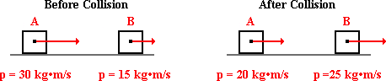

The total momentum of the system before the collision is ____ kg • m/s. The total momentum of the system after the collision is ____ kg • m/s. Enter the letters of the two answers in their respective order with no commas or spaces between letters. (Assign a negative value to all leftward momentum values.)

a. -15 b. 10 c. -5 d. 5

e. 10 f. 15 g. 45 h. 50

i. None of these choices appropriately fill in this blank.

**Question 2:**

aa. The magnitude of the before- and after-collision momentum of two colliding objects is shown in the diagram below. The direction of the momentum is indicated by the arrow.

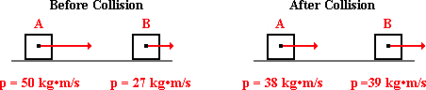

The total momentum of the system before the collision is ____ kg • m/s. The total momentum of the system after the collision is ____ kg • m/s. Enter the letters of the two answers in their respective order with no commas or spaces between letters. (Assign a negative value to all leftward momentum values.)

a. -21 b. -12 c. 1 d. 11

e. 12 f. 21 g. 23 h. 77

i. None of these choices appropriately fill in this blank.

**Question 3:**

aa. The magnitude of the before- and after-collision momentum of two colliding objects is shown in the diagram below. The direction of the momentum is indicated by the arrow.

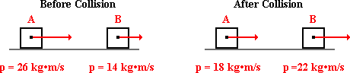

The total momentum of the system before the collision is ____ kg • m/s. The total momentum of the system after the collision is ____ kg • m/s. Enter the letters of the two answers in their respective order with no commas or spaces between letters. (Assign a negative value to all leftward momentum values.)

a. -8 b. -4 c. 4 d. 8

e. 12 f. 36 g. 40 h. 44

i. None of these choices appropriately fill in this blank.

**Question 4:**

aa. The magnitude of the before- and after-collision momentum of two colliding objects is shown in the diagram below. The direction of the momentum is indicated by the arrow.

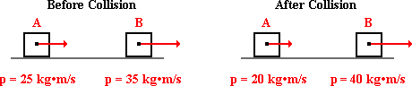

The total momentum of the system before the collision is ____ kg • m/s. The total momentum of the system after the collision is ____ kg • m/s. Enter the letters of the two answers in their respective order with no commas or spaces between letters. (Assign a negative value to all leftward momentum values.)

a. -15 b. -5 c. 5 d. 10

e. 15 f. 45 g. 60 h. 75

i. None of these choices appropriately fill in this blank.

**Question 5:**

aa. The magnitude of the before- and after-collision momentum of two colliding objects is shown in the diagram below. The direction of the momentum is indicated by the arrow.



The change in momentum of object A is ____ kg • m/s. The change in momentum of object B is ____ kg • m/s. Enter the letters of the two answers in their respective order with no commas or spaces between letters. (Assign a negative value to all leftward momentum values.)

a. -15 b. -10 c. -5 d. 5

e. 10 f. 15 g. 40 h. 50

i. None of these choices appropriately fill in this blank.

**Question 6:**

aa. The magnitude of the before- and after-collision momentum of two colliding objects is shown in the diagram below. The direction of the momentum is indicated by the arrow.



The change in momentum of object A is ____ kg • m/s. The change in momentum of object B is ____ kg • m/s. Enter the letters of the two answers in their respective order with no commas or spaces between letters. (Assign a negative value to all leftward momentum values.)

a. -21 b. -12 c. 1 d. 11

e. 12 f. 21 g. 23 h. 77

i. None of these choices appropriately fill in this blank.

**Question 7:**

aa. The magnitude of the before- and after-collision momentum of two colliding objects is shown in the diagram below. The direction of the momentum is indicated by the arrow.



The change in momentum of object A is ____ kg • m/s. The change in momentum of object B is ____ kg • m/s. Enter the letters of the two answers in their respective order with no commas or spaces between letters. (Assign a negative value to all leftward momentum values.)

a. -8 b. -4 c. 4 d. 8

e. 12 f. 36 g. 40 h. 44

i. None of these choices appropriately fill in this blank.

**Question 8:**

aa. The magnitude of the before- and after-collision momentum of two colliding objects is shown in the diagram below. The direction of the momentum is indicated by the arrow.



The change in momentum of object A is ____ kg • m/s. The change in momentum of object B is ____ kg • m/s. Enter the letters of the two answers in their respective order with no commas or spaces between letters. (Assign a negative value to all leftward momentum values.)

a. -15 b. -5 c. 5 d. 10

e. 15 f. 45 g. 60 h. 75

i. None of these choices appropriately fill in this blank.

**Question 9:**

aa. Which of these collisions demonstrate momentum conservation?

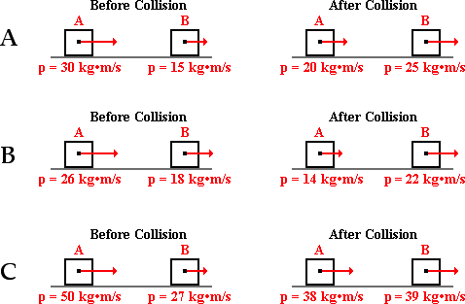

List all that apply. Answer 'D' if none of the collisions demonstrate momentum conservation.

**Question 10:**

aa. Which of these collisions demonstrate momentum conservation?

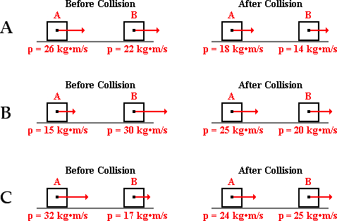

List all that apply. Answer 'D' if none of the collisions demonstrate momentum conservation.

**Question 11:**

aa. Which of these collisions demonstrate momentum conservation?

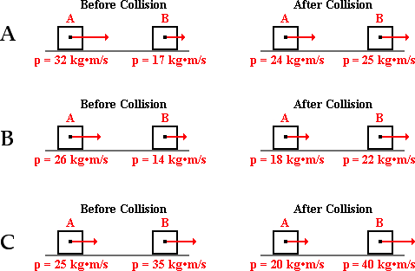

List all that apply. Answer 'D' if none of the collisions demonstrate momentum conservation.

**Question 12:**

aa. Which of these collisions demonstrate momentum conservation?

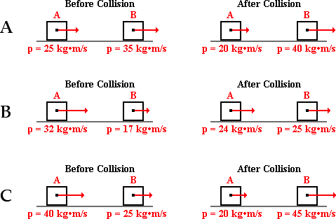

List all that apply. Answer 'D' if none of the collisions demonstrate momentum conservation.

**Question 13:**

aa. Which of these collisions demonstrate momentum conservation?

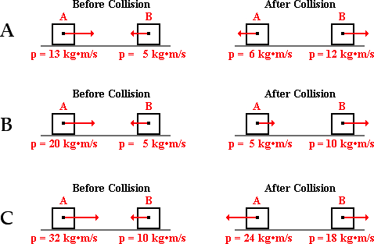

List all that apply. Answer 'D' if none of the collisions demonstrate momentum conservation.

**Question 14:**

aa. Which of these collisions demonstrate momentum conservation?

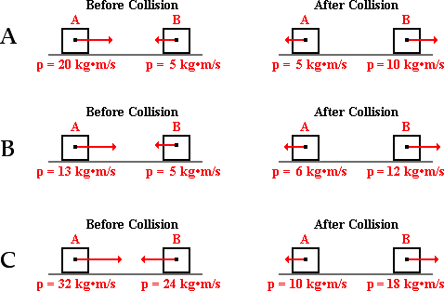

List all that apply. Answer 'D' if none of the collisions demonstrate momentum conservation.

**Question 15:**

aa. Which of these collisions demonstrate momentum conservation?

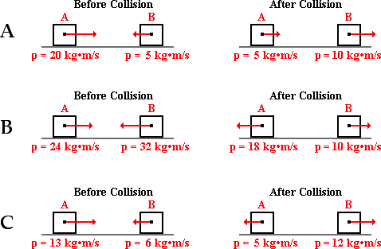

List all that apply. Answer 'D' if none of the collisions demonstrate momentum conservation.

**Question 16:**

aa. Which of these collisions demonstrate momentum conservation?

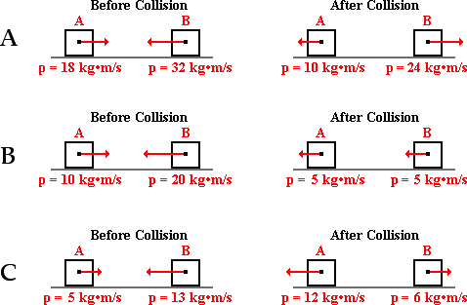

List all that apply. Answer 'D' if none of the collisions demonstrate momentum conservation.

**Question 17:**

aa. Object A and object B collide in an isolated system. The vector arrows shown in the diagram below represent the before- and after-collision momentum of object A and object B.

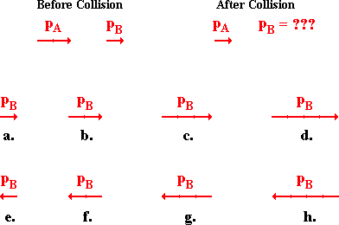

Which vector best represents the magnitude and direction of the momentum of object B after the collision?

**Question 18:**

aa. Object A and object B collide in an isolated system. The vector arrows shown in the diagram below represent the before- and after-collision momentum of object A and object B.

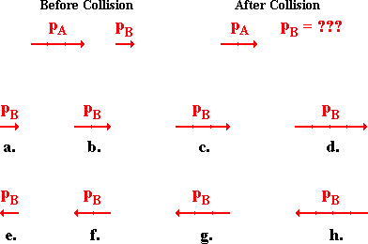

Which vector best represents the magnitude and direction of the momentum of object B after the collision?

**Question 19:**

aa. Object A and object B collide in an isolated system. The vector arrows shown in the diagram below represent the before- and after-collision momentum of object A and object B.

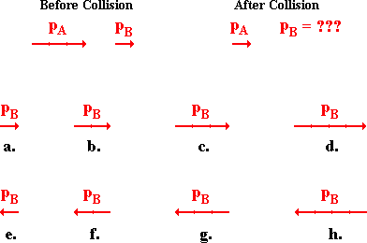

Which vector best represents the magnitude and direction of the momentum of object B after the collision?

**Question 20:**

aa. Object A and object B collide in an isolated system. The vector arrows shown in the diagram below represent the before- and after-collision momentum of object A and object B.

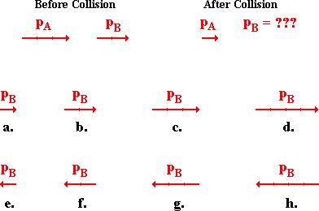

Which vector best represents the magnitude and direction of the momentum of object B after the collision?

**Question 21:**

aa. Object A and object B collide in an isolated system. The vector arrows shown in the diagram below represent the before- and after-collision momentum of object A and object B.

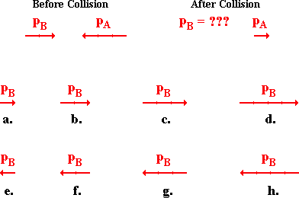

Which vector best represents the magnitude and direction of the momentum of object B after the collision?

**Question 22:**

aa. Object A and object B collide in an isolated system. The vector arrows shown in the diagram below represent the before- and after-collision momentum of object A and object B.

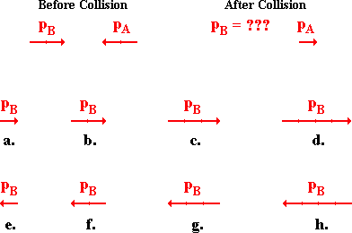

Which vector best represents the magnitude and direction of the momentum of object B after the collision?

**Question 23:**

aa. Object A and object B collide in an isolated system. The vector arrows shown in the diagram below represent the before- and after-collision momentum of object A and object B.

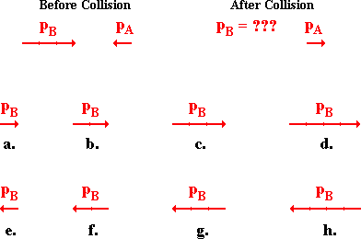

Which vector best represents the magnitude and direction of the momentum of object B after the collision?

**Question 24:**

aa. Object A and object B collide in an isolated system. The vector arrows shown in the diagram below represent the before- and after-collision momentum of object A and object B.

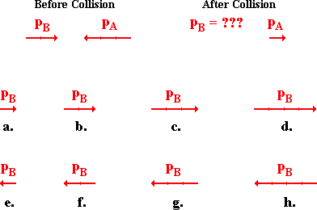

Which vector best represents the magnitude and direction of the momentum of object B after the collision?

**Question 25:**

aa. Object A and object B collide in an isolated system. The vector arrows shown in the diagram below represent the before- and after-collision momentum of object A and object B.

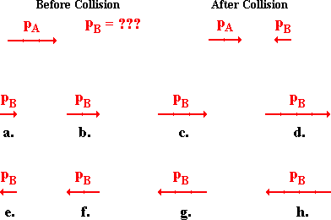

Which vector best represents the magnitude and direction of the momentum of object B before the collision?

**Question 26:**

aa. Object A and object B collide in an isolated system. The vector arrows shown in the diagram below represent the before- and after-collision momentum of object A and object B.

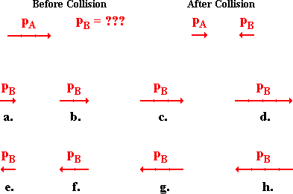

Which vector best represents the magnitude and direction of the momentum of object B before the collision?

**Question 27:**

aa. Object A and object B collide in an isolated system. The vector arrows shown in the diagram below represent the before- and after-collision momentum of object A and object B.

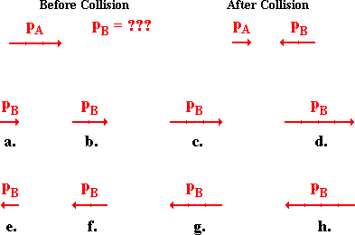

Which vector best represents the magnitude and direction of the momentum of object B before the collision?

**Question 28:**

aa. Object A and object B collide in an isolated system. The vector arrows shown in the diagram below represent the before- and after-collision momentum of object A and object B.

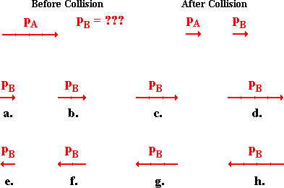

Which vector best represents the magnitude and direction of the momentum of object B before the collision?

**Question 29:**

aa. In a Physics lab, two carts of varying mass collide on a low-friction track in such a manner that the system can be considered as an isolated system. The before- and after-collision velocities of the carts are represented by vector arrows.

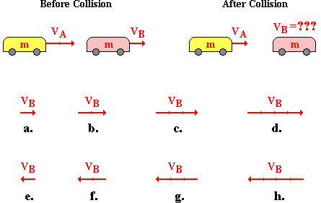

Which vector represents the after-collision velocity of cart B?

**Question 30:**

aa. In a Physics lab, two carts of varying mass collide on a low-friction track in such a manner that the system can be considered as an isolated system. The before- and after-collision velocities of the carts are represented by vector arrows.

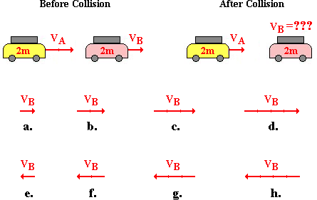

Which vector represents the after-collision velocity of cart B?

**Question 31:**

aa. In a Physics lab, two carts of varying mass collide on a low-friction track in such a manner that the system can be considered as an isolated system. The before- and after-collision velocities of the carts are represented by vector arrows.

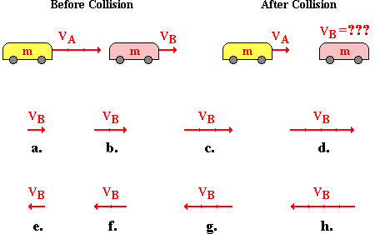

Which vector represents the after-collision velocity of cart B?

**Question 32:**

aa. In a Physics lab, two carts of varying mass collide on a low-friction track in such a manner that the system can be considered as an isolated system. The before- and after-collision velocities of the carts are represented by vector arrows.

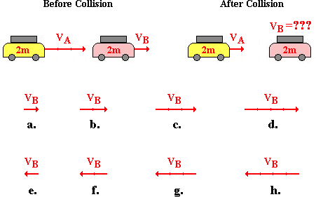

Which vector represents the after-collision velocity of cart B?

**Question 33:**

aa. In a Physics lab, two carts of varying mass collide on a low-friction track in such a manner that the system can be considered as an isolated system. The before- and after-collision velocities of the carts are represented by vector arrows.

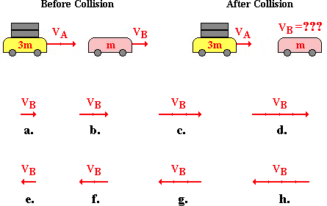

Which vector represents the after-collision velocity of cart B?

**Question 34:**

aa. In a Physics lab, two carts of varying mass collide on a low-friction track in such a manner that the system can be considered as an isolated system. The before- and after-collision velocities of the carts are represented by vector arrows.

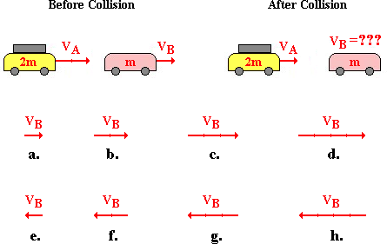

Which vector represents the after-collision velocity of cart B?

**Question 35:**

aa. In a Physics lab, two carts of varying mass collide on a low-friction track in such a manner that the system can be considered as an isolated system. The before- and after-collision velocities of the carts are represented by vector arrows.

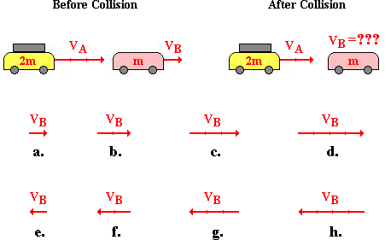

Which vector represents the after-collision velocity of cart B?

**Question 36:**

aa. In a Physics lab, two carts of varying mass collide on a low-friction track in such a manner that the system can be considered as an isolated system. The before- and after-collision velocities of the carts are represented by vector arrows.

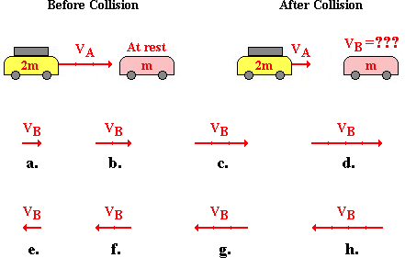

Which vector represents the after-collision velocity of cart B?

**Question 37:**

aa. In a Physics lab, two carts of varying mass collide on a low-friction track in such a manner that the system can be considered as an isolated system. The before- and after-collision velocities of the carts are represented by vector arrows.

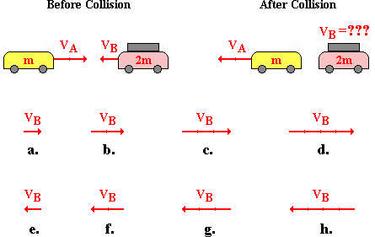

Which vector represents the after-collision velocity of cart B?

**Question 38:**

aa. In a Physics lab, two carts of varying mass collide on a low-friction track in such a manner that the system can be considered as an isolated system. The before- and after-collision velocities of the carts are represented by vector arrows.

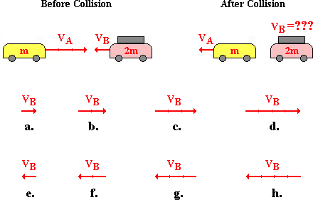

Which vector represents the after-collision velocity of cart B?

**Question 39:**

aa. In a Physics lab, two carts of varying mass collide on a low-friction track in such a manner that the system can be considered as an isolated system. The before- and after-collision velocities of the carts are represented by vector arrows.

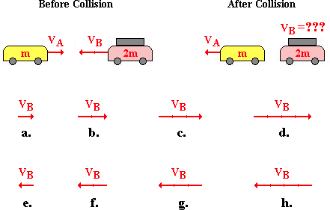

Which vector represents the after-collision velocity of cart B?

**Question 40:**

aa. In a Physics lab, two carts of varying mass collide on a low-friction track in such a manner that the system can be considered as an isolated system. The before- and after-collision velocities of the carts are represented by vector arrows.

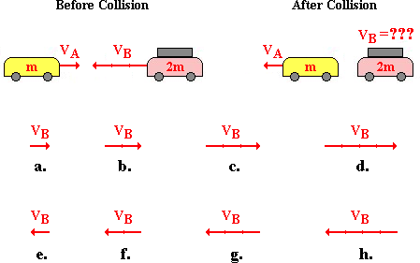

Which vector represents the after-collision velocity of cart B?

**MC6: Explosion-Like Impulses**

**Question 1:**

aa. In a physics lab, two carts (labeled A and B) are at rest on a low-friction track. A spring-like plunger connects them. The springs are compressed and then suddenly released, exerting explosion-like forces on each of the two carts. Cart A is more massive than Cart B. During this 'explosion', the force is ____; the acceleration is ____; the impulse is ____; and the momentum change is ____. Enter the letters of the four answers in their respective order with no commas or spaces between letters.

a. greatest on/for cart A

b. greatest on/for cart B

c. the same on/for each cart

**Question 2:**

aa. In a physics lab, two carts (labeled A and B) are at rest on a low-friction track. A spring-like plunger connects them. The springs are compressed and then suddenly released, exerting explosion-like forces on each of the two carts. Cart A is less massive than Cart B. During this 'explosion', the force is ____; the acceleration is ____; the impulse is ____; and the momentum change is ____. Enter the letters of the four answers in their respective order with no commas or spaces between letters.

a. greatest on/for cart A

b. greatest on/for cart B

c. the same on/for each cart

**Question 3:**

aa. In a physics lab, two carts (labeled A and B) are at rest on a low-friction track. A spring-like plunger connects them. The springs are compressed and then suddenly released, exerting explosion-like forces on each of the two carts. Cart A is more massive than Cart B. During this 'explosion', the force is ____; the acceleration is ____; the impulse is ____; and the momentum change is ____. Enter the letters of the four answers in their respective order with no commas or spaces between letters.

a. the same on/for each cart

b. greatest on/for cart A

c. greatest on/for cart B

**Question 4:**

aa. In a physics lab, two carts (labeled A and B) are at rest on a low-friction track. A spring-like plunger connects them. The springs are compressed and then suddenly released, exerting explosion-like forces on each of the two carts. Cart A is less massive than Cart B. During this 'explosion', the force is ____; the acceleration is ____; the impulse is ____; and the momentum change is ____. Enter the letters of the four answers in their respective order with no commas or spaces between letters.

a. the same on/for each cart

b. greatest on/for cart A

c. greatest on/for cart B

**Question 5:**

aa. In a physics lab, two carts (labeled A and B) are at rest on a low-friction track. A spring-like plunger connects them. The springs are compressed and then suddenly released, exerting explosion-like forces on each of the two carts. Cart A is three times as massive as Cart B. During this 'explosion', the force is ____; the acceleration is ____; the impulse is ____; and the momentum change is ____. Enter the letters of the four answers in their respective order with no commas or spaces between letters.

a. three times greater on (or for) cart A

b. nine times greater on (or for) cart A

c. three times greater on (or for) cart B

d. nine times greater on (or for) cart B

e. the same on (or for) cart A as cart B

**Question 6:**

aa. In a physics lab, two carts (labeled A and B) are at rest on a low-friction track. A spring-like plunger connects them. The springs are compressed and then suddenly released, exerting explosion-like forces on each of the two carts. Cart A is one-third as massive as Cart B. During this 'explosion', the force is ____; the acceleration is ____; the impulse is ____; and the momentum change is ____. Enter the letters of the four answers in their respective order with no commas or spaces between letters.

a. three times greater on (or for) cart A

b. nine times greater on (or for) cart A

c. three times greater on (or for) cart B

d. nine times greater on (or for) cart B

e. the same on (or for) cart A as cart B

**Question 7:**

aa. In a physics lab, two carts (labeled A and B) are at rest on a low-friction track. A spring-like plunger connects them. The springs are compressed and then suddenly released, exerting explosion-like forces on each of the two carts. Cart A is three times as massive as Cart B. During this 'explosion', the force is ____; the acceleration is ____; the impulse is ____; and the momentum change is ____. Enter the letters of the four answers in their respective order with no commas or spaces between letters.

a. three times greater on (or for) cart A

b. three times greater on (or for) cart B

c. the same on (or for) cart A as cart B

d. nine times greater on (or for) cart A

e. nine times greater on (or for) cart B

**Question 8:**

aa. In a physics lab, two carts (labeled A and B) are at rest on a low-friction track. A spring-like plunger connects them. The springs are compressed and then suddenly released, exerting explosion-like forces on each of the two carts. Cart A is one-third as massive as Cart B. During this 'explosion', the force is ____; the acceleration is ____; the impulse is ____; and the momentum change is ____. Enter the letters of the four answers in their respective order with no commas or spaces between letters.

a. three times greater on (or for) cart A

b. three times greater on (or for) cart B

c. the same on (or for) cart A as cart B

d. nine times greater on (or for) cart A

e. nine times greater on (or for) cart B

**Question 9:**

aa. A home-made cannon is loaded with a tennis ball. Fuel is placed in the explosion chamber of the cannon and ignited. The subsequent explosion exerts forces on the tennis ball and the cannon, propelling them in opposite directions. During the explosion, the ball and the cannon experience ____ force, ____ acceleration, ____ impulse, and ____ momentum change. Enter the letters of the four answers in their respective order with no commas or spaces between letters.

a. the same b. a different

**Question 10:**

aa. A home-made cannon is loaded with a tennis ball. Fuel is placed in the explosion chamber of the cannon and ignited. The subsequent explosion exerts forces on the tennis ball and the cannon, propelling them in opposite directions. During the explosion, the ball and the cannon experience ____ force, ____ acceleration, ____ impulse, and ____ momentum change. Enter the letters of the four answers in their respective order with no commas or spaces between letters.

a. a different b. the same

**Question 11:**

aa. A home-made cannon is loaded with a tennis ball. Fuel is placed in the explosion chamber of the cannon and ignited. The subsequent explosion exerts forces on the tennis ball and the cannon, propelling them in opposite directions. During the explosion, the ball and the cannon experience ____ acceleration, ____ force, ____ momentum change, and ____ impulse. Enter the letters of the four answers in their respective order with no commas or spaces between letters.

a. the same b. a different

**Question 12:**

aa. A home-made cannon is loaded with a tennis ball. Fuel is placed in the explosion chamber of the cannon and ignited. The subsequent explosion exerts forces on the tennis ball and the cannon, propelling them in opposite directions. During the explosion, the ball and the cannon experience ____ acceleration, ____ force, ____ momentum change, and ____ impulse. Enter the letters of the four answers in their respective order with no commas or spaces between letters.

a. a different b. the same

**Question 13:**

aa. Two ice dancers are at rest on the ice, facing each other with their hands together. They push off on each other in order to set each other in motion. The subsequent momentum change (magnitude only) of the two skaters will be ____.

a. greatest for the skater who pushes with the greatest force

b. greatest for the skater who is pushed upon with the greatest force

c. greatest for the skater with the least mass

d. greatest for the skater with the most mass

e. the same for each skater

**Question 14:**

aa. Two ice dancers are at rest on the ice, facing each other with their hands together. They push off on each other in order to set each other in motion. The subsequent momentum change (magnitude only) of the two skaters will be ____.

a. greatest for the skater who is pushed upon with the greatest force

b. greatest for the skater who pushes with the greatest force

c. the same for each skater

d. greatest for the skater with the most mass

e. greatest for the skater with the least mass

**Question 15:**

aa. Two ice dancers are at rest on the ice, facing each other with their hands together. They push off on each other in order to set each other in motion. The subsequent momentum change (magnitude only) of the two skaters will be ____.

a. greatest for the skater with the least mass

b. greatest for the skater with the most mass

c. the same for each skater

d. greatest for the skater who pushes with the greatest force

e. greatest for the skater who is pushed upon with the greatest force

**Question 16:**

aa. Two ice dancers are at rest on the ice, facing each other with their hands together. They push off on each other in order to set each other in motion. The subsequent momentum change (magnitude only) of the two skaters will be ____.

a. the same for each skater

b. greatest for the skater who is pushed upon with the greatest force

c. greatest for the skater who pushes with the greatest force

d. greatest for the skater with the least mass

e. greatest for the skater with the most mass

**Question 17:**

aa. Two pop cans are at rest on a stand. A firecracker is placed between the cans and lit. The firecracker explodes and exerts equal and opposite forces on the two cans. Assuming the system of two cans to be isolated, the post-explosion momentum of the system ____.

a. is dependent upon the mass and velocities of the two cans

b. is dependent upon the velocities of the two cans (but not their mass)

c. is typically a very large value

d. can be either a positive, negative or zero value

e. is definitely zero

**Question 18:**

aa. Two pop cans are at rest on a stand. A firecracker is placed between the cans and lit. The firecracker explodes and exerts equal and opposite forces on the two cans. Assuming the system of two cans to be isolated, the post-explosion momentum of the system ____.

a. is dependent upon the velocities of the two cans (but not their mass)

b. is dependent upon the mass and velocities of the two cans

c. can be either a positive, negative or zero value

d. is definitely zero

e. is typically a very large value

**Question 19:**

aa. Two pop cans are at rest on a stand. A firecracker is placed between the cans and lit. The firecracker explodes and exerts equal and opposite forces on the two cans. Assuming the system of two cans to be isolated, the post-explosion momentum of the system ____.

a. is typically a very large value

b. can be either a positive, negative or zero value

c. is definitely zero

d. is dependent upon the mass and velocities of the two cans

e. is dependent upon the velocities of the two cans (but not their mass)

**Question 20:**

aa. Two pop cans are at rest on a stand. A firecracker is placed between the cans and lit. The firecracker explodes and exerts equal and opposite forces on the two cans. Assuming the system of two cans to be isolated, the post-explosion momentum of the system ____.

a. can be either a positive, negative or zero value

b. is definitely zero

c. is typically a very large value

d. is dependent upon the velocities of the two cans (but not their mass)

e. is dependent upon the mass and velocities of the two cans

**Question 21:**

aa. The gunpowder explosion in a gun results in an expansion of gases that cause a bullet to be propelled forward. The gun in turn 'kicks' or 'recoils' backwards. The recoil momentum (magnitude only) of a gun that kicks is ____ the momentum of the bullet that it fires.

a. more than b. less than c. equal to

d. ... nonsense! There is no way to make such a prediction without the knowledge of masses and velocities.

**Question 22:**

aa. The gunpowder explosion in a gun results in an expansion of gases that cause a bullet to be propelled forward. The gun in turn 'kicks' or 'recoils' backwards. The recoil momentum (magnitude only) of a gun that kicks is ____ the momentum of the bullet that it fires.

a. less than b. more than c. equal to

d. ... nonsense! There is no way to make such a prediction without the knowledge of masses and velocities.

**Question 23:**

aa. The gunpowder explosion in a gun results in an expansion of gases that cause a bullet to be propelled forward. The gun in turn 'kicks' or 'recoils' backwards. The recoil momentum (magnitude only) of a gun that kicks is ____ the momentum of the bullet that it fires.

a. more than b. equal to c. less than

d. … nonsense! There is no way to make such a prediction without the knowledge of masses and velocities.

**Question 24:**

aa. The gunpowder explosion in a gun results in an expansion of gases that cause a bullet to be propelled forward. The gun in turn 'kicks' or 'recoils' backwards. The recoil momentum (magnitude only) of a gun that kicks is ____ the momentum of the bullet that it fires.

a. equal to b. less than c. more than

d. ... nonsense! There is no way to make such a prediction without the knowledge of masses and velocities.

**Question 25:**

aa. Students of varying mass are placed on large carts and deliver impulses to each other's carts, thus changing their momenta. In some cases, the carts are loaded with equal mass; in other cases they are unequal. In some cases, the students push off each other; in other cases, only one team does the pushing.

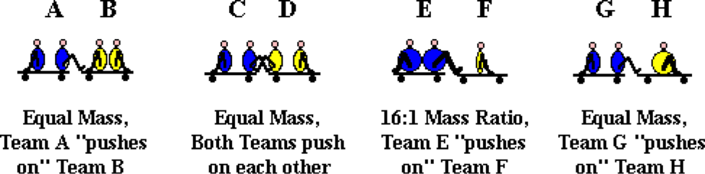

For each situation, list the letter of the team that ends up with the greatest momentum. If they have the same momentum, then do not list a letter for that situation. Enter the four letters (or three or two or ...) in alphabetical order.

**Question 26:**

aa. Students of varying mass are placed on large carts and deliver impulses to each other's carts, thus changing their momenta. In some cases, the carts are loaded with equal mass; in other cases they are unequal. In some cases, the students push off each other; in other cases, only one team does the pushing.

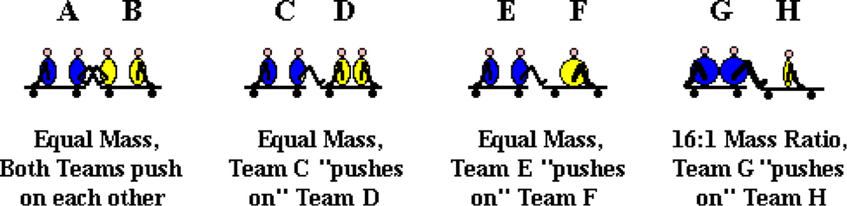

For each situation, list the letter of the team that ends up with the greatest momentum. If they have the same momentum, then do not list a letter for that situation. Enter the four letters (or three or two or ...) in alphabetical order.

**Question 27:**

aa. Students of varying mass are placed on large carts and deliver impulses to each other's carts, thus changing their momenta. In some cases, the carts are loaded with equal mass; in other cases they are unequal. In some cases, the students push off each other; in other cases, only one team does the pushing.

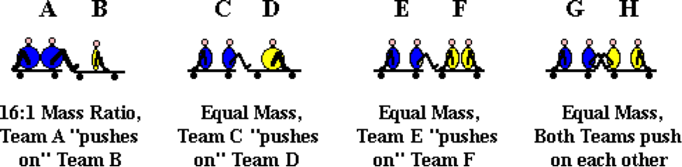

For each situation, list the letter of the team that ends up with the greatest momentum. If they have the same momentum, then do not list a letter for that situation. Enter the four letters (or three or two or ...) in alphabetical order.

**Question 28:**

aa. Students of varying mass are placed on large carts and deliver impulses to each other's carts, thus changing their momenta. In some cases, the carts are loaded with equal mass; in other cases they are unequal. In some cases, the students push off each other; in other cases, only one team does the pushing.

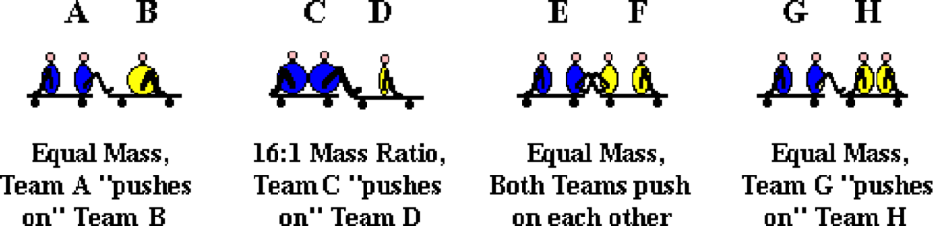

For each situation, list the letter of the team that ends up with the greatest momentum. If they have the same momentum, then do not list a letter for that situation. Enter the four letters (or three or two or ...) in alphabetical order.

**Question 29:**

aa. Students of varying mass are placed on large carts and deliver impulses to each other's carts, thus changing their momenta. In some cases, the carts are loaded with equal mass; in other cases they are unequal. In some cases, the students push off each other; in other cases, only one team does the pushing.



For each situation, list the letter of the team that ends up with the greatest speed. If they have the same speed, then do not list a letter for that situation. Enter the four letters (or three or two or ...) in alphabetical order.

**Question 30:**

aa. Students of varying mass are placed on large carts and deliver impulses to each other's carts, thus changing their momenta. In some cases, the carts are loaded with equal mass; in other cases they are unequal. In some cases, the students push off each other; in other cases, only one team does the pushing.



For each situation, list the letter of the team that ends up with the greatest speed. If they have the same speed, then do not list a letter for that situation. Enter the four letters (or three or two or ...) in alphabetical order.

**Question 31:**

aa. Students of varying mass are placed on large carts and deliver impulses to each other's carts, thus changing their momenta. In some cases, the carts are loaded with equal mass; in other cases they are unequal. In some cases, the students push off each other; in other cases, only one team does the pushing.



For each situation, list the letter of the team that ends up with the greatest speed. If they have the same speed, then do not list a letter for that situation. Enter the four letters (or three or two or …) in alphabetical order.

**Question 32:**

aa. Students of varying mass are placed on large carts and deliver impulses to each other's carts, thus changing their momenta. In some cases, the carts are loaded with equal mass; in other cases they are unequal. In some cases, the students push off each other; in other cases, only one team does the pushing.



For each situation, list the letter of the team that ends up with the greatest speed. If they have the same speed, then do not list a letter for that situation. Enter the four letters (or three or two or ...) in alphabetical order.

**MC7: Momentum Conservation**

**Question 1:**

aa. A 120-kg red bumper car moving east at 2.00 m/s collides with a 150-kg blue car moving east at 1.20 m/s. After the collision, the red car is moving east at 1.20 m/s and the blue car is moving east at 1.84 m/s.

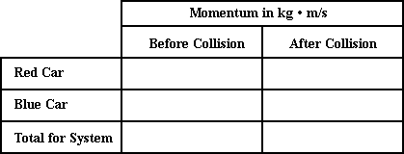

Fill in the momentum table and determine if momentum is conserved (within 1 percent). Use the notation that east is the positive direction and west is the negative direction.

**Question 2:**

aa. A 100-kg red bumper car moving east at 1.6 m/s collides with a 140-kg blue car moving east at 1.4 m/s. After the collision, the red car is moving east at 0.80 m/s and the blue car is moving east at 1.8 m/s.



Fill in the momentum table and determine if momentum is conserved (within 1 percent). (Use the notation that east is the positive direction and west is the negative direction.)

**Question 3:**

aa. A 175-kg red bumper car moving east at 1.8 m/s collides with a 140-kg blue car moving east at 1.3 m/s. After the collision, the red car is moving east at 1.35 m/s and the blue car is moving east at 1.86 m/s.



Fill in the momentum table and determine if momentum is conserved (within 1 percent). (Use the notation that east is the positive direction and west is the negative direction.)

**Question 4:**

aa. A 140-kg red bumper car moving east at 0.95 m/s collides with a 100-kg blue car moving east at 0.55 m/s. After the collision, the red car is moving east at 0.68 m/s and the blue car is moving east at 0.80 m/s.



Fill in the momentum table and determine if momentum is conserved (within 1 percent). (Use the notation that east is the positive direction and west is the negative direction.)

**Question 5:**

aa. A 150-kg red bumper car moving east at 1.80 m/s collides with a 125-kg blue car moving west at 1.20 m/s. After the collision, the red car is moving east at 0.20 m/s and the blue car is moving east at 0.72 m/s.



Fill in the momentum table and determine if momentum is conserved (within 1 percent). (Use the notation that east is the positive direction and west is the negative direction.)

**Question 6:**

aa. A 120-kg red bumper car moving east at 1.50 m/s collides with a 160-kg blue car moving west at 1.60 m/s. After the collision, the red car is moving west at 0.50 m/s and the blue car is moving west at 0.10 m/s.



Fill in the momentum table and determine if momentum is conserved (within 1 percent). (Use the notation that east is the positive direction and west is the negative direction.)

**Question 7:**

aa. A 150-kg red bumper car moving east at 1.50 m/s collides with a 100-kg blue car moving west at 1.10 m/s. After the collision, the red car is moving west at 0.50 m/s and the blue car is moving east at 1.90 m/s.



Fill in the momentum table and determine if momentum is conserved (within 1 percent). (Use the notation that east is the positive direction and west is the negative direction.)

**Question 8:**

aa. A 110-kg red bumper car moving east at 0.80 m/s collides with a 140-kg blue car moving west at 1.20 m/s. After the collision, the red car is moving west at 0.50 m/s and the blue car is moving west at 0.18 m/s.



Fill in the momentum table and determine if momentum is conserved (within 1 percent). (Use the notation that east is the positive direction and west is the negative direction.)

**Question 9:**

aa. A 110-kilogram linebacker moving east at 3.2 m/s collides head on with a 92-kg running back moving west at 6.9 m/s. After the collision, the two players move west at 1.4 m/s.

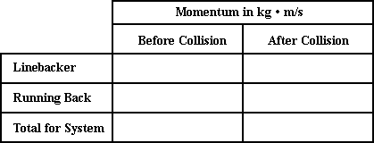

Fill in the momentum table and determine if momentum is conserved (within 1 percent). (Use the notation that east is the positive direction and west is the negative direction.)

**Question 10:**

aa. A 125-kilogram linebacker moving east at 5.80 m/s collides head on with a 80-kg running back moving west at 7.60 m/s. After the collision, the two players move east at 0.35 m/s.



Fill in the momentum table and determine if momentum is conserved (within 1 percent). (Use the notation that east is the positive direction and west is the negative direction.)

**Question 11:**

aa. A 105-kilogram linebacker moving east at 4.15 m/s collides head on with a 96.0-kg running back moving west at 8.20 m/s. After the collision, the two players move west at 1.75 m/s.



Fill in the momentum table and determine if momentum is conserved (within 1 percent). (Use the notation that east is the positive direction and west is the negative direction.)

**Question 12:**

aa. A 125-kilogram linebacker moving east at 5.80 m/s collides head on with a 80-kg running back moving west at 7.60 m/s. After the collision, the two players move east at 0.57 m/s.



Fill in the momentum table and determine if momentum is conserved (within 1 percent). (Use the notation that east is the positive direction and west is the negative direction.)

**Question 13:**

aa. A 102-kilogram linebacker moving east at 6.1 m/s collides with a 92-kg running back moving east at 3.8 m/s. After the collision, the two players move east at 5.0 m/s.



Fill in the momentum table and determine if momentum is conserved (within 1 percent). (Use the notation that east is the positive direction and west is the negative direction.)

**Question 14:**

aa. A 105-kilogram linebacker moving east at 5.8 m/s collides with a 85-kg running back moving east at 2.9 m/s. After the collision, the two players move east at 4.5 m/s.



Fill in the momentum table and determine if momentum is conserved (within 1 percent). (Use the notation that east is the positive direction and west is the negative direction.)

**Question 15:**

aa. A 111-kilogram linebacker moving east at 5.2 m/s collides with a 75-kg running back moving east at 2.2 m/s. After the collision, the two players move east at 4.0 m/s.



Fill in the momentum table and determine if momentum is conserved (within 1 percent). (Use the notation that east is the positive direction and west is the negative direction.)

**Question 16:**

aa. A 115-kilogram linebacker moving east at 8.2 m/s collides with a 88-kg running back moving east at 4.9 m/s. After the collision, the two players move east at 7.6 m/s.



Fill in the momentum table and determine if momentum is conserved (within 1 percent). (Use the notation that east is the positive direction and west is the negative direction.)

**Question 17:**

aa. In a Physics lab, a 2.1-kg brick is dropped from rest upon a 4.6-kg cart moving east with a speed of 1.9 m/s. After the collision, the brick and cart are observed to move east with a speed of 1.3 m/s.

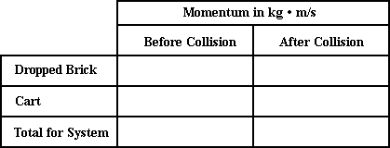

Fill in the momentum table and determine if momentum is conserved (within 1 percent). (Use the notation that east is the positive direction and west is the negative direction.)

**Question 18:**

aa. In a Physics lab, a 1.8-kg brick is dropped from rest upon a 4.6-kg cart moving east with a speed of 2.3 m/s. After the collision, the brick and cart are observed to move east with a speed of 1.4 m/s.



Fill in the momentum table and determine if momentum is conserved (within 1 percent). (Use the notation that east is the positive direction and west is the negative direction.)

**Question 19:**

aa. In a Physics lab, a 1.8-kg brick is dropped from rest upon a 4.6-kg cart moving east with a speed of 2.1 m/s. After the collision, the brick and cart are observed to move east with a speed of 1.5 m/s.



Fill in the momentum table and determine if momentum is conserved (within 1 percent). (Use the notation that east is the positive direction and west is the negative direction.)

**Question 20:**

aa. In a Physics lab, a 2.41-kg brick is dropped from rest upon a 5.60-kg cart moving east with a speed of 1.86 m/s. After the collision, the brick and cart are observed to move east with a speed of 1.30 m/s.



Fill in the momentum table and determine if momentum is conserved (within 1 percent). (Use the notation that east is the positive direction and west is the negative direction.)

**Question 21:**

aa. In a Physics lab, a 0.500-kg cart (Cart A) is moving east at 1.65 m/s and collides with a 1.000-kg cart (Cart B) moving east at 0.92 m/s. After the collision, the two carts move east together with a speed of 1.16 m/s.

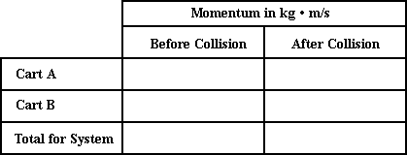

Fill in the momentum table and determine if momentum is conserved (within 1 percent). (Use the notation that east is the positive direction and west is the negative direction.)

**Question 22:**

aa. In a Physics lab, a 0.500-kg cart (Cart A) is moving east at 1.34 m/s and collides with a 1.500-kg cart (Cart B) moving east at 0.26 m/s. After the collision, the two carts move east together with a speed of 0.53 m/s.



Fill in the momentum table and determine if momentum is conserved (within 1 percent). (Use the notation that east is the positive direction and west is the negative direction.)

**Question 23:**

aa. In a Physics lab, a 1.500-kg cart (Cart A) is moving east at 1.63 m/s and collides with a 1.000-kg cart (Cart B) moving east at 0.86 m/s. After the collision, the two carts move east together with a speed of 1.32 m/s.



Fill in the momentum table and determine if momentum is conserved (within 1 percent). (Use the notation that east is the positive direction and west is the negative direction.)

**Question 24:**

aa. In a Physics lab, a 1.500-kg cart (Cart A) is moving east at 1.63 m/s and collides with a 1.000-kg cart (Cart B) moving east at 0.86 m/s. After the collision, the two carts move east together with a speed of 1.12 m/s.



Fill in the momentum table and determine if momentum is conserved (within 1 percent). (Use the notation that east is the positive direction and west is the negative direction.)

**Question 25:**

aa. In a Physics lab, a 1.000-kg cart (Cart A) is moving east at 0.76 m/s and collides with a 0.500-kg cart (Cart B) moving west at 0.54 m/s. After the collision, Cart A moves east at 0.21 m/s and Cart B moves east at 0.56 m/s.



Fill in the momentum table and determine if momentum is conserved (within 1 percent). (Use the notation that east is the positive direction and west is the negative direction.)

**Question 26:**

aa. In a Physics lab, a 2.000-kg cart (Cart A) is moving east at 0.66 m/s and collides with a 1.000-kg cart (Cart B) moving west at 0.43 m/s. After the collision, Cart A moves east at 0.16 m/s and Cart B moves east at 0.57 m/s.



Fill in the momentum table and determine if momentum is conserved (within 1 percent). (Use the notation that east is the positive direction and west is the negative direction.)

**Question 27:**

aa. In a Physics lab, a 1.500-kg cart (Cart A) is moving east at 0.82 m/s and collides with a 0.500-kg cart (Cart B) moving west at 0.35 m/s. After the collision, Cart A moves east at 0.26 m/s and Cart B moves east at 1.33 m/s.



Fill in the momentum table and determine if momentum is conserved (within 1 percent). (Use the notation that east is the positive direction and west is the negative direction.)

**Question 28:**

aa. In a Physics lab, a 1.500-kg cart (Cart A) is moving east at 0.58 m/s and collides with a 0.500-kg cart (Cart B) moving west at 0.36 m/s. After the collision, Cart A moves east at 0.12 m/s and Cart B moves east at 1.02 m/s.



Fill in the momentum table and determine if momentum is conserved (within 1 percent). (Use the notation that east is the positive direction and west is the negative direction.)

**MC8: Problem-Solving – Inelastic Collisions**

**Question 1:**

aa. A 120-kg red bumper car moving east at 2.00 m/s collides with a 150-kg blue car that is at rest. The bumpers of the two cars entangle and they move together after the collision.



Assuming that the system is isolated, fill in the momentum table and determine the final velocity of the cars. Use the notation that east is the positive direction and west is the negative direction.

**Question 2:**

aa. A 140-kg red bumper car moving east at 2.25 m/s collides with a 110-kg blue car that is at rest. The bumpers of the two cars entangle and they move together after the collision.



Assuming that the system is isolated, fill in the momentum table and determine the final velocity of the cars. Use the notation that east is the positive direction and west is the negative direction.

**Question 3:**

aa. A 120-kg red bumper car moving east at 2.50 m/s collides with a 160-kg blue car that is at rest. The bumpers of the two cars entangle and they move together after the collision.



Assuming that the system is isolated, fill in the momentum table and determine the final velocity of the cars. Use the notation that east is the positive direction and west is the negative direction.

**Question 4:**

aa. A 140-kg red bumper car moving east at 1.80 m/s collides with a 110-kg blue car that is at rest. The bumpers of the two cars entangle and they move together after the collision.



Assuming that the system is isolated, fill in the momentum table and determine the final velocity of the cars. Use the notation that east is the positive direction and west is the negative direction.

**Question 5:**

aa. In a physics lab, a 0.500-kg cart (A) moving east at 52.0 cm/s collides with a 0.750-kg cart (B) that is at rest. The two carts are equipped with Velcro strips that allow them to move together after the collision.

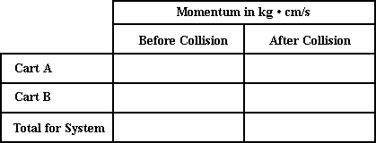

Assuming the system is isolated, fill in the momentum table and determine the final velocity of the carts. Use the notation that east is the positive direction and west is the negative direction.

**Question 6:**

aa. In a physics lab, a 0.750-kg cart (A) moving east at 52.0 cm/s collides with a 0.500-kg cart (B) that is at rest. The two carts are equipped with Velcro strips that allow them to move together after the collision.



Assuming the system is isolated, fill in the momentum table and determine the final velocity of the carts. Use the notation that east is the positive direction and west is the negative direction.

**Question 7:**

aa. In a physics lab, a 0.750-kg cart (A) moving east at 46.0 cm/s collides with a 1.000-kg cart (B) that is at rest. The two carts are equipped with Velcro strips that allow them to move together after the collision.



Assuming the system is isolated, fill in the momentum table and determine the final velocity of the carts. Use the notation that east is the positive direction and west is the negative direction.

**Question 8:**

aa. In a physics lab, a 0.500-kg cart (A) moving east at 66.0 cm/s collides with a 0.750-kg cart (B) that is at rest. The two carts are equipped with Velcro strips that allow them to move together after the collision.



Assuming the system is isolated, fill in the momentum table and determine the final velocity of the carts. Use the notation that east is the positive direction and west is the negative direction.

**Question 9:**

aa. In a physics lab, a 0.500-kg cart (A) moving east at 52.0 cm/s collides with a 0.750-kg cart (B) that is moving west at 68.0 cm/s. The two carts are equipped with Velcro strips that allow them to move together after the collision.



Assuming the system is isolated, fill in the momentum table and determine the final velocity of the carts. Use the notation that east is the positive direction and west is the negative direction.

**Question 10:**

aa. In a physics lab, a 0.750-kg cart (A) moving east at 58.0 cm/s collides with a 0.500-kg cart (B) that is moving west at 32.0 cm/s. The two carts are equipped with Velcro strips that allow them to move together after the collision.



Assuming the system is isolated, fill in the momentum table and determine the final velocity of the carts. Use the notation that east is the positive direction and west is the negative direction.

**Question 11:**

aa. In a physics lab, a 1.000-kg cart (A) moving east at 46.0 cm/s collides with a 0.750-kg cart (B) that is moving west at 27.0 cm/s. The two carts are equipped with Velcro strips that allow them to move together after the collision.



Assuming the system is isolated, fill in the momentum table and determine the final velocity of the carts. Use the notation that east is the positive direction and west is the negative direction.

**Question 12:**

aa. In a physics lab, a 0.750-kg cart (A) moving east at 36.0 cm/s collides with a 1.000-kg cart (B) that is moving west at 54.0 cm/s. The two carts are equipped with Velcro strips that allow them to move together after the collision.



Assuming the system is isolated, fill in the momentum table and determine the final velocity of the carts. Use the notation that east is the positive direction and west is the negative direction.

**Question 13:**

aa. A 110-kilogram linebacker moving east at 3.2 m/s collides head on with a 92-kg running back moving west at 6.9 m/s. The two players grab onto each other and move together after the collision.



Assuming the system is isolated, fill in the momentum table and determine the final velocity of the players. Use the notation that east is the positive direction and west is the negative direction.

**Question 14:**

aa. A 125-kilogram linebacker moving east at 5.2 m/s collides head on with a 98-kg running back moving west at 3.6 m/s. The two players grab onto each other and move together after the collision.



Assuming the system is isolated, fill in the momentum table and determine the final velocity of the players. Use the notation that east is the positive direction and west is the negative direction.

**Question 15:**

aa. A 108-kilogram linebacker moving east at 6.2 m/s collides head on with a 75-kg running back moving west at 7.1 m/s. The two players grab onto each other and move together after the collision.



Assuming the system is isolated, fill in the momentum table and determine the final velocity of the players. Use the notation that east is the positive direction and west is the negative direction.

**Question 16:**

aa. A 104-kilogram linebacker moving east at 3.5 m/s collides head on with a 86-kg running back moving west at 6.8 m/s. The two players grab onto each other and move together after the collision.



Assuming the system is isolated, fill in the momentum table and determine the final velocity of the players. Use the notation that east is the positive direction and west is the negative direction.

**Question 17:**

aa. In a Physics lab, a 1.8-kg brick is dropped from rest upon a 4.6-kg cart moving east with a speed of 52 cm/s. The brick and cart move together after the collision.

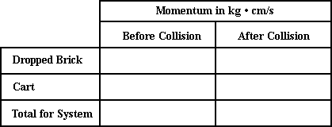

Assuming the system is isolated, fill in the momentum table and determine the final velocity of the brick and cart. Use the notation that east is the positive direction and west is the negative direction.

**Question 18:**

aa. In a Physics lab, a 2.3-kg brick is dropped from rest upon a 4.5-kg cart moving east with a speed of 38 cm/s. The brick and cart move together after the collision.



Assuming the system is isolated, fill in the momentum table and determine the final velocity of the brick and cart. Use the notation that east is the positive direction and west is the negative direction.

**Question 19:**

aa. In a Physics lab, a 1.9-kg brick is dropped from rest upon a 3.6-kg cart moving east with a speed of 67 cm/s. The brick and cart move together after the collision.



Assuming the system is isolated, fill in the momentum table and determine the final velocity of the brick and cart. Use the notation that east is the positive direction and west is the negative direction.

**Question 20:**

aa. In a Physics lab, a 2.6-kg brick is dropped from rest upon a 5.4-kg cart moving east with a speed of 39 cm/s. The brick and cart move together after the collision.



Assuming the system is isolated, fill in the momentum table and determine the final velocity of the brick and cart. Use the notation that east is the positive direction and west is the negative direction.

**Question 21:**

aa. In a physics lab, a 0.500-kg cart (A) moving east at 52.0 cm/s collides with a 0.750-kg cart (B) that is moving east at 22 cm/s. The two carts are equipped with Velcro strips that allow them to move together after the collision.



Assuming the system is isolated, fill in the momentum table and determine the final velocity of the carts. Use the notation that east is the positive direction and west is the negative direction.

**Question 22:**

aa. In a physics lab, a 0.500-kg cart (A) moving east at 35.0 cm/s collides with a 1.000-kg cart (B) that is moving east at 13.0 cm/s. The two carts are equipped with Velcro strips that allow them to move together after the collision.



Assuming the system is isolated, fill in the momentum table and determine the final velocity of the carts. Use the notation that east is the positive direction and west is the negative direction.

**Question 23:**

aa. In a physics lab, a 0.750-kg cart (A) moving east at 53.0 cm/s collides with a 1.250-kg cart (B) that is moving east at 18.0 cm/s. The two carts are equipped with Velcro strips that allow them to move together after the collision.



Assuming the system is isolated, fill in the momentum table and determine the final velocity of the carts. Use the notation that east is the positive direction and west is the negative direction.

**Question 24:**

aa. In a physics lab, a 0.500-kg cart (A) moving east at 42.0 cm/s collides with a 1.500-kg cart (B) that is moving east at 14.0 cm/s. The two carts are equipped with Velcro strips that allow them to move together after the collision.



Assuming the system is isolated, fill in the momentum table and determine the final velocity of the carts. Use the notation that east is the positive direction and west is the negative direction.

**MC9: Problem-Solving – Elastic Collisions**

**Question 1:**

aa. A 120-kg red bumper car moving east at 2.40 m/s collides with a 150-kg blue car that is moving west at 1.20 m/s. After the collision, the red car moves west at 1.40 m/s. Assume the system is isolated.



Fill in the momentum table and determine the final velocity of the blue car. Use the notation that east is the positive direction and west is the negative direction.

**Question 2:**

aa. A 160-kg red bumper car moving east at 1.80 m/s collides with a 120-kg blue car that is moving west at 0.90 m/s. After the collision, the red car moves west at 0.60 m/s. Assume the system is isolated.



Fill in the momentum table and determine the final velocity of the blue car. Use the notation that east is the positive direction and west is the negative direction.

**Question 3:**

aa. A 110-kg red bumper car moving east at 1.20 m/s collides with a 155-kg blue car that is moving west at 1.60 m/s. After the collision, the red car moves west at 2.00 m/s. Assume the system is isolated.



Fill in the momentum table and determine the final velocity of the blue car. Use the notation that east is the positive direction and west is the negative direction.

**Question 4:**

aa. A 160-kg red bumper car moving east at 1.90 m/s collides with a 95-kg blue car that is moving west at 0.80 m/s. After the collision, the red car moves east at 0.40 m/s. Assume the system is isolated.



Fill in the momentum table and determine the final velocity of the blue car. Use the notation that east is the positive direction and west is the negative direction.

**Question 5:**

aa. A 130-kg red bumper car moving east at 2.20 m/s collides with a 95-kg blue car that is moving east at 0.60 m/s. After the collision, the red car moves east at 0.85 m/s. Assume the system is isolated.



Fill in the momentum table and determine the final velocity of the blue car. Use the notation that east is the positive direction and west is the negative direction.

**Question 6:**

aa. A 112-kg red bumper car moving east at 2.60 m/s collides with a 98-kg blue car that is moving east at 1.20 m/s. After the collision, the red car moves east at 1.30 m/s. Assume the system is isolated.



Fill in the momentum table and determine the final velocity of the blue car. Use the notation that east is the positive direction and west is the negative direction.

**Question 7:**

aa. A 106-kg red bumper car moving east at 1.80 m/s collides with a 84-kg blue car that is moving east at 0.80 m/s. After the collision, the red car moves east at 0.95 m/s. Assume the system is isolated.



Fill in the momentum table and determine the final velocity of the blue car. Use the notation that east is the positive direction and west is the negative direction.

**Question 8:**

aa. A 125-kg red bumper car moving east at 1.65 m/s collides with a 94-kg blue car that is moving east at 0.64 m/s. After the collision, the red car moves east at 0.80 m/s. Assume the system is isolated.



Fill in the momentum table and determine the final velocity of the blue car. Use the notation that east is the positive direction and west is the negative direction.

**Question 9:**

aa. In a physics lab, a 1.000-kg cart (A) moving east at 44.0 cm/s collides with a 0.500-kg cart (B) that is moving west at 56.0 cm/s. After the collision, Cart A moves west at 22.5 cm/s. Assume the system is isolated.



Fill in the momentum table and determine the final velocity of Cart B. Use the notation that east is the positive direction and west is the negative direction.

**Question 10:**

aa. In a physics lab, a 0.500-kg cart (A) moving east at 42.0 cm/s collides with a 1.250-kg cart (B) that is moving west at 31.0 cm/s. After the collision, Cart A moves west at 62.0 cm/s. Assume the system is isolated.



Fill in the momentum table and determine the final velocity of Cart B. Use the notation that east is the positive direction and west is the negative direction.

**Question 11:**

aa. In a physics lab, a 0.500-kg cart (A) moving east at 38.0 cm/s collides with a 0.750-kg cart (B) that is moving west at 64.0 cm/s. After the collision, Cart A moves west at 84.0 cm/s. Assume the system is isolated.



Fill in the momentum table and determine the final velocity of Cart B. Use the notation that east is the positive direction and west is the negative direction.

**Question 12:**

aa. In a physics lab, a 1.500-kg cart (A) moving east at 32.0 cm/s collides with a 0.500-kg cart (B) that is moving west at 46.0 cm/s. After the collision, Cart A moves west at 7.00 cm/s. Assume the system is isolated.



Fill in the momentum table and determine the final velocity of Cart B. Use the notation that east is the positive direction and west is the negative direction.

**Question 13:**

aa. In a physics lab, a 0.500-kg cart (A) moving east at 62.0 cm/s collides with a 0.750-kg cart (B) that is moving east at 34.0 cm/s. After the collision, Cart A moves east at 29.0 cm/s. Assume the system is isolated.



Fill in the momentum table and determine the final velocity of Cart B. Use the notation that east is the positive direction and west is the negative direction.

**Question 14:**

aa. In a physics lab, a 0.750-kg cart (A) moving east at 62.0 cm/s collides with a 0.5-kg cart (B) that is moving east at 34.0 cm/s. After the collision, Cart A moves east at 40.0 cm/s. Assume the system is isolated.



Fill in the momentum table and determine the final velocity of Cart B. Use the notation that east is the positive direction and west is the negative direction.

**Question 15:**

aa. In a physics lab, a 0.500-kg cart (A) moving east at 72.0 cm/s collides with a 1.500-kg cart (B) that is moving east at 24.0 cm/s. After the collision, Cart A is at rest. Assume the system is isolated.



Fill in the momentum table and determine the final velocity of Cart B. Use the notation that east is the positive direction and west is the negative direction.

**Question 16:**

aa. In a physics lab, a 1.000-kg cart (A) moving east at 58.0 cm/s collides with a 1.500-kg cart (B) that is moving east at 42.0 cm/s. After the collision, Cart A moves east at 39.0 cm/s. Assume the system is isolated.



Fill in the momentum table and determine the final velocity of Cart B. Use the notation that east is the positive direction and west is the negative direction.

**Question 17:**

aa. A 0.600-kg red ball moving east at 72.0 cm/s collides with a 0.850-kg green ball that is moving east at 32.0 cm/s. After the collision, the red ball moves east at 28.0 cm/s. Assume the system is isolated.

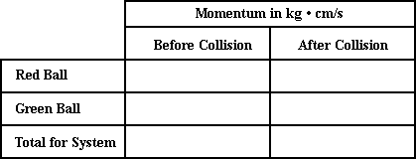

Fill in the momentum table and determine the final velocity of green ball. Use the notation that east is the positive direction and west is the negative direction.

**Question 18:**

aa. A 0.850-kg red ball moving east at 72.0 cm/s collides with a 0.600-kg green ball that is moving east at 32.0 cm/s. After the collision, the red ball moves east at 39.0 cm/s. Assume the system is isolated.



Fill in the momentum table and determine the final velocity of green ball. Use the notation that east is the positive direction and west is the negative direction.

**Question 19:**

aa. A 0.400-kg red ball moving east at 84.0 cm/s collides with a 0.750-kg green ball that is moving east at 18.0 cm/s. After the collision, the red ball moves west at 2.0 cm/s. Assume the system is isolated.



Fill in the momentum table and determine the final velocity of green ball. Use the notation that east is the positive direction and west is the negative direction.

**Question 20:**

aa. A 0.300-kg red ball moving east at 76.0 cm/s collides with a 0.950-kg green ball that is moving east at 12.0 cm/s. After the collision, the red ball moves west at 21.0 cm/s. Assume the system is isolated.



Fill in the momentum table and determine the final velocity of green ball. Use the notation that east is the positive direction and west is the negative direction.

**Question 21:**

aa. A 0.550-kg red ball moving east at 56.0 cm/s collides with a 0.650-kg green ball that is moving west at 22.0 cm/s. After the collision, the red ball moves west at 28.0 cm/s. Assume the system is isolated.



Fill in the momentum table and determine the final velocity of green ball. Use the notation that east is the positive direction and west is the negative direction.

**Question 22:**

aa. A 0.650-kg red ball moving east at 56.0 cm/s collides with a 0.550-kg green ball that is moving west at 36.0 cm/s. After the collision, the red ball moves west at 28.0 cm/s. Assume the system is isolated.



Fill in the momentum table and determine the final velocity of green ball. Use the notation that east is the positive direction and west is the negative direction.

**Question 23:**

aa. A 0.3500-kg red ball moving east at 22.0 cm/s collides with a 0.700-kg green ball that is moving west at 56.0 cm/s. After the collision, the red ball moves west at 82.0 cm/s. Assume the system is isolated.



Fill in the momentum table and determine the final velocity of green ball. Use the notation that east is the positive direction and west is the negative direction.

**Question 24:**

aa. A 0.250-kg red ball moving east at 34.0 cm/s collides with a 0.750-kg green ball that is moving west at 42.0 cm/s. After the collision, the red ball moves west at 80 cm/s. Assume the system is isolated.



Fill in the momentum table and determine the final velocity of green ball. Use the notation that east is the positive direction and west is the negative direction.

**MC10: Momentum and Proportional Reasoning**

**Question 1:**

aa. A brick with a mass of 'M' is dropped from rest upon a cart with a mass of '2M'. Before the collision, the cart was moving with a speed of 30.0 cm/s. After the collision, the cart and the brick move with a speed of ____ cm/s. Enter a numerical answer.

**Question 2:**

aa. A brick with a mass of 'M' is dropped from rest upon a cart with a mass of '3M'. Before the collision, the cart was moving with a speed of 30.0 cm/s. After the collision, the cart and the brick move with a speed of ____ cm/s. Enter a numerical answer.

**Question 3:**

aa. A brick with a mass of '2M' is dropped from rest upon a cart with a mass of 'M'. Before the collision, the cart was moving with a speed of 30.0 cm/s. After the collision, the cart and the brick move with a speed of ____ cm/s. Enter a numerical answer.

**Question 4:**

aa. A brick with a mass of '3M' is dropped from rest upon a cart with a mass of 'M'. Before the collision, the cart was moving with a speed of 30.0 cm/s. After the collision, the cart and the brick move with a speed of ____ cm/s. Enter a numerical answer.

**Question 5:**

aa. A roller skater with a mass of '2M' is moving along the ice with a speed of 6.0 m/s. She collides head-on with a stationary skater who has a mass of 'M.' After the collision, the two skaters grab onto each other (without spinning or losing their balance) and move with a speed of ____ m/s. Enter a numerical answer.

**Question 6:**

aa. A roller skater with a mass of '3M' is moving along the ice with a speed of 6.0 m/s. She collides head-on with a stationary skater who has a mass of 'M.' After the collision, the two skaters grab onto each other (without spinning or losing their balance) and move with a speed of ____ m/s. Enter a numerical answer.

**Question 7:**

aa. A roller skater with a mass of 'M' is moving along the ice with a speed of 6.0 m/s. She collides head-on with a stationary skater who has a mass of '2M.' After the collision, the two skaters grab onto each other (without spinning or losing their balance) and move with a speed of ____ m/s. Enter a numerical answer.

**Question 8:**

aa. A roller skater with a mass of 'M' is moving along the ice with a speed of 6.0 m/s. She collides head-on with a stationary skater who has a mass of '3M.' After the collision, the two skaters grab onto each other (without spinning or losing their balance) and move with a speed of ____ m/s. Enter a numerical answer.

**Question 9:**

aa. A big fish with a mass of '3M' is at rest. A little fish with a mass of 'M' is moving towards it at 40.0 cm/s. The big fish opens its mouth and catches the little fish. After lunch, the two fish move together with a speed of ___ cm/s. Enter a numerical answer.

**Question 10:**

aa. A big fish with a mass of '4M' is at rest. A little fish with a mass of 'M' is moving towards it at 40.0 cm/s. The big fish opens its mouth and catches the little fish. After lunch, the two fish move together with a speed of ___ cm/s. Enter a numerical answer.

**Question 11:**

aa. A big fish with a mass of '4M' is at rest. A little fish with a mass of 'M' is moving towards it at 60.0 cm/s. The big fish opens its mouth and catches the little fish. After lunch, the two fish move together with a speed of ___ cm/s. Enter a numerical answer.

**Question 12:**

aa. A big fish with a mass of '5M' is at rest. A little fish with a mass of 'M' is moving towards it at 60.0 cm/s. The big fish opens its mouth and catches the little fish. After lunch, the two fish move together with a speed of ___ cm/s. Enter a numerical answer.

**Question 13:**

aa. A small fish with a mass of 'M' is at rest. A big fish with a mass of '3M' is swimming towards it with a speed of 30 cm/s. The big fish opens its mouth and catches the little fish. After lunch, the two fish move together with a speed of ___ cm/s. Enter a numerical answer.

**Question 14:**

aa. A small fish with a mass of 'M' is at rest. A big fish with a mass of '4M' is swimming towards it with a speed of 30 cm/s. The big fish opens its mouth and catches the little fish. After lunch, the two fish move together with a speed of ___ cm/s. Enter a numerical answer.

**Question 15:**

aa. A small fish with a mass of 'M' is at rest. A big fish with a mass of '4M' is swimming towards it with a speed of 40 cm/s. The big fish opens its mouth and catches the little fish. After lunch, the two fish move together with a speed of ___ cm/s. Enter a numerical answer.

**Question 16:**

aa. A small fish with a mass of 'M' is at rest. A big fish with a mass of '5M' is swimming towards it with a speed of 40 cm/s. The big fish opens its mouth and catches the little fish. After lunch, the two fish move together with a speed of ___ cm/s. Enter a numerical answer.

**Question 17:**

aa. In a Physics lab, a cart with a mass of 'M' is moving with a speed of 60 cm/s. It collides with a stationary cart with a mass of '2M'. After the collision, the two carts stick together and move with a speed of ____ cm/s. Enter a numerical answer.

**Question 18:**

aa. In a Physics lab, a cart with a mass of 'M' is moving with a speed of 60 cm/s. It collides with a stationary cart with a mass of '3M'. After the collision, the two carts stick together and move with a speed of ____ cm/s. Enter a numerical answer.

**Question 19:**

aa. In a Physics lab, a cart with a mass of 'M' is moving with a speed of 60 cm/s. It collides with a stationary cart with a mass of '4M'. After the collision, the two carts stick together and move with a speed of ____ cm/s. Enter a numerical answer.

**Question 20:**

aa. In a Physics lab, a cart with a mass of 'M' is moving with a speed of 60 cm/s. It collides with a stationary cart with a mass of '5M'. After the collision, the two carts stick together and move with a speed of ____ cm/s. Enter a numerical answer.

**Question 21:**

aa. In a Physics lab, a cart with a mass of '2M' is moving with a speed of 60 cm/s. It collides with a stationary cart with a mass of 'M'. After the collision, the two carts stick together and move with a speed of ____ cm/s. Enter a numerical answer.

**Question 22:**

aa. In a Physics lab, a cart with a mass of '3M' is moving with a speed of 60 cm/s. It collides with a stationary cart with a mass of 'M'. After the collision, the two carts stick together and move with a speed of ____ cm/s. Enter a numerical answer.

**Question 23:**

aa. In a Physics lab, a cart with a mass of '4M' is moving with a speed of 60 cm/s. It collides with a stationary cart with a mass of 'M'. After the collision, the two carts stick together and move with a speed of ____ cm/s. Enter a numerical answer.

**Question 24:**

aa. In a Physics lab, a cart with a mass of '5M' is moving with a speed of 60 cm/s. It collides with a stationary cart with a mass of 'M'. After the collision, the two carts stick together and move with a speed of ____ cm/s. Enter a numerical answer.

**Question 25:**

aa. Two carts are at rest upon a track and connected by a compressed spring. The spring is released, pushing upon the two carts such that it propels them in opposite directions. One cart has a mass of '2M' and is propelled with a speed of 30 cm/s. The second cart has a mass of 'M' and is propelled with a speed of ____ cm/s. Enter a numerical answer.

**Question 26:**

aa. Two carts are at rest upon a track and connected by a compressed spring. The spring is released, pushing upon the two carts such that it propels them in opposite directions. One cart has a mass of 'M' and is propelled with a speed of 40 cm/s. The second cart has a mass of '2M' and is propelled with a speed of ____ cm/s. Enter a numerical answer.

**Question 27:**

aa. Two carts are at rest upon a track and connected by a compressed spring. The spring is released, pushing upon the two carts such that it propels them in opposite directions. One cart has a mass of '3M' and is propelled with a speed of 20 cm/s. The second cart has a mass of '2M' and is propelled with a speed of ____ cm/s. Enter a numerical answer.

**Question 28:**

aa. Two carts are at rest upon a track and connected by a compressed spring. The spring is released, pushing upon the two carts such that it propels them in opposite directions. One cart has a mass of '2M' and is propelled with a speed of 40 cm/s. The second cart has a mass of '3M' and is propelled with a speed of ____ cm/s. Enter a numerical answer.