**Minds On Physics Question Banks – Newton’s Laws**

**NL1: Inertia, Mass and Newton’s First Law**

**Question 1:**

aa. TRUE or FALSE:

Inertia is a force that keeps stationary objects at rest and moving objects in motion at a constant velocity.

a. TRUE b. FALSE

**Question 2:**

aa. TRUE or FALSE:

Inertia is a force that keeps stationary objects at rest and moving objects in motion at a constant velocity.

a. TRUE b. FALSE

**Question 3:**

aa. TRUE or FALSE:

Inertia is NOT a force. A rightward-moving object naturally maintains its state of rightward motion in the absence of forces. A rightward force is not required to keep such an object moving rightward.

a. TRUE b. FALSE

**Question 4:**

aa. TRUE or FALSE:

A rightward-moving object would naturally and ultimately come to rest in the absence of forces. A rightward force is required to keep such an object moving rightward. Inertia is the general name given to that force.

a. TRUE b. FALSE

**Question 5:**

aa. Suppose that an astronaut throws a rock in outer space at a location far from significant influences of gravity and air resistance. One would expect that the rock would ____.

a. eventually stop since all objects ultimately "lose their steam"

b. continue in motion with the same speed and direction

c. eventually stop as its inertia slowly becomes used up

d. either a, b, or c -- depending on whether the astronaut continues to push it

**Question 6:**

aa. Suppose that an astronaut throws a rock in outer space at a location far from significant influences of gravity and air resistance. One would expect that the rock would ____.

a. eventually stop since all objects ultimately "lose their steam"

b. eventually stop as its inertia slowly becomes used up

c. continue in motion with the same speed and direction

d. either a, b, or c -- depending on whether the astronaut continues to push it

**Question 7:**

aa. Suppose that an astronaut throws a rock in outer space at a location far from significant influences of gravity and air resistance. One would expect that the rock would ____.

a. continue in motion with the same speed and direction

b. eventually stop as its inertia slowly becomes used up

c. eventually stop since all objects ultimately "lose their steam"

d. either a, b, or c -- depending on whether the astronaut continues to push it

**Question 8:**

aa. When all individual forces acting on an object are balanced, it is the natural tendency of an object to _____. List all that apply in alphabetical order with no spaces between letters.

a. maintain its state of motion

b. eventually stop

c. accelerate

d. either speed up, slow down or keep the same speed

e. keep its velocity constant (either at a zero or non-zero value)

f. either stay at rest or come to a rest position

**Question 9:**

aa. When all individual forces acting on an object are balanced, it is the natural tendency of an object to _____. List all that apply in alphabetical order with no spaces between letters.

a. eventually stop

b. accelerate

c. maintain its state of motion

d. either speed up, slow down or keep the same speed

e. either stay at rest or come to a rest position

f. keep its velocity constant (either at a zero or non-zero value)

**Question 10:**

aa. When all individual forces acting on an object are balanced, it is the natural tendency of an object to _____. List all that apply in alphabetical order with no spaces between letters.

a. either stay at rest or come to a rest position

b. either speed up, slow down or keep the same speed

c. accelerate

d. maintain its state of motion

e. keep its velocity constant (either at a zero or non-zero value)

f. eventually stop

**Question 11:**

aa. When all individual forces acting on an object are balanced, it is the natural tendency of an object to _____. List all that apply in alphabetical order with no spaces between letters.

a. eventually stop

b. either stay at rest or come to a rest position

c. either speed up, slow down or keep the same speed

d. accelerate

e. keep its velocity constant (either at a zero or non-zero value)

f. maintain its state of motion

**Question 12:**

aa. The law of inertia (Newton's first law) applies _____.

a. to moving objects only

b. only to objects that are not moving

c. to both moving and nonmoving objects

**Question 13:**

aa. The law of inertia (Newton's first law) applies _____.

a. only to objects that are not moving

b. to moving objects

c. to both moving and nonmoving objects

**Question 14:**

aa. The law of inertia (Newton's first law) applies _____.

a. to both moving and nonmoving objects

b. only to moving objects

c. only to objects that are not moving

**Question 15:**

aa. Inertia refers to _____. List all that apply in alphabetical order with no spaces between letters.

a. the force that keeps stationary objects at rest

b. the force which keeps moving objects in motion with a constant velocity

c. the tendency of moving objects to remain in motion

d. the tendency of stationary objects to remain at rest

e. all of the above

**Question 16:**

aa. Inertia refers to _____. List all that apply in alphabetical order with no spaces between letters.

a. the tendency of moving objects to remain in motion

b. the tendency of stationary objects to remain at rest

c. the force that keeps stationary objects at rest

d. the force which keeps moving objects in motion with a constant velocity

e. all of the above

**Question 17:**

aa. Inertia refers to _____. List all that apply in alphabetical order with no spaces between letters.

a. the force that keeps stationary objects at rest

b. the tendency of stationary objects to remain at rest

c. the tendency of moving objects to remain in motion

d. the force which keeps moving objects in motion with a constant velocity

e. all of the above

**Question 18:**

aa. Inertia refers to _____. List all that apply in alphabetical order with no spaces between letters.

a. the tendency of moving objects to remain in motion

b. the force which keeps moving objects in motion with a constant velocity

c. the force that keeps stationary objects at rest

d. the tendency of stationary objects to remain at rest

e. all of the above

**Question 19:**

aa. A sled slides down a hill, reaches the level surface and eventually comes to a stop. The fact that the sled ultimately stops is best explained by ____. List all that apply in alphabetical order with no spaces between letters.

a. the presence of inertia causes it to stop

b. the natural tendency of any object is to ultimately stop

c. an unbalanced force would be required to keep the sled moving forward at constant speed

d. the presence of an unbalanced force (e.g., friction) can cause a moving object to stop

**Question 20:**

aa. A sled slides down a hill, reaches the level surface and eventually comes to a stop. The fact that the sled ultimately stops is best explained by ____. List all that apply in alphabetical order with no spaces between letters.

a. the natural tendency of any object is to ultimately stop

b. the presence of inertia causes it to stop

c. the presence of an unbalanced force (e.g., friction) can cause a moving object to stop

d. an unbalanced force would be required to keep the sled moving forward at constant speed

**Question 21:**

aa. A sled slides down a hill, reaches the level surface and eventually comes to a stop. The fact that the sled ultimately stops is best explained by ____. List all that apply in alphabetical order with no spaces between letters.

a. an unbalanced force would be required to keep the sled moving forward at constant speed

b. the presence of an unbalanced force (e.g., friction) can cause a moving object to stop

c. the presence of inertia causes it to stop

d. the natural tendency of any object is to ultimately stop

**Question 22:**

aa. A sled slides down a hill, reaches the level surface and eventually comes to a stop. The fact that the sled ultimately stops is best explained by ____. List all that apply in alphabetical order with no spaces between letters.

a. the presence of an unbalanced force (e.g., friction) can cause a moving object to stop

b. an unbalanced force would be required to keep the sled moving forward at constant speed

c. the natural tendency of any object is to ultimately stop

d. the presence of inertia causes it to stop

**Question 23:**

aa. Mac and Tosh are arguing in the cafeteria. Tosh says that if he flings the jello with a greater speed it will have a greater inertia. Mac argues that inertia does NOT depend upon speed, but rather upon mass. Who is correct?

a. Mac b. Tosh

c. Neither are correct in the conception of inertia.

**Question 24:**

aa. Mac and Tosh are arguing in the cafeteria. Mac says that if he flings the jello with a greater speed it will have a greater inertia. Tosh argues that inertia does NOT depend upon speed, but rather upon mass. Who is correct?

a. Mac b. Tosh

c. Neither are correct in the conception of inertia.

**Question 25:**

aa. Jack and Jill are arguing in the cafeteria. Jack says that if he flings the jello with a greater speed it have a greater inertia. Jill argues that inertia does NOT depend upon speed, but rather upon mass. Who is correct?

a. Jack b. Jill

c. Neither are correct in the conception of inertia.

**Question 26:**

aa. Jack and Jill are arguing in the cafeteria. Jill says that if she flings the jello with a greater speed it will have a greater inertia. Jack argues that inertia does NOT depend upon speed, but rather upon mass. Who is correct?

a. Jack b. Jill

c. Neither are correct in the conception of inertia.

**Question 27:**

aa. An object will not have any inertia if it is _____. List all that apply in alphabetical order with no spaces between letters.

a. in space b. at rest

c. accelerating d. moving in a circle

e. acted upon by an unbalanced force f. ...nonsense! All objects have inertia.

**Question 28:**

aa. An object will not have any inertia if it is _____. List all that apply in alphabetical order with no spaces between letters.

a. accelerating b. at rest

c. in space d. acted upon by an unbalanced force

e. ...nonsense! All objects have inertia.

**Question 29:**

aa. An object will not have any inertia if it is _____. List all that apply in alphabetical order with no spaces between letters.

a. in space b. at rest

c. accelerating d. moving in a circle

e. acted upon by an unbalanced force f. moving along an inclined surface (i.e., a hill)

g. ...nonsense! All objects have inertia.

**Question 30:**

aa. An object will not have any inertia if it is _____. List all that apply in alphabetical order with no spaces between letters.

a. accelerating b. acted upon by an unbalanced force

c. moving in a circle d. at rest

e. in space f. moving along an inclined surface (i.e., a hill)

g. changing direction h. ...nonsense! All objects have inertia.

**Question 31:**

aa. The velocities and masses of four objects are shown.

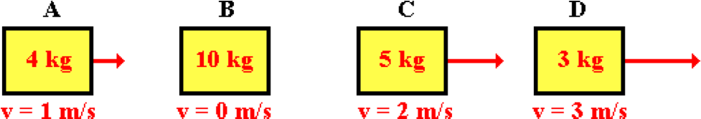

Rank these objects in order of their inertia, from least to greatest. (Type the four letters in the appropriate order with no spaces between letters.)

**Question 32:**

aa. The velocities and masses of four objects are shown.



Rank these objects in order of their inertia, from greatest to least. (Type the four letters in the appropriate order with no spaces between letters.)

**Question 33:**

aa. The velocities and masses of four objects are shown.

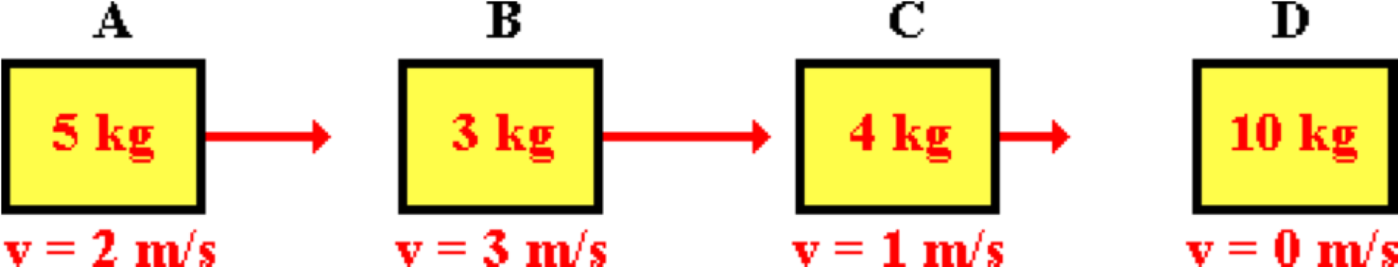

Rank these objects in order of their inertia, from least to greatest. (Type the four letters in the appropriate order with no spaces between letters.)

**Question 34:**

aa. The velocities and masses of four objects are shown.

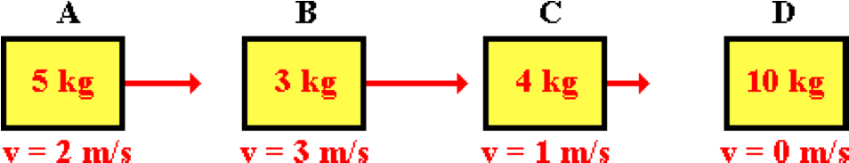

Rank these objects in order of their inertia, from greatest to least. (Type the four letters in the appropriate order with no spaces between letters.)

**Question 35:**

aa. Different forces are applied to objects of varying mass. The resulting accelerations are shown.

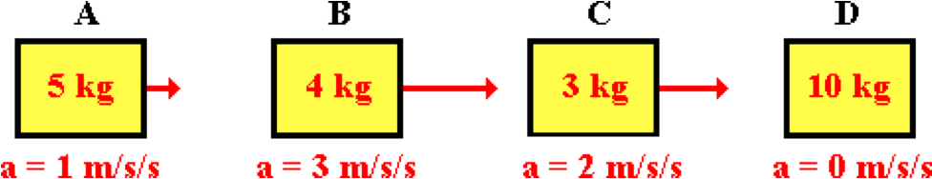

Rank these objects in order of their inertia, from least to greatest. (Type the four letters in the appropriate order with no spaces between letters.)

**Question 36:**

aa. Different forces are applied to objects of varying mass. The resulting accelerations are shown.



Rank these objects in order of their inertia, from greatest to least. (Type the four letters in the appropriate order with no spaces between letters.)

**Question 37:**

aa. Different forces are applied to objects of varying mass. The resulting accelerations are shown.

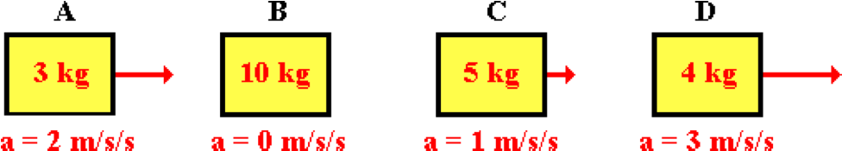

Rank these objects in order of their inertia, from least to greatest. (Type the four letters in the appropriate order with no spaces between letters.)

**Question 38:**

aa. Different forces are applied to objects of varying mass. The resulting accelerations are shown.



Rank these objects in order of their inertia, from greatest to least. (Type the four letters in the appropriate order with no spaces between letters.)

**NL2: Balanced Forces**

**Question 1:**

aa. A ball is thrown vertically upwards. After the ball is released and is moving upwards towards its peak, it slows down. During this time, ____.

a. the ball is experiencing an unbalanced force; it is directed downwards.

b. the ball is experiencing an unbalanced force; it is directed upwards.

c. there are no forces whatsoever acting upon the ball.

d. the forces acting upon the ball are balanced.

e. none of these

**Question 2:**

aa. A ball is thrown vertically upwards. After the ball is released and is moving upwards towards its peak, it slows down. During this time, ____.

a. there are no forces whatsoever acting upon the ball.

b. the forces acting upon the ball are balanced.

c. the ball is experiencing an unbalanced force; it is directed downwards.

d. the ball is experiencing an unbalanced force; it is directed upwards.

e. none of these

**Question 3:**

aa. A ball is thrown vertically upwards. After the ball is released and is moving upwards towards its peak, it slows down. During this time, ____.

a. there are no forces whatsoever acting upon the ball.

b. the ball is experiencing an unbalanced force; it is directed downwards.

c. the ball is experiencing an unbalanced force; it is directed upwards.

d. the forces acting upon the ball are balanced.

e. none of these

**Question 4:**

aa. A ball is thrown vertically upwards. After the ball is released and is moving upwards towards its peak, it slows down. During this time, ____.

a. the forces acting upon the ball are balanced.

b. the ball is experiencing an unbalanced force; it is directed upwards.

c. the ball is experiencing an unbalanced force; it is directed downwards.

d. there are no forces whatsoever acting upon the ball.

e. none of these

**Question 5:**

aa. When all individual forces acting upon an object are balanced, it is the natural tendency of the object to _____. List all that apply in alphabetical order with no spaces between letters.

a. maintain their state of motion

b. eventually stop

c. accelerate

d. either speed up, slow down or keep the same speed

e. keep their velocity constant (either at zero or non-zero)

f. either stay at rest or come to a rest position

**Question 6:**

aa. When all individual forces acting upon an object are balanced, it is the natural tendency of the object to _____. List all that apply in alphabetical order with no spaces between letters.

a. eventually stop

b. accelerate

c. maintain their state of motion

d. either speed up, slow down or keep the same speed

e. either stay at rest or come to a rest position

f. keep their velocity constant (either at zero or non-zero)

**Question 7:**

aa. When all individual forces acting upon an object are balanced, it is the natural tendency of the object to _____. List all that apply in alphabetical order with no spaces between letters.

a. either stay at rest or come to a rest position

b. either speed up, slow down or keep the same speed

c. accelerate

d. maintain their state of motion

e. keep their velocity constant (either at zero or non-zero)

f. eventually stop

**Question 8:**

aa. When all individual forces acting upon an object are balanced, it is the natural tendency of the object to _____. List all that apply in alphabetical order with no spaces between letters.

a. eventually stop

b. either stay at rest or come to a rest position

c. either speed up, slow down or keep the same speed

d. accelerate

e. keep their velocity constant (either at zero or non-zero)

f. maintain their state of motion

**Question 9:**

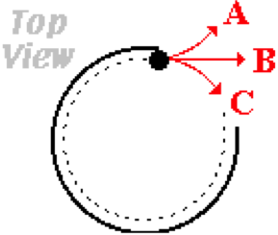aa. Mr. S guides a golf ball around the outside rim of the green at the Hole-In-One Putt-Putt Golf Course. When the ball leaves the rim, which path (A, B, or C) will the golf ball follow?

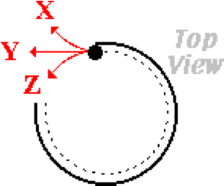**Question 10:**

aa. Mr. S guides a golf ball around the outside rim of the green at the Hole-In-One Putt-Putt Golf Course. When the ball leaves the rim, which path (X, Y, or Z) will the golf ball follow?

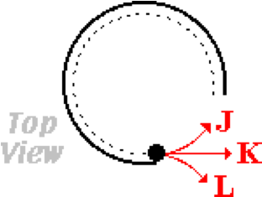**Question 11:**

aa. Mr. S guides a golf ball around the outside rim of the green at the Hole-In-One Putt-Putt Golf Course. When the ball leaves the rim, which path (J, K, or I) will the golf ball follow?

**Question 12:**

aa. The forces acting upon an object are BALANCED. Therefore, one can be absolutely certain that the object ____. List all that apply in alphabetical order with no spaces between letters.

a. is at rest

b. is not moving

c. is moving and moving in a straight line

d. is moving

e. is moving and moving with a constant velocity

f. is accelerating

g. is not accelerating

**Question 13:**

aa. The forces acting upon an object are BALANCED. Therefore, one can be absolutely certain that the object ____. List all that apply in alphabetical order with no spaces between letters.

a. is moving and moving in a straight line

b. is moving and moving with a constant velocity

c. is at rest

d. is not moving

e. is accelerating

f. is not accelerating

g. is moving

**Question 14:**

aa. The forces acting upon an object are BALANCED. Therefore, one can be absolutely certain that the object ____. List all that apply in alphabetical order with no spaces between letters.

a. is at rest

b. has an acceleration of 0 m/s/s

c. is moving and moving in a straight line

d. is moving and moving with a constant velocity

e. has a velocity of 0 m/s

f. is not accelerating

g. is accelerating

**Question 15:**

aa. The forces acting upon an object are BALANCED. Therefore, one can be absolutely certain that the object ____. List all that apply in alphabetical order with no spaces between letters.

a. has an acceleration of 0 m/s/s

b. has a velocity of 0 m/s

c. is accelerating

d. is at rest

e. is not accelerating

f. is moving and moving in a straight line

g. is moving and moving with a constant velocity

**Question 16:**

aa. The forces acting upon an object are NOT BALANCED. Therefore, one can be absolutely certain that the object ____. List all that apply in alphabetical order with no spaces between letters.

a. is at rest

b. is not moving

c. is moving and moving in a straight line

d. is changing its velocity

e. is moving and moving with a constant velocity

f. is accelerating

g. is not accelerating

**Question 17:**

aa. The forces acting upon an object are NOT BALANCED. Therefore, one can be absolutely certain that the object ____. List all that apply in alphabetical order with no spaces between letters.

a. is moving and moving in a straight line

b. is moving and moving with a constant velocity

c. is at rest

d. is not moving

e. is accelerating

f. is not accelerating

g. is changing its velocity

**Question 18:**

aa. The forces acting upon an object are NOT BALANCED. Therefore, one can be absolutely certain that the object ____. List all that apply in alphabetical order with no spaces between letters.

a. is at rest

b. has an acceleration of 0 m/s/s

c. is moving and moving in a straight line

d. is moving and moving with a constant velocity

e. has a velocity of 0 m/s

f. is not accelerating

g. is accelerating

**Question 19:**

aa. The forces acting upon an object are NOT BALANCED. Therefore, one can be absolutely certain that the object ____. List all that apply in alphabetical order with no spaces between letters.

a. has an acceleration of 0 m/s/s

b. has a velocity of 0 m/s

c. is accelerating

d. is at rest

e. is not accelerating

f. is moving and moving in a straight line

g. is moving and moving with a constant velocity

**Question 20:**

aa. If you were in a spaceship and fired a cannonball into frictionless space, the amount of force needed to keep the cannonball in motion would be ____.

a. more than the force with which it was fired

b. less than the force with which it was fired

c. equal to the force with which it was fired

d. equal to the weight of the cannonball

e. zero, since no force is necessary to keep an object moving

**Question 21:**

aa. If you were in a spaceship and fired a cannonball into frictionless space, the amount of force needed to keep the cannonball in motion would be ____.

a. equal to the weight of the cannonball

b. zero, since no force is necessary to keep an object moving

c. equal to the force with which it was fired

d. more than the force with which it was fired

e. less than the force with which it was fired

**Question 22:**

aa. If you were in a spaceship and fired a cannonball into frictionless space, the amount of force needed to keep the cannonball in motion would be ____.

a. equal to the force with which it was fired

b. more than the force with which it was fired

c. less than the force with which it was fired

d. zero, since no force is necessary to keep an object moving

e. equal to the weight of the cannonball

**Question 23:**

aa. An object moving at a constant velocity MUST _____. Choose one.

a. have a net force acting on it

b. eventually stop due to the force of gravity

c. not have a force of gravity acting on it

d. be experiencing a balance of forces

e. not have a force of friction acting on it

f. not have any forces exerted upon it

g. none of these

**Question 24:**

aa. An object moving at a constant velocity MUST _____. Choose one.

a. not have a force of friction acting on it

b. not have any forces exerted upon it

c. be experiencing a balance of forces

d. have a net force acting on it

e. eventually stop due to the force of gravity

f. not have a force of gravity acting on it

g. none of these

**Question 25:**

aa. An object moving at a constant velocity MUST _____. Choose one.

a. be experiencing a balance of forces

b. have a net force acting on it

c. not have a force of friction acting on it

d. eventually stop due to the force of gravity

e. not have any forces exerted upon it

f. not have a force of gravity acting on it

g. none of these

**Question 26:**

aa. An object moving at a constant velocity MUST _____. Choose one.

a. not have any forces exerted upon it

b. eventually stop due to the force of gravity

c. have a net force acting on it

d. not have a force of friction acting on it

e. not have a force of gravity acting on it

f. be experiencing a balance of forces

g. none of these

**Question 27:**

aa. The diagrams below depict the individual forces acting upon an object. Each arrow represents a force and the length of the arrow represents the size of the force.

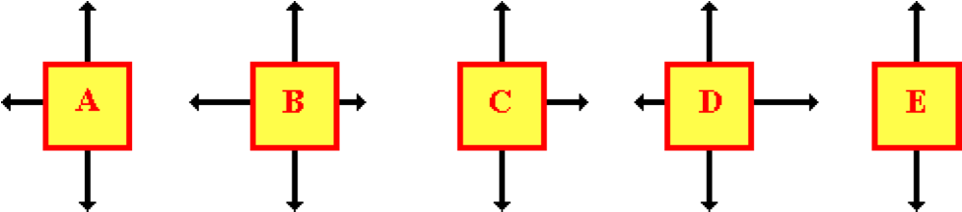

Based on this information, which objects could be moving to the right at a constant speed? List all that apply in alphabetical order with no spaces between letters.

**Question 28:**

aa. The diagrams below depict the individual forces acting upon an object. Each arrow represents a force and the length of the arrow represents the size of the force.

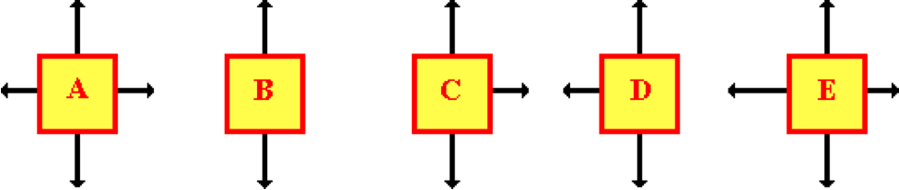

Based on this information, which objects could be moving to the right at a constant speed? List all that apply in alphabetical order with no spaces between letters.

**Question 29:**

aa. The diagrams below depict the individual forces acting upon an object. Each arrow represents a force and the length of the arrow represents the size of the force.

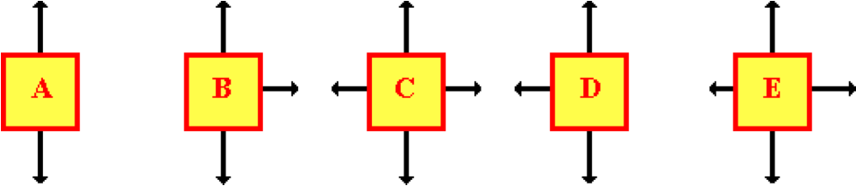

Based on this information, which objects could be moving to the right at a constant speed? List all that apply in alphabetical order with no spaces between letters.

**Question 30:**

aa. The diagrams below depict the individual forces acting upon an object. Each arrow represents a force and the length of the arrow represents the size of the force.

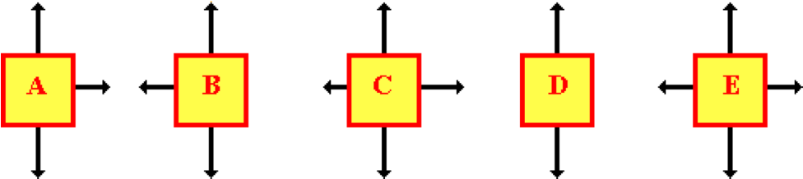

Based on this information, which objects could be moving to the right at a constant speed? List all that apply in alphabetical order with no spaces between letters.

**Question 31:**

aa. The diagrams below depict the individual forces acting upon an object. Each arrow represents a force and the length of the arrow represents the size of the force.



Based on this information, which objects could be moving to the right? List all that apply in alphabetical order with no spaces between letters.

**Question 32:**

aa. The diagrams below depict the individual forces acting upon an object. Each arrow represents a force and the length of the arrow represents the size of the force.



Based on this information, which objects could be moving to the right? List all that apply in alphabetical order with no spaces between letters.

**Question 33:**

aa. The diagrams below depict the individual forces acting upon an object. Each arrow represents a force and the length of the arrow represents the size of the force.



Based on this information, which objects could be moving to the right? List all that apply in alphabetical order with no spaces between letters.

**Question 34:**

aa. The diagrams below depict the individual forces acting upon an object. Each arrow represents a force and the length of the arrow represents the size of the force.



Based on this information, which objects could be moving to the right? List all that apply in alphabetical order with no spaces between letters.

**Question 35:**

aa. The oil drop diagram below depicts the motion of a rightward-moving object.

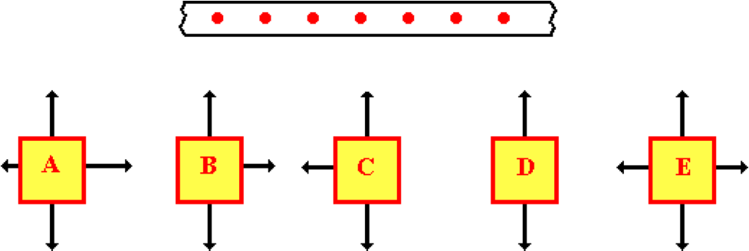

Which one of the force diagrams is consistent with the oil drop diagram? (The arrows on the force diagrams represent forces; the length represents the size of the force.) List all that apply in alphabetical order with no spaces between letters.

**Question 36:**

aa. The oil drop diagram below depicts the motion of a rightward-moving object.

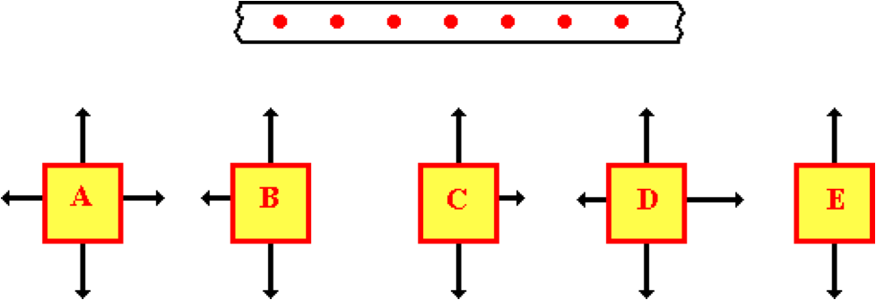

Which one of the force diagrams is consistent with the oil drop diagram? (The arrows on the force diagrams represent forces; the length represents the size of the force.) List all that apply in alphabetical order with no spaces between letters.

**Question 37:**

aa. The oil drop diagram below depicts the motion of a leftward-moving object.

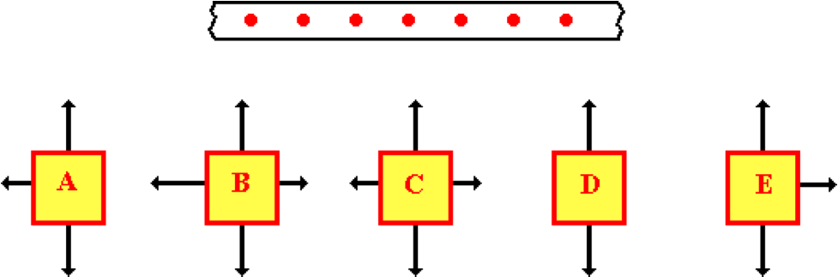

Which one of the force diagrams is consistent with the oil drop diagram? (The arrows on the force diagrams represent forces; the length represents the size of the force.) List all that apply in alphabetical order with no spaces between letters.

**Question 38:**

aa. The oil drop diagram below depicts the motion of a leftward-moving object.

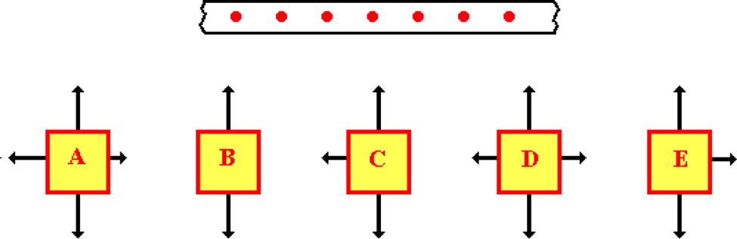

Which one of the force diagrams is consistent with the oil drop diagram? (The arrows on the force diagrams represent forces; the length represents the size of the force.) List all that apply in alphabetical order with no spaces between letters.

**NL3: Unbalanced Forces and Acceleration**

**Question 1:**

aa. The diagrams below depict the individual forces acting upon an object. Each arrow represents a force and the length of the arrow represents the size of the force.



Based on this information, which objects could be moving to the right at a constant speed? List all that apply in alphabetical order with no spaces between letters.

**Question 2:**

aa. The diagrams below depict the individual forces acting upon an object. Each arrow represents a force and the length of the arrow represents the size of the force.

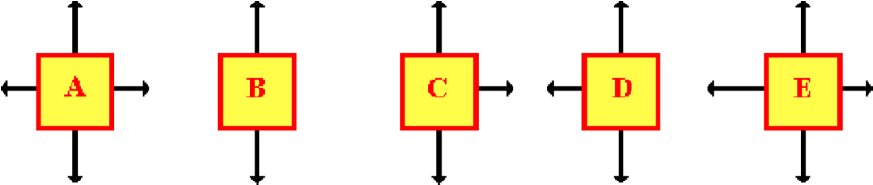

Based on this information, which objects could be moving to the right at a constant speed? List all that apply in alphabetical order with no spaces between letters.

**Question 3:**

aa. The diagrams below depict the individual forces acting upon an object. Each arrow represents a force and the length of the arrow represents the size of the force.



Based on this information, which objects could be moving to the right at a constant speed? List all that apply in alphabetical order with no spaces between letters.

**Question 4:**

aa. The diagrams below depict the individual forces acting upon an object. Each arrow represents a force and the length of the arrow represents the size of the force.



Based on this information, which objects could be moving to the right at a constant speed? List all that apply in alphabetical order with no spaces between letters.

**Question 5:**

aa. The oil drop diagram below depicts the motion of a rightward-moving object.

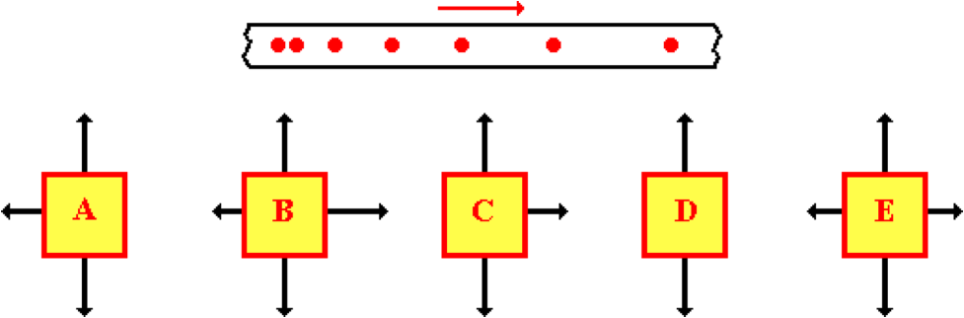

Which of the force diagrams is consistent with the oil drop diagram? (The arrows on the force diagrams represent forces; the length represents the size of the force.) List all that apply in alphabetical order with no spaces between letters.

**Question 6:**

aa. The oil drop diagram below depicts the motion of a rightward-moving object.

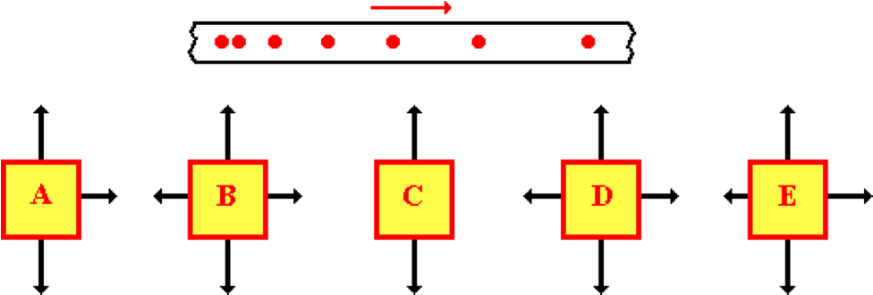

Which of the force diagrams is consistent with the oil drop diagram? (The arrows on the force diagrams represent forces; the length represents the size of the force.) List all that apply in alphabetical order with no spaces between letters.

**Question 7:**

aa. The oil drop diagram below depicts the motion of a leftward-moving object.

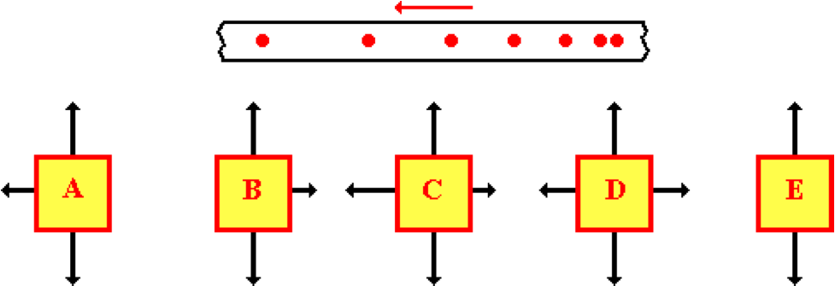

Which of the force diagrams is consistent with the oil drop diagram? (The arrows on the force diagrams represent forces; the length represents the size of the force.) List all that apply in alphabetical order with no spaces between letters.

**Question 8:**

aa. The oil drop diagram below depicts the motion of a leftward-moving object.

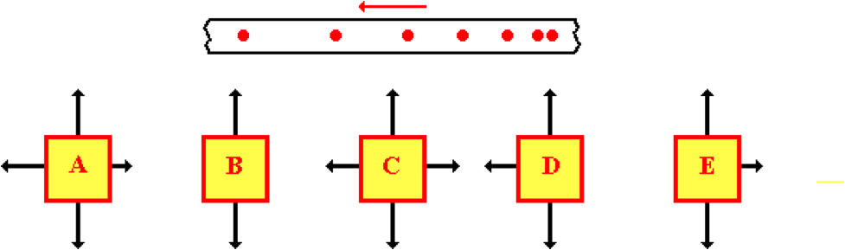

Which of the force diagrams is consistent with the oil drop diagram? (The arrows on the force diagrams represent forces; the length represents the size of the force.) List all that apply in alphabetical order with no spaces between letters.

**Question 9:**

aa. The oil drop diagram below depicts the motion of a rightward-moving object.

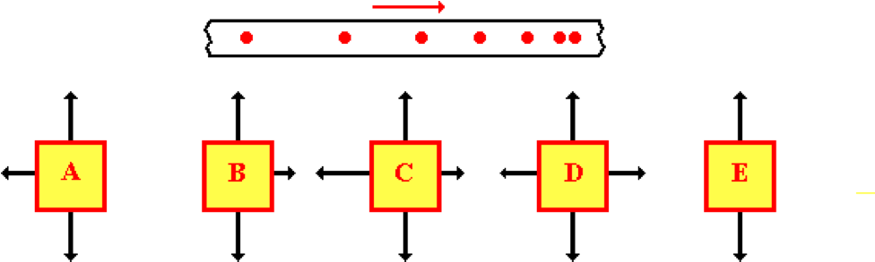

Which of the force diagrams is consistent with the oil drop diagram? (The arrows on the force diagrams represent forces; the length represents the size of the force.) List all that apply in alphabetical order with no spaces between letters.

**Question 10:**

aa. The oil drop diagram below depicts the motion of a rightward-moving object.

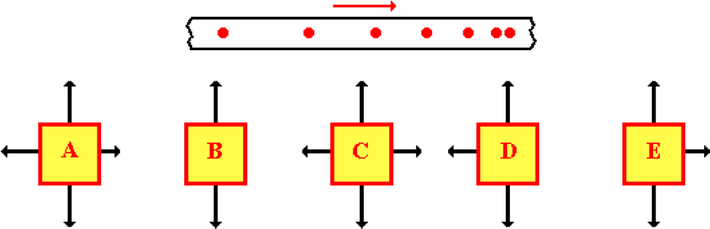

Which of the force diagrams is consistent with the oil drop diagram? (The arrows on the force diagrams represent forces; the length represents the size of the force.) List all that apply in alphabetical order with no spaces between letters.

**Question 11:**

aa. The oil drop diagram below depicts the motion of a leftward-moving object.

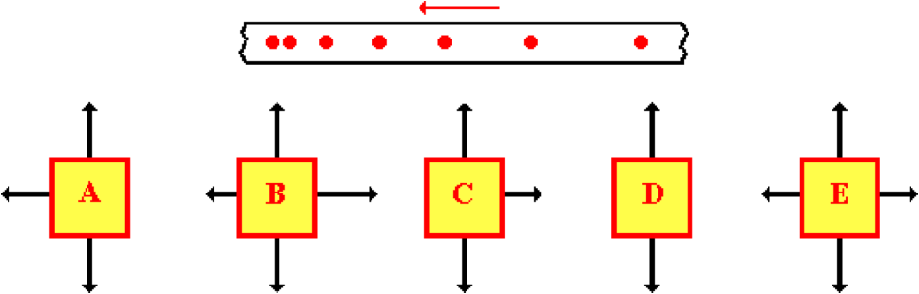

Which of the force diagrams is consistent with the oil drop diagram? (The arrows on the force diagrams represent forces; the length represents the size of the force.) List all that apply in alphabetical order with no spaces between letters.

**Question 12:**

aa. The oil drop diagram below depicts the motion of a leftward-moving object.

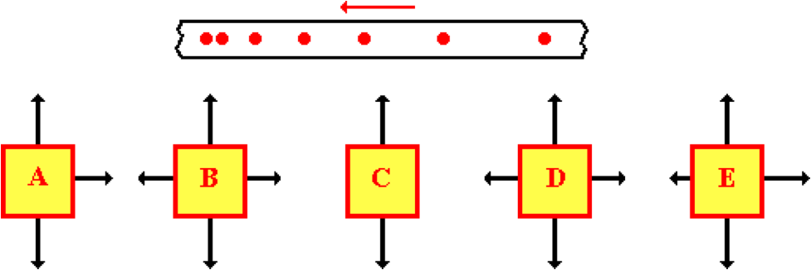

Which of the force diagrams is consistent with the oil drop diagram? (The arrows on the force diagrams represent forces; the length represents the size of the force.) List all that apply in alphabetical order with no spaces between letters.

**Question 13:**

aa. An upward moving elevator is slowing down.

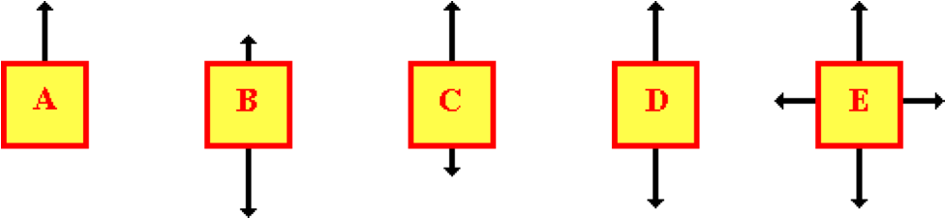

Which of the following force diagrams could be representative of the forces acting upon the elevator? (The arrows on the force diagrams represent forces; the length represents the size of the force.) List all that apply in alphabetical order with no spaces between letters.

**Question 14:**

aa. An upward moving elevator is slowing down.

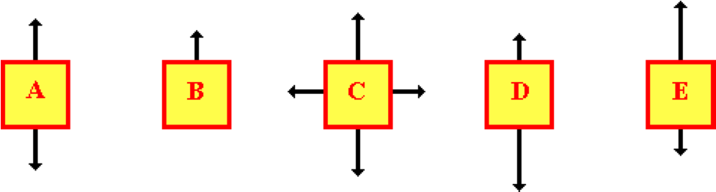

Which of the following force diagrams could be representative of the forces acting upon the elevator? (The arrows on the force diagrams represent forces; the length represents the size of the force.) List all that apply in alphabetical order with no spaces between letters.

**Question 15:**

aa. A downward moving elevator is slowing down.

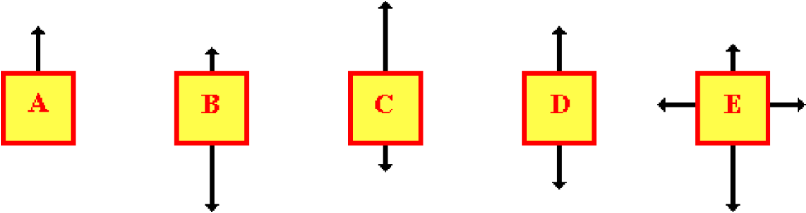

Which of the following force diagrams could be representative of the forces acting upon the elevator? (The arrows on the force diagrams represent forces; the length represents the size of the force.) List all that apply in alphabetical order with no spaces between letters.

**Question 16:**

aa. A downward moving elevator is slowing down.

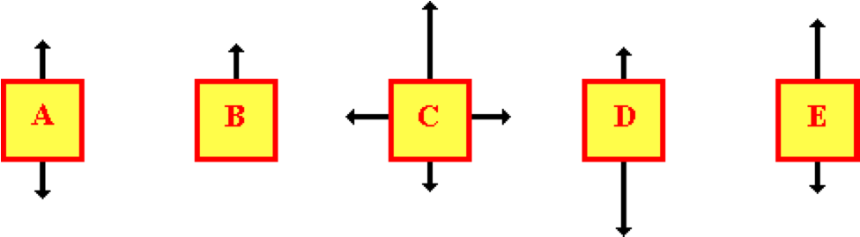

Which of the following force diagrams could be representative of the forces acting upon the elevator? (The arrows on the force diagrams represent forces; the length represents the size of the force.) List all that apply in alphabetical order with no spaces between letters.

**Question 17:**

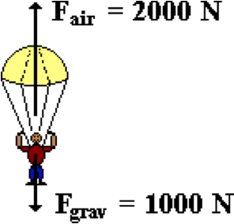aa. A skydiver pulls the chord of his parachute. The forces acting upon the skydiver and his parachute are shown in the diagram at the right. From this diagram, one might infer that ____. List all that apply in alphabetical order with no spaces between letters.

a. The skydiver will immediately stop.

b. The skydiver will begin moving upwards.

c. The skydiver will have an acceleration that is directed upwards.

d. The skydiver will continue to fall, but now will slow down.

e. None of these will occur

**Question 18:**

aa. A skydiver pulls the chord of his parachute. The forces acting upon the skydiver and his parachute are shown in the diagram at the right. From this diagram, one might infer that ____. List all that apply in alphabetical order with no spaces between letters.

a. The skydiver will immediately stop.

b. The skydiver will continue to fall, but now will slow down.

c. The skydiver will begin moving upwards.

d. The skydiver will have an acceleration that is directed upwards.

e. None of these will occur

**Question 19:**

aa. A skydiver pulls the chord of his parachute. The forces acting upon the skydiver and his parachute are shown in the diagram at the right. From this diagram, one might infer that ____. List all that apply in alphabetical order with no spaces between letters.

a. The skydiver will have an acceleration that is directed upwards.

b. The skydiver will begin moving upwards.

c. The skydiver will immediately stop.

d. The skydiver will continue to fall, but now will slow down.

e. None of these will occur

**Question 20:**

aa. Askydiver pulls the chord of his parachute. The forces acting the skydiver and his parachute are shown in the diagram at the right. From this diagram, one might infer that ____. List all that apply in alphabetical order with no spaces between letters.

a. The skydiver will immediately stop.

b. The skydiver will have an acceleration that is directed upwards.

c. The skydiver will continue to fall, but now will slow down.

d. The skydiver will begin moving upwards.

e. None of these will occur

**Question 21:**

aa. A 3-kg object is moving to the right at a constant velocity of 2 m/s. Which one of the following horizontal forces is required to maintain this state of motion?

a. 6 N b. 1.5 N c. 0.667 N d. 0 N

e. none of these

**Question 22:**

aa. A 6-kg object is moving to the right at a constant velocity of 2 m/s. Which one of the following horizontal forces is required to maintain this state of motion?

a. 0 N b. 0.333 N c. 3 N d. 12 N

e. none of these

**Question 23:**

aa. A 10-kg object is moving to the right at a constant velocity of 4 m/s. Which one of the following horizontal forces is required to maintain this state of motion?

a. 40 N b. 0 N c. 2.5 N d. 0.4 N

e. none of these

**Question 24:**

aa. A 12-kg object is moving to the right at a constant velocity of 2 m/s. Which one of the following horizontal forces is required to maintain this state of motion?

a. 6 N b. 0.166 N c. 0 N d. 24 N

e. none of these

**Question 25:**

aa. An object is moving along a level surface with a constant velocity. The net force acting upon the object is _____.

a. in the direction of motion

b. opposite the direction of motion

c. zero

d. ... none of these can be determined without further information.

**Question 26:**

aa. An object is moving along a level surface with a constant velocity. The net force acting upon the object is _____.

a. zero

b. in the direction of motion

c. opposite the direction of motion

d. ... none of these can be determined without further information.

**Question 27:**

aa. An object is moving along a level surface with a constant velocity. The net force acting upon the object is _____.

a. opposite the direction of motion

b. zero

c. in the direction of motion

d. ... none of these can be determined without further information.

**Question 28:**

aa. TRUE or FALSE?

If a moving object experiences an unbalanced force, then the object will have an acceleration that is in the same direction as the direction as the unbalanced force.

a. True b. False

**Question 29:**

aa. TRUE or FALSE?

If a rightward-moving object experiences an unbalanced force, then the object will have an acceleration which is directed to the right.

a. True b. False

**Question 30:**

aa. TRUE or FALSE?

If a leftward-moving object experiences an unbalanced force, then the object will have an acceleration which is directed to the left.

a. True b. False

**Question 31:**

aa. TRUE or FALSE?

If an upward-moving object experiences an unbalanced force, then the object will have an acceleration which is directed upward.

a. True b. False

**Question 32:**

aa. A rightward moving object is coasting to a stop along a straight, level surface. The net force acting upon the object MUST be ____.

a. directed rightward

b. directed leftward

c. zero

d. ... impossible to answer without further information.

**Question 33:**

aa. A rightward moving object is coasting to a stop along a straight, level surface. The net force acting upon the object MUST be ____.

a. zero

b. directed rightward

c. directed leftward

d. ... impossible to answer without further information.

**Question 34:**

aa. A leftward moving object is coasting to a stop along a straight, level surface. The net force acting upon the object MUST be ____.

a. directed rightward

b. zero

c. directed leftward

d. ... impossible to answer without further information.

**Question 35:**

aa. A leftward moving object is coasting to a stop along a straight, level surface. The net force acting upon the object MUST be ____.

a. directed leftward

b. directed rightward

c. zero

d. ... impossible to answer without further information.

**Question 36:**

aa. A westward-moving object is changing its speed. The net force on the object ____.

a. must be zero

b. must be directed westward

c. must be directed eastward

d. must either be directed eastward or westward

e. could be directed eastward or westward or be zero

**Question 37:**

aa. A westward-moving object is changing its speed. The net force on the object ____.

a. must be zero

b. could be directed eastward or westward or be zero

c. must either be directed eastward or westward

d. must be directed westward

e. must be directed eastward

**Question 38:**

aa. A westward-moving object is changing its speed. The net force on the object ____.

a. must be zero

b. could be directed eastward or westward or be zero

c. must either be directed eastward or westward

d. must be directed westward

e must be directed eastward

**Question 39:**

aa. A westward-moving object is changing its speed. The net force on the object ____.

a. must be zero

b. must be directed westward

c. must be directed eastward

d. must either be directed eastward or westward

e. could be directed eastward or westward or be zero

**NL4: Types of Forces**

**Question 1:**

aa. For the following physical situation, identify the forces that are exerted upon the object. List all that apply in alphabetical order with no spaces between letters.

A book is at rest upon a table.

a. Force due to gravity b. Force of Friction

c. Normal Force d. Tension

e. Magnetic Force f. Spring Force

g. Air Resistance h. Applied Force

**Question 2:**

aa. For the following physical situation, identify the forces that are exerted upon the object. List all that apply in alphabetical order with no spaces between letters.

A book is at rest upon a table.

a. Air Resistance b. Force of Friction

c. Force due to gravity d. Magnetic Force

e. Normal Force f. Spring Force

g. Tension h. Applied Force

**Question 3:**

aa. For the following physical situation, identify the forces that are exerted upon the object. List all that apply in alphabetical order with no spaces between letters.

A book is at rest upon a table.

a. Force of Friction b. Air Resistance

c. Normal Force d. Force due to gravity

e. Magnetic Force f. Spring Force

g. Tension h. Applied Force

**Question 4:**

aa. For the following physical situation, identify the forces that are exerted upon the object. List all that apply in alphabetical order with no spaces between letters.

A person is standing upon the ground.

a. Force due to gravity b. Force of Friction

c. Normal Force d. Tension

e. Magnetic Force f. Spring Force

g. Air Resistance h. Applied Force

**Question 5:**

aa. For the following physical situation, identify the forces that are exerted upon the object. List all that apply in alphabetical order with no spaces between letters.

A person is standing upon the ground.

a. Air Resistance b. Force of Friction

c. Force due to gravity d. Magnetic Force

e. Normal Force f. Spring Force

g. Tension h. Applied Force

**Question 6:**

aa. For the following physical situation, identify the forces that are exerted upon the object. List all that apply in alphabetical order with no spaces between letters.

A person is standing upon the ground.

a. Force of Friction b. Air Resistance

c. Normal Force d. Force due to gravity

e. Magnetic Force f. Spring Force

g. Tension h. Applied Force

**Question 7:**

aa. For the following physical situation, identify the forces that are exerted upon the object. List all that apply in alphabetical order with no spaces between letters.

A dog is being slowly pulled by his dog chain across the ground at a constant speed. (Neglect air resistance.)

a. Force due to gravity b. Force of Friction

c. Normal Force d. Tension

e. Magnetic Force f. Spring Force

g. Air Resistance h. Applied Force

**Question 8:**

aa. For the following physical situation, identify the forces that are exerted upon the object. List all that apply in alphabetical order with no spaces between letters.

A dog is being slowly pulled by his dog chain across the ground at a constant speed. (Neglect air resistance.)

a. Air Resistance b. Force of Friction

c. Force due to gravity d. Magnetic Force

e. Normal Force f. Spring Force

g. Tension h. Applied Force

**Question 9:**

aa. For the following physical situation, identify the forces that are exerted upon the object. List all that apply in alphabetical order with no spaces between letters.

A dog is being slowly pulled by his dog chain across the ground at a constant speed. (Neglect air resistance.)

a. Force of Friction b. Air Resistance

c. Normal Force d. Force due to gravity

e. Magnetic Force f. Spring Force

g. Tension h. Applied Force

**Question 10:**

aa. For the following physical situation, identify the forces that are exerted upon the object. List all that apply in alphabetical order with no spaces between letters.

A sign is suspended by two cables and hangs at rest.

a. Force due to gravity b. Force of Friction

c. Normal Force d. Tension

e. Magnetic Force f. Spring Force

g. Air Resistance h. Applied Force

**Question 11:**

aa. For the following physical situation, identify the forces that are exerted upon the object. List all that apply in alphabetical order with no spaces between letters.

A sign is suspended by two cables and hangs at rest.

a. Air Resistance b. Force of Friction

c. Force due to gravity d. Magnetic Force

e. Normal Force f. Spring Force

g. Tension h. Applied Force

**Question 12:**

aa. For the following physical situation, identify the forces that are exerted upon the object. List all that apply in alphabetical order with no spaces between letters.

A sign is suspended by two cables and hangs at rest.

a. Force of Friction b. Air Resistance

c. Normal Force d. Force due to gravity

e. Magnetic Force f. Spring Force

g. Tension h. Applied Force

**Question 13:**

aa. For the following physical situation, identify the forces that are exerted upon the object. List all that apply in alphabetical order with no spaces between letters.

A sledder slows down as it glides into the wind across some unpacked snow.

a. Force due to gravity b. Force of Friction

c. Normal Force d. Tension

e. Magnetic Force f. Spring Force

g. Air Resistance h. Applied Force

**Question 14:**

aa. For the following physical situation, identify the forces that are exerted upon the object. List all that apply in alphabetical order with no spaces between letters.

A sledder slows down as it glides into the wind across some unpacked snow.

a. Air Resistance b. Force of Friction

c. Force due to gravity d. Magnetic Force

e. Normal Force f. Spring Force

g. Tension h. Applied Force

**Question 15:**

aa. For the following physical situation, identify the forces that are exerted upon the object. List all that apply in alphabetical order with no spaces between letters.

A sledder slows down as it glides into the wind across some unpacked snow.

a. Force of Friction b. Air Resistance

c. Normal Force d. Force due to gravity

e. Magnetic Force f. Spring Force

g. Tension h. Applied Force

**Question 16:**

aa. For the following physical situation, identify the forces that are exerted upon the object. List all that apply in alphabetical order with no spaces between letters.

A physics book is sliding across a level table. (Neglect air resistance.)

a. Force due to gravity b. Force of Friction

c. Normal Force d. Tension

e. Magnetic Force f. Spring Force

g. Air Resistance h. Applied Force

**Question 17:**

aa. For the following physical situation, identify the forces that are exerted upon the object. List all that apply in alphabetical order with no spaces between letters.

A physics book is sliding across a level table. (Neglect air resistance.)

a. Air Resistance b. Force of Friction

c. Force due to gravity d. Magnetic Force

e. Normal Force f. Spring Force

g. Tension h. Applied Force

**Question 18:**

aa. For the following physical situation, identify the forces that are exerted upon the object. List all that apply in alphabetical order with no spaces between letters.

A physics book is sliding across a level table. (Neglect air resistance.)

a. Force of Friction b. Air Resistance

c. Normal Force d. Force due to gravity

e. Magnetic Force f. Spring Force

g. Tension h. Applied Force

**Question 19:**

aa. For the following physical situation, identify the forces that are exerted upon the object. List all that apply in alphabetical order with no spaces between letters.

An eagle glides (emphasis on glides) through the air along a horizontal path.

a. Force due to gravity b. Force of Friction

c. Normal Force d. Tension

e. Magnetic Force f. Spring Force

g. Air Resistance h. Applied Force

**Question 20:**

aa. For the following physical situation, identify the forces that are exerted upon the object. List all that apply in alphabetical order with no spaces between letters.

An eagle glides (emphasis on glides) through the air along a horizontal path.

a. Air Resistance b. Force of Friction

c. Force due to gravity d. Magnetic Force

e. Normal Force f. Spring Force

g. Tension h. Applied Force

**Question 21:**

aa. For the following physical situation, identify the forces that are exerted upon the object. List all that apply in alphabetical order with no spaces between letters.

An eagle glides (emphasis on glides) through the air along a horizontal path.

a. Force of Friction b. Air Resistance

c. Normal Force d. Force due to gravity

e. Magnetic Force f. Spring Force

g. Tension h. Applied Force

**Question 22:**

aa. For the following physical situation, identify the forces that are exerted upon the object. List all that apply in alphabetical order with no spaces between letters.

A rightward-moving truck skids to a stop from a very high speed with its wheels locked.

a. Force due to gravity b. Force of Friction

c. Normal Force d. Tension

e. Magnetic Force f. Spring Force

g. Air Resistance h. Applied Force

**Question 23:**

aa. For the following physical situation, identify the forces that are exerted upon the object. List all that apply in alphabetical order with no spaces between letters.

A rightward-moving truck skids to a stop from a very high speed with its wheels locked.

a. Air Resistance b. Force of Friction

c. Force due to gravity d. Magnetic Force

e. Normal Force f. Spring Force

g. Tension h. Applied Force

**Question 24:**

aa. For the following physical situation, identify the forces that are exerted upon the object. List all that apply in alphabetical order with no spaces between letters.

A rightward-moving truck skids to a stop from a very high speed with its wheels locked.

a. Force of Friction b. Air Resistance

c. Normal Force d. Force due to gravity

e. Magnetic Force f. Spring Force

g. Tension h. Applied Force

**Question 25:**

aa. For the following physical situation, identify the forces that are exerted upon the object. List all that apply in alphabetical order with no spaces between letters.

A parachutist falls to the ground at a constant velocity.

a. Force due to gravity b. Force of Friction

c. Normal Force d. Tension

e. Magnetic Force f. Spring Force

g. Air Resistance h. Applied Force

**Question 26:**

aa. For the following physical situation, identify the forces that are exerted upon the object. List all that apply in alphabetical order with no spaces between letters.

A parachutist falls to the ground at a constant velocity.

a. Air Resistance b. Force of Friction

c. Force due to gravity d. Magnetic Force

e. Normal Force f. Spring Force

g. Tension h. Applied Force

**Question 27:**

aa. For the following physical situation, identify the forces that are exerted upon the object. List all that apply in alphabetical order with no spaces between letters.

A parachutist falls to the ground at a constant velocity.

a. Force of Friction b. Air Resistance

c. Normal Force d. Force due to gravity

e. Magnetic Force f. Spring Force

g. Tension h. Applied Force

**Question 28:**

aa. For the following physical situation, identify the forces that are exerted upon the object. List all that apply in alphabetical order with no spaces between letters.

A football is moving upward and rightward toward the peak of its trajectory. Neglect air resistance.

a. Force due to gravity b. Force of Friction

c. Normal Force d. Tension

e. Magnetic Force f. Spring Force

g. Air Resistance h. Applied Force

**Question 29:**

aa. For the following physical situation, identify the forces that are exerted upon the object. List all that apply in alphabetical order with no spaces between letters.

A football is moving upward and rightward toward the peak of its trajectory. Neglect air resistance.

a. Air Resistance b. Force of Friction

c. Force due to gravity d. Magnetic Force

e. Normal Force f. Spring Force

g. Tension h. Applied Force

**Question 30:**

aa. For the following physical situation, identify the forces that are exerted upon the object. List all that apply in alphabetical order with no spaces between letters.

A football is moving upward and rightward toward the peak of its trajectory. Neglect air resistance.

a. Force of Friction b. Air Resistance

c. Normal Force d. Force due to gravity

e. Magnetic Force f. Spring Force

g. Tension h. Applied Force

**Question 31:**

aa. For the following physical situation, identify the forces that are exerted upon the object. List all that apply in alphabetical order with no spaces between letters.

A large crate is being pushed leftward across the floor at a constant velocity. Neglect air resistance.

a. Force due to gravity b. Force of Friction

c. Normal Force d. Tension

e. Magnetic Force f. Spring Force

g. Air Resistance h. Applied Force

**Question 32:**

aa. For the following physical situation, identify the forces that are exerted upon the object. List all that apply in alphabetical order with no spaces between letters.

A large crate is being pushed leftward across the floor at a constant velocity. Neglect air resistance.

a. Air Resistance b. Force of Friction

c. Force due to gravity d. Magnetic Force

e. Normal Force f. Spring Force

g. Tension h. Applied Force

**Question 33:**

aa. For the following physical situation, identify the forces that are exerted upon the object. List all that apply in alphabetical order with no spaces between letters.

A large crate is being pushed leftward across the floor at a constant velocity. Neglect air resistance.

a. Force of Friction b. Air Resistance

c. Normal Force d. Force due to gravity

e. Magnetic Force f. Spring Force

g. Tension h. Applied Force

**Question 34:**

aa. For the following physical situation, identify the forces that are exerted upon the object. List all that apply in alphabetical order with no spaces between letters.

An elevator is suspended by cables and slowly descends through the elevator shaft. There is no contact with the walls of the elevator shaft. Neglect air resistance.

a. Force due to gravity b. Force of Friction

c. Normal Force d. Tension

e. Magnetic Force f. Spring Force

g. Air Resistance h. Applied Force

**Question 35:**

aa. For the following physical situation, identify the forces that are exerted upon the object. List all that apply in alphabetical order with no spaces between letters.

An elevator is suspended by cables and slowly descends through the elevator shaft. There is no contact with the walls of the elevator shaft. Neglect air resistance.

a. Air Resistance b. Force of Friction

c. Force due to gravity d. Magnetic Force

e. Normal Force f. Spring Force

g. Tension h. Applied Force

**Question 36:**

aa. For the following physical situation, identify the forces that are exerted upon the object. List all that apply in alphabetical order with no spaces between letters.

An elevator is suspended by cables and slowly descends through the elevator shaft. There is no contact with the walls of the elevator shaft. Neglect air resistance.

a. Force of Friction b. Air Resistance

c. Normal Force d. Force due to gravity

e. Magnetic Force f. Spring Force

g. Tension h. Applied Force

**NL5: Force Diagrams**

**Question 1:**

aa. The diagrams below represent forces acting on an object. The size of the arrow represents the magnitude of the force.

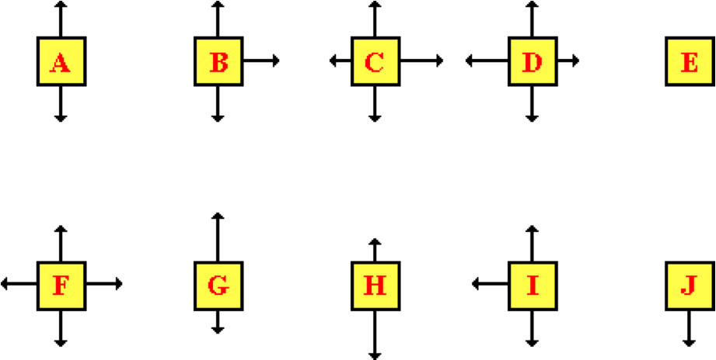

Which one would be most consistent for the following scenario?

A 1.0 kg book is at rest on a table top.

**Question 2:**

aa. The diagrams below represent forces acting on an object. The size of the arrow represents the magnitude of the force.

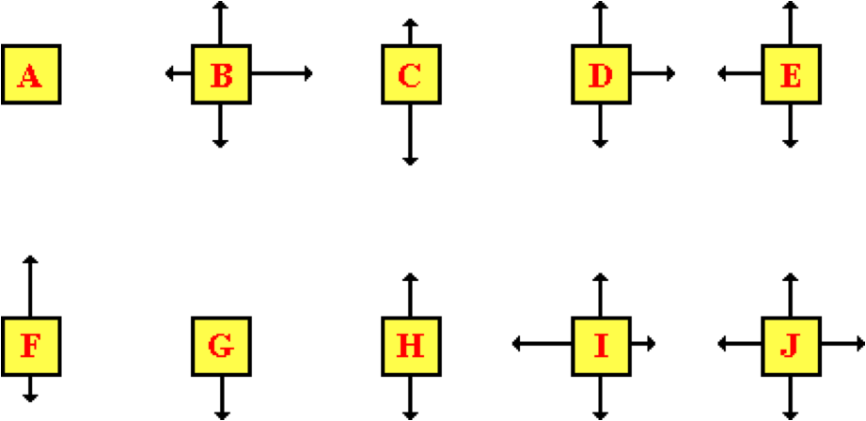

Which one would be most consistent for the following scenario?

A 1.0 kg book is at rest on a table top.

**Question 3:**

aa. The diagrams below represent forces acting on an object. The size of the arrow represents the magnitude of the force.

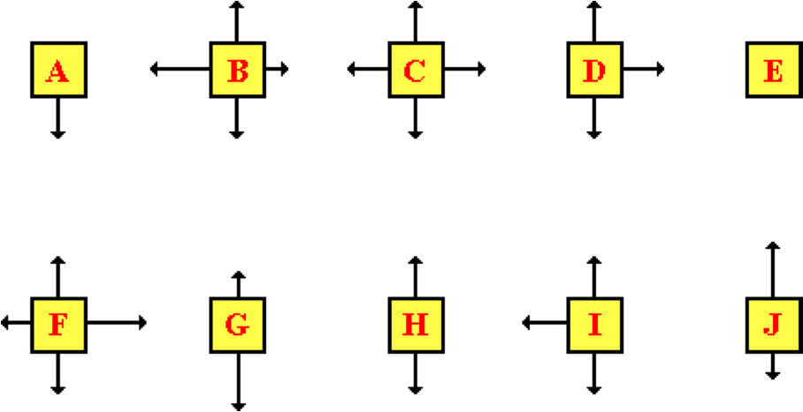

Which one would be most consistent for the following scenario?

A 1.0 kg book is at rest on a table top.

**Question 4:**

aa. The diagrams below represent forces acting on an object. The size of the arrow represents the magnitude of the force.



Which one would be most consistent for the following scenario?

A force is applied to a 1.0 kg book in order to move it toward the right and across a desk at constant velocity.

**Question 5:**

aa. The diagrams below represent forces acting on an object. The size of the arrow represents the magnitude of the force.



Which one would be most consistent for the following scenario?

A force is applied to a 1.0 kg book in order to move it toward the right and across a desk at constant velocity.

**Question 6:**

aa. The diagrams below represent forces acting on an object. The size of the arrow represents the magnitude of the force.



Which one would be most consistent for the following scenario?

A force is applied to a 1.0 kg book in order to move it toward the right and across a desk at constant velocity.

**Question 7:**

aa. The diagrams below represent forces acting on an object. The size of the arrow represents the magnitude of the force.



Which one would be most consistent for the following scenario?

A force is applied to a 1.0 kg book in order to move it toward the left and across a desk at constant velocity.

**Question 8:**

aa. The diagrams below represent forces acting on an object. The size of the arrow represents the magnitude of the force.



Which one would be most consistent for the following scenario?

A force is applied to a 1.0 kg book in order to move it toward the left and across a desk at constant velocity.

**Question 9:**

aa. The diagrams below represent forces acting on an object. The size of the arrow represents the magnitude of the force.



Which one would be most consistent for the following scenario?

A force is applied to a 1.0 kg book in order to move it toward the left and across a desk at constant velocity.

**Question 10:**

aa. The diagrams below represent forces acting on an object. The size of the arrow represents the magnitude of the force.



Which one would be most consistent for the following scenario?

A 5.0 kg flying squirrel is gliding vertically from a tree to the ground at constant velocity. Consider air resistance.

**Question 11:**

aa. The diagrams below represent forces acting on an object. The size of the arrow represents the magnitude of the force.



Which one would be most consistent for the following scenario?

A 5.0 kg flying squirrel is gliding vertically from a tree to the ground at constant velocity. Consider air resistance.

**Question 12:**

aa. The diagrams below represent forces acting on an object. The size of the arrow represents the magnitude of the force.



Which one would be most consistent for the following scenario?

A 5.0 kg flying squirrel is gliding vertically from a tree to the ground at constant velocity. Consider air resistance.

**Question 13:**

aa. The diagrams below represent forces acting on an object. The size of the arrow represents the magnitude of the force.



Which one would be most consistent for the following scenario?

A 40.0 kg girl is suspended motionless from a bar that hangs from the ceiling.

**Question 14:**

aa. The diagrams below represent forces acting on an object. The size of the arrow represents the magnitude of the force.



Which one would be most consistent for the following scenario?

A 40.0 kg girl is suspended motionless from a bar that hangs from the ceiling.

**Question 15:**

aa. The diagrams below represent forces acting on an object. The size of the arrow represents the magnitude of the force.



Which one would be most consistent for the following scenario?

A 40.0 kg girl is suspended motionless from a bar that hangs from the ceiling.

**Question 16:**

aa. The diagrams below represent forces acting on an object. The size of the arrow represents the magnitude of the force.



Which one would be most consistent for the following scenario?

A trapeze artist is raised by the bar at a constant speed.

**Question 17:**

aa. The diagrams below represent forces acting on an object. The size of the arrow represents the magnitude of the force.



Which one would be most consistent for the following scenario?

A trapeze artist is raised by the bar at a constant speed.

**Question 18:**

aa. The diagrams below represent forces acting on an object. The size of the arrow represents the magnitude of the force.



Which one would be most consistent for the following scenario?

A trapeze artist is raised by the bar at a constant speed.

**Question 19:**

aa. The diagrams below represent forces acting on an object. The size of the arrow represents the magnitude of the force.



Which one would be most consistent for the following scenario?

A trapeze artist is lowered by the bar at a constant speed.

**Question 20:**

aa. The diagrams below represent forces acting on an object. The size of the arrow represents the magnitude of the force.



Which one would be most consistent for the following scenario?

A trapeze artist is lowered by the bar at a constant speed.

**Question 21:**

aa. The diagrams below represent forces acting on an object. The size of the arrow represents the magnitude of the force.



Which one would be most consistent for the following scenario?

A trapeze artist is lowered by the bar at a constant speed.

**Question 22:**

aa. The diagrams below represent forces acting on an object. The size of the arrow represents the magnitude of the force.



Which one would be most consistent for the following scenario?

A rightward moving car is skidding to a stop; the wheels of the car are locked.

**Question 23:**

aa. The diagrams below represent forces acting on an object. The size of the arrow represents the magnitude of the force.



Which one would be most consistent for the following scenario?

A rightward moving car is skidding to a stop; the wheels of the car are locked.

**Question 24:**

aa. The diagrams below represent forces acting on an object. The size of the arrow represents the magnitude of the force.



Which one would be most consistent for the following scenario?

A rightward moving car is skidding to a stop; the wheels of the car are locked.

**Question 25:**

aa. The diagrams below represent forces acting on an object. The size of the arrow represents the magnitude of the force.



Which one would be most consistent for the following scenario?

A baseball player slows down as he slides to a stop while moving toward the left.

**Question 26:**

aa. The diagrams below represent forces acting on an object. The size of the arrow represents the magnitude of the force.



Which one would be most consistent for the following scenario?

A baseball player slows down as he slides to a stop while moving toward the left.

**Question 27:**

aa. The diagrams below represent forces acting on an object. The size of the arrow represents the magnitude of the force.



Which one would be most consistent for the following scenario?

A baseball player slows down as he slides to a stop while moving toward the left.

**Question 28:**

aa. The diagrams below represent forces acting on an object. The size of the arrow represents the magnitude of the force.



Which one would be most consistent for the following scenario?

A rightward moving sledder slows down as it coasts to a stop.

**Question 29:**

aa. The diagrams below represent forces acting on an object. The size of the arrow represents the magnitude of the force.



Which one would be most consistent for the following scenario?

A rightward moving sledder slows down as it coasts to a stop.

**Question 30:**

aa. The diagrams below represent forces acting on an object. The size of the arrow represents the magnitude of the force.



Which one would be most consistent for the following scenario?

A rightward moving sledder slows down as it coasts to a stop.

**Question 31:**

aa. The diagrams below represent forces acting on an object. The size of the arrow represents the magnitude of the force.



Which one would be most consistent for the following scenario?

A motor cycle is moving rightward and speeding up while encountering significant air resistance.

**Question 32:**

aa. The diagrams below represent forces acting on an object. The size of the arrow represents the magnitude of the force.



Which one would be most consistent for the following scenario?

A motor cycle is moving rightward and speeding up while encountering significant air resistance.

**Question 33:**

The diagrams below represent forces acting on an object. The size of the arrow represents the magnitude of the force.



Which one would be most consistent for the following scenario?

A motor cycle is moving rightward and speeding up while encountering significant air resistance.

**Question 34:**

aa. The diagrams below represent forces acting on an object. The size of the arrow represents the magnitude of the force.



Which one would be most consistent for the following scenario?

A skydiver falls while speeding up.

**Question 35:**

aa. The diagrams below represent forces acting on an object. The size of the arrow represents the magnitude of the force.



Which one would be most consistent for the following scenario?

A skydiver falls while speeding up.

**Question 36:**

aa. The diagrams below represent forces acting on an object. The size of the arrow represents the magnitude of the force.



Which one would be most consistent for the following scenario?

A skydiver falls while speeding up.

**Question 37:**

aa. The diagrams below represent forces acting on an object. The size of the arrow represents the magnitude of the force.



Which one would be most consistent for the following scenario?

A skydiver falls while slowing down.

**Question 38:**

aa. The diagrams below represent forces acting on an object. The size of the arrow represents the magnitude of the force.



Which one would be most consistent for the following scenario?

A skydiver falls while slowing down.

**Question 39:**

aa. The diagrams below represent forces acting on an object. The size of the arrow represents the magnitude of the force.



Which one would be most consistent for the following scenario?

A skydiver falls while slowing down.

**NL6: Mass vs. Weight**

**Question 1:**

aa. Mass is expressed in units of _____ and weight is expressed in units of _____. (Choose the appropriate units as listed in their respective order.)

a. Newtons (N), kilograms (kg) b. kilograms (kg), m/s/s

c. kilograms (kg), Newtons (N) d. Newtons (N), pounds (lbs)

e. m/s/s, pounds (lbs) f. pounds (lbs), Newtons (N)

g. ...nonsense! Mass and weight are the same thing; both are expressed in kilograms.

**Question 2:**

aa. Mass is expressed in units of _____ and weight is expressed in units of _____. (Choose the appropriate units as listed in their respective order.)

a. kilograms (kg), m/s/s b. Newtons (N), kilograms (kg)

c. Newtons (N), pounds (lbs) d. kilograms (kg), Newtons (N)

e. pounds (lbs), Newtons (N) f. m/s/s, pounds (lbs)

g. ...nonsense! Mass and weight are the same thing; both are expressed in kilograms.

**Question 3:**

aa. Weight is expressed in units of _____ and mass is expressed in units of _____. (Choose the appropriate units as listed in their respective order.)

a. pounds (lbs), Newtons (N) b. kilograms (kg), m/s/s

c. kilograms (kg), Newtons (N) d. Newtons (N), pounds (lbs)

e. m/s/s, pounds (lbs) f. Newtons (N), kilograms (kg)

g. ...nonsense! Mass and weight are the same thing; both are expressed in kilograms.

**Question 4:**

aa. Weight is expressed in units of _____ and mass is expressed in units of _____. (Choose the appropriate units as listed in their respective order.)

a. kilograms (kg), m/s/s b. kilograms (kg), Newtons (N)

c. Newtons (N), pounds (lbs) d. m/s/s, pounds (lbs)

e. Newtons (N), kilograms (kg) f. pounds (lbs), Newtons (N)

g. ...nonsense! Mass and weight are the same thing; both are expressed in kilograms.

**Question 5:**

aa. The amount of matter or "stuff" in an object is referred to as the _____ of the object.

a. weight b. force c. mass

d. pressure e. density

f. ... nonsense! Call it anything you want; nobody listens to you anyway.

**Question 6:**

aa. The amount of matter or "stuff" in an object is referred to as the _____ of the object.

a. weight b. pressure c. density

d. force e. mass

f. ... nonsense! Call it anything you want; nobody listens to you anyway.

**Question 7:**

aa. The amount of matter or "stuff" in an object is referred to as the _____ of the object.

a. weight b. mass c. force

d. pressure e. density

f. ... nonsense! Call it anything you want; nobody listens to you anyway.

**Question 8:**

aa. The amount of matter or "stuff" in an object is referred to as the _____ of the object.

a. force b. pressure c. weight

d. mass e. density

f. ... nonsense! Call it anything you want; nobody listens to you anyway.

**Question 9:**

aa. The force of gravity that acts upon an object is referred to as the _____ of the object.

a. force b. pressure

c. weight d. mass

e. density f. kilograms

g. inertia

**Question 10:**

aa. The force of gravity that acts upon an object is referred to as the _____ of the object.

a. pressure b. force

c. kilograms d. mass

e. density f. weight

g. inertia

**Question 11:**

aa. The force of gravity that acts upon an object is referred to as the _____ of the object.

a. pressure b. inertia

c. kilograms d. force

e. mass f. density

g. weight

**Question 12:**

aa. The force of gravity that acts upon an object is referred to as the _____ of the object.

a. inertia b. force

c. mass d. kilograms

e. weight f. density

g. pressure

**Question 13:**

aa. Which of the following statements are TRUE? List all that apply in alphabetical order with no spaces between letters.

a. The mass and weight of an object are the same thing.

b. The mass of an object is the force of gravity acting upon an object.

c. The weight of an object is its mass multiplied by the force of gravity.

d. The mass of an object on the moon will be the same as its mass on Earth.

e. The weight of an object on the moon will be the same as its weight on Earth.

f. On Earth, more massive objects weigh more than less massive ones.

**Question 14:**

aa. Which of the following statements are TRUE? List all that apply in alphabetical order with no spaces between letters.

a. On Earth, more massive objects weigh more than less massive ones.

b. The mass of an object on the moon will be the same as its mass on Earth.

c. The weight of an object on the moon will be the same as its weight on Earth.

d. The weight of an object is its mass multiplied by the force of gravity.

e. The mass and weight of an object are the same thing.

f. The mass of an object is the force of gravity acting upon an object.

**Question 15:**

aa. Which of the following statements are TRUE? List all that apply in alphabetical order with no spaces between letters.

a. The mass of an object is the force of gravity acting upon an object.

b. The weight of an object on the moon will be the same as its weight on Earth.

c. The mass of an object on the moon will be the same as its mass on Earth.

d. On Earth, more massive objects weigh more than less massive ones.

e. The mass and weight of an object are the same thing.

f. The weight of an object is its mass multiplied by the force of gravity.

**Question 16:**

aa. Which of the following statements are FALSE? List all that apply in alphabetical order with no spaces between letters.

a. The mass and weight of an object are the same thing.

b. The mass of an object is the force of gravity acting upon an object.

c. The weight of an object is its mass multiplied by the force of gravity.

d. The mass of an object on the moon will be the same as its mass on Earth.

e. The weight of an object on the moon will be the same as its weight on Earth.

f. On Earth, more massive objects weigh more than less massive ones.

**Question 17:**

aa. Which of the following statements are FALSE? List all that apply in alphabetical order with no spaces between letters.

a. On Earth, more massive objects weigh more than less massive ones.

b. The mass of an object on the moon will be the same as its mass on Earth.

c. The weight of an object on the moon will be the same as its weight on Earth.

d. The weight of an object is its mass multiplied by the force of gravity.

e. The mass and weight of an object are the same thing.

f. The mass of an object is the force of gravity acting upon an object.

**Question 18:**

aa. Which of the following statements are FALSE? List all that apply in alphabetical order with no spaces between letters.

a. The mass of an object is the force of gravity acting upon an object.

b. The weight of an object on the moon will be the same as its weight on Earth.

c. The mass of an object on the moon will be the same as its mass on Earth.

d. On Earth, more massive objects weigh more than less massive ones.

e. The mass and weight of an object are the same thing.

f. The weight of an object is its mass multiplied by the force of gravity.

**Question 19:**

aa. The force of gravity of objects on the moon is approximately one-sixth of their value on Earth. Joe weighs 600 N on earth. Joe's mass on the moon will be approximately _____.

a. 60 kg b. 100 kg c. 1000 kg d. 6000 kg

e. 60 N f. 100 N g. 1000 N h. 6000 N

i. nonsense! None of these values are even close.

**Question 20:**

aa. The force of gravity of objects on the moon is approximately one-sixth of their value on Earth. Joe weighs 600 N on earth. Joe's mass on the moon will be approximately _____.

a. 60 N b. 100 N c. 1000 N d. 6000 N

e. 60 kg f. 100 kg g. 1000 kg h. 6000 kg

i. nonsense! None of these values are even close.

**Question 21:**

aa. The force of gravity of objects on the moon is approximately one-sixth of their value on Earth. Joe weighs 600 N on earth. Joe's mass on the moon will be approximately _____.

a. 60 N b. 60 kg c. 100 N d. 100 kg

e. 1000 N f. 1000 kg g. 6000 N h. 6000 kg

i. nonsense! None of these values are even close.

**Question 22:**

aa. The force of gravity of objects on the moon is approximately one-sixth of their value on Earth. Joe weighs 600 N on earth. Joe's mass on the moon will be approximately _____.

a. 6000 N b. 1000 N c. 100 N d. 60 N

e. 6000 kg f. 1000 kg g. 100 kg h. 60 kg

i. nonsense! None of these values are even close.

**Question 23:**

aa. The force of gravity of objects on the moon is approximately one-sixth of their value on Earth. Joe's weight on the moon is 100 N. Joe's mass on the Earth will be approximately _____.

a. 60 kg b. 100 kg c. 1000 kg d. 6000 kg

e. 60 N f. 100 N g. 1000 N h. 6000 N

i. nonsense! None of these values are even close.

**Question 24:**

aa. The force of gravity of objects on the moon is approximately one-sixth of their value on Earth. Joe's weight on the moon is 100 N. Joe's mass on the Earth will be approximately _____.

a. 60 N b. 100 N c. 1000 N d. 6000 N

e. 60 kg f. 100 kg g. 1000 kg h. 6000 kg

i. nonsense! None of these values are even close.

**Question 25:**

aa. The force of gravity of objects on the moon is approximately one-sixth of their value on Earth. Joe's weight on the moon is 100 N. Joe's mass on the Earth will be approximately _____.

a. 60 N b. 60 kg c. 100 N d. 100 kg

e. 1000 N f. 1000 kg g. 6000 N h. 6000 kg

i. nonsense! None of these values are even close.

**Question 26:**

aa. The force of gravity of objects on the moon is approximately one-sixth of their value on Earth. Joe's weight on the moon is 100 N. Joe's mass on the Earth will be approximately _____.

a. 6000 N b. 1000 N c. 100 N d. 60 N

e. 6000 kg f. 1000 kg g. 100 kg h. 60 kg

i. nonsense! None of these values are even close.

**Question 27:**

aa. Determine the weight of a 2959.0-kg car that is moving at a speed of 21 m/s. Enter a numerical answer.

**Question 28:**

aa. Determine the weight of a 4989.0-kg car that is moving at a speed of 32.0 m/s. Enter a numerical answer.

**Question 29:**

aa. Determine the weight of a 1768.0-kg car that is moving at a speed of 26 m/s. Enter a numerical answer.

**Question 30:**

aa. Determine the weight of a 70.0-kg person who is running with a speed of 5.0 m/s. Enter a numerical answer.

**Question 31:**

aa. Determine the weight of a 67.0-kg person who is running with a speed of 10.0 m/s. Enter a numerical answer.

**Question 32:**

aa. Determine the weight of a 59.0-kg person who is running with a speed of 9.0 m/s. Enter a numerical answer.

**Question 33:**

aa. An object weighs 578.0 Newton. It is being pushed along a horizontal surface by a 429.0-Newton force. Determine the mass of the object. Enter a numerical answer.

**Question 34:**

aa. An object weighs 653.0 Newton. It is being pushed along a horizontal surface by a 268.0-Newton force. Determine the mass of the object. Enter a numerical answer.

**Question 35:**

aa. An object weighs 530.0 Newton. It is being pushed along a horizontal surface by a 340.0-Newton force. Determine the mass of the object. Enter a numerical answer.

**Question 36:**

aa. An object weighs 712.0 Newton. It is being pushed along a horizontal surface by a 440.0-Newton force. Determine the mass of the object. Enter a numerical answer.

**Question 37:**

aa. An object weighs 582.0 Newton. It is being pushed along a horizontal surface by a 475.0-Newton force. Determine the mass of the object. Enter a numerical answer.

**Question 38:**

aa. An object weighs 580.0 Newton. It is being pushed along a horizontal surface by a 379.0-Newton force. Determine the mass of the object. Enter a numerical answer.

**NL7: Newton’s Second Law**

**Question 1:**

aa. The acceleration of an object is ______ proportional to the net force and ______ proportional to its mass. (Choose the appropriate units as listed in their respective order.)

a. directly, directly b. inversely, inversely

c. directly, inversely d. inversely, directly

e. ...nonsense! The acceleration of an object is independent of the net force and of its mass.

**Question 2:**

aa. The acceleration of an object is ______ proportional to the net force and ______ proportional to its mass. (Choose the appropriate units as listed in their respective order.)

a. directly, inversely b. inversely, directly

c. directly, directly d. inversely, inversely

e. ...nonsense! The acceleration of an object is independent of the net force and of its mass.

**Question 3:**

aa. The acceleration of an object is ______ proportional to its mass and ______ proportional to the net force. (Choose the appropriate units as listed in their respective order.)

a. directly, directly b. inversely, inversely

c. directly, inversely d. inversely, directly

e. ...nonsense! The acceleration of an object is independent of the net force and of its mass.

**Question 4:**

aa. The acceleration of an object is ______ proportional to its mass and ______ proportional to the net force. (Choose the appropriate units as listed in their respective order.)

a. directly, inversely b. inversely, directly

c. directly, directly d. inversely, inversely

e. ...nonsense! The acceleration of an object is independent of the net force and of its mass.

**Question 5:**

aa. Which of the following would have the effect of increasing the acceleration of an object? List all that apply in alphabetical order with no spaces between letters.

a. Tripling the mass of the object.

b. Decreasing the net force experienced by the object.

c. Decreasing the mass of the object.

d. Doubling the net force experienced by the object.

e. Halving the mass of the object.

**Question 6:**

aa. Which of the following would have the effect of increasing the acceleration of an object? List all that apply in alphabetical order with no spaces between letters.

a. Decreasing the mass of the object.

b. Decreasing the net force experienced by the object.

c. Doubling the mass of the object.

d. Tripling the net force experienced by the object.

e. Halving the mass of the object.

**Question 7:**

aa. Which of the following would have the effect of decreasing the acceleration of an object? List all that apply in alphabetical order with no spaces between letters.

a. Tripling the mass of the object.

b. Decreasing the net force experienced by the object.

c. Decreasing the mass of the object.

d. Doubling the net force experienced by the object.

e. Halving the mass of the object.

**Question 8:**

aa. Which of the following would have the effect of decreasing the acceleration of an object? List all that apply in alphabetical order with no spaces between letters.

a. Decreasing the mass of the object.

b. Decreasing the net force experienced by the object.

c. Doubling the mass of the object.

d. Tripling the net force experienced by the object.

e. Halving the mass of the object.

**Question 9:**

aa. Force diagrams depicting the magnitudes and directions of the forces acting upon four objects are shown below. Each object has the same mass - approximately 5 kg.

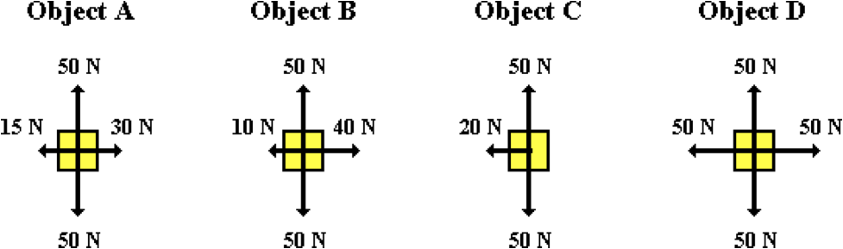

Rank these objects in order of their acceleration, from smallest to largest. List the four letters in their proper order with no spaces between letters. (Consider magnitude only when making the ranking; that is, -5 m/s/s is larger than +3 m/s/s.)

**Question 10:**

aa. Force diagrams depicting the magnitudes and directions of the forces acting upon four objects are shown below. Each object has the same mass - approximately 5 kg.

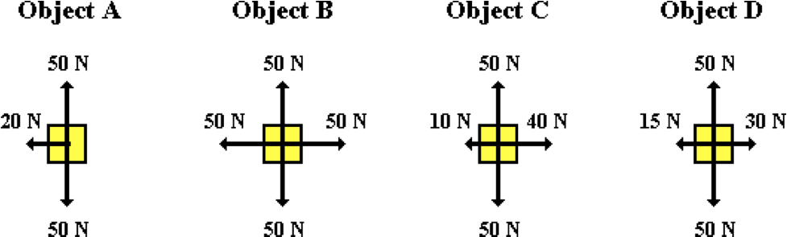

Rank these objects in order of their acceleration, from smallest to largest. List the four letters in their proper order with no spaces between letters. (Consider magnitude only when making the ranking; that is, -5 m/s/s is larger than +3 m/s/s.)

**Question 11:**

aa. Force diagrams depicting the magnitudes and directions of the forces acting upon four objects are shown below. Each object has the same mass - approximately 5 kg.

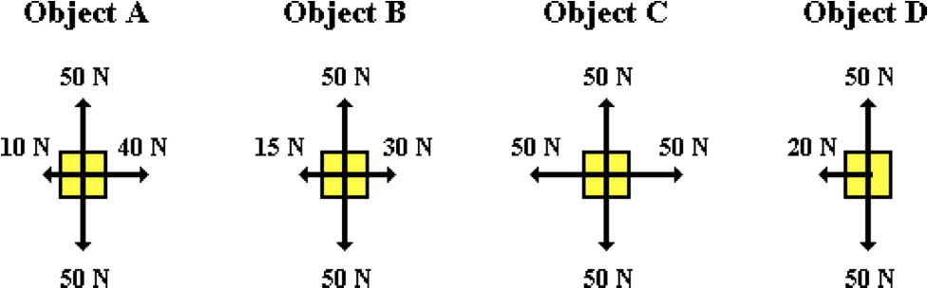

Rank these objects in order of their acceleration, from smallest to largest. List the four letters in their proper order with no spaces between letters. (Consider magnitude only when making the ranking; that is, -5 m/s/s is larger than +3 m/s/s.)

**Question 12:**

aa. Force diagrams depicting the magnitudes and directions of the forces acting upon four objects are shown below. Each object has the same mass - approximately 5 kg.

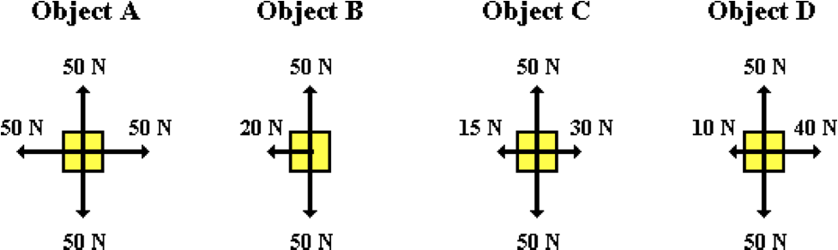

Rank these objects in order of their acceleration, from smallest to largest. List the four letters in their proper order with no spaces between letters. (Consider magnitude only when making the ranking; that is, -5 m/s/s is larger than +3 m/s/s.)

**Question 13:**

aa. Force diagrams depicting the magnitudes and directions of the forces acting upon four objects are shown below. In each case, the down force is the force of gravity.

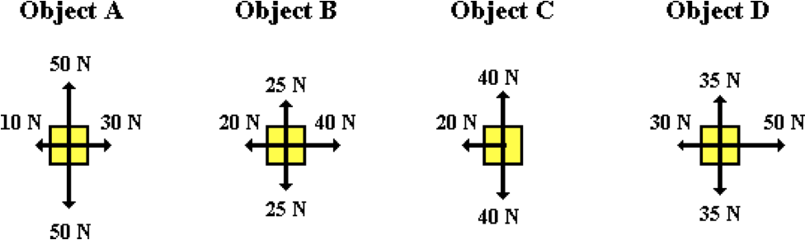

Rank these objects in order of their acceleration, from smallest to largest. List the four letters in their proper order with no spaces between letters. (Consider magnitude only when making the ranking; that is, -5 m/s/s is larger than +3 m/s/s.)

**Question 14:**

aa. Force diagrams depicting the magnitudes and directions of the forces acting upon four objects are shown below. In each case, the down force is the force of gravity.

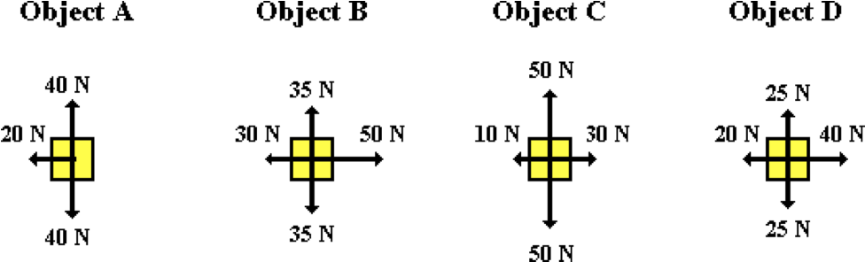

Rank these objects in order of their acceleration, from smallest to largest. List the four letters in their proper order with no spaces between letters. (Consider magnitude only when making the ranking; that is, -5 m/s/s is larger than +3 m/s/s.)

**Question 15:**

aa. Force diagrams depicting the magnitudes and directions of the forces acting upon four objects are shown below. In each case, the down force is the force of gravity.

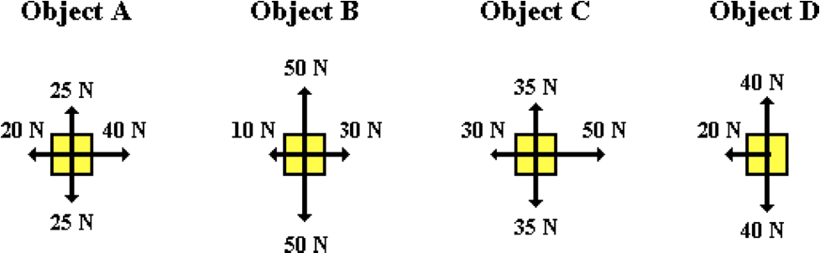

Rank these objects in order of their acceleration, from smallest to largest. List the four letters in their proper order with no spaces between letters. (Consider magnitude only when making the ranking; that is, -5 m/s/s is larger than +3 m/s/s.)

**Question 16:**

aa. Force diagrams depicting the magnitudes and directions of the forces acting upon four objects are shown below. In each case, the down force is the force of gravity.

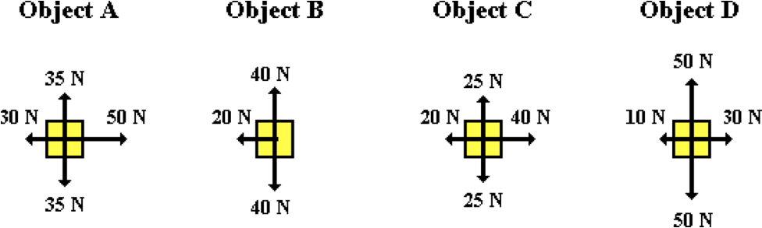

Rank these objects in order of their acceleration, from smallest to largest. List the four letters in their proper order with no spaces between letters. (Consider magnitude only when making the ranking; that is, -5 m/s/s is larger than +3 m/s/s.)

**Question 17:**

aa. An object has an acceleration of 4.8 m/s/s. If the net force experienced by the object is increased by a factor of 2.5, then the new acceleration would be ____ m/s/s. Enter a numerical answer.

**Question 18:**

aa. An object has an acceleration of 3.1 m/s/s. If the net force experienced by the object is increased by a factor of 2.9, then the new acceleration would be ____ m/s/s. Enter a numerical answer.

**Question 19:**

aa. An object has an acceleration of 7.6 m/s/s. If the net force experienced by the object is increased by a factor of 3.5, then the new acceleration would be ____ m/s/s. Enter a numerical answer.

**Question 20:**

aa. An object has an acceleration of 18.2 m/s/s. If the net force experienced by the object is decreased by a factor of 3.9, then the new acceleration would be ____ m/s/s. Enter a numerical answer.

**Question 21:**

aa. An object has an acceleration of 12.5 m/s/s. If the net force experienced by the object is decreased by a factor of 4.5, then the new acceleration would be ____ m/s/s. Enter a numerical answer.

**Question 22:**

aa. An object has an acceleration of 14.8 m/s/s. If the net force experienced by the object is decreased by a factor of 4.8, then the new acceleration would be ____ m/s/s. Enter a numerical answer.

**Question 23:**

aa. An object has an acceleration of 65.8 m/s/s. If the mass of the object is increased by a factor of 1.9, then the new acceleration would be ____ m/s/s. Enter a numerical answer.

**Question 24:**

aa. An object has an acceleration of 34.7 m/s/s. If the mass of the object is increased by a factor of 2.7, then the new acceleration would be ____ m/s/s. Enter a numerical answer.

**Question 25:**

aa. An object has an acceleration of 50.4 m/s/s. If the mass of the object is increased by a factor of 3.4, then the new acceleration would be ____ m/s/s. Enter a numerical answer.

**Question 26:**

aa. An object has an acceleration of 14.6 m/s/s. If the mass of the object is decreased by a factor of 2.2, then the new acceleration would be ____ m/s/s. Enter a numerical answer.

**Question 27:**

aa. An object has an acceleration of 14.1 m/s/s. If the mass of the object is decreased by a factor of 1.6, then the new acceleration would be ____ m/s/s. Enter a numerical answer.

**Question 28:**

aa. An object has an acceleration of 13.4 m/s/s. If the mass of the object is decreased by a factor of 3.4, then the new acceleration would be ____ m/s/s. Enter a numerical answer.

**Question 29:**

aa. An object has an acceleration of 4.0 m/s/s. If the net force experienced by the object is increased by a factor of 2.5 and if the mass of the object is increased by a factor of 3.3, then the new acceleration would be ____ m/s/s. Enter a numerical answer.

**Question 30:**

aa. An object has an acceleration of 6.0 m/s/s. If the net force experienced by the object is increased by a factor of 3.3 and if the mass of the object is increased by a factor of 2.5, then the new acceleration would be ____ m/s/s. Enter a numerical answer.

**Question 31:**

aa. An object has an acceleration of 8.0 m/s/s. If the net force experienced by the object is decreased by a factor of 3.7 and if the mass of the object is decreased by a factor of 2.6, then the new acceleration would be ____ m/s/s. Enter a numerical answer.

**Question 32:**

aa. An object has an acceleration of 3.0 m/s/s. If the net force experienced by the object is decreased by a factor of 2.1 and if the mass of the object is decreased by a factor of 3.4, then the new acceleration would be ____ m/s/s. Enter a numerical answer.

**NL8: F = m•a Calculations**

**Question 1:**

aa. The net force and the resulting acceleration as experienced by four objects are listed below.

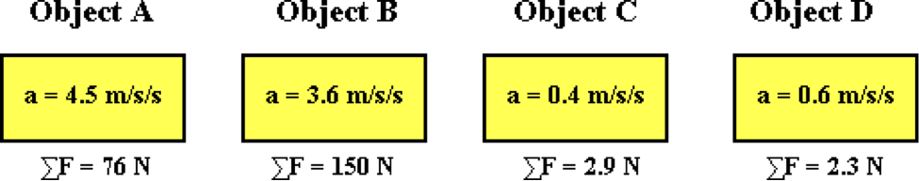

Rank the objects in order of increasing mass, beginning with the least massive. List the letters in their proper order with no spaces between letters.

**Question 2:**

aa. The net force and the resulting acceleration as experienced by four objects are listed below.

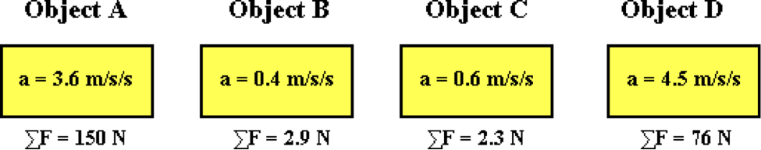

Rank the objects in order of increasing mass, beginning with the least massive. List the letters in their proper order with no spaces between letters.

**Question 3:**

aa. The net force and the resulting acceleration as experienced by four objects are listed below.

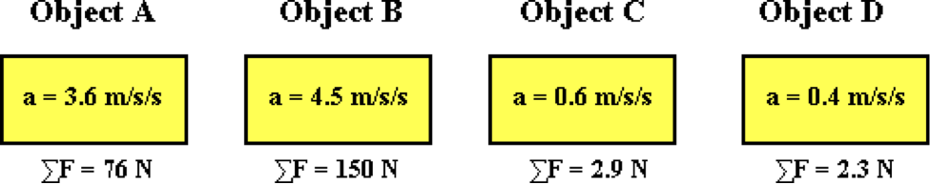

Rank the objects in order of increasing mass, beginning with the least massive. List the letters in their proper order with no spaces between letters.

**Question 4:**

aa. The net force and the resulting acceleration as experienced by four objects are listed below.

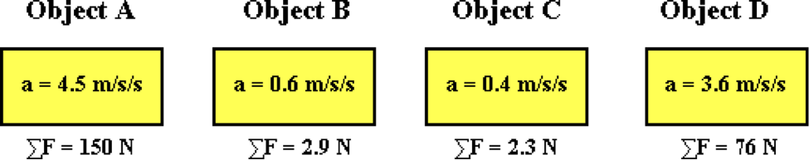

Rank the objects in order of increasing mass, beginning with the least massive. List the letters in their proper order with no spaces between letters.

**Question 5:**

aa. What net force (in Newton) would cause a 30.0-kg object to experience an acceleration of 2.0 m/s/s? Enter a numerical answer.

**Question 6:**

aa. What net force (in Newton) would cause a 15.0-kg object to experience an acceleration of 3.0 m/s/s? Enter a numerical answer.

**Question 7:**

aa. What net force (in Newton) would cause a 14.0-kg object to experience an acceleration of 4.0 m/s/s? Enter a numerical answer.

**Question 8:**

aa. What net force (in Newton) would cause a 37.0-kg object to experience an acceleration of 5.0 m/s/s? Enter a numerical answer.

**Question 9:**

aa. Determine the acceleration (in m/s/s) of a 8.0-kg object that experiences a net force of 44.0 N. Enter a numerical answer.

**Question 10:**

aa. Determine the acceleration (in m/s/s) of a 7.0-kg object that experiences a net force of 36.0 N. Enter a numerical answer.

**Question 11:**

aa. Determine the acceleration (in m/s/s) of a 7.0-kg object that experiences a net force of 35.0 N. Enter a numerical answer.

**Question 12:**

aa. Determine the acceleration (in m/s/s) of a 6.0-kg object that experiences a net force of 21.0 N. Enter a numerical answer.

**Question 13:**

aa. Determine the mass (in kg) of an object that experiences an acceleration of 6.0 m/s/s when it encounters a net force of 340.0 N. Enter a numerical answer.

**Question 14:**

aa. Determine the mass (in kg) of an object that experiences an acceleration of 5.0 m/s/s when it encounters a net force of 493.0 N. Enter a numerical answer.

**Question 15:**

aa. Determine the mass (in kg) of an object that experiences an acceleration of 5.0 m/s/s when it encounters a net force of 404.0 N. Enter a numerical answer.

**Question 16:**

aa. Determine the mass (in kg) of an object that experiences an acceleration of 5.0 m/s/s when it encounters a net force of 347.0 N. Enter a numerical answer.

**Question 17:**

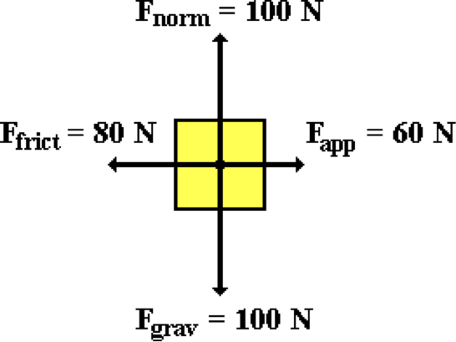aa. Analyze the free body diagram and determine which of the following statements are true of this rightward-moving object. List all that apply in alphabetical order with no spaces between letters. (Use the approximate value of g = 10 m/s/s.)

a. This object weighs 100 N.

b. The magnitude of the acceleration is 2 m/s/s.

c. The object has a mass of 1000 kg.

d. The acceleration is rightward.

e. The object is gaining speed.

f. The acceleration is leftward.

**Question 18:**

aa. Analyze the free body diagram and determine which of the following statements are true of this rightward-moving object. List all that apply in alphabetical order with no spaces between letters. (Use the approximate value of g = 10 m/s/s.)

a. The object is gaining speed.

b. The acceleration is leftward.

c. The magnitude of the acceleration is 2 m/s/s.

d. The object has a mass of 1000 kg.

e. The acceleration is rightward.

f. This object weighs 100 N.

**Question 19:**

aa. Analyze the free body diagram and determine which of the following statements are true of this rightward-moving object. List all that apply in alphabetical order with no spaces between letters. (Use the approximate value of g = 10 m/s/s.)

a. This object weighs 1000 N.

b. The magnitude of the acceleration is 14 m/s/s.

c. The object has a mass of 10 kg.

d. The acceleration is leftward.

e. The object is slowing down.

f. The acceleration is rightward.

**Question 20:**

aa. Analyze the free body diagram and determine which of the following statements are true of this rightward-moving object. List all that apply in alphabetical order with no spaces between letters. (Use the approximate value of g = 10 m/s/s.)

a. The acceleration is leftward.

b. The object has a mass of 10 kg.

c. The magnitude of the acceleration is 14 m/s/s.

d. The acceleration is rightward.

e. The object is slowing down.

f. This object weighs 1000 N.

**Question 21:**

aa. A 5-kg object is moving to the right with a constant velocity. The velocity value is 4 m/s. The net force encountered by the object is ____.

a. 200 N, left b. 20 N, left c. 1.25 N, left

d. 0.80 N, left e. 0 N f. 0.80 N, right

g. 1.25 N, right h. 20 N, right i. 200 N, right

**Question 22:**

aa. A 5-kg object is moving to the right with a constant velocity. The velocity value is 4 m/s. The net force encountered by the object is ____.

a. 0 N b. 0.80 N, left c. 0.80 N, right

d. 1.25 N, left e. 1.25 N, right f. 20 N, left

g. 20 N, right h. 200 N, left i. 200 N, right

**Question 23:**

aa. A 6-kg object is moving to the right with a constant velocity. The velocity value is 4 m/s. The net force encountered by the object is ____.

a. 240 N, left b. 24 N, left c. 1.5 N, left

d. 0.667 N, left e. 0 N f. 0.667 N, right

g. 1.5 N, right h. 24 N, right i. 240 N, right

**Question 24:**

aa. A 6-kg object is moving to the right with a constant velocity. The velocity value is 4 m/s. The net force encountered by the object is ____.

a. 0 N b. 0.667 N, left c. 0.667 N, right

d. 1.5 N, left e. 1.5 N, right f. 24 N, left

g. 24 N, right h. 240 N, left i. 240 N, right

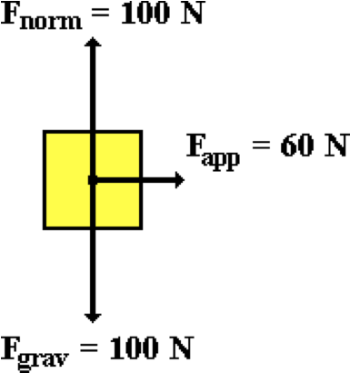**Question 25:**

aa. Consider the free-body diagram shown at the right. Use the numerical value for the individual forces and the approximate value of g (10 m/s/s) to determine the acceleration of the object (in units of m/s/s). Assign a negative number to the acceleration if it is leftward or downward. Enter a numerical answer.

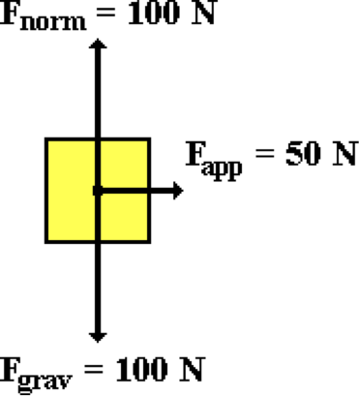**Question 26:**

aa. Consider the free-body diagram shown at the right. Use the numerical value for the individual forces and the approximate value of g (10 m/s/s) to determine the acceleration of the object (in units of m/s/s). Assign a negative number to the acceleration if it is leftward or downward. Enter a numerical answer.

**Question 27:**

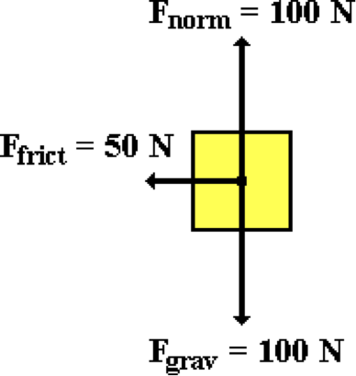aa. Consider the free-body diagram shown at the right. Use the numerical value for the individual forces and the approximate value of g (10 m/s/s) to determine the acceleration of the object (in units of m/s/s). Assign a negative number to the acceleration if it is leftward or downward. Enter a numerical answer.

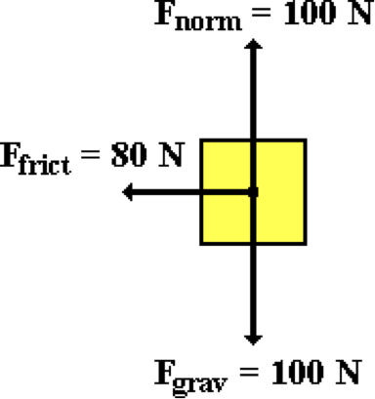**Question 28:**

aa. Consider the free-body diagram shown at the right. Use the numerical value for the individual forces and the approximate value of g (10 m/s/s) to determine the acceleration of the object (in units of m/s/s). Assign a negative number to the acceleration if it is leftward or downward. Enter a numerical answer.

**Question 29:**

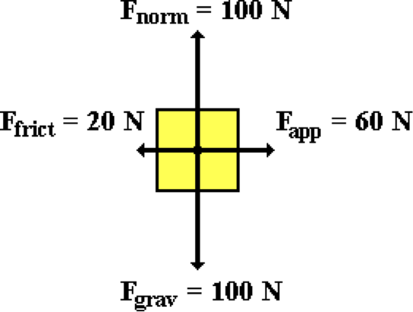aa. Consider the free-body diagram shown at the right. Use the numerical value for the individual forces and the approximate value of g (10 m/s/s) to determine the acceleration of the object (in units of m/s/s). Assign a negative number to the acceleration if it is leftward or downward. Enter a numerical answer.

**Question 30:**

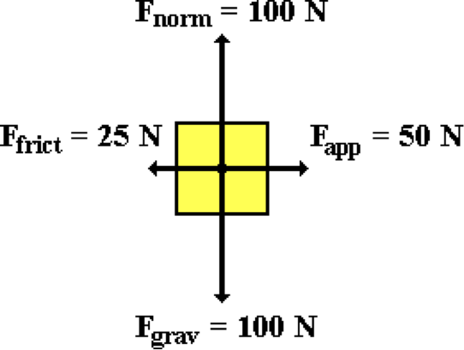aa. Consider the free-body diagram shown at the right. Use the numerical value for the individual forces and the approximate value of g (10 m/s/s) to determine the acceleration of the object (in units of m/s/s). Assign a negative number to the acceleration if it is leftward or downward. Enter a numerical answer.

**Question 31:**

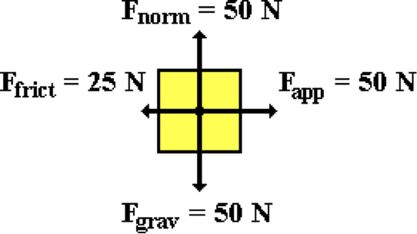aa. Consider the free-body diagram shown at the right. Use the numerical value for the individual forces and the approximate value of g (10 m/s/s) to determine the acceleration of the object (in units of m/s/s). Assign a negative number to the acceleration if it is leftward or downward. Enter a numerical answer.

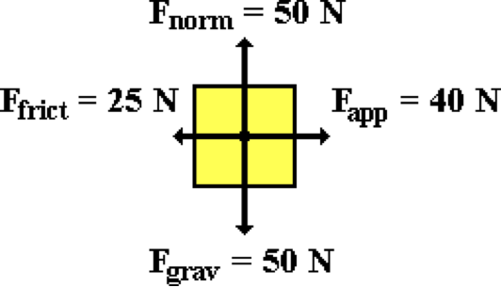**Question 32:**

aa. Consider the free-body diagram shown at the right. Use the numerical value for the individual forces and the approximate value of g (10 m/s/s) to determine the acceleration of the object (in units of m/s/s). Assign a negative number to the acceleration if it is leftward or downward. Enter a numerical answer.

**Question 33:**

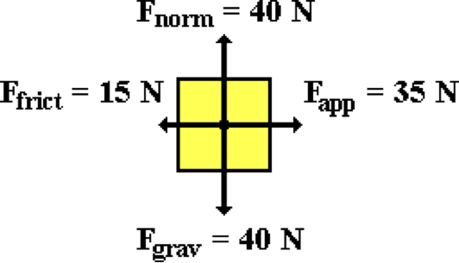aa. Consider the free-body diagram shown at the right. Use the numerical value for the individual forces and the approximate value of g (10 m/s/s) to determine the acceleration of the object (in units of m/s/s). Assign a negative number to the acceleration if it is leftward or downward. Enter a numerical answer.

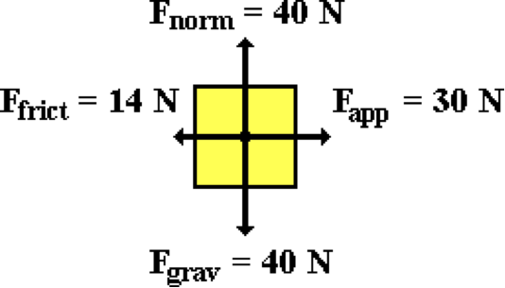**Question 34:**

aa. Consider the free-body diagram shown at the right. Use the numerical value for the individual forces and the approximate value of g (10 m/s/s) to determine the acceleration of the object (in units of m/s/s). Assign a negative number to the acceleration if it is leftward or downward. Enter a numerical answer.

**Question 35:**

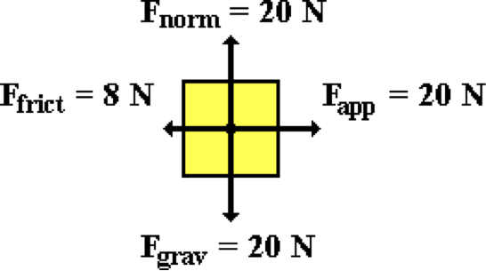aa. Consider the free-body diagram shown at the right. Use the numerical value for the individual forces and the approximate value of g (10 m/s/s) to determine the acceleration of the object (in units of m/s/s). Assign a negative number to the acceleration if it is leftward or downward. Enter a numerical answer.

**Question 36:**

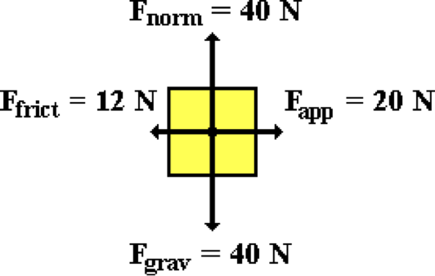aa. Consider the free-body diagram shown at the right. Use the numerical value for the individual forces and the approximate value of g (10 m/s/s) to determine the acceleration of the object (in units of m/s/s). Assign a negative number to the acceleration if it is leftward or downward. Enter a numerical answer.

**NL9: Force Analysis**

**Question 1:**

aa. A 50-Newton rightward force is applied to a 20-kg object to accelerate it to the right. The object encounters a friction force of 30 Newton.

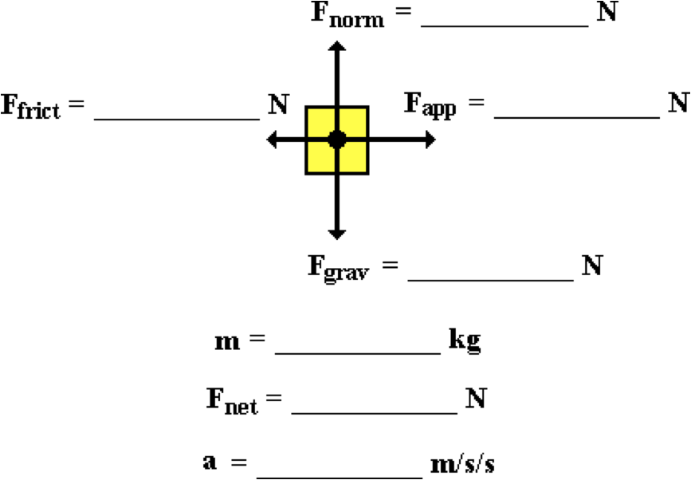

Fill in all blanks in the diagram and determine the magnitude of the acceleration (in m/s/s) of the object. (Use the approximation that g ~ 10 m/s/s.) Enter positive numbers only.

**Question 2:**

aa. A 60-Newton rightward force is applied to a 15-kg object to accelerate it to the right. The object encounters a friction force of 30 Newton.



Fill in all blanks in the diagram and determine the magnitude of the acceleration (in m/s/s) of the object. (Use the approximation that g ~ 10 m/s/s.) Enter positive numbers only.

**Question 3:**

aa. A 65-Newton rightward force is applied to a 10-kg object to accelerate it to the right. The object encounters a friction force of 25 Newton.



Fill in all blanks in the diagram and determine the magnitude of the acceleration (in m/s/s) of the object. (Use the approximation that g ~ 10 m/s/s.) Enter positive numbers only.

**Question 4:**

aa. A 50-Newton rightward force is applied to a 25-kg object to accelerate it to the right. The object encounters a friction force of 20 Newton.



Fill in all blanks in the diagram and determine the magnitude of the acceleration (in m/s/s) of the object. (Use the approximation that g ~ 10 m/s/s.) Enter positive numbers only.

**Question 5:**

aa. The cable of a freight elevator applies a 3000-N force to accelerate a 250-kg elevator upward.

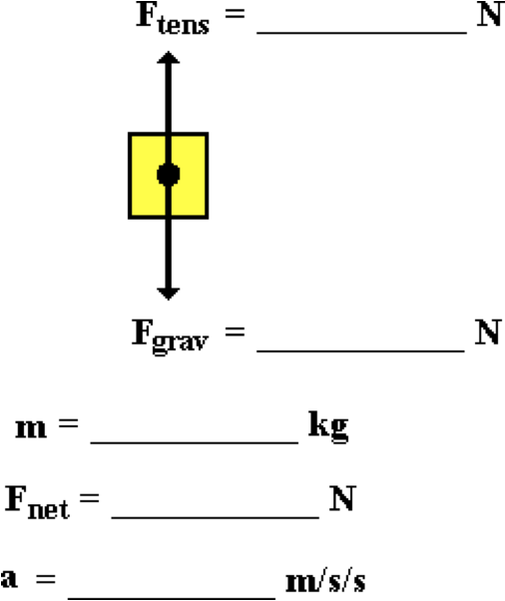

Fill in all blanks in the diagram and determine the magnitude of the acceleration (in m/s/s) of the elevator. (Use the approximation that g ~ 10 m/s/s.) Enter positive numbers only.

**Question 6:**

aa. The cable of a freight elevator applies a 2300-N force to accelerate a 200-kg elevator upward.



Fill in all blanks in the diagram and determine the magnitude of the acceleration (in m/s/s) of the elevator. (Use the approximation that g ~ 10 m/s/s.) Enter positive numbers only.

**Question 7:**

aa. The cable of a freight elevator applies a 1800-N force to accelerate a 150-kg elevator upward.



Fill in all blanks in the diagram and determine the magnitude of the acceleration (in m/s/s) of the elevator. (Use the approximation that g ~ 10 m/s/s.) Enter positive numbers only.

**Question 8:**

aa. The cable of a freight elevator applies a 2100-N force to accelerate a 150-kg elevator upward.



Fill in all blanks in the diagram and determine the magnitude of the acceleration (in m/s/s) of the elevator. (Use the approximation that g ~ 10 m/s/s.) Enter positive numbers only.

**Question 9:**

aa. A 900-kg rightward-moving car encounters 4500-N of resistive forces as it skids to a stop.

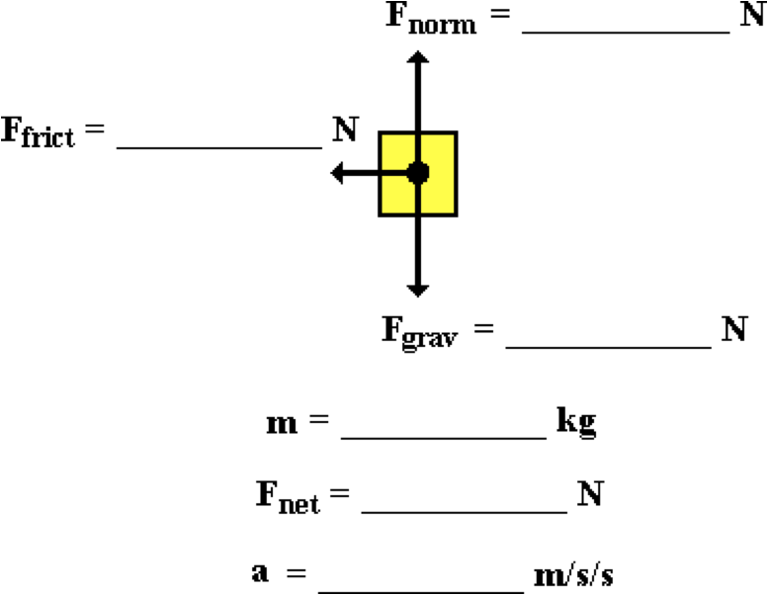

Fill in all blanks in the diagram and determine the magnitude of the acceleration (in m/s/s) of the car. (Use the approximation that g ~ 10 m/s/s.) Enter positive numbers only.

**Question 10:**

aa. A 1000-kg rightward-moving car encounters 7500-N of resistive forces as it skids to a stop.



Fill in all blanks in the diagram and determine the magnitude of the acceleration (in m/s/s) of the car. (Use the approximation that g ~ 10 m/s/s.) Enter positive numbers only.

**Question 11:**

aa. A 1200-kg rightward-moving car encounters 8400-N of resistive forces as it skids to a stop.



Fill in all blanks in the diagram and determine the magnitude of the acceleration (in m/s/s) of the car. (Use the approximation that g ~ 10 m/s/s.) Enter positive numbers only.

**Question 12:**

aa. A 1400-kg rightward-moving car encounters 9100-N of resistive forces as it skids to a stop.



Fill in all blanks in the diagram and determine the magnitude of the acceleration (in m/s/s) of the car. (Use the approximation that g ~ 10 m/s/s.) Enter positive numbers only.

**Question 13:**

aa. A 70-kg skydiver encounters a 490-N air resistance force.

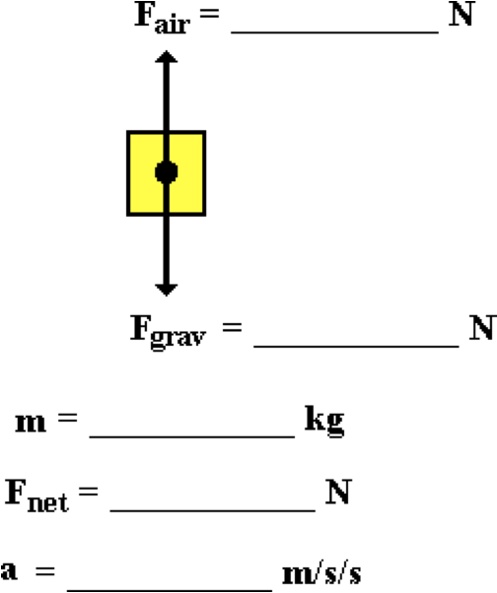

Fill in all blanks in the diagram and determine the acceleration (in m/s/s) of the skydiver. (Use the approximation that g ~ 10 m/s/s.) Enter positive numbers only.

**Question 14:**

aa. An 80-kg skydiver encounters a 640-N air resistance force.



Fill in all blanks in the diagram and determine the acceleration (in m/s/s) of the skydiver. (Use the approximation that g ~ 10 m/s/s.) Enter positive numbers only.

**Question 15:**

aa. A 90-kg skydiver encounters a 720-N air resistance force.



Fill in all blanks in the diagram and determine the acceleration (in m/s/s) of the skydiver. (Use the approximation that g ~ 10 m/s/s.) Enter positive numbers only.

**Question 16:**

aa. A 60-kg skydiver encounters a 300-N air resistance force.



Fill in all blanks in the diagram and determine the acceleration (in m/s/s) of the skydiver. (Use the approximation that g ~ 10 m/s/s.) Enter positive numbers only.

**Question 17:**

aa. Chuck Wagon applies a 300-N force to accelerate a 30-kg box at 2.5 m/s/s.



Fill in all blanks in the diagram and determine the force of friction (in Newtons) encountered by the box. (Use the approximation that g ~ 10 m/s/s.) Enter positive numbers only.

**Question 18:**

aa. Chuck Wagon applies a 400-N force to accelerate a 50-kg box at 2.0 m/s/s.



Fill in all blanks in the diagram and determine the force of friction (in Newtons) encountered by the box. (Use the approximation that g ~ 10 m/s/s.) Enter positive numbers only.

**Question 19:**

aa. Chuck Wagon applies a 450-N force to accelerate a 40-kg box at 1.2 m/s/s.



Fill in all blanks in the diagram and determine the force of friction (in Newtons) encountered by the box. (Use the approximation that g ~ 10 m/s/s.) Enter positive numbers only.

**Question 20:**

aa. Chuck Wagon applies a 500-N force to accelerate a 50-kg box at 1.6 m/s/s.



Fill in all blanks in the diagram and determine the force of friction (in Newtons) encountered by the box. (Use the approximation that g ~ 10 m/s/s.) Enter positive numbers only.

**Question 21:**

aa. A 2-kg pail is attached to a cable and raised upward with a constant speed of 1.5 m/s.



Fill in all blanks in the diagram and determine the tension force (in Newtons) in the cable. (Use the approximation that g ~ 10 m/s/s.) Enter positive numbers only.

**Question 22:**

aa. A 3-kg pail is attached to a cable and raised upward with a constant speed of 2.0 m/s.



Fill in all blanks in the diagram. (Use the approximation that g ~ 10 m/s/s.) Enter positive numbers only.

**Question 23:**

aa. A 4-kg pail is attached to a cable and raised upward with a constant speed of 1.2 m/s.



Fill in all blanks in the diagram. (Use the approximation that g ~ 10 m/s/s.) Enter positive numbers only.

**Question 24:**

aa. A 5-kg pail is attached to a cable and raised upward with a constant speed of 1.4 m/s.



Fill in all blanks in the diagram. (Use the approximation that g ~ 10 m/s/s.) Enter positive numbers only.

**Question 25:**

aa. A 2400-kg car is moving at 20 m/s when it slams on the brakes and skids to a stop with a leftward acceleration of 7 m/s/s.



Fill in all blanks in the diagram and determine the force of friction. (Use the approximation that g ~ 10 m/s/s.) Enter positive numbers only.

**Question 26:**

aa. A 1200-kg car is moving at 20 m/s when it slams on the brakes and skids to a stop with a leftward acceleration of 8 m/s/s.



Fill in all blanks in the diagram and determine the force of friction. (Use the approximation that g ~ 10 m/s/s.) Enter positive numbers only.

**Question 27:**

aa. A 1500-kg car is moving at 18 m/s when it slams on the brakes and skids to a stop with a leftward acceleration of 9 m/s/s.



Fill in all blanks in the diagram and determine the force of friction. (Use the approximation that g ~ 10 m/s/s.) Enter positive numbers only.

**Question 28:**

aa. A 1000-kg car is moving at 27 m/s when it slams on the brakes and skids to a stop with a leftward acceleration of 9 m/s/s.



Fill in all blanks in the diagram and determine the force of friction. (Use the approximation that g ~ 10 m/s/s.) Enter positive numbers only.

**Question 29:**

aa. A 500-kg upward-moving freight elevator nears its destination and accelerates downward at a rate of 1.6 m/s/s.



Fill in all blanks in the diagram and determine the tension force. (Use the approximation that g ~ 10 m/s/s.) Enter positive numbers only.

**Question 30:**

aa. A 600-kg upward-moving freight elevator nears its destination and accelerates downward at a rate of 1.4 m/s/s.



Fill in all blanks in the diagram and determine the tension force. (Use the approximation that g ~ 10 m/s/s.) Enter positive numbers only.

**Question 31:**

aa. A 700-kg upward-moving freight elevator nears its destination and accelerates downward at a rate of 1.2 m/s/s.



Fill in all blanks in the diagram and determine the tension force. (Use the approximation that g ~ 10 m/s/s.) Enter positive numbers only.

**Question 32:**

aa. A 400-kg upward-moving freight elevator nears its destination and accelerates downward at a rate of 1.8 m/s/s.



Fill in all blanks in the diagram and determine the tension force. (Use the approximation that g ~ 10 m/s/s.) Enter positive numbers only.

**NL10: Free Fall Acceleration**

**Question 1:**

aa. A free-falling object is an object ____. List one.

a. that is falling

b. that has reached a terminal velocity

c. upon which the force of air resistance is equal to the force of gravity

d. upon which gravity is the only force

e. None of these appropriately complete this sentence.

**Question 2:**

aa. A free-falling object is an object ____. List one.

a. that has reached a terminal velocity

b. upon which the force of air resistance is equal to the force of gravity

c. upon which gravity is the only force

d. that is falling

e. None of these appropriately complete this sentence.

**Question 3:**

aa. A free-falling object is an object ____. List one.

a. upon which the force of air resistance is equal to the force of gravity

b. upon which gravity is the only force

c. that is falling

d. that has reached a terminal velocity

e. None of these appropriately complete this sentence.

**Question 4:**

aa. A free-falling object is an object ____. List one.

a. upon which gravity is the only force

b. which is falling

c. which has reached a terminal velocity

d. upon which the force of air resistance is equal to the force of gravity

e. None of these appropriately complete this sentence.

**Question 5:**

aa. The diagrams below show free-body diagrams and velocity values at an instant during the fall of several objects.

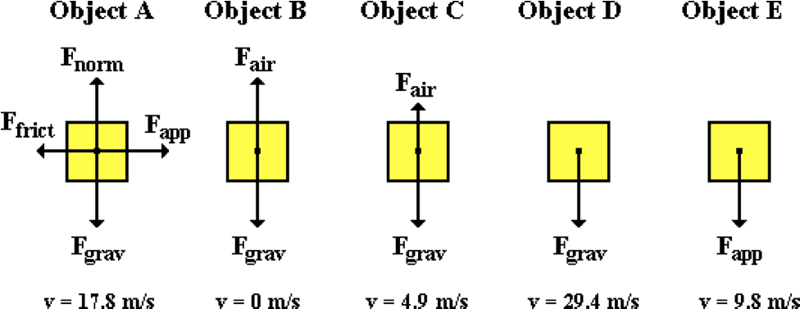

Based on the diagrams, which objects could be in free fall? List all that apply in alphabetical order with no spaces between letters. If none are in free fall, then enter 'F' as the answer.

**Question 6:**

aa. The diagrams below show free-body diagrams and velocity values at an instant during the fall of several objects.

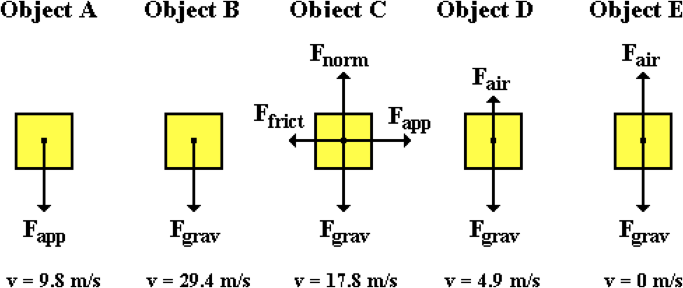

Based on the diagrams, which objects could be in free fall? List all that apply in alphabetical order with no spaces between letters. If none are in free fall, then enter 'F' as the answer.

**Question 7:**

aa. The diagrams below show free-body diagrams and velocity values at an instant during the fall of several objects.

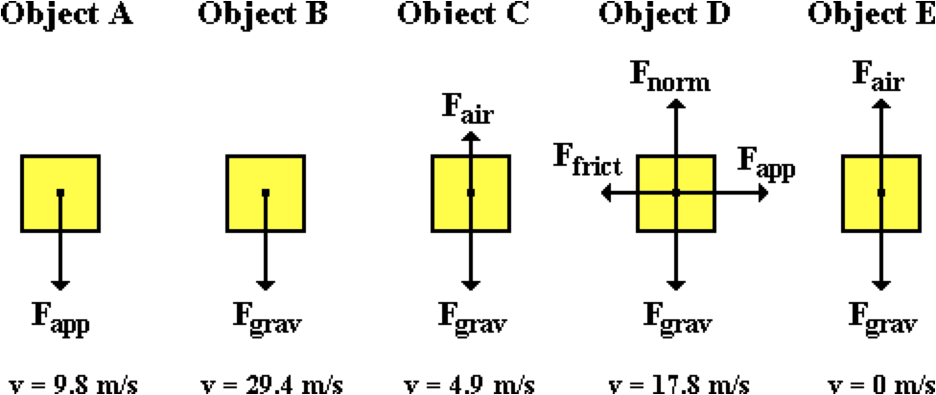

Based on the diagrams, which objects could be in free fall? List all that apply in alphabetical order with no spaces between letters. If none are in free fall, then enter 'F' as the answer.

**Question 8:**

aa. The diagrams below show free-body diagrams and velocity values at an instant during the fall of several objects.

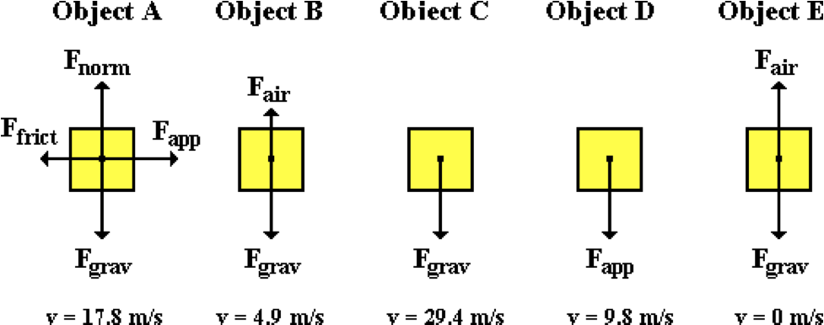

Based on the diagrams, which objects could be in free fall? List all that apply in alphabetical order with no spaces between letters. If none are in free fall, then enter 'F' as the answer.

**Question 9:**

aa. Which of the following statements are true of all free-falling objects? List all that apply in alphabetical order with no spaces between letters.

a. The velocity of the object is a constant value.

b. The mass of the object does not effect the rate at which it free-falls.

c. Gravity is the only force acting upon the object.

d. Air resistance has a negligible effect upon the object.

e. The acceleration of the object is 0 m/s/s.

f. The net force on the object is 0 Newton.

g. None of these statements are true.

**Question 10:**

aa. Which of the following statements are true of all free-falling objects? List all that apply in alphabetical order with no spaces between letters.

a. Air resistance has a negligible effect upon the object.

b. Gravity is the only force acting upon the object.

c. The mass of the object does not effect the rate at which it free-falls.

d. The net force on the object is equal to m•g.

e. The acceleration of the object is 0 m/s/s.

f. The velocity of the object is a constant value.

g. None of these statements are true.

**Question 11:**

aa. Which of the following statements are true of all free-falling objects? List all that apply in alphabetical order with no spaces between letters.

a. Air resistance has a negligible effect upon the object.

b. Gravity is the only force acting upon the object.

c. The mass of the object does not effect the rate at which it free-falls.

d. The net force on the object is 0 N.

e. The acceleration of the object has a magnitude of 9.8 m/s/s.

f. The velocity of the object is a continuously changing.

g. None of these statements are true.

**Question 12:**

aa. Which of the following statements are true of all free-falling objects? List all that apply in alphabetical order with no spaces between letters.

a. Gravity is the only force acting upon the object.

b. The velocity of the object is a continuously changing.

c. The acceleration of the object has a magnitude of 9.8 m/s/s.

d. The net force on the object is equal to m•g.

e. Such objects accelerate at a rate dependent upon their mass.

f. Air resistance has a negligible effect upon the object.

g. None of these statements are true.

**Question 13:**

aa. TRUE or FALSE:

An object is in free-fall if gravity is the only force acting upon it, even if the object is rising.

a. True b. False

**Question 14:**

aa. TRUE or FALSE:

An object is in free-fall if it is falling and no one is pushing it and there are no strings or ropes attached to it.

a. True b. False

**Question 15:**

aa. TRUE or FALSE:

An object is thrown upward; after being thrown, air resistance has a negligible effect and gravity can be considered the only force acting upon it. Because the object is rising towards its peak, it is not in free-fall.

a. True b. False

**Question 16:**

aa. TRUE or FALSE:

An object is thrown upward; after being thrown, air resistance has a negligible effect and gravity can be considered the only force acting upon it. Even though the object is rising towards its peak, it can be considered to be in free-fall.

a. True b. False

**Question 17:**

aa. The value of g is 9.8 m/s/s. 'g' stands for

a. gravity b. force of gravity

c. acceleration of gravity d. Isaac Newton

e. geeky f. greasy

g. giggly

**Question 18:**

aa. The value of g is 9.8 m/s/s. 'g' stands for

a. gravity b. acceleration of gravity

c. force of gravity d. Isaac Newton

e. geeky f. greasy

g. giggly

**Question 19:**

aa. The value of g is 9.8 m/s/s. 'g' stands for

a. Isaac Newton b. geeky

c. greasy d. giggly

e. gravity f. force of gravity

g. acceleration of gravity

**Question 20:**

aa. The value of g is 9.8 m/s/s. 'g' stands for

a. Isaac Newton b. geeky

c. greasy d. giggly

e. gravity f. acceleration of gravity

g. force of gravity

**Question 21:**

aa. Which of the following statements are true of free-falling objects of different mass? List all that apply in alphabetical order with no spaces between letters.

a. They have the same g value but a different acceleration.

b. They have the same acceleration but a different g value.

c. The rate of acceleration is the same for all objects.

d. They experience the same force of gravity.

e. ... nonsense! None of these statements are true of such objects.

**Question 22:**

aa. Which of the following statements are true of free-falling objects of different mass? List all that apply in alphabetical order with no spaces between letters.

a. They have the same acceleration but a different g value.

b. They have the same g value but a different acceleration.

c. They experience the same force of gravity.

d. The rate of acceleration is the same for all objects.

e. ... nonsense! None of these statements are true of such objects.

**Question 23:**

aa. Which of the following statements are true of free-falling objects of different mass? List all that apply in alphabetical order with no spaces between letters.

a. The rate of acceleration is the same for all objects.

b. They experience the same force of gravity.

c. They have the same g value but a different acceleration.

d. They have the same acceleration but a different g value.

e. ... nonsense! None of these statements are true of such objects.

**Question 24:**

aa. Which of the following statements are true of free-falling objects of different mass? List all that apply in alphabetical order with no spaces between letters.

a. They experience the same force of gravity.

b. The rate of acceleration is the same for all objects.

c. They have the same acceleration but a different g value.

d. They have the same g value but a different acceleration.

e. ... nonsense! None of these statements are true of such objects.

**Question 25:**

aa. A massive and a less massive object free-fall at the same rate because ___.

a. they weigh the same amount.

b. they experience the same force of gravity.

c. the ratio of the net force to mass is the same for each.

d. the gravity is the same on each.

e. None of these can explain this phenomenon.

**Question 26:**

aa. A massive and a less massive object free-fall at the same rate because ___.

a. they experience the same force of gravity.

b. they weigh the same amount.

c. the gravity is the same on each.

d. the ratio of the net force to mass is the same for each.

e. None of these can explain this phenomenon.

**Question 27:**

aa. A massive and a less massive object free-fall at the same rate because ___.

a. the ratio of the net force to mass is the same for each.

b. the gravity is the same on each.

c. they weigh the same amount.

d. they experience the same force of gravity.

e. None of these can explain this phenomenon.

**Question 28:**

aa. A massive and a less massive object free-fall at the same rate because ___.

a. the gravity is the same on each.

b. the ratio of the net force to mass is the same for each.

c. they experience the same force of gravity.

d. they weigh the same amount.

e. None of these can explain this phenomenon.

**Question 29:**

aa. A 2-kg object is thrown upwards with an initial velocity of 16 m/s. At the peak of the trajectory, the approximate magnitudes of the net force and acceleration are ____ N and ____ m/s/s.

a. 0, 0 b. 20, 0 c. 20, 10

d. 32, 0 e. 32, 10 f. 10, 32

g. 0, 32 h. 0, 10

**Question 30:**

aa. A 2-kg object is thrown upwards with an initial velocity of 16 m/s. At the peak of the trajectory, the approximate magnitudes of the net force and acceleration are ____ N and ____ m/s/s.

a. 32, 0 b. 32, 10 c. 20, 0

d. 20, 10 e. 10, 32 f. 0, 32

g. 0, 10 h. 0, 0

**Question 31:**

aa. A 3-kg object is thrown upwards with an initial velocity of 15 m/s. At the peak of the trajectory, the approximate magnitudes of the net force and acceleration are ____ N and ____ m/s/s.

a. 0, 0 b. 0, 45 c. 0, 10

d. 10, 45 e. 30, 0 f. 30, 10

g. 45, 0 h. 45, 10

**Question 32:**

aa. A 3-kg object is thrown upwards with an initial velocity of 15 m/s. At the peak of the trajectory, the approximate magnitudes of the net force and acceleration are ____ N and ____ m/s/s.

a. 0, 0 b. 0, 45 c. 0, 10

d. 45, 0 e. 45, 10 f. 30, 0

g. 30, 10 h. 10, 45

**Question 33:**

aa. A 2-kg object is dropped from rest and free falls from the top of a tall building. After 3 seconds of free fall, its speed will be approximately ___ m/s and its distance of fall will be approximately ___ meters.

a. 20, 30 b. 20, 20 c. 20, 45

d. 30, 20 e. 30, 30 f. 30, 45

g. 10, 30 h. 10, 45 i. Impossible to tell.

**Question 34:**

aa. A 2-kg object is dropped from rest and free falls from the top of a tall building. After 3 seconds of free fall, its speed will be approximately ___ m/s and its distance of fall will be approximately ___ meters.

a. 10, 30 b. 10, 45 c. 20, 20

d. 20, 30 e. 20, 45 f. 30, 20

g. 30, 30 h. 30, 45 i. Impossible to tell.

**Question 35:**

aa. A 3-kg object is dropped from rest and free falls from the top of a tall building. After 2 seconds of free fall, its speed will be approximately ___ m/s and its distance of fall will be approximately ___ meters.

a. 20, 30 b. 20, 20 c. 20, 45

d. 30, 20 e. 30, 30 f. 30, 45

g. 10, 30 h. 10, 45 i. Impossible to tell.

**Question 36:**

aa. A 3-kg object is dropped from rest and free falls from the top of a tall building. After 2 seconds of free fall, its speed will be approximately ___ m/s and its distance of fall will be approximately ___ meters.

a. 10, 30 b. 10, 45 c. 20, 20

d. 20, 30 e. 20, 45 f. 30, 20

g. 30, 30 h. 30, 45 i. Impossible to tell.

**Question 37:**

aa. A 4-kg object is is dropped from rest and free falls from the top of a tall building. After 5 seconds of free fall, its speed will be approximately ___ m/s and its distance of fall will be approximately ___ meters.

a. 10, 50 b. 10, 125 c. 25, 25

d. 25, 40 e. 25, 125 f. 50, 125

g. 50, 40 h. 50, 30 i. Impossible to tell.

**Question 38:**

aa. A 4-kg object is is dropped from rest and free falls from the top of a tall building. After 5 seconds of free fall, its speed will be approximately ___ m/s and its distance of fall will be approximately ___ meters.

a. 50, 10 b. 25, 25 c. 25, 40

d. 10, 50 e. 50, 50 f. 10, 125

g. 25, 125 h. 50, 125 i. Impossible to tell.

**Question 39:**

aa. A 2-kg object is is dropped from rest and free falls from the top of a tall building. After 4 seconds of free fall, its speed will be approximately ___ m/s and its distance of fall will be approximately ___ meters.

a. 40, 40 b. 40, 80 c. 40, 20

d. 40, 10 e. 20, 40 f. 20, 80

g. 20, 10 h. 10, 40 i. Impossible to tell.

**Question 40:**

aa. A 2-kg object is is dropped from rest and free falls from the top of a tall building. After 4 seconds of free fall, its speed will be approximately ___ m/s and its distance of fall will be approximately ___ meters.

a. 10, 40 b. 20, 10 c. 20, 40

d. 20, 80 e. 40, 10 f. 40, 20

g. 40, 40 h. 40, 80 i. Impossible to tell.

**NL11: Air Resistance**

**Question 1:**

aa. When under the influence of air resistance, ____.

a. heavier objects fall faster than lighter objects (with the same dimensions)

b. lighter objects fall faster than heavier object (with the same dimensions)

c. all objects (with the same dimensions) fall at the same rate, regardless of their mass

**Question 2:**

aa. When under the influence of air resistance, ____.

a. lighter objects fall faster than heavier object (with the same dimensions)

b. heavier objects fall faster than lighter objects (with the same dimensions)

c. all objects (with the same dimensions) fall at the same rate, regardless of their mass

**Question 3:**

aa. When under the influence of air resistance, ____.

a. all objects (with the same dimensions) fall at the same rate, regardless of their mass

b. lighter objects fall faster than heavier object (with the same dimensions)

c. heavier objects fall faster than lighter objects (with the same dimensions)

**Question 4:**

aa. Which of the following factors would serve to INCREASE the amount of air resistance acting upon a falling object? List all that apply in alphabetical order with no spaces between letters.

a. The speed of the falling object increases.

b. The speed of the falling object decreases.

c. The cross-sectional area of the object increases.

d. The cross-sectional area of the object decreases.

e. The air density increases.

f. The air density decreases.

g. None of these would have an effect upon the amount of air resistance.

**Question 5:**

aa. Which of the following factors would serve to INCREASE the amount of air resistance acting upon a falling object? List all that apply in alphabetical order with no spaces between letters.

a. The air density increases.

b. The cross-sectional area of the object increases.

c. The speed of the falling object increases.

d. The air density decreases.

e. The cross-sectional area of the object decreases.

f. The speed of the falling object decreases.

g. None of these would have an effect upon the amount of air resistance.

**Question 6:**

aa. Which of the following factors would serve to DECREASE the amount of air resistance acting upon a falling object? List all that apply in alphabetical order with no spaces between letters.

a. The speed of the falling object increases.

b. The speed of the falling object decreases.

c. The cross-sectional area of the object increases.

d. The cross-sectional area of the object decreases.

e. The air density increases.

f. The air density decreases.

g. None of these would have an effect upon the amount of air resistance.

**Question 7:**

aa. Which of the following factors would serve to DECREASE the amount of air resistance acting upon a falling object? List all that apply in alphabetical order with no spaces between letters.

a. The air density increases.

b. The cross-sectional area of the object increases.

c. The speed of the falling object increases.

d. The air density decreases.

e. The cross-sectional area of the object decreases.

f. The speed of the falling object decreases.

g. None of these would have an effect upon the amount of air resistance.

**Question 8:**

aa. The diagrams below represent the free-body diagrams for different skydivers at various moments during their fall.

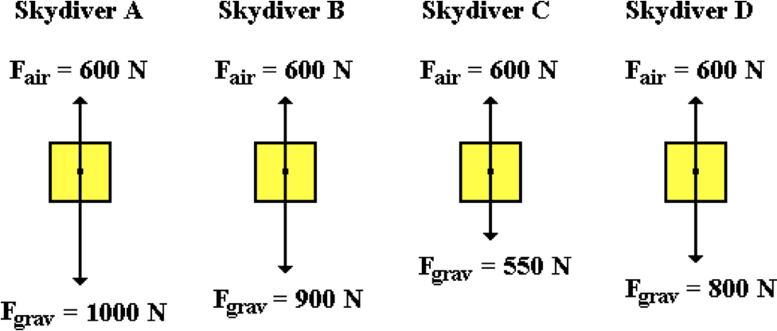

Rank the diagrams in order of increasing acceleration (magnitude only), beginning with the smallest. Enter your answer as a string of letters with no spaces between letters. Example: 'ABCD'

**Question 9:**

aa. The diagrams below represent the free-body diagrams for different skydivers at various moments during their fall.

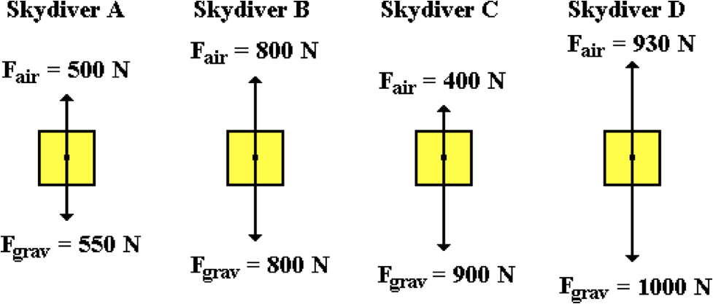

Rank the diagrams in order of increasing acceleration (magnitude only), beginning with the smallest. Enter your answer as a string of letters with no spaces between letters. Example: 'ABCD'

**Question 10:**

aa. The diagrams below represent the free-body diagrams for different skydivers at various moments during their fall.

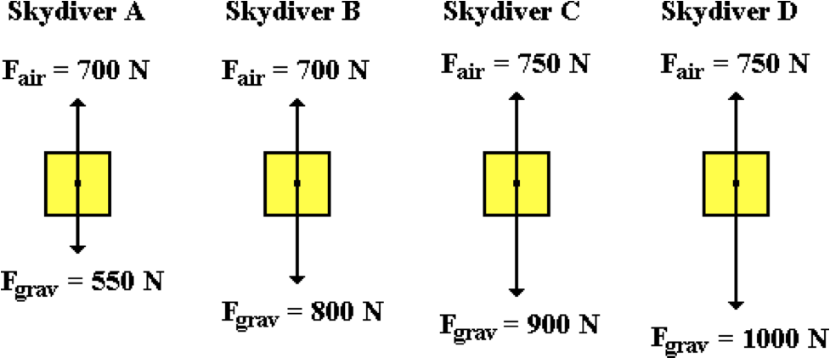

Rank the diagrams in order of increasing acceleration (magnitude only), beginning with the smallest. Enter your answer as a string of letters with no spaces between letters. Example: 'ABCD'

**Question 11:**

aa. The diagrams below represent the free-body diagrams for different skydivers at various moments during their fall.

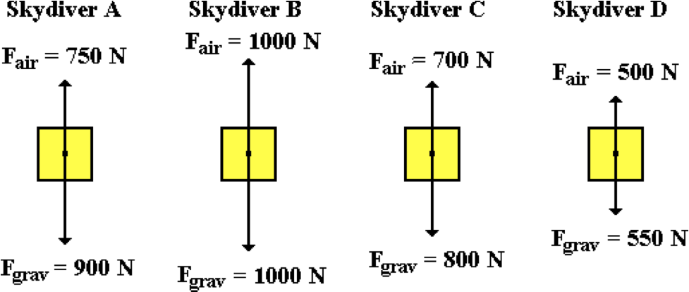

Rank the diagrams in order of increasing acceleration (magnitude only), beginning with the smallest. Enter your answer as a string of letters with no spaces between letters. Example: 'ABCD'

**Question 12:**

aa. A skydiver steps off a plane at an altitude of 10 000 feet. As the skydiver falls, her speed steadily increases. This causes the air resistance force to ____ and the acceleration to ____.

a. increase, increase b. decrease, decrease

c. increase, decrease d. decrease, increase

e. stay the same, increase f. stay the same, decrease

g. increase, stay the same h. decrease, stay the same

**Question 13:**

aa. A skydiver steps off a plane at an altitude of 10 000 feet. As the skydiver falls, her speed steadily increases. This causes the air resistance force to ____ and the acceleration to ____.

a. increase, increase b. increase, decrease

c. increase, stay the same d. decrease, decrease

e. decrease, increase f. decrease, stay the same

g. stay the same, increase h. stay the same, decrease

**Question 14:**

aa. A skydiver steps off a plane at an altitude of 10 000 feet. As the skydiver falls, her speed steadily increases. This causes the air resistance force to ____ and the acceleration to ____.

a. decrease, decrease b. decrease, increase

c. decrease, stay the same d. increase, increase

e. increase, decrease f. increase, stay the same

g. stay the same, increase h. stay the same, decrease

**Question 15:**

aa. A skydiver steps off a plane at an altitude of 10 000 feet. As the skydiver falls, her speed steadily increases. This causes the air resistance force to ____ and the acceleration to ____.

a. decrease, decrease b. decrease, increase

c. decrease, stay the same d. stay the same, increase

e. stay the same, decrease f. increase, increase

g. increase, decrease h. increase, stay the same

**Question 16:**

aa. Suppose that an elephant and a feather are dropped from a skyscraper (just suppose). In the presence of air resistance, the elephant would fall faster than the feather because ____. List all that apply in alphabetical order with no spaces between letters.

a. the elephant experiences a smaller air resistance force

b. the acceleration of gravity is greatest for the elephant

c. though they have the same mass, the elephant weighs more

d. the greater mass of the feather provides more resistance to its fall

e. the weight of the elephant is so much greater; air resistance effects it less

f. ... nonsense! The elephant and the feather would fall at the same rate.

**Question 17:**

aa. Suppose that an elephant and a feather are dropped from a skyscraper (just suppose). In the presence of air resistance, the elephant would fall faster than the feather because ____. List all that apply in alphabetical order with no spaces between letters.

a. though they have the same mass, the elephant weighs more

b. the greater mass of the feather provides more resistance to its fall

c. the weight of the elephant is so much greater; air resistance effects it less

d. the acceleration of gravity is greatest for the elephant

e. the elephant experiences a smaller air resistance force

f. ... nonsense! The elephant and the feather would fall at the same rate.

**Question 18:**

aa. Suppose that an elephant and a feather are dropped from a skyscraper (just suppose). In the presence of air resistance, the elephant would fall faster than the feather because ____. List all that apply in alphabetical order with no spaces between letters.

a. the acceleration of gravity is greatest for the elephant

b. the elephant experiences a smaller air resistance force

c. the greater mass of the feather provides more resistance to its fall

d. the weight of the elephant is so much greater; air resistance effects it less

e. though they have the same mass, the elephant weighs more

f. ... nonsense! The elephant and the feather would fall at the same rate.

**Question 19:**

aa. Suppose that an elephant and a feather are dropped from a skyscraper (just suppose). In the presence of air resistance, the elephant would fall faster than the feather because ____. List all that apply in alphabetical order with no spaces between letters.

a. though they have the same mass, the elephant weighs more

b. the weight of the elephant is so much greater; air resistance effects it less

c. the greater mass of the feather provides more resistance to its fall

d. the acceleration of gravity is greatest for the elephant

e. the elephant experiences a smaller air resistance force

f. ... nonsense! The elephant and the feather would fall at the same rate.

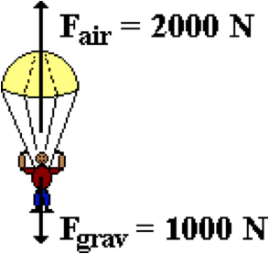**Question 20:**

aa. Darrel Deval the skydiver pulls the chord of his parachute. The forces acting upon Darrel and his parachute are shown in the diagram. From this diagram, one might infer that ____. List all that apply in alphabetical order with no spaces between letters.

a. Darrel will immediately stop.

b. Darrel will begin moving upwards.

c. Darrel will be accelerating upwards.

d. Darrel will continue to fall, but now will slow down.

e. None of these will occur

**Question 21:**

aa. Darrel Deval the skydiver pulls the chord of his parachute. The forces acting upon Darrel and his parachute are shown in the diagram. From this diagram, one might infer that ____. List all that apply in alphabetical order with no spaces between letters.

a. Darrel will immediately stop.

b. Darrel will continue to fall, but now will slow down.

c. Darrel will begin moving upwards.

d. Darrel will be accelerating upwards.

e. None of these will occur.

**Question 22:**

aa. Darrel Deval the skydiver pulls the chord of his parachute. The forces acting upon Darrel and his parachute are shown in the diagram. From this diagram, one might infer that ____. List all that apply in alphabetical order with no spaces between letters.

a. Darrel will be accelerating upwards.

b. Darrel will begin moving upwards.

c. Darrel will immediately stop.

d. Darrel will continue to fall, but now will slow down.

e. None of these will occur.

**Question 23:**

aa. Darrel Deval the skydiver pulls the chord of his parachute. The forces acting upon Darrel and his parachute are shown in the diagram. From this diagram, one might infer that ____. List all that apply in alphabetical order with no spaces between letters.

a. Darrel will immediately stop.

b. Darrel will be accelerating upwards.

c. Darrel will continue to fall, but now will slow down.

d. Darrel will begin moving upwards.

e. None of these will occur.

**Question 24:**

aa. A falling object has just reached terminal velocity. Which of the following statements are true of the object? List all that apply in alphabetical order with no spaces between letters.

a. The acceleration of the object is 0 m/s/s.

b. The object has stopped moving.

c. The net force on the object is 0 Newton.

d. The force of gravity is equal to the force of air resistance.

e. The velocity of the object is 0 m/s.

f. The velocity of the object has attained a constant value.

g. None of these statements are true of an object at terminal velocity.

**Question 25:**

aa. A falling object has just reached terminal velocity. Which of the following statements are true of the object? List all that apply in alphabetical order with no spaces between letters.

a. The force of gravity is equal to the force of air resistance.

b. The velocity of the object has attained a constant value

c. The object has stopped accelerating.

d. The net force on the object is 0 Newton.

e. The acceleration of the object is 0 m/s/s.

f. Gravity is the only force acting upon the object.

g. None of these statements are true of an object at terminal velocity.

**Question 26:**

aa. A falling object has just reached terminal velocity. Which of the following statements are true of the object? List all that apply in alphabetical order with no spaces between letters.

a. The acceleration of the object is 9.8 m/s/s, down.

b. The object has stopped moving.

c. The net force on the object is 0 Newton.

d. The force of gravity is less than the force of air resistance.

e. The velocity of the object will now change at a constant rate.

f. Gravity is the only force acting upon the object.

g. None of these statements are true of an object at terminal velocity.

**Question 27:**

aa. A falling object has just reached terminal velocity. Which of the following statements are true of the object? List all that apply in alphabetical order with no spaces between letters.

a. The force of gravity is equal to the force of air resistance.

b. The acceleration of the object is 0 m/s/s.

c. The velocity of the object is 0 m/s.

d. The object has stopped moving.

e. The velocity of the object has attained a constant value

f. The net force on the object is 0 Newton.

g. None of these statements are true of an object at terminal velocity.

**Question 28:**

aa. When an object has reached terminal velocity, it has stopped ____. List all that apply in alphabetical order with no spaces between letters.

a. falling b. moving

c. accelerating d. gaining (or losing) speed

e. None of the above.

**Question 29:**

aa. When an object has reached terminal velocity, it has stopped ____. List all that apply in alphabetical order with no spaces between letters.

a. moving b. accelerating

c. gaining (or losing) speed d. falling

e. None of the above.

**Question 30:**

aa. When an object has reached terminal velocity, it has stopped ____. List all that apply in alphabetical order with no spaces between letters.

a. accelerating b. gaining (or losing) speed

c. falling d. moving

e. None of the above.

**Question 31:**

When an object has reached terminal velocity, it has stopped ____. List all that apply in alphabetical order with no spaces between letters.

a. gaining (or losing) speed b. falling

c. moving d. accelerating

e. None of the above.

**Question 32:**

aa. Which of the following free-body diagrams would be characteristic of an object that has reached terminal velocity?

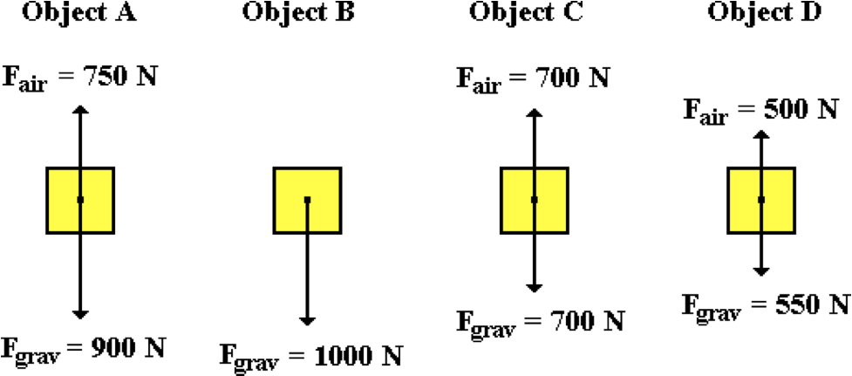

List all that apply in alphabetical order with no spaces between letters. If none apply, then enter 'E' as the answer.

**Question 33:**

aa. Which of the following free-body diagrams would be characteristic of an object that has reached terminal velocity?

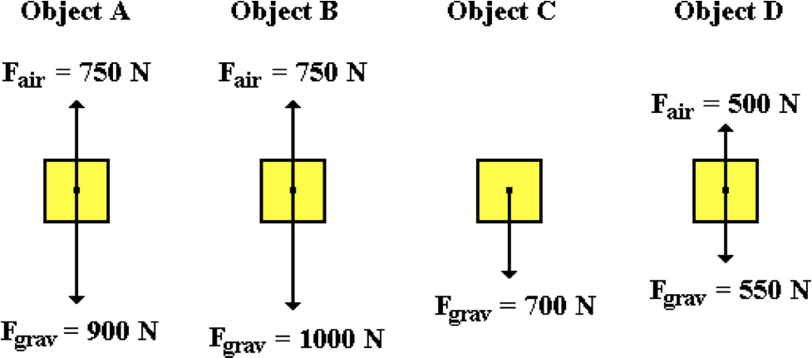

List all that apply in alphabetical order with no spaces between letters. If none apply, then enter 'E' as the answer.

**Question 34:**

aa. Which of the following free-body diagrams would be characteristic of an object that has reached terminal velocity?

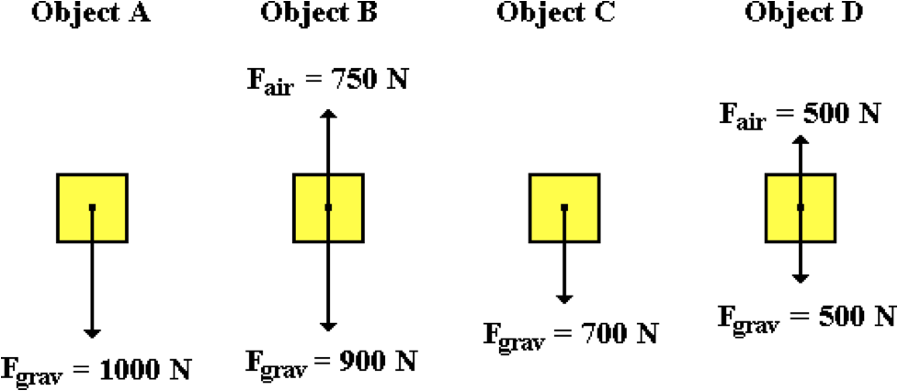

List all that apply in alphabetical order with no spaces between letters. If none apply, then enter 'E' as the answer.

**Question 35:**

aa. Which of the following free-body diagrams would be characteristic of an object that has reached terminal velocity?

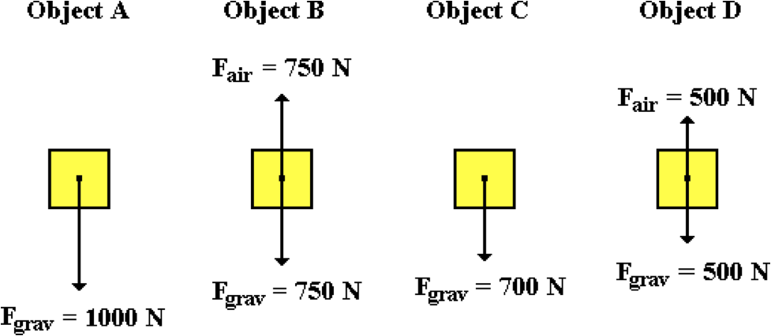

List all that apply in alphabetical order with no spaces between letters. If none apply, then enter 'E' as the answer.

**NL12: Newton’s Third Law**

**Question 1:**

aa. After missing a layup, Jonny expresses his anger by hitting the wall. The reaction force to the force of Jonny's palm hitting the wall is ____.

a. the wall denting b. Jonny's palm forcing itself

c. Jonny's palm forcing the wall d. Jonny's palm stops

e. the wall forcing itself f. the wall forcing Johnny's palm

g. the loud sound that is produced h. Jonny never misses another layup

**Question 2:**

aa. A carpenter is pounding a nail into the wall. The reaction force to the force of a hammer hitting a nail is ____.

a. the hammer forcing itself b. the nail forcing the hammer

c. the nail being driven into the wood d. the hammer forcing the nail

e. a loud sound is produced f. the wall forcing itself

g. the nail forcing itself h. the carpenter gets off work on time

**Question 3:**

aa. In a careless moment, Jane miscalculates her footing and falls from a low branch on a tree. As Jane falls from a tree, the reaction force to the force of the earth pulling Jane down is ____.

a. Jane falling b. Jane pulling herself down

c. Jane pulling the earth up d. the earth forcing itself up

e. the earth pulling Jane up f. Jane striking the ground

g. the weight of Jane's body h. the *thud* sound when Jane strikes the ground

**Question 4:**

aa. Out on the playground, big Fred comes up to little Harry and gives him a shove. The reaction force to the force of Fred pushing Harry is ____.

a. Fred gets a choice of a Saturday detention or an in-school suspension

b. Harry falls backwards to the ground

c. Harry falls over, gets up, and then shoves Fred

d. Harry pushing himself

e. Fred pulling Harry

f. Fred pushing himself

g. Harry pushing Fred

h. the sound of Harry crying

**Question 5:**

aa. A linebacker strikes a fullback with full force in a football game. The reaction force to the force of the linebacker striking the fullback is ____.

a. the fullback falls backwards to the ground

b. the force of the fullback colliding with the ground

c. the fullback fumbles

d. the fullback applies a force to the linebacker

e. the linebacker applies a force to himself

f. the fullback applies a force to himself

g. the sound of the pads colliding

h. there is a 3-yard loss and the linebacker is applauded

**Question 6:**

aa. In an Olympic boxing match, Ricardo delivers a sharp blow to Sonny's forehead. The reaction force to the force of Ricardo striking Sonny is ____.

a. Ricardo's glove recoils

b. Ricardo applies a force to himself

c. Sonny applies a force to himself

d. Sonny applies a force to Ricardo

e. the force of the Earth pulling Sonny downwards

f. the sound of Sonny's body striking the mat

g. Sonny falls backwards to the mat

h. Sonny falls over, gets up and then punches Ricardo

**Question 7:**

aa. A quiet moment during a test is interrupted as a physics book falls from a table and strikes the floor. The reaction force to the force of the Earth pulling the book downwards is ____.

a. the book begins to fall towards the floor

b. the force of gravity on the book

c. the book hits the floor

d. the floor pushes up on the book

e. the book pushes down upon itself

f. the book exerts an upward pull on the Earth

g. the sound of the impact with the floor

h. the weight of the book

**Question 8:**

aa. A quiet moment during a test is interrupted as a physics book falls from a table and strikes the floor. The reaction force to the force of the floor pushing upwards on the book (when it hits the ground) is ____.

a. the force of the Earth pulling the book downwards

b. the force of the book upon itself

c. the weight of the book

d. the loud sound created by the collision

e. the book stops falling

f. the force of the Earth pushing up on the floor

g. the force of the floor pushing down on the Earth

h. the force of the book pushing down on the floor

**Question 9:**

aa. A fish happily swims through the water due to the marvel of Newton's third law. Identify the two letters corresponding to the action-reaction FORCE pairs that are responsible for the fish's motion. List the two letters in alphabetical order with no spaces between letters.

a. The fins of the fish push backward on the water.

b. The water moves backward and out of the way of the fish.

c. The water pressure is greatest behind the fish than in front of it.

d. The fish moves forward.

e. The water pushes forward upon the fish's fins.

f. The muscular and internal pressure of the fish stabilizes its skeletal structure.

g. Small bubbles are created as the water swirls and moves backwards.

**Question 10:**

aa. A fish happily swims through the water due to the marvel of Newton's third law. Identify the two letters corresponding to the action-reaction FORCE pairs that are responsible for the fish's motion. List the two letters in alphabetical order with no spaces between letters.

a. The water pressure is greatest behind the fish than in front of it.

b. Small bubbles are created as the water swirls and moves backwards.

c. The muscular and internal pressure of the fish stabilizes its skeletal structure.

d. The fish moves forward.

e. The fins of the fish push backward on the water.

f. The water moves backward and out of the way of the fish.

g. The water pushes forward upon the fish's fins.

**Question 11:**

aa. A fish happily swims through the water due to the marvel of Newton's third law. Identify the two letters corresponding to the action-reaction FORCE pairs that are responsible for the fish's motion. List the two letters in alphabetical order with no spaces between letters.

a. The water pushes forward upon the fish's fins.

b. The muscular and internal pressure of the fish stabilizes its skeletal structure.

c. Small bubbles are created as the water swirls and moves backwards.

d. The fins of the fish push backward on the water.

e. The water moves backward and out of the way of the fish.

f. The water pressure is greatest behind the fish than in front of it.

g. The fish moves forward.

**Question 12:**

aa. A fish happily swims through the water due to the marvel of Newton's third law. Identify the two letters corresponding to the action-reaction FORCE pairs that are responsible for the fish's motion. List the two letters in alphabetical order with no spaces between letters.

a. The muscular and internal pressure of the fish stabilizes its skeletal structure.

b. The fish moves forward.

c. The water pushes forward upon the fish's fins.

d. The water moves backward and out of the way of the fish.

e. Small bubbles are created as the water swirls and moves backwards.

f. The fins of the fish push backward on the water.

g. The water pressure is greatest behind the fish than in front of it.

**Question 13:**

aa. A bird is able to fly due to the marvels of Newton's third law. Identify the two letters corresponding to the action-reaction FORCE pairs that are responsible for the bird’s flight. List the two letters in alphabetical order with no spaces between letters.

a. The bird's wings push downward upon the air.

b. Air moves out of the way of the bird making it easier to move forward.

c. The air pushes upward on the bird’s wings.

d. The bird's wings move upward after every downward stroke.

e. Air is compressed and a partial vacuum is created above the bird.

f. The force of gravity pulls the bird downward.

g. The bird's weight is reduced as it flaps its wings.

**Question 14:**

aa. A bird is able to fly due to the marvels of Newton's third law. Identify the two letters corresponding to the action-reaction FORCE pairs that are responsible for the bird's flight. List the two letters in alphabetical order with no spaces between letters.

a. Air moves out of the way of the bird making it easier to move forward.

b. The bird's wings push downward upon the air.

c. Air is compressed and a partial vacuum is created above the bird.

d. The force of gravity pulls the bird downward.

e. The bird's wings move upward after every downward stroke.

f. The air pushes upward on the bird’s wings.

g. The bird's weight is reduced as it flaps its wings.

**Question 15:**

aa. A bird is able to fly due to the marvels of Newton's third law. Identify the two letters corresponding to the action-reaction FORCE pairs that are responsible for the bird's flight. List the two letters in alphabetical order with no spaces between letters.

a. The bird's weight is reduced as it flaps its wings.

b. The force of gravity pulls the bird downward.

c. The air pushes upward on the bird’s wings.

d. The bird's wings push downward upon the air.

e. Air is compressed and a partial vacuum is created above the bird.

f. The bird's wings move upward after every downward stroke.

g. Air moves out of the way of the bird making it easier to move forward.

**Question 16:**

aa. A bird is able to fly due to the marvels of Newton's third law. Identify the two letters corresponding to the action-reaction FORCE pairs that are responsible for the bird's flight. List the two letters in alphabetical order with no spaces between letters.

a. The force of gravity pulls the bird downward.

b. The bird's weight is reduced as it flaps its wings.

c. Air is compressed and a partial vacuum is created above the bird.

d. Air moves out of the way of the bird making it easier to move forward.

e. The bird's wings push downward upon the air.

f. The bird's wings move upward after every downward stroke.

g. The air pushes upward on the bird’s wings.

**Question 17:**

aa. In baseball, the baseball strikes the catcher's mitt and is stopped due to the marvels of Newton's third law. Identify the two letters corresponding to the action-reaction FORCE pairs that are responsible for the stopping of the baseball. List the two letters in alphabetical order with no spaces between letters.

a. The catcher's mitt pushes backward upon the ball.

b. The ball pushes upon itself.

c. At the atomic level, there is compressing of the atoms in the leather of the glove.

d. There is a downward pull of the Earth upon the ball.

e. The ball applies a forward force to the catcher's mitt.

f. The ball slows down as the mitt closes upon it.

g. The mitt recoils backward a very small distance.

**Question 18:**

aa. In baseball, the baseball strikes the catcher's mitt and is stopped due to the marvels of Newton's third law. Identify the two letters corresponding to the action-reaction FORCE pairs that are responsible for the stopping of the baseball. List the two letters in alphabetical order with no spaces between letters.

a. The ball slows down as the mitt closes upon it.

b. The mitt recoils backward a very small distance.

c. The ball pushes upon itself.

d. There is a downward pull of the Earth upon the ball.

e. At the atomic level, there is compressing of the atoms in the leather of the glove.

f. The ball applies a forward force to the catcher's mitt.

g. The catcher's mitt pushes backward upon the ball.

**Question 19:**

aa. In baseball, the baseball strikes the catcher's mitt and is stopped due to the marvels of Newton's third law. Identify the two letters corresponding to the action-reaction FORCE pairs that are responsible for the stopping of the baseball. List the two letters in alphabetical order with no spaces between letters.

a. The ball slows down as the mitt closes upon it.

b. The catcher's mitt pushes backward upon the ball.

c. At the atomic level, there is compressing of the atoms in the leather of the glove.

d. The mitt recoils backward a very small distance.

e. There is a downward pull of the Earth upon the ball.

f. The ball pushes upon itself.

g. The ball applies a forward force to the catcher's mitt.

**Question 20:**

aa. In baseball, the baseball strikes the catcher's mitt and is stopped due to the marvels of Newton's third law. Identify the two letters corresponding to the action-reaction FORCE pairs that are responsible for the stopping of the baseball. List the two letters in alphabetical order with no spaces between letters.

a. There is a downward pull of the Earth upon the ball.

b. At the atomic level, there is compressing of the atoms in the leather of the glove.

c. The ball pushes upon itself.

d. The ball applies a forward force to the catcher's mitt.

e. The mitt recoils backward a very small distance.

f. The catcher's mitt pushes backward upon the ball.

g. The ball slows down as the mitt closes upon it.

**Question 21:**

aa. A sprinter in track is able to progress towards the finish line due to the marvels of Newton's third law. Identify the two letters corresponding to the action-reaction FORCE pairs that are responsible for this running action. List the two letters in alphabetical order with no spaces between letters.

a. The muscular action of the legs propels the sprinter forward.

b. The force of gravity pulls the sprinter towards the track surface.

c. The sprinter pushes backward upon the ground with her shoes.

d. The ground pushes forward upon the sprinter's shoes.

e. The sprinter pushes herself forward using her leg muscles.

f. The ground pushes upward upon the sprinter and reduces her weight.

g. The left leg moves forward as the right leg moves backward; and vice versa.

**Question 22:**

aa. A sprinter in track is able to progress towards the finish line due to the marvels of Newton's third law. Identify the two letters corresponding to the action-reaction FORCE pairs that are responsible for this running action. List the two letters in alphabetical order with no spaces between letters.

a. The left leg moves forward as the right leg moves backward; and vice versa.

b. The sprinter pushes backward upon the ground with her shoes.

c. The force of gravity pulls the sprinter towards the track surface.

d. The sprinter pushes herself forward using her leg muscles.

e. The ground pushes forward upon the sprinter's shoes.

f. The muscular action of the legs propels the sprinter forward.

g. The ground pushes upward upon the sprinter and reduces her weight.

**Question 23:**

aa. A sprinter in track is able to progress towards the finish line due to the marvels of Newton's third law. Identify the two letters corresponding to the action-reaction FORCE pairs that are responsible for this running action. List the two letters in alphabetical order with no spaces between letters.

a. The ground pushes upward upon the sprinter and reduces her weight.

b. The force of gravity pulls the sprinter towards the track surface.

c. The left leg moves forward as the right leg moves backward; and vice versa.

d. The muscular action of the legs propels the sprinter forward.

e. The sprinter pushes herself forward using her leg muscles.

f. The ground pushes forward upon the sprinter's shoes.

g. The sprinter pushes backward upon the ground with her shoes.

**Question 24:**

aa. A sprinter in track is able to progress towards the finish line due to the marvels of Newton's third law. Identify the two letters corresponding to the action-reaction FORCE pairs that are responsible for this running action. List the two letters in alphabetical order with no spaces between letters.

a. The sprinter pushes herself forward using her leg muscles.

b. The ground pushes forward upon the sprinter's shoes.

c. The sprinter pushes backward upon the ground with her shoes.

d. The force of gravity pulls the sprinter towards the track surface.

e. The left leg moves forward as the right leg moves backward; and vice versa.

f. The muscular action of the legs propels the sprinter forward.

g. The ground pushes upward upon the sprinter and reduces her weight.

**Question 25:**

aa. Late one night, an unfortunate bug collides with the windshield of a fast-moving bus. The force of the bus on the bug is _____ the force of the bug on the bus; the resulting acceleration of the bug is ____ the acceleration of the bus.

a. greater than, greater than b. less than, less than

c. less than, greater than d. greater than, less than

e. equal to, equal to f. greater than, equal to

g. equal to, greater than h. equal to, less than

i. less than, equal to

**Question 26:**

aa. Late one night, an unfortunate bug collides with the windshield of a fast-moving bus. The force of the bus on the bug is _____ the force of the bug on the bus; the resulting acceleration of the bug is ____ the acceleration of the bus.

a. greater than, greater than b. greater than, less than

c. greater than, equal to d. equal to, equal to

e. equal to, greater than f. equal to, less than

g. less than, less than h. less than, greater than

i. less than, equal to

**Question 27:**

aa. Late one night, an unfortunate bug collides with the windshield of a fast-moving bus. The force of the bug on the bus is _____ the force of the bus on the bug; the resulting acceleration of the bus is ____ the acceleration of the bug.

a. greater than, greater than b. less than, less than

c. less than, greater than d. greater than, less than

e. equal to, equal to f. greater than, equal to

g. equal to, greater than h. equal to, less than

i. less than, equal to

**Question 28:**

aa. Late one night, an unfortunate bug collides with the windshield of a fast-moving bus. The force of the bug on the bus is _____ the force of the bus on the bug; the resulting acceleration of the bus is ____ the acceleration of the bug.

a. greater than, greater than b. greater than, less than

c. greater than, equal to d. equal to, equal to

e. equal to, greater than f. equal to, less than

g. less than, less than h. less than, greater than

i. less than, equal to

**Question 29:**

aa. A large truck rear-ends a less massive car at a stop sign. The force of the truck on the car is _____ the force of the car on the truck; the resulting acceleration of the truck is ____ the acceleration of the car.

a. greater than, greater than b. less than, less than

c. less than, greater than d. greater than, less than

e. equal to, equal to f. greater than, equal to

g. equal to, greater than h. equal to, less than

i. less than, equal to

**Question 30:**

aa. A large truck rear-ends a less massive car at a stop sign. The force of the truck on the car is _____ the force of the car on the truck; the resulting acceleration of the truck is ____ the acceleration of the car.

a. greater than, greater than b. greater than, less than

c. greater than, equal to d. equal to, equal to

e. equal to, greater than f. equal to, less than

g. less than, less than h. less than, greater than

i. less than, equal to

**Question 31:**

aa. A large truck rear-ends a less massive car at a stop sign. The force of the car on the truck is _____ the force of the truck on the car; the resulting acceleration of the car is ____ the acceleration of the truck.

a. greater than, greater than b. less than, less than

c. less than, greater than d. greater than, less than

e. equal to, equal to f. greater than, equal to

g. equal to, greater than h. equal to, less than

i. less than, equal to

**Question 32:**

aa. A large truck rear-ends a less massive car at a stop sign. The force of the car on the truck is _____ the force of the truck on the car; the resulting acceleration of the car is ____ the acceleration of the truck.

a. greater than, greater than b. greater than, less than

c. greater than, equal to d. equal to, equal to

e. equal to, greater than f. equal to, less than

g. less than, less than h. less than, greater than

i. less than, equal to

**Question 33:**

aa. The Earth is held in orbit by the force of gravity between the Earth and the more massive Sun. The force of the Earth on the Sun is ____ the force of the Sun on the Earth; the resulting acceleration of the Earth is ____ the acceleration of the Sun.

a. greater than, greater than b. less than, less than

c. less than, greater than d. greater than, less than

e. equal to, equal to f. greater than, equal to

g. equal to, greater than h. equal to, less than

i. less than, equal to

**Question 34:**

aa. The Earth is held in orbit by the force of gravity between the Earth and the more massive Sun. The force of the Earth on the Sun is ____ the force of the Sun on the Earth; the resulting acceleration of the Earth is ____ the acceleration of the Sun.

a. greater than, greater than b. greater than, less than

c. greater than, equal to d. equal to, equal to

e. equal to, greater than f. equal to, less than

g. less than, less than h. less than, greater than

i. less than, equal to

**Question 35:**

aa. The Earth is held in orbit by the force of gravity between the more massive Sun and the Earth. The force of the Sun on the Earth is ____ the force of the Earth on the Sun; the resulting acceleration of the Sun is ____ the acceleration of the Earth.

a. greater than, greater than b. less than, less than

c. less than, greater than d. greater than, less than

e. equal to, equal to f. greater than, equal to

g. equal to, greater than h. equal to, less than

i. less than, equal to

**Question 36:**

aa. The Earth is held in orbit by the force of gravity between the more massive Sun and the Earth. The force of the Sun on the Earth is ____ the force of the Earth on the Sun; the resulting acceleration of the Sun is ____ the acceleration of the Earth.

a. greater than, greater than b. greater than, less than

c. greater than, equal to d. equal to, equal to

e. equal to, greater than f. equal to, less than

g. less than, less than h. less than, greater than

i. less than, equal to

**Question 37:**

aa. Action and reaction forces always occur in equal and opposite pairs. They do not balance each other because the ____.

a. action force acts for a longer time than the reaction force

b. action and reaction forces act on different objects

c. action and reaction forces act in the same direction

d. reaction force acts only after the action force is removed

e. reaction force acts for a longer time than the action force

f. ... nonsense! They do balance each other since they are equal and opposite.

**Question 38:**

aa. Action and reaction forces always occur in equal and opposite pairs. They do not balance each other because the ____.

a. reaction force acts only after the action force is removed

b. reaction force acts for a longer time than the action force

c. action force acts for a longer time than the reaction force

d. action and reaction forces act in the same direction

e. action and reaction forces act on different objects

f. ... nonsense! They do balance each other since they are equal and opposite.

**Question 39:**

aa. Action and reaction forces always occur in equal and opposite pairs. They do not balance each other because the ____.

a. action and reaction forces act on different objects

b. reaction force acts only after the action force is removed

c. action and reaction forces act in the same direction

d. action force acts for a longer time than the reaction force

e. reaction force acts for a longer time than the action force

f. ... nonsense! They do balance each other since they are equal and opposite.

**Question 40:**

aa. Action and reaction forces always occur in equal and opposite pairs. They do not balance each other because the ____.

a. action force acts for a longer time than the reaction force

b. reaction force acts for a longer time than the action force

c. reaction force acts only after the action force is removed

d. action and reaction forces act on different objects

e. action and reaction forces act in the same direction

f. ... nonsense! They do balance each other since they are equal and opposite.