**Minds On Physics Question Banks – Reflection and Mirrors**

**RM1: Law of Reflection**

**Question 1:**

aa. The angle of incidence is defined as the angle between the ____ and the ____.

a. incident ray, reflected ray b. incident ray, surface

c. incident ray, normal d. reflected ray, surface

e. reflected ray, normal f. none of these

**Question 2:**

aa. The angle of incidence is defined as the angle between the ____ and the ____.

a. incident ray, normal b. incident ray, surface

c. incident ray, reflected ray d. reflected ray, surface

e. reflected ray, normal f. none of these

**Question 3:**

aa. The angle of incidence is defined as the angle between the ____ and the ____.

a. incident ray, surface b. incident ray, normal

c. incident ray, reflected ray d. reflected ray, normal

e. reflected ray, surface f. none of these

**Question 4:**

aa. The angle of incidence is defined as the angle between the ____ and the ____.

a. incident ray, reflected ray b. incident ray, surface

c. reflected ray, surface d. incident ray, normal

e. reflected ray, normal f. none of these

**Question 5:**

aa. The angle of reflection is defined as the angle between the ____ and the ____.

a. incident ray, surface b. incident ray, normal

c. reflected ray, normal d. reflected ray, surface

e. incident ray, reflected ray f. none of these

**Question 6:**

aa. The angle of reflection is defined as the angle between the ____ and the ____.

a. incident ray, normal b. reflected ray, normal

c. incident ray, surface d. reflected ray, surface

e. incident ray, reflected ray f. none of these

**Question 7:**

aa. The angle of reflection is defined as the angle between the ____ and the ____.

a. incident ray, surface b. incident ray, normal

c. incident ray, reflected ray d. reflected ray, normal

e. reflected ray, surface f. none of these

**Question 8:**

aa. The angle of reflection is defined as the angle between the ____ and the ____.

a. incident ray, reflected ray b. incident ray, surface

c. reflected ray, surface d. incident ray, normal

e. reflected ray, normal f. none of these

**Question 9:**

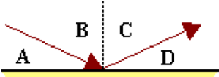aa. The diagram below depicts a ray of light reflecting off a planar surface. The angle of incidence is depicted by angle _____.

a. A

b. B

c. C

d. D

e. none of these

**Question 10:**

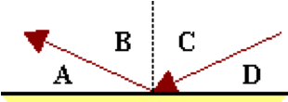aa. The diagram below depicts a ray of light reflecting off a planar surface. The angle of incidence is depicted by angle _____.

a. A

b. B

c. C

d. D

e. none of these

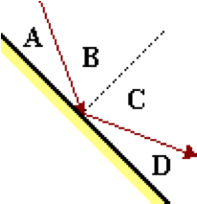**Question 11:**

aa. The diagram below depicts a ray of light reflecting off a planar surface. The angle of incidence is depicted by angle _____.

a. A

b. B

c. C

d. D

e. none of these

**Question 12:**

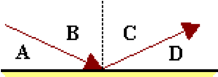aa. The diagram below depicts a ray of light reflecting off a planar surface. The angle of reflection is depicted by angle _____.

a. A

b. B

c. C

d. D

e. none of these

**Question 13:**

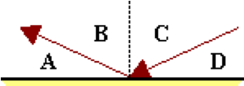aa. The diagram below depicts a ray of light reflecting off a planar surface. The angle of reflection is depicted by angle _____.

a. A

b. B

c. C

d. D

e. none of these

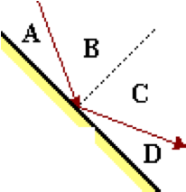**Question 14:**

aa. The diagram below depicts a ray of light reflecting off a planar surface. The angle of reflection is depicted by angle _____.

a. A

b. B

c. C

d. D

e. none of these

**Question 15:**

aa. The diagram below depicts light reflecting off a planar surface. The incident ray, reflected ray, normal and surface are labeled with a letter.

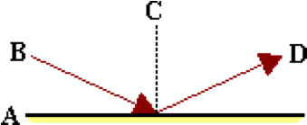

The incident ray is labeled with a letter ____, the reflected ray is labeled with a letter ____, and the normal with a letter _____.

**Question 16:**

aa. The diagram below depicts light reflecting off a planar surface. The incident ray, reflected ray, normal and surface are labeled with a letter.

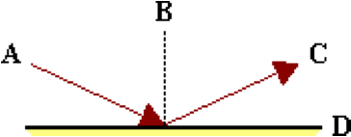

The incident ray is labeled with a letter ____, the reflected ray is labeled with a letter ____, and the normal with a letter _____.

**Question 17:**

aa. The diagram below depicts light reflecting off a planar surface. The incident ray, reflected ray, normal and surface are labeled with a letter.

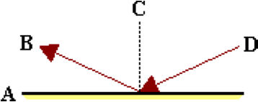

The incident ray is labeled with a letter ____, the reflected ray is labeled with a letter ____, and the normal with a letter _____.

**Question 18:**

aa. The diagram below depicts light reflecting off a planar surface. The incident ray, reflected ray, normal and surface are labeled with a letter.

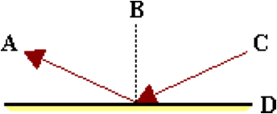

The incident ray is labeled with a letter ____, the reflected ray is labeled with a letter ____, and the normal with a letter _____.

**Question 19:**

aa. The diagram below depicts light reflecting off a planar surface. The incident and reflected rays are labeled. If ray A makes an angle of 25 degrees with the mirror surface, then the angle of reflection is _____ degrees.

a. 25

b. 65

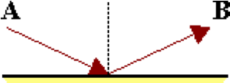 c. 135

d. 155

e. 180

f. 205

g. none of these

**Question 20:**

aa. The diagram below depicts light reflecting off a planar surface. The incident and reflected rays are labeled. If ray A makes an angle of 25 degrees with the mirror surface, then the angle of reflection is _____ degrees.

a. 205

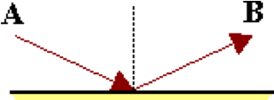 b. 180

c. 155

d. 135

e. 65

f. 25

g. none of these

**Question 21:**

aa. The diagram below depicts light reflecting off a planar surface. The incident and reflected rays are labeled. If ray A makes an angle of 65 degrees with the mirror surface, then the angle of reflection is _____ degrees.

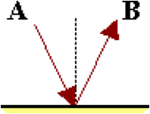 a. 25

b. 65

c. 135

d. 155

e. 180

f. 205

g. none of these

**Question 22:**

aa. The diagram below depicts light reflecting off a planar surface. The incident and reflected rays are labeled. If ray A makes an angle of 65 degrees with the mirror surface, then the angle of reflection is _____ degrees.

a. 205

b. 180

 c. 155

d. 135

e. 65

f. 25

g. none of these

**Question 23:**

aa. The diagram below depicts light reflecting off a planar surface. If angle A is a 25-degree angle, then the angle of reflection is ____ degrees.

a. 25

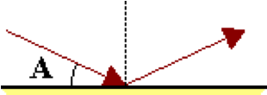 b. 65

c. 135

d. 155

e. 180

f. 205

g. none of these

**Question 24:**

aa. The diagram below depicts light reflecting off a planar surface. If angle A is a 25-degree angle, then the angle of reflection is ____ degrees.

a. 205

 b. 180

c. 155

d. 135

e. 65

f. 25

g. none of these

**Question 25:**

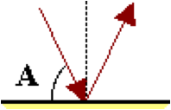aa. The diagram below depicts light reflecting off a planar surface. If angle A is a 65-degree angle, then the angle of reflection is ____ degrees.

a. 25

b. 65

c. 135

d. 155

e. 180

f. 205

g. none of these

**Question 26:**

aa. The diagram below depicts light reflecting off a planar surface. If angle A is a 65-degree angle, then the angle of reflection is ____ degrees.

a. 205

b. 180

c. 155

d. 135

e. 65

f. 25

g. none of these

**Question 27:**

aa. The diagram below depicts light reflecting off a planar surface. If angle A is a 25-degree angle, then the angle of reflection is ____ degrees.

a. 25

b. 65

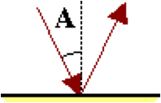 c. 135

d. 155

e. 180

f. 205

g. none of these

**Question 28:**

aa. The diagram below depicts light reflecting off a planar surface. If angle A is a 25-degree angle, then the angle of reflection is ____ degrees.

a. 205

b. 180

 c. 155

d. 135

e. 65

f. 25

g. none of these

**Question 29:**

aa. The diagram below depicts light reflecting off a planar surface. If angle A is a 65-degree angle, then the angle of reflection is ____ degrees.

a. 25

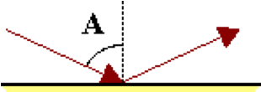 b. 65

c. 135

d. 155

e. 180

f. 205

g. none of these

**Question 30:**

aa. The diagram below depicts light reflecting off a planar surface. If angle A is a 65-degree angle, then the angle of reflection is ____ degrees.

a. 205

b. 180

c. 155

d. 135

e. 65

f. 25

g. none of these

**Question 31:**

aa. The diagram below depicts a ray of light (drawn in red) approaching a planar surface. Which one of the green rays is representative of the reflected ray?

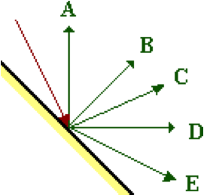

**Question 32:**

aa. The diagram below depicts a ray of light (drawn in red) approaching a planar surface. Which one of the green rays is representative of the reflected ray?

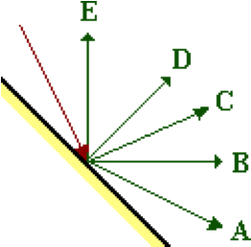

**Question 33:**

aa. The diagram below depicts a ray of light (drawn in red) approaching a planar surface. Which one of the green rays is representative of the reflected ray?

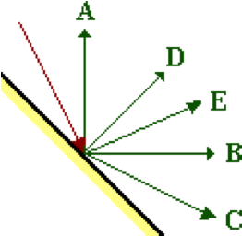

**Question 34:**

aa. The diagram below depicts a ray of light (drawn in red) approaching a planar surface. Which one of the green rays is representative of the reflected ray?

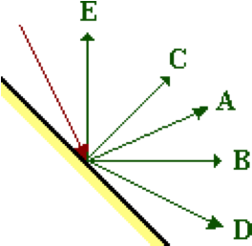

**RM2: Plane Mirror Images**

**Question 1:**

aa. An image can be defined as the location where ______.

a. all reflected rays appear to diverge from

b. all incident rays intersect

c. incident rays and reflected rays meet

d. any observer's line of sight intersects the mirror

e. a ray drawn from object and perpendicular to the mirror meets the mirror

**Question 2:**

aa. An image can be defined as the location where ______.

a. incident rays and reflected rays meet

b. all incident rays intersect

c. all reflected rays appear to diverge from

d. any observer's line of sight intersects the mirror

e. a ray drawn from object and perpendicular to the mirror meets the mirror

**Question 3:**

aa. An image can be defined as the location where ______.

a. any observer's line of sight intersects the mirror

b. all incident rays intersect

c. incident rays and reflected rays meet

d. all reflected rays appear to diverge from

e. a ray drawn from object and perpendicular to the mirror meets the mirror

**Question 4:**

aa. Which of the following statements are true of plane mirror images? Select all that apply.

a. Observers at different locations will sight along different lines at the same image.

b. All observers (regardless of their location) will sight at the same image location.

c. Every image is located on the mirror surface, but at a different location for different observers.

d. Every image is located on the mirror surface and at the same location for different observers.

e. The location of an image is different for different observers.

**Question 5:**

aa. Which of the following statements are true of plane mirror images? Select all that apply.

a. Every image is located on the mirror surface, but at a different location for different observers.

b. Every image is located on the mirror surface and at the same location for different observers.

c. The location of an image is different for different observers.

d. Observers at different locations will sight along different lines at the same image.

e. All observers (regardless of their location) will sight at the same image location.

**Question 6:**

aa. Which of the following statements are true of plane mirror images? Select all that apply.

a. The location of an image is different for different observers.

b. Observers at different locations will sight along different lines at the same image.

c. Every image is located on the mirror surface and at the same location for different observers.

d. Every image is located on the mirror surface, but at a different location for different observers.

e. All observers (regardless of their location) will sight at the same image location.

**Question 7:**

aa. The diagram below depicts the path of four incident rays emerging from an object and approaching a mirror. Five lettered locations are shown on the opposite side of the mirror.

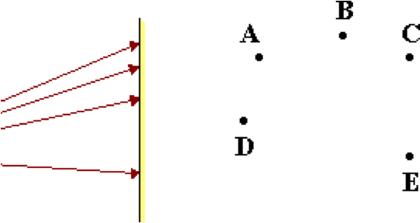

Which location is representative of the image location?

**Question 8:**

aa. The diagram below depicts the path of four incident rays emerging from an object and approaching a mirror. Five lettered locations are shown on the opposite side of the mirror.

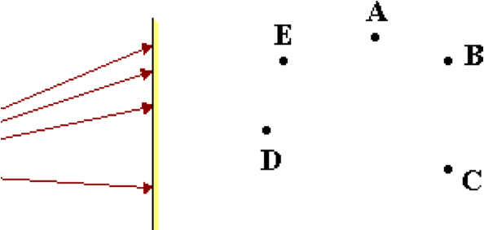

Which location is representative of the image location?

**Question 9:**

aa. The diagram below depicts the path of four incident rays emerging from an object and approaching a mirror. Five lettered locations are shown on the opposite side of the mirror.

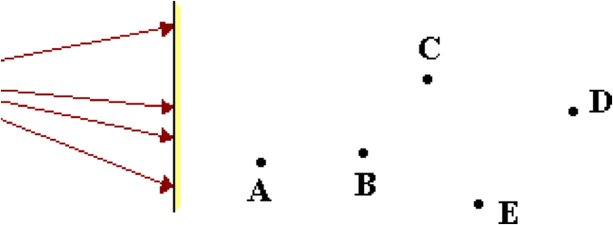

Which location is representative of the image location?

**Question 10:**

aa. The diagram below depicts the path of four incident rays emerging from an object and approaching a mirror. Five lettered locations are shown on the opposite side of the mirror.

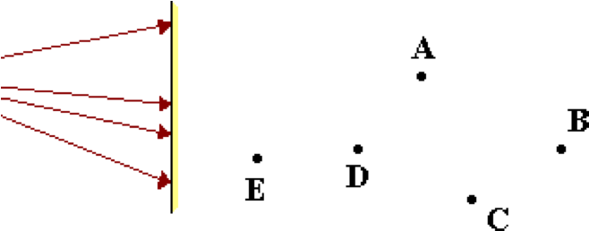

Which location is representative of the image location?

**Question 11:**

aa. The diagram below depicts the path of four reflected rays that originated at the object on the left side of the mirror and have subsequently reflected from the mirror. Five lettered locations are shown on the right side of the mirror.

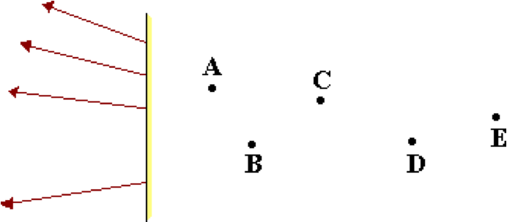

Which location is representative of the image location?

**Question 12:**

aa. The diagram below depicts the path of four reflected rays that originated at the object on the left side of the mirror and have subsequently reflected from the mirror. Five lettered locations are shown on the right side of the mirror.

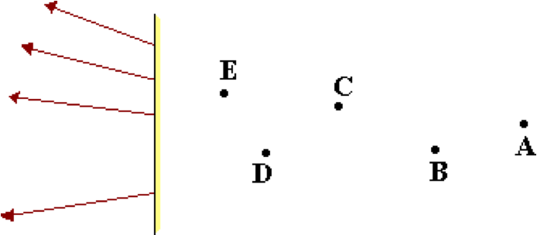

Which location is representative of the image location?

**Question 13:**

aa. The diagram below depicts the path of four reflected rays that originated at the object on the left side of the mirror and have subsequently reflected from the mirror. Five lettered locations are shown on the right side of the mirror.

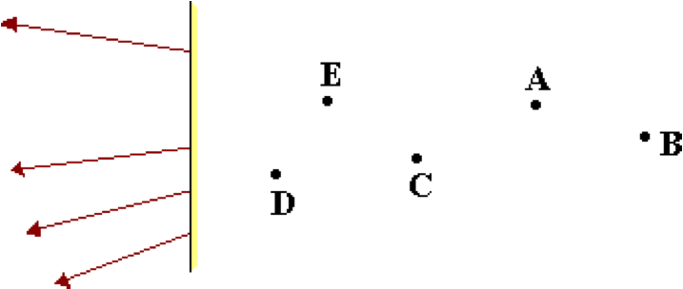

Which location is representative of the image location?

**Question 14:**

aa. The diagram below depicts the path of four reflected rays that originated at the object on the left side of the mirror and have subsequently reflected from the mirror. Five lettered locations are shown on the right side of the mirror.

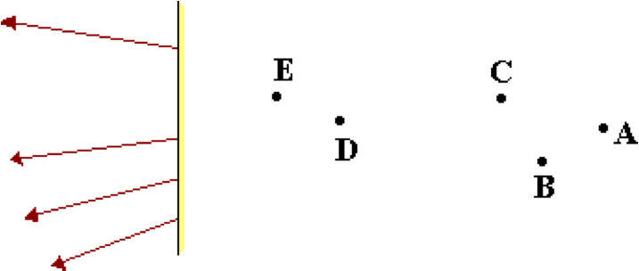

Which location is representative of the image location?

**Question 15:**

aa. Which one of the following accurately depicts the path of light from object to eye?

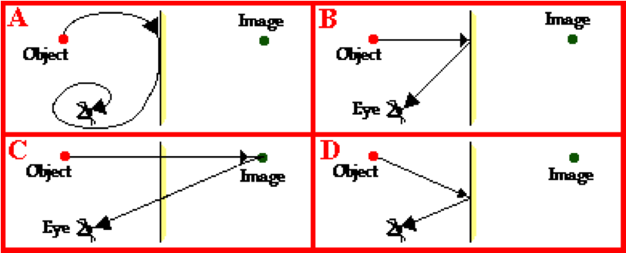

**Question 16:**

aa. Which one of the following accurately depicts the path of light from object to eye?

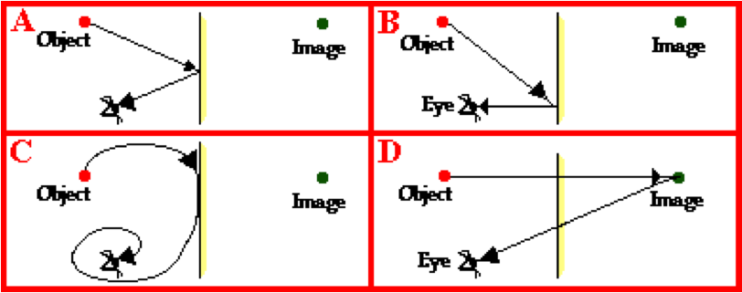

**Question 17:**

aa. Which one of the following accurately depicts the path of light from object to eye?

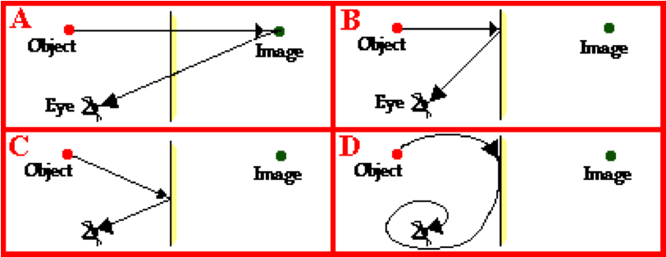

**Question 18:**

aa. If an object is located 4 meters in front of a plane mirror, then the image is located ____.

a. on the mirror surface

b. 2 meters in front of the mirror surface

c. 2 meters behind the mirror surface

d. 4 meters behind the mirror surface

e. 8 meters behind the mirror surface

f. none of the above

**Question 19:**

aa. If an object is located 4 meters in front of a plane mirror, then the image is located ____.

a. 2 meters behind the mirror surface

b. 4 meters behind the mirror surface

c. 8 meters behind the mirror surface

d. on the mirror surface

e. 2 meters in front of the mirror surface

f. none of the above

**Question 20:**

aa. If an object is located 8 meters in front of a plane mirror, then the image is located ____.

a. 4 meters in front of the mirror surface

b. 4 meters behind the mirror surface

c. on the mirror surface

d. 16 meters behind the mirror surface

e. 8 meters behind the mirror surface

f. none of the above

**Question 21:**

aa. If an object is located 8 meters in front of a plane mirror, then the image is located ____.

a. 16 meters behind the mirror surface

b. 8 meters behind the mirror surface

c. 4 meters behind the mirror surface

d. 4 meters in front of the mirror surface

e. on the mirror surface

f. none of the above

**Question 22:**

aa. If an object is located 4 meters in front of a plane mirror, then the image is located ____ meters from the object.

a. 2 b. 4 c. 6 d. 8

e. 12 f. 16 g. none of these

**Question 23:**

aa. If an object is located 4 meters in front of a plane mirror, then the image is located ____ meters from the object.

a. 16 b. 12 c. 8 d. 6

e. 4 f. 2 g. none of these

**Question 24:**

aa. If an object is located 8 meters in front of a plane mirror, then the image is located ____ meters from the object.

a. 2 b. 4 c. 6 d. 8

e. 12 f. 16 g. none of these

**Question 25:**

aa. If an object is located 8 meters in front of a plane mirror, then the image is located ____ meters from the object.

a. 16 b. 12 c. 8 d. 6

e. 4 f. 2 g. none of these

**Question 26:**

aa. If an object is located 6 meters in front of a plane mirror, then the image is located ____ meters from the object.

a. 2 b. 4 c. 6 d. 8

e. 12 f. 16 g. none of these

**Question 27:**

aa. A shirt with **TOYOTA** written on it is placed in front of a plane mirror.

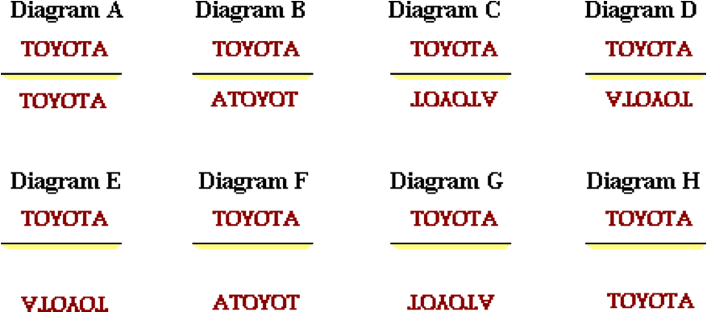

Which one of the following diagrams best describes the size, location, and orientation of the image?

**Question 28:**

aa. A shirt with **TOYOTA** written on it is placed in front of a plane mirror.

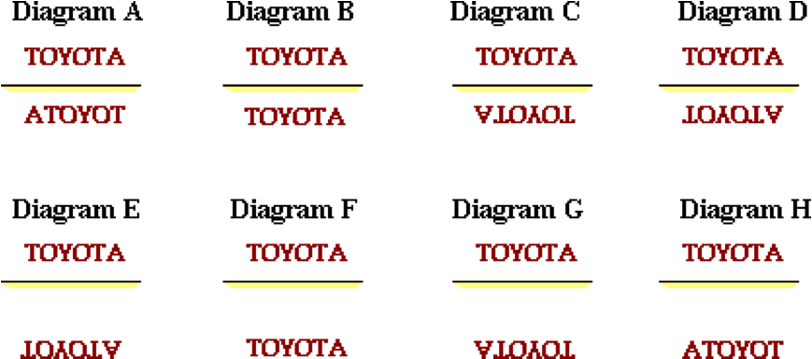

Which one of the following diagrams best describes the size, location, and orientation of the image?

**Question 29:**

aa. A shirt with **TOYOTA** written on it is placed in front of a plane mirror.

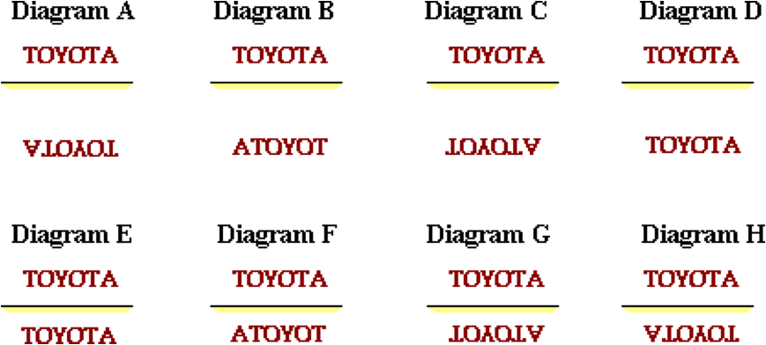

Which one of the following diagrams best describes the size, location, and orientation of the image?

**Question 30:**

aa. A shirt with **TOYOTA** written on it is placed in front of a plane mirror.

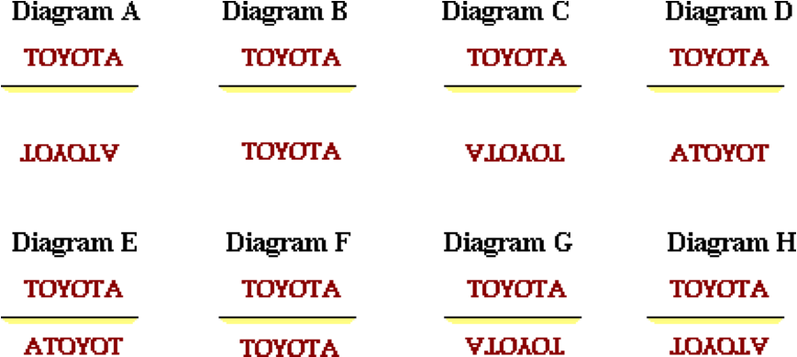

Which one of the following diagrams best describes the size, location, and orientation of the image?

**Question 31:**

aa. A shirt with **TOYOTA** written on it is placed in front of a plane mirror.

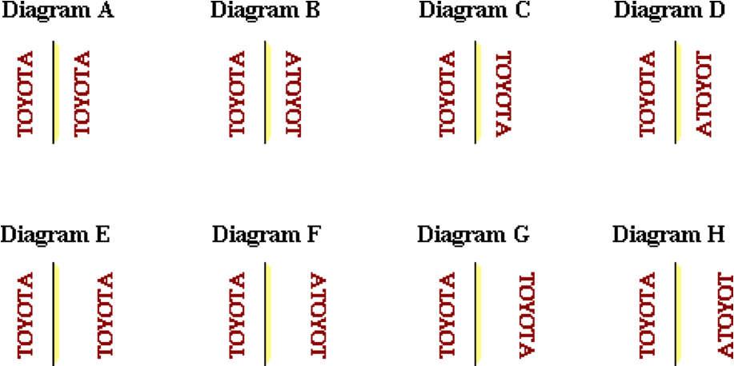

Which one of the following diagrams best describes the size, location, and orientation of the image?

**Question 32:**

aa. A shirt with **TOYOTA** written on it is placed in front of a plane mirror.

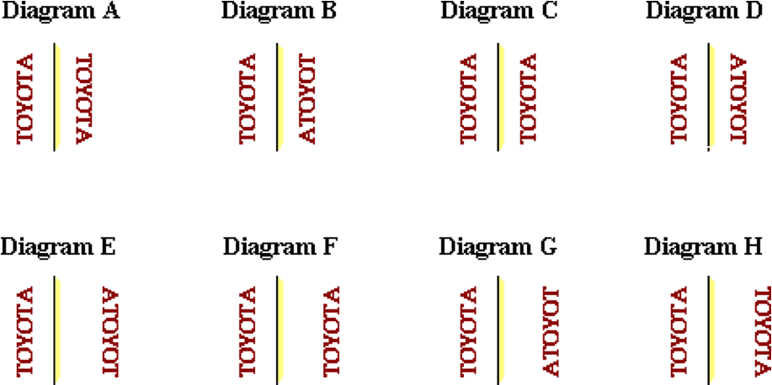

Which one of the following diagrams best describes the size, location, and orientation of the image?

**Question 33:**

aa. A shirt with **TOYOTA** written on it is placed in front of a plane mirror.

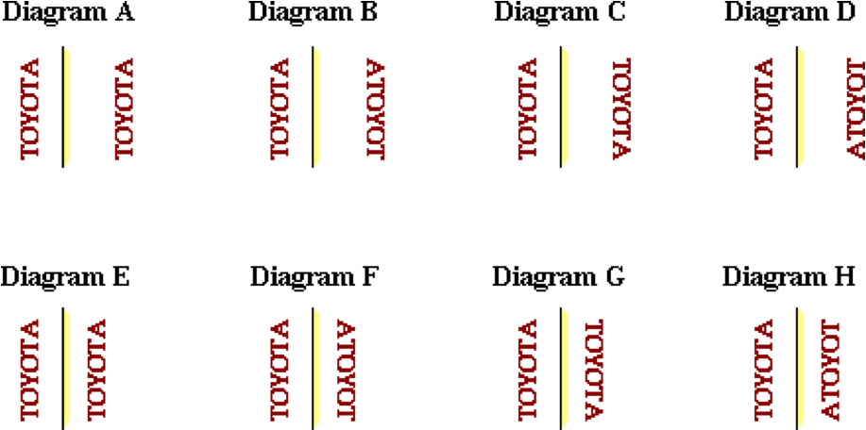

Which one of the following diagrams best describes the size, location, and orientation of the image?

**Question 34:**

aa. A shirt with **TOYOTA** written on it is placed in front of a plane mirror.

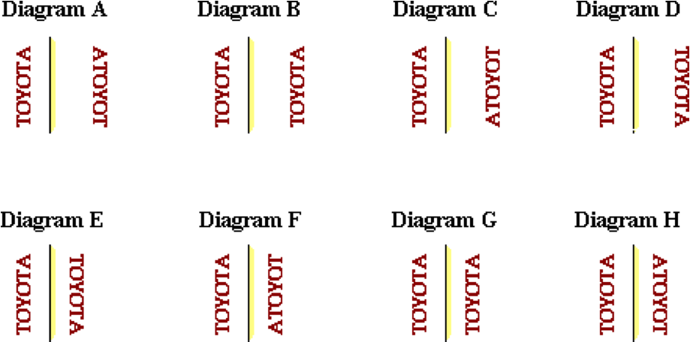

Which one of the following diagrams best describes the size, location, and orientation of the image?

**Question 35:**

aa. The image of an object as formed by a plane mirror is located ____.

a. on the mirror surface

b. in front of the mirror surface

c. behind the mirror surface

d. any of the above, depending upon the location of the object.

**Question 36:**

aa. The image of an object as formed by a plane mirror is located ____.

a. in front of the mirror surface

b. behind the mirror surface

c. on the mirror surface

d. any of the above, depending upon the location of the object.

**Question 37:**

aa. The image of an object as formed by a plane mirror is located ____.

a. behind the mirror surface

b. in front of the mirror surface

c. on the mirror surface

d. any of the above, depending upon the location of the object.

**RM3: Plane Mirror Ray Tracing**

**Question 1:**

aa. Which one of the following accurately depicts the path of light from object to eye?



**Question 2:**

aa. Which one of the following accurately depicts the path of light from object to eye?



**Question 3:**

aa. Which one of the following accurately depicts the path of light from object to eye?



**Question 4:**

aa. Along which line of sight must the eye look in order to see the image of the RED object?

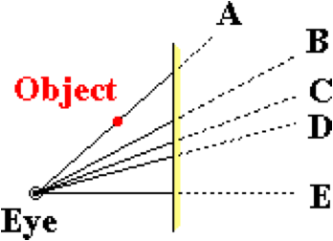

**Question 5:**

aa. Along which line of sight must the eye look in order to see the image of the RED object?

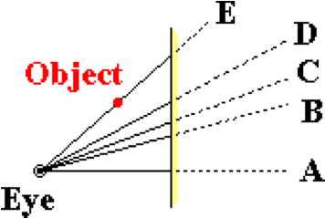

**Question 6:**

aa. Along which line of sight must the eye look in order to see the image of the RED object?

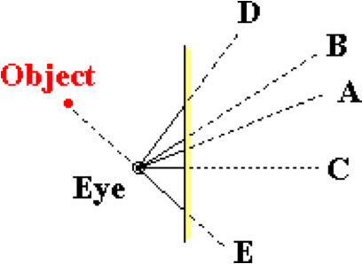

**Question 7:**

aa. Along which line of sight must the eye look in order to see the image of the RED object?

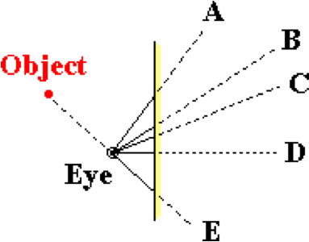

**Question 8:**

aa. Along which line of sight must the eye look in order to see the image of the RED object?

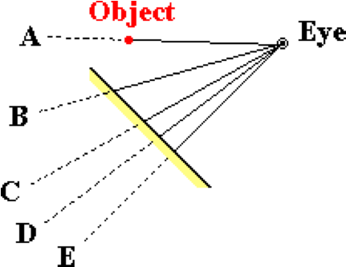

**Question 9:**

aa. Along which line of sight must the eye look in order to see the image of the RED object?

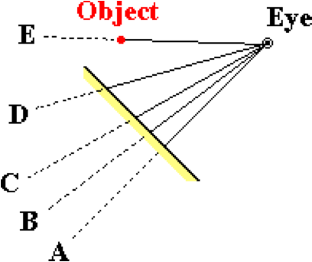

**Question 10:**

aa. Along which line of sight must the eye look in order to see the image of the RED object?

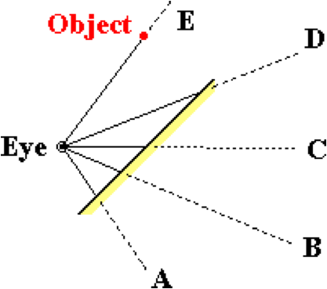

**Question 11:**

aa. Along which line of sight must the eye look in order to see the image of the RED object?

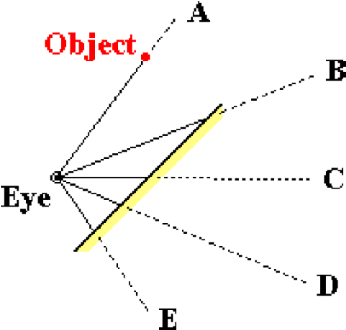

**Question 12:**

aa. An 'arrow object' is positioned in front of a plane mirror as shown. Along which line of sight must the eye look in order to see the topmost part of the image (i.e., the arrowhead)?

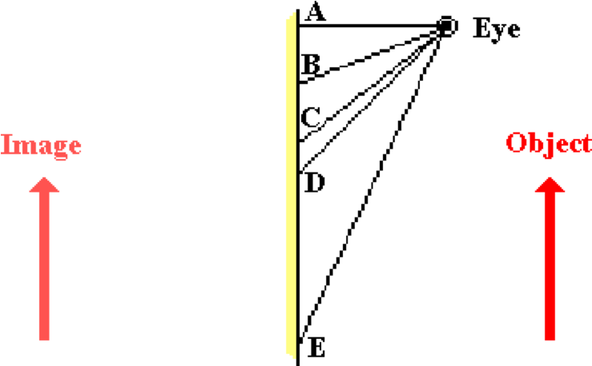

**Question 13:**

aa. An 'arrow object' is positioned in front of a plane mirror as shown. Along which line of sight must the eye look in order to see the topmost part of the image (i.e., the arrowhead)?

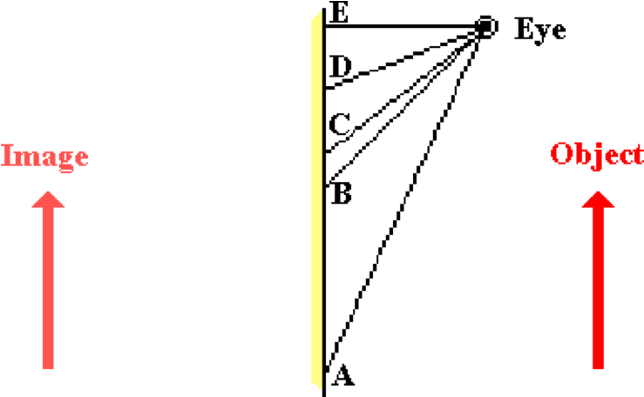

**Question 14:**

aa. An 'arrow object' is positioned in front of a plane mirror as shown. Along which line of sight must the eye look in order to see the topmost part of the image (i.e., the arrowhead)?

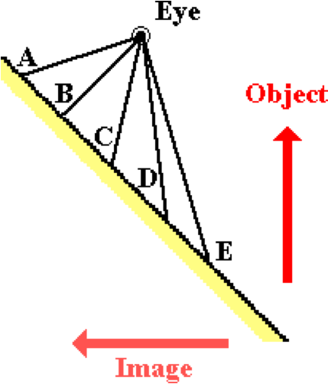

**Question 15:**

aa. An 'arrow object' is positioned in front of a plane mirror as shown. Along which line of sight must the eye look in order to see the topmost part of the image (i.e., the arrowhead)?

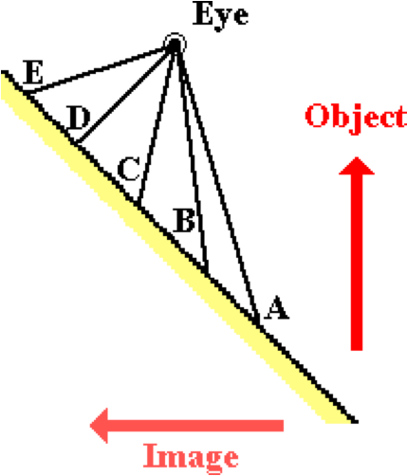

**Question 16:**

aa. An 'arrow object' is positioned in front of a plane mirror as shown. Along which line of sight must the eye look in order to see the topmost part of the image (i.e., the arrowhead)?



**Question 17:**

aa. An 'arrow object' is positioned in front of a plane mirror as shown. Along which line of sight must the eye look in order to see the topmost part of the image (i.e., the arrowhead)?



**Question 18:**

aa. An 'arrow object' is positioned in front of a plane mirror as shown. Along which line of sight must the eye look in order to see the topmost part of the image (i.e., the arrowhead)?

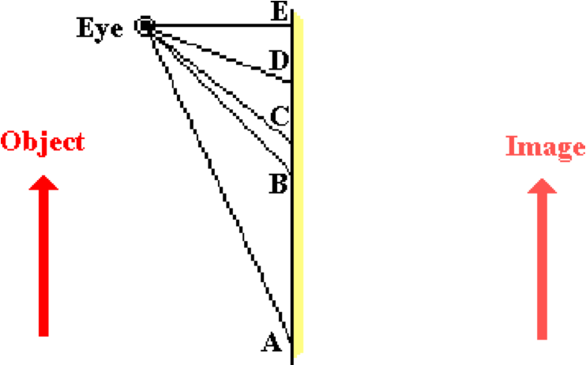

**Question 19:**

aa. An 'arrow object' is positioned in front of a plane mirror as shown. Along which line of sight must the eye look in order to see the topmost part of the image (i.e., the arrowhead)?

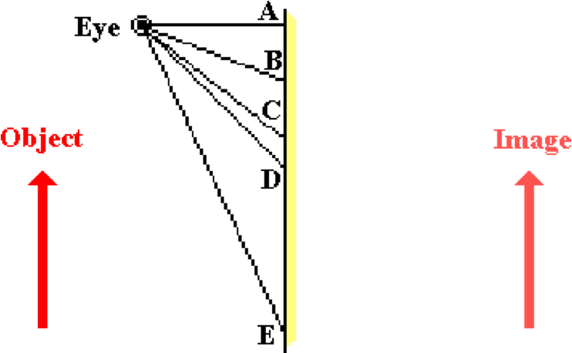

**Question 20:**

aa. Which of the following diagrams are correct ray diagrams showing how light from an object (in RED) travels to the eye when sighting at the image (in PINK)? Select all that apply.

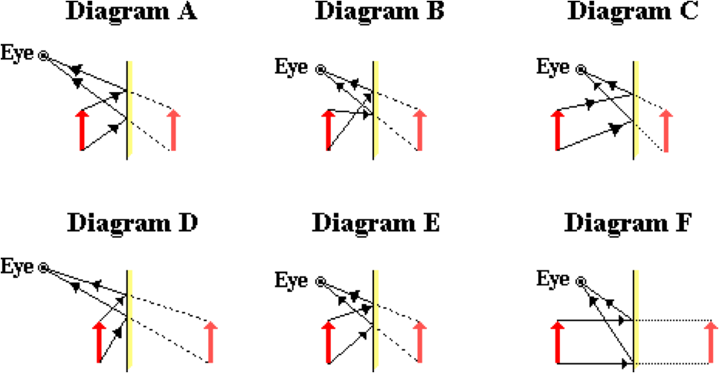

**Question 21:**

aa. Which of the following diagrams are correct ray diagrams showing how light from an object (in RED) travels to the eye when sighting at the image (in PINK)? Select all that apply.

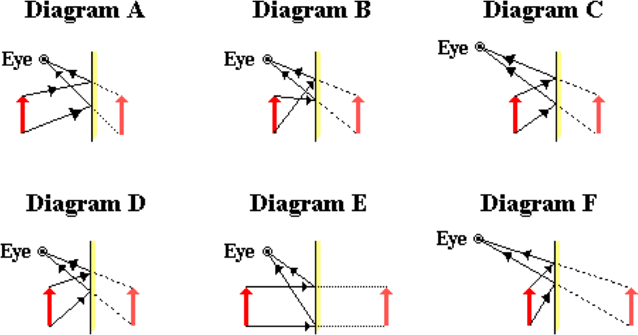

**Question 22:**

aa. Which of the following diagrams are correct ray diagrams showing how light from an object (in RED) travels to the eye when sighting at the image (in PINK)? Select all that apply.

.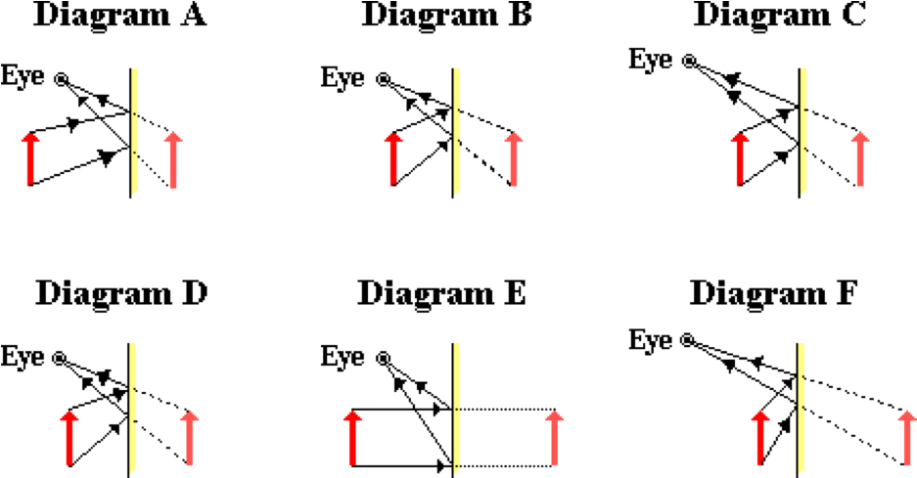

**Question 23:**

aa. Al, Bo, Cy, Di, Ed and Fred (shown in RED) sit in front of a plane mirror; their image locations are shown (in PINK). Which students can Al see? List the first letters of each visible student (from Al's vantage point, and including Al).

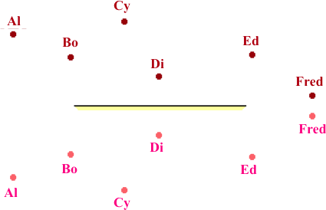

**Question 24:**

aa. Al, Bo, Cy, Di, Ed and Fred (shown in RED) sit in front of a plane mirror; their image locations are shown (in PINK).

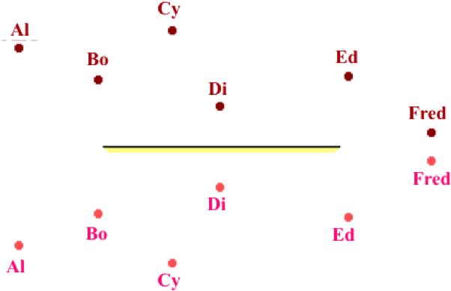

Which students can Bo see? List the first letters of each visible student (from Bo's vantage point, and including Bo) in alphabetical order.

**Question 25:**

aa. Al, Bo, Cy, Di, Ed and Fred (shown in RED) sit in front of a plane mirror; their image locations are shown (in PINK).

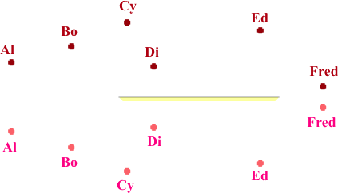

Which students can Ed see? List the first letters of each visible student (from Ed's vantage point, and including Ed) in alphabetical order.

**Question 26:**

aa. Al, Bo, Cy, Di, Ed and Fred (shown in RED) sit in front of a plane mirror; their image locations are shown (in PINK).



Which students can Fred see? List the first letters of each visible student (from Fred's vantage point, and including Fred) in alphabetical order.

**Question 27:**

aa. Al, Bo, Cy, Di, Ed and Fred (shown in RED) sit in front of a plane mirror; their image locations are shown (in PINK).



Which students can Cy see? List the first letters of each visible student (from Cy's vantage point, and including Cy) in alphabetical order.

**Question 28:**

aa. Al, Bo, Cy, Di, Ed and Fred (shown in RED) sit in front of a plane mirror; their image locations are shown (in PINK).

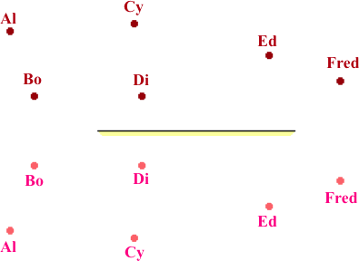

Which students can Di see? List the first letters of each visible student (from Di's vantage point, and including Di) in alphabetical order.

**Question 29:**

aa. Al, Bo, Cy, Di, Ed and Fred (shown in RED) sit in front of a plane mirror; their image locations are shown (in PINK).

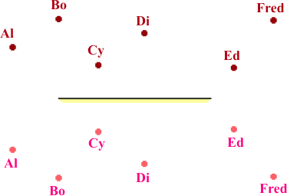

Which students can Al see? List the first letters of each visible student (from Al's vantage point, and including Al) in alphabetical order.

**Question 30:**

aa. Al, Bo, Cy, Di, Ed and Fred (shown in RED) sit in front of a plane mirror; their image locations are shown (in PINK).

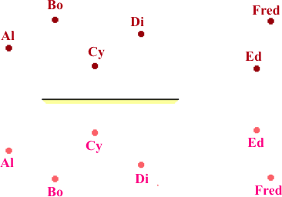

Which students can Bo see? List the first letters of each visible student (from Bo's vantage point, and including Bo) in alphabetical order.

**Question 31:**

aa. Al, Bo, Cy, Di, Ed and Fred (shown in RED) sit in front of a plane mirror; their image locations are shown (in PINK).

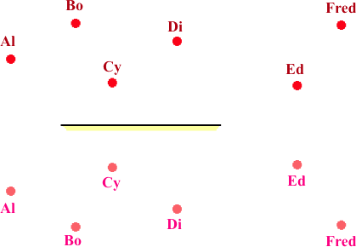

Which students can Ed see? List the first letters of each visible student (from Ed's vantage point, and including Ed) in alphabetical order.

**Question 32:**

aa. Al, Bo, Cy, Di, Ed and Fred (shown in RED) sit in front of a plane mirror; their image locations are shown (in PINK).

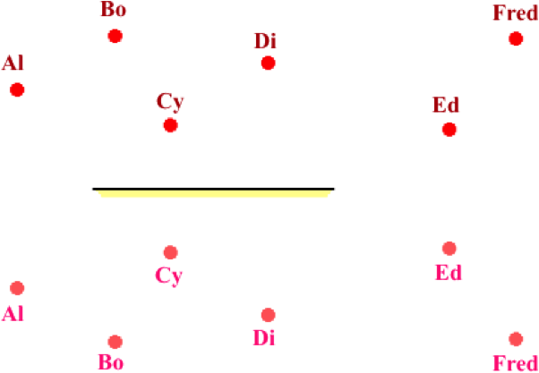

Which students can Fred see? List the first letters of each visible student (from Fred's vantage point, and including Fred) in alphabetical order.

**Question 33:**

aa. Al, Bo, Cy, Di, Ed and Fred (shown in RED) sit in front of a plane mirror; their image locations are shown (in PINK).



Which students can Cy see? List the first letters of each visible student (from Cy's vantage point, and including Cy) in alphabetical order.

**Question 34:**

aa. Al, Bo, Cy, Di, Ed and Fred (shown in RED) sit in front of a plane mirror; their image locations are shown (in PINK).



Which students can Di see? List the first letters of each visible student (from Di's vantage point, and including Di) in alphabetical order.

**RM4: Regular vs. Diffuse Reflection**

**Question 1:**

aa. The diagrams below show a microscopic view of light rays reflecting off a surface.

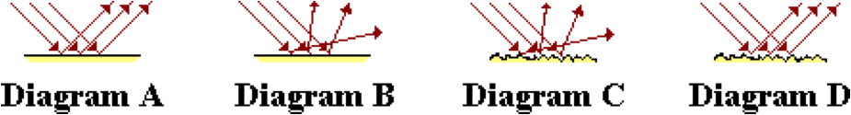

Which one of the diagrams best depicts the phenomenon of diffuse reflection?

**Question 2:**

aa. The diagrams below show a microscopic view of light rays reflecting off a surface.

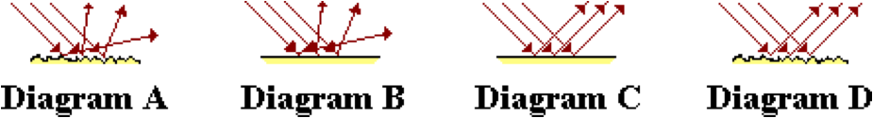

Which one of the diagrams best depicts the phenomenon of diffuse reflection?

**Question 3:**

aa. The diagrams below show a microscopic view of light rays reflecting off a surface.

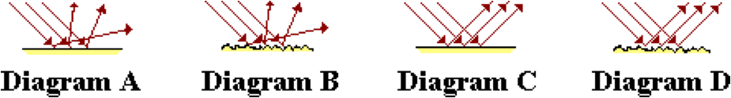

Which one of the diagrams best depicts the phenomenon of diffuse reflection?

**Question 4:**

aa. The diagrams below show a microscopic view of light rays reflecting off a surface.

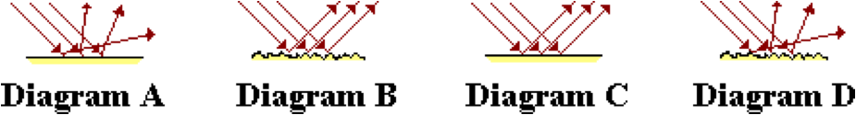

Which one of the diagrams best depicts the phenomenon of diffuse reflection?

**Question 5:**

aa. Which of the following are TRUE of diffuse reflection? Select all that apply.

a. Light does NOT follow the law of reflection.

b. Light rays within a narrow beam become scattered in many directions.

c. Occurs when light reflects off a microscopically rough surface.

d. Results in the formation of a clear and focused image.

e. ... nonsense! None of these are TRUE

**Question 6:**

aa. Which of the following are TRUE of diffuse reflection? Select all that apply.

a. Light rays within a narrow beam become scattered in many directions.

b. Light does NOT follow the law of reflection.

c. Results in the formation of a clear and focused image.

d. Occurs when light reflects off a microscopically rough surface.

e. ... nonsense! None of these are TRUE

**Question 7:**

aa. Which of the following are TRUE of diffuse reflection? Select all that apply.

a. Light follows the law of reflection.

b. Occurs when light reflects off a smooth surface.

c. Parallel incident rays reflect and travel in the same direction.

d. Results in the formation of a clear and focused image.

e. ... nonsense! None of these are TRUE

**Question 8:**

aa. Which of the following are TRUE of diffuse reflection? Select all that apply.

a. Light rays within a narrow beam become scattered in many directions.

b. Light follows the law of reflection.

c. Results in the formation of a clear and focused image.

d. Occurs when light reflects off a microscopically rough surface.

e. ... nonsense! None of these are TRUE

**Question 9:**

aa. Diffuse reflection is different than regular (or specular) reflection. In diffuse reflection, light _____; this is not the case for regular reflection. Select all that apply.

a. does not follow the law of reflection

b. does follow the law of reflection

c. reflects off a smooth surface

d. rays within a narrow beam become scattered in different directions

e. None of these apply.

**Question 10:**

aa. Diffuse reflection is different than regular (or specular) reflection. In diffuse reflection, light _____; this is not the case for regular reflection. Select all that apply.

a. does follow the law of reflection

b. does not follow the law of reflection

c. reflects off a smooth surface

d. rays within a narrow beam reflect and remain in a beam

e. None of these apply.

**Question 11:**

aa. Diffuse reflection is different than regular (or specular) reflection. In diffuse reflection, light _____; this is not the case for regular reflection. Select all that apply.

a. reflects off a rough surface

b. rays within a narrow beam reflect and remain in a beam

c. does not follow the law of reflection

d. does follow the law of reflection

e. None of these apply.

**Question 12:**

aa. Diffuse reflection is different than regular (or specular) reflection. In diffuse reflection, light _____; this is not the case for regular reflection. Select all that apply.

a. reflects off a rough surface

b. rays within a narrow beam become scattered in different directions.

c. does follow the law of reflection

d. does not follow the law of reflection

e. None of these apply.

**Question 13:**

aa. In the diagrams below, ray A would reflect and follow the law of reflection.

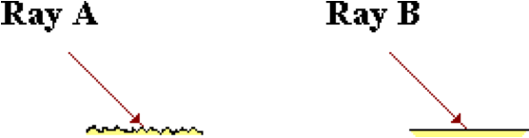

On the other hand, ray B would _____.

a. not reflect at all

b. not follow the law of reflection

c. ... nonsense! Ray B would reflect and would follow the law of reflection.

**Question 14:**

aa. In the diagrams below, ray B would reflect and follow the law of reflection.



On the other hand, ray A would _____.

a. not follow the law of reflection

b. not reflect at all

c. ... nonsense! Ray A would reflect and would follow the law of reflection.

**Question 15:**

aa. In the diagrams below, ray A would reflect and follow the law of reflection.

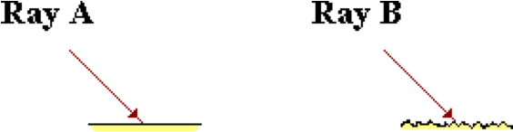

On the other hand, ray B would _____.

a. not reflect at all

b. not follow the law of reflection

c. ... nonsense! Ray B would reflect and would follow the law of reflection

**Question 16:**

aa. Diffuse reflection is attributable to the fact that light ____ when reflecting off rough surfaces.

a. becomes diffused

b. does NOT follow the law of reflection

c. Both a and b explain the cause of diffuse reflection.

d. nonsense! Diffuse reflection occurs for smooth surfaces.

**Question 17:**

aa. Diffuse reflection is attributable to the fact that light ____ when reflecting off rough surfaces.

a. does NOT follow the law of reflection

b. becomes diffused

c. Both a and b explain the cause of diffuse reflection.

d. nonsense! Diffuse reflection occurs for smooth surfaces.

**Question 18:**

aa. Diffuse reflection is attributable to the fact that light ____ when reflecting off smooth surfaces.

a. becomes diffused

b. does NOT follow the law of reflection

c. Both a and b explain the cause of diffuse reflection.

d. nonsense! Diffuse reflection occurs for rough surfaces.

**Question 19:**

aa. Diffuse reflection is attributable to the fact that light ____ when reflecting off smooth surfaces.

a. does NOT follow the law of reflection

b. becomes diffused

c. Both a and b explain the cause of diffuse reflection.

d. nonsense! Diffuse reflection occurs for rough surfaces.

**Question 20:**

aa. Which one of the following phenomenon is best explained by the diffuse reflection of light rays? Select all that apply.

a. On a calm day, clear images of distant objects can be seen in a body of water.

b. A glare results when reading from the glossy pages of a fancy magazine.

c. When driving at night on wet asphalt pavement, the headlights of oncoming cars produce a glare.

d. Images of cars in a side mirror are actually closer than they appear.

e. ...nonsense! None of these are due to the diffuse reflection of light.

**Question 21:**

aa. Which one of the following phenomenon is best explained by the diffuse reflection of light rays? Select all that apply.

a. Images of cars in a side mirror are actually closer than they appear.

b. A glare results when reading from the glossy pages of a fancy magazine.

c. On a calm day, clear images of distant objects can be seen in a body of water.

d. When driving at night on dry pavement, the headlights of oncoming cars are scattered, illuminating the entire road.

e. ...nonsense! None of these are due to the diffuse reflection of light.

**Question 22:**

aa. Which one of the following phenomenon is best explained by the diffuse reflection of light rays? Select all that apply.

a. When driving at night after a rain shower, the headlights of oncoming cars produce a glare.

b. On a windy day, images of distant objects cannot be seen when looking upon the surface of a body of water.

c. Images of cars in a side mirror are actually closer than they appear.

d. A glare results when reading from the glossy pages of a fancy magazine.

e. ...nonsense! None of these are due to the diffuse reflection of light.

**Question 23:**

aa. Which one of the following phenomenon is best explained by the diffuse reflection of light rays? Select all that apply.

a. When driving at night after a rain shower, the headlights of oncoming cars produce a glare.

b. On a calm day, clear images of distant objects can be seen in a body of water.

c. When reading from your Physics textbook, light from the lamp is scattered about the entire page; no glare results.

d. Images of cars in a side mirror are actually closer than they appear.

e. ...nonsense! None of these are due to the diffuse reflection of light.

**Question 24:**

aa. **TRUE** or **FALSE**:

When a bundle of light undergoes diffuse reflection, each individual ray in the bundle of light rays fails to follow the law of reflection.

a. True b. False

**Question 25:**

aa. **TRUE** or **FALSE**:

When a bundle of light undergoes diffuse reflection, each individual ray in the bundle of light rays follows the law of reflection.

a. True b. False

**Question 26:**

aa. **TRUE** or **FALSE**:

Diffuse reflection is different than regular reflection in that light rays undergoing diffuse reflection do NOT follow the law of reflection.

a. True b. False

**RM5: Concave Mirror Ray Tracing**

**Question 1:**

aa. Any ray of incident light that is traveling parallel to the principal axis and strikes a concave mirror will reflect and _____.

a. pass through the center of curvature

b. pass through the focal point

c. and continue traveling parallel to the principal axis

d. never cross the principal axis

e. nonsense! No such prediction can be made.

**Question 2:**

aa. Any ray of incident light that is traveling parallel to the principal axis and strikes a concave mirror will reflect and _____.

a. and continue traveling parallel to the principal axis

b. pass through the center of curvature

c. pass through the focal point

d. never cross the principal axis

e. nonsense! No such prediction can be made.

**Question 3:**

aa. Any ray of incident light that is traveling parallel to the principal axis and strikes a concave mirror will reflect and _____.

a. and continue traveling parallel to the principal axis

b. never cross the principal axis

c. pass through the center of curvature

d. pass through the focal point

e. nonsense! No such prediction can be made.

**Question 4:**

aa. Any ray of incident light that passes through the focal point and strikes a concave mirror will reflect and _____.

a. pass through the center of curvature

b. pass through the focal point again

c. and travel parallel to the principal axis

d. pass through the mirror to the other side

e. nonsense! No such prediction can be made.

**Question 5:**

aa. Any ray of incident light that passes through the focal point and strikes a concave mirror will reflect and _____.

a. and travel parallel to the principal axis

b. pass through the mirror to the other side

c. pass through the center of curvature

d. pass through the focal point again

e. nonsense! No such prediction can be made.

**Question 6:**

aa. Any ray of incident light that passes through the focal point and strikes a concave mirror will reflect and _____.

a. pass through the center of curvature

b. pass through the focal point again

c. pass through the mirror to the other side

d. and travel parallel to the principal axis

e. nonsense! No such prediction can be made.

**Question 7:**

aa. An image is a likeness of an object that is at a location where ______.

a. all reflected rays appear to diverge from

b. all incident rays intersect

c. incident rays and reflected rays meet

d. any observer's line of sight intersects the mirror

e. a ray drawn from object and perpendicular to the mirror meets the mirror

**Question 8:**

aa. An image is a likeness of an object that is at a location where ______.

a. incident rays and reflected rays meet

b. all incident rays intersect

c. all reflected rays appear to diverge from

d. any observer's line of sight intersects the mirror

e. a ray drawn from object and perpendicular to the mirror meets the mirror

**Question 9:**

aa. An image is a likeness of an object that is at a location where ______.

a. any observer's line of sight intersects the mirror

b. all incident rays intersect

c. incident rays and reflected rays meet

d. all reflected rays appear to diverge from

e. a ray drawn from object and perpendicular to the mirror meets the mirror

**Question 10:**

aa. The diagram below shows an *object arrow* (drawn in RED) placed in front of a concave mirror. Five sets of incident and reflected rays (numbered 1, 2, 3, 4, and 5) are shown.

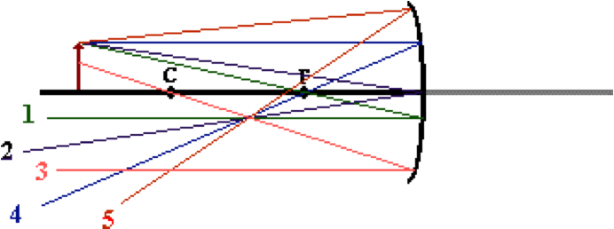

Which of these sets are incorrect? Select all that apply.

**Question 11:**

aa. The diagram below shows an *object arrow* (drawn in RED) placed in front of a concave mirror. Five sets of incident and reflected rays (numbered 1, 2, 3, 4, and 5) are shown.

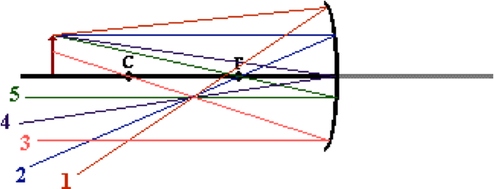

Which of these sets are incorrect? Select all that apply.

**Question 12:**

aa. The diagram below shows an *object arrow* (drawn in RED) placed in front of a concave mirror. Five sets of incident and reflected rays (numbered 1, 2, 3, 4, and 5) are shown.

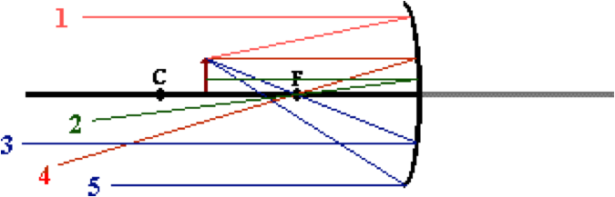

Which of these sets are incorrect? Select all that apply.

**Question 13:**

aa. The diagram below shows an *object arrow* (drawn in RED) placed in front of a concave mirror. Five sets of incident and reflected rays (numbered 1, 2, 3, 4, and 5) are shown.

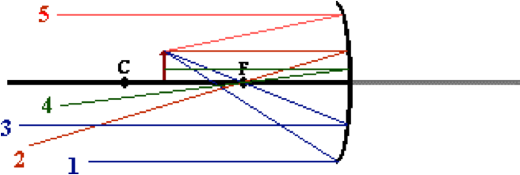

Which of these sets are incorrect? Select all that apply.

**Question 14:**

aa. The diagram below shows an *object arrow* (drawn in RED) placed in front of a concave mirror. Five sets of incident and reflected rays (numbered 1, 2, 3, 4, and 5) are shown.

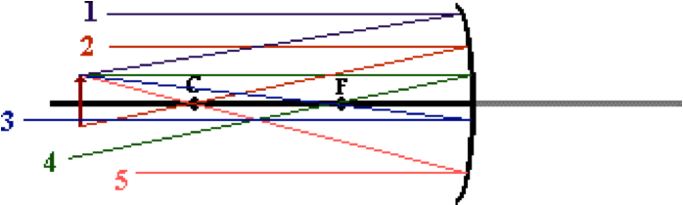

Which of these sets are incorrect? Select all that apply.

**Question 15:**

aa. The diagram below shows an *object arrow* (drawn in RED) placed in front of a concave mirror. Five sets of incident and reflected rays (numbered 1, 2, 3, 4, and 5) are shown.

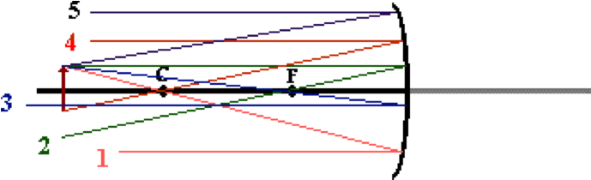

Which of these sets are incorrect? Select all that apply.

**Question 16:**

aa. The following diagrams are ray diagrams, showing how to locate the image (in GREEN) of an 'arrow object' (in RED).

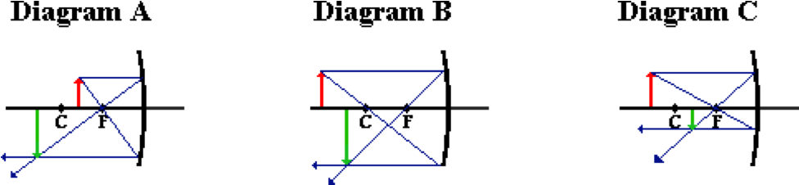

Which of these diagrams are correctly drawn? Select all that apply. If none apply, then select D.

**Question 17:**

aa. The following diagrams are ray diagrams, showing how to locate the image (in GREEN) of an 'arrow object' (in RED).

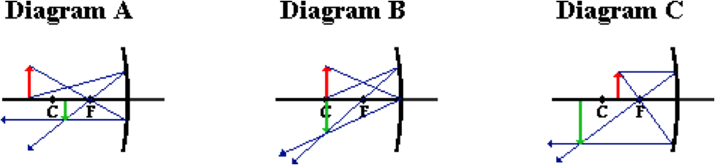

Which of these diagrams are correctly drawn? Select all that apply. If none apply, then select D.

**Question 18:**

aa. The following diagrams are ray diagrams, showing how to locate the image (in GREEN) of an 'arrow object' (in RED).

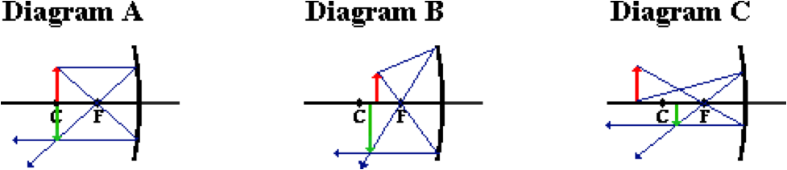

Which of these diagrams are correctly drawn? Select all that apply. If none apply, then select D.

**Question 19:**

aa. The following diagrams are ray diagrams, showing how to locate the image (in GREEN) of an 'arrow object' (in RED).

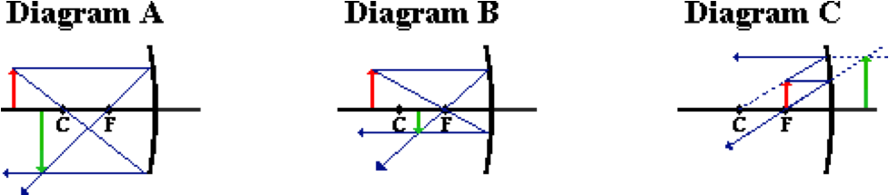

Which of these diagrams are correctly drawn? Select all that apply. If none apply, then select D.

**Question 20:**

aa. The following diagrams are ray diagrams, showing how to locate the image (in GREEN) of an 'arrow object' (in RED).

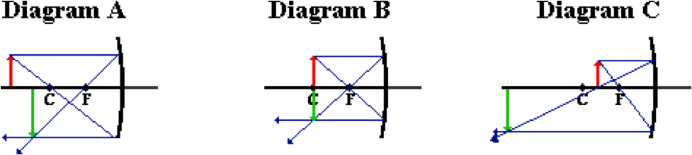

Which of these diagrams are correctly drawn? Select all that apply. If none apply, then select D.

**Question 21:**

aa. The following diagrams are ray diagrams, showing how to locate the image (in GREEN) of an 'arrow object' (in RED).

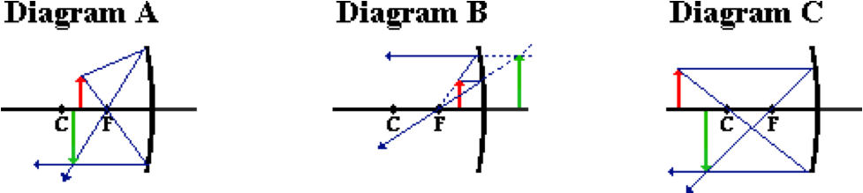

Which of these diagrams are correctly drawn? Select all that apply. If none apply, then select D.

**Question 22:**

aa. The following diagrams are ray diagrams, showing how to locate the image (in GREEN) of an 'arrow object' (in RED).

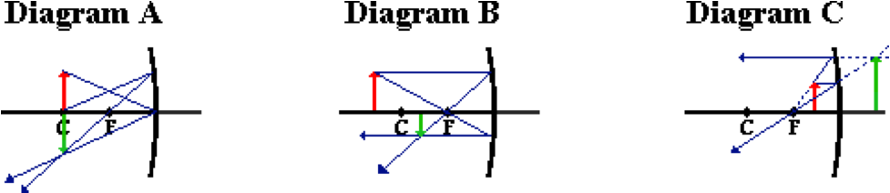

Which of these diagrams are correctly drawn? Select all that apply. If none apply, then select D.

**Question 23:**

aa. The following diagrams are ray diagrams, showing how to locate the image (in GREEN) of an 'arrow object' (in RED).

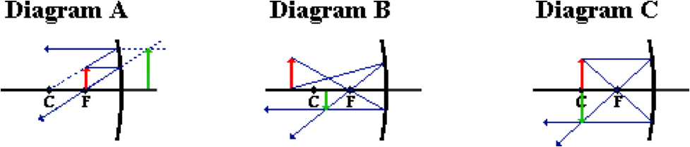

Which of these diagrams are correctly drawn? Select all that apply. If none apply, then select D.

**Question 24:**

aa. The following diagrams are ray diagrams, showing how to locate the image (in GREEN) of an 'arrow object' (in RED).

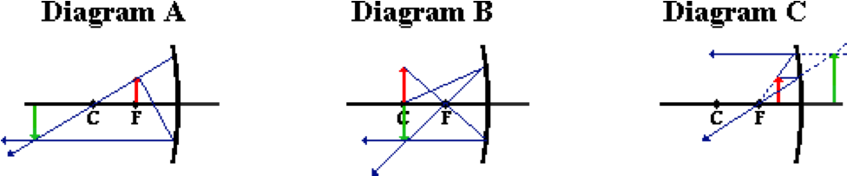

Which of these diagrams are correctly drawn? Select all that apply. If none apply, then select D.

**Question 25:**

aa. The following diagrams are ray diagrams, showing how to locate the image (in GREEN) of an 'arrow object' (in RED).

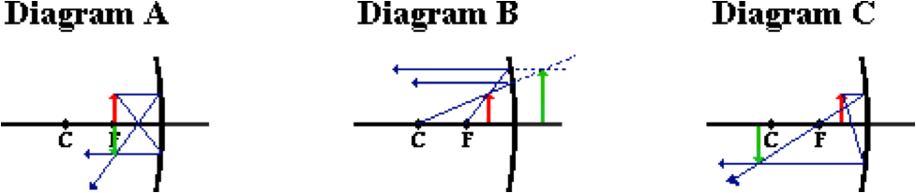

Which of these diagrams are correctly drawn? Select all that apply. If none apply, then select D.

**Question 26:**

aa. The following diagrams are ray diagrams, showing how to locate the image (in GREEN) of an 'arrow object' (in RED).

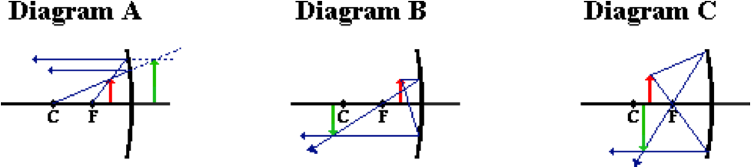

Which of these diagrams are correctly drawn? Select all that apply. If none apply, then select D.

**Question 27:**

aa. The following diagrams are ray diagrams, showing how to locate the image (in GREEN) of an 'arrow object' (in RED).

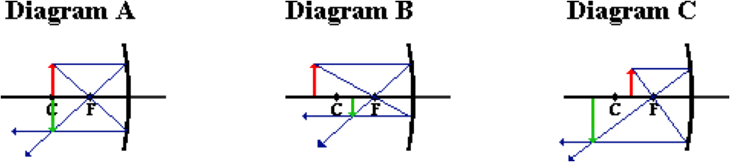

Which of these diagrams are correctly drawn? Select all that apply. If none apply, then select D.

**RM6: Concave Mirror Images**

**Question 1:**

aa. If an object is placed at a position beyond the center of curvature of a concave mirror, then the image will be ____. Select all that apply.

a. inverted

b. upright

c. real

d. virtual

e. magnified in size

f. reduced in size

g. located beyond the center of curvature

h. located between the center of curvature and the focal point

i. located between the focal point and the mirror

j. located on the other side of the mirror

k. located at the center of curvature

**Question 2:**

aa. If an object is placed at a position beyond the center of curvature of a concave mirror, then the image will be ____. Select all that apply.

a. reduced in size

b. magnified in size

c. upright

d. inverted

e. virtual

f. real

g. located between the focal point and the mirror

h. located between the center of curvature and the focal point

i. located beyond the center of curvature

j. located at the center of curvature

k. located on the other side of the mirror

**Question 3:**

aa. If an object is placed at a position beyond the center of curvature of a concave mirror, then the image will be ____. Select all that apply.

a. virtual

b. real

c. magnified in size

d. reduced in size

e. inverted

f. upright

g. located between the center of curvature and the focal point

h. located beyond the center of curvature

i. located on the other side of the mirror

j. located between the focal point and the mirror

k. located at the center of curvature

**Question 4:**

aa. If an object is placed at the center of curvature of a concave mirror, then the image will be ____. Select all that apply.

a. inverted

b. upright

c. real

d. virtual

e. magnified in size

f. reduced in size

g. located beyond the center of curvature

h. located between the center of curvature and the focal point

i. located between the focal point and the mirror

j. located on the other side of the mirror

k. located at the center of curvature

**Question 5:**

aa. If an object is placed at the center of curvature of a concave mirror, then the image will be ____. Select all that apply.

a. reduced in size

b. magnified in size

c. upright

d. inverted

e. virtual

f. real

g. located between the focal point and the mirror

h. located between the center of curvature and the focal point

i. located beyond the center of curvature

j. located at the center of curvature

k. located on the other side of the mirror

**Question 6:**

aa. If an object is placed at the center of curvature of a concave mirror, then the image will be ____. Select all that apply.

a. virtual

b. real

c. magnified in size

d. reduced in size

e. inverted

f. upright

g. located between the center of curvature and the focal point

h. located beyond the center of curvature

i. located on the other side of the mirror

j. located between the focal point and the mirror

k. located at the center of curvature

**Question 7:**

aa. If an object is placed at a position between the center of curvature and the focal point of a concave mirror, then the image will be ____. Select all that apply.

a. inverted

b. upright

c. real

d. virtual

e. magnified in size

f. reduced in size

g. located beyond the center of curvature

h. located between the center of curvature and the focal point

i. located between the focal point and the mirror

j. located on the other side of the mirror

k. located at the center of curvature

**Question 8:**

aa. If an object is placed at a position between the center of curvature and the focal point of a concave mirror, then the image will be ____. Select all that apply.

a. reduced in size

b. magnified in size

c. upright

d. inverted

e. virtual

f. real

g. located between the focal point and the mirror

h. located between the center of curvature and the focal point

i. located beyond the center of curvature

j. located at the center of curvature

k. located on the other side of the mirror

**Question 9:**

aa. If an object is placed at a position between the center of curvature and the focal point of a concave mirror, then the image will be ____. Select all that apply.

a. virtual

b. real

c. magnified in size

d. reduced in size

e. inverted

f. upright

g. located between the center of curvature and the focal point

h. located beyond the center of curvature

i. located on the other side of the mirror

j. located between the focal point and the mirror

k. located at the center of curvature

**Question 10:**

aa. If an object is placed at a position between the focal point and a concave mirror, then the image will be ____. Select all that apply.

a. inverted

b. upright

c. real

d. virtual

e. magnified in size

f. reduced in size

g. located beyond the center of curvature

h. located between the center of curvature and the focal point

i. located between the focal point and the mirror

j. located on the other side of the mirror

k. located at the center of curvature

**Question 11:**

aa. If an object is placed at a position between the focal point and a concave mirror, then the image will be ____. Select all that apply.

a. reduced in size

b. magnified in size

c. upright

d. inverted

e. virtual

f. real

g. located between the focal point and the mirror

h. located between the center of curvature and the focal point

i. located beyond the center of curvature

j. located at the center of curvature

k. located on the other side of the mirror

**Question 12:**

aa. If an object is placed at a position between the focal point and a concave mirror, then the image will be ____. Select all that apply.

a. virtual

b. real

c. magnified in size

d. reduced in size

e. inverted

f. upright

g. located between the center of curvature and the focal point

h. located beyond the center of curvature

i. located on the other side of the mirror

j. located between the focal point and the mirror

k. located at the center of curvature

**Question 13:**

aa. When an object is placed ___ in front of a concave mirror, then one can be certain that an image will not be formed. Select all that apply.

a. at the center of curvature

b. at the focal point

c. beyond the center of curvature

d. between the center of curvature and the mirror

e. between the focal point and the mirror

f. ... nonsense! None of these apply.

**Question 14:**

aa. When an object is placed ___ in front of a concave mirror, then one can be certain that an image will not be formed. Select all that apply.

a. between the center of curvature and the mirror

b. beyond the center of curvature

c. at the center of curvature

d. at the focal point

e. between the focal point and the mirror

f. ... nonsense! None of these apply.

**Question 15:**

aa. When an object is placed ___ in front of a concave mirror, then one can be certain that an image will not be formed. Select all that apply.

a. beyond the center of curvature

b. at the center of curvature

c. between the center of curvature and the mirror

d. between the focal point and the mirror

e. at the focal point

f. ... nonsense! None of these apply.

**Question 16:**

aa. An object arrow (in RED) is placed in front of a concave mirror as shown in the diagram below.

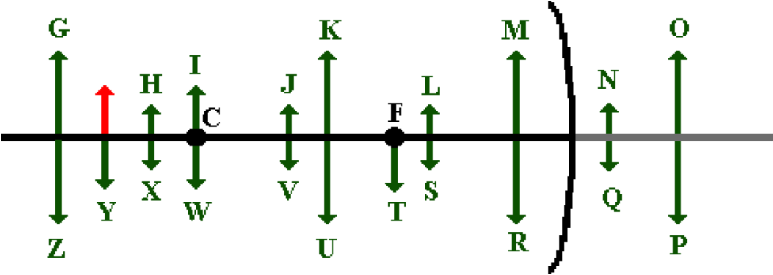

Which image (in GREEN) represents the approximate location, size and orientation for such an object position?

**Question 17:**

aa. An object arrow (in RED) is placed in front of a concave mirror as shown in the diagram below.

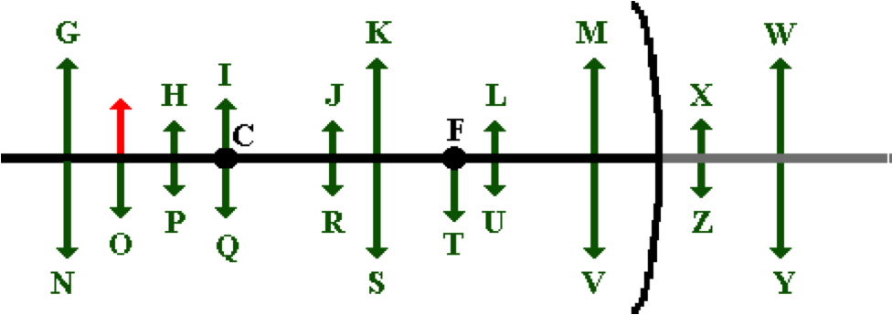

Which image (in GREEN) represents the approximate location, size and orientation for such an object position?

**Question 18:**

aa. An object arrow (in RED) is placed in front of a concave mirror as shown in the diagram below.

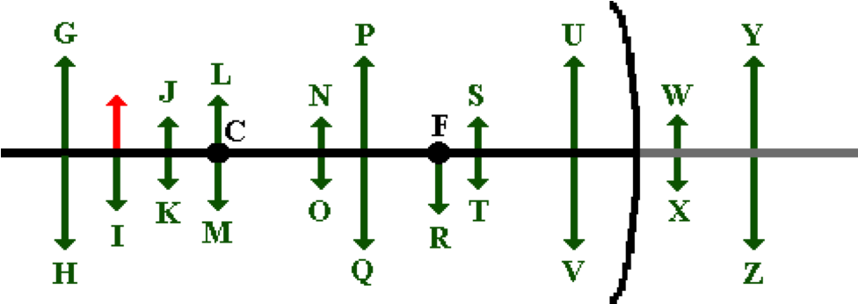

Which image (in GREEN) represents the approximate location, size and orientation for such an object position?

**Question 19:**

aa. An object arrow (in RED) is placed in front of a concave mirror as shown in the diagram below.

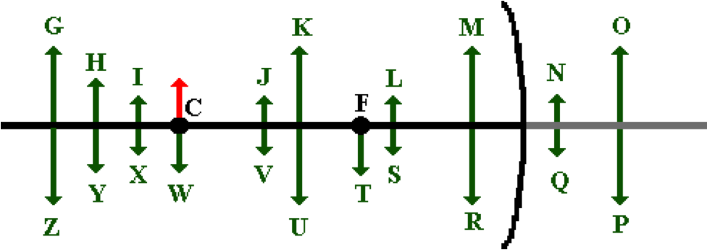

Which image (in GREEN) represents the approximate location, size and orientation for such an object position?

**Question 20:**

aa. An object arrow (in RED) is placed in front of a concave mirror as shown in the diagram below.

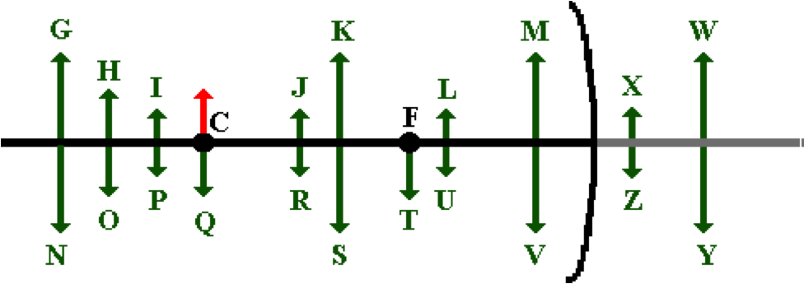

Which image (in GREEN) represents the approximate location, size and orientation for such an object position?

**Question 21:**

aa. An object arrow (in RED) is placed in front of a concave mirror as shown in the diagram below.

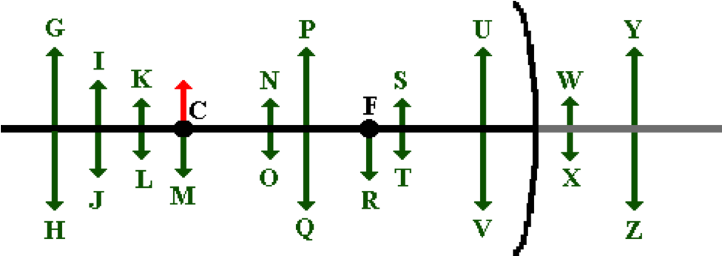

Which image (in GREEN) represents the approximate location, size and orientation for such an object position?

**Question 22:**

aa. An object arrow (in RED) is placed in front of a concave mirror as shown in the diagram below.

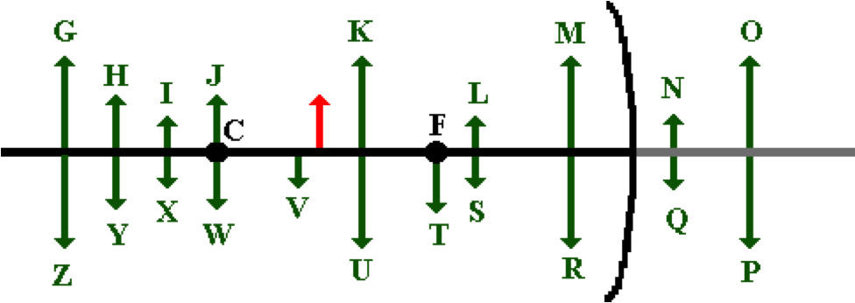

Which image (in GREEN) represents the approximate location, size and orientation for such an object position?

**Question 23:**

aa. An object arrow (in RED) is placed in front of a concave mirror as shown in the diagram below.

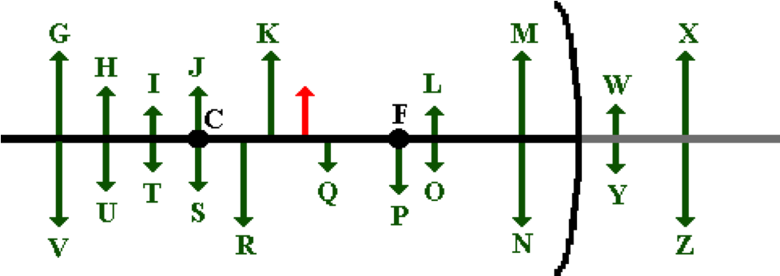

Which image (in GREEN) represents the approximate location, size and orientation for such an object position?

**Question 24:**

aa. An object arrow (in RED) is placed in front of a concave mirror as shown in the diagram below.

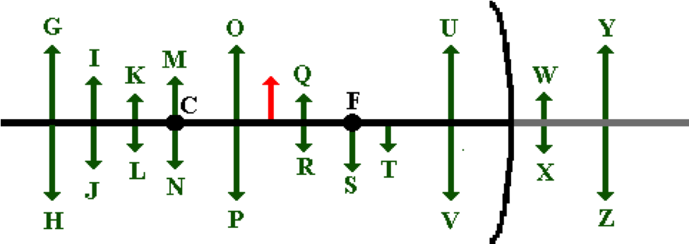

Which image (in GREEN) represents the approximate location, size and orientation for such an object position?

**Question 25:**

aa. An object arrow (in RED) is placed in front of a concave mirror as shown in the diagram below.

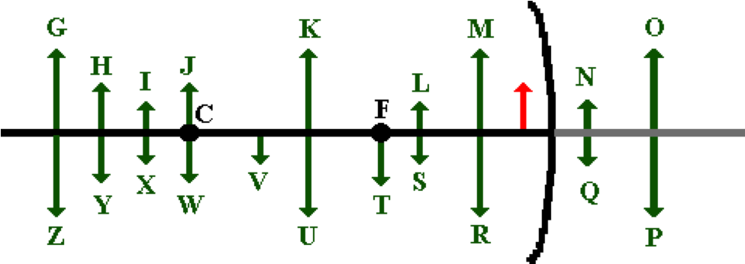

Which image (in GREEN) represents the approximate location, size and orientation for such an object position?

**Question 26:**

aa. An object arrow (in RED) is placed in front of a concave mirror as shown in the diagram below.

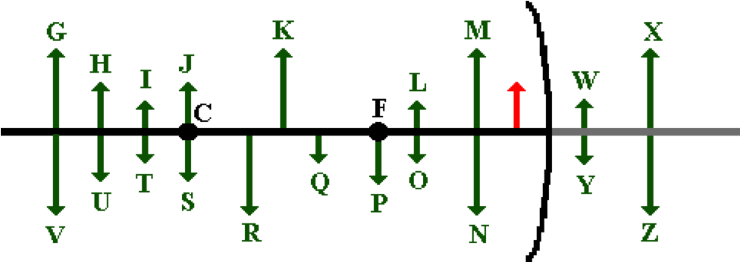

Which image (in GREEN) represents the approximate location, size and orientation for such an object position?

**Question 27:**

aa. An object arrow (in RED) is placed in front of a concave mirror as shown in the diagram below.

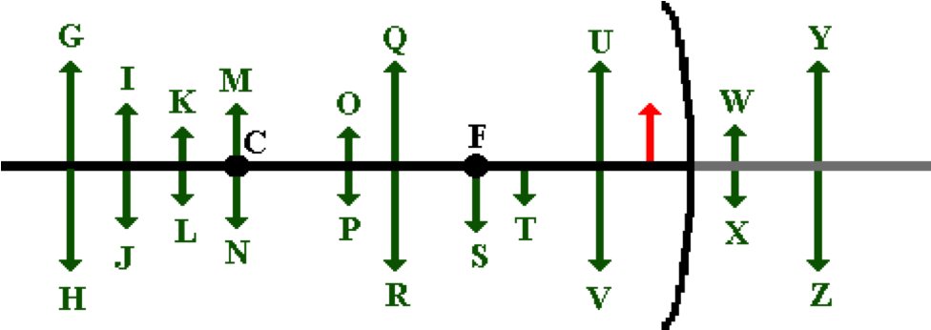

Which image (in GREEN) represents the approximate location, size and orientation for such an object position?

**Question 28:**

aa. Which of the following object arrows would not have a corresponding image? Select all that apply.

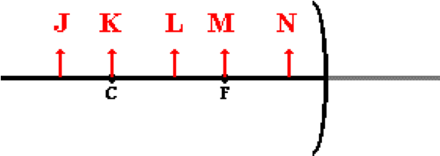

**Question 29:**

aa. Which of the following object arrows would not have a corresponding image? Select all that apply.

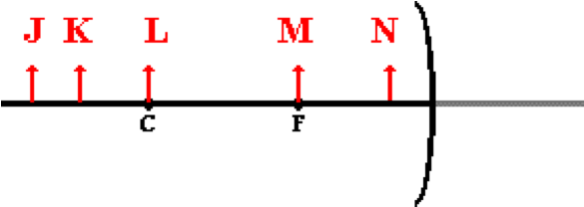

**Question 30:**

aa. Which of the following object arrows would not have a corresponding image? Select all that apply.

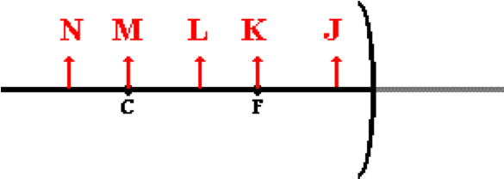

**RM7: Concave Mirror Mathematics**

**Question 1:**

aa. Jack and Jill are doing the Concave Mirror Lab. They place a light bulb a distance of 36 cm from a concave mirror with a focal length of 13.3 cm. What would be the corresponding image distance (in cm) for such an object location?

**Question 2:**

aa. Jack and Jill are doing the Concave Mirror Lab. They place a light bulb a distance of 49.1 cm from a concave mirror with a focal length of 17.7 cm. What would be the corresponding image distance (in cm) for such an object location?

**Question 3:**

aa. Jack and Jill are doing the Concave Mirror Lab.” They place a light bulb a distance of 66.2 cm from a concave mirror with a focal length of 25.5 cm. What would be the corresponding image distance (in cm) for such an object location?

**Question 4:**

aa. Jack and Jill are doing the Concave Mirror Lab. They place a 4.5-cm high light bulb a distance of 17.9 cm from a concave mirror with a focal length of 14.0 cm. What would be the corresponding image distance (in cm) for such an object location?

**Question 5:**

aa. Jack and Jill are doing the Concave Mirror Lab. They place a 4.5-cm high light bulb a distance of 22.6 cm from a concave mirror with a focal length of 19.7 cm. What would be the corresponding image distance (in cm) for such an object location?

**Question 6:**

aa. Jack and Jill are doing the Concave Mirror Lab. They place a 4.5-cm high light bulb a distance of 28.2 cm from a concave mirror with a focal length of 22.0 cm. What would be the corresponding image distance (in cm) for such an object location?

**Question 7:**

aa. In a classroom demonstration, a physics teacher places a candle a distance of 68.1 cm from a concave mirror and measures an image distance of 94.9 cm. What is the focal length of the mirror (in cm)?

**Question 8:**

aa. In a classroom demonstration, a physics teacher places a candle a distance of 52.6 cm from a concave mirror and measures an image distance of 84.4 cm. What is the focal length of the mirror (in cm)?

**Question 9:**

aa. In a classroom demonstration, a physics teacher places a candle a distance of 37.1 cm from a concave mirror and measures an image distance of 67.3 cm. What is the focal length of the mirror (in cm)?

**Question 10:**

aa. Ima Primpin places her 22.3-cm high face a distance of 24.9 cm from the surface of a concave mirror. If the mirror has a focal length of 30.6 cm, then what is the image distance (in cm) and magnification of Ima's image?

**Question 11:**

aa. Ima Primpin places her 22.3-cm high face a distance of 17.9 cm from the surface of a concave mirror. If the mirror has a focal length of 26.1 cm, then what is the image distance (in cm) and magnification of Ima's image?

**Question 12:**

aa. Ima Primpin places her 22.3-cm high face a distance of 14.9 cm from the surface of a concave mirror. If the mirror has a focal length of 21.9 cm, then what is the image distance (in cm) and magnification of Ima's image?

**Question 13:**

aa. Ima Primpin places her 20.8-cm high face a distance of 24.9 cm from the surface of a concave mirror. If the mirror has a focal length of 32.6 cm, then what is her image distance (in cm) and her image height (in cm)?

**Question 14:**

aa. Ima Primpin places her 20.8-cm high face a distance of 17.9 cm from the surface of a concave mirror. If the mirror has a focal length of 25.9 cm, then what is her image distance (in cm) and her image height (in cm)?

**Question 15:**

aa. Ima Primpin places her 20.8-cm high face a distance of 14.9 cm from the surface of a concave mirror. If the mirror has a focal length of 23.8 cm, then what is her image distance (in cm) and her image height (in cm)?

**Question 16:**

aa. A Chinese magician named Foo Ling Yu uses a concave mirror with a 48.4-cm focal length in order to perform a magic trick. Foo places a 2.8-cm wide coin a distance of 98.2 cm from the mirror. What is the image distance (in cm) and the image width (in cm) of the coin?

**Question 17:**

aa. A Chinese magician named Foo Ling Yu uses a concave mirror with a 38.4-cm focal length in order to perform a magic trick. Foo places a 2.8-cm wide coin a distance of 84.2 cm from the mirror. What is the image distance (in cm) and the image width (in cm) of the coin?

**Question 18:**

aa. A Chinese magician named Foo Ling Yu uses a concave mirror with a 58.4-cm focal length in order to perform a magic trick. Foo places a 2.8-cm wide coin a distance of 126.4 cm from the mirror. What is the image distance (in cm) and the image width (in cm) of the coin?

**RM8: Concave Mirror Ray Tracing**

**Question 1:**

aa. Any ray of incident light that is traveling parallel to the principal axis and strikes a convex mirror will _____ and _____.

a. reflect, travel in a direction in line with the center of curvature

b. reflect, travel in a direction in line with the focal point

c. cross through the mirror, pass through the center of curvature

d. cross through the mirror, pass through the focal point

e. nonsense! No such prediction can be made.

**Question 2:**

aa. Any ray of incident light that is traveling parallel to the principal axis and strikes a convex mirror will _____ and _____.

a. reflect, travel in a direction in line with the center of curvature

b. cross through the mirror, pass through the center of curvature

c. reflect, travel in a direction in line with the focal point

d. cross through the mirror, pass through the focal point

e. nonsense! No such prediction can be made.

**Question 3:**

aa. Any ray of incident light that is traveling parallel to the principal axis and strikes a convex mirror will _____ and _____.

a. cross through the mirror, pass through the center of curvature

b. cross through the mirror, pass through the focal point

c. reflect, travel in a direction in line with the center of curvature

d. reflect, travel in a direction in line with the focal point

e. nonsense! No such prediction can be made.

**Question 4:**

aa. Any ray of incident light that heads towards the focal point of a convex mirror will _____ and _____.

a. reflect, travel parallel to the principal axis

b. reflect, pass through the focal point

c. reflect, pass through the center of curvature

d. cross through the mirror, pass through the center of curvature

e. cross through the mirror, travel parallel to the principal axis

f. nonsense! No such prediction can be made.

**Question 5:**

aa. Any ray of incident light that heads towards the focal point of a convex mirror will _____ and _____.

a. reflect, pass through the center of curvature

b. reflect, pass through the focal point

c. reflect, travel parallel to the principal axis

d. cross through the mirror, travel parallel to the principal axis

e. cross through the mirror, pass through the center of curvature

f. nonsense! No such prediction can be made.

**Question 6:**

aa. Any ray of incident light that heads towards the focal point of a convex mirror will _____ and _____.

a. cross through the mirror, pass through the center of curvature

b. reflect, pass through the center of curvature

c. cross through the mirror, travel parallel to the principal axis

d. reflect, travel parallel to the principal axis

e. reflect, pass through the focal point

f. nonsense! No such prediction can be made.

**Question 7:**

aa. An image is a likeness of an object that is at a location where ______.

a. all reflected rays appear to diverge from

b. all incident rays intersect

c. incident rays and reflected rays meet

d. any observer's line of sight intersects the mirror

e. a ray drawn from object and perpendicular to the mirror meets the mirror

**Question 8:**

aa. An image is a likeness of an object that is at a location where ______.

a. incident rays and reflected rays meet

b. all incident rays intersect

c. all reflected rays appear to diverge from

d. any observer's line of sight intersects the mirror

e. a ray drawn from object and perpendicular to the mirror meets the mirror

**Question 9:**

aa. An image is a likeness of an object that is at a location where ______.

a. any observer's line of sight intersects the mirror

b. all incident rays intersect

c. incident rays and reflected rays meet

d. all reflected rays appear to diverge from

e. a ray drawn from object and perpendicular to the mirror meets the mirror

**Question 10:**

aa. The diagram below shows a point object (drawn in RED) placed in front of a convex mirror. Five sets of incident and reflected rays (numbered 1, 2, 3, 4, and 5) are shown.

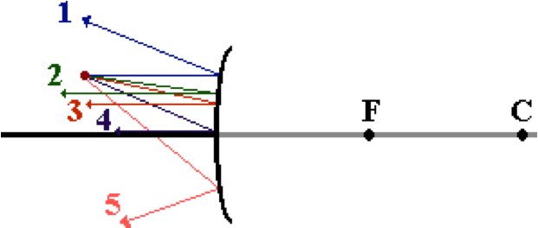

Which two of these sets are correct? Select all that apply.

**Question 11:**

aa. The diagram below shows a point object (drawn in RED) placed in front of a convex mirror. Five sets of incident and reflected rays (numbered 1, 2, 3, 4, and 5) are shown.

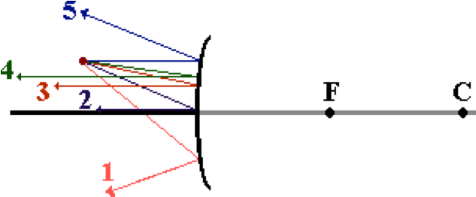

Which two of these sets are correct? Select all that apply.

**Question 12:**

aa. The diagram below shows a point object (drawn in RED) placed in front of a convex mirror. Five sets of incident and reflected rays (numbered 1, 2, 3, 4, and 5) are shown.

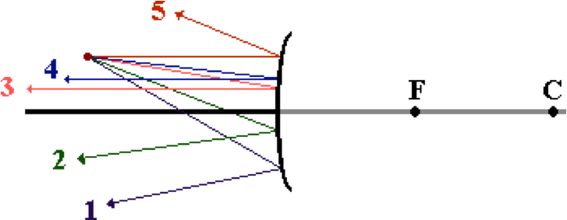

Which two of these sets are correct? Select all that apply.

**Question 13:**

aa. The diagram below shows a point object (drawn in RED) placed in front of a convex mirror. Five sets of incident and reflected rays (numbered 1, 2, 3, 4, and 5) are shown.

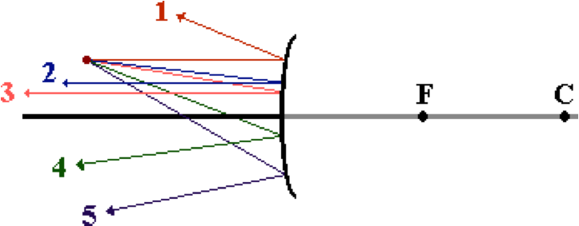

Which two of these sets are correct? Select all that apply.

**Question 14:**

aa. The diagram below shows a point object (drawn in RED) placed in front of a convex mirror. Five sets of incident and reflected rays (numbered 1, 2, 3, 4, and 5) are shown.

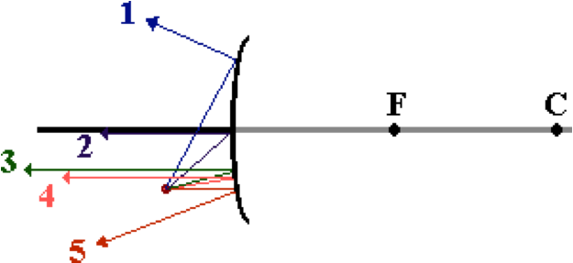

Which two of these sets are correct? Select all that apply.

**Question 15:**

aa. The diagram below shows a point object (drawn in RED) placed in front of a convex mirror. Five sets of incident and reflected rays (numbered 1, 2, 3, 4, and 5) are shown.

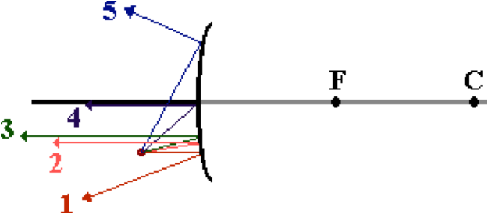

Which two of these sets are correct? Select all that apply.

**Question 16:**

aa. The following diagrams are ray diagrams, showing how to locate the image (in GREEN) of an arrow object (in RED).

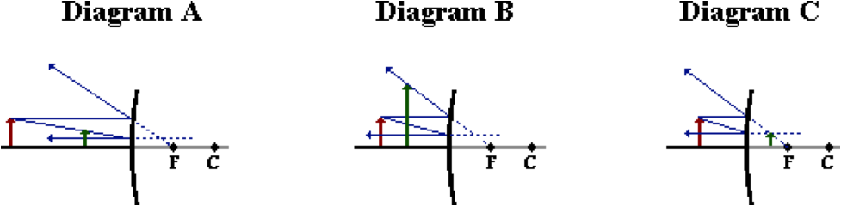

Which of these diagrams are correctly drawn and show the proper image location, size and orientation? Select all that apply. If none apply, then select D as the answer.

**Question 17:**

aa. The following diagrams are ray diagrams, showing how to locate the image (in GREEN) of an arrow object (in RED).

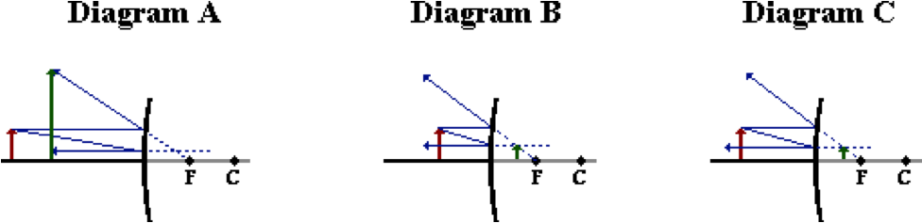

Which of these diagrams are correctly drawn and show the proper image location, size and orientation? Select all that apply. If none apply, then select D as the answer.

**Question 18:**

aa. The following diagrams are ray diagrams, showing how to locate the image (in GREEN) of an arrow object (in RED).

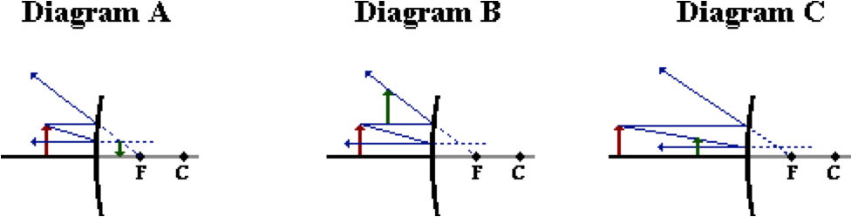

Which of these diagrams are correctly drawn and show the proper image location, size and orientation? Select all that apply. If none apply, then select D as the answer.

**Question 19:**

aa. The following diagrams are ray diagrams, showing how to locate the image (in GREEN) of an arrow object (in RED).

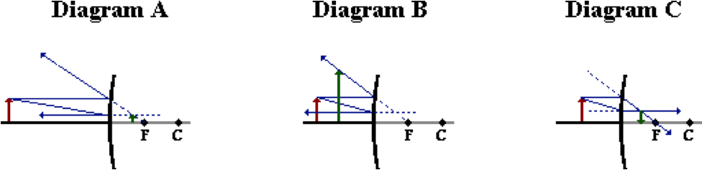

Which of these diagrams are correctly drawn and show the proper image location, size and orientation? Select all that apply. If none apply, then select D as the answer.

**Question 20:**

aa. The following diagrams are ray diagrams, showing how to locate the image (in GREEN) of an arrow object (in RED).

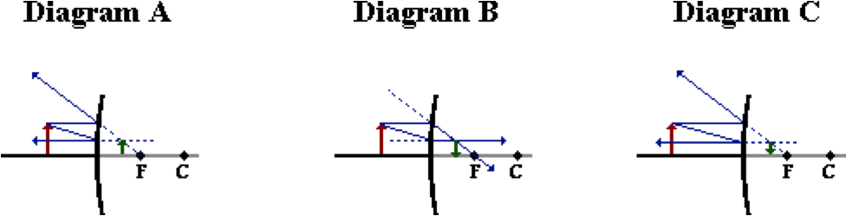

Which of these diagrams are correctly drawn and show the proper image location, size and orientation? Select all that apply. If none apply, then select D as the answer.

**Question 21:**

aa. The following diagrams are ray diagrams, showing how to locate the image (in GREEN) of an arrow object (in RED).

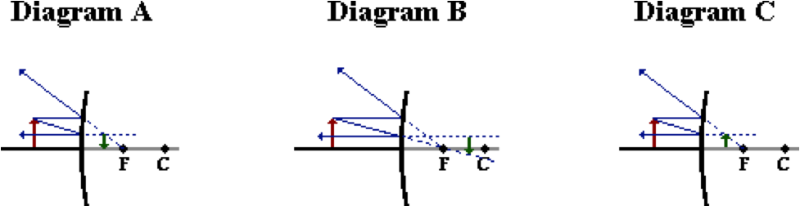

Which of these diagrams are correctly drawn and show the proper image location, size and orientation? Select all that apply. If none apply, then select D as the answer.

**Question 22:**

aa. The following diagrams are ray diagrams, showing how to locate the image (in GREEN) of an arrow object (in RED).

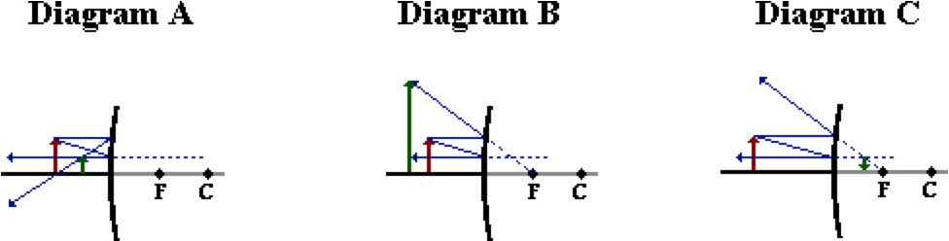

Which of these diagrams are correctly drawn and show the proper image location, size and orientation? Select all that apply. If none apply, then select D as the answer.

**Question 23:**

aa. The following diagrams are ray diagrams, showing how to locate the image (in GREEN) of an arrow object (in RED).

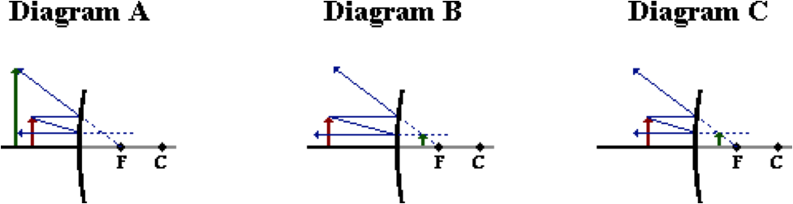

Which of these diagrams are correctly drawn and show the proper image location, size and orientation? Select all that apply. If none apply, then select D as the answer.

**Question 24:**

aa. The following diagrams are ray diagrams, showing how to locate the image (in GREEN) of an arrow object (in RED).

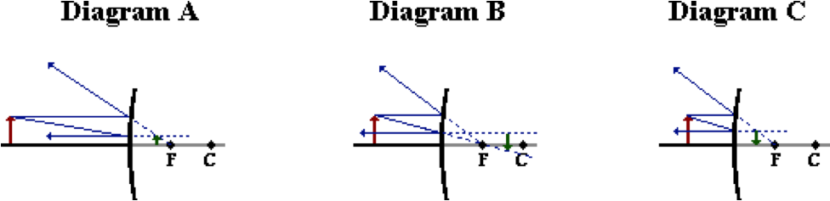

Which of these diagrams are correctly drawn and show the proper image location, size and orientation? Select all that apply. If none apply, then select D as the answer.

**Question 25:**

aa. The following diagrams are ray diagrams, showing how to locate the image (in GREEN) of an arrow object (in RED).

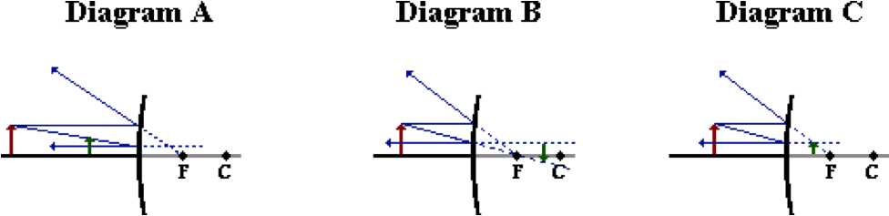

Which of these diagrams are correctly drawn and show the proper image location, size and orientation? Select all that apply. If none apply, then select D as the answer.

**Question 26:**

aa. The following diagrams are ray diagrams, showing how to locate the image (in GREEN) of an arrow object (in RED).

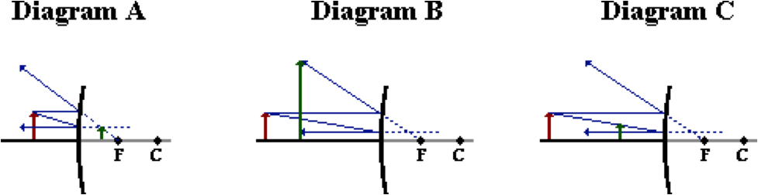

Which of these diagrams are correctly drawn and show the proper image location, size and orientation? Select all that apply. If none apply, then select D as the answer.

**RM9: Convex Mirror Images**

**Question 1:**

aa. When an object is placed in front of a convex mirror, then the image will be ____. Select all that apply.

a. inverted b. upright

c. real d. virtual

e. magnified in size f. reduced in size

g. located on the opposite side of the mirror

h. located on the same side of the mirror as the object

**Question 2:**

aa. When an object is placed in front of a convex mirror, then the image will be ____. Select all that apply.

a. upright b. inverted

c. magnified in size d. reduced in size

e. virtual f. real

g. located on the same side of the mirror as the object

h. located on the opposite side of the mirror

**Question 3:**

aa. When an object is placed in front of a convex mirror, then the image will be ____. Select all that apply.

a. located on the opposite side of the mirror

b. located on the same side of the mirror as the object

c. magnified in size d. reduced in size

e. inverted f. upright

g. real h. virtual

**Question 4:**

aa. When an object is placed in front of a convex mirror, then the image will be ____. Select all that apply.

a. located on the opposite side of the mirror

b. real c. inverted

d. magnified in size e. reduced in size

f. upright g. virtual

h. located on the same side of the mirror as the object

**Question 5:**

aa. When an object is placed in front of a convex mirror, then the image will be ____. Select all that apply.

a. real b. upright

c. magnified in size

d. located on the opposite side of the mirror

e. located on the same side of the mirror as the object

f. reduced in size g. inverted

h. virtual

**Question 6:**

aa. When an object is placed in front of a convex mirror, then the image will be ____. Select all that apply.

a. located on the same side of the mirror as the object

b. real c. inverted

d. reduced in size e. magnified in size

f. upright g. virtual

h. located on the opposite side of the mirror

**Question 7:**

aa. Convex mirror images are DIFFERENT than concave mirror images in that the image formed by a convex mirror ______. Select all that apply.

a. is always a real image

b. could be (but may not be) a real image

c. is always magnified in size

d. could be (but may not be) magnified in size

e. is always located on the opposite side of the mirror

f. could be (but may not be) located on the opposite side of the mirror

g. ... nonsense! None of these explain the difference.

**Question 8:**

aa. Convex mirror images are DIFFERENT than concave mirror images in that the image formed by a convex mirror ______. Select all that apply.

a. is always located on the opposite side of the mirror

b. could be (but may not be) located on the opposite side of the mirror

c. is always a real image

d. could be (but may not be) a real image

e. is always magnified in size

f. could be (but may not be) magnified in size

g. ... nonsense! None of these explain the difference.

**Question 9:**

aa. Convex mirror images are DIFFERENT than concave mirror images in that the image formed by a convex mirror ______. Select all that apply.

a. is always located on the same side of the mirror

b. could be (but may not be) located on the same side of the mirror

c. is always magnified in size

d. could be (but may not be) magnified in size

e. is always a real image

f. could be (but may not be) a real image

g. ... nonsense! None of these explain the difference.

**Question 10:**

aa. Convex mirror images are DIFFERENT than concave mirror images in that the image formed by a convex mirror ______. Select all that apply.

a. is always located on the same side of the mirror

b. could be (but may not be) located on the same side of the mirror

c. is always reduced in size

d. could be (but may not be) reduced in size

e. is always a real image

f. could be (but may not be) a real image

g. ... nonsense! None of these explain the difference.

**Question 11:**

aa. Convex mirror images are DIFFERENT than concave mirror images in that the image formed by a convex mirror ______. Select all that apply.

a. is always a virtual image

b. could be (but may not be) a virtual image

c. is always located on the same side of the mirror

d. could be (but may not be) located on the same side of the mirror

e. is always reduced in size

f. could be (but may not be) reduced in size

g. ... nonsense! None of these explain the difference.

**Question 12:**

aa. Convex mirror images are DIFFERENT than concave mirror images in that the image formed by a convex mirror ______. Select all that apply.

a. is always located on the same side of the mirror

b. could be (but may not be) located on the same side of the mirror

c. is always magnified in size

d. could be (but may not be) magnified in size

e. is always a virtual image

f. could be (but may not be) a virtual image

g. ... nonsense! None of these explain the difference.

**Question 13:**

aa. The characteristic(s) of images formed by concave mirrors that make them different than those formed by convex mirrors is that a concave mirror image ____. Select all that apply.

a. is always virtual

b. is always magnified in size

c. is always located on the opposite side of the mirror

d. is always located on the same side of the mirror

e. could be inverted

f. is always an upright image

**Question 14:**

aa. The characteristic(s) of images formed by convex mirrors that make them different than those formed by concave mirrors is that a concave mirror image ____. Select all that apply.

a. is always an upright image

b. is always located on the same side of the mirror

c. could be magnified in size

d. could be real

e. is always magnified in size

f. could be inverted

**Question 15:**

aa. The characteristic(s) of images formed by convex mirrors that make them different than those formed by concave mirrors is that a convex mirror image ____. Select all that apply.

a. is always real

b. could be magnified in size

c. is always magnified in size

d. is always located on the same side of the mirror

e. could be inverted

f. is always an upright image

**Question 16:**

aa. An object arrow (in RED) is placed in front of a convex mirror as shown in the diagram below.

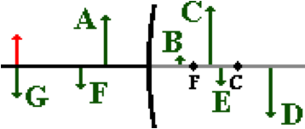

Which image (drawn and labeled in GREEN) represents the approximate location, size and orientation for such an object position?

**Question 17:**

aa. An object arrow (in RED) is placed in front of a convex mirror as shown in the diagram below.

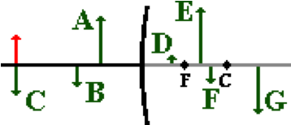

Which image (drawn and labeled in GREEN) represents the approximate location, size and orientation for such an object position?

**Question 18:**

aa. An object arrow (in RED) is placed in front of a convex mirror as shown in the diagram below.

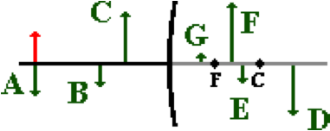

Which image (drawn and labeled in GREEN) represents the approximate location, size and orientation for such an object position?

**Question 19:**

aa. An object arrow (in RED) is placed in front of a convex mirror as shown in the diagram below.

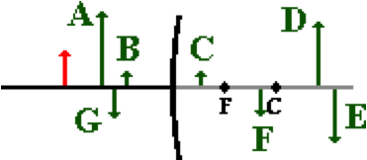

Which image (drawn and labeled in GREEN) represents the approximate location, size and orientation for such an object position?

**Question 20:**

aa. An object arrow (in RED) is placed in front of a convex mirror as shown in the diagram below.

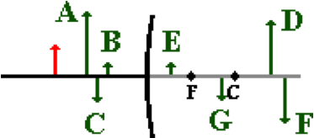

Which image (drawn and labeled in GREEN) represents the approximate location, size and orientation for such an object position?

**Question 21:**

aa. An object arrow (in RED) is placed in front of a convex mirror as shown in the diagram below.

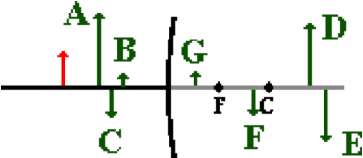

Which image (drawn and labeled in GREEN) represents the approximate location, size and orientation for such an object position?

**Question 22:**

aa. An object arrow (in RED) is placed in front of a convex mirror as shown in the diagram below.

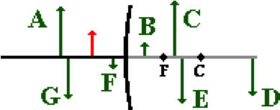

Which image (drawn and labeled in GREEN) represents the approximate location, size and orientation for such an object position?

**Question 23:**

aa. An object arrow (in RED) is placed in front of a convex mirror as shown in the diagram below.

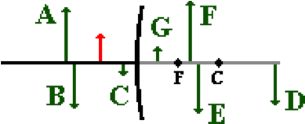

Which image (drawn and labeled in GREEN) represents the approximate location, size and orientation for such an object position?

**Question 24:**

aa. An object arrow (in RED) is placed in front of a convex mirror as shown in the diagram below.

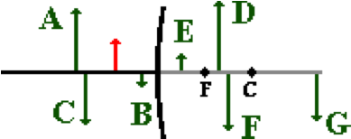

Which image (drawn and labeled in GREEN) represents the approximate location, size and orientation for such an object position?

**RM10: Convex Mirror Mathematics**

**Question 1:**

aa. Ima Vain is using a convex mirror with a focal length of -59.3 cm in order to apply her hourly makeup. Ima's eyebrow is a distance of 30.0 cm from the mirror surface. What is the corresponding image distance (in cm)?

**Question 2:**

aa. Ima Vain is using a convex mirror with a focal length of -36.7 cm in order to apply her hourly makeup. Ima's eyebrow is a distance of 25.0 cm from the mirror surface. What is the corresponding image distance (in cm)?

**Question 3:**

aa. Ima Vain is using a convex mirror with a focal length of -44.7 cm in order to apply her hourly makeup. Ima's eyebrow is a distance of 20.0 cm from the mirror surface. What is the corresponding image distance (in cm)?

**Question 4:**

aa. Ima Vain is using a convex mirror with a focal length of -45.8 cm in order to apply her hourly makeup. Ima's eyebrow is a distance of 50.0 cm from the mirror surface. What is the corresponding image distance (in cm)?

**Question 5:**

aa. Ima Vain is using a convex mirror with a focal length of -41.0 cm in order to apply her hourly makeup. Ima's eyebrow is a distance of 80.0 cm from the mirror surface. What is the corresponding image distance (in cm)?

**Question 6:**

aa. A local drug store has installed a convex mirror with a focal length of -98.4 cm in an effort to monitor the aisles and reduce theft. Robin Storz stands a distance of 3.2 m from the mirror as he inspects the candy aisle. What is the corresponding image distance (in cm)?

**Question 7:**

aa. A local drug store has installed a convex mirror with a focal length of -81.4 cm in an effort to monitor the aisles and reduce theft. Robin Storz stands a distance of 2.2 m from the mirror as he inspects the candy aisle. What is the corresponding image distance (in cm)?

**Question 8:**

aa. A local drug store has installed a convex mirror with a focal length of -51.5 cm in an effort to monitor the aisles and reduce theft. Robin Storz stands a distance of 3.6 m from the mirror as he inspects the candy aisle. What is the corresponding image distance (in cm)?

**Question 9:**

aa. A local drug store has installed a convex mirror with a focal length of -89.0 cm in an effort to monitor the aisles and reduce theft. Robin Storz stands a distance of 4.5 m from the mirror as he inspects the candy aisle. What is the corresponding image distance (in cm)?

**Question 10:**

aa. A local drug store has installed a convex mirror with a focal length of -80.6 cm in an effort to monitor the aisles and reduce theft. Robin Storz stands a distance of 4.2 m from the mirror as he inspects the candy aisle. What is the corresponding image distance (in cm)?

**Question 11:**

aa. Ken Tryliving lives off a wooded country road. He has installed a convex mirror at the end of the driveway in order to assist him in viewing approaching traffic as he pulls onto the road. The mirror has a focal length of -1.108 m. If a car is a distance of 20.0 meters from the mirror, then what is the corresponding image distance (in m) and the magnification?

**Question 12:**

aa. Ken Tryliving lives off a wooded country road. He has installed a convex mirror at the end of the driveway in order to assist him in viewing approaching traffic as he pulls onto the road. The mirror has a focal length of -1.311 m. If a car is a distance of 25.0 meters from the mirror, then what is the corresponding image distance (in m) and the magnification?

**Question 13:**

aa. Ken Tryliving lives off a wooded country road. He has installed a convex mirror at the end of the driveway in order to assist him in viewing approaching traffic as he pulls onto the road. The mirror has a focal length of -1.421 m. If a car is a distance of 30.0 meters from the mirror, then what is the corresponding image distance (in m) and the magnification?

**Question 14:**

aa. Ken Tryliving lives off a wooded country road. He has installed a convex mirror at the end of the driveway in order to assist him in viewing approaching traffic as he pulls onto the road. The mirror has a focal length of -0.976 m. If a car is a distance of 35.0 meters from the mirror, then what is the corresponding image distance (in m) and the magnification?

**Question 15:**

aa. Ken Tryliving lives off a wooded country road. He has installed a convex mirror at the end of the driveway in order to assist him in viewing approaching traffic as he pulls onto the road. The mirror has a focal length of -1.438 m. If a car is a distance of 40.0 meters from the mirror, then what is the corresponding image distance (in m) and the magnification?

**RM11: Real and Virtual Images**

**Question 1:**

aa. An image is a likeness of an object which is at a location where ______.

a. all reflected rays appear to diverge from

b. all incident rays intersect

c. incident rays and reflected rays meet

d. any observer's line of sight intersects the mirror

e. a ray drawn from object and perpendicular to the mirror meets the mirror

**Question 2:**

aa. An image is a likeness of an object which is at a location where ______.

a. incident rays and reflected rays meet

b. all incident rays intersect

c. all reflected rays appear to diverge from

d. any observer's line of sight intersects the mirror

e. a ray drawn from object and perpendicular to the mirror meets the mirror

**Question 3:**

aa. An image is a likeness of an object which is at a location where ______.

a. any observer's line of sight intersects the mirror

b. all incident rays intersect

c. incident rays and reflected rays meet

d. all reflected rays appear to diverge from

e. a ray drawn from object and perpendicular to the mirror meets the mirror

**Question 4:**

aa. Virtual images (as created by mirrors of all types) are different than real images in that ____. Select all that apply.

a. real images actually exist; a virtual image does not exist and cannot be seen.

b. virtual always images are reduced in size; real images can be magnified or reduced.

c. virtual images are always inverted; real images can be either upright or inverted.

d. real images are located on the object's side of the mirror; virtual images are not.

e. ... nonsense! None of these are explain the difference.

**Question 5:**

aa. Virtual images (as created by mirrors of all types) are different than real images in that ____. Select all that apply.

a. virtual images are always reduced in size; real images can be magnified or reduced.

b virtual images are always inverted; real images can be either upright or inverted.

c. virtual images are located on the object's side of the mirror; real images are not.

d. real images actually exist; a virtual image does not exist and cannot be seen.

e. ... nonsense! None of these are explain the difference.

**Question 6:**

aa. Virtual images (as created by mirrors of all types) are different than real images in that ____. Select all that apply.

a. virtual images are always upright; real images are always inverted.

b. virtual images are always reduced in size; real images can be magnified or reduced.

c. real images are located on the object's side of the mirror; virtual images are not.

d. real images actually exist; a virtual image does not exist and cannot be seen.

e. ... nonsense! None of these are explain the difference.

**Question 7:**

aa. Virtual images (as created by mirrors of all types) are different than real images in that ____. Select all that apply.

a. real images actually exist; a virtual image does not exist and cannot be seen.

b. virtual images are always upright; real images can be either upright or inverted.

c. real images are located on the object's side of the mirror; virtual images are not.

d. virtual images are always reduced in size; real images can be magnified or reduced.

e. ... nonsense! None of these are explain the difference.

**Question 8:**

aa. **TRUE** or **FALSE**:

A real image can be seen and can even be projected onto a screen. A virtual image, on the other hand, cannot even be seen when looking directly at it in a mirror.

a. TRUE b. FALSE

**Question 9:**

aa. **TRUE** or **FALSE**:

A real image can be seen and can even be projected onto a screen. A virtual image, on the other hand, cannot even be seen when looking directly at it in a mirror.

a. TRUE b. FALSE

**Question 10:**

aa. Suppose that light rays originating from the object strike a mirror and diverge. When this occurs, one can be certain that ____.

a. the image will be a real image

b. the image will be a virtual image

c. ...nonsense! You can't be certain of anything in this life.

**Question 11:**

aa. Suppose that light rays originating from the object strike a mirror and diverge. When this occurs, one can be certain that ____.

a. the image will be a virtual image

b. the image will be a real image

c. ...nonsense! You can't be certain of anything in this life.

**Question 12:**

aa. If any type of mirror produces an image that is real, then that image MUST also be _____. Select all that apply.

a. virtual

b. reduced in size

c. located on the object's side of the mirror

d. located at a position where reflected light rays actually converge

e. upright

f. None of these describe a real image.

**Question 13:**

aa. If any type of mirror produces an image that is real, then that image MUST also be _____. Select all that apply.

a. virtual

b. located at a position where reflected light rays actually converge

c. upright

d. located on the object's side of the mirror

e. reduced in size

f. None of these describe a real image.

**Question 14:**

aa. If any type of mirror produces an image that is real, then that image MUST also be _____. Select all that apply.

a. virtual

b. magnified in size

c. located on the opposite side of the mirror as the object

d. located at a position where reflected light rays actually converge

e. inverted

f. None of these describe a real image.

**Question 15:**

aa. If any type of mirror produces an image that is real, then that image MUST also be _____. Select all that apply.

a. virtual

b. inverted

c. located at a position where reflected light rays actually converge

d. magnified in size

e. located on the opposite side of the mirror as the object

f. None of these describe a real image.

**Question 16:**

aa. If any type of mirror produces an image that is virtual, then that image MUST also be _____. Select all that apply.

a. real

b. reduced in size

c. located on the object's side of the mirror

d. located at a position where reflected light rays actually converge

e. upright

f. None of these describe a virtual image.

**Question 17:**

aa. If any type of mirror produces an image that is virtual, then that image MUST also be _____. Select all that apply.

a. real

b. upright

c. located at a position where reflected light rays actually converge

d. located on the object's side of the mirror

e. reduced in size

f. None of these describe a virtual image.

**Question 18:**

aa. If any type of mirror produces an image that is virtual, then that image MUST also be _____. Select all that apply.

a. real

b. magnified in size

c. located on the opposite side of the mirror as the object

d. located at a position where reflected light rays actually converge

e. inverted

f. None of these describe a virtual image.

**Question 19:**

aa. If any type of mirror produces an image that is virtual, then that image MUST also be _____. Select all that apply.

a. real

b. inverted

c. located at a position where reflected light rays actually converge

d. magnified in size

e. located on the opposite side of the mirror as the object

f. None of these describe a virtual image.

**Question 20:**

aa. In which of the following situations will a virtual image always be formed? Select all that apply.

a. Concave mirror

b. Convex mirror

c. Plane mirror

d. None of these will always result in the formation of a virtual image.

**Question 21:**

aa. In which of the following situations will a virtual image always be formed? Select all that apply.

a. Convex mirror

b. Concave mirror

c. Plane mirror

d. None of these will always result in the formation of a virtual image.

**Question 22:**

aa. In which of the following situations will a virtual image always be formed? Select all that apply.

a. Plane mirror

b. Convex mirror

c. Concave mirror

d. None of these will always result in the formation of a virtual image.

**Question 23:**

aa. In which of the following situations will a real image always be formed? Select all that apply.

a. Concave mirror

b. Convex mirror

c. Plane mirror

d. None of these will always result in the formation of a real image.

**Question 24:**

aa. In which of the following situations will a real image always be formed? Select all that apply.

a. Convex mirror

b. Concave mirror

c. Plane mirror

d. None of these will always result in the formation of a real image.

**Question 25:**

aa. In which of the following situations will a real image always be formed? Select all that apply.

a. Plane mirror

b. Concave mirror

c. Convex mirror

d. None of these will always result in the formation of a real image.

**Question 26:**

aa. In which of the following situations will a real image be formed? Select all that apply.

a. Concave mirror: Object located at the center of curvature.

b. Convex mirror: Object located far away from mirror.

c. Plane mirror: Object located nearby the mirror.

d. None of these will result in the formation of a real image.

**Question 27:**

aa. In which of the following situations will a real image be formed? Select all that apply.

a. Plane mirror: Object located nearby the mirror.

b. Convex mirror: Object located far away from mirror.

c. Concave mirror: Object located beyond the center of curvature.

d. None of these will result in the formation of a real image.

**Question 28:**

aa. In which of the following situations will a virtual image be formed? Select all that apply.

a. Concave mirror: Object located at the center of curvature.

b. Convex mirror: Object located far away from mirror.

c. Plane mirror: Object located nearby the mirror.

d. None of these will result in the formation of a virtual image.

**Question 29:**

aa. In which of the following situations will a virtual image be formed? Select all that apply.

a. Concave mirror: Object located beyond the focal point.

b. Convex mirror: Object located far away from mirror.

c. Plane mirror: Object located nearby the mirror.

d. None of these will result in the formation of a virtual image.