**Minds On Physics Question Banks – Sound and Music**

**SM1: The Nature of a Sound Wave**

**Question 1:**

aa. In terms of the motion of the particles of the medium, a sound wave can be best described as a ____ wave.

a. longitudinal b. transverse

c. circular d. vibratory

e. None of these describe the motion of particles.

**Question 2:**

aa. In terms of the motion of the particles of the medium, a sound wave can be best described as a ____ wave.

a. transverse b. longitudinal

c. vibratory d. circular

e. None of these describe the motion of particles.

**Question 3:**

aa. In terms of the motion of the particles of the medium, a sound wave can be best described as a ____ wave.

a. circular b. vibratory

c. longitudinal d. transverse

e. None of these describe the motion of particles.

**Question 4:**

aa. In terms of the motion of the particles of the medium, a sound wave can be best described as a ____ wave.

a. circular b. transverse

c. vibratory d. longitudinal

e. None of these describe the motion of particles.

**Question 5:**

aa. Waves are often categorized as being electromagnetic waves or mechanical waves. A sound wave is best categorized as a _____ wave.

a. electromagnetic

b. mechanical

c. usually mechanical, but at times electromagnetic

d. None of these categories describe a sound wave.

**Question 6:**

aa. Waves are often categorized as being electromagnetic waves or mechanical waves. A sound wave is best categorized as a _____ wave.

a. mechanical

b. electromagnetic

c. usually mechanical, but at times electromagnetic

d. None of these categories describe a sound wave.

**Question 7:**

aa. Waves are often categorized as being electromagnetic waves or mechanical waves. A sound wave is best categorized as a _____ wave.

a. usually mechanical, but at times electromagnetic

b. electromagnetic

c. mechanical

d. None of these categories describe a sound wave.

**Question 8:**

aa. Sound cannot travel through ____. List all that apply in alphabetical order with no commas or spaces between letters.

a. a solid substance b. a liquid substance

c. a gaseous substance d. a vacuum

e. ... nonsense! Sound can travel through all of these.

**Question 9:**

aa. Sound cannot travel through ____. List all that apply in alphabetical order with no commas or spaces between letters.

a. a gaseous substance b. a vacuum

c. a solid substance d. a liquid substance

e. ... nonsense! Sound can travel through all of these.

**Question 10:**

aa. Sound cannot travel through ____. List all that apply in alphabetical order with no commas or spaces between letters.

a. a liquid substance b. a solid substance

c. a vacuum d. a gaseous substance

e. ... nonsense! Sound can travel through all of these.

**Question 11:**

aa. Sound cannot travel through ____. List all that apply in alphabetical order with no commas or spaces between letters.

a. a vacuum b. a gaseous substance

c. a liquid substance d. a solid substance

e. ... nonsense! Sound can travel through all of these.

**Question 12:**

aa. Sammy is talking to Sally. Position A is a position in front of Sammy's mouth. Position B is a position in front of Sally's ear.



In order for Sally to hear Sammy's voice, air particles must ____.

a. move from A to B

b. move from A to B and then back to A

c. vibrate parallel to a line connecting A and B

d. vibrate perpendicular to a line connecting A and B

e. more than one of the above

**Question 13:**

aa. Sammy is talking to Sally. Position A is a position in front of Sammy's mouth. Position B is a position in front of Sally's ear.



In order for Sally to hear Sammy's voice, air particles must ____.

a. move from A to B and then back to A

b. move from A to B

c. vibrate perpendicular to a line connecting A and B

d. vibrate parallel to a line connecting A and B

e. more than one of the above

**Question 14:**

aa. Sammy is talking to Sally. Position A is a position in front of Sammy's mouth. Position B is a position in front of Sally's ear.



In order for Sally to hear Sammy's voice, air particles must ____.

a. vibrate parallel to a line connecting A and B

b. vibrate perpendicular to a line connecting A and B

c. move from A to B

d. move from A to B and then back to A

e. more than one of the above

**Question 15:**

aa. Sammy is talking to Sally. Position A is a position in front of Sammy's mouth. Position B is a position in front of Sally's ear.



In order for Sally to hear Sammy's voice, air particles must ____.

a. vibrate perpendicular to a line connecting A and B

b. vibrate parallel to a line connecting A and B

c. move from A to B

d. move from A to B and then back to A

e. more than one of the above

**Question 16:**

aa. **TRUE** or **FALSE**:

In order to hear a person talking, air particles (or some kind of particle) must move from the mouth of the talking person to the ear of the listening person.

a. True b. False

**Question 17:**

aa. **TRUE** or **FALSE**:

In order to hear a person talking, it is not necessary that air particles (or any kind of particle) move from the mouth of the talking person to the ear of the listening person.

a. True b. False

**Question 18:**

aa. A sound wave is often called a pressure wave because there are regions of high and low pressure established in the medium through which the sound wave travels. The regions of high pressure are known as ____ and the regions of low pressure are known as ____.

a. compressions, rarefactions b. crests, troughs

c. antinodes, nodes d. longitudes, transverses

e. none of these

**Question 19:**

aa. A sound wave is often called a pressure wave because there are regions of high and low pressure established in the medium through which the sound wave travels. The regions of high pressure are known as ____ and the regions of low pressure are known as ____.

a. crests, troughs b. compressions, rarefactions

c. longitudes, transverses d. antinodes, nodes

e. none of these

**Question 20:**

aa. A sound wave is often called a pressure wave because there are regions of high and low pressure established in the medium through which the sound wave travels. The regions of high pressure are known as ____ and the regions of low pressure are known as ____.

a. longitudes, transverses b. antinodes, nodes

c. crests, troughs d. compressions, rarefactions

e. none of these

**Question 21:**

aa. A sound wave is often called a pressure wave because there are regions of high and low pressure established in the medium through which the sound wave travels. The regions of high pressure are known as ____ and the regions of low pressure are known as ____.

a. antinodes, nodes b. longitudes, transverses

c. compressions, rarefactions d. crests, troughs

e. none of these

**Question 22:**

aa. The tines of a vibrating tuning fork create a sound that travels through a long tube. The diagram below portrays the presence of position of air molecules within the tube at an instant in time.

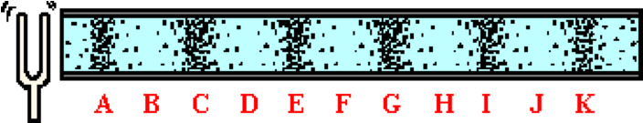

Which of the labeled regions are compressions? List all that apply in alphabetical order with no commas or spaces between letters.

**Question 23:**

aa. The tines of a vibrating tuning fork create a sound that travels through a long tube. The diagram below portrays the presence of position of air molecules within the tube at an instant in time.

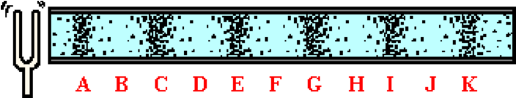

Which of the labeled regions are rarefactions? List all that apply in alphabetical order with no commas or spaces between letters.

**Question 24:**

aa. The tines of a vibrating tuning fork create a sound that travels through a long tube. The diagram below portrays the presence of position of air molecules within the tube at an instant in time.

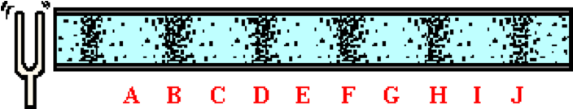

Which of the labeled regions are compressions? List all that apply in alphabetical order with no commas or spaces between letters.

**Question 25:**

aa. The tines of a vibrating tuning fork create a sound that travels through a long tube. The diagram below portrays the presence of position of air molecules within the tube at an instant in time.

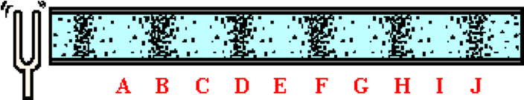

Which of the labeled regions are rarefactions? List all that apply in alphabetical order with no commas or spaces between letters.

**Question 26:**

aa. Suppose that you are watching a science fiction film involving two space ships in the deep void of outer space. In the film, an explosion occurs on space ship A. After seeing the fiery blast from a long distance away, the occupants of space ship B hear the loud boom of the blast. This is an example of _____.

a. sound behaving as a mechanical wave

b. sound behaving as an electromagnetic wave

c. sound behaving as a pressure wave

d. sound traveling slower than light

e. bad physics since sound could never traverse the empty space from ship A and ship B

**Question 27:**

aa. Suppose that you are watching a science fiction film involving two space ships in the deep void of outer space. In the film, an explosion occurs on space ship A. After seeing the fiery blast from a long distance away, the occupants of space ship B hear the loud boom of the blast. This is an example of _____.

a. sound behaving as a pressure wave

b. sound behaving as a mechanical wave

c. sound traveling slower than light

d. sound behaving as an electromagnetic wave

e. bad physics since sound could never traverse the empty space from ship A and ship B

**Question 28:**

aa. Suppose that you are watching a science fiction film involving two space ships in the deep void of outer space. In the film, an explosion occurs on space ship A. After seeing the fiery blast from a long distance away, the occupants of space ship B hear the loud boom of the blast. This is an example of _____.

a. sound behaving as a pressure wave

b. sound traveling slower than light

c. sound behaving as a mechanical wave

d. sound behaving as an electromagnetic wave

e. bad physics since sound could never traverse the empty space from ship A and ship B

**Question 29:**

aa. Suppose that you are watching a science fiction film involving two space ships in the deep void of outer space. In the film, an explosion occurs on space ship A. After seeing the fiery blast from a long distance away, the occupants of space ship B hear the loud boom of the blast. This is an example of _____.

a. sound behaving as an electromagnetic wave

b. sound behaving as a mechanical wave

c. sound traveling slower than light

d. sound behaving as a pressure wave

e. bad physics since sound could never traverse the empty space from ship A and ship B

**SM2: Characteristics of Sound Waves**

**Question 1:**

aa. High intensity sounds are perceived as relatively loud sounds. The sound waves that are most intense and perceived as loud sounds are those that have a _____. Identify the one characteristic that is unique of such sound waves.

a. high speed b. low speed

c. long wavelength d. short wavelength

e. high amplitude f. low amplitude

g. None of these are wave features unique to loud sounds.

**Question 2:**

aa. High intensity sounds are perceived as relatively loud sounds. The sound waves that are most intense and perceived as loud sounds are those that have a _____. Identify the one characteristic that is unique of such sound waves.

a. low speed b. high speed

c. short wavelength d. long wavelength

e. low amplitude f. high amplitude

g. None of these are wave features unique to loud sounds.

**Question 3:**

aa. High intensity sounds are perceived as relatively loud sounds. The sound waves that are most intense and perceived as loud sounds are those that have a _____. Identify the one characteristic that is unique of such sound waves.

a. high speed b. low speed

c. high amplitude d. low amplitude

e. long wavelength f. short wavelength

g. None of these are wave features unique to loud sounds.

**Question 4:**

aa. High intensity sounds are perceived as relatively loud sounds. The sound waves that are most intense and perceived as loud sounds are those that have a _____. Identify the one characteristic that is unique of such sound waves.

a. high amplitude b. low amplitude

c. long wavelength d. short wavelength

e. high speed f. low speed

g. None of these are wave features unique to loud sounds.

**Question 5:**

aa. High-pitched sounds are characterized by sound waves that have a _____. List all that apply in alphabetical order with no commas or spaces between letters.

a. high frequency b. low frequency

c. long wavelength d. short wavelength

e. high amplitude f. low amplitude

g. None of these are wave features unique to high-pitched sounds.

**Question 6:**

aa. High-pitched sounds are characterized by sound waves that have a _____. List all that apply in alphabetical order with no commas or spaces between letters.

a. low frequency b. high frequency

c. short wavelength d. long wavelength

e. low amplitude f. high amplitude

g. None of these are wave features unique to high-pitched sounds.

**Question 7:**

aa. Low-pitched sounds are characterized by sound waves that have a _____. List all that apply in alphabetical order with no commas or spaces between letters.

a. long wavelength b. short wavelength

c. high amplitude d. low amplitude

e. high frequency f. low frequency

g. None of these are wave features unique to low-pitched sounds.

**Question 8:**

aa. Low-pitched sounds are characterized by sound waves that have a _____. List all that apply in alphabetical order with no commas or spaces between letters.

a. short wavelength b. long wavelength

c. low amplitude d. high amplitude

e. low frequency f. high frequency

g. None of these are wave features unique to low-pitched sounds.

**Question 9:**

aa. A sound wave is traveling through a medium. The diagram below depicts the presence and location of the particles at a given instant in time.

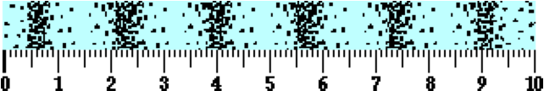

Utilize the ruler to determine the best approximation of the wavelength of the wave. The wavelength is ____ units.

a. 0.6 b. 1.4 c. 1.7 d. 5.0

e. 6.0 f. 9.1 g. 10.0

**Question 10:**

aa. A sound wave is traveling through a medium. The diagram below depicts the presence and location of the particles at a given instant in time.

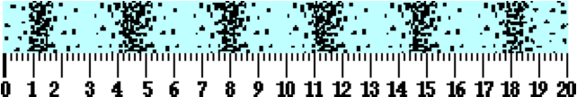

Utilize the ruler to determine the best approximation of the wavelength of the wave. The wavelength is ____ units.

a. 1.2 b. 2.8 c. 3.4 d. 5.0

e. 6.0 f. 18.2 g. 20.0

**Question 11:**

aa. A sound wave is traveling through a medium. The diagram below depicts the presence and location of the particles at a given instant in time.



Utilize the ruler to determine the best approximation of the wavelength of the wave. The wavelength is ____ units.

a. 0.29 b. 0.85 c. 1.15 d. 1.7

e. 4.60 f. 5.00 g. 6.00

**Question 12:**

aa. Some sound waves have short wavelengths and others have long wavelengths. Suppose a comparison is made of two sound waves of varying wavelengths traveling through the same medium. The long wave can be certain to also have a relatively ____. List all that apply in alphabetical order with no commas or spaces between letters.

a. high speed b. low speed

c. high frequency d. low frequency

e. high amplitude f. low amplitude

g. high period h. low period

i. None of these characteristics are unique features of long waves.

**Question 13:**

aa. Some sound waves have short wavelengths and others have long wavelengths. Suppose a comparison is made of two sound waves of varying wavelengths traveling through the same medium. The long wave can be certain to also have a relatively ____. List all that apply in alphabetical order with no commas or spaces between letters.

a. high period b. low period

c. high frequency d. low frequency

e. high speed f. low speed

g. high amplitude h. low amplitude

i. None of these characteristics are unique features of long waves.

**Question 14:**

aa. Some sound waves have short wavelengths and others have long wavelengths. Suppose a comparison is made of two sound waves of varying wavelengths traveling through the same medium. The short wave can be certain to also have a relatively ____. List all that apply in alphabetical order with no commas or spaces between letters.

a. high speed b. low speed

c. high frequency d. low frequency

e. high amplitude f. low amplitude

g. high period h. low period

i. None of these characteristics are unique features of short waves.

**Question 15:**

aa. Some sound waves have short wavelengths and others have long wavelengths. Suppose a comparison is made of two sound waves of varying wavelengths traveling through the same medium. The short wave can be certain to also have a relatively ____. List all that apply in alphabetical order with no commas or spaces between letters.

a. high period b. low period

c. high frequency d. low frequency

e. high speed f. low speed

g. high amplitude h. low amplitude

i. None of these characteristics are unique features of short waves.

**Question 16:**

aa. Several sounds waves travel through the same sample of air. A fast sound wave would be the wave that ____.

a. is longest b. vibrates most frequently

c. has the greatest amplitude d. has the shortest period

e. ...nonsense! None of these would affect the speed of a sound wave

**Question 17:**

aa. Several sounds waves travel through the same sample of air. A fast sound wave would be the wave that ____.

a. vibrates most frequently b. is longest

c. has the shortest period d. has the greatest amplitude

e. ...nonsense! None of these would affect the speed of a sound wave

**Question 18:**

aa. Several sounds waves travel through the same sample of air. A fast sound wave would be the wave that ____.

a. has the greatest amplitude b. has the shortest period

c. is longest d. vibrates most frequently

e. ...nonsense! None of these would affect the speed of a sound wave

**Question 19:**

aa. Several sounds waves travel through the same sample of air. A fast sound wave would be the wave that ____.

a. has the shortest period b. has the greatest amplitude

c. vibrates most frequently d. is longest

e. ...nonsense! None of these would affect the speed of a sound wave

**Question 20:**

aa. Altering the _______ will be sure to result in an alteration of the speed of the sound wave. List all that apply in alphabetical order with no spaces or commas between letters.

a. wavelength of the wave b. frequency of the wave

c. amplitude of the wave d. intensity of the wave

e. period of the wave f. properties of the medium

**Question 21:**

aa. Altering the _______ will be sure to result in an alteration of the speed of the sound wave. List all that apply in alphabetical order with no spaces or commas between letters.

a. frequency of the wave b. wavelength of the wave

c. intensity of the wave d. amplitude of the wave

e. properties of the medium f. period of the wave

**Question 22:**

aa. Altering the _______ will be sure to result in an alteration of the speed of the sound wave. List all that apply in alphabetical order with no spaces or commas between letters.

a. period of the wave b. intensity of the wave

c. properties of the medium d. wavelength of the wave

e. amplitude of the wave f. frequency of the wave

**Question 23:**

aa. Altering the _______ will be sure to result in an alteration of the speed of the sound wave. List all that apply in alphabetical order with no spaces or commas between letters.

a. intensity of the wave b. period of the wave

c. wavelength of the wave d. properties of the medium

e. frequency of the wave f. amplitude of the wave

**Question 24:**

aa. **TRUE** or **FALSE**:

A loud sound has a greater speed than a soft sound. Yelling loud would make a sound wave travel measurably faster.

a. True b. False

**Question 25:**

aa. **TRUE** or **FALSE**:

A loud sound travels at the same speed as a soft sound. Yelling loud would not make a measurable impact upon the speed at which the sound wave travels.

a. True b. False

**Question 26:**

aa. **TRUE** or **FALSE**:

A loud sound has a smaller speed than a soft sound. Yelling loud would make a sound wave travel measurably slower.

a. True b. False

**Question 27:**

aa. Sound wave A and sound wave B are simultaneously traveling through the auditorium. Wave A has twice the frequency as wave B. Thus, the wavelength of wave A will be _____ the wavelength of wave B and the speed of wave A will be ____ the speed of wave B.

a. two times, two times b. one-half, one-half

c. two times, one-half d. one-half, two times

e. two times, the same as f. one-half, the same as

g. the same as, two times h. the same as, one-half

i. the same as, the same as j. none of these

**Question 28:**

aa. Sound wave A and sound wave B are simultaneously traveling through the auditorium. Wave A has twice the frequency as wave B. Thus, the wavelength of wave A will be _____ the wavelength of wave B and the speed of wave A will be ____ the speed of wave B.

a. two times, two times b. two times, one-half

c. two times, the same as d. one-half, the same as

e. one-half, one-half f. one-half, two times

g. the same as, two times h. the same as, one-half

i. the same as, the same as j. none of these

**Question 29:**

aa. Sound wave A and sound wave B are simultaneously traveling through the auditorium. Wave A has twice the frequency as wave B. Thus, the wavelength of wave A will be _____ the wavelength of wave B and the speed of wave A will be ____ the speed of wave B.

a. the same as, two times b. the same as, one-half

c. the same as, the same as d. two times, two times

e. two times, one-half f. two times, the same as

g. one-half, one-half h. one-half, two times

i. one-half, the same as j. none of these

**Question 30:**

aa. Sound wave A and sound wave B are simultaneously traveling through the auditorium. Wave A has twice the frequency as wave B. Thus, the wavelength of wave A will be _____ the wavelength of wave B and the speed of wave A will be ____ the speed of wave B.

a. two times, two times b. two times, one-half

c. two times, the same as d. the same as, two times

e. the same as, one-half f. the same as, the same as

g. one-half, the same as h. one-half, one-half

i. one-half, two times j. none of these

**Question 31:**

aa. Sound wave A and sound wave B are simultaneously traveling through the auditorium. Wave A has one-half the frequency as wave B. Thus, the wavelength of wave A will be _____ the wavelength of wave B and the speed of wave A will be ____ the speed of wave B.

a. two times, two times b. one-half, one-half

c. two times, one-half d. one-half, two times

e. two times, the same as f. one-half, the same as

g. the same as, two times h. the same as, one-half

i. the same as, the same as j. none of these

**Question 32:**

aa. Sound wave A and sound wave B are simultaneously traveling through the auditorium. Wave A has one-half the frequency as wave B. Thus, the wavelength of wave A will be _____ the wavelength of wave B and the speed of wave A will be ____ the speed of wave B.

a. two times, two times b. two times, one-half

c. two times, the same as d. one-half, one-half

e. one-half, two times f. one-half, the same as

g. the same as, two times h. the same as, one-half

i. the same as, the same as j. none of these

**Question 33:**

aa. Doubling the frequency of a sound wave within a uniform (unchanging) medium will _____. List all that apply in alphabetical order with no spaces or commas between letters.

a. double the speed of the wave b. halve the speed of the wave

c. double the wavelength of the wave d. halve the wavelength of the wave

e. double the amplitude of the wave f. halve the amplitude of the wave

g. not alter any of these characteristics - speed, wavelength nor amplitude

**Question 34:**

aa. Doubling the frequency of a sound wave within a uniform (unchanging) medium will _____. List all that apply in alphabetical order with no spaces or commas between letters.

a. halve the amplitude of the wave b. halve the wavelength of the wave

c. halve the speed of the wave d. double the amplitude of the wave

e. double the speed of the wave f. double the wavelength of the wave

g. not alter any of these characteristics - speed, wavelength nor amplitude

**Question 35:**

aa. Doubling the frequency of a sound wave within a uniform (unchanging) medium will _____. List all that apply in alphabetical order with no spaces or commas between letters.

a. double the amplitude of the wave b. double the speed of the wave

c. double the wavelength of the wave d. halve the amplitude of the wave

e. halve the wavelength of the wave f. halve the speed of the wave

g. not alter any of these characteristics - speed, wavelength nor amplitude

**SM3: Sound Intensity and Decibel Levels**

**Question 1:**

aa. The deciBel scale gives an indication of a sound's _____.

a. intensity b. frequency

c. wavelength d. speed

e. none of these

**Question 2:**

aa. The deciBel scale gives an indication of a sound's _____.

a. frequency b. wavelength

c. speed d. intensity

e. none of these

**Question 3:**

aa. The deciBel scale gives an indication of a sound's _____.

a. wavelength b. speed

c. intensity d. frequency

e. none of these

**Question 4:**

aa. The deciBel scale gives an indication of a sound's _____.

a. speed b. intensity

c. frequency d. wavelength

e. none of these

**Question 5:**

aa. If a sound has a high deciBel level, then that sound also has a ____.

a. high sound intensity b. low sound intensity

c. high frequency d. low frequency

e. high speed f. low speed

g. none of these

**Question 6:**

aa. If a sound has a high deciBel level, then that sound also has a ____.

a. high speed b. low speed

c. high frequency d. low frequency

e. high sound intensity f. low sound intensity

g. none of these

**Question 7:**

aa. If a sound has a high deciBel level, then that sound also has a ____.

a. high speed b. high frequency

c. high sound intensity d. low sound intensity

e. low frequency f. low speed

g. none of these

**Question 8:**

aa. If a sound has a high deciBel level, then that sound also has a ____.

a. low sound intensity b. low frequency

c. low speed d. high speed

e. high frequency f. high sound intensity

g. none of these

**Question 9:**

aa. If sound A is two times as intense as sound B, then sound A ____ sound B.

a. has two times the deciBel level as

b. is two deciBels higher than

c. has 20 times the deciBel level as

d. is 20 deciBels higher than

e. has one-half the deciBel level as

f. is two deciBels lower than

g. has 1/20-th the deciBel level as

h. is 20 deciBels lower than

i. none of these

**Question 10:**

aa. If sound A is two times as intense as sound B, then sound A ____ sound B.

a. has one-half the deciBel level as

b. is two deciBels lower than

c. has 1/20-th the deciBel level as

d. is 20 deciBels lower than

e. has two times the deciBel level as

f. is two deciBels higher than

g. has 20 times the deciBel level as

h. is 20 deciBels higher than

i. none of these

**Question 11:**

aa. If sound A is two times as intense as sound B, then sound A ____ sound B.

a. has two times the deciBel level as

b. has 20 times the deciBel level as

c. has one-half the deciBel level as

d. has 1/20-th the deciBel level as

e. is two deciBels higher than

f. is 20 deciBels higher than

g. is two deciBels lower than

h. is 20 deciBels lower than

i. none of these

**Question 12:**

aa. If sound A is two times as intense as sound B, then sound A ____ sound B.

a. is two deciBels higher than

b. is 20 deciBels higher than

c. is two deciBels lower than

d. is 20 deciBels lower than

e. has two times the deciBel level as

f. has 20 times the deciBel level as

g. has one-half the deciBel level as

h. has 1/20-th the deciBel level as

i. none of these

**Question 13:**

aa. If sound A is 100 times as intense as sound B, then sound A ____ sound B.

a. has 10 times the deciBel level as

b. is 10 deciBels higher than

c. has 100 times the deciBel level as

d. is 100 deciBels higher than

e. has two times the deciBel level as

f. is two deciBels higher than

g. has 20 times the deciBel level as

h. is 20 deciBels higher than

i. none of these

**Question 14:**

aa. If sound A is 100 times as intense as sound B, then sound A ____ sound B.

a. has two times the deciBel level as

b. is two deciBels higher than

c. has 10 times the deciBel level as

d. is 10 deciBels higher than

e. has 20 times the deciBel level as

f. is 20 deciBels higher than

g. has 100 times the deciBel level as

h. is 100 deciBels higher than

i. none of these

**Question 15:**

aa. If sound A is 100 times as intense as sound B, then sound A ____ sound B.

a. has two times the deciBel level as

b. has 10 times the deciBel level as

c. has 20 times the deciBel level as

d. has 100 times the deciBel level as

e. is two deciBels higher than

f. is 10 deciBels higher than

g. is 20 deciBels higher than

h. is 100 deciBels higher than

i. none of these

**Question 16:**

aa. If sound A is 100 times as intense as sound B, then sound A ____ sound B.

a. is two deciBels higher than

b. is 10 deciBels higher than

c. is 20 deciBels higher than

d. is 100 deciBels higher than

e. has two times the deciBel level as

f. has 10 times the deciBel level as

g. has 20 times the deciBel level as

h. has 100 times the deciBel level as

i. none of these

**Question 17:**

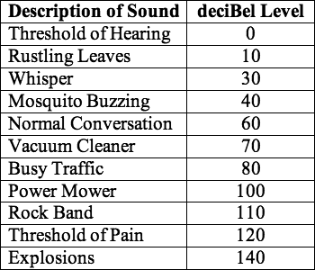aa. The table at the right lists several sounds and their typical deciBel level. Based on this listing, one would conclude that the sound of normal conversation is ____ times more intense than the sound of a mosquito buzzing.

a. 1.5 b. 2

c. 10 d. 15

e. 20 f. 100

g. 200 h. 1000

i. none of these

**Question 18:**

aa. The table at the right lists several sounds and their typical deciBel level. Based on this listing, one would conclude that the sound of busy traffic is ____ times more intense than the sound of normal conversation.

a. 1.33 b. 2

c. 10 d. 13.3

e. 20 f. 100

g. 200 h. 1000

i. none of these



**Question 19:**

aa. The table at the right lists several sounds and their typical deciBel level. Based on this listing, one would conclude that the sound of a power mower is ____ times more intense than the sound of busy traffic.

a. 1.25 b. 2

c. 10 d. 125

e. 20 f. 100

g. 200 h. 1000

i. none of these

**Question 20:**

aa. The table at the right lists several sounds and their typical deciBel level. Based on this listing, one would conclude that the sound of a whisper is ____ times more intense than the sound of rustling leaves.

a. 2 b. 3

c. 10 d. 20

e. 30 f. 100

g. 200 h. 1000

i. none of these

**Question 21:**

aa. The table at the right lists several sounds and their typical deciBel level. Based on this listing, one would conclude that the threshold of pain is ____ times more intense than the sound of a power mower.

a. 1.2 b. 2

c. 10 d. 12

e. 20 f. 100

g. 200 h. 1000

i. none of these

**Question 22:**

aa. The table at the right lists several sounds and their typical deciBel level. Based on this listing, one would conclude that the sound of a vacuum cleaner is ____ times more intense than the sound of a mosquito buzzing.

a. 1.75 b. 3

c. 17.5 d. 30

e. 100 f. 300

g. 1000 h. 10000

i. none of these

**Question 23:**

aa. The table at the right lists several sounds and their typical deciBel level. Based on this listing, one would conclude that the sound of a power mower is ____ times more intense than the sound of a vacuum cleaner.

a. 1.43 b. 3

c. 14.3 d. 30

e. 100 f. 300

g. 1000 h. 10000

i. none of these

**Question 24:**

aa. The table at the right lists several sounds and their typical deciBel level. Based on this listing, one would conclude that the sound of a rock band is ____ times more intense than the sound of busy traffic.

a. 1.38 b. 3

c. 13.8 d. 30

e. 100 f. 300

g. 1000 h. 10000

i. none of these

**Question 25:**

aa. The table at the right lists several sounds and their typical deciBel level. Based on this listing, one would conclude that the sound of a mosquito buzzing is ____ times more intense than the sound of rustling leaves.

a. 3 b. 4

c. 30 d. 40

e. 100 f. 300

g. 1000 h. 10000

i. none of these

**Question 26:**

aa. The table at the right lists several sounds and their typical deciBel level. Based on this listing, one would conclude that the sound of whisper is ____ times more intense than the threshold of hearing.

a. 0 b. 3

c. 30 d. 100

e. 300 f. 1000

g. 10000 h. an infinite

i. none of these

**Question 27:**

aa. The table at the right lists several sounds and their typical deciBel level. Based on this listing, one would conclude that the sound of busy traffic is ____ times more intense than the sound of a mosquito buzzing.

a. 2 b. 4

c. 20 d. 40

e. 200 f. 400

g. 1000 h. 10000

i. none of these

**Question 28:**

aa. The table at the right lists several sounds and their typical deciBel level. Based on this listing, one would conclude that the sound of a rock band is ____ times more intense than the sound of a vacuum cleaner.

a. 2 b. 4

c. 20 d. 40

e. 200 f. 400

g. 1000 h. 10000

i. none of these

**Question 29:**

aa. Sound A has a deciBel level of 40 deciBels. Sound B is 100 times more intense than sound A. The deciBel level of sound B is ____ dB.

a. 2 b. 20 c. 60 d. 80

e. 100 f. 400 g. 4000 h. none of these

**Question 30:**

aa. Sound A has a deciBel level of 50 deciBels. Sound B is 100 times more intense than sound A. The deciBel level of sound B is ____ dB.

a. 2 b. 20 c. 70 d. 100

e. 500 f. 1000 g. 5000 h. 50000

i. none of these

**Question 31:**

aa. Sound A has a deciBel level of 40 deciBels. Sound B is 1000 times more intense than sound A. The deciBel level of sound B is ____ dB.

a. 3 b. 30 c. 70 d. 80

e. 120 f. 100 g. 400 h. 4000

i. none of these

**Question 32:**

aa. Sound A has a deciBel level of 30 deciBels. Sound B is 1000 times more intense than sound A. The deciBel level of sound B is ____ dB.

a. 3 b. 30 c. 60 d. 90

e. 300 f. 900 g. 3000 h. 30000

i. none of these

**Question 33:**

aa. Sound A has a deciBel level of 50 deciBels. Sound B is 1000 times more intense than sound A. The deciBel level of sound B is ____ dB.

a. 5 b. 20 c. 30 d. 80

e. 100 f. 150 g. 300 h. 500

i. 5000 j. none of these

**Question 34:**

aa. Sound A has a deciBel level of 50 deciBels. Sound B is 10000 times more intense than sound A. The deciBel level of sound B is ____ dB.

a. 20 b. 70 c. 90 d. 100

e. 200 f. 400 g. 5000 h. 50000

i. none of these

**Question 35:**

aa. Sound A has a deciBel level of 100 deciBels. Sound B is 1000 times more intense than sound A. The deciBel level of sound B is ____ dB.

a. 10 b. 20 c. 80 d. 120

e. 130 f. 200 g. 300 h. 1000

i. none of these

**Question 36:**

aa. Sound A has a deciBel level of 100 deciBels. Sound B is 100 times more intense than sound A. The deciBel level of sound B is ____ dB.

a. 2 b. 10 c. 20 d. 80

e. 110 f. 120 g. 200 h. 2000

i. none of these

**SM4: The Doppler Effect**

**Question 1:**

aa. The Doppler effect is observed ____.

a. only of sound waves

b. of both sound waves and light waves

c. of all sound waves and some (but not all) light waves

d. ... nonsense! The Doppler effect is just a theory that has never been observed.

**Question 2:**

aa. The Doppler effect is observed ____.

a. of both sound waves and light waves

b. of all sound waves and some (but not all) light waves

c. only of sound waves

d. ... nonsense! The Doppler effect is just a theory that has never been observed.

**Question 3:**

aa. The Doppler effect is observed ____.

a. only of sound waves

b. of all sound waves and some (but not all) light waves

c. of both sound waves and light waves

d. ... nonsense! The Doppler effect is just a theory that has never been observed.

**Question 4:**

aa. The Doppler shift can be observed when ____. List all that apply in alphabetical order with no spaces or commas between letters.

a. the source of sound moves towards an observer

b. the source of sound moves away from an observer

c. an observer moves towards a stationary sound source

d. an observer moves away from a stationary sound source

e. the observer and sound source move at the same speed in the same direction

f. none of these

**Question 5:**

aa. The Doppler shift can be observed when ____. List all that apply in alphabetical order with no spaces or commas between letters.

a. the source of sound moves towards an observer

b. an observer moves towards a stationary sound source

c. the source of sound moves away from an observer

d. an observer moves away from a stationary sound source

e. the observer and sound source move at the same speed in the same direction

f. none of these

**Question 6:**

aa. The Doppler shift can be observed when ____. List all that apply in alphabetical order with no spaces or commas between letters.

a. the observer and sound source move at the same speed in the same direction

b. the source of sound moves away from an observer

c. an observer moves towards a stationary sound source

d. the source of sound moves towards an observer

e. an observer moves away from a stationary sound source

f. none of these

**Question 7:**

aa. The Doppler shift involves a shift in the ____. List all that apply in alphabetical order with no spaces or commas between letters.

a. actual frequency produced by the source of sound

b. actual intensity produced by the source of sound

c. the loudness of a sound observed by a listener

d. the perceived pitch of a sound observed by a listener

e. none of these

**Question 8:**

aa. The Doppler shift involves a shift in the ____. List all that apply in alphabetical order with no spaces or commas between letters.

a. the perceived pitch of a sound observed by a listener

b. actual intensity produced by the source of sound

c. actual frequency produced by the source of sound

d. the loudness of a sound observed by a listener

e. none of these

**Question 9:**

aa. The Doppler shift involves a shift in the ____. List all that apply in alphabetical order with no spaces or commas between letters.

a. the loudness of a sound observed by a listener

b. the perceived pitch of a sound observed by a listener

c. actual frequency produced by the source of sound

d. actual intensity produced by the source of sound

e. none of these

**Question 10:**

aa. The Doppler shift involves a shift in the ____. List all that apply in alphabetical order with no spaces or commas between letters.

a. actual intensity produced by the source of sound

b. actual frequency produced by the source of sound

c. the perceived pitch of a sound observed by a listener

d. the loudness of a sound observed by a listener

e. none of these

**Question 11:**

aa. **TRUE** or **FALSE**:

Ken Fused is standing on a corner when a police car passes by with its siren on. Ken hears a different pitch when the police car is approaching him than when it is past him. This is because the siren on the front of the car is set to a higher pitch than the siren on the back of the car.

a. True b. False

**Question 12:**

aa. **TRUE** or **FALSE**:

Ken Fused is standing on a corner when a police car passes by with its siren on. Ken hears a different pitch when the police car is approaching him than when it is past him. This is because the siren on the front of the car is set to a lower pitch than the siren on the back of the car.

a. True b. False

**Question 13:**

aa. **TRUE** or **FALSE**:

Ken Fused is standing on a corner when a police car passes by with its siren on. Ken hears a different pitch when the police car is approaching him than when it is past him. This is because the loudness of a sound increases as the source of a sound approaches an observer.

a. True b. False

**Question 14:**

aa. A source of sound produces sound waves with a frequency of f. As the source of sound approaches an observer, the _____.

a. source produces waves with a frequency greater than f

b. source produces waves with a frequency less than f

c. observer perceives the sound to have a frequency greater than f

d. observer perceives the sound to have a frequency less than f

e. none of these

**Question 15:**

aa. A source of sound produces sound waves with a frequency of f. As the source of sound approaches an observer, the _____.

a. source produces waves with a frequency greater than f

b. observer perceives the sound to have a frequency greater than f

c. source produces waves with a frequency less than f

d. observer perceives the sound to have a frequency less than f

e. none of these

**Question 16:**

aa. A source of sound produces sound waves with a frequency of f. As the source of sound approaches an observer, the _____.

a. source produces waves with a frequency less than f

b. observer perceives the sound to have a frequency less than f

c. source produces waves with a frequency greater than f

d. observer perceives the sound to have a frequency greater than f

e. none of these

**Question 17:**

aa. A source of sound produces sound waves with a frequency of f. As the source of sound approaches an observer, the _____.

a. observer perceives the sound to have a frequency greater than f

b. source produces waves with a frequency greater than f

c. observer perceives the sound to have a frequency less than f

d. source produces waves with a frequency less than f

e. none of these

**Question 18:**

aa. A source of sound produces sound waves with a frequency of f. As the source of sound moves away from an observer, the _____.

a. source produces waves with a frequency greater than f

b. source produces waves with a frequency less than f

c. observer perceives the sound to have a frequency greater than f

d. observer perceives the sound to have a frequency less than f

e. none of these

**Question 19:**

aa. A source of sound produces sound waves with a frequency of f. As the source of sound moves away from an observer, the _____.

a. source produces waves with a frequency less than f

b. source produces waves with a frequency greater than f

c. observer perceives the sound to have a frequency less than f

d. observer perceives the sound to have a frequency greater than f

e. none of these

**Question 20:**

aa. A source of sound produces sound waves with a frequency of f. As the source of sound moves away from an observer, the _____.

a. observer perceives the sound to have a frequency less than f

b. observer perceives the sound to have a frequency greater than f

c. source produces waves with a frequency less than f

d. source produces waves with a frequency greater than f

e. none of these

**Question 21:**

aa. A source of sound produces sound waves with a frequency of f. As the source of sound moves away from an observer, the _____.

a. observer perceives the sound to have a frequency greater than f

b. observer perceives the sound to have a frequency less than f

c. source produces waves with a frequency greater than f

d. source produces waves with a frequency less than f

e. none of these

**Question 22:**

aa. Which diagram below depicts the correct pattern of sound waves for a car approaching an observer at a constant speed with the horn depressed?

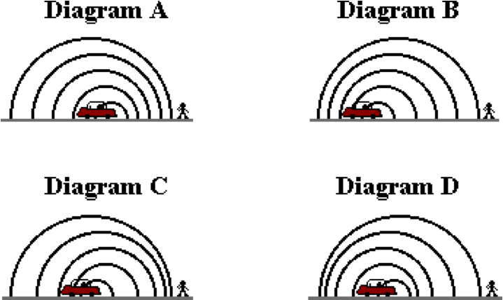

**Question 23:**

aa. Which diagram below depicts the correct pattern of sound waves for a car approaching an observer at a constant speed with the horn depressed?

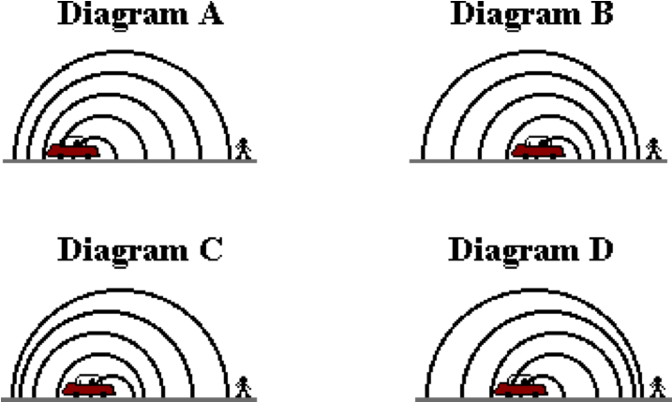

**Question 24:**

aa. Which diagram below depicts the correct pattern of sound waves for a car approaching an observer at a constant speed with the horn depressed?

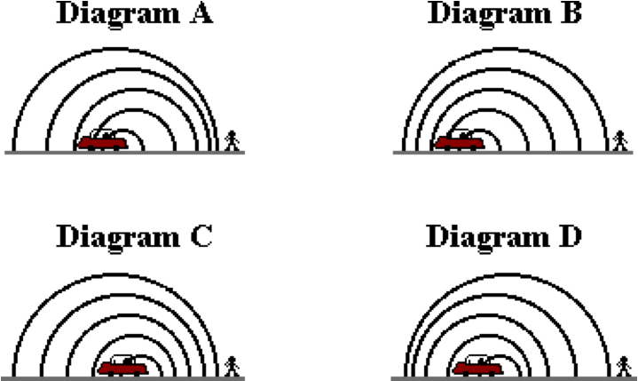

**Question 25:**

aa. Which diagram below depicts the correct pattern of sound waves for a car approaching an observer at a constant speed with the horn depressed?

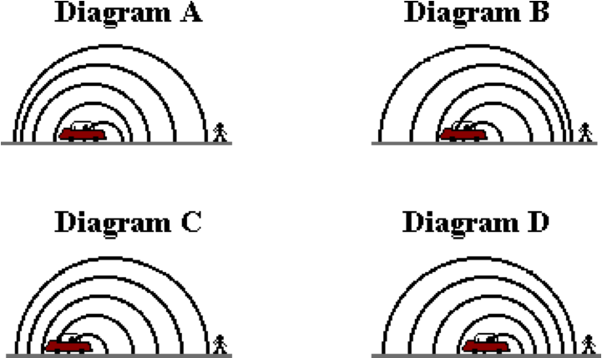

**Question 26:**

aa. Which diagram below depicts the correct pattern of sound waves for a car moving away from an observer at a constant speed with the horn depressed?

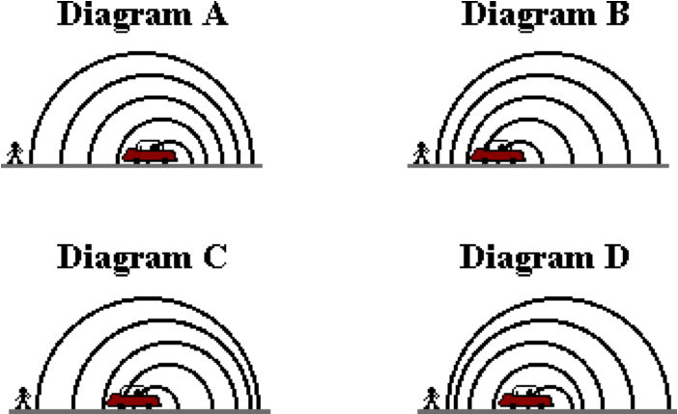

**Question 27:**

aa. Which diagram below depicts the correct pattern of sound waves for a car moving away from an observer at a constant speed with the horn depressed?

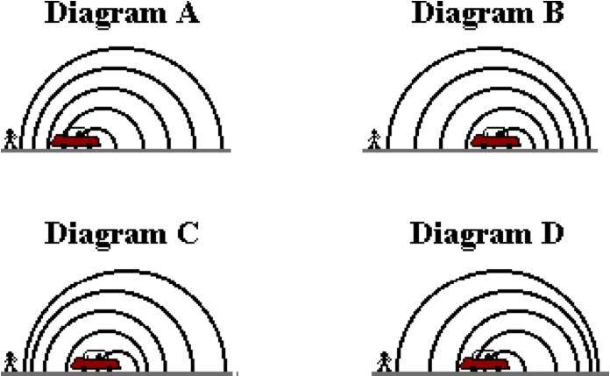

**Question 28:**

aa. Which diagram below depicts the correct pattern of sound waves for a car moving away from an observer at a constant speed with the horn depressed?

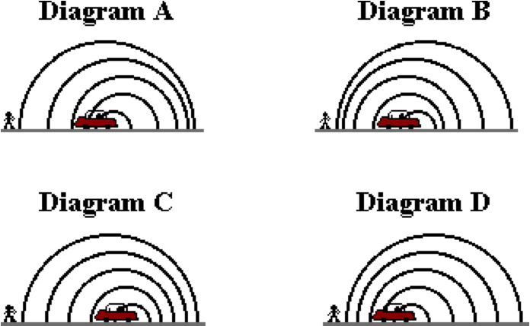

**Question 29:**

aa. Which diagram below depicts the correct pattern of sound waves for a car moving away from an observer at a constant speed with the horn depressed?

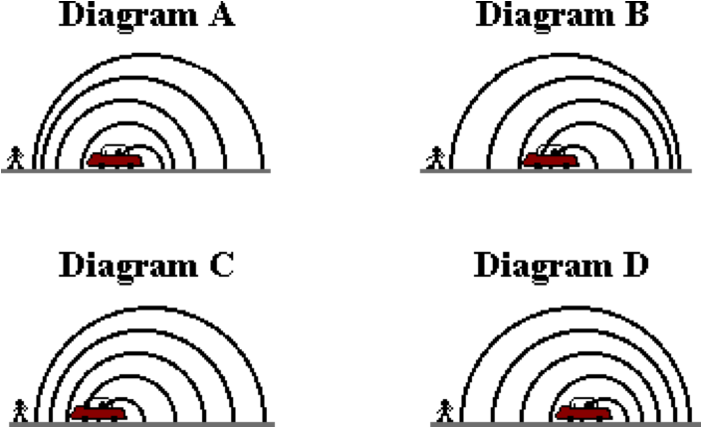

**SM5: Resonance and Standing Wave patterns**

**Question 1:**

aa. Resonance occurs when _____.

a. an object vibrates

b. an object vibrates at its natural frequency

c. two objects vibrate simultaneously

d. one vibrating object forces another object to vibrate at its natural frequency

**Question 2:**

aa. Resonance occurs when _____.

a. an object vibrates at its natural frequency

b. two objects vibrate simultaneously

c. one vibrating object forces another object to vibrate at its natural frequency

d. an object vibrates

**Question 3:**

aa. Resonance occurs when _____.

a. two objects vibrate simultaneously

b. one vibrating object forces another object to vibrate at its natural frequency

c. an object vibrates

d. an object vibrates at its natural frequency

**Question 4:**

aa. Resonance occurs when _____.

a. one vibrating object forces another object to vibrate at its natural frequency

b. an object vibrates

c. an object vibrates at its natural frequency

d. two objects vibrate simultaneously

**Question 5:**

aa. The result of resonance is ____.

a. a noisy or clangy sound

b. a broken instrument

c. an amplified vibration or loud sound

d. that bridges fall and dogs die

**Question 6:**

aa. The result of resonance is ____.

a. a broken instrument

b. an amplified vibration or loud sound

c. that bridges fall and dogs die

d. a noisy or clangy sound

**Question 7:**

aa. The result of resonance is ____.

a. an amplified vibration or loud sound

b. that bridges fall and dogs die

c. a noisy or clangy sound

d. a broken instrument

**Question 8:**

aa. The result of resonance is ____.

a. that bridges fall and dogs die

b. a noisy or clangy sound

c. a broken instrument

d. an amplified vibration or loud sound

**Question 9:**

aa. A guitar string has a set of natural frequencies at which they naturally resonate. The following numbers represent sets of frequencies. Which would be a set of typical natural frequencies for a guitar string?

a. 1 Hz, 2 Hz, 3 Hz, 4 Hz

b. 1 Hz, 10 Hz, 100 Hz, 1000 Hz

c. 250 Hz, 267 Hz, 317 Hz, 323 Hz

d. 250 Hz, 257 Hz, 264 Hz, 271 Hz

e. 250 Hz, 500 Hz, 750 Hz, 1000 Hz

f. 250 Hz, 251 Hz, 252 Hz, 253 Hz

g. 251 Hz, 252 Hz, 253 Hz, 254 Hz

**Question 10:**

aa. A guitar string has a set of natural frequencies at which they naturally resonate. The following numbers represent sets of frequencies. Which would be a set of typical natural frequencies for a guitar string?

a. 250 Hz, 267 Hz, 317 Hz, 323 Hz

b. 250 Hz, 257 Hz, 264 Hz, 271 Hz

c. 250 Hz, 500 Hz, 750 Hz, 1000 Hz

d. 1 Hz, 2 Hz, 3 Hz, 4 Hz

e. 1 Hz, 10 Hz, 100 Hz, 1000 Hz

f. 250 Hz, 251 Hz, 252 Hz, 253 Hz

g. 251 Hz, 252 Hz, 253 Hz, 254 Hz

**Question 11:**

aa. A guitar string has a set of natural frequencies at which they naturally resonate. The following numbers represent sets of frequencies. Which would be a set of typical natural frequencies for a guitar string?

a. 1 Hz, 2 Hz, 3 Hz, 4 Hz

b. 1 Hz, 10 Hz, 100 Hz, 1000 Hz

c. 200 Hz, 207 Hz, 223 Hz, 229 Hz

d. 20 Hz, 207 Hz, 214 Hz, 221 Hz

e. 200 Hz, 201 Hz, 202 Hz, 203 Hz

f. 201 Hz, 202 Hz, 203 Hz, 204 Hz

g. 200 Hz, 400 Hz, 600 Hz, 800 Hz

**Question 12:**

aa. A guitar string has a set of natural frequencies at which they naturally resonate. The following numbers represent sets of frequencies. Which would be a set of typical natural frequencies for a guitar string?

a. 1 Hz, 10 Hz, 100 Hz, 1000 Hz

b. 200 Hz, 207 Hz, 223 Hz, 229 Hz

c. 200 Hz, 207 Hz, 214 Hz, 221 Hz

d. 200 Hz, 400 Hz, 600 Hz, 800 Hz

e. 200 Hz, 201 Hz, 202 Hz, 203 Hz

f. 201 Hz, 202 Hz, 203 Hz, 204 Hz

g. 1 Hz, 2 Hz, 3 Hz, 4 Hz

**Question 13:**

aa. The fundamental frequency of a guitar string is _____.

a. the lowest possible frequency at which the guitar string would resonate

b. the multiplier used to relate one natural frequency to another natural frequency

c. the number of waves present in the standing wave pattern for a harmonic

d. the harmonic number for any given standing wave pattern

e. the highest audible frequency that a typical human could hear

f. none of these

**Question 14:**

aa. The fundamental frequency of a guitar string is _____.

a. the number of waves present in the standing wave pattern for a harmonic

b. the harmonic number for any given standing wave pattern

c. the highest audible frequency that a typical human could hear

d. the lowest possible frequency at which the guitar string would resonate

e. the multiplier used to relate one natural frequency to another natural frequency

f. none of these

**Question 15:**

aa. The fundamental frequency of a guitar string is _____.

a. the harmonic number for any given standing wave pattern

b. the highest audible frequency that a typical human could hear

c. the lowest possible frequency at which the guitar string would resonate

d. the multiplier used to relate one natural frequency to another natural frequency

e. the number of waves present in the standing wave pattern for a harmonic

f. none of these

**Question 16:**

aa. The fundamental frequency of a guitar string is _____.

a. the highest audible frequency that a typical human could hear

b. the number of waves present in the standing wave pattern for a harmonic

c. the harmonic number for any given standing wave pattern

d. the multiplier used to relate one natural frequency to another natural frequency

e. the lowest possible frequency at which the guitar string would resonate

f. none of these

**Question 17:**

aa. A harmonic is ____.

a. one of the frequencies at which an instrument naturally vibrates at

b. a point on the standing wave pattern that is oscillating rapidly

c. the number of waves present in a standing wave pattern

d. the multiplier used to relate one natural frequency to another natural frequency

e. none of these

**Question 18:**

aa. A harmonic is ____.

a. a point on the standing wave pattern that is oscillating rapidly

b. the number of waves present in a standing wave pattern

c. the multiplier used to relate one natural frequency to another natural frequency

d. one of the frequencies at which an instrument naturally vibrates at

e. none of these

**Question 19:**

aa. A harmonic is ____.

a. the number of waves present in a standing wave pattern

b. the multiplier used to relate one natural frequency to another natural frequency

c. one of the frequencies at which an instrument naturally vibrates at

d. a point on the standing wave pattern that is oscillating rapidly

e. none of these

**Question 20:**

aa. A harmonic is ____.

a. the multiplier used to relate one natural frequency to another natural frequency

b. one of the frequencies at which an instrument naturally vibrates at

c. a point on the standing wave pattern that is oscillating rapidly

d. the number of waves present in a standing wave pattern

e. none of these

**Question 21:**

aa. Various standing wave patterns for a resonating guitar string are shown below.

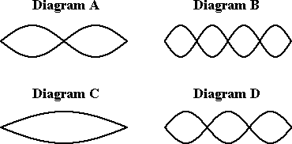

Which one of the diagrams represents the standing wave pattern for the first harmonic? If none apply, then enter 'E' as the answer.

**Question 22:**

aa. Various standing wave patterns for a resonating guitar string are shown below.

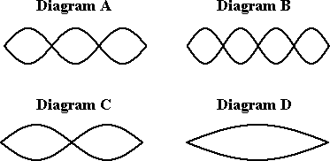

Which one of the diagrams represents the standing wave pattern for the first harmonic? If none apply, then enter 'E' as the answer.

**Question 23:**

aa. Various standing wave patterns for a resonating guitar string are shown below.

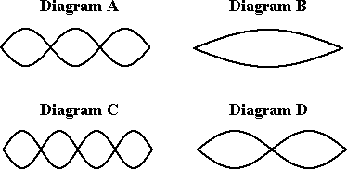

Which one of the diagrams represents the standing wave pattern for the first harmonic? If none apply, then enter 'E' as the answer.

**Question 24:**

aa. Various standing wave patterns for a resonating guitar string are shown below.

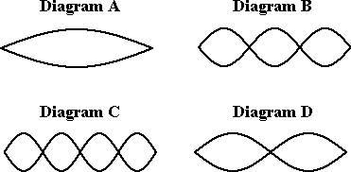

Which one of the diagrams represents the standing wave pattern for the first harmonic? If none apply, then enter 'E' as the answer.

**Question 25:**

aa. Various standing wave patterns for a resonating guitar string are shown below.



Which one of the diagrams represents the standing wave pattern for the second harmonic? If none apply, then enter 'E' as the answer.

**Question 26:**

aa. Various standing wave patterns for a resonating guitar string are shown below.



Which one of the diagrams represents the standing wave pattern for the third harmonic? If none apply, then enter 'E' as the answer.

**Question 27:**

aa. Various standing wave patterns for a resonating guitar string are shown below.



Which one of the diagrams represents the standing wave pattern for the fourth harmonic? If none apply, then enter 'E' as the answer.

**Question 28:**

aa. Various standing wave patterns for a resonating guitar string are shown below.



Which one of the diagrams represents the standing wave pattern for the fifth harmonic? If none apply, then enter 'E' as the answer.

**Question 29:**

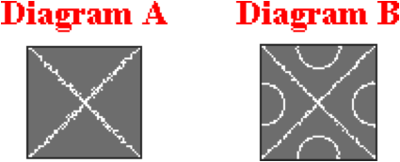aa. A physics teacher clamps a metal plate to a table, sprinkles salt onto it and draws a violin bow across its edge. The plate vibrates at 600 Hz and the salt moves around and finally settles forming the pattern shown in Diagram A. The teacher repeats the process producing the even more spectacular pattern shown in diagram B. What frequency did the plate vibrate at to produce the pattern shown in Diagram B?

a. 200 Hz b. 400 Hz c. 1200 Hz d. 1800 Hz

e. Any or all of the above. f. Impossible to tell

**Question 30:**

aa. A physics teacher clamps a metal plate to a table, sprinkles salt onto it and draws a violin bow across its edge. The plate vibrates at 800 Hz and the salt moves around and finally settles forming the pattern shown in Diagram A. The teacher repeats the process producing the even more spectacular pattern shown in diagram B. What frequency did the plate vibrate at to produce the pattern shown in Diagram B?

a. 200 Hz b. 400 Hz c. 1600 Hz d. 2400 Hz

e. Any or all of the above. f. Impossible to tell

**Question 31:**

aa. A physics teacher clamps a metal plate to a table, sprinkles salt onto it and draws a violin bow across its edge. The plate vibrates at 1200 Hz and the salt moves around and finally settles forming the pattern shown in Diagram A. The teacher repeats the process producing the even more spectacular pattern shown in diagram B. What frequency did the plate vibrate at to produce the pattern shown in Diagram B?

a. 400 Hz b. 600 Hz c. 2400 Hz d. 3600 Hz

e. Any or all of the above. f. Impossible to tell

**Question 32:**

aa. A physics teacher clamps a metal plate to a table, sprinkles salt onto it and draws a violin bow across its edge. The plate vibrates at 900 Hz and the salt moves around and finally settles forming the pattern shown in Diagram A. The teacher repeats the process producing the even more spectacular pattern shown in diagram B. What frequency did the plate vibrate at to produce the pattern shown in Diagram B?

a. 450 Hz b. 1800 Hz c. 2700 Hz d. 3600 Hz

e. Any or all of the above. f. Impossible to tell

**Question 33:**

aa. The first harmonic frequency of a musical instrument is 200 Hz. The second, third, and fourth harmonic frequencies are ____ Hz, ____ Hz, and ____ Hz respectively.

a. 50, 100, 150 b. 150, 100, 50

c. 202, 203, 204 d. 400, 800, 1200

e. 400, 600, 800 f. 400, 1200, 4800

g. none of these

**Question 34:**

aa. The first harmonic frequency of a musical instrument is 200 Hz. The second, third, and fourth harmonic frequencies are ____ Hz, ____ Hz, and ____ Hz respectively.

a. 202, 203, 204 b. 150, 100, 50

c. 50, 100, 150 d. 400, 600, 800

e. 400, 1200, 4800 f. 400, 800, 1200

g. none of these

**Question 35:**

aa. The first harmonic frequency of a musical instrument is 400 Hz. The second, third, and fourth harmonic frequencies are ____ Hz, ____ Hz, and ____ Hz respectively.

a. 100, 200, 300 b. 300, 200, 100

c. 500, 600, 700 d. 800, 1600, 3200

e. 600, 800, 1000 f. 800, 1200, 1600

g. none of these

**Question 36:**

aa. The first harmonic frequency of a musical instrument is 400 Hz. The second, third, and fourth harmonic frequencies are ____ Hz, ____ Hz, and ____ Hz respectively.

a. 800, 1600, 3200 b. 800, 1200, 1600

c. 600, 800, 1000 d. 500, 600, 700

e. 100, 200, 300 f. 300, 200, 100

g. none of these

**Question 37:**

aa. A musical instrument produces a frequency of 600 Hz when it vibrates in the fifth harmonic. The fundamental frequency of this instrument is ____ Hz.

a. 100 b. 120 c. 200

d. 595 e. 605 g. 3000

h. More than one of the above could be correct.

g. Impossible to tell with so little information.

**Question 38:**

aa. A musical instrument produces a frequency of 1200 Hz when it vibrates in the fifth harmonic. The fundamental frequency of this instrument is ____ Hz.

a. 100 b. 200 c. 240

d. 1195 e. 1205 f. 6000

g. More than one of the above could be correct.

h. Impossible to tell with so little information.

**Question 39:**

aa. A musical instrument produces a frequency of 2400 Hz when it vibrates in the fifth harmonic. The fundamental frequency of this instrument is ____ Hz.

a. 100 b. 400 c. 480

d. 2395 e. 2405 f. 12000

g. More than one of the above could be correct.

h. Impossible to tell with so little information.

**SM6: Harmonics for String Instruments**

**Question 1:**

aa. The nodal positions on a standing wave pattern for a stringed instrument are ____.

a. always located one-half wavelength apart

b. always located a full wavelength apart

c. usually located one-half wavelength apart

d. usually (but not always) located a full wavelength apart

e. distanced varying number of wavelengths apart, depending upon the harmonic number

f. none of the above

**Question 2:**

aa. The nodal positions on a standing wave pattern for a stringed instrument are ____.

a. distanced varying number of wavelengths apart, depending upon the harmonic number

b. always located one-half wavelength apart

c. usually located one-half wavelength apart

d. always located a full wavelength apart

e. usually (but not always) located a full wavelength apart

f. none of the above

**Question 3:**

aa. The nodal positions on a standing wave pattern for a stringed instrument are ____.

a. distanced varying number of wavelengths apart, depending upon the harmonic number

b. always located a full wavelength apart

c. usually (but not always) located a full wavelength apart

d. always located one-half wavelength apart

e. usually located one-half wavelength apart

f. none of the above

**Question 4:**

aa. The nodal positions on a standing wave pattern for a stringed instrument are ____.

a. distanced varying number of wavelengths apart, depending upon the harmonic number

b. usually (but not always) located a full wavelength apart

c. usually located one-half wavelength apart

d. always located a full wavelength apart

e. always located one-half wavelength apart

f. none of the above

**Question 5:**

aa. A standing wave pattern is established in a guitar string as it vibrates with the pattern shown below.



The guitar string has a length of 80 cm. This pattern represents the ___ harmonic; its wavelength is ____ cm. Choose two letters in their respective order; enter them together without any commas or spaces between letters. Example: 'AM'

**Harmonic # Wavelength(cm)**

a. 1st b. 2nd m. 20 n. 40 o. 60

c. 3rd d. 4th p. 80 q. 100 r. 120

e. 5th f. 6th s. 160 t. 240 u. 320

g. 7th h. 8th v. None of these

**Question 6:**

aa. A standing wave pattern is established in a guitar string as it vibrates with the pattern shown below.



The guitar string has a length of 90 cm. This pattern represents the ___ harmonic; its wavelength is ____ cm. Choose two letters in their respective order; enter them together without any commas or spaces between letters. Example: 'AM'

**Harmonic # Wavelength(cm)**

a. 1st b. 2nd m. 30 n. 45 o. 60

c. 3rd d. 4th p. 90 q. 120 r. 135

e. 5th f. 6th s. 150 t.180 u. 270

g. 7th h. 8th v. None of these

**Question 7:**

aa. A standing wave pattern is established in a guitar string as it vibrates with the pattern shown below.



The guitar string has a length of 120 cm. This pattern represents the ___ harmonic; its wavelength is ____ cm. Choose two letters in their respective order; enter them together without any commas or spaces between letters. Example: 'AM'

**Harmonic # Wavelength(cm)**

a. 1st b. 2nd m. 40 n. 60 o. 80

c. 3rd d. 4th p. 100 q. 120 r. 160

e. 5th f. 6th s. 200 t. 240 u. 360

g. 7th h. 8th v. None of these

**Question 8:**

aa. A standing wave pattern is established in a violin string as it vibrates with the pattern shown below.



The violin string has a length of 60 cm. This pattern represents the ___ harmonic; its wavelength is ____ cm. Choose two letters in their respective order; enter them together without any commas or spaces between letters. Example: 'AM'

**Harmonic # Wavelength(cm)**

a. 1st b. 2nd m. 20 n. 40 o. 60

c. 3rd d. 4th p. 90 q. 100 r. 120

e. 5th f. 6th s. 150 t. 180 u. 240

g. 7th h. 8th v. None of these

**Question 9:**

aa. A standing wave pattern is established in a guitar string as it vibrates with the pattern shown below.



The guitar string has a length of 120 cm. This pattern represents the ___ harmonic; its wavelength is ____ cm. Choose two letters in their respective order; enter them together without any commas or spaces between letters. Example: 'AM'

**Harmonic # Wavelength(cm)**

a. 1st b. 2nd m. 40 n. 60 o. 80

c. 3rd d. 4th p. 100 q. 120 r. 160

e. 5th f. 6th s. 200 t. 240 u. 360

g. 7th h. 8th v. None of these

**Question 10:**

aa. A standing wave pattern is established in a violin string as it vibrates with the pattern shown below.



The violin string has a length of 60 cm. This pattern represents the ___ harmonic; its wavelength is ____ cm. Choose two letters in their respective order; enter them together without any commas or spaces between letters. Example: 'AM'

**Harmonic # Wavelength(cm)**

a. 1st b. 2nd m. 20 n. 40 o. 60

c. 3rd d. 4th p. 80 q. 90 r. 120

e. 5th f. 6th s. 150 t. 180 u. 240

g. 7th h. 8th v. None of these

**Question 11:**

aa. A standing wave pattern is established in a cello string as it vibrates with the pattern shown below.



The cello string has a length of 150 cm. This pattern represents the ___ harmonic; its wavelength is ____ cm. Choose two letters in their respective order; enter them together without any commas or spaces between letters. Example: 'AM'

**Harmonic # Wavelength(cm)**

a. 1st b. 2nd m. 50 n. 75 o. 100

c. 3rd d. 4th p. 125 q. 150 r. 200

e. 5th f. 6th s. 250 t. 300 u. 450

g. 7th h. 8th v. None of these

**Question 12:**

aa. A standing wave pattern is established in a guitar string as it vibrates with the pattern shown below.



The guitar string has a length of 90 cm. This pattern represents the ___ harmonic; its wavelength is ____ cm. Choose two letters in their respective order; enter them together without any commas or spaces between letters. Example: 'AM'

**Harmonic # Wavelength(cm)**

a. 1st b. 2nd m. 30 n. 45 o. 60

c. 3rd d. 4th p. 120 q. 135 r. 150

e. 5th f. 6th s. 180 t. 225 u. 270

g. 7th h. 8th v. None of these

**Question 13:**

aa. A standing wave pattern is established in a guitar string as it vibrates with the pattern shown below.



The guitar string has a length of 80 cm. This pattern represents the ___ harmonic; its wavelength is ____ cm. Choose two letters in their respective order; enter them together without any commas or spaces between letters. Example: 'AM'

**Harmonic # Wavelength(cm)**

a. 1st b. 2nd m. 20 n. 40 o. 60

c. 3rd d. 4th p. 8 q. 100 r. 120

e. 5th f. 6th s. 160 t. 240 u. 320

g. 7th h. 8th v. None of these

**Question 14:**

aa. A standing wave pattern is established in a guitar string as it vibrates with the pattern shown below.



The guitar string has a length of 90 cm. This pattern represents the ___ harmonic; its wavelength is ____ cm. Choose two letters in their respective order; enter them together without any commas or spaces between letters. Example: 'AM'

**Harmonic # Wavelength(cm)**

a. 1st b. 2nd m. 30 n. 45 o. 60

c. 3rd d. 4th p. 90 q. 120 r. 135

e. 5th f. 6th s. 150 t. 180 u. 270

g. 7th h. 8th v. None of these

**Question 15:**

aa. A standing wave pattern is established in a guitar string as it vibrates with the pattern shown below.



The guitar string has a length of 100 cm. This pattern represents the ___ harmonic; its wavelength is ____ cm. Choose two letters in their respective order; enter them together without any commas or spaces between letters. Example: 'AM'

**Harmonic # Wavelength(cm)**

a. 1st b. 2nd m. 25 n. 50 o. 75

c. 3rd d. 4th p. 100 q. 125 r. 150

e. 5th f. 6th s. 200 t. 250 u. 300

g. 7th h. 8th v. None of these

**Question 16:**

aa. A standing wave pattern is established in a cello string as it vibrates with the pattern shown below.



The cello string has a length of 120 cm. This pattern represents the ___ harmonic; its wavelength is ____ cm. Choose two letters in their respective order; enter them together without any commas or spaces between letters. Example: 'AM'

**Harmonic # Wavelength(cm)**

a. 1st b. 2nd m. 30 n. 40 o. 60

c. 3rd d. 4th p. 80 q. 120 r. 180

e. 5th f. 6th s. 240 t. 360 u. 480

g. 7th h. 8th v. None of these

**Question 17:**

aa. A standing wave pattern is established in a guitar string as it vibrates with the pattern shown below.



The guitar string has a length of 80 cm. This pattern represents the ___ harmonic; its wavelength is ____ cm. Choose two letters in their respective order; enter them together without any commas or spaces between letters. Example: 'AM'

**Harmonic # Wavelength(cm)**

a. 1st b. 2nd m. 20 n. 40 o. 80

c. 3rd d. 4th p. 120 q. 160 r. 200

e. 5th f. 6th s. 240 t. 320 u. 400

g. 7th h. 8th v. None of these

**Question 18:**

aa. A standing wave pattern is established in a guitar string as it vibrates with the pattern shown below.



The guitar string has a length of 90 cm. This pattern represents the ___ harmonic; its wavelength is ____ cm. Choose two letters in their respective order; enter them together without any commas or spaces between letters. Example: 'AM'

**Harmonic # Wavelength(cm)**

a. 1st b. 2nd m. 30 n. 60 o. 90

c. 3rd d. 4th p. 135 q. 180 r. 225

e. 5th f. 6th s. 270 t. 360 u. 450

g. 7th h. 8th v. None of these

**Question 19:**

aa. A standing wave pattern is established in a guitar string as it vibrates with the pattern shown below.



The guitar string has a length of 100 cm. This pattern represents the ___ harmonic; its wavelength is ____ cm. Choose two letters in their respective order; enter them together without any commas or spaces between letters. Example: 'AM'

**Harmonic # Wavelength(cm)**

a. 1st b. 2nd m. 25 n. 50 o. 75

c. 3rd d. 4th p. 100 q. 125 r. 150

e. 5th f. 6th s. 200 t. 300 u. 400

g. 7th h. 8th v. None of these

**Question 20:**

aa. A standing wave pattern is established in a cello string as it vibrates with the pattern shown below.



The cello string has a length of 120 cm. This pattern represents the ___ harmonic; its wavelength is ____ cm. Choose two letters in their respective order; enter them together without any commas or spaces between letters. Example: 'AM'

**Harmonic # Wavelength(cm)**

a. 1st b. 2nd m. 30 n. 40 o. 60

c. 3rd d. 4th p. 80 q. 120 r. 180

e. 5th f. 6th s. 240 t. 360 u. 480

g. 7th h. 8th v. None of these

**Question 21:**

aa. A standing wave pattern is established in a violin string as it vibrates with the pattern shown below.



The violin string has a length of 80 cm. This pattern represents the ___ harmonic; its wavelength is ____ cm. Choose two letters in their respective order; enter them together without any commas or spaces between letters. Example: 'AM'

**Harmonic # Wavelength(cm)**

a. 1st b. 2nd m. 16 n. 32 o. 40

c. 3rd d. 4th p. 64 q. 96 r. 112

e. 5th f. 6th s. 12 t. 160 u. 200

g. 7th h. 8th v. None of these

**Question 22:**

aa. A standing wave pattern is established in a guitar string as it vibrates with the pattern shown below.



The guitar string has a length of 90 cm. This pattern represents the ___ harmonic; its wavelength is ____ cm. Choose two letters in their respective order; enter them together without any commas or spaces between letters. Example: 'AM'

**Harmonic # Wavelength(cm)**

a. 1st b. 2nd m. 18 n. 30 o. 36

c. 3rd d. 4th p. 45 q. 54 r. 108

e. 5th f. 6th s. 120 t. 135 u. 225

g. 7th h. 8th v. None of these

**Question 23:**

aa. A standing wave pattern is established in a guitar string as it vibrates with the pattern shown below.



The guitar string has a length of 100 cm. This pattern represents the ___ harmonic; its wavelength is ____ cm. Choose two letters in their respective order; enter them together without any commas or spaces between letters. Example: 'AM'

**Harmonic # Wavelength(cm)**

a. 1st b. 2nd m. 25 n. 40 o. 50

c. 3rd d. 4th p. 75 q. 80 r. 125

e. 5th f. 6th s. 150 t. 225 u. 250

g. 7th h. 8th v. None of these

**Question 24:**

aa. A standing wave pattern is established in a cello string as it vibrates with the pattern shown below.



The cello string has a length of 120 cm. This pattern represents the ___ harmonic; its wavelength is ____ cm. Choose two letters in their respective order; enter them together without any commas or spaces between letters. Example: 'AM'

**Harmonic # Wavelength(cm)**

a. 1st b. 2nd m. 24 n. 40 o. 50

c. 3rd d. 4th p. 80 q. 96 r. 144

e. 5th f. 6th s. 168 t. 300 u. 600

g. 7th h. 8th v. None of these

**Question 25:**

aa. Diagram A shows the standing wave pattern created in a 95-cm long guitar string when it is vibrated at 240 Hz.

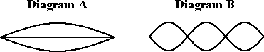

Determine the vibration frequency (in Hertz) that would be required of the same guitar string to produce the standing wave pattern shown in Diagram B. Enter a numerical answer.

**Question 26:**

aa. Diagram A shows the standing wave pattern created in a 105-cm long guitar string when it is vibrated at 220 Hz.

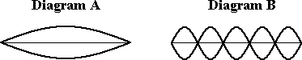

Determine the vibration frequency (in Hertz) that would be required of the same guitar string to produce the standing wave pattern shown in Diagram B. Enter a numerical answer.

**Question 27:**

aa. Diagram A shows the standing wave pattern created in a 100-cm long guitar string when it is vibrated at 260 Hz.

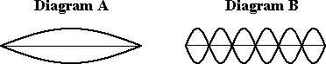

Determine the vibration frequency (in Hertz) that would be required of the same guitar string to produce the standing wave pattern shown in Diagram B. Enter a numerical answer.

**Question 28:**

aa. Diagram A shows the standing wave pattern created in a 90-cm long guitar string when it is vibrated at 250 Hz.

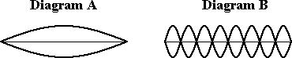

Determine the vibration frequency (in Hertz) that would be required of the same guitar string to produce the standing wave pattern shown in Diagram B. Enter a numerical answer.

**Question 29:**

aa. Diagram A shows the standing wave pattern created in a 95-cm long guitar string when it is vibrated at 210 Hz.

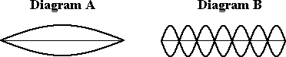

Determine the vibration frequency (in Hertz) that would be required of the same guitar string to produce the standing wave pattern shown in Diagram B. Enter a numerical answer.

**Question 30:**

aa. Diagram A shows the standing wave pattern created in a 95-cm long guitar string when it is vibrated at 210 Hz.

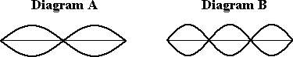

Determine the vibration frequency (in Hertz) that would be required of the same guitar string to produce the standing wave pattern shown in Diagram B. Enter a numerical answer.

**Question 31:**

aa. Diagram A shows the standing wave pattern created in a 110-cm long guitar string when it is vibrated at 230 Hz.

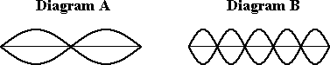

Determine the vibration frequency (in Hertz) that would be required of the same guitar string to produce the standing wave pattern shown in Diagram B. Enter a numerical answer.

**Question 32:**

aa. Diagram A shows the standing wave pattern created in a 105-cm long guitar string when it is vibrated at 240 Hz.

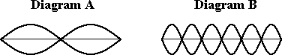

Determine the vibration frequency (in Hertz) that would be required of the same guitar string to produce the standing wave that shown in Diagram B. Enter a numerical answer.

**Question 33:**

aa. Diagram A shows the standing wave pattern created in a 100-cm long guitar string when it is vibrated at 250 Hz.

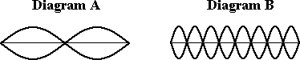

Determine the vibration frequency (in Hertz) that would be required of the same guitar string to produce the standing wave pattern shown in Diagram B. Enter a numerical answer.

**Question 34:**

aa. Diagram A shows the standing wave pattern created in a 90-cm long guitar string when it is vibrated at 260 Hz.

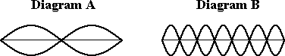

Determine the vibration frequency (in Hertz) that would be required of the same guitar string to produce the standing wave pattern shown in Diagram B. Enter a numerical answer.

**Question 35:**

aa. Diagram A shows the standing wave pattern created in a guitar string when it is vibrated at 480 Hz.

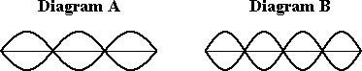

Determine the vibration frequency (in Hertz) that would be required of the same guitar string to produce the standing wave pattern shown in Diagram B. Enter a numerical answer.

**Question 36:**

aa. Diagram A shows the standing wave pattern created in a guitar string when it is vibrated at 540 Hz.

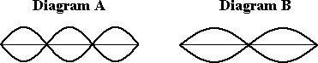

Determine the vibration frequency (in Hertz) that would be required of the same guitar string to produce the standing wave pattern shown in Diagram B. Enter a numerical answer.

**Question 37:**

aa. Diagram A shows the standing wave pattern created in a guitar string when it is vibrated at 900 Hz.

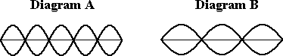

Determine the vibration frequency (in Hertz) that would be required of the same guitar string to produce the standing wave pattern shown in Diagram B. Enter a numerical answer.

**Question 38:**

aa. Diagram A shows the standing wave pattern created in a guitar string when it is vibrated at 1200 Hz.

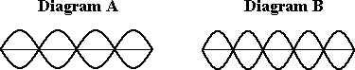

Determine the vibration frequency (in Hertz) that would be required of the same guitar string to produce the standing wave pattern shown in Diagram B. Enter a numerical answer.

**Question 39:**

aa. Diagram A shows the standing wave pattern created in a guitar string when it is vibrated at 1300 Hz.

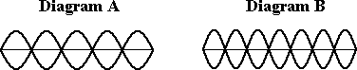

Determine the vibration frequency (in Hertz) that would be required of the same guitar string to produce the standing wave pattern shown in Diagram B. Enter a numerical answer.

**Question 40:**

aa. Diagram A shows the standing wave pattern created in a guitar string when it is vibrated at 1200 Hz.

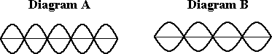

Determine the vibration frequency (in Hertz) that would be required of the same guitar string to produce the standing wave pattern shown in Diagram B. Enter a numerical answer.

**SM7: Mathematics of String Instruments**

**Question 1:**

aa. Determine the fundamental frequency (in Hertz) and associated wavelength (in centimeters) of a 82.1-centimeter long guitar string through which vibrations travel at 448 m/s. Enter numerical answers.

**Question 2:**

aa. Determine the fundamental frequency (in Hertz) and associated wavelength (in centimeters) of a 76.5-centimeter long guitar string through which vibrations travel at 462 m/s. Enter numerical answers.

**Question 3:**

aa. Determine the fundamental frequency (in Hertz) and associated wavelength (in centimeters) of a 91.4-centimeter long guitar string through which vibrations travel at 512 m/s. Enter numerical answers.

**Question 4:**

aa. Determine the fundamental frequency (in Hertz) and associated wavelength (in centimeters) of a 96.8-centimeter long guitar string through which vibrations travel at 497 m/s. Enter numerical answers.

**Question 5:**

aa. Determine the frequency (in Hertz) and the associated wavelength (in centimeters) of the third harmonic for a 82.1-centimeter long guitar string through which vibrations travel at 468 m/s. Enter numerical answers.

**Question 6:**

aa. Determine the frequency (in Hertz) and the associated wavelength (in centimeters) of the third harmonic for a 73.6-centimeter long guitar string through which vibrations travel at 449 m/s. Enter numerical answers.

**Question 7:**

aa. Determine the frequency (in Hertz) and the associated wavelength (in centimeters) of the third harmonic for a 92.1-centimeter long guitar string through which vibrations travel at 521 m/s. Enter numerical answers.

**Question 8:**

aa. Determine the frequency (in Hertz) and the associated wavelength (in centimeters) of the third harmonic for a 98.5-centimeter long guitar string through which vibrations travel at 542 m/s. Enter numerical answers.

**Question 9:**

aa. Determine the frequency (in Hertz) and the associated wavelength (in centimeters) of the fourth harmonic for a 77.9-centimeter long guitar string through which vibrations travel at 419 m/s. Enter numerical answers.

**Question 10:**

aa. Determine the frequency (in Hertz) and the associated wavelength (in centimeters) of the fourth harmonic for a 82.3-centimeter long guitar string through which vibrations travel at 463 m/s. Enter numerical answers.

**Question 11:**

aa. Determine the frequency (in Hertz) and the associated wavelength (in centimeters) of the fourth harmonic for a 87.1-centimeter long guitar string through which vibrations travel at 471 m/s. Enter numerical answers.

**Question 12:**

aa. Determine the frequency (in Hertz) and the associated wavelength (in centimeters) of the fourth harmonic for a 99.3-centimeter long guitar string through which vibrations travel at 499 m/s. Enter numerical answers.

**Question 13:**

aa. Determine the frequency (in Hertz) and the associated wavelength (in centimeters) of the fifth harmonic for a 73.6-centimeter long guitar string through which vibrations travel at 448 m/s. Enter numerical answers.

**Question 14:**

aa. Determine the frequency (in Hertz) and the associated wavelength (in centimeters) of the fifth harmonic for a 81.9-centimeter long guitar string through which vibrations travel at 472 m/s. Enter numerical answers.

**Question 15:**

aa. Determine the frequency (in Hertz) and the associated wavelength (in centimeters) of the fifth harmonic for a 85.6-centimeter long guitar string through which vibrations travel at 488 m/s. Enter numerical answers.

**Question 16:**

aa. Determine the frequency (in Hertz) and the associated wavelength (in centimeters) of the fifth harmonic for a 92.9-centimeter long guitar string through which vibrations travel at 506 m/s. Enter numerical answers.

**Question 17:**

aa. Consider the standing wave pattern for a guitar string as shown below.

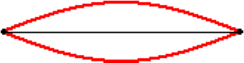

The speed of waves in the string is 462 m/s and the frequency associated with this pattern is 278 Hertz. Determine the wavelength (in centimeters) associated with this pattern and the length (in centimeters) of the string. Enter numerical answers.

**Question 18:**

aa. Consider the standing wave pattern for a guitar string as shown below.



The speed of waves in the string is 477 m/s and the frequency associated with this pattern is 333 Hertz. Determine the wavelength (in centimeters) associated with this pattern and the length (in centimeters) of the string. Enter numerical answers.

**Question 19:**

aa. Consider the standing wave pattern for a guitar string as shown below.



The speed of waves in the string is 482 m/s and the frequency associated with this pattern is 444 Hertz. Determine the wavelength (in centimeters) associated with this pattern and the length (in centimeters) of the string. Enter numerical answers.

**Question 20:**

aa. Consider the standing wave pattern for a guitar string as shown below.



The speed of waves in the string is 496 m/s and the frequency associated with this pattern is 484 Hertz. Determine the wavelength (in centimeters) associated with this pattern and the length (in centimeters) of the string. Enter numerical answers.

**Question 21:**

aa. Consider the standing wave pattern for a guitar string as shown below.

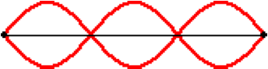

The speed of waves in the string is 436 m/s and the frequency associated with this pattern is 812 Hertz. Determine the wavelength (in centimeters) associated with this pattern and the length (in centimeters) of the string. Enter numerical answers.

**Question 22:**

aa. Consider the standing wave pattern for a guitar string as shown below.



The speed of waves in the string is 462 m/s and the frequency associated with this pattern is 875 Hertz. Determine the wavelength (in centimeters) associated with this pattern and the length (in centimeters) of the string. Enter numerical answers.

**Question 23:**

aa. Consider the standing wave pattern for a guitar string as shown below.



The speed of waves in the string is 472 m/s and the frequency associated with this pattern is 948 Hertz. Determine the wavelength (in centimeters) associated with this pattern and the length (in centimeters) of the string. Enter numerical answers.

**Question 24:**

aa. Consider the standing wave pattern for a guitar string as shown below.



The speed of waves in the string is 485 m/s and the frequency associated with this pattern is 1034 Hertz. Determine the wavelength (in centimeters) associated with this pattern and the length (in centimeters) of the string. Enter numerical answers.

**Question 25:**

aa. Consider the standing wave pattern for a guitar string as shown below.

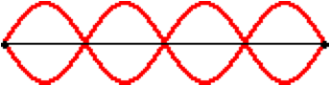

The speed of waves in the string is 409 m/s and the frequency associated with this pattern is 1230 Hertz. Determine the wavelength (in centimeters) associated with this pattern and the length (in centimeters) of the string. Enter numerical answers.

**Question 26:**

aa. Consider the standing wave pattern for a guitar string as shown below.



The speed of waves in the string is 412 m/s and the frequency associated with this pattern is 1289 Hertz. Determine the wavelength (in centimeters) associated with this pattern and the length (in centimeters) of the string. Enter numerical answers.

**Question 27:**

aa. Consider the standing wave pattern for a guitar string as shown below.



The speed of waves in the string is 477 m/s and the frequency associated with this pattern is 1311 Hertz. Determine the wavelength (in centimeters) associated with this pattern and the length (in centimeters) of the string. Enter numerical answers.

**Question 28:**

aa. Consider the standing wave pattern for a guitar string as shown below.



The speed of waves in the string is 496 m/s and the frequency associated with this pattern is 1378 Hertz. Determine the wavelength (in centimeters) associated with this pattern and the length (in centimeters) of the string. Enter numerical answers.

**Question 29:**

aa. Consider the standing wave pattern for a guitar string as shown below.

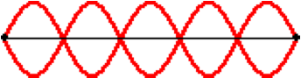

The speed of waves in the string is 426 m/s and the frequency associated with this pattern is 1344 Hertz. Determine the wavelength (in centimeters) associated with this pattern and the length (in centimeters) of the string. Enter numerical answers.

**Question 30:**

aa. Consider the standing wave pattern for a guitar string as shown below.



The speed of waves in the string is 465 m/s and the frequency associated with this pattern is 1386 Hertz. Determine the wavelength (in centimeters) associated with this pattern and the length (in centimeters) of the string. Enter numerical answers.

**Question 31:**

aa. Consider the standing wave pattern for a guitar string as shown below.



The speed of waves in the string is 482 m/s and the frequency associated with this pattern is 1395 Hertz. Determine the wavelength (in centimeters) associated with this pattern and the length (in centimeters) of the string. Enter numerical answers.

**Question 32:**

aa. Consider the standing wave pattern for a guitar string as shown below.



The speed of waves in the string is 506 m/s and the frequency associated with this pattern is 1406 Hertz. Determine the wavelength (in centimeters) associated with this pattern and the length (in centimeters) of the string. Enter numerical answers.

**SM8: Harmonics for Open-End Air Columns**

**Question 1:**

aa. The nodal positions on a standing wave pattern for an open-end air column are ____.

a. always located one-half wavelength apart

b. always located a full wavelength apart

c. usually located one-half wavelength apart

d. usually (but not always) located a full wavelength apart

e. distanced varying number of wavelengths apart, depending upon the harmonic number

f. none of the above

**Question 2:**

aa. The nodal positions on a standing wave pattern for an open-end air column are ____.

a. distanced varying number of wavelengths apart, depending upon the harmonic number

b. always located one-half wavelength apart

c. usually located one-half wavelength apart

d. always located a full wavelength apart

e. usually (but not always) located a full wavelength apart

f. none of the above

**Question 3:**

aa. The nodal positions on a standing wave pattern for an open-end air column are ____.

a. distanced varying number of wavelengths apart, depending upon the harmonic number

b. always located a full wavelength apart

c. usually (but not always) located a full wavelength apart

d. always located one-half wavelength apart

e. usually located one-half wavelength apart

f. none of the above

**Question 4:**

aa. The nodal positions on a standing wave pattern for an open-end air column are ____.

a. distanced varying number of wavelengths apart, depending upon the harmonic number

b. usually (but not always) located a full wavelength apart

c. usually located one-half wavelength apart

d. always located a full wavelength apart

e. always located one-half wavelength apart

f. none of the above

**Question 5:**

aa. A standing wave pattern is established in an open-end air column as it vibrates with the pattern shown below.

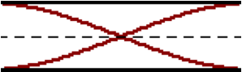

The air column has a length of 80 cm. This pattern represents the ___ harmonic; its wavelength is ____ cm. Choose two letters in their respective order; enter them together without any commas or spaces between letters. Example: 'AI'

**Harmonic # Wavelength(cm)**

a. 1st b. 2nd i. 20 j. 40 k. 60 l. 80

c. 3rd d. 4th m. 100 n. 106.7 o. 120 p. 140

e. 5th f. 6th q. 160 r. 180 s. 240 t. 320

g. 7th h. 9th u. None of these are even close.

**Question 6:**

aa. A standing wave pattern is established in an open-end air column as it vibrates with the pattern shown below.



The air column has a length of 90 cm. This pattern represents the ___ harmonic; its wavelength is ____ cm. Choose two letters in their respective order; enter them together without any commas or spaces between letters. Example: 'AI'

**Harmonic # Wavelength(cm)**

a. 1st b. 2nd i. 22.5 j. 30 k. 45 l. 60

c. 3rd d. 4th m. 67.5 n. 72 o. 90 p. 120

e. 5th f. 6th q. 135 r. 180 s. 270 t. 360

g. 7th h. 9th u. None of these are even close.

**Question 7:**

aa. A standing wave pattern is established in an open-end air column as it vibrates with the pattern shown below.



The air column has a length of 120 cm. This pattern represents the ___ harmonic; its wavelength is ____ cm. Choose two letters in their respective order; enter them together without any commas or spaces between letters. Example: 'AI'

**Harmonic # Wavelength(cm)**

a. 1st b. 2nd i. 30 j. 40 k. 60 l. 90

c. 3rd d. 4th m. 96 n. 120 o. 150 p. 160

e. 5th f. 6th q. 180 r. 240 s. 360 t. 480

g. 7th h. 9th u. None of these are even close.

**Question 8:**

aa. A standing wave pattern is established in an open-end air column as it vibrates with the pattern shown below.



The air column has a length of 60 cm. This pattern represents the ___ harmonic; its wavelength is ____ cm. Choose two letters in their respective order; enter them together without any commas or spaces between letters. Example: 'AI'

**Harmonic # Wavelength(cm)**

a. 1st b. 2nd i. 15 j. 20 k. 30 l. 45

c. 3rd d. 4th m. 48 n. 60 o. 75 p. 80

e. 5th f. 6th q. 90 r. 120 s. 180 t. 240

g. 7th h. 9th u. None of these are even close.

**Question 9:**

aa. A standing wave pattern is established in an open-end air column as it vibrates with the pattern shown below.



The air column has a length of 80 cm. This pattern represents the ___ harmonic; its wavelength is ____ cm. Choose two letters in their respective order; enter them together without any commas or spaces between letters. Example: 'AI'

**Harmonic # Wavelength(cm)**

a. 1st b. 2nd i. 20 j. 40 k. 60 l. 80

c. 3rd d. 4th m. 100 n. 106.7 o. 120 p. 140

e. 5th f. 6th q. 160 r. 180 s. 240 t. 320

g. 7th h. 9th u. None of these are even close.

**Question 10:**

aa. A standing wave pattern is established in an open-end air column as it vibrates with the pattern shown below.



The air column has a length of 90 cm. This pattern represents the ___ harmonic; its wavelength is ____ cm. Choose two letters in their respective order; enter them together without any commas or spaces between letters. Example: 'AI'

**Harmonic # Wavelength(cm)**

a. 1st b. 2nd i. 22.5 j. 30 k. 45 l. 60

c. 3rd d. 4th m. 67.5 n. 72 o. 90 p. 120

e. 5th f. 6th q. 135 r. 180 s. 270 t. 360

g. 7th h. 9th u. None of these are even close.

**Question 11:**

aa. A standing wave pattern is established in an open-end air column as it vibrates with the pattern shown below.



The air column has a length of 120 cm. This pattern represents the ___ harmonic; its wavelength is ____ cm. Choose two letters in their respective order; enter them together without any commas or spaces between letters. Example: 'AI'

**Harmonic # Wavelength(cm)**

a. 1st b. 2nd i. 30 j. 40 k. 60 l. 90

c. 3rd d. 4th m. 96 n. 120 o. 150 p. 160

e. 5th f. 6th q. 180 r. 240 s. 360 t. 480

g. 7th h. 9th u. None of these are even close.

**Question 12:**

aa. A standing wave pattern is established in an open-end air column as it vibrates with the pattern shown below.



The air column has a length of 60 cm. This pattern represents the ___ harmonic; its wavelength is ____ cm. Choose two letters in their respective order; enter them together without any commas or spaces between letters. Example: 'AI'

**Harmonic # Wavelength(cm)**

a. 1st b. 2nd i. 15 j. 20 k. 30 l. 45

c. 3rd d. 4th m. 48 n. 60 o. 75 p. 80

e. 5th f. 6th q. 90 r. 120 s. 180 t. 240

g. 7th h. 9th u. None of these are even close.

**Question 13:**

aa. A standing wave pattern is established in an open-end air column as it vibrates with the pattern shown below.

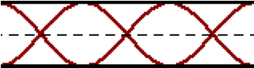

The air column has a length of 80 cm. This pattern represents the ___ harmonic; its wavelength is ____ cm. Choose two letters in their respective order; enter them together without any commas or spaces between letters. Example: 'AI'

**Harmonic # Wavelength(cm)**

a. 1st b. 2nd i. 20 j. 40 k. 60 l. 80

c. 3rd d. 4th m. 100 n. 106.7 o. 120 p. 140

e. 5th f. 6th q. 160 r. 180 s. 240 t. 320

g. 7th h. 9th u. None of these are even close.

**Question 14:**

aa. A standing wave pattern is established in an open-end air column as it vibrates with the pattern shown below.



The air column has a length of 90 cm. This pattern represents the ___ harmonic; its wavelength is ____ cm. Choose two letters in their respective order; enter them together without any commas or spaces between letters. Example: 'AI'

**Harmonic # Wavelength(cm)**

a. 1st b. 2nd i. 22.5 j. 30 k. 45 l. 60

c. 3rd d. 4th m. 67.5 n. 72 o. 90 p. 120

e. 5th f. 6th q. 135 r. 180 s. 270 t. 360

g. 7th h. 9th u. None of these are even close.

**Question 15:**

aa. A standing wave pattern is established in an open-end air column as it vibrates with the pattern shown below.



The air column has a length of 120 cm. This pattern represents the ___ harmonic; its wavelength is ____ cm. Choose two letters in their respective order; enter them together without any commas or spaces between letters. Example: 'AI'

**Harmonic # Wavelength(cm)**

a. 1st b. 2nd i. 30 j. 40 k. 60 l. 80

c. 3rd d. 4th m. 96 n. 120 o. 150 p. 160

e. 5th f. 6th q. 180 r. 240 s. 360 t. 480

g. 7th h. 9th u. None of these are even close.

**Question 16:**

aa. A standing wave pattern is established in an open-end air column as it vibrates with the pattern shown below.



The air column has a length of 60 cm. This pattern represents the ___ harmonic; its wavelength is ____ cm. Choose two letters in their respective order; enter them together without any commas or spaces between letters. Example: 'AI'

**Harmonic # Wavelength(cm)**

a. 1st b. 2nd i. 15 j. 20 k. 30 l. 40

c. 3rd d. 4th m. 48 n. 60 o. 75 p. 80

e. 5th f. 6th q. 90 r. 120 s. 180 t. 240

g. 7th h. 9th u. None of these are even close.

**Question 17:**

aa. A standing wave pattern is established in an open-end air column as it vibrates with the pattern shown below.

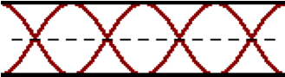

The air column has a length of 80 cm. This pattern represents the ___ harmonic; its wavelength is ____ cm. Choose two letters in their respective order; enter them together without any commas or spaces between letters. Example: 'AI'

**Harmonic # Wavelength(cm)**

a. 1st b. 2nd i. 20 j. 26.7 k. 40 l. 60

c. 3rd d. 4th m. 64 n. 80 o. 100 p. 106.7

e. 5th f. 6th q. 120 r. 140 s. 160 t. 320

g. 7th h. 9th u. None of these are even close.

**Question 18:**

aa. A standing wave pattern is established in an open-end air column as it vibrates with the pattern shown below.



The air column has a length of 60 cm. This pattern represents the ___ harmonic; its wavelength is ____ cm. Choose two letters in their respective order; enter them together without any commas or spaces between letters. Example: 'AI'

**Harmonic # Wavelength(cm)**

a. 1st b. 2nd i. 12 j. 15 k. 20 l. 24

c. 3rd d. 4th m. 30 n. 45 o. 48 p. 60

e. 5th f. 6th q. 90 r. 105 s. 120 t. 180

g. 7th h. 9th u. None of these are even close.

**Question 19:**

aa. A standing wave pattern is established in an open-end air column as it vibrates with the pattern shown below.



The air column has a length of 100 cm. This pattern represents the ___ harmonic; its wavelength is ____ cm. Choose two letters in their respective order; enter them together without any commas or spaces between letters. Example: 'AI'

**Harmonic # Wavelength(cm)**

a. 1st b. 2nd i. 20 j. 30 k. 33.3 l. 40

c. 3rd d. 4th m. 60 n. 80 o. 100 p. 125

e. 5th f. 6th q. 133.3 r. 150 s. 175 t. 200

g. 7th h. 9th u. None of these are even close.

**Question 20:**

aa. A standing wave pattern is established in an open-end air column as it vibrates with the pattern shown below.



The air column has a length of 120 cm. This pattern represents the ___ harmonic; its wavelength is ____ cm. Choose two letters in their respective order; enter them together without any commas or spaces between letters. Example: 'AI'

**Harmonic # Wavelength(cm)**

a. 1st b. 2nd i. 24 j. 30 k. 40 l. 48

c. 3rd d. 4th m. 60 n. 90 o. 96 p. 120

e. 5th f. 6th q. 180 r. 210 s. 240 t. 360

g. 7th h. 9th u. None of these are even close.

**Question 21:**

aa. A standing wave pattern is established in an open-end air column as it vibrates with the pattern shown below.

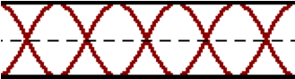

The air column has a length of 80 cm. This pattern represents the ___ harmonic; its wavelength is ____ cm. Choose two letters in their respective order; enter them together without any commas or spaces between letters. Example: 'AI'

**Harmonic # Wavelength(cm)**

a. 1st b. 2nd i. 16 j. 20 k. 26.7 l. 32

c. 3rd d. 4th m. 35.5 n. 40 o. 45.7 p. 48

e. 5th f. 6th q. 60 r. 64 s. 100 t. 120

g. 7th h. 9th u. None of these are even close.

**Question 22:**

aa. A standing wave pattern is established in an open-end air column as it vibrates with the pattern shown below.



The air column has a length of 60 cm. This pattern represents the ___ harmonic; its wavelength is ____ cm. Choose two letters in their respective order; enter them together without any commas or spaces between letters. Example: 'AI'

**Harmonic # Wavelength(cm)**

a. 1st b. 2nd i. 8.6 j. 10 k. 12 l. 15

c. 3rd d. 4th m. 17.1 n. 20 o. 24 p. 26.7

e. 5th f. 6th q. 30 r. 34.3 s. 36 t. 40

g. 7th h. 9th u. None of these are even close.

**Question 23:**

aa. A standing wave pattern is established in an open-end air column as it vibrates with the pattern shown below.



The air column has a length of 100 cm. This pattern represents the ___ harmonic; its wavelength is ____ cm. Choose two letters in their respective order; enter them together without any commas or spaces between letters. Example: 'AI'

**Harmonic # Wavelength(cm)**

a. 1st b. 2nd i. 10 j. 12.5 k. 16.7 l. 20

c. 3rd d. 4th m. 22.2 n. 25 o. 28.6 p. 33.3

e. 5th f. 6th q. 40 r. 44.4 s. 50 t. 57.1

g. 7th h. 9th u. None of these are even close.

**Question 24:**

aa. A standing wave pattern is established in an open-end air column as it vibrates with the pattern shown below.



The air column has a length of 120 cm. This pattern represents the ___ harmonic; its wavelength is ____ cm. Choose two letters in their respective order; enter them together without any commas or spaces between letters. Example: 'AI'

**Harmonic # Wavelength(cm)**

a. 1st b. 2nd i. 15 j. 17.1 k. 20 l. 24

c. 3rd d. 4th m. 26.7 n. 30 o. 34.3 p. 36

e. 5th f. 6th q. 40 r. 48 s. 50 t. 53.3

g. 7th h. 9th u. None of these are even close.

**Question 25:**

aa. Diagram A shows the standing wave pattern created in a 95-cm long open-end air column when it is vibrated at 240 Hz.

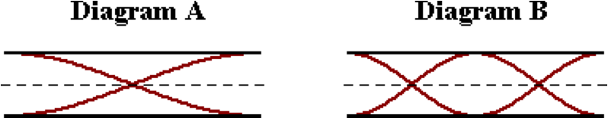

Determine the vibration frequency (in Hertz) that would be required of the same air column to produce the standing wave pattern shown in Diagram B. Enter a numerical answer.

**Question 26:**

aa. Diagram A shows the standing wave pattern created in a 105-cm long open-end air column when it is vibrated at 220 Hz.

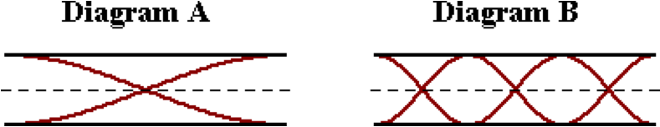

Determine the vibration frequency (in Hertz) that would be required of the same air column to produce the standing wave pattern shown in Diagram B. Enter a numerical answer.

**Question 27:**

aa. Diagram A shows the standing wave pattern created in a 100-cm long open-end air column when it is vibrated at 260 Hz.

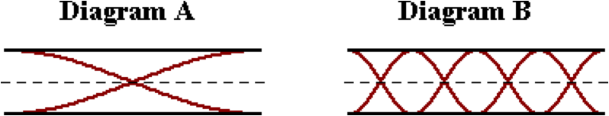

Determine the vibration frequency (in Hertz) that would be required of the same air column to produce the standing wave pattern shown in Diagram B. Enter a numerical answer.

**Question 28:**

aa. Diagram A shows the standing wave pattern created in a 90-cm long open-end air column when it is vibrated at 250 Hz.

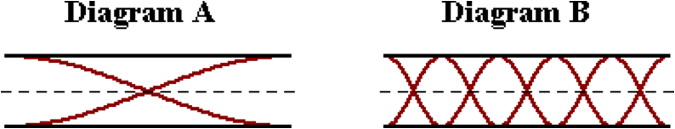

Determine the vibration frequency (in Hertz) that would be required of the same air column to produce the standing wave pattern shown in Diagram B. Enter a numerical answer.

**Question 29:**

aa. Diagram A shows the standing wave pattern created in a 95-cm long open-end air column when it is vibrated at 210 Hz.

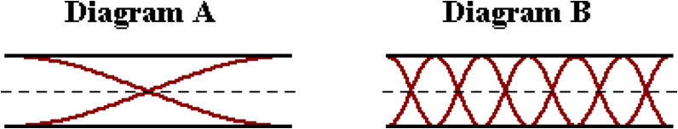

Determine the vibration frequency (in Hertz) that would be required of the same air column to produce the standing wave pattern shown in Diagram B. Enter a numerical answer.

**Question 30:**

aa. Diagram A shows the standing wave pattern created in a 95-cm long open-end air column when it is vibrated at 210 Hz.

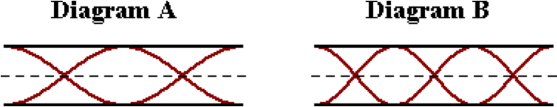

Determine the vibration frequency (in Hertz) that would be required of the same air column to produce the standing wave pattern shown in Diagram B. Enter a numerical answer.

**Question 31:**

aa. Diagram A shows the standing wave pattern created in a 110-cm long open-end air column when it is vibrated at 230 Hz.

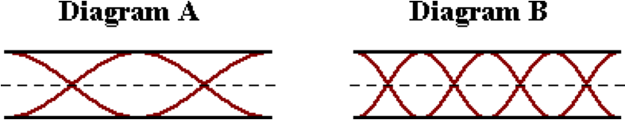

Determine the vibration frequency (in Hertz) that would be required of the same air column to produce the standing wave pattern shown in Diagram B. Enter a numerical answer.

**Question 32:**

aa. Diagram A shows the standing wave pattern created in a 105-cm long open-end air column when it is vibrated at 240 Hz.

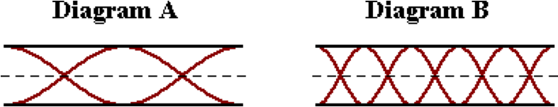

Determine the vibration frequency (in Hertz) that would be required of the same air column to produce the standing wave pattern shown in Diagram B. Enter a numerical answer.

**Question 33:**

aa. Diagram A shows the standing wave pattern created in a 100-cm long open-end air column when it is vibrated at 250 Hz.

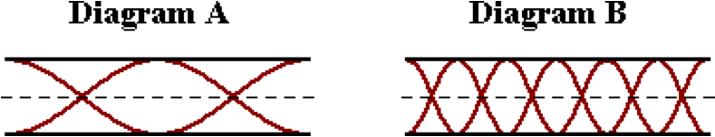

Determine the vibration frequency (in Hertz) that would be required of the same air column to produce the standing wave pattern shown in Diagram B. Enter a numerical answer.

**Question 34:**

aa. Diagram A shows the standing wave pattern created in a 90-cm long open-end air column when it is vibrated at 260 Hz.

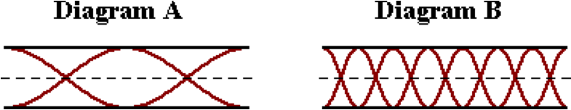

Determine the vibration frequency (in Hertz) that would be required of the same air column to produce the standing wave pattern shown in Diagram B. Enter a numerical answer.

**Question 35:**

aa. Diagram A shows the standing wave pattern created in open-end air column when it is vibrated at 480 Hz.

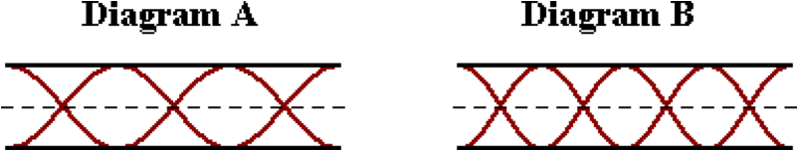

Determine the vibration frequency (in Hertz) that would be required of the same air column to produce the standing wave pattern shown in Diagram B. Enter a numerical answer.

**Question 36:**

aa. Diagram A shows the standing wave pattern created in open-end air column when it is vibrated at 540 Hz.

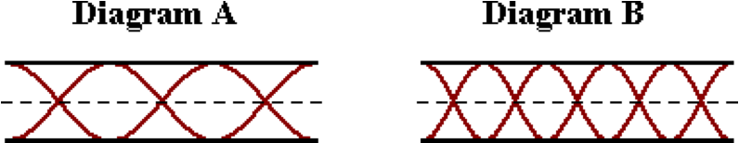

Determine the vibration frequency (in Hertz) that would be required of the same air column to produce the standing wave pattern shown in Diagram B. Enter a numerical answer.

**Question 37:**

aa. Diagram A shows the standing wave pattern created in open-end air column when it is vibrated at 900 Hz.

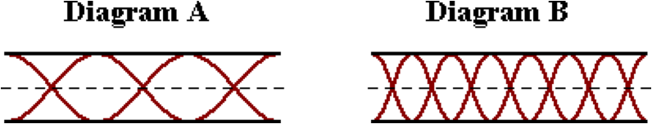

Determine the vibration frequency (in Hertz) that would be required of the same air column to produce the standing wave pattern shown in Diagram B. Enter a numerical answer.

**Question 38:**

aa. Diagram A shows the standing wave pattern created in open-end air column when it is vibrated at 1200 Hz.

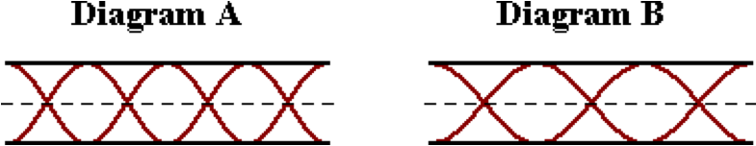

Determine the vibration frequency (in Hertz) that would be required of the same air column to produce the standing wave pattern shown in Diagram B. Enter a numerical answer.

**Question 39:**

aa. Diagram A shows the standing wave pattern created in open-end air column when it is vibrated at 1300 Hz.

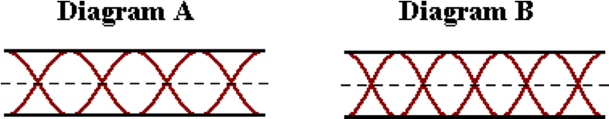

Determine the vibration frequency (in Hertz) that would be required of the same air column to produce the standing wave pattern shown in Diagram B. Enter a numerical answer.

**Question 40:**

aa. Diagram A shows the standing wave pattern created in open-end air column when it is vibrated at 1200 Hz.

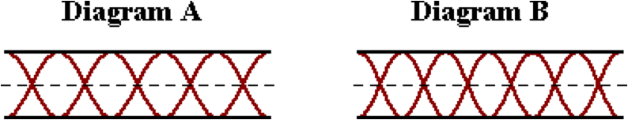

Determine the vibration frequency (in Hertz) that would be required of the same air column to produce the standing wave pattern shown in Diagram B. Enter a numerical answer.

**SM9: Mathematics for Open-End Air Columns**

**Question 1:**

aa. Determine the fundamental frequency (in Hertz) and associated wavelength (in centimeters) of a 82.1-centimeter long open-end air column through which sound travels at 335 m/s. Enter numerical answers.

**Question 2:**

aa. Determine the fundamental frequency (in Hertz) and associated wavelength (in centimeters) of a 76.5-centimeter long open-end air column through which sound travels at 340 m/s. Enter numerical answers.

**Question 3:**

aa. Determine the fundamental frequency (in Hertz) and associated wavelength (in centimeters) of a 91.4-centimeter long open-end air column through which sound travels at 345 m/s. Enter numerical answers.

**Question 4:**

aa. Determine the fundamental frequency (in Hertz) and associated wavelength (in centimeters) of a 96.8-centimeter long open-end air column through which sound travels at 350 m/s. Enter numerical answers.

**Question 5:**

aa. Determine the frequency (in Hertz) and the associated wavelength (in centimeters) of the third harmonic for a 82.1-centimeter long open-end air column through which sound travels at 335 m/s. Enter numerical answers.

**Question 6:**

aa. Determine the frequency (in Hertz) and the associated wavelength (in centimeters) of the third harmonic for a 73.6-centimeter long open-end air column through which sound travels at 340 m/s. Enter numerical answers.

**Question 7:**

aa. Determine the frequency (in Hertz) and the associated wavelength (in centimeters) of the third harmonic for a 92.1-centimeter long open-end air column through which sound travels at 345 m/s. Enter numerical answers.

**Question 8:**

aa. Determine the frequency (in Hertz) and the associated wavelength (in centimeters) of the third harmonic for a 98.5-centimeter long open-end air column through which sound travels at 350 m/s. Enter numerical answers.

**Question 9:**

aa. Determine the frequency (in Hertz) and the associated wavelength (in centimeters) of the fourth harmonic for a 77.9-centimeter long open-end air column through which sound travels at 335 m/s. Enter numerical answers.

**Question 10:**

aa. Determine the frequency (in Hertz) and the associated wavelength (in centimeters) of the fourth harmonic for a 82.3-centimeter long open-end air column through which sound travels at 340 m/s. Enter numerical answers.

**Question 11:**

aa. Determine the frequency (in Hertz) and the associated wavelength (in centimeters) of the fourth harmonic for a 87.1-centimeter long open-end air column through which sound travels at 345 m/s. Enter numerical answers.

**Question 12:**

aa. Determine the frequency (in Hertz) and the associated wavelength (in centimeters) of the fourth harmonic for a 99.3-centimeter long open-end air column through which sound travels at 350 m/s. Enter numerical answers.

**Question 13:**

aa. Determine the frequency (in Hertz) and the associated wavelength (in centimeters) of the fifth harmonic for a 84.2-centimeter long open-end air column through which sound travels at 335 m/s. Enter numerical answers.

**Question 14:**

aa. Determine the frequency (in Hertz) and the associated wavelength (in centimeters) of the fifth harmonic for a 98.2-centimeter long open-end air column through which sound travels at 340 m/s. Enter numerical answers.

**Question 15:**

aa. Determine the frequency (in Hertz) and the associated wavelength (in centimeters) of the fifth harmonic for a 101.4-centimeter long open-end air column through which sound travels at 345 m/s. Enter numerical answers.

**Question 16:**

aa. Determine the frequency (in Hertz) and the associated wavelength (in centimeters) of the fifth harmonic for a 117.6-centimeter long open-end air column through which sound travels at 350 m/s. Enter numerical answers.

**Question 17:**

aa. Consider the standing wave pattern for an open-end air column as shown below.

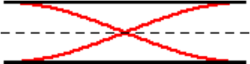

The speed of sound in the air is 335 m/s and the frequency associated with this pattern is 278 Hertz. Determine the wavelength (in centimeters) associated with this pattern and the length (in centimeters) of the air column. Enter numerical answers.

**Question 18:**

aa. Consider the standing wave pattern for an open-end air column as shown below.



The speed of sound in the air is 340 m/s and the frequency associated with this pattern is 333 Hertz. Determine the wavelength (in centimeters) associated with this pattern and the length (in centimeters) of the air column. Enter numerical answers.

**Question 19:**

aa. Consider the standing wave pattern for an open-end air column as shown below.



The speed of sound in the air is 345 m/s and the frequency associated with this pattern is 444 Hertz. Determine the wavelength (in centimeters) associated with this pattern and the length (in centimeters) of the air column. Enter numerical answers.

**Question 20:**

aa. Consider the standing wave pattern for an open-end air column as shown below.



The speed of sound in the air is 350 m/s and the frequency associated with this pattern is 484 Hertz. Determine the wavelength (in centimeters) associated with this pattern and the length (in centimeters) of the air column. Enter numerical answers.

**Question 21:**

aa. Consider the standing wave pattern for an open-end air column as shown below.



The speed of sound in the air is 335 m/s and the frequency associated with this pattern is 812 Hertz. Determine the wavelength (in centimeters) associated with this pattern and the length (in centimeters) of the air column. Enter numerical answers.

**Question 22:**

aa. Consider the standing wave pattern for an open-end air column as shown below.



The speed of sound in the air is 340 m/s and the frequency associated with this pattern is 875 Hertz. Determine the wavelength (in centimeters) associated with this pattern and the length (in centimeters) of the air column. Enter numerical answers.

**Question 23:**

aa. Consider the standing wave pattern for an open-end air column as shown below.



The speed of sound in the air is 345 m/s and the frequency associated with this pattern is 948 Hertz. Determine the wavelength (in centimeters) associated with this pattern and the length (in centimeters) of the air column. Enter numerical answers.

**Question 24:**

aa. Consider the standing wave pattern for an open-end air column as shown below.



The speed of sound in the air is 350 m/s and the frequency associated with this pattern is 1034 Hertz. Determine the wavelength (in centimeters) associated with this pattern and the length (in centimeters) of the air column. Enter numerical answers.

**Question 25:**

aa. Consider the standing wave pattern for an open-end air column as shown below.

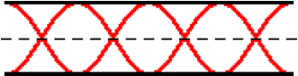

The speed of sound in the air is 335 m/s and the frequency associated with this pattern is 1106 Hertz. Determine the wavelength (in centimeters) associated with this pattern and the length (in centimeters) of the air column. Enter numerical answers.

**Question 26:**

aa. Consider the standing wave pattern for an open-end air column as shown below.



The speed of sound in the air is 340 m/s and the frequency associated with this pattern is 1128 Hertz. Determine the wavelength (in centimeters) associated with this pattern and the length (in centimeters) of the air column. Enter numerical answers.

**Question 27:**

aa. Consider the standing wave pattern for an open-end air column as shown below.



The speed of sound in the air is 345 m/s and the frequency associated with this pattern is 1188 Hertz. Determine the wavelength (in centimeters) associated with this pattern and the length (in centimeters) of the air column. Enter numerical answers.

**Question 28:**

aa. Consider the standing wave pattern for an open-end air column as shown below.



The speed of sound in the air is 350 m/s and the frequency associated with this pattern is 1209 Hertz. Determine the wavelength (in centimeters) associated with this pattern and the length (in centimeters) of the air column. Enter numerical answers.

**Question 29:**

aa. Consider the standing wave pattern for an open-end air column as shown below.

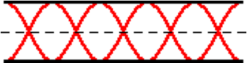

The speed of sound in the air is 335 m/s and the frequency associated with this pattern is 1187 Hertz. Determine the wavelength (in centimeters) associated with this pattern and the length (in centimeters) of the air column. Enter numerical answers.

**Question 30:**

aa. Consider the standing wave pattern for an open-end air column as shown below.



The speed of sound in the air is 340 m/s and the frequency associated with this pattern is 1190 Hertz. Determine the wavelength (in centimeters) associated with this pattern and the length (in centimeters) of the air column. Enter numerical answers.

**Question 31:**

aa. Consider the standing wave pattern for an open-end air column as shown below.



The speed of sound in the air is 345 m/s and the frequency associated with this pattern is 1234 Hertz. Determine the wavelength (in centimeters) associated with this pattern and the length (in centimeters) of the air column. Enter numerical answers.

**Question 32:**

aa. Consider the standing wave pattern for an open-end air column as shown below.



The speed of sound in the air is 350 m/s and the frequency associated with this pattern is 1269 Hertz. Determine the wavelength (in centimeters) associated with this pattern and the length (in centimeters) of the air column. Enter numerical answers.

**SM10: Harmonics for Closed-End Air Columns**

**Question 1:**

aa. The nodal positions on a standing wave pattern for a closed-end air column are ____.

a. always located one-half wavelength apart

b. always located a full wavelength apart

c. usually located one-half wavelength apart

d. usually (but not always) located a full wavelength apart

e. distanced a varying number of wavelengths apart, depending upon the harmonic numberr

f. none of the above

**Question 2:**

aa. The nodal positions on a standing wave pattern for a closed-end air column are ____.

a. distanced a varying number of wavelengths apart, depending upon the harmonic number

b. always located one-half wavelength apart

c. usually located one-half wavelength apart

d. always located a full wavelength apart

e. usually (but not always) located a full wavelength apart

f. none of the above

**Question 3:**

aa. The nodal positions on a standing wave pattern for a closed-end air column are ____.

a. distanced a varying number of wavelengths apart, depending upon the harmonic number

b. always located a full wavelength apart

c. usually (but not always) located a full wavelength apart

d. always located one-half wavelength apart

e. usually located one-half wavelength apart

f. none of the above

**Question 4:**

aa. The nodal positions on a standing wave pattern for a closed-end air column are ____.

a. distanced a varying number of wavelengths apart, depending upon the harmonic number

b. usually (but not always) located a full wavelength apart

c. usually located one-half wavelength apart

d. always located a full wavelength apart

e. always located one-half wavelength apart

f. none of the above

**Question 5:**

aa. A standing wave pattern is established in a closed-end air column as it vibrates with the pattern shown below.

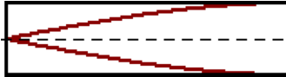

The air column has a length of 80 cm. This pattern represents the ___ harmonic; its wavelength is ____ cm. Choose two letters in their respective order; enter them together without any commas or spaces between letters. Example: 'AI'

**Harmonic # Wavelength (cm)**

a. 1st b. 2nd i. 20 j. 40 k. 60 l. 80

c. 3rd d. 4th m. 100 n. 106.7 o. 120 p. 140

e. 5th f. 6th q. 160 r. 180 s. 240 t. 320

g. 7th h. 9th u. None of these are even close.

**Question 6:**

aa. A standing wave pattern is established in a closed-end air column as it vibrates with the pattern shown below.



The air column has a length of 90 cm. This pattern represents the ___ harmonic; its wavelength is ____ cm. Choose two letters in their respective order; enter them together without any commas or spaces between letters. Example: 'AI'

**Harmonic # Wavelength (cm)**

a. 1st b. 2nd i. 22.5 j. 30 k. 45 l. 60

c. 3rd d. 4th m. 67.5 n. 72 o. 90 p. 120

e. 5th f. 6th q. 135 r. 180 s. 270 t. 360

g. 7th h. 9th u. None of these are even close.

**Question 7:**

aa. A standing wave pattern is established in a closed-end air column as it vibrates with the pattern shown below.



The air column has a length of 120 cm. This pattern represents the ___ harmonic; its wavelength is ____ cm. Choose two letters in their respective order; enter them together without any commas or spaces between letters. Example: 'AI'

**Harmonic # Wavelength (cm)**

a. 1st b. 2nd i. 30 j. 40 k. 60 l. 90

c. 3rd d. 4th m. 96 n. 120 o. 150 p. 160

e. 5th f. 6th q. 180 r. 240 s. 360 t. 480

g. 7th h. 9th u. None of these are even close.

**Question 8:**

aa. A standing wave pattern is established in a closed-end air column as it vibrates with the pattern shown below.



The air column has a length of 60 cm. This pattern represents the ___ harmonic; its wavelength is ____ cm. Choose two letters in their respective order; enter them together without any commas or spaces between letters. Example: 'AI'

**Harmonic # Wavelength (cm)**

a. 1st b. 2nd i. 15 j. 20 k. 30 l. 45

c. 3rd d. 4th m. 48 n. 60 o. 75 p. 80

e. 5th f. 6th q. 90 r. 120 s. 180 t. 240

g. 7th h. 9th u. None of these are even close.

**Question 9:**

aa. A standing wave pattern is established in a closed-end air column as it vibrates with the pattern shown below.

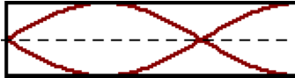

The air column has a length of 80 cm. This pattern represents the ___ harmonic; its wavelength is ____ cm. Choose two letters in their respective order; enter them together without any commas or spaces between letters. Example: 'AI'

**Harmonic # Wavelength (cm)**

a. 1st b. 2nd i. 20 j. 40 k. 60 l. 80

c. 3rd d. 4th m. 100 n. 106.7 o. 120 p. 140

e. 5th f. 6th q. 160 r. 180 s. 240 t. 320

g. 7th h. 9th u. None of these are even close.

**Question 10:**

aa. A standing wave pattern is established in a closed-end air column as it vibrates with the pattern shown below.



The air column has a length of 90 cm. This pattern represents the ___ harmonic; its wavelength is ____ cm. Choose two letters in their respective order; enter them together without any commas or spaces between letters. Example: 'AI'

**Harmonic # Wavelength (cm)**

a. 1st b. 2nd i. 22.5 j. 30 k. 45 l. 60

c. 3rd d. 4th m. 67.5 n. 72 o. 90 p. 120

e. 5th f. 6th q. 135 r. 180 s. 270 t. 360

g. 7th h. 9th u. None of these are even close.

**Question 11:**

aa. A standing wave pattern is established in a closed-end air column as it vibrates with the pattern shown below.



The air column has a length of 120 cm. This pattern represents the ___ harmonic; its wavelength is ____ cm. Choose two letters in their respective order; enter them together without any commas or spaces between letters. Example: 'AI'

**Harmonic # Wavelength (cm)**

a. 1st b. 2nd i. 30 j. 40 k. 60 l. 90

c. 3rd d. 4th m. 96 n. 120 o. 150 p. 160

e. 5th f. 6th q. 180 r. 240 s. 360 t. 480

g. 7th h. 9th u. None of these are even close.

**Question 12:**

aa. A standing wave pattern is established in a closed-end air column as it vibrates with the pattern shown below.



The air column has a length of 60 cm. This pattern represents the ___ harmonic; its wavelength is ____ cm. Choose two letters in their respective order; enter them together without any commas or spaces between letters. Example: 'AI'

**Harmonic # Wavelength (cm)**

a. 1st b. 2nd i. 15 j. 20 k. 30 l. 34.3

c. 3rd d. 4th m. 45 n. 48 o. 60 p. 75

e. 5th f. 6th q. 80 r. 90 s. 180 t. 240

g. 7th h. 9th u. None of these are even close.

**Question 13:**

aa. A standing wave pattern is established in a closed-end air column as it vibrates with the pattern shown below.

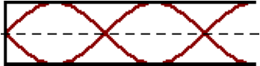

The air column has a length of 80 cm. This pattern represents the ___ harmonic; its wavelength is ____ cm. Choose two letters in their respective order; enter them together without any commas or spaces between letters. Example: 'AI'

**Harmonic # Wavelength (cm)**

a. 1st b. 2nd i. 20 j. 26.7 k. 32 l. 45.7

c. 3rd d. 4th m. 48 n. 53.3 o. 60 p. 64

e. 5th f. 6th q. 100 r. 106.7 s. 140 t. 320

g. 7th h. 9th u. None of these are even close.

**Question 14:**

aa. A standing wave pattern is established in a closed-end air column as it vibrates with the pattern shown below.



The air column has a length of 90 cm. This pattern represents the ___ harmonic; its wavelength is ____ cm. Choose two letters in their respective order; enter them together without any commas or spaces between letters. Example: 'AI'

**Harmonic # Wavelength (cm)**

a. 1st b. 2nd i. 30 j. 51.4 k. 54 l. 60

c. 3rd d. 4th m. 64.3 n. 67.5 o. 72 p. 112.5

e. 5th f. 6th q. 120 r. 150 s. 157.5 t. 360

g. 7th h. 9th u. None of these are even close.

**Question 15:**

aa. A standing wave pattern is established in a closed-end air column as it vibrates with the pattern shown below.



The air column has a length of 120 cm. This pattern represents the ___ harmonic; its wavelength is ____ cm. Choose two letters in their respective order; enter them together without any commas or spaces between letters. Example: 'AI'

**Harmonic # Wavelength (cm)**

a. 1st b. 2nd i. 53.3 j. 68.6 k. 72 l. 80

c. 3rd d. 4th m. 90 n. 96 o. 100 p. 150

e. 5th f. 6th q. 180 r. 210 s. 480 t. 600

g. 7th h. 9th u. None of these are even close.

**Question 16:**

aa. A standing wave pattern is established in a closed-end air column as it vibrates with the pattern shown below.



The air column has a length of 60 cm. This pattern represents the ___ harmonic; its wavelength is ____ cm. Choose two letters in their respective order; enter them together without any commas or spaces between letters. Example: 'AI'

**Harmonic # Wavelength (cm)**

a. 1st b. 2nd i. 17.1 j. 24 k. 34.3 l. 36

c. 3rd d. 4th m. 40 n. 45 o. 48 p. 50

e. 5th f. 6th q. 72 r. 105 s. 300 t. 420

g. 7th h. 9th u. None of these are even close.

**Question 17:**

aa. A standing wave pattern is established in a closed-end air column as it vibrates with the pattern shown below.

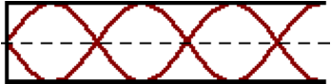

The air column has a length of 80 cm. This pattern represents the ___ harmonic; its wavelength is ____ cm. Choose two letters in their respective order; enter them together without any commas or spaces between letters. Example: 'AI'

**Harmonic # Wavelength (cm)**

a. 1st b. 2nd i. 26.7 j. 32 k. 35.6 l. 45.7

c. 3rd d. 4th m. 53.3 n. 60 o. 64 p. 120

e. 5th f. 6th q. 140 r. 400 s. 480 t. 560

g. 7th h. 9th u. None of these are even close.

**Question 18:**

aa. A standing wave pattern is established in a closed-end air column as it vibrates with the pattern shown below.



The air column has a length of 60 cm. This pattern represents the ___ harmonic; its wavelength is ____ cm. Choose two letters in their respective order; enter them together without any commas or spaces between letters. Example: 'AI'

**Harmonic # Wavelength (cm)**

a. 1st b. 2nd i. 20 j. 24 k. 26.7 l. 30

c. 3rd d. 4th m. 34.3 n. 36 o. 40 p. 48

e. 5th f. 6th q. 80 r. 90 s. 105 t. 135

g. 7th h. 9th u. None of these are even close.

**Question 19:**

aa. A standing wave pattern is established in a closed-end air column as it vibrates with the pattern shown below.



The air column has a length of 100 cm. This pattern represents the ___ harmonic; its wavelength is ____ cm. Choose two letters in their respective order; enter them together without any commas or spaces between letters. Example: 'AI'

**Harmonic # Wavelength (cm)**

a. 1st b. 2nd i. 28.6 j. 44.4 k. 57.1 l. 60

c. 3rd d. 4th m. 66.6 n. 75 o. 80 p. 150

e. 5th f. 6th q. 160 r. 175 s. 200 t. 225

g. 7th h. 9th u. None of these are even close.

**Question 20:**

aa. A standing wave pattern is established in a closed-end air column as it vibrates with the pattern shown below.



The air column has a length of 120 cm. This pattern represents the ___ harmonic; its wavelength is ____ cm. Choose two letters in their respective order; enter them together without any commas or spaces between letters. Example: 'AI'

**Harmonic # Wavelength (cm)**

a. 1st b. 2nd i. 40 j. 48 k. 53.3 l. 60

c. 3rd d. 4th m. 68.6 n. 72 o. 80 p. 96

e. 5th f. 6th q. 160 r. 180 s. 210 t. 270

g. 7th h. 9th u. None of these are even close.

**Question 21:**

aa. A standing wave pattern is established in a closed-end air column as it vibrates with the pattern shown below.

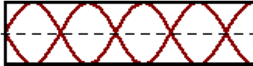

The air column has a length of 80 cm. This pattern represents the ___ harmonic; its wavelength is ____ cm. Choose two letters in their respective order; enter them together without any commas or spaces between letters. Example: 'AI'

**Harmonic # Wavelength (cm)**

a. 1st b. 2nd i. 20 j. 22.9 k. 29.1 l. 32

c. 3rd d. 4th m. 35.6 n. 40 o. 45.7 p. 60

e. 5th f. 6th q. 100 r. 112.5 s. 180 t. 200

g. 7th h. 9th u. None of these are even close.

**Question 22:**

aa. A standing wave pattern is established in a closed-end air column as it vibrates with the pattern shown below.



The air column has a length of 60 cm. This pattern represents the ___ harmonic; its wavelength is ____ cm. Choose two letters in their respective order; enter them together without any commas or spaces between letters. Example: 'AI'

**Harmonic # Wavelength (cm)**

a. 1st b. 2nd i. 24 j. 26.7 k. 30 l. 34.3

c. 3rd d. 4th m. 36 n. 40 o. 48 p. 96

e. 5th f. 6th q. 105 r. 108 s. 135 t. 180

g. 7th h. 9th u. None of these are even close.

**Question 23:**

aa. A standing wave pattern is established in a closed-end air column as it vibrates with the pattern shown below.



The air column has a length of 100 cm. This pattern represents the ___ harmonic; its wavelength is ____ cm. Choose two letters in their respective order; enter them together without any commas or spaces between letters. Example: 'AI'

**Harmonic # Wavelength (cm)**

a. 1st b. 2nd i. 28.6 j. 33.3 k. 36.4 l. 37.5

c. 3rd d. 4th m. 37.5 n. 40 o. 57.1 p. 150

e. 5th f. 6th q. 166.7 r. 175 s. 225 t. 275

g. 7th h. 9th u. None of these are even close.

**Question 24:**

aa. A standing wave pattern is established in a closed-end air column as it vibrates with the pattern shown below.



The air column has a length of 120 cm. This pattern represents the ___ harmonic; its wavelength is ____ cm. Choose two letters in their respective order; enter them together without any commas or spaces between letters. Example: 'AI'

**Harmonic # Wavelength (cm)**

a. 1st b. 2nd i. 48 j. 53.3 k. 60 l. 68.6

c. 3rd d. 4th m. 72 n. 80 o. 96 p. 192

e. 5th f. 6th q. 210 r. 216 s. 270 t. 360

g. 7th h. 9th u. None of these are even close.

**Question 25:**

aa. Diagram A shows the standing wave pattern created in a 95-cm long closed-end air column when it is vibrated at 240 Hz.

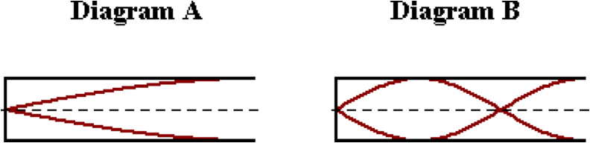

Determine the vibration frequency (in Hertz) that would be required of the same air column to produce the standing wave pattern shown in Diagram B. Enter a numerical answer.

**Question 26:**

aa. Diagram A shows the standing wave pattern created in a 105-cm long closed-end air column when it is vibrated at 220 Hz.

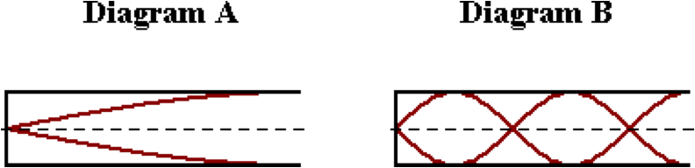

Determine the vibration frequency (in Hertz) that would be required of the same air column to produce the standing wave pattern shown in Diagram B. Enter a numerical answer.

**Question 27:**

aa. Diagram A shows the standing wave pattern created in a 100-cm long closed-end air column when it is vibrated at 260 Hz.

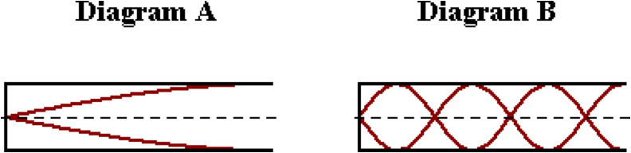

Determine the vibration frequency (in Hertz) that would be required of the same air column to produce the standing wave pattern shown in Diagram B. Enter a numerical answer.

**Question 28:**

aa. Diagram A shows the standing wave pattern created in a 90-cm long closed-end air column when it is vibrated at 250 Hz.

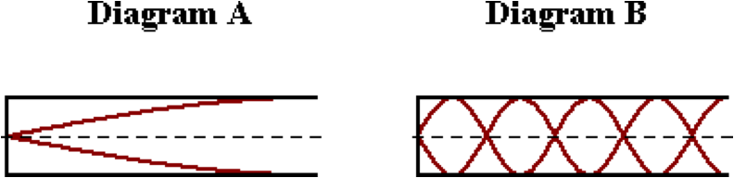

Determine the vibration frequency (in Hertz) that would be required of the same air column to produce the standing wave pattern shown in Diagram B. Enter a numerical answer.

**Question 29:**

aa. Diagram A shows the standing wave pattern created in a 95-cm long closed-end air column when it is vibrated at 210 Hz.

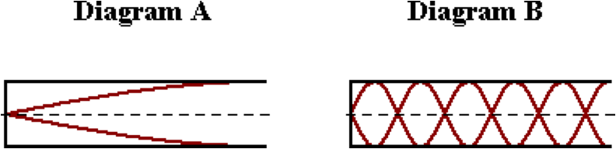

Determine the vibration frequency (in Hertz) that would be required of the same air column to produce the standing wave pattern shown in Diagram B. Enter a numerical answer.

**Question 30:**

aa. Diagram A shows the standing wave pattern created in a 95-cm long closed-end air column when it is vibrated at 270 Hz.

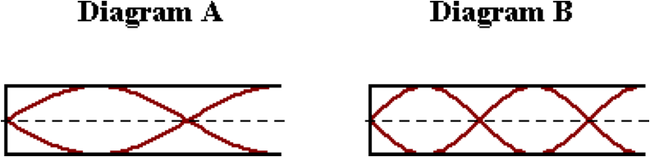

Determine the vibration frequency (in Hertz) that would be required of the same air column to produce the standing wave pattern shown in Diagram B. Enter a numerical answer.

**Question 31:**

aa. Diagram A shows the standing wave pattern created in a 110-cm long closed-end air column when it is vibrated at 230 Hz.

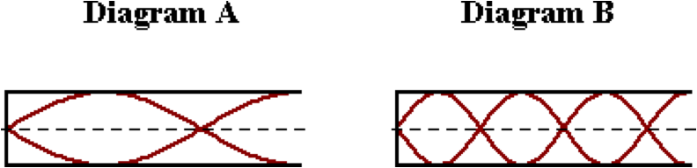

Determine the vibration frequency (in Hertz) that would be required of the same air column to produce the standing wave pattern shown in Diagram B. Enter a numerical answer.

**Question 32:**

aa. Diagram A shows the standing wave pattern created in a 105-cm long closed-end air column when it is vibrated at 240 Hz.

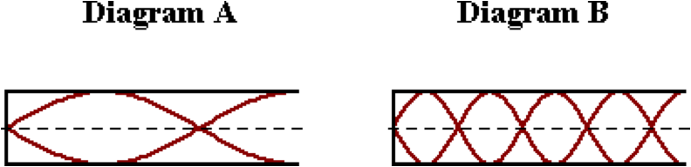

Determine the vibration frequency (in Hertz) that would be required of the same air column to produce the standing wave pattern shown in Diagram B. Enter a numerical answer.

**Question 33:**

aa. Diagram A shows the standing wave pattern created in a 100-cm long closed-end air column when it is vibrated at 250 Hz.

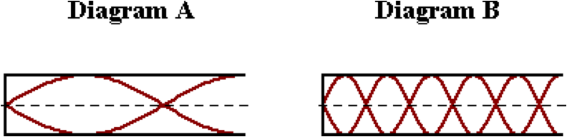

Determine the vibration frequency (in Hertz) that would be required of the same air column to produce the standing wave pattern shown in Diagram B. Enter a numerical answer.

**Question 34:**

aa. Diagram A shows the standing wave pattern created in a 90-cm long closed-end air column when it is vibrated at 260 Hz.

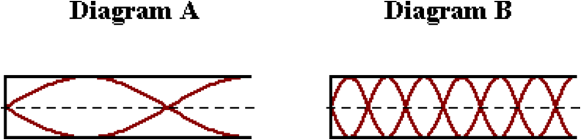

Determine the vibration frequency (in Hertz) that would be required of the same air column to produce the standing wave pattern shown in Diagram B. Enter a numerical answer.

**Question 35:**

aa. Diagram A shows the standing wave pattern created in a closed-end air column when it is vibrated at 480 Hz.

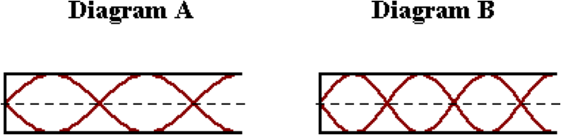

Determine the vibration frequency (in Hertz) that would be required of the same air column to produce the standing wave pattern shown in Diagram B. Enter a numerical answer.

**Question 36:**

aa. Diagram A shows the standing wave pattern created in a closed-end air column when it is vibrated at 540 Hz.

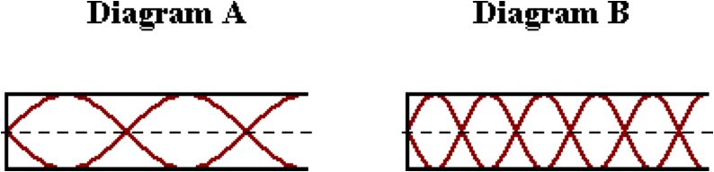

Determine the vibration frequency (in Hertz) would be required of the same air column to produce the standing wave pattern shown in Diagram B. Enter a numerical answer.

**Question 37:**

aa. Diagram A shows the standing wave pattern created in a closed-end air column when it is vibrated at 900 Hz.

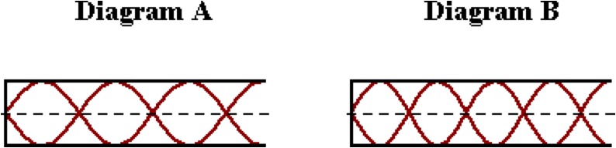

Determine the vibration frequency (in Hertz) that would be required of the same air column to produce the standing wave pattern shown in Diagram B. Enter a numerical answer.

**Question 38:**

aa. Diagram A shows the standing wave pattern created in a closed-end air column when it is vibrated at 1200 Hz.

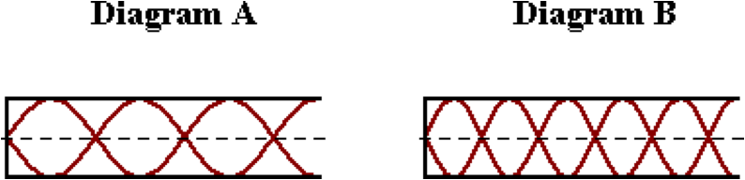

Determine the vibration frequency (in Hertz) that would be required of the same air column to produce the standing wave pattern shown in Diagram B. Enter a numerical answer.

**Question 39:**

aa. Diagram A shows the standing wave pattern created in a closed-end air column when it is vibrated at 1300 Hz.

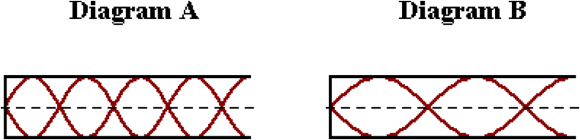

Determine the vibration frequency (in Hertz) that would be required of the same air column to produce the standing wave pattern shown in Diagram B. Enter a numerical answer.

**Question 40:**

aa. Diagram A shows the standing wave pattern created in a closed-end air column when it is vibrated at 1200 Hz.

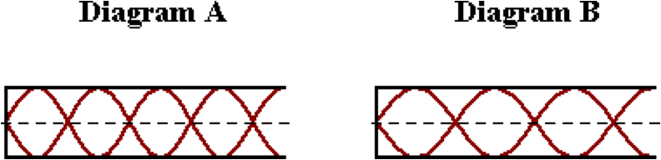

Determine the vibration frequency (in Hertz) that would be required of the same air column to produce the standing wave pattern shown in Diagram B. Enter a numerical answer.

**SM11: Mathematics for Closed-End Air Columns**

**Question 1:**

aa. Determine the fundamental frequency (in Hertz) and associated wavelength (in centimeters) of an 82.1-centimeter long closed-end air column through which sound travels at 335 m/s. Enter numerical answers.

**Question 2:**

aa. Determine the fundamental frequency (in Hertz) and associated wavelength (in centimeters) of a 76.5-centimeter long closed-end air column through which sound travels at 340 m/s. Enter numerical answers.

**Question 3:**

aa. Determine the fundamental frequency (in Hertz) and associated wavelength (in centimeters) of a 91.4-centimeter long closed-end air column through which sound travels at 345 m/s. Enter numerical answers.

**Question 4:**

aa. Determine the fundamental frequency (in Hertz) and associated wavelength (in centimeters) of a 96.8-centimeter long closed-end air column through which sound travels at 350 m/s. Enter numerical answers.

**Question 5:**

aa. Determine the frequency (in Hertz) and the associated wavelength (in centimeters) of the third harmonic for an 82.1-centimeter long closed-end air column through which sound travels at 335 m/s. Enter numerical answers.

**Question 6:**

aa. Determine the frequency (in Hertz) and the associated wavelength (in centimeters) of the third harmonic for a 73.6-centimeter long closed-end air column through which sound travels at 340 m/s. Enter numerical answers.

**Question 7:**

aa. Determine the frequency (in Hertz) and the associated wavelength (in centimeters) of the third harmonic for a 92.1-centimeter long closed-end air column through which sound travels at 345 m/s. Enter numerical answers.

**Question 8:**

aa. Determine the frequency (in Hertz) and the associated wavelength (in centimeters) of the third harmonic for a 98.5-centimeter long closed-end air column through which sound travels at 350 m/s. Enter numerical answers.

**Question 9:**

aa. Determine the frequency (in Hertz) and the associated wavelength (in centimeters) of the fifth harmonic for a 77.9-centimeter long closed-end air column through which sound travels at 335 m/s. Enter numerical answers.

**Question 10:**

aa. Determine the frequency (in Hertz) and the associated wavelength (in centimeters) of the fifth harmonic for an 82.3-centimeter long closed-end air column through which sound travels at 340 m/s. Enter numerical answers.

**Question 11:**

aa. Determine the frequency (in Hertz) and the associated wavelength (in centimeters) of the fifth harmonic for an 87.1-centimeter long closed-end air column through which sound travels at 345 m/s. Enter numerical answers.

**Question 12:**

aa. Determine the frequency (in Hertz) and the associated wavelength (in centimeters) of the fifth harmonic for a 99.3-centimeter long closed-end air column through which sound travels at 350 m/s. Enter numerical answers.

**Question 13:**

aa. Determine the frequency (in Hertz) and the associated wavelength (in centimeters) of the seventh harmonic for an 84.2-centimeter long closed-end air column through which sound travels at 335 m/s. Enter numerical answers.

**Question 14:**

aa. Determine the frequency (in Hertz) and the associated wavelength (in centimeters) of the seventh harmonic for a 98.2-centimeter long closed-end air column through which sound travels at 340 m/s. Enter numerical answers.

**Question 15:**

aa. Determine the frequency (in Hertz) and the associated wavelength (in centimeters) of the seventh harmonic for a 101.4-centimeter long closed-end air column through which sound travels at 345 m/s. Enter numerical answers.

**Question 16:**

aa. Determine the frequency (in Hertz) and the associated wavelength (in centimeters) of the seventh harmonic for a 117.6-centimeter long closed-end air column through which sound travels at 350 m/s. Enter numerical answers.

**Question 17:**

aa. Consider the standing wave pattern for a closed-end air column as shown below.

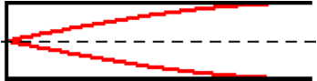

The speed of sound in the air is 335 m/s and the frequency associated with this pattern is 125 Hertz. Determine the wavelength (in centimeters) associated with this pattern and the length (in centimeters) of the air column. Enter numerical answers.

**Question 18:**

aa. Consider the standing wave pattern for a closed-end air column as shown below.



The speed of sound in the air is 340 m/s and the frequency associated with this pattern is 145 Hertz. Determine the wavelength (in centimeters) associated with this pattern and the length (in centimeters) of the air column. Enter numerical answers.

**Question 19:**

aa. Consider the standing wave pattern for a closed-end air column as shown below.



The speed of sound in the air is 345 m/s and the frequency associated with this pattern is 187 Hertz. Determine the wavelength (in centimeters) associated with this pattern and the length (in centimeters) of the air column. Enter numerical answers.

**Question 20:**

aa. Consider the standing wave pattern for a closed-end air column as shown below.



The speed of sound in the air is 350 m/s and the frequency associated with this pattern is 212 Hertz. Determine the wavelength (in centimeters) associated with this pattern and the length (in centimeters) of the air column. Enter numerical answers.

**Question 21:**

aa. Consider the standing wave pattern for a closed-end air column as shown below.

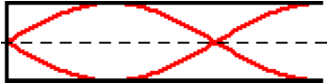

The speed of sound in the air is 335 m/s and the frequency associated with this pattern is 345 Hertz. Determine the wavelength (in centimeters) associated with this pattern and the length (in centimeters) of the air column. Enter numerical answers.

**Question 22:**

aa. Consider the standing wave pattern for a closed-end air column as shown below.



The speed of sound in the air is 340 m/s and the frequency associated with this pattern is 388 Hertz. Determine the wavelength (in centimeters) associated with this pattern and the length (in centimeters) of the air column. Enter numerical answers.

**Question 23:**

aa. Consider the standing wave pattern for a closed-end air column as shown below.



The speed of sound in the air is 345 m/s and the frequency associated with this pattern is 412 Hertz. Determine the wavelength (in centimeters) associated with this pattern and the length (in centimeters) of the air column. Enter numerical answers.

**Question 24:**

aa. Consider the standing wave pattern for a closed-end air column as shown below.



The speed of sound in the air is 350 m/s and the frequency associated with this pattern is 467 Hertz. Determine the wavelength (in centimeters) associated with this pattern and the length (in centimeters) of the air column. Enter numerical answers.

**Question 25:**

aa. Consider the standing wave pattern for a closed-end air column as shown below.

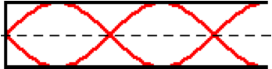

The speed of sound in the air is 335 m/s and the frequency associated with this pattern is 688 Hertz. Determine the wavelength (in centimeters) associated with this pattern and the length (in centimeters) of the air column. Enter numerical answers.

**Question 26:**

aa. Consider the standing wave pattern for a closed-end air column as shown below.



The speed of sound in the air is 340 m/s and the frequency associated with this pattern is 723 Hertz. Determine the wavelength (in centimeters) associated with this pattern and the length (in centimeters) of the air column. Enter numerical answers.

**Question 27:**

aa. Consider the standing wave pattern for a closed-end air column as shown below.



The speed of sound in the air is 345 m/s and the frequency associated with this pattern is 796 Hertz. Determine the wavelength (in centimeters) associated with this pattern and the length (in centimeters) of the air column. Enter numerical answers.

**Question 28:**

aa. Consider the standing wave pattern for a closed-end air column as shown below.



The speed of sound in the air is 350 m/s and the frequency associated with this pattern is 855 Hertz. Determine the wavelength (in centimeters) associated with this pattern and the length (in centimeters) of the air column. Enter numerical answers.

**Question 29:**

aa. Consider the standing wave pattern for a closed-end air column as shown below.

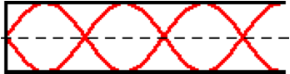

The speed of sound in the air is 335 m/s and the frequency associated with this pattern is 890 Hertz. Determine the wavelength (in centimeters) associated with this pattern and the length (in centimeters) of the air column. Enter numerical answers.

**Question 30:**

aa. Consider the standing wave pattern for a closed-end air column as shown below.



The speed of sound in the air is 340 m/s and the frequency associated with this pattern is 909 Hertz. Determine the wavelength (in centimeters) associated with this pattern and the length (in centimeters) of the air column. Enter numerical answers.

**Question 31:**

aa. Consider the standing wave pattern for a closed-end air column as shown below.



The speed of sound in the air is 345 m/s and the frequency associated with this pattern is 943 Hertz. Determine the wavelength (in centimeters) associated with this pattern and the length (in centimeters) of the air column. Enter numerical answers.

**Question 32:**

aa. Consider the standing wave pattern for a closed-end air column as shown below.



The speed of sound in the air is 350 m/s and the frequency associated with this pattern is 989 Hertz. Determine the wavelength (in centimeters) associated with this pattern and the length (in centimeters) of the air column. Enter numerical answers.