**Minds On Physics Question Banks – Static Electricity**

**SE1: Charges and Atoms**

**Question 1:**

aa. ____ are the charged parts of an atom.

a. Only electrons b. Only protons

c. Neutrons only d. Electrons and neutrons

e. Electrons and protons f. Protons and neutrons

**Question 2:**

aa. ____ are the charged parts of an atom.

a. Only electrons b. Only protons

c. Neutrons only d. Protons and neutrons

e. Electrons and neutrons f. Electrons and protons

**Question 3:**

aa. ____ are the charged parts of an atom.

a. Only electrons b. Only protons

c. Neutrons only d. Electrons and protons

e. Protons and neutrons f. Electrons and neutrons

**Question 4:**

aa. ____ are negatively charged.

a. Only electrons b. Only protons

c. Neutrons only d. Electrons and neutrons

e. Electrons and protons f. Protons and neutrons

**Question 5:**

aa. ____ are positively charged.

a. Only electrons b. Only protons

c. Neutrons only d. Electrons and neutrons

e. Electrons and protons f. Protons and neutrons

**Question 6:**

aa. ____ are negatively charged.

a. Neutrons only b. Only protons

c. Only electrons d. Electrons and protons

e. Electrons and neutrons f. Protons and neutrons

**Question 7:**

aa. ____ are positively charged.

a. Only protons b. Only electrons

c. Neutrons only d. Electrons and protons

e. Electrons and neutrons f. Protons and neutrons

**Question 8:**

aa. ____ are found in the nucleus of an atom.

a. Only electrons b. Only protons

c. Neutrons only d. Electrons and neutrons

e. Electrons and protons f. Protons and neutrons

**Question 9:**

aa. ____ are found outside the nucleus of an atom.

a. Only electrons b. Only protons

c. Only neutrons d. Electrons and neutrons

e. Electrons and protons f. Protons and neutrons

**Question 10:**

aa. Which of the following are located outside the nucleus of an atom? List all that apply in alphabetical order without any spaces between letters.

a. Electrons b. Protons c. Neutrons

d. Nonsense! None of these are located outside the nucleus of the atom.

**Question 11:**

aa. Which of the following are located inside the nucleus of an atom? List all that apply in alphabetical order without any spaces between letters.

a. Electrons b. Protons c. Neutrons

d. Nonsense! None of these are located inside the nucleus of the atom.

**Question 12:**

aa. Which of the following are located inside the nucleus of an atom? List all that apply in alphabetical order without any spaces between letters.

a. Neutrons b. Electrons c. Protons

d. Nonsense! None of these are located inside the nucleus of the atom.

**Question 13:**

aa. Most of the mass of an atom is found in ____.

a. only the electrons b. only the protons

c. only the neutrons d. the protons and neutrons

e. the protons and electrons f. the electrons and neutrons

**Question 14:**

aa. In typical electrostatic experiments, protons cannot be gained or lost from an atom because they are _____.

a. positively charged

b. negatively charged

c. more massive than electrons

d. less massive than electrons

e. tightly bound in the atom’s nucleus

f. loosely bound outside the atom’s nucleus

g. ... nonsense! Protons could be gained or lost from any atom.

**Question 15:**

aa. In typical electrostatic experiments, protons cannot be gained or lost from an atom because they are _____.

a. negatively charged

b. positively charged

c. less massive than electrons

d. more massive than electrons

e. loosely bound outside the atom’s nucleus

f. tightly bound in the atom’s nucleus

g. ... nonsense! Protons could be gained or lost from any atom.

**Question 16:**

aa. An atom that is positively-charged contains ____.

a. electrons only

b. protons only

c. neutrons only

d. more protons than electrons

e. more electrons than protons

f. more protons than neutrons

g. more electrons than neutrons

**Question 17:**

aa. An object is considered to be neutral when ____.

a. there are no charges in the object

b. the object contains no charges

c. the object contains no protons

d. the object contains no electrons

e. the object contains no neutrons

f. the object contains the same number of electrons as protons

g. the object contains the same number of neutrons as electrons

h. the object contains the same number of protons as neutrons

**Question 18:**

aa. An atom that is negatively-charged contains ____.

a. electrons only

b. protons only

c. neutrons only

d. more protons than electrons

e. more electrons than protons

f. more protons than neutrons

g. more electrons than neutrons

**Question 19:**

aa. If an atom is positively-charged, then one can be sure that it contains ____.

a. electrons only

b. protons only

c. neutrons only

d. more electrons than protons

e. more protons than neutrons

f. more protons than electrons

g. more electrons than neutrons

**Question 20:**

aa. If an atom is negatively-charged, then one can be sure that it contains ____.

a. electrons only

b. protons only

c. neutrons only

d. more electrons than protons

e. more protons than electrons

f. more protons than neutrons

g. more electrons than neutrons

**Question 21:**

aa. If an object is electrically neutral, then one can be sure that ____.

a. there are no charges in the object

b. the object contains no charges

c. the object contains no protons

d. the object contains no electrons

e. the object contains no neutrons

f. the object contains the same number of protons as neutrons

g. the object contains the same number of electrons as protons

h. the object contains the same number of neutrons as electrons

**Question 22:**

aa. In order for a neutral object to become positively-charged, ____ the object.

a. protons are added to b. protons are removed from

c. electrons are added to d. electrons are removed from

e. neutrons are added to f. neutrons are removed from

**Question 23:**

aa. In order for a neutral object to become negatively-charged, ____ the object.

a. protons are added to b. protons are removed from

c. electrons are added to d. electrons are removed from

e. neutrons are added to f. neutrons are removed from

**Question 24:**

aa. A neutral object can become negatively-charged by _______.

a. gaining protons b. losing protons

c. gaining electrons d. losing electrons

e. gaining neutrons f. losing neutrons

**Question 25:**

aa. A neutral object can become positively-charged by _______.

a. gaining protons b. losing protons

c. gaining electrons d. losing electrons

e. gaining neutrons f. losing neutrons

**Question 26:**

aa. Substances through which charges move easily are called ____.

a. insulators b. electators c. engineers d. conductors

**Question 27:**

aa. Substances through which charges have difficulty moving are called ____.

a. insulators b. electators c. engineers d. conductors

**Question 28:**

aa. Substances through which charges move easily are called ____.

a. insulators b. conductors c. electators d. engineers

**Question 29:**

aa. Substances through which charges have difficulty moving are called ____.

a. electators b. insulators c. conductors d. engineers

**Question 30:**

aa. Substances through which charges move easily are called ____.

a. electators b. insulators c. conductors d. engineers

**Question 31:**

aa. Substances through which charges have difficulty moving are called ____.

a. electators b. conductors c. engineers d. insulators

**Question 32:**

aa. The charges on several spheres are shown.

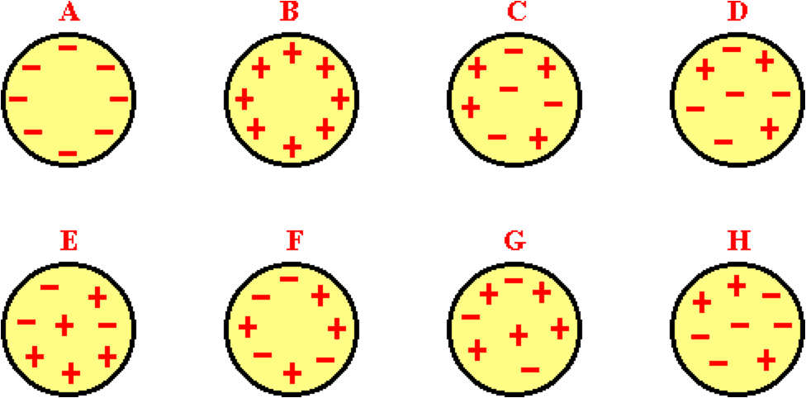

Which spheres are positively-charged? (Note that there are 8 individual charge signs on each sphere.) Choose all that apply in alphabetical order with no commas or spaces between letters.

**Question 33:**

aa. The charges on several spheres are shown.



Which spheres are negatively-charged? (Note that there are 8 individual charge signs on each sphere.) Choose all that apply in alphabetical order with no commas or spaces between letters.

**Question 34:**

aa. The charges on several spheres are shown.



Which spheres are neutral? (Note that there are 8 individual charge signs on each sphere.) Choose all that apply in alphabetical order with no commas or spaces between letters.

**Question 35:**

aa. The charges on several spheres are shown.

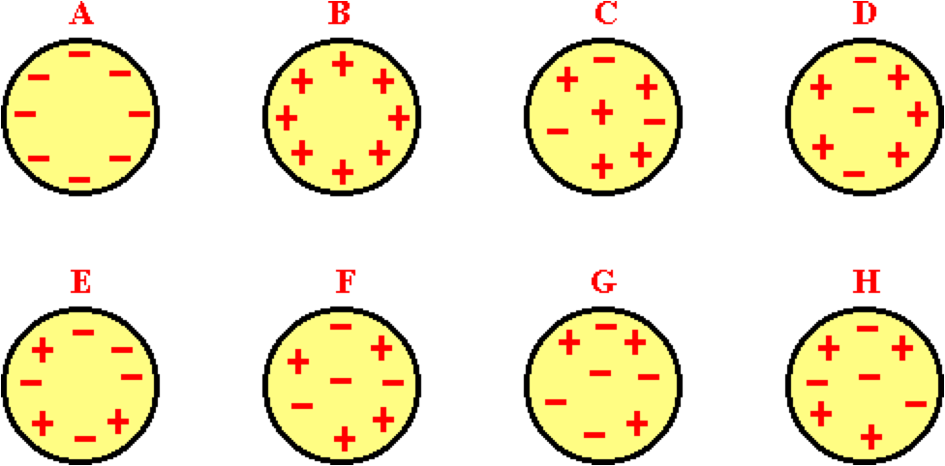

Which spheres are positively-charged? (Note that there are 8 individual charge signs on each sphere.) Choose all that apply in alphabetical order with no commas or spaces between letters.

**Question 36:**

aa. The charges on several spheres are shown.



Which spheres are negatively-charged? (Note that there are 8 individual charge signs on each sphere.) Choose all that apply in alphabetical order with no commas or spaces between letters.

**Question 37:**

aa. The charges on several spheres are shown.



Which spheres are neutral? (Note that there are 8 individual charge signs on each sphere.) Choose all that apply in alphabetical order with no commas or spaces between letters.

**Question 38:**

aa. The charges on several spheres are shown.

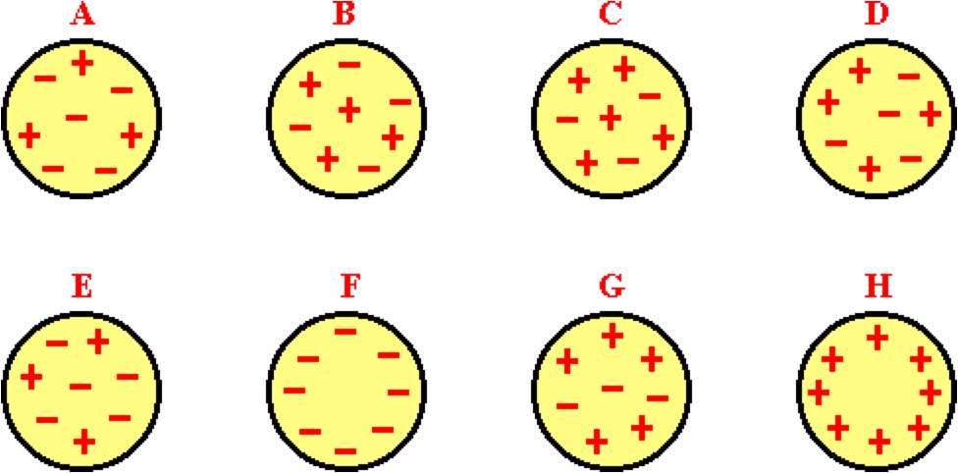

Which spheres are positively-charged? (Note that there are 8 individual charge signs on each sphere.) Choose all that apply in alphabetical order with no commas or spaces between letters.

**Question 39:**

aa. The charges on several spheres are shown.



Which spheres are negatively-charged? (Note that there are 8 individual charge signs on each sphere.) Choose all that apply in alphabetical order with no commas or spaces between letters.

**Question 40:**

aa. The charges on several spheres are shown.



Which spheres are neutral? (Note that there are 8 individual charge signs on each sphere.) Choose all that apply in alphabetical order with no commas or spaces between letters.

**SE2: Interactions Between Charged Objects**

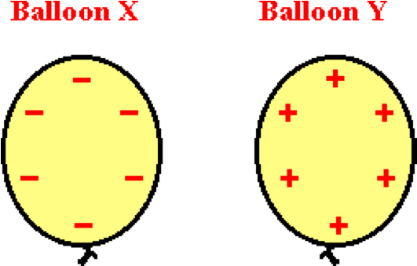**Question 1:**

aa. Two balloons are charged as shown below. Balloon X will ____ balloon Y.

a. attract

b. repel

c. not affect

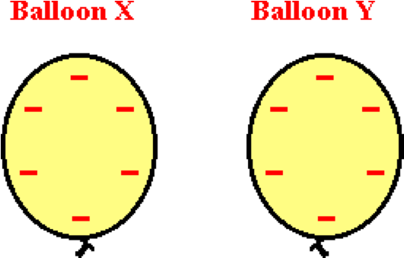**Question 2:**

aa. Two balloons are charged as shown below. Balloon X will ____ balloon Y.

a. attract

b. repel

c. not affect

**Question 3:**

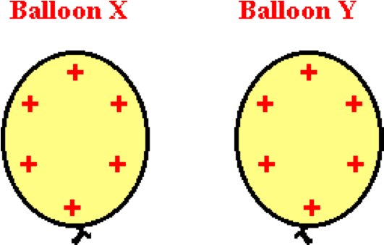aa. Two balloons are charged as shown below. Balloon X will ____ balloon Y.

a. attract

b. repel

c. not affect

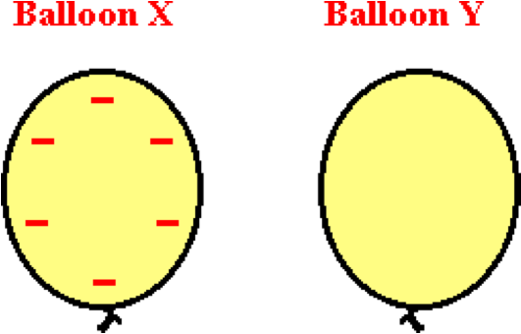**Question 4:**

aa. Two balloons are shown below ; one is neutral and the other is negative. Balloon X will ____ balloon Y.

a. attract

b. repel

c. not affect

**Question 5:**

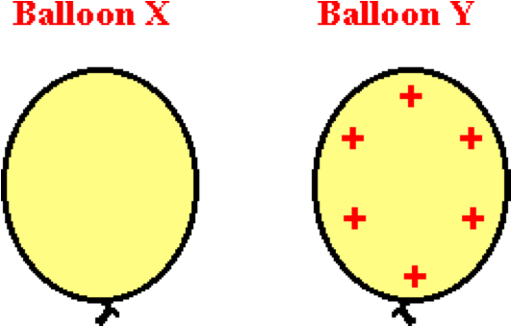aa. Two balloons are shown below; one is neutral and the other is positive. Balloon X will ____ balloon Y.

a. attract

b. repel

c. not affect

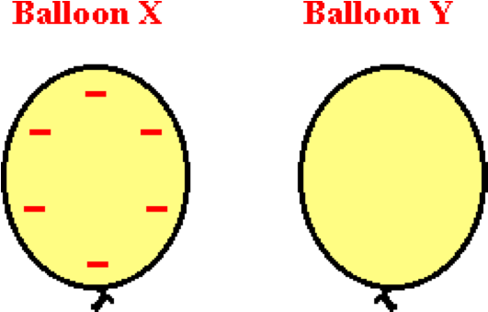**Question 6:**

aa. Two balloons are shown below; one is neutral and the other is negative. Balloon X will ____ balloon Y.

a. not affect

b. attract

c. repel

**Question 7:**

aa. Two balloons are shown below; one is neutral and the other is positive. Balloon X will ____ balloon Y.

a. not affect

b. repel

c. attract

**Question 8:**

aa. Two balloons, X and Y are placed near each other and subsequently repel each other. If balloon X is negatively charged, then Y MUST be ___.

a. positively-charged b. negatively-charged

c. neutral d. either positively or negatively-charged

**Question 9:**

aa. Two balloons, X and Y are placed near each other and subsequently repel each other. If balloon X is positively charged, then Y MUST be ___.

a. positively-charged b. negatively-charged

c. neutral d. either positively or negatively-charged

**Question 10:**

aa. Two balloons, X and Y are placed near each other and subsequently repel each other. If balloon X is positively charged, then Y MUST NOT be ___. List all that apply in alphabetical order with no spaces between letters.

a. positively-charged b. negatively-charged c. neutral

**Question 11:**

aa. Two balloons, X and Y are placed near each other and subsequently attract each other. If balloon X is negatively charged, then Y MAY be ___. List all that apply in alphabetical order with no spaces between letters.

a. positively-charged b. negatively-charged c. neutral

**Question 12:**

aa. Two balloons, X and Y are placed near each other and subsequently attract each other. If balloon X is positively charged, then Y MAY be ___. List all that apply in alphabetical order with no spaces between letters.

a. positively-charged b. negatively-charged c. neutral

**Question 13:**

aa. Two balloons, X and Y are placed near each other and subsequently attract each other. If balloon X is positively charged, then Y MUST NOT be ___. List all that apply in alphabetical order with no spaces between letters.

a. positively-charged b. negatively-charged c. neutral

**Question 14:**

aa. Balloons X, Y and Z are suspended from strings as shown below.

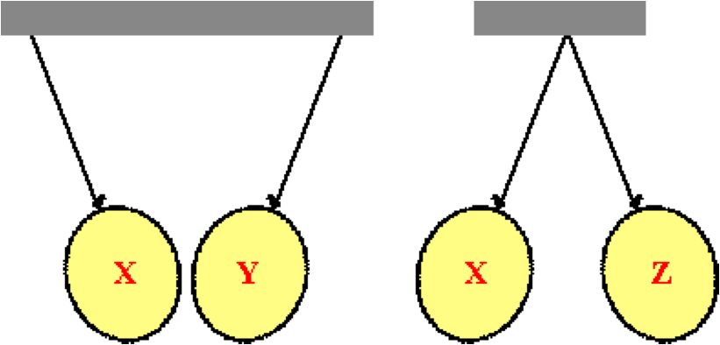

Positively-charged balloon X attracts balloon Y and repels balloon Z. Balloon Y ____. List all that apply in alphabetical order with no spaces between letters.

a. must be positively-charged b. must be negatively-charged

c. must be neutral d. may be either positively-charged or neutral

e. may be either negatively-charged or neutral

**Question 15:**

aa. Balloons X, Y and Z are suspended from strings as shown below.



Positively-charged balloon X attracts balloon Y and repels balloon Z. Balloon Y ____. List all that apply in alphabetical order with no spaces between letters.

a. must be positively-charged b. must be negatively-charged

c. must be neutral d. may be positively-charged

e. may be negatively-charged f. may be neutral

**Question 16:**

aa. Balloons X, Y and Z are suspended from strings as shown below.



Negatively-charged balloon X attracts balloon Y and repels balloon Z. Balloon Y ____. List all that apply in alphabetical order with no spaces between letters.

a. must be positively-charged b. must be negatively-charged

c. must be neutral d. may be either positively-charged or neutral

e. may be either negatively-charged or neutral

**Question 17:**

aa. Balloons X, Y and Z are suspended from strings as shown below.



Negatively-charged balloon X attracts balloon Y and repels balloon Z. Balloon Y ____. List all that apply in alphabetical order with no spaces between letters.

a. must be positively-charged b. must be negatively-charged

c. must be neutral d. may be positively-charged

e. may be negatively-charged f. may be neutral

**Question 18:**

aa. Balloons X, Y and Z are suspended from strings as shown below.

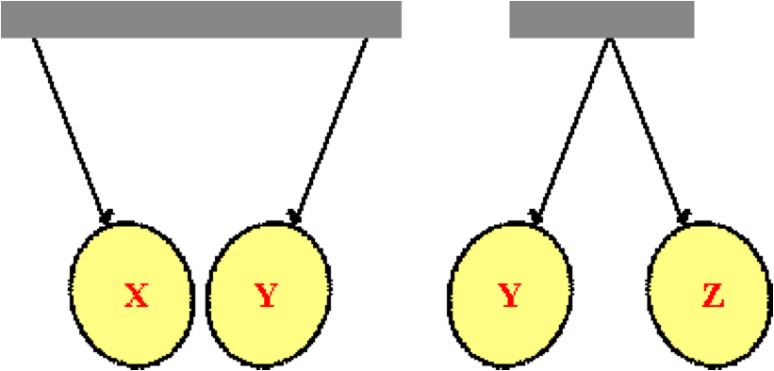

Positively-charged balloon X attracts balloon Y, while balloon Y repels balloon Z. Balloon Z ____. List all that apply in alphabetical order with no spaces between letters.

a. may be either positively-charged or neutral

b. may be either negatively-charged or neutral

c. must be positively-charged

d. must be negatively-charged

e must be neutral

**Question 19:**

Balloons X , Y and Z are suspended from strings as shown below.



Positively-charged balloon X attracts balloon Y, while balloon Y repels balloon Z. Balloon Z ____. List all that apply in alphabetical order with no spaces between letters.

a. must be positively-charged

b. must be negatively-charged

c. must be neutral

d. may be either positively-charged or neutral

e. may be either negatively-charged or neutral

**Question 20:**

aa. Balloons X, Y and Z are suspended from strings as shown below.



Negatively-charged balloon X attracts balloon Y, while balloon Y repels balloon Z. Balloon Z ____. List all that apply in alphabetical order with no spaces between letters.

a. must be positively-charged

b. must be negatively-charged

c. must be neutral

d. may be either positively-charged or neutral

e. may be either negatively-charged or neutral

**Question 21:**

aa. Balloons X, Y and Z are suspended from strings as shown below.



Negatively-charged balloon X attracts balloon Y, while balloon Y repels balloon Z. Balloon Z ____. List all that apply in alphabetical order with no spaces between letters.

a. may be either positively-charged or neutral

b. may be either negatively-charged or neutral

c. must be positively-charged

d. must be negatively-charged

e. must be neutral

**Question 22:**

aa. Balloons X, Y and Z are suspended from strings as shown below.

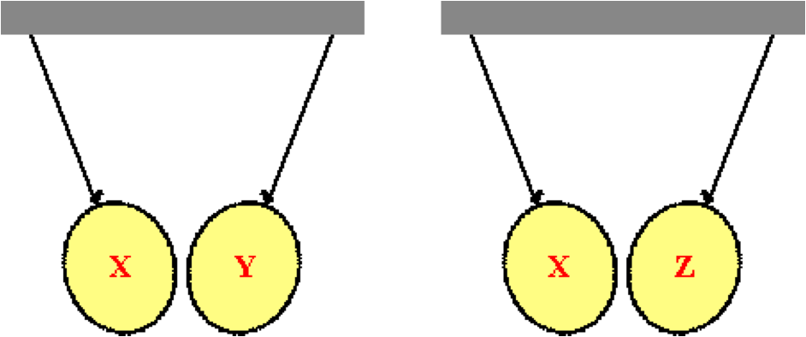

Negatively-charged balloon X attracts balloon Y and attracts balloon Z. Balloon Z ____. List all that apply in alphabetical order with no spaces between letters.

a. must be positively-charged b. must be negatively-charged

c. must be neutral d. may be positively-charged

e. may be negatively-charged f. may be neutral

**Question 23:**

aa. Balloons X, Y and Z are suspended from strings as shown below.



Negatively-charged balloon X attracts balloon Y and attracts balloon Z. Balloon Y ____. List all that apply in alphabetical order with no spaces between letters.

a. may be positively-charged b. may be negatively-charged

c. may be neutral d. must be positively-charged

e. must be negatively-charged f. must be neutral

**Question 24:**

aa. Balloons X, Y and Z are suspended from strings as shown below.



Positively-charged balloon X attracts balloon Y and attracts balloon Z. Balloon Z ____. List all that apply in alphabetical order with no spaces between letters.

a. must be negatively-charged b. must be positively-charged

c. must be neutral d. may be negatively-charged

e. may be positively-charged f. may be neutral

**Question 25:**

aa. Balloons X, Y and Z are suspended from strings as shown below.



Positively-charged balloon X attracts balloon Y and attracts balloon Z. Balloon Y ____. List all that apply in alphabetical order with no spaces between letters.

a. must be positively-charged b. must be negatively-charged

c. must be neutral d. may be positively-charged

e. may be negatively-charged f. may be neutral

**Question 26:**

aa. Balloons X, Y and Z are suspended from strings as shown below.

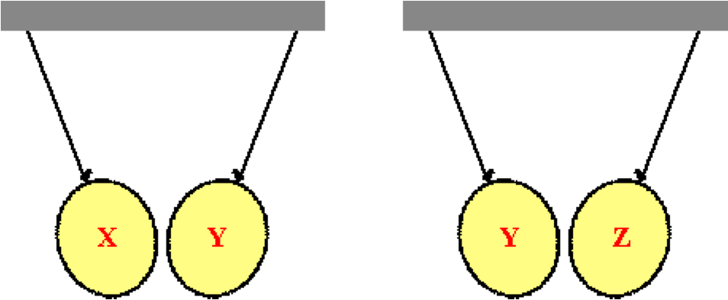

Positively-charged balloon X attracts balloon Y while balloon Y attracts balloon Z. Balloon Z ____. List all that apply in alphabetical order with no spaces between letters.

a. may be positively-charged b. may be negatively-charged

c. may be neutral d. must be positively-charged

e. must be negatively-charged f. must be neutral

**Question 27:**

aa. Balloons X, Y and Z are suspended from strings as shown below.



Positively-charged balloon X attracts balloon Y while balloon Y attracts balloon Z. Balloon Z ____. List all that apply in alphabetical order with no spaces between letters.

a. may be positively-charged b. may be negatively-charged

c. may be neutral d. must be positively-charged

e. must be negatively-charged f. must be neutral

**Question 28:**

aa. Balloons X, Y and Z are suspended from strings as shown below.



Negatively-charged balloon X attracts balloon Y while balloon Y attracts balloon Z. Balloon Z ____. List all that apply in alphabetical order with no spaces between letters.

a. must be neutral b. must be positively-charged

c. must be negatively-charged d. may be neutral

e. may be positively-charged f. may be negatively-charged

**Question 29:**

aa. Balloons X, Y and Z are suspended from strings as shown below.



Negatively-charged balloon X attracts balloon Y while balloon Y attracts balloon Z. Balloon Z ____. List all that apply in alphabetical order with no spaces between letters.

a. must be positively-charged b. must be negatively-charged

c. must be neutral d. may be positively-charged

e. may be negatively-charged f. may be neutral

**Question 30:**

aa. Which of the diagrams below best represents the charge distribution on a metal sphere when a negatively-charged plastic tube is placed nearby?

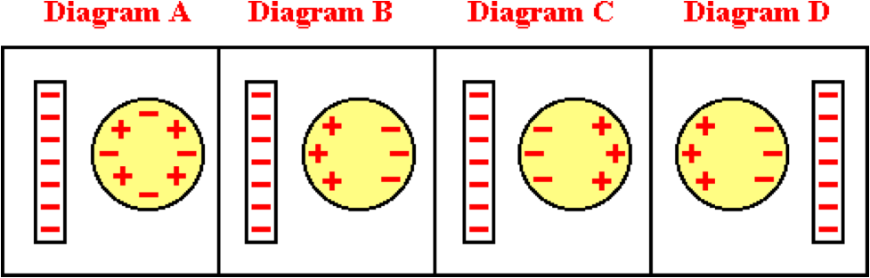

**Question 31:**

aa. Which of the diagrams below best represents the charge distribution on a metal sphere when a negatively-charged plastic tube is placed nearby?

.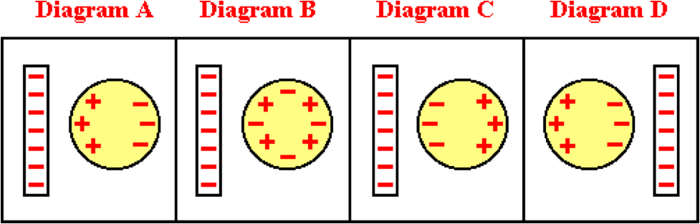

**Question 32:**

aa. Which of the diagrams below best represents the charge distribution on a metal sphere when a positively-charged plastic tube is placed nearby?

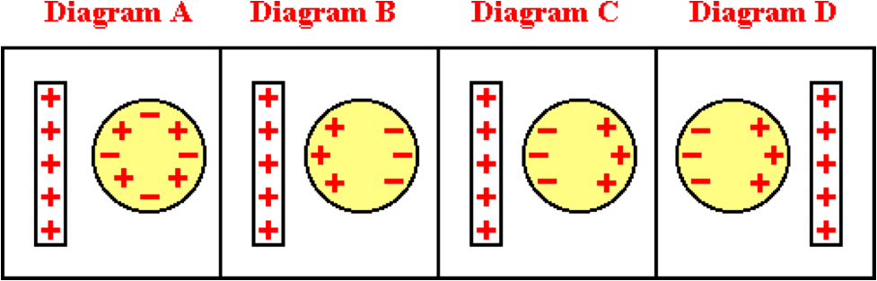

**Question 33:**

aa. Which of the diagrams below best represents the charge distribution on a metal sphere when a positively-charged plastic tube is placed nearby?

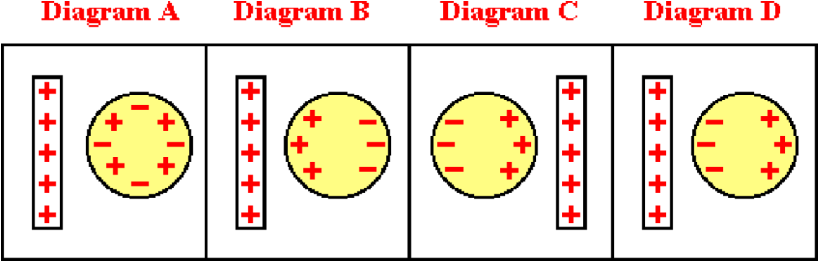

**Question 34:**

aa. Balloons X, Y and Z are suspended from strings as shown below.

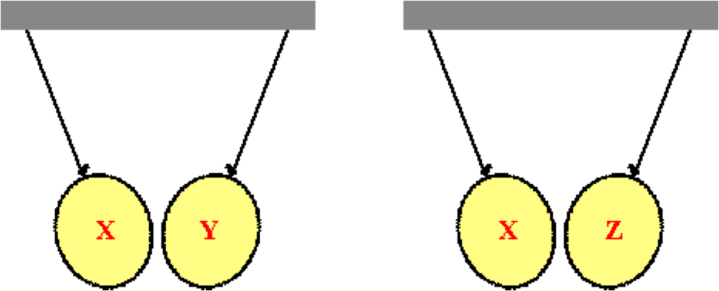

Both balloons Y and Z are neutral. Both balloons Y and Z attract balloon X. Balloon X ____. List all that apply in alphabetical order with no spaces between letters.

a. must be positively-charged

b. must be negatively-charged

c. must be either positively-charged or negatively-charged

d. may be either positively-charged or neutral

e. may be either negatively-charged or neutral

f. must be neutral

**Question 35:**

aa. Balloons X, Y and Z are suspended from strings as shown below.



Both balloons Y and Z are neutral. Both balloons Y and Z attract balloon X. Balloon X ____. List all that apply in alphabetical order with no spaces between letters.

a. must be either positively-charged or negatively-charged

b. must be negatively-charged

c. must be positively-charged

d. may be either negatively-charged or neutral

e. may be either positively-charged or neutral

f. must be neutral

**Question 36:**

aa. Balloons X, Y and Z are suspended from strings as shown below.



Both balloons Y and Z are neutral. Both balloons Y and Z attract balloon X. Balloon X ____. List all that apply in alphabetical order with no spaces between letters.

a. may be either negatively-charged or neutral

b. may be either positively-charged or neutral

c. must be either positively-charged or negatively-charged

d. must be negatively-charged

e. must be positively-charged

f. must be neutral

**Question 37:**

aa. Balloons X, Y and Z are suspended from strings as shown below.



Both balloons Y and Z are neutral. Both balloon Y and Z attract balloon X. Balloon X ____. List all that apply in alphabetical order with no spaces between letters.

a. may be either positively-charged or neutral

b. may be either negatively-charged or neutral

c. must be positively-charged

d. must be negatively-charged

e. must be either positively-charged or negatively-charged

f. must be neutral

**SE3: Charging by Friction**

**Question 1:**

aa. Two neutral objects - object A and object B - are rubbed together. During the process, electrons are transferred from object A to object B. This would cause object A to acquire a _____ charge and object B to acquire a _____ charge.

a. positive, positive b. negative, negative

c. positive, neutral d. negative, neutral

e. positive, negative f. negative, positive

**Question 2:**

aa. Two neutral objects - object A and object B - are rubbed together. During the process, electrons are transferred from object A to object B. This would cause object A to acquire a _____ charge and object B to acquire a _____ charge.

a. positive, negative b. negative, positive

c. positive, positive d. negative, negative

e. neutral, positive f. neutral, negative

**Question 3:**

aa. Two neutral objects - object A and object B - are rubbed together. During the process, electrons are transferred from object B to object A. This would cause object A to acquire a _____ charge and object B to acquire a _____ charge.

a. positive, positive b. negative, negative

c. positive, neutral d. negative, neutral

e. positive, negative f. negative, positive

**Question 4:**

aa. Two neutral objects - object A and object B - are rubbed together. During the process, electrons are transferred from object B to object A. This would cause object A to acquire a _____ charge and object B to acquire a _____ charge.

a. positive, negative b. negative, positive

c. positive, positive d. negative, negative

e. neutral, positive f. neutral, negative

**Question 5:**

aa. Two neutral objects - object A and object B - are rubbed together. During the process, object A becomes charged positively and object B becomes charged negatively. This is because ______.

a. object A gains protons and object B gains electrons.

b. object A gains electrons and object B gains protons.

c. object A loses electrons and object B loses protons.

d. object A loses protons and object B loses electrons.

e. object A loses protons and object B gains protons.

f. object A loses electrons and object B gains electrons.

g. object A gains electrons and object B loses electrons.

**Question 6:**

aa. Two neutral objects - object A and object B - are rubbed together. During the process, object A becomes charged negatively and object B becomes charged positively. This is because ______.

a. object A gains protons and object B gains electrons.

b. object A gains electrons and object B gains protons.

c. object A loses electrons and object B loses protons.

d. object A loses protons and object B loses electrons.

e. object A loses protons and object B gains protons.

f. object A loses electrons and object B gains electrons.

g. object A gains electrons and object B loses electrons.

**Question 7:**

aa. Two neutral objects - object A and object B - are rubbed together. During the process, object A becomes charged positively and object B becomes charged negatively. This is because ______.

a. object A gains protons and object B gains electrons.

b. object A gains electrons and object B gains protons.

c. object A loses electrons and object B loses protons.

d. object A loses electrons and object B gains electrons.

e. object A gains electrons and object B loses electrons.

f. object A loses protons and object B loses electrons.

g. object A loses protons and object B gains protons.

**Question 8:**

aa. Two neutral objects - object A and object B - are rubbed together. During the process, object A becomes charged negatively and object B becomes charged positively. This is because ______.

a. object A gains protons and object B gains electrons.

b. object A gains electrons and object B gains protons.

c. object A loses electrons and object B loses protons.

d. object A loses electrons and object B gains electrons.

e. object A gains electrons and object B loses electrons.

f. object A loses protons and object B loses electrons.

g. object A loses protons and object B gains protons.

**Question 9:**

aa. Two neutral objects - object A and object B - are rubbed together. During the process, object A becomes charged negatively and object B becomes charged positively. This is because ______.

a. protons are transferred from object A to object B.

b. protons are transferred from object B to object A.

c. electrons are transferred from object A to object B.

d. electrons are transferred from object B to object A.

e. object A exchanges a proton for one of object B's electrons.

f. object A exchanges an electron for one of object B's protons.

**Question 10:**

aa. Two neutral objects - object A and object B - are rubbed together. During the process, object A becomes charged negatively and object B becomes charged positively. This is because ______.

a. object A exchanges a proton for one of object B's electrons.

b. object A exchanges an electron for one of object B's protons.

c. protons are transferred from object B to object A.

d. protons are transferred from object A to object B.

e. electrons are transferred from object A to object B.

f. electrons are transferred from object B to object A.

**Question 11:**

aa. Two neutral objects - object A and object B - are rubbed together. During the process, object A becomes charged positively and object B becomes charged negatively. This is because ______.

a. protons are transferred from object B to object A.

b. protons are transferred from object A to object B.

c. electrons are transferred from object A to object B.

d. electrons are transferred from object B to object A.

e. object A exchanges a proton for one of object B's electrons.

f. object A exchanges an electron for one of object B's protons.

**Question 12:**

aa. Two neutral objects - object A and object B - are rubbed together. During the process, object A becomes charged positively and object B becomes charged negatively. This is because ______.

a. object A exchanges a proton for one of object B's electrons.

b. object A exchanges an electron for one of object B's protons.

c. protons are transferred from object A to object B.

d. protons are transferred from object B to object A.

e. electrons are transferred from object A to object B.

f. electrons are transferred from object B to object A.

**Question 13:**

aa. In typical electrostatic experiments, protons cannot be gained or lost from an atom because they are _____.

a. positively charged

b. negatively charged

c. more massive than electrons

d. less massive than electrons

e. tightly bound in the atom’s nucleus

f. loosely bound outside the atom’s nucleus

g. ... nonsense! Protons could be gained or lost from any atom.

**Question 14:**

aa. In typical electrostatic experiments, protons cannot be gained or lost from an atom because they are _____.

a. positively charged

b. negatively charged

c. more massive than electrons

d. less massive than electrons

e. loosely bound outside the atom’s nucleus

f. tightly bound in the atom’s nucleus

g. ... nonsense! Protons could be gained or lost from any atom.

**Question 15:**

aa. Material X has a greater electron affinity than material Y. When two neutral samples of these materials are rubbed together, _______. List all that apply in alphabetical order with no spaces between letters.

a. protons are transferred from X to Y

b. protons are transferred from Y to X

c. electrons are transferred from X to Y

d. electrons are transferred from Y to X

e. electrons are created and deposited upon X

f. electrons are created and deposited upon Y

**Question 16:**

aa. Material X has a greater electron affinity than material Y. When two neutral samples of these materials are rubbed together, _______. List all that apply in alphabetical order with no spaces between letters.

a. electrons are created and deposited upon X

b. electrons are created and deposited upon Y

c. protons are transferred from X to Y

d. protons are transferred from Y to X

e. electrons are transferred from X to Y

f. electrons are transferred from Y to X

**Question 17:**

aa. Material Y has a greater electron affinity than material X. When two neutral samples of these materials are rubbed together, _______. List all that apply in alphabetical order with no spaces between letters.

a. protons are transferred from X to Y

b. protons are transferred from Y to X

c. electrons are transferred from X to Y

d. electrons are transferred from Y to X

e. electrons are created and deposited upon X

f. electrons are created and deposited upon Y

**Question 18:**

aa. Material Y has a greater electron affinity than material X. When two neutral samples of these materials are rubbed together, _______. List all that apply in alphabetical order with no spaces between letters.

a. electrons are created and deposited upon X

b. electrons are created and deposited upon Y

c. protons are transferred from X to Y

d. protons are transferred from Y to X

e. electrons are transferred from X to Y

f. electrons are transferred from Y to X

**Question 19:**

aa. Material X has a greater electron affinity than material Y. When two neutral samples of these materials are rubbed together, X acquires a ____ charge and Y acquires a ____ charge.

a. positive, positive b. negative, negative

c. negative, neutral d. neutral, negative

e. negative, positive f. positive, negative

**Question 20:**

aa. Material X has a greater electron affinity than material Y. When two neutral samples of these materials are rubbed together, X acquires a ____ charge and Y acquires a ____ charge.

a. positive, positive b. negative, negative

c. negative, positive d. positive, negative

e. negative, neutral f. neutral, negative

**Question 21:**

aa. Material X has a lower electron affinity than material Y. When two neutral samples of these materials are rubbed together, X acquires a ____ charge and Y acquires a ____ charge.

a. positive, positive b. negative, negative

c. negative, neutral d. neutral, negative

e. negative, positive f. positive, negative

**Question 22:**

aa. Material X has a greater electron affinity than material Y. When two neutral samples of these materials are rubbed together, X acquires a ____ charge and Y acquires a ____ charge.

a. positive, positive b. negative, negative

c. positive, negative d. negative, positive

e. negative, neutral f. neutral, negative

**Question 23:**

aa. Material X and material Y are rubbed together. As a result, material X acquires a negative charge. This means that ______.

a. material X is the conductor and Y the insulator

b. material X is the insulator and Y the conductor

c. material X has the greater affinity for electrons

d. material Y has the greater affinity for electrons

e. material X more easily creates electrons than Y

f. material X just got plain lucky

**Question 24:**

aa. Material X and material Y are rubbed together. As a result, material X acquires a negative charge. This means that ______.

a. material X has the greater affinity for electrons

b. material Y has the greater affinity for electrons

c. material X is the conductor and Y the insulator

d. material X is the insulator and Y the conductor

e. material X more easily creates electrons than Y

f. material X just got plain lucky

**Question 25:**

aa. Material X and material Y are rubbed together. As a result, material Y acquires a negative charge. This means that ______.

a. material X is the conductor and Y the insulator

b. material X is the insulator and Y the conductor

c. material X has the greater affinity for electrons

d. material Y has the greater affinity for electrons

e. material Y more easily creates electrons than X

f. material Y just got plain lucky

**Question 26:**

aa. Material X and material Y are rubbed together. As a result, material Y acquires a negative charge. This means that ______.

a. material X has the greater affinity for electrons

b. material Y has the greater affinity for electrons

c. material X is the conductor and Y the insulator

d. material X is the insulator and Y the conductor

e. material Y more easily creates electrons than X

f. material Y just got plain lucky

**Question 27:**

aa. Material X and material Y are rubbed together. As a result, material X acquires a positive charge. This means that ______.

a. material X is the conductor and Y the insulator

b. material X is the insulator and Y the conductor

c. material X has the greater affinity for electrons

d. material Y has the greater affinity for electrons

e. material X more easily creates protons than Y

f. material X just got plain lucky

**Question 28:**

aa. Material X and material Y are rubbed together. As a result, material X acquires a positive charge. This means that ______.

a. material X has the greater affinity for electrons

b. material Y has the greater affinity for electrons

c. material X is the conductor and Y the insulator

d. material X is the insulator and Y the conductor

e. material X more easily creates protons than Y

f. material X just got plain lucky

**Question 29:**

aa. Material X and material Y are rubbed together. As a result, material Y acquires a positive charge. This means that ______.

a. material Y more easily creates protons than Y

b. material Y just got plain lucky

c. material X is the conductor and Y the insulator

d. material X is the insulator and Y the conductor

e. material X has the greater affinity for electrons

f. material Y has the greater affinity for electrons

**Question 30:**

aa. Material X and material Y are rubbed together. As a result, material Y acquires a positive charge. This means that ______.

a. material Y more easily creates protons than Y

b. material Y just got plain lucky

c. material X is the conductor and Y the insulator

d. material X is the insulator and Y the conductor

e. material Y has the greater affinity for electrons

f. material X has the greater affinity for electrons

**Question 31:**

aa. A rubber balloon is rubbed on a wool sweater. In the process, electrons are transferred from the wool sweater to the rubber balloon. As a result the balloon acquires ____.

a. a positive charge b. a negative charge

c. no charge d. a lot of mass

e. negative mass

**Question 32:**

aa. A rubber balloon is rubbed on a wool sweater. In the process, electrons are transferred from the wool sweater to the rubber balloon. As a result the balloon acquires ____.

a. no charge b. a lot of mass

c. negative mass d. a positive charge

e. a negative charge

**Question 33:**

aa. A rubber balloon is rubbed on a wool sweater. In the process, electrons are transferred from the wool sweater to the rubber balloon. As a result the sweater acquires ____.

a. a positive charge b. a negative charge

c. no charge d. a lot of mass

e. negative mass

**Question 34:**

aa. A rubber balloon is rubbed on a wool sweater. In the process, electrons are transferred from the wool sweater to the rubber balloon. As a result the sweater acquires ____.

a. no charge b. a lot of mass

c. negative mass d. a positive charge

e. a negative charge

**Question 35:**

aa. A plastic golf tube is rubbed by bunny fur and electrons are transferred from the fur to the tube. As a result, the plastic golf tube acquires ____.

a. a positive charge b. a negative charge

c. no charge d. a lot of mass

e. negative mass

**Question 36:**

aa. A plastic golf tube is rubbed by bunny fur and electrons are transferred from the fur to the tube. As a result, the bunny fur acquires ____.

a. no charge b. a negative charge

c. a positive charge d. a lot of mass

e. negative mass

**Question 37:**

aa. A plastic golf tube is rubbed by bunny fur and electrons are transferred from the fur to the tube. This means that the _____.

a. golf tube is the conductor and the fur is the insulator

b. golf tube is the insulator and the fur is the conductor

c. golf tube has the greater affinity for electrons

d. fur has the greater affinity for electrons

e. golf tube more easily creates electrons than Y

f. golf tube just got plain lucky

**Question 38:**

aa. A plastic golf tube is rubbed by bunny fur and electrons are transferred from the fur to the tube. This means that the _____.

a. golf tube is the conductor and the fur is the insulator

b. golf tube is the insulator and the fur is the conductor

c. golf tube more easily creates electrons than Y

d. golf tube just got plain lucky

e. golf tube has the greater affinity for electrons

f. fur has the greater affinity for electrons

**Question 39:**

aa. A rubber balloon is rubbed on a wool sweater. In the process, electrons are transferred from the wool sweater to the rubber balloon. This means that the _____.

a. rubber balloon has the greater affinity for electrons

b. wool sweater has the greater affinity for electrons

c. rubber balloon is the conductor and the wool sweater is the insulator

d. rubber balloon is the insulator and the wool sweater is the conductor

e. rubber balloon more easily creates electrons than Y

f. rubber balloon just got plain lucky

**Question 40:**

aa. A rubber balloon is rubbed on a wool sweater. In the process, electrons are transferred from the wool sweater to the rubber balloon. This means that the _____.

a. rubber balloon is the conductor and the wool sweater is the insulator

b. rubber balloon is the insulator and the wool sweater is the conductor

c. wool sweater has the greater affinity for electrons

d. rubber balloon has the greater affinity for electrons

e. rubber balloon more easily creates electrons than Y

f. rubber balloon just got plain lucky

**SE4: Charging by Contact and the Grounding Process**

**Question 1:**

aa. A neutral metal sphere is touched by a negatively-charged metal rod. As a result, the sphere will become charged by ____.

a. friction b. conduction

c. induction d. reduction

e. deduction f. oxidation

**Question 2:**

aa. A neutral metal sphere is touched by a negatively-charged metal rod. As a result, the sphere will become charged by ____.

a. induction b. reduction

c. oxidation d. friction

e. conduction f. deduction

**Question 3:**

aa. A neutral metal sphere is touched by a positively-charged metal rod. As a result, the sphere will become charged by ____.

a. friction b. induction

c. conduction d. reduction

e. deduction f. oxidation

**Question 4:**

aa. A neutral metal sphere is touched by a positively-charged metal rod. As a result, the sphere will become charged by ____.

a. induction b. reduction

c. oxidation d. conduction

e. friction f. deduction

**Question 5:**

aa. A neutral metal sphere is touched by a negatively-charged metal rod. During the process, electrons are transferred from the _____ to the _____ and the sphere acquires a _____ charge.

a. neutral sphere, charged rod, negative

b. neutral sphere, charged rod, positive

c. charged rod, neutral sphere, negative

d. charged rod, neutral sphere, positive

e. ... nonsense! None of these describe what occurs.

**Question 6:**

aa. A neutral metal sphere is touched by a negatively-charged metal rod. During the process, electrons are transferred from the _____ to the _____ and the sphere acquires a _____ charge.

a. neutral sphere, charged rod, positive

b. neutral sphere, charged rod, negative

c. charged rod, neutral sphere, positive

d. charged rod, neutral sphere, negative

e. ... nonsense! None of these describe what occurs.

**Question 7:**

aa. A neutral metal sphere is touched by a negatively-charged metal rod. During the process, electrons are transferred from the _____ to the _____ and the sphere acquires a _____ charge.

a. charged rod, neutral sphere, negative

b. charged rod, neutral sphere, positive

c. neutral sphere, charged rod, negative

d. neutral sphere, charged rod, positive

e. ... nonsense! None of these describe what occurs.

**Question 8:**

aa. A neutral metal sphere is touched by a negatively-charged metal rod. During the process, electrons are transferred from the _____ to the _____ and the sphere acquires a _____ charge.

a. charged rod, neutral sphere, positive

b. charged rod, neutral sphere, negative

c. neutral sphere, charged rod, positive

d. neutral sphere, charged rod, negative

e. ... nonsense! None of these describe what occurs.

**Question 9:**

aa. A neutral metal sphere is touched by a positively-charged metal rod. During the process, protons are transferred from the _____ to the _____ and the sphere acquires a _____ charge.

a. neutral sphere, charged rod, negative

b. neutral sphere, charged rod, positive

c. charged rod, neutral sphere, negative

d. charged rod, neutral sphere, positive

e. ... nonsense! None of these describe what occurs.

**Question 10:**

aa. A neutral metal sphere is touched by a positively-charged metal rod. During the process, protons are transferred from the _____ to the _____ and the sphere acquires a _____ charge.

a. charged rod, neutral sphere, negative

b. charged rod, neutral sphere, positive

c. neutral sphere, charged rod, negative

d. neutral sphere, charged rod, positive

e. ... nonsense! None of these describe what occurs.

**Question 11:**

aa. A metal sphere is electrically neutral. It is touched by a positively-charged metal rod. As a result, the metal sphere becomes charged positively. This occurs because the metal sphere _____.

a. gained protons from the rod

b. gained negative electrons from the rod

c. gained positive electrons from the rod

d. lost protons to the rod

e. lost electrons to the rod

f. lost negative protons to the rod

g. ... nonsense. The metal sphere would acquire a negative charge.

**Question 12:**

aa. A metal sphere is electrically neutral. It is touched by a positively-charged metal rod. As a result, the metal sphere becomes charged positively. This occurs because the metal sphere _____.

a. gained negative electrons from the rod

b. gained positive electrons from the rod

c. gained protons from the rod

d. lost electrons to the rod

e. lost protons to the rod

f. lost negative protons to the rod

g. ... nonsense. The metal sphere would acquire a negative charge.

**Question 13:**

aa. A metal sphere is electrically neutral. It is touched by a positively-charged metal rod. As a result, the metal sphere becomes charged positively. Which of the following occur during the process? List all that apply in alphabetical order without any spaces between letters.

a. Electrons are transferred from the sphere to the rod.

b. The metal sphere gains some protons.

c. Protons are transferred from the rod to the sphere.

d. Positive electrons are moved between the two objects.

e. The metal sphere loses electrons.

f. The overall charge of the system is conserved.

**Question 14:**

aa. A metal sphere is electrically neutral. It is touched by a positively-charged metal rod. As a result, the metal sphere becomes charged positively. Which of the following occur during the process? List all that apply in alphabetical order without any spaces between letters.

a. The metal sphere gains some protons.

b. Electrons are transferred from the sphere to the rod.

c. The metal sphere loses electrons.

d. The overall charge of the system is conserved.

e. Protons are transferred from the rod to the sphere.

f. Positive electrons are moved between the two objects.

**Question 15:**

aa. A charged metal sphere is touched by a person standing on the ground. The metal sphere subsequently becomes neutral. This process is known as _____.

a. charging by conduction b. polarization

c. induction d. oxidation

e. grounding f. frictional charging

g. reduction

**Question 16:**

aa. A charged metal sphere is touched by a person standing on the ground. The metal sphere subsequently becomes neutral. This process is known as _____.

a. polarization b. charging by conduction

c. oxidation d. induction

e. frictional charging f. grounding

g. reduction

**Question 17:**

aa. A charged metal sphere is touched by a person standing on the ground. The metal sphere subsequently becomes neutral. This process is known as _____.

a. induction b. charging by conduction

c. frictional charging d. grounding

e. oxidation f. polarization

g. reduction

**Question 18:**

aa. A positively-charged metal sphere is touched by a person standing on the ground. The metal sphere subsequently becomes neutral. The metal sphere becomes neutral during this process because ______.

a. protons pass from the sphere to the person (ground)

b. protons pass from the person (ground) to the sphere

c. positive electrons pass from the sphere to the person (ground)

d. positive electrons pass from the person (ground) to the sphere

e. electrons pass from the sphere to the person (ground)

f. electrons pass from the person (ground) to the sphere

**Question 19:**

aa. A positively-charged metal sphere is touched by a person standing on the ground. The metal sphere subsequently becomes neutral. The metal sphere becomes neutral during this process because ______.

a. positive electrons pass from the sphere to the person (ground)

b. positive electrons pass from the person (ground) to the sphere

c. electrons pass from the sphere to the person (ground)

d. electrons pass from the person (ground) to the sphere

e. protons pass from the sphere to the person (ground)

f. protons pass from the person (ground) to the sphere

**Question 20:**

aa. A positively-charged metal sphere is touched by a person standing on the ground. The metal sphere subsequently becomes neutral. The metal sphere becomes neutral during this process because ______.

a. protons pass from the person (ground) to the sphere

b. protons pass from the sphere to the person (ground)

c. positive electrons pass from the person (ground) to the sphere

d. positive electrons pass from the sphere to the person (ground)

e. electrons pass from the person (ground) to the sphere

f. electrons pass from the sphere to the person (ground)

**Question 21:**

aa. A negatively-charged metal sphere is touched by a person standing on the ground. The metal sphere subsequently becomes neutral. The metal sphere becomes neutral during this process because ______.

a. protons pass from the sphere to the person (ground)

b. protons pass from the person (ground) to the sphere

c. electrons pass from the sphere to the person (ground)

d. electrons pass from the person (ground) to the sphere

**Question 22:**

aa. A negatively-charged metal sphere is touched by a person standing on the ground. The metal sphere subsequently becomes neutral. The metal sphere becomes neutral during this process because ______.

a. protons pass from the person (ground) to the sphere

b. protons pass from the sphere to the person (ground)

c. electrons pass from the person (ground) to the sphere

d. electrons pass from the sphere to the person (ground)

**Question 23:**

aa. A negatively-charged metal sphere is touched by a person standing on the ground. The metal sphere subsequently becomes neutral. The metal sphere becomes neutral during this process because ______.

a. electrons pass from the person (ground) to the sphere

b. electrons pass from the sphere to the person (ground)

c. protons pass from the person (ground) to the sphere

d. protons pass from the sphere to the person (ground)

**Question 24:**

aa. A negatively-charged metal sphere is touched by a person standing on the ground. The metal sphere subsequently becomes neutral. The metal sphere becomes neutral during this process because ______.

a. electrons pass from the sphere to the person (ground)

b. electrons pass from the person (ground) to the sphere

c. protons pass from the sphere to the person (ground)

d. protons pass from the person (ground) to the sphere

**Question 25:**

aa. The best explanation for how a positively-charged object can become grounded is that the object ______.

a. loses protons to another object b. loses electrons to another object

c. gains protons from another object d. gains electrons from another object

**Question 26:**

aa. The best explanation for how a positively-charged object can become grounded is that the object ______.

a. loses electrons to another object b. loses protons to another object

c. gains electrons from another object d. gains protons from another object

**Question 27:**

aa. The best explanation for how a positively-charged object can become grounded is that the object ______.

a. loses protons to another object b. gains electrons from another object

c. loses electrons to another object d. gains protons from another object

**Question 28:**

aa. A physics student, standing on the ground, touches an uncharged plastic baseball bat to a negatively charged electroscope. This will cause ____.

a. the electroscope to be grounded as electrons flow out of the electroscope

b. the electroscope to be grounded as electrons flow into the electroscope

c. the electroscope to be grounded as protons flow out of the electroscope

d. the electroscope to be grounded as protons flow into the electroscope

e. the baseball bat to acquire an excess of protons

f. absolutely nothing (or very little) to happen since the plastic bat does not conduct

**Question 29:**

aa. A physics student, standing on the ground, touches an uncharged plastic baseball bat to a negatively charged electroscope. This will cause ____.

a. the electroscope to be grounded as protons flow out of the electroscope

b. the electroscope to be grounded as protons flow into the electroscope

c. the electroscope to be grounded as electrons flow out of the electroscope

d. the electroscope to be grounded as electrons flow into the electroscope

e. absolutely nothing (or very little) to happen since the plastic bat does not conduct

f. the baseball bat to acquire an excess of protons

**Question 30:**

aa. A physics student, standing on the ground, touches an uncharged plastic baseball bat to a negatively charged electroscope. This will cause ____.

a. the electroscope to be grounded as protons flow out of the electroscope

b. the electroscope to be grounded as protons flow into the electroscope

c. the baseball bat to acquire an excess of protons

d. absolutely nothing (or very little) to happen since the plastic bat does not conduct

e. the electroscope to be grounded as electrons flow out of the electroscope

f. the electroscope to be grounded as electrons flow into the electroscope

**Question 31:**

aa. A physics student, standing on the ground, touches an uncharged plastic baseball bat to a negatively charged electroscope. This will cause ____.

a. the electroscope to be grounded as protons flow out of the electroscope

b. the electroscope to be grounded as protons flow into the electroscope

c. absolutely nothing (or very little) to happen since the plastic bat does not conduct

d. the baseball bat to acquire an excess of protons

e. the electroscope to be grounded as electrons flow out of the electroscope

f. the electroscope to be grounded as electrons flow into the electroscope

**Question 32:**

aa. A positively-charged Van de Graaff generator is touched by a daring student. A spark of lightning is seen as _______.

a. protons flow from the student towards the Van de Graaff generator

b. protons flow from the Van de Graaff generator towards the student

c. electrons flow from the student towards the Van de Graaff generator

d. electrons flow from the Van de Graaff generator towards the student

e. the daring student breathes her last breath

**Question 33:**

aa. A positively-charged Van de Graaff generator is touched by a daring student. A spark of lightning is seen as _______.

a. electrons flow from the student towards the Van de Graaff generator

b. electrons flow from the Van de Graaff generator towards the student

c. protons flow from the student towards the Van de Graaff generator

d. protons flow from the Van de Graaff generator towards the student

e. the daring student breathes her last breath

**Question 34:**

aa. A positively-charged Van de Graaff generator is touched by a daring student. A spark of lightning is seen as _______.

a. protons flow from the Van de Graaff generator towards the student

b. protons flow from the student towards the Van de Graaff generator

c. electrons flow from the Van de Graaff generator towards the student

d. electrons flow from the student towards the Van de Graaff generator

e. the daring student breathes her last breath

**SE5: Charging by Induction – Pop Can Induction**

**Question 1:**

aa. Two neutral conducting pop cans are touching each other. A negatively-charged balloon is brought near one of the cans. The cans are separated while the balloon is nearby. After the balloon is removed the cans are charged. The cans were charged by the method of ____.

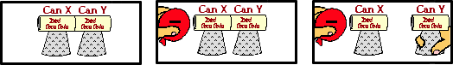

a. friction b. conduction c. induction d. reduction

e. deduction f. oxidation

**Question 2:**

aa. Two neutral conducting pop cans are touching each other. A positively-charged balloon is brought near one of the cans. The cans are separated while the balloon is nearby. After the balloon is removed the cans are charged. The cans were charged by the method of ____.



a. induction b. reduction c. friction d. conduction

e. oxidation f. deduction

**Question 3:**

aa. Two neutral conducting pop cans are touching each other. A negatively-charged balloon is brought near one of the cans. The cans are separated while the balloon is nearby. After the balloon is removed the cans are charged. The cans were charged by the method of ____.



a. friction b. conduction c. oxidation d. deduction

e. induction f. reduction

**Question 4:**

aa. Two neutral conducting pop cans are touching each other. A negatively-charged balloon is brought near one of the cans. The cans are separated while the balloon is nearby. After the balloon is removed can X is ____.



a. positively-charged b. negatively-charged

c. neutral d. much more massive

**Question 5:**

aa. Two neutral conducting pop cans are touching each other. A negatively-charged balloon is brought near one of the cans. The cans are separated while the balloon is nearby. After the balloon is removed can Y is ____.



a. positively-charged b. negatively-charged

c. neutral d. much more massive

**Question 6:**

aa. Two neutral conducting pop cans are touching each other. A negatively-charged balloon is brought near one of the cans. The cans are separated while the balloon is nearby. After the balloon is removed can X is ____.



a. neutral b. much more massive

c. positively-charged d. negatively-charged

**Question 7:**

aa. Two neutral conducting pop cans are touching each other. A negatively-charged balloon is brought near one of the cans. The cans are separated while the balloon is nearby. After the balloon is removed can Y is ____.



a. neutral b. much more massive

c. positively-charge d. negatively-charged

**Question 8:**

aa. Two neutral conducting pop cans are touching each other. A positively-charged balloon is brought near one of the cans. The cans are separated while the balloon is nearby. After the balloon is removed can X is ____.

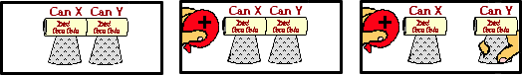

a. positively-charged b. negatively-charged

c. neutral d. much more massive

**Question 9:**

aa. Two neutral conducting pop cans are touching each other. A positively-charged balloon is brought near one of the cans. The cans are separated while the balloon is nearby. After the balloon is removed can Y is ____.



a. positively-charged b. negatively-charged

c. neutral d. much more massive

**Question 10:**

aa. Two neutral conducting pop cans are touching each other. A positively-charged balloon is brought near one of the cans. The cans are separated while the balloon is nearby. After the balloon is removed can X is ____.



a. neutral b. much more massive

c. positively-charged d. negatively-charged

**Question 11:**

aa. Two neutral conducting pop cans are touching each other. A positively-charged balloon is brought near one of the cans. The cans are separated while the balloon is nearby. After the balloon is removed can Y is ____.



a. neutral b. much more massive

c. positively-charged d. negatively-charged

**Question 12:**

aa. Two neutral conducting pop cans are touching each other. A negatively-charged balloon is brought near one of the cans. The cans are separated while the balloon is nearby. After the balloon is removed, the balloon is ____.



a. positively-charged b. negatively-charged

c. neutral d. much more massive

**Question 13:**

aa. Two neutral conducting pop cans are touching each other. A negatively-charged balloon is brought near one of the cans. The cans are separated while the balloon is nearby. After the balloon is removed, the balloon is ____.



a. neutral b. much more massive

c. positively-charged d. negatively-charged

**Question 14:**

aa. Two neutral conducting pop cans are touching each other. A positively-charged balloon is brought near one of the cans. The cans are separated while the balloon is nearby. After the balloon is removed, the balloon is ____.



a. positively-charged b. negatively-charged

c. neutral d. much more massive

**Question 15:**

aa. Two neutral conducting pop cans are touching each other. A positively-charged balloon is brought near one of the cans. The cans are separated while the balloon is nearby. After the balloon is removed, the balloon is ____.



a. neutral b. much more massive

c. positively-charged d. negatively-charged

**Question 16:**

aa. Two neutral conducting pop cans are touching each other. A negatively-charged balloon is brought near one of the cans. The cans are separated while the balloon is nearby. After the balloon is removed the cans are brought back together. When touching again, can Y is ____.

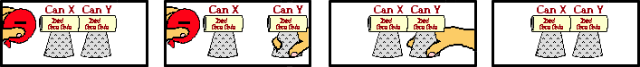

a. positively-charged b. negatively-charged

c. neutral d. impossible to tell

**Question 17:**

aa. Two neutral conducting pop cans are touching each other. A negatively-charged balloon is brought near one of the cans. The cans are separated while the balloon is nearby. After the balloon is removed the cans are brought back together. When touching again, can Y is ____.

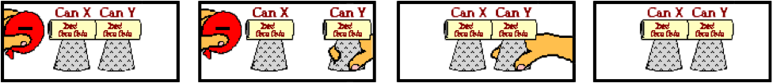

a. impossible to tell b. neutral

c. positively-charged d. negatively-charged

**Question 18:**

aa. Two neutral conducting pop cans are touching each other. A negatively-charged balloon is brought near one of the cans. The cans are separated while the balloon is nearby. After the balloon is removed the cans are brought back together. When touching again, can X is ____.



a. positively-charged b. negatively-charged

c. neutral d. impossible to tell

**Question 19:**

aa. Two neutral conducting pop cans are touching each other. A negatively-charged balloon is brought near one of the cans. The cans are separated while the balloon is nearby. After the balloon is removed the cans are brought back together. When touching again, can X is ____.



a. neutral b. impossible to tell

c. positively-charged d. negatively-charged

**Question 20:**

aa. Two neutral conducting pop cans are touching each other. A positively-charged balloon is brought near one of the cans. The cans are separated while the balloon is nearby. After the balloon is removed the cans are brought back together. When touching again, can Y is ____.

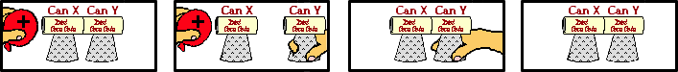

a. positively-charged b. negatively-charged

c. neutral d. impossible to tell

**Question 21:**

aa. Two neutral conducting pop cans are touching each other. A positively-charged balloon is brought near one of the cans. The cans are separated while the balloon is nearby. After the balloon is removed the cans are brought back together. When touching again, can Y is ____.



a. impossible to tell b. neutral

c. positively-charged d. negatively-charged

**Question 22:**

aa. Two neutral conducting pop cans are touching each other. A positively-charged balloon is brought near one of the cans. The cans are separated while the balloon is nearby. After the balloon is removed the cans are brought back together. When touching again, can X is ____.



a. positively-charged b. negatively-charged

c. neutral d. impossible to tell

**Question 23:**

aa. Two neutral conducting pop cans are touching each other. A positively-charged balloon is brought near one of the cans. The cans are separated while the balloon is nearby. After the balloon is removed the cans are brought back together. When touching again, can X is ____.



a. neutral b. impossible to tell

c. positively-charged d. negatively-charged

**Question 24:**

aa. Two neutral conducting pop cans are touching each other. A negatively-charged balloon is brought near one of the cans. As the balloon approaches, some _____. List all that apply in alphabetical order with no commas or spaces between letters.

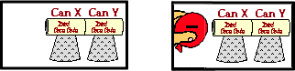

a. protons begin to move from can X to can Y

b. protons begin to move from can Y to can X

c. electrons begin to move from can X to can Y

d. electrons begin to move from can Y to can X

e. ... nonsense! None of these occur.

**Question 25:**

aa. Two neutral conducting pop cans are touching each other. A negatively-charged balloon is brought near one of the cans. As the balloon approaches, some _____. List all that apply in alphabetical order with no commas or spaces between letters.



a. electrons begin to move from can X to can Y

b. electrons begin to move from can Y to can X

c. protons begin to move from can X to can Y

d. protons begin to move from can Y to can X

e. ... nonsense! None of these occur.

**Question 26:**

aa. Two neutral conducting pop cans are touching each other. A positively-charged balloon is brought near one of the cans. As the balloon approaches, some _____. List all that apply in alphabetical order with no commas or spaces between letters.



a. protons begin to move from can X to can Y

b. protons begin to move from can Y to can X

c. electrons begin to move from can X to can Y

d. electrons begin to move from can Y to can X

e. ... nonsense! None of these occur.

**Question 27:**

aa. Two neutral conducting pop cans are touching each other. A positively-charged balloon is brought near one of the cans. As the balloon approaches, some _____. List all that apply in alphabetical order with no commas or spaces between letters.



a. electrons begin to move from can X to can Y

b. electrons begin to move from can Y to can X

c. protons begin to move from can X to can Y

d. protons begin to move from can Y to can X

e. ... nonsense! None of these occur.

**Question 28:**

aa. Two neutral conducting pop cans are touching each other. A negatively-charged balloon is brought near Can X. Once brought near, one might notice that can X has an excess of ____ charge and can Y has an excess of ____ charge.



a. negative, positive b. positive, negative

c. negative, neutral d. neutral, negative

e. positive, neutral f. neutral, positive

g. negative, negative h. positive, positive

**Question 29:**

aa. Two neutral conducting pop cans are touching each other. A negatively-charged balloon is brought near Can X as shown below. Once brought near, one might notice that can X has an excess of ____ charge and can Y has an excess of ____ charge.



a. negative, negative b. positive, positive

c. positive, neutral d. neutral, positive

e. negative, neutral f. neutral, negative

g. negative, positive h. positive, negative

**Question 30:**

aa. Two neutral conducting pop cans are touching each other. A positively-charged balloon is brought near Can X. Once brought near, one might notice that can X has an excess of ____ charge and can Y has an excess of ____ charge.



a. negative, positive b. positive, negative

c. negative, neutral d. neutral, negative

e. positive, neutral f. neutral, positive

g. negative, negative h. positive, positive

**Question 31:**

aa. Two neutral conducting pop cans are touching each other. A positively-charged balloon is brought near Can X. Once brought near, one might notice that can X has an excess of ____ charge and can Y has an excess of ____ charge.



a. negative, negative b. positive, positive

c. positive, neutral d. neutral, positive

e. negative, neutral f. neutral, negative

g. negative, positive h. positive, negative

**Question 32:**

aa. Two neutral conducting pop cans are touching each other. A negatively-charged balloon is brought near Can X. Which of the following occur as the balloon approaches Can X? List all that apply in alphabetical order with no commas or spaces between letters.



a. Electrons jump from the balloon to can X.

b. Electrons jump from the balloon to can Y.

c. Electrons jump from can X to the balloon.

d. Electrons jump from can Y to the balloon.

e. Protons jump from the balloon to can X.

f. Protons jump from can X to the balloon.

g. ... nonsense! None of these occur.

**Question 33:**

aa. Two neutral conducting pop cans are touching each other. A negatively-charged balloon is brought near Can X. Which of the following occur as the balloon approaches Can X? List all that apply in alphabetical order with no commas or spaces between letters.



a. Protons jump from the balloon to can X.

b. Protons jump from can X to the balloon.

c. Electrons jump from can Y to the balloon.

d. Electrons jump from can X to the balloon.

e. Electrons jump from the balloon to can X.

f. Electrons jump from the balloon to can Y.

g. ... nonsense! None of these occur.

**Question 34:**

aa. Two neutral conducting pop cans are touching each other. A positively-charged balloon is brought near Can X. Which of the following occur as the balloon approaches Can X? List all that apply in alphabetical order with no commas or spaces between letters.



a. Electrons jump from the balloon to can X.

b. Electrons jump from the balloon to can Y.

c. Electrons jump from can X to the balloon.

d. Electrons jump from can Y to the balloon.

e. Protons jump from the balloon to can X.

f. Protons jump from can X to the balloon.

g. ... nonsense! None of these occur.

**Question 35:**

aa. Two neutral conducting pop cans are touching each other. A positively-charged balloon is brought near Can X. Which of the following occur as the balloon approaches Can X? List all that apply in alphabetical order with no commas or spaces between letters.



a. Protons jump from the balloon to can X.

b. Protons jump from can X to the balloon.

c. Electrons jump from can Y to the balloon.

d. Electrons jump from can X to the balloon.

e. Electrons jump from the balloon to can X.

f. Electrons jump from the balloon to can Y.

g. ... nonsense! None of these occur.

**Question 36:**

aa. TRUE or FALSE?

Two neutral conducting pop cans are touching each other. A negatively-charged balloon is brought near Can X. As the balloon approaches Can X, there is a movement of electrons between the balloon and can X (in one direction or the other).

a. TRUE b. FALSE

**Question 37:**

aa. TRUE or FALSE?

Two neutral conducting pop cans are touching each other. A positively-charged balloon is brought near Can X. As the balloon approaches Can X, there is a movement of electrons between the balloon and can X (in one direction or the other).

a. TRUE b. FALSE

**Question 38:**

aa. Two neutral conducting pop cans are touching each other. A negatively-charged balloon is brought near one of the cans. The cans are separated while the balloon is nearby. During the process, can X becomes charged positively because _____.



a. protons leave can Y and enter can X

b. electrons leave can Y and enter can X

c. electrons leave can X and enter can Y

d. electrons leave can X and enter the balloon

e. ... nonsense! Can X does not become charged positively.

**Question 39:**

aa. Two neutral conducting pop cans are touching each other. A positively-charged balloon is brought near one of the cans. The cans are separated while the balloon is nearby. During the process, can X becomes charged negatively because _____.



a. protons leave can Y and enter can X

b. electrons leave can Y and enter can X

c. electrons leave can X and enter can Y

d. electrons leave the balloon and enter can X

e. ... nonsense! Can X does not become charged negatively.

**Question 40:**

aa. Two neutral conducting pop cans are touching each other. A positively-charged balloon is brought near one of the cans. The cans are separated while the balloon is nearby. During the process, can Y becomes charged positively because _____.



a. protons leave can Y and enter can X

b. electrons leave can Y and enter can X

c. electrons leave can X and enter can Y

d. electrons leave the balloon, enter can X and then enter can Y

e. ... nonsense! Can X does not become charged positively.

**SE6: Charging by Induction – a Single Sphere**

**Question 1:**

aa. A negatively-charged balloon is brought near a neutral conducting sphere. While the balloon is near, the sphere is touched (grounded). The ground is removed, while the balloon is still near.

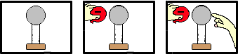

The sphere is being charged by the method of ____.

a. friction b. conduction c. induction

d. reduction e. deduction f. oxidation

**Question 2:**

aa. A positively-charged balloon is brought near a neutral conducting sphere. While the balloon is near, the sphere is touched (grounded). The ground is removed, while the balloon is still near.

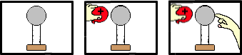

The sphere is being charged by the method of ____.

a. reduction b. deduction c. oxidation

d. friction e. conduction f. induction

**Question 3:**

aa. A negatively-charged balloon is brought near a neutral conducting sphere. While the balloon is near, the sphere is touched (grounded). The ground is removed, while the balloon is still near.



The sphere is being charged by the method of ____.

a. induction b. reduction

c. deduction d. oxidation

e. friction f. conduction

**Question 4:**

aa. A negatively-charged balloon is brought near a neutral conducting sphere. While the balloon is near, the sphere is touched (grounded). The ground is removed, while the balloon is still near.



As a result, the sphere will be ____ .

a. positively-charged

b. negatively-charged

c. neutral

**Question 5:**

aa. A negatively-charged balloon is brought near a neutral conducting sphere. While the balloon is near, the sphere is touched (grounded). The ground is removed, while the balloon is still near.



As a result, the sphere will be ____ .

a. negatively-charged

b. positively-charged

c. neutral

**Question 6:**

aa. A positively-charged balloon is brought near a neutral conducting sphere. While the balloon is near, the sphere is touched (grounded). The ground is removed, while the balloon is still near.



As a result, the sphere will be ____ .

a. positively-charged

b. negatively-charged

c. neutral

**Question 7:**

aa. A positively-charged balloon is brought near a neutral conducting sphere. While the balloon is near, the sphere is touched (grounded). The ground is removed, while the balloon is still near.



As a result, the sphere will be ____ .

a. negatively-charged

b. positively-charged

c. neutral

**Question 8:**

aa. A negatively-charged balloon is brought near a neutral conducting sphere. While the balloon is near, the sphere is touched (grounded). The ground is removed, while the balloon is still near.



Afterwards, the balloon will be ____.

a. positively-charged

b. negatively-charged

c. neutral

**Question 9:**

aa. A negatively-charged balloon is brought near a neutral conducting sphere. While the balloon is near, the sphere is touched (grounded). The ground is removed, while the balloon is still near.



Afterwards, the balloon will be ____.

a. negatively-charged

b. positively-charged

c. neutral

**Question 10:**

aa. A positively-charged balloon is brought near a neutral conducting sphere. While the balloon is near, the sphere is touched (grounded). The ground is removed, while the balloon is still near.



Afterwards, the balloon will be ____.

a. positively-charged

b. negatively-charged

c. neutral

**Question 11:**

aa. A positively-charged balloon is brought near a neutral conducting sphere. While the balloon is near, the sphere is touched (grounded). The ground is removed, while the balloon is still near.



Afterwards, the balloon will be ____.

a. negatively-charged

b. positively-charged

c. neutral

**Question 12:**

aa. A negatively-charged balloon is brought near a neutral conducting sphere. While the balloon is near, the sphere is touched (grounded).



At this point, there is a movement of electrons. Electrons move ____ .

a. into the sphere from the ground (hand)

b. out of the sphere into the ground (hand)

c. into the sphere from the balloon

d. out of the sphere into the balloon

e. from the ground through the sphere to the balloon

f. from the balloon through the sphere to the ground

g. .... nonsense! Electrons do not move at all.

**Question 13:**

aa. A negatively-charged balloon is brought near a neutral conducting sphere. While the balloon is near, the sphere is touched (grounded).



At this point, there is a movement of electrons. Electrons move ____ .

a. into the sphere from the balloon

b. out of the sphere into the balloon

c. into the sphere from the ground (hand)

d. out of the sphere into the ground (hand)

e. from the ground through the sphere to the balloon

f. from the balloon through the sphere to the ground

g. .... nonsense! Electrons do not move at all.

**Question 14:**

aa. A negatively-charged balloon is brought near a neutral conducting sphere. While the balloon is near, the sphere is touched (grounded).



At this point, there is a movement of electrons. Electrons move ____ .

a. from the ground through the sphere to the balloon

b. from the balloon through the sphere to the ground

c. out of the sphere into the ground (hand)

d. into the sphere from the ground (hand)

e. into the sphere from the balloon

f. out of the sphere into the balloon

g. .... nonsense! Electrons do not move at all.

**Question 15:**

aa. A positively-charged balloon is brought near a neutral conducting sphere. While the balloon is near, the sphere is touched (grounded).



At this point, there is a movement of electrons. Electrons move ____ .

a. into the sphere from the ground (hand)

b. out of the sphere into the ground (hand)

c. into the sphere from the balloon

d. out of the sphere into the balloon

e. from the ground through the sphere to the balloon

f. from the balloon through the sphere to the ground

g. .... nonsense! Electrons do not move at all.

**Question 16:**

aa. A positively-charged balloon is brought near a neutral conducting sphere. While the balloon is near, the sphere is touched (grounded).



At this point, there is a movement of electrons. Electrons move ____ .

a. into the sphere from the balloon

b. out of the sphere into the balloon

c. into the sphere from the ground (hand)

d. out of the sphere into the ground (hand)

e. from the ground through the sphere to the balloon

f. from the balloon through the sphere to the ground

g. .... nonsense! Electrons do not move at all.

**Question 17:**

aa. A positively-charged balloon is brought near a neutral conducting sphere. While the balloon is near, the sphere is touched (grounded).



At this point, there is a movement of electrons. Electrons move ____ .

a. from the ground through the sphere to the balloon

b. from the balloon through the sphere to the ground

c. out of the sphere into the ground (hand)

d. into the sphere from the ground (hand)

e. into the sphere from the balloon

f. out of the sphere into the balloon

g. .... nonsense! Electrons do not move at all.

**Question 18:**

aa. A negatively-charged balloon is brought near a neutral conducting sphere. As the balloon is brought near, there is a movement of electrons.

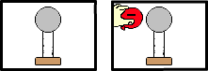

Electrons move ____ .

a. out of the sphere into the balloon

b. into the sphere from the balloon

c. from the left side of the sphere to the right side

d. from the right side of the sphere to the left side

e. out of the sphere into the surrounding air

f. into the sphere from the surrounding air

g. ... nonsense! There is no movement of electrons.

**Question 19:**

aa. A negatively-charged balloon is brought near a neutral conducting sphere. As the balloon is brought near, there is a movement of electrons.



Electrons move ____ .

a. out of the sphere into the surrounding air

b. into the sphere from the surrounding air

c. out of the sphere into the balloon

d. into the sphere from the balloon

e. from the left side of the sphere to the right side

f. from the right side of the sphere to the left side

g. ... nonsense! There is no movement of electrons.

**Question 20:**

aa. A negatively-charged balloon is brought near a neutral conducting sphere. As the balloon is brought near, there is a movement of electrons.



Electrons move ____ .

a. from the left side of the sphere to the right side

b. from the right side of the sphere to the left side

c. out of the sphere into the balloon

d. into the sphere from the balloon

e. out of the sphere into the surrounding air

f. into the sphere from the surrounding air

g. ... nonsense! There is no movement of electrons.

**Question 21:**

aa. A positively-charged balloon is brought near a neutral conducting sphere. As the balloon is brought near, there is a movement of electrons.

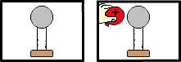

Electrons move ____ .

a. out of the sphere into the surrounding air

b. into the sphere from the surrounding air

c. out of the sphere into the balloon

d. into the sphere from the balloon

e. from the left side of the sphere to the right side

f. from the right side of the sphere to the left side

g. ... nonsense! There is no movement of electrons.

**Question 22:**

aa. A positively-charged balloon is brought near a neutral conducting sphere. As the balloon is brought near, there is a movement of electrons.



Electrons move ____ .

a. out of the sphere into the surrounding air

b. into the sphere from the surrounding air

c. from the right side of the sphere to the left side

d. from the left side of the sphere to the right side

e. out of the sphere into the balloon

f. into the sphere from the balloon

g. ... nonsense! There is no movement of electrons.

**Question 23:**

aa. A positively-charged balloon is brought near a neutral conducting sphere. As the balloon is brought near, there is a movement of electrons.



Electrons move ____ .

a. from the left side of the sphere to the right side

b. from the right side of the sphere to the left side

c. out of the sphere into the balloon

d. into the sphere from the balloon

e. out of the sphere into the surrounding air

f. into the sphere from the surrounding air

g. ... nonsense! There is no movement of electrons.

**Question 24:**

aa. A negatively-charged balloon is brought near a neutral conducting sphere. While the balloon is near, the sphere is touched (grounded).



At this point, there is a movement of protons. Protons move ____ .

a. from the ground through the sphere to the balloon

b. from the balloon through the sphere to the ground

c. out of the sphere into the ground (hand)

d. into the sphere from the ground (hand)

e. into the sphere from the balloon

f. out of the sphere into the balloon

g. .... nonsense! Protons do not move at all.

**Question 25:**

aa. A positively-charged balloon is brought near a neutral conducting sphere. While the balloon is near, the sphere is touched (grounded).



At this point, there is a movement of protons. Protons move ____ .

a. from the ground through the sphere to the balloon

b. from the balloon through the sphere to the ground

c. out of the sphere into the ground (hand)

d. into the sphere from the ground (hand)

e. into the sphere from the balloon

f. out of the sphere into the balloon

g. .... nonsense! Protons do not move at all.

**Question 26:**

aa. A negatively-charged balloon is brought near a neutral conducting sphere.



As the balloon is brought near, there is a movement of protons. Protons move ____ .

a. out of the sphere into the surrounding air

b. into the sphere from the surrounding air

c. out of the sphere into the balloon

d. into the sphere from the balloon

e. from the left side of the sphere to the right side

f. from the right side of the sphere to the left side

g. ... nonsense! There is no movement of protons.

**Question 27:**

aa. A positively-charged balloon is brought near a neutral conducting sphere.



As the balloon is brought near, there is a movement of protons. Protons move ____ .

a. out of the sphere into the surrounding air

b. into the sphere from the surrounding air

c. out of the sphere into the balloon

d. into the sphere from the balloon

e. from the left side of the sphere to the right side

f. from the right side of the sphere to the left side

g. ... nonsense! There is no movement of protons.

**Question 28:**

aa. A negatively-charged balloon is brought near a neutral conducting sphere as shown below.

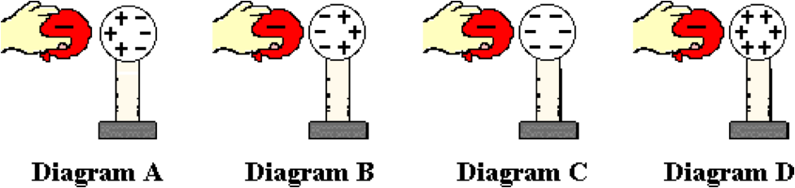

As it approaches, charge within the sphere will distribute itself in a very specific manner. Which one of the diagrams below properly depicts the distribution of charge in the sphere?

**Question 29:**

aa. A negatively-charged balloon is brought near a neutral conducting sphere as shown below.

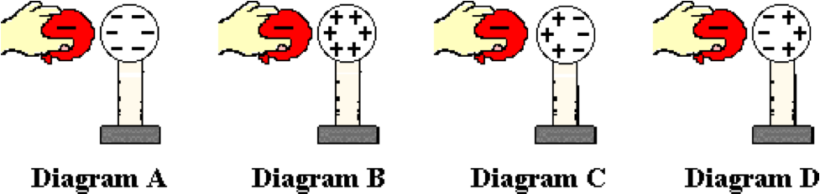

As it approaches, charge within the sphere will distribute itself in a very specific manner. Which one of the diagrams below properly depicts the distribution of charge in the sphere?

**Question 30:**

aa. A positively-charged balloon is brought near a neutral conducting sphere as shown below.

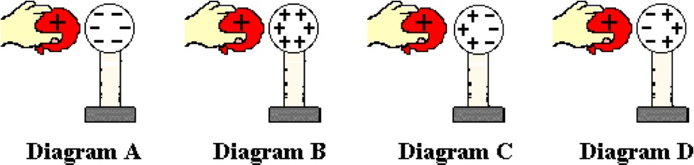

As it approaches, charge within the sphere will distribute itself in a very specific manner. Which one of the diagrams below properly depicts the distribution of charge in the sphere?

**Question 31:**

aa. A positively-charged balloon is brought near a neutral conducting sphere as shown below.

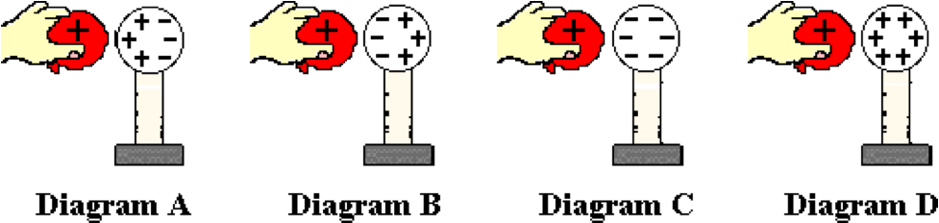

As it approaches, charge within the sphere will distribute itself in a very specific manner. Which one of the diagrams below properly depicts the distribution of charge in the sphere?

**Question 32:**

aa. Suppose that a charged balloon is used to charge a neutral object by the method of induction. One can be sure that the charge that the neutral object would acquire is ______

a. the same as the type of charge on the balloon

b. the opposite of the type of charge on the balloon

c. not at all dependent upon the type of charge on the balloon

d. ... nonsense! You can't be sure of anything in this world.

**Question 33:**

aa. Suppose that a charged balloon is used to charge a neutral object by the method of induction. One can be sure that the charge that the neutral object would acquire is ______

a. the opposite of the type of charge on the balloon

b. the same as the type of charge on the balloon

c. not at all dependent upon the type of charge on the balloon

d. ... nonsense! You can't be sure of anything in this world.

**Question 34:**

aa. Suppose that a charged balloon is used to charge a neutral object by the method of induction. One can be sure that the charge that the neutral object would acquire is ______

a. not at all dependent upon the type of charge on the balloon

b. the same as the type of charge on the balloon

c. the opposite of the type of charge on the balloon

d. ... nonsense! You can't be sure of anything in this world.

**SE7: Charging by Induction – Electrophorous Plate.**

**Question 1:**

aa. A negatively-charged piece of Styrofoam is placed on the table. A neutral aluminum plate is brought near. While held above the Styrofoam, the aluminum plate is touched (grounded). The ground is removed, while the aluminum pie plate is still above the Styrofoam.

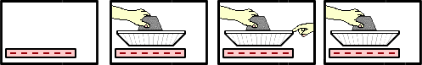

The aluminum pie plate is being charged by the method of ____.

a. friction b. conduction c. induction

d. reduction e. deduction f. oxidation

**Question 2:**

aa. A positively-charged piece of Styrofoam is placed on the table. A neutral aluminum plate is brought near. While held above the Styrofoam, the aluminum plate is touched (grounded). The ground is removed, while the aluminum pie plate is still above the Styrofoam.

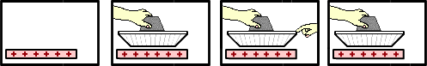

The aluminum pie plate is being charged by the method of ____.

a. reduction b. deduction c. oxidation

d. friction e. conduction f. induction

**Question 3:**

aa. A negatively-charged piece of Styrofoam is placed on the table. A neutral aluminum plate is brought near. While held above the Styrofoam, the aluminum plate is touched (grounded). The ground is removed, while the aluminum pie plate is still above the Styrofoam.

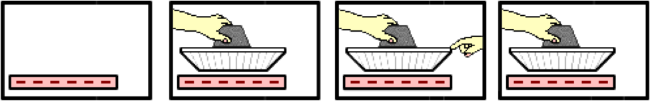

The aluminum pie plate is being charged by the method of ____.

a. induction b. reduction c. deduction

d. oxidation e. friction f. conduction

**Question 4:**

aa. A negatively-charged piece of Styrofoam is placed on the table. A neutral aluminum plate is brought near. While held above the Styrofoam, the aluminum plate is touched (grounded). The ground is removed, while the aluminum pie plate is still above the Styrofoam.



As a result, the aluminum pie plate will be ____.

a. positively-charged

b. negatively-charged

c. neutral

**Question 5:**

aa. A negatively-charged piece of Styrofoam is placed on the table. A neutral aluminum plate is brought near. While held above the Styrofoam, the aluminum plate is touched (grounded). The ground is removed, while the aluminum pie plate is still above the Styrofoam.



As a result, the aluminum pie plate will be ____ .

a. negatively-charged

b. positively-charged

c. neutral

**Question 6:**

aa. A positively-charged piece of Styrofoam is placed on the table. A neutral aluminum plate is brought near. While held above the Styrofoam, the aluminum plate is touched (grounded). The ground is removed, while the aluminum pie plate is still above the Styrofoam.



As a result, the aluminum pie plate will be ____ .

a. positively-charged

b. negatively-charged

c. neutral

**Question 7:**

aa. A positively-charged piece of Styrofoam is placed on the table. A neutral aluminum plate is brought near. While held above the Styrofoam, the aluminum plate is touched (grounded). The ground is removed, while the aluminum pie plate is still above the Styrofoam.



As a result, the aluminum pie plate will be ____ .

a. negatively-charged

b. positively-charged

c. neutral

**Question 8:**

aa. A negatively-charged piece of Styrofoam is placed on the table. A neutral aluminum plate is brought near. While held above the Styrofoam, the aluminum plate is touched (grounded). The ground is removed, while the aluminum pie plate is still above the Styrofoam.



As a result, the Styrofoam will be ____ .

a. positively-charged

b. negatively-charged

c. neutral

**Question 9:**

aa. A negatively-charged piece of Styrofoam is placed on the table. A neutral aluminum plate is brought near. While held above the Styrofoam, the aluminum plate is touched (grounded). The ground is removed, while the aluminum pie plate is still above the Styrofoam.



As a result, the Styrofoam will be ____ .

a. negatively-charged

b. positively-charged

c. neutral

**Question 10:**

aa. A positively-charged piece of Styrofoam is placed on the table. A neutral aluminum plate is brought near. While held above the Styrofoam, the aluminum plate is touched (grounded). The ground is removed, while the aluminum pie plate is still above the Styrofoam.



As a result, the Styrofoam will be ____ .

a. positively-charged

b. negatively-charged

c. neutral

**Question 11:**

aa. A positively-charged piece of Styrofoam is placed on the table. A neutral aluminum plate is brought near. While held above the Styrofoam, the aluminum plate is touched (grounded). The ground is removed, while the aluminum pie plate is still above the Styrofoam.



As a result, the Styrofoam will be ____ .

a. negatively-charged

b. positively-charged

c. neutral

**Question 12:**

aa. A negatively-charged piece of styrofoam is placed on the table. A neutral aluminum plate is brought near. While held above the styrofoam, the aluminum plate is touched (grounded).

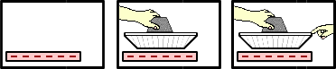

At this point, there is a movement of electrons. Electrons move ____ .

a. into the aluminum plate from the ground (hand)

b. out of the aluminum plate into the ground (hand)

c. into the aluminum plate from the Styrofoam

d. out of the aluminum plate into the Styrofoam

e. from the ground through the aluminum plate to the Styrofoam

f. from the Styrofoam through the aluminum plate to the ground

g. .... nonsense! Electrons do not move at all.

**Question 13:**

aa. A negatively-charged piece of Styrofoam is placed on the table. A neutral aluminum plate is brought near. While held above the Styrofoam, the aluminum plate is touched (grounded).

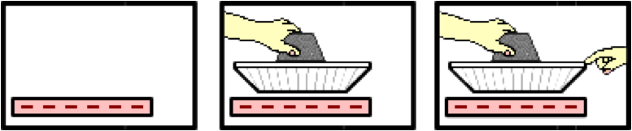

At this point, there is a movement of electrons. Electrons move ____ .

a. into the aluminum plate from the Styrofoam

b. out of the aluminum plate into the Styrofoam

c. into the aluminum plate from the ground (hand)

d. out of the aluminum plate into the ground (hand)

e. from the ground through the aluminum plate to the Styrofoam

f. from the Styrofoam through the aluminum plate to the ground

g. .... nonsense! Electrons do not move at all.

**Question 14:**

aa. A negatively-charged piece of Styrofoam is placed on the table. A neutral aluminum plate is brought near. While held above the Styrofoam, the aluminum plate is touched (grounded).



At this point, there is a movement of electrons. Electrons move ____ .

a. from the ground through the aluminum plate to the Styrofoam

b. from the Styrofoam through the aluminum plate to the ground

c. out of the aluminum plate into the ground (hand)

d. into the aluminum plate from the ground (hand)

e. into the aluminum plate from the Styrofoam

f. out of the aluminum plate into the Styrofoam

g. .... nonsense! Electrons do not move at all.

**Question 15:**

aa. A positively-charged piece of Styrofoam is placed on the table. A neutral aluminum plate is brought near. While held above the Styrofoam, the aluminum plate is touched (grounded).



At this point, there is a movement of electrons. Electrons move ____ .

a. into the aluminum plate from the ground (hand)

b. out of the aluminum plate into the ground (hand)

c. into the aluminum plate from the Styrofoam

d. out of the aluminum plate into the Styrofoam

e. from the ground through the aluminum plate to the Styrofoam

f. from the Styrofoam through the aluminum plate to the ground

g. .... nonsense! Electrons do not move at all.

**Question 16:**

aa. A positively-charged piece of Styrofoam is placed on the table. A neutral aluminum plate is brought near. While held above the Styrofoam, the aluminum plate is touched (grounded).



At this point, there is a movement of electrons. Electrons move ____ .

a. into the aluminum plate from the Styrofoam

b. out of the aluminum plate into the Styrofoam

c. into the aluminum plate from the ground (hand)

d. out of the aluminum plate into the ground (hand)

e. from the ground through the aluminum plate to the Styrofoam

f. from the Styrofoam through the aluminum plate to the ground

g. .... nonsense! Electrons do not move at all.

**Question 17:**

aa. A positively-charged piece of Styrofoam is placed on the table. A neutral aluminum plate is brought near. While held above the Styrofoam, the aluminum plate is touched (grounded).



At this point, there is a movement of electrons. Electrons move ____ .

a. from the ground through the aluminum plate to the Styrofoam

b. from the Styrofoam through the aluminum plate to the ground

c. out of the aluminum plate into the ground (hand)

d. into the aluminum plate from the ground (hand)

e. into the aluminum plate from the Styrofoam

f. out of the aluminum plate into the Styrofoam

g. .... nonsense! Electrons do not move at all.

**Question 18:**

aa. A negatively-charged piece of Styrofoam is placed on the table. A neutral aluminum plate is brought near. As the aluminum plate approaches, there is a movement of electrons.

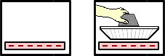

Electrons move ____ .

a. out of the aluminum plate into the Styrofoam

b. into the aluminum plate from the Styrofoam

c. from the bottom of the aluminum plate to the top

d. from the top of the aluminum plate to the bottom

e. out of the aluminum plate into the surrounding air

f. into the aluminum plate from the surrounding air

g. ... nonsense! There is no movement of electrons.

**Question 19:**

aa. A negatively-charged piece of Styrofoam is placed on the table. A neutral aluminum plate is brought near. As the aluminum plate approaches, there is a movement of electrons.



Electrons move ____ .

a. out of the aluminum plate into the surrounding air

b. into the aluminum plate from the surrounding air

c. out of the aluminum plate into the Styrofoam

d. into the aluminum plate from the Styrofoam

e. from the bottom of the aluminum plate to the top

f. from the top of the aluminum plate to the bottom

g. ... nonsense! There is no movement of electrons.

**Question 20:**

aa. A negatively-charged piece of Styrofoam is placed on the table. A neutral aluminum plate is brought near. As the aluminum plate approaches, there is a movement of electrons.



Electrons move ____ .

a. from the bottom of the aluminum plate to the top

b. from the top of the aluminum plate to the bottom

c. out of the aluminum plate into the Styrofoam

d. into the aluminum plate from the Styrofoam

e. out of the aluminum plate into the surrounding air

f. into the aluminum plate from the surrounding air

g. ... nonsense! There is no movement of electrons.

**Question 21:**

aa. A positively-charged piece of Styrofoam is placed on the table. A neutral aluminum plate is brought near. As the aluminum plate approaches, there is a movement of electrons.

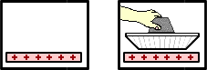

Electrons move ____ .

a. out of the aluminum plate into the surrounding air

b. into the aluminum plate from the surrounding air

c. out of the aluminum plate into the Styrofoam

d. into the aluminum plate from the Styrofoam

e. from the bottom of the aluminum plate to the top

f. from the top of the aluminum plate to the bottom

g. ... nonsense! There is no movement of electrons.

**Question 22:**

aa. A positively-charged piece of Styrofoam is placed on the table. A neutral aluminum plate is brought near. As the aluminum plate approaches, there is a movement of electrons.



Electrons move ____ .

a. out of the aluminum plate into the surrounding air

b. into the aluminum plate from the surrounding air

c. from the top of the aluminum plate to the bottom

d. from the bottom of the aluminum plate to the top

e. out of the aluminum plate into the Styrofoam

f. into the aluminum plate from the Styrofoam

g. ... nonsense! There is no movement of electrons.

**Question 23:**

aa. A positively-charged piece of Styrofoam is placed on the table. A neutral aluminum plate is brought near. As the aluminum plate approaches, there is a movement of electrons.



Electrons move ____ .

a. from the bottom of the aluminum plate to the top

b. from the top of the aluminum plate to the bottom

c. out of the aluminum plate into the Styrofoam

d. into the aluminum plate from the Styrofoam

e. out of the aluminum plate into the surrounding air

f. into the aluminum plate from the surrounding air

g. ... nonsense! There is no movement of electrons.

**Question 24:**

aa. A negatively-charged piece of Styrofoam is placed on the table. A neutral aluminum plate is brought near. While held above the Styrofoam, the aluminum plate is touched (grounded).



At this point, there is a movement of protons. Protons move ____ .

a. from the ground through the aluminum plate to the Styrofoam

b. from the styrofoam through the aluminum plate to the ground

c. out of the aluminum plate into the ground (hand)

d. into the aluminum plate from the ground (hand)

e. into the aluminum plate from the Styrofoam

f. out of the aluminum plate into the Styrofoam

g. .... nonsense! Protons do not move at all.

**Question 25:**

aa. A positively-charged piece of Styrofoam is placed on the table. A neutral aluminum plate is brought near. While held above the Styrofoam, the aluminum plate is touched (grounded).



At this point, there is a movement of protons. Protons move ____ .

a. from the ground through the aluminum plate to the Styrofoam

b. from the styrofoam through the aluminum plate to the ground

c. out of the aluminum plate into the ground (hand)

d. into the aluminum plate from the ground (hand)

e. into the aluminum plate from the Styrofoam

f. out of the aluminum plate into the Styrofoam

g. .... nonsense! Protons do not move at all.

**Question 26:**

aa. A negatively-charged piece of Styrofoam is placed on the table. A neutral aluminum plate is brought near. As the aluminum plate approaches, there is a movement of protons.



Protons move ____ .

a. out of the aluminum plate into the surrounding air

b. into the aluminum plate from the surrounding air

c. out of the aluminum plate into the Styrofoam

d. into the aluminum plate from the Styrofoam

e. from the bottom of the aluminum plate to the top

f. from the top of the aluminum plate to the bottom

g. ... nonsense! There is no movement of protons.

**Question 27:**

aa. A positively-charged piece of Styrofoam is placed on the table. A neutral aluminum plate is brought near. As the aluminum plate approaches, there is a movement of protons.



Protons move ____ .

a. out of the aluminum plate into the surrounding air

b. into the aluminum plate from the surrounding air

c. out of the aluminum plate into the Styrofoam

d. into the aluminum plate from the Styrofoam

e. from the bottom of the aluminum plate to the top

f. from the top of the aluminum plate to the bottom

g. ... nonsense! There is no movement of protons.

**Question 28:**

aa. A negatively-charged piece of Styrofoam is placed on the table. A neutral aluminum plate is brought near. As the aluminum plate approaches, charge within the aluminum plate will distribute itself in a very specific manner. Which one of the diagrams below properly depicts the distribution of charge on the aluminum plate?

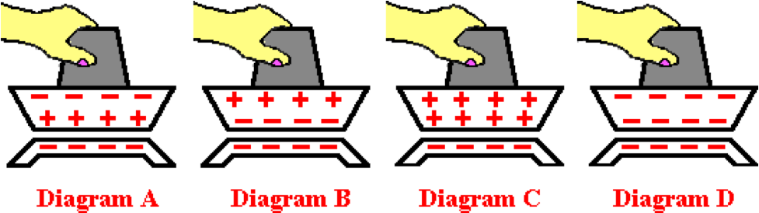

**Question 29:**

aa. A negatively-charged piece of Styrofoam is placed on the table. A neutral aluminum plate is brought near. As the aluminum plate approaches, charge within the aluminum plate will distribute itself in a very specific manner. Which one of the diagrams below properly depicts the distribution of charge on the aluminum plate?

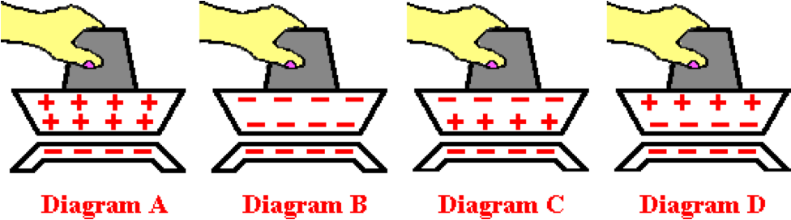

**Question 30:**

aa. A positively-charged piece of Styrofoam is placed on the table. A neutral aluminum plate is brought near. As the aluminum plate approaches, charge within the aluminum plate will distribute itself in a very specific manner. Which one of the diagrams below properly depicts the distribution of charge on the aluminum plate?

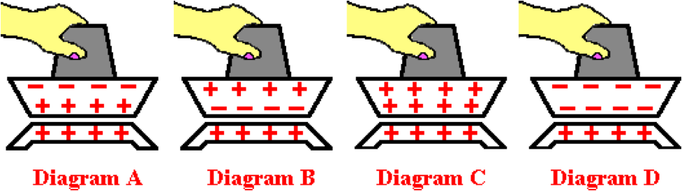

**Question 31:**

aa. A positively-charged piece of Styrofoam is placed on the table. A neutral aluminum plate is brought near. As the aluminum plate approaches, charge within the aluminum plate will distribute itself in a very specific manner. Which one of the diagrams below properly depicts the distribution of charge on the aluminum plate?

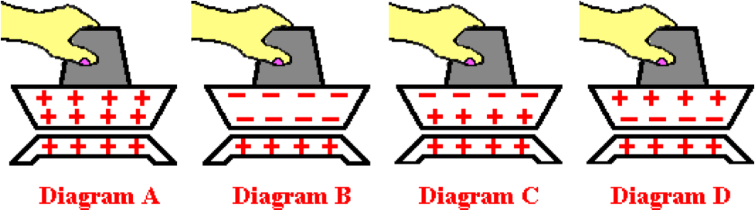

**Question 32:**

aa. Suppose that a charged balloon is used to charge a neutral object by the method of induction. One can be sure that the charge that the neutral object would acquire is ______

a. the same as the type of charge on the balloon

b. the opposite of the type of charge on the balloon

c. not at all dependent upon the type of charge on the balloon

d. ... nonsense! You can't be sure of anything in this world.

**Question 33:**

aa. Suppose that a charged balloon is used to charge a neutral object by the method of induction. One can be sure that the charge that the neutral object would acquire is ______

a. the opposite of the type of charge on the balloon

b. the same as the type of charge on the balloon

c. not at all dependent upon the type of charge on the balloon

d. ... nonsense! You can't be sure of anything in this world.

**Question 34:**

aa. Suppose that a charged balloon is used to charge a neutral object by the method of induction. One can be sure that the charge that the neutral object would acquire is ______

a. not at all dependent upon the type of charge on the balloon

b. the same as the type of charge on the balloon

c. the opposite of the type of charge on the balloon

d. ... nonsense! You can't be sure of anything in this world.

**SE8: Coulomb’s Law Equation as a Guide to Thinking**

**Question 1:**

aa. What is the unit of charge?

a. volt b. ampere c. watt

d. coulomb e. joule

**Question 2:**

aa. What is the unit of charge?

a. volt b. joule c. ampere

d. watt e. coulomb

**Question 3:**

aa. A coulomb is a unit of ____.

a. current b. charge c. potential difference

d. potential energy e. power

**Question 4:**

aa. A coulomb is a unit of ____.

a. current b. potential difference c. charge

d. potential energy e. power

**Question 5:**

aa. The electrical force between two objects depends on the ___ and ___ the objects.

a. mass of; distance between b. mass of; size of

c. charge on; distance between d. charge on; size of

e. mass of; charge on

**Question 6:**

aa. The electrical force between two objects depends on the ___ and ___ the objects.

a. mass of; size of b. mass of; distance between

c. mass of; charge on d. charge on; size of

e. charge on; distance between

**Question 7:**

aa. The electrical force between two objects depends on the ___ and ___ the objects.

a. charge on; distance between b. mass of; distance between

c. mass of; size of d. charge on; size of

e. mass of; charge on

**Question 8:**

aa. The electrical force between two objects depends on the ___ and ___ the objects.

a. mass of; distance between b. charge on; distance between

c. mass of; charge on d. charge on; size of

e. mass of; size of

**Question 9:**

aa. Which of the following would cause the electrical force between two objects to increase? List all that apply in alphabetical order without any spaces between letters.

a. increase the charge on one object

b. increase the charge on both objects

c. increase the mass of one object

d. increase the mass of both objects

e. increase the distance between the objects' centers

f. decrease the distance between the objects' centers

**Question 10:**

aa. Which of the following would cause the electrical force between two objects to increase? List all that apply in alphabetical order without any spaces between letters.

a. increase the distance between the objects' centers

b. decrease the distance between the objects' centers

c. increase the mass of one object

d. increase the mass of both objects

e. increase the charge on one object

f. increase the charge on both objects

**Question 11:**

aa. Which of the following would cause the electrical force between two objects to decrease? List all that apply in alphabetical order without any spaces between letters.

a. increase the charge on one object

b. increase the charge on both objects

c. increase the mass of one object

d. increase the mass of both objects

e. increase the distance between the objects' centers

f. decrease the distance between the objects' centers

**Question 12:**

aa. Which of the following would cause the electrical force between two objects to decrease? List all that apply in alphabetical order without any spaces between letters.

a. increase the distance between the objects' centers

b. decrease the distance between the objects' centers

c. increase the mass of one object

d. increase the mass of both objects

e. increase the charge on one object

f. increase the charge on both objects

**Question 13:**

aa. Doubling the distance between two charged objects will cause the electrical force between them to be ___ the initial force.

a. the same as b. four times c. one-fourth d. three times

e. one-third f. twice g. one-half

**Question 14:**

aa. Doubling the distance between two charged objects will cause the electrical force between them to be ___ the initial force.

a. the same as b. one-half c. one-third d. one-fourth

e. twice f. three times g. four times

**Question 15:**

aa. Halving the distance (i.e., decreasing by a factor of two) between two charged objects will cause the electrical force between them to be ___ the initial force.

a. the same as b. twice c. one-half d. three times

e. one-third f. four times g. one-fourth

**Question 16:**

aa. Halving the distance (i.e., decreasing by a factor of two) between two charged objects will cause the electrical force between them to be ___ the initial force.

a. the same as b. one-half c. one-third d. one-fourth

e. twice f. three times g. four times

**Question 17:**

aa. Tripling the distance between two charged objects will cause the electrical force between them to be ___ the initial force.

a. nine times b. one-ninth c. six times d. one-sixth

e. three times f. one-third g. the same as

**Question 18:**

aa. Tripling the distance between two charged objects will cause the electrical force between them to be ___ the initial force.

a. the same as b. one-third c. one-sixth d. one-ninth

e. three times f. six times g. nine times

**Question 19:**

aa. The electrical force between two objects is 36 N. If the distance between the objects is doubled, the force between them will be ___.

a. 4 N b. 9 N c. 12 N d. 18 N

e. 36 N f. 72 N g. 108 N h. 144 N

i. 324 N j. none of these are correct

**Question 20:**

aa. The electrical force between two objects is 36 N. If the distance between the objects is tripled, the force between them will be ___.

a. 4 N b. 9 N c. 12 N d. 18 N

e. 36 N f. 72 N g. 108 N h. 144 N

i. 324 N j. none of these are correct

**Question 21:**

aa. The electrical force between two objects is 36 N. If the distance between the objects is cut in half, the force between them will be ___.

a. 4 N b. 9 N c. 12 N d. 18 N

e. 36 N f. 72 N g. 108 N h. 144 N

i. 324 N j. none of these are correct

**Question 22:**

aa. The electrical force between two objects is 36 N. If the distance between the objects is doubled, the force between them will be ___.

a. 324 N b. 144 N c. 108 N d. 72 N

e. 36 N f. 18 N g. 12 N h. 9 N

i. 4 N j. none of these are correct

**Question 23:**

aa. The electrical force between two objects is 36 N. If the distance between the objects is tripled, the force between them will be ___.

a. 324 N b. 144 N c. 108 N d. 72 N

e. 36 N f. 18 N g. 12 N h. 9 N

i. 4 N j. none of these are correct

**Question 24:**

aa. The electrical force between two objects is 36 N. If the distance between the objects is cut in half, the force between them will be ___.

a. 324 N b. 144 N c. 108 N d. 72 N

e. 36 N f. 18 N g. 12 N h. 9 N

i. 4 N j. none of these are correct

**Question 25:**

aa. The electrical force between two objects is 36 N. If the charge on one of the objects is doubled, the force between them will be ___.

a. 4 N b. 9 N c. 12 N d. 18 N

e. 36 N f. 72 N g. 108 N h. 144 N

i. 324 N j. none of these are correct

**Question 26:**

aa. The electrical force between two objects is 36 N. If the charge on BOTH of the objects is doubled, the force between them will be ___.

a. 4 N b. 9 N c. 12 N d. 18 N

e. 36 N f. 72 N g. 108 N h. 144 N

i. 324 N j. none of these are correct

**Question 27:**

aa. The electrical force between two objects is 36 N. If the charge on one of the objects is tripled, the force between them will be ___.

a. 4 N b. 9 N c. 12 N d. 18 N

e. 36 N f. 72 N g. 108 N h. 144 N

i. 324 N j. none of these are correct

**Question 28:**

aa. The electrical force between two objects is 36 N. If the charge on BOTH of the objects is tripled, the force between them will be ___.

a. 4 N b. 9 N c. 12 N d. 18 N

e. 36 N f. 72 N g. 108 N h. 144 N

i. 324 N j. none of these are correct

**Question 29:**

aa. The electrical force between two objects is 36 N. If the charge on one of the objects is cut in half, the force between them will be ___.

a. 4 N b. 9 N c. 12 N d. 18 N

e. 36 N f. 72 N g. 108 N h. 144 N

i. 324 N j. none of these are correct

**Question 30:**

aa. The electrical force between two objects is 36 N. If the charge on BOTH of the objects is cut in half, the force between them will be ___.

a. 4 N b. 9 N c. 12 N d. 18 N

e. 36 N f. 72 N g. 108 N h. 144 N

i. 324 N j. none of these are correct

**Question 31:**

aa. The electrical force between two objects is 36 N. If the charge on one of the objects is doubled AND the distance between them is doubled, the force between them will be ___.

a. 4 N b. 9 N c. 12 N d. 18 N

e. 36 N f. 72 N g. 108 N h. 144 N

i. 324 N j. none of these are correct

**Question 32:**

aa. The electrical force between two objects is 36 N. If the charge on BOTH of the objects is doubled AND the distance between them is doubled, the force between them will be ___.

a. 4 N b. 9 N c. 12 N d. 18 N

e. 36 N f. 72 N g. 108 N h. 144 N

i. 324 N j. none of these are correct

**Question 33:**

aa. The electrical force between two objects is 36 N. If the charge on one of the objects is doubled AND the distance between them is tripled, the force between them will be ___.

a. 4 N b. 8 N c. 12 N d. 18 N

e. 36 N f. 72 N g. 108 N h. 144 N

i. 324 N j. none of these are correct

**Question 34:**

aa. The electrical force between two objects is 36 N. If the charge on BOTH of the objects is doubled AND the distance between them is tripled, the force between them will be ___.

a. 4 N b. 9 N c. 16 N d. 18 N

e. 36 N f. 72 N g. 108 N h. 144 N

i. 324 N j. none of these are correct

**Question 35:**

aa. The electrical force between two objects is 36 N. If the charge on one of the objects is tripled AND the distance between them is doubled, the force between them will be ___.

a. 4 N b. 8 c. 12 N d. 18 N

e. 36 N f. 72 N g. 108 N h. 144 N

i. 324 N j. none of these are correct

**Question 36:**

aa. The electrical force between two objects is 36 N. If the charge on BOTH of the objects is tripled AND the distance between them is doubled, the force between them will be ___.

a. 4 N b. 9 N c. 16 N d. 18 N

e. 36 N f. 72 N g. 108 N h. 144 N

i. 324 N j. none of these are correct

**Question 37:**

aa. The electrical force between two objects is 36 N. If the charge on BOTH of the objects is tripled AND the distance between them is tripled, the force between them will be ___.

a. 4 N b. 9 N c. 16 N d. 18 N

e. 36 N f. 72 N g. 108 N h. 144 N

i. 324 N j. none of these are correct

**SE9: Coulomb’s Law Calculations**

**Question 1:**

aa. Two objects (X and Y) are placed a distance of 0.300 m from each other. The charge on X is 1.38 x 10-6 C and the charge on Y is 2.48 x 10-6 C. What is the value of the electrical force (in Newton) between the two objects? Enter a numerical answer.

**Question 2:**

aa. Two objects (X and Y) are placed a distance of 0.400 m from each other. The charge on X is 3.83 x 10-6 C and the charge on Y is 4.43 x 10-6 C. What is the value of the electrical force (in Newton) between the two objects? Enter a numerical answer.

**Question 3:**

aa. Two objects (X and Y) are placed a distance of 0.600 m from each other. The charge on X is 5.99 x 10-6 C and the charge on Y is 6.80 x 10-6 C. What is the value of the electrical force (in Newton) between the two objects? Enter a numerical answer.

**Question 4:**

aa. Two objects (X and Y) are placed a distance of 0.800 m from each other. The charge on X is 6.65 x 10-6 C and the charge on Y is 7.73 x 10-6 C. What is the value of the electrical force (in Newton) between the two objects? Enter a numerical answer.

**Question 5:**

aa. Two objects (X and Y) are placed a distance of 0.800 m from each other. The charge on X is 7.52 x 10-6 C and the charge on Y is 8.37 x 10-6 C. What is the value of the electrical force (in Newton) between the two objects? Enter a numerical answer.

**Question 6:**

aa. Two objects (X and Y) are placed a distance of 0.900 m from each other. The charge on X is 8.45 x 10-6 C and the charge on Y is 9.49 x 10-6 C. What is the value of the electrical force (in Newton) between the two objects? Enter a numerical answer.

**Question 7:**

aa. Two objects (X and Y) are placed a particular distance from each other. The charge on X is 1.16 x 10-6 C and the charge on Y is 2.68 x 10-6 C. If the force between the objects is 0.0500 N, what is the distance (in meters) between the two objects? Enter a numerical answer.

**Question 8:**

aa. Two objects (X and Y) are placed a particular distance from each other. The charge on X is 3.87 x 10-6 C and the charge on Y is 4.44 x 10-6 C. If the force between the objects is 0.0800 N, what is the distance (in meters) between the two objects? Enter a numerical answer.

**Question 9:**

aa. Two objects (X and Y) are placed a particular distance from each other. The charge on X is 5.54 x 10-6 C and the charge on Y is 6.10 x 10-6 C. If the force between the objects is 0.200 N, what is the distance (in meters) between the two objects? Enter a numerical answer.

**Question 10:**

aa. Two objects (X and Y) are placed a particular distance from each other. The charge on X is 7.95 x 10-6 C and the charge on Y is 8.15 x 10-6 C. If the force between the objects is 0.250 N, what is the distance (in meters) between the two objects? Enter a numerical answer.

**Question 11:**

aa. Two objects (X and Y) are placed a particular distance from each other. The charge on X is 7.55 x 10-6 C and the charge on Y is 8.98 x 10-6 C. If the force between the objects is 0.350 N, what is the distance (in meters) between the two objects? Enter a numerical answer.

**Question 12:**

aa. Two objects (X and Y) are placed a particular distance from each other. The charge on X is 8.37 x 10-6 C and the charge on Y is 9.44 x 10-6 C. If the force between the objects is 0.380 N, what is the distance (in meters) between the two objects? Enter a numerical answer.

**SE10: Electric Field**

**Question 1:**

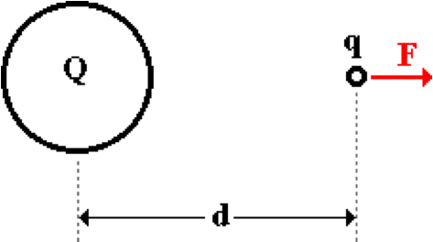aa. A charge Q creates an electric field. A test charge q is used to measure the strength of the electric field at a distance d from Q. The force F is experienced by the test charge q. The electric field strength at this location is given by the expression ___. List the two that apply in alphabetical order with no commas or spaces between letters.

a. F/Q b. F/q c. F/d2

d. kq/d2 e. kQ/d2 f. FQ/d2

**Question 2:**

aa. A charge Q creates an electric field. A test charge q is used to measure the strength of the electric field at a distance d from Q. The force F is experienced by the test charge q. The electric field strength at this location is given by the expression ___. List the two that apply in alphabetical order with no commas or spaces between letters.

a. F/d2 b. kq/d2 c. kQ/d2

d. FQ/d2 e. F/Q f. F/q

**Question 3:**

aa. A charge Q creates an electric field. A test charge q is used to measure the strength of the electric field at a distance d from Q. The force F is experienced by the test charge q. The electric field strength at this location is given by the expression ___. List the two that apply in alphabetical order with no commas or spaces between letters.

a. F/q b. F/Q c. FQ/d2

d. kQ/d2 e. kq/d2 f. F/d2

**Question 4:**

aa. A charge Q creates an electric field. A test charge q is used to measure the strength of the electric field at a distance d from Q. The force F is experienced by the test charge q. The electric field strength at this location is given by the expression ___. List the two that apply in alphabetical order with no commas or spaces between letters.

a. kq/d2 b. F/d2 c. FQ/d2

d. kQ/d2 e. F/q f. F/Q

**Question 5:**

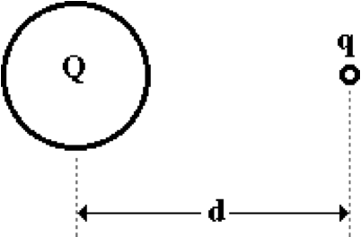aa. A charge Q creates an electric field. A test charge q is used to measure the strength of the electric field at a distance d from Q. The electric field strength is defined as ____.

a. the force on charge q

b. the force on charge Q

c. the force on q per distance from Q

d. the force per charge on the test charge

e. the effect on charge q

f. none of these

**Question 6:**

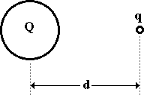aa. A charge Q creates an electric field. A test charge q is used to measure the strength of the electric field at a distance d from Q. The electric field strength is defined as ____.

a. the force on charge Q

b. the force on charge q

c. the force per charge on the test charge

d. the effect on charge q

e. the force on q per distance from Q

f. none of these

**Question 7:**

aa. A charge Q creates an electric field. A test charge q is used to measure the strength of the electric field at a distance d from Q. The electric field strength is defined as ____.

a. the force per charge on the test charge

b. the force on q per distance from Q

c. the force on charge q

d. the force on charge Q

e. the effect on charge q

f. none of these

**Question 8:**

aa. A charge Q creates an electric field. A test charge q is used to measure the strength of the electric field at a distance d from Q. The electric field strength is defined as ____.

a. the effect on charge q

b. the force on charge q

c. the force on charge Q

d. the force on q per distance from Q

e. the force per charge on the test charge

f. none of these

**Question 9:**

aa. The standard metric unit on electric field strength is the ____.

a. Newton b. Newton/m

c. Newton/m2 d. Coulomb

e. Coulomb/meter f. Coulomb/Newton

g. Newton/Coulomb h. None of these

**Question 10:**

aa. The standard metric unit on electric field strength is the ____.

a. Coulomb b. Coulomb/meter

c. Coulomb/Newton d. Newton

e. Newton/m f. Newton/Coulomb

g. Newton/m2 h. None of these

**Question 11:**

aa. The standard metric unit on electric field strength is the ____.

a. Coulomb b. Newton

c. Coulomb/meter d. Coulomb/Newton

e. Newton/Coulomb f. Newton/m

g. Newton/m2 h. None of these

**Question 12:**

aa. The standard metric unit on electric field strength is the ____.

a. Newton/m2 b. Coulomb/meter

c. Newton/m d. Newton/Coulomb

e. Coulomb f. Coulomb/Newton

g. Newton h. None of these

**Question 13:**

aa. A 4 microCoulomb charge exerts a force of 9.0 x 106 Newton on a 3.0 x 10-9 Coulomb test charge. The electric field strength created by the 4 microCoulomb charge is ____ N/C.

a. 2.67 x 10-9 b. 3.33 x 10-4

c. 3.75 x 10-4 d. 1.13

e. 2.40 x 101 f. 8.89 x 10-1

g. 2.67 x 106 h. 3.00 x 103

**Question 14:**

aa. A 4 microCoulomb charge exerts a force of 9.0 x 106 Newton on a 3.0 x 10-9 Coulomb test charge. The electric field strength created by the 4 microCoulomb charge is ____ N/C.

a. 1.13 b. 2.40 x 101

c. 2.67 x 10-9 d. 2.67 x 106

e. 3.00 x 103 f. 3.33 x 10-4

g. 3.75 x 10-4 h. 8.89 x 10-1

**Question 15:**

aa. An 8 microCoulomb charge exerts a force of 4.0 x 1106 Newton on a 6.0 x 10-9 Coulomb test charge. The electric field strength created by the 8 microCoulomb charge is ____ N/C.

a. 1.20 x 10-8 b. 7.50 x 10-4

c. 1.50x 10-3 d. 5.00 x 10-1

e. 2.00 f. 1.08 x 102

g. 6.67 x 102 h. 1.33 x 104

i. 2.70 x 107

**Question 16:**

aa. An 8 microCoulomb charge exerts a force of 4.0 x 106 Newton on a 6.0 x 10-9 Coulomb test charge. The electric field strength created by the 8 microCoulomb charge is ____ N/C.

a. 1.08 x 102 b. 1.20 x 10-8

c. 1.33 x 104 d. 1.50x 10-3

e. 2.00 f. 2.70 x 107

g. 5.00 x 10-1 h. 6.67 x 102

i. 7.50 x 10-4

**Question 17:**

aa. **TRUE** or **FALSE**

The quantity electric field is a vector quantity.

a. True b. False

**Question 18:**

aa. **TRUE** or **FALSE**

The quantity electric field is a scalar quantity.

a. True b. False

**Question 19:**

aa. **TRUE** or **FALSE**

The quantity electric field is a vector quantity.

a. True b. False

**Question 20:**

aa. By convention, the direction of the electric field is ____.

a. the direction of the force on a test charge

b. away from the charge which creates the electric field

c. towards the charge which creates the electric field

d. away from the test charge

e. towards the test charge

f. in the direction which a positive test charge would accelerate

g. in the direction which a negative test charge would accelerate

h. in any direction which one wishes it to be

**Question 21:**

aa. By convention, the direction of the electric field is ____.

a. away from the test charge

b. towards the test charge

c. away from the charge which creates the electric field

d. in the direction which a negative test charge would accelerate

e. in the direction which a positive test charge would accelerate

f. towards the charge which creates the electric field

g. the direction of the force on a test charge

h. in any direction which one wishes it to be

**Question 22:**

aa. By convention, the direction of the electric field is ____.

a. the direction of the force on a test charge

b. in the direction which a positive test charge would accelerate

c. in the direction which a negative test charge would accelerate

d. away from the test charge

e. away from the charge which creates the electric field

f. towards the test charge

g. towards the charge which creates the electric field

h. in any direction which one wishes it to be

**Question 23:**

aa. By convention, the direction of the electric field is ____.

a. towards the charge which creates the electric field

b. towards the test charge

c. away from the charge which creates the electric field

d. away from the test charge

e. the direction of the force on a test charge

f. in the direction which a negative test charge would accelerate

g. in the direction which a positive test charge would accelerate

h. in any direction which one wishes it to be

**Question 24:**

aa. A positive charge creates an electric field. The direction of the electric field would be ____.

a. away from the positive charge

b. towards the positive charge

c. dependent upon whether the test charge is positive or negative

d. none of these

**Question 25:**

aa. A positive charge creates an electric field. The direction of the electric field would be ____.

a. towards the positive charge

b. away from the positive charge

c. dependent upon whether the test charge is positive or negative

d. none of these

**Question 26:**

aa. A positive charge creates an electric field. The direction of the electric field would be ____.

a. dependent upon whether the test charge is positive or negative

b. away from the positive charge

c. towards the positive charge

d. none of these

**Question 27:**

aa. A positive charge creates an electric field. The direction of the electric field would be ____.

a. dependent upon whether the test charge is positive or negative

b. towards the positive charge

c. away from the positive charge

d. none of these

**Question 28:**

aa. A negative charge creates an electric field. The direction of the electric field would be ____.

a. away from the negative charge

b. towards the negative charge

c. dependent upon whether the test charge is positive or negative

d. none of these

**Question 29:**

aa. A negative charge creates an electric field. The direction of the electric field would be ____.

a. towards the negative charge

b. away from the negative charge

c. dependent upon whether the test charge is positive or negative

d. none of these

**Question 30:**

aa. A negative charge creates an electric field. The direction of the electric field would be ____.

a. dependent upon whether the test charge is positive or negative

b. away from the negative charge

c. towards the negative charge

d. none of these

**Question 31:**

aa. A negative charge creates an electric field. The direction of the electric field would be ____.

a. dependent upon whether the test charge is positive or negative

b. towards the negative charge

c. away from the negative charge

d. none of these

**SE11: Electric Field Equation**

**Question 1:**

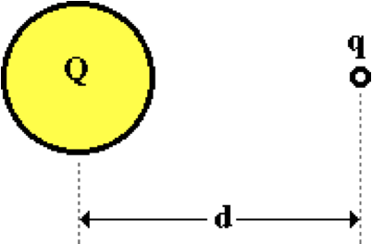aa. A charge Q creates an electric field; a test charge q is placed a distance d away in order to measure the strength of the electric field at that location. Which of the following alterations would INCREASE the electric field strength as measured by the test charge q? List all that apply in alphabetical with no commas nor spaces between letters.

a. Increase the distance d from the charge Q.

b. Decrease the distance d from the charge Q.

c. Increase the amount of charge on q.

d. Decrease the amount of charge on q.

e. Increase the amount of charge on Q.

f. Decrease the amount of charge on Q.

**Question 2:**

aa. A charge Q creates an electric field; a test charge q is placed a distance d away in order to measure the strength of the electric field at that location. Which of the following alterations would INCREASE the electric field strength as measured by the test charge q? List all that apply in alphabetical with no commas nor spaces between letters.

a. Decrease the distance d from the charge Q.

b. Increase the distance d from the charge Q.

c. Decrease the amount of charge on q.

d. Increase the amount of charge on q.

e. Decrease the amount of charge on Q.

f. Increase the amount of charge on Q.

**Question 3:**

aa. A charge Q creates an electric field; a test charge q is placed a distance d away in order to measure the strength of the electric field at that location. Which of the following alterations would DECREASE the electric field strength as measured by the test charge q? List all that apply in alphabetical with no commas nor spaces between letters.

a. Increase the distance d from the charge Q.

b. Decrease the distance d from the charge Q

c. Increase the amount of charge on q.

d. Decrease the amount of charge on q.

e. Increase the amount of charge on Q.

f. Decrease the amount of charge on Q.

**Question 4:**

aa. A charge Q creates an electric field; a test charge q is placed a distance d away in order to measure the strength of the electric field at that location. Which of the following alterations would DECREASE the electric field strength as measured by the test charge q? List all that apply in alphabetical with no commas nor spaces between letters.

a. Decrease the distance d from the charge Q.

b. Increase the distance d from the charge Q.

c. Decrease the amount of charge on q.

d. Increase the amount of charge on q.

e. Decrease the amount of charge on Q.

f. Increase the amount of charge on Q.

**Question 5:**

aa. A charge Q creates an electric field; a test charge q is placed a distance d away in order to measure the strength of the electric field (E) at that location. A doubling of the amount of charge on Q would ___.

a. increase E by a factor of 2

b. decrease E by a factor of 2

c. increase E by a factor of 4

d. decrease E by a factor of 4

e. not alter the electric field strength.

**Question 6:**

aa. A charge Q creates an electric field; a test charge q is placed a distance d away in order to measure the strength of the electric field (E) at that location. A doubling of the amount of charge on Q would ___.

a. increase E by a factor of 4

b. decrease E by a factor of 2

c. decrease E by a factor of 4

d. increase E by a factor of 2

e. not alter the electric field strength.

**Question 7:**

aa. A charge Q creates an electric field; a test charge q is placed a distance d away in order to measure the strength of the electric field (E) at that location. A halving of the amount of charge on Q would ___.

a. decrease E by a factor of 2

b. decrease E by a factor of 4

c. increase E by a factor of 2

d. increase E by a factor of 4

e. not alter the electric field strength.

**Question 8:**

aa. A charge Q creates an electric field; a test charge q is placed a distance d away in order to measure the strength of the electric field (E) at that location. A halving of the amount of charge on Q would ___.

a. increase E by a factor of 2

b. increase E by a factor of 4

c. decrease E by a factor of 2

d. decrease E by a factor of 4

e. not alter the electric field strength.

**Question 9:**

aa. A charge Q creates an electric field; a test charge q is placed a distance d away in order to measure the strength of the electric field (E) at that location. A doubling of the amount of charge on the test charge q would ___.

a. increase E by a factor of 2

b. decrease E by a factor of 2

c. increase E by a factor of 4

d. decrease E by a factor of 4

e. not alter the electric field strength.

**Question 10:**

aa. A charge Q creates an electric field; a test charge q is placed a distance d away in order to measure the strength of the electric field (E) at that location. A doubling of the amount of charge on the test charge q would ___.

a. increase E by a factor of 2

b. increase E by a factor of 4

c. decrease E by a factor of 2

d. decrease E by a factor of 4

e. not alter the electric field strength.

**Question 11:**

aa. A charge Q creates an electric field; a test charge q is placed a distance d away in order to measure the strength of the electric field (E) at that location. A halving of the amount of charge on the test charge q would ___.

a. increase E by a factor of 2

b. decrease E by a factor of 2

c. increase E by a factor of 4

d. decrease E by a factor of 4

e. not alter the electric field strength.

**Question 12:**

aa. A charge Q creates an electric field; a test charge q is placed a distance d away in order to measure the strength of the electric field (E) at that location. A halving of the amount of charge on the test charge q would ___.

a. increase E by a factor of 2

b. increase E by a factor of 4

c. decrease E by a factor of 2

d. decrease E by a factor of 4

e. not alter the electric field strength.

**Question 13:**

aa. A charge Q creates an electric field; a test charge q is placed a distance d away in order to measure the strength of the electric field (E) at that location. A doubling of the distance between Q and test charge q would ___.

a. increase E by a factor of 2

b. decrease E by a factor of 2

c. increase E by a factor of 4

d. decrease E by a factor of 4

e. not alter the electric field strength.

**Question 14:**

aa. A charge Q creates an electric field; a test charge q is placed a distance d away in order to measure the strength of the electric field (E) at that location. A doubling of the distance between Q and test charge q would ___.

a. increase E by a factor of 2

b. increase E by a factor of 4

c. decrease E by a factor of 2

d. decrease E by a factor of 4

e. not alter the electric field strength.

**Question 15:**

aa. A charge Q creates an electric field; a test charge q is placed a distance d away in order to measure the strength of the electric field (E) at that location. A halving of the distance between Q and test charge q would ___.

 a. increase E by a factor of 2

b. decrease E by a factor of 2

c. increase E by a factor of 4

d. decrease E by a factor of 4

e. not alter the electric field strength.

**Question 16:**

aa. A charge Q creates an electric field; a test charge q is placed a distance d away in order to measure the strength of the electric field (E) at that location. A halving of the distance between Q and test charge q would ___.

a. increase E by a factor of 2

b. increase E by a factor of 4

c. decrease E by a factor of 2

d. decrease E by a factor of 4

e. not alter the electric field strength.

**Question 17:**

aa. A charge Q creates an electric field; a test charge q is placed at various labeled locations from the charge Q as shown in the diagram below.

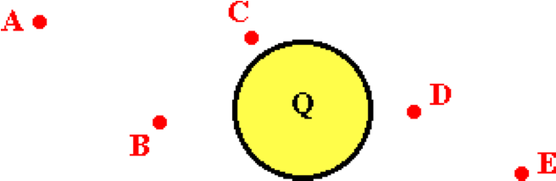

Rank the five locations in order of increasing electric field strength, beginning with the smallest. List the letters in increasing order with no commas or spaces between letters.

**Question 18:**

aa. A charge Q creates an electric field; a test charge q is placed at various labeled locations from the charge Q as shown in the diagram below.

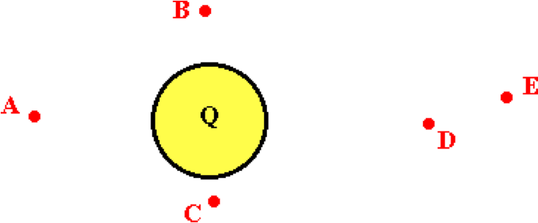

Rank the five locations in order of increasing electric field strength, beginning with the smallest. List the letters in increasing order with no commas or spaces between letters.

**Question 19:**

aa. A charge Q creates an electric field; a test charge q is placed at various labeled locations from the charge Q as shown in the diagram below.

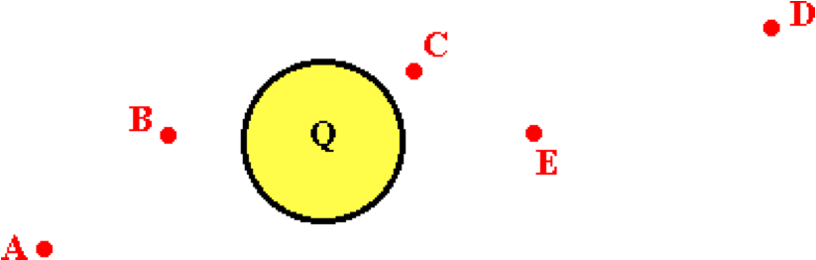

Rank the five locations in order of increasing electric field strength, beginning with the smallest. List the letters in increasing order with no commas or spaces between letters.

**Question 20:**

aa. A charge Q creates an electric field; a test charge q is placed at various labeled locations from the charge Q as shown in the diagram below.

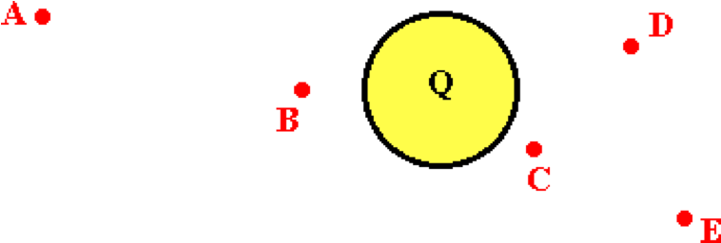

Rank the five locations in order of increasing electric field strength, beginning with the smallest. List the letters in increasing order with no commas or spaces between letters.

**Question 21:**

aa. The electric field strength at a distance of 2.0 meters from a charged Van de Graaff sphere is 32 N/C. The electric field strength a distance of 4.0 meters from the same sphere is ____ N/C.

a. 4 b. 8 c. 16 d. 32

e. 64 f. 128 g. 256

h. None of these are even close.

**Question 22:**

aa. The electric field strength at a distance of 2.0 meters from a charged Van de Graaff sphere is 48 N/C. The electric field strength a distance of 4.0 meters from the same sphere is ____ N/C.

a. 6 b. 12 c. 24 d. 48

e. 96 f. 192 g. 384

h. None of these are even close.

**Question 23:**

aa. The electric field strength at a distance of 2.0 meters from a charged Van de Graaff sphere is 64 N/C. The electric field strength a distance of 4.0 meters from the same sphere is ____ N/C.

a. 8 b. 16 c. 32 d. 64

e. 128 f. 256 g. 512

h. None of these are even close.

**Question 24:**

aa. The electric field strength at a distance of 2.0 meters from a charged Van de Graaff sphere is 96 N/C. The electric field strength a distance of 4.0 meters from the same sphere is ____ N/C.

a. 12 b. 24 c. 48 d. 96

e. 192 f. 384 g. 768

h. None of these are even close.

**Question 25:**

aa. The electric field strength at a distance of 2.0 meters from a charged Van de Graaff sphere is 32 N/C. The electric field strength a distance of 6.0 meters from the same sphere is ____ N/C.

a. 2.67 b. 3.6 c. 10.7 d. 64

e. 96 f. 192 g. 288 h. 384

i. None of these are even close.

**Question 26:**

aa. The electric field strength at a distance of 2.0 meters from a charged Van de Graaff sphere is 48 N/C. The electric field strength a distance of 6.0 meters from the same sphere is ____ N/C.

a. 4 b. 5.3 c. 16 d. 96

e. 144 f. 288 g. 432 h. 576

i. None of these are even close.

**Question 27:**

aa. The electric field strength at a distance of 2.0 meters from a charged Van de Graaff sphere is 64 N/C. The electric field strength a distance of 6.0 meters from the same sphere is ____ N/C.

a. 5.3 b. 7.1 c. 21.3 d. 192

e. 128 f. 384 g. 576 h. 768

i. None of these are even close.

**Question 28:**

aa. The electric field strength at a distance of 2.0 meters from a charged Van de Graaff sphere is 96 N/C. The electric field strength a distance of 6.0 meters from the same sphere is ____ N/C.

a. 8 b. 10.7 c. 32 d. 192

e. 288 f. 576 g. 864 h. 1152

i. None of these are even close.

**Question 29:**

aa. The electric field strength at a distance of 2.0 meters from a charged Van de Graaff sphere is 32 N/C. The electric field strength a distance of 1.0 meters from the same sphere is ____ NC.

a. 4 b. 8 c. 16 d. 32

e. 64 f. 128 g. 256

h. None of these are even close.

**Question 30:**

aa. The electric field strength at a distance of 2.0 meters from a charged Van de Graaff sphere is 48 N/C. The electric field strength a distance of 1.0 meter from the same sphere is ____ N/C.

a. 6 b. 12 c. 24 d. 48

e. 96 f. 192 g. 384

h. None of these are even close.

**Question 31:**

aa. The electric field strength at a distance of 2.0 meters from a charged Van de Graaff sphere is 64 N/C. The electric field strength a distance of 1.0 meter from the same sphere is ____ N/C.

a. 8 b. 16 c. 32 d. 64

e. 128 f. 256 g. 512

h. None of these are even close.

**Question 32:**

aa. The electric field strength at a distance of 2.0 meters from a charged Van de Graaff sphere is 96 N/C. The electric field strength a distance of 1.0 meter from the same sphere is ____ N/C.

a. 12 b. 24 c. 48 d. 96

e. 192 f. 384 g. 768

h. None of these are even close.

**Question 33:**

aa. The electric field strength at a distance of 2.0 meters from a charged Van de Graaff sphere is 32 N/C. The electric field strength a distance of 0.50 meters from the same sphere is ____ N/C.

a. 2 b. 8 c. 16 d. 32

e. 64 f. 128 g. 512

h. None of these are even close.

**Question 34:**

aa. The electric field strength at a distance of 2.0 meters from a charged Van de Graaff sphere is 48 N/C. The electric field strength a distance of 0.50 meters from the same sphere is ____ N/C.

a. 3 b. 12 c. 24 d. 48

e. 96 f. 192 g. 768

h. None of these are even close.

**Question 35:**

aa. The electric field strength at a distance of 2.0 meters from a charged Van de Graaff sphere is 64 N/C. The electric field strength a distance of 0.50 meters from the same sphere is ____ N/C.

a. 4 b. 16 c. 32 d. 64

e. 128 f. 256 g. 512 h. 1024

i. None of these are even close.

**Question 36:**

aa. The electric field strength at a distance of 2.0 meters from a charged Van de Graaff sphere is 96 N/C. The electric field strength a distance of 0.50 meters from the same sphere is ____ N/C.

a. 6 b. 24 c. 48 d. 96

e. 192 f. 384 g. 762 h. 1536

i. None of these are even close.

**SE12: Electric Field Lines**

**Question 1:**

aa. Electric field lines have a distinct direction. In general, electric field lines can be directed ____. List the three that apply in alphabetical order with no commas or spaces between letters.

a. from a + charge to a – charge b. from a - charge to a + charge

c. from a + charge to a + charge d. from a - charge to a - charge

e. from infinity to a – charge f. from infinity to a + charge

g. from a - charge to infinity h. from a + charge to infinity

**Question 2:**

aa. Electric field lines have a distinct direction. In general, electric field lines can be directed ____. List the three that apply in alphabetical order with no commas or spaces between letters.

a. from a - charge to a + charge b. from a + charge to a - charge

c. from a - charge to a – charge d. from a + charge to a + charge

e. from infinity to a + charge f. from infinity to a - charge

g. from a + charge to infinity h. from a - charge to infinity

**Question 3:**

aa. Electric field lines have a distinct direction. In general, electric field lines can be directed ____. List the three that apply in alphabetical order with no commas or spaces between letters.

a. from infinity to a – charge b. from infinity to a + charge

c. from a - charge to infinity d. from a + charge to infinity

e. from a + charge to a + charge f. from a - charge to a - charge

g. from a + charge to a – charge h. from a - charge to a + charge

**Question 4:**

aa. Electric field lines have a distinct direction. In general, electric field lines can be directed ____. List the three that apply in alphabetical order with no commas or spaces between letters.

a. from a + charge to a + charge b. from a - charge to a - charge

c. from a - charge to infinity d. from a + charge to infinity

e. from infinity to a – charge f. from infinity to a + charge

g. from a + charge to a – charge h. from a - charge to a + charge

**Question 5:**

aa. Consider field lines surrounding objects A-E below.

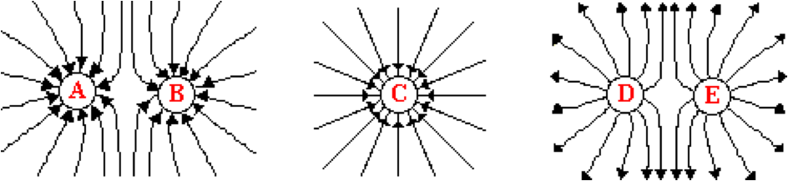

Which of these objects are charged positively? List all that apply in alphabetical order with no commas or spaces between letters.

**Question 6:**

aa. Consider field lines surrounding objects A-E below.

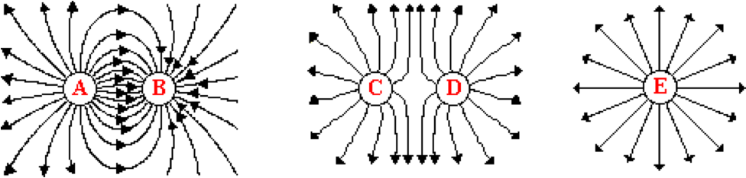

Which of these objects are charged positively? List all that apply in alphabetical order with no commas or spaces between letters.

**Question 7:**

aa. Consider field lines surrounding objects A-E below.

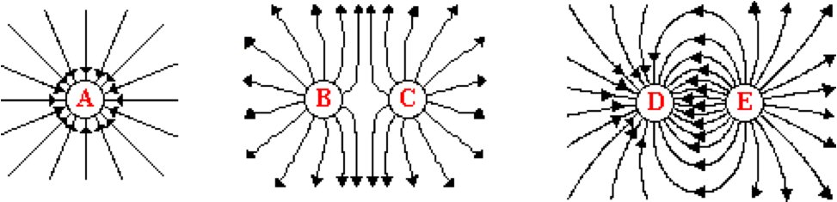

Which of these objects are charged positively? List all that apply in alphabetical order with no commas or spaces between letters.

**Question 8:**

aa. Consider field lines surrounding objects A-E below.

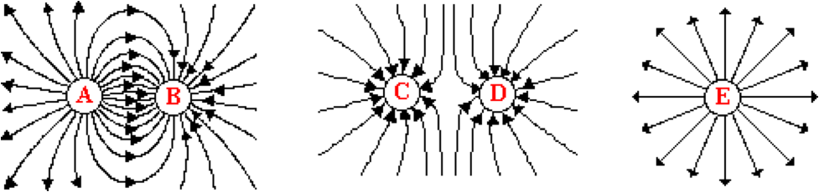

Which of these objects are charged positively? List all that apply in alphabetical order with no commas or spaces between letters.

**Question 9:**

aa. Consider field lines surrounding objects A-E below.



Which of these objects are charged negatively? List all that apply in alphabetical order with no commas or spaces between letters.

**Question 10:**

aa. Consider field lines surrounding objects A-E below.



Which of these objects are charged negatively? List all that apply in alphabetical order with no commas or spaces between letters.

**Question 11:**

aa. Consider field lines surrounding objects A-E below.



Which of these objects are charged negatively? List all that apply in alphabetical order with no commas or spaces between letters.

**Question 12:**

aa. Consider field lines surrounding objects A-E below.



Which of these objects are charged negatively? List all that apply in alphabetical order with no commas or spaces between letters.

**Question 13:**

aa. The three diagrams below represent electric field lines for a configuration of charges.

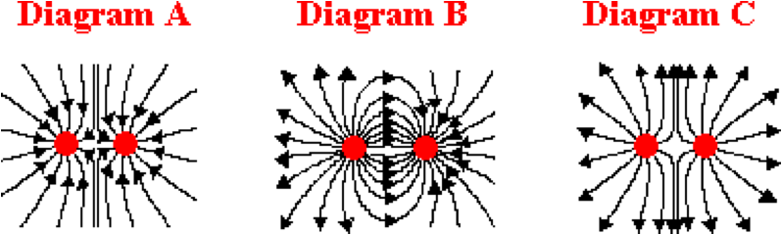

Which diagram(s) correctly represent two like-charged objects? List all that apply with no commas or spaces between letters.

**Question 14:**

aa. The three diagrams below represent electric field lines for a configuration of charges.

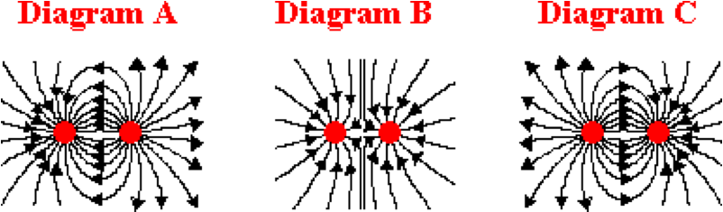

Which diagram(s) correctly represent two like-charged objects? List all that apply with no commas or spaces between letters.

**Question 15:**

aa. The three diagrams below represent electric field lines for a configuration of charges.

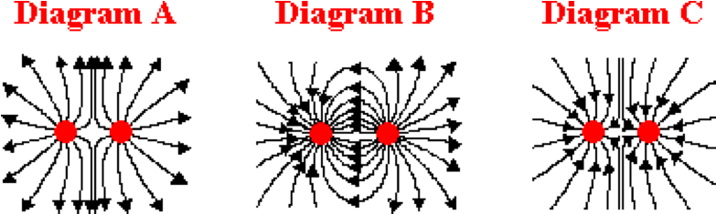

Which diagram(s) correctly represent two like-charged objects? List all that apply with no commas or spaces between letters.

**Question 16:**

aa. The three diagrams below represent electric field lines for a configuration of charges.

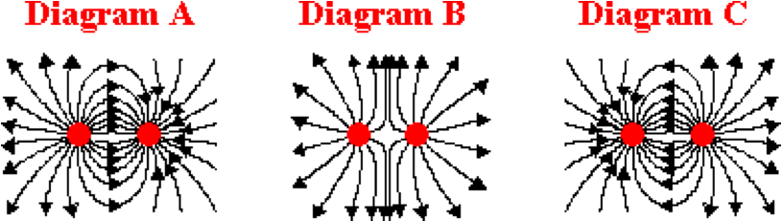

Which diagram(s) correctly represent two like-charged objects? List all that apply with no commas or spaces between letters.

**Question 17:**

aa. The three diagrams below represent electric field lines for a configuration of charges.



Which diagram(s) correctly represent two oppositely-charged objects? List all that apply with no commas or spaces between letters.

**Question 18:**

aa. The three diagrams below represent electric field lines for a configuration of charges.



Which diagram(s) correctly represent two oppositely-charged objects? List all that apply with no commas or spaces between letters.

**Question 19:**

aa. The three diagrams below represent electric field lines for a configuration of charges.



Which diagram(s) correctly represent two oppositely-charged objects? List all that apply with no commas or spaces between letters.

**Question 20:**

aa. The three diagrams below represent electric field lines for a configuration of charges.



Which diagram(s) correctly represent two oppositely-charged objects? List all that apply with no commas or spaces between letters.

**Question 21:**

aa. Two negatively-charged objects A and B are charged and create an electric field. The electric field strength at a point precisely midway between these two charges is 10 N/C, directed leftward.



This provides evidence that ____.

a. the quantity of charge on A is greater than the quantity of charge on B

b. the quantity of charge on A is less than the quantity of charge on B

c. the quantity of charge on A is equal to the quantity of charge on B

d. ... nonsense! This could never be possible. The E is 0 N/C at the midpoint.

e. None of these apply.

**Question 22:**

aa. Two positively-charged objects A and B are charged and create an electric field. The electric field strength at the point precisely midway between these two charges is 10 N/C, directed leftward.



This provides evidence that ____.

a. the quantity of charge on A is equal to the quantity of charge on B

b. the quantity of charge on A is less than the quantity of charge on B

c. the quantity of charge on A is greater than the quantity of charge on B

d. ... nonsense! This could never be possible. The E is 0 N/C at the midpoint.

e. None of these apply.

**Question 23:**

aa. Two negatively-charged objects A and B are charged and create an electric field. The electric field strength at the point precisely midway between these two charges is 10 N/C, directed rightward.



This provides evidence that ____.

a. the quantity of charge on A is greater than the quantity of charge on B

b. the quantity of charge on A is less than the quantity of charge on B

c. the quantity of charge on A is equal to the quantity of charge on B

d. ... nonsense! This could never be possible. The E is 0 N/C at the midpoint.

e. None of these apply.

.

**Question 24:**

aa. Two positively-charged objects A and B are charged and create an electric field. The electric field strength at the point precisely midway between these two charges is 10 N/C, directed rightward.



This provides evidence that ____.

a. the quantity of charge on A is equal to the quantity of charge on B

b. the quantity of charge on A is less than the quantity of charge on B

c. the quantity of charge on A is greater than the quantity of charge on B

d. ... nonsense! This could never be possible. The E is 0 N/C at the midpoint.

e. None of these apply.

**Question 25:**

aa. Electric field lines for charges A and B are shown below.

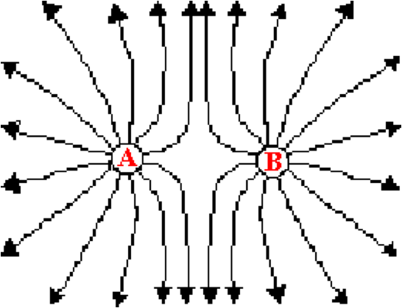

Which of the following statements is/are consistent with the diagram? List all that apply in alphabetical order with no commas or spaces between letters.

a. A is + and B is - b. A is - and B is +

c. Both A and B are + d. Both A and B are -

e. A has more charge than B f. B has more charge than A

g. The charge of A and B are the same.

**Question 26:**

aa. Electric field lines for charges A and B are shown below.



Which of the following statements is/are consistent with the diagram? List all that apply in alphabetical order with no commas or spaces between letters.

a. A is - and B is + b. A is + and B is -

c. Both A and B are - d. Both A and B are +

e. B has more charge than A f. A has more charge than B

g. The charge of A and B are the same.

**Question 27:**

aa. Electric field lines for charges A and B are shown below.

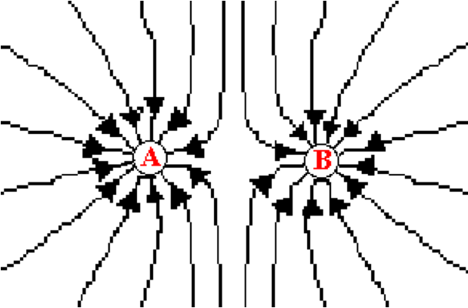

Which of the following statements is/are consistent with the diagram? List all that apply in alphabetical order with no commas or spaces between letters.

a. A has more charge than B b. B has more charge than A

c. Both A and B are - d. Both A and B are +

e. A is + and B is - f. A is - and B is +

g. The charge of A and B are the same.

**Question 28:**

aa. Electric field lines for charges A and B are shown below.



Which of the following statements is/are consistent with the diagram? List all that apply in alphabetical order with no commas or spaces between letters.

a. B has more charge than A b. A has more charge than B

c. Both A and B are + d. Both A and B are -

e. A is - and B is + f. A is + and B is -

g. The charge of A and B are the same.

**Question 29:**

aa. Electric field lines for charges A and B are shown below.

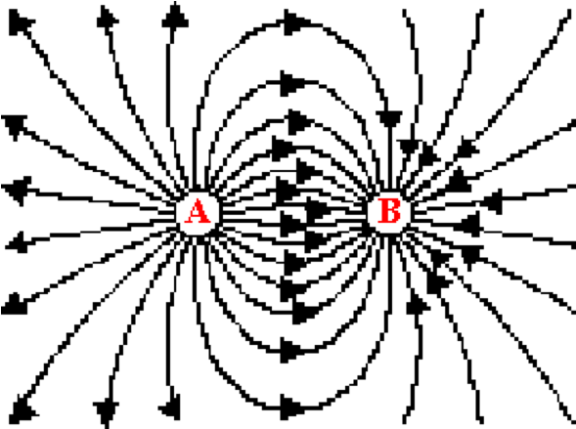

Which of the following statements is/are consistent with the diagram? List all that apply in alphabetical order with no commas or spaces between letters.

a. A is + and B is - b. A is - and B is +

c. Both A and B are + d. Both A and B are -

e. A has more charge than B f. B has more charge than A

g. The charge of A and B are the same.

**Question 30:**

aa. Electric field lines for charges A and B are shown below.



Which of the following statements is/are consistent with the diagram? List all that apply in alphabetical order with no commas or spaces between letters.

a. A is - and B is + b. A is + and B is -

c. Both A and B are - d. Both A and B are +

e. B has more charge than A f. A has more charge than B

g. The charge of A and B are the same.

**Question 31:**

aa. Electric field lines for charges A and B are shown below.

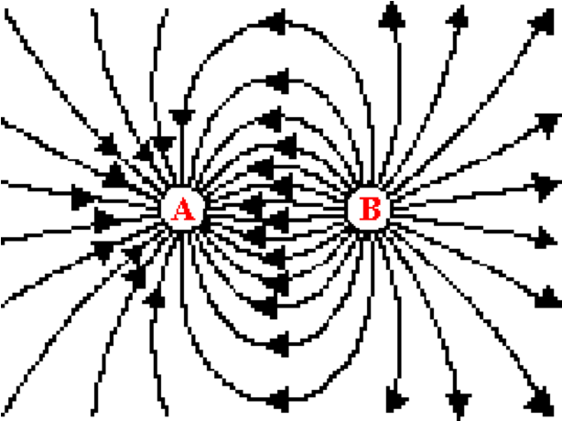

Which of the following statements is/are consistent with the diagram? List all that apply in alphabetical order with no commas or spaces between letters.

a. A has more charge than B b. B has more charge than A

c. Both A and B are - d. Both A and B are +

e. A is + and B is - f. A is - and B is +

g. The charge of A and B are the same.

**Question 32:**

aa. Electric field lines for charges A and B are shown below.



Which of the following statements is/are consistent with the diagram? List all that apply in alphabetical order with no commas or spaces between letters.

a. B has more charge than A b. A has more charge than B

c. Both A and B are + d. Both A and B are -

e. A is - and B is + f. A is + and B is -

g. The charge of A and B are the same.

**Question 33:**

aa. Electric field lines for charges A and B are shown below.

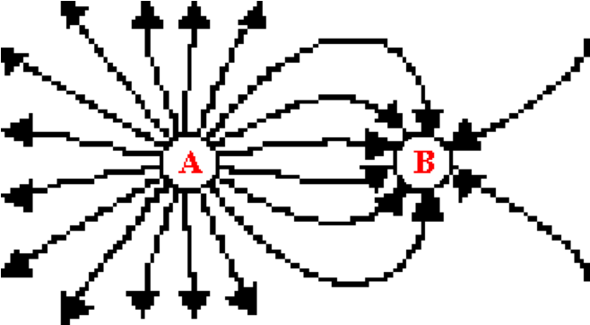

of the following statements is/are consistent with the diagram? List all that apply in alphabetical order with no commas or spaces between letters.

a. A is + and B is - b. A is - and B is +

c. Both A and B are + d. Both A and B are -

E. A has more charge than B f. B has more charge than A

g. The charge of A and B are the same.

**Question 34:**

aa. Electric field lines for charges A and B are shown below.



Which of the following statements is/are consistent with the diagram? List all that apply in alphabetical order with no commas or spaces between letters.

a. A is - and B is + b. A is + and B is -

c. Both A and B are - d. Both A and B are +

e. B has more charge than A f. A has more charge than B

g. The charge of A and B are the same.

**Question 35:**

aa. Electric field lines for charges A and B are shown below.

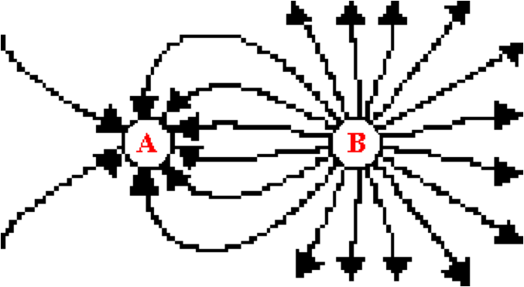

Which of the following statements is/are consistent with the diagram? List all that apply in alphabetical order with no commas or spaces between letters.

a. A has more charge than B b. B has more charge than A

c. Both A and B are - d. Both A and B are +

e. A is + and B is - f. A is - and B is +

g. The charge of A and B are the same.

**Question 36:**

aa. Electric field lines for charges A and B are shown below.



Which of the following statements is/are consistent with the diagram? List all that apply in alphabetical order with no commas or spaces between letters.

a. B has more charge than A b. A has more charge than B

c. Both A and B are + d. Both A and B are -

e. A is - and B is + f. A is + and B is -

g. The charge of A and B are the same.

**Question 37:**

aa. Electric field lines for charges A and B are shown below.

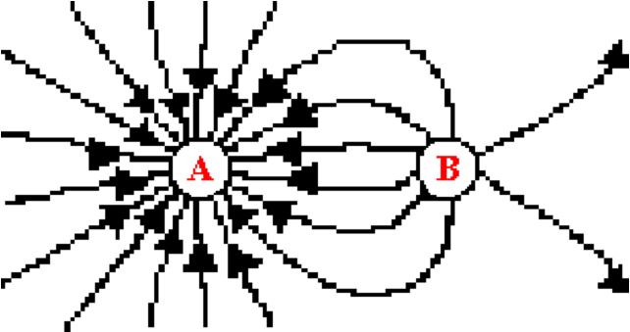

Which of the following statements is/are consistent with the diagram? List all that apply in alphabetical order with no commas or spaces between letters.

a. A is + and B is - b. A is - and B is +

c. Both A and B are + d. Both A and B are -

e. A has more charge than B f. B has more charge than A

g. The charge of A and B are the same.

**Question 38:**

aa. Electric field lines for charges A and B are shown below.



Which of the following statements is/are consistent with the diagram? List all that apply in alphabetical order with no commas or spaces between letters.

a. A is - and B is + b. A is + and B is -

c. Both A and B are - d. Both A and B are +

e. B has more charge than A f. A has more charge than B

g. The charge of A and B are the same.

**Question 39:**

aa. Electric field lines for charges A and B are shown below.

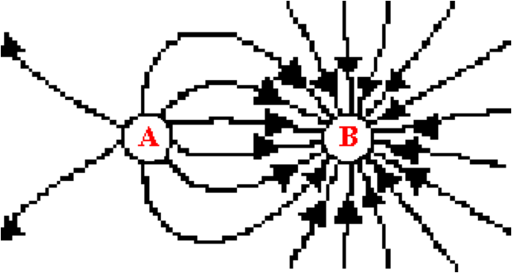

Which of the following statements is/are consistent with the diagram? List all that apply in alphabetical order with no commas or spaces between letters.

a. A has more charge than B b. B has more charge than A

c. Both A and B are - d. Both A and B are +

e. A is + and B is - f. A is - and B is +

g. The charge of A and B are the same.

**Question 40:**

aa. Electric field lines for charges A and B are shown below.



Which of the following statements is/are consistent with the diagram? List all that apply in alphabetical order with no commas or spaces between letters.

a. B has more charge than A b. A has more charge than B

c. Both A and B are + d. Both A and B are -

e. A is - and B is + f. A is + and B is -

g. The charge of A and B are the same.