**Minds On Physics Question Banks – Vectors and Projectiles**

**VP1: Direction of Vectors**

**Question 1:**

aa. According to the counter-clockwise convention, the direction of the vector shown below is closest to ___ degrees.

The answer is a multiple of 15 degrees and between 0 degrees and 345 degrees. Enter a numerical answer.

**Question 2:**

aa. According to the counter-clockwise convention, the direction of the vector shown below is closest to ___ degrees.

The answer is a multiple of 15 degrees and between 0 degrees and 345 degrees. Enter a numerical answer.

**Question 3:**

aa. According to the counter-clockwise convention, the direction of the vector shown below is closest to ___ degrees.

The answer is a multiple of 15 degrees and between 0 degrees and 345 degrees. Enter a numerical answer.

**Question 4:**

aa. According to the counter-clockwise convention, the direction of the vector shown below is closest to ___ degrees.

The answer is a multiple of 15 degrees and between 0 degrees and 345 degrees. Enter a numerical answer.

**Question 5:**

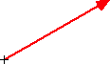aa. According to the counter-clockwise convention, the direction of the vector shown below is closest to ___ degrees.

The answer is a multiple of 15 degrees and between 0 degrees and 345 degrees. Enter a numerical answer.

**Question 6:**

aa. According to the counter-clockwise convention, the direction of the vector shown below is closest to ___ degrees.

The answer is a multiple of 15 degrees and between 0 degrees and 345 degrees. Enter a numerical answer.

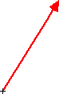**Question 7:**

aa. According to the counter-clockwise convention, the direction of the vector shown below is closest to ___ degrees.

The answer is a multiple of 15 degrees and between 0 degrees and 345 degrees. Enter a numerical answer.

**Question 8:**

aa. According to the counter-clockwise convention, the direction of the vector shown below is closest to ___ degrees.

The answer is a multiple of 15 degrees and between 0 degrees and 345 degrees. Enter a numerical answer.

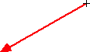**Question 9:**

aa. According to the counter-clockwise convention, the direction of the vector shown below is closest to ___ degrees.

The answer is a multiple of 15 degrees and between 0 degrees and 345 degrees. Enter a numerical answer.

**Question 10:**

aa. According to the counter-clockwise convention, the direction of the vector shown below is closest to ___ degrees.

The answer is a multiple of 15 degrees and between 0 degrees and 345 degrees. Enter a numerical answer.

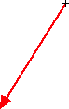**Question 11:**

aa. According to the counter-clockwise convention, the direction of the vector shown below is closest to ___ degrees.

The answer is a multiple of 15 degrees and between 0 degrees and 345 degrees. Enter a numerical answer.

**Question 12:**

aa. According to the counter-clockwise convention, the direction of the vector shown below is closest to ___ degrees.

The answer is a multiple of 15 degrees and between 0 degrees and 345 degrees. Enter a numerical answer.

**Question 13:**

aa. According to the counter-clockwise convention, the direction of the vector shown below is closest to ___ degrees.

The answer is a multiple of 15 degrees and between 0 degrees and 345 degrees. Enter a numerical answer.

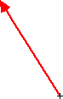

**Question 14:**

aa. According to the counter-clockwise convention, the direction of the vector shown below is closest to ___ degrees.

The answer is a multiple of 15 degrees and between 0 degrees and 345 degrees. Enter a numerical answer.

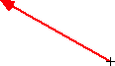**Question 15:**

aa. According to the counter-clockwise convention, the direction of the vector shown below is closest to ___ degrees.

The answer is a multiple of 15 degrees and between 0 degrees and 345 degrees. Enter a numerical answer.

**Question 16:**

aa. According to the counter-clockwise convention, the direction of the vector shown below is closest to ___ degrees.

The answer is a multiple of 15 degrees and between 0 degrees and 345 degrees. Enter a numerical answer.



**Question 17:**

aa. According to the counter-clockwise convention, the direction of the vector shown below is closest to ___ degrees.

The answer is a multiple of 15 degrees and between 0 degrees and 345 degrees. Enter a numerical answer.

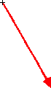**Question 18:**

aa. According to the counter-clockwise convention, the direction of the vector shown below is closest to ___ degrees.

The answer is a multiple of 15 degrees and between 0 degrees and 345 degrees. Enter a numerical answer.

**Question 19:**

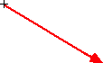aa. According to the counter-clockwise convention, the direction of the vector shown below is closest to ___ degrees.

The answer is a multiple of 15 degrees and between 0 degrees and 345 degrees. Enter a numerical answer.

**Question 20:**

According to the counter-clockwise convention, the direction of the vector shown below is closest to ___ degrees.

The answer is a multiple of 15 degrees and between 0 degrees and 345 degrees. Enter a numerical answer.

**Question 21:**

aa. The diagram below shows three vectors at various orientations. According to the counter-clockwise convention, the direction of the vector A is closest to ___ degrees.

The answer is a multiple of 15 degrees and between 0 degrees and 345 degrees. Enter a numerical answer.

**Question 22:**

aa. The diagram below shows three vectors at various orientations. According to the counter-clockwise convention, the direction of the vector C is closest to ___ degrees.

The answer is a multiple of 15 degrees and between 0 degrees and 345 degrees. Enter a numerical answer.

**Question 23:**

aa. The diagram below shows three vectors at various orientations. According to the counter-clockwise convention, the direction of the vector C is closest to ___ degrees.

The answer is a multiple of 15 degrees and between 0 degrees and 345 degrees. Enter a numerical answer.

**Question 24:**

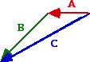aa. The diagram below shows three vectors at various orientations. According to the counter-clockwise convention, the direction of the vector B is closest to ___ degrees.

The answer is a multiple of 15 degrees and between 0 degrees and 345 degrees. Enter a numerical answer.

**Question 25:**

aa. The diagram below shows three vectors at various orientations. According to the counter-clockwise convention, the direction of the vector C is closest to ___ degrees.

The answer is a multiple of 15 degrees and between 0 degrees and 345 degrees. Enter a numerical answer.

**Question 26:**

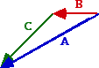aa. The diagram below shows three vectors at various orientations. According to the counter-clockwise convention, the direction of the vector A is closest to ___ degrees.

The answer is a multiple of 15 degrees and between 0 degrees and 345 degrees. Enter a numerical answer.

**Question 27:**

aa. The diagram below shows three vectors at various orientations. According to the counter-clockwise convention, the direction of the vector B is closest to ___ degrees.

The answer is a multiple of 15 degrees and between 0 degrees and 345 degrees. Enter a numerical answer.

**Question 28:**

aa. The diagram below shows three vectors at various orientations. According to the counter-clockwise convention, the direction of the vector C is closest to ___ degrees.

The answer is a multiple of 15 degrees and between 0 degrees and 345 degrees. Enter a numerical answer.

**Question 29:**

aa. The diagram below shows three vectors at various orientations. According to the counter-clockwise convention, the direction of the vector A is closest to ___ degrees.

The answer is a multiple of 15 degrees and between 0 degrees and 345 degrees. Enter a numerical answer.

**Question 30:**

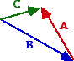aa. The diagram below shows three vectors at various orientations. According to the counter-clockwise convention, the direction of the vector A is closest to ___ degrees.

The answer is a multiple of 15 degrees and between 0 degrees and 345 degrees. Enter a numerical answer.

**Question 31:**

aa. The diagram below shows three vectors at various orientations. According to the counter-clockwise convention, the direction of the vector B is closest to ___ degrees.

The answer is a multiple of 15 degrees and between 0 degrees and 345 degrees. Enter a numerical answer.

**Question 32:**

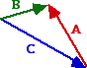aa. The diagram below shows three vectors at various orientations. According to the counter-clockwise convention, the direction of the vector C is closest to ___ degrees.

The answer is a multiple of 15 degrees and between 0 degrees and 345 degrees. Enter a numerical answer.

**VP2: Vector Addition Diagrams**

**Question 1:**

aa. Vectors A, B and C are being added using the head-to-tail method in order to determine the resultant. Vector A is added first, then B, then C. If the vectors were added in a different order, then the resultant would have ___.

a. the same magnitude and direction

b. the same magnitude but a different direction

c. a different magnitude but the same direction

d. both a different magnitude and a different direction

**Question 2:**

aa. Vectors A, B and C are being added using the head-to-tail method in order to determine the resultant. Vector A is added first, then B, then C. If the vectors were added in a different order, then the resultant would have ___.

a. the same magnitude but a different direction

b. a different magnitude but the same direction

c. the same magnitude and direction

d. both a different magnitude and a different direction

**Question 3:**

aa. Vectors A, B and C are being added using the head-to-tail method in order to determine the resultant. Vector A is added first, then B, then C. If the vectors were added in a different order, then the resultant would have ___.

a. both a different magnitude and a different direction

b. the same magnitude but a different direction

c. a different magnitude but the same direction

d. the same magnitude and direction

**Question 4:**

aa. Vectors A, B and C are being added using the head-to-tail method in order to determine the resultant. Vector A is added first, then B, then C. If the vectors were added in a different order, then the resultant would have ___.

a. both a different magnitude and a different direction

b. the same magnitude and direction

c. the same magnitude but a different direction

d. a different magnitude but the same direction

**Question 5:**

aa. A northeast and a southeast vector are being added using the head-to-tail method. Which diagram below illustrates the correct method of adding two such vectors?

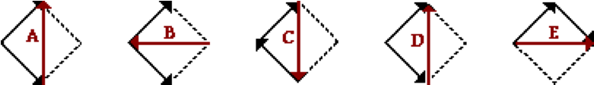

**Question 6:**

aa. A northeast and a southeast vector are being added using the head-to-tail method. Which diagram below illustrates the correct method of adding two such vectors?



**Question 7:**

aa. A northeast and a southeast vector are being added using the head-to-tail method. Which diagram below illustrates the correct method of adding two such vectors?



**Question 8:**

aa. A northeast and a southeast vector are being added using the head-to-tail method. Which diagram below illustrates the correct method of adding two such vectors?



**Question 9:**

aa. Consider the vectors below.

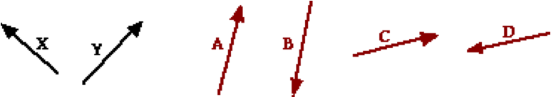

If vectors X and Y are added, then the resultant would be best represented by vector _____.

**Question 10:**

aa. Consider the vectors below.

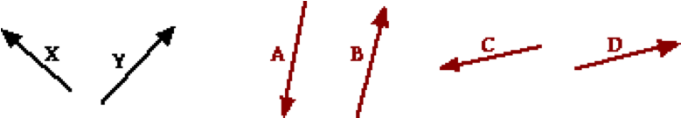

If vectors X and Y are added, then the resultant would be best represented by vector _____.

**Question 11:**

aa. Consider the vectors below.

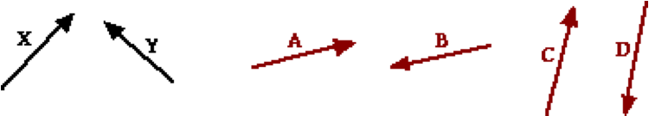

If vectors X and Y are added, then the resultant would be best represented by vector _____.

**Question 12:**

aa. Consider the vectors below.

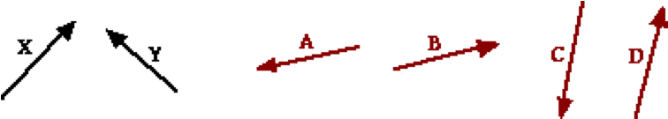

If vectors X and Y are added, then the resultant would be best represented by vector _____.

**Question 13:**

aa. Consider the vectors below.

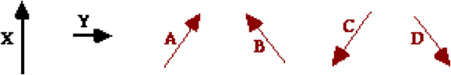

If vectors X and Y are added, then the resultant would be best represented by vector _____.

**Question 14:**

aa. Consider the vectors below.

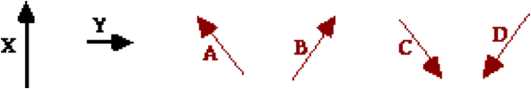

If vectors X and Y are added, then the resultant would be best represented by vector _____.

**Question 15:**

aa. Consider the vectors below.

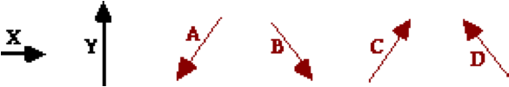

If vectors X and Y are added, then the resultant would be best represented by vector _____.

**Question 16:**

aa. Consider the vectors below.

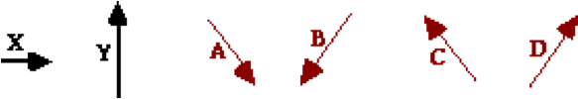

If vectors X and Y are added, then the resultant would be best represented by vector _____.

**Question 17:**

aa. Consider the vectors below.

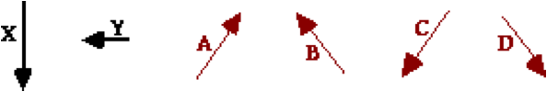

If vectors X and Y are added, then the resultant would be best represented by vector _____.

**Question 18:**

aa. Consider the vectors below.

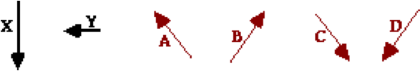

If vectors X and Y are added, then the resultant would be best represented by vector _____.

**Question 19:**

aa. Consider the vectors below.

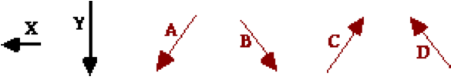

If vectors X and Y are added, then the resultant would be best represented by vector _____.

**Question 20:**

aa. Consider the vectors below.

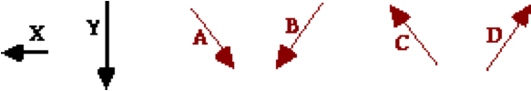

If vectors X and Y are added, then the resultant would be best represented by vector _____.

**Question 21:**

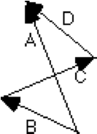aa. Aaron Agin is adding vectors for his homework assignment. He adds three vectors and draws the resultant. However, Aaron did not label the resultant. What is the letter of the resultant vector?

**Question 22:**

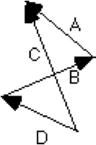aa. Aaron Agin is adding vectors for his homework assignment. He adds three vectors and draws the resultant. However, Aaron did not label the resultant. What is the letter of the resultant vector?

**Question 23:**

aa. Aaron Agin is adding vectors for his homework assignment. He adds three vectors and draws the resultant. However, Aaron did not label the resultant. What is the letter of the resultant vector?

**Question 24:**

aa. Aaron Agin is adding vectors for his homework assignment. He adds three vectors and draws the resultant. However, Aaron did not label the resultant. What is the letter of the resultant vector?

**Question 25:**

aa. Aaron Agin is adding vectors for his homework assignment. What was Aaron trying to add (A + B + C or B + A + D or ...)? If you believe Aaron was adding vectors A + B + C, then enter ABC as your answer. That is, enter the three letters in the order they are being added without any spaces or commas between letters.

**Question 26:**

aa. Aaron Agin is adding vectors for his homework assignment. What was Aaron trying to add (A + B + C or B + A + D or ...)? If you believe Aaron was adding vectors A + B + C, then enter ABC as your answer. That is, enter the three letters in the order they are being added without any spaces or commas between letters.

**Question 27:**

aa. Aaron Agin is adding vectors for his homework assignment. What was Aaron trying to add (A + B + C or B + A + D or ...)? If you believe Aaron was adding vectors A + B + C, then enter ABC as your answer. That is, enter the three letters in the order they are being added without any spaces or commas between letters.

**Question 28:**

aa. Aaron Agin is adding vectors for his homework assignment. What was Aaron trying to add (A + B + C or B + A + D or ...)? If you believe Aaron was adding vectors A + B + C, then enter ABC as your answer. That is, enter the three letters in the order they are being added without any spaces or commas between letters.

**Question 29:**

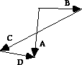aa. Aaron Agin is adding vectors for his homework assignment. What was Aaron trying to add (A + B + C or B + A + D or ...)? If you believe Aaron was adding vectors A + B + C, then enter ABC as your answer. That is, enter the three letters in the order they are being added without any spaces or commas between letters.

**Question 30:**

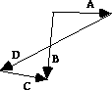aa. Aaron Agin is adding vectors for his homework assignment. What was Aaron trying to add (A + B + C or B + A + D or ...)? If you believe Aaron was adding vectors A + B + C, then enter ABC as your answer. That is, enter the three letters in the order they are being added without any spaces or commas between letters.

**Question 31:**

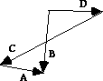aa. Aaron Agin is adding vectors for his homework assignment. What was Aaron trying to add (A + B + C or B + A + D or ...)? If you believe Aaron was adding vectors A + B + C, then enter ABC as your answer. That is, enter the three letters in the order they are being added without any spaces or commas between letters.

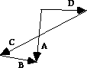**Question 32:**

aa. Aaron Agin is adding vectors for his homework assignment. What was Aaron trying to add (A + B + C or B + A + D or ...)? If you believe Aaron was adding vectors A + B + C, then enter ABC as your answer. That is, enter the three letters in the order they are being added without any spaces or commas between letters.

**Question 33:**

aa. When a vector diagram is used to add three vectors using the head-to-tail method, the resultant is drawn with a specific direction and orientation. The proper direction for drawing the resultant is ___.

a. from the head of the first vector to the tail of the last vector

b. from the head of the last vector to the tail of the first vector

c. from the tail of the first vector to the head of the last vector

d. from the tail of the last vector to the head of the first vector

e. ... nonsense! The resultant can be drawn in any direction as long as it connects two vectors.

**Question 34:**

aa. When a vector diagram is used to add three vectors using the head-to-tail method, the resultant is drawn with a specific direction and orientation. The proper direction for drawing the resultant is ___.

a. from the head of the last vector to the tail of the first vector

b. from the head of the first vector to the tail of the last vector

c. from the tail of the last vector to the head of the first vector

d. from the tail of the first vector to the head of the last vector

e. ... nonsense! The resultant can be drawn in any direction as long as it connects two vectors.

**Question 35:**

aa. When a vector diagram is used to add three vectors using the head-to-tail method, the resultant is drawn with a specific direction and orientation. The proper direction for drawing the resultant is ___.

a. from the tail of the first vector to the head of the last vector

b. from the tail of the last vector to the head of the first vector

c. from the head of the first vector to the tail of the last vector

d. from the head of the last vector to the tail of the first vector

e. ... nonsense! The resultant can be drawn in any direction as long as it connects two vectors.

**Question 36:**

aa. When a vector diagram is used to add three vectors using the head-to-tail method, the resultant is drawn with a specific direction and orientation. The proper direction for drawing the resultant is ___.

a. from the tail of the last vector to the head of the first vector

b. from the tail of the first vector to the head of the last vector

c. from the head of the last vector to the tail of the first vector

d. from the head of the first vector to the tail of the last vector

e. ... nonsense! The resultant can be drawn in any direction as long as it connects two vectors.

**VP3: Vector Addition Applications**

**Question 1:**

aa. The vector sum of two or more vectors is known as the ____.

a. resultant b. component

c. shadow d. resolution

e. scalar f. none of these

**Question 2:**

aa. The vector sum of two or more vectors is known as the ____.

a. scalar b. shadow

c. resolution d. resultant

e. component f. none of these

**Question 3:**

aa. The vector sum of two or more vectors is known as the ____.

a. scalar b. shadow

c. resultant d. resolution

e. component f. none of these

**Question 4:**

aa. The vector sum of two or more vectors is known as the ____.

a. resolution b. shadow

c. component d. scalar

e. resultant f. none of these

**Question 5:**

aa. Two vectors with a magnitude of 5 units and 8 units are being added. The resultant vector could have a magnitude that ranges from ___ units to ___ units.

a. 0, 3 b. 0, 8 c. 0, 40 d. 1.6, 40

e. 3, 8 f. 3, 13 g. 3, 40 h. None of these

**Question 6:**

aa. Two vectors with a magnitude of 5 units and 8 units are being added. The resultant vector could have a magnitude that ranges from ___ units to ___ units.

a. 0, 3 b. 0, 8 c. 3, 8 d. 3, 13

e. 0, 40 f. 1.6, 40 g. 3, 40 h. None of these

**Question 7:**

aa. Two vectors with a magnitude of 5 units and 12 units are being added. The resultant vector could have a magnitude that ranges from ___ units to ___ units.

a. 0, 7 b. 0, 17 c. 0, 60 d. 2.4, 60

e. 5, 17 f. 7, 17 g. 7, 60 h. None of these

**Question 8:**

aa. Two vectors with a magnitude of 5 units and 12 units are being added. The resultant vector could have a magnitude that ranges from ___ units to ___ units.

a. 0, 7 b. 0, 17 c. 5, 17 d. 7, 17

e. 0, 60 f. 2.4, 60 g. 7, 60 h. None of these

**Question 9:**

aa. A 5-ton airplane normally flies at 200 km/hr. If it experiences a 50 km/hr tailwind (i.e., a wind from behind), then its resultant velocity will be ___ km/hr.

a. 30 b. 50 c. 150 d. 250

e. 750 f. 1250 g. None of these

**Question 10:**

aa. A 5-ton airplane normally flies at 240 km/hr. If it experiences a 80 km/hr tailwind (i.e., a wind from behind), then its resultant velocity will be ___ km/hr.

a. 32 b. 64 c. 160 d. 320

e. 800 f. 1600 g. None of these

**Question 11:**

aa. A 3-ton airplane normally flies at 300 km/hr. If it experiences a 30 km/hr tailwind (i.e., a wind from behind), then its resultant velocity will be ___ km/hr.

a. 90 b. 110 c. 270 d. 330

e. 810 f. 990 g. None of these

**Question 12:**

aa. A 5-ton airplane normally flies at 200 km/hr. If it experiences a 50 km/hr tailwind (i.e., a wind from behind), then its resultant velocity will be ___ km/hr.

a. 30 b. 50 c. 150 d. 250

e. 750 f. 1250 g. None of these

**Question 13:**

aa. A 5-ton airplane normally flies at 200 km/hr. If it experiences a 50 km/hr headwind (i.e., a wind coming 'head-on'), then its resultant velocity will be ___ km/hr.

a. 30 b. 50 c. 150 d. 250

e. 750 f. 1250 g. None of these

**Question 14:**

aa. A 5-ton airplane normally flies at 240 km/hr. If it experiences a 80 km/hr headwind (i.e., a wind coming 'head-on'), then its resultant velocity will be ___ km/hr.

a. 32 b. 64 c. 160 d. 320

e. 800 f. 1600 g. None of these

**Question 15:**

aa. A 3-ton airplane normally flies at 300 km/hr. If it experiences a 30 km/hr headwind (i.e., a wind coming 'head-on'), then its resultant velocity will be ___ km/hr.

a. 90 b. 110 c. 270 d. 330

e. 810 f. 990 g. None of these

**Question 16:**

aa. A 5-ton airplane normally flies at 200 km/hr. If it experiences a 50 km/hr headwind (i.e., a wind coming 'head-on'), then its resultant velocity will be ___ km/hr.

a. 30 b. 50 c. 150 d. 250

e. 750 f. 1250 g. None of these

**Question 17:**

aa. A pilot wishes to fly from airport A to airport B. Airport B is located due west from airport A. The pilot’s aircraft averages a speed of 160 mi/hr. If the pilot is flying in a wind that blows out of the north at a speed of 40 mi/hr, then the pilot should head his plane in the direction of vector ____.

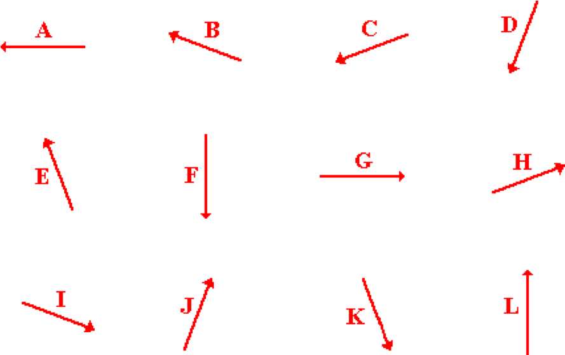

**Question 18:**

aa. A pilot wishes to fly from airport A to airport B. Airport B is located due west from airport A. The pilot’s aircraft averages a speed of 160 mi/hr. If the pilot is flying in a wind that blows out of the north at a speed of 40 mi/hr, then the pilot should head his plane in the direction of vector ____.

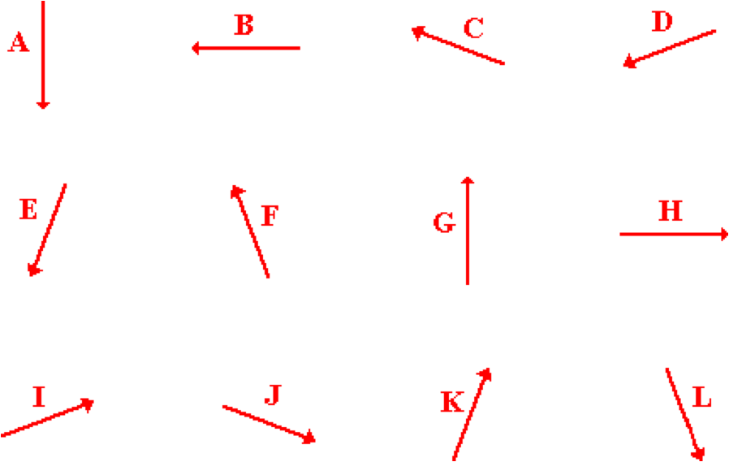

**Question 19:**

aa. A pilot wishes to fly from airport A to airport B. Airport B is located due west from airport A. The pilot’s aircraft averages a speed of 160 mi/hr. If the pilot is flying in a wind that blows out of the south at a speed of 40 mi/hr, then the pilot should head his plane in the direction of vector ____.

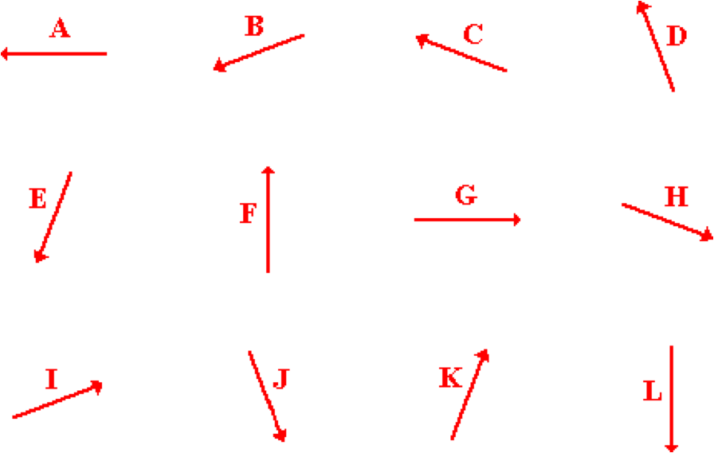

**Question 20:**

aa. A pilot wishes to fly from airport A to airport B. Airport B is located due west from airport A. The pilot’s aircraft averages a speed of 160 mi/hr. If the pilot is flying in a wind that blows out of the south at a speed of 40 mi/hr, then the pilot should head his plane in the direction of vector ____.

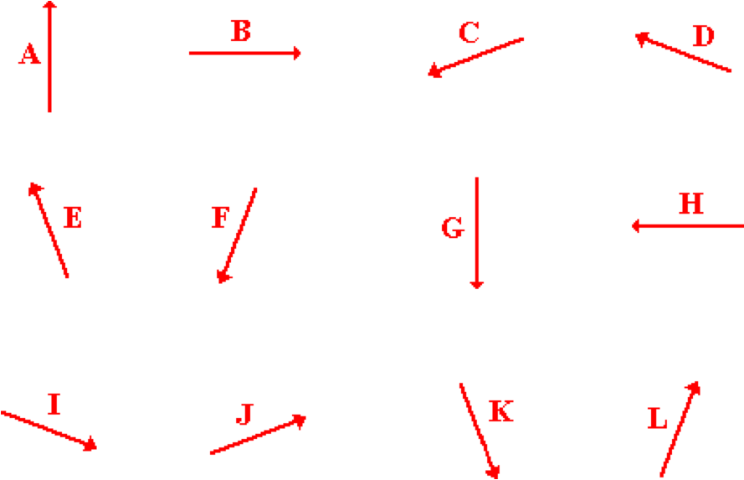

**Question 21:**

aa. A pilot wishes to fly from airport A to airport B. Airport B is located due south from airport A. The pilot’s aircraft averages a speed of 160 mi/hr. If the pilot is flying in a wind that blows out of the west at a speed of 40 mi/hr, then the pilot should head his plane in the direction of vector ____.



**Question 22:**

aa. A pilot wishes to fly from airport A to airport B. Airport B is located due south from airport A. The pilot’s aircraft averages a speed of 160 mi/hr. If the pilot is flying in a wind that blows out of the west at a speed of 40 mi/hr, then the pilot should head his plane in the direction of vector ____.



**Question 23:**

aa. A pilot wishes to fly from airport A to airport B. Airport B is located due south from airport A. The pilot’s aircraft averages a speed of 160 mi/hr. If the pilot is flying in a wind that blows out of the east at a speed of 40 mi/hr, then the pilot should head his plane in the direction of vector ____.



**Question 24:**

aa. A pilot wishes to fly from airport A to airport B. Airport B is located due south from airport A. The pilot’s aircraft averages a speed of 160 mi/hr. If the pilot is flying in a wind that blows out of the east at a speed of 40 mi/hr, then the pilot should head his plane in the direction of vector ____.



**Question 25:**

aa. Consider the diagram below. Vectors A + D + B + P would be equal to vector ____.

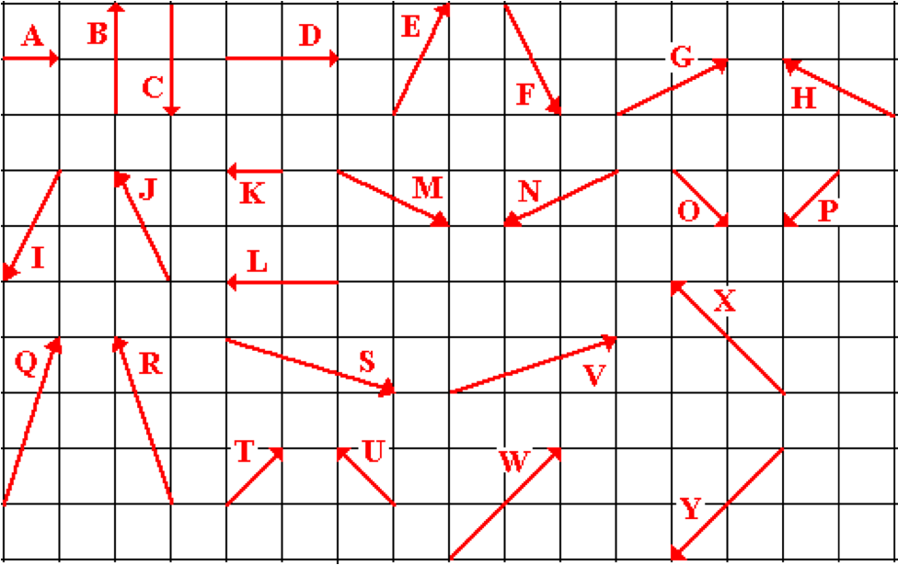

**Question 26:**

aa. Consider the diagram below. Vectors K + L + C + G would be equal to vector ____.



**Question 27:**

aa. Consider the diagram below. Vectors M + W + H + I would be equal to vector ____.



**Question 28:**

aa. Consider the diagram below. Vectors Q + L + O + M would be equal to vector ____.



**Question 29:**

aa. Consider the diagram below. Vectors Y + R + S + J would be equal to vector ____.



**Question 30:**

aa. Consider the diagram below. Vectors U + E + M + C would be equal to vector ____.



**Question 31:**

aa. Consider the diagram below. Vectors S + X + F + P would be equal to vector ____.



**Question 32:**

aa. Consider the diagram below. Vectors T + J + O + F would be equal to vector ____.



**Question 33:**

aa. Consider the diagram below. Vectors A + E + C + Q would be equal to vector ____.

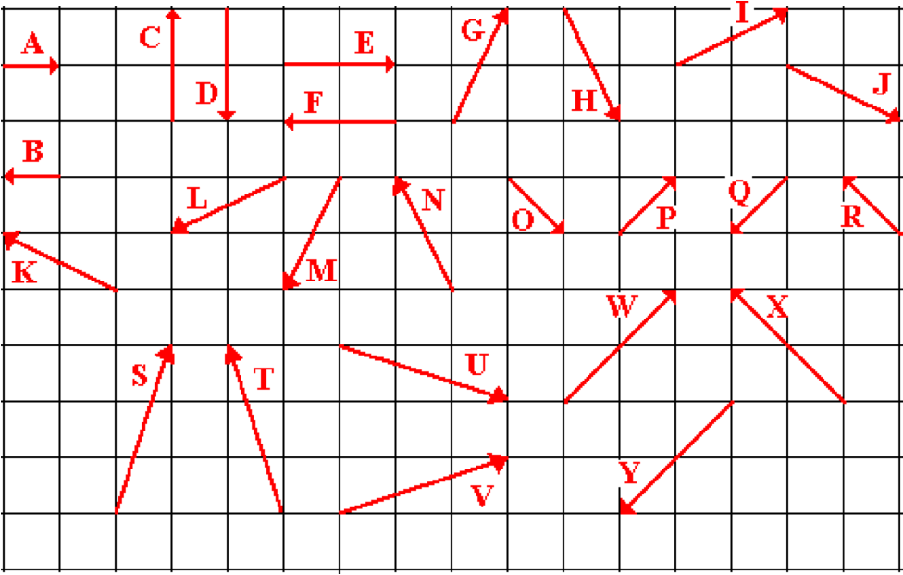

**Question 34:**

aa. Consider the diagram below. Vectors B + F + D + I would be equal to vector ____.



**Question 35:**

aa. Consider the diagram below. Vectors I + W + K + M would be equal to vector ____.



**Question 36:**

aa. Consider the diagram below. Vectors P + F + O + J would be equal to vector ____.



**Question 37:**

aa. Consider the diagram below. Vectors Y + T + U + N would be equal to vector ____.



**Question 38:**

aa. Considering the diagram below. Vectors R + G + J + D would be equal to vector ____.



**Question 39:**

aa. Consider the diagram below. Vectors U + X + H + Q would be equal to vector ____.



**Question 40:**

aa. Consider the diagram below. Vectors P + N + O + H would be equal to vector ____.



**VP4: Adding Right Angle Vectors**

**Question 1:**

aa. A city jogger runs 5.0 blocks due east and then 7.0 blocks due north. The magnitude of the jogger's displacement is ____ blocks. Enter a numerical answer.

**Question 2:**

aa. A city jogger runs 6.0 blocks due east and then 9.0 blocks due north. The magnitude of the jogger's displacement is ____ blocks. Enter a numerical answer.

**Question 3:**

aa. A city jogger runs 7.0 blocks due east and then 11.0 blocks due north. The magnitude of the jogger's displacement is ____ blocks. Enter a numerical answer.

**Question 4:**

aa. An ant walks 1.0 meter due west and then 3.0 meters due north. The magnitude of the ant's displacement is ___ meters. Enter a numerical answer.

**Question 5:**

aa. An ant walks 3.0 meters due west and then 6.0 meters due north. The magnitude of the ant's displacement is ___meters. Enter a numerical answer.

**Question 6:**

aa. An ant walks 3.0 meters due west and then 7.0 meters due north. The magnitude of the ant's displacement is ___meters. Enter a numerical answer.

**Question 7:**

aa. A student in 1982 was playing the interactive video game known as Pac-man. In this game he moved a yellow Pac-man 10.0 cm up and 16.0 cm left. The Pac-man's net displacement was closest to ___ cm. Enter a numerical answer.

**Question 8:**

aa. A student in 1983 was playing the interactive video game known as Pac-man. In this game he moved a yellow Pac-man 11.0 cm up and 17.0 cm left. The Pac-man's net displacement was closest to ___ cm. Enter a numerical answer.

**Question 9:**

aa. A student in 1984 was playing the interactive video game known as Pac-man. In this game he moved a yellow Pac-man 13.0 cm up and 18.0 cm left. The Pac-man's net displacement was closest to ___ cm. Enter a numerical answer.

**Question 10:**

aa. In the Vector Addition Lab, the following data was collected for determining the displacement from the door of the Physics classroom to another location in the building: 2 m, West; 14.0 m, South; 25.0 m, East; 11.0 m, North; and 2 m, West. The magnitude of the resultant displacement from the physics classroom to the assigned location is closest to ___ meters. Enter a numerical answer.

**Question 11:**

aa. In the Vector Addition Lab, the following data was collected for determining the displacement from the door of the Physics classroom to another location in the building: 2 m, West; 14.0 m, South; 30.0 m, East; 9.0 m, North; and 3 m, West. The magnitude of the resultant displacement from the physics classroom to the assigned location is closest to ___ meters. Enter a numerical answer.

**Question 12:**

aa. In the Vector Addition Lab, the following data was collected for determining the displacement from the door of the Physics classroom to another location in the building: 2 m, West; 22.0 m, South; 25.0 m, East; 9.0 m, North; and 4 m, West. The magnitude of the resultant displacement from the physics classroom to the assigned location is closest to ___ meters. Enter a numerical answer.

**Question 13:**

aa. An ant on a picnic table travels 25.0 cm eastward, then 20 cm northward and finally 14.0 cm westward. What is the magnitude of the ant's displacement (in cm)? Enter a numerical answer.

**Question 14:**

aa. An ant on a picnic table travels 24.0 cm eastward, then 25 cm northward and finally 13.0 cm westward. What is the magnitude of the ant's displacement (in cm)? Enter a numerical answer.

**Question 15:**

aa. An ant on a picnic table travels 28.0 cm eastward, then 30 cm northward and finally 11.0 cm westward. What is the magnitude of the ant's displacement (in cm)? Enter a numerical answer.

**Question 16:**

aa. While on a Boy Scout hike, Jeremy walked 9.0 km north, 3 km east, 11.0 km north, and 15.0 km west. The resultant displacement for Jeremy's hike is ____ km. Enter a numerical answer.

**Question 17:**

aa. While on a Boy Scout hike, Jeremy walked 13.0 km north, 4 km east, 16.0 km north, and 18.0 km west. The resultant displacement for Jeremy's hike is ____ km. Enter a numerical answer.

**Question 18:**

aa. While on a Boy Scout hike, Jeremy walked 15.0 km north, 5 km east, 18.0 km north, and 32.0 km west. The resultant displacement for Jeremy's hike is ____ km. Enter a numerical answer.

**Question 19:**

aa. A city jogger runs 5.0 blocks due east and then 7.0 blocks due north. The direction of the jogger's displacement is ____ degrees. (Use the counter-clockwise from East convention.) Enter a numerical answer.

**Question 20:**

aa. A city jogger runs 6.0 blocks due east and then 9.0 blocks due north. The direction of the jogger's displacement is ____ degrees. (Use the counter-clockwise from East convention.) Enter a numerical answer.

**Question 21:**

aa. A city jogger runs 7.0 blocks due east and then 11.0 blocks due north. The direction of the jogger's displacement is ____ degrees. (Use the counter-clockwise from East convention.) Enter a numerical answer.

**Question 22:**

aa. An ant walks 1.0 meters due west and then 3.0 meters due north. The direction of the ant's displacement is ____ degrees. (Use the counter-clockwise from East convention.) Enter a numerical answer.

**Question 23:**

aa. An ant walks 3.0 meters due west and then 6.0 meters due north. The direction of the ant's displacement is ____ degrees. (Use the counter-clockwise from East convention.) Enter a numerical answer.

**Question 24:**

aa. An ant walks 3.0 meters due west and then 7.0 meters due north. The direction of the ant's displacement is ____ degrees. (Use the counter-clockwise from East convention.) Enter a numerical answer.

**Question 25:**

aa. In the Vector Addition Lab, the following data was collected for determining the displacement from the door of the Physics classroom to another location in the building: 2 m, West; 14.0 m, South; 25.0 m, East; 11.0 m, North; and 2 m, West. The direction of the resultant displacement is closest to ___ degrees. (Use the counter-clockwise from East convention.) Enter a numerical answer.

**Question 26:**

aa. In the Vector Addition Lab, the following data was collected for determining the displacement from the door of the Physics classroom to another location in the building: 2 m, West; 14.0 m, South; 30.0 m, East; 9.0 m, North; and 3 m, West. The direction of the resultant displacement is closest to ___ degrees. (Use the counter-clockwise from East convention.) Enter a numerical answer.

**Question 27:**

aa. In the Vector Addition Lab, the following data was collected for determining the displacement from the door of the Physics classroom to another location in the building: 2 m, West; 22.0 m, South; 25.0 m, East; 9.0 m, North; and 4 m, West. The direction of the resultant displacement is closest to ___ degrees. (Use the counter-clockwise from East convention.) Enter a numerical answer.

**VP5: Vector Components**

**Question 1:**

aa. Vector components might be best defined as the ____.

a. sum of two or more vectors

b. projection of a vector onto an axis

c. direction associated with a vector

d. product of two or more vectors

e. vector which must be added to two or more other vectors to result in 0

f. axis upon which a vector is resolved

g. unit associated with the magnitude of a vector

h. magnitude of a vector

**Question 2:**

aa. Vector components might be best defined as the ____.

a. product of two or more vectors

b. direction associated with a vector

c. unit associated with the magnitude of a vector

d. projection of a vector onto an axis

e. vector which must be added to two or more other vectors to result in 0

f. magnitude of a vector

g. axis upon which a vector is resolved

h. sum of two or more vectors

**Question 3:**

aa. Vector components might be best defined as the ____.

a. unit associated with the magnitude of a vector

b. direction associated with a vector

c. magnitude of a vector

d. sum of two or more vectors

e. axis upon which a vector is resolved

f. product of two or more vectors

g. projection of a vector onto an axis

h. vector which must be added to two or more other vectors to result in 0

**Question 4:**

aa. Vector components might be best defined as the ____.

a. magnitude of a vector

b. direction associated with a vector

c. unit associated with the magnitude of a vector

d. axis upon which a vector is resolved

e. projection of a vector onto an axis

f. sum of two or more vectors

g. product of two or more vectors

h. vector which must be added to two or more other vectors to result in 0

**Question 5:**

aa. Vector components are important in physics because they describe the ____.

a. effect of a vector in a given direction

b. result of the vector addition process

c. combined effect of two or more vectors

d. amount of rotation which a vector has experienced about its axis

e. the magnitude which another vector must have to cancel a given vector

**Question 6:**

aa. Vector components are important in physics because they describe the ____.

a. result of the vector addition process

b. combined effect of two or more vectors

c. effect of a vector in a given direction

d. the magnitude which another vector must have to cancel a given vector

e. amount of rotation which a vector has experienced about its axis

**Question 7:**

aa. Vector components are important in physics because they describe the ____.

a. the magnitude which another vector must have to cancel a given vector

b. amount of rotation which a vector has experienced about its axis

c. combined effect of two or more vectors

d. result of the vector addition process

e. effect of a vector in a given direction

**Question 8:**

aa. Vector components are important in physics because they describe the ____.

a. combined effect of two or more vectors

b. the magnitude which another vector must have to cancel a given vector

c. result of the vector addition process

d. effect of a vector in a given direction

e. amount of rotation which a vector has experienced about its axis

**Question 9:**

aa. Vector A is resolved into two components - Ax and Ay. If the two components are added together in head-to-tail fashion, then the resultant would ____.

a. be zero

b. be the original vector A

c. have the same magnitude as A but the opposite direction

d. have a direction of 45 degrees

e. have no relationship to the original vector A

**Question 10:**

aa. Vector A is resolved into two components - Ax and Ay. If the two components are added together in head-to-tail fashion, then the resultant would ____.

a. be the original vector A

b. have a direction of 45 degrees

c. have the same magnitude as A but the opposite direction

d. be zero

e. have no relationship to the original vector A

**Question 11:**

aa. Vector A is resolved into two components - Ax and Ay. If the two components are added together in head-to-tail fashion, then the resultant would ____.

a. be zero

b. have the same magnitude as A but the opposite direction

c. be the original vector A

d. have a direction of 45 degrees

e. have no relationship to the original vector A

**Question 12:**

aa. Vector A is resolved into two components - Ax and Ay. If the two components are added together in head-to-tail fashion, then the resultant would ____.

a. have the same magnitude as A but the opposite direction

b. have a direction of 45 degrees

c. be zero

d. be the original vector A

e. have no relationship to the original vector A

**Question 13:**

aa. Consider the vector below.

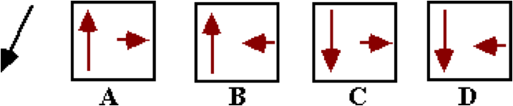

Its x- and y- components are best represented by ____.

**Question 14:**

aa. Consider the vector below.

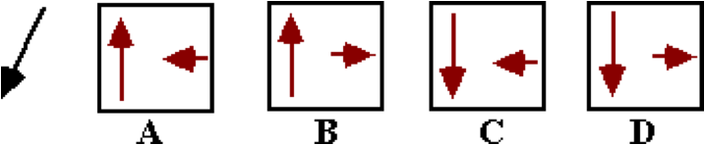

Its x- and y- components are best represented by ____.

**Question 15:**

aa. Consider the vector below.

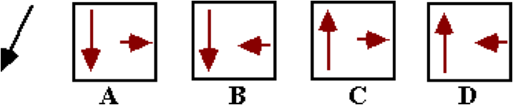

Its x- and y- components are best represented by ____.

**Question 16:**

aa. Consider the vector below.

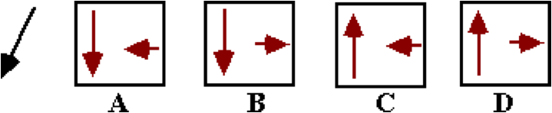

Its x- and y- components are best represented by ____.

**Question 17:**

aa. Consider the vector below.

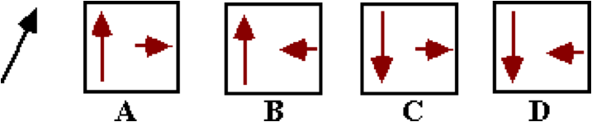

Its x- and y- components are best represented by ____.

**Question 18:**

aa. Consider the vector below.

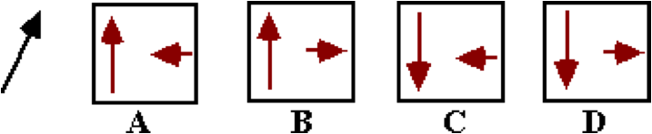

Its x- and y- components are best represented by ____.

**Question 19:**

aa. Consider the vector below.

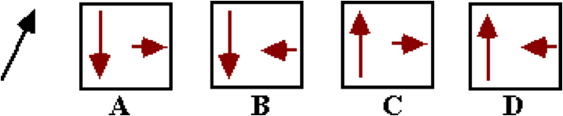

Its x- and y- components are best represented by ____.

**Question 20:**

aa. Consider the vector below.

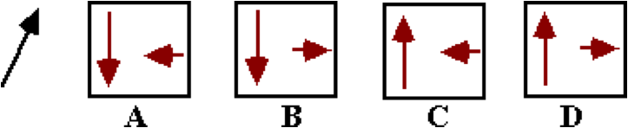

Its x- and y- components are best represented by ____.

**Question 21:**

aa. Consider the vector below.

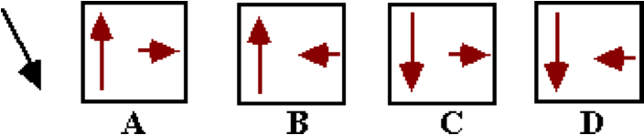

Its x- and y- components are best represented by ____.

**Question 22:**

aa. Consider the vector below.

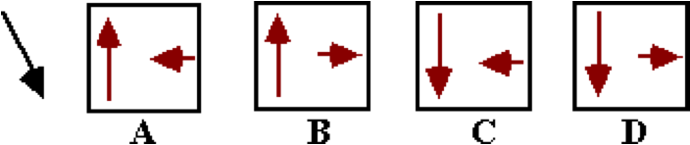

Its x- and y- components are best represented by ____.

**Question 23:**

aa. Consider the vector below.

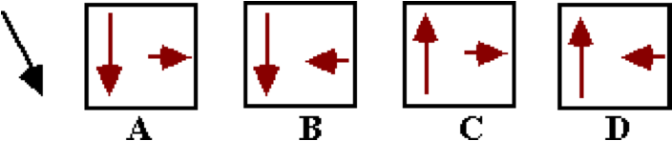

Its x- and y- components are best represented by ____.

**Question 24:**

aa. Consider the vector below.

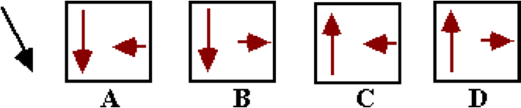

Its x- and y- components are best represented by ____.

**Question 25:**

aa. Consider the vector below.

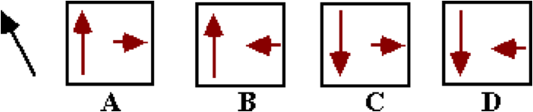

Its x- and y- components are best represented by ____.

**Question 26:**

aa. Consider the vector below.

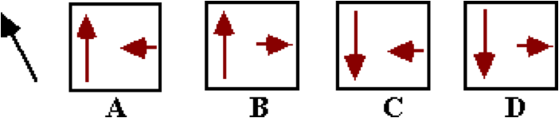

Its x- and y- components are best represented by ____.

**Question 27:**

aa. Consider the vector below.

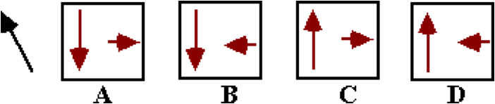

Its x- and y- components are best represented by ____.

**Question 28:**

aa. Consider the vector below.

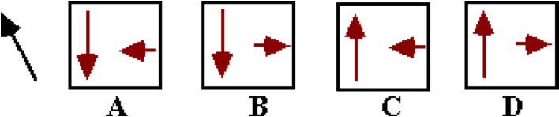

Its x- and y- components are best represented by ____.

**Question 29:**

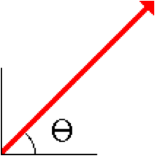aa. Consider the vector shown below. The magnitude and direction of the vector are known. To trigonometrically determine the x-component, the ____ function would be used; and to trigonometrically determine the y-component, the ____ function would be used.

a. sine, cosine b. cosine, sine

c. tangent, cotangent d. cotangent, tangent

e. sine, tangent f. cosine, tangent

g. tangent, sine h. tangent, cosine

**Question 30:**

aa. Consider the vector shown in the diagram. The magnitude and direction of the vector are known. To trigonometrically determine the x-component, the ____ function would be used; and to trigonometrically determine the y-component, the ____ function would be used.

a. tangent, cotangent b. cotangent, tangent

c. sine, cosine d. cosine, sine

e. cosine, tangent f. sine, tangent

g. tangent, cosine h. tangent, sine

**Question 31:**

aa. Consider the vector shown below. The magnitude and direction of the vector are known. To trigonometrically determine the x-component, the ____ function would be used; and to trigonometrically determine the y-component, the ____ function would be used.

a. tangent, cosine b. tangent, sine

c. cosine, tangent d. sine, tangent

e. sine, cosine f. cosine, sine

g. cotangent, tangent h. tangent, cotangent

**Question 32:**

aa. Consider the vector shown below. The magnitude and direction of the vector are known. To trigonometrically determine the x-component, the ____ function would be used; and to trigonometrically determine the y-component, the ____ function would be used.

a. cotangent, tangent b. tangent, cotangent

c. cosine, tangent d. sine, tangent

e. tangent, cosine f. tangent, sine

g. cosine, sine h. sine, cosine

**Question 33:**

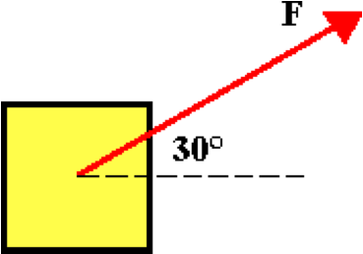aa. A 50-N force is applied at 30 degrees (sometimes called 30 degrees north of east). This would be the same as applying two forces at ___.

a. 25 N east and 43 N north

b. 35 N east and 15 N north

c. 25 N east and 25 N north

d. 43 N east and 25 N north

e. None of the above

**Question 34:**

aa. A 50-N force is applied at 30 degrees (sometimes called 30 degrees north of east). This would be the same as applying two forces at ___.

a. 35 N east and 15 N north

b. 25 N east and 43 N north

c. 43 N east and 25 N north

d. 25 N east and 25 N north

e. None of the above

**Question 35:**

aa. A 50-N force is applied at 30 degrees (sometimes called 30 degrees north of east). This would be the same as applying two forces at ___.

a. 25 N east and 25 N north

b. 43 N east and 25 N north

c. 25 N east and 43 N north

d. 35 N east and 15 N north

e. None of the above

**Question 36:**

aa. A 50-N force is applied at 30 degrees (sometimes called 30 degrees north of east). This would be the same as applying two forces at ___.

a. 43 N east and 25 N north

b. 25 N east and 25 N north

c. 35 N east and 15 N north

d. 25 N east and 43 N north

e. None of the above

**Question 37:**

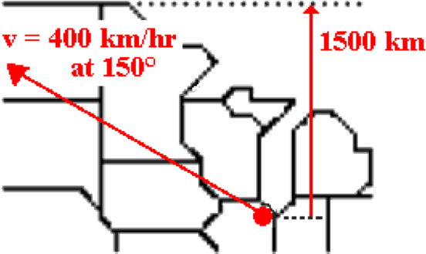aa. A plane flies northwest out of O'Hare Airport in Chicago at a speed of 400 km/hr in a direction of 150 degrees (i.e., 30 degrees north of west). The Canadian border is located a distance of 1500 km due north of Chicago. The plane will cross into Canada after approximately ____ hours.

a. 0.13 b. 0.23

c. 0.27 d. 3.75

e. 4.33 f. 6.49

g. 7.50

h. None of these are even close.

**Question 38:**

aa. A plane flies northwest out of O'Hare Airport in Chicago at a speed of 400 km/hr in a direction of 150 degrees (i.e., 30 degrees north of west). The Canadian border is located a distance of 1500 km due north of Chicago. The plane will cross into Canada after approximately ____ hours.

a. 7.50 b. 6.49

c. 4.33 d. 3.75

e. 0.27 f. 0.23

g. 0.13

h. None of these are even close.

**Question 39:**

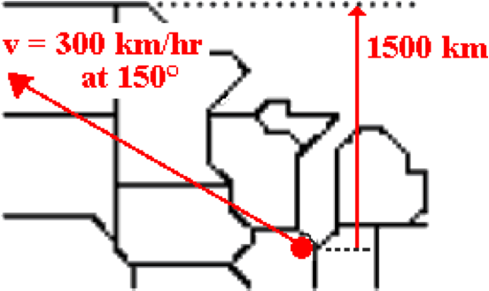aa. A plane flies northwest out of O'Hare Airport in Chicago at a speed of 300 km/hr in a direction of 150 degrees (i.e., 30 degrees north of west). The Canadian border is located a distance of 1500 km due north of Chicago. The plane will cross into Canada after approximately ____ hours.

a. 0.2 b. 0.40

c. 2.50 d. 4.33

e. 5.00 f. 5.77

g. 10.00

h. None of these are even close.

**Question 40:**

aa. A plane flies northwest out of O'Hare Airport in Chicago at a speed of 300 km/hr in a direction of 150 degrees (i.e., 30 degrees north of west). The Canadian border is located a distance of 1500 km due north of Chicago. The plane will cross into Canada after approximately ____ hours.

a. 10.00 b. 5.77 c. 5.00

d. 4.3 e. 2.50 f. 0.40

g. 0.20

h. None of these are even close.

**VP6: Velocity and River Boats**

**Question 1:**

aa. A boat begins at point A and heads straight across a river. Because of the 2 m/s river current, the boat lands on the opposite shore at point C.

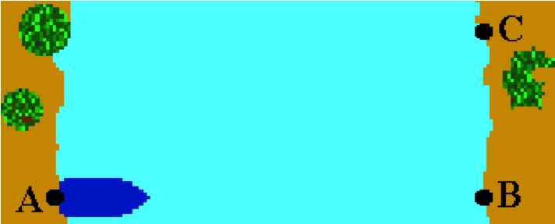

If the river current was 3 m/s, then the boat would land on the opposite shore at ___. (Assume that the boat speed relative to the water does not change.)

a. a location south of C

b. a location north of C

c. the same location of C

d. Nonsense! This is impossible to answer without knowing the time to cross the river.

**Question 2:**

aa. A boat begins at point A and heads straight across a river. Because of the 2 m/s river current, the boat lands on the opposite shore at point C.



If the river current was 3 m/s, then the boat would land on the opposite shore at ___. (Assume that the boat speed relative to the water does not change.)

a. the same location of C

b. a location south of C

c. a location north of C

d. Nonsense! This is impossible to answer without knowing the time to cross the river.

**Question 3:**

aa. A boat begins at point A and heads straight across a river. Because of the 2 m/s river current, the boat lands on the opposite shore at point C.



If the river current was 3 m/s, then the boat would land on the opposite shore at ___. (Assume that the boat speed relative to the water does not change.)

a. a location north of C

b. a location south of C

c. the same location of C

d. Nonsense! This is impossible to answer without knowing the time to cross the river.

**Question 4:**

aa. A boat begins at point A and heads straight across a river. Because of the 2 m/s river current, the boat lands on the opposite shore at point C.



If the river current was 1 m/s, then the boat would land on the opposite shore at ___. (Assume that the boat speed relative to the water does not change.)

a. a location south of C

b. a location north of C

c. the same location of C

d. Nonsense! This is impossible to answer without knowing the time to cross the river.

**Question 5:**

aa. A boat begins at point A and heads straight across a river. Because of the 2 m/s river current, the boat lands on the opposite shore at point C.



If the river current was 1 m/s, then the boat would land on the opposite shore at ___. (Assume that the boat speed relative to the water does not change.)

a. the same location of C

b. a location south of C

c. a location north of C

d. Nonsense! This is impossible to answer without knowing the time to cross the river.

**Question 6:**

aa. A boat begins at point A and heads straight across a river. Because of the 2 m/s river current, the boat lands on the opposite shore at point C.



If the river current was 1 m/s, then the boat would land on the opposite shore at ___. (Assume that the boat speed relative to the water does not change.)

a. the same location of C

b. a location north of C

c. a location south of C

d. Nonsense! This is impossible to answer without knowing the time to cross the river.

**Question 7:**

aa. A boat begins at point A and heads straight across a 60-meter wide river with a speed of 4 m/s (relative to the water). The river water flows north at a speed of 3 m/s (relative to the shore). The boat reaches the opposite shore at point C.



Which of the following would cause the boat to reach the opposite shore in LESS time? List all that apply in alphabetical order with no spaces between letters.

a. The river is 40 meters wide.

b. The river is 80 meters wide.

c. The boat heads across the river at 3 m/s.

d. The boat heads across the river at 5 m/s.

e. The river flows north at 2 m/s.

f. The river flows north at 4 m/s.

g. Nonsense! None of these affect the time to cross the river.

**Question 8:**

aa. A boat begins at point A and heads straight across a 60-meter wide river with a speed of 4 m/s (relative to the water). The river water flows north at a speed of 3 m/s (relative to the shore). The boat reaches the opposite shore at point C.



Which of the following would cause the boat to reach the opposite shore in LESS time? List all that apply in alphabetical order with no spaces between letters.

a. The boat heads across the river at 3 m/s.

b. The boat heads across the river at 5 m/s.

c. The river is 40 meters wide.

d. The river is 80 meters wide.

e. The river flows north at 2 m/s.

f. The river flows north at 4 m/s.

g. Nonsense! None of these affect the time to cross the river.

**Question 9:**

aa. A boat begins at point A and heads straight across a 60-meter wide river with a speed of 4 m/s (relative to the water). The river water flows north at a speed of 3 m/s (relative to the shore). The boat reaches the opposite shore at point C.



Which of the following would cause the boat to reach the opposite shore in LESS time? List all that apply in alphabetical order with no spaces between letters.

a. The river flows north at 2 m/s.

b. The river flows north at 4 m/s.

c. The boat heads across the river at 3 m/s.

d. The boat heads across the river at 5 m/s.

e. The river is 40 meters wide.

f. The river is 80 meters wide.

g. Nonsense! None of these affect the time to cross the river.

**Question 10:**

aa. A boat begins at point A and heads straight across a 60-meter wide river with a speed of 4 m/s (relative to the water). The river water flows north at a speed of 3 m/s (relative to the shore). The boat reaches the opposite shore at point C.



Which of the following would cause the boat to reach the opposite shore in MORE time? List all that apply in alphabetical order with no spaces between letters.

a. The river is 40 meters wide.

b. The river is 80 meters wide.

c. The boat heads across the river at 3 m/s.

d. The boat heads across the river at 5 m/s.

e. The river flows north at 2 m/s.

f. The river flows north at 4 m/s.

g. Nonsense! None of these affect the time to cross the river.

**Question 11:**

aa. A boat begins at point A and heads straight across a 60-meter wide river with a speed of 4 m/s (relative to the water). The river water flows north at a speed of 3 m/s (relative to the shore). The boat reaches the opposite shore at point C.



Which of the following would cause the boat to reach the opposite shore in MORE time? List all that apply in alphabetical order with no spaces between letters.

a. The boat heads across the river at 3 m/s.

b. The boat heads across the river at 5 m/s.

c. The river is 80 meters wide.

d. The river is 40 meters wide.

e. The river flows north at 2 m/s.

f. The river flows north at 4 m/s.

g. Nonsense! None of these affect the time to cross the river.

**Question 12:**

aa. A boat begins at point A and heads straight across a 60-meter wide river with a speed of 4 m/s (relative to the water). The river water flows north at a speed of 3 m/s (relative to the shore). The boat reaches the opposite shore at point C.



Which of the following would cause the boat to reach the opposite shore in MORE time? List all that apply in alphabetical order with no spaces between letters.

a. The river flows north at 2 m/s.

b. The river flows north at 4 m/s.

c. The boat heads across the river at 3 m/s.

d. The boat heads across the river at 5 m/s.

e. The river is 40 meters wide.

f. The river is 80 meters wide.

g. Nonsense! None of these affect the time to cross the river.

**Question 13:**

aa. A boat begins at point A and heads straight across a 60-meter wide river with a speed of 4 m/s (relative to the water). The river water flows north at a speed of 3 m/s (relative to the shore). The boat reaches the opposite shore at point C.



Which of the following would cause the boat to reach the opposite shore at a location NORTH of C? List all that apply in alphabetical order with no spaces between letters.

a. The boat heads across the river at 3 m/s.

b. The boat heads across the river at 5 m/s.

c. The river flows north at 2 m/s.

d. The river flows north at 4 m/s.

e. Nonsense! None of these affect the location where the boat lands.

**Question 14:**

aa. A boat begins at point A and heads straight across a 60-meter wide river with a speed of 4 m/s (relative to the water). The river water flows north at a speed of 3 m/s (relative to the shore). The boat reaches the opposite shore at point C.



Which of the following would cause the boat to reach the opposite shore at a location NORTH of C? List all that apply in alphabetical order with no spaces between letters.

a. The boat heads across the river at 5 m/s.

b. The boat heads across the river at 3 m/s.

c. The river flows north at 4 m/s.

d. The river flows north at 2 m/s.

e. Nonsense! None of these affect the location where the boat lands.

**Question 15:**

aa. A boat begins at point A and heads straight across a 60-meter wide river with a speed of 4 m/s (relative to the water). The river water flows north at a speed of 3 m/s (relative to the shore). The boat reaches the opposite shore at point C.



Which of the following would cause the boat to reach the opposite shore at a location NORTH of C? List all that apply in alphabetical order with no spaces between letters.

a. The river flows north at 2 m/s.

b. The river flows north at 4 m/s.

c. The boat heads across the river at 5 m/s.

d. The boat heads across the river at 3 m/s.

e. Nonsense! None of these affect the location where the boat lands.

**Question 16:**

aa. A boat begins at point A and heads straight across a 60-meter wide river with a speed of 4 m/s (relative to the water). The river water flows north at a speed of 3 m/s (relative to the shore). The boat reaches the opposite shore at point C.



Which of the following would cause the boat to reach the opposite shore at a location SOUTH of C? List all that apply in alphabetical order with no spaces between letters.

a. The boat heads across the river at 3 m/s.

b. The boat heads across the river at 5 m/s.

c. The river flows north at 2 m/s.

d. The river flows north at 4 m/s.

e. Nonsense! None of these affect the location where the boat lands.

**Question 17:**

aa. A boat begins at point A and heads straight across a 60-meter wide river with a speed of 4 m/s (relative to the water). The river water flows north at a speed of 3 m/s (relative to the shore). The boat reaches the opposite shore at point C.



Which of the following would cause the boat to reach the opposite shore at a location SOUTH of C? List all that apply in alphabetical order with no spaces between letters.

a. The boat heads across the river at 5 m/s.

b. The boat heads across the river at 3 m/s.

c. The river flows north at 4 m/s.

d. The river flows north at 2 m/s.

e. Nonsense! None of these affect the location where the boat lands.

**Question 18:**

aa. A boat begins at point A and heads straight across a 60-meter wide river with a speed of 4 m/s (relative to the water). The river water flows north at a speed of 3 m/s (relative to the shore). The boat reaches the opposite shore at point C.



Which of the following would cause the boat to reach the opposite shore at a location SOUTH of C? List all that apply in alphabetical order with no spaces between letters.

a. The river flows north at 2 m/s.

b. The river flows north at 4 m/s.

c. The boat heads across the river at 5 m/s.

d. The boat heads across the river at 3 m/s.

e. Nonsense! None of these affect the location where the boat lands.

**Question 19:**

aa. TRUE or FALSE:

A boat heads straight across a river. The river flows north at a speed of 3 m/s. If the river current were greater, then the time required for the boat to reach the opposite shore would be less.

a. True b. False

**Question 20:**

aa. TRUE or FALSE:

A boat heads straight across a river. The river flows north at a speed of 3 m/s. If the river current were greater, then the time required for the boat to reach the opposite shore would be greater.

a. True b. False

**Question 21:**

aa. TRUE or FALSE:

A boat heads straight across a river. The river flows north at a speed of 3 m/s. If the river current were greater, then the time required for the boat to reach the opposite shore would not change.

a. True b. False

**Question 22:**

aa. A boat begins at point A and heads straight across a 60.0-meter wide river with a speed of 4.0 m/s (relative to the water). The river water flows north at a speed of 3.0 m/s (relative to the shore). The boat reaches the opposite shore at point C.



It will take the boat a time of approximately ___ seconds to travel across the river from point A to point C.

a. 5.0 b. 12 c. 15 d. 18

e. 20 f. 22.5 g. 30 h. None of these.

**Question 23:**

aa. A boat begins at point A and heads straight across a 90.0-meter wide river with a speed of 4.0 m/s (relative to the water). The river water flows north at a speed of 3.0 m/s (relative to the shore). The boat reaches the opposite shore at point C.



It will take the boat a time of approximately ___ seconds to travel across the river from point A to point C.

a. 5.0 b. 12 c. 15 d. 18

e. 20 f. 22.5 g. 30 h. None of these.

**Question 24:**

aa. A boat begins at point A and heads straight across a 60.0-meter wide river with a speed of 3.0 m/s (relative to the water). The river water flows north at a speed of 4.0 m/s (relative to the shore). The boat reaches the opposite shore at point C.



It will take the boat a time of approximately ___ seconds to travel across the river from point A to point C.

a. 5.0 b. 12 c. 15 d. 18

e. 20 f. 22.5 g. 30 h. None of these.

**Question 25:**

aa. A boat begins at point A and heads straight across a 90.0-meter wide river with a speed of 3.0 m/s (relative to the water). The river water flows north at a speed of 4.0 m/s (relative to the shore). The boat reaches the opposite shore at point C.



It will take the boat a time of approximately ___ seconds to travel across the river from point A to point C.

a. 5.0 b. 12 c. 15 d. 18

e. 20 f. 22.5 g. 30 h. None of these.

**Question 26:**

aa. A boat begins at point A and heads straight across a 80.0-foot wide river with a speed of 8.0 ft/s (relative to the water). The river water flows north at a speed of 6.0 ft/s (relative to the shore). The boat reaches the opposite shore at point C. Point C is approximately ___ feet north of point B.

a. 48 b. 60 c. 64 d. 80

e. 100 f. 107 g. 133 h. None of these

**Question 27:**

aa. A boat begins at point A and heads straight across a 80.0-foot wide river with a speed of 6.0 ft/s (relative to the water). The river water flows north at a speed of 8.0 ft/s (relative to the shore). The boat reaches the opposite shore at point C.



Point C is approximately ___ feet north of point B.

a. 48 b. 60 c. 64 d. 80

e. 100 f. 107 g. 133 h. None of these

**Question 28:**

aa. A boat begins at point A and heads straight across a 40.0-foot wide river with a speed of 8.0 ft/s (relative to the water). The river water flows north at a speed of 6.0 ft/s (relative to the shore). The boat reaches the opposite shore at point C.



Point C is approximately ___ feet north of point B.

a. 24 b. 30 c. 32 d. 40

e. 50 f. 53 g. 67 h. None of these

**Question 29:**

aa. A boat begins at point A and heads straight across a 40.0-foot wide river with a speed of 6.0 ft/s (relative to the water). The river water flows north at a speed of 8.0 ft/s (relative to the shore). The boat reaches the opposite shore at point C.



Point C is approximately ___ feet north of point B.

a. 24 b. 30 c. 32 d. 40

e. 50 f. 53 g. 67 h. None of these

**Question 30:**

aa. A boat begins on the west side of a river and heads straight EAST across the river with a speed of 6.16 m/s (relative to the water). The river water flows NORTH at a speed of 2.34 m/s (relative to the shore). The resultant velocity of the boat (relative to the shore) is approximately ____ m/s at ____ degrees (CCW from east). Enter the two answers in their respective order with neither commas nor spaces between letters.

a. 3.82 b. 6.59 c. 8.50

d. 15.4 e. 20.8 f. 22.3

g. 31.8 h. 43.4 i. 66.9

j. 67.7 k. 69.2 l. 72.3

m. None of these are even close to the correct magnitude.

n. None of these are even close to the correct direction.

**Question 31:**

aa. A boat begins on the west side of a river and heads straight EAST across the river with a speed of 4.05 m/s (relative to the water). The river water flows NORTH at a speed of 1.95 m/s (relative to the shore). The resultant velocity of the boat (relative to the shore) is approximately ____ m/s at ____ degrees (CCW from east). Enter the two answers in their respective order with neither commas nor spaces between letters.

a. 2.10 b. 4.49 c. 6.00

d. 19.0 e. 25.7 f. 28.8

g. 34.0 h. 42.0 i. 47.5

j. 61.2 k. 64.3 l. 71.0

m. None of these are even close to the correct magnitude.

n. None of these are even close to the correct direction.

**Question 32:**

aa. A boat begins on the west side of a river and heads straight EAST across the river with a speed of 1.9 ft/s (relative to the water). The river water flows NORTH at a speed of 2.6 ft/s (relative to the shore). The resultant velocity of the boat (relative to the shore) is approximately ____ ft/s at ____ degrees (CCW from east). Enter the two answers in their respective order with neither commas nor spaces between letters.

a. 0.70 b. 3.22 c. 4.50

d. 22.9 e. 25.0 f. 35.3

g. 36.2 h. 43.0 i. 47.0

j. 53.8 k. 65.0 l. 67.1

m. None of these are even close to the correct magnitude.

n. None of these are even close to the correct direction.

**Question 33:**

aa. A boat begins on the west side of a river and heads straight EAST across the river with a speed of 2.4 ft/s (relative to the water). The river water flows NORTH at a speed of 3.6 ft/s (relative to the shore). The resultant velocity of the boat (relative to the shore) is approximately ____ ft/s at ____ degrees (CCW from east). Enter the two answers in their respective order with neither commas nor spaces between letters.

a. 0.80 b. 4.33 c. 6.00

d. 29.0 e. 31.0 f. 33.7

g. 39.8 h. 41.8 i. 48.2

j. 51.4 k. 56.3 l. 66.4

m. None of these are even close to the correct magnitude.

n. None of these are even close to the correct direction.

**Question 34:**

aa. A boat begins on the west side of a river and heads straight EAST across the river with a speed of 3.7 m/s (relative to the water). The river water flows SOUTH at a speed of 1.8 m/s (relative to the shore). The resultant velocity of the boat (relative to the shore) is approximately ____ m/s at ____ degrees (CCW from east). Enter the two answers in their respective order with neither commas nor spaces between letters.

a. 1.90 b. 4.11 c. 5.50

d. 293.7 e. 295.9 f. 299.1

g. 312.0 h. 312.3 i. 318

j. 330.9 k. 334.1 l. 336.4

m. None of these are even close to the correct magnitude.

n. None of these are even close to the correct direction.

**Question 35:**

aa. A boat begins on the west side of a river and heads straight EAST across the river with a speed of 2.1 ft/s (relative to the water). The river water flows SOUTH at a speed of 3.6 ft/s (relative to the shore). The resultant velocity of the boat (relative to the shore) is approximately ____ ft/s at ____ degrees (CCW from east). Enter the two answers in their respective order with neither commas nor spaces between letters.

a. 1.5 b. 4.17 c. 5.7

d. 291.6 e. 300.3 f. 305.5

g. 305.7 h. 315.6 i. 319.2

j. 324.3 k. 329.7 l. 333.3

m. None of these are even close to the correct magnitude.

n. None of these are even close to the correct direction.

**Question 36:**

aa. A boat begins on the east side of a river and heads straight WEST across the river with a speed of 3.7 m/s (relative to the water). The river water flows SOUTH at a speed of 1.8 m/s (relative to the shore). The resultant velocity of the boat (relative to the shore) is approximately ____ m/s at ____ degrees (CCW from east). Enter the two answers in their respective order with neither commas nor spaces between letters.

a. 1.90 b. 4.11 c. 5.50

d. 203.6 e. 205.9 f. 209.1

g. 222.0 h. 227.7 i. 228.0

j. 240.9 k. 244.1 l. 246.3

m. None of these are even close to the correct magnitude.

n. None of these are even close to the correct direction.

**Question 37:**

aa. A boat begins on the east side of a river and heads straight WEST across the river with a speed of 2.1 ft/s (relative to the water). The river water flows SOUTH at a speed of 3.6 ft/s (relative to the shore). The resultant velocity of the boat (relative to the shore) is approximately ____ ft/s at ____ degrees (CCW from east). Enter the two answers in their respective order with neither commas nor spaces between letters.

a. 1.5 b. 4.17 c. 5.7

d. 206.7 e. 210.3 f. 215.7

g. 220.8 h. 224.4 i. 234.3

j. 234.5 k. 239.7 l. 248.4

m. None of these are even close to the correct magnitude.

n. None of these are even close to the correct direction.

**VP7: The Nature of a Projectile**

**Question 1:**

aa. Which of the following statements are true of projectile motion? List all that apply in alphabetical order with no commas or spaces between letters.

a. Projectiles are objects that experience free fall.

b. Projectiles move through the air with a constant velocity.

c. The acceleration of a projectile is downward.

d. If moving fast, projectiles can experience considerable air resistance.

e. Gravity is the only force influencing the motion of a projectile.

f. None of these statements are true of projectile motion.

**Question 2:**

aa. Which of the following statements are true of projectile motion? List all that apply in alphabetical order with no commas or spaces between letters.

a. Projectiles move through the air with a constant velocity.

b. The acceleration of a projectile is downward.

c. Gravity is the only force influencing the motion of a projectile.

d. If moving fast, projectiles can experience considerable air resistance.

e. Projectiles are objects that experience free fall.

f. None of these statements are true of projectile motion.

**Question 3:**

aa. Which of the following statements are true of projectile motion? List all that apply in alphabetical order with no commas or spaces between letters.

a. Gravity is the only force influencing the motion of a projectile.

b. Projectiles are objects that experience free fall.

c. Projectiles move through the air with a constant velocity.

d. If moving fast, projectiles can experience considerable air resistance.

e. The acceleration of a projectile is downward.

f. None of these statements are true of projectile motion.

**Question 4:**

aa. Which of the following statements are true of projectile motion? List all that apply in alphabetical order with no commas or spaces between letters.

a. If moving fast, projectiles can experience considerable air resistance.

b. Projectiles move through the air with a constant velocity.

c. Gravity is the only force influencing the motion of a projectile.

d. Projectiles are objects that experience free fall.

e. The acceleration of a projectile is downward.

f. None of these statements are true of projectile motion.

**Question 5:**

aa. Which of the following objects are projectiles? List all that apply in alphabetical order with no commas or spaces between letters.

a. A skydiver is falling from 10000 feet with her parachute opened.

b. A car is skidding to a stop.

c. A car is coasting to a stop.

d. A book is at rest upon a table.

e. An apple is free-falling from a tall tree.

**Question 6:**

aa. Which of the following objects are projectiles? List all that apply in alphabetical order with no commas or spaces between letters.

a. A car is coasting to a stop.

b. A car is skidding to a stop.

c. A book is at rest upon a table.

d. An apple is free-falling from a tall tree.

e. A skydiver is falling from 10000 feet with her parachute opened.

**Question 7:**

aa. Which of the following objects are projectiles? List all that apply in alphabetical order with no commas or spaces between letters.

a. A book is at rest upon a table.

b. An apple is free-falling from a tall tree.

c. A skydiver is falling from 10000 feet with her parachute opened.

d. A car is coasting to a stop.

e. A car is skidding to a stop.

**Question 8:**

aa. Which of the following objects are projectiles? List all that apply in alphabetical order with no commas or spaces between letters.

a. A skydiver is falling from 10000 feet with her parachute opened.

b. A book is at rest upon a table.

c. An apple is free-falling from a tall tree.

d. A car is coasting to a stop.

e. A car is skidding to a stop.

**Question 9:**

aa. A projectile can ____. List all that apply in alphabetical order with no commas or spaces between letters.

a. be moving upwards b. be moving downwards

c. be on a surface d. encounter air resistance

e. have a constant speed f. experience a balance of forces

**Question 10:**

aa. A projectile can ____. List all that apply in alphabetical order with no commas or spaces between letters.

a. be on a surface b. encounter air resistance

c. be moving upwards d. be moving downwards

e. experience a balance of forces f. have a constant speed

**Question 11:**

aa. A projectile can ____. List all that apply in alphabetical order with no commas or spaces between letters.

a. experience a balance of forces b. be on a surface

c. encounter air resistance d. have a constant speed

e. be moving upwards f. be moving downwards

**Question 12:**

aa. A projectile can ____. List all that apply in alphabetical order with no commas or spaces between letters.

a. have a constant speed b. experience a balance of forces

c. be moving upwards d. be on a surface

e. encounter air resistance f. be moving downwards

**Question 13:**

aa. A projectile MUST ____. List all that apply in alphabetical order with no commas or spaces between letters.

a. be accelerating

b. be moving downward

c. be changing its velocity

d. have a constant speed

e. have a horizontal motion in addition to a vertical motion

f. experience either an applied force or air resistance

**Question 14:**

aa. A projectile MUST ____. List all that apply in alphabetical order with no commas or spaces between letters.

a. be moving downward

b. have a horizontal motion in addition to a vertical motion

c. experience either an applied force or air resistance

d. be changing its velocity

e. have a constant speed

f. be accelerating

**Question 15:**

aa. A projectile MUST ____. List all that apply in alphabetical order with no commas or spaces between letters.

a. experience a net downward force

b. have a constant speed

c. be accelerating

d. be changing its velocity

e. be moving downward

f. have a horizontal motion in addition to a vertical motion

**Question 16:**

aa. A projectile MUST ____. List all that apply in alphabetical order with no commas or spaces between letters.

a. be changing its velocity

b. be moving downward

c. have a vertical component of motion (and maybe even a horizontal component of motion)

d. experience a net downward force

e. be accelerating

f. have a constant speed

**Question 17:**

aa. The forces on a projectile are ____.

a. balanced

b. unbalanced

c. either balanced or unbalanced (depending on the amount of air resistance)

d. non-existent

**Question 18:**

aa. The forces on a projectile are ____.

a. unbalanced

b. balanced

c. either balanced or unbalanced (depending on the amount of air resistance)

d. non-existent

**Question 19:**

aa. The forces on a projectile are ____.

a. either balanced or unbalanced (depending on the amount of air resistance)

b. balanced

c. unbalanced

d. non-existent

**Question 20:**

aa. The forces on a projectile are ____.

a. non-existent

b. either balanced or unbalanced (depending on the amount of air resistance)

c. balanced

d. unbalanced

**Question 21:**

aa. A projectile is moving upwards and rightwards towards the peak of its trajectory. Which one of the following force diagrams is representative of the FORCES acting upon the projectile during this portion of its flight? (The arrows represent the presence of a force; its length represents the strength of the force.)

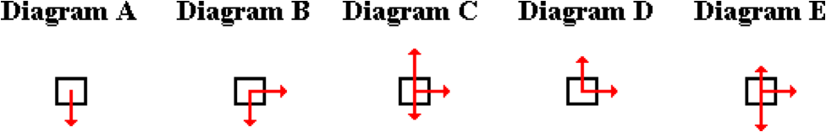

**Question 22:**

aa. A projectile is moving upwards and rightwards towards the peak of its trajectory. Which one of the following force diagrams is representative of the FORCES acting upon the projectile during this portion of its flight? (The arrows represent the presence of a force; its length represents the strength of the force.)

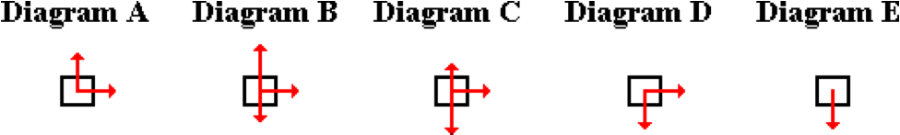

**Question 23:**

aa. A projectile is moving upwards and rightwards towards the peak of its trajectory. Which one of the following force diagrams is representative of the FORCES acting upon the projectile during this portion of its flight? (The arrows represent the presence of a force; its length represents the strength of the force.)

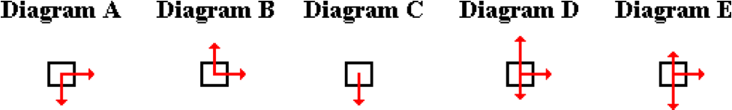

**Question 24:**

aa. A projectile is moving upwards and rightwards towards the peak of its trajectory. Which one of the following force diagrams is representative of the FORCES acting upon the projectile during this portion of its flight? (The arrows represent the presence of a force; its length represents the strength of the force.)

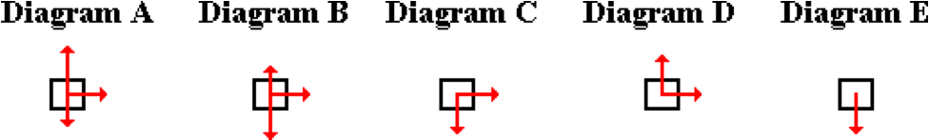

**Question 25:**

aa. A projectile is launched upwards and rightwards. After several seconds, it reaches the peak of its trajectory. Which one of the following force diagrams is representative of the FORCES acting upon the projectile the instant it is at the peak of its trajectory? (The arrows represent the presence of a force; its length represents the strength of the force.)

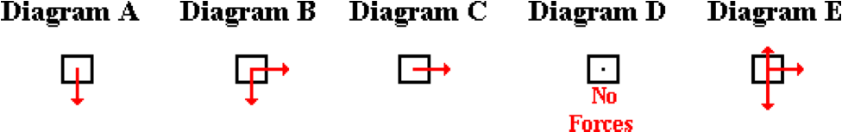

**Question 26:**

aa. A projectile is launched upwards and rightwards. After several seconds, it reaches the peak of its trajectory. Which one of the following force diagrams is representative of the FORCES acting upon the projectile the instant it is at the peak of its trajectory? (The arrows represent the presence of a force; its length represents the strength of the force.)

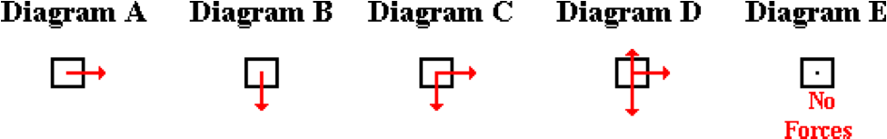

**Question 27:**

aa. A projectile is launched upwards and rightwards. After several seconds, it reaches the peak of its trajectory. Which one of the following force diagrams is representative of the FORCES acting upon the projectile the instant it is at the peak of its trajectory? (The arrows represent the presence of a force; its length represents the strength of the force.)

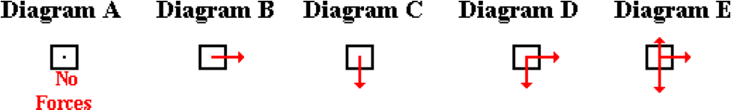

**Question 28:**

aa. A projectile is launched upwards and rightwards. After several seconds, it reaches the peak of its trajectory. Which one of the following force diagrams is representative of the FORCES acting upon the projectile the instant it is at the peak of its trajectory? (The arrows represent the presence of a force; its length represents the strength of the force.)

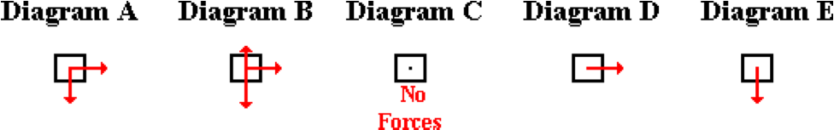

**Question 29:**

aa. At any given moment during the trajectory of a projectile, it could be experiencing a component of FORCE that is directed ____. List all that apply in alphabetical order with no commas or spaces between letters.

a. upward b. downward c. rightward d. leftward

**Question 30:**

aa. At any given moment during the trajectory of a projectile, it could be experiencing a component of FORCE that is directed ____. List all that apply in alphabetical order with no commas or spaces between letters.

a. downward b. upward c. leftward d. rightward

**Question 31:**

aa. At any given moment during the trajectory of a projectile, it could be experiencing a component of FORCE that is directed ____. List all that apply in alphabetical order with no commas or spaces between letters.

a. rightward b. leftward c. upward d. downward

**Question 32:**

aa. At any given moment during the trajectory of a projectile, it could be experiencing a component of FORCE that is directed ____. List all that apply in alphabetical order with no commas or spaces between letters.

a. leftward b. rightward c. downward d. upward

**Question 33:**

aa. A 2-kg object is launched upwards and rightwards and subsequently experiences projectile motion. Just prior to reaching the peak of its trajectory, the net force on the 2-kg object is ____.

a. exactly 0 N

b. a little greater than 0 N

c. approximately 20 N, directed upward

d. approximately 20 N, directed downward

e. approximately 20 N, directed mostly rightward

f. impossible to determine since the acceleration is NOT known.

**Question 34:**

aa. A 2-kg object is launched upwards and rightwards and subsequently experiences projectile motion. Just prior to reaching the peak of its trajectory, the net force on the 2-kg object is ____.

a. exactly 0 N

b. a little greater than 0 N

c. approximately 20 N, directed downward

d. approximately 20 N, directed mostly rightward

e. approximately 20 N, directed upward

f. impossible to determine since the acceleration is NOT known.

**Question 35:**

aa. A 2-kg object is launched upwards and rightwards and subsequently experiences projectile motion. Just prior to reaching the peak of its trajectory, the net force on the 2-kg object is ____.

a. approximately 20 N, directed upward

b. approximately 20 N, directed downward

c. approximately 20 N, directed mostly rightward

d. exactly 0 N

e. a little greater than 0 N

f. impossible to determine since the acceleration is NOT known.

**Question 36:**

aa. A 2-kg object is launched upwards and rightwards and subsequently experiences projectile motion. Just prior to reaching the peak of its trajectory, the net force on the 2-kg object is ____.

a. approximately 20 N, directed downward

b. approximately 20 N, directed upward

c. approximately 20 N, directed mostly rightward

d. exactly 0 N

e. a little greater than 0 N

f. impossible to determine since the acceleration is NOT known.

**VP8: The Acceleration and Velocity of a Projectile**

**Question 1:**

aa. The acceleration of a projectile is always directed _____.

a. in the direction that the object is moving

b. in the opposite direction of that which the object is moving

c. downward

d. ... nonsense! No such generalization can be made

**Question 2:**

aa. The acceleration of a projectile is always directed _____.

a. downward

b. in the direction that the object is moving

c. in the opposite direction of that which the object is moving

d. ... nonsense! No such generalization can be made

**Question 3:**

aa. The acceleration of a projectile is always directed _____.

a. in the opposite direction of that which the object is moving

b. downward

c. in the direction that the object is moving

d. ... nonsense! No such generalization can be made

**Question 4:**

aa. The acceleration of a projectile has the greatest magnitude ____.

a. at the peak of its trajectory

b. just after being launched

c. just prior to landing on the ground

d. either c or d, depending on the initial and final heights

e. ... nonsense! A projectile's acceleration value is constant.

**Question 5:**

aa. The acceleration of a projectile has the greatest magnitude ____.

a. just prior to landing on the ground

b. just after being launched

c. either a or b, depending on the initial and final heights

d. at the peak of its trajectory

e. ... nonsense! A projectile's acceleration value is constant.

**Question 6:**

aa. The acceleration of a projectile has the greatest magnitude ____.

a. at the peak of its trajectory

b. just prior to landing on the ground

c. just after being launched

d. either b or c, depending on the initial and final heights

e. ... nonsense! A projectile's acceleration value is constant.

**Question 7:**

aa. The acceleration of a projectile has the smallest magnitude ____.

a. at the peak of its trajectory

b. just after being launched

c. just prior to landing on the ground

d. either b or c, depending on the initial and final heights

e. ... nonsense! A projectile's acceleration value is constant.

**Question 8:**

aa. The acceleration of a projectile has the smallest magnitude ____.

a. just prior to landing on the ground

b. just after being launched

c. either a or b, depending on the initial and final heights

d. at the peak of its trajectory

e. ... nonsense! A projectile's acceleration value is constant.

**Question 9:**

aa. The acceleration of a projectile has the smallest magnitude ____.

a. at the peak of its trajectory

b. just prior to landing on the ground

c. just after being launched

d. either b or c, depending on the initial and final heights

e. ... nonsense! A projectile's acceleration value is constant.

**Question 10:**

aa. A 3-kg projectile is launched upward and rightward from ground level. The magnitude of the acceleration of the 3-kg projectile at the peak of its trajectory is ___ m/s/s.

a. zero

b. approximately 10

c. approximately 30

d. ... nonsense! This cannot be determined without knowing the net force.

**Question 11:**

aa. A 3-kg projectile is launched upward and rightward from ground level. The magnitude of the acceleration of the 3-kg projectile at the peak of its trajectory is ___ m/s/s.

a. approximately 10

b. approximately 30

c. zero

d. ... nonsense! This cannot be determined without knowing the net force.

**Question 12:**

aa. A 3-kg projectile is launched upward and rightward from ground level. The magnitude of the acceleration of the 3-kg projectile at the peak of its trajectory is ___ m/s/s.

a. zero

b. approximately 30

c. approximately 10

d. ... nonsense! This cannot be determined without knowing the net force.

**Question 13:**

aa. Which of the following statements are true of a projectile's acceleration? List all that apply in alphabetical order with neither commas nor spaces between letters.

a. The acceleration is directed upward as the projectile rises toward its peak.

b. The acceleration is decreasing as the projectile rises upward toward its peak.

c. The acceleration is increasing as the projectile falls downward from its peak.

d. The acceleration is always directed downward.

e. The acceleration value is dependent upon the mass of the projectile.

f. The acceleration is a constant value.

g. The acceleration value is zero at the peak of the projectile's trajectory.

h. None of these statements are true.

**Question 14:**

aa. Which of the following statements are true of a projectile's acceleration? List all that apply in alphabetical order with neither commas nor spaces between letters.

a. The acceleration is a constant value.

b. The acceleration value is zero at the peak of the projectile's trajectory.

c. The acceleration is directed upward as the projectile rises toward its peak.

d. The acceleration is always directed downward.

e. The acceleration is increasing as the projectile falls downward from its peak.

f. The acceleration is decreasing as the projectile rises upward toward its peak.

g. The acceleration value is dependent upon the mass of the projectile.

h. None of these statements are true.

**Question 15:**

aa. Which of the following statements are true of a projectile's acceleration? List all that apply in alphabetical order with neither commas nor spaces between letters.

a. The acceleration is always directed downward.

b. The acceleration is directed upward as the projectile rises toward its peak.

c. The acceleration value is zero at the peak of the projectile's trajectory.

d. The acceleration is increasing as the projectile falls downward from its peak.

e. The acceleration is decreasing as the projectile rises upward toward its peak.

f. The acceleration is a constant value.

g. The acceleration value is dependent upon the mass of the projectile.

h. None of these statements are true.

**Question 16:**

aa. Which of the following statements are true of a projectile's acceleration? List all that apply in alphabetical order with neither commas nor spaces between letters.

a. The acceleration value is dependent upon the mass of the projectile.

b. The acceleration is increasing as the projectile falls downward from its peak.

c. The acceleration is decreasing as the projectile rises upward toward its peak.

d. The acceleration is directed upward as the projectile rises toward its peak.

e. The acceleration value is zero at the peak of the projectile's trajectory.

f. The acceleration is a constant value.

g. The acceleration is always directed downward.

h. None of these statements are true.

**Question 17:**

aa. The magnitude of the horizontal velocity of a projectile is ALWAYS ____. List all that apply in alphabetical order with neither commas nor spaces between letters.

a. constant b. zero c. changing

d. 9.8 m/s e. increasing

**Question 18:**

aa. The magnitude of the horizontal velocity of a projectile is ALWAYS ____. List all that apply in alphabetical order with neither commas nor spaces between letters.

a. 9.8 m/s b. zero c. changing

d. constant e. increasing

**Question 19:**

aa. The magnitude of the horizontal velocity of a projectile is ALWAYS ____. List all that apply in alphabetical order with neither commas nor spaces between letters.

a. increasing b. constant c. changing

d. 9.8 m/s e. zero

**Question 20:**

aa. The magnitude of the horizontal velocity of a projectile is ALWAYS ____. List all that apply in alphabetical order with neither commas nor spaces between letters.

a. zero b. 9.8 m/s c. changing

d. increasing e. constant

**Question 21:**

aa. The horizontal velocity of a projectile is changing because ____.

a. the applied force balances the air resistance

b. the force of gravity is not balanced

c. the force of air resistance is not balanced

d. the applied force exerted upon it when it is projected overwhelms all other forces

e. nonsense! The horizontal velocity of a projectile is NOT changing.

**Question 22:**

aa. The horizontal velocity of a projectile is changing because ____.

a. the force of gravity is not balanced

b. the applied force balances the air resistance

c. the applied force exerted upon it when it is projected overwhelms all other forces

d. the force of air resistance is not balanced

e. nonsense! The horizontal velocity of a projectile is NOT changing.

**Question 23:**

aa. The horizontal velocity of a projectile is changing because ____.

a. the force of air resistance is not balanced

b. the applied force exerted upon it when it is projected overwhelms all other forces

c. the applied force balances the air resistance

d. the force of gravity is not balanced

e. nonsense! The horizontal velocity of a projectile is NOT changing.

**Question 24:**

aa. The horizontal velocity of a projectile is changing because ____.

a. the applied force exerted upon it when it is projected overwhelms all other forces

b. the force of air resistance is not balanced

c. the force of gravity is not balanced

d. the applied force balances the air resistance

e. nonsense! The horizontal velocity of a projectile is NOT changing.

**Question 25:**

aa. The magnitude of the vertical velocity of a projectile is ALWAYS ____. List all that apply in alphabetical order with neither commas nor spaces between letters.

a. constant b. zero c. changing

d. 9.8 m/s e. increasing

**Question 26:**

aa. The magnitude of the vertical velocity of a projectile is ALWAYS ____. List all that apply in alphabetical order with neither commas nor spaces between letters.

a. 9.8 m/s b. zero c. constant

d. changing e. increasing

**Question 27:**

aa. The magnitude of the vertical velocity of a projectile is ALWAYS ____. List all that apply in alphabetical order with neither commas nor spaces between letters.

a. constant b. changing c. increasing

d. 9.8 m/s e. zero

**Question 28:**

aa. The magnitude of the vertical velocity of a projectile is ALWAYS ____. List all that apply in alphabetical order with neither commas nor spaces between letters.

a. zero b. 9.8 m/s c. constant

d. increasing e. changing

**Question 29:**

aa. Which of the following statements are true of the vertical velocity (vy) of a projectile? List all that apply in alphabetical order with neither commas nor spaces between letters.

a. The vy is directed upward as a projectile is rising and downward as it is falling.

b. The vy value is constant.

c. The vy value is a constant value of 9.8 m/s.

d. The vy value is changing by 9.8 m/s every second.

e. The vy value is 0 m/s at the peak of a projectile's trajectory.

f. The vy is always directed downward.

g. None of the above statements are true.

**Question 30:**

aa. Which of the following statements are true of the vertical velocity (vy) of a projectile? List all that apply in alphabetical order with neither commas nor spaces between letters.

a. The vy is always directed downward.

b. The vy is directed upward as a projectile is rising and downward as it is falling.

c. The vy value is 0 m/s at the peak of a projectile's trajectory.

d. The vy value is changing by 9.8 m/s every second.

e. The vy value is constant.

f. The vy value is a constant value of 9.8 m/s.

g. None of the above statements are true.

**Question 31:**

aa. Which of the following statements are true of the vertical velocity (vy) of a projectile? List all that apply in alphabetical order with neither commas nor spaces between letters.

a. The vy is directed upward as a projectile is rising and downward as it is falling.

b. The vy is always directed downward.

c. The vy value is a constant value of 9.8 m/s.

d. The vy value is constant.

e. The vy value is 0 m/s at the peak of a projectile's trajectory.

f. The vy value is changing by 9.8 m/s every second.

g. None of the above statements are true.

**Question 32:**

aa. Which of the following statements are true of the vertical velocity (vy) of a projectile? List all that apply in alphabetical order with neither commas nor spaces between letters.

a. The vy value is constant.

b The vy value is a constant value of 9.8 m/s.

c. The vy value is 0 m/s at the peak of a projectile's trajectory.

d. The vy value is changing by 9.8 m/s every second.

e. The vy is always directed downward.

f. The vy is directed upward as a projectile is rising and downward as it is falling.

g. None of the above statements are true.

**VP9: Velocity Components for a Projectile**

**Question 1:**

aa. A projectile is launched horizontally. As it travels along its trajectory toward the ground, the horizontal component of its velocity ____ and the vertical component of its velocity ____.

a. increases, increases b. decreases, decreases

c. increases, decreases d. decreases, increases

e. remains the same, increases f. remains the same, decreases

g. increases, remains the same h. decreases, remains the same

i. remains the same, remains the same

**Question 2:**

aa. A projectile is launched horizontally. As it travels along its trajectory toward the ground, the horizontal component of its velocity ____ and the vertical component of its velocity ____.

a. increases, increases b. increases, decreases

c. increases, remains the same d. decreases, decreases

e. decreases, increases f. decreases, remains the same

g. remains the same, increases h. remains the same, decreases

i. remains the same, remains the same

**Question 3:**

aa. A projectile is launched horizontally. As it travels along its trajectory toward the ground, the horizontal component of its velocity ____ and the vertical component of its velocity ____.

a. remains the same, increases b. remains the same, decreases

c. remains the same, remains the same d. decreases, decreases

e. decreases, increases f. decreases, remains the same

g. increases, increases h. increases, decreases

i. increases, remains the same

**Question 4:**

aa. A projectile is launched horizontally. As it travels along its trajectory toward the ground, the horizontal component of its velocity ____ and the vertical component of its velocity ____.

a. decreases, remains the same b. decreases, increases

c. decreases, decreases d. increases, remains the same

e. increases, increases f. increases, decreases

g. remains the same, remains the same h. remains the same, increases

i. remains the same, decreases

**Question 5:**

aa. A projectile is launched horizontally. The initial velocity vector is shown.

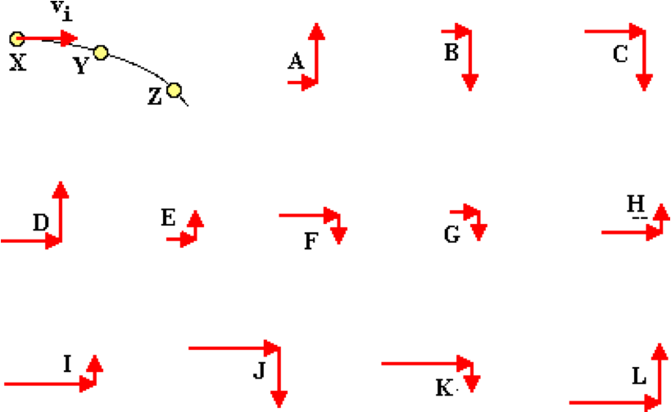

Choose the letters that represent the components of the velocity vector at positions Y and Z respectively. List the two letters in their respective order (position Y first, then Z).

**Question 6:**

aa. A projectile is launched horizontally. The initial velocity vector is shown.

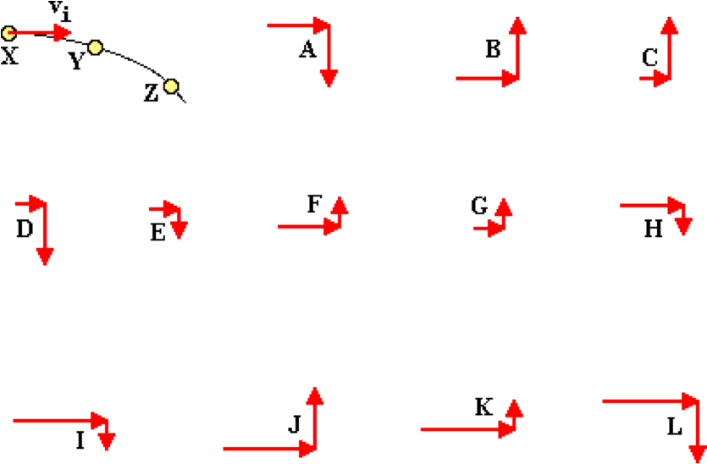

Choose the letters that represent the components of the velocity vector at positions Y and Z respectively. List the two letters in their respective order (position Y first, then Z).

**Question 7:**

aa. A projectile is launched horizontally. The initial velocity vector is shown.

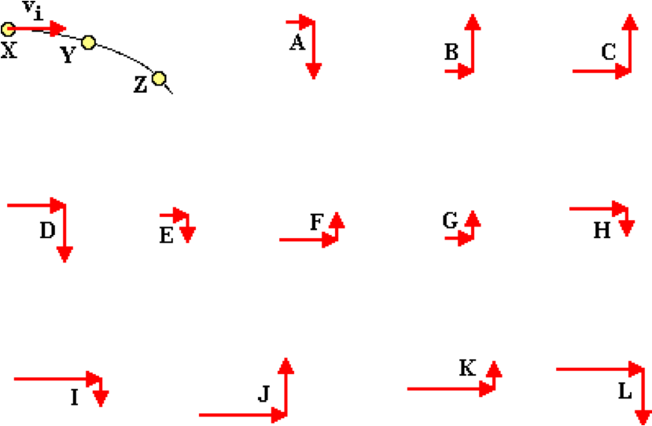

Choose the letters that represent the components of the velocity vector at positions Y and Z respectively. List the two letters in their respective order (position Y first, then Z).

**Question 8:**

aa. A projectile is launched horizontally. The initial velocity vector is shown.

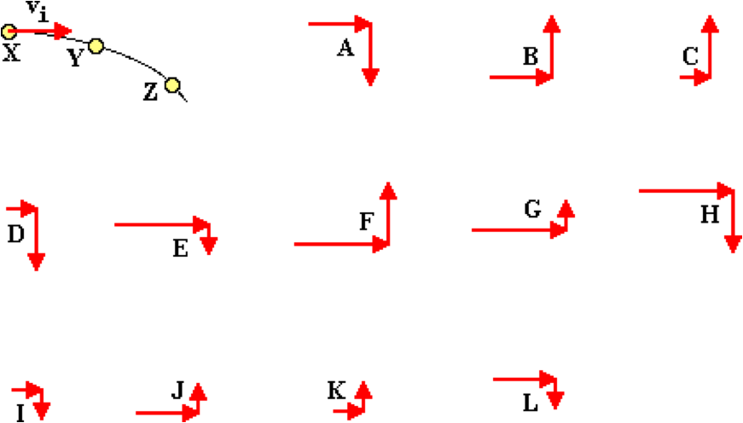

Choose the letters that represent the components of the velocity vector at positions Y and Z respectively. List the two letters in their respective order (position Y first, then Z).

**Question 9:**

aa. A ball is thrown upward at an angle to the horizontal. The components of the initial velocity vector are shown.

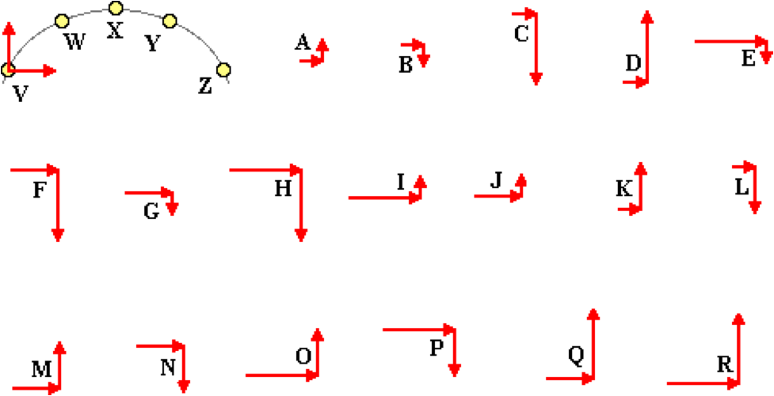

Choose the letters that represent the components of the velocity vector at positions W and Y respectively. List the two letters in their respective order (position W first, then Y).

**Question 10:**

aa. A ball is thrown upward at an angle to the horizontal. The components of the initial velocity vector are shown.

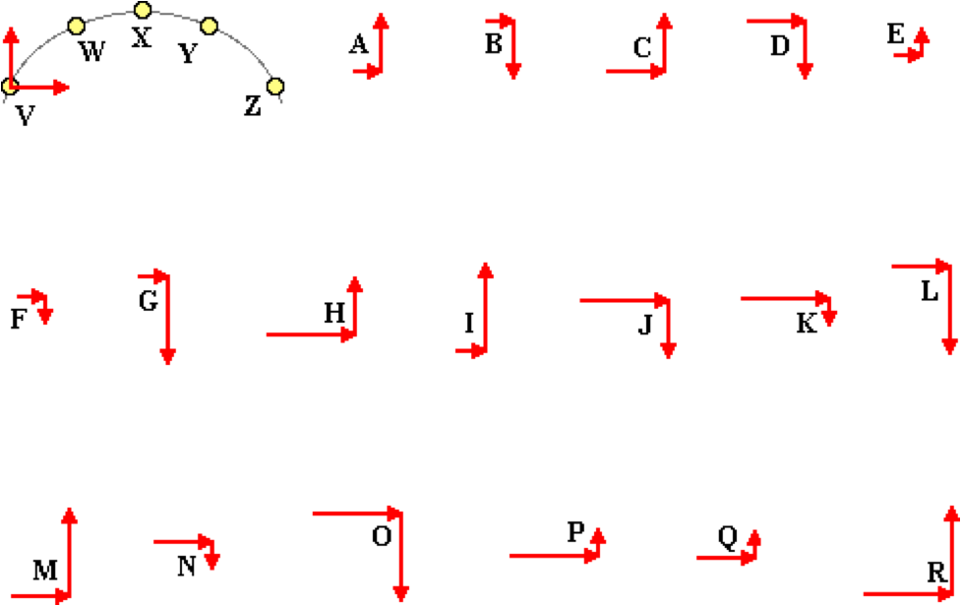

Choose the letters that represent the components of the velocity vector at positions W and Y respectively. List the two letters in their respective order (position W first, then Y).

**Question 11:**

aa. A ball is thrown upward at an angle to the horizontal. The components of the initial velocity vector are shown.



Choose the letters that represent the components of the velocity vector at positions W and Y respectively. List the two letters in their respective order (position W first, then Y).

**Question 12:**

aa. A ball is thrown upward at an angle to the horizontal. The components of the initial velocity vector are shown.

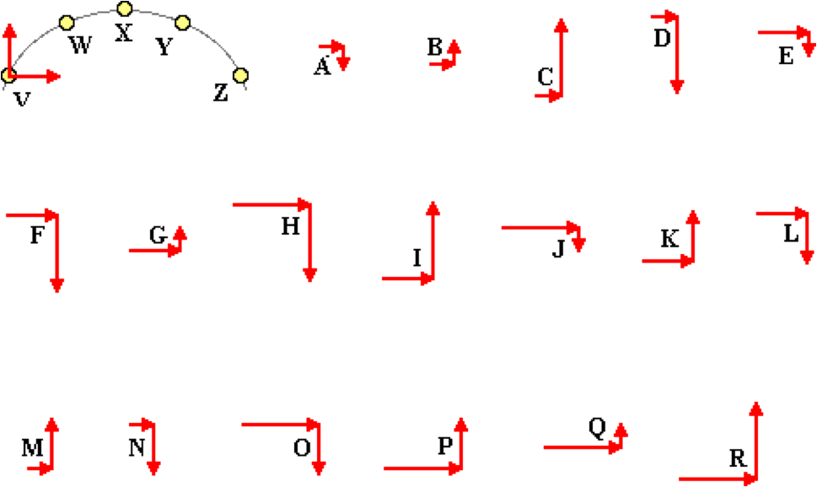

Choose the letters that represent the components of the velocity vector at positions W and Y respectively. List the two letters in their respective order (position W first, then Y).

**Question 13:**

aa. A ball is thrown upward at an angle to the horizontal. The components of the initial velocity vector are shown.



Choose the letter that represents the components of the velocity vector at position Z.

**Question 14:**

aa. A ball is thrown upward at an angle to the horizontal. The components of the initial velocity vector are shown.



Choose the letter that represents the components of the velocity vector at position Z.

**Question 15:**

aa. A ball is thrown upward at an angle to the horizontal. The components of the initial velocity vector are shown.



Choose the letter that represents the components of the velocity vector at position Z.

**Question 16:**

aa. A ball is thrown upward at an angle to the horizontal. The components of the initial velocity vector are shown.



Choose the letter that represents the components of the velocity vector at position Z.

**Question 17:**

aa. A ball is thrown upward at an angle to the horizontal. The components of the initial velocity vector are shown.

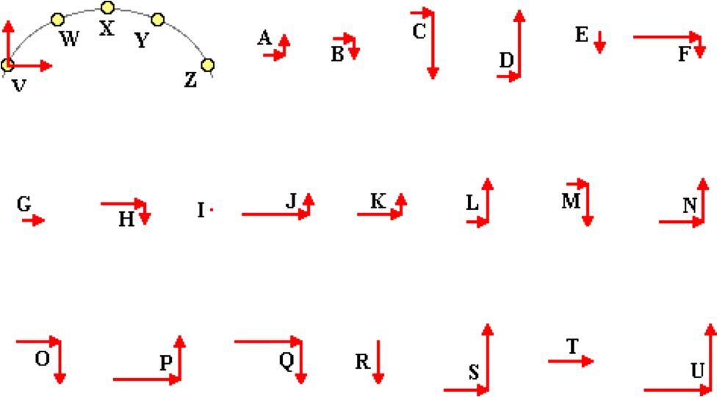

Choose the letters that represent the components of the velocity vector at positions W and X respectively. List the two letters in their respective order (position W first, then X).

**Question 18:**

aa. A ball is thrown upward at an angle to the horizontal. The components of the initial velocity vector are shown.

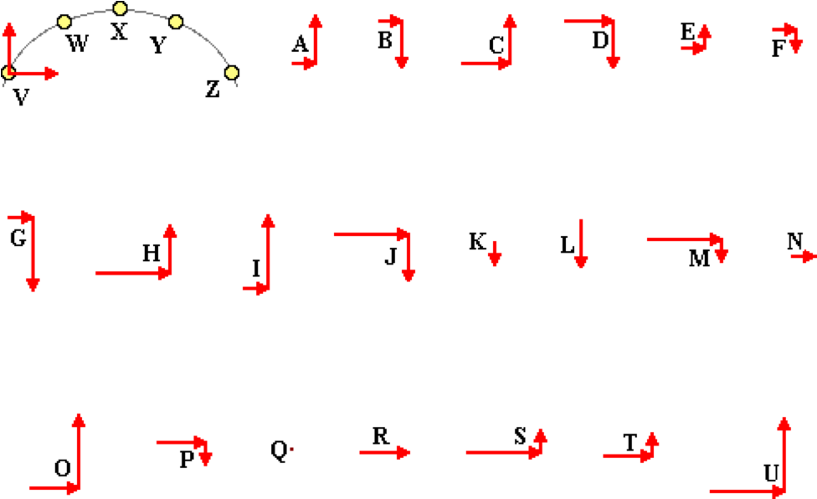

Choose the letters that represent the components of the velocity vector at positions W and X respectively. List the two letters in their respective order (position W first, then X).

**Question 19:**

aa. A ball is thrown upward at an angle to the horizontal. The components of the initial velocity vector are shown.

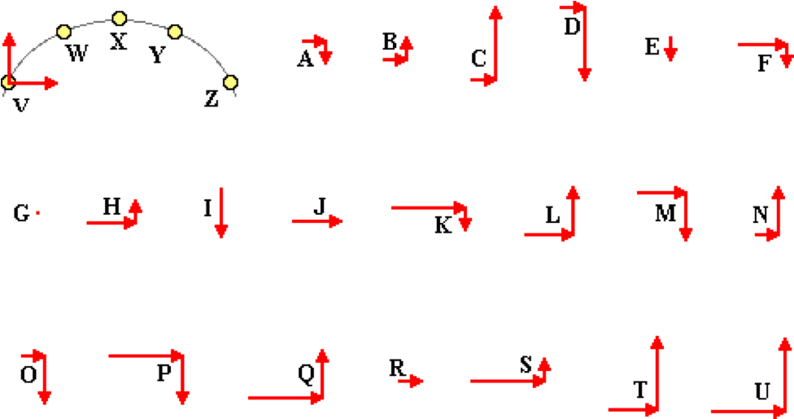

Choose the letters that represent the components of the velocity vector at positions W and X respectively. List the two letters in their respective order (position W first, then X).

**Question 20:**

aa. A ball is thrown upward at an angle to the horizontal. The components of the initial velocity vector are shown.

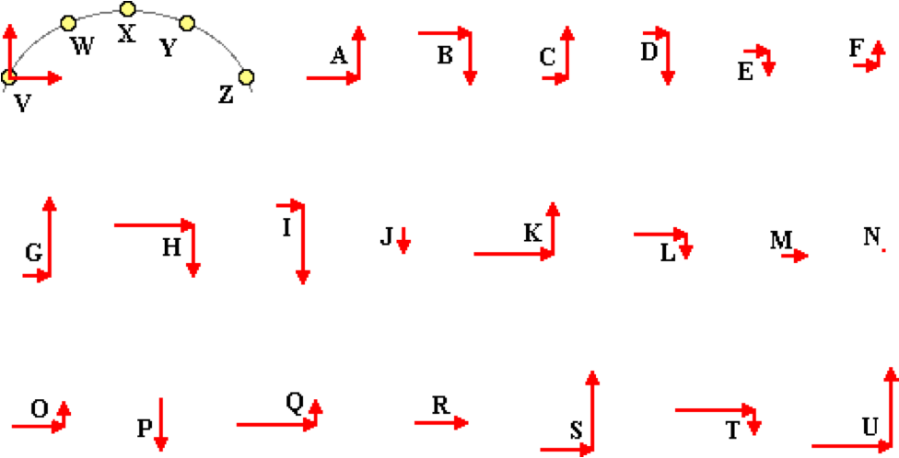

Choose the letters that represent the components of the velocity vector at positions W and X respectively. List the two letters in their respective order (position W first, then X).

**Question 21:**

aa. A projectile is launched horizontally with a velocity of 40 m/s. After 4 seconds, the magnitude of the horizontal component of velocity is ____ m/s and the magnitude of the vertical component of velocity is ____ m/s. List the letters of the two answers in their respective order (horizontal first, then vertical).

a. 0 b. 10 c. 20 d. 30

e. 40 f. 50 g. 60 h. 70

i. 80 j. 90 k. 100 l. None of these

**Question 22:**

aa. A projectile is launched horizontally with a velocity of 50 m/s. After 4 seconds, the magnitude of the horizontal component of velocity is approximately ____ m/s and the magnitude of the vertical component of velocity is approximately ____ m/s. List the letters of the two answers in their respective order (horizontal first, then vertical).

a. 0 b. 10 c. 20 d. 30

e. 40 f. 50 g. 60 h. 70

i. 80 j. 90 k. 100 l. None of these

**Question 23:**

aa. A projectile is launched horizontally with a velocity of 40 m/s. After 3 seconds, the magnitude of the horizontal component of velocity is approximately ____ m/s and the magnitude of the vertical component of velocity is approximately ____ m/s. List the letters of the two answers in their respective order (horizontal first, then vertical).

a. 0 b. 10 c. 20 d. 30

e. 40 f. 50 g. 60 h. 70

i. 80 j. 90 k. 100 l. None of these

**Question 24:**

aa. A projectile is launched horizontally with a velocity of 50 m/s. After 3 seconds, the magnitude of the horizontal component of velocity is approximately ____ m/s and the magnitude of the vertical component of velocity is approximately ____ m/s. List the letters of the two answers in their respective order (horizontal first, then vertical).

a. 0 b. 10 c. 20 d. 30

e. 40 f. 50 g. 60 h. 70

i. 80 j. 90 k. 100 l. None of these

**Question 25:**

aa. A projectile is launched horizontally with a velocity of 60 m/s. After 4 seconds, the magnitude of the horizontal component of velocity is approximately ____ m/s and the magnitude of the vertical component of velocity is approximately ____ m/s. List the letters of the two answers in their respective order (horizontal first, then vertical).

a. 0 b. 10 c. 20 d. 30

e. 40 f. 50 g. 60 h. 70

i. 80 j. 90 k. 100 l. None of these

**Question 26:**

aa. A projectile is launched horizontally with a velocity of 60 m/s. After 3 seconds, the magnitude of the horizontal component of velocity is approximately ____ m/s and the magnitude of the vertical component of velocity is approximately ____ m/s. List the letters of the two answers in their respective order (horizontal first, then vertical).

a. 0 b. 10 c. 20 d. 30

e. 40 f. 50 g. 60 h. 70

i. 80 j. 90 k. 100 l. None of these

**Question 27:**

aa. A projectile is launched horizontally with a velocity of 30 m/s. After 3 seconds, the magnitude of the horizontal component of velocity is approximately ____ m/s and the magnitude of the vertical component of velocity is approximately ____ m/s. List the letters of the two answers in their respective order (horizontal first, then vertical).

a. 0 b. 10 c. 20 d. 30

e. 40 f. 50 g. 60 h. 70

i. 80 j. 90 k. 100 l. None of these

**Question 28:**

aa. A projectile is launched horizontally with a velocity of 30 m/s. After 2 seconds, the magnitude of the horizontal component of velocity is approximately ____ m/s and the magnitude of the vertical component of velocity is approximately ____ m/s. List the letters of the two answers in their respective order (horizontal first, then vertical).

a. 0 b. 10 c. 20 d. 30

e. 40 f. 50 g. 60 h. 70

i. 80 j. 90 k. 100 l. None of these

**Question 29:**

aa. A projectile is launched upward at an angle to the horizontal. The initial horizontal velocity is 40 m/s; the initial vertical velocity is 30 m/s. After 3 seconds, the magnitude of the horizontal component of velocity is approximately ____ m/s and the magnitude of the vertical component of velocity is approximately ____ m/s. List the letters of the two answers in their respective order (horizontal first, then vertical).

a. 0 b. 10 c. 20 d. 30

e. 40 f. 50 g. 60 h. 70

i. 80 j. 90 k. 100 l. None of these

**Question 30:**

aa. A projectile is launched upward at an angle to the horizontal. The initial horizontal velocity is 40 m/s; the initial vertical velocity is 30 m/s. After 6 seconds, the magnitude of the horizontal component of velocity is approximately ____ m/s and the magnitude of the vertical component of velocity is approximately ____ m/s. List the letters of the two answers in their respective order (horizontal first, then vertical).

a. 0 b. 10 c. 20 d. 30

e. 40 f. 50 g. 60 h. 70

i. 80 j. 90 k. 100 l. None of these

**Question 31:**

aa. A projectile is launched upward at an angle to the horizontal. The initial horizontal velocity is 40 m/s; the initial vertical velocity is 40 m/s. After 3 seconds, the magnitude of the horizontal component of velocity is approximately ____ m/s and the magnitude of the vertical component of velocity is approximately ____ m/s. List the letters of the two answers in their respective order (horizontal first, then vertical).

a. 0 b. 10 c. 20 d. 3

e. 40 f. 50 g. 60 h. 70

i. 80 j. 90 k. 100 l. None of these

**Question 32:**

aa. A projectile is launched upward at an angle to the horizontal. The initial horizontal velocity is 40 m/s; the initial vertical velocity is 40 m/s. After 6 seconds, the magnitude of the horizontal component of velocity is approximately ____ m/s and the magnitude of the vertical component of velocity is approximately ____ m/s. List the letters of the two answers in their respective order (horizontal first, then vertical).

a. 0 b. 10 c. 20 d. 30

e. 40 f. 50 g. 60 h. 70

i. 80 j. 90 k. 100 l. None of these

**Question 33:**

aa. A projectile is launched upward at an angle to the horizontal. The initial horizontal velocity is 30 m/s; the initial vertical velocity is 50 m/s. After 3 seconds, the magnitude of the horizontal component of velocity is approximately ____ m/s and the magnitude of the vertical component of velocity is approximately ____ m/s. List the letters of the two answers in their respective order (horizontal first, then vertical).

a. 0 b. 10 c. 20 d. 30

e. 40 f. 50 g. 60 h. 70

i. 80 j. 90 k. 100 l. None of these

**Question 34:**

aa. A projectile is launched upward at an angle to the horizontal. The initial horizontal velocity is 30 m/s; the initial vertical velocity is 50 m/s. After 4 seconds, the magnitude of the horizontal component of velocity is approximately ____ m/s and the magnitude of the vertical component of velocity is approximately ____ m/s. List the letters of the two answers in their respective order (horizontal first, then vertical).

a. 0 b. 10 c. 20 d. 30

e. 40 f. 50 g. 60 h. 70

i. 80 j. 90 k. 100 l. None of these

**Question 35:**

aa. A projectile is launched upward at an angle to the horizontal. The initial horizontal velocity is 30 m/s; the initial vertical velocity is 40 m/s. After 5 seconds, the magnitude of the horizontal component of velocity is approximately ____ m/s and the magnitude of the vertical component of velocity is approximately ____ m/s. List the letters of the two answers in their respective order (horizontal first, then vertical).

a. 0 b. 10 c. 20 d. 30

e. 4 f. 50 g. 60 h. 70

i. 80 j. 90 k. 100 l. None of these

**Question 36:**

aa. A projectile is launched upward at an angle to the horizontal. The initial horizontal velocity is 30 m/s; the initial vertical velocity is 40 m/s. After 6 seconds, the magnitude of the horizontal component of velocity is approximately ____ m/s and the magnitude of the vertical component of velocity is approximately ____ m/s. List the letters of the two answers in their respective order (horizontal first, then vertical).

a. 0 b. 10 c. 20 d. 30

e. 40 f. 50 g. 60 h. 70

i. 80 j. 90 k. 100 l. None of these

**VP10: Displacement and Time**

**Question 1:**

aa. A projectile is launched horizontally and hits the ground in 0.50 second. If it is launched horizontally with twice the speed in the same direction, then it would hit the ground in ____.

a. the same amount of time - 0.50 second

b. in twice the time - 1.00 second

c. in half the time - 0.25 second

d. in more time than 0.50 second but less time than 1.00 second

e. in less time than 0.50 second but more time than 0.25 second

**Question 2:**

aa. A projectile is launched horizontally and hits the ground in 0.50 second. If it is launched horizontally with twice the speed in the same direction, then it would hit the ground in ____.

a. in half the time - 0.25 second

b. in less time than 0.50 second but more time than 0.25 second

c. the same amount of time - 0.50 second

d. in twice the time - 1.00 second

e. in more time than 0.50 second but less time than 1.00 second

**Question 3:**

aa. A projectile is launched horizontally and hits the ground in 0.50 second. If it is launched horizontally with twice the speed in the same direction, then it would hit the ground in ____.

a. in twice the time - 1.00 second

b. in more time than 0.50 second but less time than 1.00 second

c. the same amount of time - 0.50 second

d. in half the time - 0.25 second

e. in less time than 0.50 second but more time than 0.25 second

**Question 4:**

aa. A projectile is launched horizontally and hits the ground in 0.50 second. If it is launched horizontally with twice the speed in the same direction, then it would hit the ground in ____.

a. in half the time - 0.25 second

b. in twice the time - 1.00 second

c. in less time than 0.50 second but more time than 0.25 second

d. in more time than 0.50 second but less time than 1.00 second

e. the same amount of time - 0.50 second

**Question 5:**

aa. A projectile of mass "m" is launched horizontally from an elevated height of "h" meters with an initial speed of "v" m/s. The time for the horizontally-launched projectile to fall to the ground below is dependent upon _____. List all that apply in alphabetical order with no commas or spaces between letters.

a. The mass "m" b. The initial speed "v"

c. The initial height "h" d. The acceleration of gravity "g"

e. None of these effect the time for a projectile to fall.

**Question 6:**

aa. A projectile of mass "m" is launched horizontally from an elevated height of "h" meters with an initial speed of "v" m/s. The time for the horizontally-launched projectile to fall to the ground below is dependent upon _____. List all that apply in alphabetical order with no commas or spaces between letters.

a. The acceleration of gravity "g" b. The mass "m"

c. The initial height "h" d. The initial speed "v"

e. None of these effect the time for a projectile to fall.

**Question 7:**

aa. A projectile of mass "m" is launched horizontally from an elevated height of "h" meters with an initial speed of "v" m/s. The time for the horizontally-launched projectile to fall to the ground below is dependent upon _____. List all that apply in alphabetical order with no commas or spaces between letters.

a. The mass "m" b. The acceleration of gravity "g"

c. The initial height "h" d. The initial speed "v"

e. None of these effect the time for a projectile to fall.

**Question 8:**

aa. A projectile of mass "m" is launched horizontally from an elevated height of "h" meters with an initial speed of "v" m/s. The time for the horizontally-launched projectile to fall to the ground below is dependent upon _____. List all that apply in alphabetical order with no commas or spaces between letters.

a. The initial height "h" b. The initial speed "v"

c. The mass "m" d. The acceleration of gravity "g"

e. None of these effect the time for a projectile to fall.

**Question 9:**

aa. Two projectiles are launched horizontally from the same initial height at different speeds. Projectile A is launched with a speed of 4 m/s and projectile B is launched with a speed of 12 m/s. Compared to projectile A, projectile B will take _____ to hit the ground.

a. the same amount of time b. three times as much time

c. one-third the amount of time d. more time (but not three times as much)

e. less time (but not one-third as much)

**Question 10:**

aa. Two projectiles are launched horizontally from the same initial height at different speeds. Projectile A is launched with a speed of 4 m/s and projectile B is launched with a speed of 12 m/s. Compared to projectile A, projectile B will take _____ to hit the ground.

a. one-third the amount of time b. less time (but not one-third as much)

c. the same amount of time d. three times as much time

e. more time (but not three times as much)

**Question 11:**

aa. Two projectiles are launched horizontally from the same initial height at different speeds. Projectile A is launched with a speed of 4 m/s and projectile B is launched with a speed of 8 m/s. Compared to projectile A, projectile B will take _____ to hit the ground.

a. two times as much time b. more time (but not two times as much)

c. one-half the amount of time d. less time (but not one-half as much)

e. the same amount of time

**Question 12:**

aa. Two projectiles are launched horizontally from the same initial height at different speeds. Projectile A is launched with a speed of 4 m/s and projectile B is launched with a speed of 8 m/s. Compared to projectile A, projectile B will take _____ to hit the ground.

a. two times as much time

b. one-half the amount of time

c. more time (but not two times as much)

d. less time (but not one-half as much)

e. the same amount of time

**Question 13:**

aa. A projectile is launched from the ground at an angle to the horizontal and subsequently hits the ground at the same initial height. The projectile requires 3.0 seconds to reach the peak of its trajectory. Which of the following are true of the projectile? List all that apply in alphabetical order with no spaces or commas between letters. (Use g = ~10 m/s/s)

a. The projectile will remain in the air for a total time of 6.0 seconds.

b. The projectile will require 6.0 seconds to fall from the peak to the ground.

c. The initial velocity of the projectile is about 30 m/s.

d. The initial vertical velocity of the projectile is about 30 m/s.

e. None of these statements are true of this projectile.

**Question 14:**

aa. A projectile is launched from the ground at an angle to the horizontal and subsequently hits the ground at the same initial height. The projectile requires 3.0 seconds to reach the peak of its trajectory. Which of the following are true of the projectile? List all that apply in alphabetical order with no spaces or commas between letters. (Use g = ~10 m/s/s)

a. The projectile will require 6.0 seconds to fall from the peak to the ground.

b. The projectile will remain in the air for a total time of 6.0 seconds.

c. The initial vertical velocity of the projectile is about 30 m/s.

d. The initial velocity of the projectile is about 30 m/s.

e. None of these statements are true of this projectile.

**Question 15:**

aa. A projectile is launched from the ground at an angle to the horizontal and subsequently hits the ground at the same initial height. The projectile requires 5.0 seconds to reach the peak of its trajectory. Which of the following are true of the projectile? List all that apply in alphabetical order with no spaces or commas between letters. (Use g = ~10 m/s/s)

a. The initial vertical velocity of the projectile is about 50 m/s.

b. The initial velocity of the projectile is about 50 m/s.

c. The projectile will require 10.0 seconds to fall from the peak to the ground.

d. The projectile will remain in the air for a total time of 10.0 seconds.

e. None of these statements are true of this projectile.

**Question 16:**

aa. A projectile is launched from the ground at an angle to the horizontal and subsequently hits the ground at the same initial height. The projectile requires 5.0 seconds to reach the peak of its trajectory. Which of the following are true of the projectile? List all that apply in alphabetical order with no spaces or commas between letters. (Use g = ~10 m/s/s)

a. The initial velocity of the projectile is about 50 m/s.

b. The initial vertical velocity of the projectile is about 50 m/s.

c. The projectile will require 10.0 seconds to fall from the peak to the ground.

d. The projectile will remain in the air for a total time of 10.0 seconds.

e. None of these statements are true of this projectile.

**Question 17:**

aa. An airplane is flying horizontally across the sky at a constant speed. It drops a package from its cargo pin. By the time the package lands on the ground, the airplane is at the position shown.

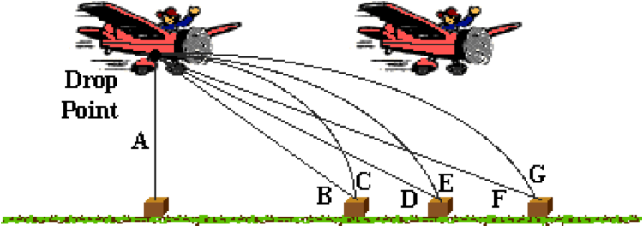

Assuming negligible air resistance on the package, the package would follow path ____.

**Question 18:**

aa. An airplane is flying horizontally across the sky at a constant speed. It drops a package from its cargo pin. By the time the package lands on the ground, the airplane is at the position shown.

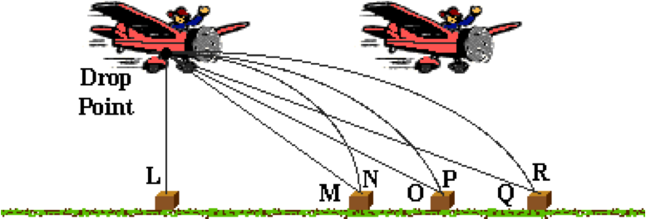

Assuming negligible air resistance on the package, the package would follow path ____.

**Question 19:**

aa. An airplane is flying horizontally across the sky at a constant speed. It drops a package from its cargo pin. By the time the package lands on the ground, the airplane is at the position shown.

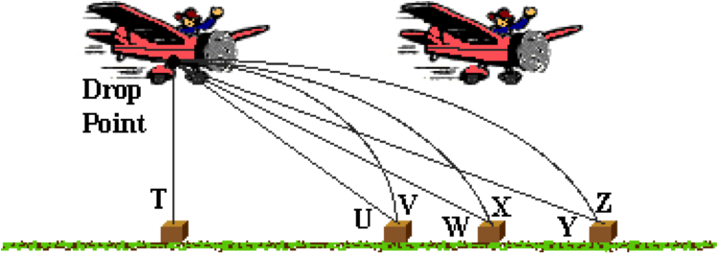

Assuming negligible air resistance on the package, the package would follow path ____.

**Question 20:**

aa. An airplane is flying horizontally across the sky at a constant speed. It drops a package from its cargo pin. By the time the package lands on the ground, the airplane is at the position shown.

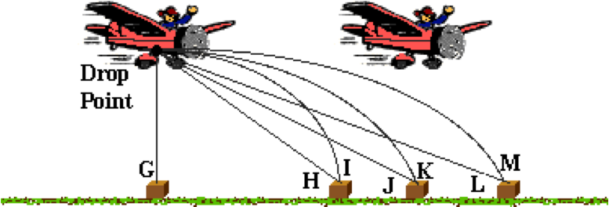

Assuming negligible air resistance on the package, the package would follow path ____.

**Question 21:**

aa. A truck drives down the road at a constant speed. A ball is launched from the back of the truck. By the time the ball returns to its original launch height, the truck is at the position shown.

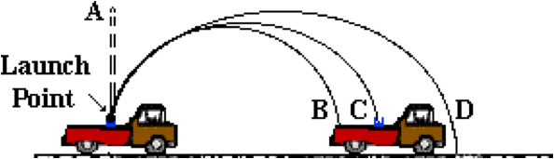

Assuming negligible air resistance on the ball, the ball would follow path ____.

**Question 22:**

aa. A truck drives down the road at a constant speed. A ball is launched from the back of the truck. By the time the ball returns to its original launch height, the truck is at the position shown.

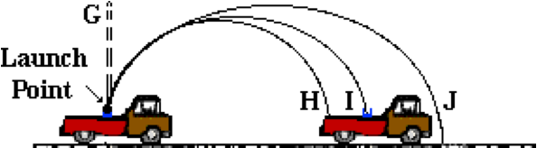

Assuming negligible air resistance on the ball, the ball would follow path ____.

**Question 23:**

aa. A truck drives down the road at a constant speed. A ball is launched from the back of the truck. By the time the ball returns to its original launch height, the truck is at the position shown.

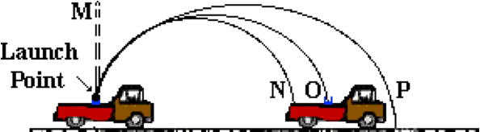

Assuming negligible air resistance on the ball, the ball would follow path ____.

**Question 24:**

aa. A truck drives down the road at a constant speed. A ball is launched from the back of the truck. By the time the ball returns to its original launch height, the truck is at the position shown.

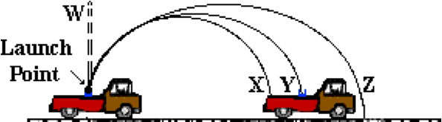

Assuming negligible air resistance on the ball, the ball would follow path ____.

**Question 25:**

aa. Several projectiles are launched from ground height with the same launch speeds and varying angles between 0 degrees and 90 degrees with the horizontal. The projectile launched at ___ degrees would remain in the air the longest. The projectile launched at ___ degrees would have the greatest horizontal displacement. The projectile launched at ___ degrees would have the same horizontal displacement as the projectile launched at 20 degrees. Enter your three answers in respective order with no spaces or commas between letters.

a. 0 b. 5 c. 10 d. 15 e. 20

f. 25 g. 30 h. 35 i. 40 j. 45

k. 50 l. 55 m. 60 n. 65 o. 70

p. 75 q. 80 r. 85 s. 90

t. None of these choices suitably fill this blank.

**Question 26:**

aa. Several projectiles are launched from ground height with the same launch speeds and varying angles between 0 degrees and 90 degrees with the horizontal. The projectile launched at ___ degrees would have the greatest horizontal displacement. The projectile launched at ___ degrees would remain in the air the longest. The projectile launched at ___ degrees would have the same horizontal displacement as the projectile launched at 20 degrees. Enter your three answers in respective order with no spaces or commas between letters.

a. 0 b. 5 c. 10 d. 15 e. 20

f. 25 g. 30 h. 35 i. 40 j. 45

k. 50 l. 55 m. 60 n. 65 o. 70

p. 75 q. 80 r. 85 s. 90

t. None of these choices suitably fill this blank.

**Question 27:**

aa. Several projectiles are launched from ground height with the same launch speeds and varying angles between 0 degrees and 90 degrees with the horizontal. The projectile launched at ___ degrees would remain in the air the longest. The projectile launched at ___ degrees would have the greatest horizontal displacement. The projectile launched at ___ degrees would have the same horizontal displacement as the projectile launched at 25 degrees. Enter your three answers in respective order with no spaces or commas between letters.

a. 0 b. 5 c. 10 d. 15 e. 20

f. 25 g. 30 h. 35 i. 40 j. 45

k. 50 l. 55 m. 60 n. 65 o. 70

p. 75 q. 80 r. 85 s. 90

t. None of these choices suitably fill this blank.

**Question 28:**

aa. Several projectiles are launched from ground height with the same launch speeds and varying angles between 0 degrees and 90 degrees with the horizontal. The projectile launched at ___ degrees would have the greatest horizontal displacement. The projectile launched at ___ degrees would remain in the air the longest. The projectile launched at ___ degrees would have the same horizontal displacement as the projectile launched at 25 degrees. Enter your three answers in respective order with no spaces or commas between letters.

a. 0 b. 5 c. 10 d. 15 e. 20

f. 25 g. 30 h. 35 i. 40 j. 45

k. 50 l. 55 m. 60 n. 65 o. 70

p. 75 q. 80 r. 85 s. 90

t. None of these choices suitably fill this blank.

**Question 29:**

aa. A ball is thrown with a horizontal velocity of 25 m/s from the edge of a 85-meter high cliff. After 2 seconds, the ball will be approximately ____ meters down range (horizontal displacement). (Use g = 10 m/s/s.)

a. 13 b. 43 c. 44 d. 50

e. 53 f. 89 g. 103 h. 170

i. 177 j. None of these are even close

**Question 30:**

aa. A ball is thrown with a horizontal velocity of 25 m/s from the edge of a 85-meter high cliff. After 2 seconds, the ball will be approximately ____ meters down range (horizontal displacement). (Use g = 10 m/s/s.)

a. 177 b. 170 c. 103 d. 89

e. 53 f. 50 g. 44 h. 43

i. 13 j. None of these are even close

**Question 31:**

aa. A ball is thrown with a horizontal velocity of 30 m/s from the edge of a 105-meter high cliff. After 3 seconds, the ball will be approximately ____ meters down range (horizontal displacement). (Use g = 10 m/s/s.)

a. 10 b. 53 c. 55 d. 69

e. 90 f. 109 g. 137 h. 210

i. 218 j. None of these are even close

**Question 32:**

aa. A ball is thrown with a horizontal velocity of 30 m/s from the edge of a 105-meter high cliff. After 3 seconds, the ball will be approximately ____ meters down range (horizontal displacement). (Use g = 10 m/s/s.)

a. 218 b. 210 c. 137 d. 109

e. 90 f. 69 g. 55h. 53

i. 10 j. None of these are even close

**Question 33:**

aa. Tom the cat is chasing Jerry the mouse on a table. Jerry puts on the brakes and stops and Tom continues right off the edge of the table at 4.00 m/s. If it takes Tom 0.50 seconds to hit the ground, then the table is approximately ____ meters high and Tom hit the ground a horizontal distance of ____ meters from the table’s edge. (Use g = 10 m/s/s.) Enter your two answers in their respective order with no spaces or commas between letters.

a. 0.20 b. 1.25 c. 2.00 d. 2.50

e. 4.03 f. 40.3 g. 80. h. 82.0

i. None of these are even close

**Question 34:**

aa. Tom the cat is chasing Jerry the mouse on a table. Jerry puts on the brakes and stops and Tom continues right off the edge of the table at 6.00 m/s. If it takes Tom 0.40 seconds to hit the ground, then the table is approximately ____ meters high and Tom hit the ground a horizontal distance of ____ meters from the table’s edge. (Use g = 10 m/s/s.) Enter your two answers in their respective order with no spaces or commas between letters.

a. 0.24 b. 0.80 c. 1.60 d. 2.00

e. 2.40 f. 6.01 g. 15.0 h. 60.1

i. 150 j. None of these are even close

**Question 35:**

aa. Tom the cat is chasing Jerry the mouse on a table. Jerry puts on the brakes and stops and Tom continues right off the edge of the table at 4.00 m/s. If it takes Tom 0.60 seconds to hit the ground, then the table is approximately ____ meters high and Tom hit the ground a horizontal distance of ____ meters from the table’s edge. (Use g = 10 m/s/s.) Enter your two answers in their respective order with no spaces or commas between letters.

a. 0.24 b. 1.80 c. 2.40 d. 3.00

e. 3.60 f. 4.04 g. 6.67 h. 40.4

i. 66.7 j. None of these are even close

**Question 36:**

aa. Tom the cat is chasing Jerry the mouse on a table. Jerry puts on the brakes and stops and Tom continues right off the edge of the table at 4.0 m/s. If it takes Tom 0.35 seconds to hit the ground, then the table is approximately ____ meters high and Tom hit the ground a horizontal distance of ____ meters from the table’s edge. (Use g = 10 m/s/s.) Enter your two answers in their respective order with no spaces or commas between letters.

a. 0.14 b. 0.61 c. 1.23 d. 1.40

e. 1.75 f. 4.01 g. 11.4 h. 40.2

i. 114 j. None of these are even close