**Minds On Physics Question Banks – Wave Motion**

**WM1: Nature and Categories of Waves**

**Question 1:**

aa. Which three of the following descriptions are true of wave motion? List the three letters in alphabetical order with no spaces between letters.

a. Waves involve the transport of energy from one location to another.

b. Waves involve the movement of matter from one location to another.

c. As waves pass through a medium, particles of the medium undergo a back-and-forth vibration about a fixed position.

d. Waves involve periodic and repeated disturbances of the medium.

e. ... nonsense! None of these describe wave motion.

**Question 2:**

aa. Which three of the following descriptions are true of wave motion? List the three letters in alphabetical order with no spaces between letters.

a. Waves involve the movement of matter from one location to another.

b. Waves involve the transport of energy from one location to another.

c. Waves involve periodic and repeated disturbances of the medium.

d. As waves pass through a medium, particles of the medium undergo a back-and-forth vibration about a fixed position.

e. ... nonsense! None of these describe wave motion.

**Question 3:**

aa. Which three of the following descriptions are true of wave motion? List the three letters in alphabetical order with no spaces between letters.

a. As waves pass through a medium, particles of the medium undergo a back-and-forth vibration about a fixed position.

b. Waves involve periodic and repeated disturbances of the medium.

c. Waves involve the transport of energy from one location to another.

d. Waves involve the movement of matter from one location to another.

e. ... nonsense! None of these describe wave motion.

**Question 4:**

aa. Which three of the following descriptions are true of wave motion? List the three letters in alphabetical order with no spaces between letters.

a. Waves involve periodic and repeated disturbances of the medium.

b. As waves pass through a medium, particles of the medium undergo a back-and-forth vibration about a fixed position.

c. Waves involve the movement of matter from one location to another.

d. Waves involve the transport of energy from one location to another.

e. ... nonsense! None of these describe wave motion.

**Question 5:**

aa. **TRUE**  or **FALSE**:

Waves transport energy from one location to another without transporting matter.

a. True b. False

**Question 6:**

aa. **TRUE**  or **FALSE**:

Waves transport matter from one location to another without transporting energy.

a. True b. False

**Question 7:**

aa. **TRUE**  or **FALSE**:

Waves transport both energy and matter from one location to another.

a. True b. False

**Question 8:**

aa. **TRUE**  or **FALSE**:

As a water wave moves from the middle of the ocean to the sandy shore, one might expect particles of water to be displaced from the middle of the ocean to locations closer to the shore.

a. True b. False

**Question 9:**

aa. **TRUE**  or **FALSE**:

As a water wave moves from the middle of the ocean to the sandy shore, there would be particles of water that become displaced from locations far from shore to locations closer to shore.

a. True b. False

**Question 10:**

aa. **TRUE**  or **FALSE**:

As a water wave moves from the middle of the ocean to the sandy shore, particles of water become transported from locations far from shore to locations closer to shore.

a. True b. False

**Question 11:**

aa. Which one of the following best describes the means by which a wave transports its energy along a slinky from coil A to coil Z?

a. Coil A pushes on coil B which pushes on coil C which pushes on ... coil Z.

b. Coil A trades positions with coil B and then with coil C ... and finally with coil Z.

c. Coil A and coil Z trade positions.

d. ... nonsense! Waves do not transport energy along the medium; they're simply vibrations.

**Question 12:**

aa. Which one of the following best describes the means by which a wave transports its energy along a slinky from coil A to coil Z?

a. Coil A and coil Z trade positions.

b. Coil A pushes on coil B which pushes on coil C which pushes on ... coil Z.

c. Coil A trades positions with coil B and then with coil C ... and finally with coil Z.

d. ... nonsense! Waves do not transport energy along the medium; they're simply vibrations.

**Question 13:**

aa. Which one of the following best describes the means by which a wave transports its energy along a slinky from coil A to coil Z?

a. Coil A trades positions with coil B and then with coil C ... and finally with coil Z.

b. Coil A and coil Z trade positions.

c. Coil A pushes on coil B which pushes on coil C which pushes on ... coil Z.

d. ... nonsense! Waves do not transport energy along the medium; they're simply vibrations.

**Question 14:**

aa. The diagrams below depict various wave patterns in a slinky. The arrows represent potential directions of hand movement for the creation of such patterns.

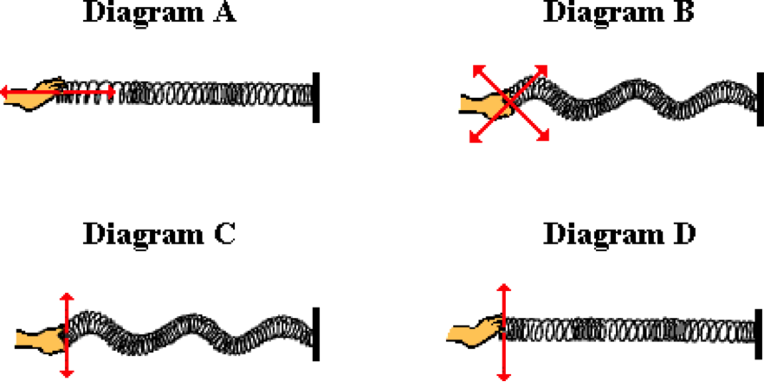

Which diagram - A, B, C, or D - represents the appropriate hand movements and patterns for a longitudinal wave?

**Question 15:**

aa. The diagrams below depict various wave patterns in a slinky. The arrows represent potential direction of hand movements for the creation of such patterns.

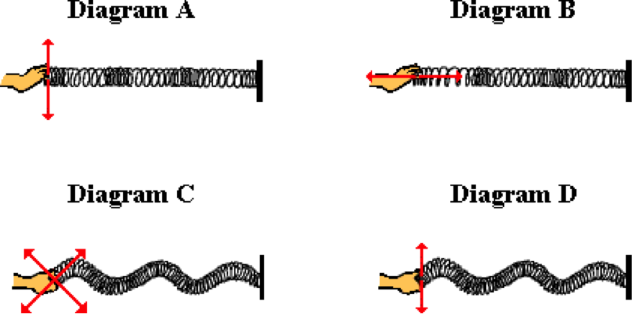

Which diagram - A, B, C, or D - represents the appropriate hand movements and patterns for a longitudinal wave?

**Question 16:**

aa. The diagrams below depict various wave patterns in a slinky. The arrows represent potential direction of hand movements for the creation of such patterns.

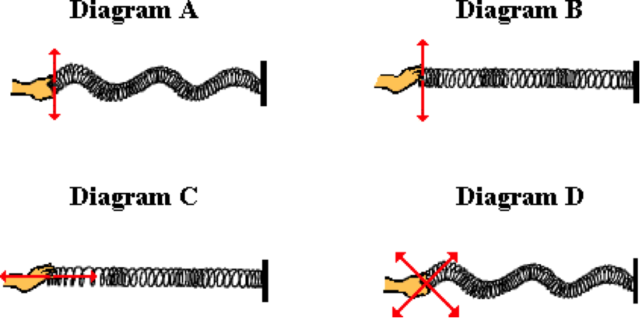

Which diagram - A, B, C, or D - represents the appropriate hand movements and patterns for a longitudinal wave?

**Question 17:**

aa. The diagrams below depict various wave patterns in a slinky. The arrows represent potential direction of hand movements for the creation of such patterns.

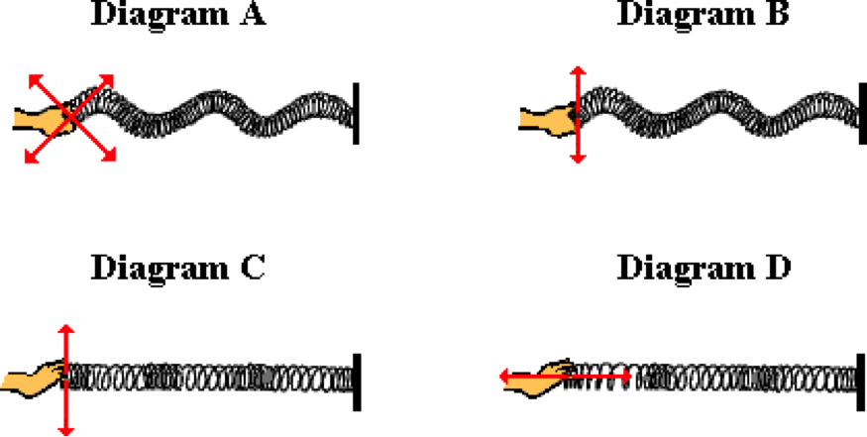

Which diagram - A, B, C, or D - represents the appropriate hand movements and patterns for a longitudinal wave?

**Question 18:**

aa. The diagrams below depict various wave patterns in a slinky. The arrows represent potential direction of hand movements for the creation of such patterns.



Which diagram - A, B, C, or D - represents the appropriate hand movements and patterns for a transverse wave?

**Question 19:**

aa. The diagrams below depict various wave patterns in a slinky. The arrows represent potential direction of hand movements for the creation of such patterns.



Which diagram - A, B, C, or D - represents the appropriate hand movements and patterns for a transverse wave?

**Question 20:**

aa. The diagrams below depict various wave patterns in a slinky. The arrows represent potential direction of hand movements for the creation of such patterns.



Which diagram - A, B, C, or D - represents the appropriate hand movements and patterns for a transverse wave?

**Question 21:**

aa. The diagrams below depict various wave patterns in a slinky. The arrows represent potential direction of hand movements for the creation of such patterns.



Which diagram - A, B, C, or D - represents the appropriate hand movements and patterns for a transverse wave?

**Question 22:**

aa. If a longitudinal wave is created in a medium that extends horizontally from left to right, then the particles of the medium will vibrate in a ____ direction.

a. horizontal

b. vertical

c. diagonal (both horizontal and vertical)

d. circular

e. none of these

**Question 23:**

aa. If a longitudinal wave is created in a medium that extends horizontally from left to right, then the particles of the medium will vibrate in a ____ direction.

a. vertical

b. horizontal

c. circular

d. diagonal (both horizontal and vertical)

e. none of these

**Question 24:**

aa. If a longitudinal wave is created in a medium that extends horizontally from left to right, then the particles of the medium will vibrate in a ____ direction.

a. diagonal (both horizontal and vertical)

b. circular

c. horizontal

d. vertical

e. none of these

**Question 25:**

aa. If a longitudinal wave is created in a medium that extends horizontally from left to right, then the particles of the medium will vibrate in a ____ direction.

a. circular

b. diagonal (both horizontal and vertical)

c. vertical

d. horizontal

e. none of these

**Question 26:**

aa. If a transverse wave is created in a medium that extends horizontally from left to right, then the particles of the medium will vibrate in a ____ direction.

a. horizontal

b. vertical

c. diagonal (both horizontal and vertical)

d. circular

e. none of these

**Question 27:**

aa. If a transverse wave is created in a medium that extends horizontally from left to right, then the particles of the medium will vibrate in a ____ direction.

a. vertical

b. horizontal

c. circular

d. diagonal (both horizontal and vertical)

e. none of these

**Question 28:**

aa. If a transverse wave is created in a medium that extends horizontally from left to right, then the particles of the medium will vibrate in a ____ direction.

a. diagonal (both horizontal and vertical)

b. circular

c. horizontal

d. vertical

e. none of these

**Question 29:**

aa. If a transverse wave is created in a medium that extends horizontally from left to right, then the particles of the medium will vibrate in a ____ direction.

a. circular

b. diagonal (both horizontal and vertical)

c. vertical

d. horizontal

e. none of these

**WM2: Wave Characteristics**

**Question 1:**

aa. A wave is established in a rope. The diagram below represents a *snapshot* of the pattern in the rope at a given instant in time. Several points on the rope are labeled with a letter.

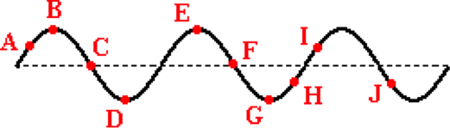

Identify the letters of any wave crests. List all that apply in alphabetical order with no spaces or commas between letters.

**Question 2:**

aa. A wave is established in a rope. The diagram below represents a *snapshot* of the pattern in the rope at a given instant in time. Several points on the rope are labeled with a letter.

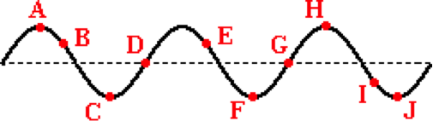

Identify the letters of any wave crests. List all that apply in alphabetical order with no spaces or commas between letters.

**Question 3:**

aa. A wave is established in a rope. The diagram below represents a *snapshot* of the pattern in the rope at a given instant in time. Several points on the rope are labeled with a letter.

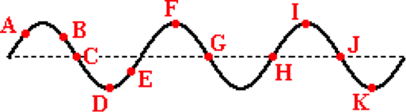

Identify the letters of any wave crests. List all that apply in alphabetical order with no spaces or commas between letters.

**Question 4:**

aa. A wave is established in a rope. The diagram below represents a *snapshot* of the pattern in the rope at a given instant in time. Several points on the rope are labeled with a letter.



Identify the letters of any wave troughs. List all that apply in alphabetical order with no spaces or commas between letters.

**Question 5:**

aa. A wave is established in a rope. The diagram below represents a *snapshot* of the pattern in the rope at a given instant in time. Several points on the rope are labeled with a letter.



Identify the letters of any wave troughs. List all that apply in alphabetical order with no spaces or commas between letters.

**Question 6:**

aa. A wave is established in a rope. The diagram below represents a *snapshot* of the pattern in the rope at a given instant in time. Several points on the rope are labeled with a letter.



Identify the letters of any wave troughs. List all that apply in alphabetical order with no spaces or commas between letters.

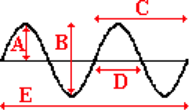**Question 7:**

aa. A wave is established in a rope. The diagram below represents a *snapshot* of the pattern in the rope at a given instant in time. Which of the given distances represent the wavelength of the wave? List all that apply in alphabetical order with no spaces or commas between letters.

**Question 8:**

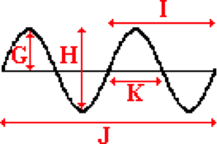aa. A wave is established in a rope. The diagram below represents a *snapshot* of the pattern in the rope at a given instant in time. Which of the given distances represent the wavelength of the wave? List all that apply in alphabetical order with no spaces or commas between letters.

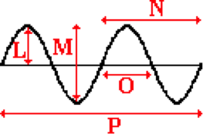**Question 9:**

aa. A wave is established in a rope. The diagram below represents a *snapshot* of the pattern in the rope at a given instant in time. Which of the given distances represent the wavelength of the wave? List all that apply in alphabetical order with no spaces or commas between letters.

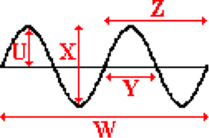**Question 10:**

aa. A wave is established in a rope. The diagram below represents a *snapshot* of the pattern in the rope at a given instant in time. Which of the given distances represent the wavelength of the wave? List all that apply in alphabetical order with no spaces or commas between letters.

**Question 11:**

aa. A wave is established in a rope. The diagram below represents a *snapshot* of the pattern in the rope at a given instant in time. Which of the given distances represent the amplitude of the wave? List all that apply in alphabetical order with no spaces or commas between letters.

**Question 12:**

aa. A wave is established in a rope. The diagram below represents a *snapshot* of the pattern in the rope at a given instant in time. Which of the given distances represent the amplitude of the wave? List all that apply in alphabetical order with no spaces or commas between letters.

**Question 13:**

aa. A wave is established in a rope. The diagram below represents a *snapshot* of the pattern in the rope at a given instant in time. Which of the given distances represent the amplitude of the wave? List all that apply in alphabetical order with no spaces or commas between letters.

**Question 14:**

aa. A wave is established in a rope. The diagram below represents a *snapshot* of the pattern in the rope at a given instant in time. Which of the given distances represent the amplitude of the wave? List all that apply in alphabetical order with no spaces or commas between letters.

**Question 15:**

aa. A wave is moving through a medium. A point on the medium is undergoing many up and down oscillations in a short amount of time. This is conclusive evidence that the wave has a relatively large ____.

a. frequency b. period

c. speed d. amplitude

e. wavelength

**Question 16:**

aa. A wave is moving through a medium. A point on the medium is undergoing many up and down oscillations in a short amount of time. This is conclusive evidence that the wave has a relatively large ____.

a. speed b. wavelength

c. amplitude d. frequency

e. period

**Question 17:**

aa. A wave is moving through a medium. A point on the medium is undergoing many up and down oscillations in a short amount of time. This is conclusive evidence that the wave has a relatively large ____.

a. amplitude b. wavelength

c. speed d. period

e. frequency

**Question 18:**

aa. A wave is moving through a medium. A point on the medium is undergoing many up and down oscillations in a short amount of time. This is conclusive evidence that the wave has a relatively large ____.

a. speed b. period

c. amplitude d. frequency

e. wavelength

**Question 19:**

aa. Which three of the following are units of frequency? List the three that apply in alphabetical order with no spaces or commas between letters.

a. cycles/second b. meters

c. Hertz d. meters/second

e. second/vibration f. waves/second

g. Nonsense! None of these are units of frequency.

**Question 20:**

aa. Which three of the following are units of frequency? List the three that apply in alphabetical order with no spaces or commas between letters.

a. meters/second b. second/vibration

c. cycles/second d. meters

e. Hertz f. waves/second

g. Nonsense! None of these are units of frequency.

**Question 21:**

aa. Which three of the following are units of frequency? List the three that apply in alphabetical order with no spaces or commas between letters.

a. second/vibration b. cycles/second

c. meters d. Hertz

e. meters/second f. waves/second

g. Nonsense! None of these are units of frequency.

**Question 22:**

aa. A wave that is traveling fast can be said to have a high ____.

a. frequency b. amplitude

c. wavelength d. period

e. None of these

**Question 23:**

aa. A wave that is traveling fast can be said to have a high ____.

a. amplitude b. frequency

c. period d. speed

e. None of these

**Question 24:**

aa. A wave that is traveling fast can be said to have a high ____.

a. frequency b. speed

c. wavelength d. amplitude

e. period f. None of these

**Question 25:**

aa. Which of the following two quantities are reciprocals of each other?

a. wavelength and frequency b. amplitude and speed

c. frequency and period d. frequency and speed

e. wavelength and period

f. None of these are reciprocals of each other.

**Question 26:**

aa. Which of the following two quantities are reciprocals of each other?

a. frequency and period b. wavelength and frequency

c. amplitude and speed d. wavelength and period

e. frequency and speed

f. None of these are reciprocals of each other.

**Question 27:**

aa. Which of the following two quantities are reciprocals of each other?

a. frequency and speed b. wavelength and period

c. wavelength and frequency d. amplitude and speed

e. frequency and period

f. None of these are reciprocals of each other.

**Question 28:**

aa. Which of the following two quantities are reciprocals of each other?

a. frequency and speed b. frequency and period

c. wavelength and period d. wavelength and frequency

e. amplitude and speed

f. None of these are reciprocals of each other.

**Question 29:**

aa. A wave is present in a slinky. A coil of the slinky makes 12 complete up and down cycles of vibration in 4 seconds. The period of this wave is _____ and the frequency is _____.

a. 3 Hz (1st blank), 48 seconds (2nd blank)

b. 48 seconds (1st blank), 3 Hz (2nd blank)

c. 3 Hz (1st blank), 4 seconds (2nd blank)

d. 4 seconds (1st blank), 3 Hz (2nd blank)

e. 3 seconds (1st blank), 0.333 Hz (2nd blank)

f. 0.333 seconds (1st blank), 3 Hz (2nd blank)

g. 4 seconds (1st blank), 0.25 Hz (2nd blank)

h. 0.25 seconds (1st blank), 4 Hz (2nd blank)

i. None of these are fully correct.

**Question 30:**

aa. A wave is present in a slinky. A coil of the slinky makes 12 complete up and down cycles of vibration in 4 seconds. The period of this wave is _____ and the frequency is _____.

a. 3 Hz (1st blank), 4 seconds (2nd blank)

b. 4 seconds (1st blank), 3 Hz (2nd blank)

c. 3 Hz (1st blank), 48 seconds (2nd blank)

d. 48 seconds (1st blank), 3 Hz (2nd blank)

e. 4 seconds (1st blank), 0.25 Hz (2nd blank)

f. 0.25 Hz (1st blank), 4 seconds (2nd blank)

g. 3 seconds (1st blank), 0.333 Hz (2nd blank)

h. 0.333 Hz (1st blank), 3 seconds (2nd blank)

i. None of these are fully correct.

**Question 31:**

aa. A wave is present in a slinky. A coil of the slinky makes 12 complete up and down cycles of vibration in 4 seconds. The period of this wave is _____ and the frequency is _____.

a. 4 Hz (1st blank), 48 seconds (2nd blank)

b. 48 seconds (1st blank), 4 Hz (2nd blank)

c. 4 Hz (1st blank), 3 seconds (2nd blank)

d. 3 seconds (1st blank), 4 Hz (2nd blank)

e. 4 seconds (1st blank), 0.25 Hz (2nd blank)

f. 0.25 Hz (1st blank), 4 seconds (2nd blank)

g. 0.333 seconds (1st blank), 3 Hz (2nd blank)

h. 3 Hz (1st blank), 0.333 seconds (2nd blank)

i. None of these are fully correct.

**Question 32:**

aa. A wave is present in a slinky. A coil of the slinky makes 12 complete up and down cycles of vibration in 4 seconds. The period of this wave is _____ and the frequency is _____.

a. 4 Hz (1st blank), 3 seconds (2nd blank)

b. 3 seconds (1st blank), 4 Hz (2nd blank)

c. 4 seconds (1st blank), 0.25 Hz (2nd blank)

d. 0.25 Hz (1st blank), 4 seconds (2nd blank)

e. 4 Hz (1st blank), 48 seconds (2nd blank)

f. 48 seconds (1st blank), 4 Hz (2nd blank)

g. 3 seconds (1st blank), 0.333 Hz (2nd blank)

h. 0.333 seconds (1st blank), 3 Hz (2nd blank)

i. None of these are fully correct.

**Question 33:**

aa. Two boats - Boat A and Boat B - are anchored a distance of 20 meters apart. The incoming water waves force the boats to oscillate up and down, making one complete cycle every 10 seconds. When Boat A is at its peak, Boat B is at its low point. There are never any wave crests between the two boats. The vertical distance between Boat A and Boat B at their extreme is 8 meters. The wavelength is ___ m, the period is ___ s, the frequency is ___ Hz, and the amplitude is ___ m. (HINT: begin with a diagram.)

a. 10, 10, 0.1, 8 b. 10, 0.1, 10, 8

c. 20, 0.10, 10, 4 d. 16, 0.10, 10, 20

e. 20, 10, 0.10, 8 f. 40, 0.10, 10, 4

g. 40, 10, 0.10, 4 h. 20, 10, 0.10, 4

i. None of these

**Question 34:**

aa. Two boats - Boat A and Boat B - are anchored a distance of 24 meters apart. The incoming water waves force the boats to oscillate up and down, making one complete cycle every 10 seconds. When Boat A is at its peak, Boat B is at its low point and there is a crest in between the two boats. The vertical distance between Boat A and Boat B at their extreme is 8 meters. The wavelength is ___ m, the period is ___ s, the frequency is ___ Hz, and the amplitude is ___ m. (HINT: begin with a diagram.)

a. 48, 10, 0.1, 8 b. 24, 10, 0.1, 8

c. 16, 10, 0.1, 8 d. 48, 0.10, 10, 4

e. 36, 0.10, 10, 4 f. 16, 0.10, 10, 4

g. 36, 10, 0.10, 4 h. 16, 10, 0.10, 4

i. None of these

**Question 35:**

aa. Two boats - Boat A and Boat B - are anchored a distance of 24 meters apart. The incoming water waves force the boats to oscillate up and down, making one complete cycle every 20 seconds. When Boat A is at its peak, Boat B is at its low point. There are never any wave crests between the two boats. The vertical distance between Boat A and Boat B at their extreme is 10 meters. The wavelength is ___ m, the period is ___ s, the frequency is ___ Hz, and the amplitude is ___ m. (HINT: begin with a diagram.)

a. 24, 0.05, 20, 10 b. 48, 20, 0.05, 5

c. 24, 0.05, 20, 5 d. 12, 0.05, 20, 10

e. 48, 20, 0.20, 5 f. 48, 0.05, 20, 5

g. 12, 20, 0.05, 5 h. 24, 20, 0.05, 10

i. None of these

**Question 36:**

aa. Two boats - Boat A and Boat B - are anchored a distance of 18 meters apart. The incoming water waves force the boats to oscillate up and down, making one complete cycle every 20 seconds. When Boat A is at its peak, Boat B is at its low point and there is a crest in between the two boats. The vertical distance between Boat A and Boat B at their extreme is 12 meters. The wavelength is ___ m, the period is ___ s, the frequency is ___ Hz, and the amplitude is ___ m. (HINT: begin with a diagram.)

a. 36, 20, 0.05, 12 b. 12, 20, 0.05, 12

c. 27, 20, 0.05, 6 d. 36, 0.05, 20, 6

e. 12, 20, 0.05, 6 f. 27, 0.05, 20, 6

g. 12, 0.05, 20, 6 h. 36, 20, 0.05, 6

i. None of these

**Question 37:**

aa. A 'snapshot in time' of a wave is shown below left. Which one of the diagrams below represents a wave with twice the amplitude and one-half the wavelength?

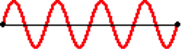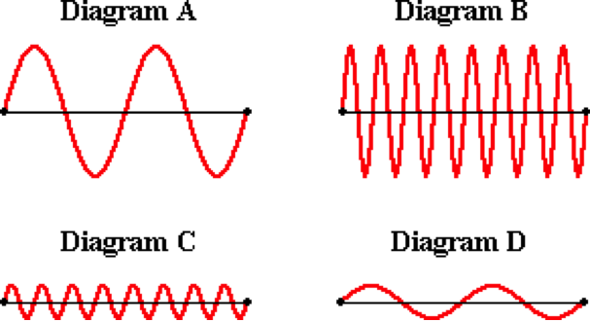

**Question 38:**

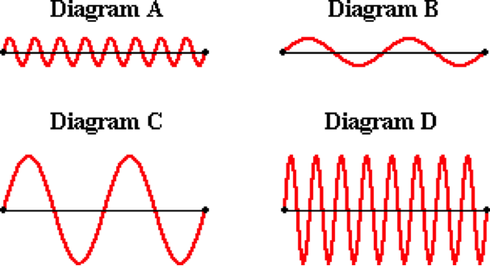aa. A 'snapshot in time' of a wave is shown below left. Which one of the diagrams below represents a wave with twice the amplitude and one-half the wavelength?

**Question 39:**

aa. A 'snapshot in time' of a wave is shown below left. Which one of the diagrams below represents a wave with twice the wavelength and one-half the amplitude?

**Question 40:**

aa. A 'snapshot in time' of a wave is shown below left. Which one of the diagrams below represents a wave with twice the wavelength and twice the amplitude?

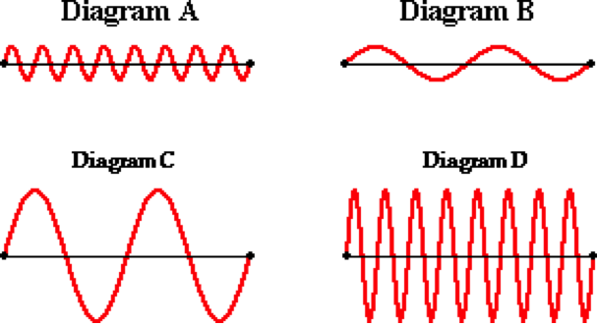

**WM3: Speed of a Wave**

**Question 1:**

aa. The speed of a wave is DEFINED as _____. (The word DEFINED is being emphasized.)

a. how rapidly it vibrates up and down (or back and forth)

b. the frequency at which a point on the medium vibrates back and forth

c. the distance which a crest travels per unit of time

d. the wavelength divided by the frequency

e. the time it takes for one complete wave cycle to be completed

**Question 2:**

aa. The speed of a wave is DEFINED as _____. (The word DEFINED is being emphasized.)

a. the wavelength divided by the frequency

b. the distance which a crest travels per unit of time

c. the time it takes for one complete wave cycle to be completed

d. the frequency at which a point on the medium vibrates back and forth

e. how rapidly it vibrates up and down (or back and forth)

**Question 3:**

aa. The speed of a wave is DEFINED as _____. (The word DEFINED is being emphasized.)

a. the frequency at which a point on the medium vibrates back and forth

b. the wavelength divided by the frequency

c. how rapidly it vibrates up and down (or back and forth)

d. the time it takes for one complete wave cycle to be completed

e. the distance which a crest travels per unit of time

**Question 4:**

aa. If a traveling wave is described as moving fast, then one can be sure that _____.

a. the medium undergoes rapid up and down vibrations

b. it is a long wave

c. it is a tall wave

d. it is a wave with a relatively short period

e. a crest moves a relatively large distance in a short time

**Question 5:**

aa. If a traveling wave is described as moving fast, then one can be sure that _____.

a. it is a tall wave

b. it is a long wave

c. the medium undergoes rapid up and down vibrations

d. a crest moves a relatively large distance in a short time

e. it is a wave with a relatively short period

**Question 6:**

aa. If a traveling wave is described as moving fast, then one can be sure that _____.

a. a crest moves a relatively large distance in a short time

b. it is a wave with a relatively short period

c. the medium undergoes rapid up and down vibrations

d. it is a tall wave

e. it is a long wave

**Question 7:**

aa. The speed of a wave depends upon the ____. List all that apply in alphabetical order with no commas or spaces between letters.

a. frequency of the wave b. wavelength of the wave

c. period of the wave d. properties of the medium

e. None of these

**Question 8:**

aa. The speed of a wave depends upon the ____. List all that apply in alphabetical order with no commas or spaces between letters.

a period of the wave b. properties of the medium

c. frequency of the wave d. wavelength of the wave

e. None of these

**Question 9:**

aa. The speed of a wave depends upon the ____. List all that apply in alphabetical order with no commas or spaces between letters.

a. period of the wave b. wavelength of the wave

c. properties of the medium d. frequency of the wave

e. None of these

**Question 10:**

aa. The speed of a wave depends upon the ____. List all that apply in alphabetical order with no commas or spaces between letters.

a. properties of the medium b period of the wave

c. wavelength of the wave d. frequency of the wave

e. None of these

**Question 11:**

aa. Which of the following would affect the speed of a water wave? That is, which could be altered and subsequently alter the wave speed? List all that apply in alphabetical order with no commas or spaces between letters.

a. depth of the water b. period of the wave

c. wavelength of the wave d. frequency of the wave

e. None of these

**Question 12:**

aa. Which of the following would affect the speed of a water wave? That is, which could be altered and subsequently alter the wave speed? List all that apply in alphabetical order with no commas or spaces between letters.

a. period of the wave b. frequency of the wave

c. wavelength of the wave d. depth of the water

e. None of these

**Question 13:**

aa. Which of the following would affect the speed of a water wave? That is, which could be altered and subsequently alter the wave speed? List all that apply in alphabetical order with no commas or spaces between letters.

a. frequency of the wave b. wavelength of the wave

c. depth of the water d. period of the wave

e. None of these

**Question 14:**

aa. Which of the following would affect the speed of a water wave? That is, which could be altered and subsequently alter the wave speed? List all that apply in alphabetical order with no commas or spaces between letters.

a. frequency of the wave b. depth of the water

c. wavelength of the wave d. period of the wave

e. None of these

**Question 15:**

aa. Two waves - wave A and wave B - are introduced into two Slinkies having identical properties. Wave A has a frequency of 4 Hz and an amplitude of 50 cm. Wave B has a frequency of 2.5 Hz and an amplitude of 50 cm. Which wave is likely to have the greatest speed?

a. Wave A

b. Wave B

c. Both waves have the same speed

d. ... nonsense! It is impossible to tell without a knowledge of the wavelength.

**Question 16:**

aa. Two waves - wave A and wave B - are introduced into two Slinkies having identical properties. Wave A has a frequency of 2 Hz and an amplitude of 50 cm. Wave B has a frequency of 2.5 Hz and an amplitude of 50 cm. Which wave is likely to have the greatest speed?

a. Wave A

b. Wave B

c. Both waves have the same speed

d. ... nonsense! It is impossible to tell without a knowledge of the wavelength.

**Question 17:**

aa. Two waves - wave A and wave B - are introduced into two Slinkies having identical properties. Wave A has a frequency of 4 Hz and an amplitude of 50 cm. Wave B has a frequency of 4 Hz and an amplitude of 50 cm. Which wave is likely to have the greatest speed?

a. Wave A

b. Wave B

c. Both waves have the same speed

d. ... nonsense! It is impossible to tell without a knowledge of the wavelength.

**Question 18:**

aa. Mac and Tosh are creating waves using a 3-inch zinc-coiled Slinky. If they double the frequency of the waves which they are creating (without any alteration in the medium), then one can be sure that ____.

a. the speed will be doubled

b. the speed will be halved

c. the speed will not be changed

d. ...nonsense! One cannot be sure of anything in such an uncertain world.

**Question 19:**

aa. Mac and Tosh are creating waves using a 3-inch zinc-coiled Slinky. If they double the frequency of the waves which they are creating (without any alteration in the medium), then one can be sure that ____.

a. the speed will not be changed

b. the speed will be halved

c. the speed will be doubled

d. ...nonsense! One cannot be sure of anything in such an uncertain world.

**Question 20:**

aa. Mac and Tosh are creating waves using a 3-inch zinc-coiled Slinky. If they halve the frequency of the waves which they are creating (without any alteration in the medium), then one can be sure that ____.

a. the speed will be halved

b. the speed will be doubled

c. the speed will not be changed

d. ...nonsense! One cannot be sure of anything in such an uncertain world.

**Question 21:**

aa. Mac and Tosh are creating waves using a 3-inch zinc-coiled Slinky. If they halve the frequency of the waves which they are creating (without any alteration in the medium), then one can be sure that ____.

a. the speed will not be changed

b. the speed will be halved

c. the speed will be doubled

d. ...nonsense! One cannot be sure of anything in such an uncertain world.

**Question 22:**

aa. An ocean-going vessel uses sonar to measure the depth of the ocean. If a sound wave sent from the ship bounces off the ocean floor 525.0 m below and returns to the ship after 0.875 seconds, then what is the speed (in m/s) of the sound waves in water? Enter a numerical answer.

**Question 23:**

aa. An ocean-going vessel uses sonar to measure the depth of the ocean. If a sound wave sent from the ship bounces off the ocean floor 525.0 m below and returns to the ship after 0.875 seconds, then what is the speed (in m/s) of the sound waves in water? Enter a numerical answer.

**Question 24:**

aa. An ocean-going vessel uses sonar to measure the depth of the ocean. If a sound wave sent from the ship bounces off the ocean floor 105.0 m below and returns to the ship after 0.175 seconds, then what is the speed (in m/s) of the sound waves in water? Enter a numerical answer.

**Question 25:**

aa. A water wave travels through a reflecting pool that is 10.0 m long. A physics student times one complete down-and-back motion of a ripple through the pool to take 8.80 seconds. What is the speed (in m/s) of the water wave? Enter a numerical answer.

**Question 26:**

aa. A water wave travels through a reflecting pool that is 60.0 m long. A physics student times one complete down-and-back motion of a ripple through the pool to take 26.40 seconds. What is the speed (in m/s) of the water wave? Enter a numerical answer.

**Question 27:**

aa. A water wave travels through a reflecting pool that is 12.0 m long. A physics student times one complete down-and-back motion of a ripple through the pool to take 8.90 seconds. What is the speed (in m/s) of the water wave? Enter a numerical answer.

**Question 28:**

aa. A sound wave having a frequency of 261 Hz is observed to travel 341.0 meters in 1.0 seconds. What is the speed (in m/s) of the sound wave? Enter a numerical answer.

**Question 29:**

aa. A sound wave having a frequency of 384 Hz is observed to travel 561.25 meters in 1.65 seconds. What is the speed (in m/s) of the sound wave? Enter a numerical answer.

**Question 30:**

aa. A sound wave having a frequency of 512 Hz is observed to travel 1076.0 meters in 3.20 seconds. What is the speed (in m/s) of the sound wave? Enter a numerical answer.

**WM4: Wavelength-Frequency-Speed Relationship**

**Question 1:**

aa. Find the speed of a wave (in meters/second) whose wavelength is 4 meters and whose frequency is 3.5 Hz. Enter a numerical answer.

**Question 2:**

aa. Find the speed of a wave (in meters/second) whose wavelength is 4 meters and whose frequency is 2.5 Hz. Enter a numerical answer.

**Question 3:**

aa. Find the speed of a wave (in meters/second) whose wavelength is 4 meters and whose frequency is 4.5 Hz. Enter a numerical answer.

**Question 4:**

aa. Find the wavelength of a wave (in meters) whose frequency is 1.3 Hz and which travels at 5 meters/second. Enter a numerical answer.

**Question 5:**

aa. Find the wavelength of a wave (in meters) whose frequency is 3.3 Hz and which travels at 10 meters/second. Enter a numerical answer.

**Question 6:**

aa. Find the wavelength of a wave (in meters) whose frequency is 7.8 Hz and which travels at 8 meters/second. Enter a numerical answer.

**Question 7:**

aa. Find the frequency of a wave (in Hertz) whose wavelength is 2.3 meters and which travels at 7 meters/second. Enter a numerical answer.

**Question 8:**

aa. Find the frequency of a wave (in Hertz) whose wavelength is 3.5 meters and which travels at 15.3 meters/second. Enter a numerical answer.

**Question 9:**

aa. Find the frequency of a wave (in Hertz) whose wavelength is 5 meters and which travels at 14.2 meters/second. Enter a numerical answer.

**Question 10:**

aa. A wave with a frequency of 1.4 Hz is created in an elastic rope. The diagram below represents a *snapshot* of the wave at a given instant of time.

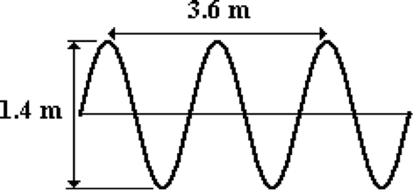

Determine the speed of the wave (in meters/second). Enter a numerical answer.

**Question 11:**

aa. A wave with a frequency of 4.5 Hz is created in an elastic rope. The diagram below represents a *snapshot* of the wave at a given instant of time.

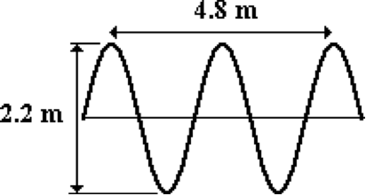

Determine the speed of the wave (in meters/second). Enter a numerical answer.

**Question 12:**

aa. A wave with a frequency of 5.6 Hz is created in an elastic rope. The diagram below represents a *snapshot* of the wave at a given instant of time.

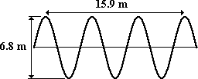

Determine the speed of the wave (in meters/second). Enter a numerical answer.

**Question 13:**

aa. A wave is created in an elastic rope. The diagram below represents a *snapshot* of the wave at a given instant of time. The distance from point A to points B and C are given. Point A on the wave moves to the position of point C in 0.50 seconds.

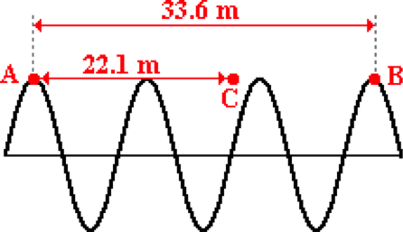

Determine the wavelength (in meters), frequency (in Hertz), and speed (in meters/second) of this wave.

**Question 14:**

aa. A wave is created in an elastic rope. The diagram below represents a *snapshot* of the wave at a given instant of time. The distance from point A to points B and C are given. Point A on the wave moves to the position of point B in 0.40 seconds.

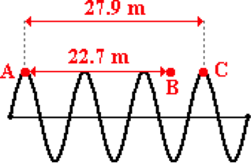

Determine the wavelength (in meters), frequency (in Hertz), and speed (in meters/second) of this wave.

**Question 15:**

aa. A wave is created in an elastic rope. The diagram below represents a *snapshot* of the wave at a given instant of time. The distance from point A to points B and C are given. Point A on the wave moves to the position of point B in 2.90 seconds.

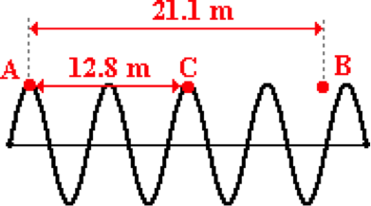

Determine the wavelength (in meters), frequency (in Hertz), and speed (in meters/second) of this wave.

**Question 16:**

aa. A pelican is sitting on its perch in the harbor as ocean waves come splashing in. The crests of the waves drench the pelican as it collides with its perch. The drenchings occur every 2.40 seconds. The crests are positioned 9.90 meters apart. Determine the wavelength (in meters), frequency (in Hertz), and speed (in meters/second) of the wave.

**Question 17:**

aa. A pelican is sitting on its perch in the harbor as ocean waves come splashing in. The crests of the waves drench the pelican as it collides with its perch. The drenchings occur every 2.40 seconds. The crests are positioned 6.30 meters apart. Determine the wavelength (in meters), frequency (in Hertz), and speed (in meters/second) of the wave.

**Question 18:**

aa. A pelican is sitting on its perch in the harbor as ocean waves come splashing in. The crests of the waves drench the pelican as it collides with its perch. The drenchings occur every 1.40 seconds. The crests are positioned 9.80 meters apart. Determine the wavelength (in meters), frequency (in Hertz), and speed (in meters/second) of the wave.

**Question 19:**

aa. Two boats - Boat A and Boat B - are anchored a distance of 6.6 meters apart. The incoming water waves force the boats to oscillate up and down, making three complete cycles every 12.7 seconds. When Boat A is at its peak, Boat B is at its low point. There are never any wave crests between the two boats. The vertical distance between Boat A and Boat B at their extreme is 8 meters. Determine the wavelength (in meters), frequency (in Hertz), and speed (in meters/second) of the wave. (HINT: begin with a diagram.)

**Question 20:**

aa. Two boats - Boat A and Boat B - are anchored a distance of 4.3 meters apart. The incoming water waves force the boats to oscillate up and down, making two complete cycles every 9.2 seconds. When Boat A is at its peak, Boat B is at its low point. There are never any wave crests between the two boats. The vertical distance between Boat A and Boat B at their extreme is 6.3 meters. Determine the wavelength (in meters), frequency (in Hertz), and speed (in meters/second) of the wave. (HINT: begin with a diagram.)

**Question 21:**

aa. Two boats - Boat A and Boat B - are anchored a distance of 17.3 meters apart. The incoming water waves force the boats to oscillate up and down, making four complete cycles every 16.4 seconds. When Boat A is at its peak, Boat B is at its low point. There is one crest between the two boats. The vertical distance between Boat A and Boat B at their extreme is 9.8 meters. Determine the wavelength (in meters), frequency (in Hertz), and speed (in meters/second) of the wave. (HINT: begin with a diagram.)

**Question 22:**

aa. Two boats - Boat A and Boat B - are anchored a distance of 15.8 meters apart. The incoming water waves force the boats to oscillate up and down, making five complete cycles every 28.9 seconds. When Boat A is at its peak, Boat B is at its low point. There is one crest between the two boats. The vertical distance between Boat A and Boat B at their extreme is 12.3 meters. Determine the wavelength (in meters), frequency (in Hertz), and speed (in meters/second) of the wave. (HINT: begin with a diagram.)

**Question 23:**

aa. Two boats - Boat A and Boat B - are anchored a distance of 19.6 meters apart. The incoming water waves force the boats to oscillate up and down, making one complete cycle every 7.2 seconds. When Boat A is at its peak, Boat B is at its low point. There are two wave crests between the two boats. The vertical distance between Boat A and Boat B at their extreme is 9.4 meters. Determine the wavelength (in meters), frequency (in Hertz), and speed (in meters/second) of the wave. (HINT: begin with a diagram.)

**Question 24:**

aa. Two boats - Boat A and Boat B - are anchored a distance of 4.1 meters apart. The incoming water waves force the boats to oscillate up and down, making five complete cycles every 26.1 seconds. When Boat A is at its peak, Boat B is at its low point. There are never any waves between the two boats. The vertical distance between Boat A and Boat B at their extreme is 6.9 meters. Determine the wavelength (in meters), frequency (in Hertz), and speed (in meters/second) of the wave. (HINT: begin with a diagram.)

**WM5: Boundary Behavior of Waves**

**Question 1:**

aa. Diagram 1 below shows a pulse traveling through a medium and approaching a boundary with a second medium. Diagram 2 shows the appearance of the media several seconds later.

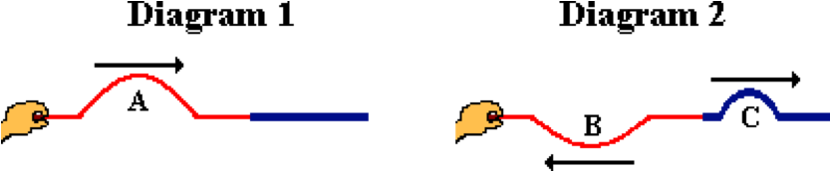

In these diagrams, A is the ___ pulse, B is the ____ pulse, and C is the ____ pulse.

a. incident, transmitted, reflected b. transmitted, incident, reflected

c. transmitted, reflected, incident d. incident, reflected, transmitted

e. None of these appropriately name these three pulses

**Question 2:**

aa. Diagram 1 below shows a pulse traveling through a medium and approaching a boundary with a second medium. Diagram 2 shows the appearance of the media several seconds later.



In these diagrams, A is the ___ pulse, B is the ____ pulse, and C is the ____ pulse.

a. incident, reflected, transmitted b. transmitted, reflected, incident

c. incident, transmitted, reflected d. transmitted, incident, reflected

e. None of these appropriately name these three pulses

**Question 3:**

aa. Diagram 1 below shows a pulse traveling through a medium and approaching a boundary with a second medium. Diagram 2 shows the appearance of the media several seconds later.

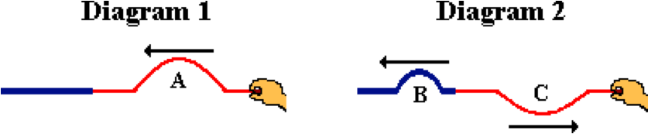

In these diagrams, A is the ___ pulse, B is the ____ pulse, and C is the ____ pulse.

a. incident, reflected, transmitted b. transmitted, reflected, incident

c. incident, transmitted, reflected d. transmitted, incident, reflected

e. None of these appropriately name these three pulses

**Question 4:**

aa. Diagram 1 below shows a pulse traveling through a medium and approaching a boundary with a second medium. Diagram 2 shows the appearance of the media several seconds later.



In these diagrams, A is the ___ pulse, B is the ____ pulse, and C is the ____ pulse.

a. incident, reflected, transmitted b. incident, transmitted, reflected

c. transmitted, reflected, incident d. transmitted, incident, reflected

e. None of these appropriately name these three pulses

**Question 5:**

aa. A wave is traveling through a dense rope and approaching the boundary with a less dense rope. The transmitted wave will have ____ the incident wave. List all that apply in alphabetical order with no commas or spaces between letters.

a. a greater speed than b. a greater frequency than

c. a smaller wavelength than d. none of these

**Question 6:**

aa. A wave is traveling through a dense rope and approaching the boundary with a less dense rope. The transmitted wave will have ____ the incident wave. List all that apply in alphabetical order with no commas or spaces between letters.

a. a greater wavelength than b. a smaller frequency than

c. a greater speed than d. none of these

**Question 7:**

aa. A wave is traveling through a dense rope and approaching the boundary with a less dense rope. The incident wave will have ____ the transmitted wave. List all that apply in alphabetical order with no commas or spaces between letters.

a. a greater speed than b. a smaller frequency than

c. the same wavelength as d. none of these

**Question 8:**

aa. A wave is traveling through a dense rope and approaching the boundary with a less dense rope. The incident wave will have ____ the transmitted wave. List all that apply in alphabetical order with no commas or spaces between letters.

a. a greater speed than b. a smaller wavelength than

c. the same frequency as d. none of these

**Question 9:**

aa. A wave is traveling through a dense rope and approaching the boundary with a less dense rope. The incident wave will have ____ the transmitted wave. List all that apply in alphabetical order with no commas or spaces between letters.

a. a greater wavelength than b. a greater speed than

c. the same frequency as d. none of these

**Question 10:**

aa. A wave is traveling through a dense rope and approaching the boundary with a less dense rope. The transmitted wave will have ____ the incident wave. List all that apply in alphabetical order with no commas or spaces between letters.

a. a greater wavelength than b. a greater speed than

c. the same frequency as d. none of these

**Question 11:**

aa. A wave is traveling through a rope and approaching the boundary with a more dense rope. The transmitted wave will have ____ the incident wave. List all that apply in alphabetical order with no commas or spaces between letters.

a. a greater speed than b. a greater frequency than

c. a smaller wavelength than d. none of these

**Question 12:**

aa. A wave is traveling through a rope and approaching the boundary with a more dense rope. The transmitted wave will have ____ the incident wave. List all that apply in alphabetical order with no commas or spaces between letters.

a. a greater wavelength than b. a smaller frequency than

c. a greater speed than d. none of these

**Question 13:**

aa. A wave is traveling through a rope and approaching the boundary with a more dense rope. The transmitted wave will have ____ the incident wave. List all that apply in alphabetical order with no commas or spaces between letters.

a. a greater speed than b. a smaller frequency than

c. the same wavelength as d. none of these

**Question 14:**

aa. A wave is traveling through a rope and approaching the boundary with a more dense rope. The transmitted wave will have ____ the incident wave. List all that apply in alphabetical order with no commas or spaces between letters.

a. a greater speed than b. a smaller wavelength than

c. the same frequency as d. none of these

**Question 15:**

aa. A wave is traveling through a rope and approaching the boundary with a more dense rope. The transmitted wave will have ____ the incident wave. List all that apply in alphabetical order with no commas or spaces between letters.

a. a greater wavelength than b. a greater speed than

c. the same frequency as d. none of these

**Question 16:**

aa. A wave is traveling through a rope and approaching the boundary with a more dense rope. The transmitted wave will have ____ the incident wave. List all that apply in alphabetical order with no commas or spaces between letters.

a. a greater wavelength than b. a greater speed than

c. the same frequency as d. none of these

**Question 17:**

aa. When comparing the wave characteristics of a wave in two different ropes, one can be sure that the wavelength and speed will be ____.

a. greatest in the least dense medium

b. smallest in the least dense medium

c. the same regardless of the density of the medium

**Question 18:**

aa. When comparing the wave characteristics of a wave in two different ropes, one can be sure that the wavelength and speed will be ____.

a. greatest in the most dense medium

b. smallest in the most dense medium

c. the same regardless of the density of the medium

**Question 19:**

aa. When comparing the wave characteristics of a wave in two different ropes, one can be sure that the wavelength and speed will be ____.

a. smallest in the least dense medium

b. greatest in the least dense medium

c. the same regardless of the density of the medium

**Question 20:**

aa. When comparing the wave characteristics of a wave in two different ropes, one can be sure that the wavelength and speed will be ____.

a. smallest in the most dense medium

b. greatest in the most dense medium

c. the same regardless of the density of the medium

**Question 21:**

aa. Diagram 1 below shows a pulse traveling through a medium and approaching a boundary with a second medium. Diagram 2 shows the appearance of the media several seconds later.

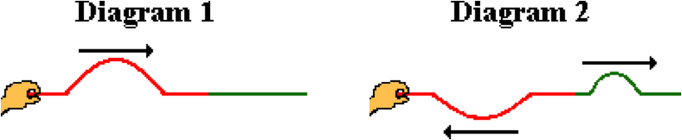

Comparing Diagrams 1 and 2 would lead one to believe that the ____-colored medium is the most dense medium.

a. red (on the left) b. green (on the right)

c. ... nonsense! Both media have the same density.

**Question 22:**

aa. Diagram 1 below shows a pulse traveling through a medium and approaching a boundary with a second medium. Diagram 2 shows the appearance of the media several seconds later.



Comparing Diagrams 1 and 2 would lead one to believe that the ____-colored medium is the most dense medium.

a. green (on the right) b. red (on the left)

c. ... nonsense! Both media have the same density.

**Question 23:**

aa. Diagram 1 below shows a pulse traveling through a medium and approaching a boundary with a second medium. Diagram 2 shows the appearance of the media several seconds later.



Comparing Diagrams 1 and 2 would lead one to believe that the ____-colored medium is the least dense medium.

a. red (on the left) b. green (on the right)

c. ... nonsense! Both media have the same density.

**Question 24:**

aa. Diagram 1 below shows a pulse traveling through a medium and approaching a boundary with a second medium. Diagram 2 shows the appearance of the media several seconds later.



Comparing Diagrams 1 and 2 would lead one to believe that the ____-colored medium is the least dense medium.

a. green (on the right) b. red (on the left)

c. ... nonsense! Both media have the same density.

**Question 25:**

aa. An elastic rope is tied securely to a wall. An upward-displaced pulse is introduced into the rope. The pulse travels through the rope, reaches the boundary with the wall and reflects. The reflected pulse will be ____.

a. inverted (displaced downwards)

b. upright (displaced upwards)

c. either inverted or upright, depending upon its amplitude

**Question 26:**

aa. An elastic rope is tied securely to a wall. An upward-displaced pulse is introduced into the rope. The pulse travels through the rope, reaches the boundary with the wall and reflects. The reflected pulse will be ____.

a. upright (displaced upwards)

b. inverted (displaced downwards)

c. either inverted or upright, depending upon its amplitude

**Question 27:**

aa. An elastic rope is tied securely to a wall. An upward-displaced pulse is introduced into the rope. The pulse travels through the rope, reaches the boundary with the wall and reflects. The reflected pulse will be ____.

a. either inverted or upright, depending upon its amplitude

b. upright (displaced upwards)

c. inverted (displaced downwards)

**Question 28:**

aa. An elastic rope is stretched out and loosely attached to a wall such that its end is free to move. An upward-displaced pulse is introduced into the rope. The pulse travels through the rope, reaches the boundary with the wall and reflects. The reflected pulse will be ____.

a. inverted (displaced downwards)

b. upright (displaced upwards)

c. either inverted or upright, depending upon its amplitude

**Question 29:**

aa. An elastic rope is stretched out and loosely attached to a wall such that its end is free to move. An upward-displaced pulse is introduced into the rope. The pulse travels through the rope, reaches the boundary with the wall and reflects. The reflected pulse will be ____.

a. upright (displaced upwards)

b. inverted (displaced downwards)

c. either inverted or upright, depending upon its amplitude

**Question 30:**

aa. An elastic rope is stretched out and loosely attached to a wall such that its end is free to move. An upward-displaced pulse is introduced into the rope. The pulse travels through the rope, reaches the boundary with the wall and reflects. The reflected pulse will be ____.

a. either inverted or upright, depending upon its amplitude

b. inverted (displaced downwards)

c. upright (displaced upwards)

**Question 31:**

aa. When a transverse wave is moving through a more dense medium and approaching the boundary with a less dense medium, a portion of the wave will be transmitted across the boundary and a portion of the wave will be reflected. The reflected wave will ___

a. be inverted b. not be inverted

c. be either inverted or not, depending upon its amplitude

**Question 32:**

aa. When a transverse wave is moving through a more dense medium and approaching the boundary with a less dense medium, a portion of the wave will be transmitted across the boundary and a portion of the wave will be reflected. The reflected wave will ___

a. not be inverted b. be inverted

c. be either inverted or not, depending upon its amplitude

**Question 33:**

aa. When a transverse wave is moving through a less dense medium and approaching the boundary with a more dense medium, a portion of the wave will be transmitted across the boundary and a portion of the wave will be reflected. The reflected wave will ___

a. be inverted b. not be inverted

c. be either inverted or not, depending upon its amplitude

**Question 34:**

aa. When a transverse wave is moving through a less dense medium and approaching the boundary with a more dense medium, a portion of the wave will be transmitted across the boundary and a portion of the wave will be reflected. The reflected wave will ___

a. not be inverted b. be inverted

c. be either inverted or not, depending upon its amplitude

**Question 35:**

aa. The diagram shows a pulse traveling in a less dense medium towards a more dense medium.



How will the two media look after reflection and transmission? Choose the one diagram - labeled A, B, C, D or E.

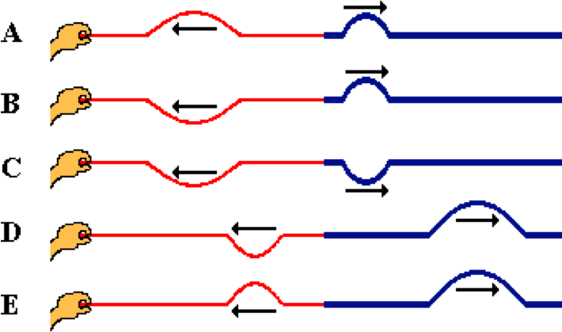

**Question 36:**

aa. The diagram shows a pulse traveling in a less dense medium towards a more dense medium.



How will the two media look after reflection and transmission? Choose the one diagram - labeled A, B, C, D or E.

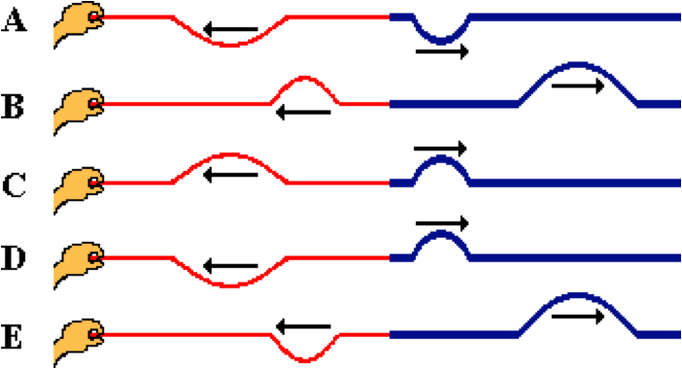

**Question 37:**

aa. The diagram shows a pulse traveling in a less dense medium towards a more dense medium.



How will the two media look after reflection and transmission? Choose the one diagram - labeled A, B, C, D or E.

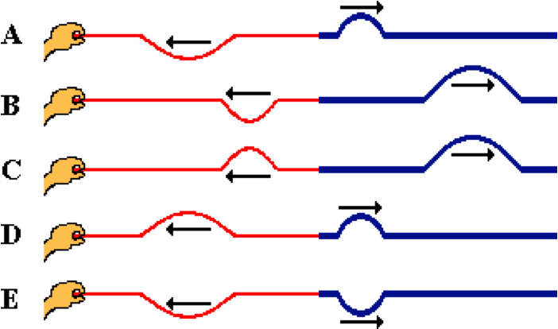

**Question 38:**

aa. The diagram shows a pulse traveling in a more dense medium towards a less dense medium.



How will the two media look after reflection and transmission? Choose the one diagram - labeled A, B, C, D or E.

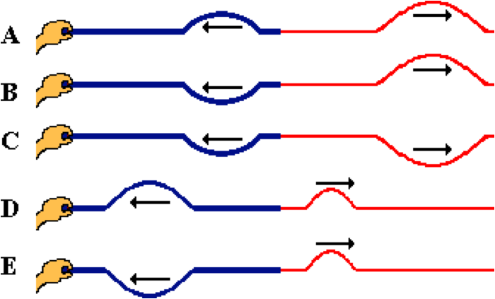

**Question 39:**

aa. The diagram shows a pulse traveling in a more dense medium towards a less dense medium.



How will the two media look after reflection and transmission? Choose the one diagram - labeled A, B, C, D or E.

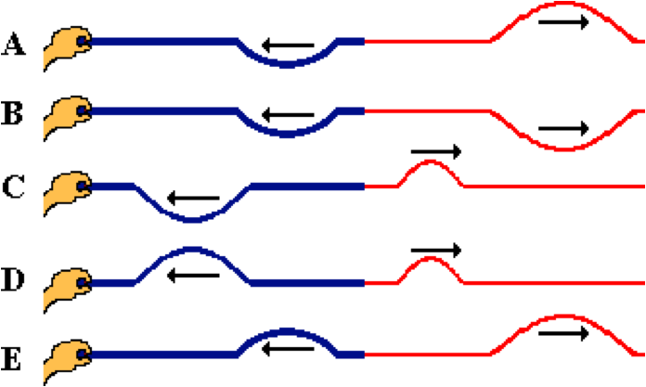

**Question 40:**

aa. The diagram shows a pulse traveling in a more dense medium towards a less dense medium.



How will the two media look after reflection and transmission? Choose the one diagram - labeled A, B, C, D or E.

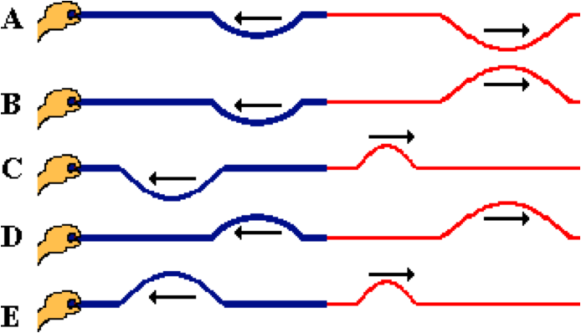

**WM6: Interference of Waves**

**Question 1:**

aa. Interference occurs when a wave ____.

a. reaches the end of its medium

b. crosses over a boundary into another medium

c. bounces off a surface

d. encounters an obstacle in its path

e. changes direction when passing from one medium to another

f. meets up with another wave traveling in the same medium

**Question 2:**

aa. Interference occurs when a wave ____.

a. changes direction when passing from one medium to another

b. bounces off a surface

c. crosses over a boundary into another medium

d. encounters an obstacle in its path

e. meets up with another wave traveling in the same medium

f. reaches the end of its medium

**Question 3:**

aa. Interference occurs when a wave ____.

a. encounters an obstacle in its path

b. reaches the end of its medium

c. changes direction when passing from one medium to another

d. meets up with another wave traveling in the same medium

e. crosses over a boundary into another medium

f. bounces off a surface

**Question 4:**

aa. Interference occurs when a wave ____.

a. crosses over a boundary into another medium

b. meets up with another wave traveling in the same medium

c. changes direction when passing from one medium to another

d. bounces off a surface

e. reaches the end of its medium

f. encounters an obstacle in its path

**Question 5:**

aa. Constructive interference would occur when a ____. List all that apply in alphabetical order with no commas or spaces between letters.

a. crest of one wave interferes with a trough of another wave

b. crest of one wave interferes with a crest of another wave

c. trough of one wave interferes with a trough of another wave

d. none of these

**Question 6:**

aa. Constructive interference would occur when a ____. List all that apply in alphabetical order with no commas or spaces between letters.

a. trough of one wave interferes with a trough of another wave

b. crest of one wave interferes with a trough of another wave

c. crest of one wave interferes with a crest of another wave

d. none of these

**Question 7:**

aa. Constructive interference would occur when a ____. List all that apply in alphabetical order with no commas or spaces between letters.

a. trough of one wave interferes with a trough of another wave

b. crest of one wave interferes with a crest of another wave

c. crest of one wave interferes with a trough of another wave

d. none of these

**Question 8:**

aa. Destructive interference would occur when a ____. List all that apply in alphabetical order with no commas or spaces between letters.

a. crest of one wave interferes with a trough of another wave

b. crest of one wave interferes with a crest of another wave

c. trough of one wave interferes with a trough of another wave

d. none of these

**Question 9:**

aa. Destructive interference would occur when a ____. List all that apply in alphabetical order with no commas or spaces between letters.

a. trough of one wave interferes with a trough of another wave

b. crest of one wave interferes with a trough of another wave

c. crest of one wave interferes with a crest of another wave

d. none of these

**Question 10:**

aa. Destructive interference would occur when a ____. List all that apply in alphabetical order with no commas or spaces between letters.

a. trough of one wave interferes with a trough of another wave

b. crest of one wave interferes with a crest of another wave

c. crest of one wave interferes with a trough of another wave

d. none of these

**Question 11:**

aa. The diagram below shows two sine waves present in the same medium; several points along the medium are labeled with letters.

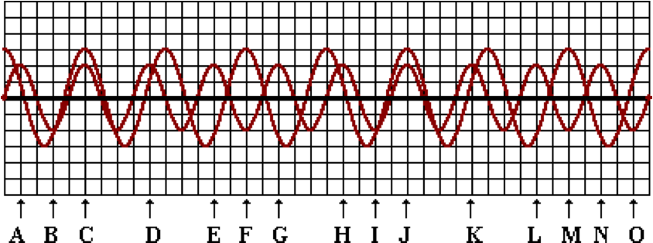

At which points does constructive interference occur? List all that apply in alphabetical order with no commas or spaces between letters.

**Question 12:**

aa. The diagram below shows two sine waves present in the same medium; several points along the medium are labeled with letters.

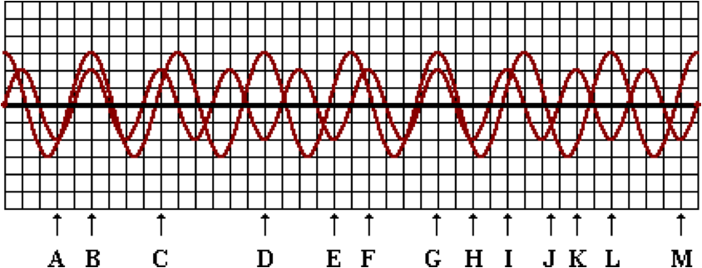

At which points does constructive interference occur? List all that apply in alphabetical order with no commas or spaces between letters.

**Question 13:**

aa. The diagram below shows two sine waves present in the same medium; several points along the medium are labeled with letters.

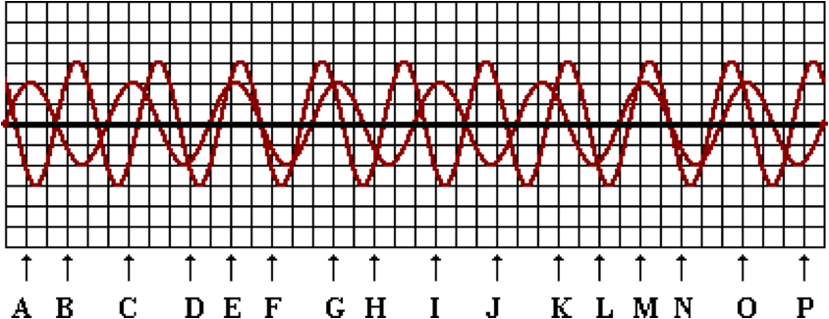

At which points does constructive interference occur? List all that apply in alphabetical order with no commas or spaces between letters.

**Question 14:**

aa. The diagram below shows two sine waves present in the same medium; several points along the medium are labeled with letters.

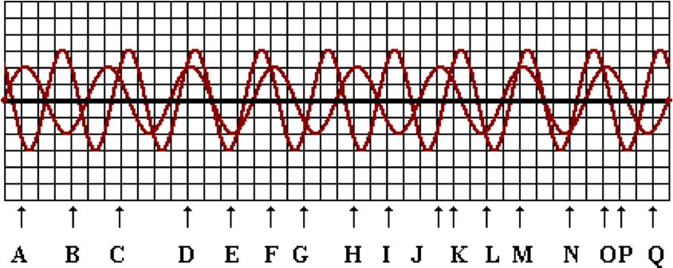

At which points does constructive interference occur? List all that apply in alphabetical order with no commas or spaces between letters.

**Question 15:**

aa. The diagram below shows two sine waves present in the same medium; several points along the medium are labeled with letters.



At which points does destructive interference occur? List all that apply in alphabetical order with no commas or spaces between letters.

**Question 16:**

aa. The diagram below shows two sine waves present in the same medium; several points along the medium are labeled with letters.



At which points does destructive interference occur? List all that apply in alphabetical order with no commas or spaces between letters.

**Question 17:**

aa. The diagram below shows two sine waves present in the same medium; several points along the medium are labeled with letters.



At which points does destructive interference occur? List all that apply in alphabetical order with no commas or spaces between letters.

**Question 18:**

aa. The diagram below shows two sine waves present in the same medium; several points along the medium are labeled with letters.



At which points does destructive interference occur? List all that apply in alphabetical order with no commas or spaces between letters.

**Question 19:**

aa. The diagram below shows two sine waves present in the same medium; several points along the medium are labeled with letters.



The displacement of the resultant wave pattern at point B would be approximately ___ units.

a. 0 b. +1 c. +2

d. +5 e. -1 f. -2

g. -3 h. -4 i. -5

**Question 20:**

aa. The diagram below shows two sine waves present in the same medium; several points along the medium are labeled with letters.



The displacement of the resultant wave pattern at point F would be approximately ___ units.

a. 0 b. +1 c. +2

d. +3 e. +5 f. -1

g. -2 h. -3 i. -5

**Question 21:**

aa. The diagram below shows two sine waves present in the same medium; several points along the medium are labeled with letters.



The displacement of the resultant wave pattern at point J would be approximately ___ units.

a. 0 b. +1 c. +2

d. +3 e. +5 f. -1

g. -2 h. -3 i. -5

**Question 22:**

aa. The diagram below shows two sine waves present in the same medium; several points along the medium are labeled with letters.



The displacement of the resultant wave pattern at point O would be approximately ___ units.

a. 0 b. +1 c. +2 d. +3

e. -1 f. -2 g. -3

**Question 23:**

aa. The diagram below shows two sine waves present in the same medium; several points along the medium are labeled with letters.



The displacement of the resultant wave pattern at point A would be approximately ___ units.

a. 0 b. +2 c. +4 d. -2

e. -4 f. None of these answers are even close.

**Question 24:**

aa. The diagram below shows two sine waves present in the same medium; several points along the medium are labeled with letters.



The displacement of the resultant wave pattern at point D would be approximately ___ units.

a. 0 b. +1 c. +2 d. +4

e. -1 f. -2 g. -4

**Question 25:**

aa. The diagram below shows two sine waves present in the same medium; several points along the medium are labeled with letters.



The displacement of the resultant wave pattern at point H would be approximately ___ units.

a. 0 b. +0.5 c. +1 d. -0.5

e. -1 f. -2 g. -3

**Question 26:**

aa. The diagram below shows two sine waves present in the same medium; several points along the medium are labeled with letters.



The displacement of the resultant wave pattern at point O would be approximately ___ units.

a. 0 b. +2 c. +4 d. -2

e. -4 f. None of these answers are even close.

**Question 27:**

aa. The diagram below right shows two pulses - a square pulse and a triangle pulse - approaching each other along the same medium.

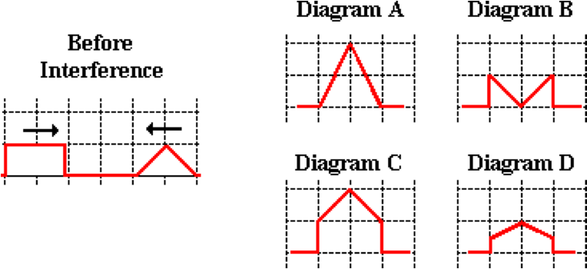

Which diagram shows the shape of the medium when they are completely interfering?

**Question 28:**

aa. The diagram below right shows two pulses - a square pulse and a triangle pulse - approaching each other along the same medium.

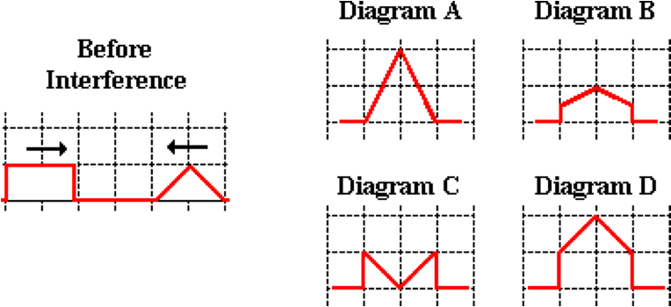

Which diagram shows the shape of the medium when they are completely interfering?

**Question 29:**

aa. The diagram below right shows two pulses - a square pulse and a sine pulse - approaching each other along the same medium.

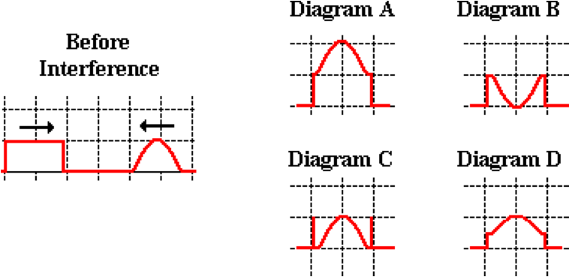

Which diagram shows the shape of the medium when they are completely interfering?

**Question 30:**

aa. The diagram below right shows two pulses - a square pulse and a sine pulse - approaching each other along the same medium.

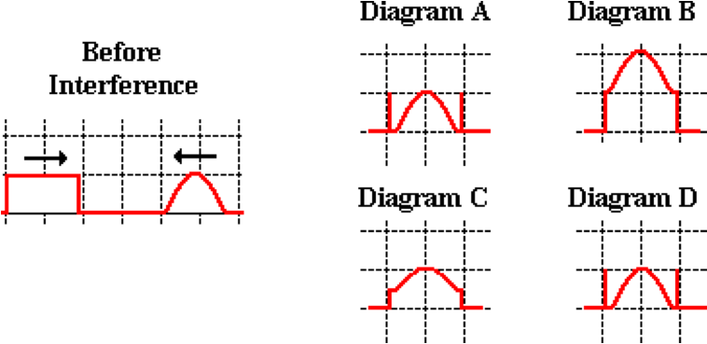

Which diagram shows the shape of the medium when they are completely interfering?

**WM7: Mathematics of Standing Waves**

**Question 1:**

aa. Consider the standing wave pattern shown below.

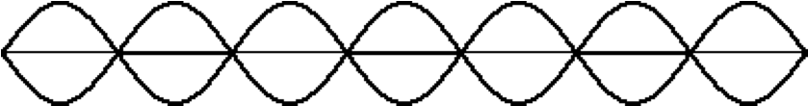

There are ___ nodes and ___ antinodes shown on the pattern. Enter your answers in respective order as two integers with no spaces or commas between numbers. For example: '63' and '88'

**Question 2:**

aa. Consider the standing wave pattern shown below.



There are ___ nodes and ___ antinodes shown on the pattern. Enter your answers in respective order as two integers with no spaces or commas between numbers. For example: '63' and '88'

**Question 3:**

aa. Consider the standing wave pattern shown below.



There are ___ antinodes and ___ nodes shown on the pattern. Enter your answers in respective order as two integers with no spaces or commas between numbers. For example: '63' and '88'

**Question 4:**

aa. Consider the standing wave pattern shown below.



There are ___ antinodes and ___ nodes shown on the pattern. Enter your answers in respective order as two integers with no spaces or commas between numbers. For example: '65' and '88'

**Question 5:**

aa. Consider the standing wave pattern shown below.

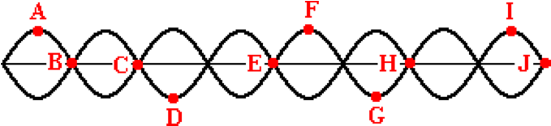

There are several labeled points on the diagram. Point A is separated from point F by a horizontal distance equivalent to ____ wavelengths. Enter a number into the answer field.

**Question 6:**

aa. Consider the standing wave pattern shown below.



There are several labeled points on the diagram. Point A is separated from point I by a horizontal distance equivalent to ____ wavelengths. Enter a number into the answer field.

**Question 7:**

aa. Consider the standing wave pattern shown below.



There are several labeled points on the diagram. Point B is separated from point E by a horizontal distance equivalent to ____ wavelengths. Enter a number into the answer field.

**Question 8:**

aa. Consider the standing wave pattern shown below.



There are several labeled points on the diagram. Point B is separated from point H by a horizontal distance equivalent to ____ wavelengths. Enter a number into the answer field.

**Question 9:**

aa. Consider the standing wave pattern shown below.



There are several labeled points on the diagram. Point B is separated from point J by a horizontal distance equivalent to ____ wavelengths. Enter a number into the answer field.

**Question 10:**

aa. Consider the standing wave pattern shown below.



There are several labeled points on the diagram. Point B is separated from point G by a horizontal distance equivalent to ____ wavelengths. Enter a number into the answer field.

**Question 11:**

aa. Consider the standing wave pattern shown below.

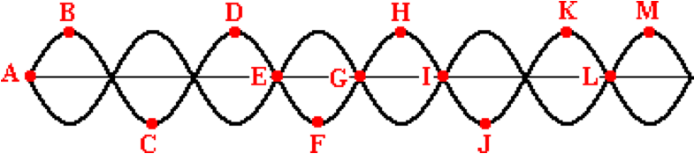

There are several labeled points on the diagram. Point A is separated from point D by a horizontal distance equivalent to ____ wavelengths. Enter a number into the answer field.

**Question 12:**

aa. Consider the standing wave pattern shown below.



There are several labeled points on the diagram. Point A is separated from point E by a horizontal distance equivalent to ____ wavelengths. Enter a number into the answer field.

**Question 13:**

aa. Consider the standing wave pattern shown below.



There are several labeled points on the diagram. Point A is separated from point L by a horizontal distance equivalent to ____ wavelengths. Enter a number into the answer field.

**Question 14:**

aa. Consider the standing wave pattern shown below.



There are several labeled points on the diagram. Point B is separated from point J by a horizontal distance equivalent to ____ wavelengths. Enter a number into the answer field.

**Question 15:**

aa. Consider the standing wave pattern shown below.



There are several labeled points on the diagram. Point C is separated from point M by a horizontal distance equivalent to ____ wavelengths. Enter a number into the answer field.

**Question 16:**

aa. Consider the standing wave pattern shown below.



There are several labeled points on the diagram. Point C is separated from point L by a horizontal distance equivalent to ____ wavelengths. Enter a number into the answer field.

**Question 17:**

aa. A young girl connects a rope to a tree and vibrates the free end in order to establish a standing wave pattern. The pattern is shown in the diagram below.

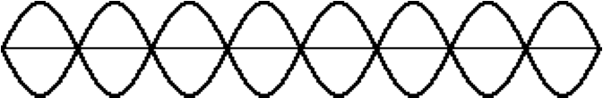

There are ____ waves in this pattern, stretching from the girl's hand to the tree. Enter a number into the answer field.

**Question 18:**

aa. A young girl connects a rope to a tree and vibrates the free end in order to establish a standing wave pattern. The pattern is shown in the diagram below.



There are ____ waves in this pattern, stretching from the girl's hand to the tree. Enter a number into the answer field.

**Question 19:**

aa. A young girl connects a rope to a tree and vibrates the free end in order to establish a standing wave pattern. The pattern is shown in the diagram below.



There are ____ waves in this pattern, stretching from the girl's hand to the tree. Enter a number into the answer field.

**Question 20:**

aa. A young boy connects a rope to a tree and vibrates the free end in order to establish a standing wave pattern. The pattern is shown in the diagram below.



There are ____ waves in this pattern, stretching from the girl's hand to the tree. Enter a number into the answer field.

**Question 21:**

aa. A young boy connects a rope to a tree and vibrates the free end in order to establish a standing wave pattern. The pattern is shown in the diagram below.



There are ____ waves in this pattern, stretching from the girl's hand to the tree. Enter a number into the answer field.

**Question 22:**

aa. A young boy connects a rope to a tree and vibrates the free end in order to establish a standing wave pattern. The pattern is shown in the diagram below.



There are ____ waves in this pattern, stretching from the girl's hand to the tree. Enter a number into the answer field.

**Question 23:**

aa. A standing wave pattern is established in a rope as shown below.



If the rope is 5.0 meters long, then the wavelength of the wave is ___ meters. Enter a number into the answer field.

**Question 24:**

aa. A standing wave pattern is established in a rope as shown below.



If the rope is 2.0 meters long, then the wavelength of the wave is ___ meters. Enter a number into the answer field.

**Question 25:**

aa. A standing wave pattern is established in a rope as shown below.



If the rope is 3.6 meters long, then the wavelength of the wave is ___ meters. Enter a number into the answer field.

**Question 26:**

aa. A standing wave pattern is established in a rope as shown below.



If the rope is 1.8 meters long, then the wavelength of the wave is ___ meters. Enter a number into the answer field.

**Question 27:**

aa. A standing wave pattern is established in a rope as shown below.



If the rope is 4.2 meters long, then the wavelength of the wave is ___ meters. Enter a number into the answer field.

**Question 28:**

aa. A standing wave pattern is established in a rope as shown below.



If the rope is 2.8 meters long, then the wavelength of the wave is ___ meters. Enter a number into the answer field.

**Question 29:**

aa. A standing wave pattern is established in a rope as shown below.



If the wavelength is 0.70 meters, then the rope is ___ meters long. Enter a number into the answer field.

**Question 30:**

aa. A standing wave pattern is established in a rope as shown below.



If the wavelength is 1.2 meters, then the rope is ___ meters long. Enter a number into the answer field.

**Question 31:**

aa. A standing wave pattern is established in a rope as shown below.



If the wavelength is 0.8 meters, then the rope is ___ meters long. Enter a number into the answer field.

**Question 32:**

aa. A standing wave pattern is established in a rope as shown below.



If the wavelength is 1.2 meters, then the rope is ___ meters long. Enter a number into the answer field.

**Question 33:**

aa. A standing wave pattern is established in a rope as shown below.



If the wavelength is 1.1 meters, then the rope is ___ meters long. Enter a number into the answer field.

**Question 34:**

aa. A standing wave pattern is established in a rope as shown below.



If the wavelength is 0.80 meters, then the rope is ___ meters long. Enter a number into the answer field.

**WM8: Mathematics of Standing Waves**

**Question 1:**

aa. Jack and Jill create a standing wave pattern in a Slinky by vibrating the slinky 27 times (i.e., 27 complete vibration cycles) in 19.1 seconds. The pattern contains one loop between the ends of the Slinky (the first harmonic). The Slinky is stretched to a length of 4.6 meters. Determine the wavelength (in meters), frequency (in Hertz) and speed (in meters/second). Enter numerical answers below.

**Question 2:**

aa. Jack and Jill create a standing wave pattern in a Slinky by vibrating the slinky 18 times (i.e., 18 complete vibration cycles) in 11.6 seconds. The pattern contains one loop between the ends of the Slinky (the first harmonic). The Slinky is stretched to a length of 3.9 meters. Determine the wavelength (in meters), frequency (in Hertz) and speed (in meters/second). Enter numerical answers below.

**Question 3:**

aa. Jack and Jill create a standing wave pattern in a Slinky by vibrating the slinky 25 times (i.e., 25 complete vibration cycles) in 19.4 seconds. The pattern contains one loop between the ends of the Slinky (the first harmonic). The Slinky is stretched to a length of 3.8 meters. Determine the wavelength (in meters), frequency (in Hertz) and speed (in meters/second). Enter numerical answers below.

**Question 4:**

aa. Jack and Jill create a standing wave pattern in a Slinky by vibrating the slinky 32 times (i.e., 32 complete vibration cycles) in 15.9 seconds. The pattern contains one loop between the ends of the Slinky (the first harmonic). The Slinky is stretched to a length of 4.4 meters. Determine the wavelength (in meters), frequency (in Hertz) and speed (in meters/second). Enter numerical answers below.

**Question 5:**

aa. Jack and Jill create a standing wave pattern in a Slinky by vibrating the slinky 33 times (i.e., 33 complete vibration cycles) in 12.8 seconds. The pattern contains two loops between the ends of the Slinky (the second harmonic). The Slinky is stretched to a length of 2.9 meters. Determine the wavelength (in meters), frequency (in Hertz) and speed (in meters/second). Enter numerical answers below.

**Question 6:**

aa. Jack and Jill create a standing wave pattern in a Slinky by vibrating the slinky 42 times (i.e., 42 complete vibration cycles) in 16.7 seconds. The pattern contains two loops between the ends of the Slinky (the second harmonic). The Slinky is stretched to a length of 3.5 meters. Determine the wavelength (in meters), frequency (in Hertz) and speed (in meters/second). Enter numerical answers below.

**Question 7:**

aa. Jack and Jill create a standing wave pattern in a Slinky by vibrating the slinky 62 times (i.e., 62 complete vibration cycles) in 21.1 seconds. The pattern contains two loops between the ends of the Slinky (the second harmonic). The Slinky is stretched to a length of 3.2 meters. Determine the wavelength (in meters), frequency (in Hertz) and speed (in meters/second). Enter numerical answers below.

**Question 8:**

aa. Jack and Jill create a standing wave pattern in a Slinky by vibrating the slinky 20 times (i.e., 20 complete vibration cycles) in 6.6 seconds. The pattern contains two loops between the ends of the Slinky (the second harmonic). The Slinky is stretched to a length of 2.8 meters. Determine the wavelength (in meters), frequency (in Hertz) and speed (in meters/second). Enter numerical answers below.

**Question 9:**

aa. Jack and Jill create a standing wave pattern in a Slinky by vibrating the slinky 51 times (i.e., 51 complete vibration cycles) in 9.8 seconds. The pattern contains three loops between the ends of the Slinky (the third harmonic). The Slinky is stretched to a length of 2.6 meters. Determine the wavelength (in meters), frequency (in Hertz) and speed (in meters/second). Enter numerical answers below.

**Question 10:**

aa. Jack and Jill create a standing wave pattern in a Slinky by vibrating the slinky 43 times (i.e., 43 complete vibration cycles) in 8.6 seconds. The pattern contains three loops between the ends of the Slinky (the third harmonic). The Slinky is stretched to a length of 3.8 meters. Determine the wavelength (in meters), frequency (in Hertz) and speed (in meters/second). Enter numerical answers below.

**Question 11:**

aa. Jack and Jill create a standing wave pattern in a Slinky by vibrating the slinky 24 times (i.e., 24 complete vibration cycles) in 4.8 seconds. The pattern contains three loops between the ends of the Slinky (the third harmonic). The Slinky is stretched to a length of 3.7 meters. Determine the wavelength (in meters), frequency (in Hertz) and speed (in meters/second). Enter numerical answers below.

**Question 12:**

aa. Jack and Jill create a standing wave pattern in a Slinky by vibrating the slinky 53 times (i.e., 53 complete vibration cycles) in 11.1 seconds. The pattern contains three loops between the ends of the Slinky (the third harmonic). The Slinky is stretched to a length of 4.6 meters. Determine the wavelength (in meters), frequency (in Hertz) and speed (in meters/second). Enter numerical answers below.

**Question 13:**

aa. A standing wave is created in a 2.8-meter long rope by vibrating the rope 22 times in 6.9 seconds. The diagram below represents the standing wave pattern created for this frequency.

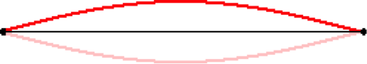

Determine the wavelength (in meters), frequency (in Hertz) and speed (in meters/second). Enter numerical answers below.

**Question 14:**

aa. A standing wave is created in a 1.6-meter long rope by vibrating the rope 16 times in 4.7 seconds. The diagram below represents the standing wave pattern created for this frequency.



Determine the wavelength (in meters), frequency (in Hertz) and speed (in meters/second). Enter numerical answers below.

**Question 15:**

aa. A standing wave is created in a 1.9-meter long rope by vibrating the rope 19 times in 6.1 seconds. The diagram below represents the standing wave pattern created for this frequency.



Determine the wavelength (in meters), frequency (in Hertz) and speed (in meters/second). Enter numerical answers below.

**Question 16:**

aa. A standing wave is created in a 4.2-meter long rope by vibrating the rope 27 times in 8.1 seconds. The diagram below represents the standing wave pattern created for this frequency.



Determine the wavelength (in meters), frequency (in Hertz) and speed (in meters/second). Enter numerical answers below.

**Question 17:**

aa. A standing wave is created in a 3.3-meter long rope by vibrating the rope 14 times in 2.9 seconds. The diagram below represents the standing wave pattern created for this frequency.

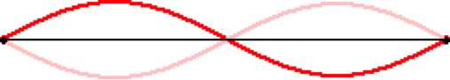

Determine the wavelength (in meters), frequency (in Hertz) and speed (in meters/second). Enter numerical answers below.

**Question 18:**

aa. A standing wave is created in a 1.8-meter long rope by vibrating the rope 62 times in 10.4 seconds. The diagram below represents the standing wave pattern created for this frequency.



Determine the wavelength (in meters), frequency (in Hertz) and speed (in meters/second). Enter numerical answers below.

**Question 19:**

aa. A standing wave is created in a 3.8-meter long rope by vibrating the rope 49 times in 8.8 seconds. The diagram below represents the standing wave pattern created for this frequency.



Determine the wavelength (in meters), frequency (in Hertz) and speed (in meters/second). Enter numerical answers below.

**Question 20:**

aa. A standing wave is created in a 1.7-meter long rope by vibrating the rope 82 times in 20.0 seconds. The diagram below represents the standing wave pattern created for this frequency.



Determine the wavelength (in meters), frequency (in Hertz) and speed (in meters/second). Enter numerical answers below.

**Question 21:**

aa. A standing wave is created in a 2.2-meter long rope by vibrating the rope 76 times in 10.0 seconds. The diagram below represents the standing wave pattern created for this frequency.

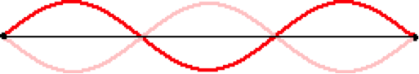

Determine the wavelength (in meters), frequency (in Hertz) and speed (in meters/second). Enter numerical answers below.

**Question 22:**

aa. A standing wave is created in a 2.6-meter long rope by vibrating the rope 62 times in 8.8 seconds. The diagram below represents the standing wave pattern created for this frequency.



Determine the wavelength (in meters), frequency (in Hertz) and speed (in meters/second). Enter numerical answers below.

**Question 23:**

aa. A standing wave is created in a 1.9-meter long rope by vibrating the rope 76 times in 9.9 seconds. The diagram below represents the standing wave pattern created for this frequency.



Determine the wavelength (in meters), frequency (in Hertz) and speed (in meters/second). Enter numerical answers below.

**Question 24:**

aa. A standing wave is created in a 6.1-meter long rope by vibrating the rope 45 times in 8.1 seconds. The diagram below represents the standing wave pattern created for this frequency.



Determine the wavelength (in meters), frequency (in Hertz) and speed (in meters/second). Enter numerical answers below.

**Question 25:**

aa. A standing wave is created in a 4.2-meter long rope by vibrating the rope 62 times in 4.5 seconds. The diagram below represents the standing wave pattern created for this frequency.

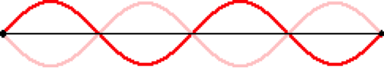

Determine the wavelength (in meters), frequency (in Hertz) and speed (in meters/second). Enter numerical answers below.

**Question 26:**

aa. A standing wave is created in a 5.5-meter long rope by vibrating the rope 76 times in 11.4 seconds. The diagram below represents the standing wave pattern created for this frequency.



Determine the wavelength (in meters), frequency (in Hertz) and speed (in meters/second). Enter numerical answers below.

**Question 27:**

aa. A standing wave is created in a 6.6-meter long rope by vibrating the rope 34 times in 2.8 seconds. The diagram below represents the standing wave pattern created for this frequency.



Determine the wavelength (in meters), frequency (in Hertz) and speed (in meters/second). Enter numerical answers below.

**Question 28:**

aa. A standing wave is created in a 2.9-meter long rope by vibrating the rope 96 times in 7.5seconds. The diagram below represents the standing wave pattern created for this frequency.



Determine the wavelength (in meters), frequency (in Hertz) and speed (in meters/second). Enter numerical answers below.

**Question 29:**

aa. A standing wave is created in a 3.3-meter long rope by vibrating the rope 72 times in 5.0 seconds. The diagram below represents the standing wave pattern created for this frequency.

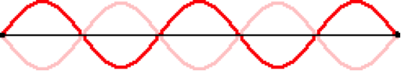

Determine the wavelength (in meters), frequency (in Hertz) and speed (in meters/second). Enter numerical answers below.

**Question 30:**

aa. A standing wave is created in a 4.2-meter long rope by vibrating the rope 78 times in 4.7 seconds. The diagram below represents the standing wave pattern created for this frequency.



Determine the wavelength (in meters), frequency (in Hertz) and speed (in meters/second). Enter numerical answers below.

**Question 31:**

aa. A standing wave is created in a 2.1-meter long rope by vibrating the rope 66 times in 5.2 seconds. The diagram below represents the standing wave pattern created for this frequency.



Determine the wavelength (in meters), frequency (in Hertz) and speed (in meters/second). Enter numerical answers below.

**Question 32:**

aa. A standing wave is created in a 3.0-meter long rope by vibrating the rope 51 times in 4.1 seconds. The diagram below represents the standing wave pattern created for this frequency.



Determine the wavelength (in meters), frequency (in Hertz) and speed (in meters/second). Enter numerical answers below.