**Minds On Physics Question Banks – Work and Energy**

**WE1: Work**

**Question 1:**

aa. Work is a ____ quantity; it is fully described by stating its ____.

a. scalar, magnitude alone

b. scalar, magnitude and direction

c. vector, magnitude alone

d. vector, magnitude and direction

e. ... nonsense! Work is simply a concept and not a quantity.

**Question 2:**

aa. Work is a ____ quantity; it is fully described by stating its ____.

a. scalar, magnitude and direction

b. scalar, magnitude alone

c. vector, magnitude and direction

d. vector, magnitude alone

e. ... nonsense! Work is simply a concept and not a quantity.

**Question 3:**

aa. Work is a ____ quantity; it is fully described by stating its ____.

a. vector, magnitude alone

b. vector, magnitude and direction

c. scalar, magnitude alone

d. scalar, magnitude and direction

e. ... nonsense! Work is simply a concept and not a quantity.

**Question 4:**

aa. Work is a ____ quantity; it is fully described by stating its ____.

a. vector, magnitude and direction

b. vector, magnitude alone

c. scalar, magnitude and direction

d. scalar, magnitude alone

e. ... nonsense! Work is simply a concept and not a quantity.

**Question 5:**

aa. The standard metric unit of work is the ____.

a. meter / second / second b. kg • meter / second

c. Newton d. Newton • second

e. Joule f. Watt

g. Newton / second

**Question 6:**

aa. The standard metric unit of work is the ____.

a. Newton b. kg • meter / second

c. meter / second / second d. Newton • second

e. Newton / second f. Joule

g. Watt

**Question 7:**

aa. The standard metric unit of work is the ____.

a. Newton b. Joule

c. Watt d. Newton • second

e. Newton / second f. meter / second / second

g. kg • meter / second

**Question 8:**

aa. The standard metric unit of work is the ____.

a. Newton / second b. Newton • second

c. Newton d. Joule

e. Watt f. kg • meter / second

g. meter / second / second

**Question 9:**

aa. In order to have work done upon an object, there must be a(n) ____ to cause a(n) ____.

a. force acting upon the object, velocity change

b. force acting upon the object, acceleration

c. force acting upon the object, displacement

d. impulse imparted to the object, velocity change

e. impulse imparted to the object, acceleration

f. impulse imparted to the object, displacement

**Question 10:**

aa. In order to have work done upon an object, there must be a(n) ____ to cause a(n) ____.

a. force acting upon the object, displacement

b. force acting upon the object, acceleration

c. force acting upon the object, velocity change

d. impulse imparted to the object, displacement

e. impulse imparted to the object, acceleration

f. impulse imparted to the object, velocity change

**Question 11:**

aa. In order to have work done upon an object, there must be a(n) ____ to cause a(n) ____.

a. impulse imparted to the object, velocity change

b. impulse imparted to the object, acceleration

c. impulse imparted to the object, displacement

d. force acting upon the object, velocity change

e. force acting upon the object, acceleration

f. force acting upon the object, displacement

**Question 12:**

aa. In order to have work done upon an object, there must be a(n) ____ to cause a(n) ____.

a. impulse imparted to the object, displacement

b. impulse imparted to the object, acceleration

c. impulse imparted to the object, velocity change

d. force acting upon the object, displacement

e. force acting upon the object, acceleration

f. force acting upon the object, velocity change

**Question 13:**

aa. Which of the following are examples of work being done (either positive or negative) upon an object? List all that apply in alphabetical order with no commas or spaces between letters.

a. A rightward force is applied to an object to move it to the right at a constant speed.

b. A rightward force is applied to an object to accelerate it to the right.

c. A force is applied to an object to hold it at rest on an inclined plane.

d. An upward force is applied to an object to suspend it motionless in mid-air.

e. An upward force is applied to a downward moving object to slow it down as it moves.

f. An upward force is applied to an object to move it upward at a constant speed.

g. An upward force is applied to an object to accelerate it upward.

**Question 14:**

aa. Which of the following are examples of work being done (either positive or negative) upon an object? List all that apply in alphabetical order with no commas or spaces between letters.

a. A force is applied to an object to hold it at rest on an inclined plane.

b. A rightward force is applied to an object to move it to the right at a constant speed.

c. A rightward force is applied to an object to accelerate it to the right.

d. An upward force is applied to a downward moving object to slow it down as it moves.

e. An upward force is applied to an object to move it upward at a constant speed.

f. An upward force is applied to an object to accelerate it upward.

g. An upward force is applied to an object to suspend it motionless in mid-air.

**Question 15:**

aa. Which of the following are examples of work being done (either positive or negative) upon an object? List all that apply in alphabetical order with no commas or spaces between letters.

a. An upward force is applied to an object to suspend it motionless in mid-air.

b. An upward force is applied to a downward moving object to slow it down as it moves.

c. An upward force is applied to an object to move it upward at a constant speed.

d. An upward force is applied to an object to accelerate it upward.

e. A rightward force is applied to an object to move it to the right at a constant speed.

f. A force is applied to an object to hold it at rest on an inclined plane.

g. A rightward force is applied to an object to accelerate it to the right.

**Question 16:**

aa. Which of the following are examples of work being done (either positive or negative) upon an object? List all that apply in alphabetical order with no commas or spaces between letters.

a. An upward force is applied to an object to accelerate it upward.

b. An upward force is applied to an object to move it upward at a constant speed.

c. An upward force is applied to a downward moving object to slow it down as it moves.

d. An upward force is applied to an object to suspend it motionless in mid-air.

e. A force is applied to an object to hold it at rest on an inclined plane.

f. A rightward force is applied to an object to accelerate it to the right.

g. A rightward force is applied to an object to move it to the right at a constant speed.

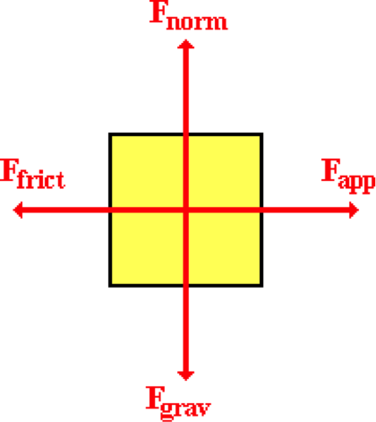**Question 17:**

aa. A 5-Newton force is applied to a 2-kg object to move it across a horizontal surface at a constant speed for a distance of 4 meters. The free-body diagram is shown at the right. Which of the following forces are doing work upon the object - either positive or negative? List all that apply in alphabetical order with no commas or spaces between letters.

a. Applied force

b. Friction force

c. Normal force

d. Gravity force

e. ... nonsense! None of these forces are doing work.



**Question 18:**

aa. A 5-Newton force is applied to a 2-kg object to move it across a horizontal surface at a constant speed for a distance of 4 meters. The free-body diagram is shown at the right. Which of the following forces are doing work upon the object - either positive or negative? List all that apply in alphabetical order with no commas or spaces between letters.

a. Friction force

b. Normal force

c. Gravity force

d. Applied force

e. ... nonsense! None of these forces are doing work.

**Question 19:**

aa. A 5-Newton force is applied to a 2-kg object to move it across a horizontal surface at a constant speed for a distance of 4 meters. The free-body diagram is shown below. Which of the following forces are doing work upon the object - either positive or negative? List all that apply in alphabetical order with no commas or spaces between letters.

a. Normal force

b. Gravity force

c. Applied force

d. Friction force

e. ... nonsense! None of these forces are doing work.

**Question 20:**

aa. A 5-Newton force is applied to a 2-kg object to move it across a horizontal surface at a constant speed for a distance of 4 meters. The free-body diagram is shown below. Which of the following forces are doing work upon the object - either positive or negative? List all that apply in alphabetical order with no commas or spaces between letters.

a. Gravity force

b. Applied force

c. Friction force

d. Normal force

e. ... nonsense! None of these forces are doing work.

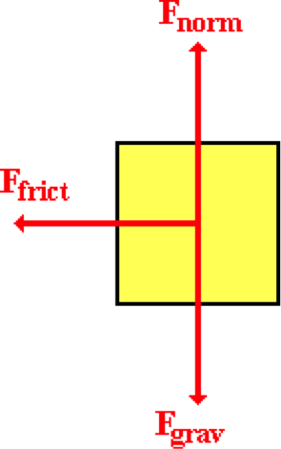

**Question 21:**

aa. A 5-Newton friction force acts upon a 2-kg object to slow it down as it moves it across a horizontal surface over a distance of 4 meters. The free-body diagram is shown at the right. Which of the following forces are doing work upon the object - either positive or negative? List all that apply in alphabetical order with no commas or spaces between letters.

a. Gravity force

b. Friction force

c. Normal force

d. ... nonsense! None of these forces are doing work.

**Question 22:**

aa. A 5-Newton friction force acts upon a 2-kg object to slow it down as it moves it across a horizontal surface over a distance of 4 meters. The free-body diagram is shown at the right. Which of the following forces are doing work upon the object - either positive or negative? List all that apply in alphabetical order with no commas or spaces between letters.

a. Friction force

b. Gravity force

c. Normal force

d. ... nonsense! None of these forces are doing work.

**Question 23:**

aa. A 5-Newton friction force acts upon a 2-kg object to slow it down as it moves it across a horizontal surface over a distance of 4 meters. The free-body diagram is shown at the right. Which of the following forces are doing work upon the object - either positive or negative? List all that apply in alphabetical order with no commas or spaces between letters.

a. Normal force

b. Gravity force

c. Friction force

d. ... nonsense! None of these forces are doing work.

**Question 24:**

aa. A 5-Newton friction force acts upon a 2-kg object to slow it down as it moves it across a horizontal surface over a distance of 4 meters. The free-body diagram is shown at the right. Which of the following forces are doing work upon the object - either positive or negative? List all that apply in alphabetical order with no commas or spaces between letters.

a. Normal force

b. Gravity force

c. Friction force

d. ... nonsense! None of these forces are doing work.

**Question 25:**

aa. A softball player is sliding into third base. Once she hits the dirt, the force of friction acts upon her to slow her down as she slides a distance of 1.5 meters across the distance. In this example, friction is doing ____ work upon the player.

a. positive b. negative c. zero

d. ... nonsense! It is impossible to tell without knowledge of the force value.

**Question 26:**

aa. A softball player is sliding into third base. Once she hits the dirt, the force of friction acts upon her to slow her down as she slides a distance of 1.5 meters across the distance. In this example, friction is doing ____ work upon the player.

a. zero b. positive c. negative

d. ... nonsense! It is impossible to tell without knowledge of the force value.

**Question 27:**

aa. A softball player is sliding into third base. Once she hits the dirt, the force of friction acts upon her to slow her down as she slides a distance of 1.5 meters across the distance. In this example, friction is doing ____ work upon the player.

a. negative b. positive c. zero

d. ... nonsense! It is impossible to tell without knowledge of the force value.

**Question 28:**

aa. A softball player is sliding into third base. Once she hits the dirt, the force of friction acts upon her to slow her down as she slides a distance of 1.5 meters across the distance. In this example, friction is doing ____ work upon the player.

a. zero b. negative c. positive

d. ... nonsense! It is impossible to tell without knowledge of the force value.

**Question 29:**

aa. A man is walking through an airport with a suitcase. The man exerts a constant upward force upon the suitcase as he walks a distance of 20 meters. In this example, the man is doing ____ work upon the suitcase.

a. zero b. negative c. positive

d. ... nonsense! It is impossible to tell without knowledge of the force value.

**Question 30:**

aa. A man is walking through an airport with a suitcase. The man exerts a constant upward force upon the suitcase as he walks a distance of 20 meters. In this example, the man is doing ____ work upon the suitcase.

a. negative b. positive c. zero

d. ... nonsense! It is impossible to tell without knowledge of the force value.

**Question 31:**

aa. A man is walking through an airport with a suitcase. The man exerts a constant upward force upon the suitcase as he walks a distance of 20 meters. In this example, the man is doing ____ work upon the suitcase.

a. zero b. positive c. negative

d. ... nonsense! It is impossible to tell without knowledge of the force value.

**Question 32:**

aa. A man is walking through an airport with a suitcase. The man exerts a constant upward force upon the suitcase as he walks a distance of 20 meters. In this example, the man is doing ____ work upon the suitcase.

a. positive b. negative c. zero

d. … nonsense! It is impossible to tell without knowledge of the force value.

**Question 33:**

aa. A child is pushing an empty box across a living room floor. The child exerts a constant rightward force upon the box to move it a distance of 2 meters to the right. In this example, the child is doing ____ work upon the box.

a. zero b. negative c. positive

d. ... nonsense! It is impossible to tell without knowledge of the force value.

**Question 34:**

aa. A child is pushing an empty box across a living room floor. The child exerts a constant rightward force upon the box to move it a distance of 2 meters to the right. In this example, the child is doing ____ work upon the box.

a. negative b. positive c. zero

d. ... nonsense! It is impossible to tell without knowledge of the force value.

**Question 35:**

aa. A child is pushing an empty box across a living room floor. The child exerts a constant rightward force upon the box to move it a distance of 2 meters to the right. In this example, the child is doing ____ work upon the box.

a. positive b. negative c. zero

d. ... nonsense! It is impossible to tell without knowledge of the force value.

**Question 36:**

aa. A child is pushing an empty box across a living room floor. The child exerts a constant rightward force upon the box to move it a distance of 2 meters to the right. In this example, the child is doing ____ work upon the box.

a. zero b. positive c. negative

d. ... nonsense! It is impossible to tell without knowledge of the force value.

**Question 37:**

aa. Jack and Jill are doing a physics lab. They apply a 15-Newton force to a 3-kg cart to pull it up an inclined plane at a constant speed. The plane is inclined at a 30-degree angle. Jack and Jill are exerting a force on the cart that is parallel to the inclined plane in order to displace it 2.0 meters along the incline to a final height of 1 meter. During this lab, the amount of work done on the cart is approximately ____ Joules.

a. 0 b. 15 c. 20 d. 26

e. 30 f. 45 g. 60 h. 90

**Question 38:**

aa. Jack and Jill are doing a physics lab. They apply a 30-Newton force to a 6-kg cart to pull it up an inclined plane at a constant speed. The plane is inclined at a 30-degree angle. Jack and Jill are exerting a force on the cart that is parallel to the inclined plane in order to displace it 2.0 meters along the incline to a final height of 1 meter. During this lab, the amount of work done on the cart is approximately ____ Joules.

a. 0 b. 15 c. 40 d. 52

e. 60 f. 90 g. 120 h. 180

**Question 39:**

aa. Jack and Jill are doing a physics lab. They apply a 20-Newton force to a 4-kg cart to pull it up an inclined plane at a constant speed. The plane is inclined at a 30-degree angle. Jack and Jill are exerting a force on the cart that is parallel to the inclined plane in order to displace it 2.0 meters along the incline to a final height of 1 meter. During this lab, the amount of work done on the cart is approximately ____ Joules.

a. 0 b. 20 c. 35 d. 40

e. 69 f. 80 g. 120 h. 160

**WE2: Power**

**Question 1:**

aa. Power is defined as _____.

a. the amount of work which is done upon an object

b. the rate at an object's velocity changes

c. the rate at which the force applied to an object is increased

d. the rate at which an object accelerates

e. the amount of energy - both kinetic and potential - which an object possesses

f. the rate at which work is done upon an object

g. the amount of energy an object possesses as a result of its position

**Question 2:**

aa. Power is defined as _____.

a. the rate at an object's velocity changes

b. the rate at which the force applied to an object is increased

c. the rate at which work is done upon an object

d. the rate at which an object accelerates

e. the amount of energy - both kinetic and potential - which an object possesses

f. the amount of energy an object possesses as a result of its position

g. the amount of work which is done upon an object

**Question 3:**

aa. Power is defined as _____.

a. the rate at which an object accelerates

b. the rate at which the force applied to an object is increased

c. the rate at an object's velocity changes

d. the rate at which work is done upon an object

e. the amount of work which is done upon an object

f. the amount of energy an object possesses as a result of its position

g. the amount of energy - both kinetic and potential - which an object possesses

**Question 4:**

aa. Power is defined as _____.

a. the amount of energy - both kinetic and potential - which an object possesses

b. the amount of work which is done upon an object

c. the amount of energy an object possesses as a result of its position

d. the rate at an object's velocity changes

e. the rate at which an object accelerates

f. the rate at which work is done upon an object

g. the rate at which the force applied to an object is increased

**Question 5:**

aa. The standard metric unit of power is a _____.

a. Watt b. Newton

c. Joule d. Newton • meter

e. Newton • second f. kilogram• meter / second

g. kilogram • meter / second2 h. none of these

**Question 6:**

aa. The standard metric unit of power is a _____.

a. Newton b. Joule

c. Watt d. kilogram • meter / second

e. kilogram • meter / second2 f. Newton • meter

g. Newton • second h. none of these

**Question 7:**

aa. The standard metric unit of power is a _____.

a. kilogram • meter / second b. kilogram • meter / second2

c. Newton • meter d. Newton • second

e. Joule f. Watt

g. Newton h. none of these

**Question 8:**

aa. The standard metric unit of power is a _____.

a. kilogram • meter / second2 b. Newton • second

c. Newton • meter d. kilogram • meter / second

e. Joule f. Newton

g. Watt h. none of these

**Question 9:**

aa. The essential difference between work and power is that power is _____.

a. a scalar quantity and work is a vector quantity

b. a vector quantity and work is a scalar quantity

c. a rate quantity and work is not a rate quantity

d. something an object does and work is something which is done to an object

e. a quantity which involves large forces and work can involve either large or small forces

f. something that you can buy and work is what you must do to buy it

g. something that politicians crave and work is what their voters do

**Question 10:**

aa. The essential difference between work and power is that power is _____.

a. a vector quantity and work is a scalar quantity

b. a scalar quantity and work is a vector quantity

c. something an object does and work is something which is done to an object

d. a rate quantity and work is not a rate quantity

e. a quantity which involves large forces and work can involve either large or small forces

f. something that you can buy and work is what you must do to buy it

g. something that politicians crave and work is what their voters do

**Question 11:**

aa. The essential difference between work and power is that power is _____.

a. something an object does and work is something which is done to an object

b. a rate quantity and work is not a rate quantity

c. a quantity which involves large forces and work can involve either large or small forces

d. a scalar quantity and work is a vector quantity

e. a vector quantity and work is a scalar quantity

f. something that you can buy and work is what you must do to buy it

g. something that politicians crave and work is what their voters do

**Question 12:**

aa. The essential difference between work and power is that power is _____.

a. a rate quantity and work is not a rate quantity

b. a quantity which involves large forces and work can involve either large or small forces

c. something an object does and work is something which is done to an object

d. a vector quantity and work is a scalar quantity

e. a scalar quantity and work is a vector quantity

f. something that you can buy and work is what you must do to buy it

g. something that politicians crave and work is what their voters do

**Question 13:**

aa. Mac and Tosh run up the same hill. Mac has twice the mass as Tosh. Tosh climbs up the hill in one-half the time as Mac. In this situation, _____.

a. Mac and Tosh do the same amount of work, but Mac has a greater power rating

b. Mac and Tosh do the same amount of work, but Tosh has a greater power rating

c. Mac does more work than Tosh, but Tosh has a greater power rating

d. Tosh does more work than Mac, but Mac has a greater power rating

e. Mac does more work than Tosh, but they have the same power rating

f. Tosh does more work than Mac, but they have the same power rating

g. Mac and Tosh do the same amount of work and have the same power rating

**Question 14:**

aa. Mac and Tosh run up the same hill. Mac has twice the mass as Tosh. Tosh climbs up the hill in one-half the time as Mac. In this situation, _____.

a. Mac and Tosh do the same amount of work, but Tosh has a greater power rating

b. Mac and Tosh do the same amount of work, but Mac has a greater power rating

c. Tosh does more work than Mac, but Mac has a greater power rating

d. Mac does more work than Tosh, but Tosh has a greater power rating

e. Tosh does more work than Mac, but they have the same power rating

f. Mac does more work than Tosh, but they have the same power rating

g. Mac and Tosh do the same amount of work and have the same power rating

**Question 15:**

aa. Mac and Tosh run up the same hill. Mac has twice the mass as Tosh. Tosh climbs up the hill in one-half the time as Mac. In this situation, _____.

a. Mac does more work than Tosh, but Tosh has a greater power rating

b. Tosh does more work than Mac, but Mac has a greater power rating

c. Mac does more work than Tosh, but they have the same power rating

d. Tosh does more work than Mac, but they have the same power rating

e. Mac and Tosh do the same amount of work, but Mac has a greater power rating

f. Mac and Tosh do the same amount of work, but Tosh has a greater power rating

g. Mac and Tosh do the same amount of work and have the same power rating

**Question 16:**

aa. Mac and Tosh run up the same hill. Mac has twice the mass as Tosh. Tosh climbs up the hill in one-half the time as Mac. In this situation, _____.

a. Tosh does more work than Mac, but Mac has a greater power rating

b. Mac does more work than Tosh, but Tosh has a greater power rating

c. Tosh does more work than Mac, but they have the same power rating

d. Mac does more work than Tosh, but they have the same power rating

e. Mac and Tosh do the same amount of work, but Tosh has a greater power rating

f. Mac and Tosh do the same amount of work, but Mac has a greater power rating

g. Mac and Tosh do the same amount of work and have the same power rating

**Question 17:**

aa. Student A and student B are doing two identical tasks involving physical work. Student A does the task in more time than student B. In this physical situation, ____.

a. the two students do the same amount of work and have the same power rating

b. the two students do the same amount of work but student A has the greater power rating

c. the two students do the same amount of work but student B has the greater power rating

d. student A does more work but both students have the same power rating

e. student B does more work but both students have the same power rating

f. student A does more work but student B has the greater power rating

g. student B does more work but student A has the greater power rating

**Question 18:**

aa. Student A and student B are doing two identical tasks involving physical work. Student A does the task in more time than student B. In this physical situation, ____.

a. the two students do the same amount of work but student A has the greater power rating

b. the two students do the same amount of work but student B has the greater power rating

c. the two students do the same amount of work and have the same power rating

d. student A does more work but student B has the greater power rating

e. student B does more work but student A has the greater power rating

f. student A does more work but both students have the same power rating

g. student B does more work but both students have the same power rating

**Question 19:**

aa. Student A and student B are doing two identical tasks involving physical work. Student A does the task in less time than student B. In this physical situation, ____.

a. the two students do the same amount of work and have the same power rating

b. the two students do the same amount of work but student A has the greater power rating

c. the two students do the same amount of work but student B has the greater power rating

d. student A does more work but both students have the same power rating

e. student B does more work but both students have the same power rating

f. student A does more work but student B has the greater power rating

g. student B does more work but student A has the greater power rating

**Question 20:**

aa. Student A and student B are doing two identical tasks involving physical work. Student A does the task in less time than student B. In this physical situation, ____.

a. the two students do the same amount of work but student A has the greater power rating

b. the two students do the same amount of work but student B has the greater power rating

c. the two students do the same amount of work and have the same power rating

d. student A does more work but student B has the greater power rating

e. student B does more work but student A has the greater power rating

f. student A does more work but both students have the same power rating

g. student B does more work but both students have the same power rating

**Question 21:**

aa. In a physics lab, a 60-kg student runs up a 2.0-meter tall flight of stairs in 1.5 seconds. The student's power rating is approximately _____ W.

a. 20 b. 45 c. 80 d. 180

e. 200 f. 450 g. 800 h. 1800

**Question 22:**

aa. In a physics lab, a 80-kg student runs up a 2.5-meter tall flight of stairs in 2.0 seconds. The student's power rating is approximately _____ W.

a. 16 b. 64 c. 100 d. 160

e. 400 f. 640 g. 1000 h. 4000

**Question 23:**

aa. In a physics lab, a 90-kg student runs up a 1.5-meter tall flight of stairs in 3.0 seconds. The student's power rating is approximately _____ W.

a. 20 b. 45 c. 180 d. 200

e. 405 f. 450 g. 1800 h. 4050

**Question 24:**

aa. In a physics lab, a 70-kg student runs up a 4.0-meter tall flight of stairs in 3.5 seconds. The student's power rating is approximately _____ W.

a. 5 b. 61 c. 50 d. 80

e. 613 f. 800 g. 980 h. 9800

**Question 25:**

aa. A horizontal force of 80 Newton is applied to a 10-kg crate to move it horizontally a distance of 4 meters across a concrete floor at a constant speed of 2 m/s. The task requires 2 seconds. The power rating for the person applying the force is approximately _____ W.

a. 20 b. 40 c. 80 d. 160

e. 200 f. 320 g. 400 h. 1600

**Question 26:**

aa. A horizontal force of 100 Newton is applied to a 12.5-kg crate to move it horizontally a distance of 4 meters across a concrete floor at a constant speed of 2 m/s. The task requires 2 seconds. The power rating for the person applying the force is approximately _____ W.

a. 25 b. 50 c. 100 d. 200

e. 250 f. 400 g. 500 h. 2000

**Question 27:**

aa. A horizontal force of 120 Newton is applied to a 15-kg crate to move it horizontally a distance of 6 meters across a concrete floor at a constant speed of 4 m/s. The task requires 1.5 seconds. The power rating for the person applying the force is approximately _____ W.

a. 60 b. 240 c. 360 d. 480

e. 600 f. 720 g. 900 h. 4800

**Question 28:**

aa. A horizontal force of 120 Newton is applied to a 15-kg crate to move it horizontally a distance of 6 meters across a concrete floor at a constant speed of 1.5 m/s. The task requires 4 seconds. The power rating for the person applying the force is approximately _____ W.

a. 23 b. 34 c. 135 d. 180

e. 225 f. 720 g. 900 h. 1800

**Question 29:**

aa. A 55-kg mountain climber ascends (climbs) 15 meters up a steep cliff in 45 seconds. The power rating of the mountain climber is ____ W.

a. 0.081 b. 0.81 c. 18 d. 165

e. 183 f. 1650 g. 37 125 h. 371 250

**Question 30:**

aa. A 75-kg mountain climber ascends (climbs) 20 meters up a steep cliff in 60 seconds. The power rating of the mountain climber is ____ W.

a. 0.062 b. 0.62 c. 25 d. 225

e. 250 f. 2250 g. 90 000 h. 900 000

**Question 31:**

aa. A 80-kg mountain climber ascends (climbs) 10 meters up a steep cliff in 50 seconds. The power rating of the mountain climber is ____ W.

a. 0.16 b. 1.60 c. 16 d. 160

e. 400 f. 4000 g. 40 000 h. 400 000

**Question 32:**

aa. A 60-kg mountain climber ascends (climbs) 15 meters up a steep cliff in 60 seconds. The power rating of the mountain climber is ____ W.

a. 0.067 b. 0.67 c. 15 d. 150

e. 240 f. 2400 g. 54 000 h. 540 000

**WE3: Kinetic and Potential Energy**

**Question 1:**

aa. Kinetic energy is the energy that an object possesses due to its ____ and potential energy is the energy that an object possesses due to its ____.

a. mass, acceleration b. acceleration, mass

c. mass, motion d. motion , mass

e. position, motion f. motion, position

g. motion, lack of motion h. lack of motion, motion

i. position, lack of position j. lack of position, position

**Question 2:**

aa. Kinetic energy is the energy that an object possesses due to its ____ and potential energy is the energy that an object possesses due to its ____.

a. acceleration, mass b. mass, acceleration

c. motion , mass d. mass, motion

e. motion, position f. position, motion

g. lack of motion, motion h. motion, lack of motion

i. lack of position, position j. position, lack of position

**Question 3:**

aa. Kinetic energy is the energy that an object possesses due to its ____ and potential energy is the energy that an object possesses due to its ____.

a. mass, motion b. motion , mass

c. motion, lack of motion d. lack of motion, motion

e. position, lack of position f. lack of position, position

g. position, motion h. motion, position

i. mass, acceleration j. acceleration, mass

**Question 4:**

aa. Kinetic energy is the energy that an object possesses due to its ____ and potential energy is the energy that an object possesses due to its ____.

a. motion, lack of motion b. lack of motion, motion

c. position, lack of position d. lack of position, position

e. mass, motion f. motion , mass

g. motion, position h. position, motion

i. acceleration, mass j. mass, acceleration

**Question 5:**

aa. An object will have kinetic energy if it is _____. List all that apply in alphabetical order with no commas or spaces between letters.

a. moving

b. moving on the ground (height = 0 m)

c. moving above the ground (a non-zero height)

d. at rest

e. at rest on the ground (height = 0 m)

f. at rest above the ground (a non-zero height)

**Question 6:**

aa. An object will have kinetic energy if it is _____. List all that apply in alphabetical order with no commas or spaces between letters.

a. moving above the ground (a non-zero height)

b. moving on the ground (height = 0 m)

c. moving

d. at rest above the ground (a non-zero height)

e. at rest on the ground (height = 0 m)

f. at rest

**Question 7:**

aa. An object will have kinetic energy if it is _____. List all that apply in alphabetical order with no commas or spaces between letters.

a. at rest

b. at rest on the ground (height = 0 m)

c. at rest above the ground (a non-zero height)

d. moving

e. moving on the ground (height = 0 m)

f. moving above the ground (a non-zero height)

**Question 8:**

aa. An object will have kinetic energy if it is _____. List all that apply in alphabetical order with no commas or spaces between letters.

a. at rest above the ground (a non-zero height)

b. at rest on the ground (height = 0 m)

c. at rest

d. moving above the ground (a non-zero height)

e. moving on the ground (height = 0 m)

f. moving

**Question 9:**

aa. **TRUE** or **FALSE**:

If an object has potential energy, then its kinetic energy is 0 J.

a. True b. False

**Question 10:**

aa. **TRUE** or **FALSE**:

If an object has potential energy, then it will not have any kinetic energy.

a. True b. False

**Question 11:**

aa. **TRUE** or **FALSE**:

If an object is moving along the ground, then it will not have any kinetic energy.

a. True b. False

**Question 12:**

**aa. TRUE or FALSE:**

If an object is moving above the ground (at a non-zero height), then it will not have any kinetic energy.

a. True b. False

**Question 13:**

aa. Which of the following variations will increase the kinetic energy of an object? List all that apply in alphabetical order with no commas or spaces between letters.

a. Increase the object's height. b. Increase the object's mass.

c. Increase the object's speed. d. Decrease the object's height.

e. Decrease the object's mass. f. Decrease the object's speed.

**Question 14:**

aa. Which of the following variations will increase the kinetic energy of an object? List all that apply in alphabetical order with no commas or spaces between letters.

a. Decrease the object's height. b. Decrease the object's mass.

c. Decrease the object's speed. d. Increase the object's height.

e. Increase the object's mass. f. Increase the object's speed.

**Question 15:**

aa. Which of the following variations will increase the kinetic energy of an object? List all that apply in alphabetical order with no commas or spaces between letters.

a. Increase the object's height. b. Decrease the object's height.

c. Increase the object's mass. d. Decrease the object's mass.

e. Increase the object's speed. f. Decrease the object's speed.

**Question 16:**

aa. Which of the following variations will increase the kinetic energy of an object? List all that apply in alphabetical order with no commas or spaces between letters.

a. Increase the object's speed. b. Decrease the object's speed.

c. Increase the object's height. d. Decrease the object's height.

e. Increase the object's mass. f. Decrease the object's mass.

**Question 17:**

aa. An object has a kinetic energy of 32 J. If the object's speed is doubled, then its new kinetic energy will be ____ J.

a. 4 b. 8 c. 16

d. 32 e. 64 f. 128

**Question 18:**

aa. An object has a kinetic energy of 32 J. If the object's speed is halved, then its new kinetic energy will be ____ J.

a. 8 b. 16 c. 32

d. 64 e. 128 f. 256

**Question 19:**

aa. An object has a kinetic energy of 18 J. If the object's speed is tripled, then its new kinetic energy will be ____ J.

a. 2 b. 3 c. 4 d. 6

e. 12 f. 54 g. 162

**Question 20:**

aa. An object has a kinetic energy of 18 J. If the object's speed is decreased to one-third of its original value, then its new kinetic energy will be ____ J.

a. 2 b. 6 c. 18 d. 27

e. 54 f. 108 g. 324

**Question 21:**

aa. A 5-kg object is moving with a speed of 4 m/s at a height of 2 m. The kinetic energy of the object is approximately ____ J.

a. 10 b. 20 c. 40

d. 50 e. 80 f. 100

**Question 22:**

aa. A 8-kg object is moving with a speed of 5 m/s at a height of 4 m. The kinetic energy of the object is approximately ____ J.

a. 10 b. 20 c. 32 d. 40

e. 64 f. 100 g. 160 h. 200

i. 320 j. 640

**Question 23:**

aa. A 6-kg object is moving with a speed of 4 m/s at a height of 8 m. The kinetic energy of the object is approximately ____ J.

a. 3 b. 12 c. 24 d. 48

e. 96 f. 192 g. 240 h. 480

i. 1920

**Question 24:**

aa. A 4-kg object is moving with a speed of 5 m/s at a height of 2 m. The kinetic energy of the object is approximately ____ J.

a. 8 b. 10 c. 20 d. 40

e. 50 f. 80 g. 100

**Question 25:**

aa. An object will definitely have potential energy if it is _____. List all that apply in alphabetical order with no commas or spaces between letters.

a. moving

b. moving on the ground (height = 0 m)

c. moving above the ground (a non-zero height)

d. at rest

e. at rest on the ground (height = 0 m)

f. at rest above the ground (a non-zero height)

**Question 26:**

aa. An object will definitely have potential energy if it is _____. List all that apply in alphabetical order with no commas or spaces between letters.

a. moving above the ground (a non-zero height)

b. moving on the ground (height = 0 m)

c. moving

d. at rest above the ground (a non-zero height)

e. at rest on the ground (height = 0 m)

f. at rest

**Question 27:**

aa. An object will definitely have potential energy if it is _____. List all that apply in alphabetical order with no commas or spaces between letters.

a. at rest

b. at rest on the ground (height = 0 m)

c. at rest above the ground (a non-zero height)

d. moving

e. moving on the ground (height = 0 m)

f. moving above the ground (a non-zero height)

**Question 28:**

aa. An object will definitely have potential energy if it is _____. List all that apply in alphabetical order with no commas or spaces between letters.

a. at rest above the ground (a non-zero height)

b. at rest on the ground (height = 0 m)

c. at rest

d. moving above the ground (a non-zero height)

e. moving on the ground (height = 0 m)

f. moving

**Question 29:**

aa. **TRUE**  or **FALSE**:

If an object has kinetic energy, then its potential energy is 0 J.

a. True b. False

**Question 30:**

aa. **TRUE**  or **FALSE**:

If an object has kinetic energy, then it will not have any potential energy.

a. True b. False

**Question 31:**

aa. **TRUE**  or **FALSE**:

If an object is moving, then it will not have any potential energy.

a. True b. False

**Question 32:**

aa. **TRUE**  or **FALSE**:

If an object is moving above the ground (at a non-zero height), then it will not have any potential energy.

a. True b. False

**Question 33:**

aa. Which of the following variations will increase the potential energy of an object? List all that apply in alphabetical order with no commas or spaces between letters.

a. Increase the object's height. b. Increase the object's mass.

c. Increase the object's speed. d. Decrease the object's height.

e. Decrease the object's mass. f. Decrease the object's speed.

**Question 34:**

aa. Which of the following variations will increase the potential energy of an object? List all that apply in alphabetical order with no commas or spaces between letters.

a. Decrease the object's height. b. Decrease the object's mass.

c. Decrease the object's speed. d. Increase the object's height.

e. Increase the object's mass. f. Increase the object's speed.

**Question 35:**

aa. Which of the following variations will increase the potential energy of an object? List all that apply in alphabetical order with no commas or spaces between letters.

a. Increase the object's height. b. Decrease the object's height.

c. Increase the object's mass. d. Decrease the object's mass.

e. Increase the object's speed. f. Decrease the object's speed.

**Question 36:**

aa. Which of the following variations will increase the potential energy of an object? List all that apply in alphabetical order with no commas or spaces between letters.

a. Increase the object's speed. b. Decrease the object's speed.

c. Increase the object's height. d. Decrease the object's height.

e. Increase the object's mass. f. Decrease the object's mass.

**Question 37:**

aa. A 5-kg object is moving with a speed of 4 m/s at a height of 2 m. The potential energy of the object is approximately ____ J.

a. 10 b. 20 c. 40 d. 50

e. 80 f. 100 g. 1000

**Question 38:**

aa. A 8-kg object is moving with a speed of 5 m/s at a height of 4 m. The potential energy of the object is approximately ____ J.

a. 10 b. 20 c. 32 d. 40

e. 64 f. 100 g. 160 h. 200

i. 320 k. 3200

**Question 39:**

aa. A 6-kg object is moving with a speed of 4 m/s at a height of 8 m. The potential energy of the object is approximately ____ J.

a. 3 b. 12 c. 24 d. 48

e. 96 f. 192 g. 240 h. 480

i. 1920 j. 4800

**Question 40:**

aa. A 4-kg object is moving with a speed of 5 m/s at a height of 2 m. The potential energy of the object is approximately ____ J.

a. 8 b. 10 c. 20 d. 40

e. 50 f. 80 g. 100 h. 800

**WE4: Total Mechanical Energy**

**Question 1:**

aa. The total mechanical energy of an object is ____.

a. the amount of energy an object possesses as a result of its motion

b. the amount of energy an object possesses as a result of its position

c. the sum of its kinetic energy and its potential energy

d. the sum of its initial energy and its final energy

e. the final energy minus the initial energy

f. simply the initial energy of the object before its motion begins

g. equal to the work done upon the object

**Question 2:**

aa. The total mechanical energy of an object is ____.

a. the amount of energy an object possesses as a result of its position

b. the amount of energy an object possesses as a result of its motion

c. the sum of its kinetic energy and its potential energy

d. the sum of its initial energy and its final energy

e. simply the initial energy of the object before its motion begins

f. the final energy minus the initial energy

g. equal to the work done upon the object

**Question 3:**

aa. The total mechanical energy of an object is ____.

a. the final energy minus the initial energy

b. simply the initial energy of the object before its motion begins

c. the amount of energy an object possesses as a result of its motion

d. the amount of energy an object possesses as a result of its position

e. the sum of its kinetic energy and its potential energy

f. the sum of its initial energy and its final energy

g. equal to the work done upon the object

**Question 4:**

aa. The total mechanical energy of an object is ____.

a. simply the initial energy of the object before its motion begins

b. the final energy minus the initial energy

c. the amount of energy an object possesses as a result of its position

d. the amount of energy an object possesses as a result of its motion

e. the sum of its initial energy and its final energy

f. the sum of its kinetic energy and its potential energy

g. equal to the work done upon the object

**Question 5:**

aa. Consider the diagram below.

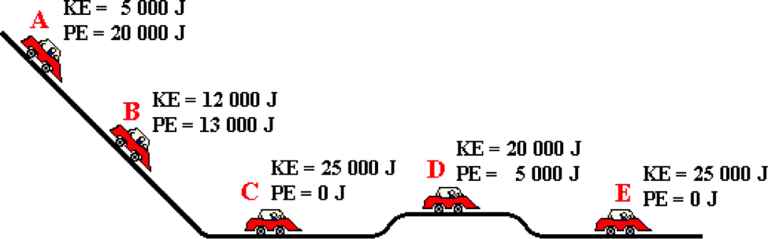

The kinetic energy and the potential energy of a car at various locations are shown. The total mechanical energy of the car at position B is ____ Joules.

a. 0 b. 1000 c. 7000 d. 12000

e. 13000 f. 20000 g. 25000 h. 125000

i. None of these.

**Question 6:**

aa. Consider the diagram below.

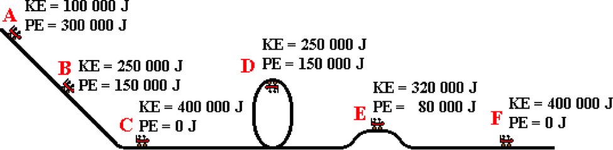

The kinetic energy and the potential energy of a roller coaster car at various locations are shown. The total mechanical energy of the car at position D is ____ Joules.

a. 0 b. 50000 c. 100000 d. 150000

e. 250000 f. 400000 g. 2000000 h. 2400000

i. None of these.

**Question 7:**

aa. Consider the diagram below.

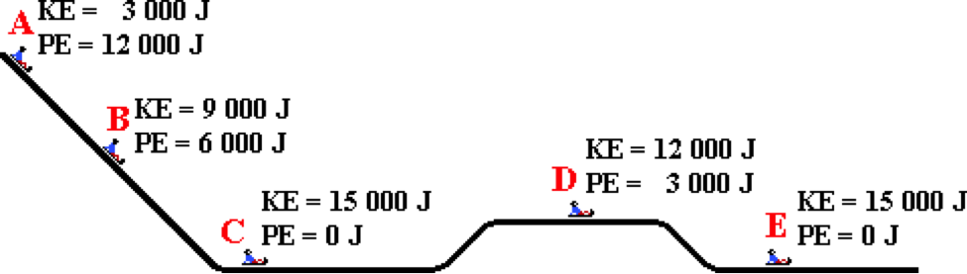

The kinetic energy and the potential energy of a sledder at various locations are shown. The total mechanical energy of the sledder at position B is ____ Joules.

a. 0 b. 3000 c. 6000 d. 9000

e. 12000 f. 15000 g. 60000 h. 75000

i. None of these.

**Question 8:**

aa. Consider the diagram below.

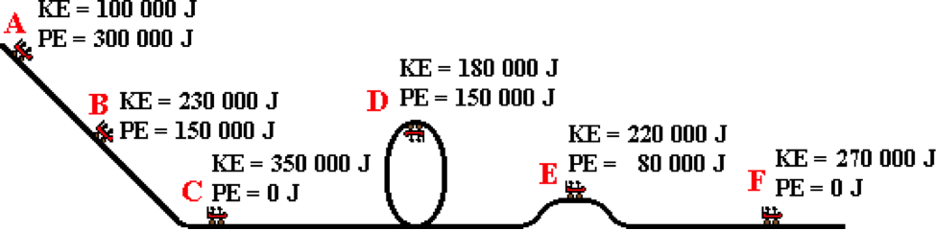

The kinetic energy and the potential energy of a roller coaster car at various locations are shown. The total mechanical energy of the car at position D is ____ Joules.

a. 0 b. 30000 c. 80000 d. 150000

e. 270000 f. 300000 g. 330000 h. 400000

i. 1930000 j. None of these.

**Question 9:**

aa. Consider the motion of the car shown in the diagram below.



The kinetic energy (KE) and potential energy (PE) values are shown for various locations. In this example, ____. List all that apply in alphabetical order with no commas or spaces between letters.

a. kinetic energy is conserved

b. potential energy is conserved

c. total mechanical energy is conserved

d. None of the above are true.

**Question 10:**

aa. Consider the motion of the roller coaster car shown in the diagram below.



The kinetic energy (KE) and potential energy (PE) values are shown for various locations. In this example, ____. List all that apply in alphabetical order with no commas or spaces between letters.

a. kinetic energy is conserved

b. potential energy is conserved

c. total mechanical energy is conserved

d. None of the above are true.

**Question 11:**

aa. Consider the motion of a sledder shown in the diagram below.



The kinetic energy (KE) and potential energy (PE) values are shown for various locations. In this example, ____. List all that apply in alphabetical order with no commas or spaces between letters.

a. kinetic energy is conserved

b. potential energy is conserved

c. total mechanical energy is conserved

d. None of the above are true.

**Question 12:**

aa. Consider the motion of the roller coaster car shown in the diagram below.



The kinetic energy (KE) and potential energy (PE) values are shown for various locations. In this example, ____. List all that apply in alphabetical order with no commas or spaces between letters.

a. kinetic energy is conserved

b. potential energy is conserved

c. total mechanical energy is conserved

d. None of the above are true.

**Question 13:**

aa. Suppose that an object slows down while moving horizontally. In this situation, the object's kinetic energy would ____, its potential energy would ____, and its total mechanical energy would ____. Enter the three answers in their respective order without any commas or spaces between letters.

a. increase b. decrease c. remain the same

d. ... nonsense! It is impossible to tell without any additional information.

**Question 14:**

aa. Suppose that an object slows down while moving horizontally. In this situation, the object's kinetic energy would ____, its potential energy would ____, and its total mechanical energy would ____. Enter the three answers in their respective order without any commas or spaces between letters.

a. decrease b. increase c. remain the same

d. ... nonsense! It is impossible to tell without any additional information.

**Question 15:**

aa. Suppose that an object slows down while moving horizontally. In this situation, the object's kinetic energy would ____, its potential energy would ____, and its total mechanical energy would ____. Enter the three answers in their respective order without any commas or spaces between letters.

a. remain the same b. increase c. decrease

d. ... nonsense! It is impossible to tell without any additional information.

**Question 16:**

aa. Suppose that an object slows down while moving horizontally. In this situation, the object's kinetic energy would ____, its potential energy would ____, and its total mechanical energy would ____. Enter the three answers in their respective order without any commas or spaces between letters.

a. remain the same b. decrease c. increase

d. ... nonsense! It is impossible to tell without any additional information.

**Question 17:**

aa. Suppose that an object speeds up while moving horizontally. In this situation, the object's kinetic energy would ____, its potential energy would ____, and its total mechanical energy would ____. Enter the three answers in their respective order without any commas or spaces between letters.

a. increase b. decrease c. remain the same

d. ... nonsense! It is impossible to tell without any additional information.

**Question 18:**

aa. Suppose that an object speeds up while moving horizontally. In this situation, the object's kinetic energy would ____, its potential energy would ____, and its total mechanical energy would ____. Enter the three answers in their respective order without any commas or spaces between letters.

a. decrease b. increase c. remain the same

d. ... nonsense! It is impossible to tell without any additional information.

**Question 19:**

aa. Suppose that an object speeds up while moving horizontally. In this situation, the object's kinetic energy would ____, its potential energy would ____, and its total mechanical energy would ____. Enter the three answers in their respective order without any commas or spaces between letters.

a. remain the same b. increase c. decrease

d. ... nonsense! It is impossible to tell without any additional information.

**Question 20:**

aa. Suppose that an object speeds up while moving horizontally. In this situation, the object's kinetic energy would ____, its potential energy would ____, and its total mechanical energy would ____. Enter the three answers in their respective order without any commas or spaces between letters.

a. remain the same b. decrease c. increase

d. ... nonsense! It is impossible to tell without any additional information.

**Question 21:**

aa. Suppose that an object moves downward at a constant speed. In this situation, the object's kinetic energy would ____, its potential energy would ____, and its total mechanical energy would ____. Enter the three answers in their respective order without any commas or spaces between letters.

a. increase b. decrease c. remain the same

d. ... nonsense! It is impossible to tell without any additional information.

**Question 22:**

aa. Suppose that an object moves downward at a constant speed. In this situation, the object's kinetic energy would ____, its potential energy would ____, and its total mechanical energy would ____. Enter the three answers in their respective order without any commas or spaces between letters.

a. decrease b. increase c. remain the same

d. ... nonsense! It is impossible to tell without any additional information.

**Question 23:**

aa. Suppose that an object moves downward at a constant speed. In this situation, the object's kinetic energy would ____, its potential energy would ____, and its total mechanical energy would ____. Enter the three answers in their respective order without any commas or spaces between letters.

a. remain the same b. increase c. decrease

d. ... nonsense! It is impossible to tell without any additional information.

**Question 24:**

aa. Suppose that an object moves downward at a constant speed. In this situation, the object's kinetic energy would ____, its potential energy would ____, and its total mechanical energy would ____. Enter the three answers in their respective order without any commas or spaces between letters.

a. remain the same b. decrease c. increase

d. ... nonsense! It is impossible to tell without any additional information.

**Question 25:**

aa. Suppose that an object moves upward at a constant speed. In this situation, the object's kinetic energy would ____, its potential energy would ____, and its total mechanical energy would ____. Enter the three answers in their respective order without any commas or spaces between letters.

a. increase b. decrease c. remain the same

d. ... nonsense! It is impossible to tell without any additional information.

**Question 26:**

aa. Suppose that an object moves upward at a constant speed. In this situation, the object's kinetic energy would ____, its potential energy would ____, and its total mechanical energy would ____. Enter the three answers in their respective order without any commas or spaces between letters.

a. decrease b. increase c. remain the same

d. ... nonsense! It is impossible to tell without any additional information.

**Question 27:**

aa. Suppose that an object moves upward at a constant speed. In this situation, the object's kinetic energy would ____, its potential energy would ____, and its total mechanical energy would ____. Enter the three answers in their respective order without any commas or spaces between letters.

a. remain the same b. increase c. decrease

d. ... nonsense! It is impossible to tell without any additional information.

**Question 28:**

aa. Suppose that an object moves upward at a constant speed. In this situation, the object's kinetic energy would ____, its potential energy would ____, and its total mechanical energy would ____. Enter the three answers in their respective order without any commas or spaces between letters.

a. remain the same b. decrease c. increase

d. ... nonsense! It is impossible to tell without any additional information.

**Question 29:**

aa. Suppose that an object moves upward with an increasing speed. In this situation, the object's kinetic energy would ____, its potential energy would ____, and its total mechanical energy would ____. Enter the three answers in their respective order without any commas or spaces between letters.

a. increase b. decrease c. remain the same

d. ... nonsense! It is impossible to tell without any additional information.

**Question 30:**

aa. Suppose that an object moves upward with an increasing speed. In this situation, the object's kinetic energy would ____, its potential energy would ____, and its total mechanical energy would ____. Enter the three answers in their respective order without any commas or spaces between letters.

a. decrease b. increase c. remain the same

d. ... nonsense! It is impossible to tell without any additional information.

**Question 31:**

aa. Suppose that an object moves upward with an increasing speed. In this situation, the object's kinetic energy would ____, its potential energy would ____, and its total mechanical energy would ____. Enter the three answers in their respective order without any commas or spaces between letters.

a. remain the same b. increase c. decrease

d. ... nonsense! It is impossible to tell without any additional information.

**Question 32:**

aa. Suppose that an object moves upward with an increasing speed. In this situation, the object's kinetic energy would ____, its potential energy would ____, and its total mechanical energy would ____. Enter the three answers in their respective order without any commas or spaces between letters.

a. remain the same b. decrease c. increase

d. ... nonsense! It is impossible to tell without any additional information.

**Question 33:**

aa. Suppose that an object moves downward with a decreasing speed. In this situation, the object's kinetic energy would ____, its potential energy would ____, and its total mechanical energy would ____. Enter the three answers in their respective order without any commas or spaces between letters.

a. increase b. decrease c. remain the same

d. ... nonsense! It is impossible to tell without any additional information.

**Question 34:**

aa. Suppose that an object moves downward with a decreasing speed. In this situation, the object's kinetic energy would ____, its potential energy would ____, and its total mechanical energy would ____. Enter the three answers in their respective order without any commas or spaces between letters.

a. decrease b. increase c. remain the same

d. ... nonsense! It is impossible to tell without any additional information.

**Question 35:**

aa. Suppose that an object downward with a decreasing speed. In this situation, the object's kinetic energy would ____, its potential energy would ____, and its total mechanical energy would ____. Enter the three answers in their respective order without any commas or spaces between letters.

a. remain the same b. increase c. decrease

d. ... nonsense! It is impossible to tell without any additional information.

**Question 36:**

aa. Suppose that an object downward with a decreasing speed. In this situation, the object's kinetic energy would ____, its potential energy would ____, and its total mechanical energy would ____. Enter the three answers in their respective order without any commas or spaces between letters.

a. remain the same b. decrease c. increase

d. ... nonsense! It is impossible to tell without any additional information.

**WE5: Conservative and Non-conservative Force**

**Question 1:**

aa. Some forces are categorized as conservative forces (or internal forces) while others are categorized as non-conservative forces (or external forces). Which of the following forces are generally categorized as conservative (or internal) forces?

a. Force of Friction b. Force of Gravity

c. Applied Force d. Normal Force

e. Spring Force f. Air Resistance Force

g. Tension Force

**Question 2:**

aa. Some forces are categorized as conservative forces (or internal forces) while others are categorized as non-conservative forces (or external forces). Which of the following forces are generally categorized as conservative (or internal) forces?

a. Air Resistance Force b. Tension Force

c. Force of Gravity d. Force of Friction

e. Normal Force f. Applied Force

g. Spring Force

**Question 3:**

aa. Some forces are categorized as conservative forces (or internal forces) while others are categorized as non-conservative forces (or external forces). Which of the following forces are generally categorized as conservative (or internal) forces?

a. Normal Force b. Applied Force

c. Air Resistance Force d. Spring Force

e. Force of Friction f. Force of Gravity

g. Tension Force

**Question 4:**

aa. Some forces are categorized as conservative forces (or internal forces) while others are categorized as non-conservative forces (or external forces). Which of the following forces are generally categorized as conservative (or internal) forces?

a. Air Resistance Force b. Spring Force

c. Applied Force d. Force of Gravity

e. Normal Force f. Force of Friction

g. Tension Force

**Question 5:**

aa. Some forces are categorized as conservative forces (or internal forces) while others are categorized as non-conservative forces (or external forces). Which of the following forces are generally categorized as non-conservative (or external) forces?

a. Force of Friction b. Force of Gravity

c. Applied Force d. Normal Force

e. Spring Force f. Air Resistance Force

g. Tension Force

**Question 6:**

aa. Some forces are categorized as conservative forces (or internal forces) while others are categorized as non-conservative forces (or external forces). Which of the following forces are generally categorized as non-conservative (or external) forces?

a. Air Resistance Force b. Tension Force

c. Force of Gravity d. Force of Friction

e. Normal Force f. Applied Force

g. Spring Force

**Question 7:**

aa. Some forces are categorized as conservative forces (or internal forces) while others are categorized as non-conservative forces (or external forces). Which of the following forces are generally categorized as non-conservative (or external) forces?

a. Normal Force b. Applied Force

c. Air Resistance Force d. Spring Force

e. Force of Friction f. Force of Gravity

g. Tension Force

**Question 8:**

aa. Some forces are categorized as conservative forces (or internal forces) while others are categorized as non-conservative forces (or external forces). Which of the following forces are generally categorized as non-conservative (or external) forces?

a. Air Resistance Force b. Spring Force

c. Applied Force d. Force of Gravity

e. Normal Force f. Force of Friction

g. Tension Force

**Question 9:**

aa. If the only forces doing work upon an object are conservative (or internal) forces, then the total mechanical energy of the object will ____. If the only forces doing work upon an object are non-conservative (or external) forces, then the total mechanical energy of the object will ____. Enter the letters of the two answers in their respective order with neither commas nor spaces between letters.

a. increase b. decrease

c. not change d. change - either increase or decrease

e. ... nonsense! There is no way to make such a prediction.

**Question 10:**

aa. If the only forces doing work upon an object are conservative (or internal) forces, then the total mechanical energy of the object will ____. If the only forces doing work upon an object are non-conservative (or external) forces, then the total mechanical energy of the object will ____. Enter the letters of the two answers in their respective order with neither commas nor spaces between letters.

a. decrease b. increase

c. change - either increase or decrease d. not change

e. ... nonsense! There is no way to make such a prediction.

**Question 11:**

aa. If the only forces doing work upon an object are conservative (or internal) forces, then the total mechanical energy of the object will ____. If the only forces doing work upon an object are non-conservative (or external) forces, then the total mechanical energy of the object will ____. Enter the letters of the two answers in their respective order with neither commas nor spaces between letters.

a. not change b. increase c. decrease

d. change - either increase or decrease

e. ... nonsense! There is no way to make such a prediction.

**Question 12:**

aa. If the only forces doing work upon an object are conservative (or internal) forces, then the total mechanical energy of the object will ____. If the only forces doing work upon an object are non-conservative (or external) forces, then the total mechanical energy of the object will ____. Enter the letters of the two answers in their respective order with neither commas nor spaces between letters.

a. not change b. decrease c. increase

d. change - either increase or decrease

e. ... nonsense! There is no way to make such a prediction.

**Question 13:**

aa. If both conservative (i.e., internal) and non-conservative (i.e., external) forces are doing net work upon an object, then the total mechanical energy of the object ____.

a. will definitely not change

b. will definitely change

c. could change, depending on how the amount of conservative work compares to the non-conservative work

d. ... nonsense! There is no way to make such a prediction.

**Question 14:**

aa. If both conservative (i.e., internal) and non-conservative (i.e., external) forces are doing net work upon an object, then the total mechanical energy of the object ____.

a. will definitely change

b. will definitely not change

c. could change, depending on how the amount of conservative work compares to the non-conservative work

d. ... nonsense! There is no way to make such a prediction.

**Question 15:**

aa. If both conservative (i.e., internal) and non-conservative (i.e., external) forces are doing net work upon an object, then the total mechanical energy of the object ____.

a. could change, depending on how the amount of conservative work compares to the non-conservative work

b. will definitely not change

c. will definitely change

d. ... nonsense! There is no way to make such a prediction.

**Question 16:**

aa. If both conservative (i.e., internal) and non-conservative (i.e., external) forces are doing net work upon an object, then the total mechanical energy of the object ____.

a. could change, depending on how the amount of conservative work compares to the non-conservative work

b. will definitely change

c. will definitely not change

d. ... nonsense! There is no way to make such a prediction.

**Question 17:**

aa. **TRUE** or **FALSE**?

If non-conservative forces (i.e., external forces) are acting upon an object, then the total mechanical energy of that object will change.

a. True b. False

**Question 18:**

aa. **TRUE** or **FALSE**?

If non-conservative forces (i.e., external forces) are acting upon an object, then the total mechanical energy of that object could still remain constant.

a. True b. False

**Question 19:**

aa. **TRUE** or **FALSE**?

If non-conservative forces (i.e., external forces) are acting upon an object, then the total mechanical energy of that object will change.

a. True b. False

**Question 20:**

aa. **TRUE** or **FALSE**?

It is possible for the total mechanical energy of an object to remain constant even though non-conservative forces (i.e., external forces) are acting upon the object.

a. True b. False

**Question 21:**

aa. Consider the types of forces present in the following physical situation:

A car is skidding to a stop.

In this situation, the total mechanical energy of the car ____.

a. will definitely change

b. will probably change, but might not if it is skidding to a stop while moving uphill

c. will remain constant

d. ... nonsense! None of these predictions are possible without actual energy values.

**Question 22:**

aa. Consider the types of forces present in the following physical situation:

A car is skidding to a stop.

In this situation, the total mechanical energy of the car ____.

a. will remain constant

b. will definitely change

c. will probably change, but might not if it is skidding to a stop while moving uphill

d. ... nonsense! None of these predictions are possible without actual energy values.

**Question 23:**

aa. Consider the types of forces present in the following physical situation:

A car is skidding to a stop.

In this situation, the total mechanical energy of the car ____.

a. will probably change, but might not if it is skidding to a stop while moving uphill

b. will definitely change

c. will remain constant

d. ... nonsense! None of these predictions are possible without actual energy values.

**Question 24:**

aa. Consider the types of forces present in the following physical situation:

A car is skidding to a stop.

In this situation, the total mechanical energy of the car ____.

a. will remain constant

b. will probably change, but might not if it is skidding to a stop while moving uphill

c. will definitely change

d. ... nonsense! None of these predictions are possible without actual energy values.

**Question 25:**

aa. Consider the types of forces present in the following physical situation:

A parachutist is falling downward, encountering a large amount of air resistance.

In this situation, the total mechanical energy of the parachutist ____.

a. will definitely change

b. will probably change, but might not if she is still accelerating

c. will remain constant

d. ... nonsense! None of these predictions are possible without actual energy values.

**Question 26:**

aa. Consider the types of forces present in the following physical situation:

A parachutist is falling downward, encountering a large amount of air resistance.

In this situation, the total mechanical energy of the parachutist ____.

a. will remain constant

b. will definitely change

c. will probably change, but might not if she is still accelerating

d. ... nonsense! None of these predictions are possible without actual energy values.

**Question 27:**

aa. Consider the types of forces present in the following physical situation:

A parachutist is falling downward, encountering a large amount of air resistance.

In this situation, the total mechanical energy of the parachutist ____.

a. will probably change, but might not if she is still accelerating

b. will definitely change

c. will remain constant

d. ... nonsense! None of these predictions are possible without actual energy values.

**Question 28:**

aa. Consider the types of forces present in the following physical situation:

A parachutist is falling downward, encountering a large amount of air resistance.

In this situation, the total mechanical energy of the parachutist ____.

a. will remain constant

b. will probably change, but might not if she is still accelerating

c. will definitely change

d. ... nonsense! None of these predictions are possible without actual energy values.

**Question 29:**

aa. Consider the types of forces present in the following physical situation:

A bucket full of water is slowly lifted by a rope out of a deep well.

In this situation, the total mechanical energy of the bucket of water ____.

a. will definitely change

b. will probably change, but might not if the bucket is slowing down as it rises

c. will remain constant

d. ... nonsense! None of these predictions are possible without actual energy values.

**Question 30:**

aa. Consider the types of forces present in the following physical situation:

A bucket full of water is slowly lifted by a rope out of a deep well.

In this situation, the total mechanical energy of the bucket of water ____.

a. will probably change, but might not if the bucket is slowing down as it rises

b. will definitely change

c. will remain constant

d. ... nonsense! None of these predictions are possible without actual energy values.

**Question 31:**

aa. Consider the types of forces present in the following physical situation:

A bucket full of water is slowly lifted by a rope out of a deep well.

In this situation, the total mechanical energy of the bucket of water ____.

a. will remain constant

b. will definitely change

c. will probably change, but might not if the bucket is slowing down as it rises

d. ... nonsense! None of these predictions are possible without actual energy values.

**Question 32:**

aa. Consider the types of forces present in the following physical situation:

A bucket full of water is slowly lifted by a rope out of a deep well.

In this situation, the total mechanical energy of the bucket of water ____.

a. will remain constant

b. will probably change, but might not if the bucket is slowing down as it rises

c. will definitely change

d. ... nonsense! None of these predictions are possible without actual energy values.

**Question 33:**

aa. Consider the types of forces present in the following physical situation:

A roller coaster car is coasting down the first drop of the track. Assume that resistance forces have no effect on the car's motion.

In this situation, the total mechanical energy of the car ____.

a. will definitely change

b. will probably change, but might not if the car's acceleration is decreasing

c. will remain constant

d. ... nonsense! None of these predictions are possible without actual energy values.

**Question 34:**

aa. Consider the types of forces present in the following physical situation:

A roller coaster car is coasting down the first drop of the track. Assume that resistance forces have no effect on the car's motion.

In this situation, the total mechanical energy of the car ____.

a. will remain constant

b. will definitely change

c. will probably change, but might not if the car's acceleration is decreasing

d. ... nonsense! None of these predictions are possible without actual energy values.

**Question 35:**

aa. Consider the types of forces present in the following physical situation:

A roller coaster car is coasting down the first drop of the track. Assume that resistance forces have no effect on the car's motion.

In this situation, the total mechanical energy of the car ____.

a. will probably change, but might not if the car's acceleration is decreasing

b. will definitely change

c. will remain constant

d. ... nonsense! None of these predictions are possible without actual energy values.

**Question 36:**

aa. Consider the types of forces present in the following physical situation:

A roller coaster car is coasting down the first drop of the track. Assume that resistance forces have no effect on the car's motion.

In this situation, the total mechanical energy of the car ____.

a. will definitely change

b. will remain constant

c. will probably change, but might not if the car's acceleration is decreasing

d. ... nonsense! None of these predictions are possible without actual energy values.

**Question 37:**

aa. Consider the types of forces present in the following physical situation:

A dart is traveling through the air towards a dart board. Assume that air resistance is negligible.

In this situation, the total mechanical energy of the dart ____.

a. will definitely change

b. will probably change, but only when it is moving upwards towards the target

c. will remain constant

d. ... nonsense! None of these predictions are possible without actual energy values.

**Question 38:**

aa. Consider the types of forces present in the following physical situation:

A dart is traveling through the air towards a dart board. Assume that air resistance is negligible.

In this situation, the total mechanical energy of the dart ____.

a. will probably change, but only when it is moving upwards towards the target

b. will definitely change

c. will remain constant

d. ... nonsense! None of these predictions are possible without actual energy values.

**Question 39:**

aa. Consider the types of forces present in the following physical situation:

A dart is traveling through the air towards a dart board. Assume that air resistance is negligible.

In this situation, the total mechanical energy of the dart ____.

a. will remain constant

b. will definitely change

c. will probably change, but only when it is moving upwards towards the target

d. ... nonsense! None of these predictions are possible without actual energy values.

**Question 40:**

aa. Consider the types of forces present in the following physical situation:

A dart is traveling through the air towards a dart board. Assume that air resistance is negligible.

In this situation, the total mechanical energy of the dart ____.

a. will definitely change

b. will remain constant

c. will probably change, but only when it is moving upwards towards the target

d. ... nonsense! None of these predictions are possible without actual energy values.

**WE6: Work-Energy Bar Chart Analysis**

**Question 1:**

aa For the physical situation described below, identify the letter of the appropriate work-energy bar chart. Simplify the work-energy equation to its proper form by cancelling zero terms.

A high speed car (initial state) is skidding to a stop (final state) along a level roadway.

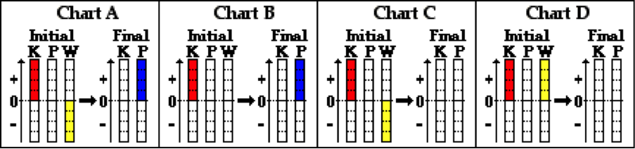

**KEi + PEi + Wnc = KEf + PEf**

**Question 2:**

aa For the physical situation described below, identify the letter of the appropriate work-energy bar chart. Simplify the work-energy equation to its proper form by cancelling zero terms.

A high speed car (initial state) is skidding to a stop (final state) along a level roadway.

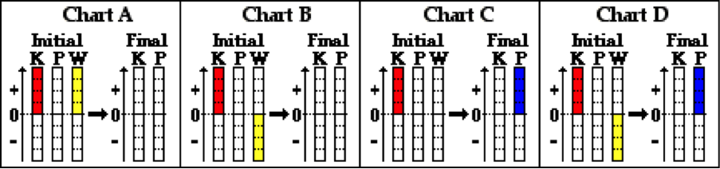

**KEi + PEi + Wnc = KEf + PEf**

**Question 3:**

aa For the physical situation described below, identify the letter of the appropriate work-energy bar chart. Simplify the work-energy equation to its proper form by cancelling zero terms.

A baseball player moving with a speed of 8.5 m/s (initial state) dives head-first and slides to a stop (final state) along level ground.



**KEi + PEi + Wnc = KEf + PEf**

**Question 4:**

aa For the physical situation described below, identify the letter of the appropriate work-energy bar chart. Simplify the work-energy equation to its proper form by cancelling zero terms.

A baseball player moving with a speed of 8.5 m/s (initial state) dives head-first and slides to a stop (final state) along level ground.



**KEi + PEi + Wnc = KEf + PEf**

**Question 5:**

aa For the physical situation described below, identify the letter of the appropriate work-energy bar chart. Simplify the work-energy equation to its proper form by cancelling zero terms.

A skydiver is falling at a terminal velocity from a 1000-foot elevation (initial state) to just above ground level (final state).

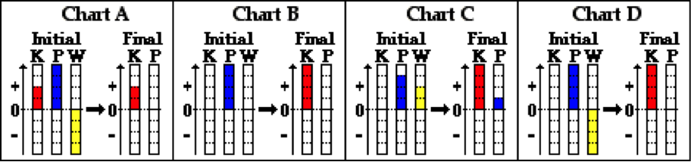

**KEi + PEi + Wnc = KEf + PEf**

**Question 6:**

aa For the physical situation described below, identify the letter of the appropriate work-energy bar chart. Simplify the work-energy equation to its proper form by cancelling zero terms.

A skydiver is falling at a terminal velocity from a 1000-foot elevation (initial state) to just above ground level (final state).

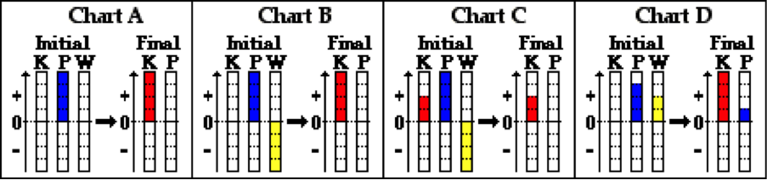

**KEi + PEi + Wnc = KEf + PEf**

**Question 7:**

aa For the physical situation described below, identify the letter of the appropriate work-energy bar chart. Simplify the work-energy equation to its proper form by cancelling zero terms.

A feather is slowly falling at a terminal velocity from an 80-foot elevation (initial state) to just above ground level (final state).



**KEi + PEi + Wnc = KEf + PEf**

**Question 8:**

aa For the physical situation described below, identify the letter of the appropriate work-energy bar chart. Simplify the work-energy equation to its proper form by cancelling zero terms.

A feather is slowly falling at a terminal velocity from an 80-foot elevation (initial state) to just above ground level (final state).



**KEi + PEi + Wnc = KEf + PEf**

**Question 9:**

aa For the physical situation described below, identify the letter of the appropriate work-energy bar chart. Simplify the work-energy equation to its proper form by cancelling zero terms.

A sledder begins from rest on an incline at a location near the top of a small hill (initial state) and slides effortlessly to ground level at the bottom of the hill (final state). Assume negligible friction and air resistance.

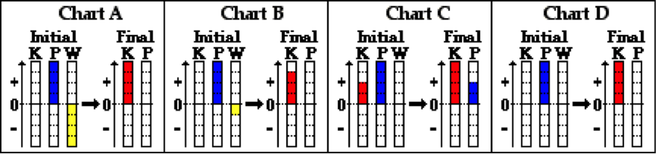

**KEi + PEi + Wnc = KEf + PEf**

**Question 10:**

aa For the physical situation described below, identify the letter of the appropriate work-energy bar chart. Simplify the work-energy equation to its proper form by cancelling zero terms.

A sledder begins from rest on an incline at a location near the top of a small hill (initial state) and slides effortlessly to ground level at the bottom of the hill (final state). Assume negligible friction and air resistance.

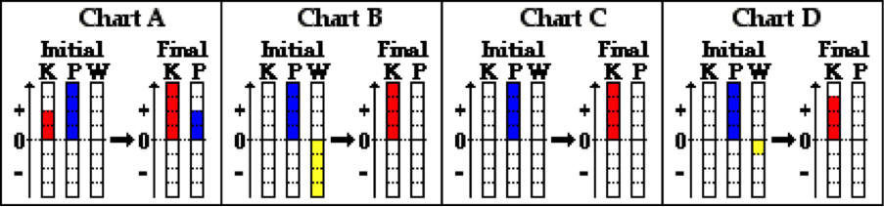

**KEi + PEi + Wnc = KEf + PEf**

**Question 11:**

aa For the physical situation described below, identify the letter of the appropriate work-energy bar chart. Simplify the work-energy equation to its proper form by cancelling zero terms.

A roller coaster car begins from rest at a location on top of the first drop (initial state) and coasts to the ground level at the bottom of the drop (final state). Assume negligible friction and air resistance.



**KEi + PEi + Wnc = KEf + PEf**

**Question 12:**

aa For the physical situation described below, identify the letter of the appropriate work-energy bar chart. Simplify the work-energy equation to its proper form by cancelling zero terms.

A roller coaster car begins from rest at a location on top of the first drop (initial state) and coasts to the ground level at the bottom of the drop (final state). Assume negligible friction and air resistance.



**KEi + PEi + Wnc = KEf + PEf**

**Question 13:**

aa For the physical situation described below, identify the letter of the appropriate work-energy bar chart. Simplify the work-energy equation to its proper form by cancelling zero terms.

A small physics cart is pulled from the bottom of a ramp (initial state) to the top of the ramp (final state) at a constant speed.

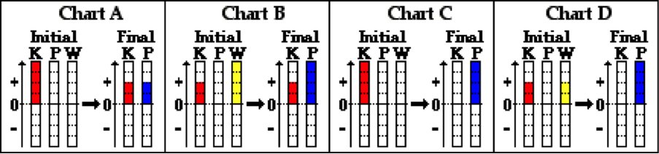

**KEi + PEi + Wnc = KEf + PEf**

**Question 14:**

aa For the physical situation described below, identify the letter of the appropriate work-energy bar chart. Simplify the work-energy equation to its proper form by cancelling zero terms.

A small physics cart is pulled from the bottom of a ramp (initial state) to the top of the ramp (final state) at a constant speed.

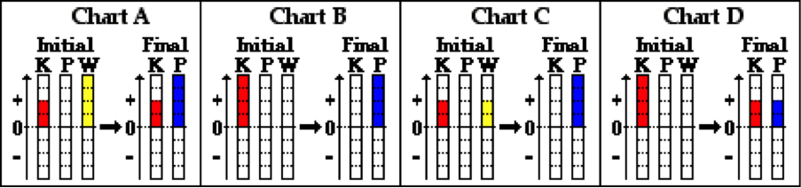

**KEi + PEi + Wnc = KEf + PEf**

**Question 15:**

aa For the physical situation described below, identify the letter of the appropriate work-energy bar chart. Simplify the work-energy equation to its proper form by cancelling zero terms.

A skier is pulled by a tow rope from the bottom of a training hill (initial state) to the top of the training hill (final state) at a constant speed.



**KEi + PEi + Wnc = KEf + PEf**

**Question 16:**

aa For the physical situation described below, identify the letter of the appropriate work-energy bar chart. Simplify the work-energy equation to its proper form by cancelling zero terms.

A skier is pulled by a tow rope from the bottom of a training hill (initial state) to the top of the training hill (final state) at a constant speed.



**KEi + PEi + Wnc = KEf + PEf**

**Question 17:**

aa For the physical situation described below, identify the letter of the appropriate work-energy bar chart. Simplify the work-energy equation to its proper form by cancelling zero terms.

A sledder is moving with a high speed at the bottom of a hill (initial state) and gradually coasts to a stop as it moves up the incline to a location near the top of the hill (final state). Ignore all frictional forces.

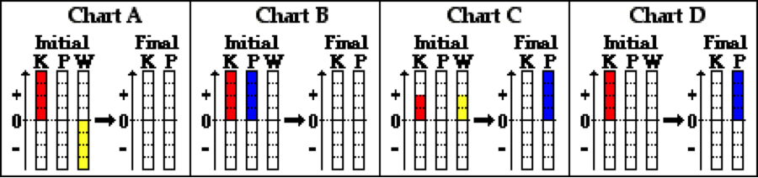

**KEi + PEi + Wnc = KEf + PEf**

**Question 18:**

aa For the physical situation described below, identify the letter of the appropriate work-energy bar chart. Simplify the work-energy equation to its proper form by cancelling zero terms.

A sledder is moving with a high speed at the bottom of a hill (initial state) and gradually coasts to a stop as it moves up the incline to a location near the top of the hill (final state). Ignore all frictional forces.

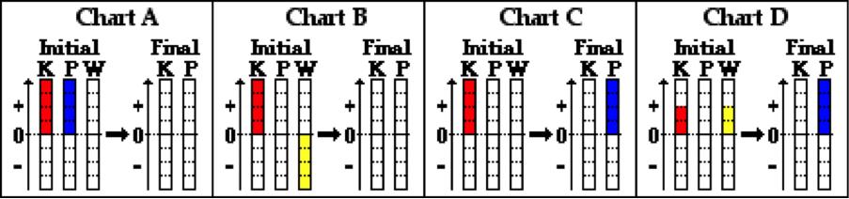

**KEi + PEi + Wnc = KEf + PEf**

**Question 19:**

aa For the physical situation described below, identify the letter of the appropriate work-energy bar chart. Simplify the work-energy equation to its proper form by cancelling zero terms.

A car is moving with a high speed at the bottom of a hill (initial state) runs out of gas and gradually coasts to a stop as it moves up the incline to a location near the top of the hill (final state). Ignore all frictional forces.



**KEi + PEi + Wnc = KEf + PEf**

**Question 20:**

aa For the physical situation described below, identify the letter of the appropriate work-energy bar chart. Simplify the work-energy equation to its proper form by cancelling zero terms.

A car is moving with a high speed at the bottom of a hill (initial state) runs out of gas and gradually coasts to a stop as it moves up the incline to a location near the top of the hill (final state). Ignore all frictional forces.



**KEi + PEi + Wnc = KEf + PEf**

**Question 21:**

aa For the physical situation described below, identify the letter of the appropriate work-energy bar chart. Simplify the work-energy equation to its proper form by cancelling zero terms.

A sledder is moving with a high speed at the bottom of a hill (initial state) and gradually coasts to a stop as it moves up the incline to a location near the top (final state). Friction and air resistance influence the motion.

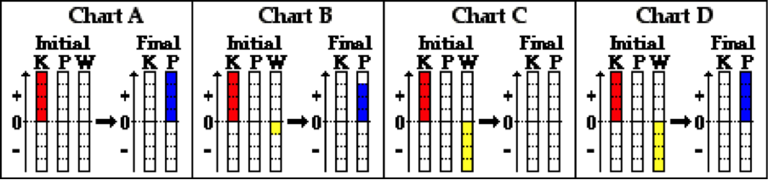

**KEi + PEi + Wnc = KEf + PEf**

**Question 22:**

aa For the physical situation described below, identify the letter of the appropriate work-energy bar chart. Simplify the work-energy equation to its proper form by cancelling zero terms.

A sledder is moving with a high speed at the bottom of a hill (initial state) and gradually coasts to a stop as it moves up the incline to a location near the top (final state). Friction and air resistance influence the motion.

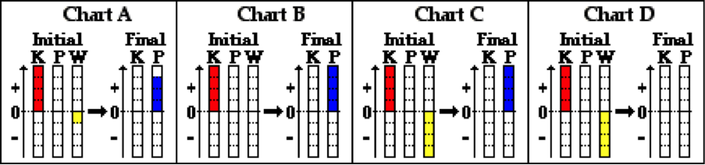

**KEi + PEi + Wnc = KEf + PEf**

**Question 23:**

aa For the physical situation described below, identify the letter of the appropriate work-energy bar chart. Simplify the work-energy equation to its proper form by cancelling zero terms.

A car is moving with a high speed at the bottom of a hill (initial state) runs out of gas and gradually coasts to a stop as it moves up the incline to a location near the top of the hill (final state). Friction and air resistance influence the motion.



**KEi + PEi + Wnc = KEf + PEf**

**Question 24:**

aa For the physical situation described below, identify the letter of the appropriate work-energy bar chart. Simplify the work-energy equation to its proper form by cancelling zero terms.

A car is moving with a high speed at the bottom of a hill (initial state) runs out of gas and gradually coasts to a stop as it moves up the incline to a location near the top of the hill (final state). Friction and air resistance influence the motion.



**KEi + PEi + Wnc = KEf + PEf**

**Question 25:**

aa For the physical situation described below, identify the letter of the appropriate work-energy bar chart. Simplify the work-energy equation to its proper form by cancelling zero terms.

A sledder begins from rest on an incline at a location near the top of a small hill (initial state) and slides to ground level at the bottom of the hill (final state). Friction and air resistance influence the motion.

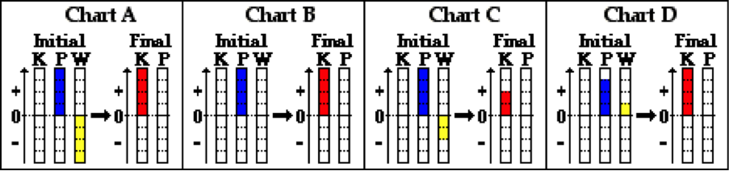

**KEi + PEi + Wnc = KEf + PEf**

**Question 26:**

aa For the physical situation described below, identify the letter of the appropriate work-energy bar chart. Simplify the work-energy equation to its proper form by cancelling zero terms.

A sledder begins from rest on an incline at a location near the top of a small hill (initial state) and slides to ground level at the bottom of the hill (final state). Friction and air resistance influence the motion.

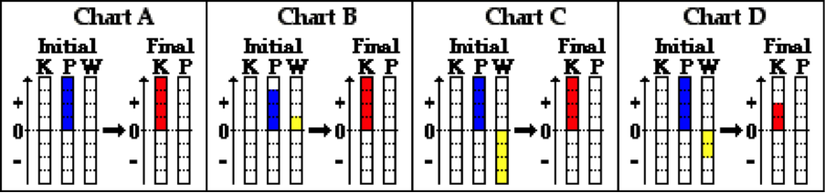

**KEi + PEi + Wnc = KEf + PEf**

**Question 27:**

aa For the physical situation described below, identify the letter of the appropriate work-energy bar chart. Simplify the work-energy equation to its proper form by cancelling zero terms.

A roller coaster car begins from rest at a location on top of the first drop (initial state) and coasts to the ground level at the bottom of the drop (final state). Friction and air resistance influence the motion.



**KEi + PEi + Wnc = KEf + PEf**

**Question 28:**

aa For the physical situation described below, identify the letter of the appropriate work-energy bar chart. Simplify the work-energy equation to its proper form by cancelling zero terms.

A roller coaster car begins from rest at a location on top of the first drop (initial state) and coasts to the ground level at the bottom of the drop (final state). Friction and air resistance influence the motion.



**KEi + PEi + Wnc = KEf + PEf**

**Question 29:**

aa For the physical situation described below, identify the letter of the appropriate work-energy bar chart. Simplify the work-energy equation to its proper form by cancelling zero terms.

A car accelerates from rest (initial state) along a level roadway to a high speed (final state).

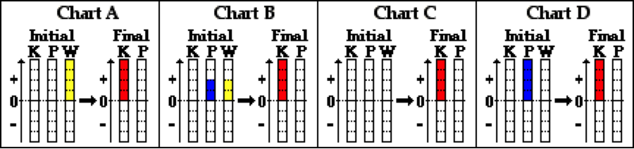

**KEi + PEi + Wnc = KEf + PEf**

**Question 30:**

aa For the physical situation described below, identify the letter of the appropriate work-energy bar chart. Simplify the work-energy equation to its proper form by cancelling zero terms.

A car accelerates from rest (initial state) along a level roadway to a high speed (final state).

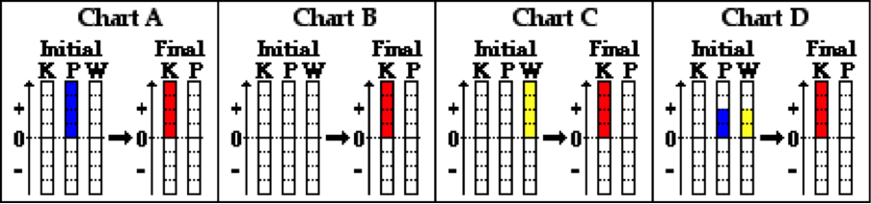

**KEi + PEi + Wnc = KEf + PEf**

**Question 31:**

aa For the physical situation described below, identify the letter of the appropriate work-energy bar chart. Simplify the work-energy equation to its proper form by cancelling zero terms.

A sprinter accelerates from rest (initial state) along a level track to a high speed (final state).



**KEi + PEi + Wnc = KEf + PEf**

**Question 32:**

aa For the physical situation described below, identify the letter of the appropriate work-energy bar chart. Simplify the work-energy equation to its proper form by cancelling zero terms.

A sprinter accelerates from rest (initial state) along a level track to a high speed (final state).



**KEi + PEi + Wnc = KEf + PEf**

**Question 33:**

aa For the physical situation described below, identify the letter of the appropriate work-energy bar chart. Simplify the work-energy equation to its proper form by cancelling zero terms.

A spring-loaded dart gun mounted at ground level (initial state) launches a dart upward at a 45-degree angle. The dart ascends upwards to the peak of its trajectory (final state). Neglect air resistance.

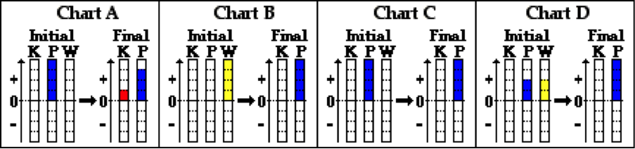

**KEi + PEi + Wnc = KEf + PEf**

**Question 34:**

aa For the physical situation described below, identify the letter of the appropriate work-energy bar chart. Simplify the work-energy equation to its proper form by cancelling zero terms.

A spring-loaded dart gun mounted at ground level (initial state) launches a dart upward at a 45-degree angle. The dart ascends upwards to the peak of its trajectory (final state). Neglect air resistance.

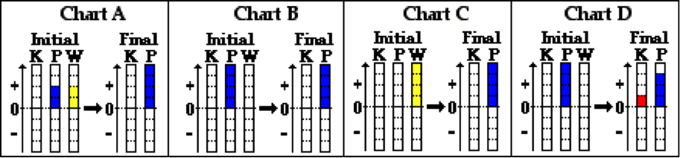

**KEi + PEi + Wnc = KEf + PEf**

**Question 35:**

aa For the physical situation described below, identify the letter of the appropriate work-energy bar chart. Simplify the work-energy equation to its proper form by cancelling zero terms.

A spring-loaded dart gun mounted at ground level (initial state) launches a dart upward at a 40-degree angle. The dart ascends upwards to the peak of its trajectory (final state). Neglect air resistance.



**KEi + PEi + Wnc = KEf + PEf**

**Question 36:**

aa For the physical situation described below, identify the letter of the appropriate work-energy bar chart. Simplify the work-energy equation to its proper form by cancelling zero terms.

A spring-loaded dart gun mounted at ground level (initial state) launches a dart upward at a 40-degree angle. The dart ascends upwards to the peak of its trajectory (final state). Neglect air resistance.



**KEi + PEi + Wnc = KEf + PEf**

**WE7: Energy Conservation**

**Question 1:**

aa. Some forces are categorized as conservative forces (or internal forces) while others are categorized as non-conservative forces (or external forces). Which of the following forces are generally categorized as conservative (or internal) forces?

a. Force of Friction b. Force of Gravity

c. Applied Force d. Normal Force

e. Spring Force f. Air Resistance Force

g. Tension Force

**Question 2:**

aa. Some forces are categorized as conservative forces (or internal forces) while others are categorized as non-conservative forces (or external forces). Which of the following forces are generally categorized as conservative (or internal) forces?

a. Air Resistance Force b. Tension Force

c. Force of Gravity d. Force of Friction

e. Normal Force f. Applied Force

g. Spring Force

**Question 3:**

aa. Some forces are categorized as conservative forces (or internal forces) while others are categorized as non-conservative forces (or external forces). Which of the following forces are generally categorized as conservative (or internal) forces?

a. Normal Force b. Applied Force

c. Air Resistance Force d. Spring Force

e. Force of Friction f. Force of Gravity

g. Tension Force

**Question 4:**

aa. Some forces are categorized as conservative forces (or internal forces) while others are categorized as non-conservative forces (or external forces). Which of the following forces are generally categorized as conservative (or internal) forces?

a. Air Resistance Force b. Spring Force

c. Applied Force d. Force of Gravity

e. Normal Force f. Force of Friction

g. Tension Force

**Question 5:**

aa. If the only forces doing work upon an object are conservative (or internal) forces, then the total mechanical energy of the object will ____. If the only forces doing work upon an object are non-conservative (or external) forces, then the total mechanical energy of the object will ____. Enter the letters of the two answers in their respective order with neither commas nor spaces between letters.

a. increase

b. decrease

c. not change

d. change - either increase or decrease

e. ... nonsense! There is no way to make such a prediction.

**Question 6:**

aa. If the only forces doing work upon an object are conservative (or internal) forces, then the total mechanical energy of the object will ____. If the only forces doing work upon an object are non-conservative (or external) forces, then the total mechanical energy of the object will ____. Enter the letters of the two answers in their respective order with neither commas nor spaces between letters.

a. decrease

b. increase

c. change - either increase or decrease

d. not change

e. ... nonsense! There is no way to make such a prediction.

**Question 7:**

aa. If the only forces doing work upon an object are conservative (or internal) forces, then the total mechanical energy of the object will ____. If the only forces doing work upon an object are non-conservative (or external) forces, then the total mechanical energy of the object will ____. Enter the letters of the two answers in their respective order with neither commas nor spaces between letters.

a. not change

b. increase

c. decrease

d. change - either increase or decrease

e. ... nonsense! There is no way to make such a prediction.

**Question 8:**

aa. If the only forces doing work upon an object are conservative (or internal) forces, then the total mechanical energy of the object will ____. If the only forces doing work upon an object are non-conservative (or external) forces, then the total mechanical energy of the object will ____. Enter the letters of the two answers in their respective order with neither commas nor spaces between letters.

a. not change

b. decrease

c. increase

d. change - either increase or decrease

e. ... nonsense! There is no way to make such a prediction.

**Question 9:**

aa. In order for an object to conserve its total mechanical energy it is absolutely necessary that ____. List all that apply in alphabetical order with no commas or spaces between letters.

a. non-conservative (i.e., external) forces do NOT act upon the object

b. conservative (i.e., internal) forces act upon the object

c. all the forces acting upon the object are balanced

d. non-conservative (i.e., external) forces do NOT do net work upon the object

e. conservative (i.e., internal) forces do work upon the object

**Question 10:**

aa. In order for an object to conserve its total mechanical energy it is absolutely necessary that ____. List all that apply in alphabetical order with no commas or spaces between letters.

a. conservative (i.e., internal) forces act upon the object

b. non-conservative (i.e., external) forces do NOT act upon the object

c. all the forces acting upon the object are balanced

d. conservative (i.e., internal) forces do work upon the object

e. non-conservative (i.e., external) forces do NOT do net work upon the object

**Question 11:**

aa. In order for an object to conserve its total mechanical energy it is absolutely necessary that ____. List all that apply in alphabetical order with no commas or spaces between letters.

a. non-conservative (i.e., external) forces do NOT do net work upon the object

b. conservative (i.e., internal) forces do work upon the objectA

c. non-conservative (i.e., external) forces do NOT act upon the object

d. conservative (i.e., internal) forces act upon the object

e. all the forces acting upon the object are balanced

**Question 12:**

aa. In order for an object to conserve its total mechanical energy it is absolutely necessary that ____. List all that apply in alphabetical order with no commas or spaces between letters.

a. conservative (i.e., internal) forces do work upon the object

b. non-conservative (i.e., external) forces do NOT do net work upon the object

c. conservative (i.e., internal) forces act upon the object

d. non-conservative (i.e., external) forces do NOT act upon the object

e. all the forces acting upon the object are balanced

**Question 13:**

aa. If the total mechanical energy of an object is conserved, then ____. List all that apply in alphabetical order with no commas or spaces between letters.

a. the sum of the kinetic energy (KE) and the potential energy (PE) is 0 Joules

b. the initial amount of KE equals the final amount of PE

c. there is neither any KE nor PE in either the initial or the final state

d. the sum of the KE and the PE is the same for the initial state as it is for the final state

e. the total amount of KE and PE gradually decreases to 0 Joules

**Question 14:**

aa. If the total mechanical energy of an object is conserved, then ____. List all that apply in alphabetical order with no commas or spaces between letters.

a. the sum of the kinetic energy (KE) and the potential energy (PE) is 0 Joules

b. there is neither any KE nor PE in either the initial or the final state

c. the initial amount of KE equals the final amount of PE

d. the total amount of KE and PE gradually decreases to 0 Joules

e. the sum of the KE and the PE is the same for the initial state as it is for the final state

**Question 15:**

aa. If the total mechanical energy of an object is conserved, then ____. List all that apply in alphabetical order with no commas or spaces between letters.

a. the sum of the kinetic energy (KE) and the potential energy (PE) is 0 Joules

b. the sum of the KE and the PE is the same for the initial state as it is for the final state

c. the total amount of KE and PE gradually decreases to 0 Joules

d. the initial amount of KE equals the final amount of PE

e. there is neither any KE nor PE in either the initial or the final state

**Question 16:**

aa. If the total mechanical energy of an object is conserved, then ____. List all that apply in alphabetical order with no commas or spaces between letters.

a. the sum of the kinetic energy (KE) and the potential energy (PE) is 0 Joules

b. the total amount of KE and PE gradually decreases to 0 Joules

c. the sum of the KE and the PE is the same for the initial state as it is for the final state

d. there is neither any KE nor PE in either the initial or the final state

e. the initial amount of KE equals the final amount of PE

**Question 17:**

aa. An object starts at rest from a height of 40 meters. It's total amount of mechanical energy is 400 Joules. The object begins a free-falling motion; there is no air resistance. When it has fallen to a height of one-fourth of its original height, its potential energy will be ____ Joules and its total amount of mechanical energy will be ____ Joules. Enter the two answers in their respective order with no commas or spaces between letters.

a. 0.25 b. 10 c. 30

d. 40 e. 100 f. 200

g. 300 h. 400 i. 500

j. ... nonsense! It is impossible to determine this value due to insufficient information.

k. ... nonsense! It is possible to determine this value, but none of the choices are even close.

**Question 18:**

aa. An object starts at rest from a height of 30 meters. It's total amount of mechanical energy is 300 Joules. The object begins a free-falling motion; there is no air resistance. When it has fallen to a height of one-third of its original height, its potential energy will be ____ Joules and its total amount of mechanical energy will be ____ Joules. Enter the two answers in their respective order with no commas or spaces between letters.

a. 0.33 b. 10 c. 30

d. 100 e. 200 f. 300

g. 400

h. 900

i. ... nonsense! It is impossible to determine this value due to insufficient information.

j. ... nonsense! It is possible to determine this value, but none of the choices are even close.

**Question 19:**

aa. An object starts at rest from a height of 50 meters. It's total amount of mechanical energy is 500 Joules. The object begins a free-falling motion; there is no air resistance. When it has fallen to a height of one-fifth of its original height, its potential energy will be ____ Joules and its total amount of mechanical energy will be ____ Joules. Enter the two answers in their respective order with no commas or spaces between letters.

a. 0.20 b. 10 c. 40

d. 50 e. 100 f. 400

g. 500 h. 600 i. 900

j. ... nonsense! It is impossible to determine this value due to insufficient information.

k. ... nonsense! It is possible to determine this value, but none of the choices are even close.

**Question 20:**

aa. An object starts at rest from a height of 40 meters. It's total amount of mechanical energy is 800 Joules. The object begins a free-falling motion; there is no air resistance. When it has fallen to a height of one-fourth of its original height, its potential energy will be ____ Joules and its total amount of mechanical energy will be ____ Joules. Enter the two answers in their respective order with no commas or spaces between letters.

a. 0.25 b. 10 c. 30

d. 40 e. 100 f. 200

g. 600 h. 700 i. 800

j. 1000

k. ... nonsense! It is impossible to determine this value due to insufficient information.

l. ... nonsense! It is possible to determine this value, but none of the choices are even close.

**Question 21:**

aa. A sledder effortlessly glides from position A across the snow to position B (as shown in the diagram below). Resistance forces are negligible.

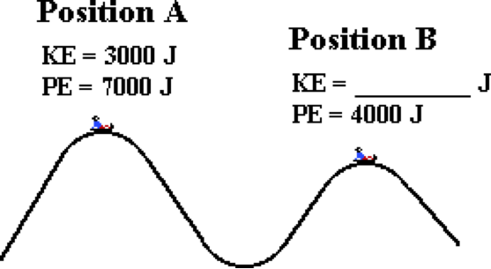

At position B, the total mechanical energy of the sledder is _____ Joules and the kinetic energy is ____ Joules. Enter the two answers in their respective order with no commas or spaces between letters.

a. 0 b. 1000 c. 3000 d. 4000

e. 6000 f. 7000 g. 8000 h. 10000

i. ... nonsense! It is impossible to determine this value due to insufficient information.

j. ... nonsense! It is possible to determine this value, but none of the choices are even close.

**Question 22:**

aa. A sledder effortlessly glides from position A across the snow to position B (as shown in the diagram below). Resistance forces are negligible.



At position B, the kinetic energy of the sledder is _____ Joules and the total mechanical energy is ____ Joules. Enter the two answers in their respective order with no commas or spaces between letters.

a. 0 b. 1000 c. 3000 d. 4000

e. 6000 f. 7000 g. 8000 h. 10000

i. ... nonsense! It is impossible to determine this value due to insufficient information.

j. ... nonsense! It is possible to determine this value, but none of the choices are even close.

**Question 23:**

aa. A sledder effortlessly glides from position A across the snow to position B (as shown in the diagram below). Resistance forces are negligible.

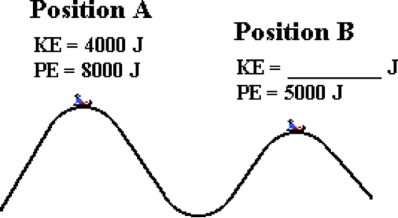

At position B, the total mechanical energy of the sledder is _____ Joules and the kinetic energy is ____ Joules. Enter the two answers in their respective order with no commas or spaces between letters.

a. 0 b. 1000 c. 2000 d. 2500

e. 3000 f. 4000 g. 7000 h. 8000

i. 9000 j. 1200

k. ... nonsense! It is impossible to determine this value due to insufficient information.

l. ... nonsense! It is possible to determine this value, but none of the choices are even close.

**Question 24:**

aa. A sledder effortlessly glides from position A across the snow to position B (as shown in the diagram below). Resistance forces are negligible.



At position B, the kinetic energy of the sledder is _____ Joules and the total mechanical energy is ____ Joules. Enter the two answers in their respective order with no commas or spaces between letters.

a. 0 b. 1000 c. 2000 d. 2500

e. 3000 f. 4000 g. 7000 h. 8000

i. 9000 j. 12000

k. ... nonsense! It is impossible to determine this value due to insufficient information.

l. ... nonsense! It is possible to determine this value, but none of the choices are even close.

**Question 25:**

aa. A roller coaster car coasts from position A to position B (as shown in the diagram below). Resistance forces are negligible.

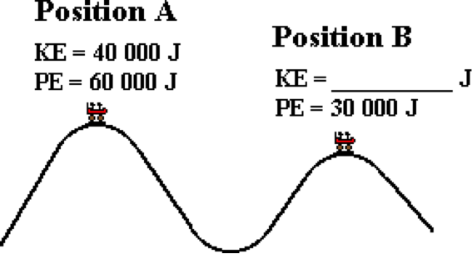

At position B, the total mechanical energy of the car is _____ Joules and the kinetic energy is ____ Joules. Enter the two answers in their respective order with no commas or spaces between letters.

a. 0 b. 10 000 c. 40 000

d. 50 000 e. 60 000 f. 70 000

g. 100 000 h. 130 000 i. 200 000

j. ... nonsense! It is impossible to determine this value due to insufficient information.

j. ... nonsense! It is possible to determine this value, but none of the choices are even close.

**Question 26:**

aa. A roller coaster car coasts from position A to position B (as shown in the diagram below). Resistance forces are negligible.



At position B, the kinetic energy of the car is _____ Joules and the total mechanical energy is ____ Joules. Enter the two answers in their respective order with no commas or spaces between letters.

a. 0 b. 10 000 c. 40 000

d. 50 000 e. 60 000 f. 70 000

g. 100 000 h. 130 000 i. 200 000

j. ... nonsense! It is impossible to determine this value due to insufficient information.

k. ... nonsense! It is possible to determine this value, but none of the choices are even close.

**Question 27:**

aa. A roller coaster car coasts from position A to position B (as shown in the diagram below). Resistance forces are negligible.

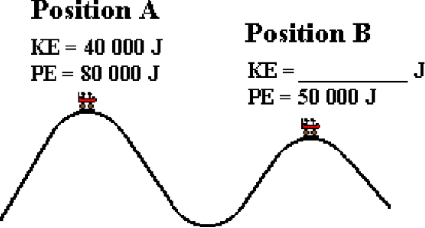

At position B, the total mechanical energy of the car is _____ Joules and the kinetic energy is ____ Joules. Enter the two answers in their respective order with no commas or spaces between letters.

a. 0 b. 10 000 c. 20 000 d. 25 000

e. 40 000 f. 50 000 g. 70 000 h. 90 000

i. 120 000 j. 170 000 k. 240 000

l. ... nonsense! It is impossible to determine this value due to insufficient information.

m. ... nonsense! It is possible to determine this value, but none of the choices are even close.

**Question 28:**

aa. A roller coaster car coasts from position A to position B (as shown in the diagram below). Resistance forces are negligible.



At position B, the kinetic energy of the car is _____ Joules and the total mechanical energy is ____ Joules. Enter the two answers in their respective order with no commas or spaces between letters.

a. 0 b. 10 000 c. 20 000 d. 25 000

e. 40 000 f. 50 000 g. 70 000 h. 90 000

i. 120 000 j. 170 000 k. 240 000

l. ... nonsense! It is impossible to determine this value due to insufficient information.

m. ... nonsense! It is possible to determine this value, but none of the choices are even close.

**Question 29:**

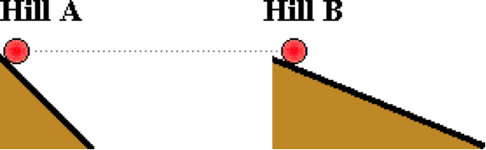aa. Two objects of identical mass begin from rest at the same height at the top of two different hills - hill A and hill B. The hills are inclined at two different angles (see diagram). The objects are released from rest and slide to the bottom; resistance forces can be considered to be negligible. The object on top of hill ____ will have the greatest speed at the bottom of the incline.

a. A b. B

c. ... nonsense! Both objects will have identical speeds at the bottom.

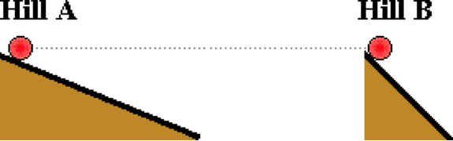**Question 30:**

aa. Two objects of identical mass begin from rest at the same height at the top of two different hills - hill A and hill B. The hills are inclined at two different angles (see diagram). The objects are released from rest and slide to the bottom; resistance forces can be considered to be negligible. The object on top of hill ____ will have the greatest speed at the bottom of the incline.

a. A b. B

c. ... nonsense! Both objects will have identical speeds at the bottom.

**Question 31:**

aa. Two objects of identical mass begin from rest at the same height at the top of two different hills - hill A and hill B. The hills are inclined at two different angles (see diagram). The objects are released from rest and slide to the bottom; resistance forces can be considered to be negligible. The object on top of hill ____ will have the smallest speed at the bottom of the incline.

a. A b. B

c. ... nonsense! Both objects will have identical speeds at the bottom.

**Question 32:**

aa. Two objects of identical mass begin from rest at the same height at the top of two different hills - hill A and hill B. The hills are inclined at two different angles (see diagram). The objects are released from rest and slide to the bottom; resistance forces can be considered to be negligible. The object on top of hill ____ will have the smallest speed at the bottom of the incline.

a. A b. B

c. ... nonsense! Both objects will have identical speeds at the bottom.

**WE8: Energy Conservation – Math Analysis**

**Question 1:**

aa. The path of a roller coaster car coasting along a track is shown in the diagram below. Frictional forces can be assumed to be negligible. Perform an energy analysis and fill in all the blanks.

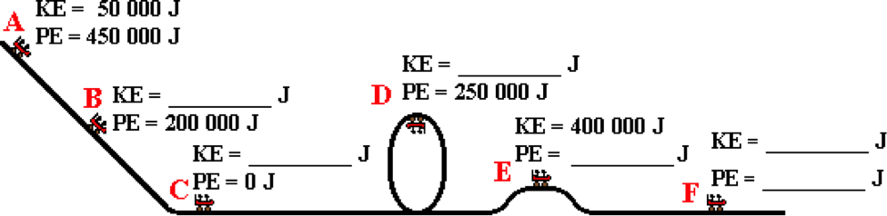

**Question 2:**

aa. The path of a roller coaster car coasting along a track is shown in the diagram below. Frictional forces can be assumed to be negligible. Perform an energy analysis and fill in all the blanks.

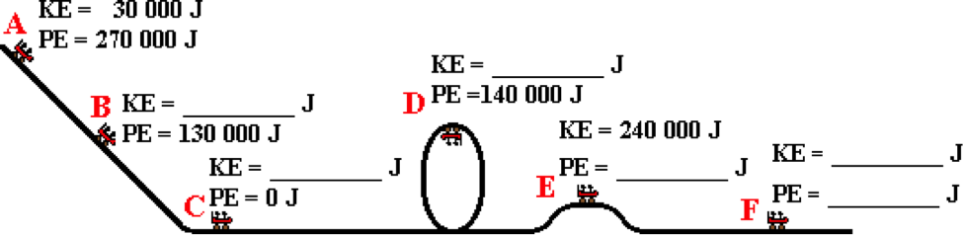

**Question 3:**

aa. The path of a sledder gliding across the ice and snow is shown in the diagram below. Frictional forces can be assumed to be negligible. Perform an energy analysis and fill in all the blanks.

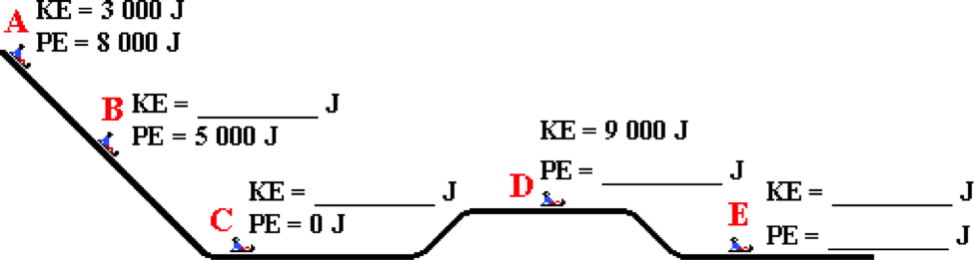

**Question 4:**

aa. The path of a sledder gliding across the ice and snow is shown in the diagram below. Frictional forces can be assumed to be negligible. Perform an energy analysis and fill in all the blanks.

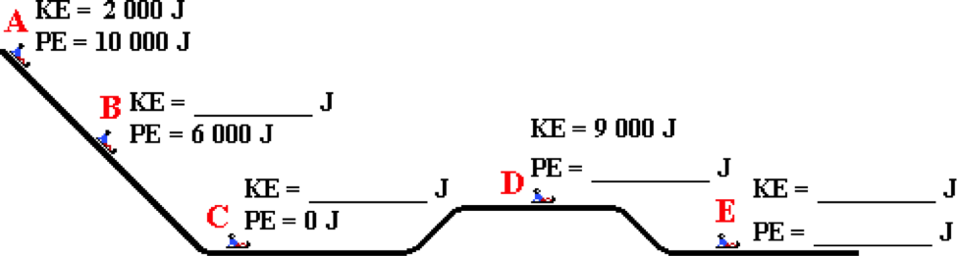

**Question 5:**

aa. The path of a projectile moving through the air is shown in the diagram below. Frictional forces can be assumed to be negligible. Perform an energy analysis and fill in all the blanks.

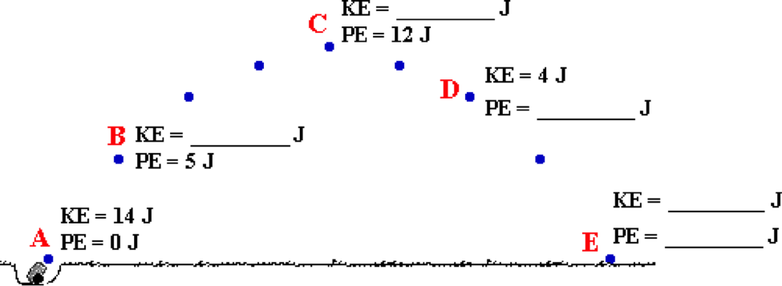

**Question 6:**

aa. The path of a projectile moving through the air is shown in the diagram below. Frictional forces can be assumed to be negligible. Perform an energy analysis and fill in all the blanks.

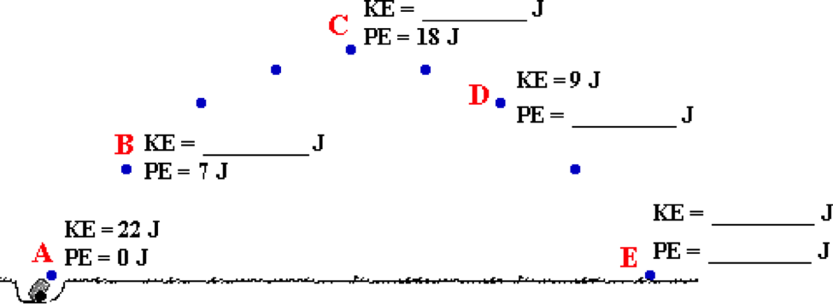

**Question 7:**

aa. The path of a pendulum bob moving to and fro is shown in the diagram below. Frictional forces can be assumed to be negligible. Perform an energy analysis and fill in all the blanks.

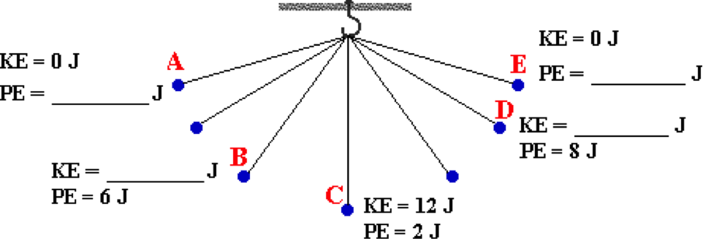

**Question 8:**

aa. The path of a pendulum bob moving to and fro is shown in the diagram below. Frictional forces can be assumed to be negligible. Perform an energy analysis and fill in all the blanks.

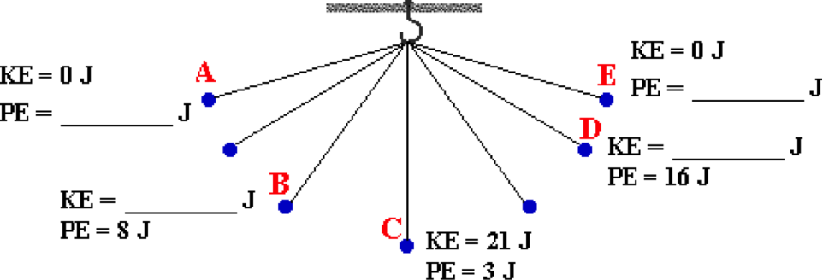

**Question 9:**

aa. The path of a roller coaster car coasting along a track is shown in the diagram below. Frictional forces can be assumed to be negligible. Use g = 10 m/s/s to perform an energy analysis and fill in all the blanks. (Given: m = 500 kg; Height at A = 44 m, Speed at A = 0 m/s)

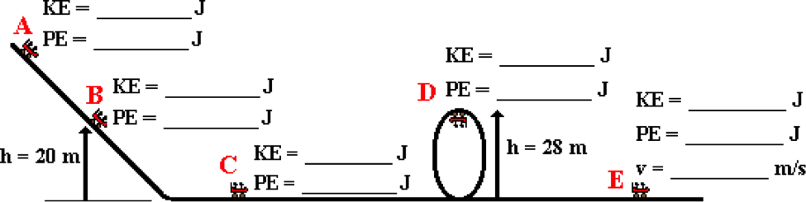

**Question 10:**

aa. The path of a roller coaster car coasting along a track is shown in the diagram below. Frictional forces can be assumed to be negligible. Use g = 10 m/s/s to perform an energy analysis and fill in all the blanks. (Given: m = 350 kg; Height at A = 44 m, Speed at A = 0 m/s)



**Question 11:**

aa. The path of a sledder gliding across the ice and snow is shown in the diagram below. Frictional forces can be assumed to be negligible. Use g = 10 m/s/s to perform an energy analysis and fill in all the blanks. (Given: m = 30 kg; Height at A = 22 m, Speed at A = 0 m/s)

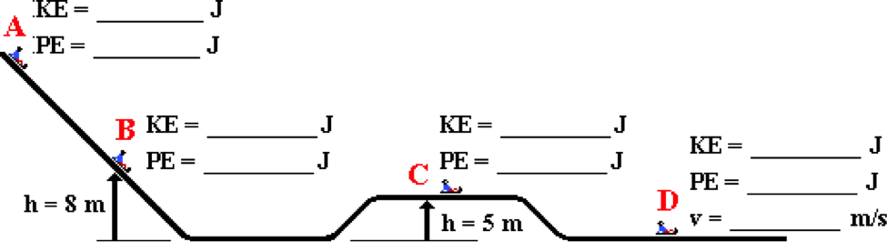

**Question 12:**

aa. The path of a sledder gliding across the ice and snow is shown in the diagram below. Frictional forces can be assumed to be negligible. Use g = 10 m/s/s to perform an energy analysis and fill in all the blanks. (Given: m = 40 kg; Height at A = 18 m, Speed at A = 0 m/s)



**Question 13:**

aa. The path of a projectile moving through the air is shown in the diagram below. Frictional forces can be assumed to be negligible. Use g = 10 m/s/s to perform an energy analysis and fill in all the blanks. (Given: m = 1.5 kg; Height at A = 0 m, Speed at A = 20 m/s)

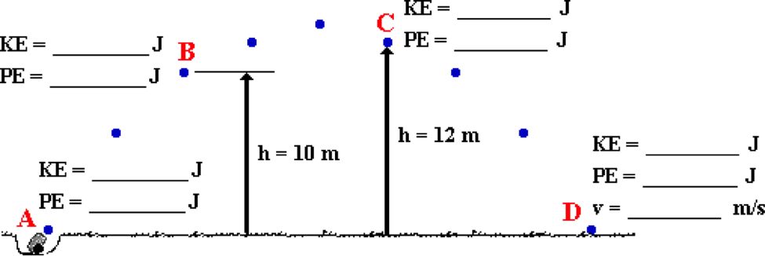

**Question 14:**

aa. The path of a projectile moving through the air is shown in the diagram below. Frictional forces can be assumed to be negligible. Use g = 10 m/s/s to perform an energy analysis and fill in all the blanks. (Given: m = 2.5 kg; Height at A = 0 m, Speed at A = 22 m/s)



**Question 15:**

aa. The path of a sledder is shown below; upon descending the hill, the sledder ultimately glides up a ramp to a final resting position (at D). Frictional forces can be assumed to be negligible. Use g = 10 m/s/s to perform an energy analysis and fill in all the blanks. (Given: m = 30 kg; Height at A = 8 m, Speed at A = 12 m/s)

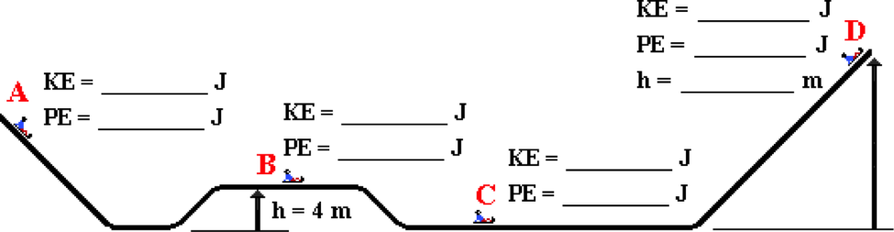

**Question 16:**

aa. The path of a sledder is shown below; upon descending the hill, the sledder ultimately glides up a ramp to a final resting position (at D). Frictional forces can be assumed to be negligible. Use g = 10 m/s/s to perform an energy analysis and fill in all the blanks. (Given: m = 30 kg; Height at A = 6 m, Speed at A = 14 m/s.)



**WE9: Work and Energy Conversions**

**Question 1:**

aa. An object's mechanical energy will NOT be conserved if ____. List all that apply in alphabetical order with no commas or spaces between letters.

a. the forces acting upon the object are NOT balanced

b. the object is accelerating

c. conservative forces (i.e., internal forces) are acting upon the object

d. non-conservative forces (i.e., external forces) are acting upon the object

e. conservative forces (i.e., internal forces) are doing work upon the object

f. non-conservative forces (i.e., external forces) are doing work upon the object

**Question 2:**

aa. An object's mechanical energy will NOT be conserved if ____. List all that apply in alphabetical order with no commas or spaces between letters.

a. the object is accelerating

b. the forces acting upon the object are NOT balanced

c. non-conservative forces (i.e., external forces) are acting upon the object

d. conservative forces (i.e., internal forces) are acting upon the object

e. non-conservative forces (i.e., external forces) are doing work upon the object

f. conservative forces (i.e., internal forces) are doing work upon the object

**Question 3:**

aa. An object's mechanical energy will NOT be conserved if ____. List all that apply in alphabetical order with no commas or spaces between letters.

a. conservative forces (i.e., internal forces) are acting upon the object

b. non-conservative forces (i.e., external forces) are acting upon the object

c. the forces acting upon the object are NOT balanced

d. the object is accelerating

e. conservative forces (i.e., internal forces) are doing work upon the object

f. non-conservative forces (i.e., external forces) are doing work upon the object

**Question 4:**

aa. An object's mechanical energy will NOT be conserved if ____. List all that apply in alphabetical order with no commas or spaces between letters.

a. conservative forces (i.e., internal forces) are doing work upon the object

b. non-conservative forces (i.e., external forces) are doing work upon the object

c. the forces acting upon the object are NOT balanced

d. the object is accelerating

e. conservative forces (i.e., internal forces) are acting upon the object

f. non-conservative forces (i.e., external forces) are acting upon the object

**Question 5:**

aa. When an object's total mechanical energy is NOT conserved, ____. List all that apply in alphabetical order with no commas or spaces between letters.

a. the initial kinetic energy cannot equal the final kinetic energy

b. the initial potential energy cannot equal the final potential energy

c. the sum of the kinetic energy and the potential energy is changing

d. mechanical energy is being converted into non-mechanical forms (or vice versa)

e. there is an increase or a decrease in the amount of kinetic energy possessed by the object

f. there is an increase or a decrease in the amount of potential energy possessed by the object

**Question 6:**

aa. When an object's total mechanical energy is NOT conserved, ____. List all that apply in alphabetical order with no commas or spaces between letters.

a. the initial potential energy cannot equal the final potential energy

b. the initial kinetic energy cannot equal the final kinetic energy

c. mechanical energy is being converted into non-mechanical forms (or vice versa)

d. the sum of the kinetic energy and the potential energy is changing

e. there is an increase or a decrease in the amount of potential energy possessed by the object

f. there is an increase or a decrease in the amount of kinetic energy possessed by the object

**Question 7:**

aa. When an object's total mechanical energy is NOT conserved, ____. List all that apply in alphabetical order with no commas or spaces between letters.

a. there is an increase or a decrease in the amount of kinetic energy possessed by the object

b. there is an increase or a decrease in the amount of potential energy possessed by the object

c. the initial kinetic energy cannot equal the final kinetic energy

d. the initial potential energy cannot equal the final potential energy

e. the sum of the kinetic energy and the potential energy is changing

f. mechanical energy is being converted into non-mechanical forms (or vice versa)

**Question 8:**

aa. When an object's total mechanical energy is NOT conserved, ____. List all that apply in alphabetical order with no commas or spaces between letters.

a. there is an increase or a decrease in the amount of potential energy possessed by the object

b. there is an increase or a decrease in the amount of kinetic energy possessed by the object

c. the initial potential energy cannot equal the final potential energy

d. the initial kinetic energy cannot equal the final kinetic energy

e. mechanical energy is being converted into non-mechanical forms (or vice versa)

f. the sum of the kinetic energy and the potential energy is changing

**Question 9:**

aa. Some forces are categorized as conservative forces (or internal forces) while others are categorized as non-conservative forces (or external forces). Which of the following forces are generally categorized as non-conservative (or external) forces? List all that apply in alphabetical order with no commas or spaces between letters.

a. Force of Friction b. Force of Gravity

c. Applied Force d. Normal Force

e. Spring Force f. Air Resistance Force

g. Tension Force

**Question 10:**

aa. Some forces are categorized as conservative forces (or internal forces) while others are categorized as non-conservative forces (or external forces). Which of the following forces are generally categorized as non-conservative (or external) forces? List all that apply in alphabetical order with no commas or spaces between letters.

a. Air Resistance Force b. Tension Force

c. Force of Gravity d. Force of Friction

e. Normal Force f. Applied Force

g. Spring Force

**Question 11:**

aa. Some forces are categorized as conservative forces (or internal forces) while others are categorized as non-conservative forces (or external forces). Which of the following forces are generally categorized as non-conservative (or external) forces? List all that apply in alphabetical order with no commas or spaces between letters.

a. Normal Force b. Applied Force

c. Air Resistance Force d. Spring Force

e. Force of Friction f. Force of Gravity

g. Tension Force

**Question 12:**

aa. Some forces are categorized as conservative forces (or internal forces) while others are categorized as non-conservative forces (or external forces). Which of the following forces are generally categorized as non-conservative (or external) forces? List all that apply in alphabetical order with no commas or spaces between letters.

a. Air Resistance Force b. Spring Force

c. Applied Force d. Force of Gravity

e. Normal Force f. Force of Friction

g. Tension Force

**Question 13:**

aa. Consider the work energy bar charts shown below. Type the letter of any bar chart that portrays a situation in which mechanical energy is NOT conserved. If there are no such situations, then enter "Z" as your answer.

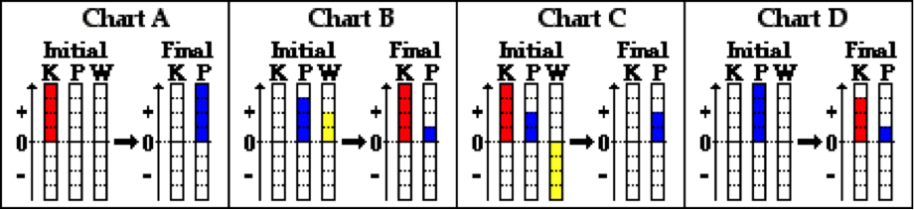

**Question 14:**

aa. Consider the work energy bar charts shown below. Type the letter of any bar chart that portrays a situation in which mechanical energy is NOT conserved. If there are no such situations, then enter "Z" as your answer.

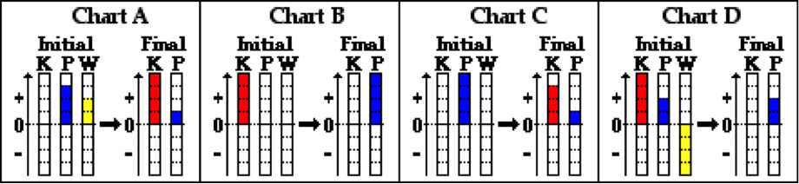

**Question 15:**

aa. Consider the work energy bar charts shown below. Type the letter of any bar chart that portrays a situation in which mechanical energy is NOT conserved. If there are no such situations, then enter "Z" as your answer.

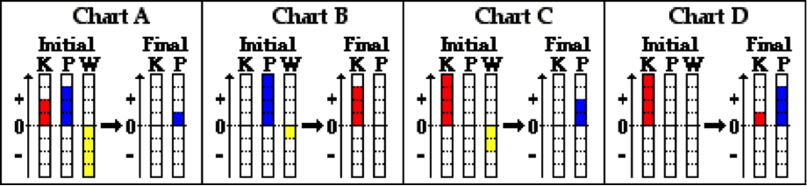

**Question 16:**

aa. Consider the work energy bar charts shown below. Type the letter of any bar chart that portrays a situation in which mechanical energy is NOT conserved. If there are no such situations, then enter "Z" as your answer.

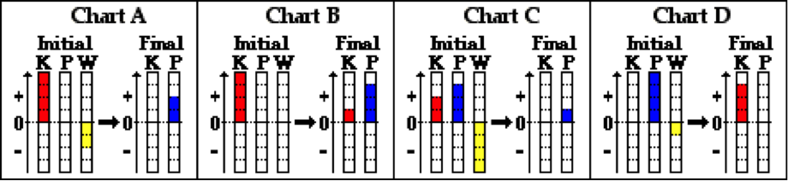

**Question 17:**

aa. Consider the three situations described below. In which situation(s) would the mechanical energy NOT be conserved? List all that apply in alphabetical order with no commas or spaces between letters. If energy is conserved in each of the three situations, then enter "Z" as your answer.

A: A softball player slides into third base across the infield dirt.

B: A roller coaster car descends the first drop of a roller coaster ride. Neglect frictional forces.

C: A force is applied to a cart to push it up an inclined plane.

**Question 18:**

aa. Consider the three situations described below. In which situation(s) would the mechanical energy NOT be conserved? List all that apply in alphabetical order with no commas or spaces between letters. If energy is conserved in each of the three situations, then enter "Z" as your answer.

A: A car skids to a stop across a level highway.

B: A projectile rises upward toward the peak of its trajectory. Neglect frictional forces.

C: A mountain climber slowly but steadily ascends a steep cliff.

**Question 19:**

aa. Consider the three situations described below. In which situation(s) would the mechanical energy NOT be conserved? List all that apply in alphabetical order with no commas or spaces between letters. If energy is conserved in each of the three situations, then enter "Z" as your answer.

A: A projectile rises upward toward the peak of its trajectory. Neglect frictional forces.

B: A softball player slides into third base across the infield dirt.

C: A force is applied to a cart to push it up an inclined plane.

**Question 20:**

aa. Consider the three situations described below. In which situation(s) would the mechanical energy NOT be conserved? List all that apply in alphabetical order with no commas or spaces between letters. If energy is conserved in each of the three situations, then enter "Z" as your answer.

A: A roller coaster car descends the first drop of a roller coaster ride. Neglect frictional forces.

B: A mountain climber slowly but steadily ascends a steep cliff.

C: A car skids to a stop across a level highway.

**Question 21:**

aa. A roller coaster car is nearing the end of the track and approaching the loading dock. It possesses 300 000 Joules of kinetic energy and 50 000 Joules of potential energy. A resistive force of 10 000 Newton is applied to the car over a distance of 25 meters along a level section of the track. The new kinetic energy of the roller coaster car is ____ Joules.

a. 0 b. 50 000 c. 100 000 d. 150 000

e. 250 000 f. 300 000 g. 350 000 h. 600 000

i. None of these answers are correct.

**Question 22:**

aa. A roller coaster car is nearing the end of the track and approaching the loading dock. It possesses 350 000 Joules of kinetic energy and 80 000 Joules of potential energy. A resistive force of 16 000 Newton is applied to the car over a distance of 20 meters along a level section of the track. The new kinetic energy of the roller coaster car is ____ Joules.

a. 0 b. 30 000 c. 50 000 d. 110 000

e. 270 000 f. 320 000 g. 670 000 h. 750 000

i. None of these answers are correct.

**Question 23:**

aa. A roller coaster car is nearing the end of the track and approaching the loading dock. It possesses 400 000 Joules of kinetic energy and 40 000 Joules of potential energy. A resistive force of 16 000 Newton is applied to the car over a distance of 20 meters along a level section of the track. The new kinetic energy of the roller coaster car is ____ Joules.

a. 0 b. 40 000 c. 80 000

d. 120 000 e. 320 000 f. 440 000

g. 680 000 h. 720 000 i. 760 000

j. None of these answers are correct.

**Question 24:**

aa. A roller coaster car is nearing the end of the track and approaching the loading dock. It possesses 280 000 Joules of kinetic energy and 70 000 Joules of potential energy. A resistive force of 20 000 Newton is applied to the car over a distance of 12 meters along a level section of the track. The new kinetic energy of the roller coaster car is ____ Joules.

a. 0 b. 30 000 c. 40 000 d. 110 000

e. 240 000 f. 350 000 g. 520 000 h. 590 000

i. None of these answers are correct.

**Question 25:**

aa. A 20-Newton force is applied parallel to an inclined plane in order to move a 3-kg cart a distance of 1.2 meters along the inclined plane to the top at a constant speed. The potential energy of the cart at the top of the incline is approximately ____ Joules.

a. 3.0 b. 3.6 c. 8.0 d. 24

e. 30 f. 36 g. 72 h. 240

i. None of these answers are even close.

**Question 26:**

aa. A 18-Newton force is applied parallel to an inclined plane in order to move a 2.8-kg cart from ground level a distance of 1.2 meters along the inclined plane to the top at a constant speed. The potential energy of the cart at the top of the incline is approximately ____ Joules.

a. 2.80 b. 3.36 c. 7.71 d. 21.6

e. 28.0 f. 33.6 g. 60.5 h. 216

i. None of these answers are even close.

**Question 27:**

aa. A 20.0-Newton force is applied parallel to an inclined plane in order to move a 3.3-kg cart from ground level a distance of 1.1 meters along the inclined plane to the top at a constant speed. The potential energy of the cart at the top of the incline is approximately ____ Joules.

a. 3.3 b. 3.6 c. 6.7 d. 22.0

e. 33.0 f. 36.3 g. 72.6 h. 220

i. None of these answers are even close.

**Question 28:**

aa. A 16.0-Newton force is applied parallel to an inclined plane in order to move a 2.8-kg cart from ground level a distance of 1.4 meters along the inclined plane to the top at a constant speed. The potential energy of the cart at the top of the incline is approximately ____ Joules.

a. 2.8 b. 3.9 c. 8.0 d. 22.4

e. 28.0 f. 39.2 g. 62.7 h. 224

i. None of these answers are even close.

**Question 29:**

aa. A boy in a wagon is moving along a level sidewalk. Together, the boy and the wagon have 20 Joules of kinetic energy. The boy's older brother applies a 25-Newton horizontal force for a distance of 2 meters. The kinetic energy of the boy and the wagon is now ____ Joules.

a. 30 b. 40 c. 45 d. 50

e. 60 f. 65 g. 70

h. None of these answers are correct.

**Question 30:**

aa. A boy in a wagon is moving along a level sidewalk. Together, the boy and the wagon have 25 Joules of kinetic energy. The boy's older brother applies a 20-Newton horizontal force for a distance of 2 meters. The kinetic energy of the boy and the wagon is now ____ Joules.

a. 15 b. 40 c. 45 d. 50

e. 65 f. 70 g. 75

h. None of these answers are correct.

**Question 31:**

aa. A boy in a wagon is moving along a level sidewalk. Together, the boy and the wagon have 30 Joules of kinetic energy. The boy's older brother applies a 20-Newton horizontal force for a distance of 2 meters. The kinetic energy of the boy and the wagon is now ____ Joules.

a. 10 b. 40 c. 50 d. 60

e. 70 f. 80 g. 90

h. None of these answers are correct.

**Question 32:**

aa. A boy in a wagon is moving along a level sidewalk. Together, the boy and the wagon have 20 Joules of kinetic energy. The boy's older brother applies a 15-Newton horizontal force for a distance of 3 meters. The kinetic energy of the boy and the wagon is now ____ Joules.

a. 25 b. 35 c. 45 d. 60

e. 65 f. 75 g. 80

h. None of these answers are correct.

**Question 33:**

aa. A 1000-kg car moving with a speed of 20 m/s is approaching a stoplight. The light turns yellow and the car makes an abrupt stop over a distance of 24 meters. The amount of mechanical energy that is converted to heat and other non-mechanical forms is approximately ____ Joules.

a. 40 000 b. 80 000 c. 200 000

d. 400 000 e. 800 000

f. None of these are even close.

**Question 34:**

aa. A 1200-kg car moving with a speed of 22 m/s is approaching a stoplight. The light turns yellow and the car makes an abrupt stop over a distance of 24 meters. The amount of mechanical energy that is converted to heat and other non-mechanical forms is approximately ____ Joules.

a. 28 800 b. 63 360 c. 288 000

d. 290 400 e. 633 6000

f. None of these are even close.

**Question 35:**

aa. A 1000-kg car moving with a speed of 24 m/s is approaching a stoplight. The light turns yellow and the car makes an abrupt stop over a distance of 28 meters. The amount of mechanical energy that is converted to heat and other non-mechanical forms is approximately ____ Joules.

a. 28 000 b. 67 200 c. 280 000

d. 288 000 e. 672 000

f. None of these are even close.

**Question 36:**

aa. A 1400-kg car moving with a speed of 32 m/s is approaching a stoplight. The light turns yellow and the car makes an abrupt stop over a distance of 60 meters. The amount of mechanical energy that is converted to heat and other non-mechanical forms is approximately ____ Joules.

a. 84 000 b. 268 800 c. 716 800

d. 840 000 e. 2 688 000

f. None of these are even close.

**WE10: Work and Energy Conversions – Math Analysis**

**Question 1:**

aa. An 800-kg car moving with a speed of 32 m/s (at A) skids to a stop (at B). Use g = 10 m/s/s to perform an energy analysis and fill in all the blanks. (Enter a negative number if an answer is negative.)

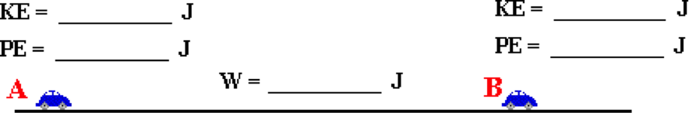

**Question 2:**

aa. A 1200-kg car moving with a speed of 24 m/s (at A) skids to a stop (at B). Use g = 10 m/s/s to perform an energy analysis and fill in all the blanks. (Enter a negative number if an answer is negative.)



**Question 3:**

aa. A 60-kg parachutist falls with a constant velocity of 8 m/s from a height of 2000 meters (A) to a height of 500 meters (B). Use g = 10 m/s/s to perform an energy analysis and fill in all the blanks. (Enter a negative number if an answer is negative.)

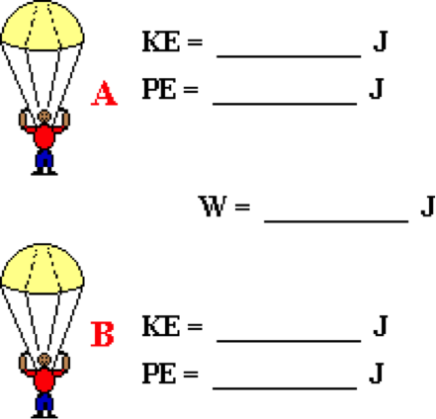

**Question 4:**

aa. A 50-kg parachutist falls with a constant velocity of 6 m/s from a height of 3000 meters (A) to a height of 500 meters (B). Use g = 10 m/s/s to perform an energy analysis and fill in all the blanks. (Enter a negative number if an answer is negative.)



**Question 5:**

aa. A 50-kg skier starts from rest at the top of a 60-meter high practice slope (A). She uses her poles to propel her forward, doing 12 000 Joules of positive work until she gets to the bottom of the hill (B). Use g = 10 m/s/s to perform an energy analysis and fill in all the blanks. (Enter a negative number if an answer is negative.) Ignore frictional forces.

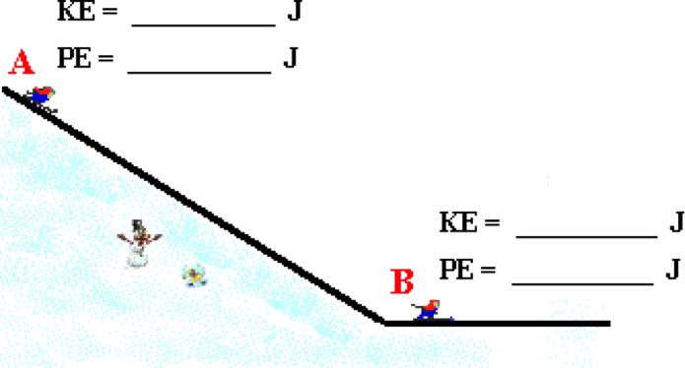

**Question 6:**

aa. A 40-kg skier starts from rest at the top of a 80-meter high practice slope (A). She uses her poles to propel her forward, doing 18 000 Joules of positive work until she gets to the bottom of the hill (B). Use g = 10 m/s/s to perform an energy analysis and fill in all the blanks. (Enter a negative number if an answer is negative.) Ignore frictional forces.



**Question 7:**

aa. A 40-kg skier uses a toe rope to ascend to the top of a practice hill. She grabs the rope while moving with a speed of 2 m/s at the bottom of the hill (A). The rope pulls her at a constant speed to the top of the 50-meter high hill (B). Use g = 10 m/s/s to perform an energy analysis and fill in all the blanks. (Enter a negative number if an answer is negative.) Ignore frictional forces.

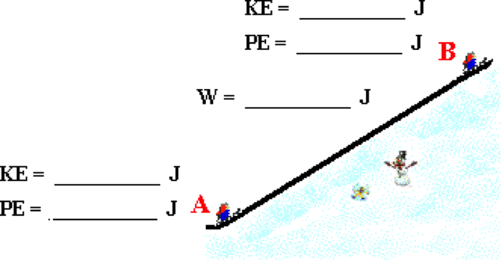

**Question 8:**

aa. A 70-kg skier uses a toe rope to ascend to the top of a practice hill. He grabs the rope while moving with a speed of 3 m/s at the bottom of the hill (A). The rope pulls him at a constant speed to the top of the 80-meter high hill (B). Use g = 10 m/s/s to perform an energy analysis and fill in all the blanks. (Enter a negative number if an answer is negative.) Ignore frictional forces.



**Question 9:**

aa. A 500-kg roller coaster car starts at rest from a height of 45 meters (A). At B, it is moving with a speed of 20 m/s and is elevated to a height of 10 meters. Use g = 10 m/s/s to perform an energy analysis and fill in all the blanks. (Enter a negative number if an answer is negative.)

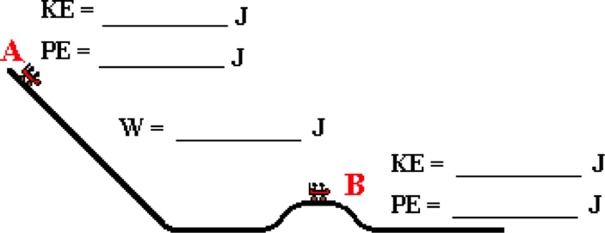

**Question 10:**

aa. A 400-kg roller coaster car starts at rest from a height of 40 meters (A). At B, it is moving with a speed of 18 m/s and is elevated to a height of 10 meters. Use g = 10 m/s/s to perform an energy analysis and fill in all the blanks. (Enter a negative number if an answer is negative.)



**Question 11:**

aa. An 800-kg car moving with a speed of 28 m/s (at A) puts on the brakes and slows down to a speed of 14 m/s (at B). Use g = 10 m/s/s to perform an energy analysis and fill in all the blanks. (Enter a negative number if an answer is negative.)



**Question 12:**

aa. A 900-kg car moving with a speed of 32 m/s (at A) puts on the brakes and slows down to a speed of 16 m/s (at B). Use g = 10 m/s/s to perform an energy analysis and fill in all the blanks. (Enter a negative number if an answer is negative.)



**Question 13:**

aa. In an amusement park ride, a 400-kg suspended car starts from rest at ground level (A) and is accelerated across a level section of track and then ascends a steep hill to a peak height of 40 meters (B) before coasting back towards its original position. Use g = 10 m/s/s to perform an energy analysis and fill in all the blanks. (Enter a negative number if an answer is negative.)

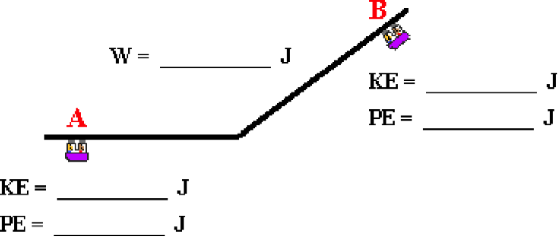

**Question 14:**

aa. In an amusement park ride, a 300-kg suspended car starts from rest at ground level (A) and is accelerated across a level section of track and then ascends a steep hill to a peak height of 50 meters (B) before coasting back towards its original position. Use g = 10 m/s/s to perform an energy analysis and fill in all the blanks. (Enter a negative number if an answer is negative.)



**Question 15:**

aa. A 75-kg skier starts from rest at the top of a 60-meter high practice slope (A). He uses his poles to propel himself forward, doing 10000 Joules of positive work from the top of the hill to the halfway point on the hill (B). Use g = 10 m/s/s to perform an energy analysis and fill in all the blanks. (Enter a negative number if an answer is negative.) Ignore frictional forces.

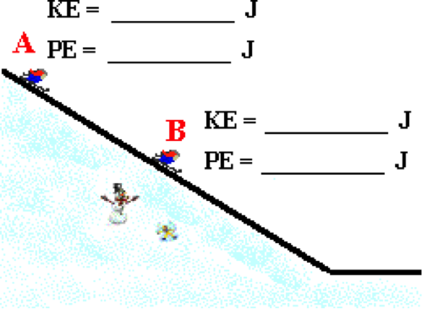

**Question 16:**

aa. A 60-kg skier starts from rest at the top of a 80-meter high practice slope (A). He uses his poles to propel himself forward, doing 12000 Joules of positive work from the top of the hill to the halfway point on the hill (B). Use g = 10 m/s/s to perform an energy analysis and fill in all the blanks. (Enter a negative number if an answer is negative.) Ignore frictional forces.

