**1D Kinematics**

**Question 1:**

aa. To ticket a driver, a police officer must measure the driver's ____.

a. instantaneous speed b. average speed

**Question 2:**

aa. Consider the graphs below.

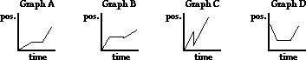

Enter the letter of the position-time graph that depicts an object moving slow, being stopped, and then moving fast.

a. Graph A b. Graph B c. Graph C d. Graph D

**Question 3:**

aa. On a position-time graph, the magnitude of the slope is representative of an object's _____.

a. rate b. speed c. direction d. acceleration

**Question 4:**

aa. Identify all the vector quantities from the following list. Select all that apply.

a. 2 mi b. 100 mi, north c. East

d. 9.8 m/s/s, down e. 61 mi/hr, west

**Question 5:**

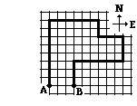aa. The diagram at the right depicts the path of a person. Each small square is 1 km along each edge. This person has a displacement of ____ km.

a. 0 km b. 3 km c. 3 km, E

d. 3 km, W e. 5 km ab. 5 km, N

ac. 5 km, S ad. 6 km ae. 6 km, E

bc. 6 km, W bd. 31 km be. 31 km, E

cd. 31 km, W ce. None of these.

**Question 6:**

aa. Mr. H’s (imaginary) Porsche accelerates from 0 to 60 mi/hr in 4 seconds. Its acceleration is _____.

a. 60 mi/hr b. 15 m/s/s c. 15 mi/hr/s d. -15 mi/hr/s

e. none of these

**Question 7:**

aa. A car slows down from +32 m/s to +8 m/s in 4 s. The average acceleration is ______ m/s/s.

a. 24 b. -24 c. 96 d. -96

e. 6 ab. -6 ac. 64 ad. -64

**Question 8:**

aa. An object with an acceleration of 10 m/s2 will ____.

a. move 10 m in 1 second b. have a velocity of 10 m/s after 1 s

c. have a velocity of 100 m/s after 10 s d. change its velocity by 10 m/s in 1 s

**Question 9:**

aa. The slope of the line on a velocity-time graph represents the _____.

a. the speed b. the direction

c. how fast one moves d. the acceleration

**Question 10:**

aa. If an object has zero acceleration, then it MUST _____.

a. be at rest b. be moving

c. be changing its velocity d. have a constant velocity

**Question 11:**

aa. An object is accelerating if it is moving _____. Select all that apply.

a. with changing speed b. extremely fast

c. with constant velocity d. in a circle

e. downward

**Question 12:**

aa. Of the following, identify all that are acceleration units. Select all that apply.

a. m/s b. (m/s)/hr c. m/s2

d. (mi/hr)/s e. (m/s)/mi

**Question 13:**

aa. A car is moving eastward and increasing its speed from 25 mph to 45 mph. The velocity direction is _____ and the acceleration direction is _____.

a. west, west b. east, west c. west, east d. east, east

**Question 14:**

aa. A downward falling parachutist pulls the chord and rapidly slows down. The velocity direction is _____ and the acceleration direction is _____.

a. up, up b. down, down c. up, down d. down, up

**Question 15:**

aa. **True**  or **False**:

The average velocity of an object is calculated by the displacement/time ratio.

a. True b. False

**Question 16:**

aa. **True**  or **False**:

Someone who claims they had an average velocity of 25 mph on a round trip is upsetting the *gods of physics*.

a. True b. False

**Question 17:**

aa. **True**  or **False**:

A person can walk a distance of 12 km and have a displacement of 20 km

a. True b. False

**Question 18:**

aa. **True**  or **False**:

A person can walk a distance of 20 km and have a displacement of 12 km.

a. True b. False

**Question 19:**

aa. **True**  or **False**:

The displacement of an object depends on the path taken from its initial point to its final point.

a. True b. False

**Question 20:**

aa. **True**  or **False**:

It is possible for the speedometer reading of a car to be constant when it is accelerating.

a. True b. False

**Question 21:**

aa. **True**  or **False**:

A person running a race on an oval track could have an average velocity of zero mph.

a. True b. False

**Question 22:**

aa. **True**  or **False**:

The average velocity of an object depends on the path taken from its initial point to its final point.

a. True b. False

**Question 23:**

aa. **True** or **False**:

The speed of an object at any instant and the velocity of an object at the same instant will always have the same value; it's just that the velocity has a direction as well.

a. True b. False

**Question 24:**

aa. **True**  or **False**:

In unit analysis, meters/second divided by seconds is meters.

a. True b. False

**Question 25:**

aa. **True**  or **False**:

The only way to accelerate is to increase speed.

a. True b. False

**Question 26:**

aa. **True**  or **False**:

If an object 's velocity is eastward and the acceleration is westward, then the object is moving backwards.

a. True b. False

**Question 27:**

aa. **True**  or **False**:

Acceleration can have a negative value due to it being a vector instead of a scalar.

a. True b. False

**Question 28:**

aa. **True**  or **False**:

An object can have a changing velocity and a constant acceleration.

a. True b. False

**Question 29:**

aa. **True**  or **False**:

An object can have a changing acceleration and a constant velocity.

a. True b. False

**Question 30:**

aa. **True**  or **False**:

Free fall means to fall downwards in the absence of any applied forces.

a. True b. False

**Question 31:**

aa. **True**  or **False**:

An object that is thrown upward would not be in a free fall state immediately after release.

a. True b. False

**Question 32:**

aa. **True**  or **False**:

A skydiver falling at a high terminal speed is in free-fall (provided that the parachute has not yet been opened).

a. True b. False

**Question 33:**

aa. A constant acceleration means that the ____.

a. velocity is zero

b. acceleration is zero

c. the velocity is changing

d. velocity is changing by the same amount each second

**Question 34:**

aa. A stone is dropped from rest into a 45-meter deep well. It hits the water after approximately 3.0 seconds. The rock's acceleration has a magnitude of approximately ____ m/s/s.

a. 5.0 b. 10.0  c. 15.0 d. none of these

**Question 35:**

aa. A car starts from rest and accelerates uniformly for a distance of 160 m over an 8.0-second time interval. The car's acceleration is ____.

a. 0.05 m/s b. 0.05 m/s/s c. 5 m/s/s d. 20 m/s e. 20 m/s/s

**Question 36:**

aa. An object that has a uniform acceleration MUST be ____. Select all that apply.

a. at rest b. moving

c. changing velocity d. changing velocity at a constant rate

**Question 37:**

aa. Consider the table below. Which of the following data sets depict a constant acceleration? Select all that apply.

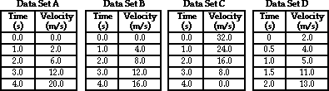

**Question 38:**

aa. Consider the table below. Which of the following data sets depict an accelerating object? Select all that apply.



**Question 39:**

aa. Heavier objects **free-fall** faster than lighter objects because of ____.

a. their greater mass b. their greater air resistance

c. their greater weight d. Nonsense! Lighter objects free-fall faster.

e. Nonsense! All objects free fall at the same rate.

**Question 40:**

aa. A football player is at the 50-yard line when the timer is started. He is at the 40-yard line after 1 second, the 30-yard line after 2 seconds, the 20-yard line after 3 seconds and the 10-yard line after 4 seconds. His acceleration is ___.

a. negative b. zero

c. a constant non-zero value d. changing

**Question 41:**

aa. A car's velocity after each consecutive second of motion is 2 m/s, 4 m/s, 6 m/s, and 8 m/s. This is evidence that the car is ____.

a. moving with a constant velocity

b. moving with a constant speed

c. moving with a constant acceleration

**Question 42:**

aa. A car is moving eastward along Lake Avenue and decreasing its speed from 35 mph to 25 mph. The direction of this car's acceleration is ____.

a. eastward b. westward c. neither; there is no acceleration

d. ... nonsense! Acceleration does not have a direction associated with it.

**Question 43:**

aa. A car with a leftward velocity and a rightward acceleration is ____.

a. moving to the right and speeding up

b. moving to the right and slowing down

c. moving to the left and speeding up

d. moving to the left and slowing down

**Question 44:**

aa. A car with a leftward velocity and a leftward acceleration is ____.

a. moving to the left and slowing down

b. moving to the right and speeding up

c. moving to the right and slowing down

d. moving to the left and speeding up

**Question 45:**

aa. Consider the dot diagrams (a.k.a., particle model diagrams) below. Which one of the diagrams provides the best representation of the motion of a free falling object?

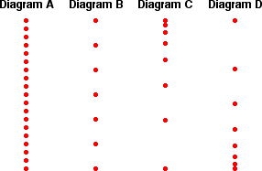

**Questions 46-49:**

Consider the four lines on the position-time graph below.

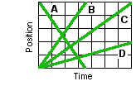

Match each line with one of the following descriptions of a chicken crossing a road. The east side of the road is the origin location. The west side of the road is 5-meters away.

aa. Which line represents the chicken casually crossing the road to simply get to the west side?

a. Line A b. Line B c. Line C d. Line D

aa. Which line represents the chicken that hurriedly crossed the road to get away from the fox?

a. Line A b. Line B c. Line C d. Line D

aa. Which line represents the chicken who had just crossed the road but now has met a fox and is running back to the original east side?

a. Line A b. Line B c. Line C d. Line D

aa. Which line represents the chicken that tried to cross the road but because it was too slow got run over by an 18-wheeler before making it across?

a. Line A b. Line B c. Line C d. Line D

**Question 50:**

aa. If an object is moving upward and slowing down while under the sole influence of gravity, then its acceleration is directed ____.

a. upwards b. downwards c. ... impossible to tell

**Question 51:**

aa. If the rate of continental drift were to abruptly slow from 1.0 cm/yr to 0.5 cm/yr over the time interval of a year, what would be the average acceleration?

a. -1.5 cm/yr b. 1.5 cm/yr     c. -2.0 cm/yr/yr d. -0.75 cm/yr/yr

e. 0.75 cm/yr ab. -0.5 cm/yr/yr ac. -0.5 cm/yr ad. 2.0 cm/yr/yr

**Question 52:**

aa. In an effort to get to school on time, Jodi walks at a constant pace of 6 ft/s for 60 seconds. She then recognizes that she has plenty of time to reach the school. She then walks at half the pace for the next 60 seconds. Which position-time graph below is an accurate representation of Jodi's motion?

|  |  |
| --- | --- |
| **Graph A** | **Graph B** |
| **Graph C** | **Graph D** |

**Question 53:**

aa. Match the dot diagram below to the appropriate letter for a velocity-time graph. It is known that the object is moving toward the right. (The rightward direction is the positive displacement direction.)

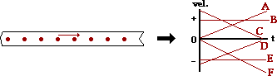

**Question 54:**

aa. Match the dot diagram below to the appropriate letter for a velocity-time graph. It is known that the object is moving toward the left. (The rightward direction is the positive displacement direction.)

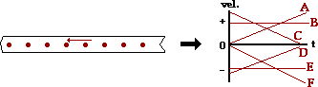

**Question 55:**

aa. Match the dot diagram below to the appropriate letter for a velocity-time graph. It is known that the object is moving toward the right. (The rightward direction is the positive displacement direction.)

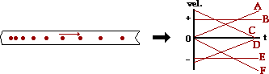

**Question 56:**

aa. Match the dot diagram below to the appropriate letter for a velocity-time graph. It is known that the object is moving toward the left. (The rightward direction is the positive displacement direction.)

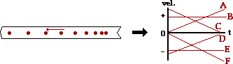

**Question 57:**

aa. Match the dot diagram below to the appropriate letter for a velocity-time graph. It is known that the object is moving toward the right. (The rightward direction is the positive displacement direction.)

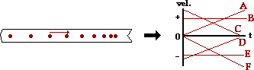

**Question 58:**

aa. Match the dot diagram below to the appropriate letter for a velocity-time graph. It is known that the object is moving toward the left. (The rightward direction is the positive displacement direction.)

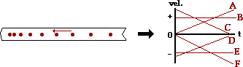

**Question 59:**

aa. Objects that are accelerating are known for certain to be _____.

a. turning . moving fast c. speeding up

d. slowing down e. changing their velocity

**Question 60:**

aa. A car that is moving at a constant velocity of 20 m/s, east for 10 seconds has an acceleration of ____ m/s/s.

a. 0 b. 2 c. 20 d. 200

e. none of these

**Question 61:**

aa. A free-falling object is an object ____. Select the most complete answer.

a. that is falling

b. upon which gravity is the only force

c. that is floating through the air like a feather

d. upon which the force of air resistance is equal to the force of gravity

**Question 62:**

aa. Which of the following statements are true of all free-falling objects? Select all that apply.

a. The acceleration of the object is 0 m/s/s.

b. The velocity of the object is a constant value.

c. Gravity is the only force acting upon the object.

d. The acceleration value is increasing as it falls through the air.

e. The mass of the object does not affect the rate at which it free-falls.

**Question 63:**

aa. A ball is thrown into the air. The ball rises upward, reaches a peak and falls back downward before being caught at the same height from which it is thrown. Its motion can be approximated as a free falling motion. Which of the following graphs best represents the motion of the ball?

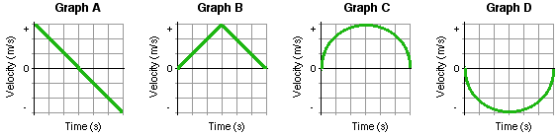

a. Graph A b. Graph B c. Graph C d. Graph D

**Question 64:**

aa. Suppose that a ball is thrown straight upward and that air resistance has no appreciable effect upon its motion. As the ball rises towards its peak, its velocity vector is directed ____ and its acceleration vector is directed ____. Which two words fill in these two blanks in their respective order?

a. upward, upward b. upward, downward

c. downward, upward d. downward, downward

**Question 65:**

aa. Suppose that a ball is thrown straight upward and that air resistance has no appreciable effect upon its motion. As the ball falls from its peak back to the ground, its velocity vector is directed ____ and its acceleration vector is directed ____. Which two words fill in these two blanks in their respective order?

a. upward, upward b. upward, downward

c. downward, upward d. downward, downward

**Question 66:**

aa. Suppose that a ball is thrown straight upward and that air resistance has no appreciable effect upon its motion. At the instant in time that the ball is at the peak of its trajectory, the _____.

a. velocity is 0.0 m/s and the acceleration is 0.0 m/s/s.

b. velocity is approximately 10 m/s and the acceleration is 0.0 m/s/s.

c. velocity is 0.0 m/s and the acceleration is approximately 10 m/s/s.

d. velocity is 0.0 m/s and the acceleration value cannot be predicted.

e. velocity cannot be predicted and the acceleration is approximately 10 m/s/s.

ab. velocity is approximately 10 m/s and the acceleration is approximately 10 m/s/s.

ac. velocity is approximately 10 m/s and the acceleration value cannot be predicted.

ad. velocity cannot be predicted and the acceleration is 0.0 m/s/s.

**Long Answers:**

**Question 67:**

aa. Observe the diagram at the right. A person starts at location A, walks along the bold path and finishes at location B. Each square is 1 km along its edge. This person walks a distance of ____ km.

**Questions 68-69:**

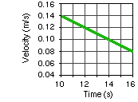The graph at the right depicts the motion of a windup toy car. A coordinate system is used in which the eastward direction is the positive direction. Use the graph to answer the following questions.

aa. Which of the following is true of the toy car's motion? Choose all that apply.

a. The toy car is moving westward.

b. The toy car is slowing down.

c. The toy car is moving eastward.

d. The toy car is speeding up.

e. The toy car has a negative velocity.

f. The toy car is moving with a constant speed.

aa. What is the magnitude and direction of the toy car's acceleration?

**Question 70:**

Consider the position-time graph at the right. Determine the velocity (in m/s) of the object whose motion is represented by the graph. (Use a + or - sign to indicate a direction.)

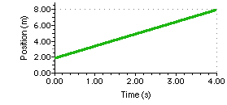

**Questions 71-73:**

Bo Lingrate gives a bowling ball a soft push and scores a strike during the fifth frame in the Wednesday night bowling league. The position-time graph below represents the motion of the bowling ball rolling southward towards the pin. Use the graph to answer the next several questions.

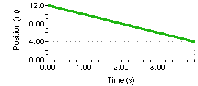

aa. The position of the ball with respect to time is given by the following equation:

d = v • t + di

where v = ________________ m/s and di = ________________ m

aa. Use your equation above to determine the position of the bowling ball at 1.7 seconds.

aa. At what time will the bowling ball have traveled a distance of 6.1 meters from its starting point. Use your equation above.

**Questions 74-78:**

A fireworks rocket consists of two fuel stages that serve to provide two consecutive accelerations of the rocket. Starting from rest at a height of 0 m and a time of 0 seconds, the rocket is ignited and the accelerations begin. The first acceleration stage lasts for 1.50 seconds and accelerates the fireworks to an upward velocity of 7.62 m/s. The second acceleration stage lasts for 3.00 seconds and accelerates the fireworks to an upward velocity of 13.72 m/s. The graph below depicts the motion. Use the graph to answer the following questions.

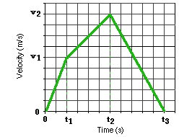

aa. Determine the acceleration of the rocket during the first fuel stage.

aa. Determine the acceleration of the fireworks during the second fuel stage (from t1 to t2).

aa. Determine the distance the rocket travels upward (i.e., height above the ground) during the first stage of motion.

aa. Determine the distance the rocket travels upward during the second stage of motion (from t1 to t2).

aa. Eventually, the rocket blows up (the fireworks). But before it does, it reaches its highest point, turns around and travels back downward. At what time does the rocket change directions and start to head back downward toward the ground?

a. At a time of t1 b. Between t1 and t2

c. At a time of t2 d. Between t2 and t3

e. At a time of t3

**Questions 79-83:**

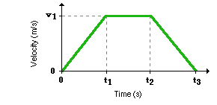A car starts from rest and accelerates at a rate of 6.38 m/s/s for a time (t1) of 6.36 seconds. The car then maintains a constant speed for a time of 7.20 seconds (t2 minus t1). Finally, the car slows down at a rate of -4.49 m/s/s. The motion of the car is represented by the velocity vs. time graph at the right. Use the graph to answer the following questions.

aa. Determine the velocity achieved by the car at 6.36 seconds.

aa. Determine the distance traveled by the car during the first 6.36 seconds.

aa. Determine the acceleration of the car during the constant speed motion from 6.36 seconds to 13.56 seconds.

aa. Determine the distance traveled by the car during the 7.20 seconds of constant speed motion.

aa. Determine the total distance traveled by the car from its starting position to its stopping position.

**Questions 84-86:**

Hiram's second putt on the fourth hole of the Glenview Mini-Golf Classic was straighter than an arrow. The position-time graph at the right represents the motion of the golf ball as it rolls towards the pin. After 2.0 seconds, the ball lands in the hole.

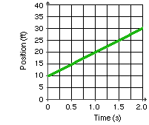

Use this graph to answer the next several questions.

aa. The position of the ball with respect to time is given by the following equation:

d = v • t + di

where v = ________________ ft/s and di = ________________ ft

aa. Use your equation from above to determine the position of the golf ball at 1.5 seconds.

aa. If the ball had missed the hole and continued in motion at the same speed, then at what time would it have had a position of 40.1 feet (relative to the origin)? Use your equation from above.

**Questions 87-92:**

Consider the velocity-time graph at the right for several different objects, each represented by a numbered line.

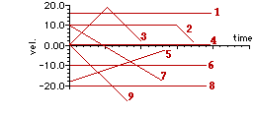

Use the graph to answer the next several questions. For each question, there may be more than one line which applies.

aa. Which object(s) is/are moving with a constant velocity during the entire motion?

aa. Which object(s) is/are speeding up during the entire motion?

aa. Which object(s) is/are slowing down during the entire motion?

aa. Which object(s) change(s) direction at anytime during the motion?

aa. Which object(s) is/are moving with a positive acceleration at any time during the motion?

aa. Which object(s) is/are moving with a negative acceleration at any time during the motion?

**Question 93:**

aa. Consider the velocity-time graph below.

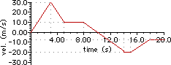

List all the times (in seconds) that the object made a direction change.

**Question 94:**

aa. The velocity-time graph below depicts an object that starts moving in one direction and turns around and moves in the other direction.

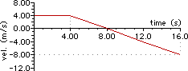

Determine the time (in seconds) at which the object reaches its initial position (i.e., starting point). (HINT: develop an equation for displacement based on the slope of the line and compute the unknown.)

**Question 95:**

aa. Consider the velocity-time graph below.

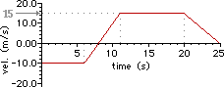

Identify all the acceleration values (in m/s/s) for the various sections of the graph.

t = 0-6 s:

t = 6-11 s:

t = 11-20 s:

t = 20-25 s:

**Question 96:**

aa. Consider the velocity-time graph below.



Determine the displacement (in m) of the object after 22.0 seconds.

**Question 97:**

aa. Consider the velocity-time graph below.

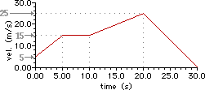

Determine the displacement (in m) of the object after 27 seconds.

**Question 98:**

aa. Consider the velocity-time graph for Car A (red line) and Car B (blue line).

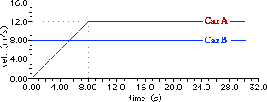

At what time (in seconds) is Car A ahead of Car B by a distance of 60 meters?

**Question 99:**

aa. Consider the velocity-time graph below.

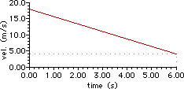

Determine the acceleration (in m/s/s) of the object whose motion is represented by the graph.

**Question 100:**

aa. Consider the velocity-time graph below.

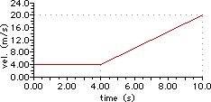

Determine the acceleration (in m/s/s) of the object at 8 seconds.

**Question 101:**

aa. Consider the velocity-time graph below.

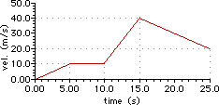

Determine the acceleration values (in m/s/s) of the object at 2.4 seconds, at 13.1 seconds, and at 21.5 seconds.

t = 2.4 s:

t = 13.1 s:

t = 21.5 s:

**Question 102:**

aa. Consider the velocity-time graph below.

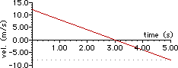

Determine the acceleration (in m/s/s) of the object at a time of 3.0 seconds.

**Question 103:**

aa. Consider the velocity-time graph below.

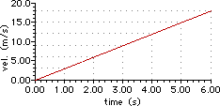

Determine the displacement (in m) of the object after a time of 5 seconds.

**Question 104:**

aa. Consider the velocity-time graph below.

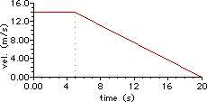

Determine the displacement (in m) of the object during the entire 20 seconds of motion.

**Question 105:**

aa. Consider the velocity-time graph below.

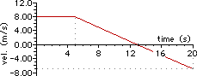

Determine the displacement (in m) of the object during the entire 20 seconds of motion.

**Question 106:**

aa. Consider the velocity-time graph below.

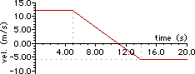

Determine the displacement (in m) of the object during the first 19 seconds of motion.

**Question 107:**

aa. Loretta is at Wendy's along Lake Avenue, 4000 feet from the school. At 4:00 PM, she walks onto Lake Avenue and walks east 400 ft/minute in an effort to get to volleyball practice on time. At 4 minutes after 4:00 PM, Helen leaves the library and walks out onto Lake Avenue. She walks east at 300.0 ft/minute towards her home. The entrance to her subdivision is 5000 feet from the school along Lake avenue. Loretta's motion is represented by the position-time graph below. Represent Helen's motion on the same graph and use it to answer the following questions.

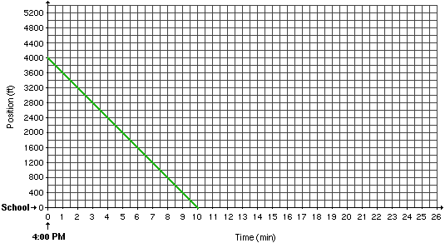

a. Convert Helen's walking pace to units of meter/second. Given: 1 meter = 3.28 feet.

b. At what time is Loretta halfway to school?

c. How far is Helen from school when Loretta is halfway to school?

d. At what time do Loretta and Helen pass by each other?

e. How far is Loretta from Wendy's when she passes by Helen?

f. How far is Helen from school when Loretta arrives at school?

g. At what time does Helen arrive at the entrance to her subdivision?

**Questions 108-118:**

It is passing period and Brendt and Tyler are talking with their respective friends in the hallway. Brendt is 56 meters down the hallway from his classroom door and Tyler is 64 meters down the hallway from his classroom door. With 50 seconds remaining in the passing period, Brendt *says his good bye* and hurries off to class. Brendt arrives just before the bell rings to start Period 5. A few seconds later, Tyler heads off to class.

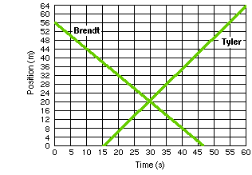

Use this information to answer the next several questions.

aa. For how much time has Tyler walked when Brendt is 44 meters from class?

Tyler has walked for _______________ s

aa. For how much time has Tyler walked when Brendt is 32 meters from class?

aa. For how much time has Tyler walked when Brendt has walked a distance of 24 meters from his starting location?

aa. At what time do Brendt and Tyler walk past each other?

aa. How far is Tyler from the classroom door at the moment he passes by Brendt.

aa. How far apart from each other are Tyler and Brendt when there are 30 seconds remaining in the passing period?

aa. How much further must Brendt walk to get to class when there are 15 seconds left in the passing period?

aa. How much further must Tyler walk to get to class when there are 15 seconds left in the passing period?

aa. When Tyler has walked a distance of 28 meters, how far is Brendt from the classroom door?

aa. When Brendt finally arrives at the classroom door, how much farther does Tyler have to walk to get to his classroom door?

aa. How many seconds late is Tyler to his period 5 class?

**Question 119:**

aa. The earliest drop towers were used for the purpose of making lead shots for muskets. The procedure involved releasing droplets of molten lead from the top of the tower. As the droplets of lead fell through the tower, they formed a spherical droplet. If given enough free fall time, the droplet of molten lead would solidify to form the perfect shot. The tallest of these drop towers in the United States was a 230-foot tower built in Baltimore.

Suppose that lead free falls through a drop tower for a distance of 63.9 meters

a. Determine how much time (in seconds) it takes the lead shot to fall this distance of 63.9 meters.

b. Determine how fast the lead shot is moving after free falling for 63.9 meters.

**Question 120:**

aa. The Deja Vu roller coaster is a popular attraction at three Six Flags parks. You can read about the coaster and view pictures of it at the Ultimate Roller Coaster web site.

<http://www.ultimaterollercoaster.com/coasters/new01/sf_dejavu/>

The coaster begins with a nearly 2.9-second free fall along a 90-degree drop.

a. Determine the speed (in m/s) of the riders after this 2.9 second period of free fall.

b. What distance do the riders free fall during this 2.9 seconds?