**Refraction and Lenses Questions**

**Question 1:**

aa. Angles of incidence, reflection and refraction are measured as the angle between the light ray and the _____.

a. surface or boundary which the ray strikes

b. normal line drawn to the surface or boundary which the ray strikes

**Question 2:**

aa. Which of the following rays of light is moving from a medium in which it moves relatively fast into a medium in which it moves slower? Select all that apply.

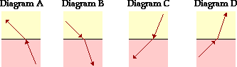

**Question 3:**

aa. Which of the following rays of light is moving from a medium with low **n** value into a medium with a high **n** value? Select all that apply.



**Question 4:**

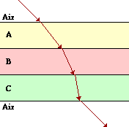aa. A ray of light moving through air enters and passes through a series of parallel layers of different materials as shown below. Based on the direction of refraction at each of the boundaries, one can rank the relative speed of light in each material. The proper ranking of speed from fastest to slowest is _____.

a. A > B > C

b. C > B > A

c. B > A > C

d. A > C > B

e. C > A > B

ab. None of these are correct.

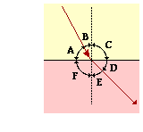**Question 5:**

aa. In the diagram at the right, a light ray is shown passing from medium 1 to medium 2. The angle of incidence for this ray is represented by angle ____.

a. A b. B c. B + C

d. B + C + D e. D ab. E

ac. E + F ad. E + F + G

**Questions 6-7:**

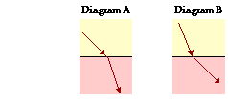aa. Suppose a beam of light is passing at an angle from a medium that is less dense into a medium which is more dense. For such a case, the angle of incidence is ____ the angle of refraction.

a. equal to

b. less than

c. greater than

d. ... nonsense! No such comparison can be made.

aa. This type of refraction is shown in diagram _____.

a. A b. B c. Both of these. d. None of these.

**Questions 8-9:**

aa. Suppose a beam of light is passing at an angle from a medium with a small **n** value into a medium with a large **n** value. For such a case, the angle of incidence is ____ the angle of refraction.

a. equal to

b. less than

c. greater than

d. ... nonsense! No such comparison can be made.

aa. This type of refraction is shown in diagram _____.

a. A b. B c. Both of these. d. None of these.

**Question 10:**

aa. Total internal reflection can most accurately be described as ____.

a. reflection of all the light at a surface

b. refraction of all the light at a surface

c. the reflection of a small portion of light striking a surface

d. transmission of light with a minimum amount of refraction

e. the dual combination of reflection and refraction off a surface

ab. transmission of light across a surface when incident at a right angle

**Question 11:**

aa. The critical angle for a water (n=1.33) - zircon (n=1.92) boundary is 39°. Which of the following diagrams depict incident rays that would undergo total internal reflection (TIR) at the angle shown? List all that apply.

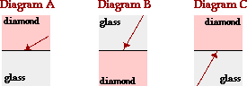

**Question 12:**

aa. When driving down an asphalt road on a sunny day, a mirage effect is often observed. Mirages occur because ______.

a. light refracts as is crosses the boundary between air and water

b. light from a distant car undergoes reflection off a water puddle in the road

c. light undergoes total internal reflection as it reaches a water puddle on the road

d. light refracts as it passes from the cool, more dense air into the hotter, less dense air

**Question 13:**

aa. The separation of white light into its component colors is known as _____.

a. dispersion b. a mirage effect c. refraction d. an optical fiber

e. diffraction ab. total internal reflection

**Questions 14-15:**

aa. When white light passes through a prism, it is separated into its component colors. The index of refraction for violet light is _____ that for red light.

a. less than b. greater than c. equal to

aa. (Continued from the previous question.) … This causes the violet light to bend ____ red light.

a. less than b. more than c. the same amount as

**Question 16:**

aa. When viewing a rainbow, suspended drops of water act as miniature prisms, dispersing light as it travels to our eye. Which one of the diagrams below best illustrates the manner in which white light is separated into red and violet (and all wavelengths in between) light?

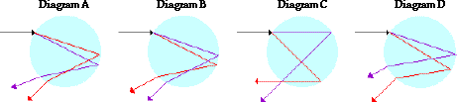

**Questions 17-20:**

aa. When viewing a rainbow in the sky, droplets high in the sky direct _____ to your eye …

a. red b. violet

aa. (Continued from the previous question.) … and droplets lower in the sky direct ____ to your eye.

a. red b. violet

aa. (Continued from the previous question.) … This is because the droplets high in the sky _____ ...

a. refract red light downwards at steep angles

b. refract violet light downwards at steep angles

c. only refract the longer wavelength red light

d. only refract the shorter wavelength violet light

aa. (Continued from the previous question.) … and droplets low in the sky _____.

a. only refract the longer wavelength red light

b. only refract the shorter wavelength violet light

c. refract red light downwards at a less steep angle

d. refract violet light downwards at a less steep angle

**Question 21:**

aa. Total internal reflection (TIR) does not always occur when light moving through one medium strikes a boundary with another medium. Two requirements must be met for TIR to occur. Which two statements below express these two requirements? Light must be _____. Select two.

a. ... incident at right angles to the boundary.

b. ... moving from the less dense towards the more dense medium.

c. ... moving from the more dense towards the less dense medium.

d. ... approaching at angles of incidence less than the critical angle.

e. ... approaching at angles of incidence greater than the critical angle.

**Question 22:**

aa. 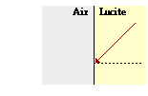A ray of light moving through lucite is approaching a lucite-air boundary. This ray of light will refract at the boundary. If the angle of incidence is increased, then the angle of refraction will be _____.

a. less than before

b. greater than before

c. no different than before

**Question 23:**

aa. 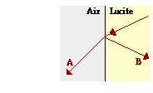A ray of light moving through lucite is approaching a lucite-air boundary. At the boundary a portion of the light will reflect and a portion will be transmitted into the air and refract. If the angle of incidence is increased, then the brightness of the reflected ray (B) will _____ and the brightness of the refracted ray (A) will _____.

a. increase, decrease

b. increase, increase

c. decrease, increase

d. decrease, decrease

e. ...nonsense! Light is not that predictable.

**Question 24:**

aa. The diagrams show incident rays approaching a boundary with a second medium. The relative index of refraction (n) of the two media is indicated. In which diagram(s) will total internal reflection occur (provided that the angle of incidence is sufficiently large)? Select the letters of all that apply.

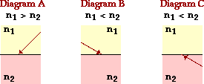

**Question 25:**

aa. The diagrams show incident rays approaching a boundary with a second medium. The relative speed of light (v) in the two media is indicated. In which diagram(s) will total internal reflection occur (provided that the angle of incidence is sufficiently large)? Select the letters of all that apply.

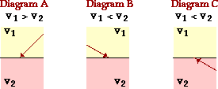

**Question 26:**

aa. The critical angle refers to _____.

a. an angle of incidence

b. an angle of reflection

c. an angle of refraction

d. any angle - whether incidence or refracted - that is 0 degrees

e. any angle - whether incidence or refracted - that is 90 degrees

**Question 27:**

aa. When light moving through water reaches the boundary with air at an angle of incidence equal to the critical angle, the light ray will ____. Select all that apply.

a. undergo total internal reflection

b. pass across the boundary without bending

c. reflect at an angle of reflection of 90 degrees

d. undergo partial reflection and partial refraction

e. reflect, but also refract at an angle of refraction of 90 degrees

**Question 28:**

aa. The critical angle for an air-water boundary is 48 degrees. Which of the following diagrams depict incident rays that would undergo total internal reflection (TIR) at the angle shown? List the letters of all that apply.

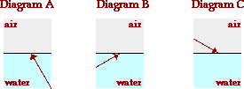

**Question 29:**

aa. An *object arrow* (in RED) is placed in front of a converging lens as shown in the diagram below.

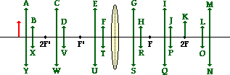

Which image (in GREEN) represents the approximate location, size and orientation for such an object position?

**Question 30:**

aa. An *object arrow* (in RED) is placed in front of a converging lens as shown in the diagram below.

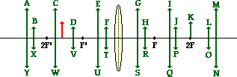

Which image (in GREEN) represents the approximate location, size and orientation for such an object position? (

**Question 31:**

aa. An *object arrow* (in RED) is placed in front of a converging lens as shown in the diagram below.

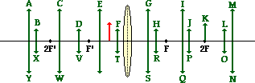

Which image (in GREEN) represents the approximate location, size and orientation for such an object position?

**Questions 32-35:**

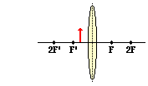Consider the lens shown at the right. An object is placed between the F' position on the left side of the lens and the lens surface.

aa. The image will be ____ in size.

a. magnified b. reduced

aa. The image will be ____.

a. inverted b. upright

aa. The image will be ____.

a. real b. virtual

aa. The image will be located ____.

a. between the focal point (F) and the lens

b. on the same side of the lens as the object

c. beyond the 2F point

d. between the focal point (F) and the 2F point

e. at the 2F point

**Questions 36-39:**

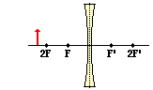Consider the lens shown at the right. An object is placed at a position beyond the 2F position (left of 2F).

aa. The image will be ____ in size.

a. magnified b. reduced

aa. The image will be ____.

a. inverted b. upright

aa. The image will be ____.

a. real b. virtual

aa. The image will be located ____.

a. between the focal point (F) and the lens

b. on the same side of the lens as the object

c. beyond the 2F point

d. between the focal point (F) and the 2F point

e. at the 2F point

**Questions 40-43:**

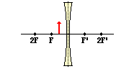Consider the lens shown at the right. An object is placed between the F position on the left side of the lens and the lens surface.

aa. The image will be ____ in size.

a. magnified b. reduced

c. neither magnified nor reduced

aa. The image will be ____.

a. inverted b. upright

aa. The image will be ____.

a. real b. virtual

aa. The image will be located ____.

a. between the focal point (F) and the lens

b. on the same side of the lens as the object

c. beyond the 2F point

d. between the focal point (F) and the 2F point

e. at the 2F point

**Question 44:**

aa. An *object arrow* (in RED) is placed in front of a diverging lens as shown in the diagram below.

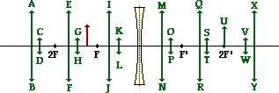

Which image (in GREEN) represents the approximate location, size and orientation for such an object position?

**Question 45:**

aa. The following diagrams are ray diagrams, showing how to locate the image (in GREEN) of an *arrow object* (in RED).

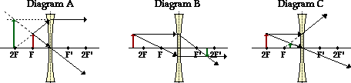

Which of these diagrams are correctly drawn? Select the letters of all that apply.

**Question 46:**

aa. Incident light traveling parallel to the principal axis of a converging or diverging lens will refract in a specific way. Which diagrams below show the proper refractive behavior of parallel rays of light? Select all that apply.

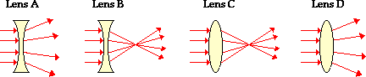

**Questions 47-52:**

Like spherical mirrors, the images formed by convex and concave lenses are consistent with mathematical equations known as the lens equation and magnification ratio. The quantities **f**, **do**, **di**, **M**, **hi**, and **ho** can be related by two simple equations. These quantities can have + or - signs associated with them. The conventions are as follows:

aa. For focal length, a positive focal length would be characteristic of a ____ lens …

a. converging b. diverging

aa. (Continued from the previous question.) … and a negative focal length would be characteristic of a ____ lens.

a. converging b. diverging

aa. For image heights, a positive image height would be characteristic of an_____

a. upright b. inverted

aa. (Continued from the previous question.) … and a negative image height would be characteristic of a ____ image.

a. upright b. inverted

aa. For image distance, a positive image distance is characteristic of image formed on the _____ side of the lens …

a. object's b. opposite

aa. (Continued from the previous question.) … and a negative image distance is characteristic of image formed on the ____ side of the lens.

a. object's b. opposite

**Question 53:**

aa. An image that is magnified in size (i.e., larger than the object itself) will have a magnification value _____.

a. that is positive b. that is negative

c. whose absolute value is less than 1.0 d. whose absolute value is greater than 1.0

**Questions 54-57:**

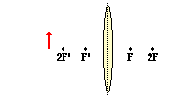Consider the lens shown at the right. An object is placed at a position beyond the 2F' position (left of 2F').

aa. The image will be ____ in size.

a. magnified b. reduced

c. neither magnified nor reduced

aa. The image will be ____.

a. inverted b. upright

aa. The image will be ____.

a. real b. virtual

aa. The image will be located ____.

a. between the focal point (F) and the lens

b. on the same side of the lens as the object

c. beyond the 2F point

d. between the focal point (F) and the 2F point

e. at the 2F point

**Questions 58-61:**

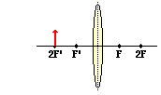Consider the lens shown at the right. An object is placed at the 2F' position on the left side of the lens.

aa. The image will be ____ in size.

a. magnified b. reduced

c. neither magnified nor reduced

aa. The image will be ____.

a. inverted b. upright

aa. The image will be ____.

a. real b. virtual

aa. The image will be located ____.

a. between the focal point (F) and the lens

b. on the same side of the lens as the object

c. beyond the 2F point

d. between the focal point (F) and the 2F point

e. at the 2F point

**Questions 62-65:**

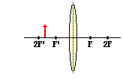Consider the lens shown at the right. An object is placed between the 2F' position and the F' position on the left side of the lens.

aa. The image will be ____ in size.

a. magnified b. reduced

c. neither magnified nor reduced

aa. The image will be ____.

a. inverted b. upright

aa. The image will be ____.

a. real b. virtual

aa. The image will be located ____.

a. between the focal point (F) and the lens

b. on the same side of the lens as the object

c. beyond the 2F point

d. between the focal point (F) and the 2F point

e. at the 2F point

**Questions 66-71:**

Complete the following sentences.

aa. A person who suffers from **myopia** or **nearsightedness** has difficulty viewing _____ objects.

a. nearby b. distant

aa. (Continued from the previous question.) … The images of such objects form at a location _____ the retina.

a. behind b. in front of

aa. (Continued from the previous question.) … On the retina itself, the image is blurry and unfocused. To correct for this type of blurred vision, a nearsighted individual should equip his eye with a _____ lens.

a. converging b. diverging

aa. A person who suffers from **hyperopia** or **farsightedness** has difficulty viewing _____ objects.

a. nearby b. distant

aa. (Continued from the previous question.) … The images of such objects form at a location _____ the retina.

a. behind b. in front of

aa. (Continued from the previous question.) … On the retina itself, the image is blurry and unfocused. To correct for this type of blurred vision, a farsighted individual should equip his eye with a _____ lens.

a. converging b. diverging

**Questions 72-75:**

Complete the following paragraph about refracting telescopes.

aa. There are two lenses in a Keplerian refracting telescope - the **objective lens** and the **eyepiece lens**. Light from the distant object (a star, for example) first passes through the _____ lens

a. objective b. eyepiece

aa. (Continued from the previous question.) … The image of the distant object is formed _____ of the objective lens and …

a. at the focal point b. at the 2F point

c. between the focal point and the surface

aa. (Continued from the previous question.) … and _____ of the eyepiece lens.

a. at the 2F point b. between the focal point and the surface

aa. (Continued from the previous question.) … The second lens then creates an image of this image that is ____ (relative size compared to primary image).

a. magnified b. reduced c. the same size

**Question 76:**

aa. In what way(s) are refracting telescopes and microscopes similar? Select all that apply.

a. They both use two lenses.

b. They are both used to view distant objects.

c. They both create an ultimate image that is inverted compared to the object.

d. They both create an image of the original object which is magnified (larger than the object).

**Question 77:**

aa. **TRUE** or **FALSE**:

Refraction is when a ray of light hits a boundary and bounces off it.

a. True b. False

**Question 78:**

aa. **TRUE** or **FALSE**:

The velocity of light always increases when going from one medium to another.

a. True b. False

**Question 79:**

aa. **TRUE** or **FALSE**:

For angles of incidence greater than crit in the most dense medium, the refracted light ray does not exist.

a. True b. False

**Question 80:**

aa. **TRUE** or **FALSE**:

The angle of reflection of a light ray undergoing total internal reflection is always greater than crit.

a. True b. False

**Question 81:**

aa. **TRUE** or **FALSE**:

A fiber optic bundle would not work correctly if it were submerged in water.

a. True b. False

**Question 82:**

aa. **TRUE** or **FALSE**:

When total internal reflection occurs, most (but not all) of the light reflects off the boundary instead of refracting into the new medium.

a. True b. False

**Question 83:**

aa. **TRUE** or **FALSE**:

Total internal reflection can occur when light slows down as it passes from one medium into another.

a. True b. False

**Question 84:**

aa. **TRUE** or **FALSE**:

The eye refracts incoming light so that it lands on the retina. Most of this refraction of light takes place as the light crosses the boundary from air into the cornea.

a. True b. False

**Question 85:**

aa. **TRUE** or **FALSE**:

The lens of the eye has a fixed focal length.

a. True b. False

**Question 86:**

aa. **TRUE** or **FALSE**:

In situations in which the refracted angles with a normal are less than the incident angles in the other medium, total internal reflection may occur.

a. True b. False

**Question 87:**

aa. **TRUE** or **FALSE**:

Total internal reflection is most likely to occur at large angles of incidence than small angles.

a. True b. False

**Question 88:**

aa. **TRUE** or **FALSE**:

The critical angle is calculated for the light ray when it is in the less optically dense medium and moving towards the more optically dense medium.

a. True b. False

**Question 89:**

aa. **TRUE** or **FALSE**:

All light rays that refract through a lens will converge at the focal point.

a. True b. False

**Question 90:**

aa. **TRUE** or **FALSE**:

A converging lens will always converge light which originates at the same point on the object.

a. True b. False

**Question 91:**

aa. **TRUE** or **FALSE**:

A diverging lens will always diverge light which originates at the same point on the object.

a. True b. False

**Question 92:**

aa. When light passes into a medium in which it travels faster, the light will refract ________ the normal. When light passes into a medium in which it travels slower, light will refract ________ the normal.

a. away from, towards b. towards, away from

**Question 93:**

aa. When light passes into a medium that is more optically dense, the light will refract ________ the normal. When light passes into a medium that is less optically dense, the light will refract ________ the normal.

a. away from, towards b. towards, away from

**Question 94:**

aa. When light passes into a medium in which it travels faster, the light will refract ________ the normal.

a. away from b. towards

**Question 95:**

aa. The critical angle is a(n) ______ angle.

a. incident b. refracted c. either refracted or incident

**Question 96:**

aa. Consider the diagram below. Presuming the angle were of sufficient measure, in which of the following could total internal reflection occur. (d = density; v = speed). Select all that apply.

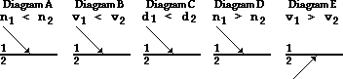

**Question 97:**

aa. If a lens has a positive focal length, then one can be sure that the lens is ____. Include all that apply.

a. large b. small c. converging d. diverging

**Question 98:**

aa. If a lens has a negative focal length, then one can be sure that the lens is ____. Choose all that apply.

a. large b. small c. converging d. diverging

**Calculations and Long Answer**

**Question 99:**

aa. Light is moving through air (n=1.00) and approaches a boundary with water (n=1.33) at an angle of incidence of 45°. Use Snell's Law to predict the measure (in degrees) of the angle of refraction.

**Question 100:**

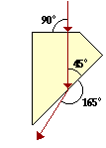aa. The diagram at the right shows the path of light as it passes from air into, through, and subsequently out of a transparent material. Use the diagram and Snell's law to determine the index of refraction of the material.

**Question 101:**

aa. 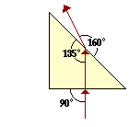The diagram at the right shows the path of light as it passes from air into, through, and subsequently out of a transparent material. Use the diagram and Snell's law to determine the index of refraction of the material.

**Question 102:**

aa. Calculate the critical angle (in degrees) for light approaching the boundary between the material zircon (n=1.92) and air (n=1.00).

**Question 103:**

aa. Calculate the critical angle (in degrees) for light approaching the boundary between the material zircon (n=1.92) and air (n=1.00).

**Question 104:**

aa. A 5.3-cm tall object is placed varying distances from a converging lens as shown in the table below. The lens has a focal length of 48.0 cm. For each object location, determine the corresponding image location, image height and magnification. Include a negative sign where appropriate.

|  |  |  |  |
| --- | --- | --- | --- |
| **Object**  **Distance (cm)** | **Image**  **Distance (cm)** | **Image**  **Height (cm)** | **Image**  **Magnification** |
| 144.0 |  |  |  |
| 96.0 |  |  |  |
| 72.0 |  |  |  |
| 24.0 |  |  |  |

**Question 105:**

aa. A converging lens has a focal length of 20.7 cm. Find the image distance (in cm) for an object distance of 34.3 cm.

**Question 106:**

aa. A thin lens has a focal length of 27.6 cm.

a. Determine the image distance (in cm) when the object distance is 29.4 cm. Enter a negative answer if it is negative.

b. Determine the image distance (in cm) when the object distance is 26.4 cm. Enter a az

**Question 107:**

aa. A thin lens has a focal length of -23.8 cm.

a. Determine the image distance (in cm) when the object distance is 25.6 cm. Enter a negative answer if it is negative.

b. Determine the image distance (in cm) when the object distance is 22.6 cm. Enter a negative answer if it is negative.

**Question 108:**

aa. A diverging lens is used to form a virtual image of an object. The object is 65.3 cm to the left of the lens and the image is 37.5 cm to the left of the lens. Determine the focal length (in cm) of the lens.

**Question 109:**

aa. 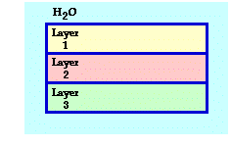A series of transparent materials are layered upon each other and surrounded by water. Layer 1 has an index of refraction of 1.850; layer 2 has an index of refraction of 1.481; layer 3 has an index of refraction of 1.672.

a. If the initial angle of incidence from the water into layer 1 is 52.0 degrees, then what is the angle of refraction (in degrees) of the light ray as it **enters** layer 3?

b. Determine the magnification of the image.

**Question 110:**

aa. A converging lens has a focal length of 21.7 cm.

a. Find the image distance (in cm) for an object distance of 54.0 cm. Enter a negative answer if it is negative.

b. Determine the magnification of this image.

**Question 111:**

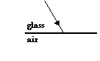aa. Complete the following diagram by drawing the reflected ray and the refracted ray (oriented in the proper direction - either towards or away from the normal). Then label the angle of incidence, the angle of reflection, the angle of refraction, the normal line, the incident ray, the reflected ray, and the refracted ray. Bring your diagram to class and be prepared to discuss what you drew.

**Question 112:**

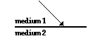aa. Consider the diagram at the right. Medium 2 slows down light as it comes from medium 1. Draw a refracted ray. Bring your diagram to class and be prepared to discuss what you drew.

**Question 113:**

aa. In each diagram, draw the "missing" ray (either incident or refracted) in order to appropriately show whether the direction of bending is towards or away from the normal.

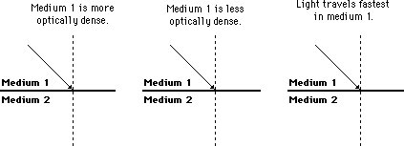

**Question 114:**

aa. Consider the three diagrams below. Measure the angle of refraction (in degrees) for each of the three diagrams.

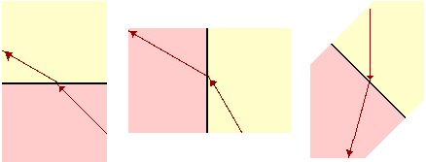

**Question 115:**

aa. Determine the speed of light (in m/s) in the material water (n=1.33).

**Question 116:**

aa. Determine the speed of light (in m/s) in the material flint glass (n=1.61).

**Question 117:**

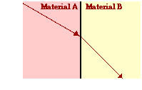aa. The diagram at the right shows light refracting from material A into material B. The index of refraction of material A is 2.04. Use your protractor to measure angles and determine the index of refraction of material B. (HINT: The angle measures are multiples of 15 degrees.)

**Question 118:**

aa. 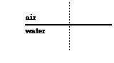Consider the diagram at the right of the water-air boundary. The critical angle for the water-air boundary is approximately 49°. In the diagram at the right, draw a ray of light approaching the boundary at the critical angle. Label the critical angle and the angle of refraction. Draw the refracted ray.

**Question 119:**

aa. 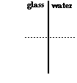Consider the diagram at the right of the glass-water boundary. Calculate the critical angle for the glass-water boundary. Then draw a light ray that *just barely* experiences total internal reflection.

**Question 120:**

aa. The diagram below show an *arrow object* positioned in front of a converging and a diverging lens. Three incident rays are shown. Construct the corresponding refracted rays. Show arrowheads.

