**Wave Motion Questions**

**Question 1:**

aa. Periodic motion can best be described as _____.

a. the straight-line motion of an object at a constant speed

b. the motion of students to and from classes during passing period

c. a motion which repeats itself over and over again at a regular interval

**Question 2:**

aa. Two springs look alike but have different spring constants. How could you determine which one has the greater spring constant?

a. Measure the length of each; the shorter spring has the greater spring constant.

b. Suspend the same mass on each and measure the amount of stretch. The one that stretches the most has the greater spring constant.

c. Measure the length of each; the longer spring has the greater spring constant.

d. Measure the length and mass of each. The spring with the greater mass/length ratio has the greater spring constant.

e. Suspend the same mass on each and measure the amount of stretch. The one that stretches the least has the greater spring constant.

ab. Measure the length and mass of each. The spring with the greater length/mass ratio has the greater spring constant.

**Questions 3-7:**

A mass is tied to the end of a light string. The other end of the light string is tied to a fixed point on the ceiling to create a simple pendulum. The mass (known as the *bob*) is pulled back and released. Once released, the bob swings to and fro. Positions A, B, C, D and E represent various locations of the bob during the course of a back-and-forth cycle. Positions A and E are locations of the bob at its two extremes.

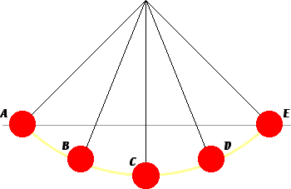

aa. At which location - A, B or C - is the net force experienced by the bob the greatest?

a. A b. B c. C

aa. At which location - A, B or C - is the acceleration of the bob the greatest?

a. A b. B c. C

aa. At which location - A, B or C - is the velocity of the bob the greatest?

a. A b. B c. C

aa. Consider the four vector arrows below. Which arrow represents the direction of the velocity on the bob when at location D and traveling towards E?

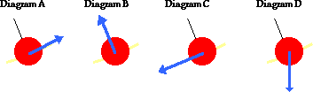

aa. Consider the four vector arrows below. Which arrow represents the direction of the net force on the bob at location D?



**Question 8:**

aa. The period of a pendulum depends upon _____. Select all that apply.

a. the mass of the bob

b. the weight of the bob

c. the length of the pendulum (from pivot to bob's center)

d. the amount which the bob is displaced from its equilibrium position

**Question 9:**

aa. How must the length of a pendulum be changed to double its period? It must be made _____.

a. two times longer

b. 2 times longer

c. 2 times shorter - i.e., 1/2 of the original size

d. four times longer

e. four times shorter - i.e, one-fourth the size

ab. two times shorter - i.e., one-half the size

**Questions 10- 14:**

Consider the following motions and categorize them as either periodic or non-periodic motions.

aa. The orbit of the moon about the earth.

a. periodic motion b. non-periodic motion

aa. The uniform acceleration of a car from rest to highway speed.

a. periodic motion b. non-periodic motion

aa. The arrival of weather systems to the Chicago area.

a. periodic motion b. non-periodic motion

aa. The back and forth motion of a pendulum bob.

a. periodic motion b. non-periodic motion

aa. The up and down motion of a mass on the end of a spring.

a. periodic motion b. non-periodic motion

**Question 15:**

aa. A pendulum clock consists of a massive object which typically hangs on the end of a bar or rigid rod. When the massive object is displaced to the left or to the right of its usual rest position and released, it tends to swing back and forth with a motion that is often referred to as **simple harmonic motion (SHM)**. The feature of the motion that best classifies it as SHM is _____.

a. it repeats its motion over and over again at a regular interval

b. it happens slowly enough to observe its cycles and measure its period

c. it always swings back and forth with the same amplitude of movement

d. the force which restores it towards rest is proportional to the amount of displacement from rest

**Questions 16-17:**

An object that encounters periodic motion can be described as having a period and an amplitude.

aa. The period is _____.

a. the frequency of its vibrational cycles

b. the speed at which it moves back and forth

c. the distance which it moves between its two extremes

d. the time for the object to complete one cycle of motion

e. the maximum amount of displacement from its equilibrium position

aa. The amplitude is _____.

a. the frequency of its vibrational cycles

b. the speed at which it moves back and forth

c. the distance which it moves between its two extremes

d. the time for the object to complete one cycle of motion

e. the maximum amount of displacement from its equilibrium position

**Question 18:**

aa. During a nervous moment of the game, the coach paced back and forth along the sidelines from the 25-yard line to the 35-yard line. The coach made 5 back and forth cycles in 2 minutes. The period of the coach's periodic pacing was _____.

a. 1.2 s b. 2.5 s c. 24.0 s d. 2.5 min

e. 5.0 yd/min ab. 25.0 yd/min ac. 50.0 yd/min

**Question 19:**

aa. A mass is placed on the end of a spring. The spring stretches. The spring follows **Hooke's law**. This means that _____.

a. potential energy is stored in the spring when it is stretched

b. the weight of the mass is equal to the spring force which is applied to it

c. the acceleration of the mass will depend on the ratio of the spring force to mass

d. the more the spring is stretched, the less force which the spring exerts upon the mass

e. the amount of force exerted upon the spring is proportional to the amount of stretch

**Questions 20-26:**

A mass is attached to a spring and allowed to hang vertically from a fixed support. The spring naturally stretches to position **A**. The mass is then pulled down to position **B** and released. The mass then vibrates up and down in periodic fashion. Positions **C** to **G** represent random positions of the mass over the course of several cycles of up and down motion. A background grid is shown in the graphic. Each small square on the grid measures 4 cm along its edge.

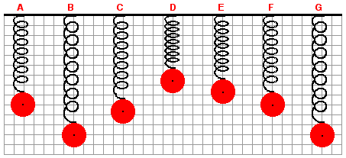

aa. The mass is at its equilibrium position when it is at position ____. (Be careful of the choices.)

a. B b. C c. D

d. E e. F

aa. When the mass is at position D, the spring is pushing it in the _____.

a. downward direction b. upward direction

c. ... nonsense! There is no spring force upon the mass at position D.

d. ... nonsense! It could be either direction, depending on the direction that the mass is moving.

aa. When the mass is at position G, the spring is pushing/pulling it in the _____.

a. downward direction b. upward direction

c. ... nonsense! There is no spring force upon the mass at position G.

d. ... nonsense! It could be either direction, depending on the direction that the mass is moving.

aa. Determine the amplitude of the mass's vibration.

a. 10 cm b. 12 cm c. 22 cm d. 24 cm

e. 36 cm ab. 48 cm

aa. At which listed position is the net force acting upon the mass equal to 0 N?

a. Position C b. Position D c. Position E

d. Position F e. Position G

aa. The spring force exerted upon the mass is a maximum when the mass is at position

a. Position C b. Position D c. Position E

d. Position F e. Position G

aa. The mass is traveling fastest when it is at position

a. Position C b. Position D c. Position E

d. Position F e. Position G

**Question 27:**

aa. **TRUE**  or **FALSE:**

Waves transport matter from one location to another without transporting energy.

a. True b. False

**Question AAA:**

aa. **TRUE**  or **FALSE:**

An ocean wave will transport ocean water from near the middle of the ocean to a location near the shore.

a. True b. False

**Question 28:**

aa. **TRUE**  or **FALSE:**

A wave is a way to move matter from one position to another.

a. True b. False

**Question 29:**

aa. **TRUE**  or **FALSE:**

It takes a vibrating object to create a wave.

a. True b. False

**Question 30:**

aa. **TRUE**  or **FALSE:**

When two waves meet while moving through the same medium, they have a tendency to permanently destroy each other or somehow alter their shape.

a. True b. False

**Question 31:**

aa. **TRUE**  or **FALSE:**

Two sound waves could never interfere in such a manner as to momentarily cancel each other out such that there is no sound.

a. True b. False

**Question 32:**

aa. **TRUE**  or **FALSE:**

Jack and Jill hold a string between them with a fixed tension (i.e., tightness) and a fixed mass density. Jill creates a wave with a gentle shake and it travels down the string. If Jill shakes more vigorously, then the wave will travel faster.

a. True b. False

**Question 33:**

aa. A wave is established in a rope. The diagram below represents a 'snapshot' of the pattern in the rope at a given instant in time.



Several points on the rope are labeled with a letter. Identify the letters of the wave crests and the wave troughs. List all that apply.

**Question 34:**

aa. A *snapshot in time* of a wave is shown at the right. Which one of the diagrams below represents a wave with twice the amplitude and one-half the wavelength?

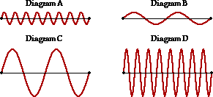

**Question 35:**

aa. A wave that is traveling fast can be said to have a high ____.

a. wavelength b. frequency     c. amplitude

d. period e. speed

**Question 36:**

aa. Some wave characteristics depend upon how the wave is produced. Other wave characteristics depend upon the properties of the medium. Which one wave characteristic is solely dependent upon the properties of the medium and independent of the way that the wave is produced?

a. wavelength b. frequency c. amplitude

d. period e. speed

**Question 37:**

aa. Waves transport energy along a medium. Which one wave property is an indicator of the amount of energy transported by a wave?

a. wavelength b. frequency c. amplitude

d. period e. speed

**Question 38:**

aa. A wave is moving through a medium. A point on the medium is undergoing many up and down oscillations in a short amount of time. This is conclusive evidence that the wave has a relatively large ____.

a. wavelength b. frequency c. amplitude

d. period e. speed

**Question 39:**

aa. Which of the following are units of frequency? Select all that apply.

a. meters/second b. oscillations/second

c. second/vibration d. Hertz

e. cycles/second

**Questions 40-42:**

Wave A and wave B are moving through the same medium. Wave A has twice the amplitude and twice the frequency of wave B.

aa. Wave A will have _____ speed as wave B.

a. the same b. two times the c. four times the

d. one-half the e. one-fourth the

aa. Wave A will have _____ wavelength as wave B.

a. the same b. two times the c. four times the

d. one-half the e. one-fourth the

aa. Wave A will transport _____ amount of energy as wave B.

a. the same b. two times the c. four times the

d. one-half the e. one-fourth the

**Question 43:**

aa. A wave is traveling in a rope. The diagram below represents a *snapshot* of the rope at a particular instant in time.

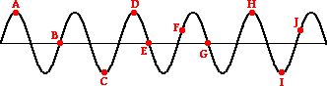

Which two points on the diagram are located one wavelength apart? ______________

**Question 44:**

aa. One type of a wave is a **mechanical wave**. Mechanical waves are different than other types of waves. Which one of the following statements describes how mechanical waves are unique?

a. Mechanical waves are always visible.

b. Mechanical waves require some form of physical material in order to exist.

c. Mechanical waves in a medium always cause the medium to take the shape of sine wave.

d. Mechanical waves are waves in which particles of the medium vibrate perpendicular to the direction of wave motion.

**Question 45:**

aa. A wave is traveling in a rope. The diagram below represents a *snapshot* of the rope at a particular instant in time.



Determine the separation distance between the following points. Express your answer in terms of the number of wavelengths.

a. Distance from A to B: ____________ 

b. Distance from A to C: ____________ 

c. Distance from D to H: ____________ 

d. Distance from B to G: ____________ 

**Question 46:**

aa. Diagram 1 below shows a pulse traveling through a medium and approaching a boundary with a second medium. Diagram 2 shows the appearance of the media several seconds later.

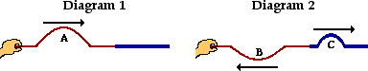

In these diagrams, A is the ___ pulse, B is the ____ pulse, and C is the ____ pulse.

a. transmitted, incident, reflected b. transmitted, reflected, incident

c. incident, reflected, transmitted d. incident, transmitted, reflected

e. ... nonsense! None of these choices appropriately name the three pulses.

**Question 47:**

aa. The diagram below shows a pulse traveling in a more dense medium towards the boundary with a less dense medium.



How will the two media look after reflection and transmission?

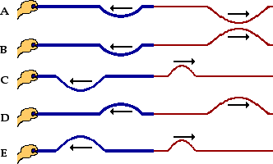

**Question 48:**

aa. An elastic rope is tied securely to a wall. An upward-displaced pulse is introduced into the rope. The pulse travels through the rope, reaches the boundary with the wall and reflects. The reflected pulse will be ____.

a. inverted (displaced downwards) b. upright (displaced upwards)

c. either inverted or upright, depending upon its amplitude

**Question 49:**

aa. An elastic rope is stretched out and loosely attached to a wall such that its end is free to move. An upward-displaced pulse is introduced into the rope. The pulse travels through the rope, reaches the boundary with the wall and reflects. The reflected pulse will be ____.

a. upright (displaced upwards) b. inverted (displaced downwards)

c. either inverted or upright, depending upon its amplitude

**Question 50:**

aa. **Interference** occurs when a wave ____.

a. bounces off a surface

b. reaches the end of its medium

c. encounters an obstacle in its path

d. crosses over a boundary into another medium

e. meets up with another wave traveling in the same medium

ab. changes direction when passing from one medium to another

**Question 51:**

aa. Constructive interference would occur when a ____. Select all that apply.

a. crest of one wave interferes with a crest of another wave

b. crest of one wave interferes with a trough of another wave

c. trough of one wave interferes with a trough of another wave

**Question 52:**

aa. Destructive interference would occur when a ____. Select all that apply.

a. crest of one wave interferes with a crest of another wave

b. crest of one wave interferes with a trough of another wave

c. trough of one wave interferes with a trough of another wave

**Questions 53-57:**

The diagram below shows two sine waves present in the same medium; several points along the medium are labeled with letters. A background grid is provided.

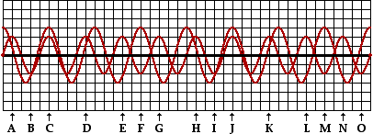

Use the principle of superposition to determine the resultant displacement of the wave pattern that results from the waves' interference.

aa. The resulting displacement at location **A** is _____ units.

a. 0 b. 1 c. 2 d. 3

e. 4 ab. 5 ac. -1 ad. -2

ae. -3 bc. -4 bd. -5

aa. The resulting displacement at location **C** is _____ units.

a. 0 b. 1 c. 2 d. 3

e. 4 ab. 5 ac. -1 ad. -2

ae. -3 bc. -4 bd. -5

aa. The resulting displacement at location **E** is _____ units.

a. 0 b. 1 c. 2 d. 3

e. 4 ab. 5 ac. -1 ad. -2

ae. -3 bc. -4 bd. -5

aa. The resulting displacement at location **F** is _____ units.

a. 0 b. 1 c. 2 d. 3

e. 4 ab. 5 ac. -1 ad. -2

ae. -3 bc. -4 bd. -5

aa. The resulting displacement at location **I** is _____ units.

a. 0 b. 1 c. 2 d. 3

e. 4 ab. 5 ac. -1 ad. -2

ae. -3 bc. -4 bd. -5

**Question 58:**

aa. Nodes are formed as a result of _____ interference and are positions along the medium in which there is ______ displacement.

a. destructive, a large b. constructive, a large

c. destructive, no d. constructive, no

**Question 59:**

aa. Antinodes are formed as a result of _____ interference and are positions along the medium in which there is ______ displacement.

a. destructive, a large b. constructive, a large

c. destructive, no d. constructive, no

**Question 60:**

aa. A wave is traveling through a dense medium and approaching the boundary with a less dense medium. The transmitted pulse will have a ____ than the incident pulse. Select all that apply.

a. smaller frequency b. smaller wavelength

c. greater frequency d. greater wavelength

e. smaller speed f. greater speed

**Questions 61-64:**

The diagram below depicts wave fronts moving across the surface of water in a ripple tank. A barrier placed in the water serves as a reflecting surface for the waves.

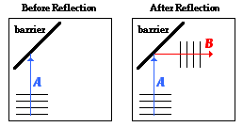

aa. The blue arrow labeled **A** in the diagram represents the _____, ….

a. wavefront b. standing wave c. incident ray d. reflected ray

aa. (Continued from previous question.) … and the red arrow labeled **B** represents the _____.

a. wavefront b. standing wave c. incident ray d. reflected ray

aa. Which of the following wave properties are different for the wave before reflection compared to after reflection? Select all that apply.

a. wavelength b. wave direction c. wave speed d. frequency

aa. Which diagram below correctly depicts the normal line for this situation? Circle the correct answer.

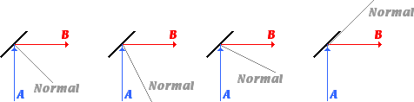

**Questions 65-68:**

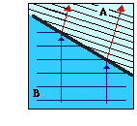The diagram at the right depicts wave fronts moving across the surface of water in a ripple tank. A glass plate is placed into the water at an angle to the sides of the tank in order to create a deep and a shallow end of the tank. The waves **refract** as they cross the boundary separating the two depths of water.

Inspect the diagram and answer the following questions.

aa. Region _____ is the deep end of the tank.

a. A b. B

aa. The diagram shows that as the wave cross the boundary, the speed of the waves ____ …

a. increases b. decreases c. remains unchanged

aa. (Continued from previous question.) … and the wavelength _____.

a. increases b. decreases c. remains unchanged

aa. How would you expect the frequency of waves in the A end of the tank to compare to the frequency of waves in the B end?

a. The frequency is greater in A. b. The frequency is greater in B.

c. The frequency is the same in each end.

**Questions 69-70:**

An incident pulse reaches the boundary with a different medium. At the boundary, there is some reflection and transmission. The transmitted pulse is observed to be traveling faster than the original incident pulse.

aa. One would expect the transmitted pulse to _____.

a. be inverted b. not invert

aa. One would expect the reflected pulse to _____.

a. be inverted b. not invert

**Questions 71-72:**

An incident pulse reaches the boundary with a different medium. At the boundary, there is some reflection and transmission. The transmitted pulse is observed to be traveling slower than the original incident pulse.

aa. One would expect the transmitted pulse to _____.

a. be inverted b. not invert

aa. One would expect the reflected pulse to _____.

a. be inverted b. not invert

**Question 73:**

aa. When comparing the wave characteristics of an incident and transmitted wave in two different media, one can be sure that the wavelength will be ____.

a. greatest in the least dense medium

b. smallest in the least dense medium

c. the same regardless of the density of the medium

d. ... nonsense! Such predictions are impossible to make.

**Question 74:**

aa. When comparing the wave characteristics of an incident and transmitted wave in two different media, one can be sure that the speed will be ____.

a. greatest in the least dense medium

b. smallest in the least dense medium

c. the same regardless of the density of the medium

d.... nonsense! Such predictions are impossible to make.

**Question 75:**

aa. When comparing the wave characteristics of an incident and transmitted wave in two different media, one can be sure that the frequency will be ____.

a. greatest in the least dense medium

b. smallest in the least dense medium

c. the same regardless of the density of the medium

d.... nonsense! Such predictions are impossible to make.

**Question 76:**

aa. Diagram 1 below shows a pulse traveling through a medium and approaching a boundary with a second medium. Diagram 2 shows the appearance of the media several seconds later.

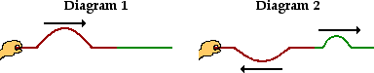

Comparing Diagrams 1 and 2 would lead one to believe that the ____-colored medium is the most dense medium.

a. red (on the left, held by the hand) b. green (on the right)

c. ... nonsense! Both media have the same density.

**Question 77:**

aa. Two waves which meet while moving in opposite directions through the same medium will tend to _________.

a. pass through each other b. bounce off each other

**Question 78:**

aa. Two pulses meet while moving along the same medium. Wave A has an upward displacement of 5 units; wave B has a downward displacement of 5 units. This would be an example of _______ interference.

a. constructive b. destructive c. neither form of

**Question 79:**

aa. Two pulses meet while moving along the same medium. Wave A has an upward displacement of 5 units; wave B has an upward displacement of 5 units. This would be an example of _______ interference.

a. constructive b. destructive c. neither form of

**Question 80:**

aa. Two pulses meet while moving along the same medium. Wave A has an upward displacement of 10 units; wave B has a downward displacement of 6 units. This would be an example of _______ interference.

a. constructive b. destructive c. neither form of

**Question 81:**

aa. A downward displaced pulse moving along a string reaches an end that is fixed. Upon reaching the fixed end, the pulse will _____

a. stop altogether

b. be reduced to a nearly invisible *ripple*

c. reflect and return as a downward displaced pulse

d. reflect and return as an upward displaced pulse

**Question 82:**

aa. A downward displaced pulse moving along a string reaches an end that is free to move. Upon reaching the free end, the pulse will _____

a. stop altogether

b. be reduced to a nearly invisible *ripple*

c. reflect and return as a downward displaced pulse

d. reflect and return as an upward displaced pulse

**Question 83:**

aa. The relationship between frequency and wavelength is ____. As frequency is increased, the wavelength is ____.

a. inverse, increased b. inverse, decreased

c. direct, decreased d. direct, increased

**Question 84:**

aa. If the frequency of a wave is increased, then its period is ____.

a. increased b. decreased c. not effected

**Question 85:**

aa. If the wavelength of a wave were increased, then the speed of the wave would _____.

a. increase b. decrease c. stay the same

**Question 86:**

aa. When one refers to the movement of a wave, they are describing the movement of ____.

a. the pattern or disturbance along the medium

b. the particles of the medium moving up and down

**Question 87:**

aa. Which of the following categories of waves require a medium in order to transport energy from one location to another?

a. mechanical b. electromagnetic

**Question 88:**

aa. In a transverse wave, the direction which particles of the medium are displaced is _____ to the direction of wave motion.

a. parallel b. perpendicular c. diagonal

**Calculations and Long Answer Questions**

**Question 89:**

aa. Draw a transverse waveform in the space below and label its parts (crest, trough, amplitude, wavelength).

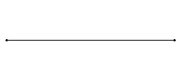

**Question 90:**

aa. On the diagrams below, draw a **Wave B** that has twice the amplitude of wave A and one-half the wavelength. Draw a **Wave C** that has one-half the amplitude of wave A and twice the wavelength.

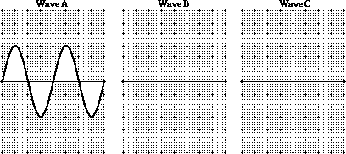

**Question 91:**

aa. What is the period on Earth of a pendulum with a length of 1.05 m?

**Question 92:**

aa. A spring has a spring constant of 83.3 N/m. How much force would be required to stretch the spring a distance of 0.216 m?

**Question 93:**

aa. A spring with a spring constant of 44.9 N/m is hung from a support on the ceiling. A 17.0-N object is hung from it. How far will this object stretch the spring?

**Question 94:**

aa. A wave has a wavelength of 13.6 meters and an amplitude of 11.6 meters. A crest on the wave travels a distance of 4.99 meters in 3.94 seconds. Determine the frequency (in Hertz) of the waves.

**Question 95:**

aa. In a physics lab, a rope is observed to make 16 complete vibration cycles in 9.8 seconds. The length of the rope is 1.76 meters and the measurements are made for the 5th harmonic.

a. Determine the wavelength (in centimeters) of the waves.

b. Determine the speed (in m/s) of the waves in the rope.

**Question 96:**

aa. There are two boats - Boat A and Boat B – in the harbor that are anchored 25.9 meters apart. The incoming water waves from the bay cause the boats to *vibrate* up and down. They make one complete cycle every 7.47 seconds. When Boat A is at its highest point, Boat B is at its lowest point; at this moment, there is one wave crest between the two boats. The vertical distance between Boat A and Boat B at their extremes is 5.84 meters.

a. Determine the amplitude (in meters) of the waves.

b. Determine the wavelength of the waves.

c. Determine the speed (in meters/second) of the waves.

**Question 97:**

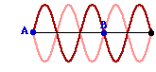aa. A Snakey vibrates in the manner shown in the diagram at the right. The distance from point A to point B on the diagram is 4.82 meters. A single pulse introduced into the Anakey will be observed to travel from point A to the opposite end and back to point A in 1.82 seconds. Determine the frequency (in Hertz) of this wave.

**Question 98:**

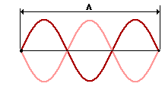aa. A rope is held tightly and shook, forming the wave pattern shown at the right. The distance marked as **A** in the diagram is 3.37 meters. Waves move along the rope at 13.1 m/s. Determine the number of up-and-down vibration cycles that a single point on the rope would make in 13.0 seconds.

**Question 99:**

aa. A 4.82-meter long rope is undergoes 413 complete vibration cycles in 12.7 seconds when vibrating in the third harmonic. Determine the speed (in meters/second) of the waves in the rope.

**Question 100:**

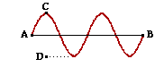aa. A wave with a frequency of 18.2 Hz is traveling through a rope as shown at the right. The horizontal distance from point A to point B is 25.7 cm. The vertical distance from point C to point D is 11.5 cm.

a. Determine the amplitude (in centimeters) of the wave.

b. Find the period (in milliseconds) of the wave.

c. Determine the wavelength (in centimeters) of the wave.

d. Determine the speed (in centimeters/second) of the wave.