**Waves Review**

From <http://www.physicsclassroom.com/reviews/waves/wavesprint.cfm>

1. A single disturbance moves from point to point along a medium. This single disturbance is referred to as a ___.

a. period b. periodic wave c. wavelength d. pulse

2. If the particles of the medium are vibrating to and fro in the same direction of energy transport, then the wave is a ____ wave.

a. longitudinal b. sound c. standing d. transverse

3. When the particles of a medium are vibrating at right angles to the direction of energy transport, then the wave is a ____ wave.

a. longitudinal b. sound c. standing d. transverse

4. The diagram below shows a *snapshot in time* of a transverse wave moving through a medium. The particles of the medium are vibrating _____.

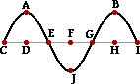

a. parallel to the line that joins points A and D

b. along the line that joins points C and I

c. perpendicular to the line that joins points A and D

d. at various angles to the line that joins points C and I

e. along the curve CAEJGBI

5. A longitudinal wave travels through a medium that stretches from north to south. The particles of the medium _____.

a. move from north to south

b. move from east to west

c. vibrate northward and southward about a fixed position

d. vibrate eastward and westward about a fixed position

6. As a pulse moves though a uniform medium, the speed of the pulse ____.

a. decreases b. increases c. remains the same

7. The main factor that affects the speed of a sound wave is the ____.

a. amplitude of the sound wave b. intensity of the sound

c. loudness of the sound d. properties of the medium

e. pitch of the sound

8. A wave traveling through medium 1 crosses the boundary and enters into medium 2. As it does, its speed increases. This causes the wavelength to _____.

a. decrease b. increase c. remain the same

d. … nonsense! Wave speed could never increase at the boundary between two media.

9. As a wave passes across a boundary into a new medium, which characteristic of the wave would NOT change?

a. speed b. frequency c. wavelength

10. What is the amplitude of the wave in the diagram below?

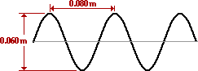

a. 0.03 m b. 0.04 m c. 0.05 m d. 0.06 m

11. The wavelength of the wave in the diagram above (**Question 10**) is ____ m.

a. 0.030 b. 0.040 c. 0.060 d. 0.080

12. A wave that is **W** meters long moves through a medium with a speed of **v** meters per second. The frequency of the wave could be expressed as ____ Hz.

a. **v** / **W** b. **W** / **v** c. **W•v** d. (**W** + **v**)

Consider the following diagram for **Questions 13-14**.

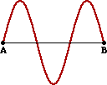

13. How many complete waves are shown in the diagram?

a. 1 b. 2 c. 3 d. 1.5

14. If the distance from point A to point B in the diagram is 60 cm, then the wavelength is ____.

a. 20 cm b. 40 cm c. 60 cm d. 90 cm

15. A wave is traveling through a medium. The number of vibration cycles of a point on the medium per unit of time is defined as the wave's ____.

a. wavelength b. period c. amplitude d. frequency

16. A periodic and repeating disturbance in a lake creates waves that emanate outward from its source to produce circular wave patterns. If the frequency of the source is 2.00 Hz and the wave speed is 5.00 m/s then the distance between adjacent wave crests is ___ meter.

a. 0.200 b. 0.400 c. 1.25

d. 2.50 e. 10.0

17. A wave has a speed of 0.80 m/s and a wavelength of 0.60 meters. What is its frequency?

a. 0.48 Hz b. 0.67 Hz c. 0.75 Hz d. 1.3 Hz

18. Many wave properties are dependent upon other wave properties. Yet, one wave property is independent of all other wave properties. Which one of the following properties of a wave is independent of all the others?

a. wavelength b. frequency c. period d. velocity

19. A pendulum makes exactly 40 vibrations in 20.0 s. Its period is ____. (Be cautious of the units.)

a. 0.500 Hz. b. 0.500 s. c. 2.00 Hz.

d. 2.00 s. e. 8.00 x 102 Hz.

20. A wave with a period of 0.0050 seconds would have a frequency of ____ Hz.

a. 20 b. 50 c. 200 d. 500 e. 2000

21. **TRUE or FALSE:**

The number of waves produced by a vibrating source each second is referred to as the frequency of the source.

a. True b. False

22. **TRUE or FALSE:**

The standard unit for frequency is the Hertz.

a. True b. False

23. **TRUE or FALSE:**

Doubling the frequency of a wave source (without any change in the medium) will double the speed of the waves that the source produces.

a. True b. False

24. If the frequency of a wave is doubled and if the speed remains constant, then the wavelength will ____.

a. be four times longer b. be one-half the length

c. not be changed d. be twice as long

25. Two different ropes with different mass densities are attached to each other. A pulse is introduced into one end of the rope and approaches the boundary as shown at the right. At the boundary, a portion of the energy is transmitted into the new medium and a portion is reflected. Which one of the diagrams below depicts the possible location and orientation of the pulse shortly after the incident pulse reaches the boundary?

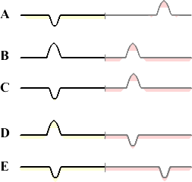

26. A pulse traveling through one medium reaches a boundary with a second medium. Which of the following describe what occurs once the pulse reaches the boundary?

a. It is entirely reflected.

b. It is entirely transmitted.

c. It is both reflected and transmitted.

d. It neither reflects nor transmits; it simply disappears.

27. The diagram at the right shows a transverse pulse traveling past point X along a dense rope toward its junction with a less dense rope. Which of the diagrams (A, B, C, D, or E) below depicts the ropes at the instant that the reflected pulse again passes through its original point X? Consider such features as amplitude and relative speed (i.e., the relative distance of the transmitted and reflected pulses from boundary).

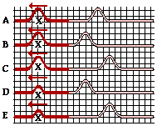

28. A wave travels through a Snakey with a speed of 8.0 m/s, approaching a boundary with a second Snakey. As the wave crosses the boundary, its wavelength changes from 2.0 m to 3.0 m. The wave in the second Snakey travels at approximately ____.

a. 4.0 m/s b. 5.3 m/s c. 8.0 m/s d. 12.0 m/s

29. The diagram at the right shows a disturbance moving through a rope towards the right. If this disturbance meets a similar disturbance moving to the left, then which one of the diagrams below depict a pattern that could NEVER appear in the rope?

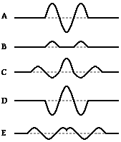

30. A 2.0-meter long rope is hanging vertically from the ceiling and attached to a mechanical oscillator at its lower end. A single pulse is observed to travel the length of the rope in 0.50 s. With what frequency should the oscillator vibrate in order for three whole waves to be established in a standing wave pattern in the rope?

a. 0.75 Hz b. 1.3 Hz c. 4.0 Hz d. 6.0 Hz e. 8.0 Hz

31. A standing wave experiment is performed to determine the speed of waves in a rope. The standing wave pattern shown below is established in the rope. The rope makes exactly 90 complete vibrational cycles in one minute. The speed of the waves is ____ m/s.



a. 3.0 b. 6.0 c. 180 d. 360 e. 540

32. Consider the standing wave pattern shown below. A wave generated at the left end of the medium undergoes reflection at the fixed end on the right side of the medium. The number of antinodes in the diagram is _____.

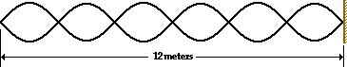

a. 3 b. 5 c. 6 d. 7 e. 12

33. A node is a point located along the medium where there is always ______.

a. a double crest b. a double trough

c. constructive interference d. destructive interference

e. a double rarefaction

34. **TRUE or FALSE:**

Constructive interference of waves occurs when two crests meet.

a. True b. False

35. Which phenomenon is produced when two or more waves passing simultaneously through the same medium meet up with one another?

a. refraction b. diffraction c. interference d. reflection

36. Two pulses are traveling in opposite directions along the same medium as shown in the diagram at the right. Which diagram below best depicts the appearance of the medium when each pulse meets in the middle?

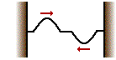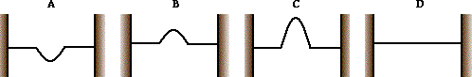

37. **TRUE or FALSE**:

A vibrating object is necessary for the production of sound.

a. True b. False

38. Through which of these materials is sound unable to travel?

a. Liquid nitrogen b. Gaseous helium

c. Liquid salt water d. Solid aluminum

e. A perfect vacuum