Minds On Physics Question Banks – Kinematic Graphing

KG1: Basics of Position-Time Graphs

Question 1:
aa. The slope of a position-time graph represents the _____ of the object.
a. displacement b. velocity
c. acceleration d. none of these

Question 2:
aa. The slope of a position-time graph represents the _____ of the object.
a. acceleration b. displacement
c. velocity d. none of these

Question 3:
aa. The slope of a position-time graph represents the _____ of the object.
a. velocity b. acceleration
c. displacement d. none of these

Question 4:
aa. Which one of the following represent the velocity of an object?
a. The slope of a position-time graph
b. The slope of a velocity-time graph
c. The area under the line of a velocity-time graph
d. none of these

Question 5:
aa. Which one of the following represent the velocity of an object?
a. The slope of a velocity-time graph
b. The area under the line of a velocity-time graph
c. The slope of a position-time graph
d. none of these

Question 6:
aa. Which one of the following represent the velocity of an object?
a. The area under the line of a velocity-time graph
b. The slope of a position-time graph
c. The slope of a velocity-time graph
d. none of these

Question 7:
aa. The position-time graph for an object with a positive velocity would be a line with ____.
a. no slope b. positive slope
c. changing slope d. a curve

Question 8:
aa. The position-time graph for an object with a positive velocity would be a line with ____.
a. positive slope b. changing slope
c. a curve d. no slope

Question 9:
aa. The position-time graph for an object with a positive velocity would be a line with ____.
a. changing slope b. a curve
c. no slope d. positive slope

Question 10:
aa. The position-time graph for an object with a positive velocity would be a line with ____.
a. a curve b. no slope
c. positive slope d. changing slope

Question 11:
aa. The position-time graph for an object with a negative velocity would be a line with ____.
a. no slope b. negative slope
c. changing slope d. a curve

Question 12:
aa. The position-time graph for an object with a negative velocity would be a line with ____.
a. negative slope b. changing slope
c. a curve d. no slope

Question 13:
aa. The position-time graph for an object with a negative velocity would be a line with ____.
a. changing slope b. a curve
c. no slope d. negative slope

Question 14:
aa. The position-time graph for an object with a negative velocity would be a line with ____.
a. a curve b. no slope
c. negative slope d. changing slope

Question 15:
aa. The position-time graph for an object with a large velocity would be a line with ____.
a. no slope b. upward slope
c. increasing slope d. large slope

Question 16:
aa. The position-time graph for an object with a large velocity would be a line with ____.
a. upward slope b. increasing slope
c. large slope d. no slope

Question 17:
aa. The position-time graph for an object with a large velocity would be a line with ____.
a. increasing slope b. large slope
c. no slope d. upward slope

Question 18:
aa. The position-time graph for an object with a large velocity would be a line with ____.
a. large slope b. no slope
c. upward slope d. increasing slope

Question 19:
aa. The position-time graph for an object with a small velocity would be a line with ____.
a. no slope b. upward slope
c. increasing slope d. small slope

Question 20:
aa. The position-time graph for an object with a small velocity would be a line with ____.
a. upward slope b. increasing slope
c. small slope d. no slope

Question 21:
aa. The position-time graph for an object with a small velocity would be a line with ____.
a. increasing slope b. small slope
c. no slope d. upward slope

Question 22:
aa. The position-time graph for an object with a small velocity would be a line with ____.
a. small slope b. no slope
c. upward slope d. increasing slope

Question 23:
aa. The position-time graph for an object with a velocity of zero would be a line with ____.
a. zero slope b. upward slope
c. constant positive slope d. changing slope

Question 24:
aa. The position-time graph for an object with a velocity of zero would be a line with ____.
a. upward slope b. constant positive slope
c. changing slope d. zero slope

Question 25:
aa. The position-time graph for an object with a velocity of zero would be a line with ____.
a. constant positive slope b. changing slope
c. zero slope d. upward slope

Question 26:
aa. The position-time graph for an object with a velocity of zero would be a line with ____.
a. changing slope b. zero slope
c. upward slope d. constant positive slope

Question 27:
aa. The position-time graph for an object with a velocity that is changing would be a line with ____.
a. zero slope b. upward slope
c. constant positive slope d. changing slope

Question 28:
aa. The position-time graph for an object with a velocity that is changing would be a line with ____.
a. changing slope b. zero slope
c. upward slope d. constant positive slope

Question 29:
aa. The position-time graph for an object with a velocity that is changing would be a line with ____.
a. constant positive slope b. changing slope
c. zero slope d. upward slope

Question 30:
aa. The position-time graph for an object with a velocity that is changing would be a line with ____.
a. upward slope b. constant positive slope
c. changing slope d. zero slope

KG2: Interpreting Position-Time Graphs

Question 1:
aa. The motion of an object is depicted by a position-time graph. Various time intervals during the motion are depicted by a letter.

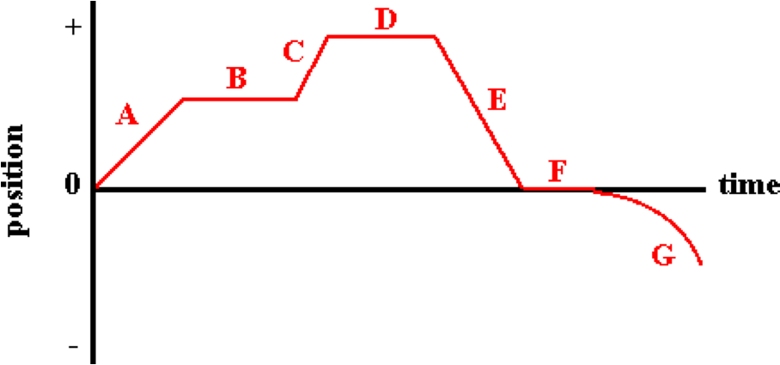

During which time interval is the object moving with the greatest average speed?

Question 2:
aa. The motion of an object is depicted by a position-time graph. Various time intervals during the motion are depicted by a letter.

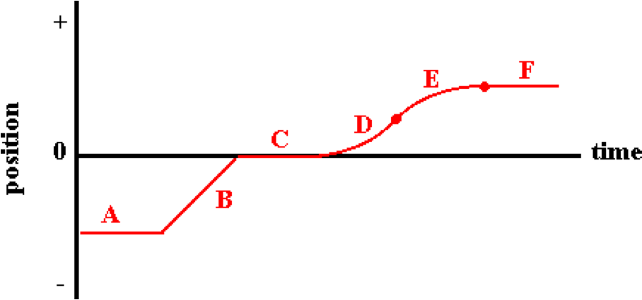

During which time interval is the object moving with the greatest average speed?

Question 3:
aa. The motion of an object is depicted by a position-time graph. Various time intervals during the motion are depicted by a letter.

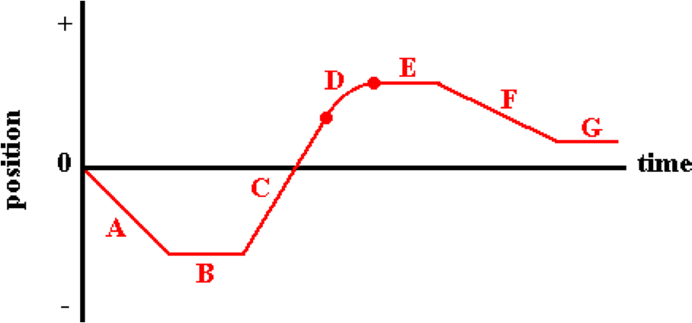

During which time interval is the object moving with the greatest average speed?

Question 4:
aa. The motion of an object is depicted by a position-time graph. Various time intervals during the motion are depicted by a letter.

During which time interval(s) is the object moving with a negative velocity? List all that apply in alphabetical order with no spaces between letters. If there are no instances of moving with a negative velocity, then enter 'Z' as the answer.

Question 5:
aa. The motion of an object is depicted by a position-time graph. Various time intervals during the motion are depicted by a letter.

During which time interval(s) is the object moving with a negative velocity? List all that apply in alphabetical order with no spaces between letters. If there are no instances of moving with a negative velocity, then enter 'Z' as the answer.

Question 6:
aa. The motion of an object is depicted by a position-time graph. Various time intervals during the motion are depicted by a letter.

During which time interval(s) is the object moving with a negative velocity? List all that apply in alphabetical order with no spaces between letters. If there are no instances of moving with a negative velocity, then enter 'Z' as the answer.

Question 7:
aa. The motion of an object is depicted by a position-time graph. Various time intervals during the motion are depicted by a letter.

During which time interval(s) is the object moving with a constant, non-zero velocity? List all that apply in alphabetical order with no spaces between letters. If there are no instances of moving with a constant, non-zero velocity, then enter 'Z' as the answer.

Question 8:
aa. The motion of an object is depicted by a position-time graph. Various time intervals during the motion are depicted by a letter.

During which time interval(s) is the object moving with a constant, non-zero velocity? List all that apply in alphabetical order with no spaces between letters. If there are no instances of moving with a constant, non-zero velocity, then enter 'Z' as the answer.

Question 9:
aa. The motion of an object is depicted by a position-time graph. Various time intervals during the motion are depicted by a letter.

During which time interval(s) is the object moving with a constant, non-zero velocity? List all that apply in alphabetical order with no spaces between letters. If there are no instances of moving with a constant, non-zero velocity, then enter 'Z' as the answer.

Question 10:
aa. The motion of an object is depicted by a position-time graph. Various time intervals during the motion are depicted by a letter.

During which time interval(s) is the object at rest? List all that apply in alphabetical order with no spaces between letters. If there are no instances of being at rest, then enter 'Z' as the answer.

Question 11:
aa. The motion of an object is depicted by a position-time graph. Various time intervals during the motion are depicted by a letter.

During which time interval(s) is the object at rest? List all that apply in alphabetical order with no spaces between letters. If there are no instances of being at rest, then enter 'Z' as the answer.

Question 12:
aa. The motion of an object is depicted by a position-time graph. Various time intervals during the motion are depicted by a letter.

During which time interval(s) is the object at rest? List all that apply in alphabetical order with no spaces between letters. If there are no instances of being at rest, then enter 'Z' as the answer.

Question 13:
aa. The motion of an object is depicted by a position-time graph. Various time intervals during the motion are depicted by a letter.

During which time interval(s) is the object moving with a positive velocity? List all that apply in alphabetical order with no spaces between letters. If there are no instances of moving with a positive velocity, then enter 'Z' as the answer.

Question 14:
aa. The motion of an object is depicted by a position-time graph. Various time intervals during the motion are depicted by a letter.

During which time interval(s) is the object moving with a positive velocity? List all that apply in alphabetical order with no spaces between letters. If there are no instances of moving with a positive velocity, then enter 'Z' as the answer.

Question 15:
aa. The motion of an object is depicted by a position-time graph. Various time intervals during the motion are depicted by a letter.

During which time interval(s) is the object moving with a positive velocity? List all that apply in alphabetical order with no spaces between letters. If there are no instances of moving with a positive velocity, then enter 'Z' as the answer.

Question 16:
aa. The motion of an object is depicted by a position-time graph. Various time intervals during the motion are depicted by a letter.

During which time interval is the object moving and moving with the smallest constant speed?

Question 17:
aa. The motion of an object is depicted by a position-time graph. Various time intervals during the motion are depicted by a letter.

During which time interval is the object moving and moving with the smallest constant speed?

Question 18:
aa. The motion of an object is depicted by a position-time graph. Various time intervals during the motion are depicted by a letter.

During which time interval is the object moving and moving with the smallest constant speed?

Question 19:
aa. The motion of an object is depicted by a position-time graph. Various time intervals during the motion are depicted by a letter.

During which time interval(s) is the object speeding up? List all that apply in alphabetical order with no spaces between letters. If there are no instances of speeding up, then enter 'Z' as the answer.

Question 20:
aa. The motion of an object is depicted by a position-time graph. Various time intervals during the motion are depicted by a letter.

During which time interval(s) is the object speeding up? List all that apply in alphabetical order with no spaces between letters. If there are no instances of speeding up, then enter 'Z' as the answer.

Question 21:
aa. The motion of an object is depicted by a position-time graph. Various time intervals during the motion are depicted by a letter.

During which time interval(s) is the object speeding up? List all that apply in alphabetical order with no spaces between letters. If there are no instances of speeding up, then enter 'Z' as the answer.

Question 22:
aa. The motion of an object is depicted by a position-time graph. Various time intervals during the motion are depicted by a letter.

During which time interval(s) is the object slowing down? List all that apply in alphabetical order with no spaces between letters. If there are no instances of slowing down, then enter 'Z' as the answer.

Question 23:
aa. The motion of an object is depicted by a position-time graph. Various time intervals during the motion are depicted by a letter.

During which time interval(s) is the object slowing down? List all that apply in alphabetical order with no spaces between letters. If there are no instances of slowing down, then enter 'Z' as the answer.

Question 24:
aa. The motion of an object is depicted by a position-time graph. Various time intervals during the motion are depicted by a letter.

During which time interval(s) is the object slowing down? List all that apply in alphabetical order with no spaces between letters. If there are no instances of slowing down, then enter 'Z' as the answer.

Question 25:
aa. The motion of an object is depicted by a position-time graph. Various time intervals during the motion are depicted by a letter.

During which time interval(s) is the object accelerating? List all that apply in alphabetical order with no spaces between letters. If there are no instances of accelerated motion, then enter 'Z' as the answer.

Question 26:
aa. The motion of an object is depicted by a position-time graph. Various time intervals during the motion are depicted by a letter.

During which time interval(s) is the object accelerating? List all that apply in alphabetical order with no spaces between letters. If there are no instances of accelerated motion, then enter 'Z' as the answer.

Question 27:
aa. The motion of an object is depicted by a position-time graph. Various time intervals during the motion are depicted by a letter.

During which time interval(s) is the object accelerating? List all that apply in alphabetical order with no spaces between letters. If there are no instances of accelerated motion, then enter 'Z' as the answer.

Question 28:
aa. The motion of an object is depicted by a position-time graph. Various time intervals during the motion are depicted by a letter.

During which time interval(s) is the object changing its velocity? List all that apply in alphabetical order with no spaces between letters. If there are no instances of a changing velocity, then enter 'Z' as the answer.

Question 29:
aa. The motion of an object is depicted by a position-time graph. Various time intervals during the motion are depicted by a letter.

During which time interval(s) is the object changing its velocity? List all that apply in alphabetical order with no spaces between letters. If there are no instances of a changing velocity, then enter 'Z' as the answer.

Question 30:
aa. The motion of an object is depicted by a position-time graph. Various time intervals during the motion are depicted by a letter.

During which time interval(s) is the object changing its velocity? List all that apply in alphabetical order with no spaces between letters. If there are no instances of a changing velocity, then enter 'Z' as the answer.

KG3: Interpreting Position-Time Graphs

Question 1:
aa. The motions of five objects - A, B, C, D, and E - are represented by lines on a position-time graph.

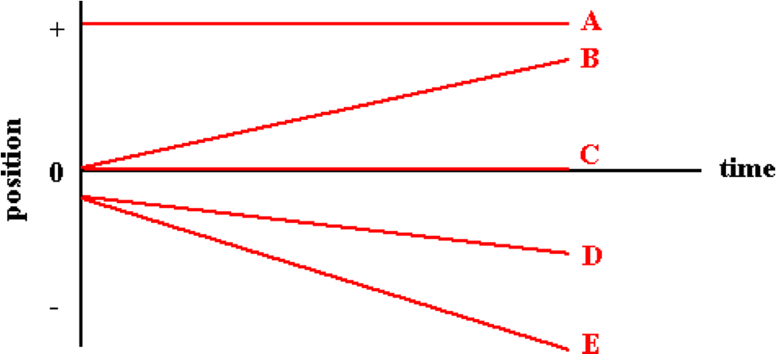

Write the letter for the object that has the greatest constant velocity (consider absolute value only).

Question 2:
aa. The motions of five objects - A, B, C, D, and E - are represented by lines on a position-time graph.

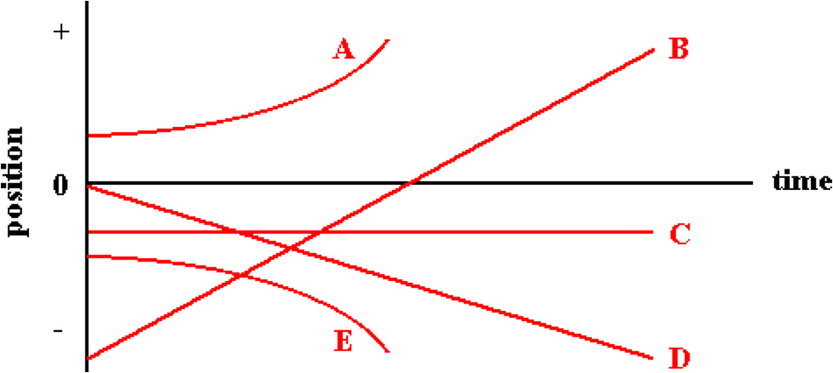

Write the letter for the object that has the greatest constant velocity (consider absolute value only).

Question 3:
aa. The motions of five objects - A, B, C, D, and E - are represented by lines on a position-time graph.

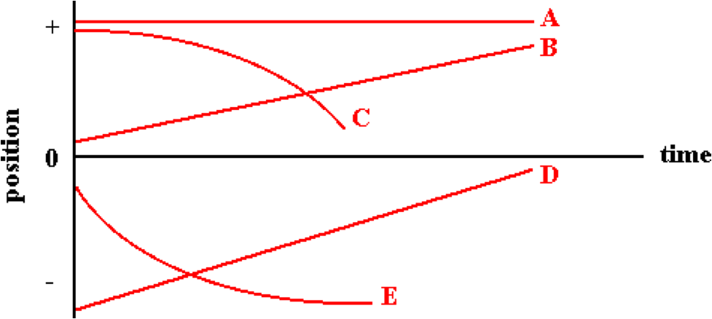

Write the letter for the object that has the greatest constant velocity (consider absolute value only).

Question 4:
aa. The motions of five objects - A, B, C, D, and E - are represented by lines on a position-time graph.

Write the letter for the object that is moving and moving with the smallest constant velocity (consider absolute value only).

Question 5:
aa. The motions of five objects - A, B, C, D, and E - are represented by lines on a position-time graph.

Write the letter for the object that is moving and moving with the smallest constant velocity (consider absolute value only).

Question 6:
aa. The motions of five objects - A, B, C, D, and E - are represented by lines on a position-time graph.

Write the letter for the object that is moving and moving with the smallest constant velocity (consider absolute value only).

Question 7:
aa. The motions of five objects - A, B, C, D, and E - are represented by lines on a position-time graph.

Write the letter(s) for any object that has a positive velocity. List all that apply in alphabetical order with no spaces between letters. If there are no instances of a positive velocity, then enter 'Z' as the answer.

Question 8:
aa. The motions of five objects - A, B, C, D, and E - are represented by lines on a position-time graph.

Write the letter(s) for any object that has a positive velocity. List all that apply in alphabetical order with no spaces between letters. If there are no instances of a positive velocity, then enter 'Z' as the answer.

Question 9:
aa. The motions of five objects - A, B, C, D, and E - are represented by lines on a position-time graph.

Write the letter(s) for any object that has a positive velocity. List all that apply in alphabetical order with no spaces between letters. If there are no instances of a positive velocity, then enter 'Z' as the answer.

Question 10:
aa. The motions of five objects - A, B, C, D, and E - are represented by lines on a position-time graph.

Write the letter(s) for any object that has a negative velocity. List all that apply in alphabetical order with no spaces between letters. If there are no instances of a negative velocity, then enter 'Z' as the answer.

Question 11:
aa. The motions of five objects - A, B, C, D, and E - are represented by lines on a position-time graph.

Write the letter(s) for any object that has a negative velocity. List all that apply in alphabetical order with no spaces between letters. If there are no instances of a negative velocity, then enter 'Z' as the answer.

Question 12:
aa. The motions of five objects - A, B, C, D, and E - are represented by lines on a position-time graph.

Write the letter(s) for any object that has a negative velocity. List all that apply in alphabetical order with no spaces between letters. If there are no instances of a negative velocity, then enter 'Z' as the answer.

Question 13:
aa. The motions of five objects - A, B, C, D, and E - are represented by lines on a position-time graph.

Write the letter(s) for any object that has a zero velocity. List all that apply in alphabetical order with no spaces between letters. If there are no instances of a zero velocity, then enter 'Z' as the answer.

Question 14:
aa. The motions of five objects - A, B, C, D, and E - are represented by lines on a position-time graph.

Write the letter(s) for any object that has a zero velocity. List all that apply in alphabetical order with no spaces between letters. If there are no instances of a zero velocity, then enter 'Z' as the answer.

Question 15:
aa. The motions of five objects - A, B, C, D, and E - are represented by lines on a position-time graph.

Write the letter(s) for any object that has a zero velocity. List all that apply in alphabetical order with no spaces between letters. If there are no instances of a zero velocity, then enter 'Z' as the answer.

Question 16:
aa. The motions of five objects - A, B, C, D, and E - are represented by lines on a position-time graph.

Write the letter(s) for any object that is moving with a constant, non-zero velocity. List all that apply in alphabetical order with no spaces between letters. If there are no instances of a constant, non-zero velocity, then enter 'Z' as the answer.

Question 17:
aa. The motions of five objects - A, B, C, D, and E - are represented by lines on a position-time graph.

Write the letter(s) for any object that is moving with a constant, non-zero velocity. List all that apply in alphabetical order with no spaces between letters. If there are no instances of a constant, non-zero velocity, then enter 'Z' as the answer.

Question 18:
aa. The motions of five objects - A, B, C, D, and E - are represented by lines on a position-time graph.

Write the letter(s) for any object that is moving with a constant, non-zero velocity. List all that apply in alphabetical order with no spaces between letters. If there are no instances of a constant, non-zero velocity, then enter 'Z' as the answer.

Question 19:
aa. The motions of five objects - A, B, C, D, and E - are represented by lines on a position-time graph.

Write the letter(s) for any object that has a changing velocity. List all that apply in alphabetical order with no spaces between letters. If there are no instances of a changing velocity, then enter 'Z' as the answer.

Question 20:
aa. The motions of five objects - A, B, C, D, and E - are represented by lines on a position-time graph.

Write the letter(s) for any object that has a changing velocity. List all that apply in alphabetical order with no spaces between letters. If there are no instances of a changing velocity, then enter 'Z' as the answer.

Question 21:
aa. The motions of five objects - A, B, C, D, and E - are represented by lines on a position-time graph.

Write the letter(s) for any object that has a changing velocity. List all that apply in alphabetical order with no spaces between letters. If there are no instances of a changing velocity, then enter 'Z' as the answer.

Question 22:
aa. The motions of five objects - A, B, C, D, and E - are represented by lines on a position-time graph.

Write the letter(s) for any object that is accelerating. List all that apply in alphabetical order with no spaces between letters. If there are no instances of accelerated motion, then enter 'Z' as the answer.

Question 23:
aa. The motions of five objects - A, B, C, D, and E - are represented by lines on a position-time graph.

Write the letter(s) for any object that is accelerating. List all that apply in alphabetical order with no spaces between letters. If there are no instances of accelerated motion, then enter 'Z' as the answer.

Question 24:
aa. The motions of five objects - A, B, C, D, and E - are represented by lines on a position-time graph.

Write the letter(s) for any object that is accelerating. List all that apply in alphabetical order with no spaces between letters. If there are no instances of accelerated motion, then enter 'Z' as the answer.

Question 25:
aa. The motions of five objects - A, B, C, D, and E - are represented by lines on a position-time graph.

Write the letter(s) for any object that is speeding up (getting faster). List all that apply in alphabetical order with no spaces between letters. If there are no instances of speeding up, then enter 'Z' as the answer.

Question 26:
aa. The motions of five objects - A, B, C, D, and E - are represented by lines on a position-time graph.

Write the letter(s) for any object that is speeding up (getting faster). List all that apply in alphabetical order with no spaces between letters. If there are no instances of speeding up, then enter 'Z' as the answer.

Question 27:
aa. The motions of five objects - A, B, C, D, and E - are represented by lines on a position-time graph.

Write the letter(s) for any object that is speeding up (getting faster). List all that apply in alphabetical order with no spaces between letters. If there are no instances of speeding up, then enter 'Z' as the answer.

Question 28:
aa. The motions of five objects - A, B, C, D, and E - are represented by lines on a position-time graph.

Write the letter(s) for any object that is slowing down (getting slower). List all that apply in alphabetical order with no spaces between letters. If there are no instances of slowing down, then enter 'Z' as the answer.

Question 29:
aa. The motions of five objects - A, B, C, D, and E - are represented by lines on a position-time graph.

Write the letter(s) for any object that is slowing down (getting slower). List all that apply in alphabetical order with no spaces between letters. If there are no instances of slowing down, then enter 'Z' as the answer.

Question 30:
aa. The motions of five objects - A, B, C, D, and E - are represented by lines on a position-time graph.

Write the letter(s) for any object that is slowing down (getting slower). List all that apply in alphabetical order with no spaces between letters. If there are no instances of slowing down, then enter 'Z' as the answer.

KG4: Position-Time Graphs – Slope Calculations

Question 1:
aa. Determine the slope (in m/s) of the following graph.

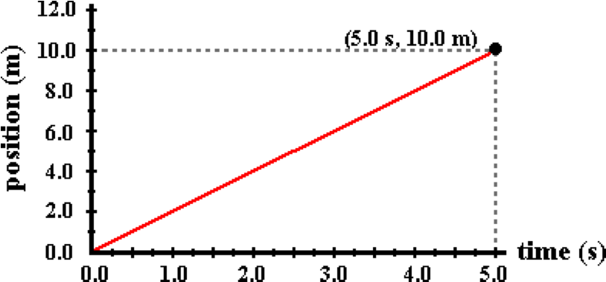

Include a numerical answer accurate to the second decimal place. If negative, include the - sign.

Question 2:
aa. Determine the slope (in m/s) of the following graph.

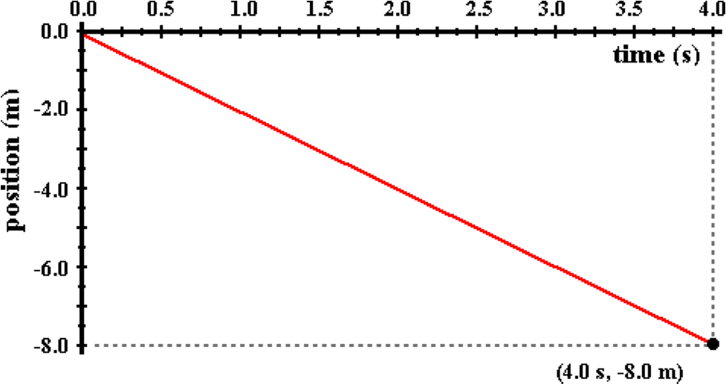

Include a numerical answer accurate to the second decimal place. If negative, include the - sign.

Question 3:
aa. Determine the slope (in m/s) of the following graph.

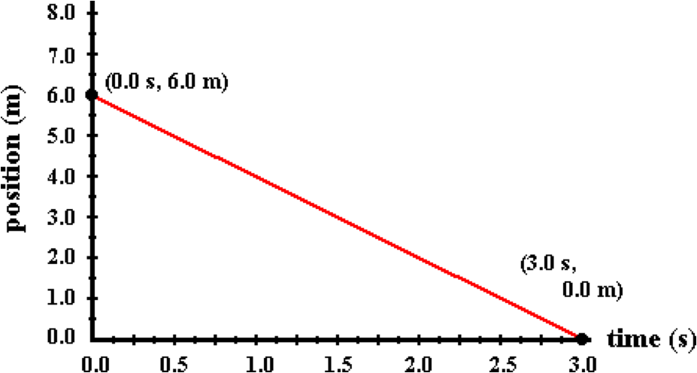

Include a numerical answer accurate to the second decimal place. If negative, include the - sign.

Question 4:
aa. Determine the slope (in m/s) of the following graph.

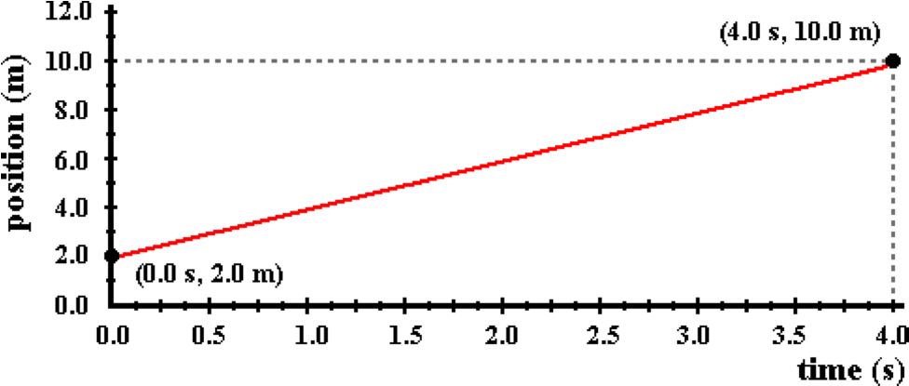

Include a numerical answer accurate to the second decimal place. If negative, include the - sign.

Question 5:
aa. Determine the slope (in m/s) of the following graph.

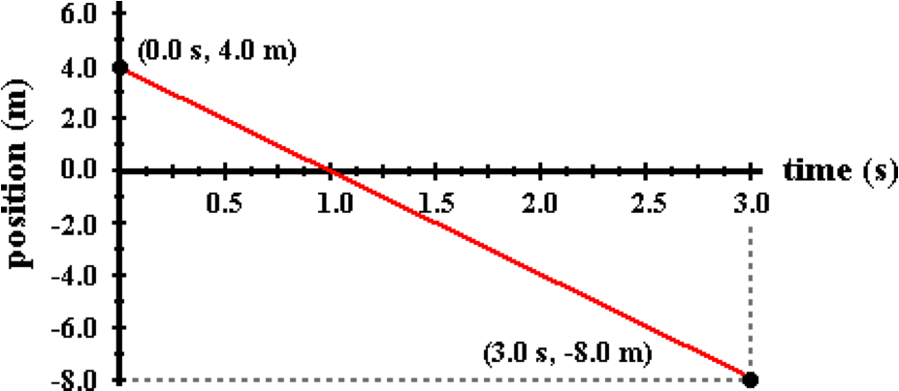

Include a numerical answer accurate to the second decimal place. If negative, include the - sign.

Question 6:
aa. Determine the slope (in m/s) of the following graph.

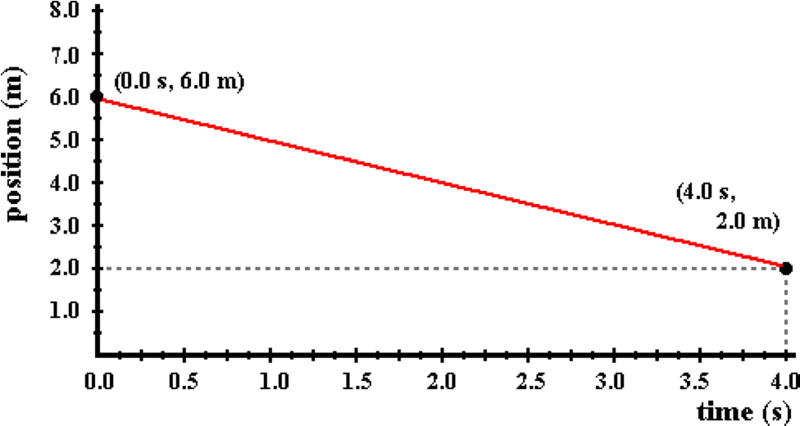

Include a numerical answer accurate to the second decimal place. If negative, include the - sign.

Question 7:
aa. The motion of an object is depicted by the position-time graph below.

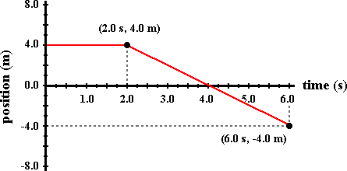

Determine the velocity (in m/s) of the object during the last four seconds. Include a numerical answer accurate to the second decimal place. If negative, include the - sign.

Question 8:
aa. The motion of an object is depicted by the position-time graph below.

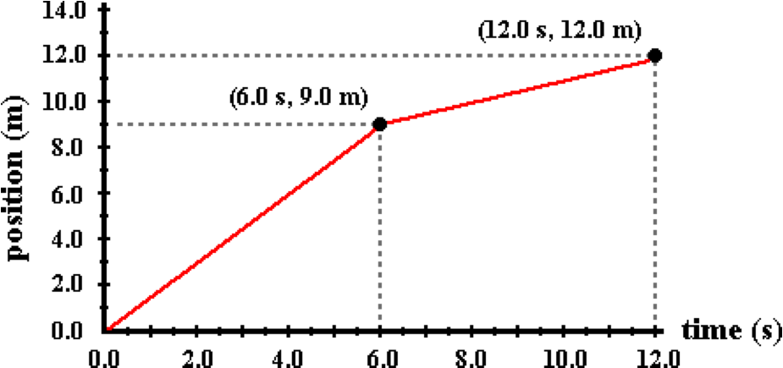

Determine the velocity (in m/s) of the object during the last six seconds. Include a numerical answer accurate to the second decimal place. If negative, include the - sign.

Question 9:
aa. The motion of an object is depicted by the position-time graph below.

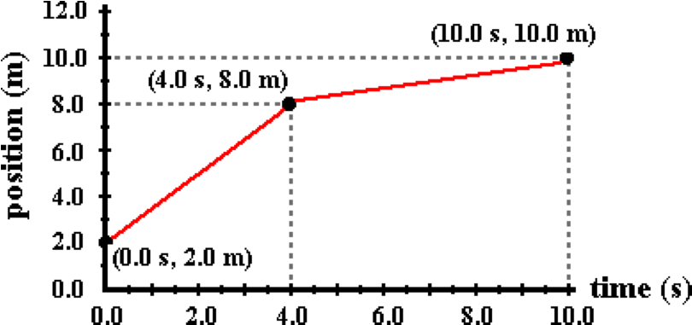

Determine the velocity (in m/s) of the object during the last six seconds. Include a numerical answer accurate to the second decimal place. If negative, include the - sign.

Question 10:
aa. The motion of an object is depicted by the position-time graph below.

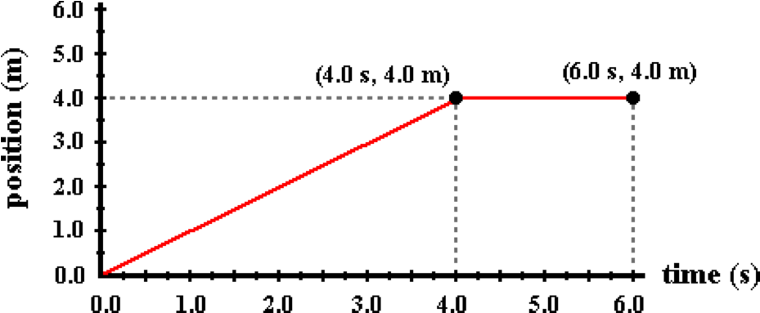

Determine the velocity (in m/s) of the object during the first four seconds. Include a numerical answer accurate to the second decimal place. If negative, include the - sign.

Question 11:
aa. The motion of an object is depicted by the position-time graph below.

Determine the velocity (in m/s) of the object during the first six seconds. Include a numerical answer accurate to the second decimal place. If negative, include the - sign.

Question 12:
aa. The motion of an object is depicted by the position-time graph below.

Determine the velocity (in m/s) of the object during the first four seconds. Include a numerical answer accurate to the second decimal place. If negative, include the - sign.

Question 13:
aa. The motion of an object moving with a constant velocity is depicted below.

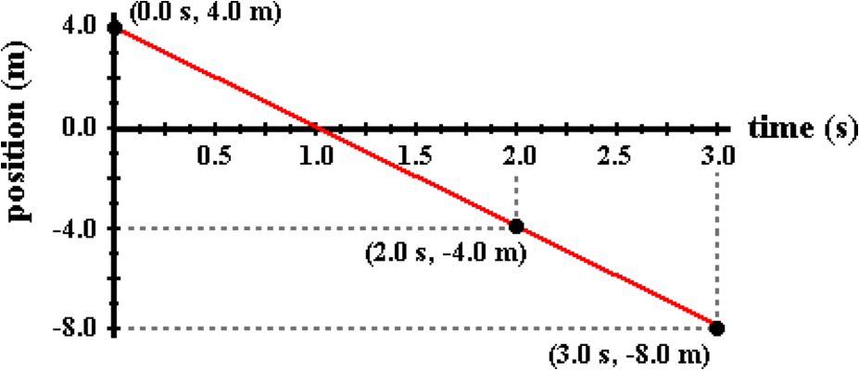

Determine the velocity (in m/s) of the object during the first two seconds. Include a numerical answer accurate to the second decimal place. If negative, include the - sign.

Question 14:
aa. The motion of an object moving with a constant velocity is depicted below.

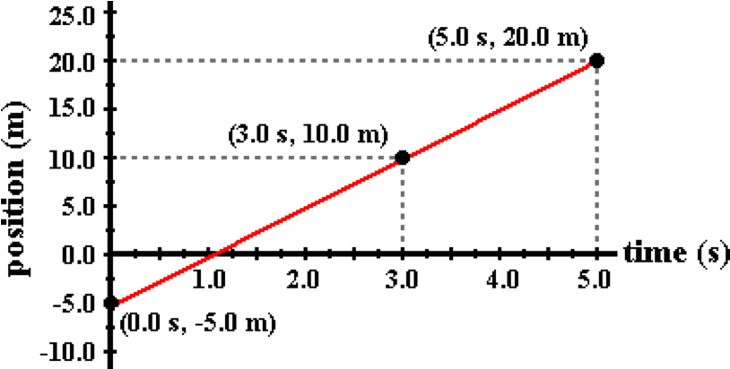

Determine the velocity (in m/s) of the object during the first three seconds. Include a numerical answer accurate to the second decimal place. If negative, include the - sign.

Question 15:
aa. The motion of an object moving with a constant velocity is depicted below.

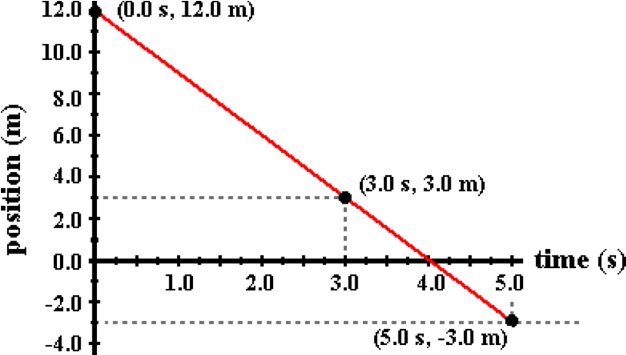

Determine the velocity (in m/s) of the object during the first three seconds. Include a numerical answer accurate to the second decimal place. If negative, include the - sign.

Question 16:
aa. The motion of an object is depicted by the position-time graph below.

Determine the velocity (in m/s) of the object at 8.0 seconds. Include a numerical answer accurate to the second decimal place. If negative, include the - sign.

Question 17:
aa. The motion of an object is depicted by the position-time graph below.

Determine the velocity (in m/s) of the object at 10.0 seconds. Include a numerical answer accurate to the second decimal place. If negative, include the - sign.

Question 18:
aa. The motion of an object is depicted by the position-time graph below.

Determine the velocity (in m/s) of the object at 3.0 seconds. Include a numerical answer accurate to the second decimal place. If negative, include the - sign.

KG5: Basics of Velocity-Time Graphs

Question 1:
aa. The slope of a velocity-time graph represents the _____ of the object.
a. displacement b. velocity
c. acceleration d. position
e. none of these

Question 2:
aa. The slope of a velocity-time graph represents the _____ of the object.
a. velocity b. displacement
c. position d. acceleration
e. none of these

Question 3:
aa. The slope of a velocity-time graph represents the _____ of the object.
a. position b. displacement
c. acceleration d. velocity
e. none of these

Question 4:
aa. The slope of a velocity-time graph represents the _____ of the object.
a. acceleration b. velocity
c. displacement d. position
e. none of these

Question 5:
aa. The area under the line of a velocity-time graph represents the _____ of the object.
a. displacement b. velocity
c. acceleration d. position
e. none of these

Question 6:
aa. The area under the line of a velocity-time graph represents the _____ of the object.
a. velocity b. displacement
c. position d. acceleration
e. none of these

Question 7:
aa. The area under the line of a velocity-time graph represents the _____ of the object.
a. position b. displacement
c. acceleration d. velocity
e. none of these

Question 8:
aa. The area under the line of a velocity-time graph represents the _____ of the object.
a. acceleration b. velocity
c. displacement d. position
e. none of these

Question 9:
aa. Which one of the following represents the acceleration of an object?
a. The slope of a position-time graph.
b. The slope of a velocity-time graph.
c. The area under the line of a position-time graph.
d. The area under the line of a velocity-time graph.
e. The slope of an acceleration-time graph.
f. none of these

Question 10:
aa. Which one of the following represents the acceleration of an object?
a. The slope of an acceleration-time graph.
b. The slope of a position-time graph.
c. The slope of a velocity-time graph.
d. The area under the line of a velocity-time graph.
e. The area under the line of a position-time graph.
f. none of these

Question 11:
aa. Which one of the following represents the acceleration of an object?
a. The area under the line of a velocity-time graph.
b. The area under the line of a position-time graph.
c. The slope of an acceleration-time graph.
d. The slope of a velocity-time graph.
e. The slope of a position-time graph.
f. none of these

Question 12:
aa. Which one of the following represents the acceleration of an object?
a. The area under the line of a position-time graph.
b. The area under the line of a velocity-time graph.
c. The slope of a position-time graph.
d. The slope of an acceleration-time graph.
e. The slope of a velocity-time graph.

Question 13:
aa. Which one of the following represents the displacement of an object?
a. The slope of a position-time graph.
b. The slope of a velocity-time graph.
c. The area under the line of a position-time graph.
d. The area under the line of a velocity-time graph.
e. The slope of an acceleration-time graph.
f. none of these

Question 14:
aa. Which one of the following represents the displacement of an object?
a. The slope of an acceleration-time graph.
b. The slope of a position-time graph.
c. The slope of a velocity-time graph.
d. The area under the line of a velocity-time graph.
e. The area under the line of a position-time graph.
f. none of these

Question 15:
aa. Which one of the following represents the displacement of an object?
a. The area under the line of a velocity-time graph.
b. The area under the line of a position-time graph.
c. The slope of an acceleration-time graph.
d. The slope of a velocity-time graph.
e. The slope of a position-time graph.
f. none of these

Question 16:
aa. Which one of the following represents the displacement of an object?
a. The area under the line of a position-time graph.
b. The area under the line of a velocity-time graph.
c. The slope of a position-time graph.
d. The slope of an acceleration-time graph.
e. The slope of a velocity-time graph.

Question 17:
aa. The velocity-time graph for an object with a constant positive acceleration would be a line ____.
a. with no slope
b. that is straight and has positive slope
c. that has changing slope
d. that curves upward
e. that curves, either upward or downward

Question 18:
aa. The velocity-time graph for an object with a constant positive acceleration would be a line ____.
a. that has changing slope
b. with no slope
c. that is straight and has positive slope
d. that curves, either upward or downward
e. that curves upward

Question 19:
aa. The velocity-time graph for an object with a constant positive acceleration would be a line ____.
a. that curves upward
b. that curves, either upward or downward
c. with no slope
d. that is straight and has positive slope
e. that has changing slope

Question 20:
aa. The velocity-time graph for an object with a constant positive acceleration would be a line ____.
a. that curves upward
b. that curves, either upward or downward
c. that has changing slope
d. with no slope
e. that is straight and has positive slope

Question 21:
aa. The velocity-time graph for an object with a constant negative acceleration would be a line ____.
a. with no slope
b. that is straight and has negative slope
c. that has changing slope
d. that curves downward
e. that curves, either upward or downward

Question 22:
aa. The velocity-time graph for an object with a constant negative acceleration would be a line ____.
a. that has changing slope
b. with no slope
c. that is straight and has negative slope
d. that curves, either upward or downward
e. that curves downward

Question 23:
aa. The velocity-time graph for an object with a constant negative acceleration would be a line ____.
a. that curves downward
b. that curves, either upward or downward
c. with no slope
d. that is straight and has negative slope
e. that has changing slope

Question 24:
aa. The velocity-time graph for an object with a constant negative acceleration would be a line ____.
a. which curves downward
b. that curves, either upward or downward
c. that has changing slope
d. with no slope
e. that is straight and has negative slope

Question 25:
aa. The velocity-time graph for an object with a constant large acceleration would be a line ____.
a. with no slope
b. with an upward slope
c. that has an increasing slope
d. that is straight and has a large slope
e. that is curved upwards
f. that is curved downwards

Question 26:
aa. The velocity-time graph for an object with a constant large acceleration would be a line ____.
a. with an upward slope
b. with no slope
c. that is straight and has a large slope
d. that has an increasing slope
e. that is curved downwards
f. that is curved upwards

Question 27:
aa. The velocity-time graph for an object with a constant large acceleration would be a line ____.
a. that is curved upwards
b. that is curved downwards
c. with no slope
d. with an upward slope
e. that has an increasing slope
f. that is straight and has a large slope

Question 28:
aa. The velocity-time graph for an object with a constant large acceleration would be a line ____.
a. that is curved upwards
b. that is curved downwards
c. with no slope
d. with an upward slope
e. that is straight and has a large slope
f. that has an increasing slope

Question 29:
aa. The velocity-time graph for an object with a constant small acceleration would be a line ____.
a. that is curved upwards
b. that is curved downwards
c. with no slope
d. with an upward slope
e. that has an increasing slope
f. that is straight and has a small slope

Question 30:
aa. The velocity-time graph for an object with a constant small acceleration would be a line ____.
a. that is curved downwards
b. that is curved upwards
c. with an upward slope
d. with no slope
e. that is straight and has a small slope
f. that has an increasing slope

Question 31:
aa. The velocity-time graph for an object with a constant small acceleration would be a line ____.
a. that has an increasing slope
b. that is straight and has a small slope
c. that is curved upwards
d. that is curved downwards
e. with no slope
f. with an upward slope

Question 32:
aa. The velocity-time graph for an object with a constant small acceleration would be a line ____.
a. that is straight and has a small slope
b. that has an increasing slope
c. that is curved downwards
d. that is curved upwards
e. with an upward slope
f. with no slope

Question 33:
aa. The velocity-time graph for an object with an acceleration of zero would be a line with____.
a. a zero slope
b. an upward slope
c. a constant positive slope
d. a constant slope, either positive or negative
e. a changing slope
f. a changing slope

Question 34:
aa. The velocity-time graph for an object with an acceleration of zero would be a line with____.
a. an upward slope
b. a zero slope
c. a constant slope, either positive or negative
d. a constant positive slope
e. a changing slope
f. a changing slope

Question 35:
aa. The velocity-time graph for an object with an acceleration of zero would be a line with____.
a. a changing slope
b. a changing slope
c. an upward slope
d. a zero slope
e. a constant slope, either positive or negative
f. a constant positive slope

Question 36:
aa. The velocity-time graph for an object with an acceleration of zero would be a line with____.
a. a constant slope, either positive or negative
b. a constant positive slope
c. a changing slope
d. a changing slope
e. an upward slope
f. a zero slope

Question 37:
aa. The velocity-time graph for an object with an acceleration that is changing would be a line ____.
a. with a zero slope
b. with an upward slope
c. with a constant positive slope
d. with a constant slope, either positive or negative
e. with a changing slope
f. that is straight and diagonal

Question 38:
aa. The velocity-time graph for an object with an acceleration that is changing would be a line ____.
a. with an upward slope
b. with a zero slope
c. with a constant slope, either positive or negative
d. with a constant positive slope
e. that is straight and diagonal
f. with a changing slope

Question 39:
aa. The velocity-time graph for an object with an acceleration that is changing would be a line ____.
a. that is straight and diagonal
b. with a constant slope, either positive or negative
c. with a constant positive slope
d. with a changing slope
e. with an upward slope
f. with a zero slope

Question 40:
aa. The velocity-time graph for an object with an acceleration that is changing would be a line ____.
a. with a changing slope
b. that is straight and diagonal
c. with a constant slope, either positive or negative
d. with a constant positive slope
e. with an upward slope
f. with a zero slope

KG6: Interpreting Velocity-Time Graphs

Question 1:
aa. The motion of an object is depicted by a velocity-time graph.

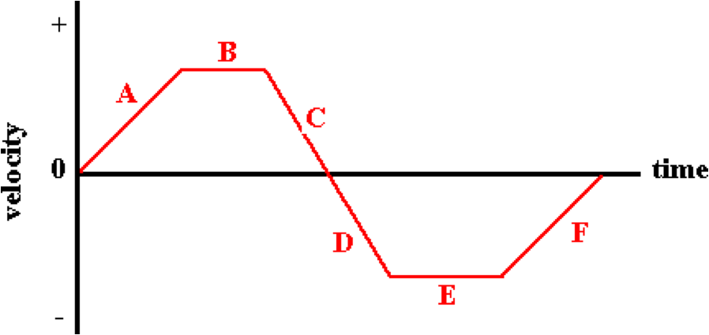

Various time intervals during the motion are depicted by a letter. During which time interval(s) is the object moving with a positive velocity? List all that apply in alphabetical order with no spaces between letters.

Question 2:
aa. The motion of an object is depicted by a velocity-time graph.

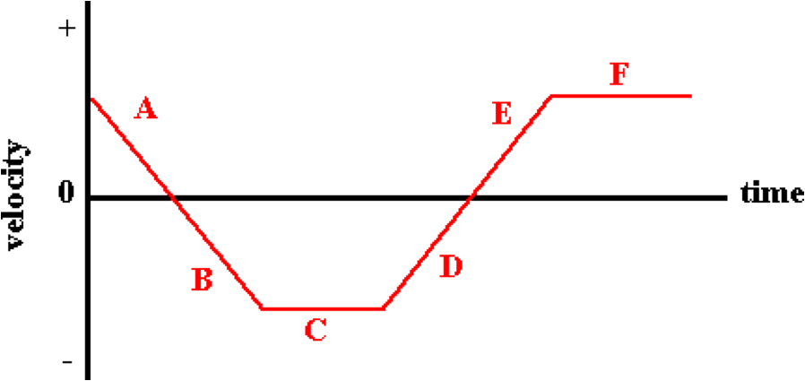

Various time intervals during the motion are depicted by a letter. During which time interval(s) is the object moving with a positive velocity? List all that apply in alphabetical order with no spaces between letters.

Question 3:
aa. The motion of an object is depicted by a velocity-time graph.

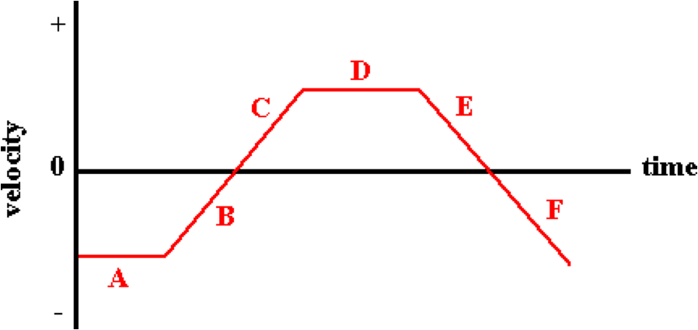

Various time intervals during the motion are depicted by a letter. During which time interval(s) is the object moving with a positive velocity? List all that apply in alphabetical order with no spaces between letters.

Question 4:
aa. The motion of an object is depicted by a velocity-time graph.

Various time intervals during the motion are depicted by a letter. During which time interval(s) is the object moving with a negative velocity? List all that apply in alphabetical order with no spaces between letters.

Question 5:
aa. The motion of an object is depicted by a velocity-time graph.

Various time intervals during the motion are depicted by a letter. During which time interval(s) is the object moving with a negative velocity? List all that apply in alphabetical order with no spaces between letters.

Question 6:
aa. The motion of an object is depicted by a velocity-time graph.

Various time intervals during the motion are depicted by a letter. During which time interval(s) is the object moving with a negative velocity? List all that apply in alphabetical order with no spaces between letters.

Question 7:
aa. The motion of an object is depicted by a velocity-time graph.

Various time intervals during the motion are depicted by a letter. During which time interval(s) is the object moving with a constant velocity? List all that apply in alphabetical order with no spaces between letters.

Question 8:
aa. The motion of an object is depicted by a velocity-time graph.

Various time intervals during the motion are depicted by a letter. During which time interval(s) is the object moving with a constant velocity? List all that apply in alphabetical order with no spaces between letters.

Question 9:
aa. The motion of an object is depicted by a velocity-time graph.

Various time intervals during the motion are depicted by a letter. During which time interval(s) is the object moving with a constant velocity? List all that apply in alphabetical order with no spaces between letters.

Question 10:
aa. The motion of an object is depicted by a velocity-time graph.

Various time intervals during the motion are depicted by a letter. During which time interval(s) is the object moving with a changing velocity? List all that apply in alphabetical order with no spaces between letters.

Question 11:
aa. The motion of an object is depicted by a velocity-time graph.

Various time intervals during the motion are depicted by a letter. During which time interval(s) is the object moving with a changing velocity? List all that apply in alphabetical order with no spaces between letters.

Question 12:
aa. The motion of an object is depicted by a velocity-time graph.

Various time intervals during the motion are depicted by a letter. During which time interval(s) is the object moving with a changing velocity? List all that apply in alphabetical order with no spaces between letters.

Question 13:
aa. The motion of an object is depicted by a velocity-time graph.

Various time intervals during the motion are depicted by a letter. During which time interval(s) is the object moving with a positive acceleration? List all that apply in alphabetical order with no spaces between letters.

Question 14:
aa. The motion of an object is depicted by a velocity-time graph.

Various time intervals during the motion are depicted by a letter. During which time interval(s) is the object moving with a positive acceleration? List all that apply in alphabetical order with no spaces between letters.

Question 15:
aa. The motion of an object is depicted by a velocity-time graph.

Various time intervals during the motion are depicted by a letter. During which time interval(s) is the object moving with a positive acceleration? List all that apply in alphabetical order with no spaces between letters.

Question 16:
aa. The motion of an object is depicted by a velocity-time graph.

Various time intervals during the motion are depicted by a letter. During which time interval(s) is the object moving with a negative acceleration? List all that apply in alphabetical order with no spaces between letters.

Question 17:
aa. The motion of an object is depicted by a velocity-time graph.

Various time intervals during the motion are depicted by a letter. During which time interval(s) is the object moving with a negative acceleration? List all that apply in alphabetical order with no spaces between letters.

Question 18:
aa. The motion of an object is depicted by a velocity-time graph.

Various time intervals during the motion are depicted by a letter. During which time interval(s) is the object moving with a negative acceleration? List all that apply in alphabetical order with no spaces between letters.

Question 19:
aa. The motion of an object is depicted by a velocity-time graph.

Various time intervals during the motion are depicted by a letter. During which time interval(s) is the object speeding up (getting faster)? List all that apply in alphabetical order with no spaces between letters.

Question 20:
aa. The motion of an object is depicted by a velocity-time graph.

Various time intervals during the motion are depicted by a letter. During which time interval(s) is the object speeding up (getting faster)? List all that apply in alphabetical order with no spaces between letters.

Question 21:
aa. The motion of an object is depicted by a velocity-time graph.

Various time intervals during the motion are depicted by a letter. During which time interval(s) is the object speeding up (getting faster)? List all that apply in alphabetical order with no spaces between letters.

Question 22:
aa. The motion of an object is depicted by a velocity-time graph.

Various time intervals during the motion are depicted by a letter. During which time interval(s) is the object moving with slowing down (getting slower)? List all that apply in alphabetical order with no spaces between letters.

Question 23:
aa. The motion of an object is depicted by a velocity-time graph.

Various time intervals during the motion are depicted by a letter. During which time interval(s) is the object moving with slowing down (getting slower)? List all that apply in alphabetical order with no spaces between letters.

Question 24:
aa. The motion of an object is depicted by a velocity-time graph.

Various time intervals during the motion are depicted by a letter. During which time interval(s) is the object moving with slowing down (getting slower)? List all that apply in alphabetical order with no spaces between letters.

KG7: Interpreting Velocity-Time Graphs

Question 1:
aa. The motion of six objects - A, B, C, D, E, and F - are represented by lines on a velocity-time graph.

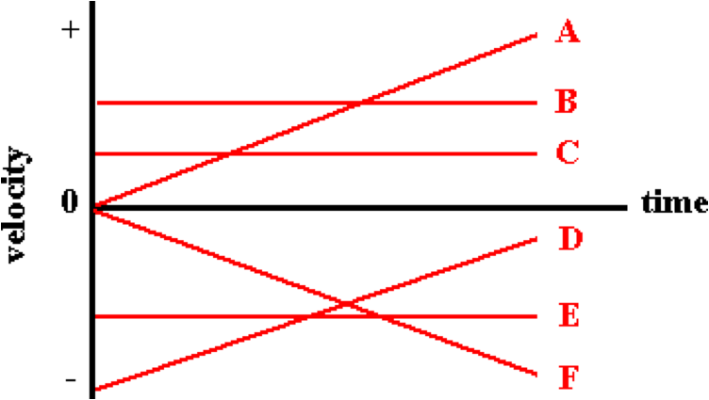

Write the letter(s) for any object which has a constant velocity (for the entire motion). List all that apply in alphabetical order with no spaces between letters. If there are no instances of a constant velocity, then enter 'Z' as the answer.

Question 2:
aa. The motion of six objects - A, B, C, D, E, and F - are represented by lines on a velocity-time graph.

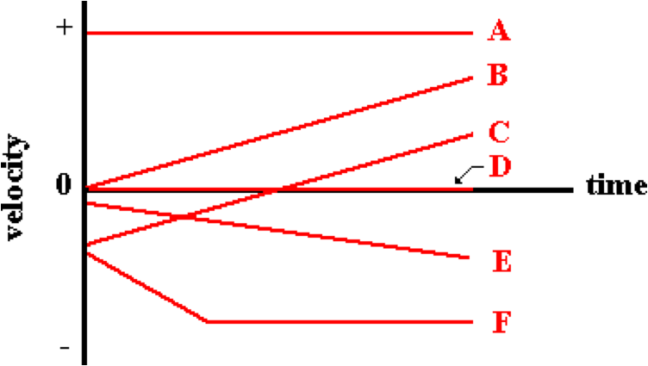

Write the letter(s) for any object which has a constant velocity (for the entire motion). List all that apply in alphabetical order with no spaces between letters. If there are no instances of a constant velocity, then enter 'Z' as the answer.

Question 3:
aa. The motion of six objects - A, B, C, D, E, and F - are represented by lines on a velocity-time graph.

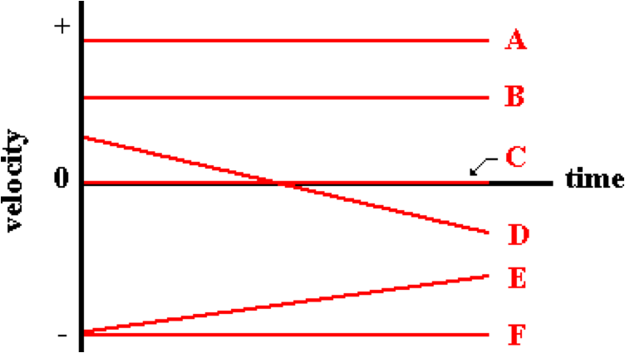

Write the letter(s) for any object which has a constant velocity (for the entire motion). List all that apply in alphabetical order with no spaces between letters. If there are no instances of a constant velocity, then enter 'Z' as the answer.

Question 4:
aa. The motion of six objects - A, B, C, D, E, and F - are represented by lines on a velocity-time graph.

Write the letter(s) for any object which has a positive velocity (for the entire motion). List all that apply in alphabetical order with no spaces between letters. If there are no instances of a positive velocity, then enter 'Z' as the answer.

Question 5:
aa. The motion of six objects - A, B, C, D, E, and F - are represented by lines on a velocity-time graph.

Write the letter(s) for any object which has a positive velocity (for the entire motion). List all that apply in alphabetical order with no spaces between letters. If there are no instances of a positive velocity, then enter 'Z' as the answer.

Question 6:
aa. The motion of six objects - A, B, C, D, E, and F - are represented by lines on a velocity-time graph.

Write the letter(s) for any object which has a positive velocity (for the entire motion). List all that apply in alphabetical order with no spaces between letters. If there are no instances of a positive velocity, then enter 'Z' as the answer.

Question 7:
aa. The motion of six objects - A, B, C, D, E, and F - are represented by lines on a velocity-time graph.

Write the letter(s) for any object which has a negative velocity (for the entire motion). List all that apply in alphabetical order with no spaces between letters. If there are no instances of a negative velocity, then enter 'Z' as the answer.

Question 8:
aa. The motion of six objects - A, B, C, D, E, and F - are represented by lines on a velocity-time graph.

Write the letter(s) for any object which has a negative velocity (for the entire motion). List all that apply in alphabetical order with no spaces between letters. If there are no instances of a negative velocity, then enter 'Z' as the answer.

Question 9:
aa. The motion of six objects - A, B, C, D, E, and F - are represented by lines on a velocity-time graph.

Write the letter(s) for any object which has a negative velocity (for the entire motion). List all that apply in alphabetical order with no spaces between letters. If there are no instances of a negative velocity, then enter 'Z' as the answer.

Question 10:
aa. The motion of six objects - A, B, C, D, E, and F - are represented by lines on a velocity-time graph.

Write the letter(s) for any object which is at rest (for the entire motion). List all that apply in alphabetical order with no spaces between letters. If there are no instances of an object at rest, then enter 'Z' as the answer.

Question 11:
aa. The motion of six objects - A, B, C, D, E, and F - are represented by lines on a velocity-time graph.

Write the letter(s) for any object which is at rest (for the entire motion). List all that apply in alphabetical order with no spaces between letters. If there are no instances of an object at rest, then enter 'Z' as the answer.

Question 12:
aa. The motion of six objects - A, B, C, D, E, and F - are represented by lines on a velocity-time graph.

Write the letter(s) for any object which is at rest (for the entire motion). List all that apply in alphabetical order with no spaces between letters. If there are no instances of an object at rest, then enter 'Z' as the answer.

Question 13:
aa. The motion of six objects - A, B, C, D, E, and F - are represented by lines on a velocity-time graph.

Write the letter(s) for any object which has a changing velocity. List all that apply in alphabetical order with no spaces between letters. If there are no instances of a changing velocity, then enter 'Z' as the answer.

Question 14:
aa. The motion of six objects - A, B, C, D, E, and F - are represented by lines on a velocity-time graph.

Write the letter(s) for any object which has a changing velocity (during at least some portion of its motion). List all that apply in alphabetical order with no spaces between letters. If there are no instances of a changing velocity, then enter 'Z' as the answer.

Question 15:
aa. The motion of six objects - A, B, C, D, E, and F - are represented by lines on a velocity-time graph.

Write the letter(s) for any object which has a changing velocity. List all that apply in alphabetical order with no spaces between letters. If there are no instances of a changing velocity, then enter 'Z' as the answer.

Question 16:
aa. The motion of six objects - A, B, C, D, E, and F - are represented by lines on a velocity-time graph.

Write the letter(s) for any object which changes its direction. List all that apply in alphabetical order with no spaces between letters. If there are no instances of a change in direction, then enter 'Z' as the answer.

Question 17:
aa. The motion of six objects - A, B, C, D, E, and F - are represented by lines on a velocity-time graph.

Write the letter(s) for any object which changes its direction. List all that apply in alphabetical order with no spaces between letters. If there are no instances of a change in direction, then enter 'Z' as the answer.

Question 18:
aa. The motion of six objects - A, B, C, D, E, and F - are represented by lines on a velocity-time graph.

Write the letter(s) for any object which changes its direction. List all that apply in alphabetical order with no spaces between letters. If there are no instances of a change in direction, then enter 'Z' as the answer.

Question 19:
aa. The motion of six objects - A, B, C, D, E, and F - are represented by lines on a velocity-time graph.

Write the letter(s) for any object which has a constant, positive acceleration. List all that apply in alphabetical order with no spaces between letters. If there are no instances of a constant, positive acceleration, then enter 'Z' as the answer.

Question 20:
aa. The motion of six objects - A, B, C, D, E, and F - are represented by lines on a velocity-time graph.

Write the letter(s) for any object which has a constant, positive acceleration. List all that apply in alphabetical order with no spaces between letters. If there are no instances of a constant, positive acceleration, then enter 'Z' as the answer.

Question 21:
aa. The motion of six objects - A, B, C, D, E, and F - are represented by lines on a velocity-time graph.

Write the letter(s) for any object which has a constant, positive acceleration. List all that apply in alphabetical order with no spaces between letters. If there are no instances of a constant, positive acceleration, then enter 'Z' as the answer.

Question 22:
aa. The motion of six objects - A, B, C, D, E, and F - are represented by lines on a velocity-time graph.

Write the letter(s) for any object which has a constant, negative acceleration. List all that apply in alphabetical order with no spaces between letters. If there are no instances of a constant, negative acceleration, then enter 'Z' as the answer.

Question 23:
aa. The motion of six objects - A, B, C, D, E, and F - are represented by lines on a velocity-time graph.

Write the letter(s) for any object which has a constant, negative acceleration. List all that apply in alphabetical order with no spaces between letters. If there are no instances of a constant, negative acceleration (for the entire motion), then enter 'Z' as the answer.

Question 24:
aa. The motion of six objects - A, B, C, D, E, and F - are represented by lines on a velocity-time graph.

Write the letter(s) for any object which has a constant, negative acceleration. List all that apply in alphabetical order with no spaces between letters. If there are no instances of a constant, negative acceleration, then enter 'Z' as the answer.

Question 25:
aa. The motion of six objects - A, B, C, D, E, and F - are represented by lines on a velocity-time graph.

Write the letter(s) for any object which is speeding up (going faster) during the entire motion. List all that apply in alphabetical order with no spaces between letters. If there are no instances of speeding up, then enter 'Z' as the answer.

Question 26:
aa. The motion of six objects - A, B, C, D, E, and F - are represented by lines on a velocity-time graph.

Write the letter(s) for any object which is speeding up (going faster) during the entire motion. List all that apply in alphabetical order with no spaces between letters. If there are no instances of speeding up, then enter 'Z' as the answer.

Question 27:
aa. The motion of six objects - A, B, C, D, E, and F - are represented by lines on a velocity-time graph.

Write the letter(s) for any object which is speeding up (going faster) during the entire motion. List all that apply in alphabetical order with no spaces between letters. If there are no instances of speeding up, then enter 'Z' as the answer.

Question 28:
aa. The motion of six objects - A, B, C, D, E, and F - are represented by lines on a velocity-time graph.

Write the letter(s) for any object which is slowing down (going slower) during the entire motion. List all that apply in alphabetical order with no spaces between letters. If there are no instances of slowing down, then enter 'Z' as the answer.

Question 29:
aa. The motion of six objects - A, B, C, D, E, and F - are represented by lines on a velocity-time graph.

Write the letter(s) for any object which is slowing down (going slower) during the entire motion. List all that apply in alphabetical order with no spaces between letters. If there are no instances of slowing down, then enter 'Z' as the answer.

Question 30:
aa. The motion of six objects - A, B, C, D, E, and F - are represented by lines on a velocity-time graph.

Write the letter(s) for any object which is slowing down (going slower) during the entire motion. List all that apply in alphabetical order with no spaces between letters. If there are no instances of slowing down, then enter 'Z' as the answer.

KG8: Velocity-Time Graphs – Slope and Area Calculations

Question 1:
aa. If a velocity-time graph is given for an object's motion, then the acceleration of the object can be determined by ____.
a. calculating the area between the line and the axis
b. calculating the slope of the line
c. simply reading the value off the vertical axis
d. ... nonsense! Velocity-time graphs cannot be used to determine an object's acceleration.

Question 2:
aa. If a velocity-time graph is given for an object's motion, then the acceleration of the object can be determined by ____.
a. calculating the slope of the line
b. simply reading the value off the vertical axis
c. calculating the area between the line and the axis
d. ... nonsense! Velocity-time graphs cannot be used to determine an object's acceleration.

Question 3:
aa. If a velocity-time graph is given for an object's motion, then the acceleration of the object can be determined by ____.
a. simply reading the value off the vertical axis
b. calculating the area between the line and the axis
c. calculating the slope of the line
d. ... nonsense! Velocity-time graphs cannot be used to determine an object's acceleration.

Question 4:
aa. This velocity-time graph depicts the motion of an object.

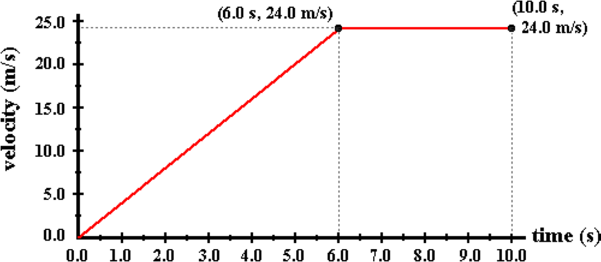

Use the graph to determine the acceleration (in m/s/s) of the object during the first 6.0 seconds. If negative, then enter a negative answer. Enter your answer accurate to the second decimal place.

Question 5:
aa. This velocity-time graph depicts the motion of an object.

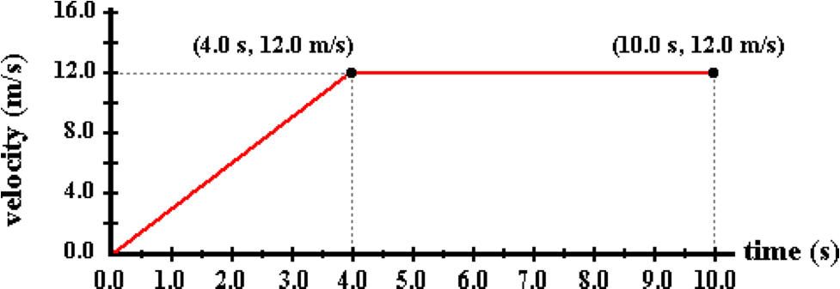

Use the graph to determine the acceleration (in m/s/s) of the object during the first 4.0 seconds. If negative, then enter a negative answer. Enter your answer accurate to the second decimal place.

Question 6:
aa. This velocity-time graph depicts the motion of an object.

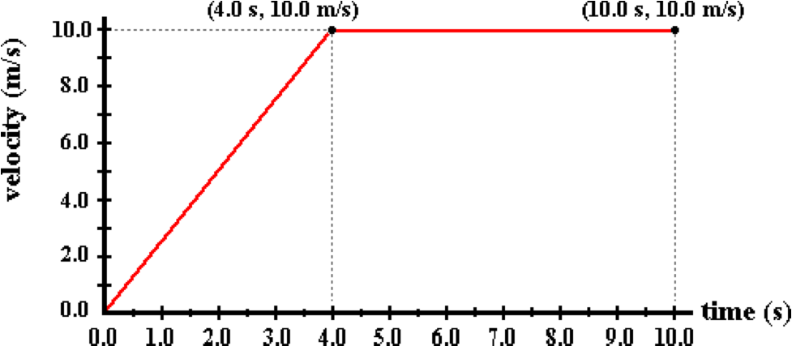

Use the graph to determine the acceleration (in m/s/s) of the object during the first 4.0 seconds. If negative, then enter a negative answer. Enter your answer accurate to the second decimal place.

Question 7:
aa. This velocity-time graph depicts the motion of an object.

Use the graph to determine the acceleration (in m/s/s) of the object during the first 4.0 seconds. If negative, then enter a negative answer. Enter your answer accurate to the second decimal place.

Question 8:
aa. This velocity-time graph depicts the motion of an object.

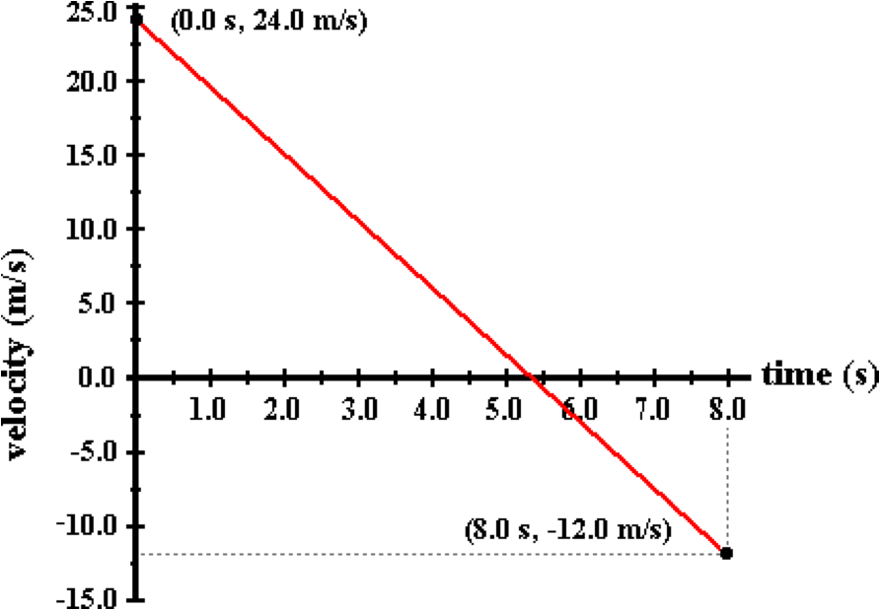

Use the graph to determine the acceleration (in m/s/s) of the object. If negative, then enter a negative answer. Enter your answer accurate to the second decimal place.

Question 9:
aa. This velocity-time graph depicts the motion of an object.

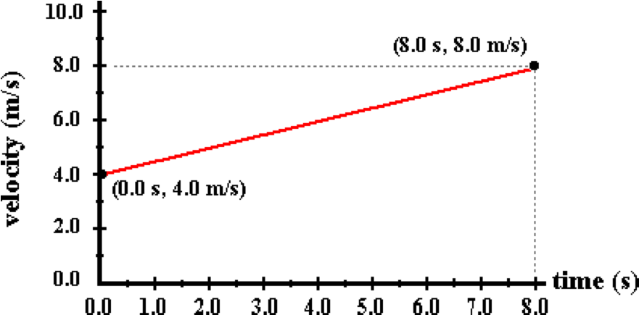

Use the graph to determine the acceleration (in m/s/s) of the object. If negative, then enter a negative answer. Enter your answer accurate to the second decimal place.

Question 10:
aa. This velocity-time graph depicts the motion of an object.

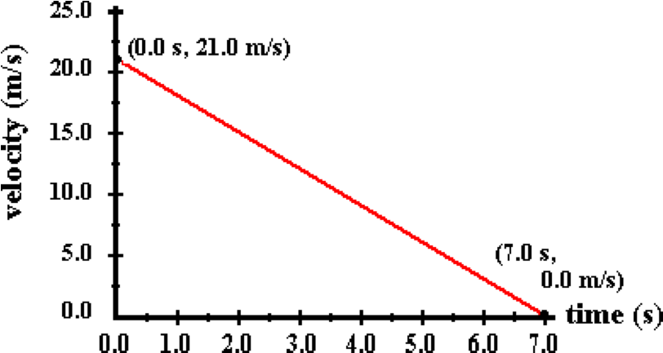

Use the graph to determine the acceleration (in m/s/s) of the object. If negative, then enter a negative answer. Enter your answer accurate to the second decimal place.

Question 11:
aa. This velocity-time graph depicts the motion of an object.

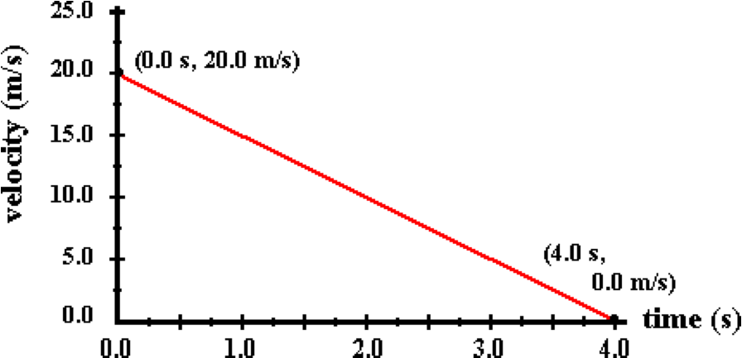

Use the graph to determine the acceleration (in m/s/s) of the object. If negative, then enter a negative answer. Enter your answer accurate to the second decimal place.

Question 12:
aa. This velocity-time graph depicts the motion of an object.

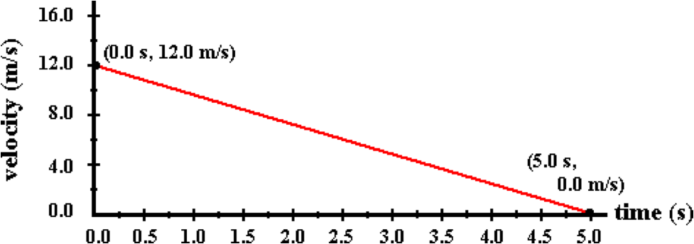

Use the graph to determine the acceleration (in m/s/s) of the object. If negative, then enter a negative answer. Enter your answer accurate to the second decimal place.

Question 13:
aa. This velocity-time graph depicts the motion of an object.

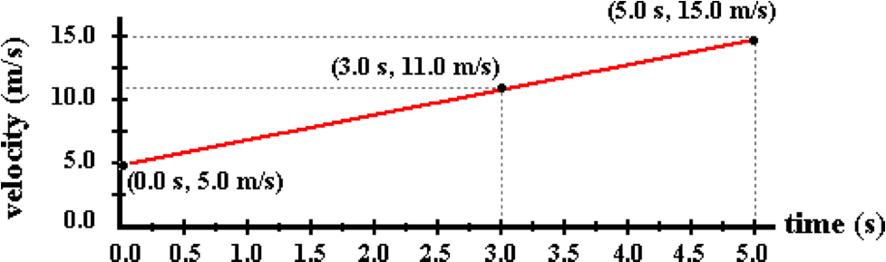

Use the graph to determine the acceleration (in m/s/s) of the object at 3.0 seconds. If negative, then enter a negative answer. Enter your answer accurate to the second decimal place.

Question 14:
aa. This velocity-time graph depicts the motion of an object.

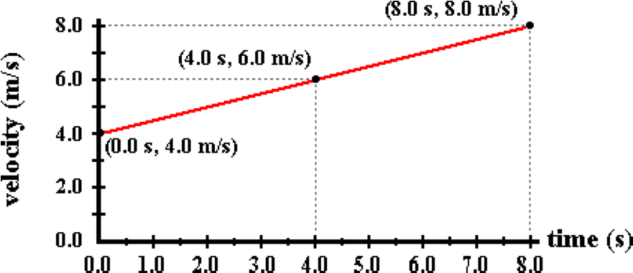

Use the graph to determine the acceleration (in m/s/s) of the object at 4.0 seconds. If negative, then enter a negative answer. Enter your answer accurate to the second decimal place.

Question 15:
aa. This velocity-time graph depicts the motion of an object.

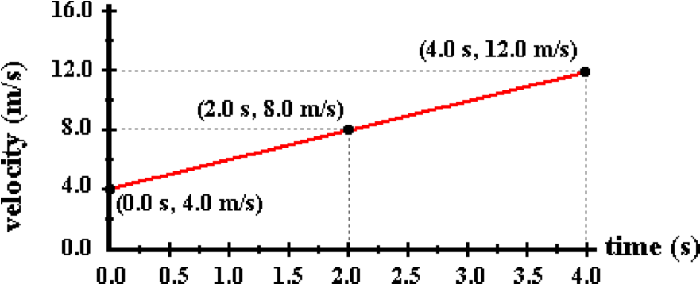

Use the graph to determine the acceleration (in m/s/s) of the object at 2.0 seconds. If negative, then enter a negative answer. Enter your answer accurate to the second decimal place.

Question 16:
aa. If a velocity-time graph is given for an object's motion, then the displacement of the object can be determined by ____.
a. calculating the area between the line and the axis
b. calculating the slope of the line
c. simply reading the value off the vertical axis
d. ... nonsense! Velocity-time graphs cannot be used to determine an object's displacement.

Question 17:
aa. If a velocity-time graph is given for an object's motion, then the displacement of the object can be determined by ____.
a. calculating the slope of the line
b. simply reading the value off the vertical axis
c. calculating the area between the line and the axis
d. ... nonsense! Velocity-time graphs cannot be used to determine an object's displacement.

Question 18:
aa. If a velocity-time graph is given for an object's motion, then the displacement of the object can be determined by ____.
a. simply reading the value off the vertical axis
b. calculating the area between the line and the axis
c. calculating the slope of the line
d. ... nonsense! Velocity-time graphs cannot be used to determine an object's displacement.

Question 19:
aa. This velocity-time graph depicts the motion of an object.

Use the graph to determine the displacement (in meters) of the object during the first 6.0 seconds. Enter your answer accurate to the second decimal place.

Question 20:
aa. This velocity-time graph depicts the motion of an object.

Use the graph to determine the displacement (in meters) of the object during the first 4.0 seconds. Enter your answer accurate to the second decimal place.

Question 21:
aa. This velocity-time graph depicts the motion of an object.

Use the graph to determine the displacement (in meters) of the object during the first 4.0 seconds. Enter your answer accurate to the second decimal place.

Question 22:
aa. This velocity-time graph depicts the motion of an object.

Use the graph to determine the displacement (in meters) of the object during the entire 5.0 seconds. Enter your answer accurate to the second decimal place.

Question 23:
aa. This velocity-time graph depicts the motion of an object.

Use the graph to determine the displacement (in meters) of the object during the entire 8.0 seconds. Enter your answer accurate to the second decimal place.

Question 24:
aa. This velocity-time graph depicts the motion of an object.

Use the graph to determine the displacement (in meters) of the object during the entire 4.0 seconds. Enter your answer accurate to the second decimal place.

Question 25:
aa. This velocity-time graph depicts the motion of an object.

Use the graph to determine the displacement (in meters) of the object during the entire 10.0 seconds. Enter your answer accurate to the second decimal place.

Question 26:
aa. This velocity-time graph depicts the motion of an object.

Use the graph to determine the displacement (in meters) of the object during the entire 10.0 seconds. Enter your answer accurate to the second decimal place.

Question 27:
aa. This velocity-time graph depicts the motion of an object.

Use the graph to determine the displacement (in meters) of the object during the entire 10.0 seconds. Enter your answer accurate to the second decimal place.

Question 28:
aa. This velocity-time graph depicts the motion of an object.

Use the graph to determine the displacement (in meters) of the object during the last 4.0 seconds. Enter your answer accurate to the second decimal place.

Question 29:
aa. This velocity-time graph depicts the motion of an object.

Use the graph to determine the displacement (in meters) of the object during the last 6.0 seconds. Enter your answer accurate to the second decimal place.

Question 30:
aa. This velocity-time graph depicts the motion of an object.

Use the graph to determine the displacement (in meters) of the object during the last 6.0 seconds. Enter your answer accurate to the second decimal place.

KG9: Graphs and Oil Drop Diagrams

Question 1:
aa. Match the oil drop representation below to the appropriate letter for a position-time graph. It is known that the object is moving toward the right (where rightward is the positive direction).

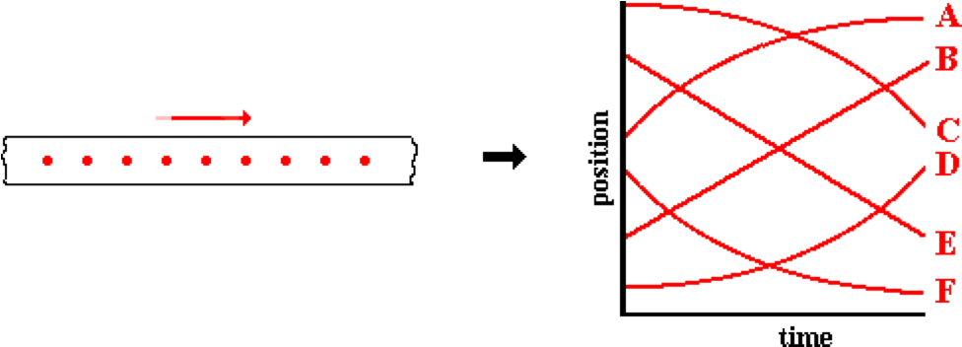

Question 2:
aa. Match the oil drop representation below to the appropriate letter for a position-time graph. It is known that the object is moving toward the right (where rightward is the positive direction).

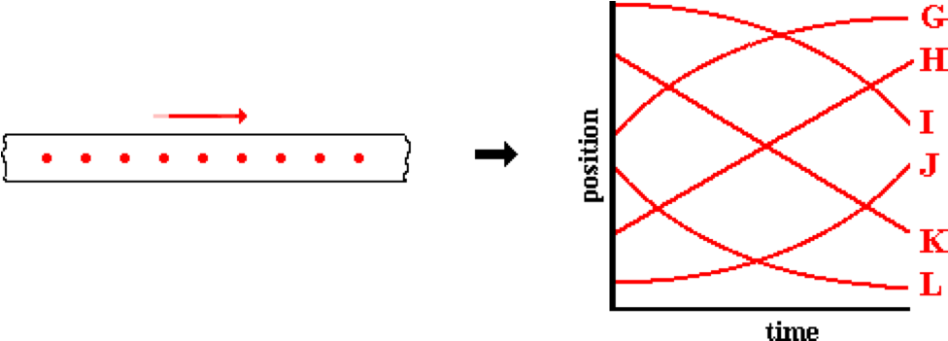

Question 3:
aa. Match the oil drop representation below to the appropriate letter for a position-time graph. It is known that the object is moving toward the left (where leftward is the negative direction).

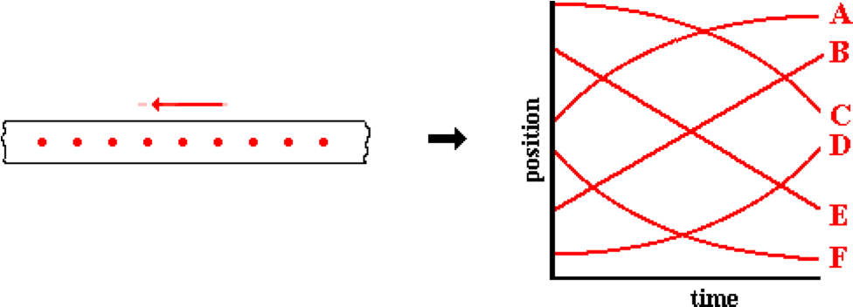

Question 4:
aa. Match the oil drop representation below to the appropriate letter for a position-time graph. It is known that the object is moving toward the left (where leftward is the negative direction).

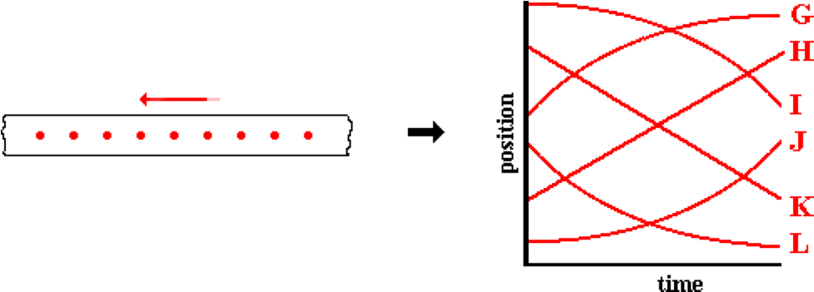

Question 5:
aa. Match the oil drop representation below to the appropriate letter for a position-time graph. It is known that the object is moving toward the right (where rightward is the positive direction).

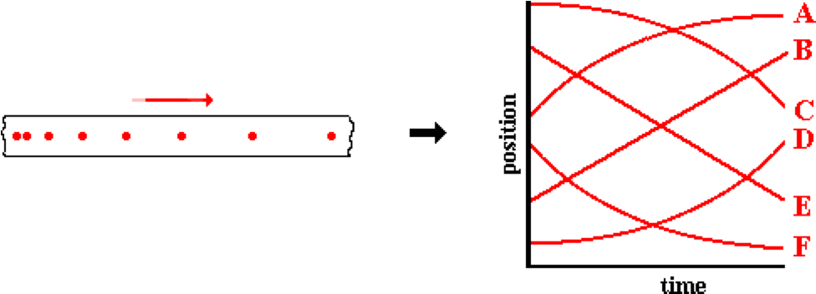

Question 6:
aa. Match the oil drop representation below to the appropriate letter for a position-time graph. It is known that the object is moving toward the right (where rightward is the positive direction).

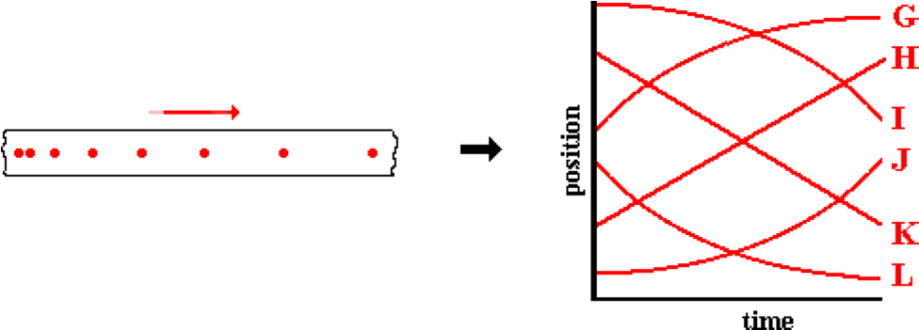

Question 7:
aa. Match the oil drop representation below to the appropriate letter for a position-time graph. It is known that the object is moving toward the right (where rightward is the positive direction).

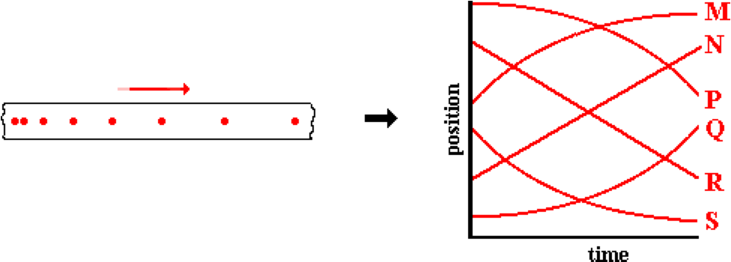

Question 8:
aa. Match the oil drop representation below to the appropriate letter for a position-time graph. It is known that the object is moving toward the right (where rightward is the positive direction).

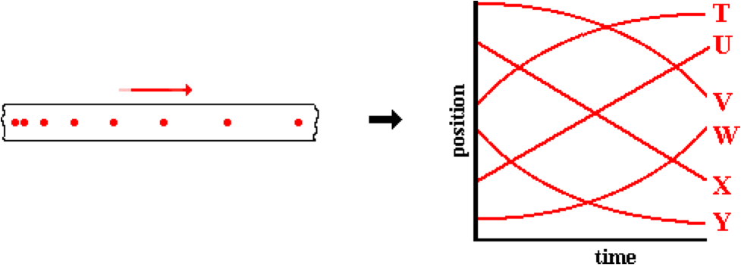

Question 9:
aa. Match the oil drop representation below to the appropriate letter for a position-time graph. It is known that the object is moving toward the right (where rightward is the positive direction).

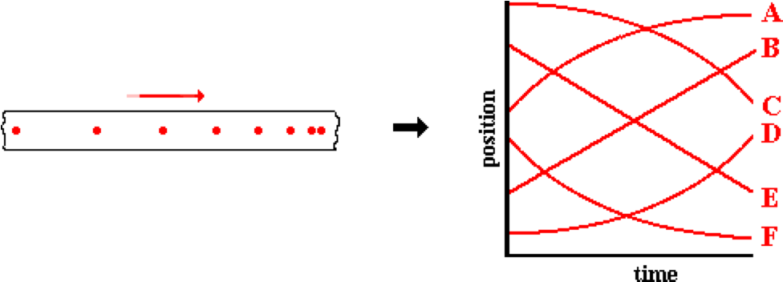

Question 10:
aa. Match the oil drop representation below to the appropriate letter for a position-time graph. It is known that the object is moving toward the right (where rightward is the positive direction).

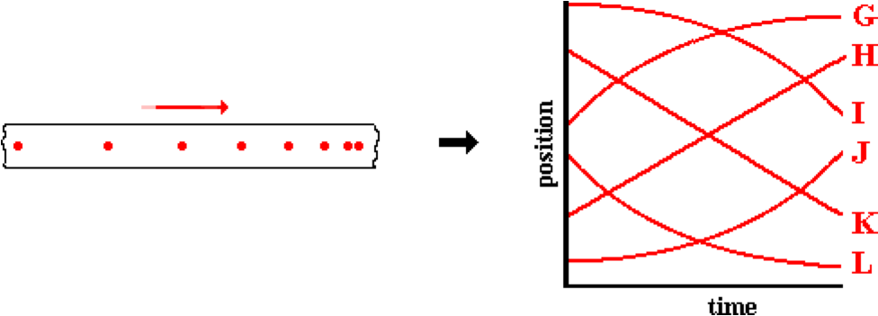

Question 11:
aa. Match the oil drop representation below to the appropriate letter for a position-time graph. It is known that the object is moving toward the right (where rightward is the positive direction).

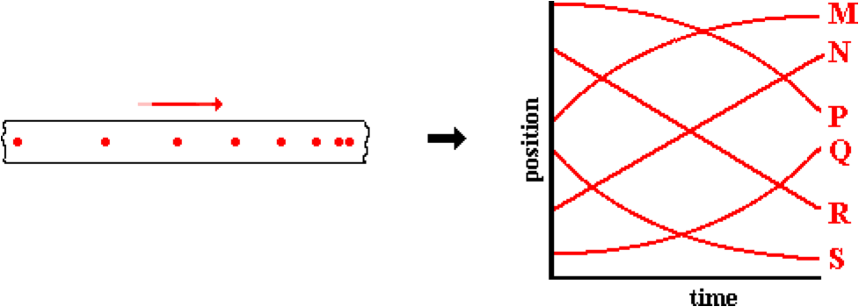

Question 12:
aa. Match the oil drop representation below to the appropriate letter for a position-time graph. It is known that the object is moving toward the right (where rightward is the positive direction).

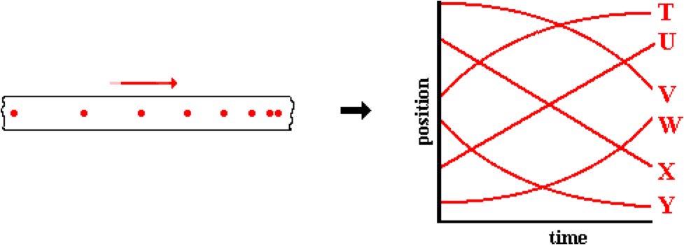

Question 13:
aa. Match the oil drop representation below to the appropriate letter for a position-time graph. It is known that the object is moving toward the left (where leftward is the negative direction).

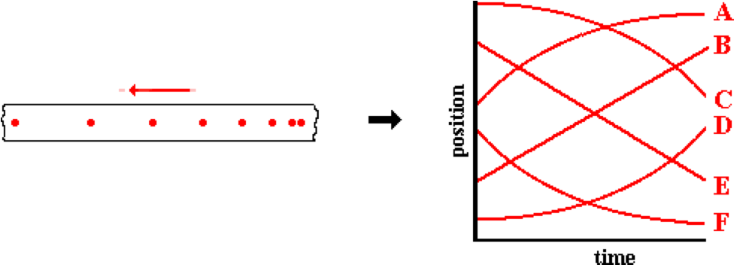

Question 14:
aa. Match the oil drop representation below to the appropriate letter for a position-time graph. It is known that the object is moving toward the left (where leftward is the negative direction).

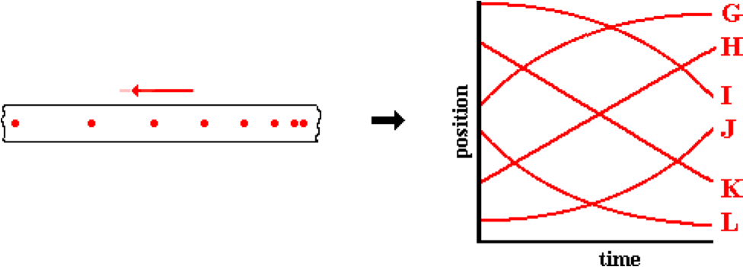

Question 15:
aa. Match the oil drop representation below to the appropriate letter for a position-time graph. It is known that the object is moving toward the left (where leftward is the negative direction).

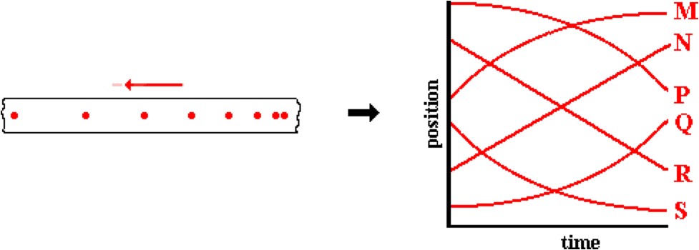

Question 16:
aa. Match the oil drop representation below to the appropriate letter for a position-time graph. It is known that the object is moving toward the left (where leftward is the negative direction).

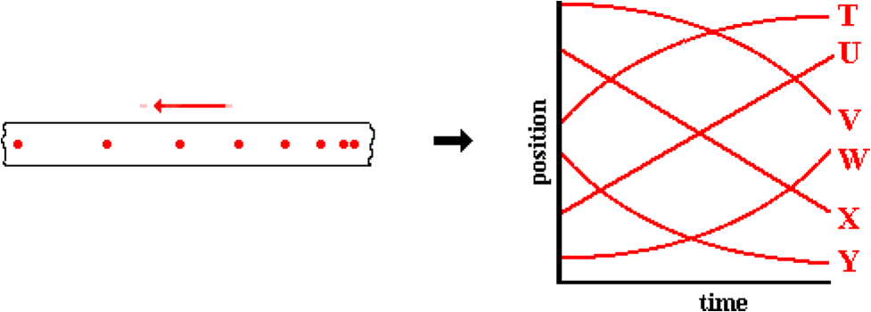

Question 17:
aa. Match the oil drop representation below to the appropriate letter for a position-time graph. It is known that the object is moving toward the left (where leftward is the negative direction).

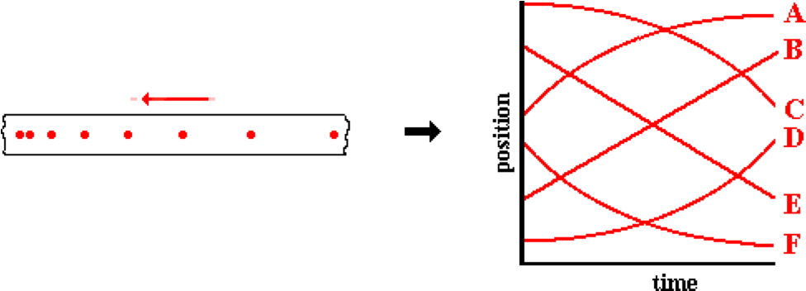

Question 18:
aa. Match the oil drop representation below to the appropriate letter for a position-time graph. It is known that the object is moving toward the left (where leftward is the negative direction).

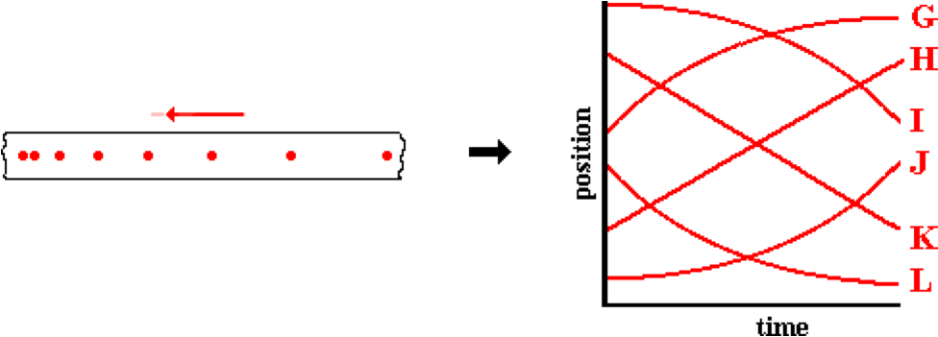

Question 19:
aa. Match the oil drop representation below to the appropriate letter for a position-time graph. It is known that the object is moving toward the left (where leftward is the negative direction).

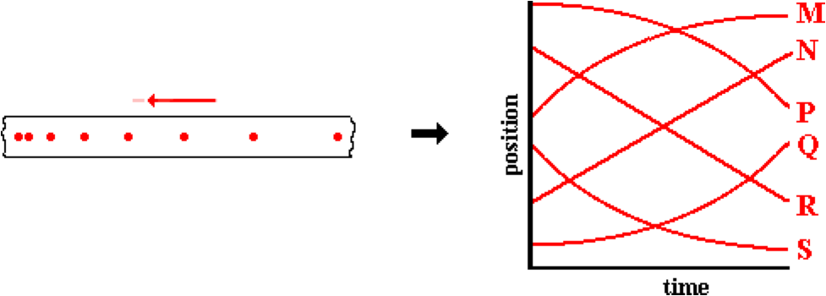

Question 20:
aa. Match the oil drop representation below to the appropriate letter for a position-time graph. It is known that the object is moving toward the left (where leftward is the negative direction).

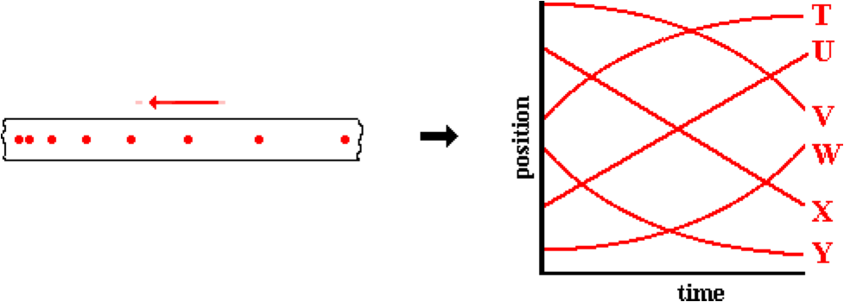

Question 21:
aa. Match the oil drop representation below to the appropriate letter for a velocity-time graph. It is known that the object is moving toward the right (where rightward is the positive direction).

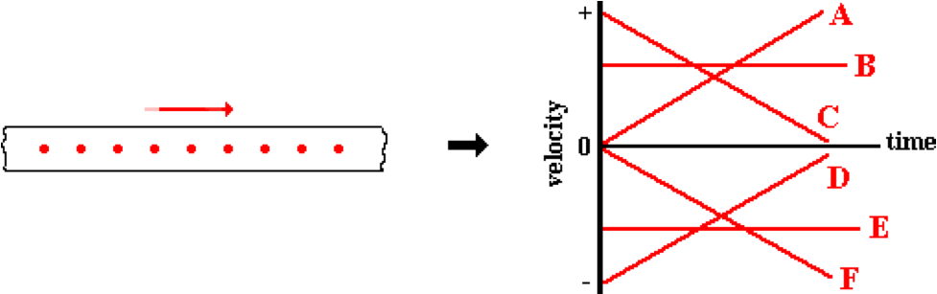

Question 22:
aa. Match the oil drop representation below to the appropriate letter for a velocity-time graph. It is known that the object is moving toward the right (where rightward is the positive direction).

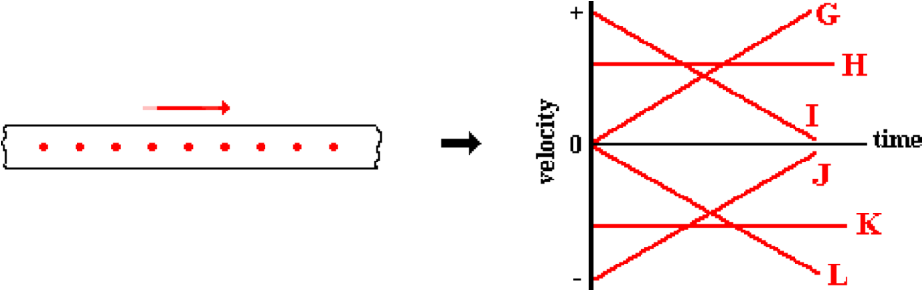

Question 23:
aa. Match the oil drop representation below to the appropriate letter for a velocity-time graph. It is known that the object is moving toward the left (where leftward is the negative direction).

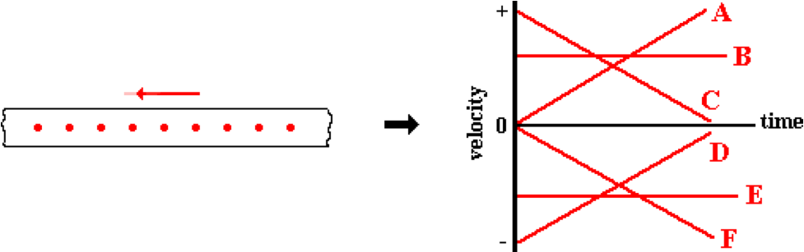

Question 24:
aa. Match the oil drop representation below to the appropriate letter for a velocity-time graph. It is known that the object is moving toward the left (where leftward is the negative direction).

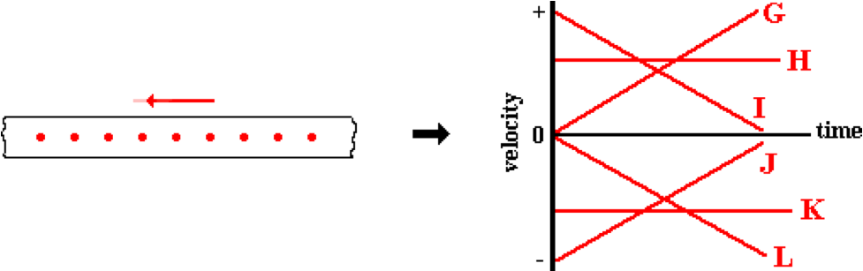

Question 25:
aa. Match the oil drop representation below to the appropriate letter for a velocity-time graph. It is known that the object is moving toward the right (where rightward is the positive direction).

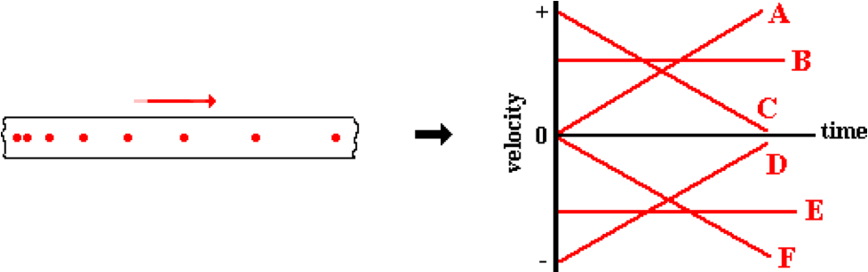

Question 26:
aa. Match the oil drop representation below to the appropriate letter for a velocity-time graph. It is known that the object is moving toward the right (where rightward is the positive direction).

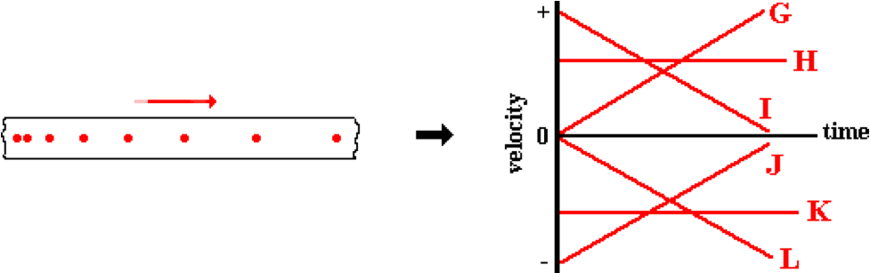

Question 27:
aa. Match the oil drop representation below to the appropriate letter for a velocity-time graph. It is known that the object is moving toward the right (where rightward is the positive direction).

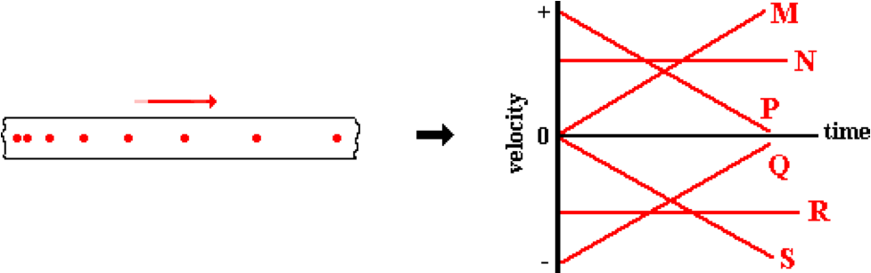

Question 28:
aa. Match the oil drop representation below to the appropriate letter for a velocity-time graph. It is known that the object is moving toward the right (where rightward is the positive direction).

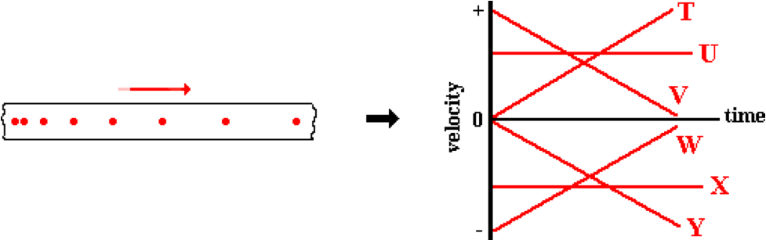

Question 29:
aa. Match the oil drop representation below to the appropriate letter for a velocity-time graph. It is known that the object is moving toward the right (where rightward is the positive direction).

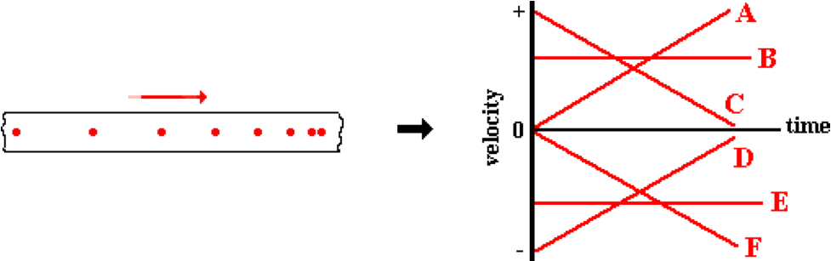

Question 30:
aa. Match the oil drop representation below to the appropriate letter for a velocity-time graph. It is known that the object is moving toward the right (where rightward is the positive direction).

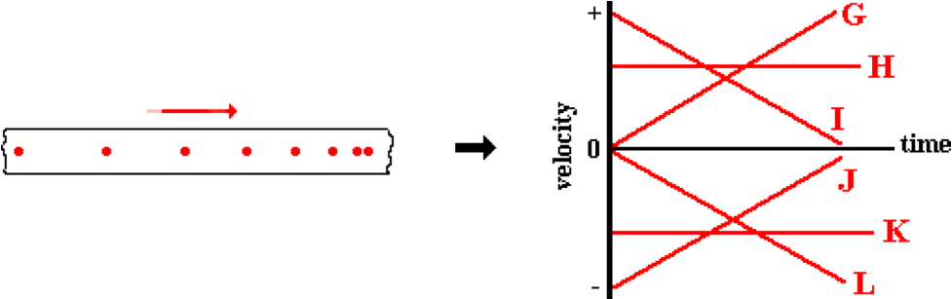

Question 31:
aa. Match the oil drop representation below to the appropriate letter for a velocity-time graph. It is known that the object is moving toward the right (where rightward is the positive direction).

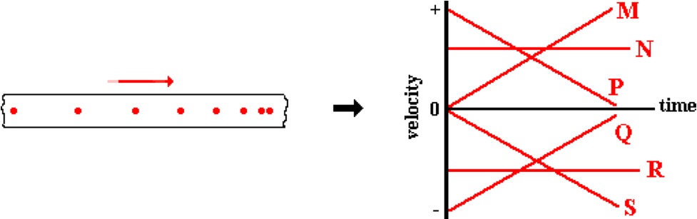

Question 32:
aa. Match the oil drop representation below to the appropriate letter for a velocity-time graph. It is known that the object is moving toward the right (where rightward is the positive direction).

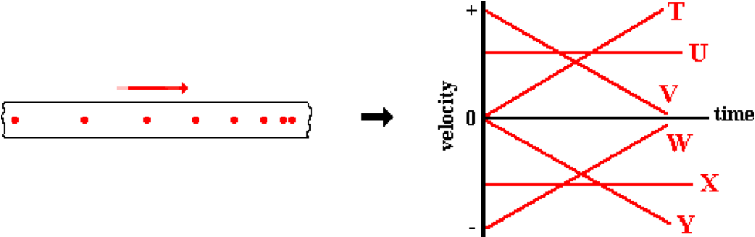

Question 33:
aa. Match the oil drop representation below to the appropriate letter for a velocity-time graph. It is known that the object is moving toward the left (where leftward is the negative direction).

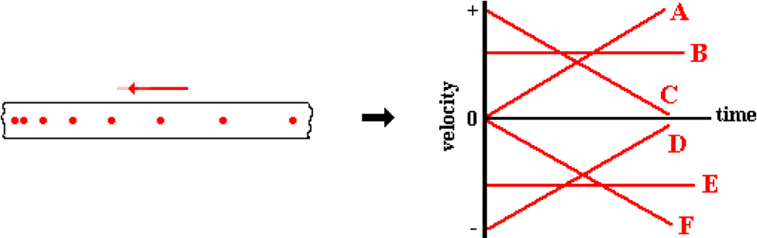

Question 34:
aa. Match the oil drop representation below to the appropriate letter for a velocity-time graph. It is known that the object is moving toward the left (where leftward is the negative direction).

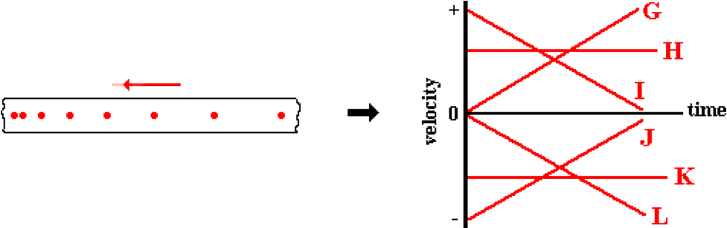

Question 35:
aa. Match the oil drop representation below to the appropriate letter for a velocity-time graph. It is known that the object is moving toward the left (where leftward is the negative direction).

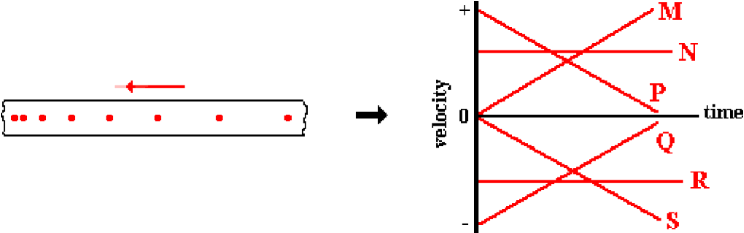

Question 36:
aa. Match the oil drop representation below to the appropriate letter for a velocity-time graph. It is known that the object is moving toward the left (where leftward is the negative direction).

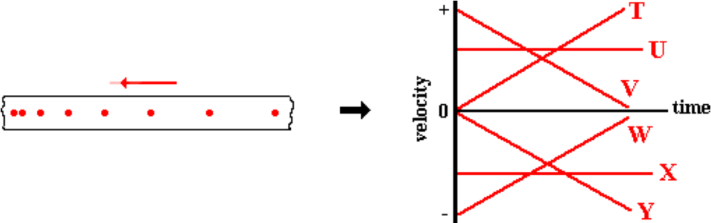

Question 37:
aa. Match the oil drop representation below to the appropriate letter for a velocity-time graph. It is known that the object is moving toward the left (where leftward is the negative direction).

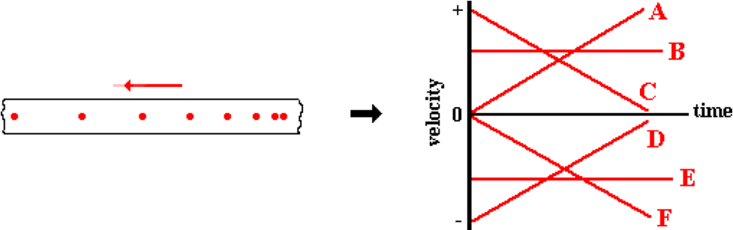

Question 38:
aa. Match the oil drop representation below to the appropriate letter for a velocity-time graph. It is known that the object is moving toward the left (where leftward is the negative direction).

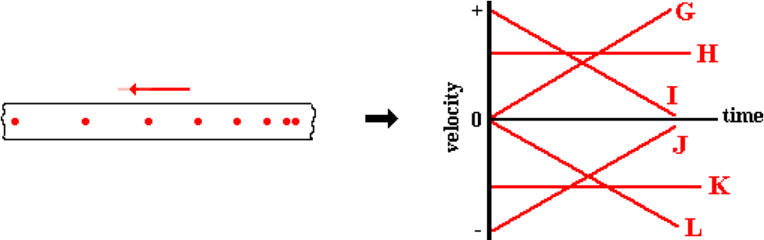

Question 39:
aa. Match the oil drop representation below to the appropriate letter for a velocity-time graph. It is known that the object is moving toward the left (where leftward is the negative direction).

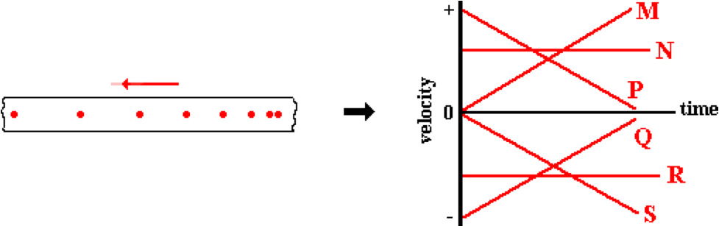

Question 40:
aa. Match the oil drop representation below to the appropriate letter for a velocity-time graph. It is known that the object is moving toward the left (where leftward is the negative direction).

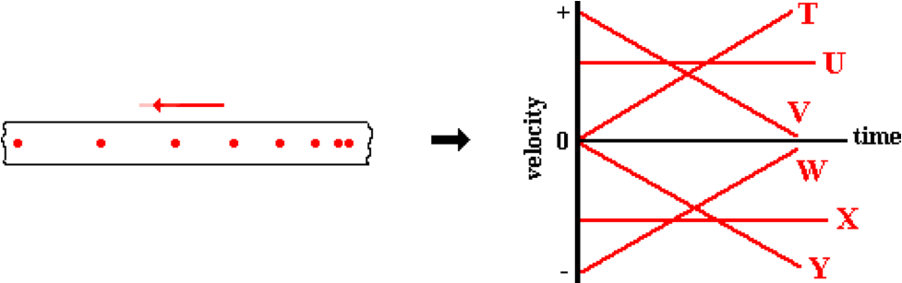

KG10: Common Misconceptions

Question 1:
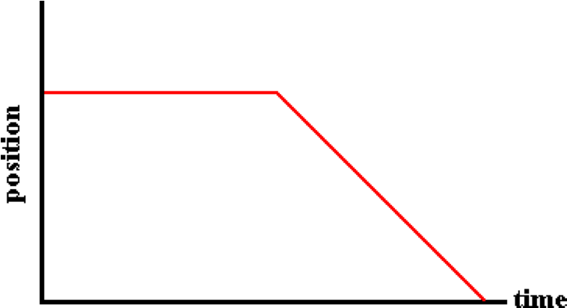
aa. As represented by this position-time graph, this object is ____.
a. moving at a constant speed for a few seconds and then slows down to a stop
b. at rest for a few seconds and then moves in the negative direction at a constant speed
c. is at rest for a few seconds and then decelerates
d. ... nonsense! None of these appropriately describe the object's motion.

Question 2:
aa. As represented by this position-time graph, this object is ____.
a. is at rest for a few seconds and then decelerates
b. moving at a constant speed for a few seconds and then slows down to a stop
c. at rest for a few seconds and then moves in the negative direction at a constant speed
d. ... nonsense! None of these appropriately describe the object's motion.

Question 3:
aa. As represented by this position-time graph, this object is ____.
a. at rest for a few seconds and then moves in the negative direction at a constant speed
b. is at rest for a few seconds and then decelerates
c. moving at a constant speed for a few seconds and then slows down to a stop
d. ... nonsense! None of these appropriately describe the object's motion.

Question 4:
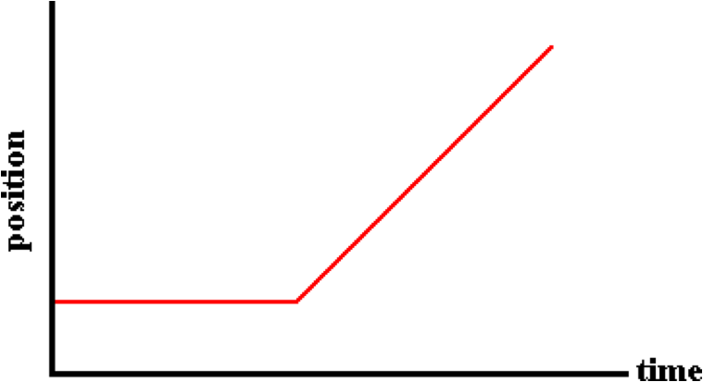
aa. As represented by this position-time graph, this object is ____.
a. moving at a constant speed and then speeds up
b. moves at a steady rate, changes direction and speeds up
c. at rest for a few seconds and then moves in the positive direction at a constant speed
d. ... nonsense! None of these appropriately describe the object's motion.

Question 5:
aa. As represented by this position-time graph, this object is ____.
a. at rest for a few seconds and then moves in the positive direction at a constant speed
b. moving at a constant speed and then speeds up
c. moves at a steady rate, changes direction and speeds up
d. ... nonsense! None of these appropriately describe the object's motion.

Question 6:
aa. As represented by this position-time graph, this object is ____.
a. moves at a steady rate, changes direction and speeds up
b. at rest for a few seconds and then moves in the positive direction at a constant speed
c. moving at a constant speed and then speeds up
d. ... nonsense! None of these appropriately describe the object's motion.

Question 7:
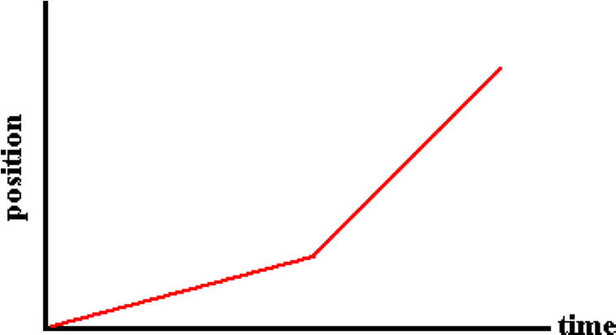
aa. As represented by this position-time graph, this object is ____.
a. accelerating slowly, then accelerating rapidly
b. moving slowly, changing directions and then accelerating
c. moving slowly, then moving rapidly, both at constant speed
d. moving slowly, changing directions and then moving rapidly
e. ... nonsense! None of these appropriately describe the object's motion.

Question 8:
aa. As represented by this position-time graph, this object is ____.
a. moving slowly, changing directions and then accelerating
b. moving slowly, changing directions and then moving rapidly
c. accelerating slowly, then accelerating rapidly
d. moving slowly, then moving rapidly, both at constant speed
e. ... nonsense! None of these appropriately describe the object's motion.

Question 9:
aa. As represented by this position-time graph, this object is ____.
a. moving slowly, then moving rapidly, both at constant speed
b. moving slowly, changing directions and then moving rapidly
c. accelerating slowly, then accelerating rapidly
d. moving slowly, changing directions and then accelerating
e. ... nonsense! None of these appropriately describe the object's motion.

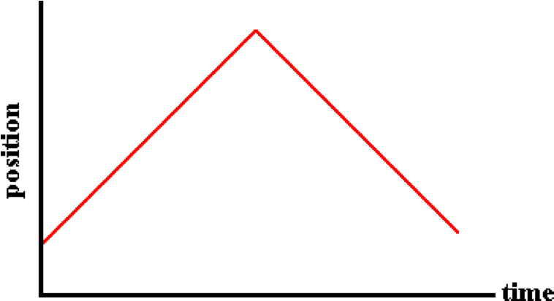
Question 10:
aa. As represented by this position-time graph, this object is ____.
a. moving in the positive direction and then in the negative direction, both at constant speed
b. speeding up and then slowing down, all while moving in the same direction
c. accelerating, first with a positive and then with a negative acceleration
d. speeding up, changing directions, and then slowing down
e. ... nonsense! None of these appropriately describe the object's motion.

Question 11:
aa. As represented by this position-time graph, this object is ____.
a. speeding up, changing directions, and then slowing down
b. accelerating, first with a positive and then with a negative acceleration
c. speeding up and then slowing down, all while moving in the same direction
d. moving in the positive direction and then in the negative direction, both at constant speed
e. ... nonsense! None of these appropriately describe the object's motion.

Question 12:
aa. As represented by this position-time graph, this object is ____.
a. accelerating, first with a positive and then with a negative acceleration
b. speeding up, changing directions, and then slowing down
c. moving in the positive direction and then in the negative direction, both at constant speed
d. speeding up and then slowing down, all while moving in the same direction
e. ... nonsense! None of these appropriately describe the object's motion.

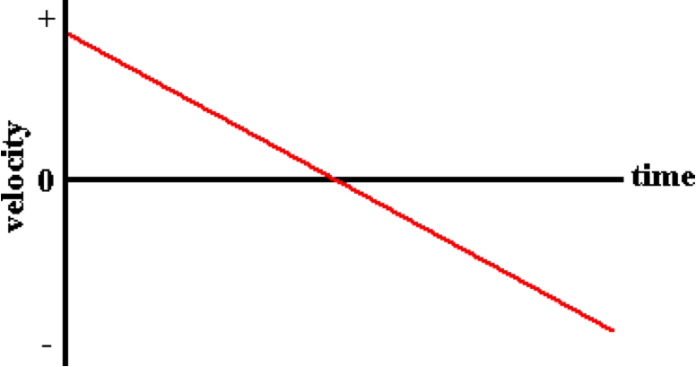
Question 13:
aa. As represented by this velocity-time graph, this object is ____.
a. moving downwards at a constant rate of acceleration
b. moving with a constant speed in the negative direction
c. slowing down, changing directions and then speeding up
d. ... nonsense! None of these appropriately describe the object's motion.

Question 14:
aa. As represented by this velocity-time graph, this object is ____.
a. slowing down, changing directions and then speeding up
b. moving downwards at a constant rate of acceleration
c. moving with a constant speed in the negative direction
d. ... nonsense! None of these appropriately describe the object's motion.

Question 15:
aa. As represented by this velocity-time graph, this object is ____.
a. moving with a constant speed in the negative direction
b. slowing down, changing directions and then speeding up
c. moving downwards at a constant rate of acceleration
d. ... nonsense! None of these appropriately describe the object's motion.

Question 16:
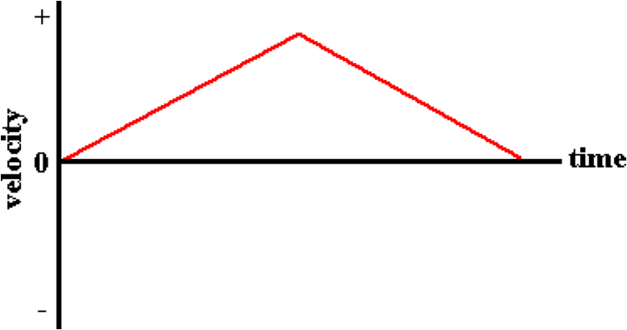
aa. As represented by this velocity-time graph, this object is ____.
a. speeding up, changing directions and then slowing down
b. speeding up and then slowing down while moving in the positive direction
c. moving with a constant positive velocity and then a constant negative velocity
d. accelerating while moving in the positive direction, then accelerating while moving in the negative direction
e. ... nonsense! None of these appropriately describe the object's motion.

Question 17:
aa. As represented by this velocity-time graph, this object is ____.
a. moving with a constant positive velocity and then a constant negative velocity
b. speeding up, changing directions and then slowing down
c. accelerating while moving in the positive direction, then accelerating while moving in the negative direction
d. speeding up and then slowing down while moving in the positive direction
e. ... nonsense! None of these appropriately describe the object's motion.

Question 18:
aa. As represented by this velocity-time graph, this object is ____.
a. accelerating while moving in the positive direction, then accelerating while moving in the negative direction
b. moving with a constant positive velocity and then a constant negative velocity
c. speeding up and then slowing down while moving in the positive direction
d. speeding up, changing directions and then slowing down
e. ... nonsense! None of these appropriately describe the object's motion.

Question 19:
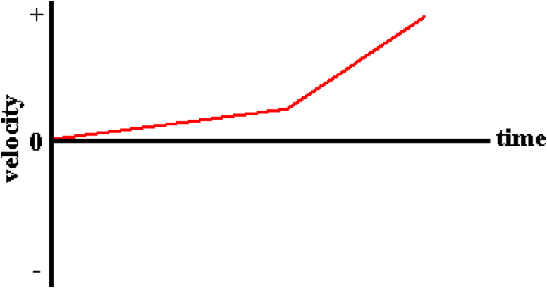
aa. As represented by this velocity-time graph, this object is ____.
a. accelerating slowly from rest and then maintaining a constant speed
b. moving slowly and then rapidly, both at a constant speed
c. accelerating at a low rate and then a high rate, both in the positive direction
d. moving slowly in one direction, then rapidly in another direction
e. ... nonsense! None of these appropriately describe the object's motion.

Question 20:
aa. As represented by this velocity-time graph, this object is ____.
a. accelerating at a low rate and then a high rate, both in the positive direction
b. moving slowly and then rapidly, both at a constant speed
c. moving slowly in one direction, then rapidly in another direction
d. accelerating slowly from rest and then maintaining a constant speed
e. ... nonsense! None of these appropriately describe the object's motion.

Question 21:
aa. As represented by this velocity-time graph, this object is ____.
a. moving slowly in one direction, then rapidly in another direction
b. accelerating at a low rate and then a high rate, both in the positive direction
c. moving slowly and then rapidly, both at a constant speed
d. accelerating slowly from rest and then maintaining a constant speed
e. ... nonsense! None of these appropriately describe the object's motion.

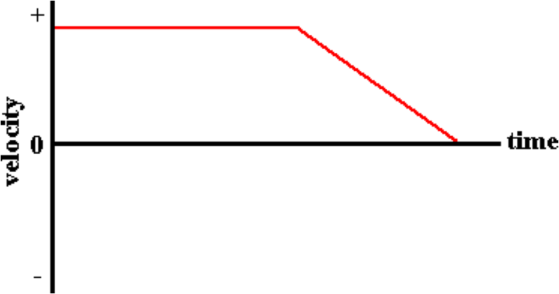
Question 22:
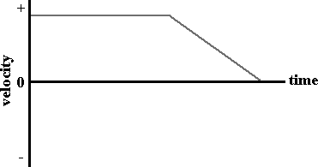
aa. As represented by this velocity-time graph, this object is ____.
a. moving at a constant speed and then slowing down
b. at rest for several seconds and then moves in the negative direction
c. at rest for several seconds and then accelerates in the negative direction
d. ... nonsense! None of these appropriately describe the object's motion.

Question 23:
aa. As represented by this velocity-time graph, this object is ____.
a. at rest for several seconds and then accelerates in the negative direction
b. moving at a constant speed and then slowing down
c. at rest for several seconds and then moves in the negative direction
d. ... nonsense! None of these appropriately describe the object's motion.

Question 24:
aa. As represented by this velocity-time graph, this object is____.
a. at rest for several seconds and then moves in the negative direction
b. at rest for several seconds and then accelerates in the negative direction
c. moving at a constant speed and then slowing down
d. ... nonsense! None of these appropriately describe the object's motion.

Question 25:
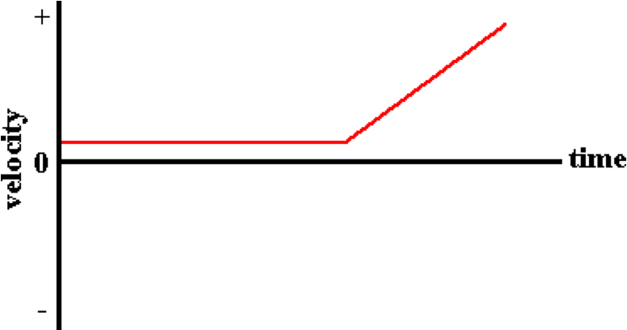
aa. As represented by this velocity-time graph, this object is____.
a. at rest for several seconds, and then speeds up
b. at rest for several seconds and then moves forward at constant speed
c. moving with a constant speed and then accelerates
d. at rest for several seconds and then moves up a hill
e. ... nonsense! None of these appropriately describe the object's motion.

Question 26:
aa. As represented by this velocity-time graph, this object is____.
a. at rest for several seconds and then moves forward at constant speed
b. at rest for several seconds, and then speeds up
c. at rest for several seconds and then moves up a hill
d. moving with a constant speed and then accelerates
e. ... nonsense! None of these appropriately describe the object's motion.

Question 27:
aa. As represented by this velocity-time graph, this object is____.
a. at rest for several seconds and then moves up a hill
b. moving with a constant speed and then accelerates
c. at rest for several seconds, and then speeds up
d. at rest for several seconds and then moves forward at constant speed
e. ... nonsense! None of these appropriately describe the object's motion.

Question 28:
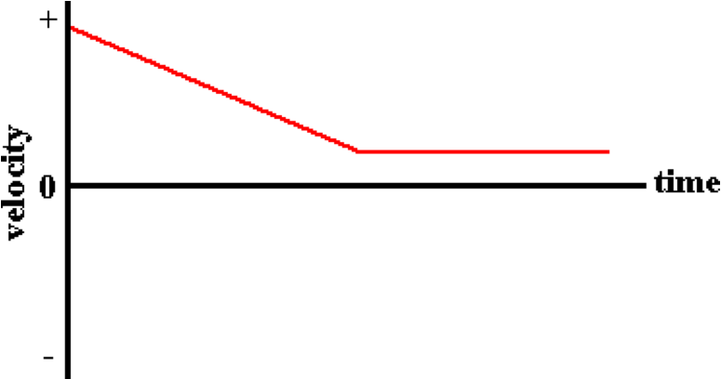
aa. As represented by this velocity-time graph, this object is ____.
a. moving in the positive direction from fast to slow, and then maintains a constant speed
b. slowing down to a rest position
c. accelerates in the negative direction and then stops
d. moving in the negative direction and speeding up, and then maintains a constant speed
e. ... nonsense! None of these appropriately describe the object's motion.

Question 29:
aa. As represented by this velocity-time graph, this object is ____.
a. accelerates in the negative direction and then stops
b. moving in the negative direction and speeding up, and then maintains a constant speed
c. moving in the positive direction from fast to slow, and then maintains a constant speed
d. slowing down to a rest position
e. ... nonsense! None of these appropriately describe the object's motion.

Question 30:
aa. As represented by this velocity-time graph, this object is ____.
a. moving in the negative direction and speeding up, and then maintains a constant speed
b. slowing down to a rest position
c. accelerates in the negative direction and then stops
d. moving in the positive direction from fast to slow, and then maintains a constant speed
e. ... nonsense! None of these appropriately describe the object's motion.

KG11: Matching Position-Time and Velocity-Time Graphs

Question 1:
aa. Which velocity-time graph is equivalent to the given position-time graph?

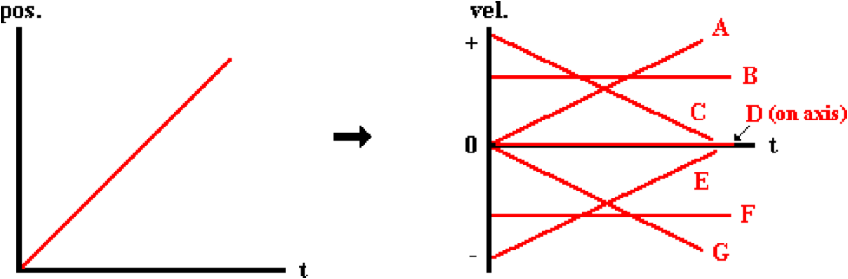

Question 2:
aa. Which velocity-time graph is equivalent to the given position-time graph?

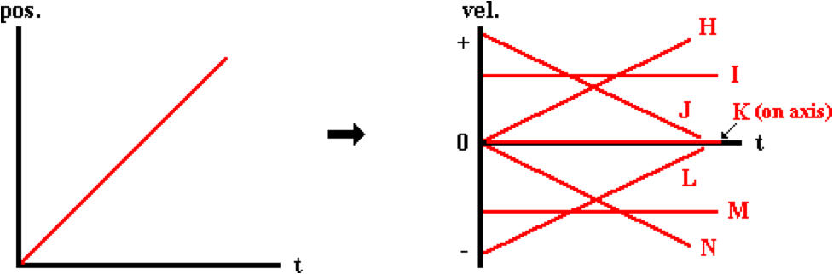

Question 3:
aa. Which velocity-time graph is equivalent to the given position-time graph?

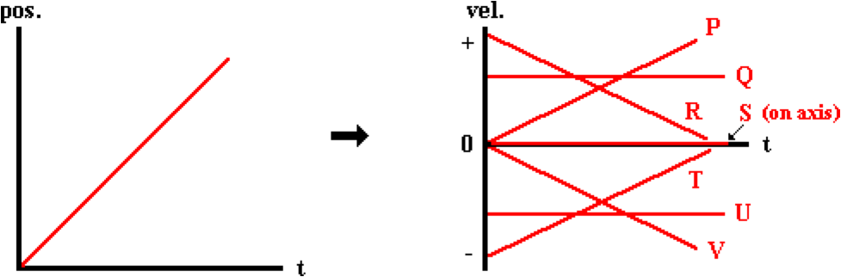

Question 4:
aa. Which velocity-time graph is equivalent to the given position-time graph?

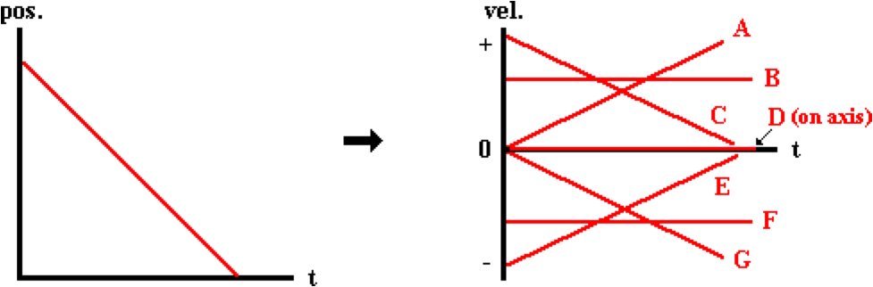

Question 5:
aa. Which velocity-time graph is equivalent to the given position-time graph?

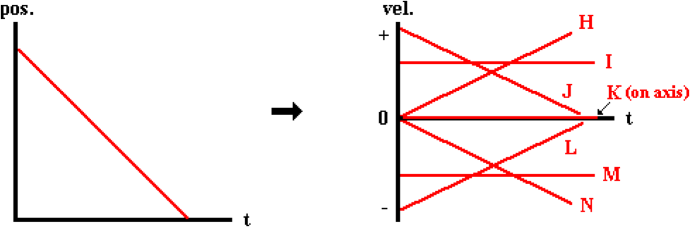

Question 6:
aa. Which velocity-time graph is equivalent to the given position-time graph?

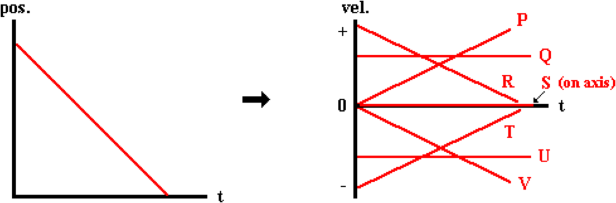

Question 7:
aa. Which velocity-time graph is equivalent to the given position-time graph?

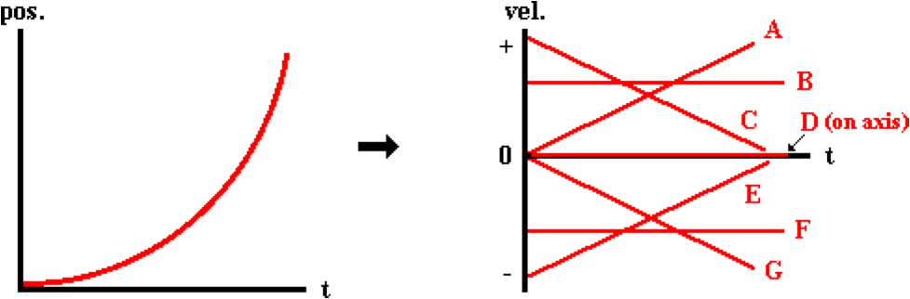

Question 8:
aa. Which velocity-time graph is equivalent to the given position-time graph?

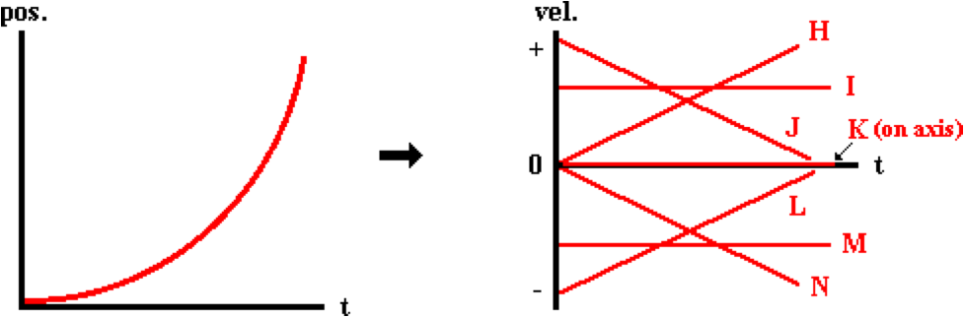

Question 9:
aa. Which velocity-time graph is equivalent to the given position-time graph?

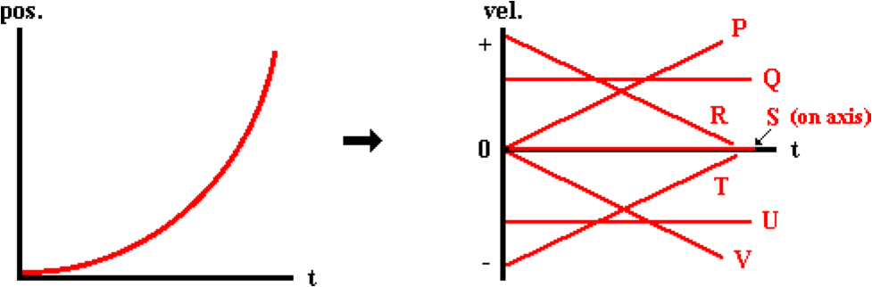

Question 10:
aa. Which velocity-time graph is equivalent to the given position-time graph?

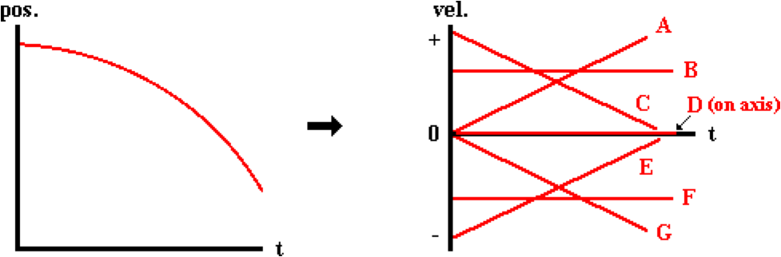

Question 11:
aa. Which velocity-time graph is equivalent to the given position-time graph?

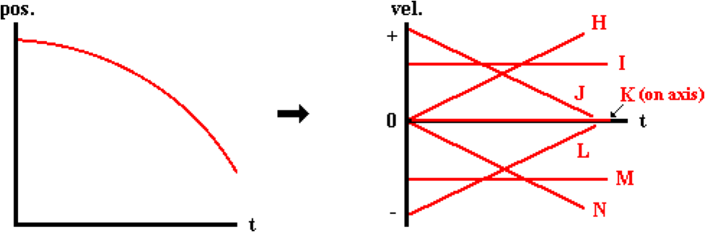

Question 12:
aa. Which velocity-time graph is equivalent to the given position-time graph?

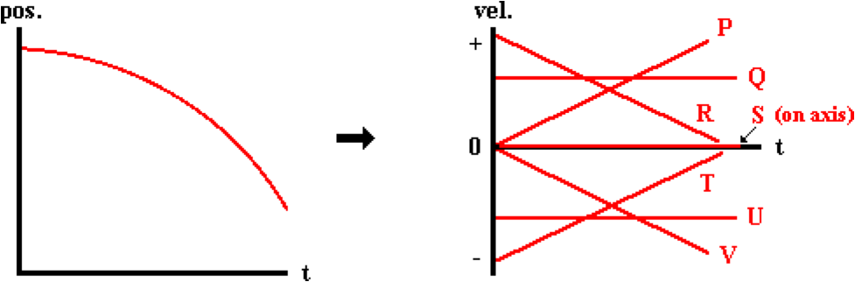

Question 13:
aa. Which velocity-time graph is equivalent to the given position-time graph?

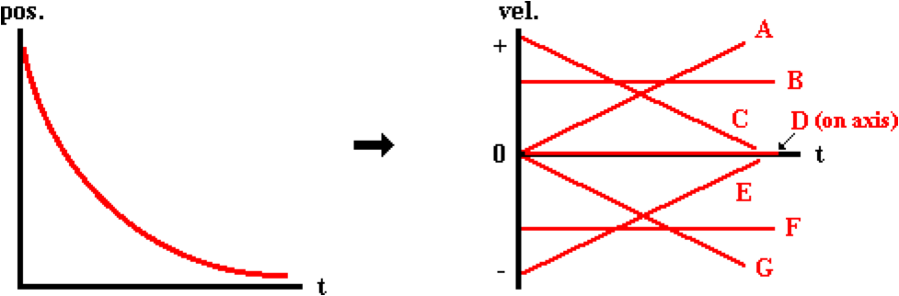

Question 14:
aa. Which velocity-time graph is equivalent to the given position-time graph?

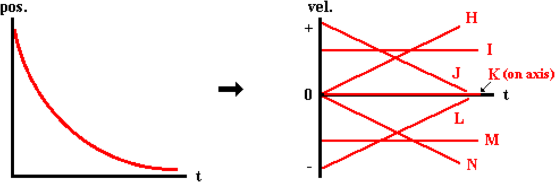

Question 15:
aa. Which velocity-time graph is equivalent to the given position-time graph?

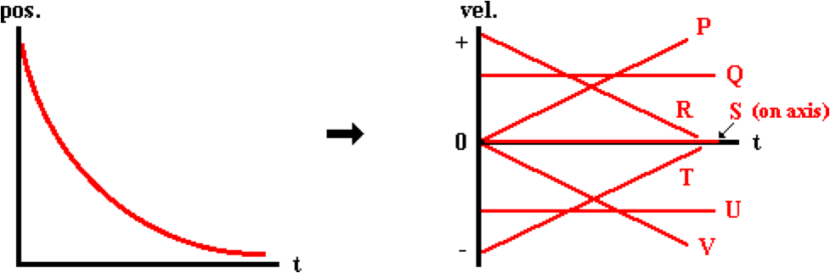

Question 16:
aa. Which velocity-time graph is equivalent to the given position-time graph?

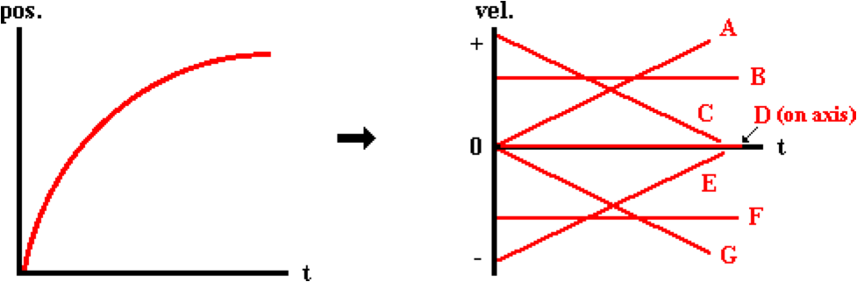

Question 17:
aa. Which velocity-time graph is equivalent to the given position-time graph?

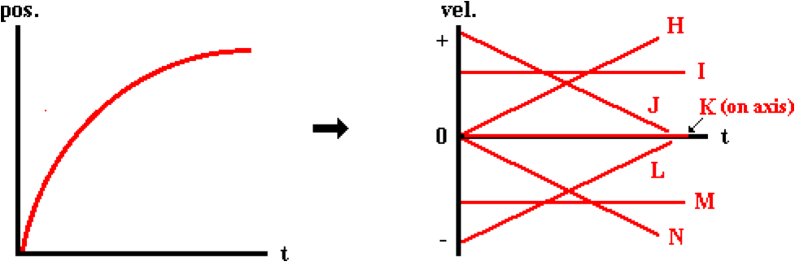

Question 18:
aa. Which velocity-time graph is equivalent to the given position-time graph?

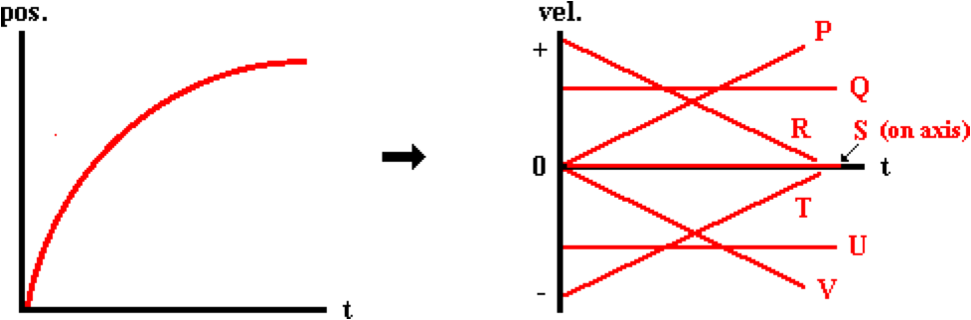

Question 19:
aa. Which position-time graph is equivalent to the given velocity-time graph?

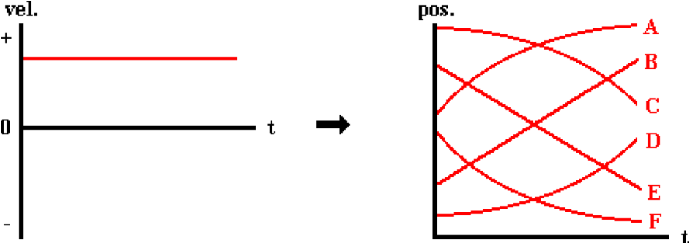

Question 20:
aa. Which position-time graph is equivalent to the given velocity-time graph?

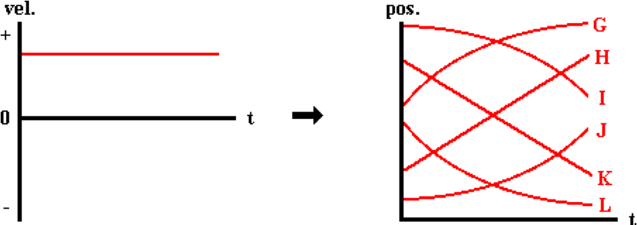

Question 21:
aa. Which position-time graph is equivalent to the given velocity-time graph?

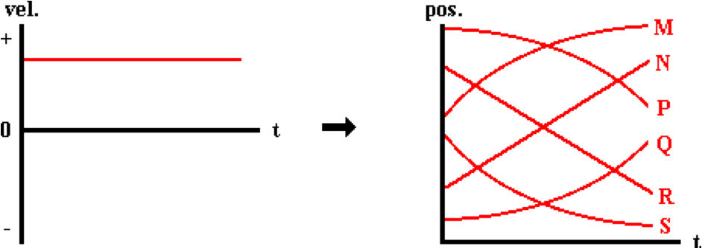

Question 22:
aa. Which position-time graph is equivalent to the given velocity-time graph?

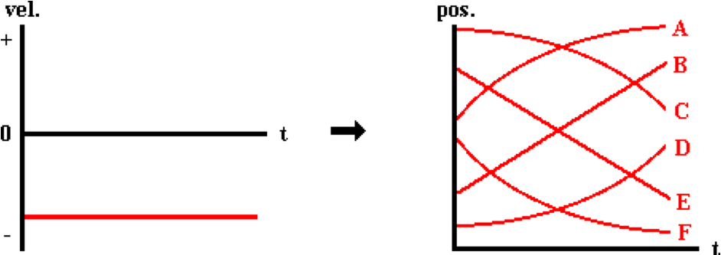

Question 23:
aa. Which position-time graph is equivalent to the given velocity-time graph?

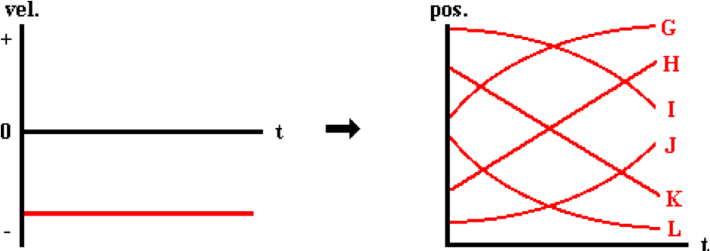

Question 24:
aa. Which position-time graph is equivalent to the given velocity-time graph?

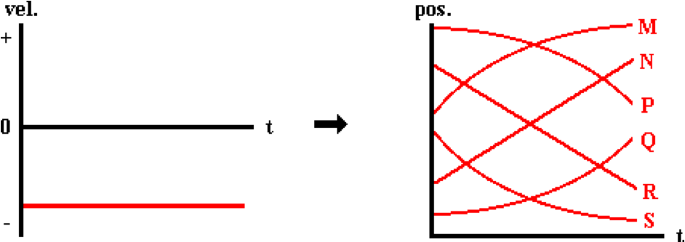

Question 25:
aa. Which position-time graph is equivalent to the given velocity-time graph?

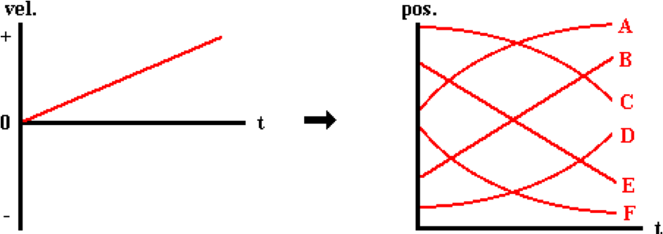

Question 26:
aa. Which position-time graph is equivalent to the given velocity-time graph?

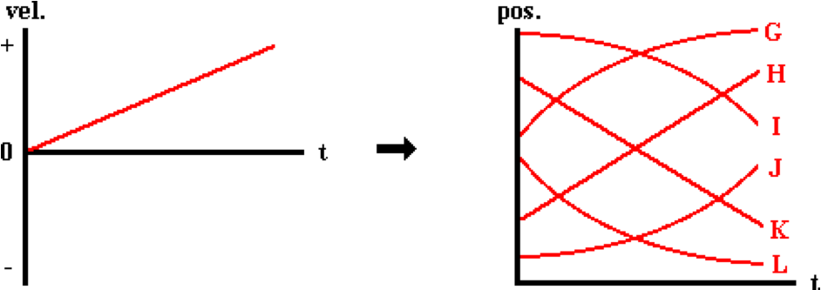

Question 27:
aa. Which position-time graph is equivalent to the given velocity-time graph?

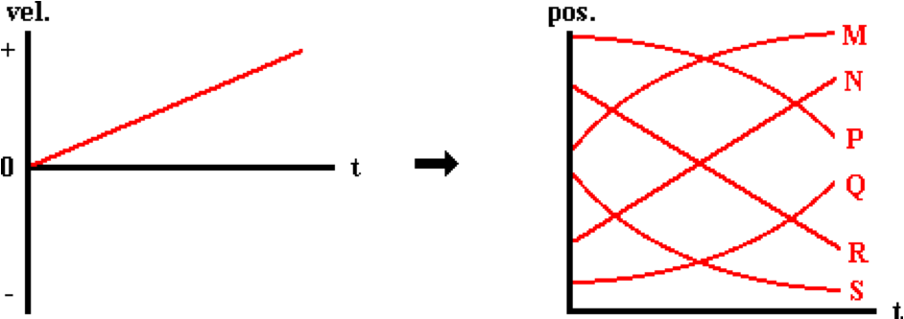

Question 28:
aa. Which position-time graph is equivalent to the given velocity-time graph?

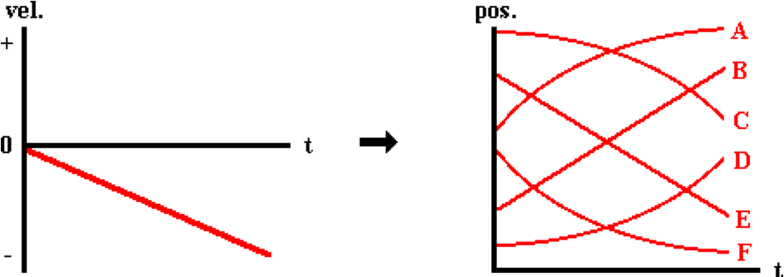

Question 29:
aa. Which position-time graph is equivalent to the given velocity-time graph?

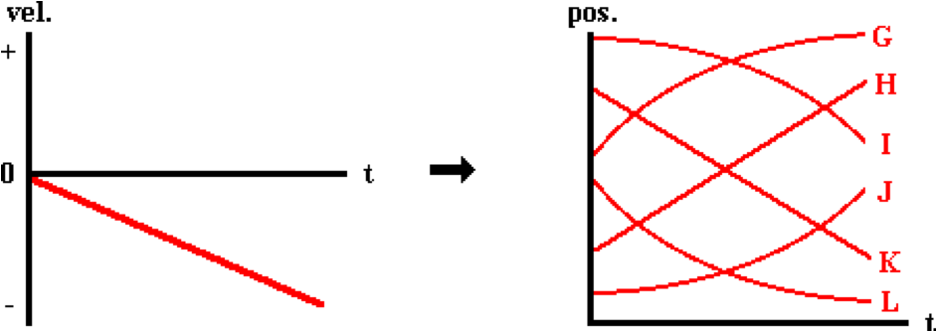

Question 30:
aa. Which position-time graph is equivalent to the given velocity-time graph?

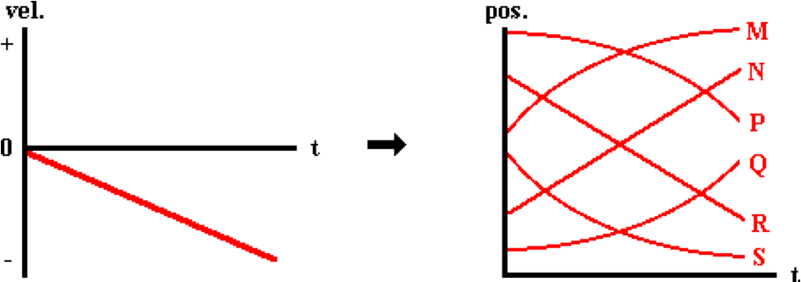

Question 31:
aa. Which position-time graph is equivalent to the given velocity-time graph?

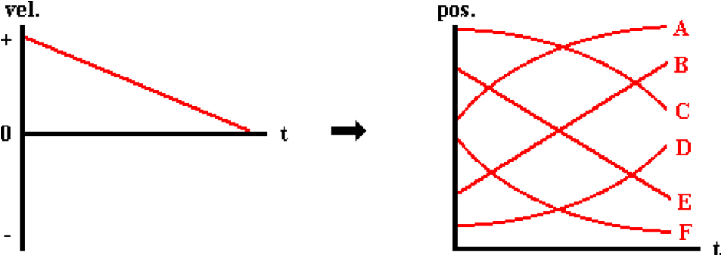

Question 32:
aa. Which position-time graph is equivalent to the given velocity-time graph?

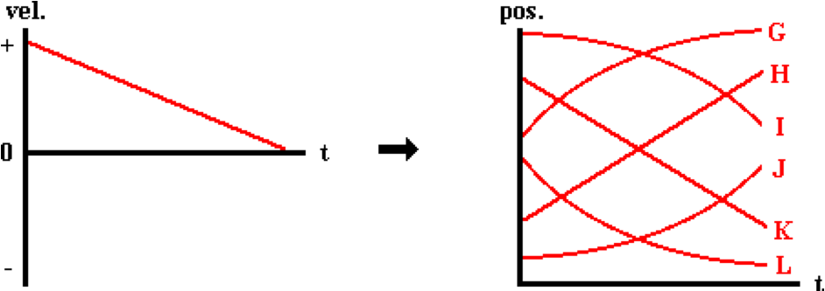

Question 33:
aa. Which position-time graph is equivalent to the given velocity-time graph?

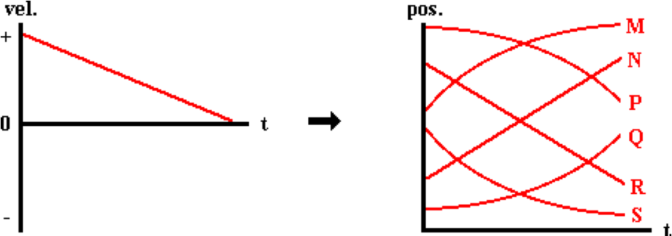

Question 34:
aa. Which position-time graph is equivalent to the given velocity-time graph?

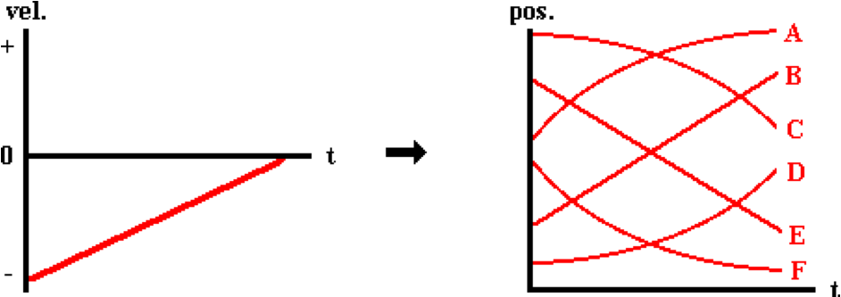

Question 35:
aa. Which position-time graph is equivalent to the given velocity-time graph?

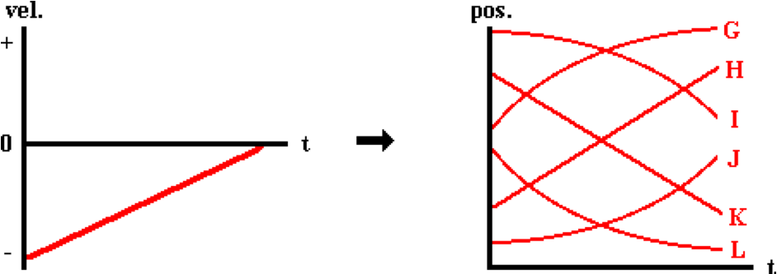

Question 36:
aa. Which position-time graph is equivalent to the given velocity-time graph?

