CF Test Framework

Regression Testing: 2
How to do the CF regression Testing? 3
Files involved in CF Regression Test: 4

Regression Testing:
Test code is mainly written in C and tests the base functionality of the Communication Framework on this level. Each test case configuration will repeat the defined test steps a configurable amount of times, before the evaluation.
The test code that is written in C directly uses the CF interfaces. All C++, C# and Java are the language extensions or wrappers provided by CF.

Following features of CF are tested here.
- Registration
- Connection
- RegularMessages (RequestReply & OneWay Messages)
- Subscriptions
- SubscribedMessages (Subscribed RequestReply & Notifications)

Here the idea is to use the common source code for testing as much as possible. The common source code can be found in \AC_NMCS_Systemtest\CommunicationFramework\Include\C\Regression and
\AC_NMCS_Systemtest\CommunicationFramework\Include\C

The test code specific to each CF feature is stored in respective folders like
\AC_NMCS_Systemtest\CommunicationFramework\Regression\Connections\C
\AC_NMCS_Systemtest\CommunicationFramework\Regression\Registrations\C
and so on. Each folder has 2 source files by name client.c and service.c to test the particular feature.

To build the test code, we need to run the \AC_NMCS_Systemtest\CommunicationFramework\build.bat file that uses the build.xml file present in the same folder. Now the new binaries related to testing (.exe & .dll files) will be stored in \AC_NMCS\AC_NMCS\tbin\win32 path.

Here the concept of Configuration and Definition files are used to create different test scenarios for each feature of CF. We need to run the batch file \AC_NMCS_Systemtest\CommunicationFramework\gathering.cmd to copy the various configuration & three definition files. It creates a folder by name “Repository” that holds all the configuration & definition files under \AC_NMCS\tbin path.

Some of the test scenarios currently available under each feature are ---

Registration
- Registration by using the default configuration
- Register and Unregister by using the external definition files
- Register the maximum amount of supported registrations by the CF
- Registrations by using multiple threads
- Try to register more than the supported amount of registrations (hammering)
- Register in multiple CFMS at the same time
- Try to reregister the same name (Name of the service is same as the registered one (hammering)
- ????
- Register service with service properties
- Register service with a handler chain
- Registration by using Http Protocol

Connection
- Connection by using the default configuration
- Connect and disconnect by using the external definition files
- Connect and disconnect with blocking (Synchronous)
- Establishing the maximum amount of connections the CFMS supports
- Establishing connections from multiple threads in parallel
- Try to establish more than the supported number of connections (hammering)
- Connect to services in multiple CFMS at the same time
- Connecting with overloaded configuration data
- Connecting with a handler chain

RegularMessages (RequestReply & OneWay Messages)
- Testing Request/Reply and One-way messages by using the default configuration.

Subscriptions
- Testing the subscription feature using the default configuration.

SubscribedMessages (Subscribed RequestReply & Notifications)
- Testing SReply, SRequest & Notification features using the default configurations.

How to do the CF regression Testing?
Let us take an example of testing the CF’s “Connection” feature.
- First make sure that the NMCS is running on the host where we are performing the testing.
- Now copy one of the configuration files for e.g. \AC_NMCS\tbin\Repository\Connections\001_ConnectDisconnect.configuration to \AC_NMCS\tbin\win32 folder i.e. to the location where our test executables reside.
- Rename the configuration file such that it takes the name as <Portion of test executable name till the first _>.configuration. That means here it is Connections.configuration because the exe names are Connections_Service.exe and Connections_Service.exe. Some other examples are:
Test executables are SubscribedMessages_Service.exe & SubscribedMessages_Client.exe Then the configuration file name should be SubscribedMessages.configuration.
Test executables are XComposite_Service.exe & XComposite_Client.exe
Then the configuration file name should be XComposite.configuration. and so on.
- Now run the service exe that is Connections_Service.exe by clicking on it.
- If the service exe is running successfully then run client exe that is Connections_Client.exe
- Based on the input data from configuration and definition files, the test runs and puts the result in a folder; in this case it is “ConnectDisconnect” under \AC_NMCS\tbin\Repository\Connections path. The name of the folder is picked form the value of the parameter “-Default.configuration_name:” present in the configuration file.
- The test result folder that is in this case “ConnectDisconnect” holds 4 result files by name:
  - configuration.result – Holds the all test parameter values used by client and service.
  - counter.result – Holds the final values of various counters used in testing.
  - environment.result – Contains the test environment details.
  - result.result – Contains the actual test result with comparison to the expected result

Files involved in CF Regression Test:
- configuration file
- definition file
- configuration.result file
- counter.result file
- environment.result file
- result.result file

- configuration file:
This file can be described as the test scenario/configuration file that lists the values of almost all parameters that are used in CF regression testing. The location of these files is \AC_NMCS\tbin\Repository folder. Two sample files are attached here:

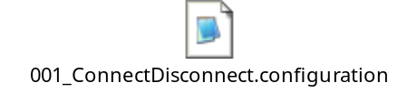

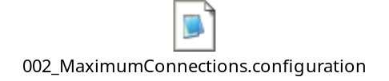

Details of various test configuration parameters can be found in the attached file whose location is
\AC_NMCS_Systemtest\CommunicationFramework\TestCaseDefinitions 1.5.xls

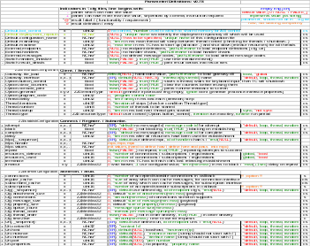

- Definition file:
This file stores the definition of some Ids (Variables) that are later referred in the configuration files. Currently there exist only 3 definition files that are used by all regression test executables. Samples of those 3 files are attached below:

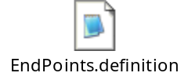

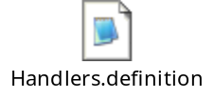

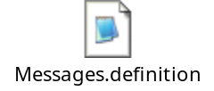

  - EndPoints.definition file
This file is used to specify the end point parameter values for both stub and skeleton. Here we specify the cfg and uri related parameter values (Refer section ZZEndPointConfiguration Skeleton. / Stub in TestCaseDefinitions 1.5.xls file) that can be used by stub and skeleton in the configuration file. All these parameter values can be referred by a single Id in the configuration file somewhat like a structure variable.
  - Handlers.definition file
???? Usage of this file needs be find out

  - Messages.definition file
This file is used to specify the parameter values for the message w.r.t. Creator (sender), message and Receiver (Refer section ZZMessageConfiguration Notify. / Reply. / Request. / Skelify. / SReply. / SRequest. / Stubify. in TestCaseDefinitions 1.5.xls file) that can be used by the following in configuration file–
Notification
Reply
Request
Notification Skeleton (Skelify)
Notification stub (Stubify)
Subscribed Request
Subscribed Reply
Here all the message related parameter values could be referred by a single Id in the configuration file somewhat like a structure variable.

- configuration.result file
This file lists the configuration (Parameter and its value) used by a test executable for a particular test. If both service and client is involved in the test then the configuration parameter values used by both of them are listed in a single file. This helps to find out what parameter value was used during the test. Sample file looks like:
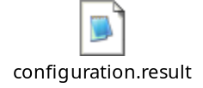

- counter.result file
This file lists the various counters and their final values once a particular test is conducted. If both service and client is involved in the test then the counters and their values related to both of them are listed in a single file. Sample file looks like:
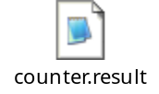

- environment.result file
This file lists the environment related details that exists while performing the test. Sample file looks like:

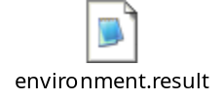

- result.result file
This file gives the details of actual test result with comparison to the expected result (Comparison with the expected results is available only if the expected results is specified in the configuration file) Sample file looks like:

