Report
1) check1
2)./compress check1.txt outcome.txt
98 10
99 10
100 10
101 10

Encoded String
11100100111001001110010011100100111001001110010011100100111001001110010011100100

3) I build the tree by starting from the least frequency number of nodes,c(10) and d(10) in this case (Note if several nodes have the same frequencies we start with nodes with larger ASCII value). Then connect them together to be the children of a parent node and sum up the frequency(20) to be the frequency of the node. Then we are left with a(10), b(10) and p(c,d)(20). Then do the same thing to connect the least frequencies node a(10) with b(10). Then p(a,b)(20) and p(c,d)(20). Finally connect them together to p(ab,cd)(40). Then assign each line connecting parent and children to be either 1 or 0.

Find
Suppose we want to find the code of a, I find the code by starting from the root p(ab,cd) and then go through the line leading to a with labels 1 or 0. The concatenated string with 0 and 1 is the code of the letter in this tree.
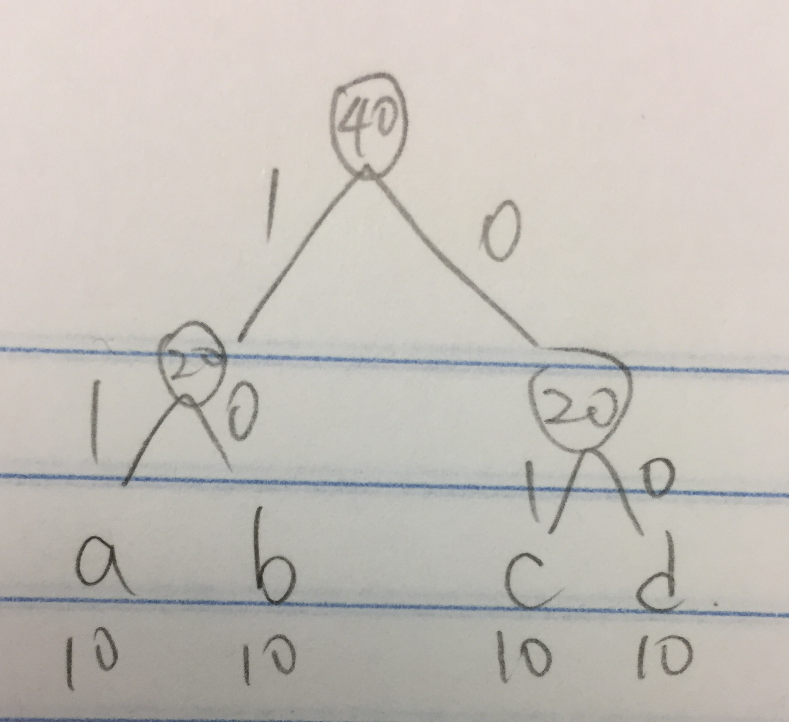

4)Use cout to debug, specifically we get
a=11
b=10
c=01
d=00
Following the encoded string, we get “11 | 10 | 01| 00 “ repeated 10 times, which is abcd repeated 10 times, the same as the inputted file.

1) check2
2) ./compress check2.txt outcome2.txt
98 4
99 8
100 16
101 32

Encoded String
0000000010010010010101010101010101111111111111111111111111111111110101010101010101001001001001000000

3).

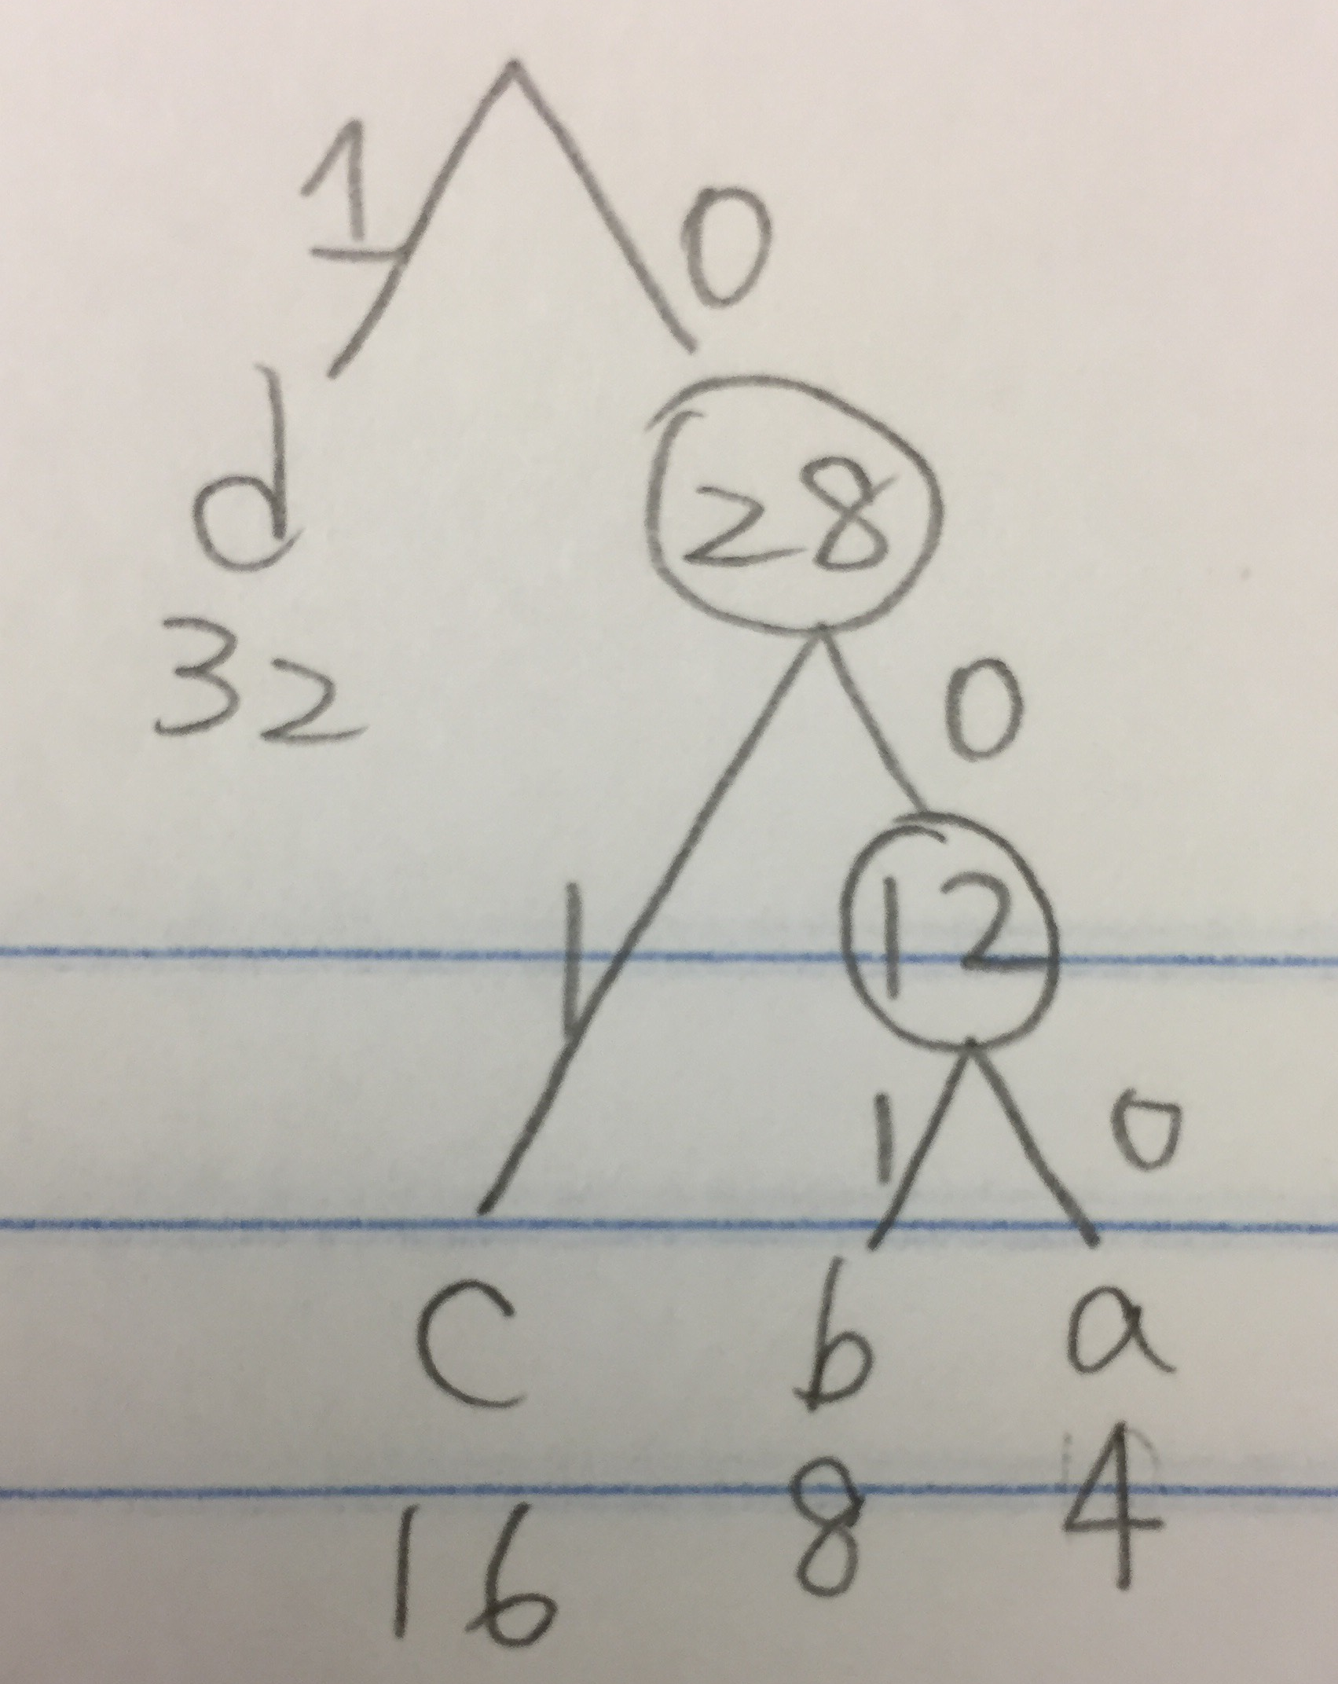

4).
a 000
b 001
c 01
d 1

