ENGINEERING DESIGN REPORT
ECA56 Advanced Wireless Communication Systems
CO1 Integrated Engineering Analysis and Planning Assignment (Unit 1)
EVOLUTION, CELLULAR PLANNING, SPECTRUM USE AND INTERFERENCE MANAGEMENT FOR A REGIONAL MOBILE NETWORK
Submitted by
Name | Register No. | Course Code
Muduliar Ratish Harikrishna | 192512414 | ECA5603

Course outcome assessed: CO1 – Evolution of mobile communication systems, cellular architecture, spectrum utilization and interference management
Assessment: Open-ended engineering design report (100 marks; Bloom levels K4 Analyze, K5 Evaluate, K6 Create)
October 2026

TABLE OF CONTENTS
ABSTRACT 3
1. REQUIREMENTS AND PLANNING DATA 4
1.1 Problem Statement and Objectives 4
1.2 Planning Data 4
1.3 Method and Report Organisation 5
1.4 Assumptions 5
2. STAGE 1: EVOLUTION OF MOBILE SYSTEMS 6
2.1 Generational Analysis from 1G to the 6G Vision 6
2.2 Wavelength at 800 MHz and Idealised 1G Channel Count 8
2.3 Improvement of 2G Digital TDMA over 1G Analog Service 8
3. STAGE 2: CELL COVERAGE AND FREQUENCY REUSE 8
3.1 Cell Area, Cluster Area and Reuse Geometry 8
3.2 Hexagonal Approximation and Radio Coverage 10
3.3 Capacity-Expansion Techniques 11
3.4 Recommended Capacity-Expansion Measure 11
4. STAGE 3: TRAFFIC CAPACITY 12
4.1 Offered Busy-Hour Traffic 12
4.2 Erlang B Blocking and Channel Requirement 12
4.3 Why This Is Only a First-Order Estimate 13
4.4 Capacity, Blocking and Infrastructure Trade-offs 13
5. STAGE 4: MOBILITY AND HANDOFF 14
5.1 Distance Travelled in the Overlap Interval 14
5.2 Hard Handoff Rate 14
5.3 Hard, Soft and Softer Handoff 15
5.4 Simple Call-Drop Risk for One Handoff 15
6. STAGE 5: INTERFERENCE AND SPECTRUM-BAND COMPARISON 16
6.1 Carrier-to-Interference Ratio with Co-channel Interference Alone 16
6.2 Total Interference and SINR 16
6.3 Recommended Mitigation and Trade-off 17
6.4 Spectrum-Band Comparison at 100 m 18
7. STAGE 6: SPECTRUM COORDINATION 20
7.1 Roles of ITU-R, WRC and the Radiocommunication Bureau 20
7.2 How International Coordination Affects Regulators and Operators 20
8. COMPARISON AND INTEGRATED RECOMMENDATION 20
8.1 Consolidated Results 20
8.2 Recommended Phased Network Plan 21
8.3 Main Trade-offs 23
9. ASSUMPTIONS AND UNCERTAINTIES 23
10. CONCLUSION 24
REFERENCES 24

ABSTRACT
This report presents an evidence-based engineering analysis for a regional wireless operator planning the next stage of its mobile network. Using the supplied planning data, it traces the evolution of mobile systems from 1G to the 6G vision and then analyses, in turn, cell geometry and frequency reuse, busy-hour traffic and Erlang B channel dimensioning, mobility and handoff behaviour, co-channel and adjacent-channel interference, and the propagation implications of the 900 MHz, 3.5 GHz and 28 GHz bands. The main results are: a hexagonal cell area of 10.39 km² and a reuse distance of 9.17 km; an offered load of 80 Erlangs that needs 92 channels for a blocking target of 2% (one 100-channel base station gives 0.40%); one hard handoff per minute at 60 km/h; a total SINR of 13.81 dB that misses the 15 dB target by 1.19 dB; and free-space path-loss penalties of 11.80 dB and 29.86 dB for 3.5 GHz and 28 GHz relative to 900 MHz. The report recommends a three-phase strategy: a 900 MHz coverage layer with 120° sectoring, then a 3.5 GHz capacity layer with beamforming and selective cell splitting, then 28 GHz hotspots and 6G readiness, followed by a list of assumptions that must be verified before deployment.

1. REQUIREMENTS AND PLANNING DATA

1.1 Problem Statement and Objectives
A regional wireless operator is planning the next stage of its mobile network and needs one evidence-based engineering report for the planning team. The report must explain how mobile systems evolved from 1G to the 6G vision, and how cellular layout, traffic demand, mobility, spectrum and interference shape deployment decisions. There is no single predetermined network choice; the recommendation must follow from correct analysis and be defended with technically sound reasoning. The objectives of the report are therefore to:
- trace generational evolution and relate it to spectrum, capacity and interference management (Stage 1);
- compute cell geometry and frequency reuse and recommend a capacity-expansion measure (Stage 2);
- dimension channels for the busy-hour traffic using the Erlang B model (Stage 3);
- evaluate mobility, handoff rate and call-drop risk (Stage 4);
- quantify co-channel and adjacent-channel interference and compare the 900 MHz, 3.5 GHz and 28 GHz bands (Stage 5); and
- explain international spectrum coordination and conclude with a staged deployment plan (Stage 6).

1.2 Planning Data
Table 1 restates the planning data supplied with the assignment. All calculations in this report use exactly these inputs.
Table 1. Planning data used in this report
Topic | Supplied data
Cell geometry | Hexagonal model; cell radius r = 2 km; planning cluster = 19 cells; reuse cluster size N = 7.
Traffic and channels | 1,000 subscribers at 0.08 Erlang each in the busy hour; initial base station with C = 100 traffic channels; target blocking probability ≤ 2%.
Mobility | Speed 60 km/h; overlap-zone dwell time 6 s; nominal cell length along the route 1 km; handoff interruption 0.5 s; target cell unavailable 1% of the time.
Interference case | Desired signal S = −70 dBm; co-channel interference I₁ = −85 dBm; adjacent-channel interference I₂ = −90 dBm; minimum target SINR = 15 dB.
Spectrum comparison | 900 MHz, 3.5 GHz and 28 GHz at d = 100 m; c = 3 × 10⁸ m/s; FSPL(dB) = 20 log₁₀(4πd/λ).
Generational examples | 1G AMPS: 800 MHz, 30 kHz analog FDMA channels, 10 MHz total. 2G GSM: 900 MHz, 200 kHz carrier, 8 TDMA slots. 3G UMTS: 5 MHz carrier. 4G LTE: OFDMA and MIMO. 5G NR: eMBB/URLLC/massive IoT, mid-band and mmWave, beamforming. 6G vision: THz, AI-native networking, holographic communication, tactile internet, ISAC.

1.3 Method and Report Organisation
The report follows the required order of requirements → analysis → calculations → comparison → recommendation. Each technical section states the concept, shows the equation with units, substitutes the supplied numbers, and ends with a short engineering interpretation. Numerical values were evaluated by hand and checked with a short script; for Erlang B, the numerically stable recursion given in Section 4 was used, so the model, inputs and interpretation are all shown. Table 2 maps the assessment rubric to the sections of this report.
Table 2. Mapping of the assessment rubric to report sections
Assessment criterion | Marks | Bloom level | Where addressed
Generational evolution and interpretation of CO1 concepts | 15 | K4 | Section 2
Cell geometry, reuse and capacity-expansion analysis | 15 | K4 / K5 | Section 3
Traffic and channel-capacity calculation | 15 | K4 / K5 | Section 4
Mobility and handoff analysis | 15 | K4 / K5 | Section 5
Interference calculations and mitigation reasoning | 20 | K4 / K5 | Section 6.1 to 6.3
Spectrum-band comparison, ITU coordination and integrated recommendation | 20 | K5 / K6 | Sections 6.4, 7, 8 and 9
Total | 100

1.4 Assumptions
The following assumptions apply throughout and are revisited in Section 9:
- A1 (geometry): cells are ideal regular hexagons of radius r served by a central omnidirectional base station on flat, uniform terrain.
- A2 (traffic): call arrivals are Poisson, holding times are exponentially distributed, the subscriber population is large, and blocked calls are cleared (the Erlang B assumptions).
- A3 (propagation): path loss is free-space loss only; shadowing, clutter, building penetration and rain are not included.
- A4 (interference): the supplied interference levels are the total powers at the receiver for each interference type, and no thermal-noise power is supplied, so the computed SINR is in effect a signal-to-interference ratio.
- A5 (mobility): the mobile moves at a constant 60 km/h along a straight route that crosses each cell boundary once.
- A6 (idealised channel count): guard bands, duplex spacing and control channels are ignored in the 1G channel count.

2. STAGE 1: EVOLUTION OF MOBILE SYSTEMS

2.1 Generational Analysis from 1G to the 6G Vision
Figure 1 summarises the progression of the five deployed generations and the 6G vision, and Table 3 compares them in terms of service capability, radio technology and the limitation that motivated the next generation [1], [6], [9], [10], [11], [12].
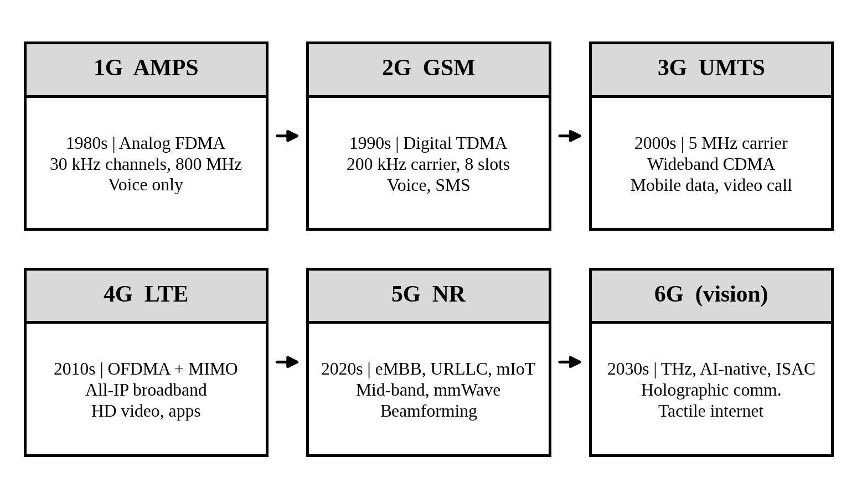
Figure 1. Progression of mobile generations from 1G to the 6G vision.
Table 3. Generational comparison, 1G to 6G
Generation | Main service capability | Access / radio technology | Limitation or change that motivated the next generation
1G (AMPS) | Analog voice only | Analog FM with FDMA; 30 kHz channels; 800 MHz band; 10 MHz total allocation | Low spectral efficiency, one call per channel, poor security and no data; digital processing was needed for capacity and quality.
2G (GSM) | Digital voice, SMS, international roaming | TDMA/FDMA; 200 kHz carrier with 8 TDMA slots; 900 MHz carrier | Circuit-switched and voice-centric with low data rate; packet data and higher rates were needed.
3G (UMTS) | Voice plus mobile packet data and video services | Wideband CDMA with 5 MHz carrier | Data rates and delay were still limited and CDMA is self-interference limited; an all-IP broadband air interface was needed.
4G (LTE) | Mobile broadband over an all-IP network | OFDMA and MIMO | Designed for broadband only; very low latency, massive device counts and mmWave bandwidth were not addressed.
5G (NR) | eMBB, URLLC and massive IoT services | NR air interface; mid-band and mmWave; beamforming | mmWave coverage is short and dense deployment raises cost and energy; sensing and AI integration motivate 6G.
6G (vision) | Holographic communication, tactile internet, sensing and AI-native services | THz bands, AI-native networking, integrated sensing and communication (ISAC) | Not yet standardised; THz propagation, energy efficiency and spectrum availability are open challenges.

Synthesis. The progression changed what spectrum, capacity and interference management mean. In 1G and 2G, capacity was obtained mainly by dividing a scarce band into channels or time slots and reusing those channels geographically, so interference management meant frequency planning. In 3G, all users shared a 5 MHz carrier, so capacity became limited by interference itself and power control became central. In 4G, OFDMA and MIMO moved the problem into scheduling and spatial multiplexing, and bandwidth became large enough that spectral efficiency, not channel count, set capacity. In 5G, mid-band and mmWave spectrum plus beamforming turned interference into a spatial problem, solved by narrow beams and dense small cells. The 6G vision extends this with THz spectrum and AI-native, sensing-aware control of the whole network. Across all generations the trend is the same: more bandwidth, tighter reuse, and interference managed with ever finer tools.

2.2 Wavelength at 800 MHz and Idealised 1G Channel Count
The wavelength follows from the relation between the speed of light c, frequency f and wavelength λ:
λ = c / f = (3 × 10⁸ m/s) / (800 × 10⁶ Hz) = 0.375 m (1)
The idealised number of AMPS channels is the total allocation divided by the channel spacing:
N_{ch} = B_{total} / Δf = (10 × 10⁶ Hz) / (30 × 10³ Hz) = 333.3 ≈ 333 channels (2)
Practical qualification. This result ignores guard bands and duplexing, as assumption A6 states. In a real FDD system each call needs a forward and a reverse channel, so if the 10 MHz were shared between both directions only about 333/2 ≈ 166 two-way calls would be possible. Guard bands and dedicated control channels reduce the figure further. The 333 channels are also a system total: with N = 7 reuse, each cell can use only about 333/7 ≈ 47 channels, which is why frequency reuse and cell size, rather than raw bandwidth, limited 1G capacity.

2.3 Improvement of 2G Digital TDMA over 1G Analog Service
In the same 10 MHz, GSM would offer 10 MHz / 200 kHz = 50 carriers, and with 8 TDMA slots per carrier this gives 50 × 8 = 400 full-rate traffic slots, compared with 333 analog channels, a raw gain of about 20% (and about 140% if half-rate speech coding doubles the slots). The larger benefit is qualitative. Digital transmission allows speech coding, error correction and encryption, which let the link tolerate a lower carrier-to-interference ratio than analog FM and therefore allow tighter frequency reuse; it also enables SMS, data services, handoff signalling and secure authentication [12]. The move to digital TDMA thus improved capacity, voice quality and security, and it prepared the platform for packet data in later generations.

3. STAGE 2: CELL COVERAGE AND FREQUENCY REUSE

3.1 Cell Area, Cluster Area and Reuse Geometry
For a regular hexagon whose circumradius equals the cell radius r, the area of one cell is [1], [3]:
A_{cell} = (3√3 / 2) r² = 2.598 × (2 km)² = 10.39 km² (3)
The 19-cell planning cluster then covers:
A₁₉ = 19 × A_{cell} = 19 × 10.39 km² = 197.45 km² (4)
With N = 7, each cell uses one seventh of the total channel set, so the frequency reuse fraction is:
1/N = 1/7 = 0.143 (14.3% of the channel set per cell) (5)
The co-channel reuse distance, measured between the centres of the nearest cells that use the same channels, is:
D = r√(3N) = 2 km × √21 = 9.17 km, D/r = √(3N) = 4.58 (6)
Table 4 collects these results and Figure 2 shows the 19-cell layout with the N = 7 reuse pattern. Adjacent cell centres are √3 r = 3.46 km apart, so the nearest co-channel cell lies about 2.6 cell-spacings away.
Table 4. Cell geometry and reuse results
Quantity | Expression | Result
Area of one cell | (3√3/2) r² | 10.39 km²
Area of 19-cell cluster | 19 × A_{cell} | 197.45 km²
Frequency reuse fraction | 1/N | 0.143
Reuse distance | D = r√(3N) | 9.17 km
Co-channel reuse ratio | D/r = √(3N) | 4.58
Adjacent cell-centre spacing | √3 r | 3.46 km

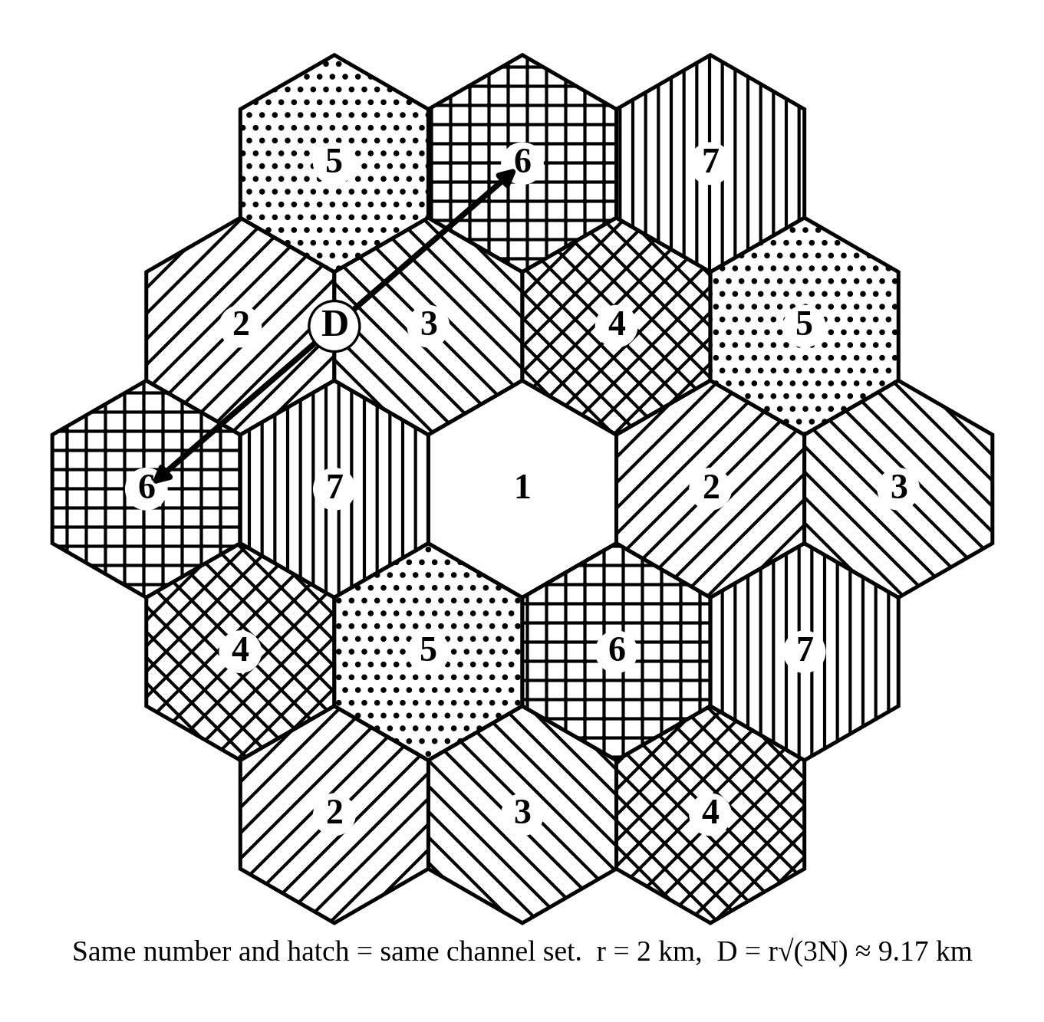
Figure 2. Nineteen-cell hexagonal planning cluster with N = 7 frequency reuse (D = 9.17 km).

3.2 Hexagonal Approximation and Radio Coverage
The hexagon is used because it is the regular polygon closest to a circle that tiles the plane with no gaps or overlaps, which makes reuse geometry tractable. It assumes a central omnidirectional antenna, uniform terrain, equal transmit power in every cell and propagation that depends only on distance. Geometric coverage is simply the area enclosed by the hexagon. Guaranteed radio coverage is different: it requires that the received signal exceeds the minimum usable level, with a fade margin for shadowing, at the edge of the cell with a stated reliability. Real cell edges are irregular because of terrain, buildings, antenna patterns and interference, so some locations inside the hexagon may have no usable service while others outside it may. Hexagonal planning is therefore a first-pass design tool that must be verified with link budgets, propagation prediction and drive tests.

3.3 Capacity-Expansion Techniques
Table 5. Effect of capacity-expansion techniques on coverage, capacity, interference and handoff
Technique | Effect on coverage | Effect on capacity | Interference and handoff implications
Cell splitting | Original cell replaced by smaller cells; total coverage unchanged | Halving r gives 4 times as many cells per area, so about 4 times the capacity per area | Reuse ratio D/r is preserved; handoff rate roughly doubles because cells are crossed twice as often; more sites to engineer
Sectoring (120°) | Same footprint, divided into three sectors | Capacity per site rises because reuse can be tightened, but channels are split among sectors (trunking loss) | Fewer co-channel interferers (about 2 instead of 6 in the first tier, ≈ 4.8 dB); more intra-site handoffs
Microcells | Street-level cells of a few hundred metres | High capacity in dense urban hotspots | Low-power, so interference is localised; fast users cross cells quickly and need an overlaid macro layer
Picocells | Indoor or hotspot cells of tens of metres | Very high capacity per area; offloads macro layer | Walls isolate cells; limited interference to outdoors; few handoffs for slow users
Femtocells | Home or small-office cells, user-installed | Adds capacity and indoor coverage with little operator infrastructure | Uncoordinated deployment can cause interference; access control and backhaul quality matter

3.4 Recommended Capacity-Expansion Measure
For this operator the demand is modest (80 Erlangs spread across about 197 km², as Section 4 shows), so new-site cost is not justified at this stage. The recommended first measure is 120° sectoring of the macro sites. It needs no new sites, raises capacity per site, and, as Section 6 demonstrates, it is the measure that lifts the SINR over the 15 dB target. Its effects are a reduction of first-tier co-channel interference by about 4.8 dB and an increase in handoff events, because mobiles now also cross sector boundaries within a site. As traffic grows, cell splitting (for example from r = 2 km to r = 1 km, which reduces the cell area to 2.60 km² and doubles the handoff rate to about 2 per minute at 60 km/h) and micro/picocells in hotspots are the logical next steps, while femtocells can serve indoor demand where the macro signal is weak.

4. STAGE 3: TRAFFIC CAPACITY

4.1 Offered Busy-Hour Traffic
The offered traffic in Erlangs is the product of the number of subscribers U and the traffic per subscriber a_{u} [1]:
A = U × a_{u} = 1000 × 0.08 E = 80 E (7)
This assumes Poisson call arrivals, exponentially distributed holding times, an essentially infinite source population and blocked-calls-cleared operation (A2), and that all 1,000 subscribers behave identically during the same busy hour.

4.2 Erlang B Blocking and Channel Requirement
The Erlang B formula gives the probability that a call is blocked when A Erlangs are offered to C channels [4]:
B(C, A) = (A^{C} / C!) / Σ_{k=0}^{C} (A^{k} / k!) (8)
For large C it is evaluated with the stable recursion below, which was used for all results in this report:
B(0, A) = 1; B(k, A) = A·B(k−1, A) / [k + A·B(k−1, A)] (9)
With A = 80 E and C = 100, the recursion gives B = 0.00399, i.e. a blocking probability of 0.40%, well within the 2% target. To find the smallest channel count meeting the target, the recursion was evaluated for decreasing C: B(91) = 2.25% exceeds the target, while B(92) = 1.92% meets it. The minimum is therefore C = 92 channels. Table 6 and Figure 3 show the neighbourhood of this result.
Table 6. Erlang B results for A = 80 E
Channels C | Blocking B (%) | Carried traffic A(1−B) (E) | Channel utilisation (%)
90 | 2.62 | 77.90 | 86.6
91 | 2.25 | 78.20 | 85.9
92 | 1.92 | 78.46 | 85.3
95 | 1.14 | 79.09 | 83.3
100 | 0.40 | 79.68 | 79.7

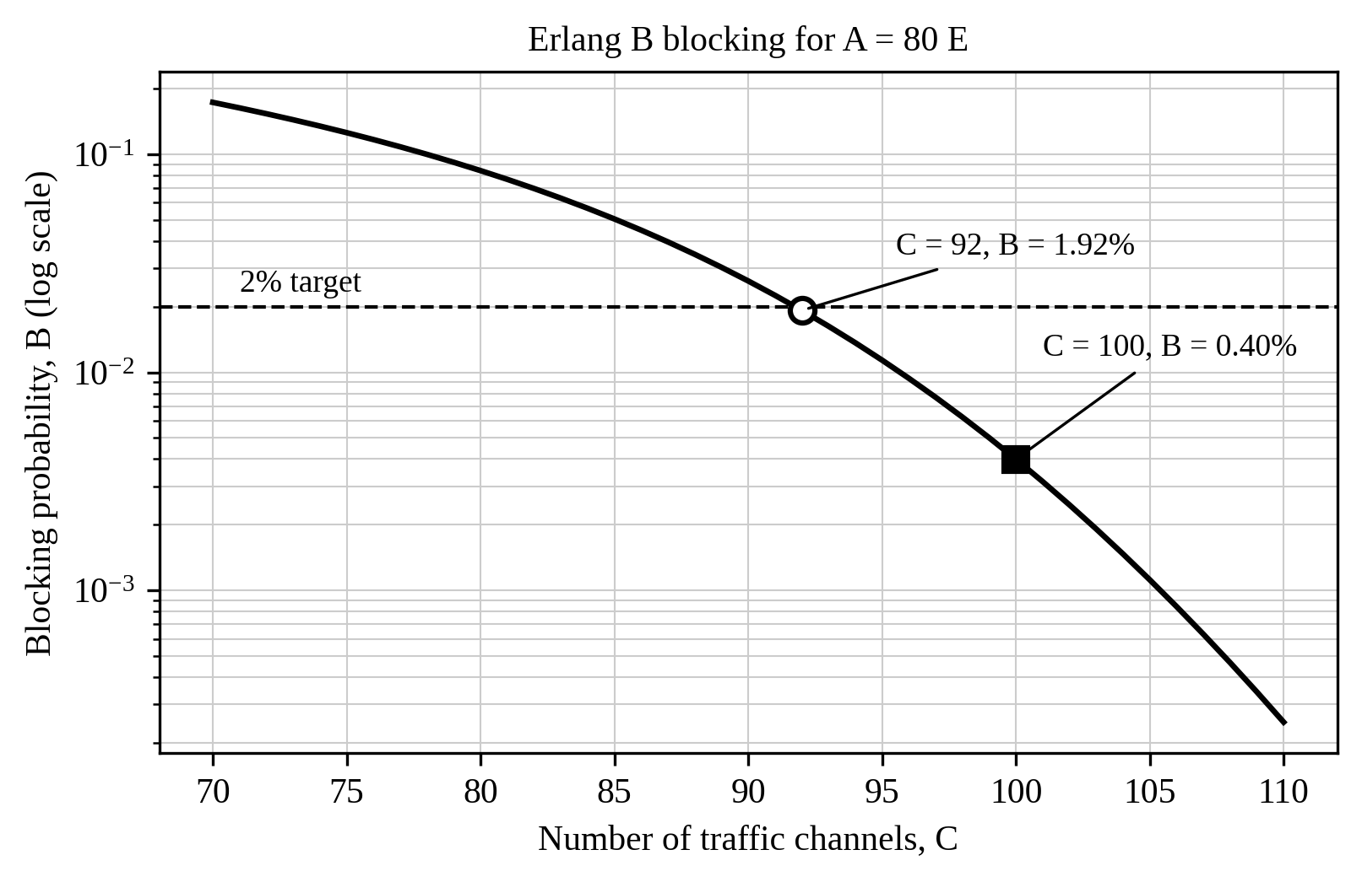
Figure 3. Erlang B blocking probability versus number of channels for A = 80 E.
The number of 100-channel groups needed to supply the 92-channel requirement is:
N_{groups} = ⌈ 92 / 100 ⌉ = 1 (10)
One 100-channel base-station group is therefore enough for the whole 80 E demand, with 8 spare channels. The maximum traffic the 100 channels could carry at 2% blocking is about 88 E, equivalent to roughly 1,100 subscribers, so the initial base station also has about 10% growth headroom.

4.3 Why This Is Only a First-Order Estimate
The result treats all 1,000 subscribers as one pooled population served by one group of channels. A real site plan must also account for: (i) the spatial distribution of users, because the 197 km² area cannot be covered from one site; if demand were uniform over the 19 cells, each cell would offer only 80/19 = 4.21 E and need about 9 channels for B ≤ 2%, so about 171 channel-units in total instead of 92, showing the trunking-efficiency cost of splitting traffic; (ii) the reuse constraint, since with N = 7 each cell can use only a fraction of the total spectrum; (iii) control and signalling channels; (iv) extra load from handoff traffic; (v) traffic growth and busy-hour variation; and (vi) the fact that coverage, not capacity, is likely to decide site count here.

4.4 Capacity, Blocking and Infrastructure Trade-offs
Blocking falls steeply as channels are added: going from 92 to 100 channels cuts blocking from 1.92% to 0.40% but lowers channel utilisation from 85.3% to 79.7%, so the extra eight channels buy service quality and growth headroom at the cost of idle capacity. Pooling traffic into larger channel groups improves efficiency (trunking gain), but pooling conflicts with the need for many smaller cells to provide coverage and reuse. In short, the operator trades spectrum and equipment cost against grade of service: the initial 100-channel station meets the target with margin, and the main infrastructure question is coverage rather than channel count.

5. STAGE 4: MOBILITY AND HANDOFF

5.1 Distance Travelled in the Overlap Interval
The speed is converted to SI units and multiplied by the overlap dwell time:
v = 60 km/h = 60 000 m / 3600 s = 16.67 m/s (11)
d_{overlap} = v × t = 16.67 m/s × 6 s = 100 m (12)
The overlap zone through which the mobile is handed off is therefore 100 m wide along the route, about 10% of the 1 km nominal cell length (Figure 4). The mobile has 6 s in which signal measurements, the handoff decision and execution must be completed.
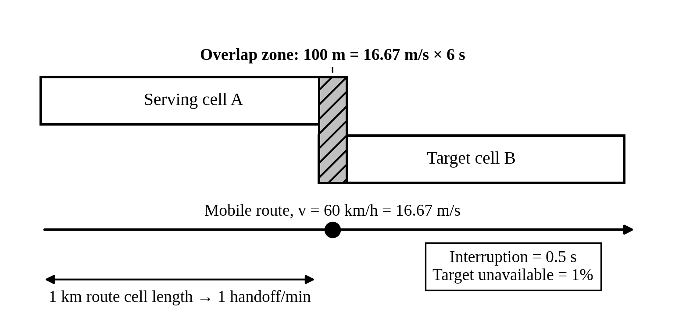
Figure 4. Overlap zone and handoff geometry for a mobile moving at 60 km/h.

5.2 Hard Handoff Rate
The 1 km nominal cell length along the route is interpreted as the route distance between successive cell-boundary crossings, so the mobile makes one handoff per kilometre. The time spent in each cell and the handoff rate are:
t_{cell} = 1000 m / 16.67 m/s = 60 s, R_{HO} = 60 s/min / 60 s = 1 handoff per minute (13)
If the 100 m overlap were instead added to the cell length (1.1 km per cell), the rate would be about 0.91 handoffs per minute, so the result is not sensitive to this interpretation. A call lasting 5 minutes would experience about 5 handoffs.

5.3 Hard, Soft and Softer Handoff
Table 7. Comparison of hard, soft and softer handoff
Type | Connection continuity | Resource use | Typical use
Hard handoff | Break-before-make: the old link is released before the new one is set up, giving a brief interruption (0.5 s here) | Lowest: only one radio link at a time | GSM and LTE
Soft handoff | Make-before-break: the mobile is connected to two or more cells at once, so the call is continuous | Higher: extra channels, backhaul and signalling during the handoff | CDMA systems such as UMTS
Softer handoff | Make-before-break between sectors of the same base station, combined at that site | Moderate: extra channel elements at the site but no extra backhaul | CDMA sectorised sites

5.4 Simple Call-Drop Risk for One Handoff
A simple model treats a handoff as failing, and the call as dropped, when the target cell is unavailable at the moment of handoff. With the supplied 1% unavailability:
P_{drop,1} ≈ P(target unavailable) = 0.01 = 1% (14)
The 0.5 s interruption occurs once per handoff, so the mobile is in interruption for 0.5 s / 60 s = 0.83% of the journey time, and the 6 s overlap window is 12 times longer than the interruption, which leaves time for the handoff to be executed. If handoffs are assumed independent, the probability that a call with n handoffs survives is (0.99)^{n}, giving drop probabilities of 1.0% for n = 1, 4.9% for n = 5 (a 5-minute call) and 9.6% for n = 10.
Limits of the estimate. The model assumes that unavailability is independent between handoffs and equal to the time-average value, whereas congestion is correlated with busy hours and with the same location. It ignores retries inside the 6 s overlap window, which would lower the risk, as well as handoff-reservation (guard) channels, ping-pong handoffs, fading near the cell edge and the possibility that a 0.5 s interruption is audible but does not itself drop a call. It is therefore a rough planning figure, not a performance guarantee.

6. STAGE 5: INTERFERENCE AND SPECTRUM-BAND COMPARISON

6.1 Carrier-to-Interference Ratio with Co-channel Interference Alone
With powers in dBm, the carrier-to-interference ratio is the difference of the levels:
C/I = S − I₁ = −70 dBm − (−85 dBm) = 15 dB (15)
The co-channel interferer alone gives exactly the 15 dB target, so there is no margin; any additional interference makes the target fail.

6.2 Total Interference and SINR
Powers must be added in linear units. Converting with P(mW) = 10^{P(dBm)/10}:
I₁ = 10^{−8.5} = 3.162 × 10⁻⁹ mW, I₂ = 10^{−9.0} = 1.000 × 10⁻⁹ mW (16)
I_{tot} = I₁ + I₂ = 4.162 × 10⁻⁹ mW = 10 log₁₀(4.162 × 10⁻⁹) = −83.81 dBm (17)
SINR = S − I_{tot} = −70 − (−83.81) = 13.81 dB (18)
Since 13.81 dB < 15 dB, the target is not met, falling short by 1.19 dB. Because no noise power was supplied (A4), this value is an upper bound on the true SINR, so adding thermal noise could only widen the shortfall. Figure 5 compares the power levels, and Table 8 lists the results.
Table 8. Interference results
Quantity | Value | Meets 15 dB?
C/I, co-channel only (S − I₁) | 15.00 dB | Exactly (no margin)
Total interference I₁ + I₂ | −83.81 dBm | –
SINR with total interference | 13.81 dB | No (short by 1.19 dB)

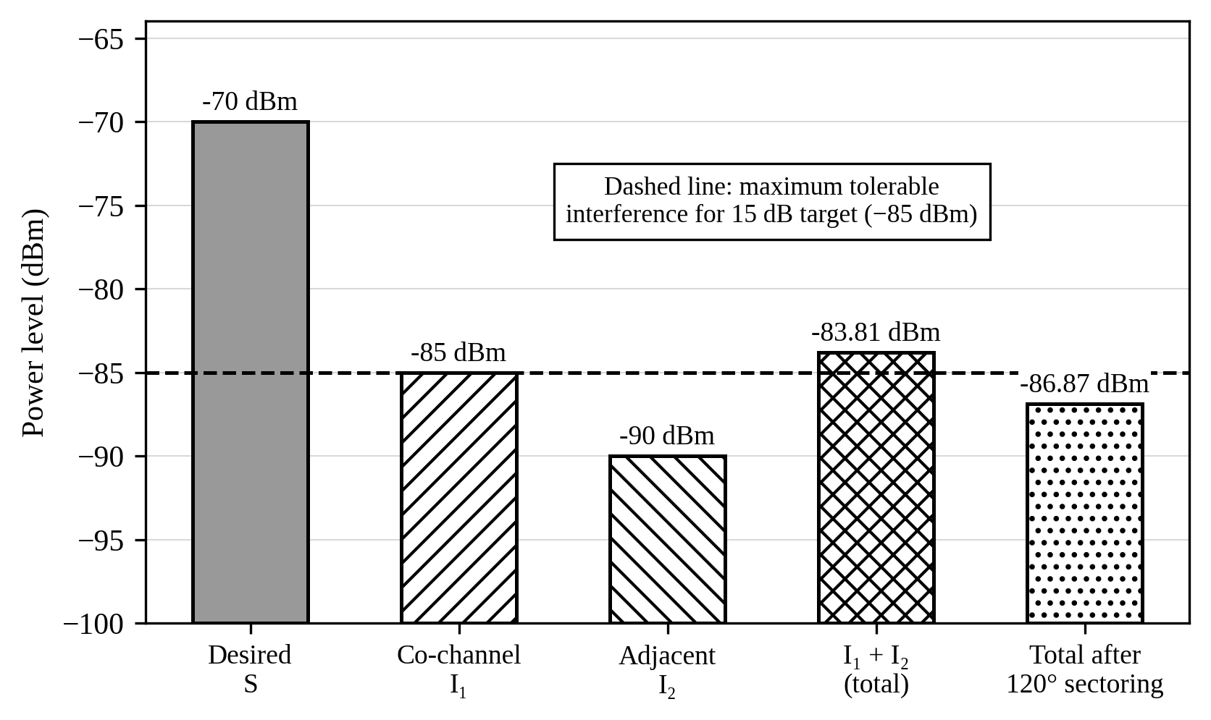
Figure 5. Signal and interference levels with the −85 dBm limit for a 15 dB target.

6.3 Recommended Mitigation and Trade-off
Because the co-channel term is the larger contributor and already sits exactly on the limit, mitigation must reduce co-channel interference. The recommended measure is 120° sectoring, which cuts the number of first-tier co-channel interferers seen by a receiver from about 6 to about 2. If I₁ falls by that factor of 3, it drops by 10 log₁₀(3) = 4.77 dB to −89.77 dBm. The new total interference is 1.05 × 10⁻⁹ + 1.00 × 10⁻⁹ = 2.05 × 10⁻⁹ mW = −86.87 dBm, giving SINR = −70 − (−86.87) = 16.87 dB, which meets the target with 1.87 dB of margin. This is an idealised estimate that should be confirmed by measurement. Table 9 compares the options considered.
Table 9. Comparison of interference-mitigation options
Option | Resulting SINR | Meets 15 dB? | Main trade-off
No mitigation | 13.81 dB | No | –
10 dB better adjacent-channel rejection (I₂ → −100 dBm) | 14.86 dB | No | Needs better filters or larger channel separation; does not address the dominant co-channel term
Remove adjacent-channel interference completely | 15.00 dB | Only just | Needs wider guard spacing, which wastes spectrum; no margin
120° sectoring (recommended) | 16.87 dB | Yes | More antennas and cost, more intra-site handoffs, and channels split among sectors reduce trunking efficiency

Other possible measures are a larger reuse cluster, for example N = 12 instead of 7, which reduces interference but leaves each cell with only 1/12 of the channels (a 42% reduction), and power control or antenna down-tilt, which reduce interference at the cost of coverage margin.

6.4 Spectrum-Band Comparison at 100 m
For each band the wavelength is λ = c/f and the free-space path loss at d = 100 m is FSPL = 20 log₁₀(4πd/λ) [5]. For 900 MHz, λ = 0.3333 m, so 4πd/λ = 1256.6/0.3333 = 3769.9 and FSPL = 71.53 dB. The same procedure gives 83.32 dB at 3.5 GHz (λ = 0.0857 m) and 101.38 dB at 28 GHz (λ = 0.0107 m). The difference relative to 900 MHz depends only on the frequency ratio:
ΔFSPL = 20 log₁₀(f / f₀) (19)
3.5 GHz: 20 log₁₀(3.889) = 11.80 dB; 28 GHz: 20 log₁₀(31.11) = 29.86 dB (20)
Table 10. Comparison of 900 MHz, 3.5 GHz and 28 GHz
Parameter | 900 MHz | 3.5 GHz | 28 GHz
Wavelength λ | 0.3333 m | 0.0857 m | 0.0107 m
FSPL at 100 m | 71.53 dB | 83.32 dB | 101.38 dB
Path loss relative to 900 MHz | 0 dB | +11.80 dB | +29.86 dB
Free-space range at equal path loss (relative) | 1.00 | 0.26 | 0.03
Half-wave antenna length (λ/2) | 16.7 cm | 4.3 cm | 5.4 mm
Likely penetration through walls and foliage | Good | Moderate | Poor; easily blocked
Typical bandwidth available | Narrow (tens of MHz) | Wide (about 100 MHz) | Very wide (hundreds of MHz or more)
Coverage / capacity role | Wide-area coverage, deep indoor, high mobility | Balanced coverage and capacity | Short-range, very high capacity hotspots

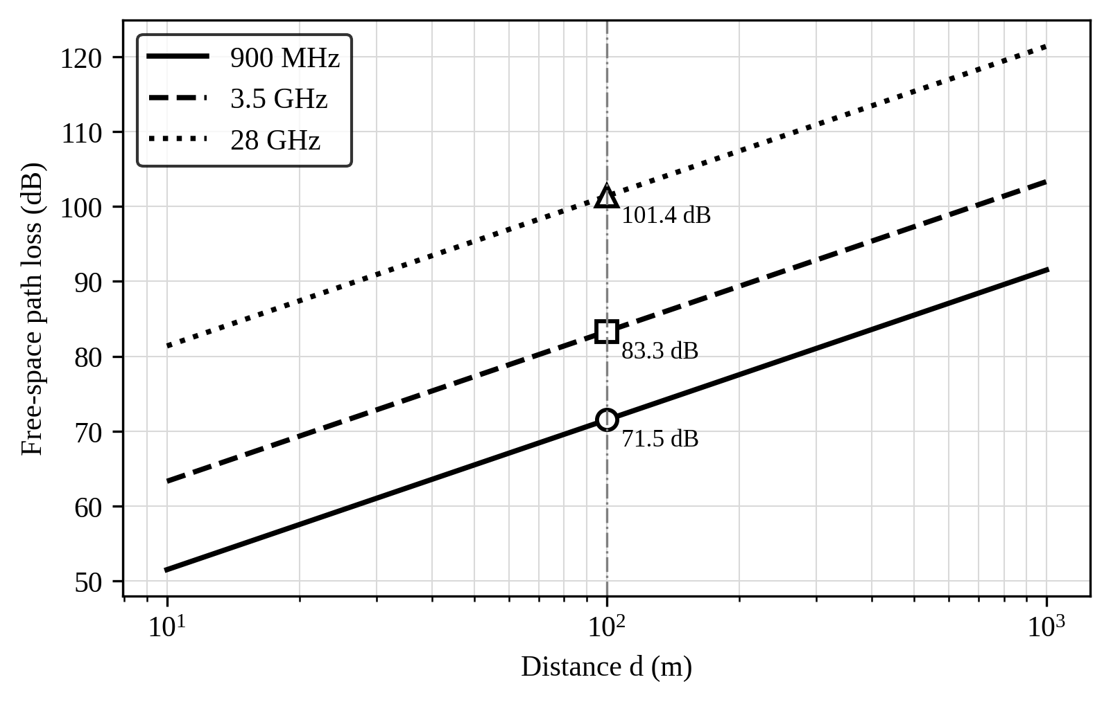
Figure 6. Free-space path loss versus distance for 900 MHz, 3.5 GHz and 28 GHz.
Interpretation. Path loss grows by 20 dB per decade of both distance and frequency. At equal path loss the free-space range at 3.5 GHz is only about 26% of that at 900 MHz, and at 28 GHz only about 3%, so covering the same area at higher frequencies needs many more sites. Higher frequencies penetrate buildings less well but allow much smaller antennas, which makes large antenna arrays practical, and they usually offer far more bandwidth. Low bands therefore favour coverage and mobility, while high bands favour capacity.
Why path loss alone does not decide performance. Free-space path loss rises with frequency partly because a fixed-gain antenna has a smaller effective aperture at a shorter wavelength. If the physical antenna area is held constant, the array gain rises roughly as 1/λ², so beamforming with many small elements can recover much of the loss at 3.5 GHz and 28 GHz [2], [10]. Achievable throughput also depends on bandwidth (Shannon capacity C = B log₂(1 + SINR)), on whether the link is noise-limited or interference-limited, on narrow beams that improve spatial reuse, on blockage, and on load. A 28 GHz link with 400 MHz of bandwidth and a high-gain beam can therefore outperform a 900 MHz link with 10 MHz, even with about 30 dB more path loss.

7. STAGE 6: SPECTRUM COORDINATION

7.1 Roles of ITU-R, WRC and the Radiocommunication Bureau
Table 11. Roles in international spectrum coordination
Body | Distinct role
ITU-R (Radiocommunication Sector) | The sector of the International Telecommunication Union responsible for the global use of the radio-frequency spectrum and satellite orbits. Its study groups develop technical Recommendations and Reports, for example the IMT vision and requirements documents for IMT-2020 and IMT-2030 [6], [7].
WRC (World Radiocommunication Conference) | The decision-making conference of ITU Member States, held every three to four years. It reviews and revises the Radio Regulations, the international treaty that allocates frequency bands to radio services and sets conditions of use, and sets the agenda for the next conference [8].
BR (Radiocommunication Bureau) | The permanent executive and administrative arm of ITU-R. It processes administrations' frequency-assignment notifications, records them in the Master International Frequency Register, helps resolve harmful-interference and coordination cases, and supports the study groups and conferences.

7.2 How International Coordination Affects Regulators and Operators
International coordination shapes national decisions through harmonised allocations. When a WRC identifies a band for IMT, national regulators normally align their national frequency tables with it and then decide how to license it, for example by auction, and operators can plan around a large common equipment ecosystem, lower device cost and easier roaming. Coordination also limits how a band can be used near borders: an operator whose network is close to a neighbouring country must respect agreed power or field-strength limits at the border, and in bands shared with other services, such as satellite earth stations near 3.5 GHz, coexistence conditions may restrict antenna siting and emissions. The operator must therefore check the national allocation table, licence conditions and any bilateral coordination agreements before committing to a band.

8. COMPARISON AND INTEGRATED RECOMMENDATION

8.1 Consolidated Results
Table 12 brings the results of all stages together and states the planning implication of each.
Table 12. Consolidated results and planning implications
Topic | Result | Implication for the plan
Cell geometry | A_{cell} = 10.39 km²; A₁₉ = 197.45 km²; D = 9.17 km (N = 7) | Coverage area is large, so site count is decided by coverage and reuse geometry.
Traffic | A = 80 E; B(100) = 0.40%; minimum C = 92 for B ≤ 2%; 1 channel group | Capacity is not the initial constraint; the 100-channel station meets the target with about 10% growth headroom.
Mobility | 100 m overlap; 1 handoff/min; ≈ 1% drop risk per handoff | Handoff reliability matters; plan overlap, guard channels and signalling for mobile users.
Interference | C/I = 15 dB; SINR = 13.81 dB (short by 1.19 dB); 16.87 dB with sectoring | Interference is the binding quality constraint; sectoring restores the margin.
Spectrum bands | FSPL 71.53, 83.32, 101.38 dB; +11.80 and +29.86 dB vs 900 MHz | Low band for coverage; mid band for capacity; mmWave for hotspots.

8.2 Recommended Phased Network Plan
The calculations show that the operator's immediate problem is coverage and signal quality, not channel count: one base-station channel group already serves the busy-hour traffic, while the interference case fails the SINR target and the area to be covered is large. The recommendation is therefore a staged strategy that adds capacity only as demand grows (Table 13 and Figure 7).
Table 13. Recommended three-phase deployment strategy
Phase | Spectrum and technology | Actions and supporting evidence | Trigger for next phase
Phase 1 Coverage and quality | 900 MHz macro layer; LTE-class or 5G NR low-band radio | Cover the 197 km² area with N = 7 reuse; apply 120° sectoring so SINR rises from 13.81 dB to about 16.87 dB; use one 100-channel group per site (B = 0.40%); plan hard handoff with guard channels for the 1 handoff/min mobile user | Measured busy-hour blocking above 2% or SINR below 15 dB in the field
Phase 2 Capacity | Add 3.5 GHz mid-band on the same sites; NR with beamforming and MIMO | Beamforming and arrays recover the extra 11.80 dB of path loss; selective cell splitting (r = 2 km to 1 km, about 4 times capacity per area, about 2 handoffs/min) and microcells in dense areas | Hotspot demand exceeding macro capacity or user data-rate targets
Phase 3 Hotspots and 6G readiness | 28 GHz small cells and fixed wireless in hotspots; prepare for 6G features | Use 28 GHz only where demand justifies the 29.86 dB loss and dense small-cell cost; adopt ISAC and AI-native management as standards mature | Standardisation, device availability and spectrum decisions at later WRC cycles

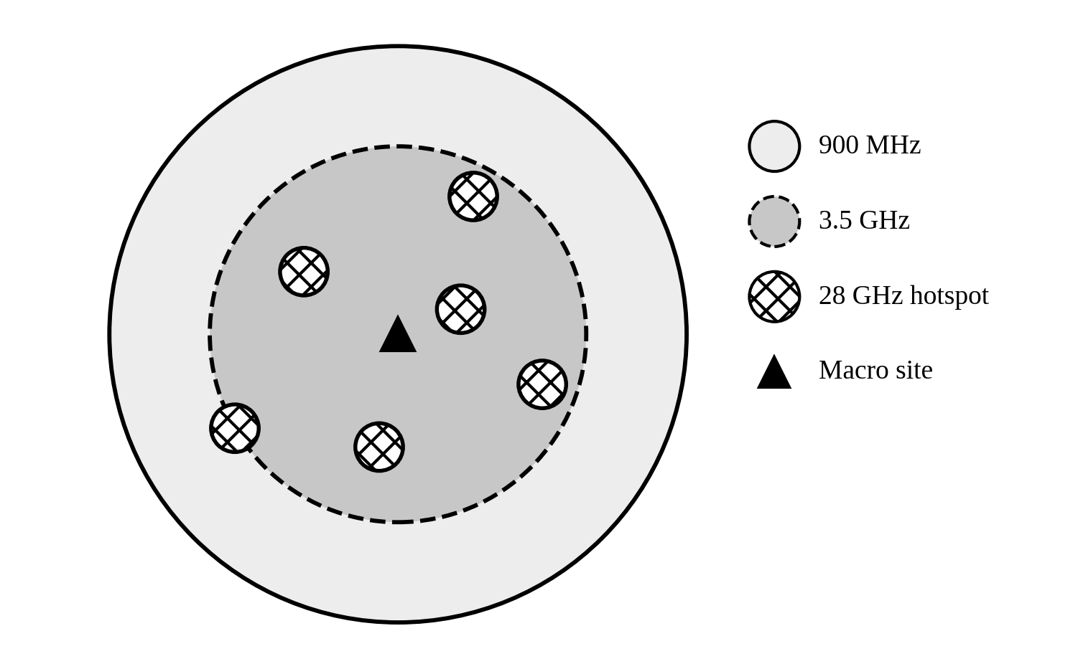
Figure 7. Layered deployment concept: 900 MHz coverage layer, 3.5 GHz capacity layer and 28 GHz hotspots.
This plan connects each part of the analysis. Generational evolution (Section 2) shows that capacity now comes mainly from wider bandwidth, tighter reuse and spatial techniques, so the plan adds mid-band and mmWave layers on top of a coverage layer. The cell and traffic results (Sections 3 and 4) show that coverage rather than channels sets the initial site count, and that splitting is the later growth path. The handoff analysis (Section 5) shows that frequent handoffs for fast users favour large macro cells, while small cells are reserved for slow or stationary users. The interference result (Section 6) shows that sectoring is needed before any densification. Finally, the band comparison and spectrum coordination (Sections 6.4 and 7) show that low band gives coverage, mid band gives balance and mmWave gives capacity, and that all three depend on national licensing under the international framework.

8.3 Main Trade-offs
- Coverage versus capacity: low bands cover more area per site but have limited bandwidth, while high bands offer capacity but need many more sites.
- Capacity versus interference: tighter reuse and sectoring increase capacity but raise interference and handoff load unless managed.
- Pooling versus distribution: large channel groups are efficient (92 channels for 80 E), but coverage forces traffic to be split among many cells.
- Cost versus phasing: a phased plan delays spending on dense sites and mmWave until demand and device ecosystems are proven.

9. ASSUMPTIONS AND UNCERTAINTIES
Table 14 lists the most important assumptions behind the analysis and the check that should be made before implementation.
Table 14. Key assumptions, uncertainties and verification actions
Area | Uncertainty | Verification before deployment
Traffic | 0.08 E per subscriber, uniform behaviour, Poisson arrivals and no growth were assumed | Measure busy-hour traffic by area; forecast growth; compare with Erlang B or Erlang C models as appropriate
Propagation | Free-space loss only; real losses include shadowing, clutter, building penetration and rain | Use link budgets with fade margins, a propagation prediction tool and drive tests in each band
Interference | Supplied powers were taken as fixed and noise was ignored; sectoring gain of 4.77 dB is idealised | Measure real co-channel and adjacent-channel levels and the noise floor; verify reuse plan and antenna patterns
Mobility | Constant speed, straight route, independent handoffs and a fixed 1% target-cell unavailability | Measure handoff success and drop rates; tune thresholds, overlap and guard channels
Spectrum | Availability, licence terms and cross-border limits for 900 MHz, 3.5 GHz and 28 GHz in the region | Check the national allocation table, licence conditions, coordination agreements and WRC decisions
Economics and ecosystem | Site, backhaul and equipment costs and device support were not analysed | Prepare cost models and confirm device and equipment availability for each band

10. CONCLUSION
This report analysed the evolution of mobile systems and the main engineering factors that shape deployment for a regional operator. The analysis found that a 2 km hexagonal cell covers 10.39 km², that the nearest co-channel cell is 9.17 km away for N = 7, that an offered load of 80 Erlangs needs only 92 channels for a 2% blocking target so a single 100-channel group suffices, that a mobile at 60 km/h makes one handoff per minute with about 1% drop risk per handoff, and that the supplied interference case reaches only 13.81 dB SINR against the 15 dB target. Sectoring at 120° is the recommended low-cost fix, giving about 16.87 dB. The band comparison shows path-loss penalties of 11.80 dB at 3.5 GHz and 29.86 dB at 28 GHz relative to 900 MHz, which is why the recommended strategy builds a 900 MHz coverage layer first, adds 3.5 GHz capacity with beamforming, and reserves 28 GHz for hotspots, all subject to the verification of the assumptions in Section 9.

REFERENCES
[1] T. S. Rappaport, Wireless Communications: Principles and Practice, 2nd ed. Upper Saddle River, NJ, USA: Prentice Hall, 2002.
[2] A. Goldsmith, Wireless Communications. Cambridge, U.K.: Cambridge University Press, 2005.
[3] V. H. MacDonald, “The cellular concept,” Bell System Technical Journal, vol. 58, no. 1, pp. 15–41, Jan. 1979.
[4] A. K. Erlang, “The theory of probabilities and telephone conversations,” Nyt Tidsskrift for Matematik B, vol. 20, pp. 33–39, 1909.
[5] H. T. Friis, “A note on a simple transmission formula,” Proc. IRE, vol. 34, no. 5, pp. 254–256, May 1946.
[6] ITU-R, “IMT Vision – Framework and overall objectives of the future development of IMT for 2020 and beyond,” Recommendation ITU-R M.2083-0, Sep. 2015.
[7] ITU-R, “Framework and overall objectives of the future development of IMT for 2030 and beyond,” Recommendation ITU-R M.2160-0, Nov. 2023.
[8] International Telecommunication Union, Radio Regulations, Geneva, Switzerland (current edition).
[9] 3GPP, “NR; NR and NG-RAN overall description,” 3GPP TS 38.300.
[10] J. G. Andrews et al., “What will 5G be?,” IEEE J. Sel. Areas Commun., vol. 32, no. 6, pp. 1065–1082, Jun. 2014.
[11] W. Saad, M. Bennis and M. Chen, “A vision of 6G wireless systems: Applications, trends, technologies, and open research problems,” IEEE Network, vol. 34, no. 3, pp. 134–142, May/Jun. 2020.
[12] M. Mouly and M.-B. Pautet, The GSM System for Mobile Communications. Palaiseau, France: Authors, 1992.

