1. Filter by expression & Reformat

**Reformat:**

1. Create a graph to drop a column from an input file.

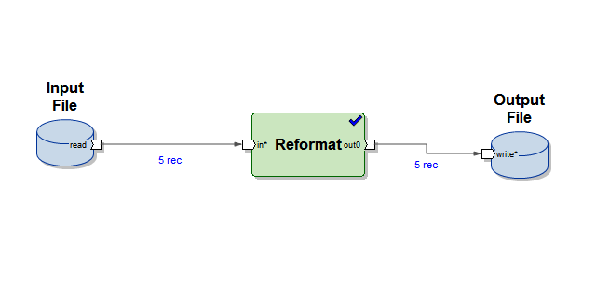

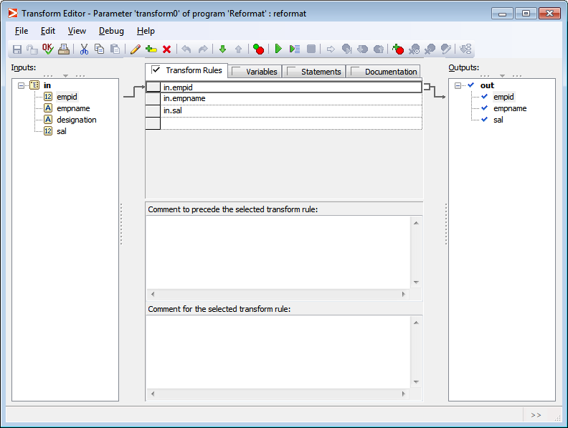

INPUT FILE:

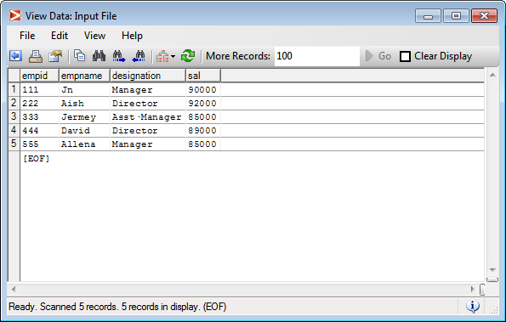

OUTPUT FILE:

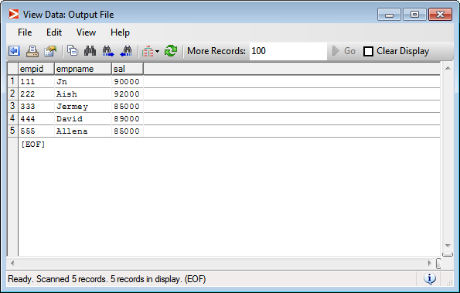

1. Create a graph to concatenate values from 2 field,

- first 3 characters from empid field

- first 3 characters from name field

Concatenated result must be stored in newly created column called as userid.

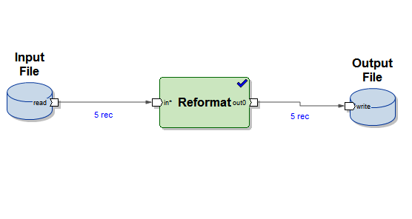

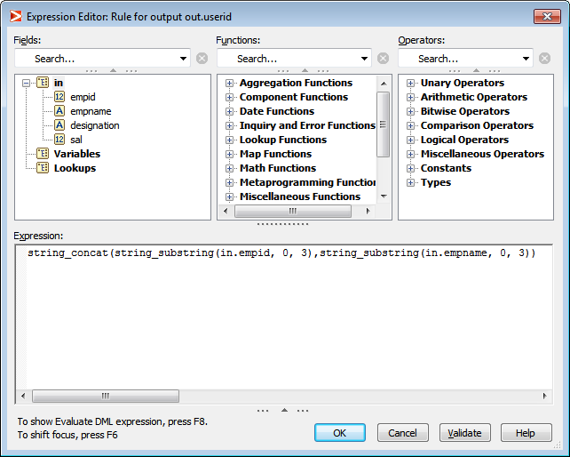

INPUT FILE:

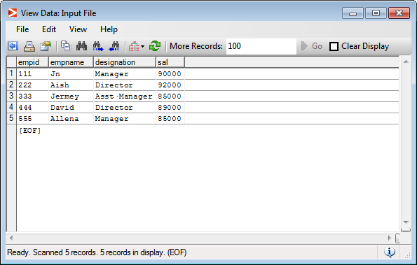

OUTPUT FILE:

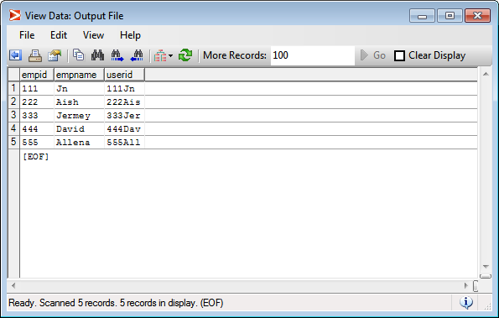

1. Create a graph which will read input from below given input file and will convert name of employee in upper case in the output file.

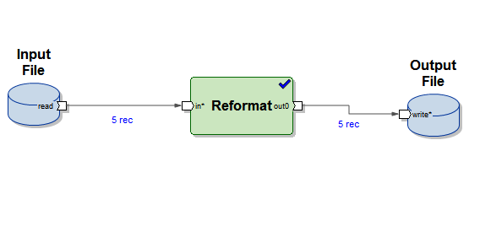

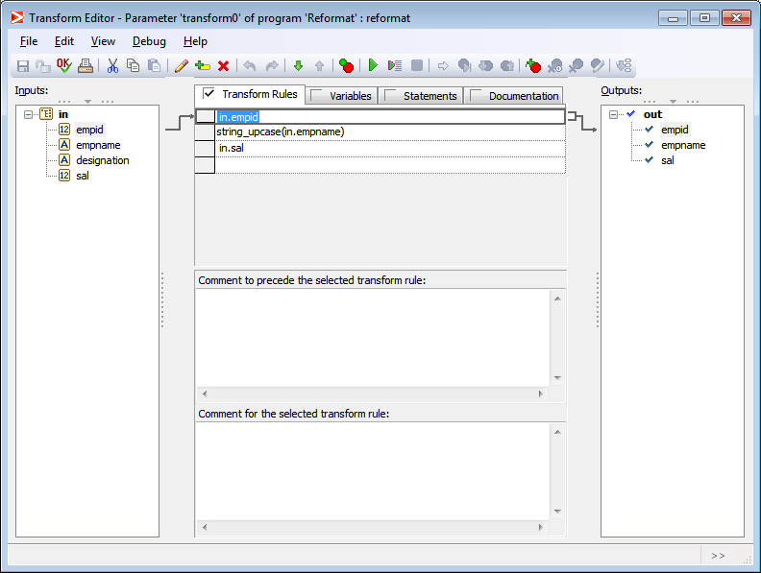

INPUT FILE:

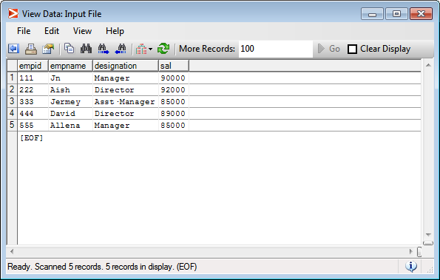

OUTPUT FILE:

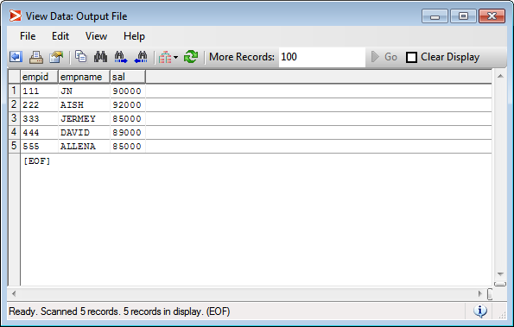

1. Create a graph which will create a new column known as slno, which creates sequence number. (Hint: use next_in_seq)

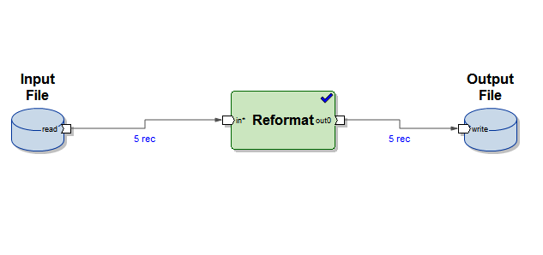

INPUT FILE:

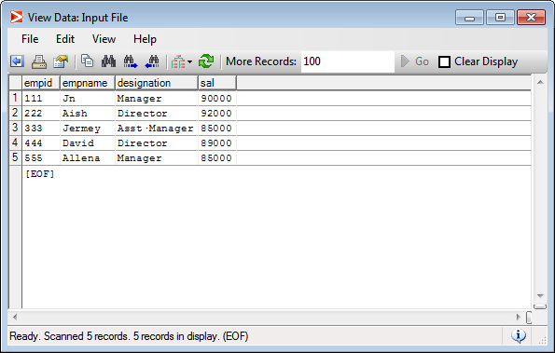

OUTPUT FILE:

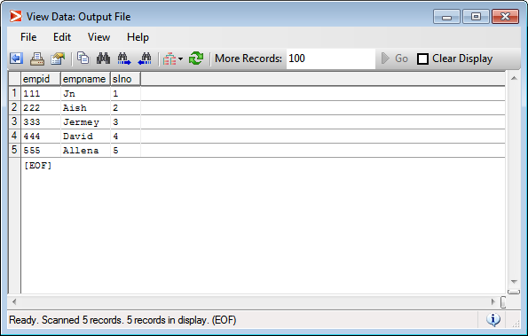

**Filter By Expression:**

1. Create a graph to filter all records who belongs to Pune city.

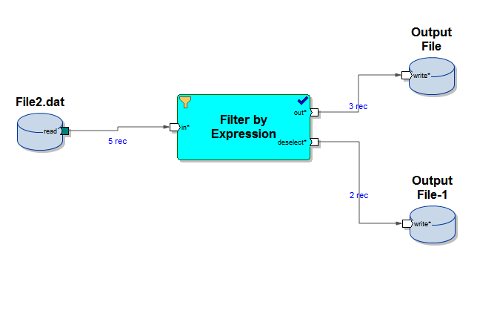

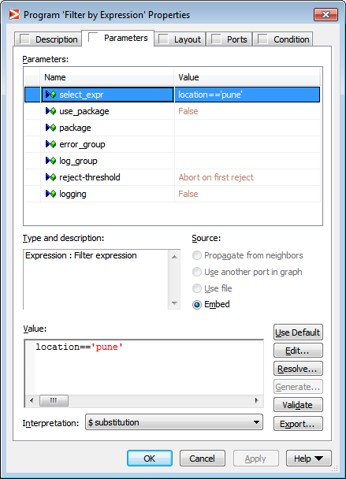

INPUT FILE:

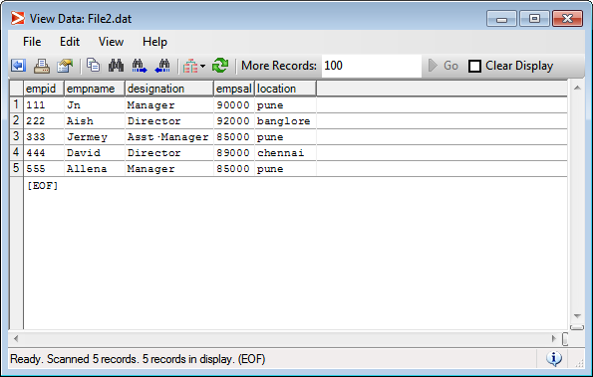

OUTPUT FILE1:

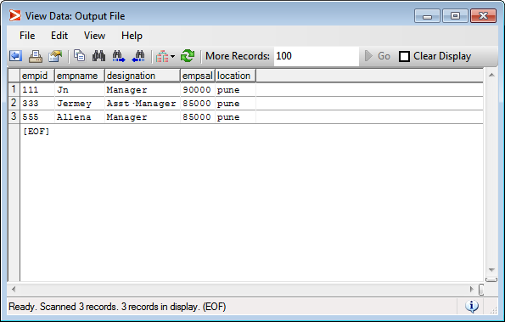

OUTPUT FILE2:

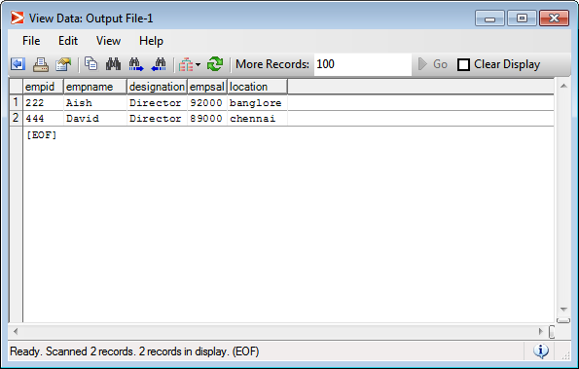

1. Create a graph to filter records who year of joining is greater than 2016 and belonging to HR dept. Create below file and populate some sample data.

Emp.dat

empid,empname,yearofjoin,department

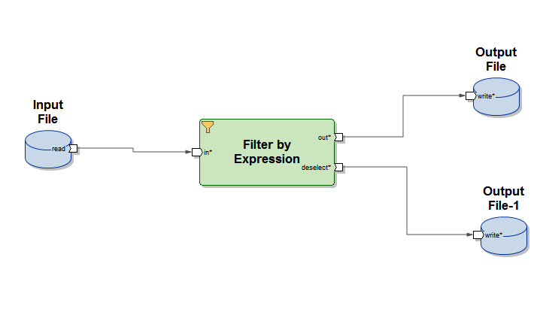

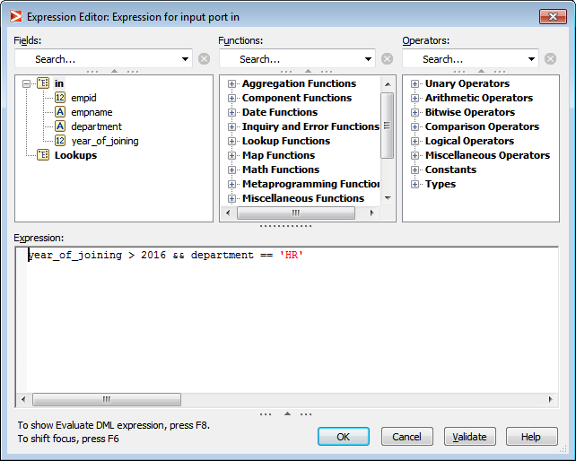

INPUT FILE:

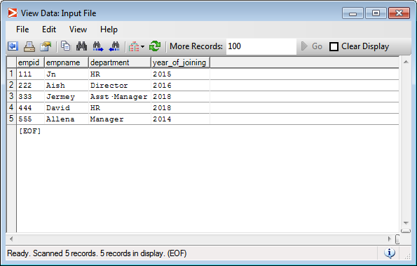

OUTPUT FILE1:

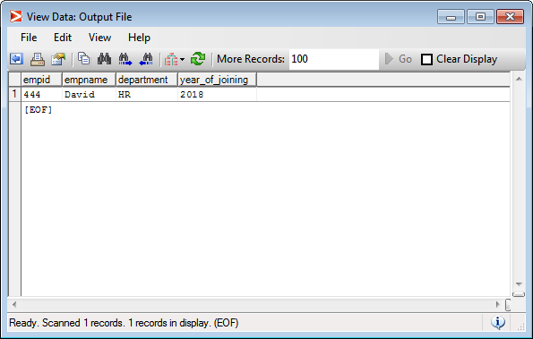

OUTPUT FILE2:

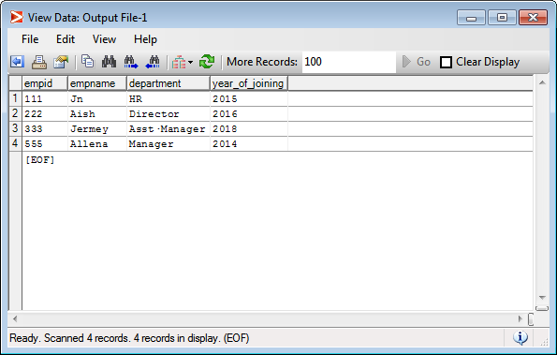

**Sort**

1. Create a graph to sort employee details based on Salary.

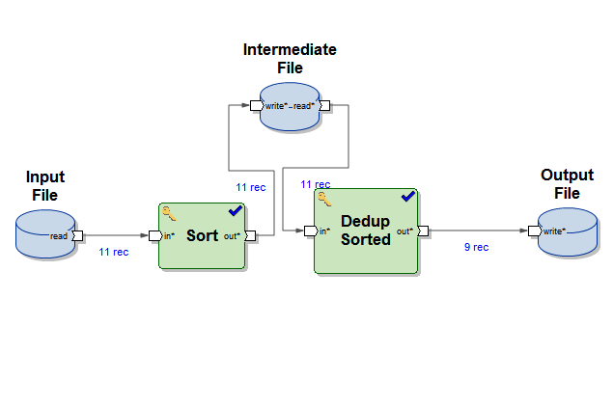

INPUT FILE:

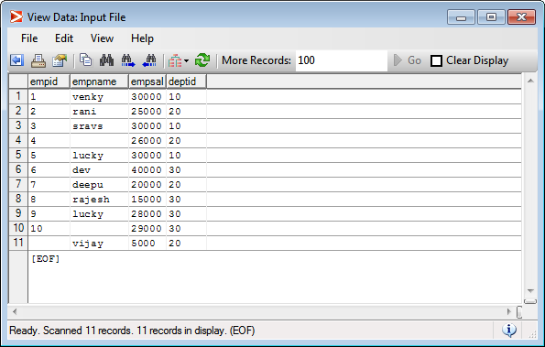

INTERMEDIATE FILE:

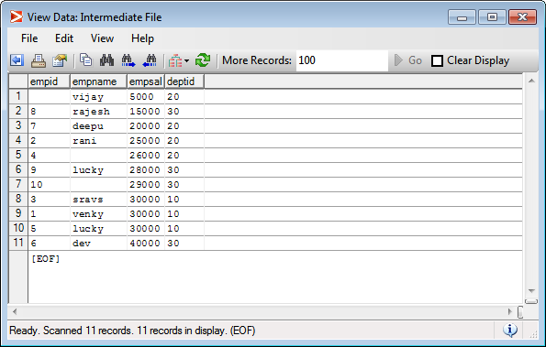

OUTPUT FILE:

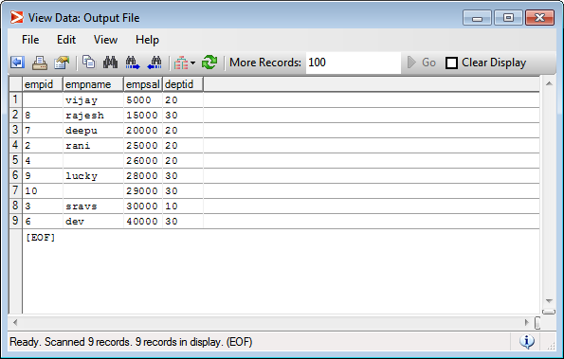

1. Create a graph to sort employee details based on Salary, If salaries are same, next it should sort data based on designation.

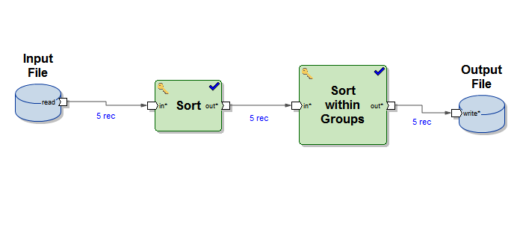

INPUT FILE:

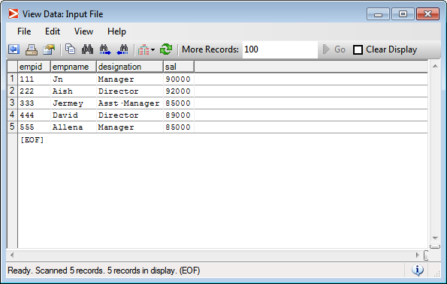

OUTPUT FILE:

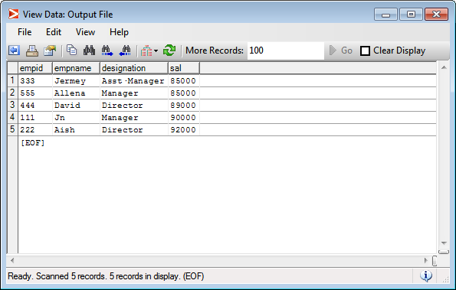

1. Create a graph to find employee details who is paid with highest salary and employee paid with lowest salary.

Joins:

**Problem Statement:** From given input file, find the sim id’s whose status is in Active mode and is not cancelled.

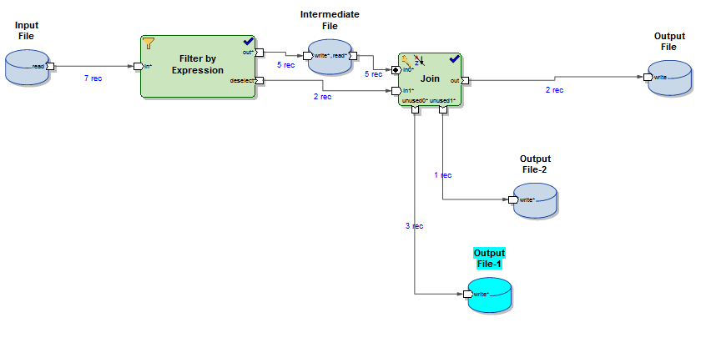

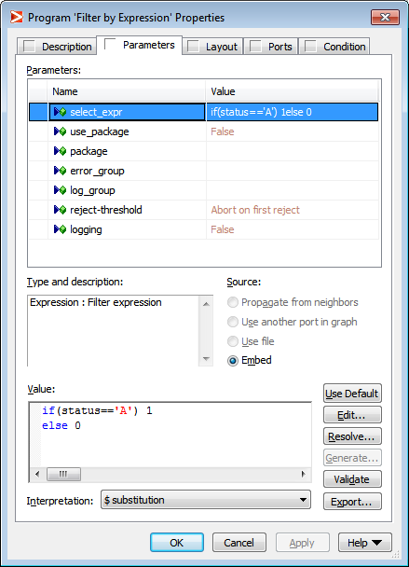

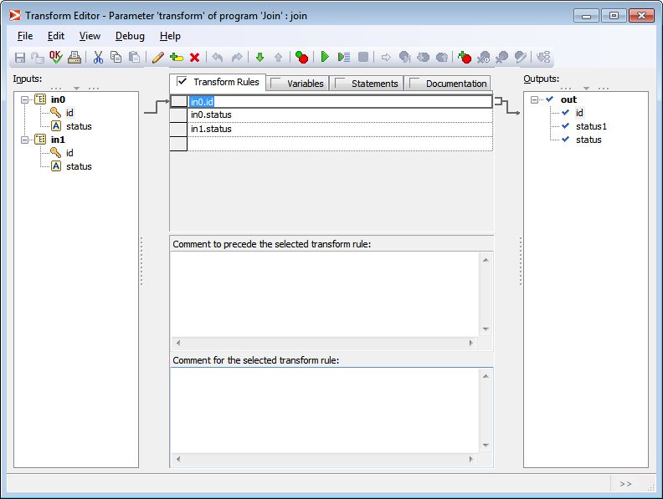

**INPUT FILE:**

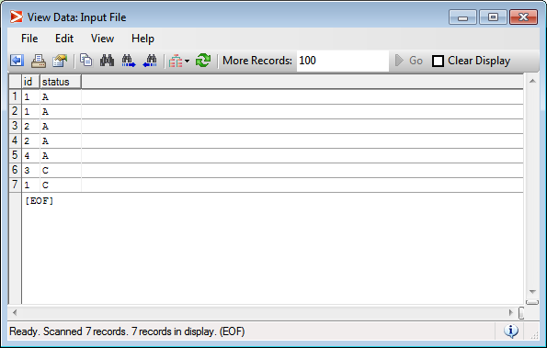

INTERMEDIATE FILE:

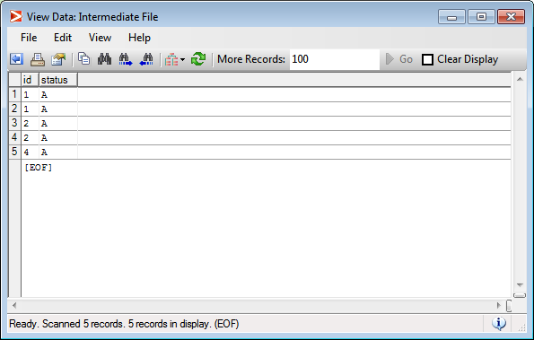

OUTPUT FILE1:

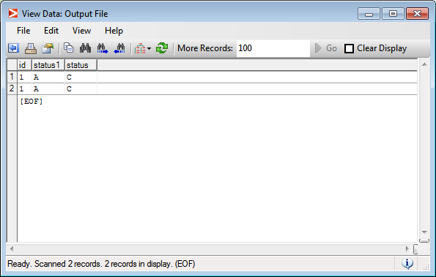

OUTPUT FILE2:

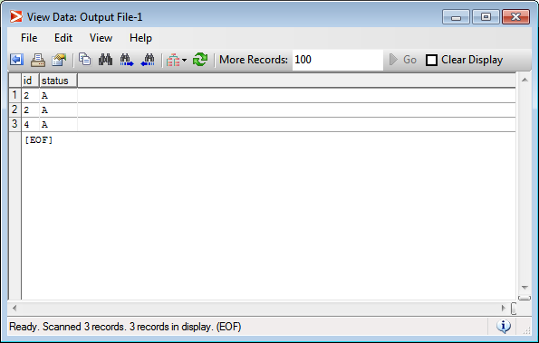

OUTPUT FILE 3:

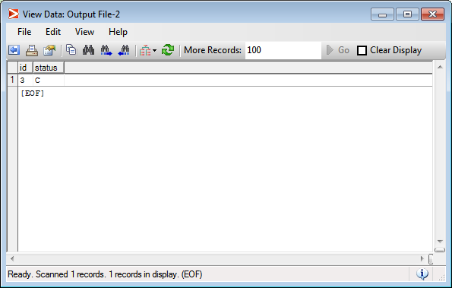

Working with Multiple files

Problem Statement: Create a grap to read data from multiple files and store it in the output file.

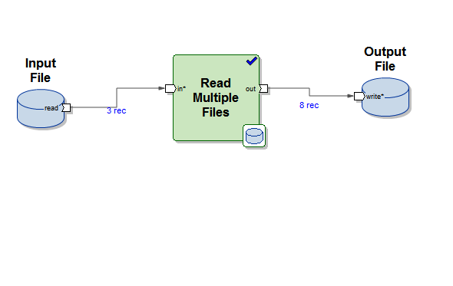

INPUT FILE:

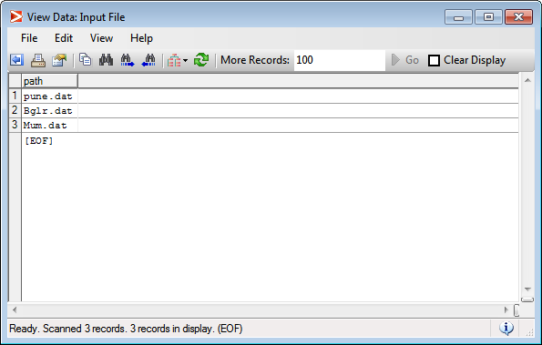

OUTPUT FILE:

