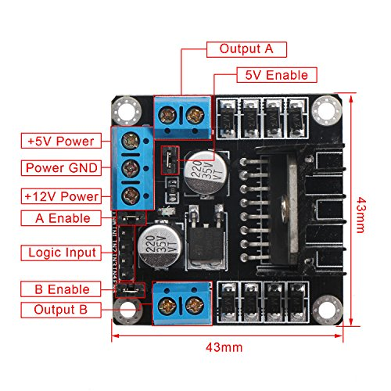**MOTOR DRIVER (L298)**

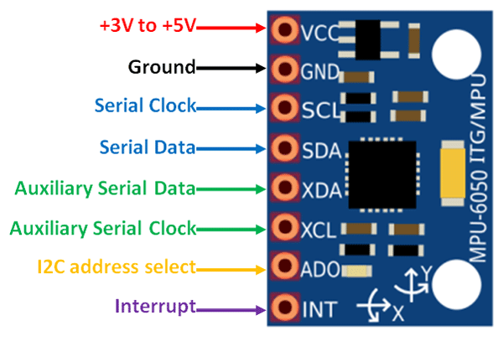**IMU SENSOR (MPU 6050)**