**Control Statements**

# Break Statement

The break in C or C++ is a loop control statement which is used to terminate the loop.

As soon as the break statement is encountered from within a loop, the loop iterations stops there and control returns from the loop immediately to the first statement after the loop.

**In simple loop:** When encountered inside a loop, the loop is immediately terminated and program control resumes at the next statement following the loop

**In switch-case:** In Switch statement used to terminate a case

**In nested loop:** If break statement is used in innemost loop, control will come out only from the innermost loop.

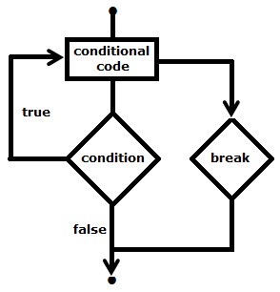

**Syntax**

**break;**

int a = 0;

do {

++a;

if(15 < a)

break;

std::cout << a << " ";

}while(a < 20);

Output: 1 2 3 4 5 6 7 8 9 10 11 12 13 14 15

# Continue statement

Continue statement is opposite to that of break statement, instead of terminating the loop; it forces to execute the next iteration of the loop.

In case of for loop, continue causes the conditional test and increment portions of the loop to execute

For while and do-while loops, program control passes to the conditional tests

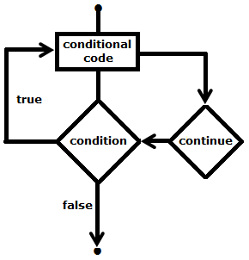

**Syntax**

**continue;**

int a = 0;

do {

++a;

if((10 < a) && (16 > a))

continue;

std::cout << a << " ";

}while(a < 20);

Output: 1 2 3 4 5 6 7 8 9 10 16 17 18 19 20

# goto statement

The goto statement can be used to jump from anywhere to anywhere within a function

* Transfers control to the labeled statement
* Can be used in case want to exit from innermost loop to next statement after loop
* Use of goto is highly discouraged

**Disadvantage:**

* Difficult to trace the control flow of a program
* Makes program hard to modify

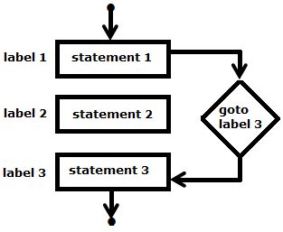

**Syntax**

|  |  |
| --- | --- |
| **goto label:**  **label:** | **label:**  **goto label:** |

void checkEvenOrNot(int num) {

if (num % 2 == 0)

goto even; // jump to even

else

goto odd; // jump to odd

even:

printf("%d is even", num);

return; // return if even

odd:

printf("%d is odd", num);

return; // return if odd

}

# Infinite Loop

A loop becomes infinite loop if a condition never becomes false

For loop is used for this purpose

Example

for( ; ; ) {

printf(“Infinite loop\n”);

}

# END