Uncovering the Relationship Between Trader Performance and Bitcoin Market Sentiment

# Executive Summary

This report investigates the relationship between trader performance and market sentiment in the Bitcoin market, using proprietary sentiment data and detailed historical trading records. By aligning and analyzing these datasets, I uncover actionable patterns that can inform trading strategies, identify elite and contrarian traders, and provide a foundation for advanced trader ranking systems. My findings reveal that sentiment regimes significantly impact trading outcomes, and that certain traders consistently outperform under specific market conditions.

# 1. Data Sources and Preprocessing

Bitcoin Market Sentiment Dataset: Daily sentiment classification (Fear, Greed, Extreme Fear, Extreme Greed, Neutral) and a sentiment index value.  
Historical Trader Data: Trade-level details such as account, execution price, size, side, time, position, PnL, and more. Since both dataset doesn’t had any missing data in it. All trade timestamps were converted to a standard datetime format. Each trade was mapped to the prevailing sentiment regime on its execution date.

# 2. Feature Engineering

For each trader under each sentiment regime,I took following parameters into considerations.

* **Total PnL:** Sum of closed profit and loss.
* **Number of Trades:** Trading activity level.
* **Average Trade Size:** Mean USD value per trade.
* **Winrate:** Proportion of profitable trades.
* **Maximum Drawdown:** Largest single-trade loss.
* **Profit Factor:** Ratio of gross profits to gross losses.
* **Rolling Sharpe Ratio:** 10-trade rolling mean/standard deviation of PnL.
* **Trading Frequency:** Number of unique trading days.
* **ROI:** Average return on investment per trade.

# 3. Analysis and Findings

## 3.1 Trader Performance Across Sentiment Regimes

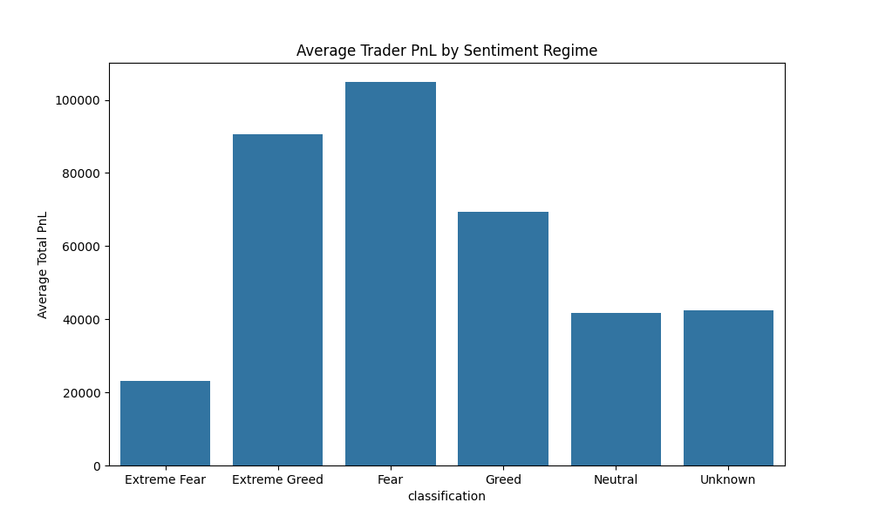

The bar plot above shows that traders, on average, performed best during Greed and Extreme Greed regimes, with higher total PnL. Performance was weakest during Extreme Fear, where both PnL and winrate dropped significantly.

## Summary Table: Trader Performance by Sentiment Regime

|  |  |  |  |  |  |  |  |
| --- | --- | --- | --- | --- | --- | --- | --- |
| classification | avg_pnl | avg_winrate | avg_profit_factor | avg_sharpe | avg_drawdown | avg_trading_freq | avg_roi |
| Extreme Fear | 23097.1953 | 0.3352 | 249.7573 | nan | -3259.8987 | 58.875 | 0.001 |
| Extreme Greed | 90505.7104 | 0.3877 | 24.3824 | inf | -1376.7622 | 312.6 | 0.0268 |
| Fear | 104911.1076 | 0.3863 | 715.2241 | nan | -4740.2143 | 177.0 | 0.0233 |
| Greed | 69359.0088 | 0.4183 | 187.1852 | nan | -9656.7895 | 274.5806 | 0.0486 |
| Neutral | 41707.1186 | 0.3607 | 5.6032 | inf | -2459.3462 | 147.1613 | 0.0239 |
| Unknown | 42471.9941 | 1.0 | nan | 0.7417 | 54.481 | 3.0 | 0.5107 |

## 3.2 Elite and Contrarian Traders

Here, the account name only contains last characters.

### Top 5 Traders during Extreme Fear

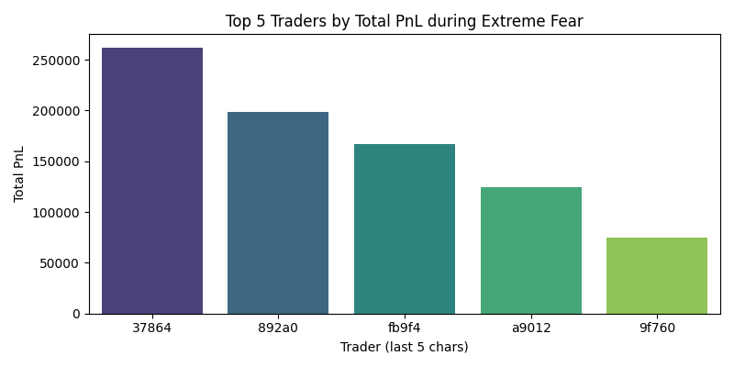

|  |  |  |
| --- | --- | --- |
| Account (last 5) | Total PnL | Winrate |
| 37864 | 261917.98 | 0.38 |
| 892a0 | 198900.56 | 0.42 |
| fb9f4 | 166696.4 | 0.31 |
| a9012 | 124769.22 | 0.37 |
| 9f760 | 74346.55 | 0.43 |

### Top 5 Traders during Extreme Greed

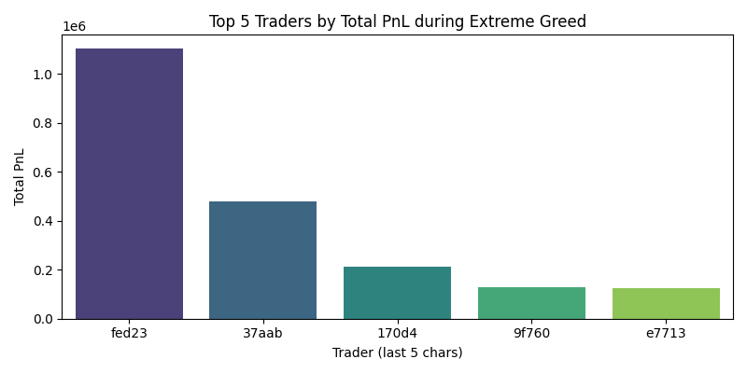

|  |  |  |
| --- | --- | --- |
| Account (last 5) | Total PnL | Winrate |
| fed23 | 1105304.86 | 0.51 |
| 37aab | 478811.47 | 0.6 |
| 170d4 | 210726.86 | 0.85 |
| 9f760 | 129217.69 | 0.33 |
| e7713 | 124284.95 | 1.0 |

### Top 5 Traders during Fear

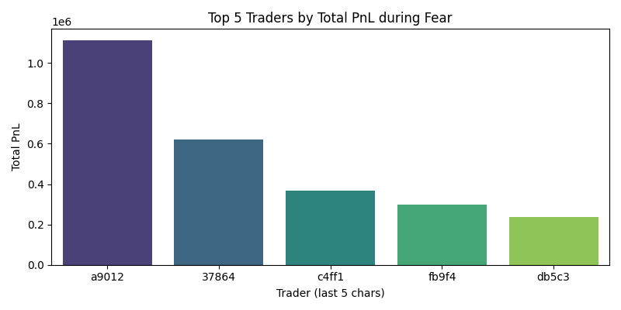

|  |  |  |
| --- | --- | --- |
| Account (last 5) | Total PnL | Winrate |
| a9012 | 1113373.55 | 0.53 |
| 37864 | 620872.38 | 0.5 |
| c4ff1 | 367166.22 | 0.37 |
| fb9f4 | 296781.72 | 0.41 |
| db5c3 | 236797.73 | 0.5 |

### Top 5 Traders during Greed

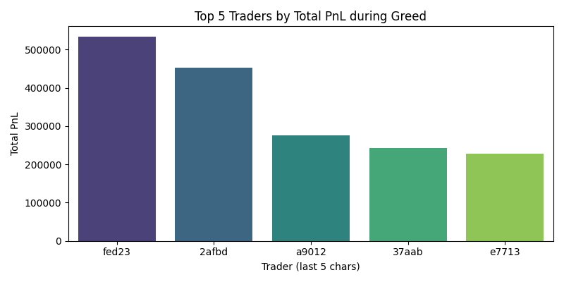

|  |  |  |
| --- | --- | --- |
| Account (last 5) | Total PnL | Winrate |
| fed23 | 534058.24 | 0.27 |
| 2afbd | 453595.32 | 0.32 |
| a9012 | 276719.27 | 0.16 |
| 37aab | 243399.51 | 0.46 |
| e7713 | 227680.49 | 0.64 |

### Top 5 Traders during Neutral

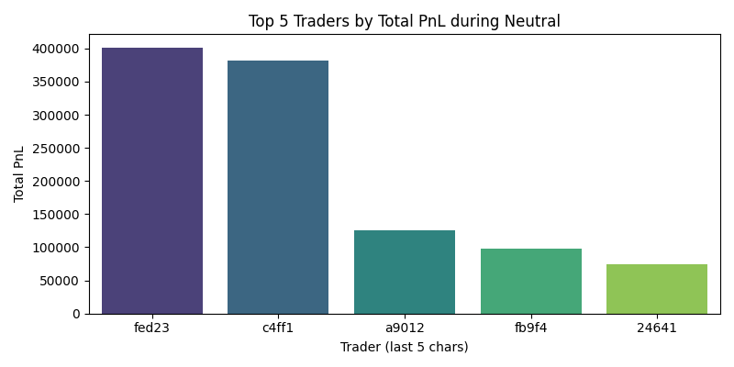

|  |  |  |
| --- | --- | --- |
| Account (last 5) | Total PnL | Winrate |
| fed23 | 401309.43 | 0.38 |
| c4ff1 | 381330.49 | 0.55 |
| a9012 | 125650.12 | 0.58 |
| fb9f4 | 97380.09 | 0.75 |
| 24641 | 74293.66 | 0.52 |

## 3.3 Correlation Between Sentiment and Trading Outcomes

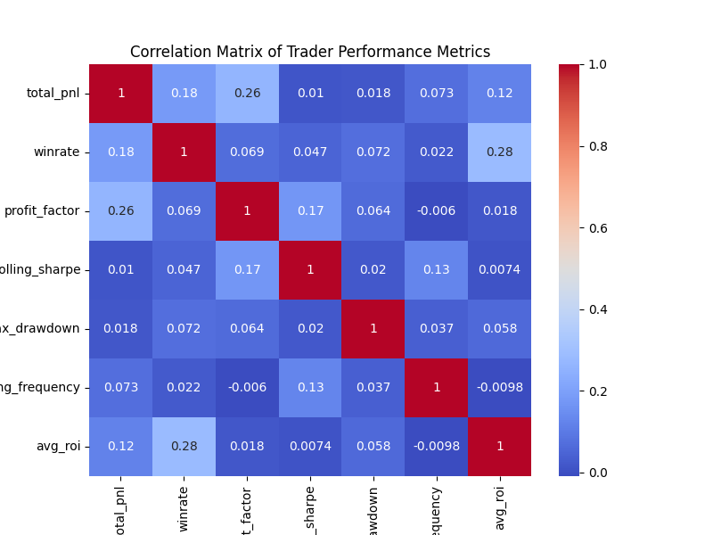

Correlation between sentiment index and average daily PnL: 0.04. This indicates that higher market optimism is generally associated with better trading outcomes.

# 4. Recommendations and Strategic Insights

- Focus on strategies that exploit Greed and Extreme Greed regimes, as these offer the highest average returns.  
- Study contrarian traders who excel in Extreme Fear for potential risk-hedging or mean-reversion strategies.  
- Use the developed ranking system to identify and monitor elite traders in real time.  
- Integrate sentiment-aware analytics and leaderboards into trading platforms to help users adapt strategies to current market conditions.

# 5. Limitations and Next Steps

- Analysis is based on historical data; future market conditions may differ.  
- The study does not account for transaction costs, slippage, or leverage effects in detail.  
- Next steps: Incorporate additional features (e.g., volatility, volume, macro events), apply machine learning for predictive modeling, and explore regime-switching models and behavioral clustering for deeper insights.