**Hive_Project**

This is a real time dataset of the iNeuron technical consultant team.

Dataset 1 - https://drive.google.com/file/d/1WrG-9qv6atP-W3P_-gYln1hHyFKRKMHP/view

Dataset 2 - https://drive.google.com/file/d/1-JIPCZ34dyN6k9CqJa-Y8yxIGq6vTVXU/view

Note: both files are csv files.

1. Create a schema based on the given dataset

**Hive> Create table AgentLogingReport**

**(**

**SL_No int,**

**Agent string,**

**Dates date,**

**Login string,**

**Logout string,**

**Duration string**

**)**

**row format delimited**

**fields terminated by ','**

**tblproperties ("skip.header.line.count" = "1");**

**Hive> Create table AgentPerformance**

**(**

**SL_No int,**

**Dates date,**

**Agent_Name string,**

**Total_chats int,**

**Avg_Response_Time string,**

**Avg_Resolution_Time string,**

**Avg_Rating float,**

**Total_Feedback int**

**)**

**row format delimited**

**fields terminated by ','**

**tblproperties ("skip.header.line.count" = "1");**

2. load data in the given schema/tables.

**Load data local inpath '/config/workspace/AgentLogingReport.csv' into table AgentLogingReport;**

**Load data local inpath '/config/workspace/AgentPerformance.csv' into table AgentPerformance;**

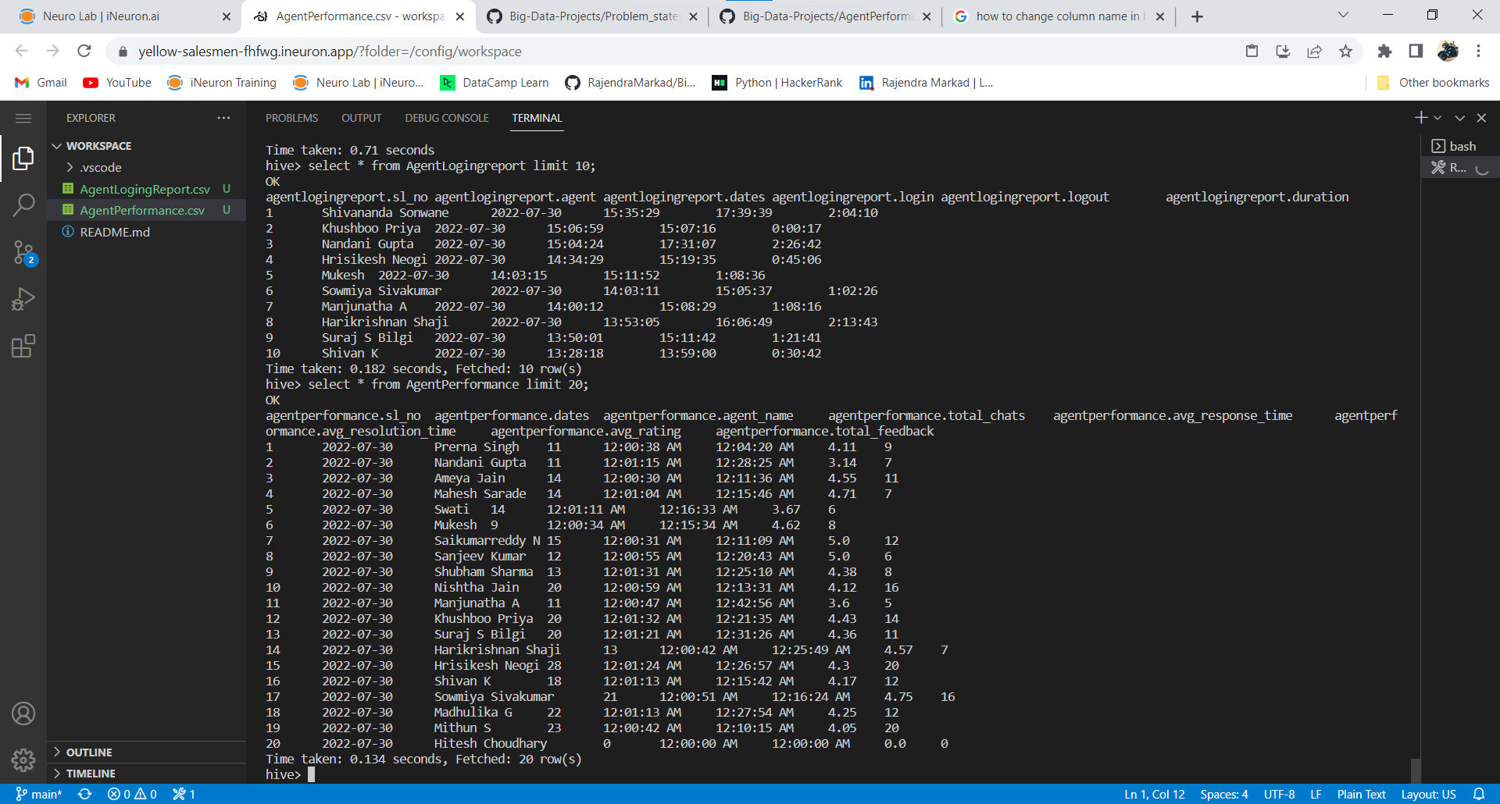

3. List of all agents names.

**Hive> select distinct Agent from AgentLogingReport;**

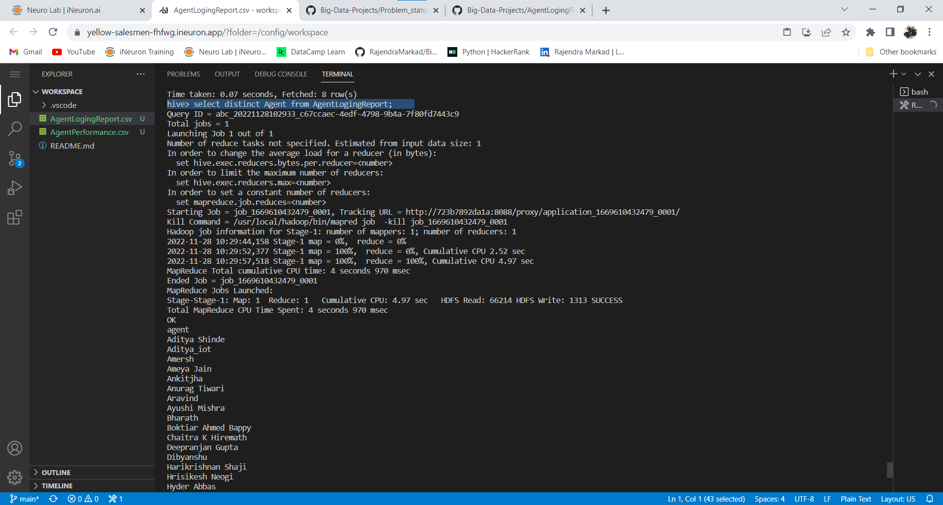

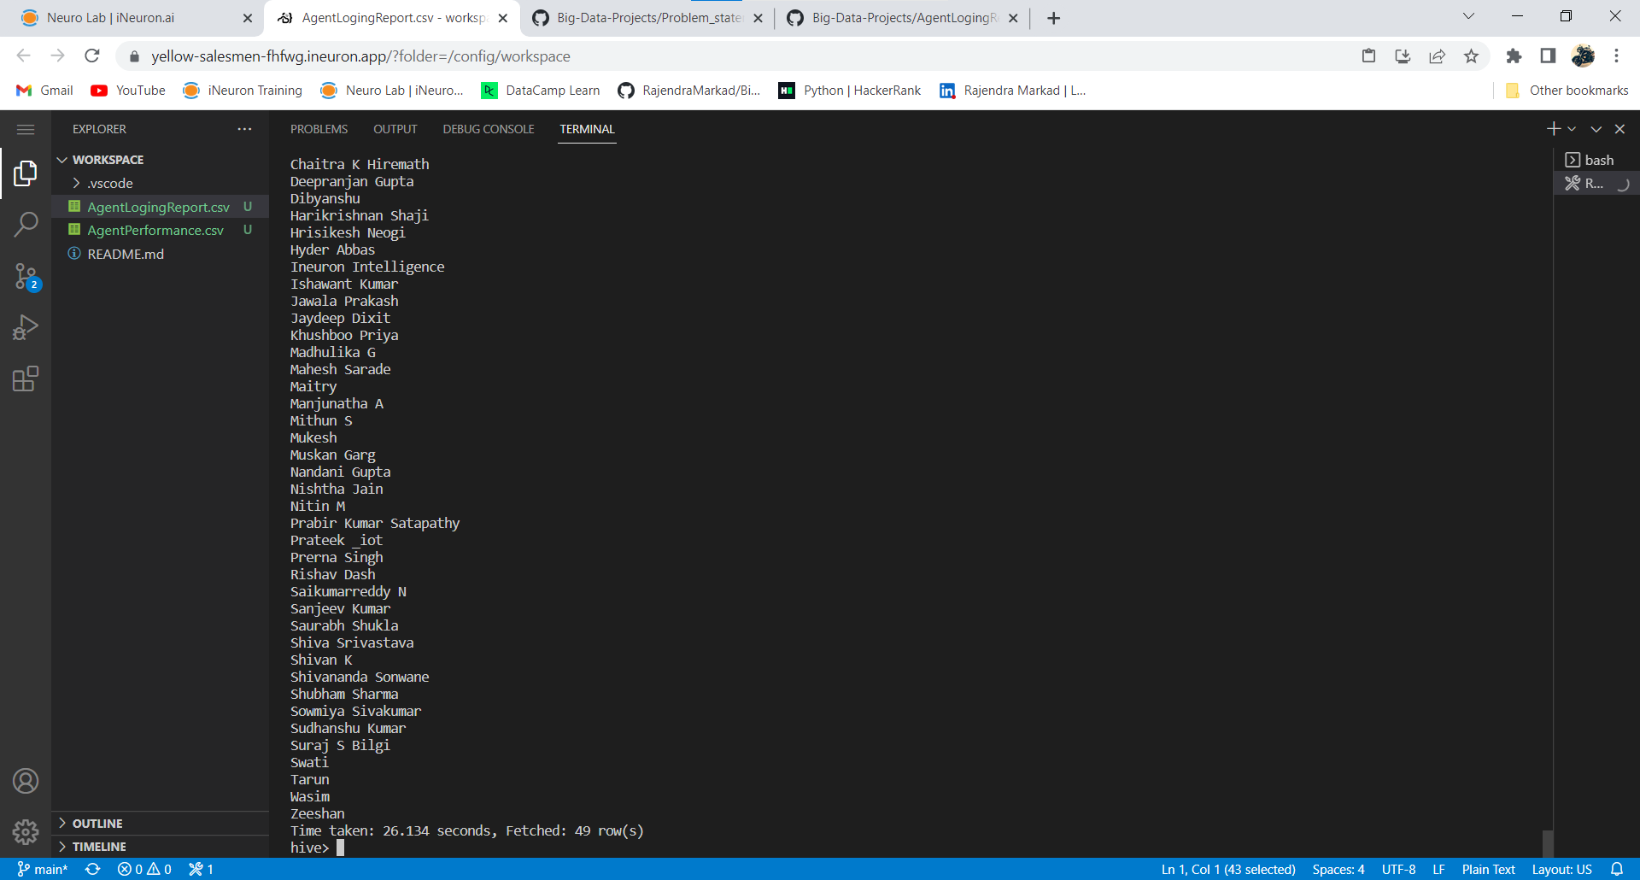

4. Find out agent average rating.

**Hive> select Agent_name, avg(Avg_Rating) from AgentPerformance group by Agent_name;**

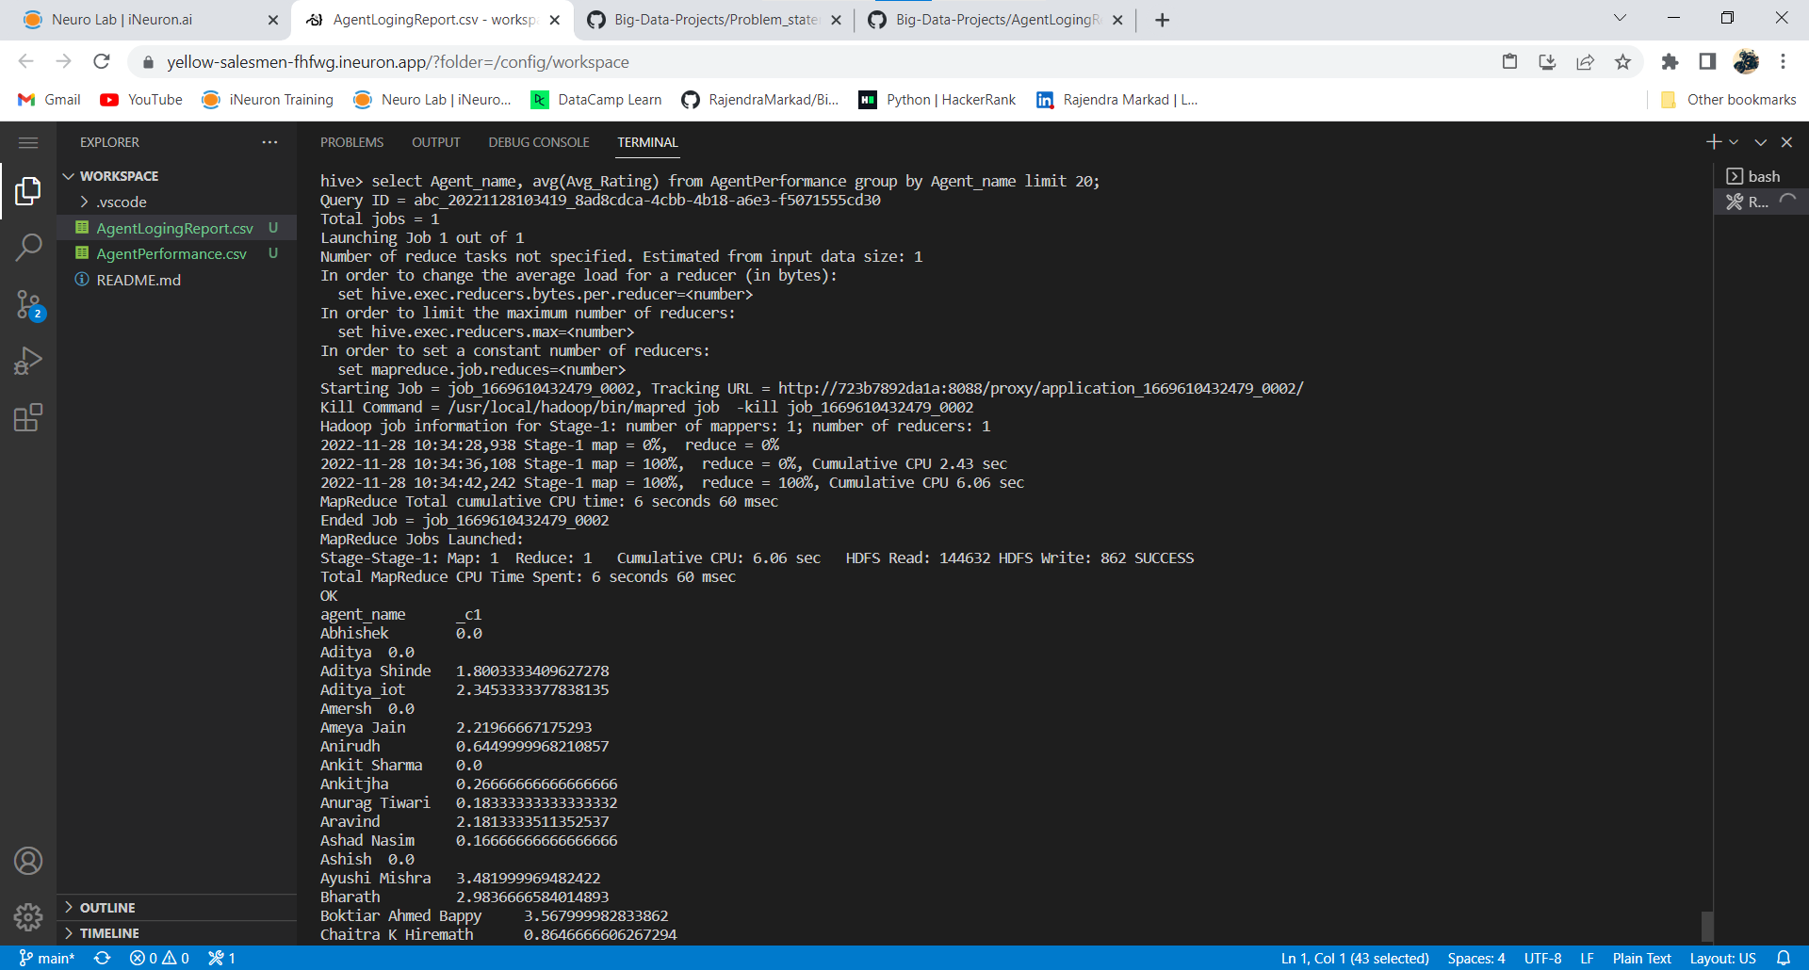

5. Total working days for each agents

**Hive> select Agent, count(distinct Dates) as total_workdays from AgentLogingReport group by Agent;**

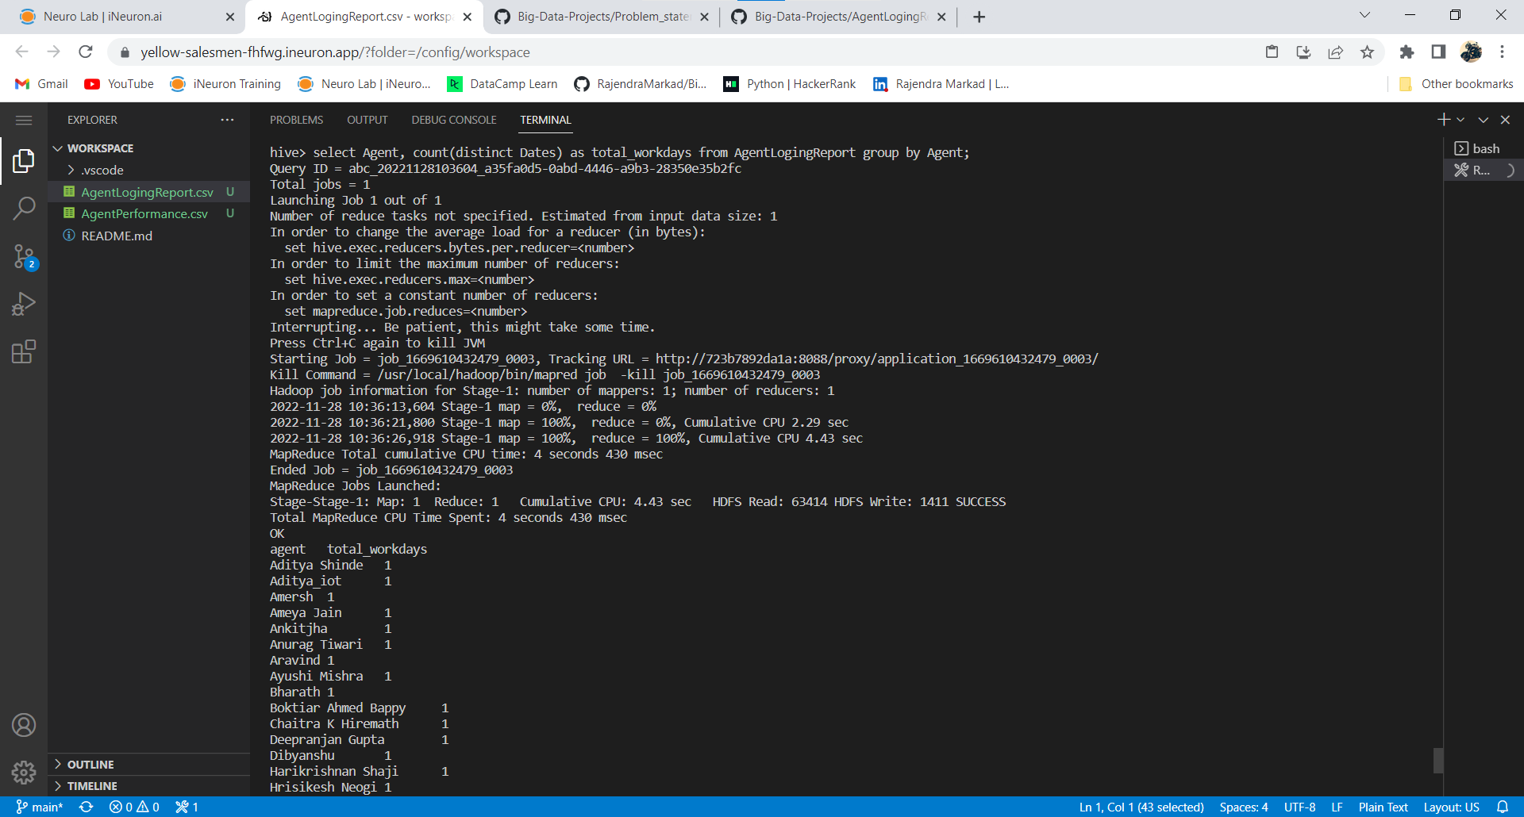

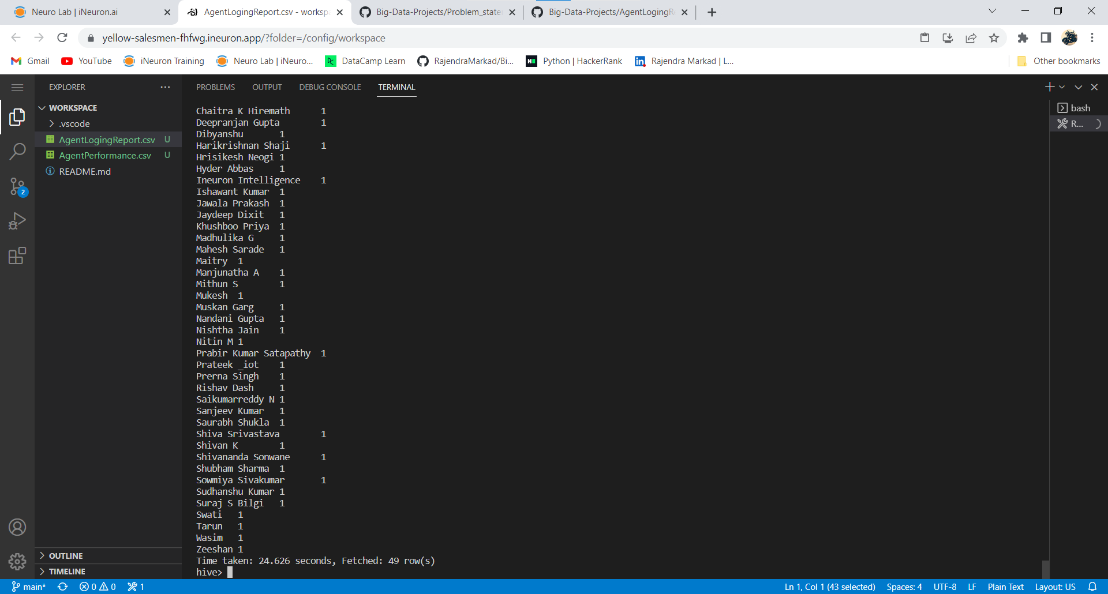

6. Total query that each agent have taken

**Hive> select Agent_name, sum(total_chats) from AgentPerformance group by Agent_name;**

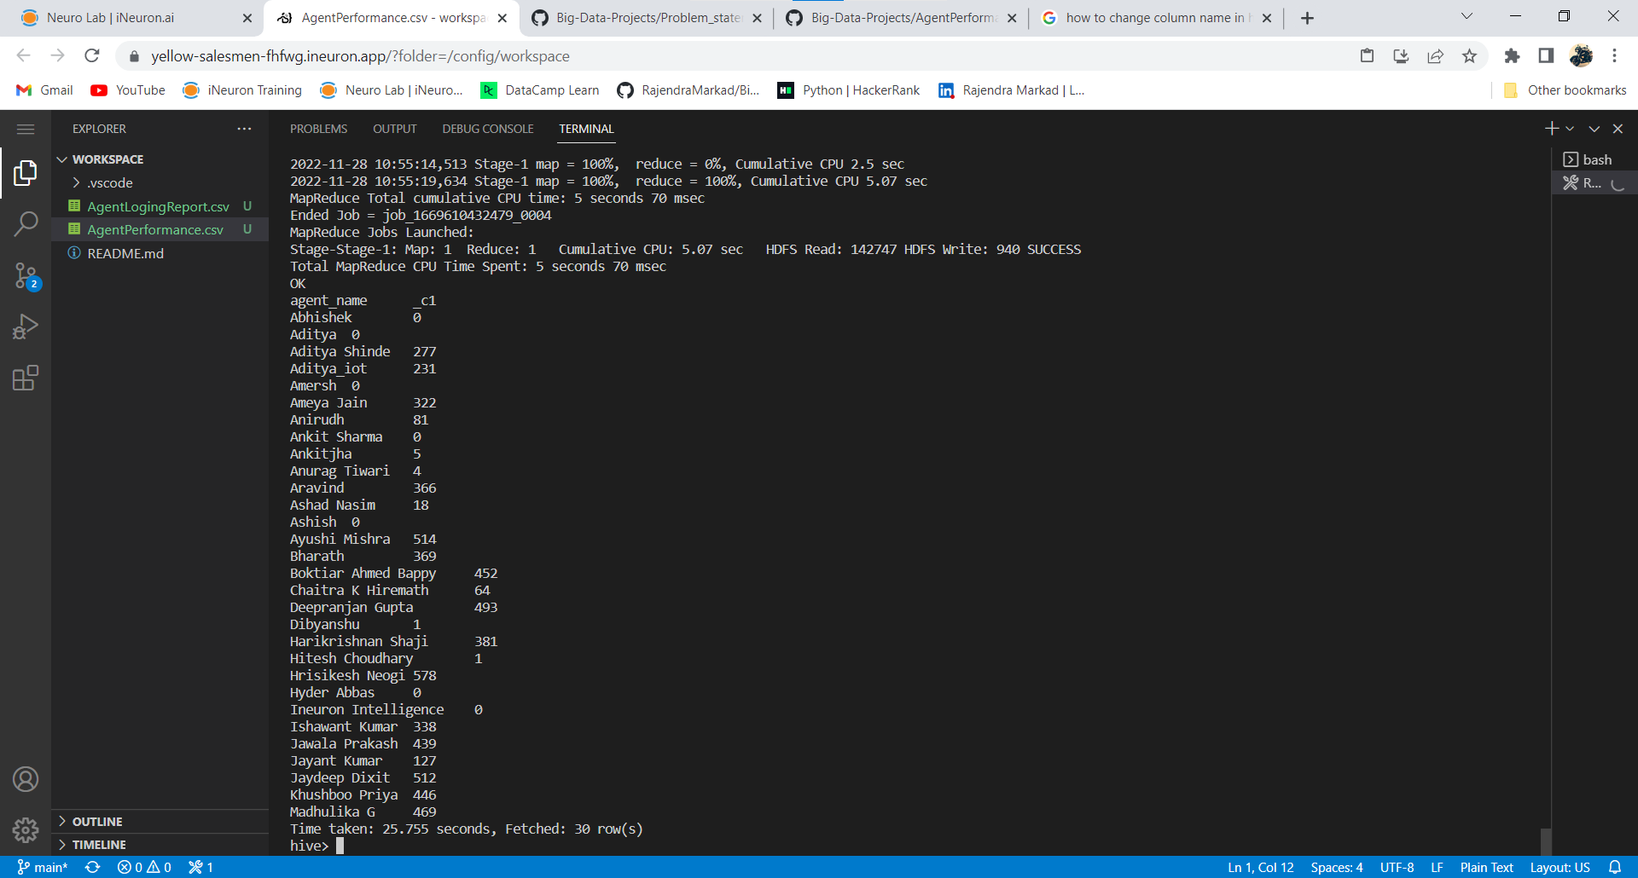

7. Total Feedback that each agent have received

**Hive> select Agent_name, sum(Total_Feedback) from AgentPerformance group by Agent_name;**

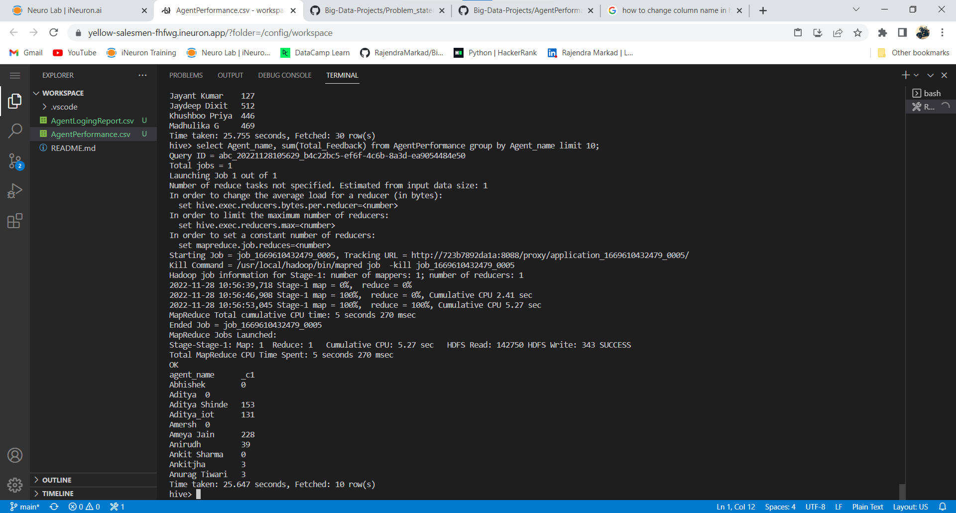

8. Agent name who have average rating between 3.5 to 4

**Hive> select Agent_name, Avg_Rating from AgentPerformance where Avg_Rating between 3.5 and 4;**

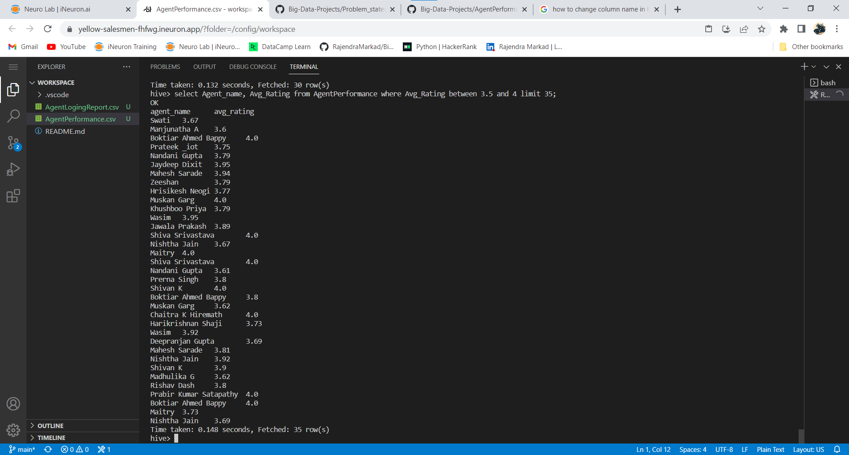

9. Agent name who have rating less than 3.5

**Hive> select Agent_name, Avg_Rating from AgentPerformance where Avg_Rating < 3.5;**

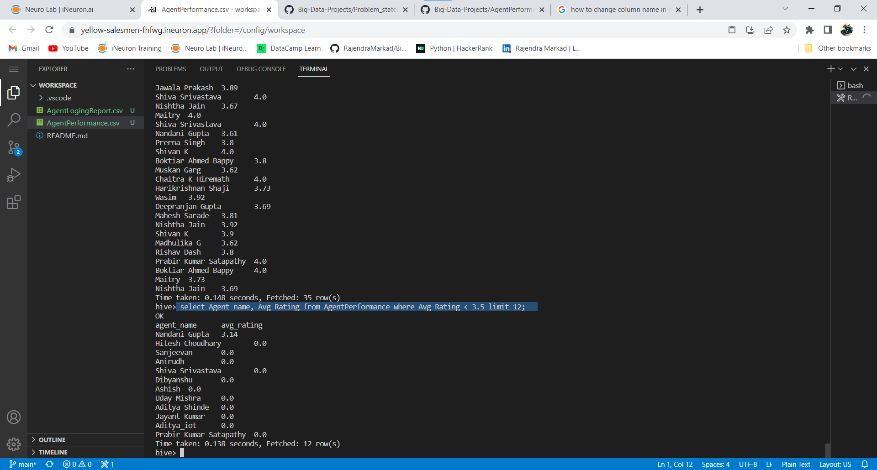

10. Agent name who have rating more than 4.5

**Hive> select Agent_name, Avg_Rating from AgentPerformance where Avg_Rating > 4.5;**

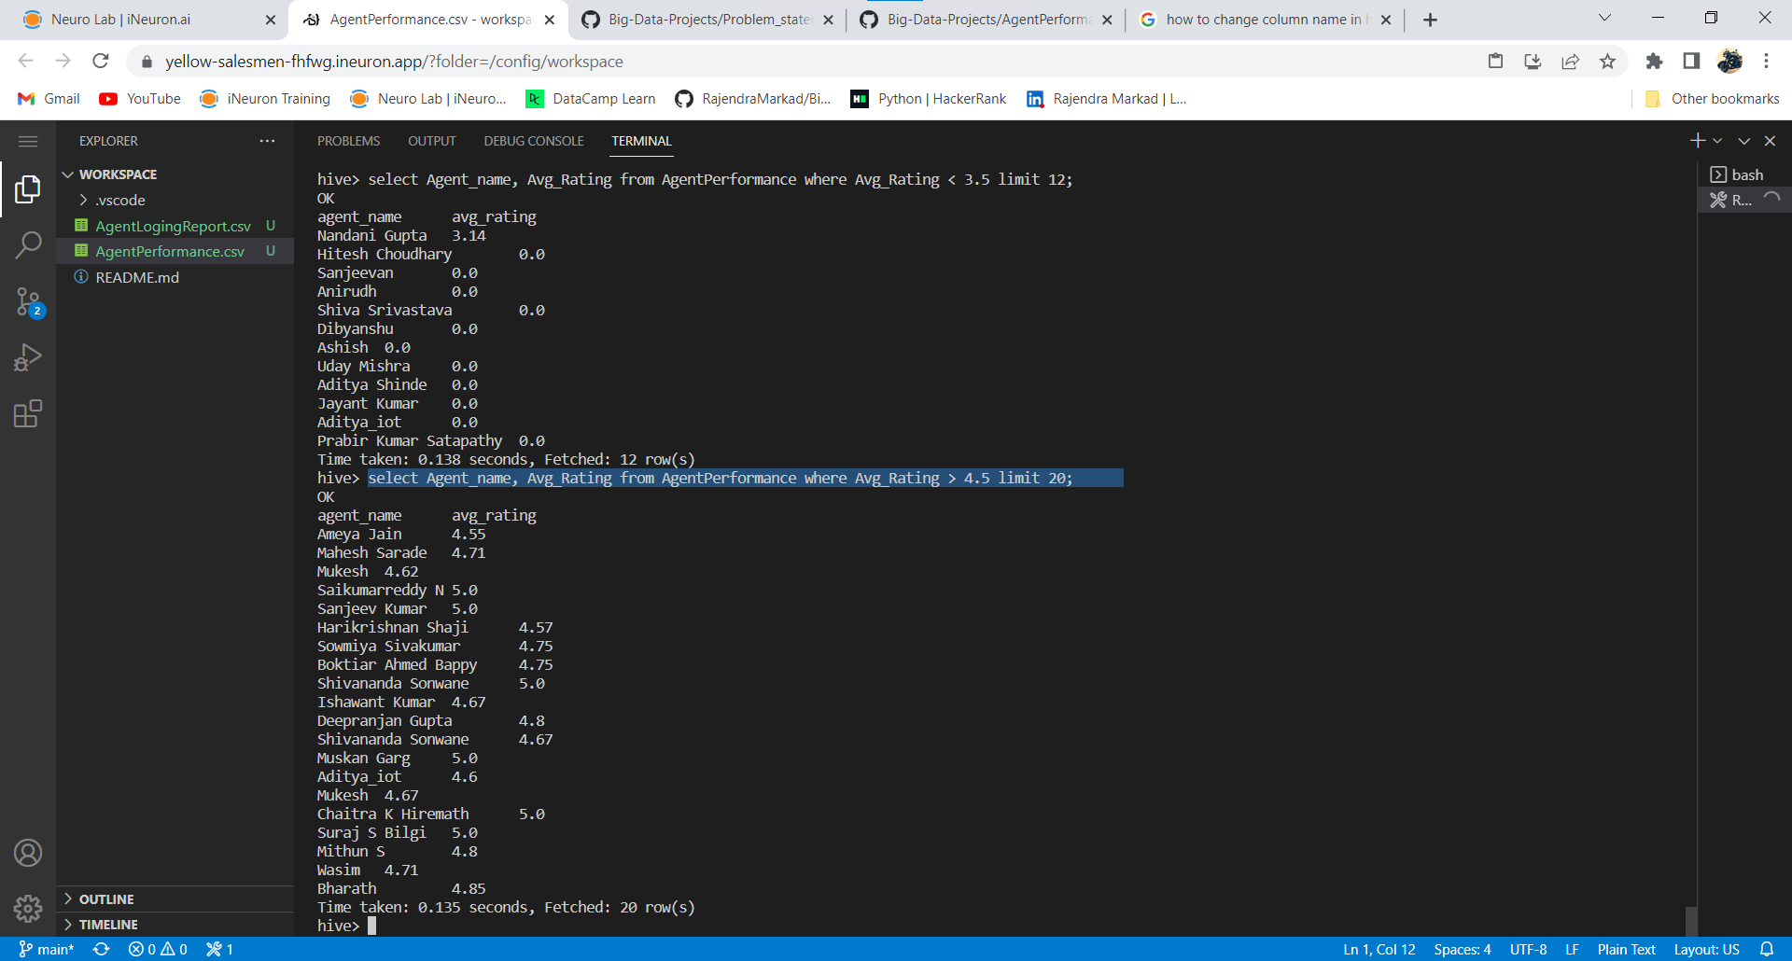

11. How many feedback agents have received more than 4.5 average

**Hive> select Agent_name, avg(Total_Feedback) from AgentPerformance group by Agent_name having avg(Total_Feedback) > 4.5;**

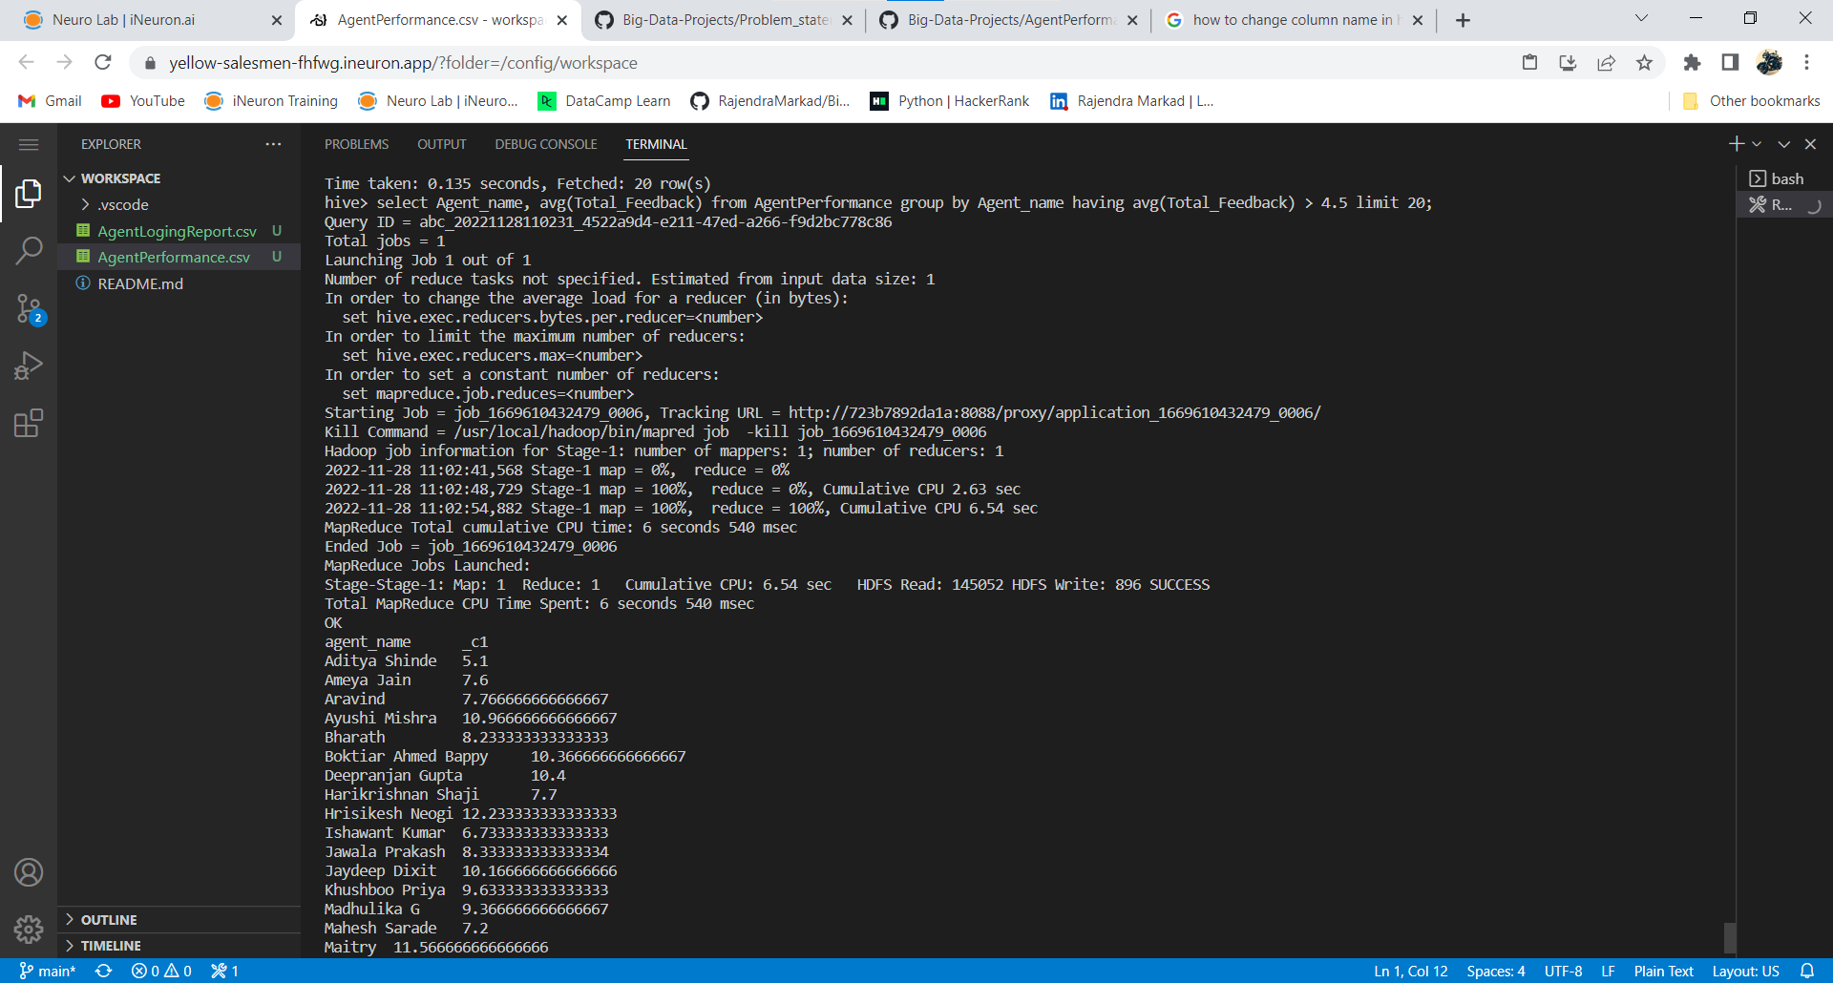

12. average weekly response time for each agent.

**Hive> select s.agent_name,avg(col1[0]*3600+col1[1]*60+substr(col1[2],1,2))/3600 from(**

**select agent_name, split(Avg_Response_Time,':') as col1 from AgentPerformance )s group by s.agent_name;**

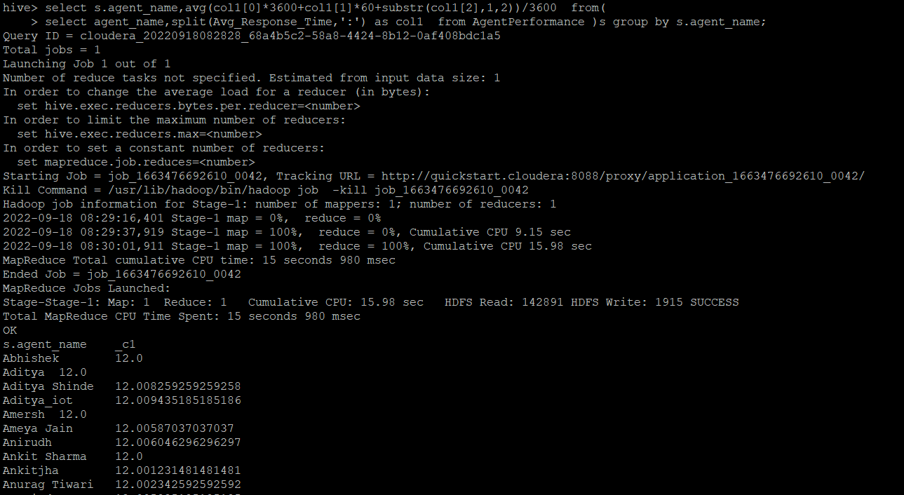

13. average weekly resolution time for each agents

**Hive> select a.agent_name,avg(col1[0]*3600+col1[1]*60+substr(col1[2],1,2))/3600 from(select agent_name, split(Avg_Resolution_Time,':') as col1 from AgentPerformance )a group by a.agent_name;**

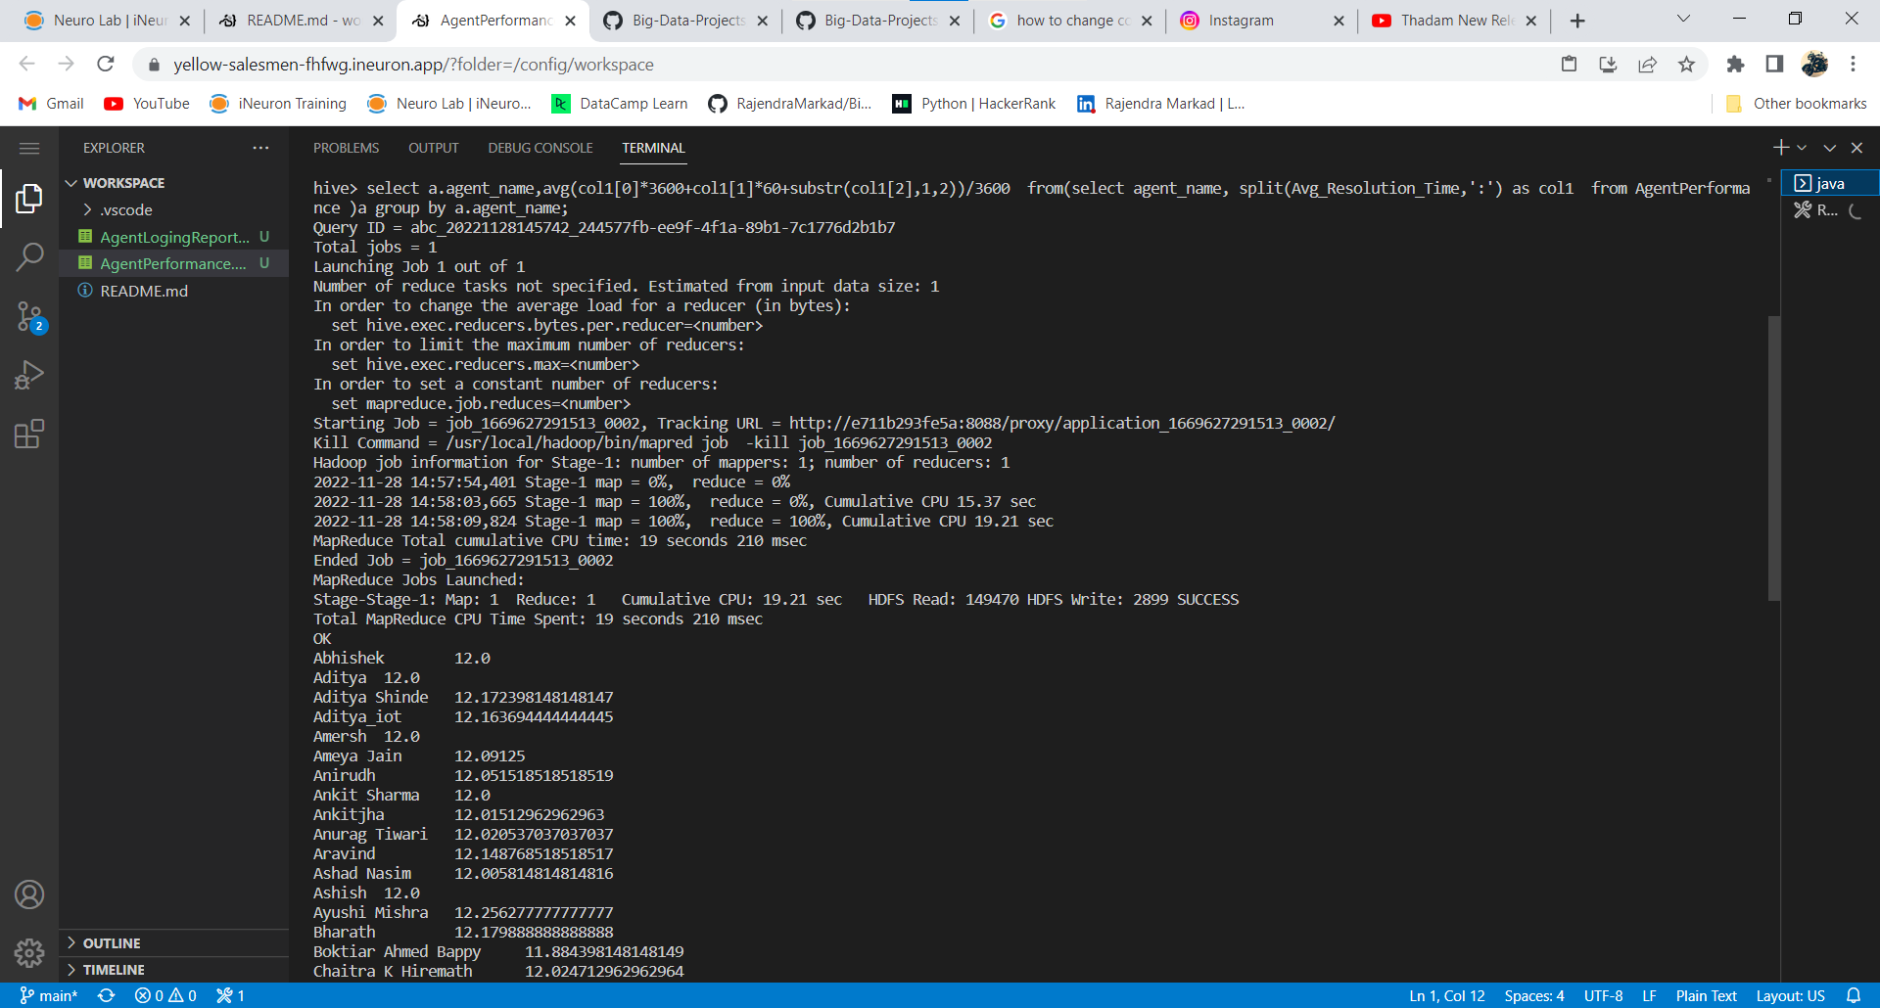

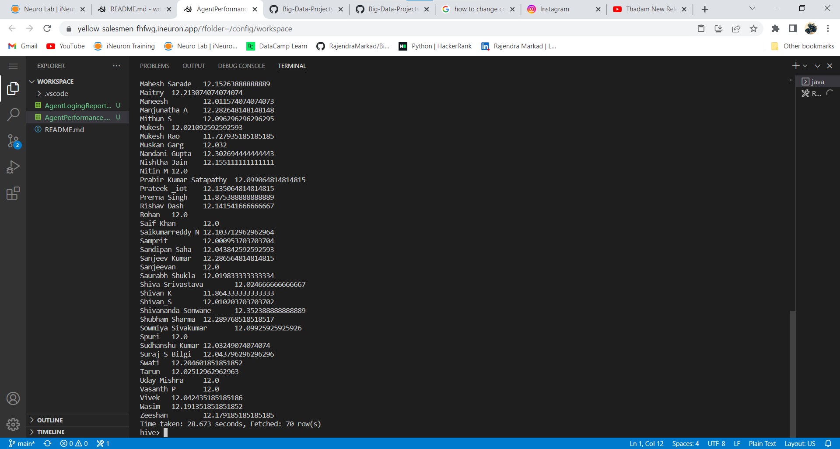

14. Find the number of chat on which they have received a feedback

**Hive> select agent_name, sum(Total_chats),Total_Feedback from AgentPerformance where Total_Feedback> 0 group by agent_name, Total_Feedback;**

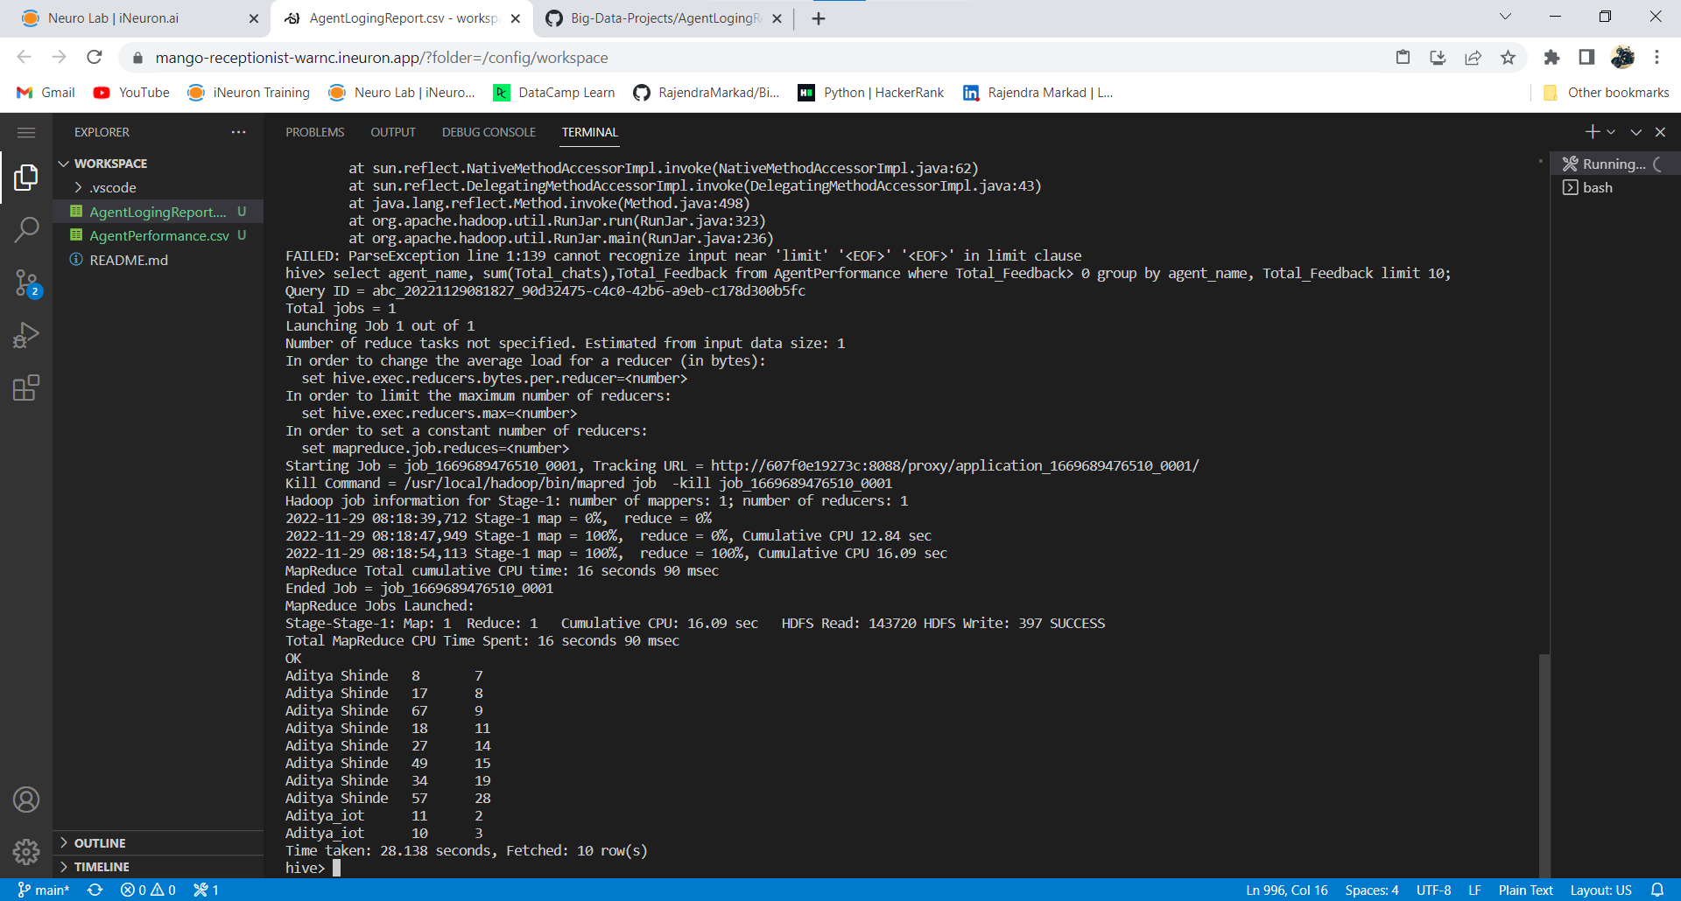

15. Total contribution hour for each and every agents weekly basis

**Hive> select s.agent, sum(col1[0]*3600+col1[1]*60+col1[2])/3600 timeinHour, s.weekly from(**

**select agent, split(duration,':') as col1 , weekofyear(Dates) as weekly from AgentLogingReport )s group by s.agent, s.weekly limit 10;**

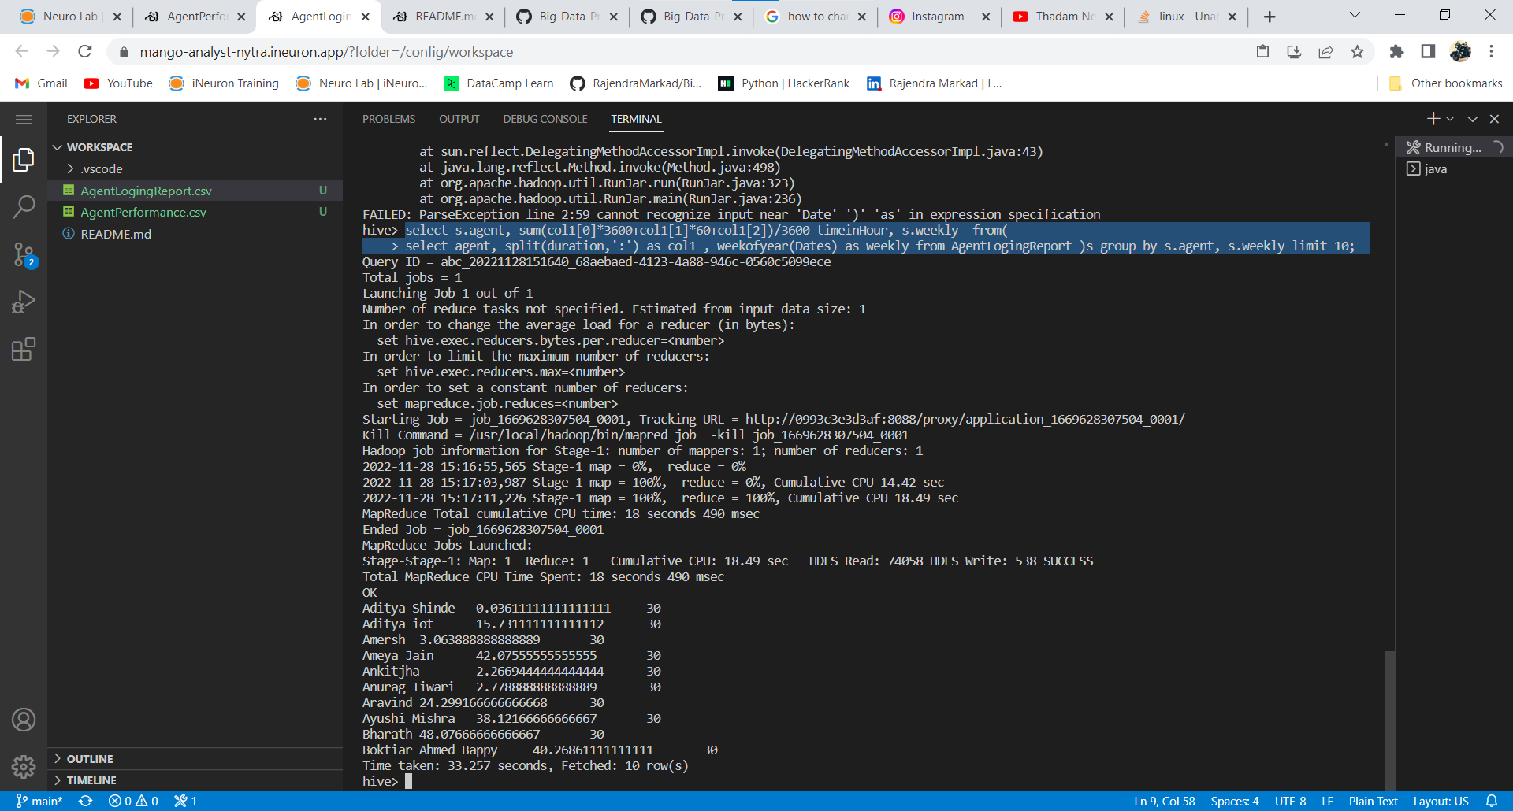

16. Perform inner join, left join and right join based on the agent column and after joining the table export that data into your local system.

**Inner join:**

**Select a.agent, a.dates, b.total_chats, b.total_feedback from agentlogingreport a join agentperformance b on a.agent = b.agent_name limit 15;**

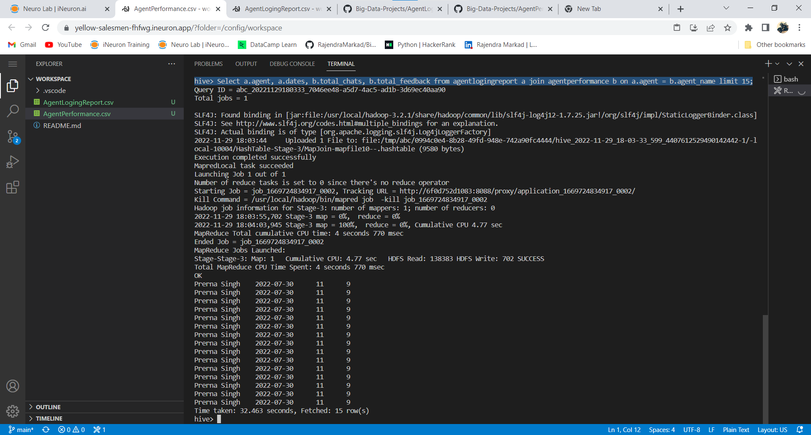

**left join:**

**hive> Select a.agent, a.dates, b.total_chats, b.total_feedback from agentlogingreport a join agentperformance b on a.agent = b.agent_name limit 15;**

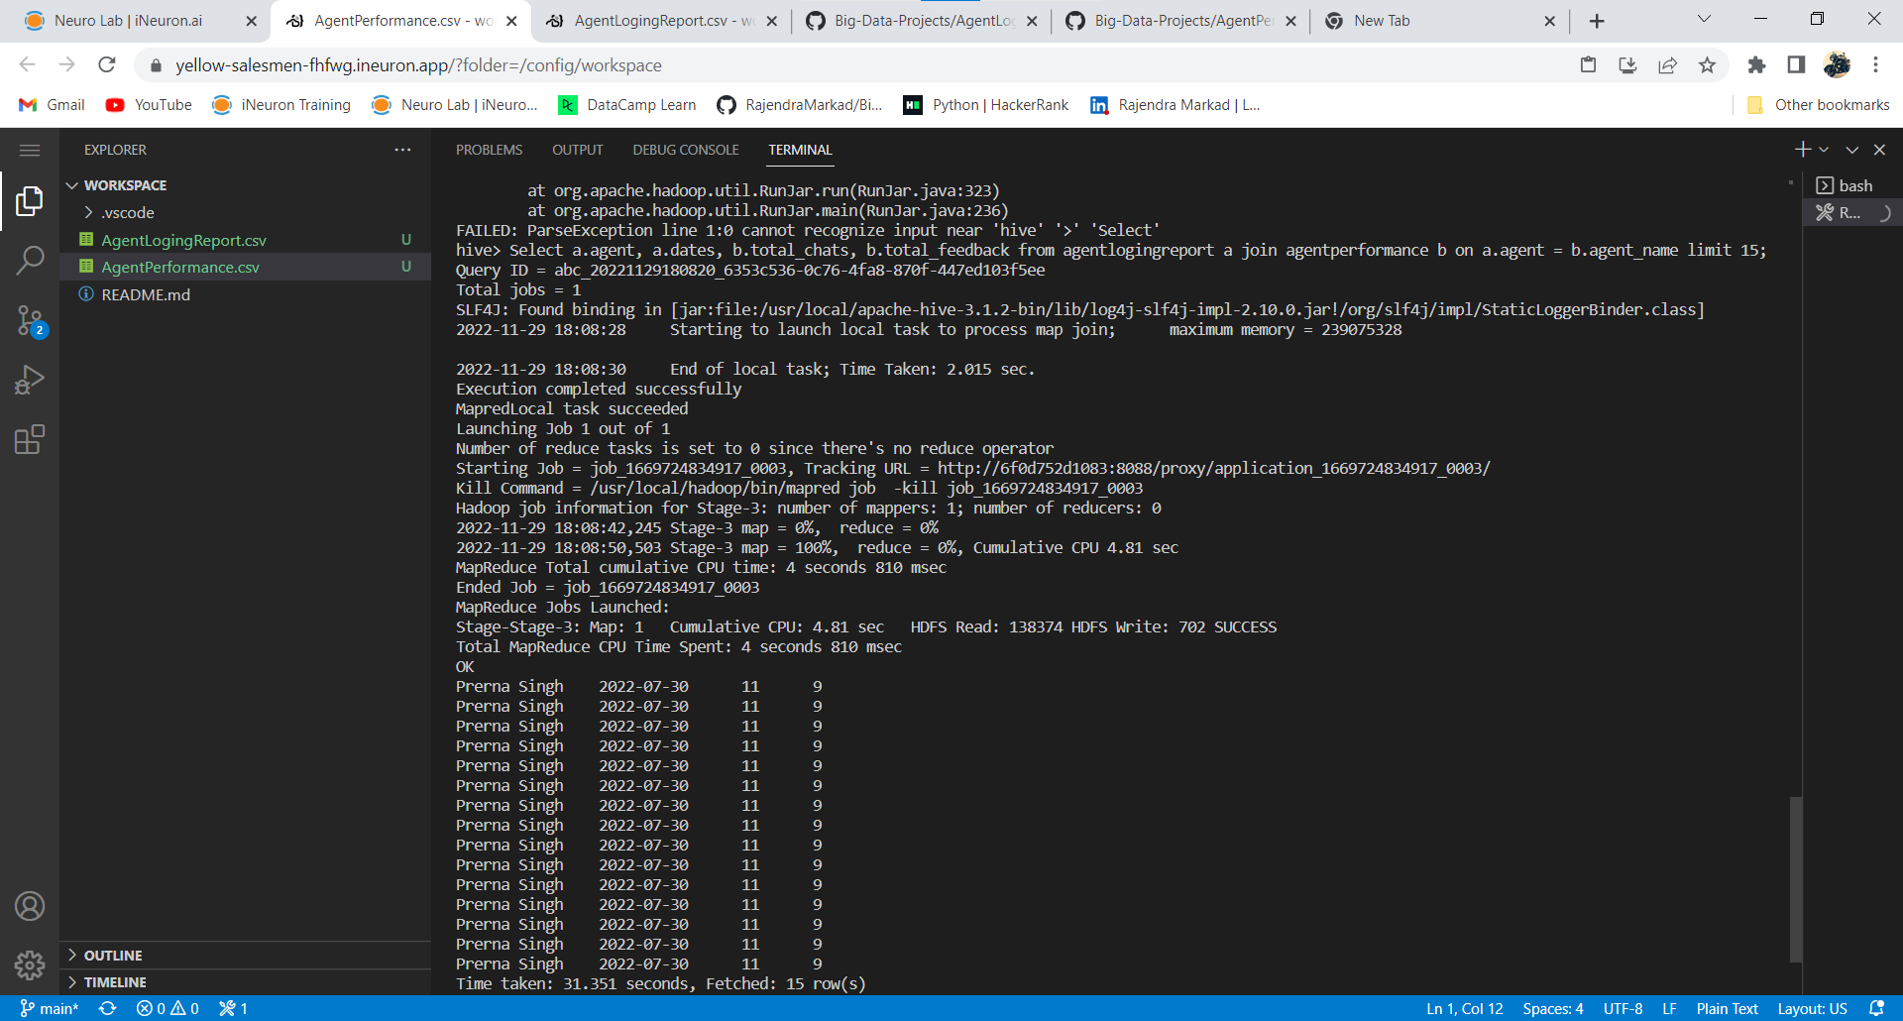

**Right join:**

**hive> Select a.agent, a.dates, b.total_chats, b.total_feedback from agentlogingreport a right join agentperformance b on a.agent = b.agent_name limit 10;**

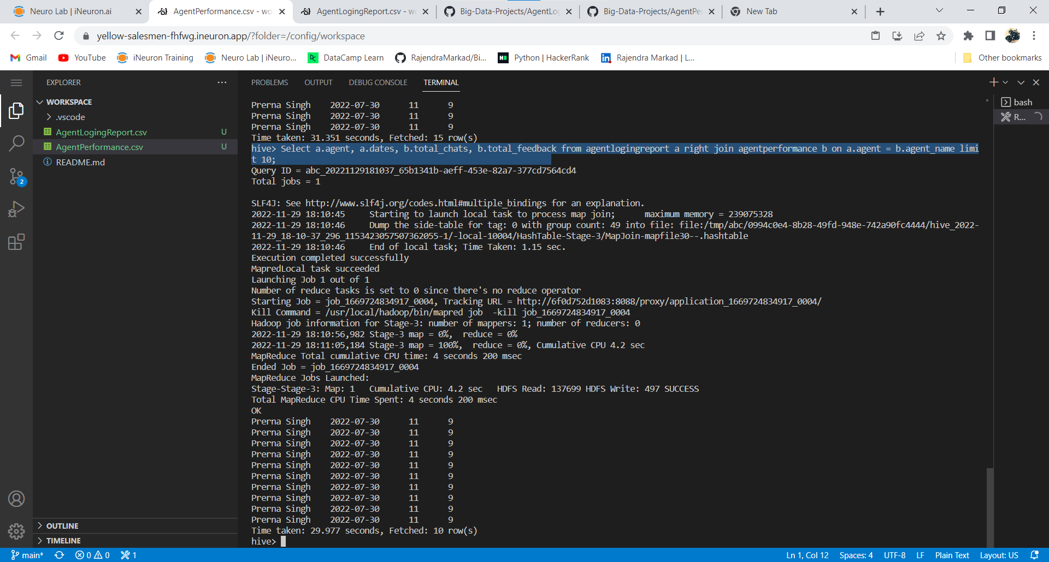

17. Perform partitioning on top of the agent column and then on top of that perform bucketing for each partitioning.

**Create table AgentLogingReport_partitioned**

**(**

**SL_no int,**

**Dates date,**

**Login string,**

**Logout string,**

**Duration string**

**)partitioned by (Agent string)**

**CLUSTERED BY (Dates)**

**sorted by (Dates)**

**INTO 4 BUCKETS**

**ROW FORMAT DELIMITED**

**FIELDS TERMINATED BY ',';**

**hive> set hive.exec.dynamic.partition=true;**

**hive> set hive.exec.dynamic.partition.mode=nonstrict;**

**hive> insert into table AgentLogingReport_partitioned partition(Agent) select sl_no,Dates,Login,Logout,Duration,Agent from AgentLogingReport;**

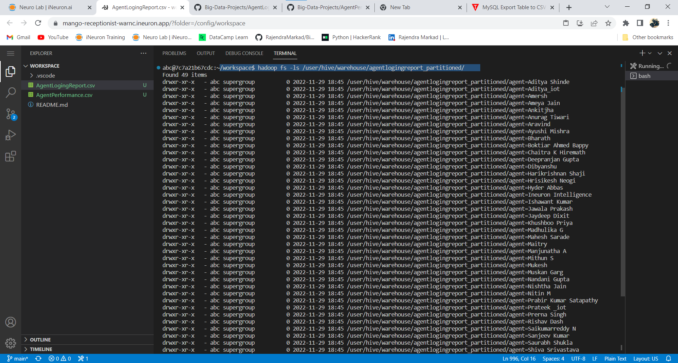

**Hive> Create table AgentPerformance_partitioned**

**(**

**SL_no int,**

**Dates date,**

**Total_charts string,**

**Avg_Response_Time string,**

**Avg_Resolution_Time string,**

**Avg_Rating float,**

**Total_Feedback int**

**) partitioned by (Agent_name string)**

**CLUSTERED BY (Dates)**

**sorted by (Dates) INTO 8 BUCKETS**

**ROW FORMAT DELIMITED**

**FIELDS TERMINATED BY ',';**

**Hive> insert into table AgentPerformance_partitioned partition(Agent_name) select sl_no,Dates,Total_chats,Avg_Response_Time,Avg_Resolution_Time,Avg_Rating,Total_Feedback,Agent_name from AgentPerformance;**

