Data Quality Report
YouTube Content Success Analytics — youtube_trending_3_countries.csv (~450,000 trending rows, 100+ countries, 28 columns)
Capstone Analytics Team | July 2026

1. Executive Summary
This is a large, real-world sample of trending YouTube videos, well suited to engagement-driver analysis. Data quality is good: no exact duplicates, a small share of missing engagement values, and a few impossible records (likes > views) that were removed. Critically, the file is stored at one row per (video, country, trending-day); ~92% of rows repeat a video_id. We therefore DEDUPLICATE to one row per unique video for the driver analysis, keeping the appearance grain only for geographic spread. After cleaning and dedup: ~442,000 appearances -> ~36,540 unique videos.

2. Dataset Overview
- Source: Kaggle — keshavbansal95/youtube-trending-videos-dataset.
- Raw grain: one row per (video, country, trending-date). ~450,000 rows, 28 columns.
- Coverage: 100+ trending countries; 14 content categories; video + channel attributes.
- Engagement metrics: views, likes, comments (plus derived rates).

3. Completeness (Missing Values)
column | missing | missing_%
video_category_id | 298 | 0.07
video_tags | 103169 | 22.94
video_view_count | 5 | 0.0
video_like_count | 5647 | 1.26
video_comment_count | 1371 | 0.3

4. Duplication & Unit of Analysis (key issue)
- No exact duplicate rows and no duplicate (video, country, trending-date) keys.
- However ~92% of rows repeat a video_id (~12 trending appearances per video on average).
- A single video appears up to 1,558 times across as many as 81 countries.
- Decision: deduplicate to one row per video (its max-views snapshot) for driver analysis.
- The appearance grain is retained ONLY for geographic-spread analysis.
Why it matters: without dedup, widely-trending videos are counted dozens of times, inflating reach figures and distorting category rankings (e.g. Music appears strong at the appearance grain but is near the bottom per video).

5. Validity & Distributions
- Removed rows with likes > views (impossible) and non-positive view counts.
- Dates parsed cleanly; median first-days-to-trend is 1 day.
- Engagement counts are heavily right-skewed -> log transforms / medians used.
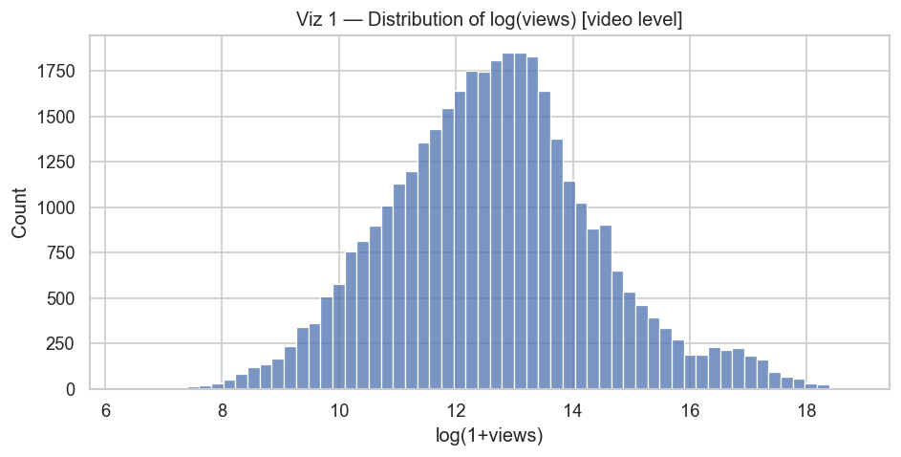

6. Verdict
Fit for purpose after dedup. ~36,540 clean, unique videos with strong, genuine engagement structure — suitable for the driver analysis in the EDA and Business Recommendations reports.

