Exploratory Data Analysis (EDA) Report
YouTube Content Success Analytics — engagement drivers & content-performance trends (video level, deduplicated)
Capstone Analytics Team | July 2026

1. Objective & Method
We analyse ~36,540 UNIQUE trending videos (deduplicated from ~442k appearances). Performance is compared across category, video length, publish timing, title/tags, production quality and channel size, using medians and per-view engagement rates for fair comparison. Geographic spread is shown separately at the appearance grain.

2. Engagement Is Real & Correlated
Likes and views move together tightly (r = 0.87 on the log scale), confirming genuine engagement signal.
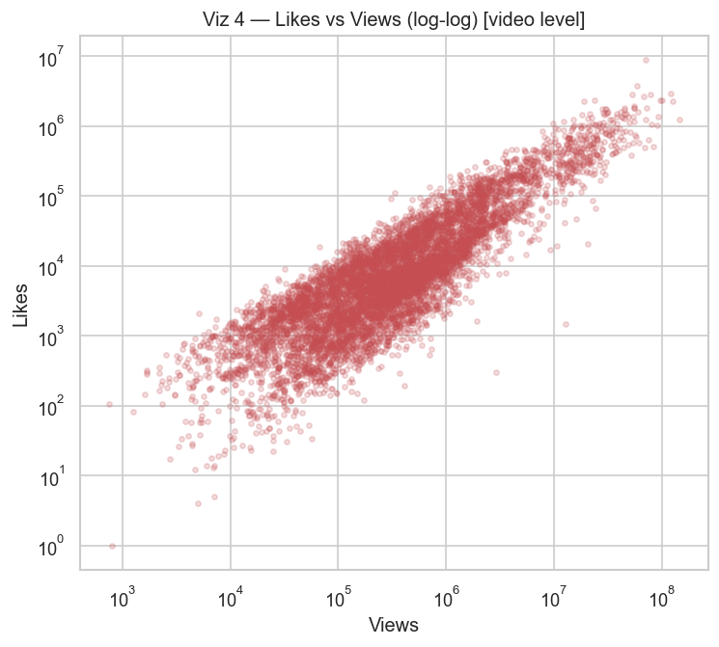
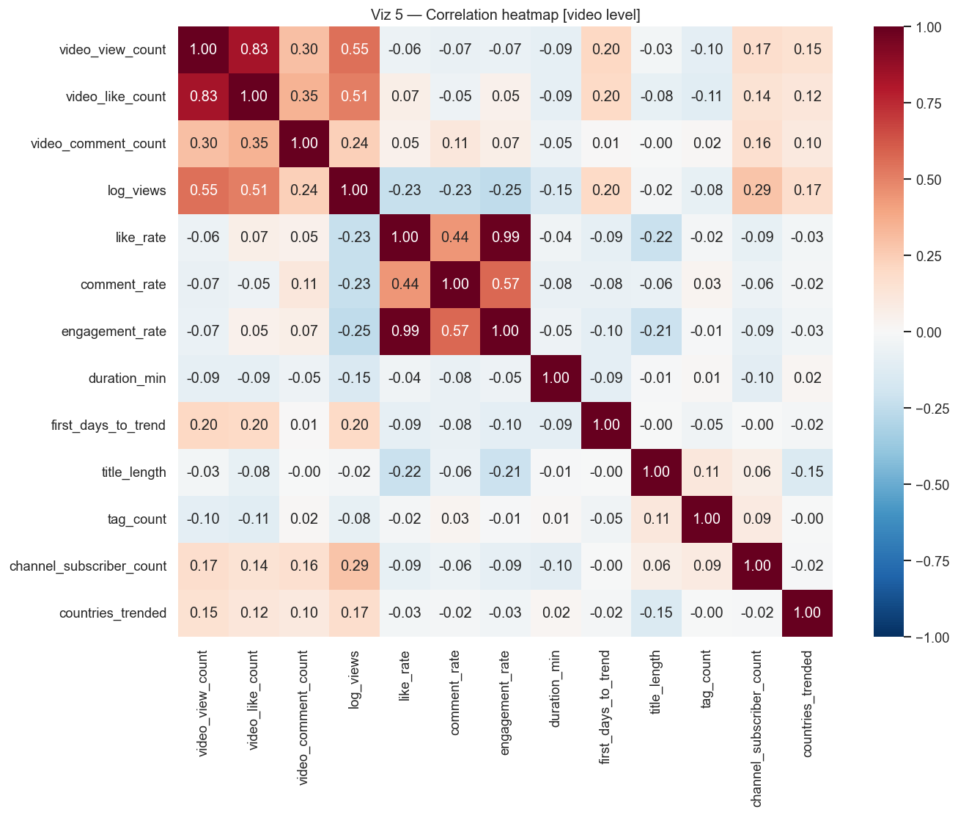

3. Performance by Category
Science & Technology leads on median views (~1.75M); Gaming and Music trail (~0.14-0.22M). Note Music's drop versus the appearance grain — it trends widely but not deeply.
video_category_id | videos | median_views | mean_like_rate | mean_engagement_rate | median_first_days_to_trend
Science & Technology | 467 | 1751174.0 | 5.12 | 5.39 | 1.0
Comedy | 829 | 938750.0 | 3.59 | 3.71 | 1.0
Pets & Animals | 20 | 679315.0 | 7.35 | 7.99 | 1.0
Entertainment | 8331 | 645181.0 | 2.9 | 3.03 | 1.0
Film & Animation | 773 | 536274.0 | 3.21 | 3.4 | 1.0
Autos & Vehicles | 205 | 492347.0 | 2.95 | 3.15 | 1.0
News & Politics | 784 | 473738.5 | 1.92 | 2.18 | 1.0
People & Blogs | 2634 | 433074.0 | 3.27 | 3.42 | 1.0
Sports | 2917 | 402214.0 | 2.17 | 2.35 | 1.0
Travel & Events | 93 | 356164.0 | 4.7 | 5.0 | 1.0
Howto & Style | 344 | 313447.0 | 2.46 | 2.61 | 1.0
Education | 349 | 282038.0 | 4.79 | 5.16 | 1.0
Music | 4942 | 220180.5 | 2.62 | 2.81 | 1.0
Gaming | 13852 | 143630.5 | 4.28 | 4.61 | 1.0
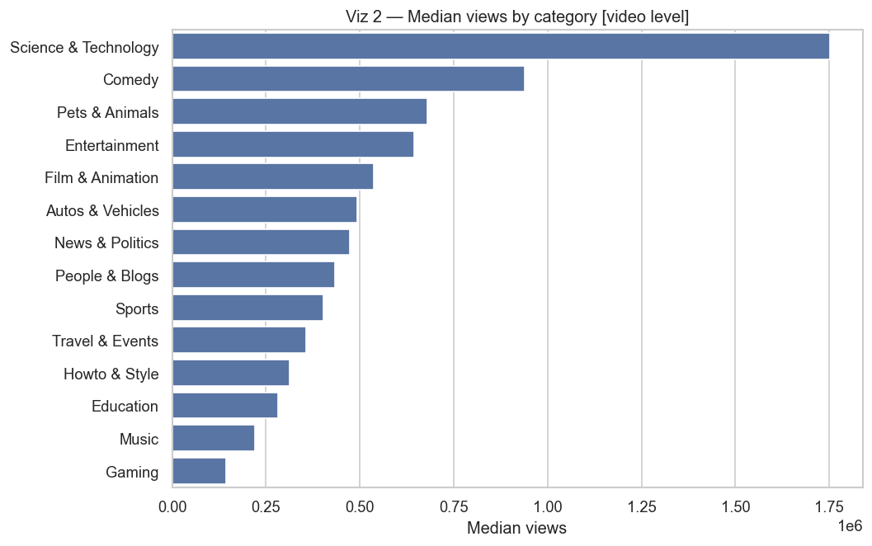
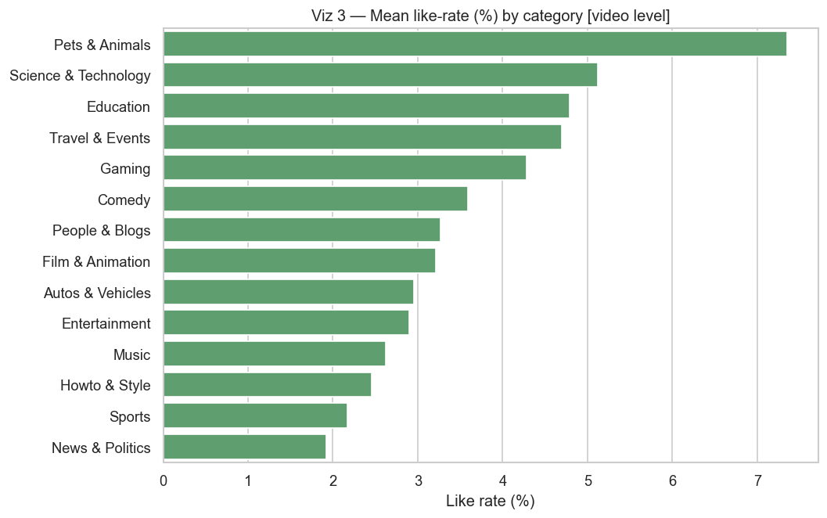

4. Performance by Video Length
Shorts win reach (~1.24M median, ~6x the 5-20 min band); like-rate peaks for 20-60 min videos — a reach vs engagement trade-off.
duration_group | videos | median_views | mean_like_rate | mean_engagement_rate
<1 min (Shorts) | 4635 | 1241892.0 | 3.03 | 3.09
1-5 min | 6269 | 537061.0 | 3.08 | 3.31
5-20 min | 11177 | 216141.0 | 3.67 | 3.99
20-60 min | 8946 | 211689.0 | 3.88 | 4.16
>60 min | 5513 | 172493.0 | 2.78 | 2.89
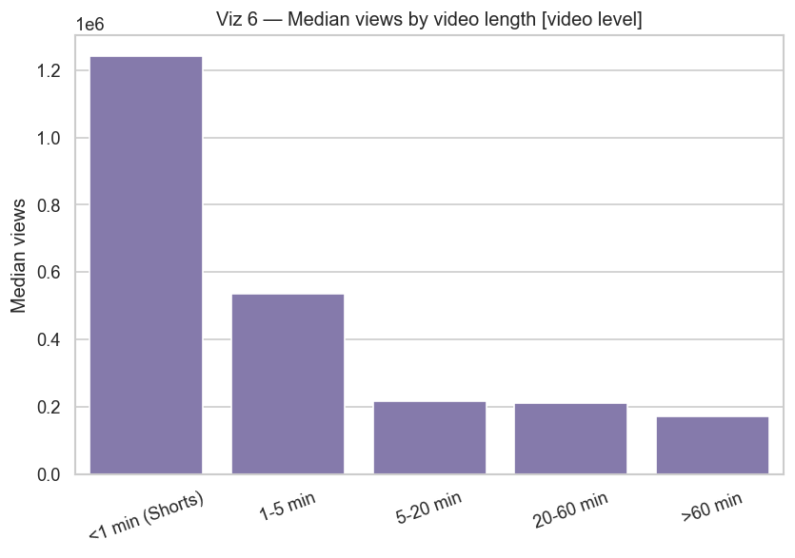
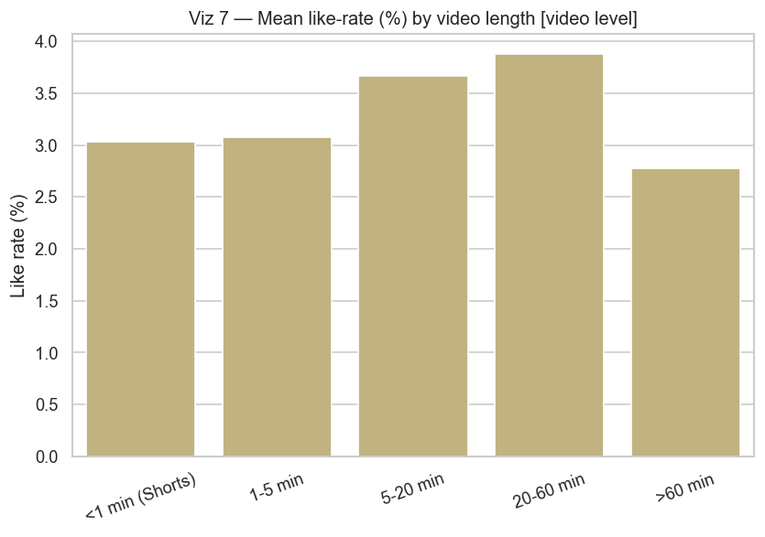

5. Publish Timing
Median views peak for uploads around 03:00-05:00 UTC; like-rate varies modestly by weekday.
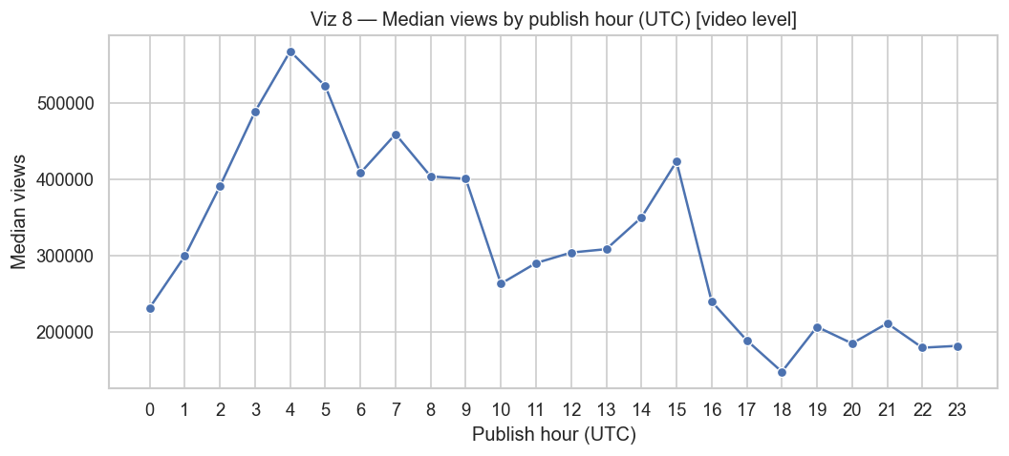
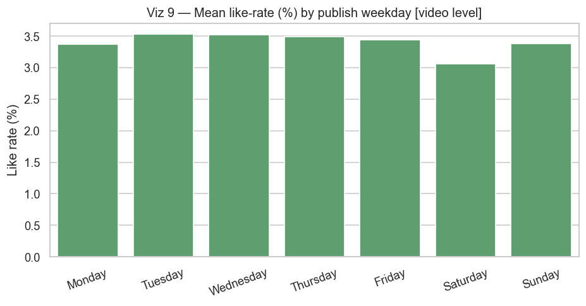

6. Title, Tags, Quality & Channel Size
Shorter titles correlate with higher like-rate (r = -0.22); more tags do not raise views; HD strongly out-engages SD; bigger channels tend to reach more viewers.
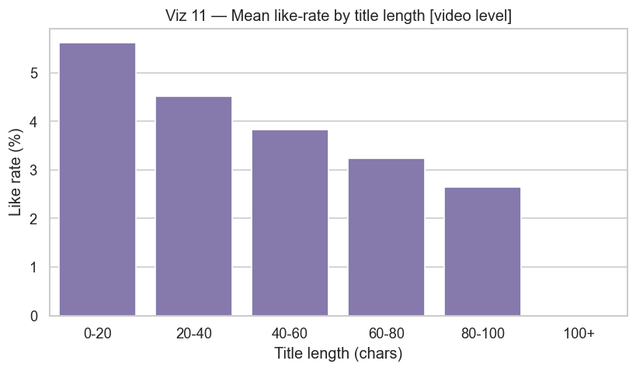
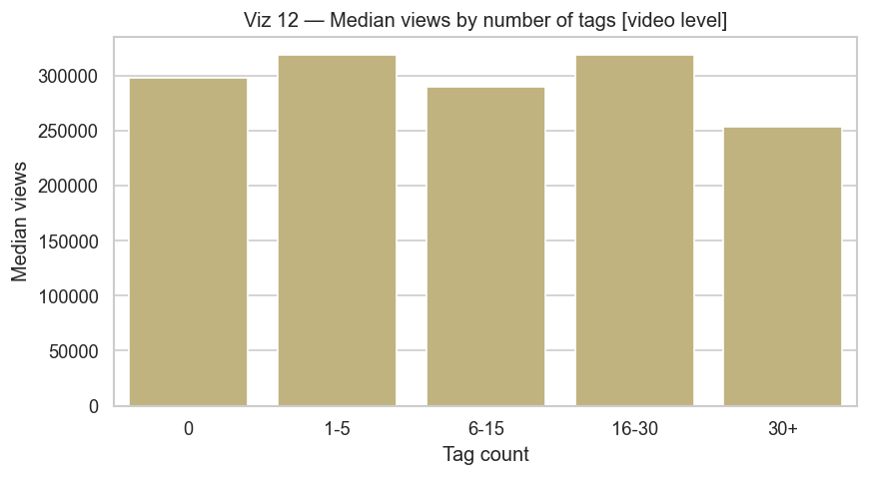
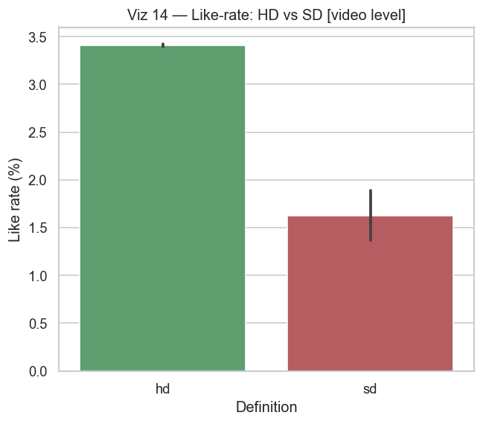
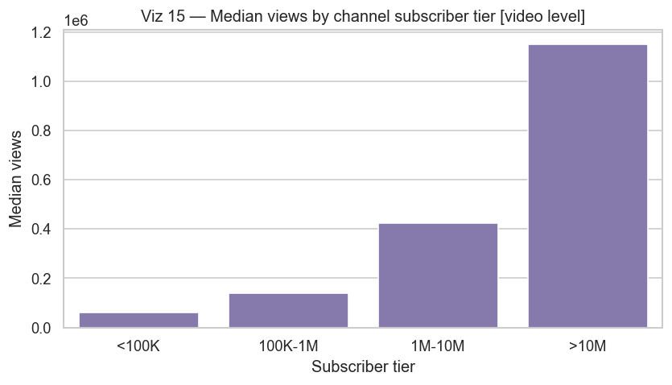

7. Speed to Trend & Geographic Spread
Most videos trend within a day of publishing, and 69% trend in only one country (median 1, max 81) — a few global hits dominate cross-country reach.
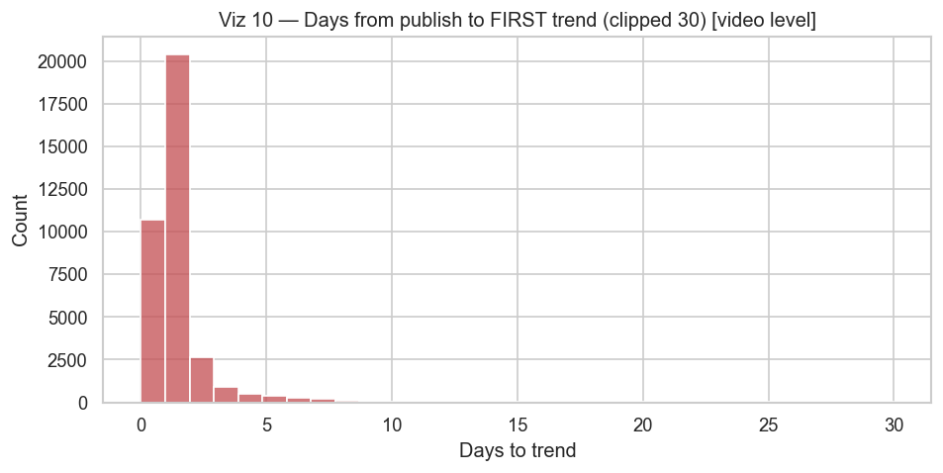
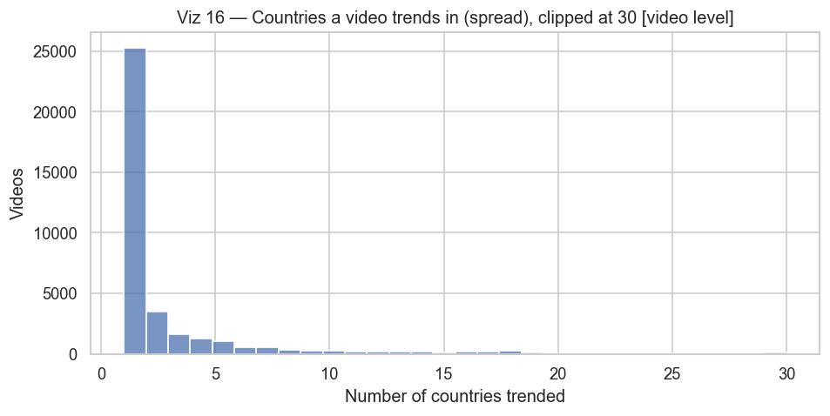
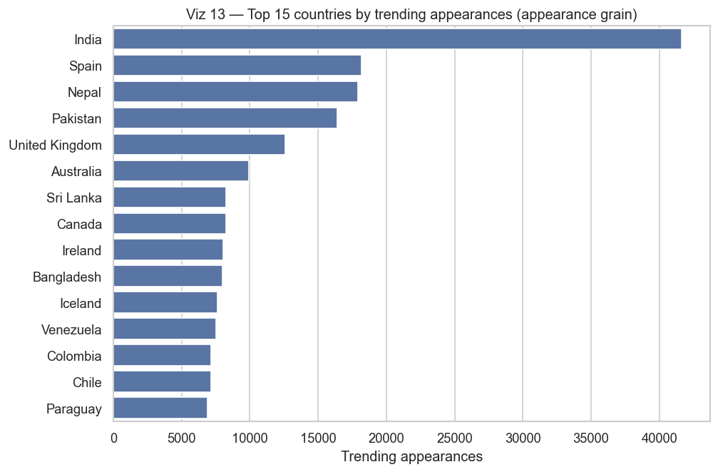

8. EDA Conclusion
Consistent drivers emerge at the video level: length (format), category, publish timing and production quality all shift reach and engagement. These are confirmed statistically (notebook Section 7) and translated into recommendations.

