BABU BANARASI DAS UNIVERSITY
2026-2027

SCHOOL OF COMPUTER APPLICATIONS
No SQL Project On
Student Management System Using MongoDB
Submitted To : Mr. Harendra Singh  Department : BCA (DS & AI)  Date : 6th October | Submitted By : Ratnesh Singh  Roll No : 35  University Roll No : 1250258350

1. CREATE DATABASE
MongoDB Query:
use CRUD
Explanation: Creates or switches to the CRUD database.
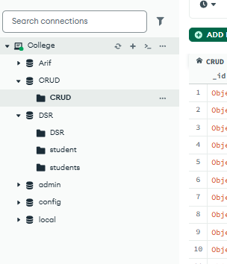
2. CREATE COLLECTION
MongoDB Query:
db. create Collection("CRUD")
Explanation: Creates a collection named CRUD.
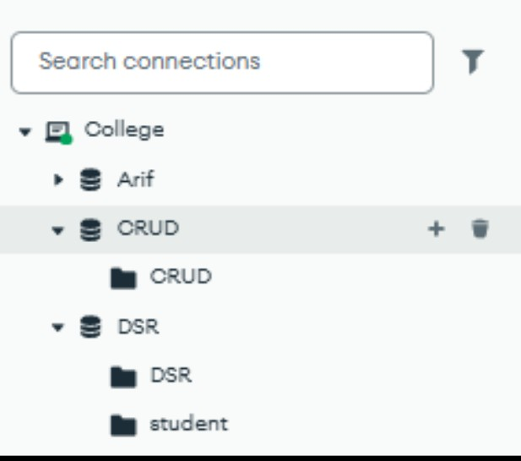

3. INSERT 50 STUDENTS
MongoDB Query:
db.students.insertMany([
{roll:1, name:"Riya Sharma", age:20, marks:87, city:"Lucknow"},
{roll:2, name:"Aryan Verma", age:19, marks:72, city:"Kanpur"},
{roll:3, name:"Sneha Gupta", age:18, marks:94, city:"Varanasi"},
{roll:4, name:"Rohan Das", age:21, marks:68, city:"Prayagraj"},
{roll:5, name:"Pooja Yadav", age:19, marks:81, city:"Ayodhya"},
{roll:6, name:"Karan Singh", age:20, marks:76, city:"Gorakhpur"},
{roll:7, name:"Anjali Mishra", age:18, marks:89, city:"Lucknow"},
{roll:8, name:"Vikas Tiwari", age:19, marks:63, city:"Bareilly"},
{roll:9, name:"Meera Joshi", age:20, marks:91, city:"Kanpur"},
{roll:10, name:"Harsh Patel", age:18, marks:55, city:"Jaunpur"},
{roll:11, name:"Nisha Rani", age:19, marks:84, city:"Lucknow"},
{roll:12, name:"Siddharth Rao", age:21, marks:79, city:"Varanasi"},
{roll:13, name:"Kritika Soni", age:18, marks:96, city:"Prayagraj"},
{roll:14, name:"Amit Kumar", age:20, marks:70, city:"Gonda"},
{roll:15, name:"Divya Nair", age:19, marks:88, city:"Lucknow"},
{roll:16, name:"Rahul Chauhan", age:18, marks:74, city:"Kanpur"},
{roll:17, name:"Shreya Pandey", age:20, marks:82, city:"Ayodhya"},
{roll:18, name:"Nikhil Bhatia", age:19, marks:67, city:"Gorakhpur"},
{roll:19, name:"Tanvi Kapoor", age:18, marks:93, city:"Lucknow"},
{roll:20, name:"Manish Rawat", age:21, marks:61, city:"Bareilly"},
{roll:21, name:"Ishita Malhotra", age:19, marks:85, city:"Varanasi"},
{roll:22, name:"Yash Thakur", age:20, marks:78, city:"Kanpur"},
{roll:23, name:"Priyanka Das", age:18, marks:90, city:"Lucknow"},
{roll:24, name:"Abhishek Jain", age:19, marks:66, city:"Jaunpur"},
{roll:25, name:"Sakshi Agrawal", age:20, marks:95, city:"Prayagraj"},
{roll:26, name:"Deepak Sharma", age:18, marks:73, city:"Ayodhya"},
{roll:27, name:"Neha Verma", age:21, marks:86, city:"Lucknow"},
{roll:28, name:"Arjun Mehta", age:19, marks:59, city:"Gonda"},
{roll:29, name:"Kavya Iyer", age:20, marks:92, city:"Kanpur"},
{roll:30, name:"Suresh Yadav", age:18, marks:80, city:"Varanasi"},
{roll:31, name:"Ritika Singh", age:19, marks:75, city:"Lucknow"},
{roll:32, name:"Mohit Gupta", age:21, marks:69, city:"Bareilly"},
{roll:33, name:"Ananya Roy", age:18, marks:97, city:"Prayagraj"},
{roll:34, name:"Vivek Choudhary", age:20, marks:64, city:"Gorakhpur"},
{roll:35, name:"Simran Kaur", age:19, marks:83, city:"Lucknow"},
{roll:36, name:"Aditya Banerjee", age:18, marks:71, city:"Kanpur"},
{roll:37, name:"Pooja Rani", age:20, marks:88, city:"Ayodhya"},
{roll:38, name:"Rohit Nair", age:19, marks:77, city:"Varanasi"},
{roll:39, name:"Snehal Patil", age:21, marks:94, city:"Lucknow"},
{roll:40, name:"Kunal Sharma", age:18, marks:58, city:"Jaunpur"},
{roll:41, name:"Ayesha Khan", age:19, marks:86, city:"Prayagraj"},
{roll:42, name:"Pranav Joshi", age:20, marks:72, city:"Kanpur"},
{roll:43, name:"Nandini Das", age:18, marks:91, city:"Lucknow"},
{roll:44, name:"Gaurav Tiwari", age:19, marks:65, city:"Bareilly"},
{roll:45, name:"Isha Malhotra", age:20, marks:89, city:"Varanasi"},
{roll:46, name:"Saurabh Verma", age:18, marks:76, city:"Gonda"},
{roll:47, name:"Tanya Gupta", age:21, marks:84, city:"Lucknow"},
{roll:48, name:"Aman Singh", age:19, marks:70, city:"Ayodhya"},
{roll:49, name:"Richa Pandey", age:20, marks:93, city:"Kanpur"},
{roll:50, name:"Varun Kapoor", age:18, marks:81, city:"Prayagraj"}
])
Explanation: Inserts 50 student documents into the students collection.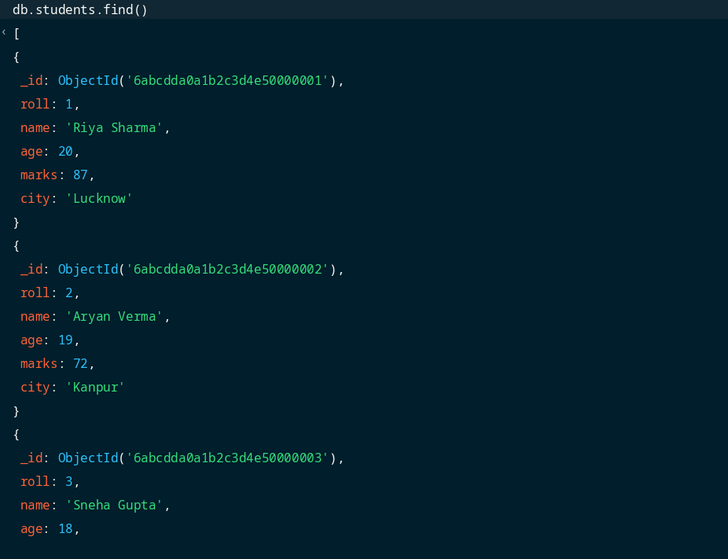

4. DISPLAY ALL STUDENTS
MongoDB Query:
db.students.find()
Explanation: Retrieves all documents from the students collection.
5. EQUAL TO — $eq
MongoDB Query:
db.students.find({marks: {$eq: 87}})
Explanation: Finds students whose marks are exactly 87.
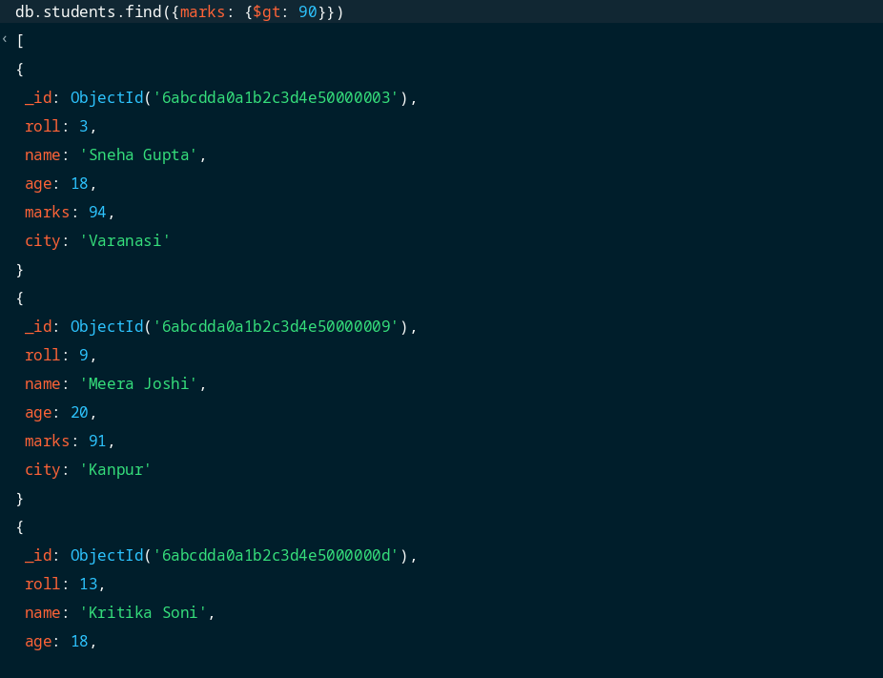
6. GREATER THAN — $gt
MongoDB Query:
db.students.find({marks: {$gt: 90}})
Explanation: Finds students whose marks are greater than 90.
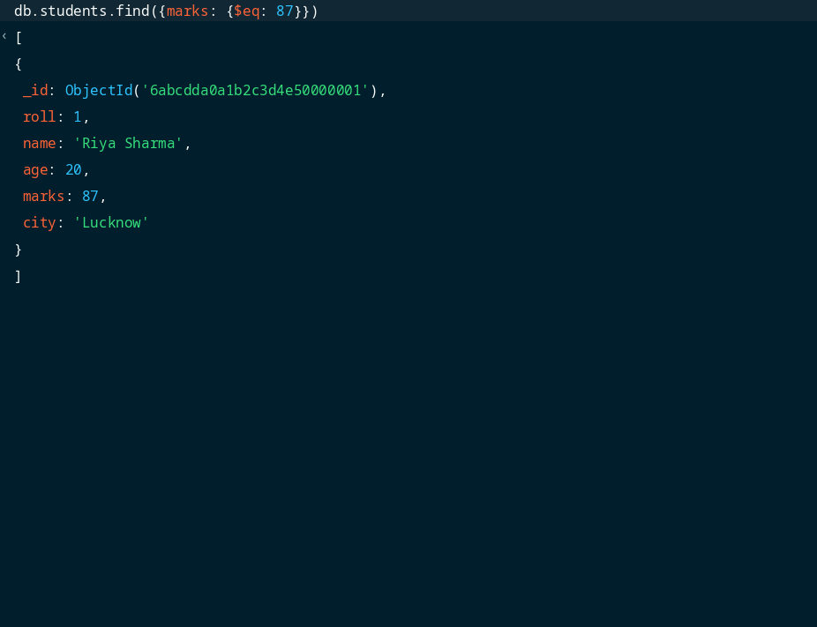
7. LESS THAN — $lt
MongoDB Query:
db.students.find({marks: {$lt: 65}})
Explanation: Finds students whose marks are less than 65.
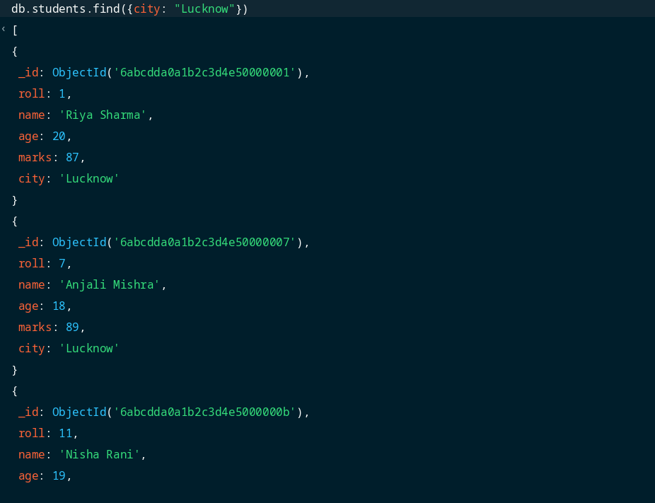
8. GREATER THAN OR EQUAL TO — $gte
MongoDB Query:
db.students.find({marks: {$gte: 85}})
Explanation: Finds students whose marks are 85 or above.
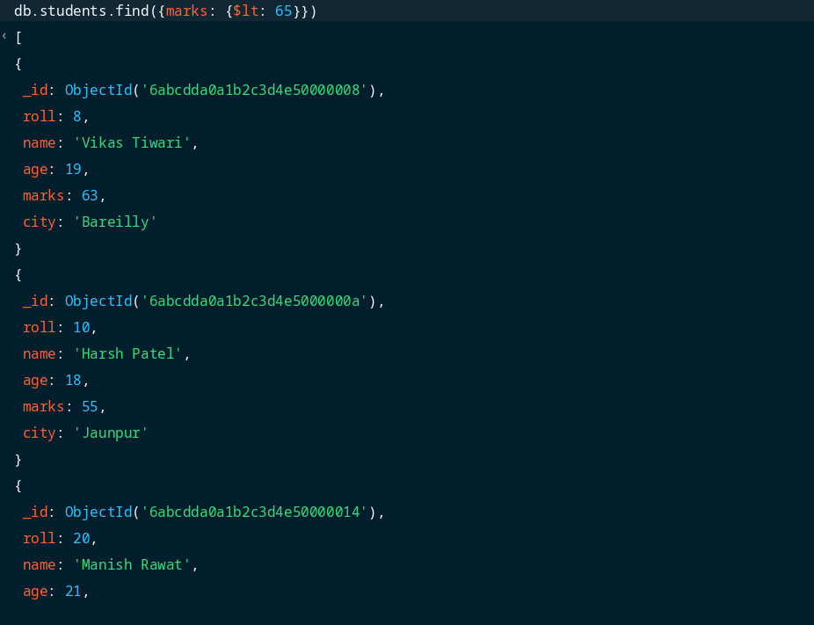
9. LESS THAN OR EQUAL TO — $lte
MongoDB Query:
db.students.find({marks: {$lte: 70}})
Explanation: Finds students whose marks are 70 or below.
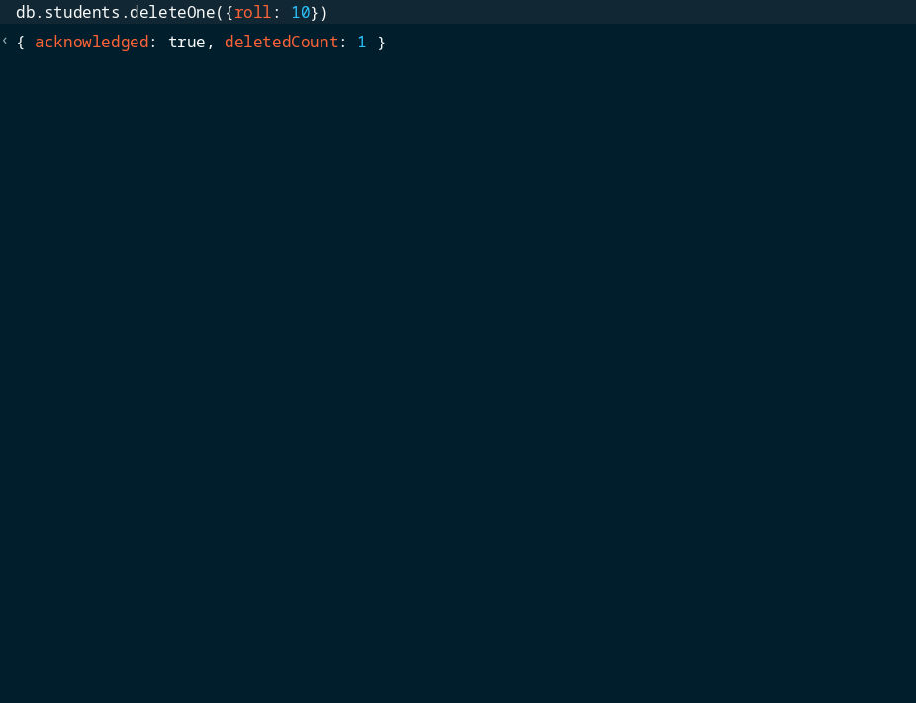
10. UPDATE OPERATION
MongoDB Query:
db.students.updateOne(
{roll: 8},
{$set: {marks: 82}}
)
Explanation: Updates the marks of the student with roll number 8 to 82.
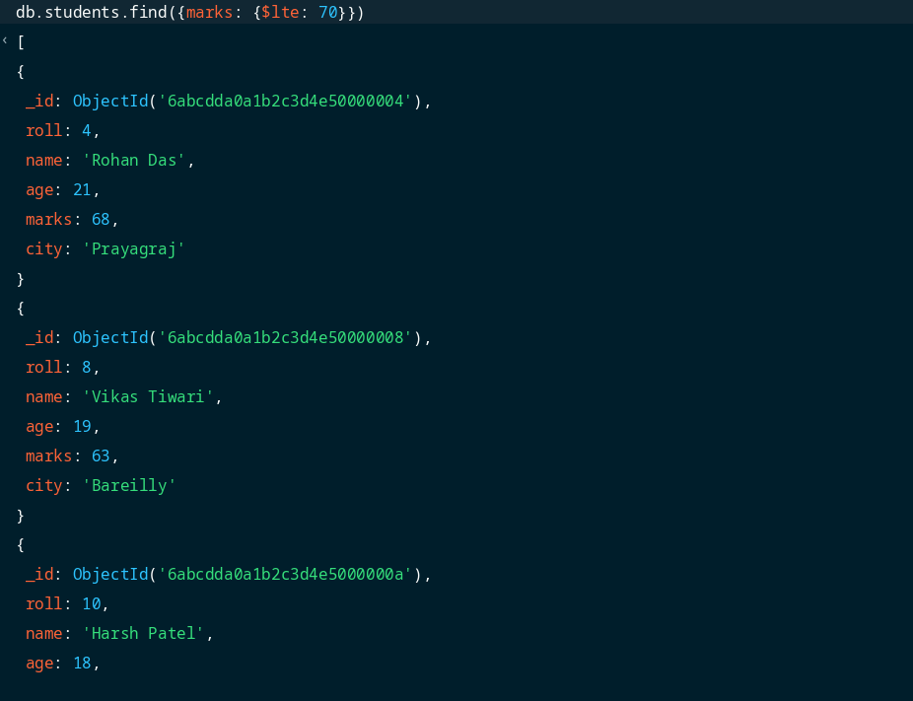
11. DELETE ONE OPERATION
MongoDB Query:
db.students.deleteOne({roll: 10})
Explanation: Deletes the document of the student with roll number 10.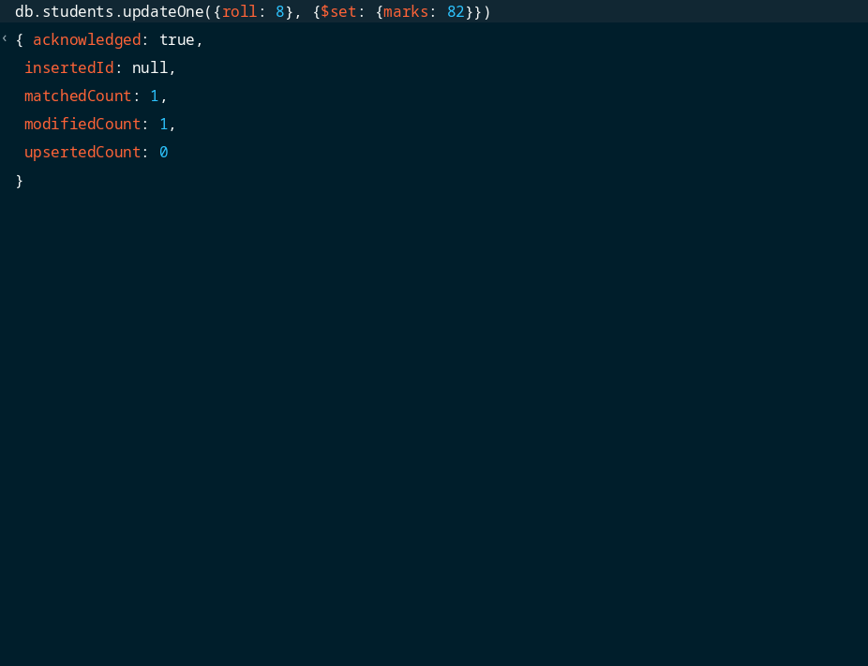
12. DELETE MANY OPERATION
MongoDB Query:
db.students.deleteMany({
marks: {$lt: 60}
})
Explanation: Deletes all students having marks less than 60.
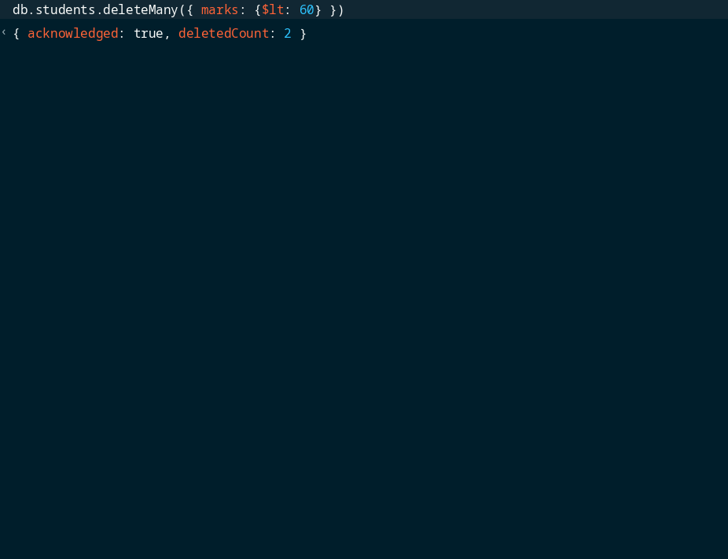
13. AND OPERATION — $and
MongoDB Query:
db.students.find({
$and: [
{marks: {$gt: 80}},
{age: 19}
]
})
Explanation: Finds students who have marks greater than 80 and age equal to 19.
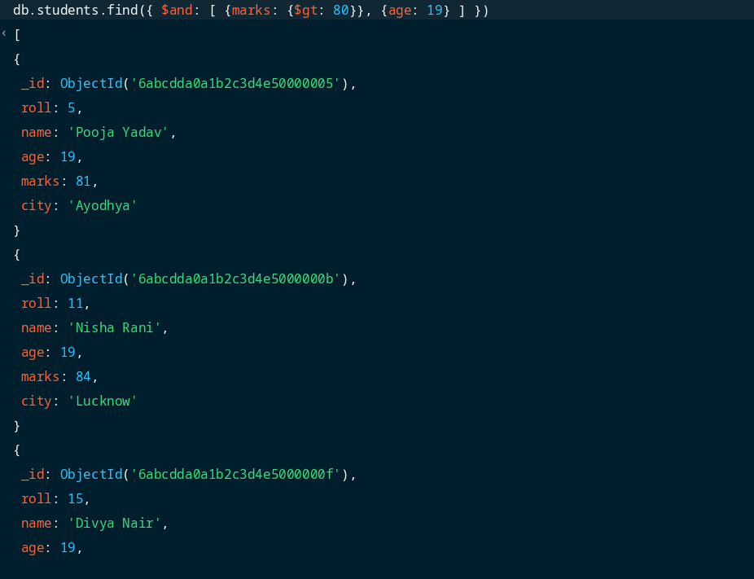
14. OR OPERATION — $or
MongoDB Query:
db.students.find({
$or: [
{city: "Lucknow"},
{city: "Varanasi"}
]
})
Explanation: Finds students who belong to either Lucknow or Varanasi.
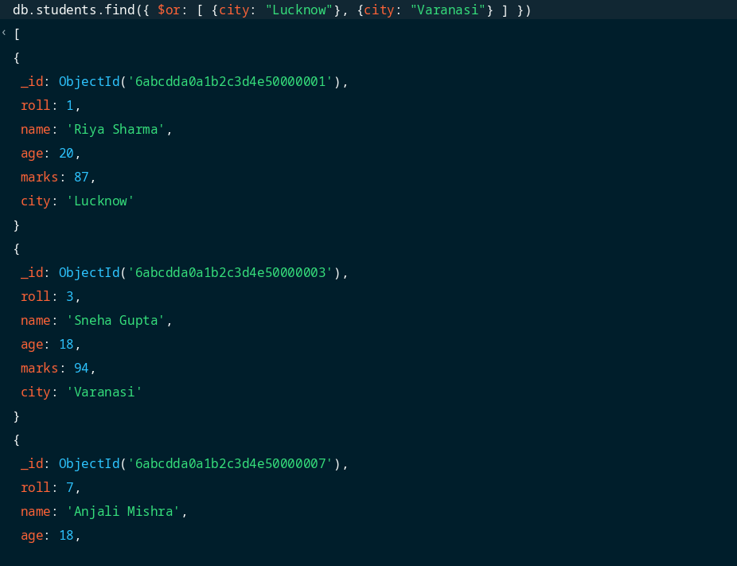
15. SORT OPERATION
MongoDB Query:
A. db.students.find().sort({marks: 1})
B. db.students.find().sort({marks: -1})
Explanation: A sorts students by marks in ascending order (lowest to highest). B sorts students by marks in descending order (highest to lowest).
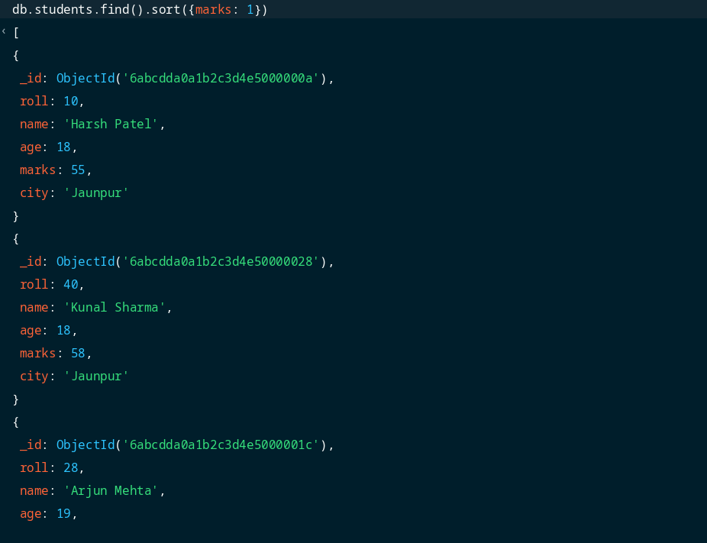
16. LIMIT OPERATION
MongoDB Query:
db.students.find().limit(5)
Explanation: Displays only the first 5 documents from the collection.
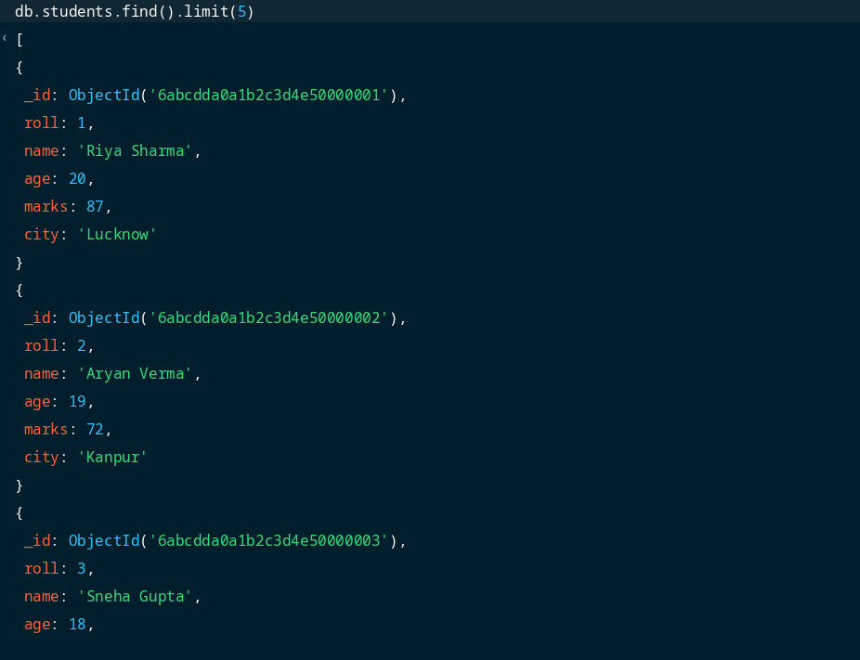
17. SEARCH BY CITY
MongoDB Query:
db.students.find({city: "Lucknow"})
Explanation: Finds all students whose city is Lucknow.
18. COUNT DOCUMENTS
MongoDB Query:
db.students.countDocuments()
Explanation: Counts the total number of documents present in the collection (after performing delete operations).
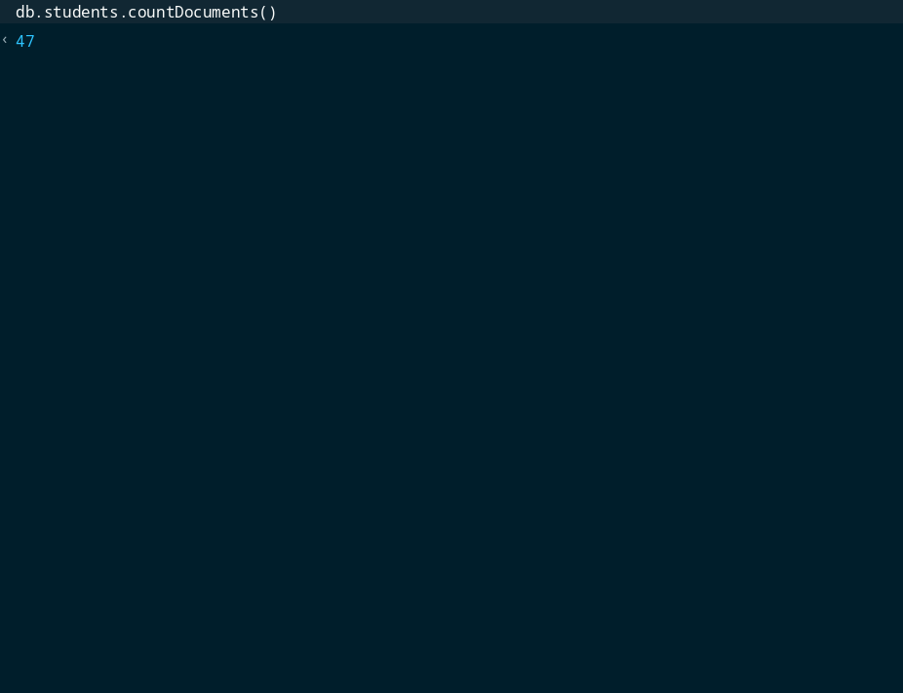

MONGODB OPERATORS USED:
Operator | Meaning | Example
$eq | Equal to | marks: {$eq: 87}
$gt | Greater than | marks: {$gt: 90}
$lt | Less than | marks: {$lt: 65}
$gte | Greater than or equal to | marks: {$gte: 85}
$lte | Less than or equal to | marks: {$lte: 70}
$and | All conditions true | $and: [...]
$or | At least one condition true | $or: [...]

