SMART SHOE WEARABLE PLATFORM
4-Layer Carrier PCB
Design Reference Document — Revision A

Document No. | MADEPLUS-PCB-001-RevA
Board Dimensions | 60 mm × 40 mm × 1.6 mm
Layer Count | 4 (L1 Signal / L2 GND / L3 Power / L4 Signal)
Modules | PowerBoost 500C + ESP32-S3 Zero + GY-86 IMU
USB-C Port | TOP edge — native (ESP32 module, no PCB slot)
Micro-USB Port | LEFT edge — native (PowerBoost module, no PCB slot)
Battery | 3.7V 300mAh LiPo via JST PH 2.0mm at RIGHT edge
Surface Finish | ENIG — Green solder mask — White silkscreen
Date | March 5, 2026
Author | Ratneswar Roychowdhury — MADEPLUS INC
Status | Released for Fabrication

MADEPLUS INC | Parole, Maryland | Confidential

1. Project Overview
This document covers the complete design specification for the 4-Layer Carrier PCB developed as part of the Smart Shoe Gait Analysis Platform. The carrier PCB integrates three modules — the Adafruit PowerBoost 500C, the Waveshare ESP32-S3 Zero, and the GY-86 10-DOF IMU — through a dual-sided socket architecture. All inter-module connections, power distribution, and passive components are pre-routed on the carrier, requiring no hand wiring after module installation.
A key design goal is natural USB connector access: the ESP32-S3 Zero socket is oriented portrait so its USB-C port reaches the top PCB edge natively, and the PowerBoost 500C socket is oriented landscape so its Micro-USB port reaches the left PCB edge natively. No edge slot cutouts are required in the PCB outline.

1.1 Module Summary
Module | Part | Location | Interface | Supply
Microcontroller | Waveshare ESP32-S3 Zero | TOP — L1 | USB-C, BLE, I²C | 5V → AMS1117 LDO → 3.3V
IMU | GY-86 (MPU6050 + HMC5883L + MS5611) | TOP — L1 | I²C 0x68 / 0x1E / 0x77 | 3.3V from ESP32
Power | Adafruit PowerBoost 500C | BOTTOM — L4 | Micro-USB (charger) | 3.7V LiPo → 5.2V boost
Battery | YTKavq 3.7V 300mAh JST PH 2.0mm | External (JST J1) | JST PH 2.0mm | 3.7V LiPo

2. PCB Layout

2.1 Top Face (L1) — ESP32-S3 Zero & GY-86
The top face carries the ESP32-S3 Zero in portrait orientation (USB-C at top edge), the GY-86 IMU module, I²C signal traces, 3.3V power traces, and all top-side passive components.

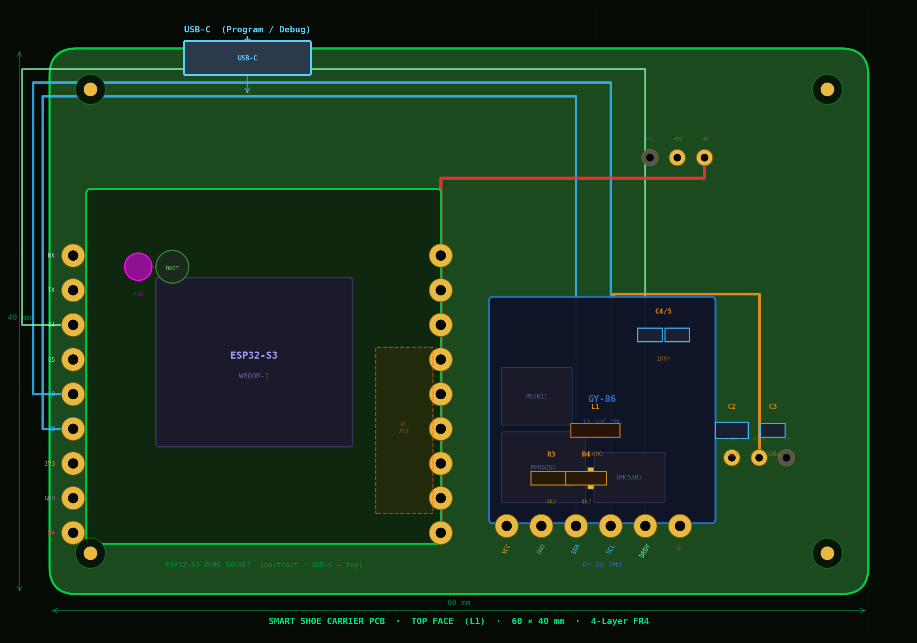
Figure 1 — PCB Top Face (L1): ESP32-S3 Zero socket (portrait, USB-C at top edge) · GY-86 IMU · I²C traces · 3V3 distribution

2.2 Bottom Face (L4) — PowerBoost 500C
The bottom face carries the PowerBoost 500C in landscape orientation (Micro-USB at left edge), the LBO voltage divider, power enable switch, battery connector, and bulk decoupling capacitors.

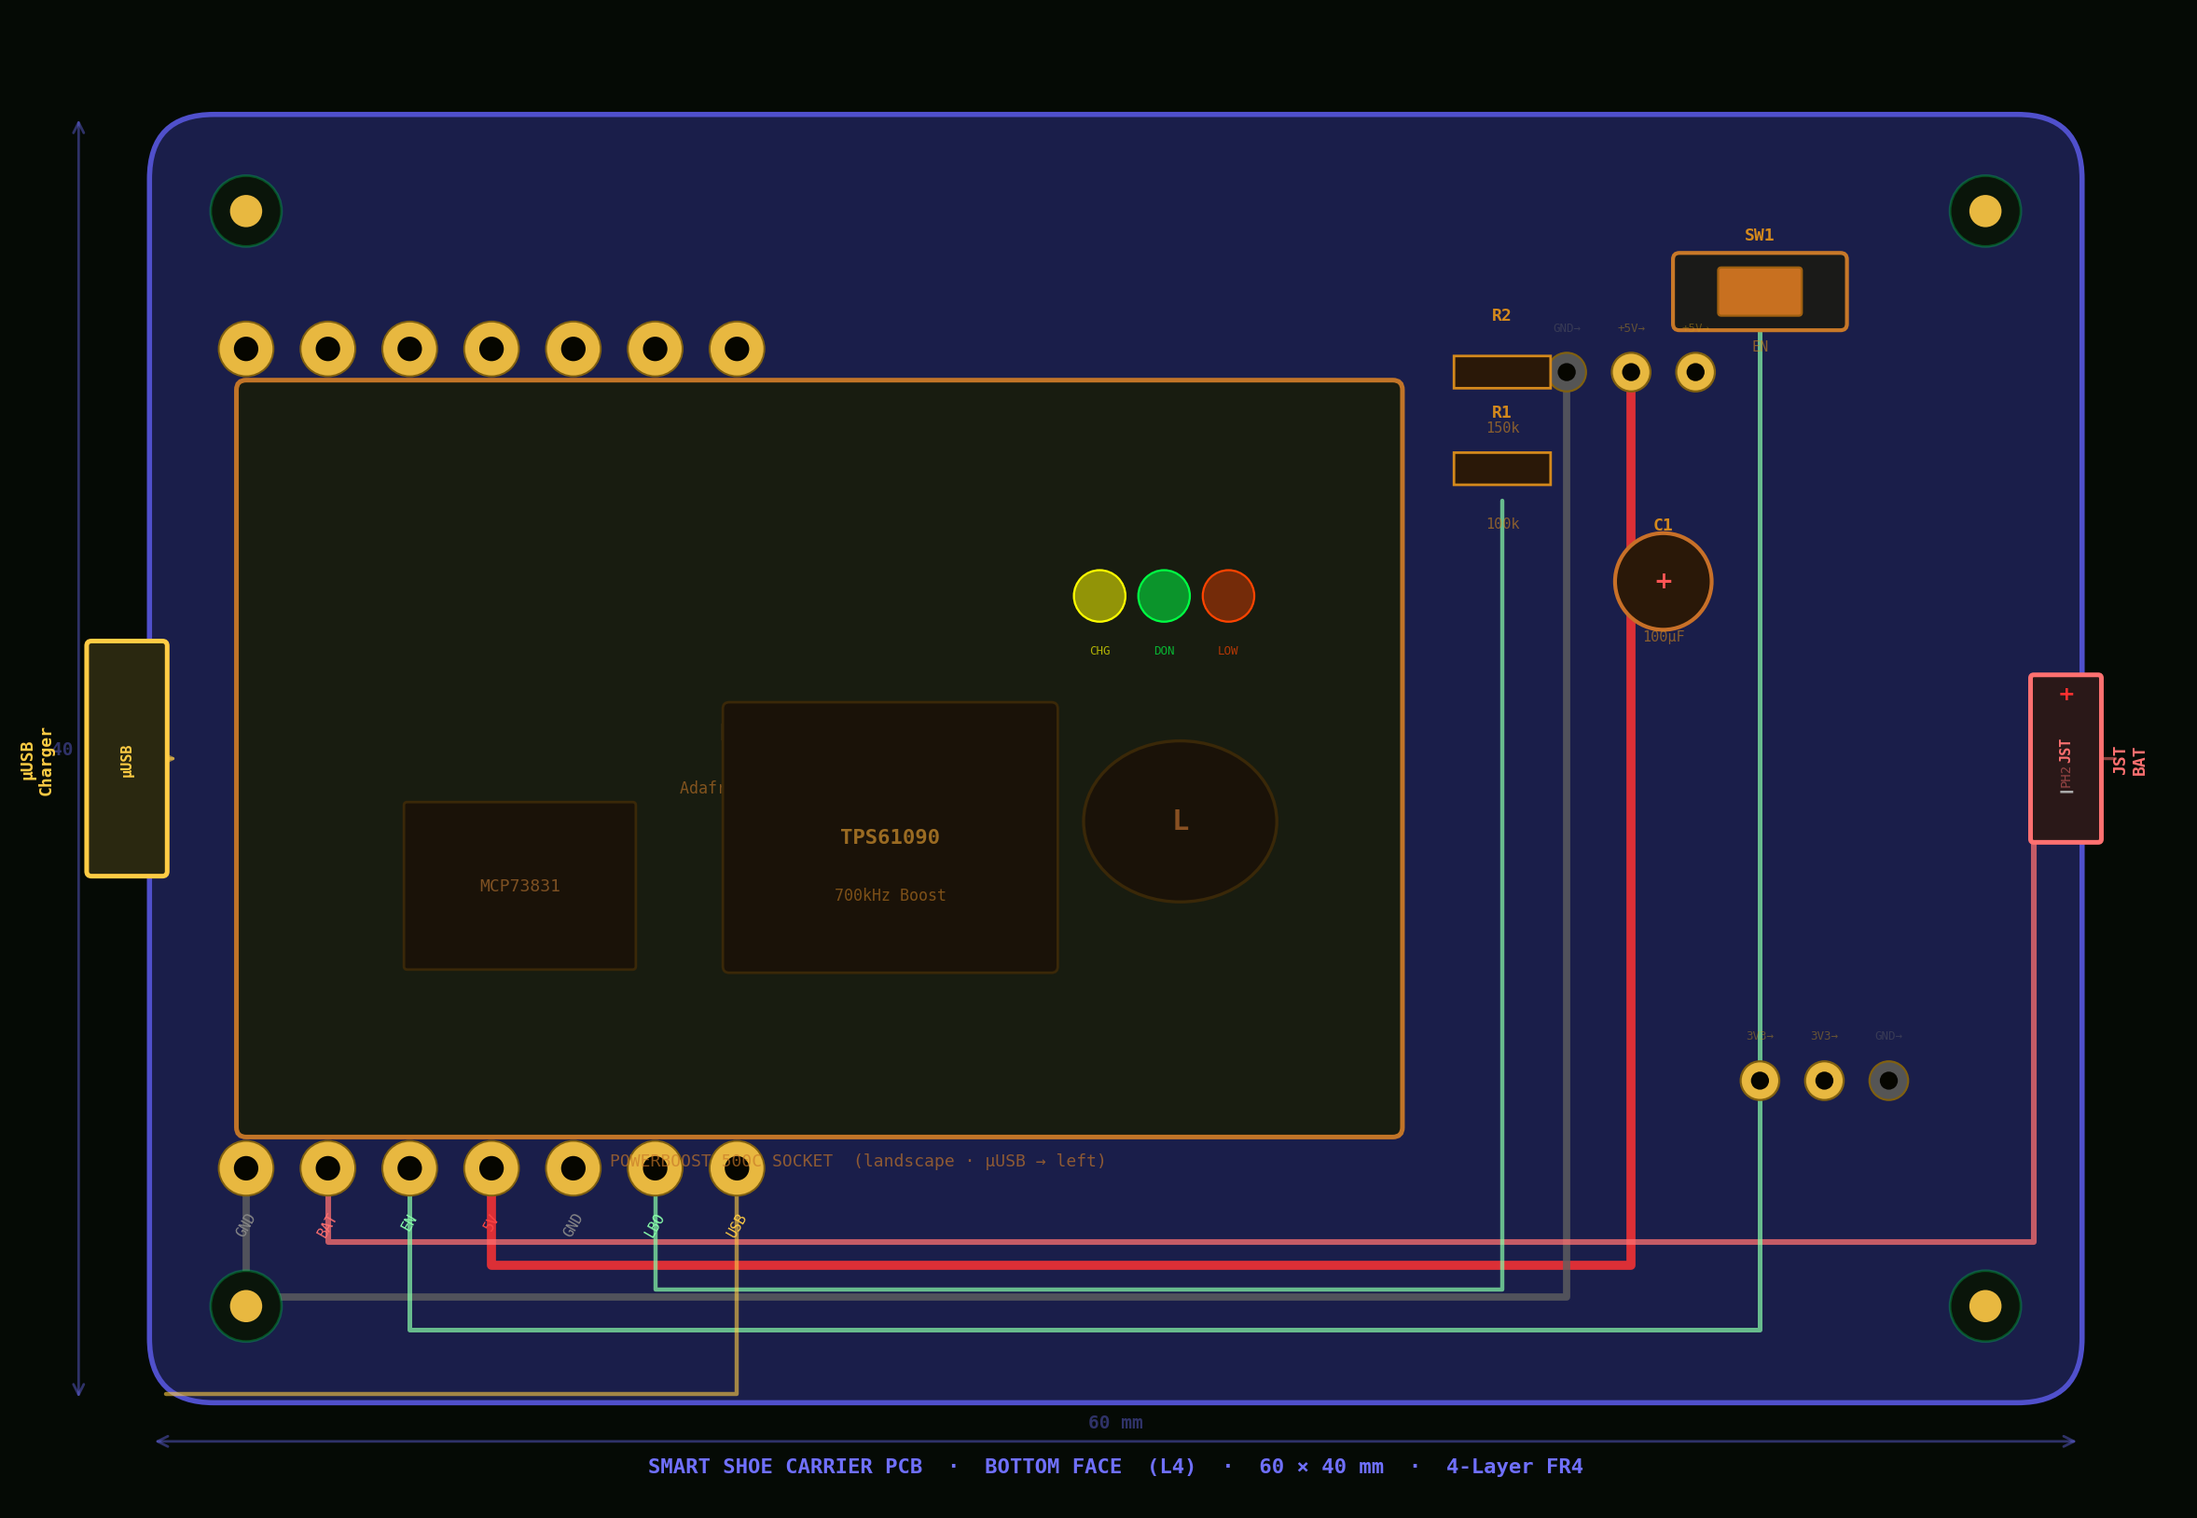
Figure 2 — PCB Bottom Face (L4): PowerBoost 500C socket (landscape, µUSB at left edge) · JST battery · LBO divider · SW1

3. Layer Stack-Up
The board uses a standard 4-layer FR4 stack. L2 provides a continuous GND plane that shields the IMU on L1 from the switching converter on L4. L3 carries 5V and 3.3V power islands with a 1 mm isolation gap between them.

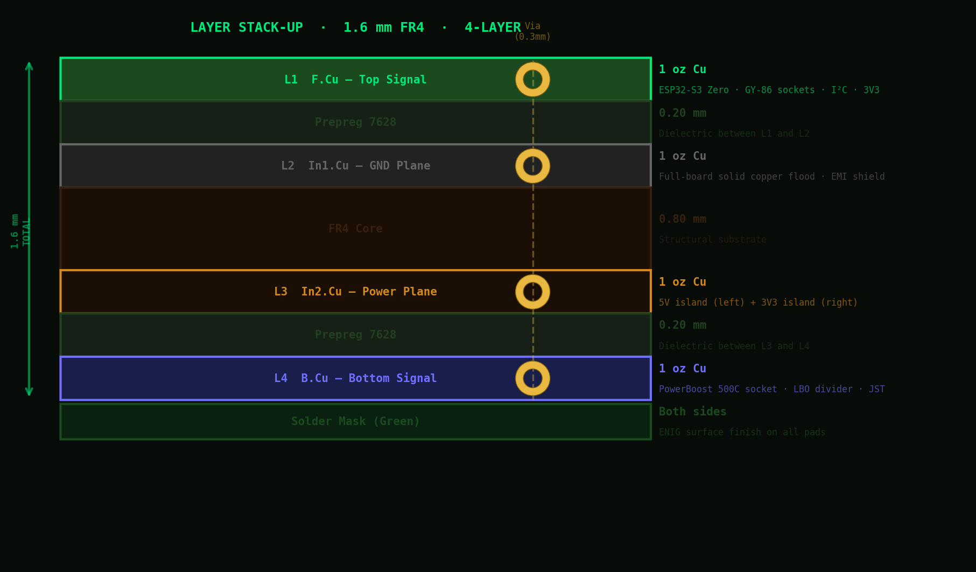
Figure 3 — 4-Layer Stack-Up: 1.6 mm FR4 · 1 oz copper all layers · ENIG finish

Layer | Function | Cu Weight | Thickness | Description
L1 — F.Cu | Signal Top | 1 oz | 35 µm | ESP32-S3 Zero + GY-86 sockets · I²C · 3V3 distribution
Prepreg 7628 | Dielectric | — | 0.20 mm | Between L1 and L2
L2 — In1.Cu | GND Plane | 1 oz | 35 µm | Solid copper flood · full board extent · EMI shield
FR4 Core | Substrate | — | 0.80 mm | Structural core
L3 — In2.Cu | Power Plane | 1 oz | 35 µm | 5V island (left) + 3V3 island (right) · 1 mm gap
Prepreg 7628 | Dielectric | — | 0.20 mm | Between L3 and L4
L4 — B.Cu | Signal Bottom | 1 oz | 35 µm | PowerBoost 500C socket · LBO divider · JST traces
Total |  |  | 1.60 mm

4. System Connections
The block diagram below shows all inter-module connections including power, I²C, status signals, and USB paths. The LiPo battery connects to the PowerBoost 500C which boosts to 5.2V; the ESP32-S3 onboard AMS1117 LDO regulates this to 3.3V for the GY-86 IMU.

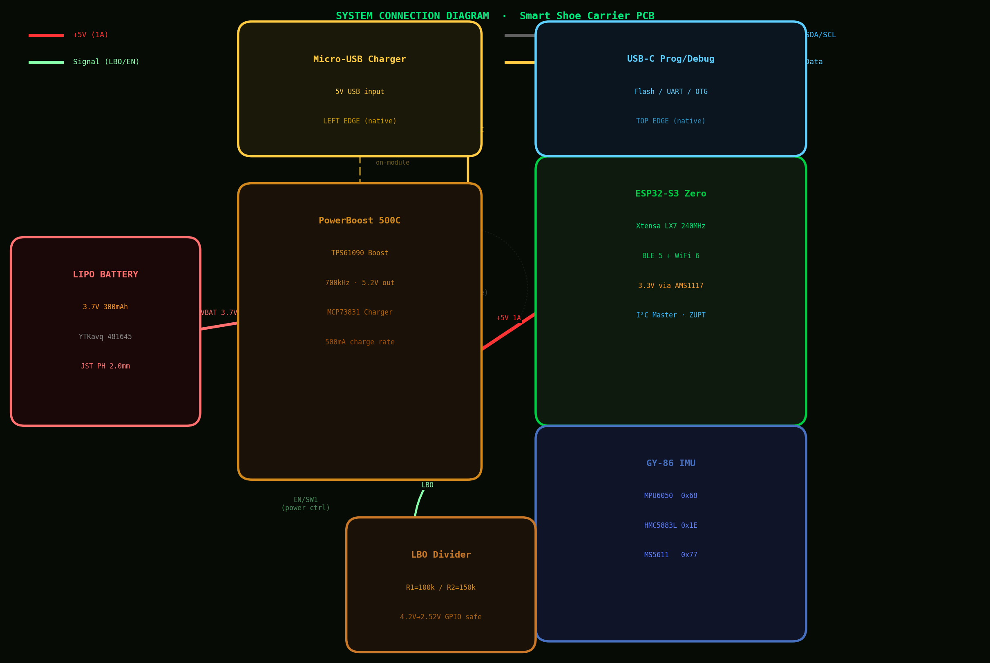
Figure 4 — System Connection Diagram: Power, I²C, USB, LBO signal, and battery paths

4.1 Power Net Routing
Net | From | To | Layers | Trace Width
+5V | PowerBoost 500C 5V pin (L4) | Via → L3 island → ESP32 5V (L1) | L4 + L3 + L1 | 1.6 mm
+3V3 | ESP32-S3 3V3 pin (L1) | Via → L3 island → GY-86 VCC (L1) | L1 + L3 | 0.8 mm
GND | All module GND pins | L2 solid copper plane | L2 | Plane
VBAT | JST J1 pin 1 (+) | PowerBoost BAT pin (L4) | L4 | 1.0 mm

4.2 Signal Net Routing
Net | From | To | Layer | Width | Notes
I2C_SDA | ESP32 GPIO8 | GY-86 SDA | L1 | 0.35 mm | R3 4.7kΩ pull-up to 3V3
I2C_SCL | ESP32 GPIO9 | GY-86 SCL | L1 | 0.35 mm | R4 4.7kΩ pull-up to 3V3
MAG_DRDY | GY-86 DRDY | ESP32 GPIO4 | L1 | 0.25 mm | HMC5883L data-ready interrupt
LBO_DIV | PowerBoost LBO | ESP32 GPIO5 | L4→via→L1 | 0.25 mm | Via R1/R2 divider — MANDATORY
PWR_EN | PowerBoost EN | SW1 → GND | L4 | 0.25 mm | Open = boost ON

5. Connector Specifications
All three external connectors are accessible from the board edges. The two USB connectors are on the modules themselves — no PCB edge slots are machined. Correct module socket orientation ensures natural edge accessibility.

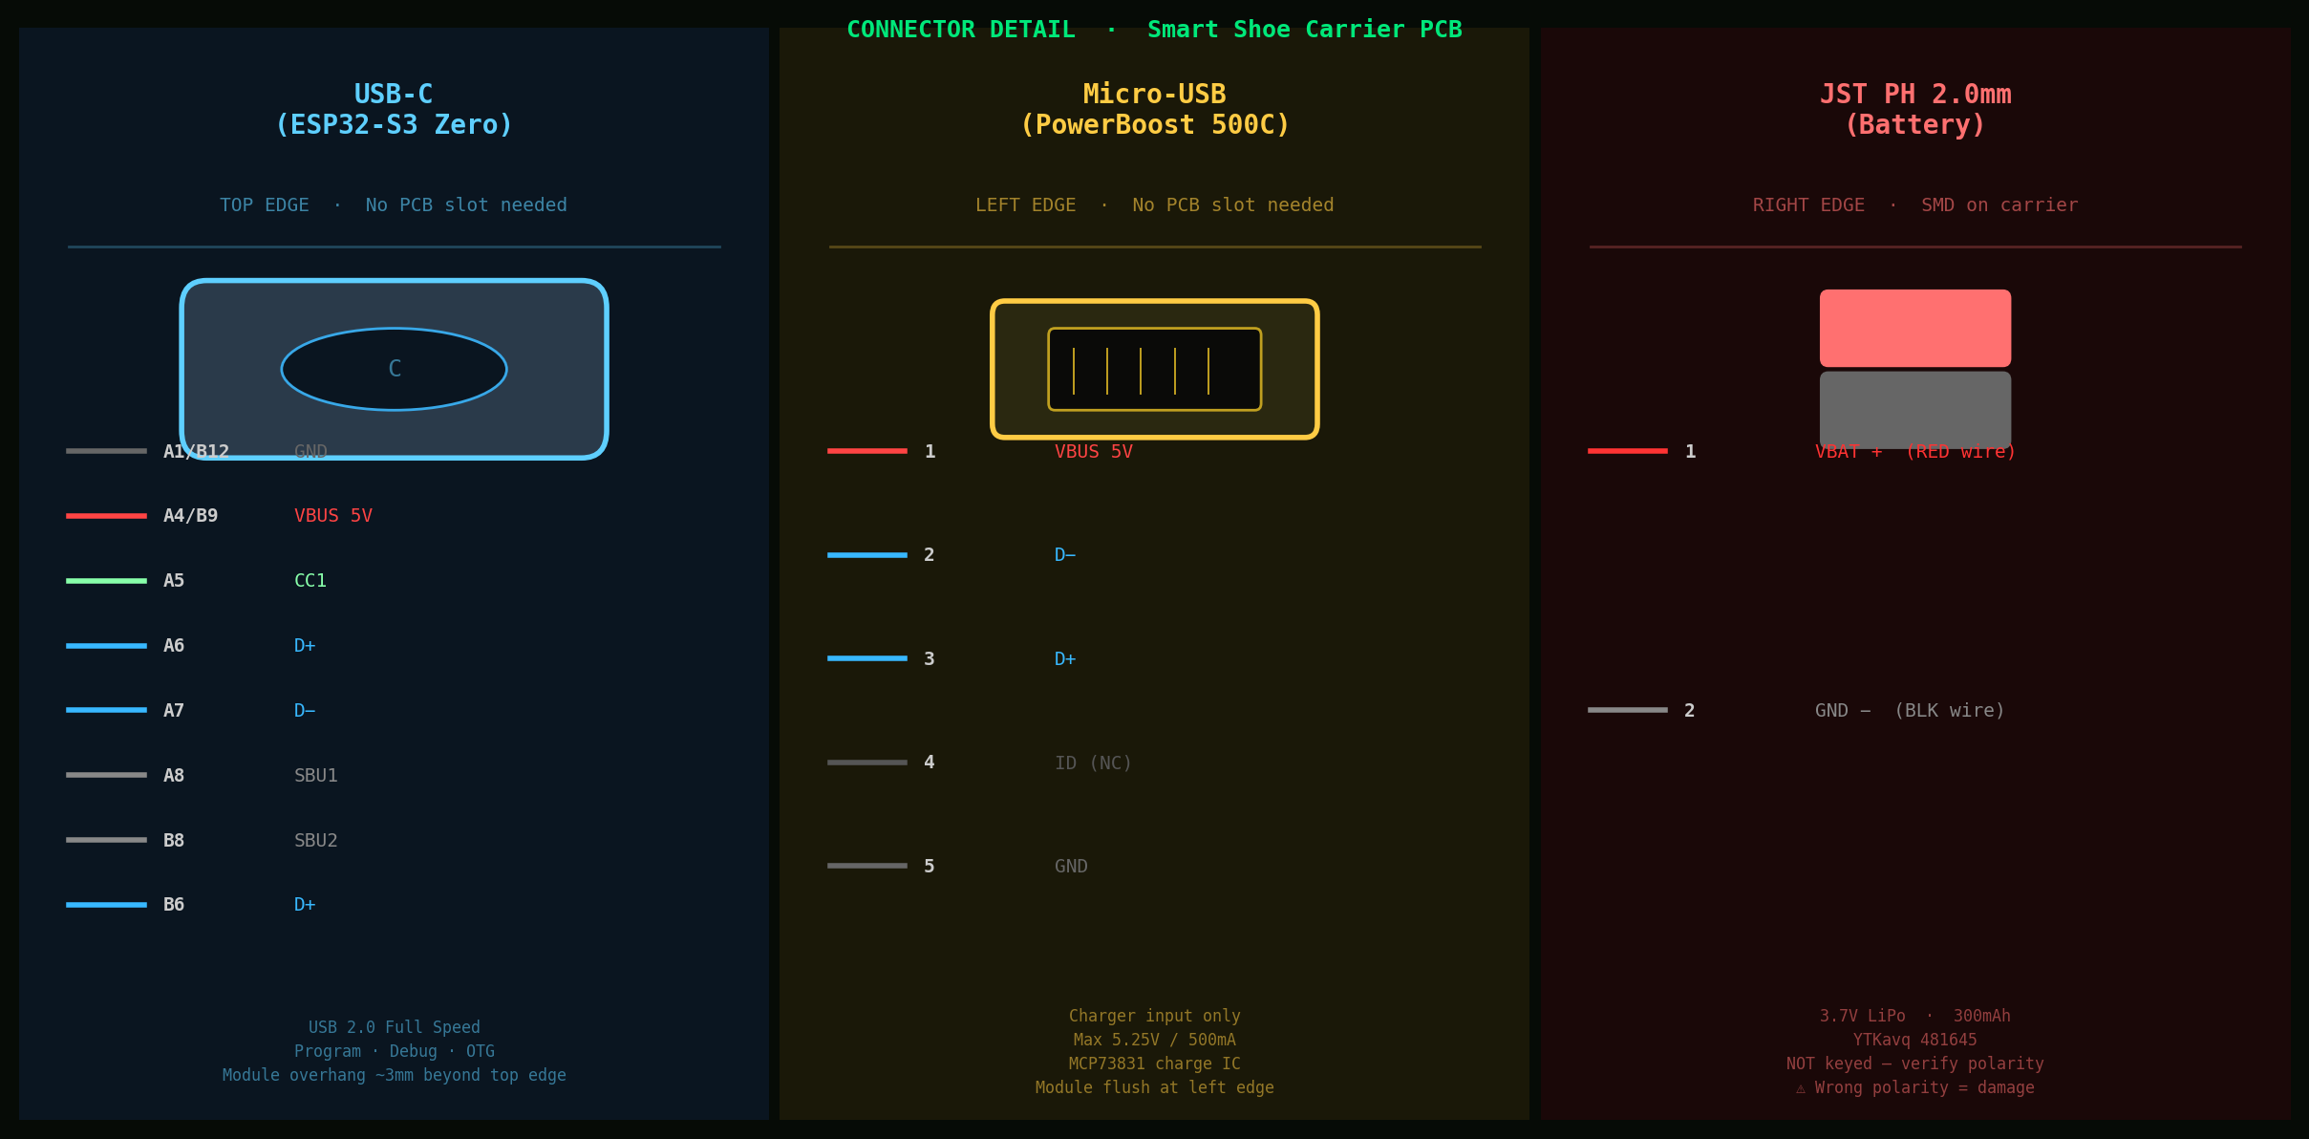
Figure 5 — Connector Detail: USB-C (top edge) · Micro-USB (left edge) · JST PH 2.0mm (right edge) with pin assignments

Connector | Type | Location | Access Method | Purpose
USB-C | USB Type-C (on ESP32 module) | TOP edge | Module overhang — no PCB slot | Firmware flash / debug / OTG
Micro-USB | USB Micro-B (on PB module) | LEFT edge | Module flush at edge — no slot | LiPo charging only (500mA)
JST J1 | JST PH 2-pin 2.0mm (carrier) | RIGHT edge | SMD receptacle on carrier PCB | 3.7V LiPo battery

⚠ JST PH 2.0mm Polarity
The JST PH 2.0mm connector is NOT keyed for polarity. Always verify RED wire = Pin 1 (+) and BLACK wire = Pin 2 (−) before inserting the battery. Reversed polarity permanently damages the PowerBoost 500C and may cause battery fire.

6. Passive Components
The carrier PCB includes 11 passive components serving decoupling, filtering, protection, and switching functions. All SMD components are 0402/0603/0805 standard packages for reflow assembly.

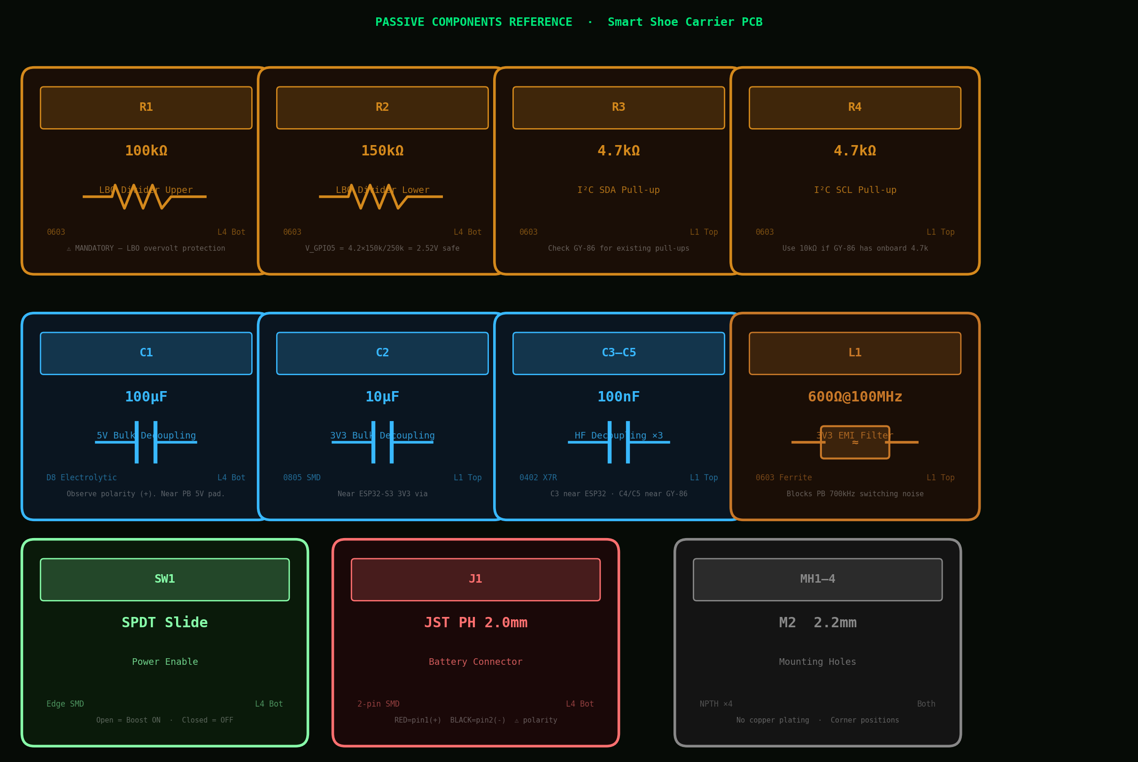
Figure 6 — Passive Components Reference: values, packages, placement layers, and functional notes

6.1 Bill of Materials
Ref | Description | Value | Package | Qty | Layer | Critical Notes
R1 | LBO divider upper | 100kΩ 1% | 0603 SMD | 1 | L4 Bot | MANDATORY — see §7.1
R2 | LBO divider lower | 150kΩ 1% | 0603 SMD | 1 | L4 Bot | MANDATORY — see §7.1
R3 | I²C SDA pull-up | 4.7kΩ | 0603 SMD | 1 | L1 Top | Check GY-86 onboard pull-ups
R4 | I²C SCL pull-up | 4.7kΩ | 0603 SMD | 1 | L1 Top | See §7.2 for value selection
C1 | 5V bulk decoupling | 100µF 10V | D8 Electrolytic | 1 | L4 Bot | Observe polarity (+)
C2 | 3V3 bulk decoupling | 10µF 6.3V | 0805 SMD | 1 | L1 Top | Near ESP32 3V3 via
C3 | 3V3 HF decoupling | 100nF X7R | 0402 SMD | 1 | L1 Top | Near ESP32 3V3 supply pin
C4 | GY-86 VCC decouple | 100nF X7R | 0402 SMD | 1 | L1 Top | Within 1mm of GY-86 VCC
C5 | GY-86 GND decouple | 100nF X7R | 0402 SMD | 1 | L1 Top | Within 1mm of GY-86 GND
L1 | 3V3 EMI ferrite | 600Ω@100MHz | 0603 SMD | 1 | L1 Top | Blocks 700kHz switching noise
SW1 | Power enable switch | SPDT Slide | Edge SMD | 1 | L4 Bot | Open = Boost ON
J1 | Battery connector | JST PH 2.0mm | 2-pin SMD | 1 | L4 Bot | Right edge · polarity marked

7. Critical Design Notes

7.1 LBO Voltage Divider — MANDATORY
The PowerBoost 500C LBO pin is internally pulled to VBAT, which ranges from 3.0V (discharged) to 4.2V (fully charged). The ESP32-S3 GPIO absolute maximum input is 3.6V. Without R1/R2, a full battery exceeds this limit and permanently damages the GPIO.
Divider math: V_GPIO5 = VBAT × R2 / (R1 + R2) = 4.2V × 150k / 250k = 2.52V ✓ (safe for 3.3V logic)
⚠ Do NOT omit R1 and R2
Connecting LBO directly to ESP32-S3 GPIO5 without the divider will destroy the pin on first full charge. These resistors must be populated before any power-on.

7.2 I²C Pull-up Selection
The GY-86 may already carry pull-up resistors on SDA and SCL. Inspect the module before soldering R3/R4:
GY-86 onboard pull-ups | R3/R4 on carrier | Effective pull-up | Max I²C speed
None | 4.7kΩ | 4.7kΩ | 400kHz Fast Mode
4.7kΩ | 10kΩ | 3.2kΩ | 400kHz Fast Mode
10kΩ | 10kΩ | 5.0kΩ | 100kHz Standard Mode

7.3 ESP32-S3 RF Antenna Keepout
The ESP32-S3 Zero ceramic antenna is on the right end of the module. A 5mm copper-free keepout is maintained around this area in the L2 GND plane. The GY-86 is placed ≥20mm from the PowerBoost switching inductor.

7.4 Module Orientation
ℹ Assembly Critical
ESP32-S3 Zero: install PORTRAIT with USB-C end toward TOP board edge. PowerBoost 500C: install LANDSCAPE with Micro-USB end toward LEFT board edge. Wrong orientation misaligns USB ports with the board edge. Silkscreen arrows indicate correct direction.
Module | Socket Orientation | Pin Rows | USB Port Faces
ESP32-S3 Zero | Portrait (long axis vertical) | Left col + Right col (9 pads each, Y-axis) | TOP edge
PowerBoost 500C | Landscape (long axis horizontal) | Top row + Bottom row (7 pads each, X-axis) | LEFT edge
GY-86 | Standard (standard horizontal) | Single row 6 pads (X-axis) | N/A

8. Firmware Pin Reference
GPIO | Net | Direction | Function | Notes
GPIO8 | I2C_SDA | I/O | I²C data → GY-86 SDA | 4.7kΩ pull-up R3
GPIO9 | I2C_SCL | Out | I²C clock → GY-86 SCL | 4.7kΩ pull-up R4
GPIO4 | MAG_DRDY | In | HMC5883L data-ready interrupt | Active high
GPIO5 | LBO_DIV | In | Low battery alert (LBO÷divider) | LOW when VBAT < 3.2V

8.1 I²C Device Addresses
Device | I²C Address | Function
MPU6050 | 0x68 | 3-axis accelerometer + 3-axis gyroscope
HMC5883L | 0x1E | 3-axis magnetometer (DRDY → GPIO4)
MS5611 | 0x77 | Barometric pressure + temperature

/* Zephyr RTOS — GY-86 I²C configuration */
#define SDA_PIN 8 // GPIO8
#define SCL_PIN 9 // GPIO9
#define DRDY_PIN 4 // HMC5883L ready
#define LBO_PIN 5 // Low battery (via R1/R2 divider)
#define MPU6050_ADDR 0x68
#define HMC5883L_ADDR 0x1E
#define MS5611_ADDR 0x77

9. Assembly Instructions

9.1 SMD Reflow — Top Face (L1)
- R3, R4 (4.7kΩ 0603) — near GY-86 SDA/SCL socket pads
- L1 (ferrite bead 0603) — on 3V3 trace between via and GY-86 VCC
- C2 (10µF 0805) — near ESP32-S3 Zero 3V3 via
- C3, C4, C5 (100nF 0402 each) — as close as possible to respective module pads

9.2 SMD Reflow — Bottom Face (L4)
- R1 (100kΩ 0603) and R2 (150kΩ 0603) — LBO divider. MANDATORY before any power-on.
- C1 (100µF D8 electrolytic) — near PowerBoost 5V pad. Observe polarity: (+) marked on silkscreen.
- SW1 (SPDT slide switch) — at SW1 footprint, bottom edge area
- J1 (JST PH 2-pin 2.0mm) — right edge. Pin 1 (+) toward top; verify silkscreen marking.

9.3 Socket Headers
- Solder SK3 (PowerBoost 500C, 2×7 female header) on bottom face. 7 pins per row at 2.54mm pitch along X-axis.
- Solder SK1 (ESP32-S3 Zero, 2×9 female header) on top face. 9 pins per row at 2.54mm pitch along Y-axis.
- Solder SK2 (GY-86, 1×6 female header) on top face. VCC at pin 1 (left end).

9.4 Module Installation
- Insert PowerBoost 500C into SK3 (bottom face). Micro-USB end must face LEFT PCB edge.
- Insert ESP32-S3 Zero into SK1 (top face). USB-C end must face TOP PCB edge. Module will overhang top edge ~3mm.
- Insert GY-86 into SK2 (top face). VCC at pin 1. Module body ≥20mm from PowerBoost inductor below.
- Connect LiPo battery to J1. RED = Pin 1 (+). BLACK = Pin 2 (−). Verify polarity before inserting.

9.5 Power-On Verification
- Confirm SW1 is OPEN (boost enabled).
- Connect battery to J1. Measure +5V across top-face 5V and GND via pads.
- Measure +3.3V at GY-86 VCC socket pad.
- Connect USB-C cable to top edge — verify ESP32-S3 Zero enumerates on host PC.
- Connect Micro-USB to left edge — verify charging LED lights on PowerBoost module.
- Flash firmware. Run I²C scan: expect devices at 0x68, 0x1E, 0x77.

10. Gerber File Reference
File | Layer / Content
SmartShoe_Carrier_RevA-F_Cu.gtl | L1 — Top copper: ESP32-S3 (portrait) + GY-86 sockets, traces
SmartShoe_Carrier_RevA-In1_Cu.g2 | L2 — GND plane: full solid pour
SmartShoe_Carrier_RevA-In2_Cu.g3 | L3 — Power plane: 5V island (left) + 3V3 island (right)
SmartShoe_Carrier_RevA-B_Cu.gbl | L4 — Bottom copper: PowerBoost (landscape) + passives
SmartShoe_Carrier_RevA-F_SilkS.gto | Top silkscreen: zone outlines, orientation arrows, pin 1 markers
SmartShoe_Carrier_RevA-B_SilkS.gbo | Bottom silkscreen: module zones, µUSB arrow, JST polarity
SmartShoe_Carrier_RevA-F_Mask.gts | Top solder mask: pad openings
SmartShoe_Carrier_RevA-B_Mask.gbs | Bottom solder mask: pad openings
SmartShoe_Carrier_RevA-Edge_Cuts.gm1 | Board outline: 60×40mm rounded rectangle — NO EDGE SLOTS
SmartShoe_Carrier_RevA-NPTH.drl | Drill file: vias (T1 0.30mm) · TH pads (T2 0.80mm) · M2 (T3 2.20mm)
FABRICATION_NOTES.txt | JLCPCB order settings checklist

ℹ Submitting to Fab
Zip all 11 files into SmartShoe_Carrier_RevA_Gerbers.zip and upload to JLCPCB or PCBWay. Order settings: 4 layers · 60×40mm · 1.6mm FR4 · ENIG · Green mask · White silk · 1oz outer copper.

11. Design Rules & Board Specifications
Parameter | Value
Board dimensions | 60 × 40 mm
Board thickness | 1.6 mm ± 10%
Material | FR4, Tg150
Corner radius | 2.0 mm
Edge slots | NONE
Mounting holes | 4× M2 2.2mm dia NPTH at corners
Surface finish | ENIG (Electroless Nickel / Immersion Gold)
Solder mask | Green LPI both sides
Silkscreen | White both sides
Min trace width (signal) | 0.20 mm
Min trace width (+5V) | 1.60 mm
Min trace width (+3V3) | 0.80 mm
Min trace width (I²C) | 0.35 mm
Min clearance | 0.20 mm
Via drill | 0.30 mm
Via annular ring | 0.75 mm outer pad
Socket TH drill | 0.80 mm

END OF DOCUMENT
MADEPLUS INC · Smart Shoe Wearable Platform · Patent Pending

