LOAD FRAME CONTROLLER MANUAL

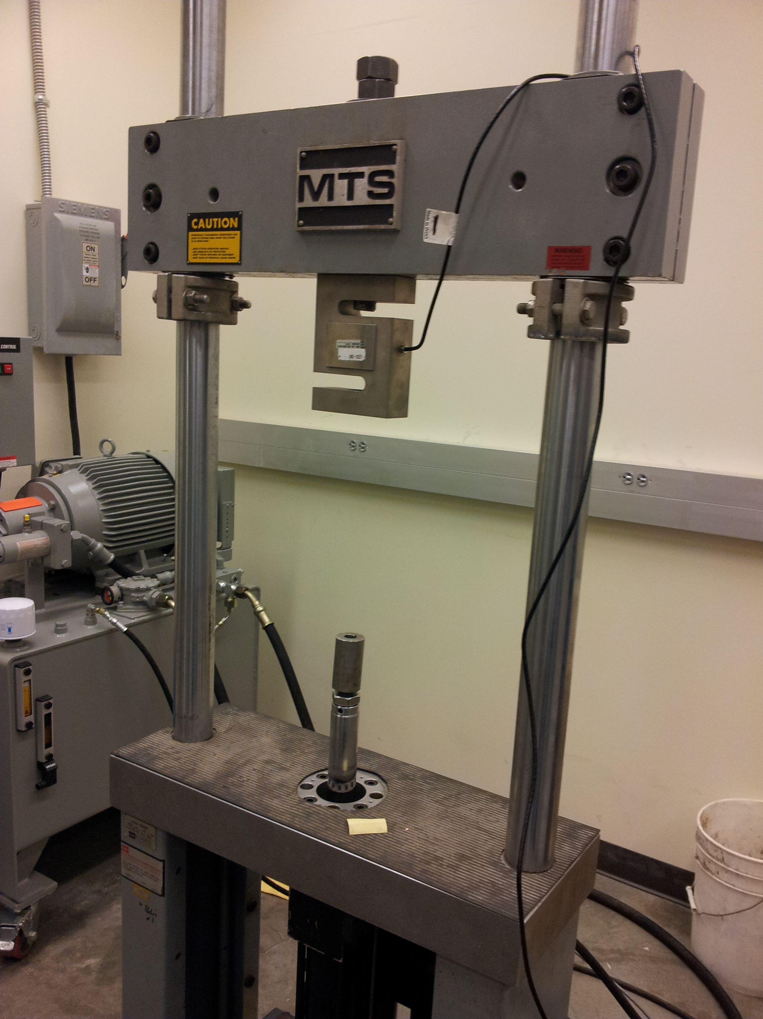

Andy Goetz, Bradon Kanyid, and Mikhail Kulekevich

Portland State University,
Department of Electrical and Computer Engineering
2013 Capstone Project

Table of Contents
Overview 2
Turning on the Load Frame 2
User Interface 3
1) Mode Switch 3
2) Encoder 3
3) Left and Right Buttons 3
Connecting the Load Frame 4
1) LVDT display 4
2) Programmer Port 4
3) Load Cell display 4
4) Program Output 5
5) Sensor Input 5
6) Sensor Output 5
7) Power Input 5
8) Control Panel 5
MTS Controller Connections 6
1) LVDT Signal 6
2) Load Cell 6
3) Set Point 6
1) Failsafe Connector 7
2) Load Cell Connector 7
3) LVDT Connector 7
4) Servovalve Connector 7
5) Power Switch 7
Calibrating the MTS 406 Servocontroller 7
LVDT Conditioner 8
Load Cell Conditioner 8
Control Signal Output 8
Glossary 9
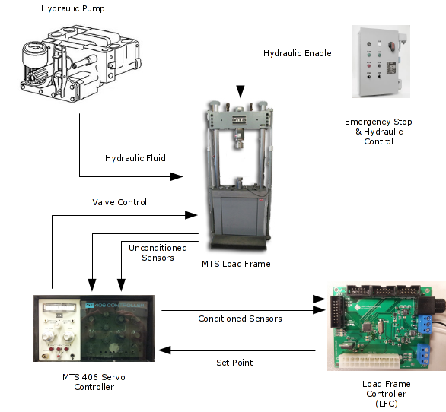Illustration 1: Top Level Diagram

Overview
The Load Frame Controller (LFC) this capstone implements can be used to control an MTS 406 servo controller, which in turn can control an MTS load frame. This manual details how to connect the load frame controller to an MTS 406 controller, as well as how to operate the LFC.

Turning on the Load Frame
Warning! Always perform these steps in this exact order: any deviation could cause the load frame to move unexpectedly during startup.
- Make sure that the hydraulic control switch is in the 'disabled' position.
- Turn on the MTS 406 Servo Controller. Make sure the mode switch is in the 'Manual' or 'Set Point' mode.
- Turn on the LFC.
- Turn on the Hydraulic Pump
- Enable hydraulic control switch.

User Interface
The user interface for the LFC consists of three parts:
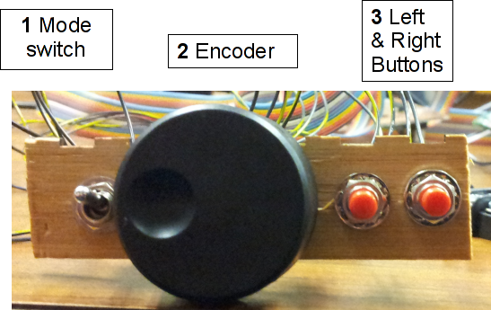Illustration 2: User Interface

1) Mode Switch
The mode switch determines the mode the LFC operates in. It can be in 3 positions:
- Manual mode: The Load frame moves to the position shown on the LVDT LED display. Any changes made with the Encoder are immediately reflected in the position of the Load Frame.
- Set Point Mode: The Encoder and Left and Right buttons are used to set a setpoint for the load frame controller. However, the load frame does not immediately move to the position shown on the LED display.
- Run Mode: The Load Frame moves to the position determined while the LFC was in Set Point Mode.
When hooking up the Mode Switch, connect the outside two pins to the Toggle A and Toggle B pins of the Control Panel header. Connect the center pin to one of the ground pins on the Control Panel Header.

2) Encoder
The encoder is used to adjust the set point and position of the load frame. Moving it left and right will increment and decrement the current digit of the LVDT display.
Connect the encoder pins labeled 'A' and 'B' to the 'Encoder A' and 'Encoder B' pins of the Controller header. Connect the encoder pin 'C' to one of the ground pins.

3) Left and Right Buttons
These buttons select which digit of the LVDT display is modified by the Encoder wheel. Connect an SPST switch between the Left and Right Button pins of the Controller header, with the other terminal of the switch grounded.

Connecting the Load Frame
Below you will find a description of the load frame controller's inputs and outputs:
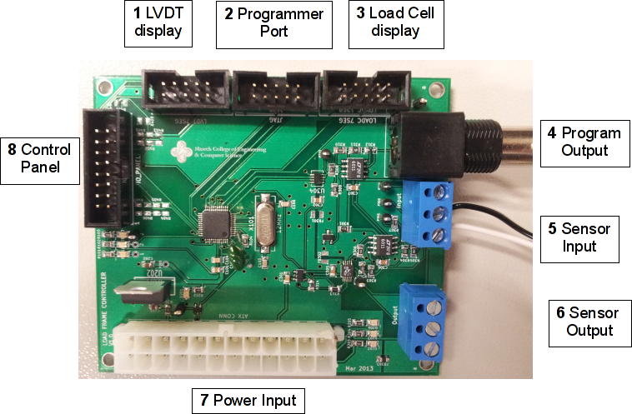Illustration 3: LFC PCB

1) LVDT display
This connector is used with the 5 segment display. In 'Run Mode' and 'Manual Mode', this display shows the current position of the actuator. In 'Set' mode, it displays the set point the controller will try to move to.

2) Programmer Port
The LPC JTAG programmer should be connected to this port in order to reprogram the device. Pin number 1 is indicated by an arrow on the connector, as well as a red stripe on the JTAG programmer.

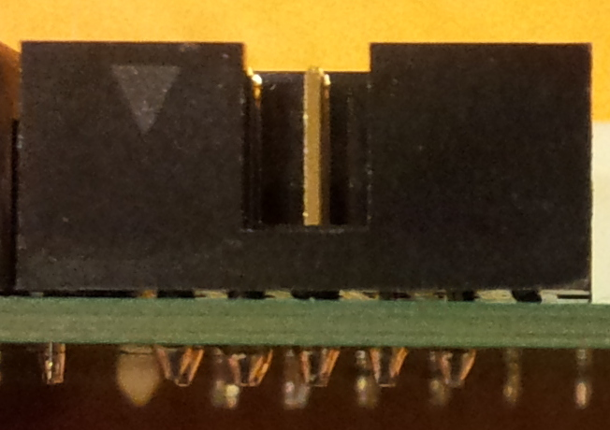Illustration 4: Pin 1 indicated by arrow
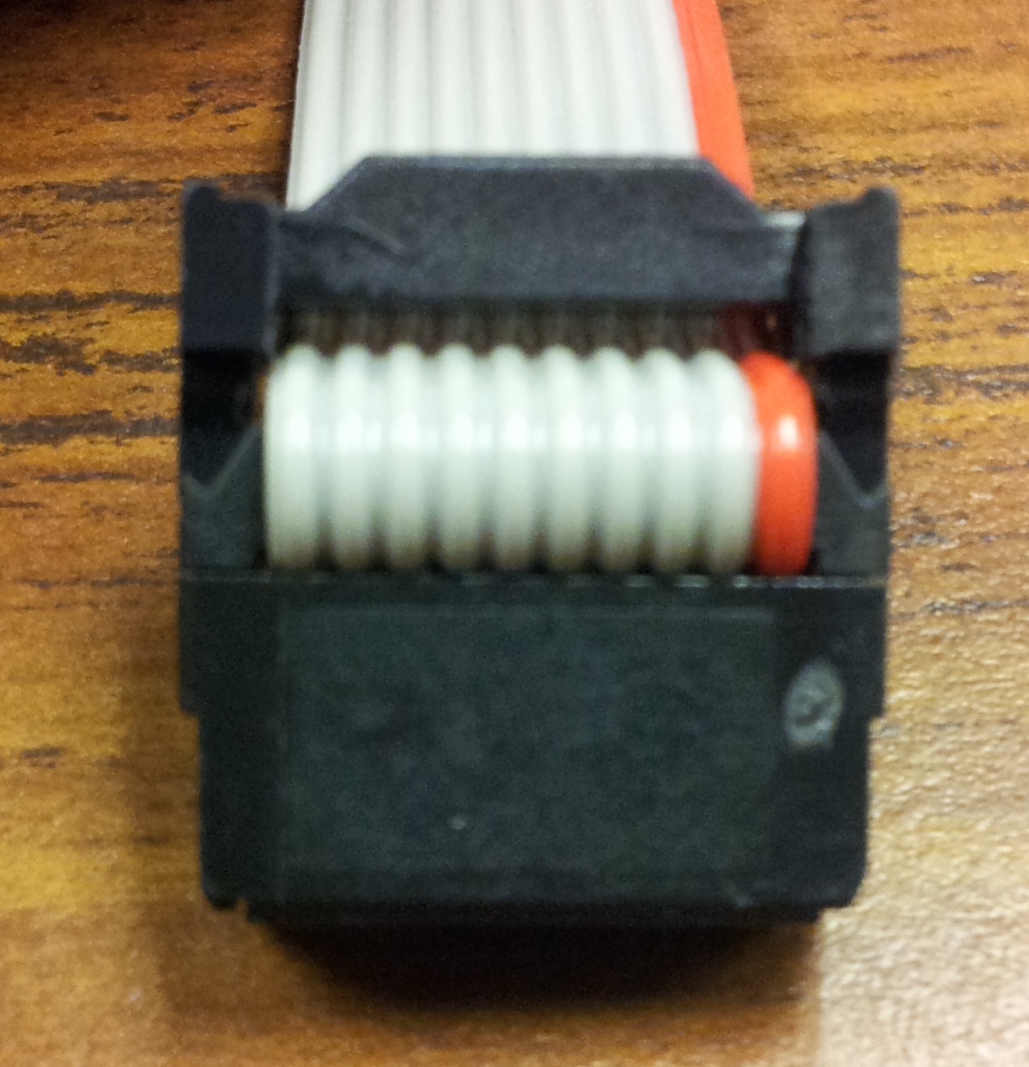Illustration 5: Pin 1 indicated by red stripe

3) Load Cell display
This connector is used for the Load cell display. The LED display used for the LVDT is interchangeable.

4) Program Output
This BNC connector outputs a ±10V signal used to control the MTS Load Controller. It can be directly connected to the BNC connector on the front of the MTS Load Controller.

5) Sensor Input
The LVDT and Load Cell signals from the MTS controller should be connected to these terminals. The connectors labeled 'LVDT' and 'LOADC' must be connected to the 'XDCR1' and 'XDCR2' connectors on the front panel of the MTS controller.
WARNING: The center pin on the Sensor Input is labeled, ground, however, it should not be connected to the ground of the MTS controller! Doing so will cause dangerous instability in the output values.

6) Sensor Output
These connectors output the sensor input voltages scaled between 0 and 4.1 volts. These are suitable for use by data acquisition modules or other microc0ontroller systems. The equation relating the input sensor voltage to the output seen on this port is as follows:

Equation 1: Output voltage relationship

7) Power Input
Power is supplied to the board through this connector. A standard PC power supply can be used to supply power to the project.

8) Control Panel
This connector is used to attach the various buttons and dials used by the LFC. See pinout below:
Left Button | 1 | 2 | GND
Right Button | 3 | 4 | GND
Unused GPIO | 5 | 6 | GND
Toggle A | 7 | 8 | GND
Toggle B | 9 | 10 | Unused GPIO
Encoder A | 11 | 12 | +5v
Encoder B | 13 | 14 | GND
Unused GPIO | 15 | 16 | Unused GPIO
Table 1: IO Connector Pinout

MTS Controller Connections
The MTS 406 Servo Controller has multiple connectors that all must be connected properly in order for the load frame to work properly.
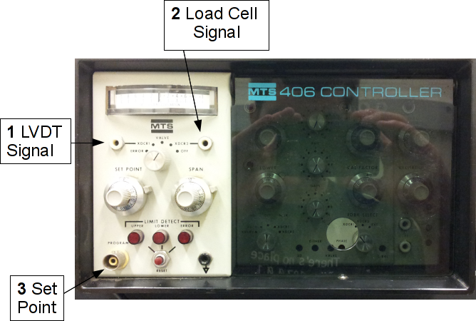Illustration 6: MTS 406 Front Panel

1) LVDT Signal
This should be connected to the LVDT input connector on the LFC circuit board.

2) Load Cell
This should be connected to the Load Cell input connector on the LFC circuit board.

3) Set Point
This should be connected to the Set Point BNC connector on the LFC circuit board.

The back of the MTS controller also has several important connectors:
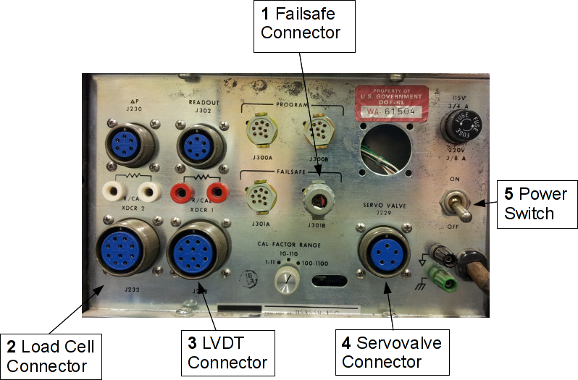Illustration 7: Back of MTS controller

1) Failsafe Connector
The failsafe connector enables the servovalve output of the MTS controller. Without the connector in place, the controller will not function.

2) Load Cell Connector
Connect the Load cell to this connector. The controller will still function without this device connected, however the load cell related functionality will not work.

3) LVDT Connector
Connect the LVDT to this connector.
Warning! If the LVDT is not connected to the MTS controller, and the controller is powered on, the system will be dangerously unstable. Always connect the LVDT to the system.

4) Servovalve Connector
The servovalves should be connected here. The device will not function without the servovalves connected.

5) Power Switch
Turns on the MTS controller.
Warning! Always make sure that hydraulic power is disabled before turning the MTS controller on or off.

Calibrating the MTS 406 Servocontroller
In order for the load frame to operate properly, the MTS 406 servo-controller must be properly calibrated. The LFC expects very specific conditioner input signals, and provides a very specific control signal. If the conditioner outputs are not properly scaled, the values displayed by the user interface will be invalid. Information on how to calibrate the MTS 406 servocontroller can be found in the MTS 406 Operators Manual.
Below, you will find a table of the values expected by the LFC:

LVDT Conditioner
This is the XDCR1 output of the MTS 406, a reactive conditioner.
Position | Voltage
Fully Retracted (-3 inches) | -10
Centered (0 inches) | 0
Fully Extended (3 inches) | 10

Load Cell Conditioner
This is the XDCR2 output of the MTS, a resistive conditioner.
Position | Voltage
20 kip Compressive Force | -10
No movement | 0
20 kip Tension Force | 10

Control Signal Output
This is the input to the MTS 406, provided by the LFC. It is provided to the MTS 406 through the front-panel BNC connector labeled 'PROGRAM'.
Position | Voltage
Fully Retracted (-3 inches) | -10
Centered (0 inches) | 0
Fully Extended (3 inches) | 10

Glossary
Conditioner: One of the functions of the MTS 406. Reactive and resistive transducers are conditioned to output a linear-scaled 10Vpp signal for use by the LFC.
LFC: Load frame controller. The custom circuit developed by this capstone to control the Load Frame via the MTS 406.
Load Cell: A wheatstone bridge used to measure the force applied by the Load Frame.
Load Frame: A servohydraulic frame used to pull apart test coupons.
LVDT: Linear Variable Differential Transformer. The transducer used to measure the position of the Load Frame.
MTS 406 Servocontroller: The PID controller that directly controls the load frame. It accepts a program signal from the LFC.

