APPASHIF

AppAshif User Manual
Product catalogue and administrator product management application
Name | Ratthaphon Khan
Section | 800
Student ID | 6730202734
Release | Cloud MySQL; payment not enabled

This manual explains how to install, navigate, and use AppAshif. The production API uses the assigned Cloud MySQL database and port 3067.

1. Installation Guide

1.1 Required software
- Git
- Node.js 22.13 or newer
- npm
- MySQL 8 or a MySQL-compatible Cloud database
- A modern web browser
- FileZilla (optional for Cloud upload)

1.2 Download the project
git clone https://github.com/ratthaphon0/appashif-offgrid-shop.git
cd AppAshif

1.3 Install and configure the backend
cd backend
cp .env.example .env
npm ci
Set the database connection and secure JWT secret in backend/.env. For the live application, the API uses Cloud database ip_std6730202734 and port 3067. Never commit .env.
For a new empty database, import backend/database/database.sql or run:
npm run db:migrate
Create an administrator and start the API:
npm run admin:create
node server.js

1.4 Install and configure the frontend
cd ..
cp .env.example .env.local
npm ci
Set these values in .env.local for the live application:
EXPO_PUBLIC_API_URL=http://119.59.102.161:3067/api/v1
EXPO_PUBLIC_DEPLOYMENT_LABEL=STD6730202734 • CLOUD MYSQL • PORT 3067
npm run web
Open the local Expo URL shown in the terminal, normally http://localhost:8081.

2. Application Navigation
AppAshif uses a bottom navigation bar on web and mobile layouts.
Page | Purpose
Home | Latest catalogue products and Cloud connection status.
Add | Admin sign-in and Add/Edit Product form.
Products | Search, filter, sort, add to bag, edit, archive, and restore products.
Categories | Browse categories and manage them as an administrator.

Typical user flow
- Open Home and confirm the status says LIVE.
- Open Products to search, filter, or sort the catalogue.
- Press the plus button on a product to add it to the Shopping Bag.
- Open the bag icon to change quantity and view the total.
- For catalogue administration, open Add and sign in as an administrator.
Release note: The Shopping Bag is a preview only. Payment and order submission are intentionally not enabled.
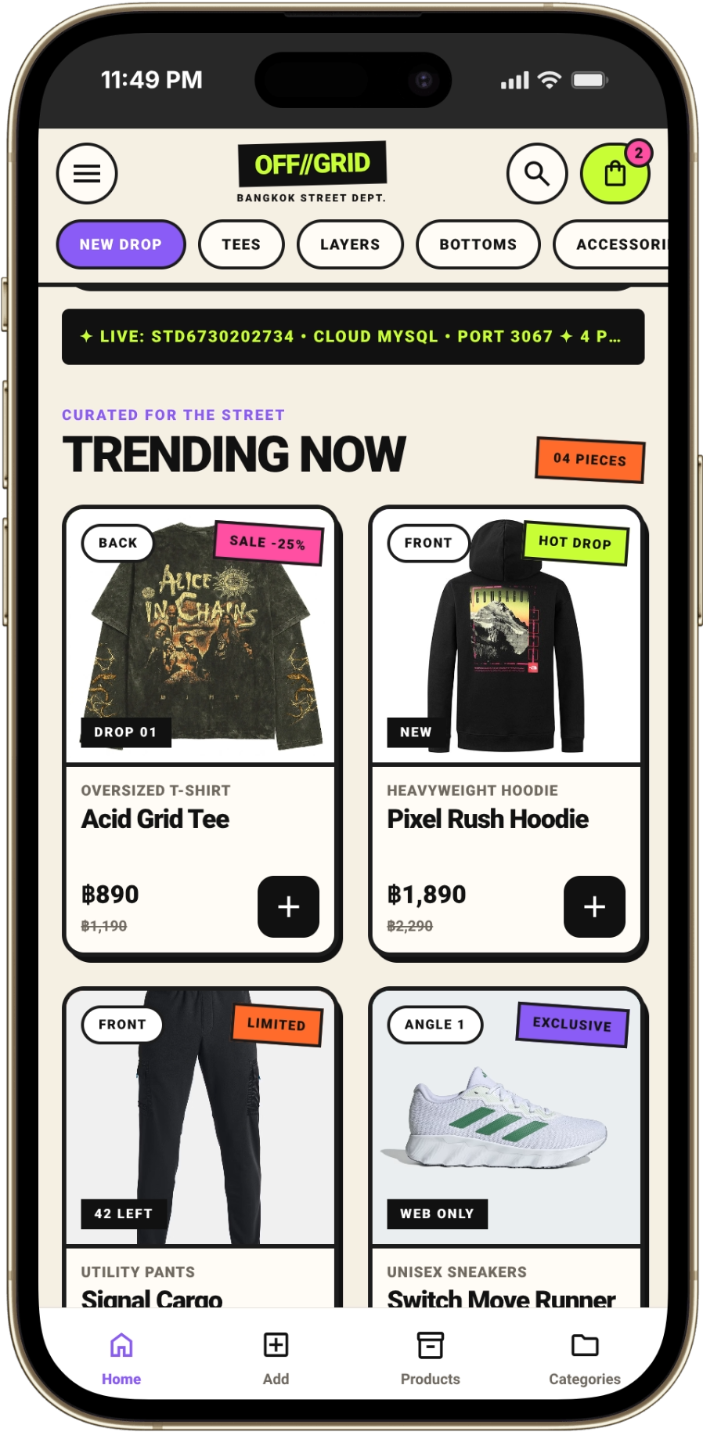 | 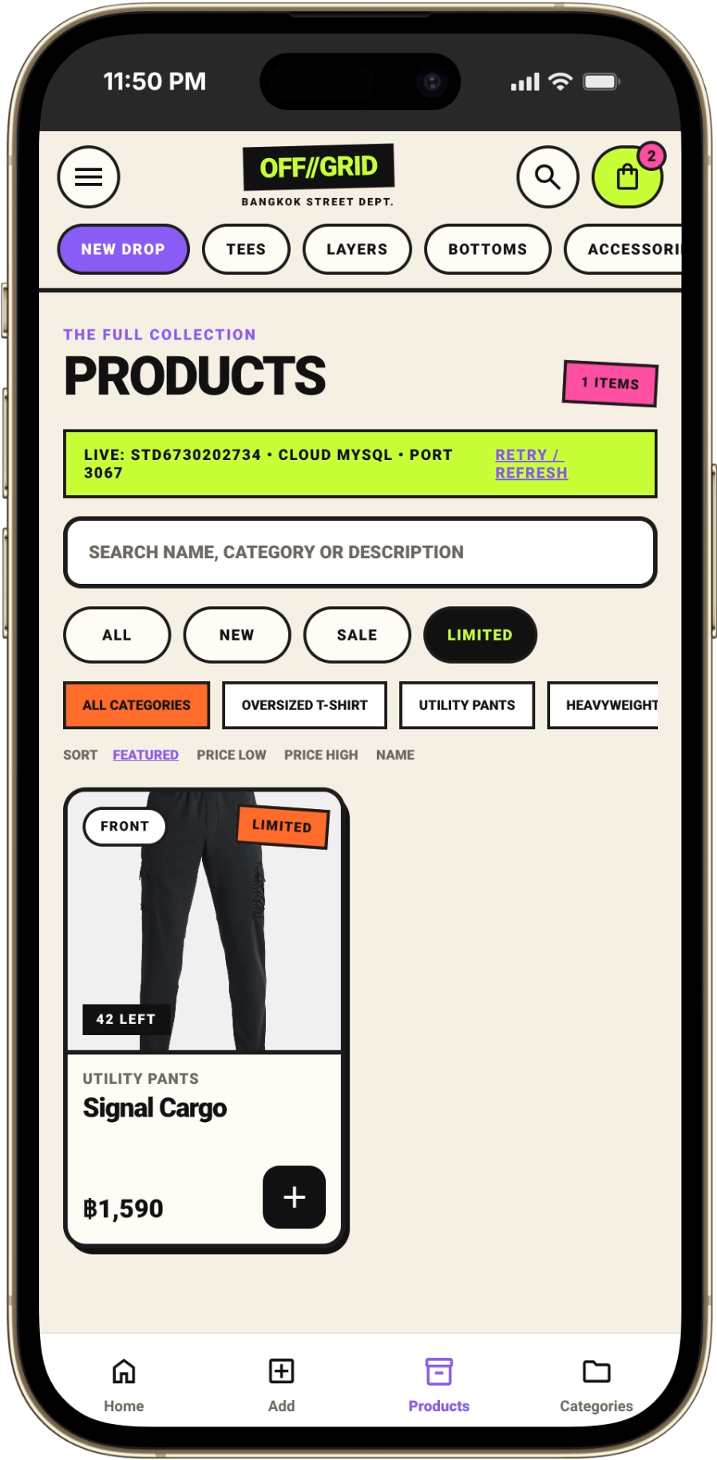
Home / live catalog | Products / search and filters

3. Page-by-Page Description

3.1 Home
Home is the public entry point. It displays the brand header, live Cloud status, product cards, prices, badges, and the cart icon. Press the plus button on a product card to add it to the Shopping Bag.

3.2 Products
Products displays the full catalogue. Search by product name, category, or description. Use drop filters, category filters, and sort controls to narrow the list. Signed-in administrators also see edit, archive/delete, and restore actions.
 | 
Figure 1. Home | Figure 2. Products

3.3 Admin sign-in
The Admin Access form protects product and category changes. Enter the administrator email and password, then press Sign In. The access token stays in memory and is cleared when the app reloads.
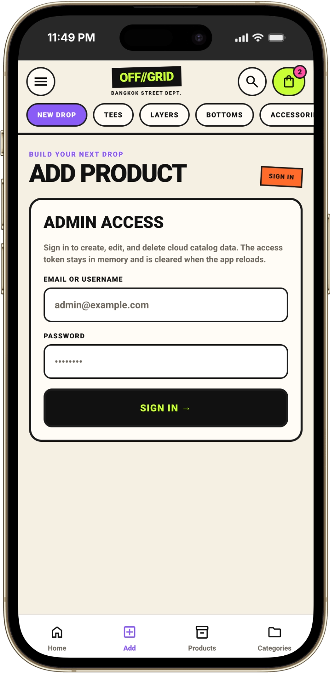
Figure 3. Admin Access screen.

3. Page-by-Page Description (continued)

3.4 Add and Edit Product
After sign-in, enter the product name, category, description, price, stock, optional original price, badge, and image URL. The category field can select an existing category or create a new category from typed text.
To edit a product, choose Edit on the Products page. The same form loads the existing values; press Update Product to save changes to Cloud MySQL.
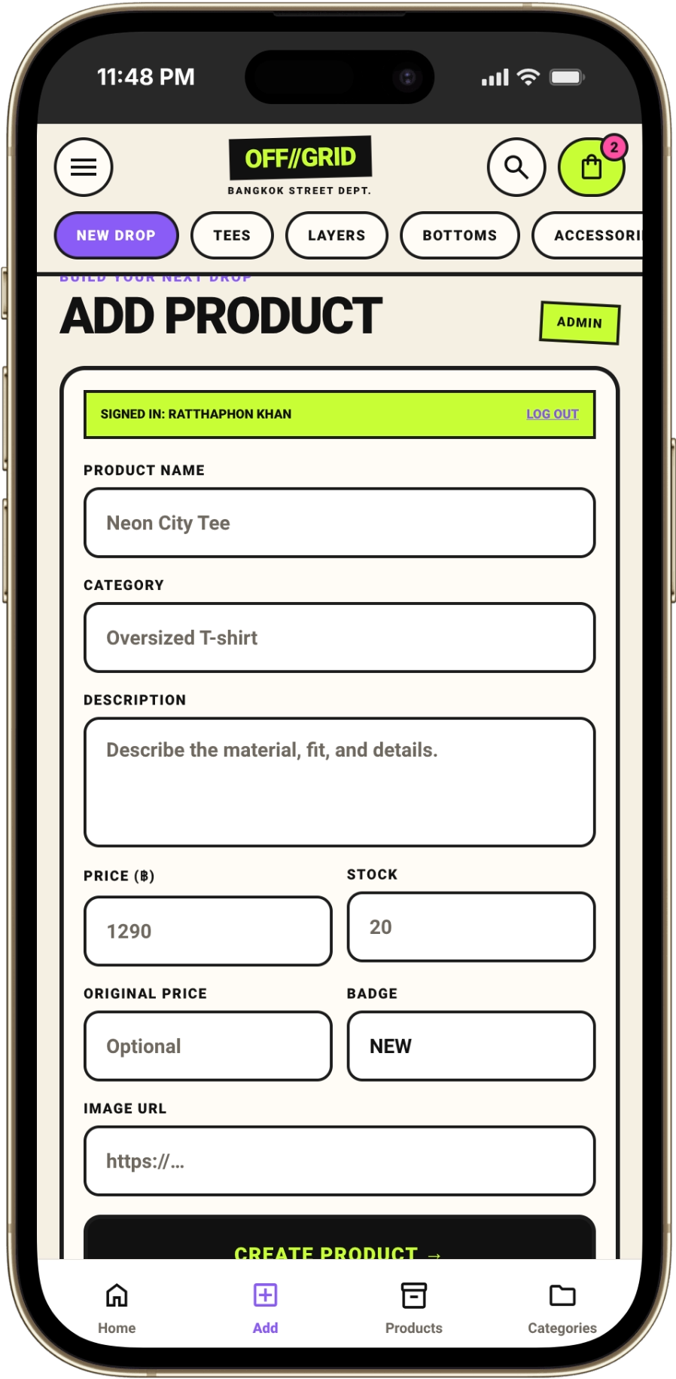
Figure 4. Add Product form.

3.5 Categories
Categories shows each group and its product count. Select a category to open its products. An administrator can add, rename, or delete a category. A category cannot be deleted while products reference it.

3.6 Shopping Bag
Shopping Bag shows selected products, quantity controls, subtotal, shipping, discount, and total. The example code STREET10 applies a 10% preview discount. This release does not submit orders or process payments.
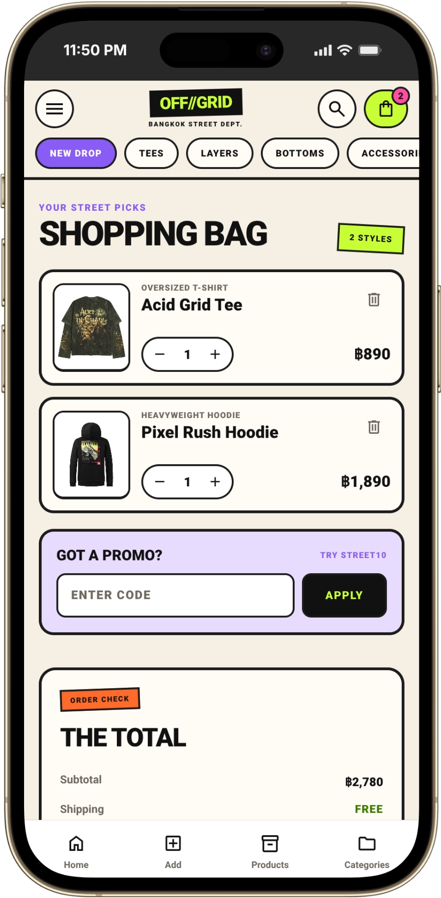
Figure 5. Shopping Bag preview.

4. Administrator Functions

Product management
- Create: sign in on Add, complete the validated form, and press Create Product.
- Edit: choose Edit on Products, change the fields, and press Update Product.
- Archive/delete: confirm the action on the product card. The app prevents repeated clicks and provides a short Undo action.
- Restore: use Undo immediately after archiving when the action is still available.

Category management
- Add a new category from Categories.
- Edit a category name and save it.
- Delete only a category with zero products.

API and database
The frontend uses the Fetch API client in src/lib/api.ts. The backend is an Express REST API connected to Cloud MySQL with mysql2/promise. Protected mutations use a JWT bearer token.
Endpoint | Function
GET /api/v1/health/live | Checks that the API process is alive.
GET /api/v1/health/ready | Checks API and database readiness.
GET /api/v1/products | Lists products with search, filters, sorting, and pagination.
POST / PATCH / DELETE products | Admin-only product changes.
GET /api/v1/categories | Lists categories and product counts.
POST / PATCH / DELETE categories | Admin-only category changes.

5. Database, Verification, and Troubleshooting

Database files
- backend/database/appashif_cloud_export.sql — sanitized Cloud MySQL catalogue export for this application; administrator credentials are omitted.
- backend/database/database.sql — schema setup file for a new empty database.
- ip_std6730202734.sql — original local Cloud export supplied for deployment work; keep it private and do not publish it.
Security: The original Cloud export contains real application data and an administrator credential hash. The GitHub-ready export is sanitized, but it should still be reviewed before importing.

Useful checks
curl --fail http://119.59.102.161:3067/api/v1/health/live
curl --fail http://119.59.102.161:3067/api/v1/health/ready
curl --fail 'http://119.59.102.161:3067/api/v1/products?limit=100'
A successful readiness response contains status: ready and database: connected.

Common problems
- Fallback products appear: check EXPO_PUBLIC_API_URL, network access to port 3067, and the readiness endpoint. Press Retry / Refresh.
- Sign In is disabled: both email and password fields must contain text.
- Product changes return 401: sign in again because the in-memory token is cleared after reload.
- Category delete returns 409: move or delete all products in that category first.
- Port conflict: do not run a second node server.js while the Cloud PM2 process uses port 3067.

Deployment reminder
Upload only reviewed backend source through FileZilla SFTP. Do not upload .env, node_modules, or local classroom seed data. On the server, install with npm ci and restart only the AppAshif PM2 process.
End of manual • AppAshif • Cloud MySQL • Payment is not enabled

