Emily Kuang
CSC 165-02
A3 – DIO – Spring 2026

- Screenshot of a Scene from the Game
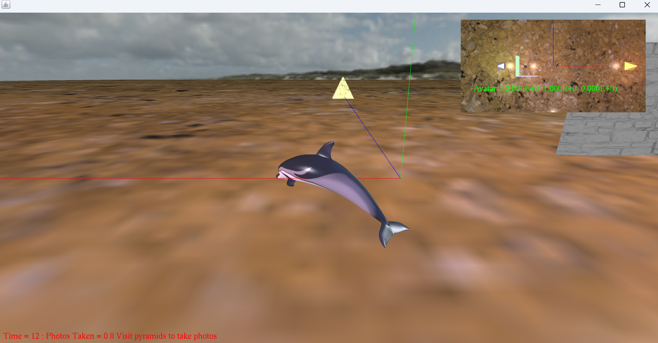
This is what the game looks like on initial spawn. You’ll be able to see the world coordinates of the dolphin displayed in your mini map on the top right. The world axis should be right next to you as well, alongside the house gallery.
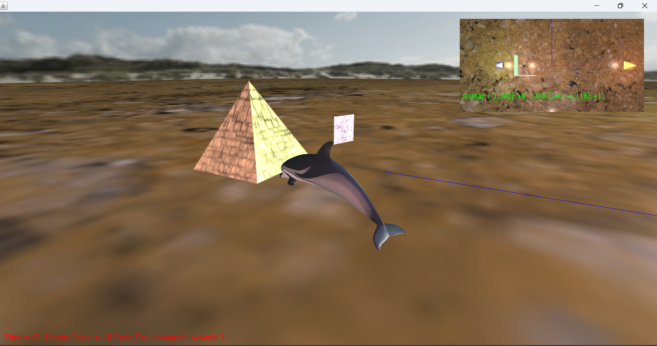
Here’s what it looks like when you’ve successfully taken a picture of a pyramid. You can see that the HUD message displays a status to take the picture to know when you’re close enough to interact. The picture will appear by your side to signify that it’s in your ‘inventory’. There is also an increment to your photos taken counter.
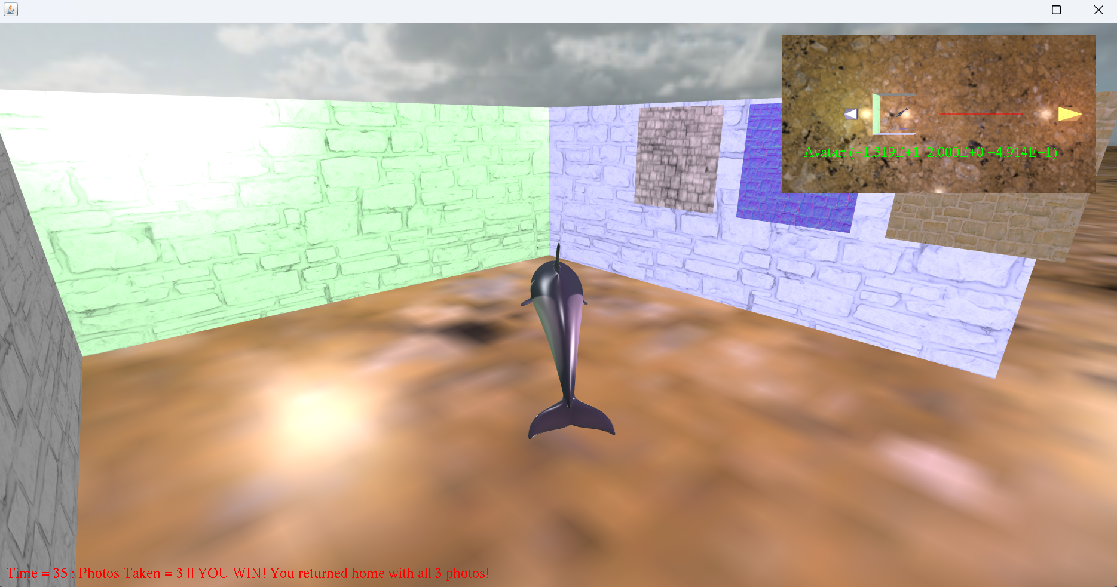
You will know you’ve won after you’ve pressed SPACE key at your home, and the photos get hung on the wall like so. The bottom status text will also change to show you met the WIN condition. In this stage, you’re free to roam around.
- How the Game is Played
The player controls a dolphin who explores the sandy dessert world and must photograph three pyramids (sand, blue, rocky). Getting close enough to a pyramid allows the player to take a photo using the P key. Each photo will attach to the dolphin respectively, until all three photos are collected. Returning to the dolphin’s home (aka spawn point) will allow the player to hit SPACE bar and complete the game. The collected photos will be hung onto the wall to display your efforts. Crashing into a pyramid will result in a loss, but any collected photos beforehand will be preserved.
- Inputs & Controls
W | Move dolphin forwards
A | Rotate dolphin left
S | Move dolphin backwards
D | Rotate dolphin right
Z | Zoom main avatar camera inwards
X | Zoom main avatar camera outwards
I | Move overhead mini-map camera forwards
J | Move overhead mini-map camera left
K | Move overhead mini-map camera backwards
L | Move overhead mini-map camera right
N | Zoom overhead mini-map camera inwards
M | Zoom overhead mini-map camera outwards
SPACE | Toggle win condition when met
UP ARROW | Orbit main avatar camera upwards
DOWN ARROW | Orbit main avatar camera downwards
LEFT ARROW | Orbit main avatar camera left
RIGHT ARROW | Orbit main avatar camera right
P | Takes a photo of a pyramid when in range
R | Reset dolphin manually
LEFT STICK Y_AXIS | Move dolphin forwards/backwards
LEFT SITCK X_AXIS | Rotate dolphin left/right

- The Dolphin's Home
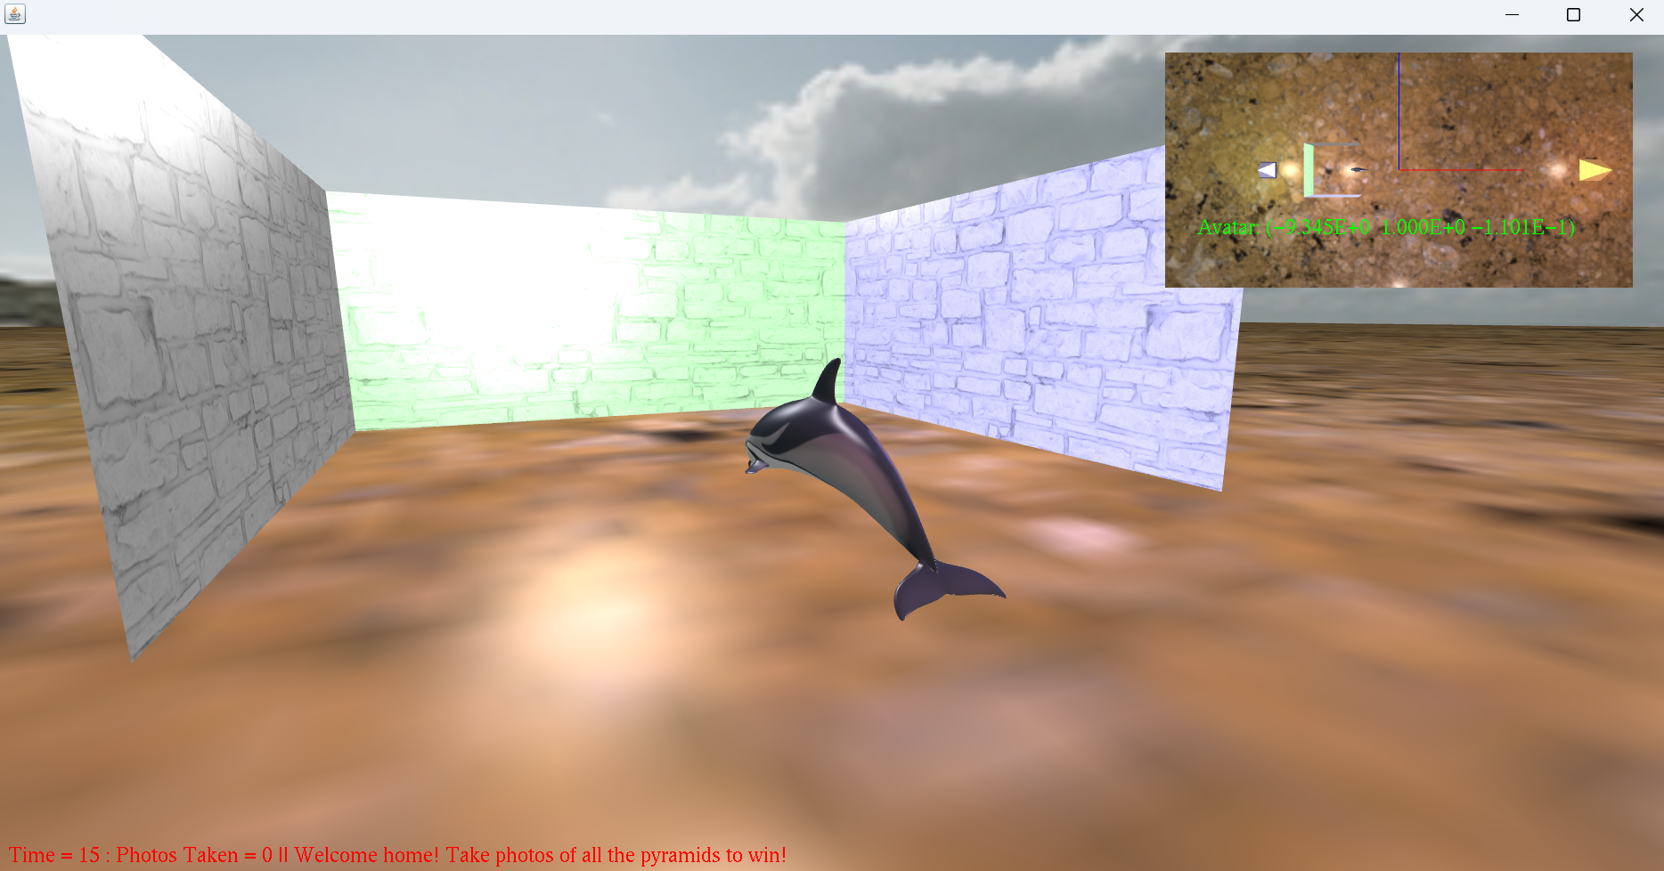 The square 3-wall marble brick house in the center of the map serves as the spawn point. This house acts as the gallery to display all your pictures once all three are collected. You’ll have to press SPACE while inside the home when all three are collected to display and meet win conditions. If you crash into a pyramid, you will end up here.
- HUD Messages
HUD 1 (Red text): Shows elapsed time, Number of photos taken, Display Status Message
HUD 2 (Green text): Shows dolphin’s world coordinate overlaying the Overhead mini map
Display Status Messages:
Initial message for starting the game
Instructions to photograph
Reminder of mission if wandering around home
Lose condition met
Instructions to win when at home with the 3 photos
Win condition met
- Changes Made to the TAGE Engine
[M] Modified since last version, [+] Added/created, * Not mine (aka TAGE’s)
[+] OverheadPanAction.java
[+] OverheadZoomAction.java
[+] KeyboardTurnLeftAction.java
[+] KeyboardTurnRightAction.java
[+] BackAction.java
[M] FwdAction.java
[M] TurnAction.java
[M] YawAction.java
[+] Pyramid.java
[M] DolphinHouse.java
[+] PulseController.java
[+] StretchController.java
[+] CameraOrbit3D.java
[M] Camera.java*
[M] Viewport.java*
[M] GameObject.java*
[M] JOALAudioManager.java*

- Requirements that Weren't Able to Function
When continuously rotating the avatar main camera forwards, the camera will swap perspective, like it’s mirrored. This can be reversed if you rotate continuously in the same direction again OR backwards the way you flipped/mirrored.
- Special Features Beyond Requirements
Respawn dolphin using R key
Colored lighting for each pyramid and the house
Skybox added using a huge inverse sphere to act as the atmosphere
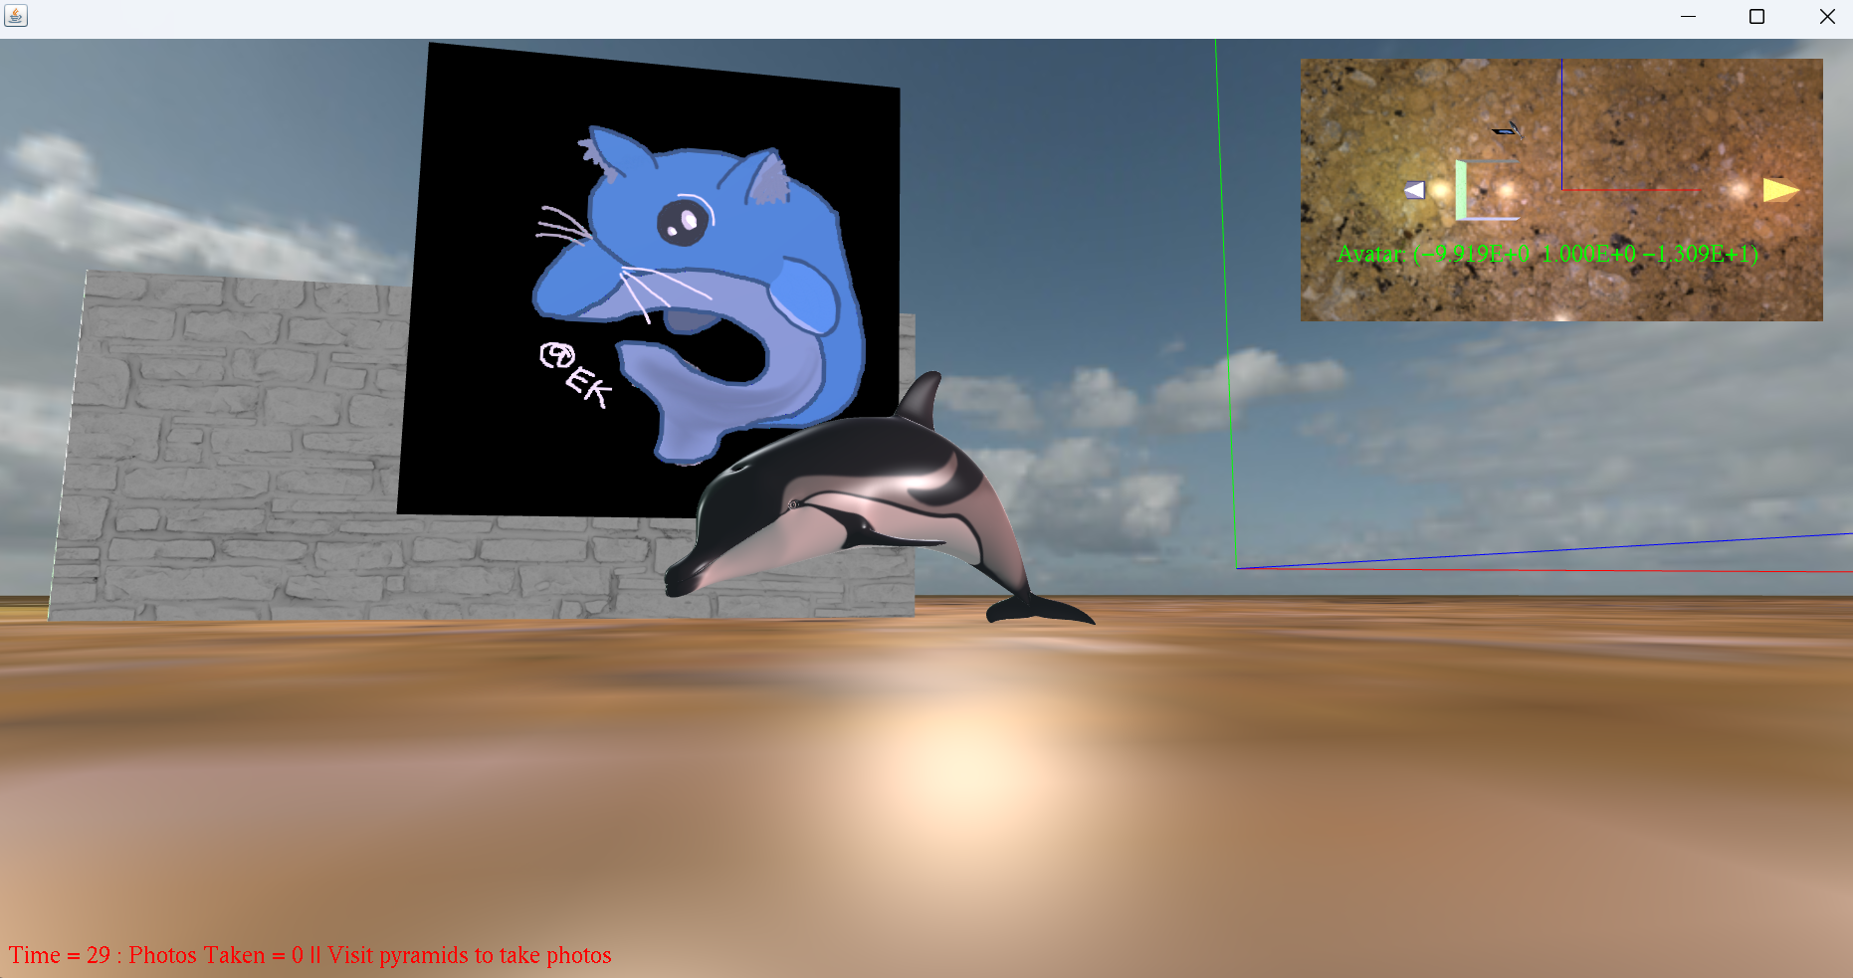
The logo is hybrid cat-dolphin drawn by me on Kleki.com (see credits below).
- Every Asset Used in the Game
Asset Name | Credits | License
blue_brick.JPG | https://ambientcg.com/view?id=Bricks084 | https://docs.ambientcg.com/license/
brick1.JPG | Dr. Scott Gordon | https://athena.ecs.csus.edu/~gordonvs/
day_sky.JPG | Day Sky HDRI 026 A | ambientCG | https://docs.ambientcg.com/license/
Dolphin_HighPolyUV.JPG | Dr. Scott Gordon | https://athena.ecs.csus.edu/~gordonvs/
marble_brick.JPG | https://ambientcg.com/view?id=Bricks084 | https://docs.ambientcg.com/license/
rocky_brick.JPG | https://ambientcg.com/view?id=Bricks084 | https://docs.ambientcg.com/license/
rocky_ground.JPG | https://ambientcg.com/view?id=Ground104 | https://docs.ambientcg.com/license/
sand_brick.JPG | https://ambientcg.com/view?id=Bricks084 | https://docs.ambientcg.com/license/
warped_gray.JPG [unused] | https://ambientcg.com/view?id=Ground104 | https://docs.ambientcg.com/license/
dolphin_logo.PNG | Emily Kuang | https://kleki.com/#licenses
Note: 084 and 104 are all retextures of their respective assets found in the link’s .zip
- Verification of Program: Used machine ECS-WOLFENSTEIN in RVR-5029.

