**Instructions**

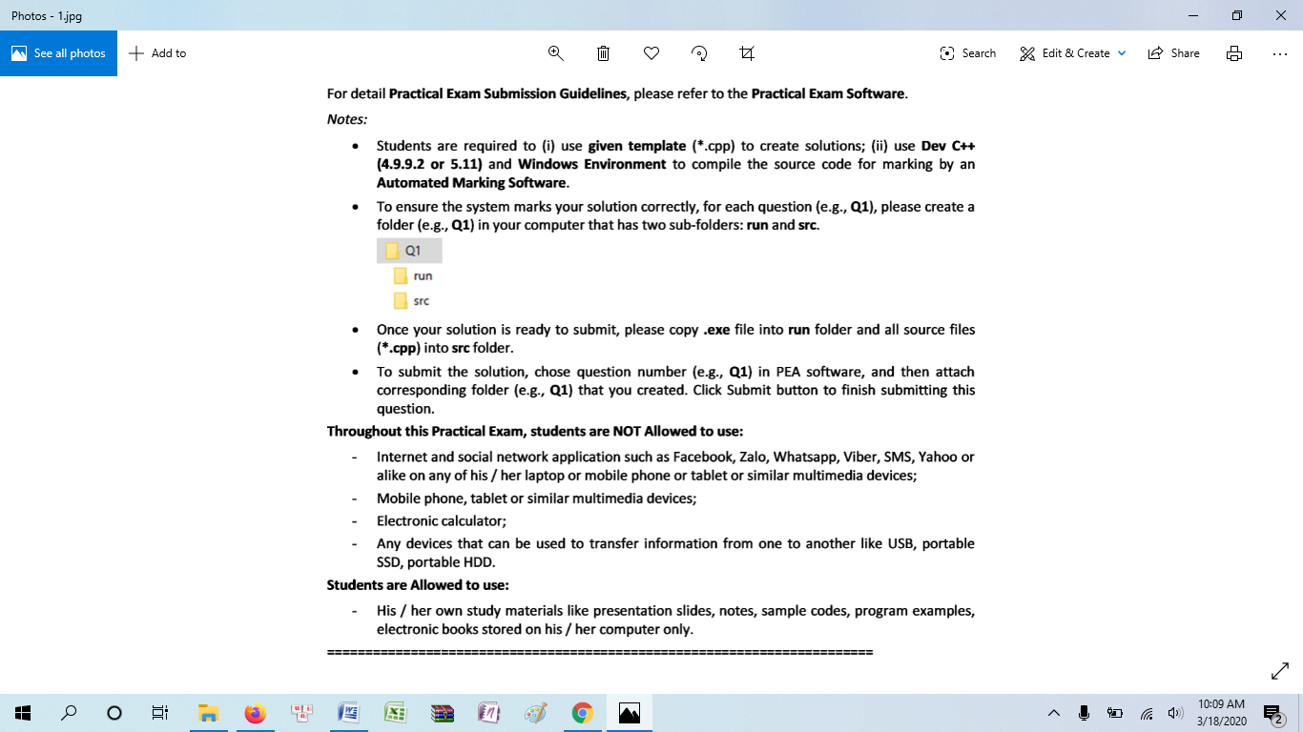

**Q1(1 mark, file to be edited: Q1.cpp)**

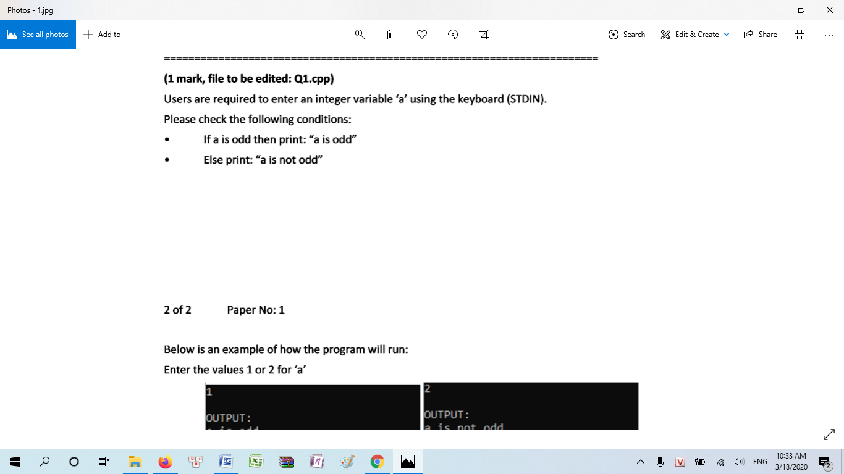

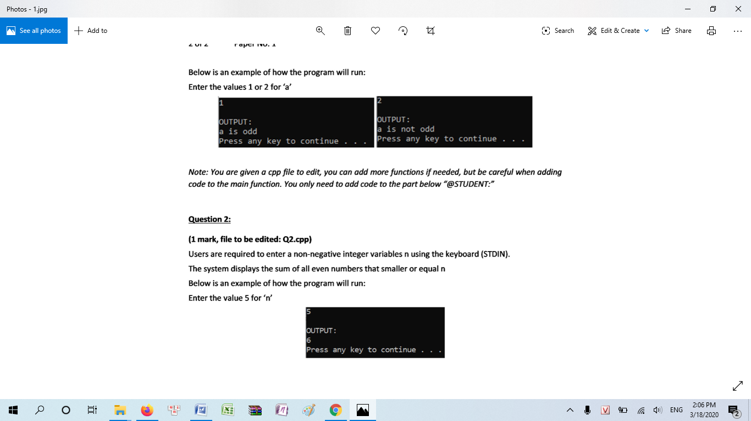

**Q2 (1 mark, file to be edited: Q2.cpp)**



**Q3 (1 mark, file to be edited: Q3.cpp)**

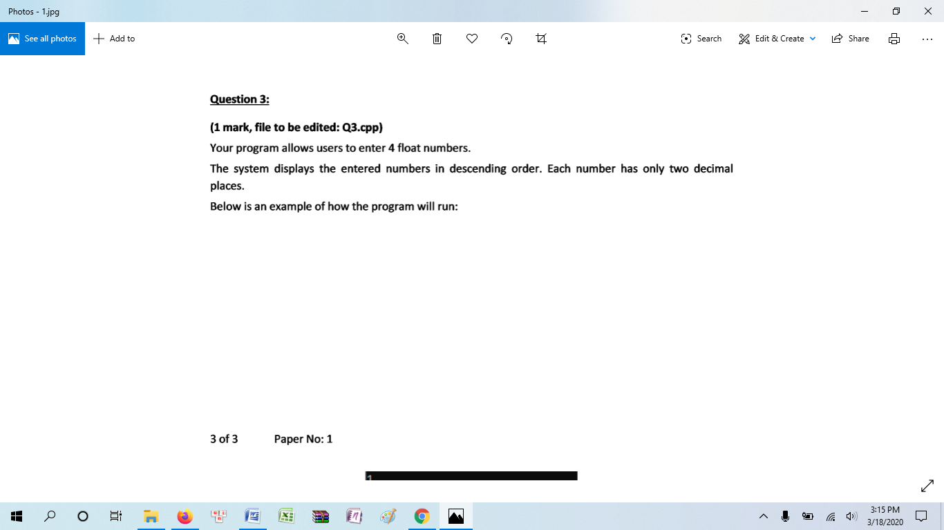

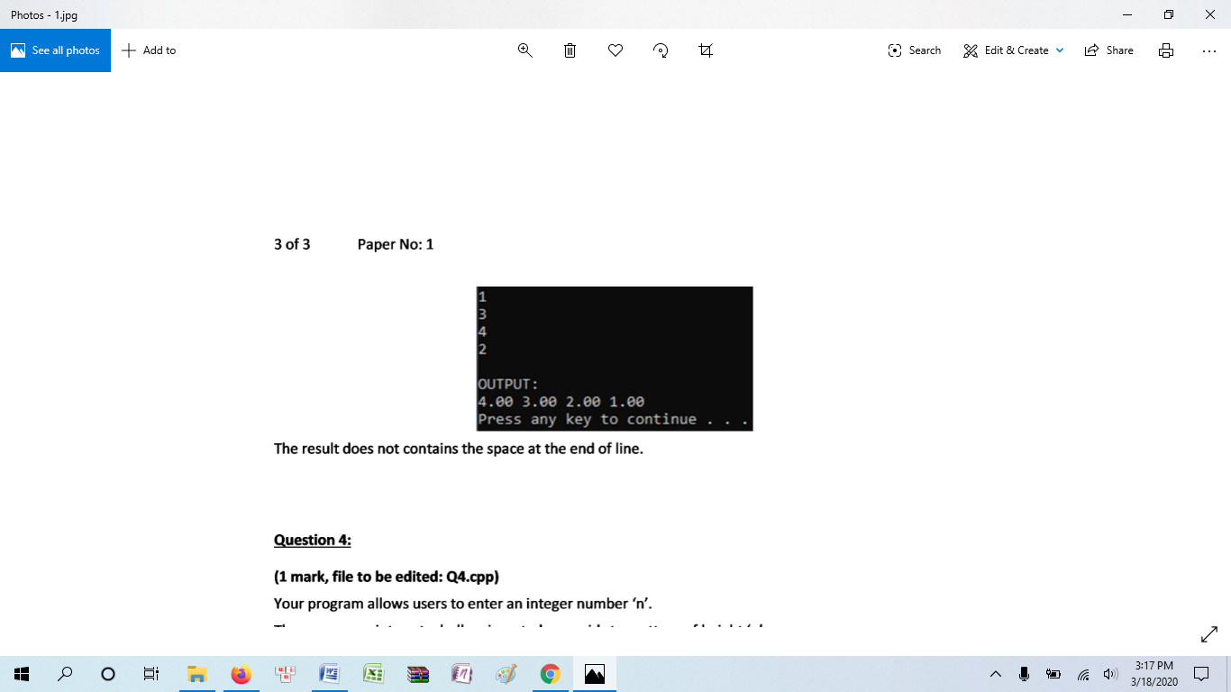

**Q4 (1 mark, file to be edited: Q4.cpp)**

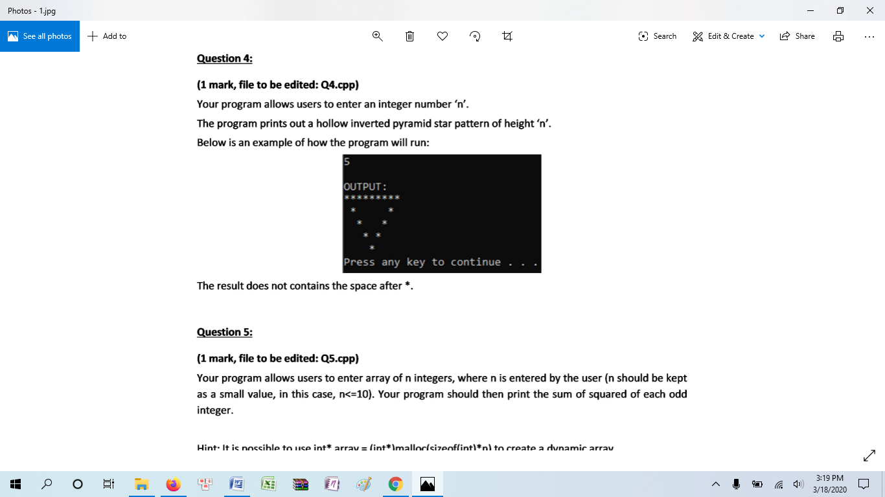

**Q5 (1 mark, file to be edited: Q5.cpp)**

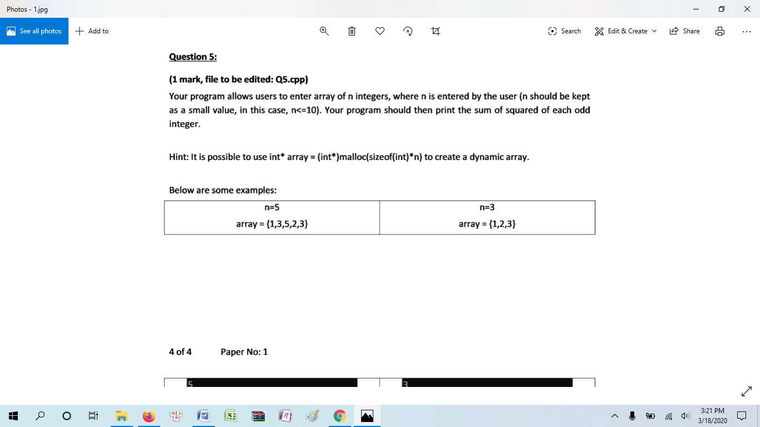

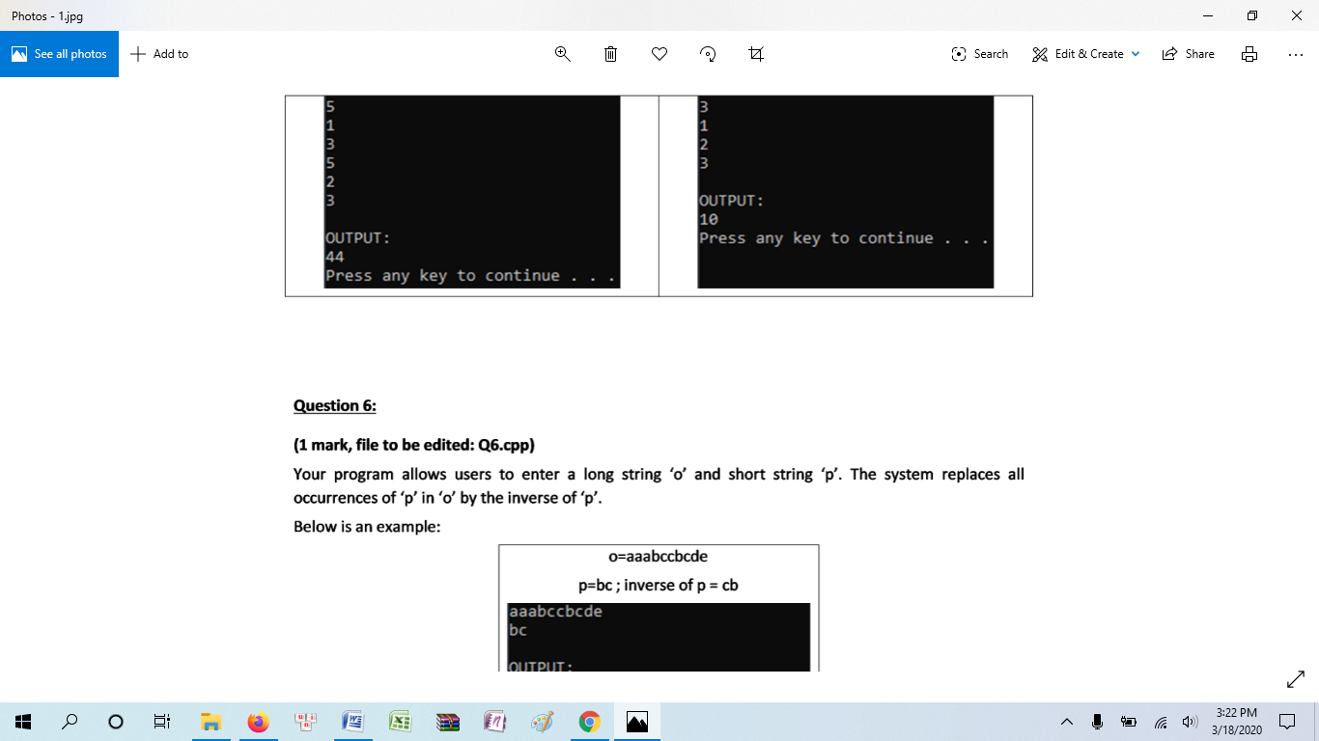

**Q6 (1 mark, file to be edited: Q6.cpp)**

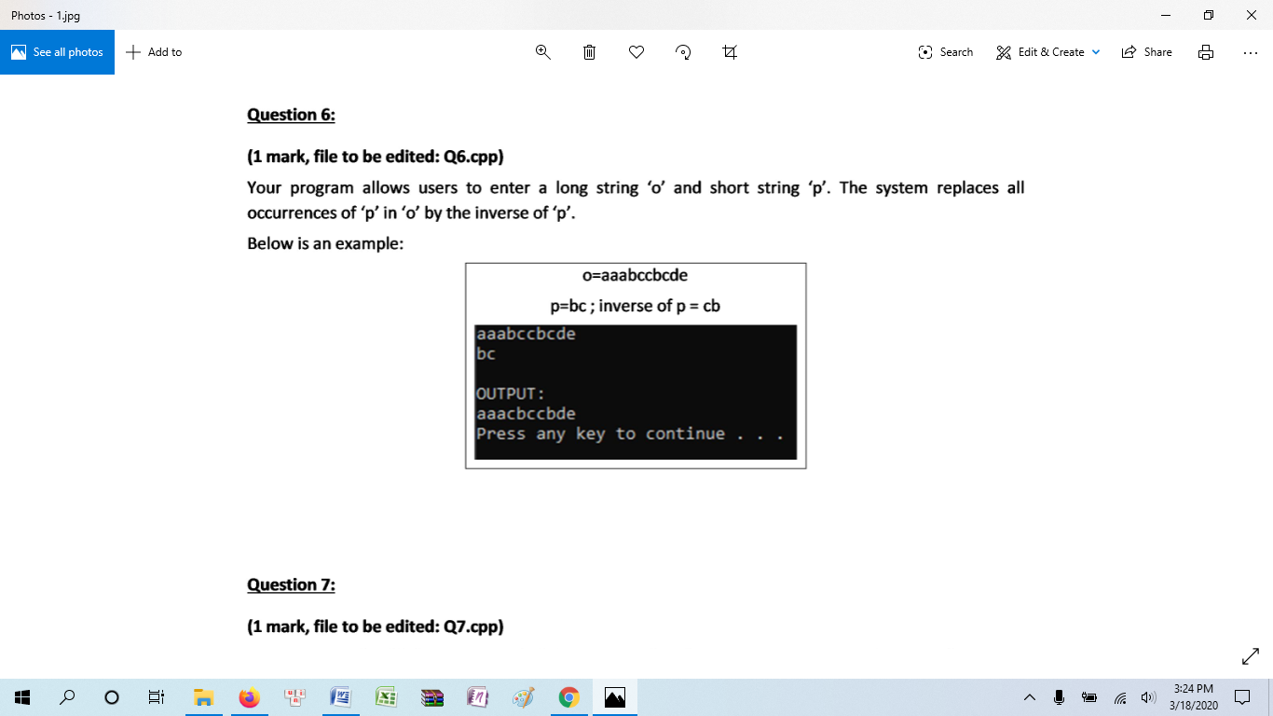

**Q7 (1 mark, file to be edited: Q7.cpp)**

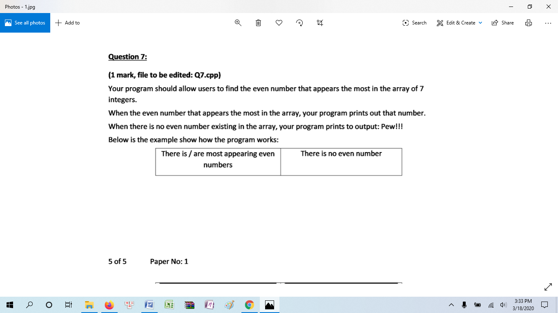

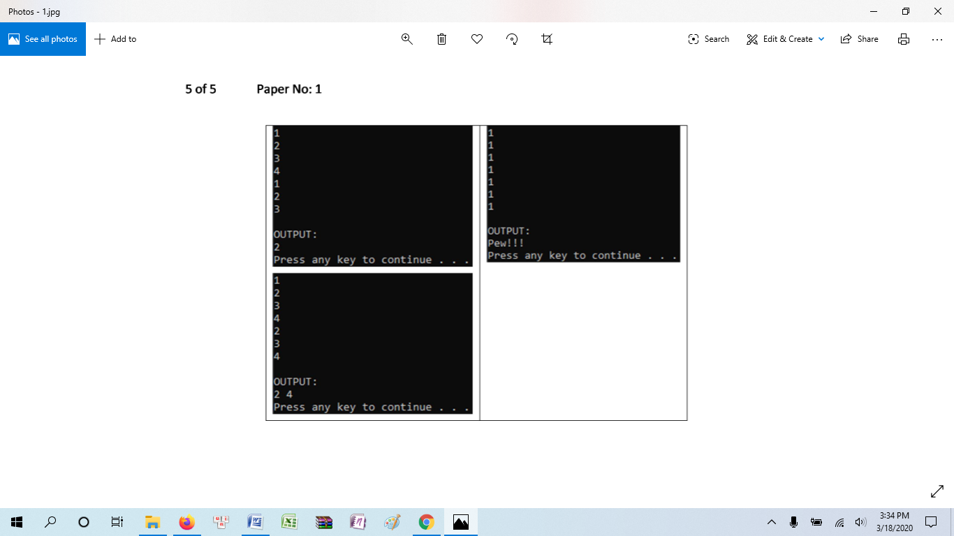

**Q8 (1 mark, file to be edited: Q8.cpp)**

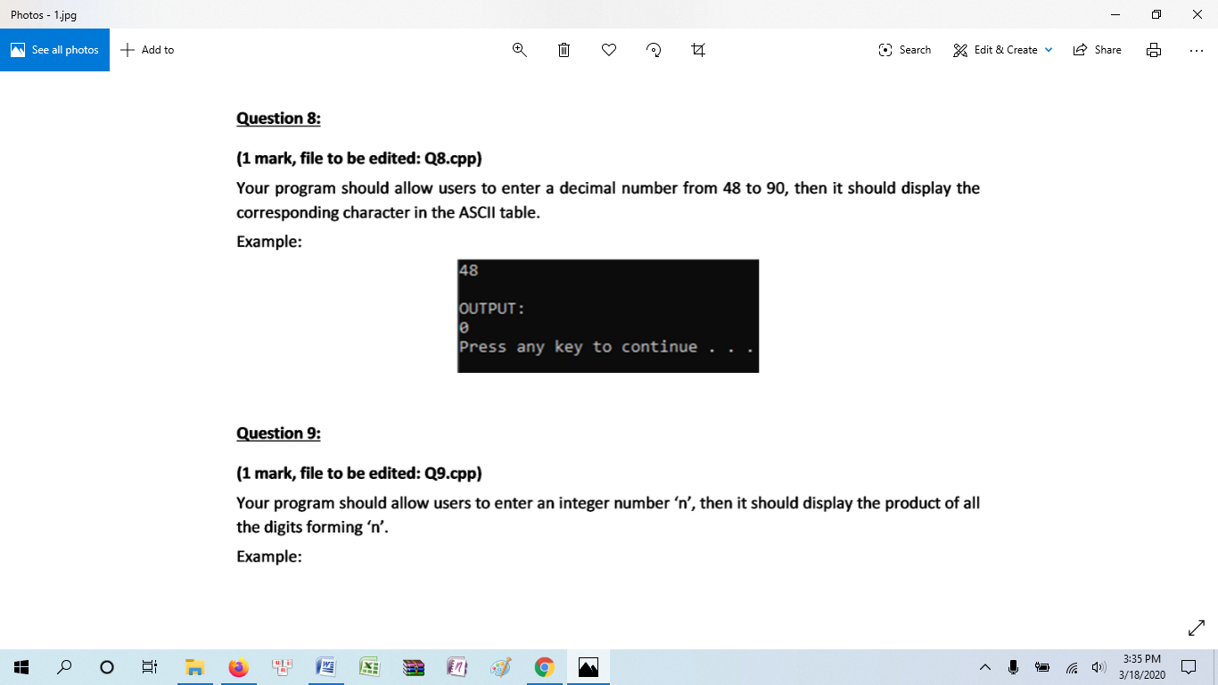

**Q9 (1 mark, file to be edited: Q9.cpp)**



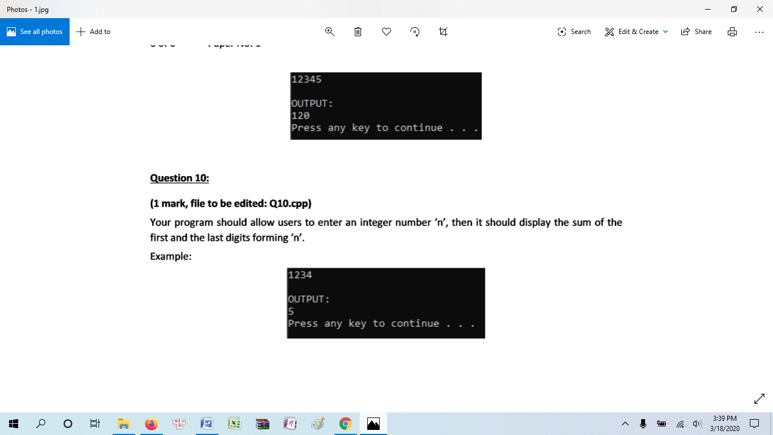

**Q10 (1 mark, file to be edited: Q10.cpp)**

