Porua — Assignment 2 Task Distribution
Oct 8, 2026 · @MD RATUL HOSSEN

Overview
Group 8 builds Porua for Assignment 2: the offline-first SSC/HSC study app from our Assignment 1 proposal, now with AI features. Every screen, file and decision has exactly one owner, so no two people ever work on the same thing.
Member | Role | One-line job
MD Ratul Hossen | UI/UX Designer, AI Integration Lead & Core UI Developer | Designs every screen in Figma, codes the theme, shared components, onboarding and AI screens, and owns all AI integration.
Abiduzzaman Rahim | Frontend Developer (Jetpack Compose) | Builds the main screens 06–17, navigation and ViewModels in Compose from Ratul's designs and components.
Saniya Sachin Pendhari | Database & Data Layer Developer | Builds the Room database, repositories and the study logic (mastery, SM-2, plan).
Muhammad Rehan Kuaiser | Security & Privacy Lead | Protects student data, API keys and AI inputs/outputs; reviews every PR for security.
Sumayya Syed | Content, QA & Documentation Lead | Writes the NCTB question bank, tests the app, and assembles the final report and demo.
Scope reference: the 20-screen prototype (Onboarding, Daily loop, Progress/Plan/Review/Me, AI features) and the Part B blueprint of Assignment 1.

Ownership map
The owner of an area is the only person who edits it. Others can suggest changes through a comment or a PR review, never by editing directly.
Member | Owns | Does NOT touch
Ratul | Figma file (all pages), design tokens, icons, prototype, usability test; code in ui/theme/, ui/components/, ui/onboarding/ (screens 01–05), ui/ai/ (screens 18–20 + AI cards), ai/ (AI client, prompts) | Screens 06–17, navigation graph, Room entities/DAOs, security config, question JSON content
Rahim | Project setup, navigation/, ui/home/, ui/practice/, ui/progress/, ui/plan/, ui/review/, ui/profile/ (screens 06–17), viewmodel/ for those screens | Figma visuals, ui/theme/, ui/components/, ai/, Room entities/DAOs
Saniya | data/ (Room entities, DAOs, database, migrations), repository/, domain/ (mastery, SM-2, plan generator), worker/ (WorkManager reminders), DataStore | Compose UI files, Figma, AI code
Rehan | security/ (encryption, key handling), network_security_config.xml, proguard-rules.pro, backup rules, permissions list, privacy policy, Play Data safety form | Screen layouts, DB schema design, question content
Sumayya | assets/questions/ (question bank JSON), test/ + androidTest/ test cases, bug tracker, final report, README, demo video script | Production code in ui/, data/, ai/, security/
Shared files (build.gradle.kts, AndroidManifest.xml, MainActivity.kt): Rahim merges changes to them. Anyone who needs a change there opens a PR and tags Rahim.

Detailed tasks
Each member's list ends with the deliverables that get checked at the end. Tick a task once it is merged or approved.

MD Ratul Hossen — UI/UX Design, AI Integration & Core UI Code
Ratul owns how the app looks, the shared UI building blocks in code, and every AI feature. He designs in Figma first, then codes the parts that define the look (theme and components), the onboarding screens and the AI screens.
UI/UX design (Figma)
- ☐ U1. Design system: colour variables, type scale (Plus Jakarta Sans + Hind Siliguri for Bangla), spacing (4/8/16/24), corner radius.
- ☐ U2. Component library: buttons, chips, cards, progress bars, mastery ring, toggles, bottom nav, top bar, chat bubbles.
- ☐ U3. All 20 screens at 360×800, with loading, empty, error, offline, AI-unavailable and camera-denied states.
- ☐ U4. Notification layouts, app icon and splash artwork; Bangla layout check and accessibility specs (contrast at least 4.5:1, touch targets at least 48dp).
- ☐ U5. Clickable Figma prototype and a usability test with 3–5 students; fix the designs from the findings.
- ☐ U6. Mark frames "Ready for dev" with spacing, sizes and exported SVG icons for Rahim.
Core UI code (Compose)
- ☐ U7. PoruaTheme: Color.kt, Type.kt, Shape.kt from the Figma tokens, finished in week 1 before Rahim starts screens.
- ☐ U8. Shared composables in ui/components/: PoruaButton, Chip, Card, MasteryRing, TopicBar, StatTile, WeeklyBarChart, LineChart.
- ☐ U9. Onboarding screens 01–05 (Splash, Welcome, Exam track, Subjects & date, Diagnostic intro) with their ViewModel, saving to Saniya's SettingsRepository.
AI integration
- ☐ A1. AiService interface with an on-device implementation (Gemini Nano via ML Kit GenAI, where the phone supports it) and a cloud implementation (Gemini API) used only when online.
- ☐ A2. Prompt design: NCTB-syllabus tutor prompt, Bangla/English answers, step-by-step format; test with real questions from Sumayya's bank.
- ☐ A3. Ask Porua chat (screen 18): question context, streamed answer, Bangla toggle, "save as review card".
- ☐ A4. AI insights (screen 19): patterns from Saniya's attempt data and suggested next steps.
- ☐ A5. Snap a question (screen 20): CameraX capture, on-device text recognition (ML Kit), solution from AiService.
- ☐ A6. AI composables that Rahim drops into his screens: AiInsightCard (Home), ExplainWithAiButton (Feedback), AiMistakeSummary (Topic detail).
- ☐ A7. Graceful fallback when AI is unavailable, and Rehan's AI safety filter plugged in before any text leaves the phone.
- ☐ A8. Design review of every screen Rahim builds, against the Figma frame.
Deliverables: Figma file + prototype link, usability test notes, theme + component library, screens 01–05 and 18–20, 3 AI features with offline fallback, short note on which phones support on-device AI.

Abiduzzaman Rahim — Frontend Development (Jetpack Compose)
Rahim owns the main app screens in code. He builds them from Ratul's Figma frames, using Ratul's theme and shared components, and reads data only through Saniya's repositories.
- ☐ F1. Project setup: Android Studio project, package structure, Gradle dependencies (Compose, Material 3, Navigation-Compose, Hilt).
- ☐ F2. Navigation graph for all 20 screens and the bottom navigation (Home, Practice, Progress, Plan, Me).
- ☐ F3. Home (06): exam countdown, today's plan, weak-area chips, weekly chart; place Ratul's AiInsightCard.
- ☐ F4. Practice flow (07–11): practice hub, chapters, question, answer feedback with the Again/Hard/Good/Easy rating, session summary.
- ☐ F5. Progress (12) and Topic detail (13): mastery list, 6-week line chart, sub-topics, recent mistakes.
- ☐ F6. Plan (14) and Review queue (15): day picker, timed tasks, road to the exam, due cards.
- ☐ F7. Offline packs (16) and Me / Settings (17).
- ☐ F8. ViewModel + StateFlow for screens 06–17, with fake data first, then Saniya's repositories.
- ☐ F9. Loading, empty, error and offline states exactly as Ratul designed them.
- ☐ F10. Open the right screen when a revision reminder notification is tapped (deep link).
- ☐ F11. Fix UI bugs Sumayya reports and UI security issues Rehan reports.
Deliverables: screens 06–17 working on real data, navigation for the whole app, all screens approved in Ratul's design review.

Saniya Sachin Pendhari — Database & Data Layer
Saniya owns where data lives and the study logic that runs on it. She exposes everything through repository interfaces so the UI never queries the database directly.
- ☐ D1. Design the ER diagram: Subject, Chapter, Topic, Question, Option, Attempt, TopicMastery, ReviewCard, PlanTask, StudySession, AiChatMessage.
- ☐ D2. Room entities, DAOs and PoruaDatabase with indices on topicId and dueDate.
- ☐ D3. DataStore for user settings: exam track, group, exam date, daily study time, language, reminder time.
- ☐ D4. Question bank loader: read Sumayya's JSON from assets/questions/ and seed the database on first launch, with a version number for updates.
- ☐ D5. Mastery calculation per topic from attempts (recent answers weigh more); output 0–100%.
- ☐ D6. SM-2 spaced-repetition scheduler: ease factor, interval and next due date from the Again/Hard/Good/Easy rating.
- ☐ D7. Revision plan generator: from exam date, subjects, daily minutes and mastery, create daily Revise / Practise / Learn tasks; move unfinished tasks forward.
- ☐ D8. Diagnostic test logic: pick 20 questions across subjects and set the first mastery values.
- ☐ D9. Repositories with Kotlin Flow: QuestionRepository, ProgressRepository, ReviewRepository, PlanRepository, SettingsRepository, AiHistoryRepository.
- ☐ D10. Fake repositories with sample data in week 1, so Rahim and Ratul can build screens before the real database is ready.
- ☐ D11. WorkManager job for daily revision reminders ("Revise Alcohols, exam in 186 days").
- ☐ D12. Database migrations and unit tests for mastery, SM-2 and the plan generator.
Deliverables: ER diagram, Room database, 6 repositories, SM-2 + mastery + plan logic with unit tests, reminder worker.

Muhammad Rehan Kuaiser — Security & Privacy
Rehan owns the protection of student data and the safe use of AI. Most users are under 18, so privacy is a marked part of the project.
- ☐ S1. Threat model: list what can go wrong (lost phone, leaked API key, unsafe AI output, data sent off the device) and the fix for each.
- ☐ S2. Encrypt the local database (SQLCipher for Room) with the key kept in Android Keystore; work with Saniya on the setup.
- ☐ S3. API key protection: no Gemini key inside the APK or in Git; use Firebase App Check or a small proxy, and add local.properties / secrets to .gitignore.
- ☐ S4. AI safety: limit prompts to syllabus topics, filter unsafe or off-topic output, block personal data (name, phone) from being sent to the cloud AI.
- ☐ S5. Network security config: HTTPS only, no cleartext traffic.
- ☐ S6. Permissions: only CAMERA (runtime, asked when Snap is opened) and POST_NOTIFICATIONS; remove anything else.
- ☐ S7. Backup rules: exclude the encryption key and sensitive tables from Android auto-backup.
- ☐ S8. Release hardening: R8 minify + obfuscation rules that do not break Room or Compose.
- ☐ S9. Privacy policy and in-app consent screen for cloud AI ("Your question will be sent to Google Gemini").
- ☐ S10. Security review of every PR that touches ai/, data/ or the manifest; security test checklist based on OWASP MASVS.
Deliverables: threat model, encrypted DB, key-handling setup, AI safety filter, privacy policy, security checklist with results.

Sumayya Syed — Content, QA & Documentation
Sumayya owns what students practise and proves the app works. Her question bank is the content the whole app depends on.
- ☐ C1. Question bank: at least 300 NCTB-aligned HSC MCQs for the MVP (Chemistry, Physics, Higher Math, English), each tagged by subject, chapter, topic and difficulty, with an explanation.
- ☐ C2. Write the questions in the JSON format agreed with Saniya; check for duplicates and wrong answers.
- ☐ C3. 20 diagnostic questions covering all four subjects.
- ☐ C4. Test plan: test cases for each of the 20 screens, offline mode, AI on/off, Bangla text, small and low-RAM phones.
- ☐ C5. Run tests every week, log bugs (screen, steps, expected vs actual, screenshot) and assign them to the owner.
- ☐ C6. Write UI tests with Compose testing for the main flow (Onboarding → Practice → Feedback).
- ☐ C7. Collect references and the user feedback from testing for the report.
- ☐ C8. Assignment 2 report: compile each member's section, architecture diagram, screenshots, testing results.
- ☐ C9. README, demo video script and slides for the final presentation.
Deliverables: question bank JSON (300+ MCQs), test plan + bug log, UI tests, final report, demo script.

UI/UX vs frontend: where Ratul stops and Rahim starts
Ratul decides what the app looks like and codes the shared pieces; Rahim builds the main screens from those pieces. They split the code by folder, so they never edit the same file.
Question | Ratul (UI/UX + core UI + AI) | Rahim (Frontend)
Colour, size, spacing, font | Decides in Figma, codes them in ui/theme/ | Uses the theme, never hard-codes values
Buttons, cards, chips, charts | Builds them once in ui/components/ | Reuses them; asks Ratul for a new variant
Screens 01–05 (onboarding) and 18–20 (AI) | Designs and builds | Not involved
Screens 06–17 | Designs in Figma | Builds in Compose
Navigation and bottom nav | Defines the flow in the prototype | Implements the navigation graph
ViewModels and data | Only for his own screens | For screens 06–17, via Saniya's repositories
AI cards inside Home, Feedback, Topic detail | Builds the composable and its AI logic | Places it in the screen
Empty, error, offline states | Designs them | Builds them in screens 06–17
A design is hard to build | Adjusts the design | Comments on the Figma frame
Handoff rules:
- Ratul finishes the theme and core components in week 1, before Rahim starts screens.
- Rahim starts a screen only after Ratul marks its Figma frame "Ready for dev".
- Rahim never edits ui/theme/, ui/components/, ui/onboarding/, ui/ai/ or ai/; he opens an issue and tags Ratul.
- Ratul never edits Rahim's screen folders; visual bugs go to Rahim as an issue with a screenshot.
- Once a screen is built, Ratul does a 10-minute design review on the APK and approves it or lists the differences.

Interfaces between members
Four contracts are agreed in week 1 and then frozen, so each person can work alone without waiting on the others.
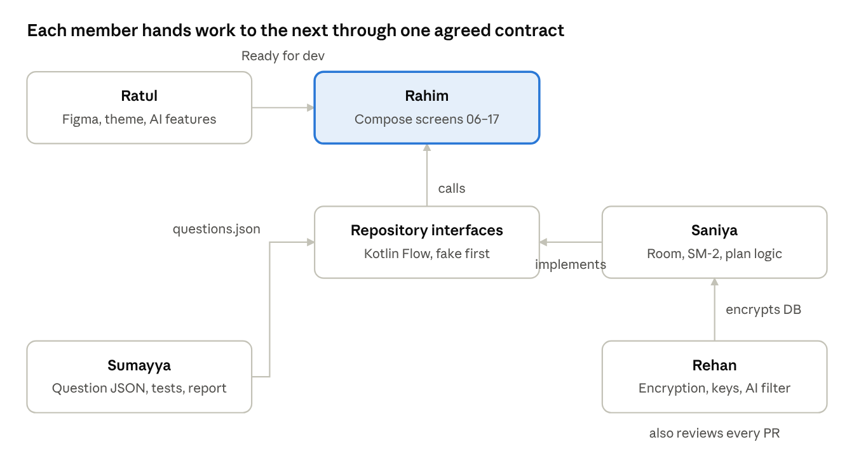
handoffs between the five members
- Design handoff (Ratul → Rahim): Figma frames marked "Ready for dev" plus exported SVG icons.
- Repository contract (Saniya → Rahim and Ratul): Saniya writes the Kotlin interfaces (for example ProgressRepository.observeTopicMastery(subjectId): Flow<List<TopicMastery>>) and a fake version in week 1. Rahim and Ratul code against the interface only.
- Question format (Sumayya → Saniya): every question follows one JSON shape, so the loader never breaks.
- AI contract (Ratul, reviewed by Rehan): one AiService interface with explain(), insights() and solveFromText(). Rehan's filter wraps it before any text leaves the phone.
Agreed question format:
{
"id": "chem2-ch5-electrode-012",
"subject": "Chemistry",
"paper": 2,
"chapter": 5,
"topic": "Electrode potential",
"difficulty": "medium",
"question": "Standard hydrogen electrode potential is...",
"options": ["1.0 V", "0.00 V", "-0.76 V", "0.34 V"],
"answerIndex": 1,
"explanation": "SHE is the reference electrode, fixed at 0.00 V.",
"lang": "en"
}
Changing a frozen contract needs a short message in the group chat and approval from both sides.

Timeline
The build runs over six weeks with four gates. Nobody waits on anyone in week 1, because Saniya's fake repositories and Ratul's first frames and theme arrive together.
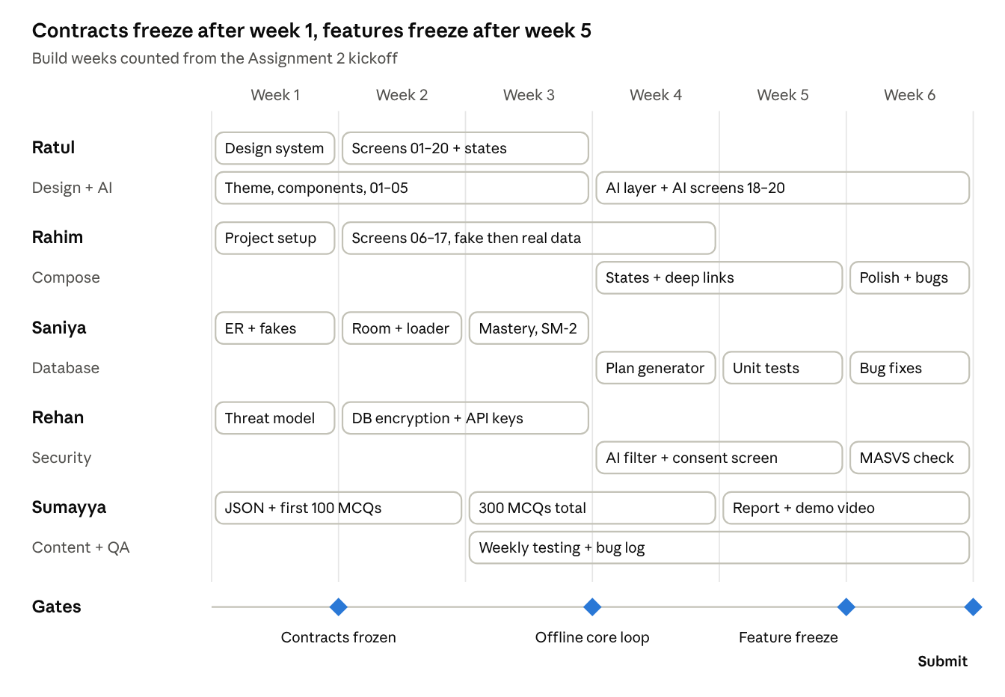
six build weeks by member, with four gates
What each gate means:
- End of week 1, contracts frozen: design system done, repository interfaces + fakes merged, question JSON format agreed, threat model written.
- End of week 3, offline core loop: a student can onboard, practise, see feedback and the mastery map with the phone in airplane mode.
- End of week 5, feature freeze: all 20 screens and AI features merged; only bug fixes after this.
- Week 6, submit: final APK, report, demo video, slides.
The week numbers are counted from the day we start Assignment 2. We fix the real dates once the lecturer confirms the deadline.

Working rules
These rules keep five people from overwriting each other's work.
Git and branches
- One GitHub repo; main is protected and only receives merged PRs.
- Branch names start with the owner: rahim/home-screen, saniya/sm2-scheduler, rehan/db-encryption, sumayya/chem-questions.
- You only commit inside the folders you own (see the ownership map). A change outside them goes through a PR that tags the owner.
- Never commit API keys, local.properties or google-services.json.
Pull requests
- Every PR gets one review before merge: code PRs by the owner of the connected area, plus Rehan for anything in ai/, data/ or the manifest.
- UI PRs include a screenshot next to the Figma frame so Ratul can compare.
- Keep PRs small: one screen, one DAO or one feature per PR.
Meetings and updates
- Weekly 30-minute meeting: each person says what they finished, what is next, and what blocks them.
- Bugs go to the bug log Sumayya keeps, assigned to the area owner, never fixed by someone else directly.
Definition of done for any task
- It works offline (unless it is a cloud AI call with a clear fallback).
- It matches the Figma frame (UI) or passes its unit tests (logic).
- It works in English and Bangla text.
- It was reviewed and merged into main.
- Sumayya tested it and the task is ticked in this doc.

