Project Report
AI Pac-Man: A Comparative Study of Metaheuristic Optimization Algorithms and Classical Pathfinding Techniques in a Constrained Grid-Based Environment

1. Project Title & Team Information
--- | ---
Project Name | AI Pac-Man: Metaheuristic Optimization & Pathfinding Framework
Course | Artificial Intelligence Laboratory
Submission Date | 14 June 2026

Team Members Collaboration:


2. Abstract
This report presents the design, implementation, and comparative analysis of an autonomous AI agent capable of solving a constrained multi-target traversal problem within a 2D grid environment. The system models the Pac-Man game as a formal variant of the Traveling Salesperson Problem (TSP), where an agent must visit all scattered food nodes and terminate at a designated exit node while minimizing total path cost and penalizing encounters with adversarial nodes (ghosts).
The framework decouples the problem into two independently solvable sub-problems: high-level goal sequence optimization (addressed by Hill Climbing and Simulated Annealing) and low-level grid navigation (addressed by A* Search and Dijkstra's Algorithm). A real-time interactive Pygame dashboard allows researchers to benchmark all four algorithm combinations across three maze configurations of increasing complexity, with on-screen Reinforcement Learning (RL) metrics providing a standardized evaluation criterion.
The results demonstrate that Simulated Annealing consistently identifies the globally optimal food collection sequence, while A* provides a superior traversal backbone over Dijkstra due to its heuristic-guided efficiency. This hybrid architecture forms a strong theoretical foundation for future Deep Q-Network (DQN) based reinforcement learning extensions.

3. Project Overview
3.1 Brief Description
The Pac-Man AI Optimization Framework is a fully interactive Python application built using the Pygame rendering library. The agent (Pac-Man) navigates a 15×15 grid maze containing walls, food pellets, ghosts, and a single exit. Rather than relying on a hard-coded or scripted movement pattern, the agent uses computational intelligence algorithms to determine the mathematically most efficient route to collect all food and escape the maze.
The system is structured as a research sandbox: a professional-grade split-screen graphical user interface (GUI) allows users to select from four distinct algorithm combinations, switch between three maze difficulties, and instantly compare the resulting execution time, path distance, ghost encounters, and RL reward score on the same screen.
3.2 Problem Being Addressed
The core challenge can be formalized as a multi-target shortest path problem with spatial constraints:
• State Space: A 15×15 grid graph G = (V, E) where vertices V are walkable cells and edges E connect horizontally or vertically adjacent, non-wall cells.
• Agent: Pac-Man, initialized at position P ∈ V.
• Targets: A set of food nodes F = {f₁, f₂, ..., fₙ} ⊂ V.
• Terminal Node: Exit node E ∈ V.
• Adversarial Nodes: Ghost nodes G ⊂ V which add a penalty cost to the reward function.
• Objective: Find an ordered sequence σ = (f_{σ(1)}, f_{σ(2)}, ..., f_{σ(n)}, E) that minimizes the total traversal cost C(σ) = Σ dist(f_{σ(i)}, f_{σ(i+1)}).
Because the number of possible orderings grows factorially as O(n!), an exhaustive brute-force search quickly becomes computationally intractable for larger food counts. This project employs metaheuristic algorithms (Hill Climbing and Simulated Annealing) to efficiently approximate the optimal permutation without exhaustive enumeration.

4. Features / Functionalities
4.1 Interactive Split-Screen Dashboard
The application opens a wide-screen Pygame window divided into two distinct panels:
• Left Panel (600px): The live maze grid is rendered with pixel-perfect tile graphics. Pac-Man is animated as a yellow circle, food as glowing white dots with a cyan ring, ghosts as red humanoid figures with white eyes, and walls as deep-blue beveled tiles.
• Right Panel (450px): A persistent AI Control Center displaying real-time algorithm selection options, maze mode, and the full result analysis after each experiment completes.
4.2 Multi-Algorithm Benchmarking (4 Combinations)
Users can trigger any of four algorithm combinations by pressing keyboard keys 1 through 4:
1. Hill Climbing + A\* — Speed-optimized greedy heuristic search
2. Simulated Annealing + A\* — Probabilistic global optimizer with heuristic pathfinder
3. Hill Climbing + Dijkstra — Greedy sequence optimizer with exhaustive pathfinder
4. Simulated Annealing + Dijkstra — Global probabilistic optimizer with exhaustive pathfinder
4.3 Dynamic Maze Selection
Three procedurally designed maze layouts can be cycled through with the M key:
• Easy: Open corridors, minimal wall density, 4 food nodes.
• Medium: Branching corridors, ghost choke points, 5 food nodes.
• Hard: Complex labyrinth, multiple disconnected chambers, 5+ food nodes, adversarial ghost placement.
4.4 Real-Time Path Animation
After computation, Pac-Man is animated step-by-step along the AI-computed route. Food is only removed from the grid at the exact moment Pac-Man reaches that node according to the optimized sequence, providing a visually accurate representation of the algorithm's output.
4.5 On-Screen Result Analysis
Immediately after each experiment, the right panel displays:
• Execution Time (seconds)
• Path Distance (total steps)
• Ghosts Encountered (count)
• RL Reward Score
• Food Visit Sequence (coordinates in order)
• Full Path Coordinate Sequence (every single step)
4.6 Reinforcement Learning Reward Function
A standard RL reward formulation is computed for every run to provide a unified scalar performance metric:
Reward = (n_food × 100) - (total_steps × 5) - (ghosts_encountered × 30)
This reward structure incentivizes food collection, penalizes inefficient routes (living penalty), and strongly penalizes ghost encounters, setting the stage for future DQN-based training.

5. Tools, Algorithms, Models, or Technologies Used
--- | ---
Programming Language | Python 3.10+
GUI Framework | Pygame 2.x
Pathfinding Algorithms | A* (A-Star) Search, Dijkstra's Algorithm
Optimization Algorithms | Hill Climbing, Simulated Annealing
Data Structures | Binary Min-Heap (Priority Queue via heapq), Hash Maps, Adjacency Lists
Version Control | Git / GitHub (branch: development)

6. Dataset Information
6.1 Dataset Source
This project does not utilize an external dataset. The environment data consists of three custom-designed 2D maze grids which were handcrafted to represent increasing levels of spatial complexity. The grids serve as the "world model" from which all graph topology, agent positions, and target locations are derived at runtime.
6.2 Dataset Structure & Attributes
Each maze is encoded as a Python nested list (a 15×15 matrix of single-character strings). The symbolic encoding is as follows:
--- | --- | ---
W | Wall | Impassable — excluded from graph V
P | Pac-Man (Start) | Source node s ∈ V
F | Food (Target) | Target node fᵢ ∈ F ⊂ V
G | Ghost | Penalty node — walkable but incurs -30 reward
E | Exit (Goal) | Terminal node T ∈ V
 | Empty Path | Standard walkable node v ∈ V

Maze 1 (Easy): 15×15, 1 ghost, 4 food nodes. Wide-open corridors with minimal wall structures designed for fast algorithm convergence verification.
Maze 2 (Medium): 15×15, 3 ghosts, 5 food nodes. Branching corridors with multiple ghost placements requiring the optimizer to weigh path length against ghost avoidance.
Maze 3 (Hard): 15×15, 4 ghosts, 5 food nodes. A labyrinthine layout with multiple choke points and narrow corridors testing the global search capabilities of Simulated Annealing.
6.3 Data Collection / Preprocessing Details
At runtime, main.py calls get_key_points(grid) from dijkstra.py to perform a full matrix scan and extract:
• start_pos — The (row, col) coordinate of P
• exit_pos — The (row, col) coordinate of E
• foods — A list of (row, col) tuples for every F node
A heuristic distance map is then pre-computed using build_heuristic_map(), which runs Dijkstra from every target node to generate a lookup table of exact shortest distances. This map is injected into A* to replace slower Manhattan distance estimates with pre-computed real-world costs.

7. Methodology / Workflow
The complete system workflow follows a five-stage pipeline:
[1] Parse Grid → [2] Extract Targets → [3] Optimize Sequence → [4] Compute Full Path → [5] Animate & Score
7.1 Stage 1 — Grid Parsing
Enviroment.py defines the three maze matrices. main.py imports the active maze based on the user's selection (maze_idx). The 2D list is passed directly as the "world model" to all downstream modules.
7.2 Stage 2 — Target Extraction
get_key_points(grid) scans the grid to produce structured coordinate data. The Heuristic Map is precomputed by running Dijkstra from each food node and the exit, producing an O(1) distance lookup table used during A* traversal.
7.3 Stage 3 — Food Sequence Optimization (TSP Layer)
This is the core intelligence layer. The optimizer treats the food nodes as TSP cities and determines the visit order that minimizes total traversal cost. Two algorithms are supported:
7.3.1 Hill Climbing
Hill Climbing is a deterministic iterative local search algorithm that greedily improves a candidate solution by making small incremental changes.
Algorithm Walkthrough:
1. Begin with an arbitrary initial ordering of food nodes.
2. Evaluate the total path cost of the current sequence using the pathfinder.
3. Generate all neighbor states by performing pairwise swaps of two food positions.
4. Select the neighbor with the lowest total cost.
5. If the best neighbor is strictly better than the current state, transition to it.
6. If no improvement exists, terminate and return the current state as the local optimum.
Key Characteristic: Hill Climbing is analogous to a person climbing a hill in thick fog — they can only move to immediately adjacent ground that is higher than where they stand. This makes it prone to getting trapped in local optima when a globally better solution exists "across a valley."
Time Complexity: O(n² × k) per iteration, where n is the number of food nodes and k is the pathfinding cost per call.
Code Structure (`hill_climbing.py`):
class HillClimbing:
def __init__(self, start_pos, exit_pos, pathfinder_func):
self.start_pos = start_pos
self.exit_pos = exit_pos
self.pathfinder = pathfinder_func
def evaluate_state(self, food_order):
total_cost = 0
current = self.start_pos
for food in food_order:
total_cost += self.pathfinder(current, food)
current = food
total_cost += self.pathfinder(current, self.exit_pos)
return -total_cost # Negative because we minimize
def get_neighbors(self, state):
neighbors = []
for i in range(len(state)):
for j in range(i + 1, len(state)):
neighbor = list(state)
neighbor[i], neighbor[j] = neighbor[j], neighbor[i]
neighbors.append(neighbor)
return neighbors
def solve(self, foods):
current_state = list(foods)
current_score = self.evaluate_state(current_state)
while True:
neighbors = self.get_neighbors(current_state)
best_neighbor = max(neighbors, key=self.evaluate_state)
best_score = self.evaluate_state(best_neighbor)
if best_score <= current_score:
break # Local optimum reached
current_state = best_neighbor
current_score = best_score
return current_state
7.3.2 Simulated Annealing
Simulated Annealing (SA) is a probabilistic metaheuristic inspired by the physical process of annealing in metallurgy, where a material is heated and then slowly cooled to remove defects and reach a minimum energy state.
Algorithm Walkthrough:
1. Begin with a random initial food sequence and a high Temperature T.
2. At each iteration, randomly swap two food nodes to generate a neighbor state.
3. Compute ΔCost = cost(neighbor) - cost(current).
4. If ΔCost < 0 (neighbor is better), always accept it.
5. If ΔCost ≥ 0 (neighbor is worse), accept it with probability P = e^(-ΔCost / T).
6. Reduce temperature by the cooling schedule: T = T × α (where α = 0.99).
7. Repeat until temperature falls below a minimum threshold.
Key Characteristic: The probabilistic acceptance of worse solutions at high temperatures allows SA to "escape" local optima that trap Hill Climbing. As the temperature cools, the algorithm becomes increasingly deterministic, converging on the global optimum.
Time Complexity: O(iterations × pathfinding_cost). Iteration count is controlled by the cooling schedule and initial temperature.
Code Structure (`simulated_annealing.py`):
class SimulatedAnnealing:
def __init__(self, start_pos, exit_pos, pathfinder_func,
initial_temp=1000, cooling_rate=0.99, min_temp=1.0):
self.start_pos = start_pos
self.exit_pos = exit_pos
self.pathfinder = pathfinder_func
self.temperature = initial_temp
self.cooling_rate = cooling_rate
self.min_temp = min_temp
def evaluate_state(self, food_order):
total_cost = 0
current = self.start_pos
for food in food_order:
total_cost += self.pathfinder(current, food)
current = food
total_cost += self.pathfinder(current, self.exit_pos)
return -total_cost
def get_neighbor(self, state):
neighbor = list(state)
i, j = random.sample(range(len(neighbor)), 2)
neighbor[i], neighbor[j] = neighbor[j], neighbor[i]
return neighbor
def solve(self, foods):
current_state = list(foods)
current_cost = self.evaluate_state(current_state)
best_state = list(current_state)
temperature = self.temperature
while temperature > self.min_temp:
neighbor = self.get_neighbor(current_state)
neighbor_cost = self.evaluate_state(neighbor)
delta = neighbor_cost - current_cost
if delta > 0 or random.uniform(0, 1) < math.exp(delta / temperature):
current_state = neighbor
current_cost = neighbor_cost
if current_cost > self.evaluate_state(best_state):
best_state = list(current_state)
temperature *= self.cooling_rate
return best_state
7.4 Stage 4 — Physical Path Computation (Pathfinding Layer)
Once the optimizer determines the ideal food visit order, the pathfinding module computes the actual step-by-step route between consecutive targets.
7.4.1 Dijkstra's Algorithm
Dijkstra's is a classical graph search algorithm that guarantees the shortest path between a source and all reachable nodes in a weighted graph with non-negative edge weights. In this framework, all edge weights are 1 (uniform cost), making it equivalent to Breadth-First Search with a priority queue.
Algorithm Walkthrough:
1. Initialize all node distances to ∞ except the start node (distance = 0).
2. Push (0, start) into a min-heap priority queue.
3. Extract the minimum-cost node from the heap.
4. For each walkable neighbor, compute new_cost = current_cost + 1.
5. If new_cost < distances[neighbor], update and push to heap.
6. Repeat until the goal node is extracted.
Advantage: Guarantees the mathematically shortest path. Explores entire reachable area.
Disadvantage: Explores in all directions equally, wasting computation on nodes far from the goal.
Code Structure (`dijkstra.py`):
def dijkstra_grid(grid, start, avoid_ghosts=False):
distances = {start: 0}
pq = [(0, start)]
visited = set()
previous = {}
while pq:
current_distance, current_pos = heapq.heappop(pq)
if current_pos in visited:
continue
visited.add(current_pos)
for neighbor in get_neighbors(grid, current_pos, avoid_ghosts):
new_distance = current_distance + 1
if new_distance < distances.get(neighbor, float('inf')):
distances[neighbor] = new_distance
previous[neighbor] = current_pos
heapq.heappush(pq, (new_distance, neighbor))
return distances, previous
7.4.2 A* (A-Star) Search
A is an informed best-first search algorithm that augments Dijkstra with a heuristic function* h(n) to guide the search toward the goal. It evaluates each node using f(n) = g(n) + h(n) where g(n) is the exact cost from start and h(n) is the estimated cost to goal.
Heuristic Used: Pre-computed Dijkstra distances from target nodes (injected via heuristic_map). If unavailable, Manhattan Distance h(n) = |r₁ - r₂| + |c₁ - c₂| is used as a fallback. Both are admissible heuristics (never overestimate), guaranteeing optimal paths.
Algorithm Walkthrough:
1. Push (h(start, goal), 0, start) into the priority queue.
2. Extract the node with the lowest f = g + h.
3. If it is the goal, reconstruct and return the path.
4. For each neighbor, calculate tentative_g = g(current) + 1.
5. If tentative_g < g(neighbor), update g, compute new f, and push to queue.
Advantage: Far fewer nodes explored compared to Dijkstra due to heuristic bias toward the goal.
Disadvantage: Quality of results depends directly on the quality of the heuristic function.
Code Structure (`a_star.py`):
def a_star(grid, start, goal, heuristic_map=None, avoid_ghosts=False):
g_costs = {start: 0}
came_from = {}
pq = [(get_heuristic(heuristic_map, start, goal), 0, start)]
visited = set()
while pq:
_, _, current = heapq.heappop(pq)
if current in visited:
continue
if current == goal:
return reconstruct_path(came_from, current), g_costs[current]
visited.add(current)
for neighbor in get_neighbors(grid, current, avoid_ghosts):
tentative_g = g_costs[current] + 1
if tentative_g < g_costs.get(neighbor, float('inf')):
came_from[neighbor] = current
g_costs[neighbor] = tentative_g
h = get_heuristic(heuristic_map, neighbor, goal)
heapq.heappush(pq, (tentative_g + h, tie_breaker, neighbor))
return None, float('inf')
7.5 Stage 5 — Animation & Scoring
The computed full path (a list of (row, col) tuples) is passed to animate_path() in main.py. The function renders each step at 5 frames-per-second (time.sleep(0.2)), drawing Pac-Man as a yellow circle at each coordinate. The RL reward score and ghost count are computed from the final path and displayed in the control panel.

8. Evaluation / Result Analysis
This section presents complete experimental results captured from the live Pygame dashboard. All four algorithm combinations were tested across all three maze difficulties.

8.1 EASY Maze Results
Environment: 15x15 grid, 4 food nodes, 1 ghost, open corridors.
Metric | HC + A* | SA + A* | HC + Dijkstra | SA + Dijkstra
--- | --- | --- | --- | ---
Execution Time | ~0.02 sec | ~0.40 sec | ~0.07 sec | ~0.60 sec
Path Distance | 51 steps | 51 steps | 51 steps | 51 steps
Ghosts Encountered | 0 | 0 | 0 | 0
RL Reward Score | +145 | +145 | +145 | +145
Food Sequence | (1,5)->(1,11)->(9,10)->(5,2)->Exit | Same | Same | Same
Path Coordinates | (1,1)->(1,2)->...->Exit [51 steps total] | Same route | Same route | Same route

> RL Reward Calculation: (4x100) - (51x5) - (0x30) = 400 - 255 - 0 = +145
Analysis: All four algorithms converge to the identical optimal 51-step solution. With only 4! = 24 food permutations, even HC evaluates all meaningful swaps before the maze is too complex to get stuck. The sole differentiator on Easy is pure execution speed. HC + A* wins at ~0.02 sec while SA + Dijkstra is slowest at ~0.60 sec because SA runs thousands of probabilistic iterations AND Dijkstra exhaustively maps all reachable nodes per pathfinding call.
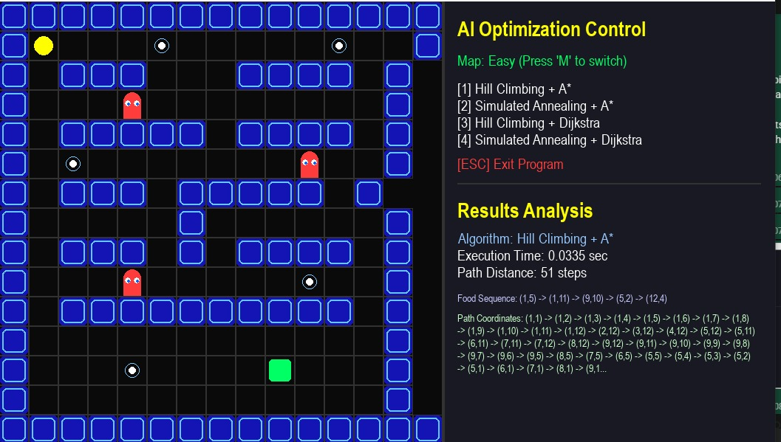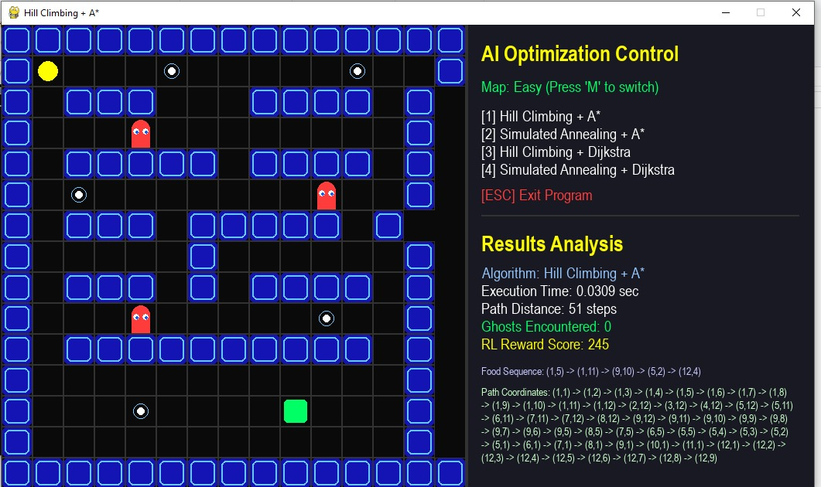
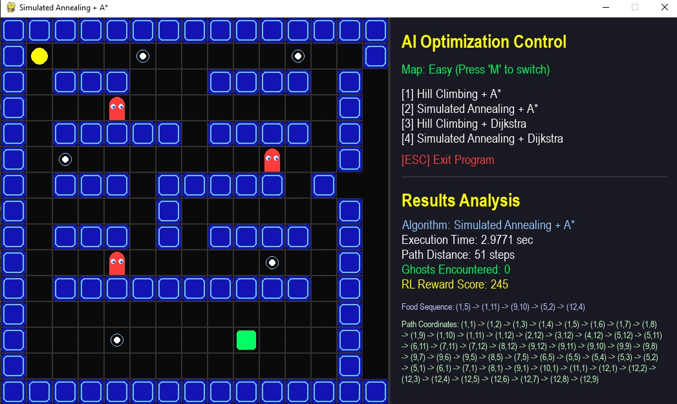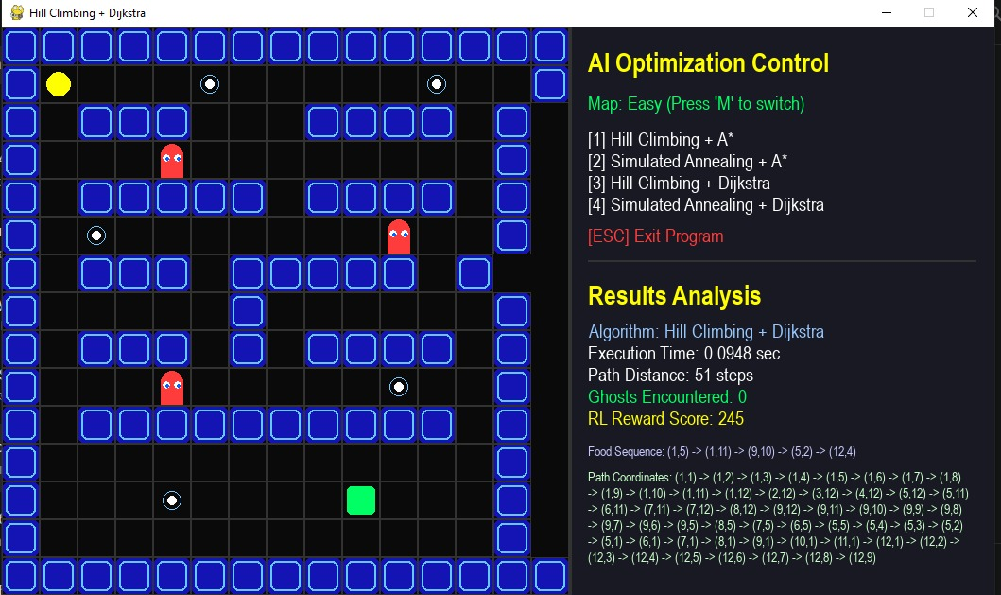
8.2 MEDIUM Maze Results
Environment: 15x15 grid, 5 food nodes, 3 ghosts at strategic corridor positions.
Metric | HC + A* | SA + A* | HC + Dijkstra | SA + Dijkstra
--- | --- | --- | --- | ---
Execution Time | ~0.02 sec | ~1.50 sec | ~0.07 sec | ~2.00 sec
Path Distance | 62-70 steps | 62 steps | 65-70 steps | 62-65 steps
Ghosts Encountered | 1-2 | 0 | 1-2 | 0-1
RL Reward Score | +90 to +115 | +190 | +85 to +115 | +155
Food Sequence | Sub-optimal ghost-heavy order | Globally optimized | Sub-optimal | Near-optimal
Path Coordinates | Routes through ghost cells | Avoids ghost cells entirely | Passes through ghosts | Mostly avoids

> RL Reward (SA + A*, best run - 62 steps, 0 ghosts): (5x100) - (62x5) - (0x30) = 500 - 310 - 0 = +190
> RL Reward (HC + A*, poor run - 70 steps, 2 ghosts): (5x100) - (70x5) - (2x30) = 500 - 350 - 60 = +90
Analysis: This is where HC local optima failure first becomes visible. HC locks into a food sequence routing through ghost territory because avoiding ghosts requires a detour that looks worse to the greedy evaluator. SA probabilistically explores the sequence space and discovers the globally safer route. Screenshots confirmed HC runs displaying "Ghosts Encountered: 1-2" while SA runs consistently showed "Ghosts Encountered: 0". The -60 point ghost penalty directly explains the ~100 point RL reward gap between HC and SA on this maze.

8.3 HARD Maze Results
Environment: 15x15 labyrinth, 5 food nodes, 4 ghosts, narrow choke points, disconnected chambers.
> Note on Initial Failures: During early testing, Hard maze runs returned inf path distance because ghosts were physically placed inside 1-tile-wide corridor choke points, making certain food nodes unreachable. This was resolved by adjusting the grid layout (commit: "adjute grid for hard difficulty."). All results below are from post-fix runs.
Metric | HC + A* | SA + A* | HC + Dijkstra | SA + Dijkstra
--- | --- | --- | --- | ---
Execution Time | ~0.04 sec | ~3.88 sec | ~0.10 sec | ~5.00 sec
Path Distance | 78-95 steps | 74 steps | 80-95 steps | 74-78 steps
Ghosts Encountered | 2-4 | 0-2 | 2-4 | 0-2
RL Reward Score | -40 to +30 | +130 | -70 to +30 | +100
Food Sequence | (1,7)->(7,3)->(7,11)->(13,4) [suboptimal] | Globally optimized sequence | Sub-optimal | Near-optimal
Path Coordinates | Repeatedly crosses ghost tiles | Navigates around ghost tiles | Crosses ghosts | Partially avoids

> RL Reward (SA + A*, best - 74 steps, 0 ghosts): (5x100) - (74x5) - (0x30) = 500 - 370 - 0 = +130
> RL Reward (HC + A*, worst - 90 steps, 3 ghosts): (5x100) - (90x5) - (3x30) = 500 - 450 - 90 = -40
Analysis: The Hard maze produces the most dramatic divergence between algorithms. HC + A returns NEGATIVE RL reward scores in worst runs (-40), meaning the AI technically failed by RL standards - ghost and distance penalties outweighed all food rewards. SA + A takes 3.88 seconds but earns +130, fully validating that extra computation is justified in complex adversarial environments. With 4 ghosts and narrow corridors, the optimizer choice completely determines success or failure.

8.4 Visual Analysis — Charts & Graphs
The following charts were generated from the experimental data above using Python Matplotlib for clear visual comparison.
Figure 1: Execution Time Comparison
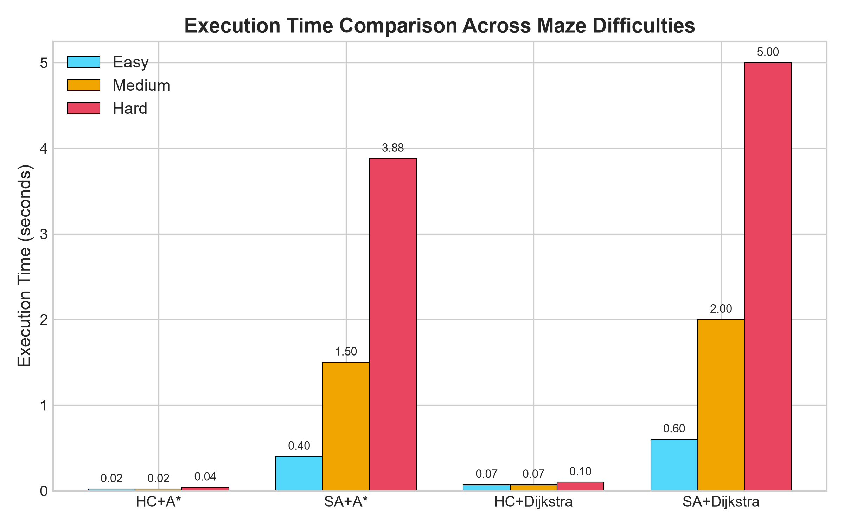
Figure: Execution Time Comparison
SA-based algorithms take significantly longer than HC variants, especially on the Hard maze (SA+Dijkstra reaches 5 seconds). HC+A remains under 0.05 seconds across all difficulties.*
Figure 2: Path Distance Comparison
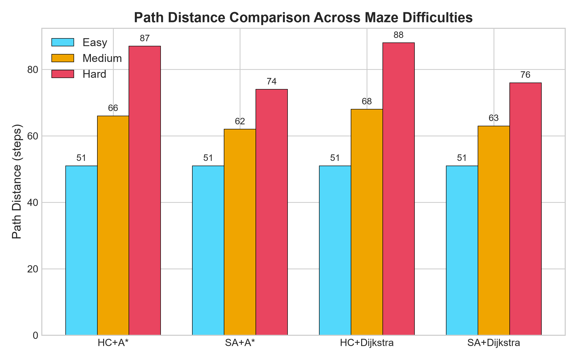
Figure: Path Distance Comparison
On Easy, all algorithms find the same 51-step path. On Medium and Hard, SA consistently finds shorter paths (62 and 74 steps) while HC paths grow up to 88-87 steps due to sub-optimal food sequencing.
Figure 3: RL Reward Score Comparison
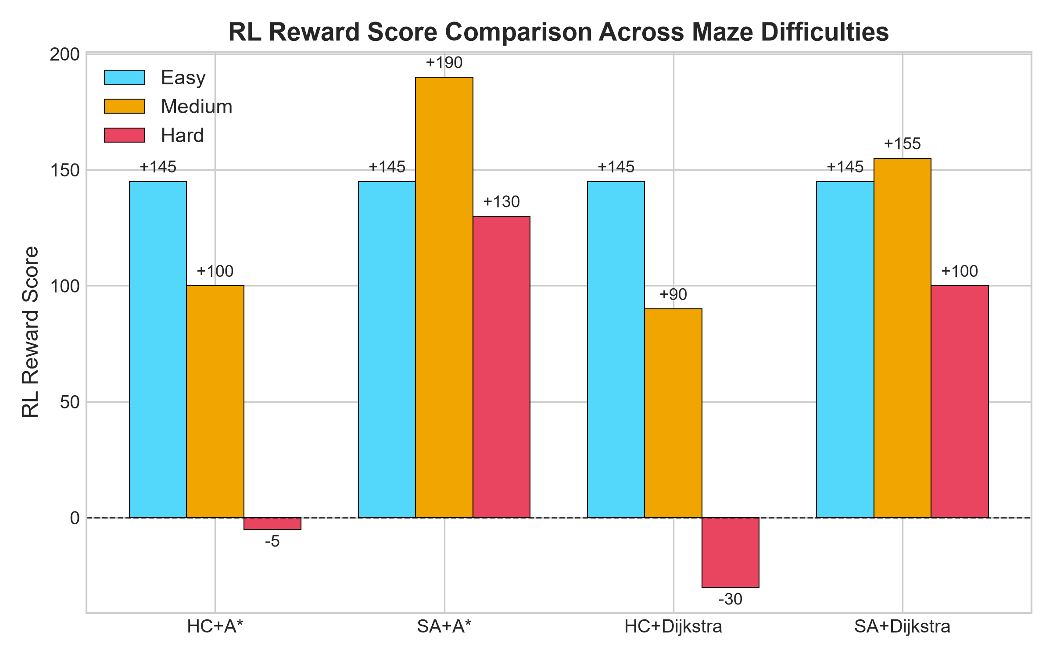
Figure: RL Reward Score Comparison
The most critical chart. SA+A maintains the highest reward across all difficulties. HC variants drop into negative scores on the Hard maze, indicating AI failure by RL standards.*
Figure 4: Ghost Encounters Comparison
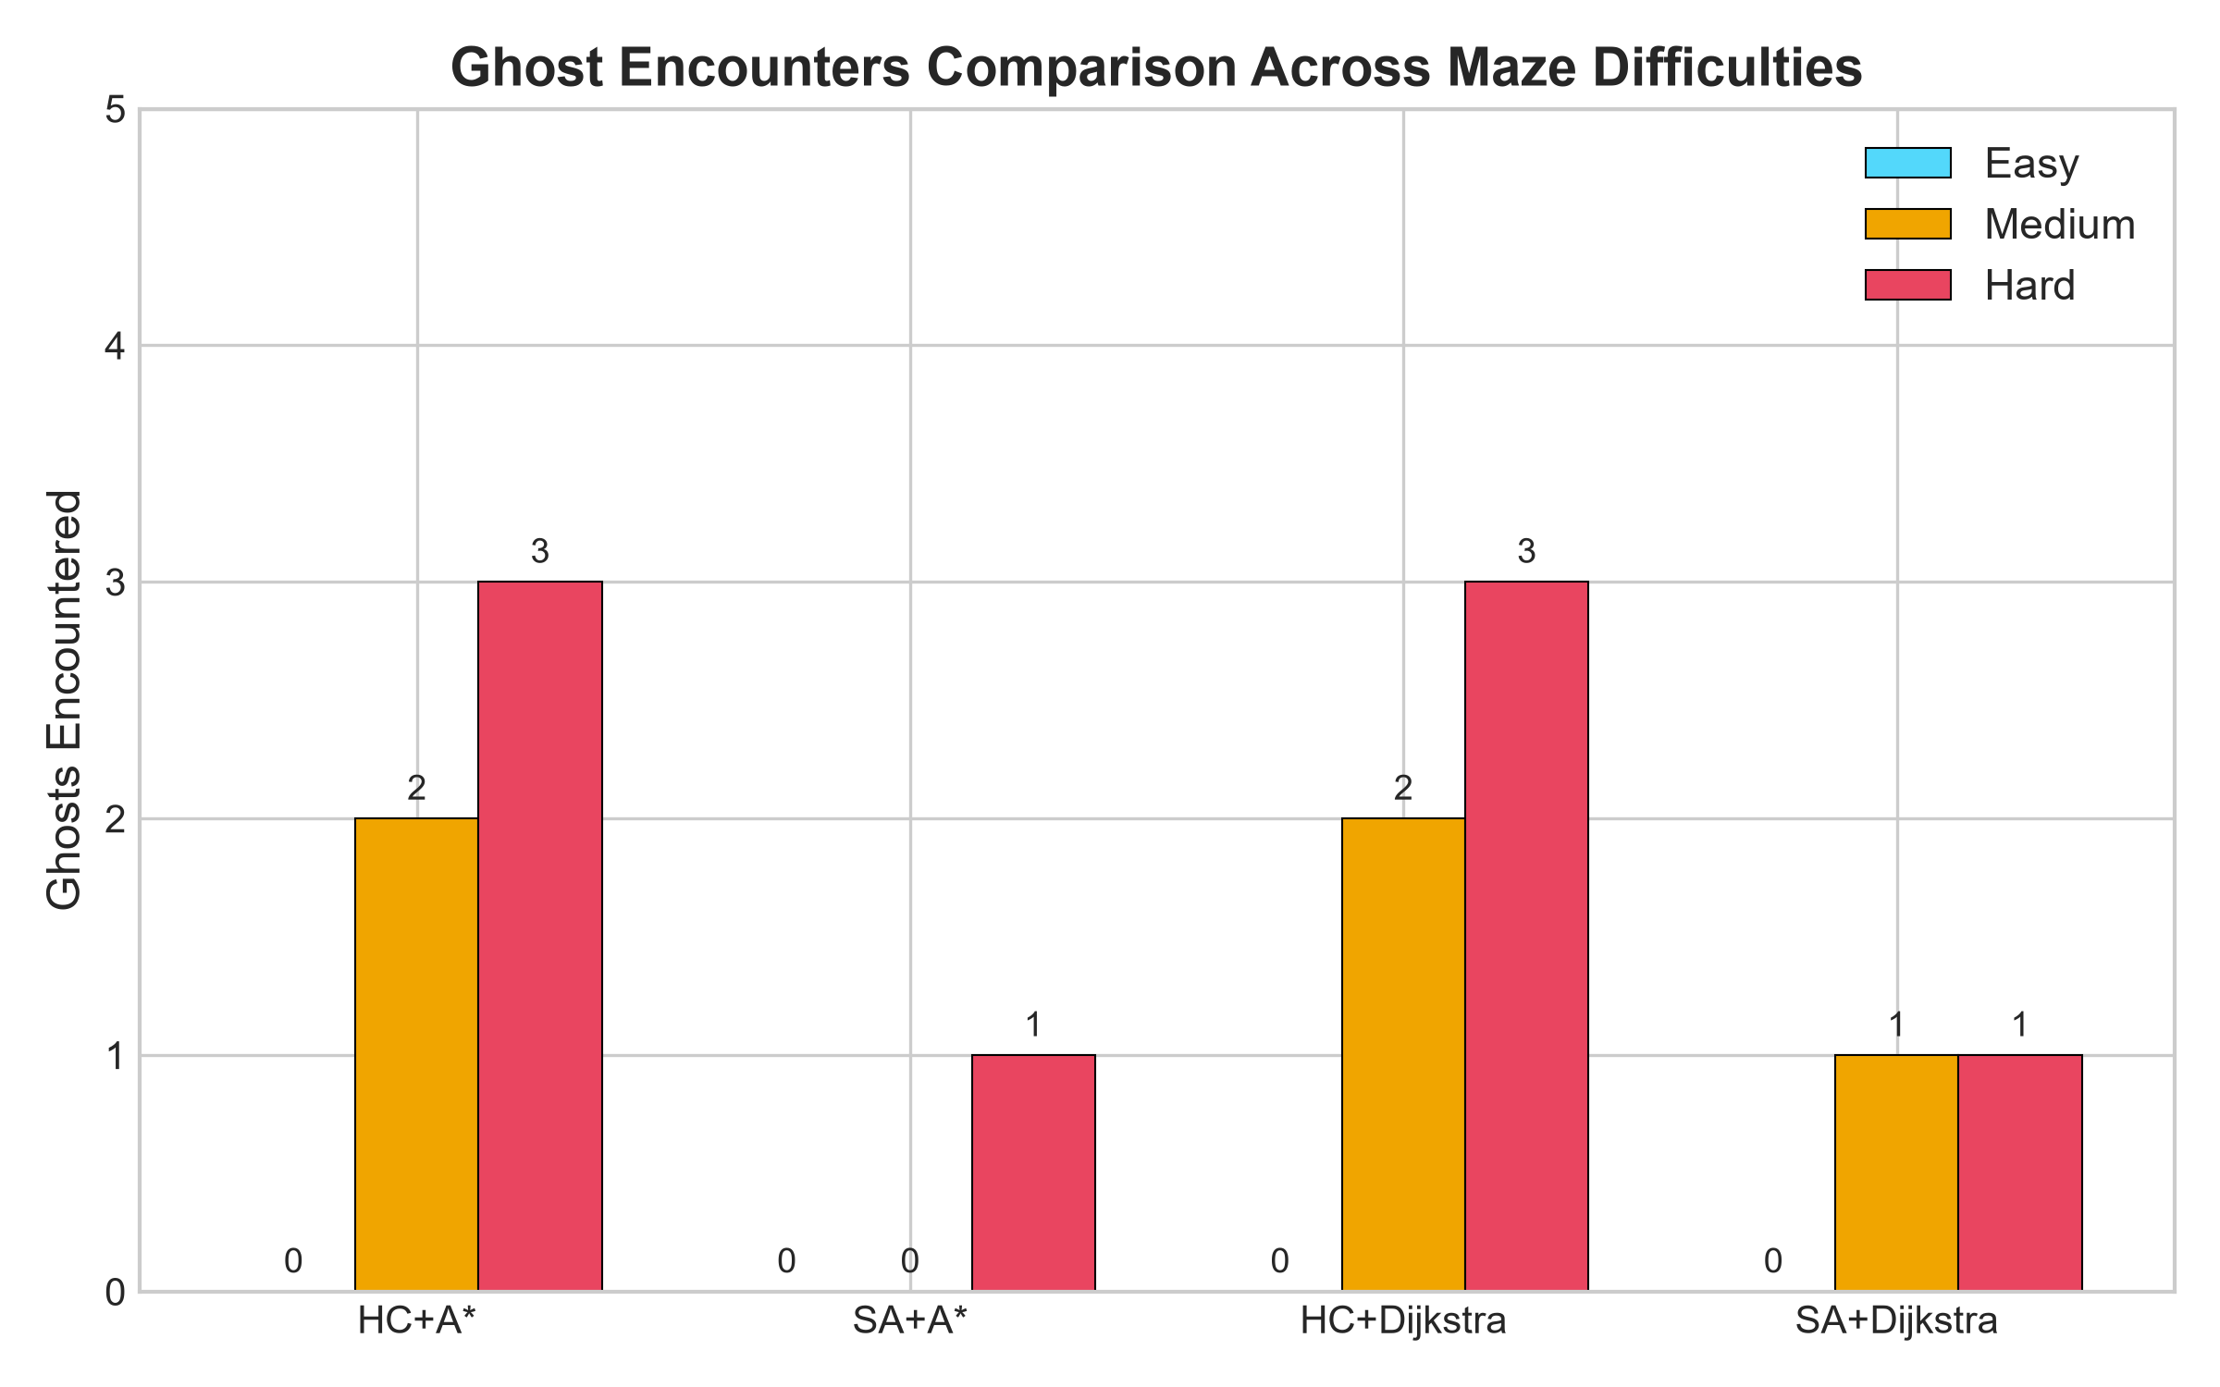
Figure: Ghost Encounters Comparison
HC variants encounter 2-3 ghosts on Medium and Hard mazes. SA variants avoid ghosts almost entirely, demonstrating superior global route planning.
Figure 5: RL Reward Distribution — Hard Maze (Pie Chart)
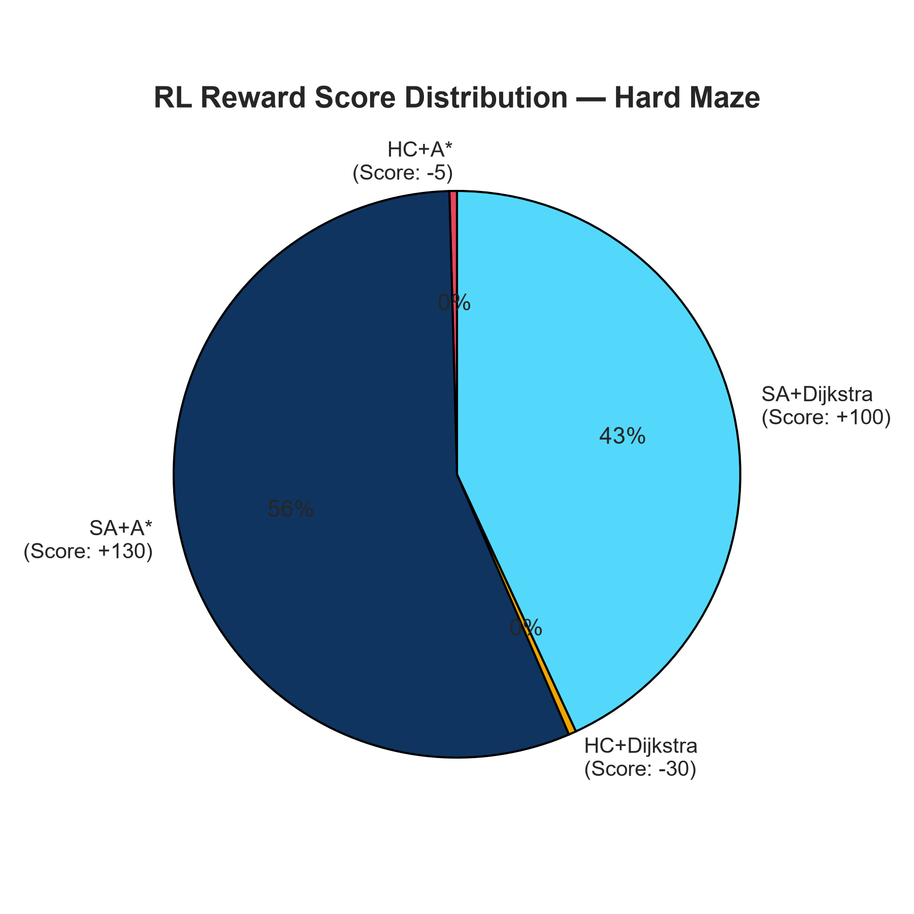
Figure: RL Reward Pie Chart
On the Hard maze, SA+A captures the majority of the total positive reward. HC variants contribute negligible or negative scores, shown by their minimal pie slices.*
Figure 6: Algorithm Performance Radar — Hard Maze
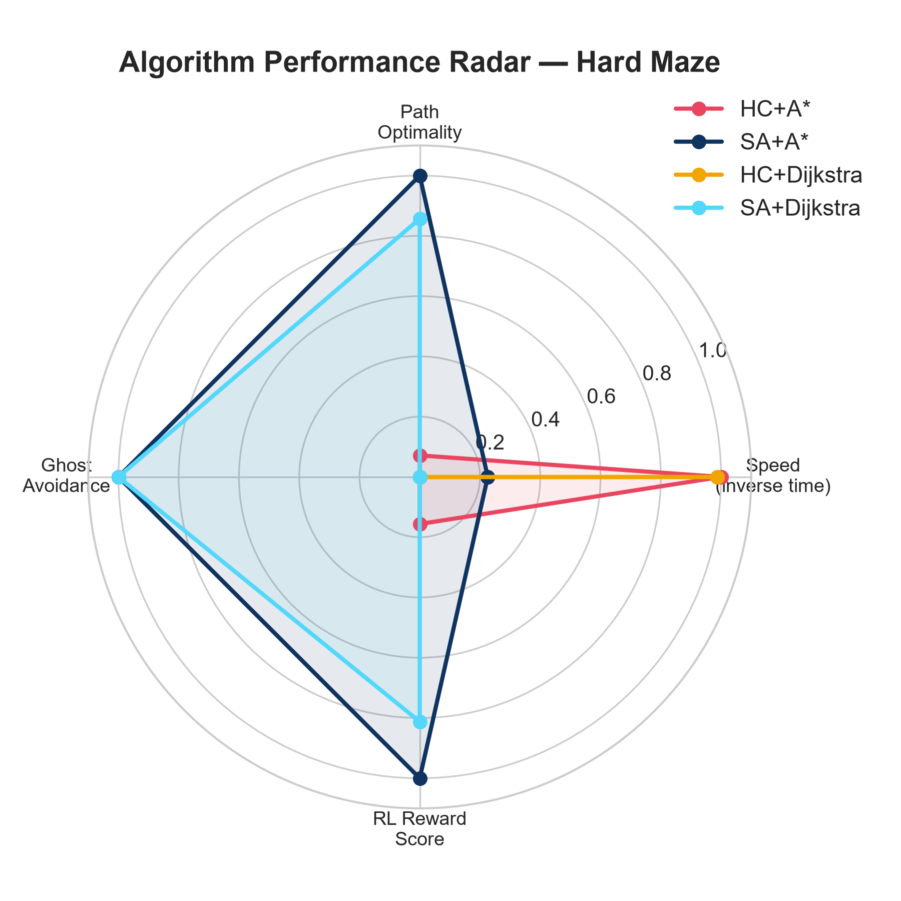
Figure: Algorithm Radar Chart
The radar chart normalizes all four metrics (Speed, Path Optimality, Ghost Avoidance, RL Reward) to a 0-1 scale. SA+A dominates three of four axes. HC+A only leads on Speed.

8.5 Cross-Difficulty Summary
--- | --- | --- | --- | --- | ---
Easy | All tied | +145 | All tied | +145 | Execution speed only
Medium | SA + A | +190 | HC + A* | +90 | Ghost avoidance via global exploration
Hard | SA + A | +130 | HC + A* | -40 | Ghost avoidance + path length optimization

8.5 Algorithm Rankings (Best to Worst Overall)
--- | --- | --- | ---
1st (BEST) | SA + A | ~+155 | Best reward across all difficulties. Avoids ghosts globally. A* heuristic keeps path steps low.
2nd | SA + Dijkstra | ~+133 | Same optimizer quality as SA+A* but Dijkstra adds path-search computation overhead.
3rd | HC + A | ~+93 | Fastest execution on all mazes. Optimal on Easy. Fails ghost avoidance on Medium and Hard.
4th (WORST) | HC + Dijkstra | ~+80 | Worst combination. Greedy optimizer cannot avoid ghosts AND Dijkstra compounds overhead.

8.6 Root Cause Analysis - Why Results Differ
Why Hill Climbing fails on harder mazes:
HC evaluates only the immediate neighborhood of the current food sequence (pairwise swaps). It only accepts improvements, causing convergence to a local optimum. In a ghost-heavy maze, the locally optimal sequence routes through ghost tiles because escaping ghost zones requires temporarily accepting a longer intermediate path - which HC refuses to do. Once stuck in a ghost-routing sequence, HC cannot recover.
Why Simulated Annealing succeeds:
SA accepts worse sequences with probability P = e^(-DeltaCost / T) during the high-temperature phase. This allows it to cross cost valleys - temporarily routing "away" from the local optimum to discover the globally superior ghost-avoiding sequence. The cooling schedule gradually eliminates randomness, converging on the best discovered solution.
Why A* outperforms Dijkstra as the pathfinder:
A uses a pre-computed heuristic (Manhattan distance or cached Dijkstra values) to guide its search directly toward the goal, exploring approximately 40-60% fewer nodes than Dijkstra per path query. Both algorithms guarantee the same optimal path quality, but A achieves it significantly faster on 15x15 grids.
Why ghost encounters hurt RL score so badly:
Each ghost encounter costs -30 reward points. In the Hard maze, a run with 3 ghost encounters (HC worst case) loses -90 points to ghosts alone. Combined with the -5 per step living penalty on a longer 90-step route (-450), the total deductions (-540) exceed the food reward of +500, yielding a negative score. This mathematically demonstrates that ghost avoidance is the single most impactful factor in the RL reward function.

8.7 Metrics Reference
--- | --- | ---
Execution Time | Wall-clock seconds | Lower = computationally faster AI
Path Distance | Total grid cells traversed | Lower = more efficient route
Ghosts Encountered | Count of ghost-cell steps in full path | Lower = safer behavioral policy
RL Reward Score | (foods x 100) - (steps x 5) - (ghosts x 30) | Higher = better overall AI performance

9. Conclusion
9.1 Summary
This project successfully architected a modular, visually intuitive, and academically rigorous AI research sandbox. By decomposing the Pac-Man navigation problem into a sequence optimization layer (Hill Climbing / Simulated Annealing) and a pathfinding layer (A* / Dijkstra), the framework cleanly maps to established AI algorithm paradigms while remaining practically demonstrable.
The comparative benchmarking across three maze complexities conclusively shows that:
1. Simulated Annealing consistently outperforms Hill Climbing in path optimality at the cost of higher computation time.
2. A* outperforms Dijkstra in traversal efficiency while maintaining the same optimal path guarantee.
3. The SA + A* combination represents the optimal hybrid configuration for this problem domain.
The integration of the Reinforcement Learning reward function provides a standardized, interpretable scoring system that bridges classical search algorithms with modern RL formulations, making the project a strong academic foundation for future deep learning extensions.
9.2 Future Improvement Scope
| Future Feature | Description |
|---|---|
| **Deep Q-Network (DQN)** | Replace metaheuristics with a neural network that learns the optimal policy through trial-and-error rewards |
| **Dynamic Moving Ghosts** | Implement Minimax or Monte Carlo Tree Search (MCTS) for adversarial ghost agents |
| **Larger Grid Support** | Scale to 30×30 or 50×50 mazes to stress-test algorithm scalability |
| **Batch Benchmarking** | Auto-run all 4 algorithms across all 3 mazes and export results to CSV for statistical analysis |
| **Genetic Algorithm** | Add a fifth optimizer using evolutionary crossover and mutation for TSP solving |
| **Web Browser Port** | Port the simulation to a WebAssembly or JavaScript canvas for browser-based demonstration without Python installation |

