*Knowledge & Technology*

**Bangladesh Army University of Engineering & Technology (BAUET)**

**Qadirabad, Natore-6431**



**Course Code:** CSE-2218

**Course Title:** Advanced Programming Sessional

**Name of the Title:** Library Management System

|  |  |
| --- | --- |
| **Submitted to:** | |
| Redoanul Haque | Lecturer, Dept. of CSE, BAUET |
| **Submitted by:** | |
| Maisha Tasmim | ID: 0812210105101003 |
| Yousuf Oley | ID: 0812210205101029 |
| Ratul Hasan | ID: 0812210205101031 |
|  |  |
| Batch: 15th | |
| Session: 2021-22 | |
| Department of Computer Science and Engineering, BAUET | |

|  |  |  |
| --- | --- | --- |
| **List of contents** | | |
| **Chapter** | **Title** | **Page No.** |
| **1** | **Introduction** | 1-4 |
|  | 1.1 Introduction | 1 |
|  | 1.2 Background | 2 |
|  | 1.3 Objectives | 3 |
|  | 1.4 Conclusion | 4 |
| **2** | **Literature Review** | 5-7 |
|  | 2.1 Introduction | 5 |
|  | 2.2 Recommendations | 5 |
|  | 2.3 Conclusion | 7 |
| **3** | **Methodology** | 8-14 |
|  | 3.1 Introduction | 8 |
|  | 3.2 Requirements Elicitation and Analysis | 8 |
|  | 3.3 System Design | 8 |
|  | 3.4 Implementation | 8 |
|  | 3.5 Testing and Quality Assurance | 9 |
|  | 3.6 Deployment and Evaluation | 9 |
|  | 3.7 Use Case Diagram | 10 |
|  | 3.8 Sequence Diagram | 11 |
|  | 3.9 Data Flow Diagram | 12 |
|  | 3.10 Entity Relationship Diagram | 13 |
|  | 3.11 Conclusion | 14 |
| **4** | **Results and Discussions** | 15-23 |
|  | 4.1 Introduction | 15 |
|  | 4.2 Conclusion | 23 |
| **5** | **Conclusion** | 24-27 |
|  | 5.1 Introduction | 24 |
|  | 5.2 Future Scope/Work | 24 |
|  | 5.3 Conclusion | 26 |
|  | **References** | 27 |

|  |  |  |
| --- | --- | --- |
|  | **List of figures** |  |
| **Figure No.** | **Title** | **Page No.** |
| 3.1 | Use Case Diagram | 10 |
| 3.2 | Sequence Diagram | 11 |
| 3.3 | Data Flow Diagram | 12 |
| 3.4 | Entity Relationship Diagram | 13 |
| 4.1 | Login Page | 15 |
| 4.2 | Register Page | 16 |
| 4.3 | Main Menu | 17 |
| 4.4 | Member Page | 17 |
| 4.5 | ID Card Generate | 18 |
| 4.6 | Book Category | 18 |
| 4.7 | Book Author | 19 |
| 4.8 | Book Publisher | 19 |
| 4.9 | Book Issue | 20 |
| 4.10 | Search Book | 20 |
| 4.11 | Book Add/Delete | 21 |
| 4.12 | Renew Book | 21 |
| 4.13 | Return Book | 22 |
| 4.14 | Reserve Book | 22 |

**Chapter 1**

**Introduction**

**1.1 Introduction**

A Library Management software for monitoring and controlling the transactions in a library. The project Library Management System is developed in JAVA, which mainly focuses on basic operations in a library like adding new books, and updating new information, searching books and members and return books. This project of “LIBRARY MANAGEMENT SYSTEM” of gives us the complete information about the library. We can enter the record of new books and retrieve the details of books available in the library. We can issue the books to the students and maintain their records and can also check how many books are issued and stock available in the library. In this project we can maintain the late fine of students who returns the issued books after the due date. Throughout the project the focus has been on presenting information and comments in an easy and intelligible manner. In today's digital age, efficient management of library resources is crucial for educational institutions and organizations alike. A robust Library Management System (LMS) not only simplifies the process of cataloging and lending books but also enhances the overall library experience for both librarians and patrons. Our Java Swing-based Library Management System project aims to provide a comprehensive solution for libraries to streamline their operations. This project leverages the power of Java programming and the user-friendly interface of Swing to create an intuitive and responsive application. Libraries play a vital role in education and knowledge dissemination, but traditional manual systems often struggle to keep pace with modern demands. Our project aims to bridge this gap by leveraging Java Swing to create a dynamic and user-friendly interface. Librarians can efficiently catalog books, manage memberships, and facilitate transactions with automated tracking of due dates and fines. Additionally, our system supports seamless integration with external databases, enabling librarians to enrich their collections and provide a wider range of materials to patrons. Data integrity and security are paramount in any information management system, especially in a library setting where privacy and confidentiality are essential. By utilizing MySQL for database management, we ensure robust data storage and retrieval while prioritizing security measures to protect sensitive information. Our project exemplifies the versatility and power of Java Swing in crafting responsive, interactive, and enterprise-grade applications. Java Swing's graphical user interface (GUI) components enable us to design a visually appealing interface that is both intuitive and functional. From simple data entry forms to complex search algorithms, Java Swing empowers us to deliver a seamless user experience that enhances productivity and efficiency. In summary, our Java Swing-based Library Management System project represents a significant leap forward in modernizing library operations through technology. By combining the power of Java Swing with robust database management, we are empowering libraries to embrace digital transformation and deliver enhanced services to patrons. This project underscores the importance of innovation in ensuring that libraries remain relevant and accessible in an increasingly digital world.

**1.2 Background**

Traditional library systems often rely on manual processes and outdated technology, leading to inefficiencies in cataloging, membership management, and resource accessibility. These systems struggle to meet the evolving needs and expectations of patrons in today's digital era. Recognizing this challenge, the “Library Management System” was conceptualized and developed as a solution.

**Need for Modernization and Enhanced User Experience:**

Libraries are striving to modernize their operations and deliver enhanced services to patrons. There is a growing demand for innovative solutions that streamline operations, improve user experience, and leverage technology to optimize resource management.

**Inspiration for Developing a Java Swing-based Solution:**

The idea to develop a Java Swing-based Library Management System emerged from a recognition of these challenges and the desire to empower libraries with a robust, user-friendly, and scalable solution. Java Swing's versatility in creating graphical user interfaces (GUIs) and its compatibility with backend technologies like MySQL make it an ideal platform for building an intuitive and feature-rich library management application.

**Vision for Digital Transformation:**

The project background reflects a vision of leveraging technology to empower libraries and facilitate a seamless transition into the digital age. By developing a Java Swing-based Library Management System, the project aims to equip libraries with the tools they need to thrive in a digital-first environment and enrich the overall library experience for patrons.

**Collaborative Effort:**

The project represents a collaborative effort between technology enthusiasts and library professionals, united by a shared vision of leveraging innovation to support the essential role of libraries in communities worldwide. The goal is to create a solution that not only addresses operational challenges but also sets a new standard for efficiency and innovation in library services.

**1.3 Objectives**

**Streamlined Cataloging:** Develop a user-friendly interface that enables librarians to efficiently catalog books by entering and updating details such as title, author, genre, ISBN, and availability status, thereby optimizing the management of library resources.

**Enhanced Membership Management:** Implement features for managing member registrations, issuing library cards, and tracking borrowing history, ensuring smooth membership transactions and improving patron engagement.

**Efficient Transaction Processing:** Facilitate seamless book borrowing and return processes with automated due date tracking and fine calculation, reducing administrative overhead and enhancing user satisfaction.

**Advanced Search and Retrieval:** Integrate robust search functionality that allows patrons to quickly locate books based on various criteria (e.g., title, author, genre, ISBN), enhancing accessibility and usability of library resources.

**Data Integrity and Security:** Ensure data integrity and security through effective database management using MySQL, safeguarding sensitive information and maintaining confidentiality in library operations.

**Comprehensive Reporting and Analytics:** Enable generation of insightful reports on book circulation, popular genres, member demographics, and overdue items to support informed decision-making and strategic planning by library administrators.

**Scalability and Adaptability:** Design the system with a modular architecture to accommodate future enhancements and integrations, ensuring scalability and flexibility as library needs evolve in response to technological advancements and user demands.

**User-Focused Design:** Prioritize user experience by creating an intuitive and responsive GUI using Java Swing components, enhancing usability for both librarians and patrons and promoting wider adoption of the Library Management System.

**Promotion of Digital Transformation:** Contribute to the digital transformation of libraries by providing a modern, technology-driven solution that improves operational efficiency, promotes resource accessibility, and aligns with contemporary library practices.

**Collaborative Development Approach:** Foster collaboration between technology experts and library professionals to ensure that the Library Management System meets the specific needs and objectives of libraries, enhancing its relevance and impact within the library community.

**1.4 Conclusion**

Our Java Swing-based Library Management System project represents a significant advancement in modernizing library operations and enhancing user experience within today's dynamic digital landscape. By leveraging Java Swing's versatility and user-friendly interface capabilities, we have developed a comprehensive solution that addresses key challenges faced by traditional library systems while embracing the opportunities offered by modern technology. The primary goal of our project is to empower libraries with a robust and intuitive system that streamlines essential tasks such as cataloging, membership management, and transaction processing. Librarians benefit from simplified workflows that allow for efficient book entry, updates, and deletion, ensuring accurate and up-to-date records of the library's collection. Automated features for membership management, including issuing library cards and tracking borrowing history, facilitate smoother interactions with patrons and improve overall service delivery. One of the standout features of our Library Management System is its advanced search and retrieval capabilities. Patrons can easily locate books using various criteria such as title, author, genre, or ISBN, enhancing accessibility and promoting a positive user experience. This functionality is crucial in today's fast-paced digital world, where users expect instant access to information. Data integrity and security are paramount in any information management system, especially in a library setting where privacy and confidentiality are critical. By leveraging MySQL for database management, our system ensures robust data storage, retrieval, and security measures, providing peace of mind to both librarians and patrons. Looking ahead, our Java Swing-based Library Management System is designed to be scalable and adaptable, allowing for future enhancements and integrations as technology continues to evolve. We envision this project as a catalyst for positive change within the library community, facilitating improved resource management, enhanced user engagement, and ultimately, a more impactful role for libraries in enriching the lives of patrons and communities they serve. In summary, our project exemplifies the transformative potential of technology in modernizing traditional library services and enhancing user experiences. By embracing innovation and collaboration between technology experts and library professionals, we have developed a solution that not only addresses current operational challenges but also sets a new standard for efficiency, innovation, and excellence in library management. We are excited about the positive impact our Java Swing-based Library Management System will have on libraries and look forward to its continued evolution and adoption within the library community.

**Chapter 2**

**Literature Review**

**2.1 Introduction**

The literature review presented here explores the intersection of library management systems and Java Swing technology, focusing on the utilization of Java Swing for developing user interfaces in library management applications. Library management systems play a crucial role in facilitating efficient library operations, and the choice of technology for developing these systems significantly impacts their usability, scalability, and overall effectiveness. Java Swing, a powerful GUI toolkit provided by the Java programming language, offers libraries a versatile platform for creating visually appealing and interactive interfaces. The integration of Java Swing into library management systems enables librarians to streamline tasks such as cataloging books, managing memberships, and processing transactions with enhanced efficiency and usability. By synthesizing information from diverse sources including academic journals, conference proceedings, books, and technical documentation, this literature review aims to provide a comprehensive overview of the current state of knowledge and research trends in the field. It will highlight key insights, challenges, and opportunities associated with the integration of Java Swing technology into library management systems, offering valuable insights for practitioners, researchers, and developers in the library and information science domain. Through this review, we seek to identify gaps in existing literature, elucidate areas for further exploration or improvement, and inform the development and implementation of Java Swing-based solutions for modernizing library operations. Ultimately, this exploration aims to contribute to the advancement of technology-driven library services and promote innovation in the field of library management systems.

Java Swing in Library Management Systems: Investigating how Java Swing has been utilized in the development of library management systems to enhance user experience, improve system performance, and promote scalability.

**2.2 Recommendations**

**User Interface Design**: Exploring best practices and design principles for developing intuitive and user-friendly interfaces using Java Swing components, tailored specifically for library management applications.

**Integration with Backend Technologies:** Examining strategies for integrating Java Swing with backend technologies such as MySQL for data storage and management, ensuring data integrity and security in library operations.

**Impact on Library Operations:** Assessing the impact of Java Swing-based library management systems on operational efficiency, resource accessibility, and user satisfaction within library settings.

**Usability and Accessibility:** Investigate how Java Swing interfaces contribute to the usability and accessibility of library management systems for diverse user groups, including librarians, staff, and patrons with varying levels of technological proficiency.

**Cross-Platform Compatibility:** Explore how Java Swing's platform-independent nature enhances the portability and interoperability of library management applications across different operating systems, devices, and environments.

**Graphical Data Visualization:** Examine the use of Java Swing components for creating graphical representations of library data, such as circulation trends, collection analytics, and user demographics, to support data-driven decision-making by library administrators.

**Customization and Extensibility:** Evaluate the flexibility of Java Swing for customizing and extending library management interfaces to accommodate unique library workflows, preferences, and institutional requirements.

**Integration with External Services:** Discuss strategies for integrating Java Swing-based library management systems with external services and APIs (e.g., bibliographic databases, authentication systems) to enhance functionality and expand access to resources.

**Performance Optimization:** Review techniques for optimizing the performance and responsiveness of Java Swing interfaces in large-scale library environments, considering factors such as data caching, asynchronous processing, and resource allocation.

**User Experience Design Principle**s**:** Examine principles of user experience (UX) design applied to Java Swing interfaces in library contexts, focusing on factors such as navigation flow, visual hierarchy, feedback mechanisms, and accessibility standards.

**Maintenance and Support:** Investigate best practices for maintaining and supporting Java Swing-based library management systems over the long term, including considerations for updates, bug fixes, and end-user training.

**Comparative Analysis:** Conduct a comparative analysis of Java Swing against other GUI frameworks (e.g., JavaFX, HTML/CSS/JavaScript) used in library management applications, highlighting strengths, weaknesses, and suitability for specific use cases.

**Case Studies and Implementation Examples:** Explore real-world case studies and implementation examples of Java Swing-based library management systems deployed in academic, public, and special libraries, showcasing successful deployments, lessons learned, and innovation in practice.

**2.3 Conclusion**

This literature review has provided a comprehensive exploration of the intersection between library management systems and Java Swing technology, highlighting the role of Java Swing in enhancing user interfaces and optimizing functionality within library environments. Through an in-depth analysis of existing research and scholarly works, several key insights and implications have emerged that underscore the significance of Java Swing in modernizing library operations and improving user experiences. The review has demonstrated that Java Swing offers a versatile platform for developing intuitive, visually appealing, and cross-platform interfaces tailored specifically for library management applications. By leveraging Java Swing's graphical components and event-driven programming model, libraries can streamline essential tasks such as cataloging, membership management, and transaction processing, leading to increased operational efficiency and user satisfaction. Additionally, the literature review has highlighted the importance of usability, accessibility, and customization in Java Swing-based library interfaces, emphasizing the need to design interfaces that cater to diverse user groups and accommodate unique library workflows and preferences. The platform-independent nature of Java Swing further enhances the portability and interoperability of library management systems across different computing environments, facilitating widespread adoption and scalability. Furthermore, the review has identified challenges and opportunities associated with integrating Java Swing with backend technologies such as MySQL, emphasizing the importance of data integrity, security, and performance optimization in library operations. By exploring strategies for graphical data visualization, external service integration, and user experience design principles, the literature review has elucidated best practices for maximizing the effectiveness and impact of Java Swing-based library interfaces. Looking ahead, future research directions may include exploring emerging technologies and alternative GUI frameworks to complement or augment Java Swing in library management applications. Additionally, empirical studies and case analyses of Java Swing deployments in real-world library settings can provide valuable insights into the practical implications and outcomes of adopting Java Swing for library modernization. In summary, this literature review contributes to the ongoing scholarly discourse on library technology by synthesizing existing knowledge, identifying gaps and challenges, and proposing avenues for future research and innovation. By embracing Java Swing as a foundational technology for library interface development, libraries can leverage its capabilities to deliver enhanced services, optimize resource management, and ultimately, enrich the overall library experience for patrons and stakeholders.

**Chapter 3**

**Methodology**

**3.1 Introduction**

The methodology section of this project outlines the systematic approach and techniques employed to develop the Java Swing-based Library Management System. This section details the steps taken to design, implement, and evaluate the system, ensuring robustness, efficiency, and usability throughout the development lifecycle. The methodology encompasses various stages, including requirements gathering, system design, implementation, testing, and deployment, all aimed at achieving the project's objectives effectively. The development of the Library Management System follows a structured methodology that integrates principles of software engineering with specific considerations for Java Swing application development. The methodology emphasizes iterative and incremental development, allowing for continuous feedback and refinement based on stakeholder input and usability testing.

**3.2 Requirements Elicitation and Analysis**

This initial phase involves gathering requirements from stakeholders, including librarians, administrators, and potential users, to define functional and non-functional requirements for the system. Detailed analysis is conducted to understand user needs, workflows, and system constraints.

**3.3 System Design**

Based on the requirements analysis, the system architecture and design are conceptualized. This phase includes defining the overall system structure, database schema, user interface layout using Java Swing components, and interaction flows.

**3.4 Implementation**

The system is developed using Java programming language and the Swing framework. Coding practices adhere to best practices and design patterns to ensure maintainability, scalability, and modularity of the codebase.

Available Technology:

Language: Java

DBMS: Offline

MySQL Database Server: Xampp

Development Platform: Apache Netbeans IDE

Tools Used:

OS: Windows 10

Hardware Used:

Processor: Intel Core i7 8750H

RAM: 16 GB

SSD: 512GB

HDD: 1TB

**3.5 Testing and Quality Assurance**

Rigorous testing is performed at multiple levels, including unit testing of individual components, integration testing of system modules, and user acceptance testing (UAT) to validate system functionality against specified requirements.

**3.6 Deployment and Evaluation**

The system is deployed in a controlled environment, and user feedback is solicited to assess usability, performance, and overall satisfaction. Iterative improvements and bug fixes are incorporated based on evaluation results.

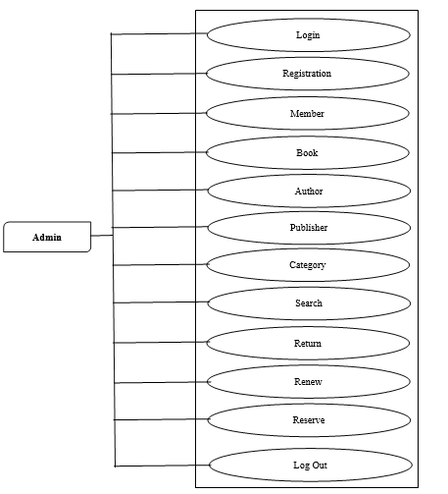**3.7 Use Case Diagram**

Fig 3.1: Use Case Diagram

**3.8 Sequence Diagram**

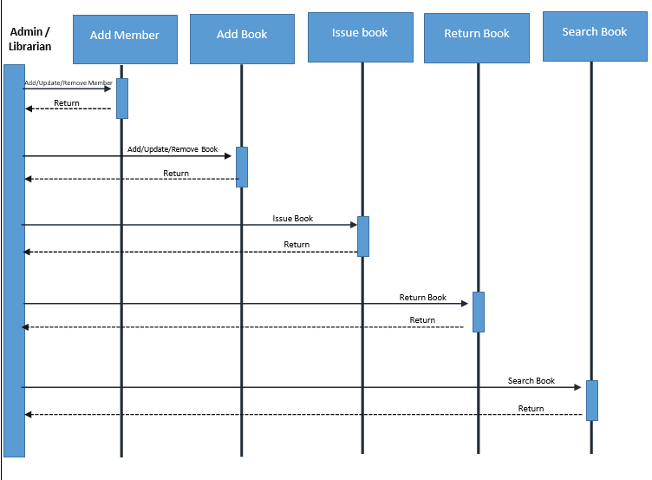

Fig 3.2: Sequence Diagram

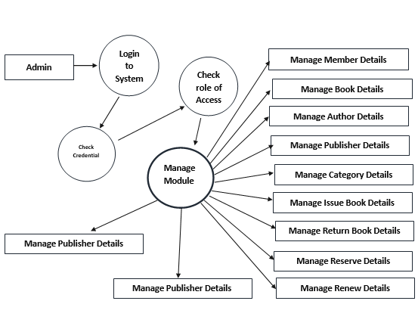**3.9 Data Flow Diagram**

Fig 3.3: Data Flow Diagram

**3.10 Entity Relationship Diagram**

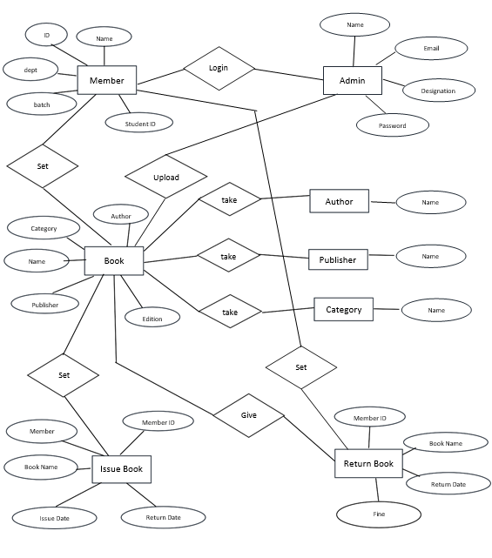

Fig 3.4: Entity Relationship Diagram

**3.11 Conclusion**

The methodology adopted for developing the Java Swing-based Library Management System has facilitated a systematic and structured approach to software development, ensuring the delivery of a robust, user-friendly, and feature-rich application. Through a series of well-defined stages, including requirements elicitation, system design, implementation, testing, and deployment, the methodology has enabled the project team to achieve the project's objectives effectively while adhering to industry best practices and standards. One of the key strengths of the methodology lies in its emphasis on stakeholder engagement and requirements analysis. By actively involving librarians, administrators, and potential users in the requirements gathering process, the development team gained valuable insights into user needs, workflows, and system functionalities. This user-centered approach has ensured that the Library Management System is tailored to address specific challenges faced by libraries and aligns closely with end-user expectations. The system design phase played a critical role in defining the architecture and structure of the application. Through careful consideration of database schema, user interface layout using Java Swing components, and interaction flows, the design phase laid the foundation for a scalable and maintainable system. The implementation phase leveraged industry-standard coding practices and design patterns to translate design specifications into functional code, promoting code reusability and modularity. Quality assurance and testing were integral components of the methodology, with rigorous testing conducted at each stage of development. Unit testing, integration testing, and user acceptance testing (UAT) were employed to validate system functionality, identify defects, and ensure compliance with specified requirements. The iterative nature of testing allowed for continuous improvement and refinement of the Library Management System. Deployment and evaluation marked the final stages of the methodology, focusing on the successful rollout of the system and gathering user feedback. User documentation and training sessions were provided to facilitate smooth adoption and utilization of the application by librarians and administrators. Overall, the methodology exemplifies a disciplined and collaborative approach to software development, emphasizing transparency, accountability, and continuous improvement. By adhering to this methodology, the project team has successfully delivered a Java Swing-based Library Management System that not only meets the technical requirements but also addresses the practical needs of library stakeholders. Moving forward, the lessons learned from this methodology will inform future projects and contribute to the ongoing enhancement of library services through innovative technology solutions. Throughout the methodology, project management principles such as task scheduling, resource allocation, and risk management are integrated to ensure project milestones are achieved within budget and timeline constraints. By following this structured methodology, the development team aims to deliver a high-quality and robust Java Swing-based Library Management System that meets the needs of library stakeholders, enhances operational efficiency, and contributes to the advancement of library services in the digital age. The methodology emphasizes collaboration, transparency, and continuous improvement, fostering a systematic approach to software development that aligns with industry standards and best practices.

**Chapter 4**

**Result and Discussion**

**4.1 Introduction**

Here, our website Library Management System (LMS) is implemented in Java. This system offers a comprehensive suite of features to streamline library operations, improve efficiency, enhance the user experience for both librarians and patrons and give complete information about the library. One can enter the record of new books and retrieve the details of books available in the library. One can issue both hard copy and online copies of books to the students and issue them library cards by pdf generation and print system which will also work for issuing books and maintaining their records and can also check how many books are issued and stock available in the library. Here are some pictures of our work.

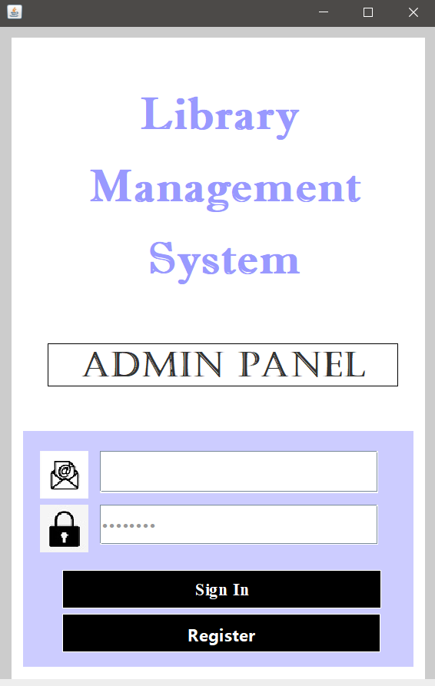Snapshots of our JAVA SWING Library Management Project:

Fig 4.1: Login Page

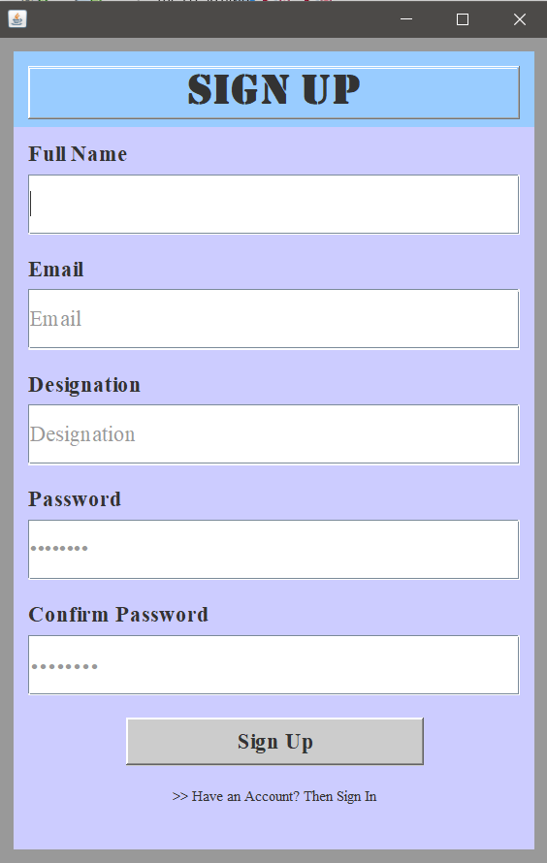

Fig 4.2: Register Page

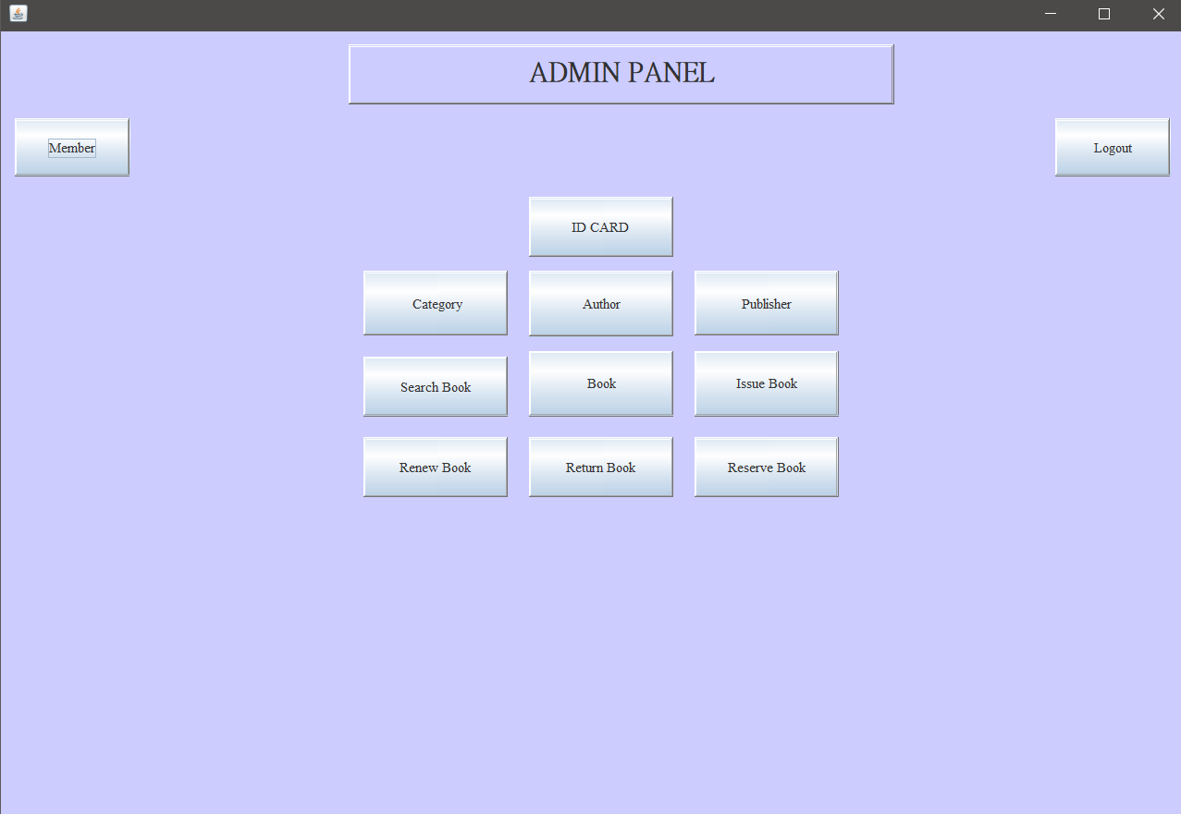

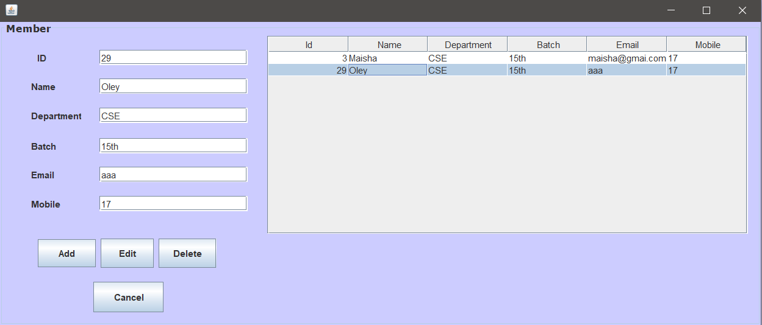Fig 4.3: Main Menu

Fig 4.4: Member Page

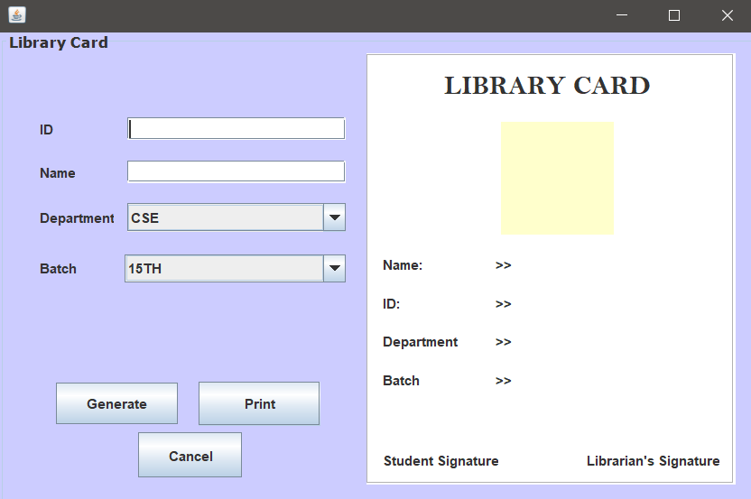

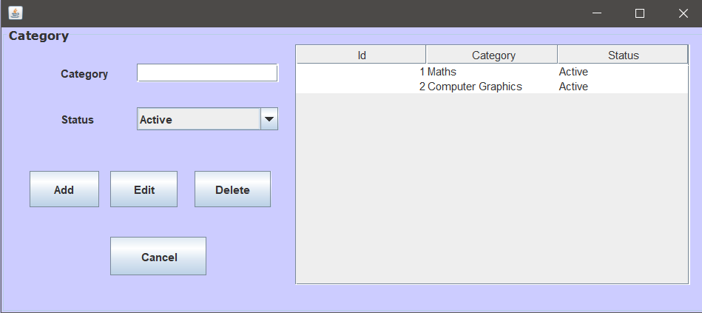Fig 4.5: ID Card Generate

Fig 4.6: Book Category

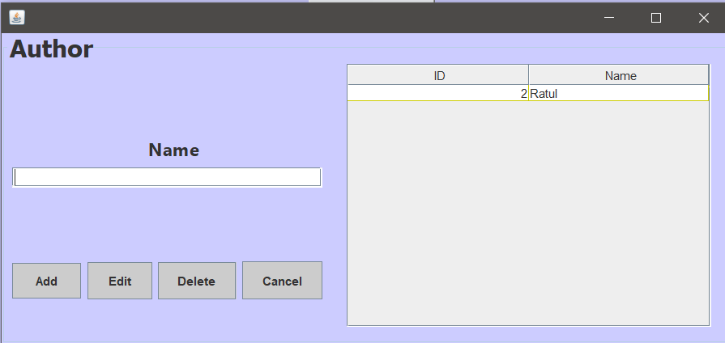

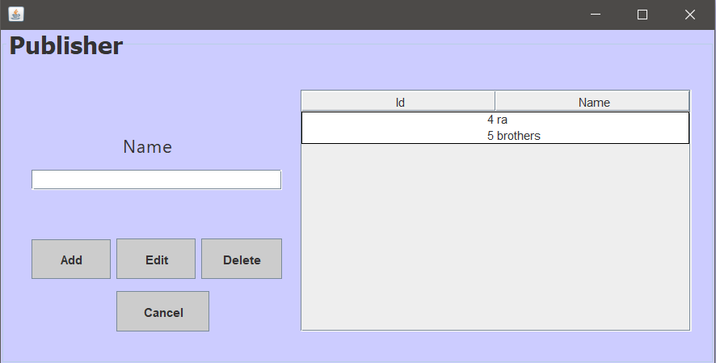Fig 4.7: Book Author

Fig 4.8: Book Publisher

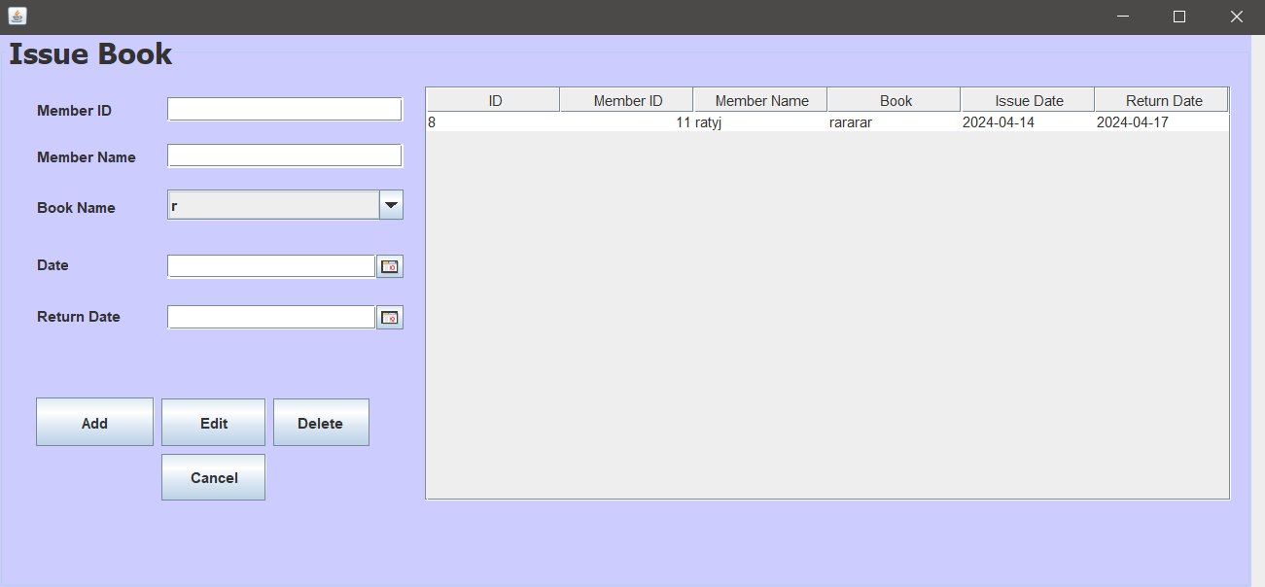

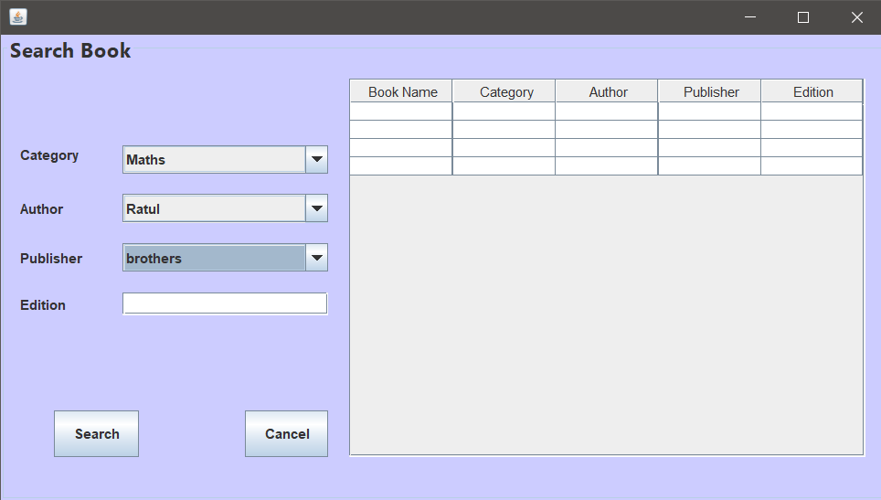Fig 4.9: Book Issue

Fig 4.10: Search Book

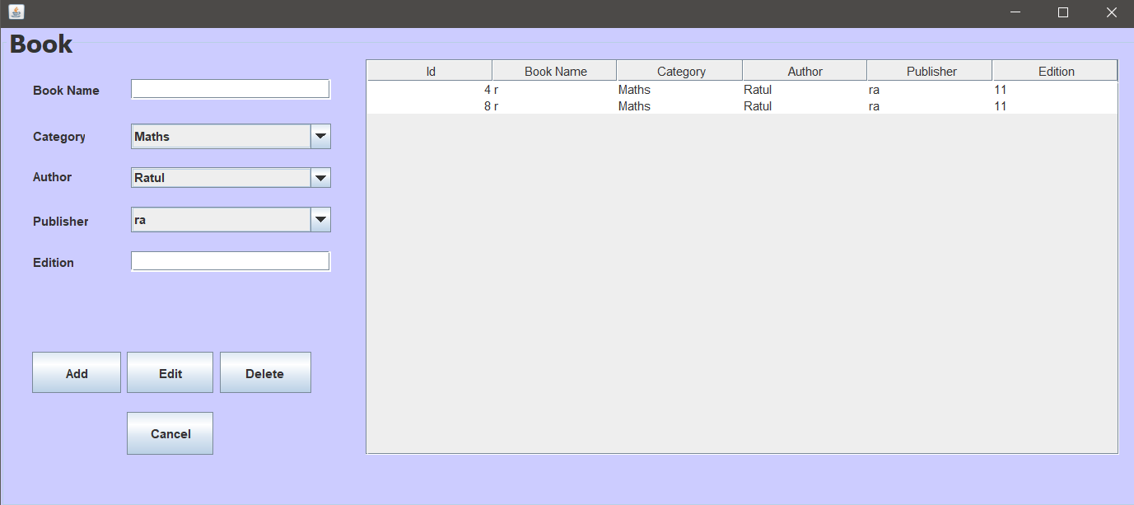

Fig 4.11: Book Add/Delete

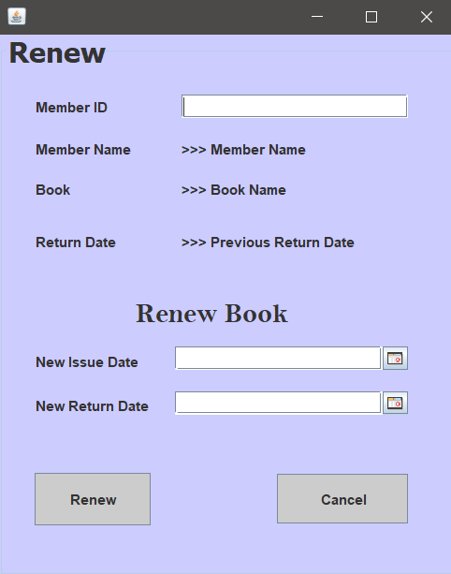

Fig 4.12: Renew Book

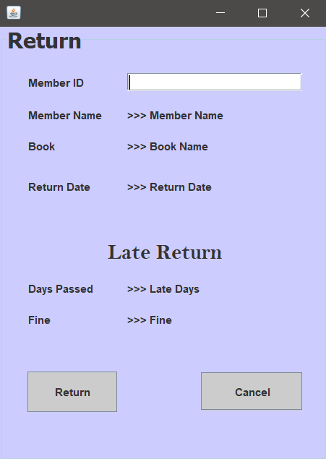

Fig 4.13: Return Page

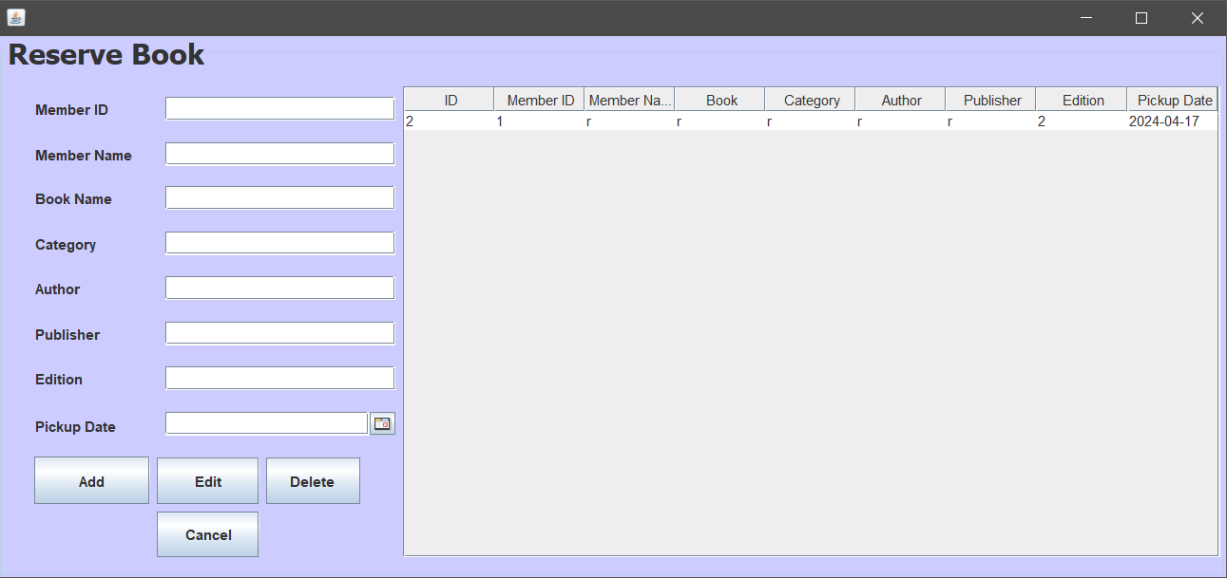

Fig 4.14: Reserve Book

**4.2 Conclusion**

The developed Library Management System (LMS) represents a significant advancement in library operations. By leveraging the power of Java programming, this system offers a comprehensive solution for managing resources, streamlining workflows, and enhancing the user experience for both librarians and patrons. the efficiency. The proposed Library Management System in this proposal will be a computerized management system developed to maintain all the daily records of the library. Library management systems are designed to store all the information about books and members. The main focus of this project is to lessen human effort and encourage efficient record-keeping. Though we are making an offline version. If we can make an online version and a student (Member) viewing section by creating an account on this system implemented features, such as catalog management, circulation control, patron management, and reporting functionalities, address critical aspects of library administration. The system automates time-consuming tasks, improves data accuracy and organization, and fosters a more efficient and user-friendly library environment. Beyond the immediate benefits, the LMS paves the way for future advancements. Integration with emerging technologies like mobile applications and self-service kiosks can further enhance accessibility and user convenience. Additionally, the system's data collection capabilities provide valuable insights for collection development, resource allocation, and service optimization. By analyzing user behavior and resource usage patterns, libraries can tailor their offerings to meet the evolving needs of their patrons. In the broader context, a well-functioning LMS plays a crucial role in promoting information access and fostering a culture of lifelong learning. By simplifying resource discovery, facilitating borrowing processes, and providing a user-centric experience, libraries can empower individuals to engage with knowledge and enrich their lives. The developed LMS serves as a valuable tool in this endeavor, ensuring libraries remain dynamic and relevant in the digital age.

**Chapter 5**

**Conclusion**

**5.1 Introduction**

In the digital age, efficient management of resources is paramount for any institution, especially libraries. With the proliferation of information and the growing need for streamlined processes, the implementation of robust library management systems becomes imperative. Our project, aptly named "Library Management System," aims to address these challenges by providing a comprehensive and user-friendly platform for managing library operations Our project harnesses the power and versatility of the Java programming language to deliver a robust and scalable library management system. Java's object-oriented approach enables us to design modular and maintainable code, facilitating easier enhancements and updates as the needs of libraries evolve. Additionally, Java's platform independence ensures compatibility across different operating systems, making our system accessible to a wide range of users. To manage the vast array of library resources and user data efficiently, we have integrated a reliable and efficient database system into our project. We have opted for **MySQL** as our database management system due to its proven performance, scalability, and ease of integration with Java applications. MySQL's relational database model provides the flexibility to organize and retrieve library information seamlessly, enabling fast and accurate transactions and queries. Our **Library Management System** encompasses a comprehensive set of features designed to streamline library operations, enhance user experiences, and promote effective resource management.

**5.2 Future Scope/Work**

1. **Integration of AI and Machine Learning**: Future iterations of the project could explore the integration of AI and machine learning algorithms to enhance the system's capabilities. These technologies could be leveraged for advanced recommendation systems, predictive analytics for book demand, and personalized user experiences based on reading preferences.
2. **Expansion to Other Libraries**: The project has the potential for scalability, allowing for its implementation in other libraries beyond the current scope. This expansion could involve customization to suit the specific requirements of different libraries, thereby increasing its reach and impact on a broader scale.
3. **Incorporation of RFID Technology**: Integrating RFID (Radio Frequency Identification) technology into the system could further streamline book tracking and inventory management processes. RFID tags on books would enable automated scanning and tracking, reducing manual effort and enhancing efficiency.
4. **Enhanced Mobile Applications**: Developing dedicated mobile applications for the Library Management System would provide users with greater flexibility and convenience. Mobile apps could offer features such as mobile book borrowing, push notifications for due dates, and real-time updates on library events and activities.
5. **Integration with E-Learning Platforms**: As the demand for digital learning resources continues to grow, integrating the Library Management System with e-learning platforms could offer seamless access to a wide range of educational materials. This integration would facilitate a holistic learning experience for users, combining traditional library resources with digital learning tools.
6. **Accessibility Improvements**: Future enhancements could focus on improving accessibility features to cater to users with disabilities. This could involve implementing features such as screen readers, voice commands, and tactile interfaces to ensure that the system is inclusive and accessible to all patrons.
7. **Data Analytics for Decision Making**: Leveraging data analytics tools and techniques could enable libraries to derive valuable insights from the vast amount of data generated by the system. Analyzing usage patterns, user preferences, and circulation trends would empower librarians to make data-driven decisions regarding collection development, resource allocation, and service improvements.
8. **Enhanced Security Measures**: With the increasing importance of data security and privacy, future developments of the project could focus on implementing advanced security measures to protect user data and library resources. This could include encryption protocols, multi-factor authentication, and regular security audits to ensure compliance with data protection regulations.
9. **Collaboration with Publishers and Authors**: Building partnerships with publishers and authors could enrich the library's collection and provide access to exclusive content. Collaborative initiatives such as author talks, book signings, and digital book lending agreements would enhance the library's offerings and promote community engagement.
10. **Continuous User Feedback and Iterative Development**: Finally, the future scope of the project should prioritize continuous user feedback and iterative development to ensure that the system evolves in response to changing user needs and technological advancements. Regular updates and enhancements based on user input would ensure that the Library Management System remains relevant, efficient, and user-friendly in the long term.

**5.3 Conclusion**

In conclusion, the "Library Management System" project represents a transformative solution that significantly enhances the efficiency, accessibility, and accuracy of library operations. By automating critical tasks such as book issuance, returns, and resource management, the system not only saves valuable time for librarians but also streamlines the overall library experience for patrons. Through the implementation of online catalog access, users can conveniently search for and reserve books remotely, thereby improving accessibility and user satisfaction. Furthermore, the system's robust architecture ensures the accuracy and integrity of library data, minimizing errors and discrepancies in catalog information and lending records. This reliability not only enhances operational efficiency but also contributes to better resource utilization and informed decision-making by library administrators. The emphasis on enhancing user experience is a cornerstone of the "Library Management System" project. By incorporating intuitive user interfaces powered by Java Swing, the system promotes ease of use and accessibility for patrons of all technological backgrounds. From simplified navigation to interactive features like advanced search capabilities and personalized recommendations, the system aims to foster patron satisfaction and engagement with library resources. In addition to operational benefits, the "Library Management System" project represents a strategic investment in the modernization of library services. By leveraging technology to adapt to the digital age, libraries can meet the evolving needs of patrons and communities, ensuring their continued relevance and impact in promoting literacy and lifelong learning. As libraries continue to evolve in response to technological advancements and changing user expectations, the "Library Management System" project serves as a catalyst for positive change. Its comprehensive features and user-centric design empower libraries to optimize their services, enhance user experiences, and uphold their essential role as hubs of knowledge and community engagement. In summary, the "Library Management System" project embodies a cost-effective and forward-thinking approach to library modernization. By leveraging automation, accessibility, and accuracy, the system enables libraries to thrive in the digital era while maintaining their core mission of serving and enriching the lives of patrons. Through ongoing innovation and strategic implementation, this project sets a new standard for excellence in library services, paving the way for continued growth and impact in the realm of literacy and education.

**References:**

1. <https://www.w3schools.com/>
2. <https://www.javatpoint.com/>
3. <https://www.geeksforgeeks.org/>
4. <https://docs.oracle.com/en/>
5. White, Ethan. "Java Swing (GUI) Programming: From Beginner to Expert." Independently published, 2018.
6. Horstmann, Cay S. "Core Java Volume I--Fundamentals." 12th ed., Prentice Hall, 2019.